Appendix S1

Table S1. Percent difference in native grass cover a) between plots with and without exotic competitors (NE vs N), b) plots in which native grasses were given two-week priority over exotic grasses as compared to plots in which native and exotic grasses were introduced at the same time (NtE vs NE), and c) priority plots and plots without invasive competitors (NtE vs N) c) . P values were generated from Tukey HSD tests comparing these two treatments. NAs were generated for percent difference when the denominator (% cover of native grasses in the NE treatment) was 0 (NtE vs. NE).

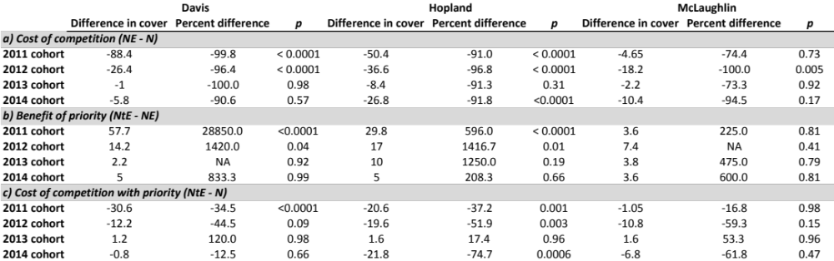

Table S2. Model fits for models of native cover from 2011 to 2013, and, separately, from 2011 to 2014. Models contained the listed environmental variable as a fixed effect, and site and planting year as random effects.

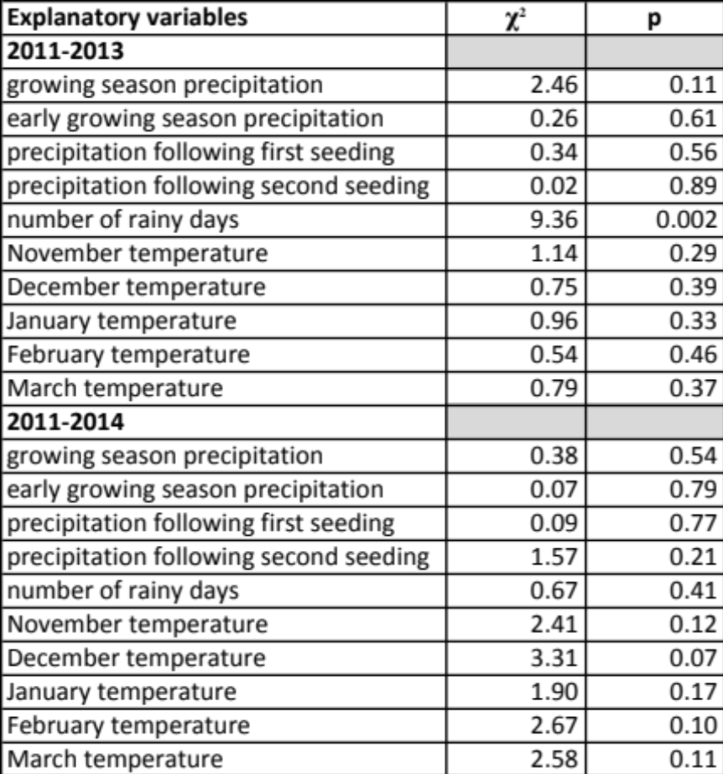
Figure S1. Mean temperature and total precipitation for each growing year. Growing years started on July 1 and ran until June 30. Horizontal lines indicate the historical mean annual temperatures for each site and vertical lines indicate historical precipitation levels at Davis in pink, Hopland in green, and McLaughlin in blue. Points to the left of the vertical lines indicate study years that were drier than the historical average while points above the horizontal lines are representative of years that were hotter than average.

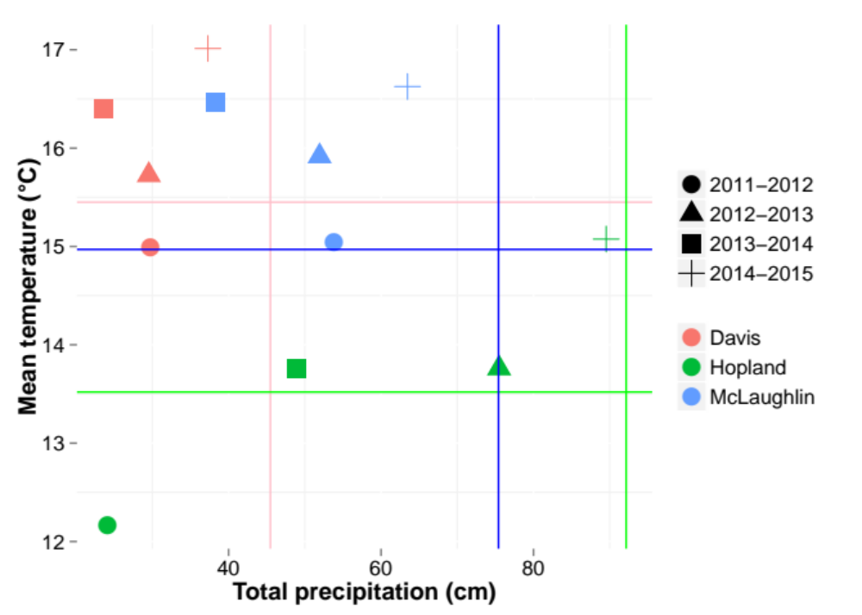
Figure S2. Cover of native grasses is negatively related to exotic grass cover in across the NE and NtE planting treatments (p < 0.0001).
