

American International University-Bangladesh (AIUB)  
**Department of Computer Science  
Faculty of Science &Technology (FST)**

**MedVerify: An AI-Powered Medicine Authentication & Verification System**

A Software EngineeringProject Submitted

By

|  |  |  |  |  |
| --- | --- | --- | --- | --- |
| **Semester: Summer_21_22** | | **Section:** | **Group Number:** | |
| SN | Student Name | Student ID | Contribution (CO3+CO4) | Individual Marks |
| 1 | Shoriful Islam | 23-50357-1 |  |  |
| 2 | Ridwan Alvi | 23-51953-2 |  |  |
| 3 | Riasad Choudhury | 22-49093-3 |  |  |
| 4 | Masrufa Sarower Tanjila | 22-48088-2 |  |  |
| 5 | Samia Islam Prioty | 22-47930-2 |  |  |

The project will be Evaluated for the following Course Outcomes

|  |  |  |
| --- | --- | --- |
| **CO3:***Select* appropriate software engineering models, project management roles and their associated skills for the complex software engineering project and evaluate the sustainability of developed software, taking into consideration the societal and environmental aspects | Total Marks | |
|  | |
| Appropriate Process Model Selection and Argumentation with Evidence | [5Marks] |  |
| Evidence of Argumentation regarding process model selection | [5Marks] |  |
| Analysis the impact of societal, health, safety, legal and cultural issues | [5Marks] |  |
| Submission, Defense, Completeness, Spelling, grammar and Organizationof the Project report | [5Marks] |  |
| **CO4:** *Develop*project management plan to managesoftware engineering projects following the principles of engineering management and economic decision process | Total Marks | |
|  | |
| Develop the project plan, its components of the proposed software products | [5Marks] |  |
| Identify all the activities/tasks related to project management and categorize them within the WBS structure. Perform detailed effort estimation correspond with the WBS and schedule the activities with resources | [5Marks] |  |
| Identify all the potential risks in your project and prioritize them to overcome these risk factors. | [5Marks] |  |

Description of Student’s Contribution in the Project work

|  |
| --- |
| Student Name: Shoriful Islam  Student ID: 23-50357-1  Contribution in Percentage (%):  Contribution in the Project:   * Contribution Description 1 * Contribution Description 2   ________Shoriful___________  Signature of the Student |
| Student Name: Ridwan Alvi  Student ID: 23-51953-2  Contribution in Percentage (%):  Contribution in the Project:   * Contribution Description 1 * Contribution Description 2   _________Ridwan Alvi___________  Signature of the Student |
| Student Name: _Riasad Choudhury_  Student ID: 22-49093-3  Contribution in Percentage (%):  Contribution in the Project:   * Contribution Description 1 * Contribution Description 2   _________Riasad Choudhury____________  Signature of the Student |
| Student Name: Masrufa Sarower Tanjila  Student ID: 22-48088-2  Contribution in Percentage (%):  Contribution in the Project:   * Contribution Description 1 * Contribution Description 2   ______Masrufa Sarower Tanjila______________  Signature of the Student |
| Student Name: Samia Islam Prioti  Student ID: 22-47930-2  Contribution in Percentage (%):  Contribution in the Project:   * Contribution Description 1 * Contribution Description 2   _____Samia Islam Prioti_______________  Signature of the Student |

# PROJECT PROPOSAL

## Project Title:

**MedVerify: An AI-Powered Healthcare Safety & Service Optimization Platform**  
**Slogan:** Trust Before Treatment

## 1.1 Background to the Problem

Bangladesh’s healthcare ecosystem faces severe challenges that compromise patient trust and safety:

1. **Unverified clinical practice** — Patients often receive treatment from unregistered practitioners due to lack of a public BMDC verification system.
2. **Circulation of counterfeit medicines** — Fake/substandard drugs flow through supply chains undetected.
3. **Opaque service discovery** — Patients cannot easily identify which nearby hospital/doctor best suits their condition, budget, or urgency.
4. **Friction in appointments** — Booking queues are manual, slow, and frustrating.
5. **Low medical decision literacy** — Patients struggle to decide where to go, which doctor to trust, or whether prescriptions are authentic.
6. **Report collection burden** — Patients waste time and money repeatedly traveling to collect diagnostic results.

**Root causes:** fragmented regulatory data, lack of integration between BMDC/DGDA, poor digitization of diagnostic services, limited emergency readiness, and no secure patient-centric record platform.

**Why this matters now:** With widespread smartphone usage and mature AI/OCR tools, an integrated solution can now **verify before treatment** (doctor, medicine, facility, report), restoring confidence in healthcare.

## 1.2 Solution to the Problem

**Core Goal:**  
“An everyday user should, from one mobile app, verify doctors and medicines, find the right hospital/department, book appointments, receive digital reports, and access emergency support—instantly and safely.”

### ✅ Features Already Built (Current MVP)

1. **Doctor Verification** — Cross-checks BMDC registration + AI OCR prescription anomaly detection.
2. **Medicine Authentication** — QR/Barcode verification with fallback AI camera recognition.

### 🔜 Upcoming Features (In Product Backlog)

1. **Geo-based Hospital & Doctor Finder** (filters: ICU, cleanliness, female doctor, budget).
2. **Smart Symptom-based Suggestion Engine** (AI-guided triage).
3. **Appointment & Token Booking** (live queue + emergency priority).
4. **Trusted Pharmacy & Lab Locator** (verified listing + crowd ratings).
5. **Emergency SOS Health Card** (offline alerts + patient health profile).
6. **Health Dashboard & Family Profile** (records, reminders, vitals).
7. **SmartReport Delivery System** (real-time digital test results, AI flags critical values).

### Tech Stack (Indicative)

* **Frontend:** Flutter (Clean Architecture)
* **Backend:** Node.js/Express + Supabase
* **AI/OCR:** TensorFlow Lite + Tesseract + Firebase ML
* **Geo-location:** Google Maps API / OpenStreetMaps
* **Auth & Sync:** Firebase Auth + encrypted APIs
* **Reports:** Lab dashboard + secure role-based upload

### Impact Summary

* **Patients:** Faster, safer, cheaper access to trusted care.
* **Hospitals:** Reduced crowding, paperless flow.
* **Regulators:** Easier fraud detection, scalable monitoring.
* **Global scaling:** Model fits South Asia, Africa, and MENA.

## 1.3 Drawbacks of the Solution (Limitations & Mitigations)

* **Quality assurance at scale:** Onboarding labs/pharmacies may vary.  
  Mitigation: Verified onboarding, periodic audits.
* **Data security & compliance:** Medical data is highly sensitive.  
  Mitigation: End-to-end encryption, MFA, audit trails, compliance with data laws.
* **Fraud evolution:** Counterfeiters may adapt.  
  Mitigation: Continuous AI retraining, geo-hotspot alerts.
* **Interoperability:** Hospital/Lab systems vary.  
  Mitigation: FHIR/HL7-inspired adapters, modular API integrations.
* **Digital divide:** Low-literacy & low-connectivity patients.  
  Mitigation: Offline mode, cached results, voice-first UX.

## Requirement Analysis

**Functional Requirements**

* Registration & Verification (patients, doctors via BMDC, pharmacies/labs).
* Profile Management (demographics, schedules, family profiles).
* Doctor Verification & Prescription OCR.
* Medicine Authentication (QR + AI fallback).
* Hospital/Doctor Finder & Symptom Triage.
* Appointment & Token Booking.
* SmartReport Delivery System.
* Trusted Pharmacy/Lab Locator.
* Admin/Moderator Console.

**Non-Functional Requirements**

* Performance: <3s p95 response, ≥500 concurrent users.
* Scalability: Horizontal scale, modular services.
* Security: SSL/TLS, MFA, PHI encryption, audit logs.
* Reliability: ≥99% uptime with offline fallback.
* Usability: Mobile-first, accessible UI.
* Maintainability: Clean architecture + CI/CD.
* Compliance: Local data protection rules.

**Constraints**

* Limited budget, student-led development.
* API dependency on regulators (BMDC/DGDA).
* Partner IT maturity varies.

## 2. SOFTWARE DEVELOPMENT LIFE CYCLE

### 2.1 Process Model — Scrum

Scrum is chosen because MedVerify requires adaptability, incremental delivery, and continuous feedback. Healthcare systems evolve rapidly, and Scrum ensures quick learning, safe iterations, and stakeholder involvement.

#### Scrum Practices in MedVerify

* **Product Backlog:** Features like doctor verification, medicine scanning, SmartReport.
* **Sprint Planning:** Define Sprint scope, tasks, effort.
* **Sprint Backlog:** Fixed list of tasks for the Sprint.
* **Daily Scrum:** 15-minute sync for updates/blockers.
* **Sprint Review:** Show increment to stakeholders (patients, doctors, regulators).
* **Sprint Retrospective:** Reflect & improve process.
* **Effort Estimation:** Story points/hours, refined over time.

#### Why Not Other Models

| **Model** | **Why Not Suitable for MedVerify** |
| --- | --- |
| **Waterfall** | **Too rigid; changes costly.** |
| **V-Model** | **Fixed requirements; healthcare evolves.** |
| **Spiral** | **Overly resource-heavy for a student team.** |
| **Prototype** | **Good for UI mockups only, lacks structure.** |
| **Incremental** | **Lacks Scrum’s roles & feedback cycles.** |
| **Iterative** | **Cycles exist but no ceremonies/roles.** |
| **Agile (general)** | **Principles only, no strict framework.** |
| **XP** | **Over-focused on coding, less on planning/regulation.** |

#### Scrum Benefits for MedVerify

* **Short Sprints:** Deliver usable features in 2–4 week cycles.
* **Fast Feedback:** Patients, doctors, pharmacists validate early.
* **Clear Roles:** Accountability for Product Owner, Scrum Master, Developers.
* **Easy to Change:** New regulations/feedback → backlog → next Sprint.
* **Early MVP:** Core features (doctor & medicine verification) already provide national value.

**Evidence of Industry Use**

* **Upwork — Agile/Scrum adoption:**  
  🔗 [Scrum Methodology Guide](https://www.upwork.com/resources/scrum-methodology-guide)
* **Fiverr Engineering — Sprint releases:**  
  🔗 [Fiverr Engineering Blog](https://medium.com/fiverr-engineering/the-lifecycle-of-a-mobile-task-2c8e40f8cb33)

### Literature Review and Existing Solutions

* **Practo (India):** Doctor booking, but no medicine verification.
* **1mg/Netmeds:** Medicine delivery, no integrated doctor verification or reporting.
* **Local BD apps:** Limited pharmacy delivery, no fraud detection or regulatory APIs.

**Gap:**

* No platform integrates **BMDC doctor license verification, counterfeit drug authentication, emergency SOS, hospital ranking, and digital test reports** in one ecosystem.

**MedVerify’s Uniqueness:**

* AI-OCR for fake prescription detection.
* QR + AI visual medicine authentication with DGDA integration.
* SmartReport real-time lab-to-patient delivery.
* Crowdsourced fraud alerts + regulator APIs.

## 2.2 Project Role Identification and Responsibilities

**Team Members:**

1. **Riasad** – Product Owner
2. **Alvi** – Scrum Master
3. **Prioty**– Backend/AI Developer
4. **Tanjila** – Frontend/Mobile Developer
5. **Shoriful** – UI/UX Designer

### ****1. Product Owner – Riasad****

**Responsibilities:**

* Define and communicate the product vision (“Trust Before Treatment”).
* Maintain and prioritize the Product Backlog (doctor verification, medicine authentication, SmartReport, SOS, etc.).
* Gather requirements from stakeholders (patients, doctors, pharmacists, regulators).
* Ensure delivered features meet acceptance criteria and deliver user value.
* Accept or reject Sprint outcomes based on quality and goals.

### ****2. Scrum Master – Alvi****

**Responsibilities:**

* Facilitate Scrum ceremonies: Sprint Planning, Daily Scrum, Sprint Review, Retrospective.
* Ensure the team follows Scrum principles and best practices.
* Remove blockers that hinder development progress (API issues, environment setup, etc.).
* Coach the team for continuous improvement and effective collaboration.
* Act as a servant-leader, supporting both Product Owner and developers.

### ****3. Backend/AI Developer – Prioty****

**Responsibilities:**

* Develop APIs for BMDC and DGDA integrations (doctor license, medicine database).
* Build OCR and AI pipelines for prescription verification and counterfeit detection.
* Implement SmartReport service: lab dashboard + patient report delivery.
* Ensure backend security (encryption, authentication, role-based access).
* Write unit tests and maintain server-side documentation.

### ****4. Frontend/Mobile Developer – Tanjila****

**Responsibilities:**

* Build Flutter mobile application (patients, pharmacists, labs).
* Integrate APIs for doctor verification, medicine authentication, SmartReport.
* Implement UI features like hospital finder map, appointment booking, SOS button.
* Optimize app for low bandwidth and offline use.
* Conduct front-end testing and bug fixing for a seamless experience.

### ****5. UI/UX Designer – Shoriful****

**Responsibilities:**

* Design mobile-first, accessible UI for diverse users (urban, rural, elderly).
* Create prototypes and wireframes for each core module (verification, reports, booking).
* Ensure usability with clear warnings (fake medicine alert, emergency indicators).
* Collaborate closely with developers to ensure design matches implementation.
* Conduct user testing to improve flow and accessibility.

### ****6. Stakeholders / External Advisors**** (Doctors, Pharmacists, Regulators, AI Consultants)

**Responsibilities:**

* Provide domain knowledge on healthcare workflows and regulations.
* Validate features like prescription scanning and fraud alerts.
* Share feedback during Sprint Reviews to refine system accuracy.
* Ensure regulatory compliance and real-world applicability.

**3.Effort Estimation (Cocomo, Budget, Risk )**

## 3.2 Budget Estimation

This document provides a detailed budget estimation for the MedVerify project, classified under the Semidetached mode of the COCOMO model. The estimation covers development, infrastructure, security, human resources, and miscellaneous costs.

**1. From Organic mode (normal schedule we found):**

* **Effort (PM): ~136.5 person-weeks**
* **Natural TDEV: ~15.8 weeks**
* **Natural Team Size: ~8–9 people**

**Final (Organic, 50 KLOC, 12 weeks target):**

* **Effort: ~136.5 PM (same work overall)**
* **Schedule: 3 months (forced)**
* **Team Size Needed: ~45–46 people**

**2. Development Costs**

|  |  |  |
| --- | --- | --- |
| Module | Description | Estimated Cost (USD) |
| Frontend (Web + Mobile) | Web app + Mobile app development | $20,000 – $25,000 |
| Backend Development | APIs, database, health record system | $15,000 – $22,000 |
| AI/ML – Doctor Verification | OCR, license check, anomaly detection | $20,000 – $28,000 |
| AI/ML – Medicine Authentication | QR/barcode and image recognition | $15,000 – $22,000 |
| Integration & Testing | System integration, QA, bug fixing | $10,000 – $15,000 |

Subtotal (Development): $80,000 – $112,000

**3. Infrastructure & Cloud Costs (3 Months)**

|  |  |  |
| --- | --- | --- |
| Item | Cost/Month | Annual Cost |
| Cloud Hosting (AWS/GCP) | $1,000 – $1,200 | $3,000 – $3,600 |
| Storage & Backup | $400 – $600 | $1,200 – $1,800 |
| API Licensing | - | $3,000 – $5,000 |
| DevOps & Monitoring Tools | - | $3,000 – $4,000 |

Subtotal (Infrastructure, 3 months): $10,200 – $14,400

**4. Security & Compliance**

|  |  |
| --- | --- |
| Item | Estimated Cost |
| HIPAA/GDPR compliance setup | $6,000 – $10,000 |
| Data encryption & RBAC | $4,000 – $6,000 |
| Penetration testing & audit | $6,000 – $8,000 |

Subtotal (Security): $16,000 – $24,000

**5. Human Resource Costs ( 3 Months)**

|  |  |  |  |
| --- | --- | --- | --- |
| Role | Count | Avg. Monthly Salary (USD) | Annual Cost |
| Project Manager | 1 | $2,200 | $6,600 |
| Developers | 6 | $1,600 | $28,800 |
| AI/ML Engineers | 3 | $2,200 | $19,800 |
| UI/UX Designer | 1 | $1,500 | $4,500 |
| QA/Test Engineer | 2 | $1,400 | $8,400 |

Subtotal (Human Resources – 3 months): $68,100

**6. Miscellaneous**

|  |  |
| --- | --- |
| Item | Estimated Cost |
| Training data for AI | $6,000 – $10,000 |
| SDK/Licensing (OCR, barcode scanner) | $3,000 – $5,000 |
| Marketing & Initial Rollout | $12,000 – $18,000 |

Subtotal (Miscellaneous): $21,000 – $33,000

**7. Total Budget Estimation**

• Development: $80,000 – $112,000  
 • Infrastructure (3 months): $10,200 – $14,400  
 • Security & Compliance: $16,000 – $24,000  
 • Human Resources: ~$$68,100  
 • Miscellaneous: $21,000 – $33,000  
   
Grand Total (Year 1): $195,300 – $251,500

**3.3 Risk Management**

|  |  |  |  |  |  |  |  |
| --- | --- | --- | --- | --- | --- | --- | --- |
| SN | Description of Risk | Likelihood | Impact | Mitigation Plan | Risk Level | Risk Owner | Notes |
| 1 | Delay in collecting requirements from BMDC/DGDA | Medium | High | Early stakeholder engagement, add buffer time | High | Product Owner & Scrum Master | Delays in regulator input can block verification modules. |
| 2 | AI OCR/Medicine Authentication not accurate enough | Medium | High | Use pre-trained models, iterative testing, continuous retraining | High | Backend/AI Developer | Accuracy below threshold may reduce user trust. |
| 3 | Data security & privacy breaches | Medium | Very High | End-to-end encryption, MFA login, role-based access, monitoring | High | Security Specialist & Scrum Master | Sensitive patient health data requires strict protection. |
| 4 | Outdated or incorrect hospital/doctor data | Medium | Medium | Crowd-sourced validation, regular API updates, feedback loop | Medium | Frontend & Backend Developers | Incorrect data could misguide patients to wrong services. |
| 5 | Smart Report integration fails with partner labs | Medium | High | Pilot testing with limited labs, fallback manual uploads | High | Backend Developer & Lab Partners | Integration issues could delay or prevent report delivery. |
| 6 | Emergency SOS feature fails offline | Medium | High | Add SMS fallback system, cached hospital directory | High | Frontend Developer | Critical in rural/low-connectivity areas. |
| 7 | Feature creep causing project delays | High | Medium | Strict backlog prioritization, PO approval for new features | Medium | Product Owner & Scrum Master | Uncontrolled scope expansion risks project timeline. |
| 8 | Critical bugs found late during final testing | Medium | High | Parallel QA, regression testing after every Sprint | High | QA Team | Late bug discovery increases cost of fixing issues. |
| 9 | Low adoption by students/clients in initial phaseLow adoption by patients/doctors/pharmacies at launch | Medium | High | Awareness campaigns, usability testing, onboarding support | High | Product Owner & UI/UX Designer | Adoption rate determines platform success. |
| 10 | Dependency on external APIs (BMDC/DGDA) | Low | High | Cache previous data, design offline fallback | Medium | Backend Developer & Scrum Master | API downtime may disrupt verification services. |

**4. Scheduling**  
 **4.1 Gantt Chart**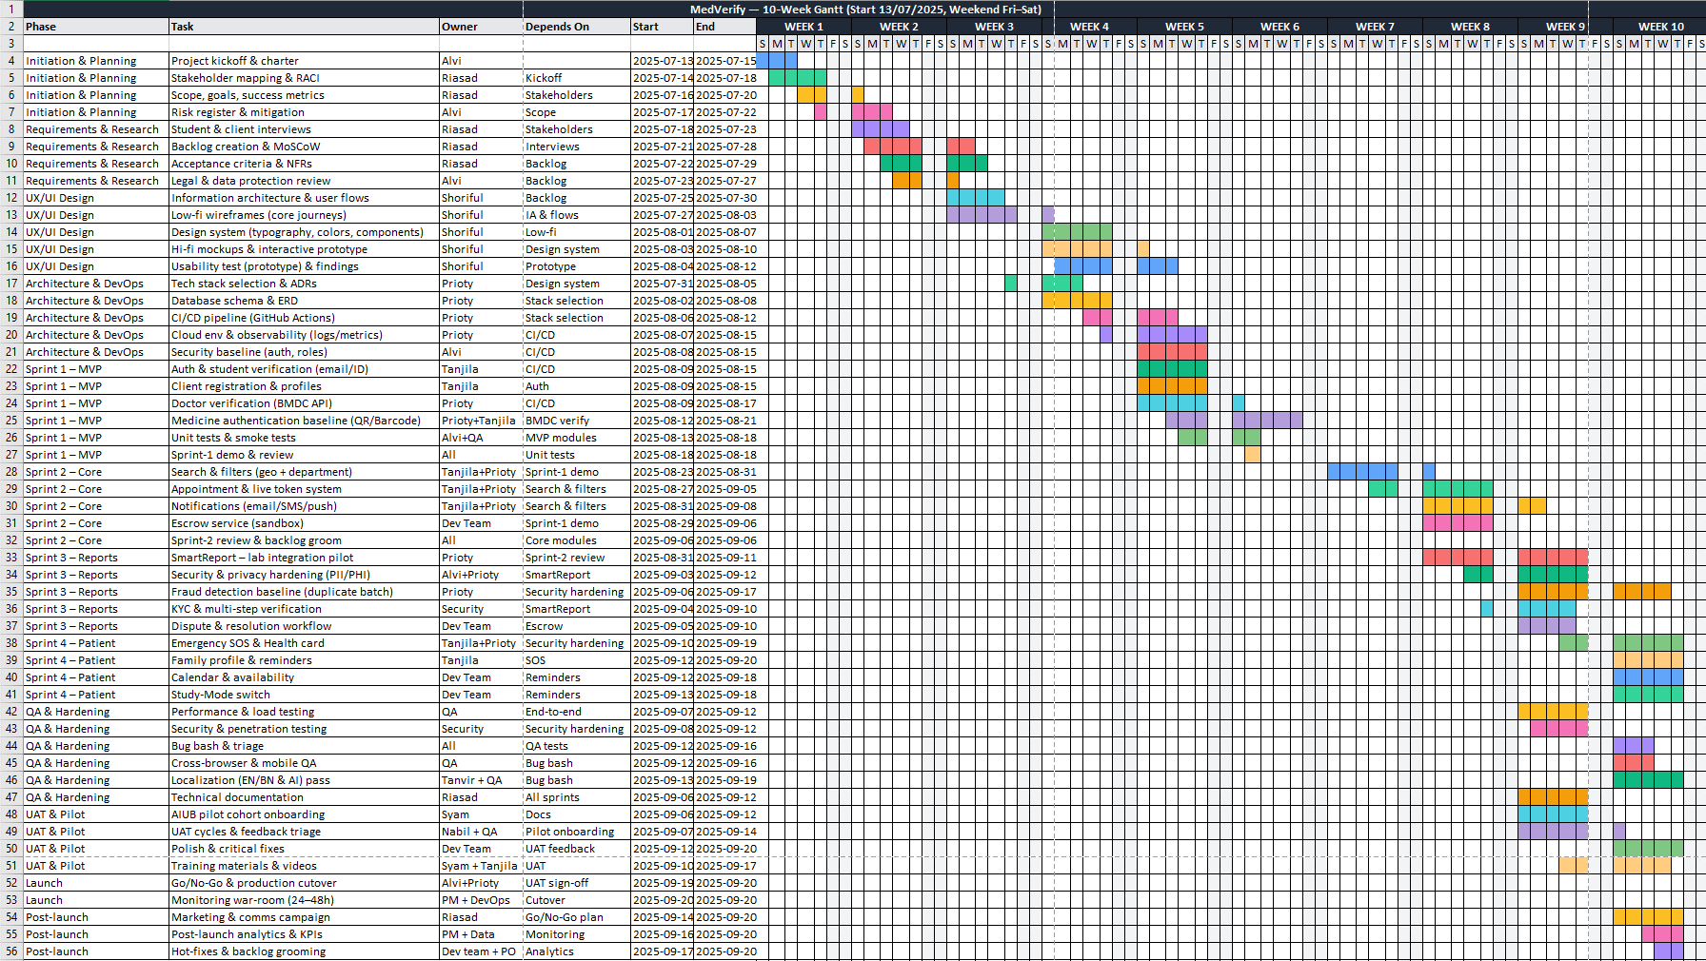

**5. Design(1. Prototype, Figma, Balsamiq and Diagrams Class, Activity, Data flow)**  
  **5.1. Figma Design   
**Homepage:**

**Doctor Verification Page :**

**5.2 Balsamiq Design**   
**Login and Registration page :**   
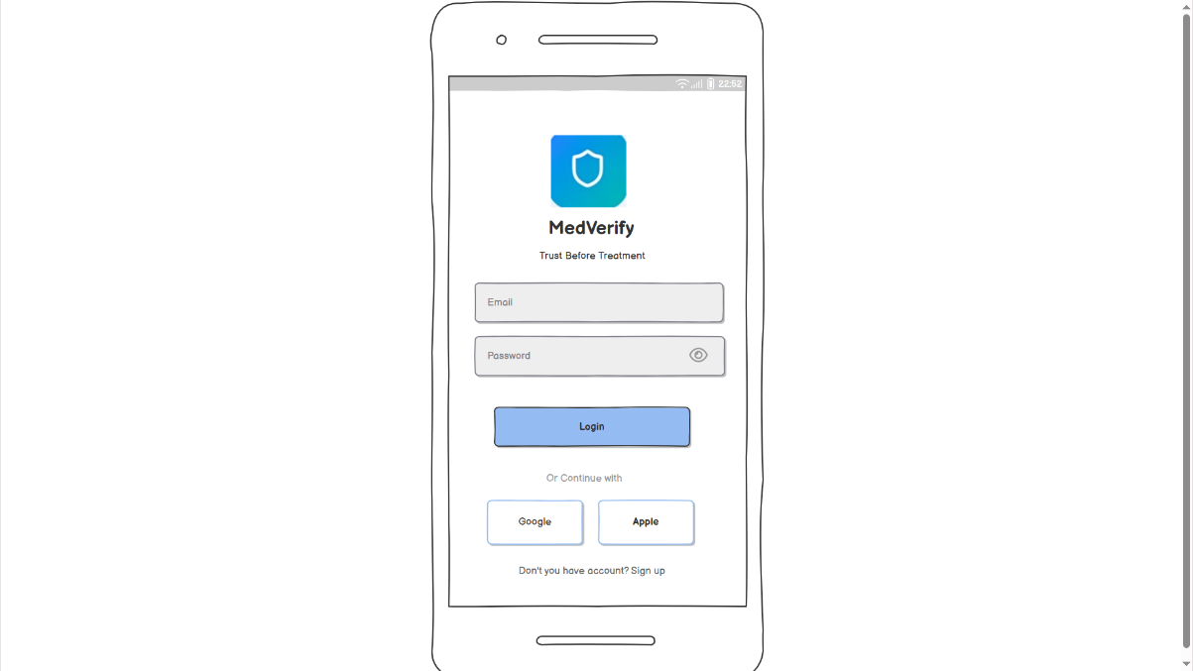  
**Homepage:**

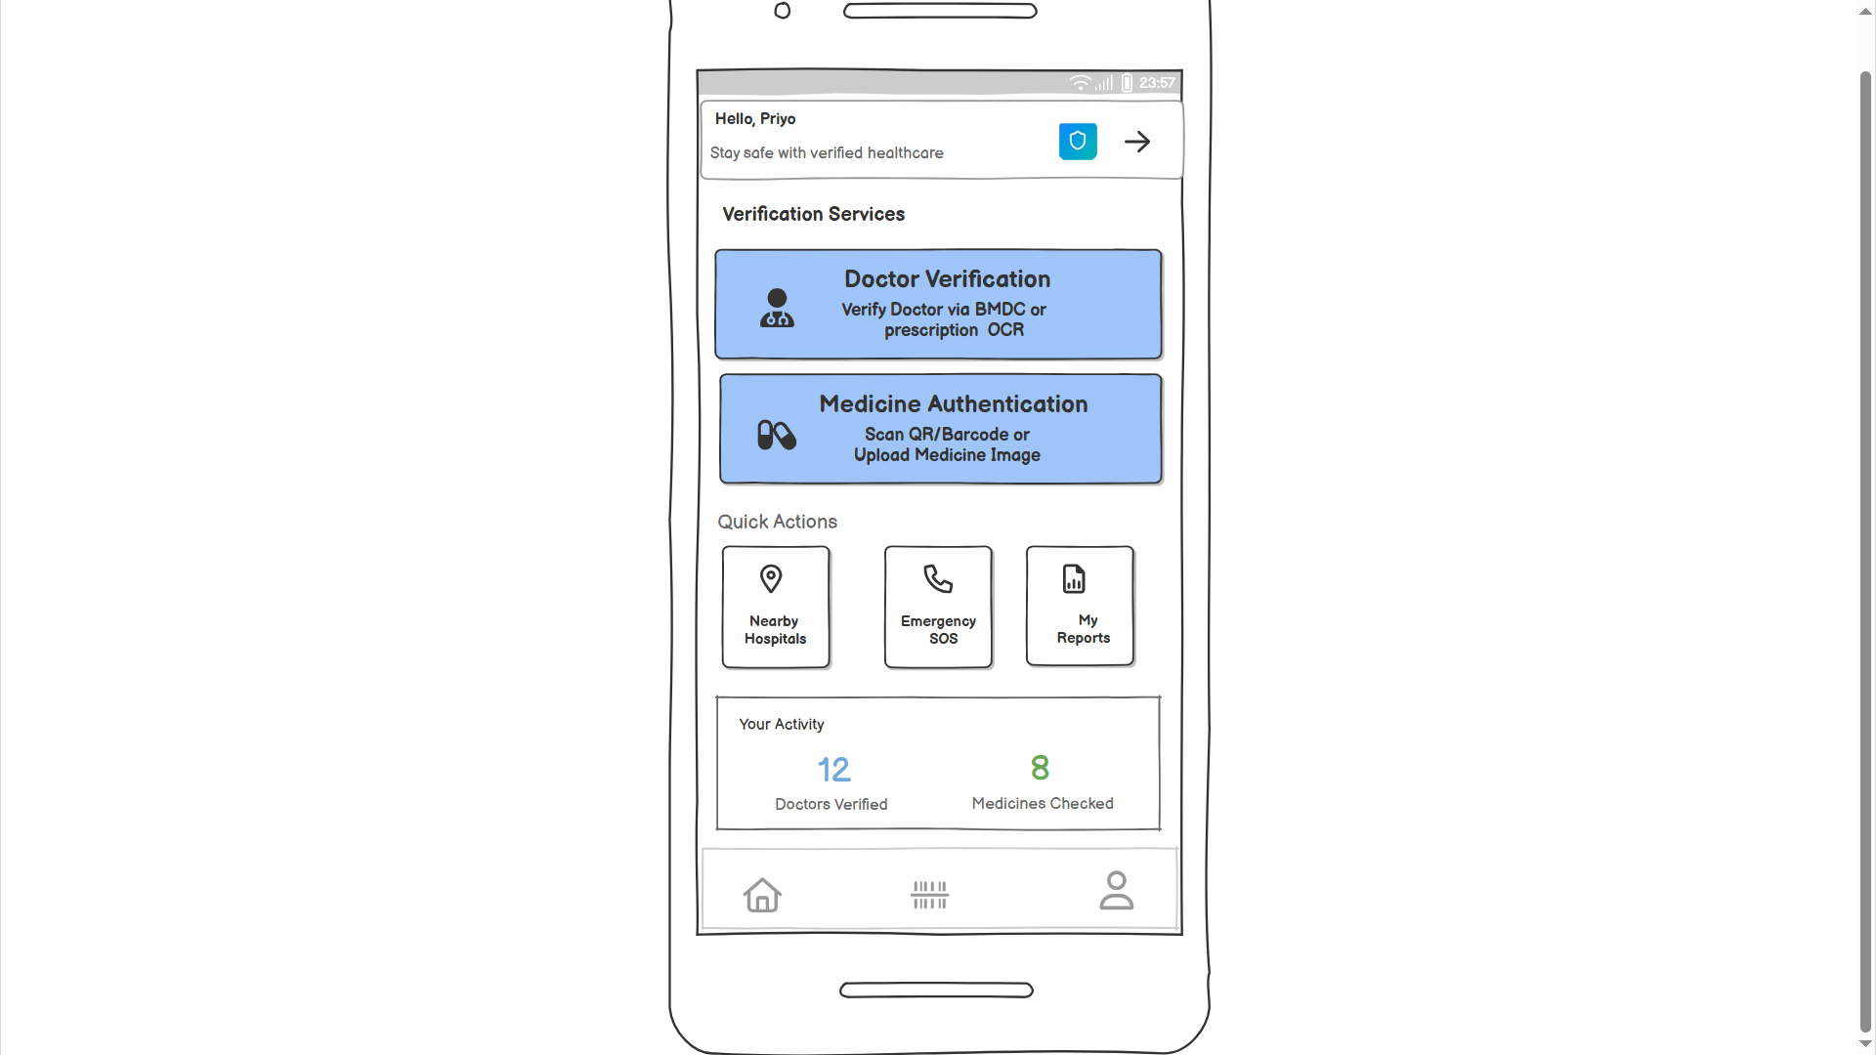

**Doctor Verification Page :**

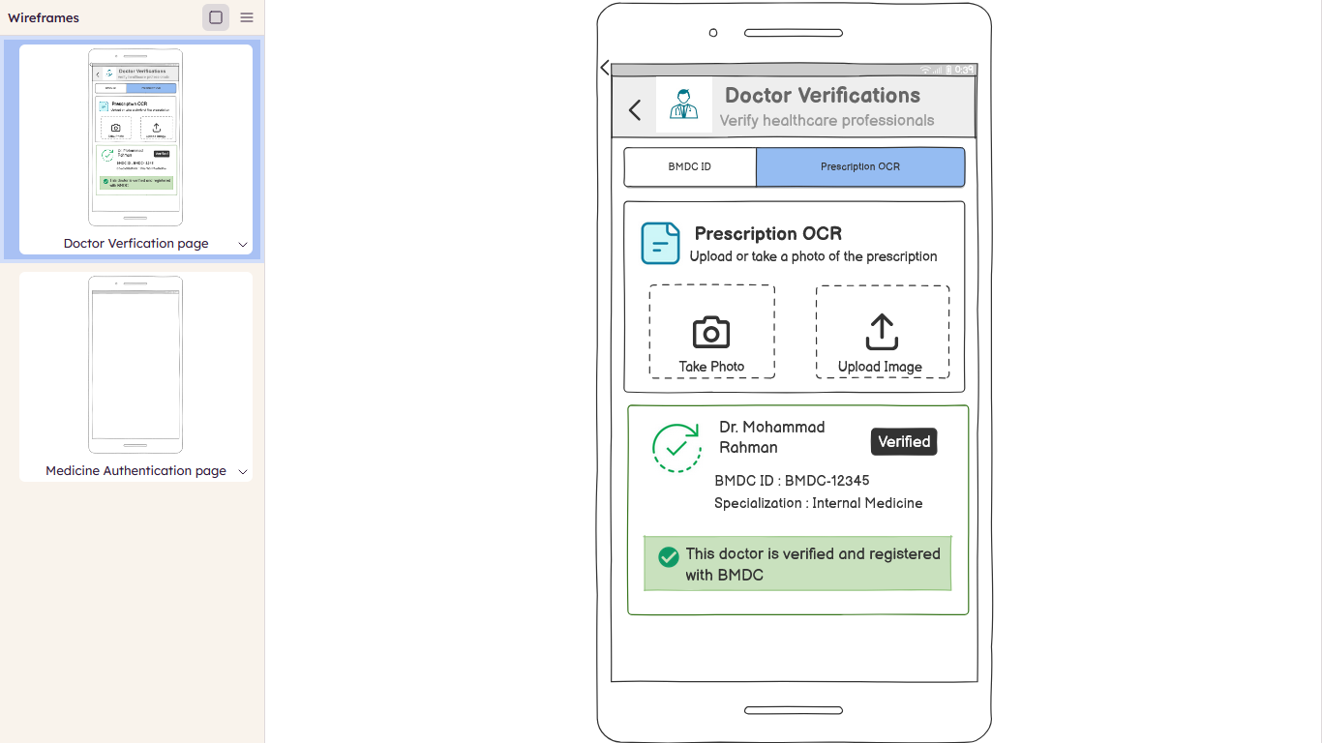  
  
**Medicine Authentication**  
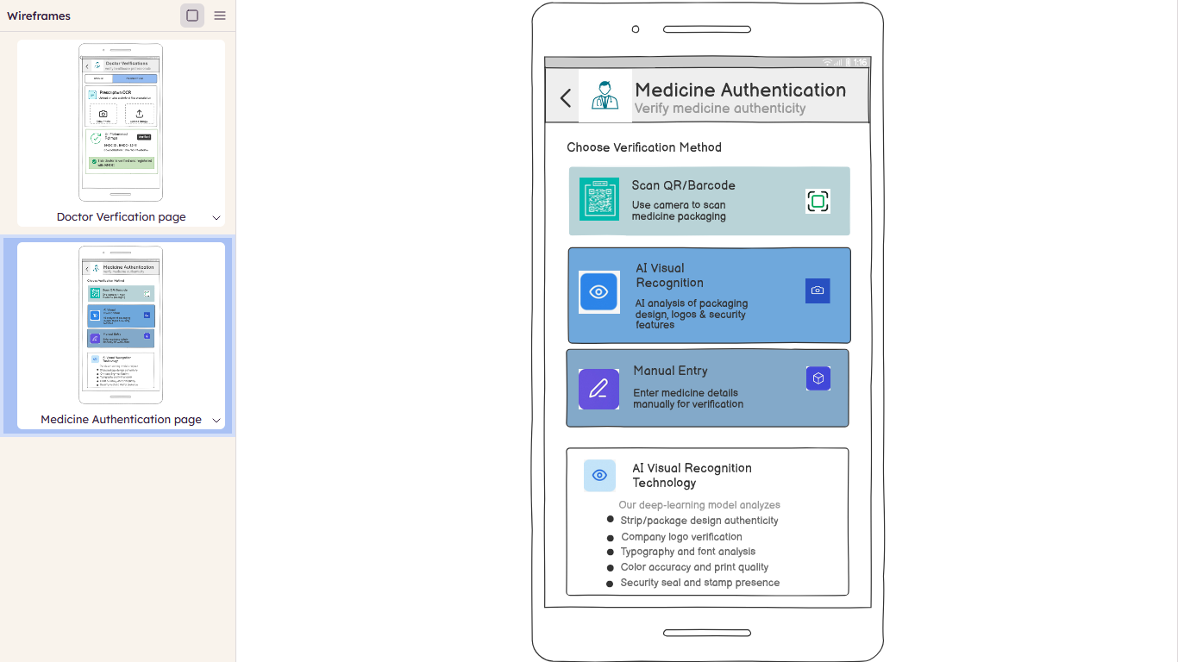  
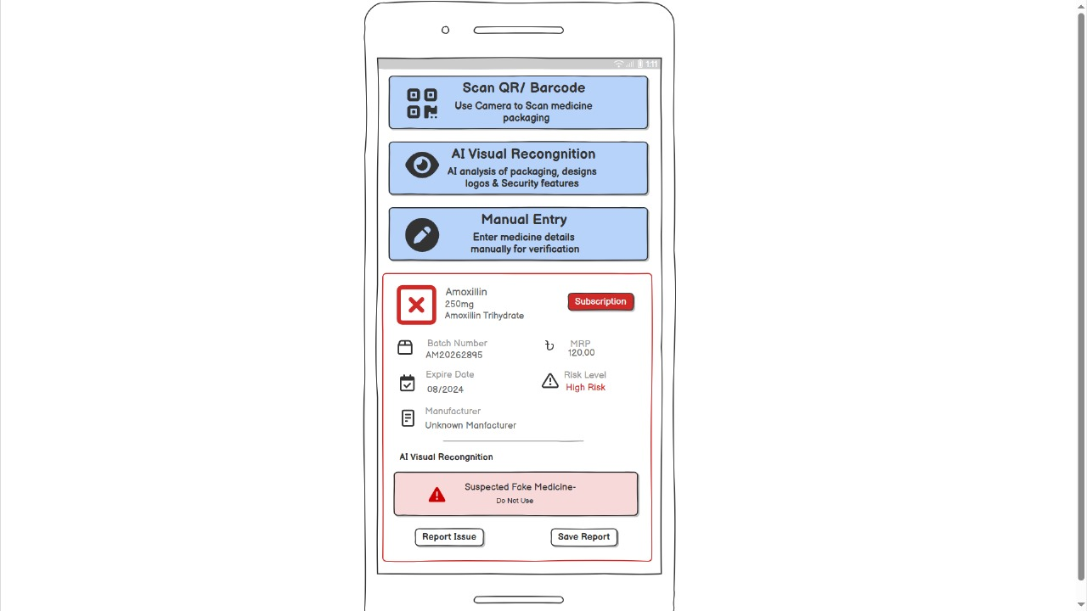  
**5.3 Diagram**  
  
 **Class Diagram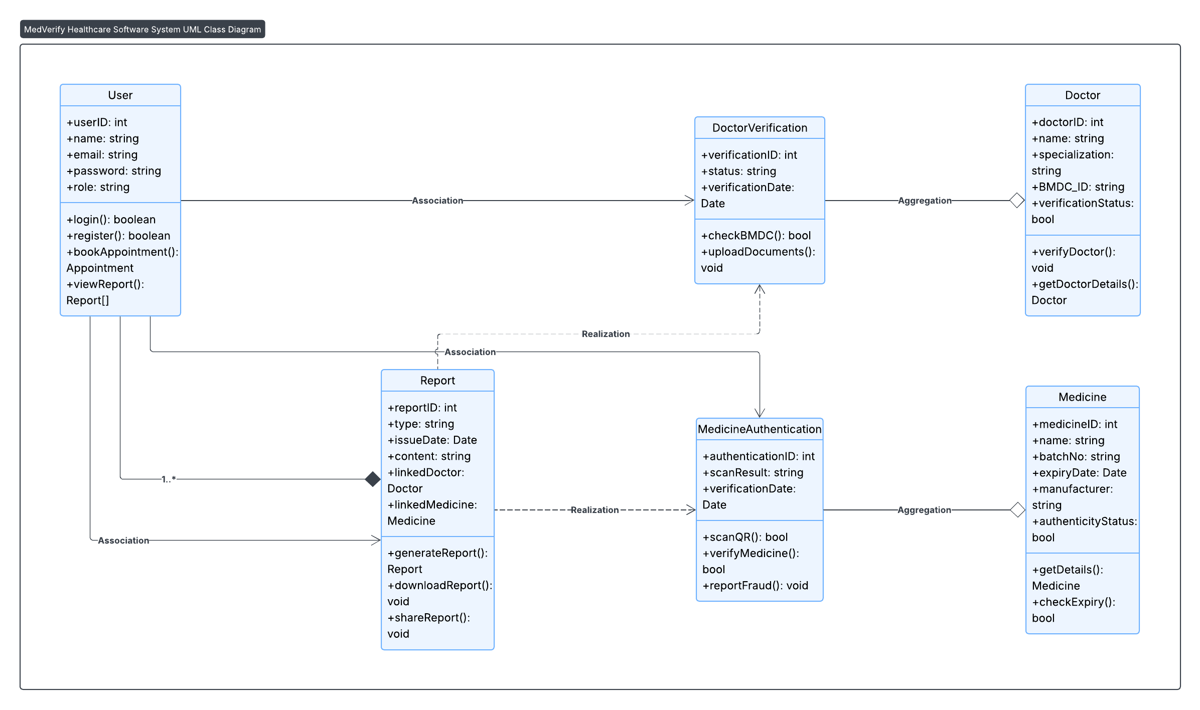 Fig: Class Diagram**

**Med Verify - UML Diagrams Report**

1. **Activity Diagram (Detailed)**

1. **Activity Diagram (Simplified)**

1. **Use Case Diagram**

Fig:Use Case Diagram

**Class Diagram**

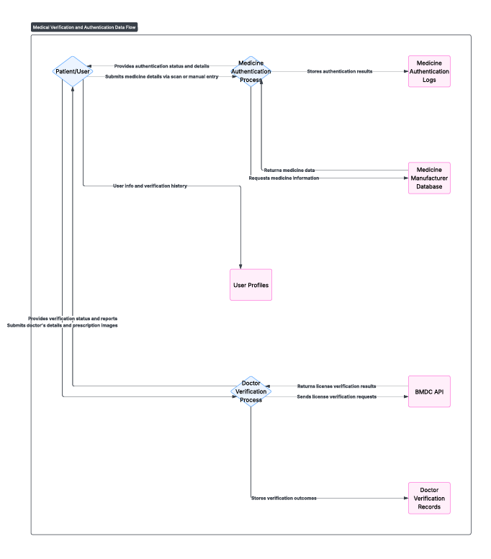

**Fig: Data Flow Diagram**

## Rubric for Project Assessment (CO3)

|  |  |  |  |  |  |
| --- | --- | --- | --- | --- | --- |
| Criteria | Marks distribution (Max 3X5= 15) | | | | Acquired  Marks |
| **Inadequate (1-2)** | **Satisfactory (3)** | **Good (4)** | **Excellent (5)** |
| Selection of Software Engineering Models | Does not articulate a position or argument of choosing appropriate model. Does not present any evidence to support the arguments for the choice of the model | Articulates a position or argument for choosing models that is unfocused or ambiguous. Presents incomplete/vague evidence to support argument for model choice | Articulates a position or argument of choosing models that is limited in scope. Does not present enough evidence to support the argument for the choice of the model | Clearly articulates a position or argument for the choosing software engineering models. Presents sufficient amount of evidence to support argument for the model selection |  |
| Role identification and Responsibility Allocation | The project has poor project management plans for identifying roles and assigning the responsibilities | Identify few roles in the project management where some of the roles are left alone with any project responsibilities | Identify most of the roles in the project management and assign their responsibilities | Well planned project with proper role identification and responsibility allocation in the project management activities |  |
| Impact identification |  |  |  |  |  |
| Formatting and Submission | Project report is not complete and Several errors in spelling and grammar. Present a Confusing organization of concepts, supporting  arguments, and  real-life example.  Sentences rambling, and details are repeated. | Some errors in spelling and grammar. Some problems  of organizing the answer in a logical order of defining,  elaborating, and providing real-life examples. | Few errors in spelling and grammar. Presents most of the details in a logical flow of  organization in  definition,  details, and  example. | Project report is complete and No errors in spelling and grammar. Consistently  presents a logical  and effective  organization of definition,  details, and real-life example of  the topic. |  |
| Acquired marks: | | | | |  |
| CO Pass / Fail: | | | | |  |

## Rubric for Project Assessment (CO4)

|  |  |  |  |  |  |
| --- | --- | --- | --- | --- | --- |
| Marking Criteria | Marks Distribution (Maximum 3X5=15) | | | | Acquired Marks |
| **Inadequate (1-2)** | **Satisfactory (3)** | **Good (4)** | **Excellent (5)** |
|  |  |  |  |  |  |
| Project Planning | No background information regarding the project is  given; project goals and benefits are  missing. | Insufficient background information is given; project goals and benefits are  poorly stated | Sufficient background information is given; the purpose and goals of the project are explained. | Thorough and relevant background information  is given; project goals are clear and easy to identify. |  |
| Effort Estimation and Scheduling | Student vaguely discuss the impact of societal, health, safety, legal and cultural issues in their project | Student provided with partial relevance to the impact of societal, health, safety, legal and cultural issues in their project | Student fairly provided the analysis to the impact of societal, health, safety, legal and cultural issues in their project | Student comprehensively provided the analysis to the impact of societal, health, safety, legal and cultural issues in their project |  |
| Risk Management | Ambiguous representative example. | Partially identify / indicate towards real-life example. | Real-life example is fairly connected towards the definition. | Comprehensively defend with real life example. |  |
| Acquired Marks: | | | | |  |
| CO Pass / Fail: | | | | |  |