Network Traffic Analysis & DDoS Attack Detection using Machine Learning

UCM FibIoT 2024 Dataset
Name:
University: VIT Bhopal University
Group no.:

Abstract
This research project involves data preprocessing and analysis of large datasets containing IoT network traffic for the purpose of using machine learning techniques for detecting DDoS attacks in these networks. In this research, we utilize the UCM FibIoT 2024 dataset consisting of three types of attacks – HTTP Flood attack, ICMP Flood attack, and SYN Flood attack. We developed an effective data cleaning pipeline that converted raw packets captured to a structured format. Several machine learning models such as logistic regression, random forest, XG Boost, Light GBM, and neural network models using Keras library were built. Our final machine learning model showed 99.91% accuracy.

Problem Statement
IoT devices are highly vulnerable to DDoS attacks due to limited security mechanisms. Raw network traffic data is unstructured and noisy, making it unsuitable for direct machine learning applications.
The objective of this project is to:
- Clean and preprocess large-scale network traffic data
- Analyze traffic patterns
- Build a machine learning model to classify attack types

Dataset Description
The dataset is derived from the UCM FibIoT 2024 dataset and contains real-world IoT network traffic.
Attack Types:
Attack Type | Layer | Description
HTTP Flood | Application | Overloads servers using HTTP requests
ICMP Flood | Network | Uses ping requests to flood network
SYN Flood | Transport | Exploits TCP handshake

Dataset Size:
- Total: 44.7+ million rows
Features:
- Source IP
- Destination IP
- Source Port
- Destination Port
- Protocol
- Packet Length
- Timestamp

Data Cleaning & Preprocessing
The dataset was processed using a structured cleaning pipeline:
- Standardized column names
- Removed irrelevant columns
- Converted timestamps to datetime
- Handled missing values (protocol-based logic)
- Removed duplicates
- Validated packet length and port ranges
- Optimized memory usage
- Sorted chronologically
- Added attack_type label
Data Integrity Maintained: >99.99%

Exploratory Data Analysis & Validation
- Missing Value Analysis:
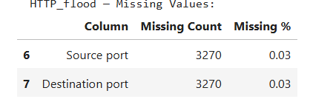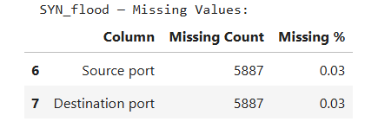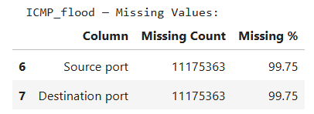

Insight:
- Missing values mainly present in port fields
- Proper handling ensured minimal data loss

Protocol Distribution
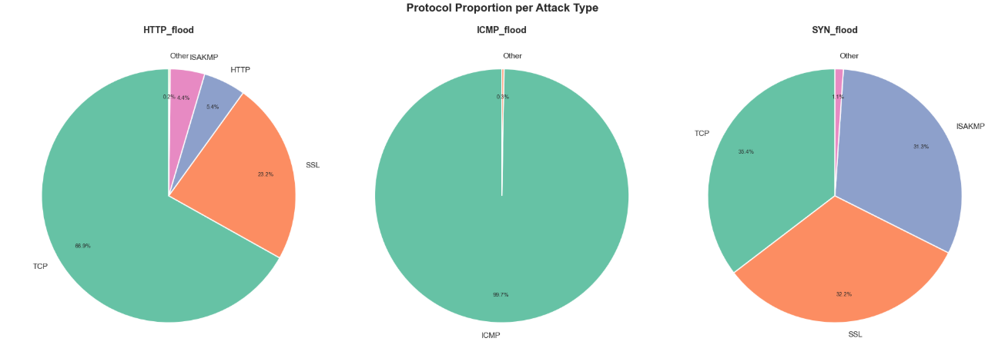
Insight:
- TCP dominates SYN Flood
- ICMP dominates ICMP Flood
- Confirms dataset correctness
Data Cleaning Impact
Dataset | Raw Rows | Cleaned Rows | Rows removed
HTTP Flood | 10,799,707 | 10,799,526 | 181
ICMP Flood | 11,203,031 | 11,202,929 | 102
SYN Flood | 22,780,665 | 22,780,333 | 332

Insight:
- Less than 0.01% data loss
- High-quality preprocessing

Data Pipeline Architecture
Raw PCAP Data → CSV → Data Cleaning → Feature Engineering → ML Models → Evaluation

Machine Learning Pipeline
🔹 Models Used:
- Logistic Regression
- Random Forest
- XGBoost
- LightGBM
- Keras MLP (Neural Network)
🔹 Steps:
- Feature selection
- Encoding categorical variables
- Train-test split (80-20)
- Model training and evaluation
Model Comparison Results
Model | Accuracy | F1 Score
Logistic regression | 0.9989 | 0.9989
Random Forest | 0.9997 | 0.9997
XGBoost | 0.9997 | 0.9997
LightBGM | 0.9997 | 0.9997
Keras MLP | 0.9991 | 0.9991

Final Model Performance (Keras MLP)
- Accuracy: 99.91%
- F1 Score: 99.91%
Classification Report:
- All classes achieved near-perfect precision and recall

Confusion Matrix
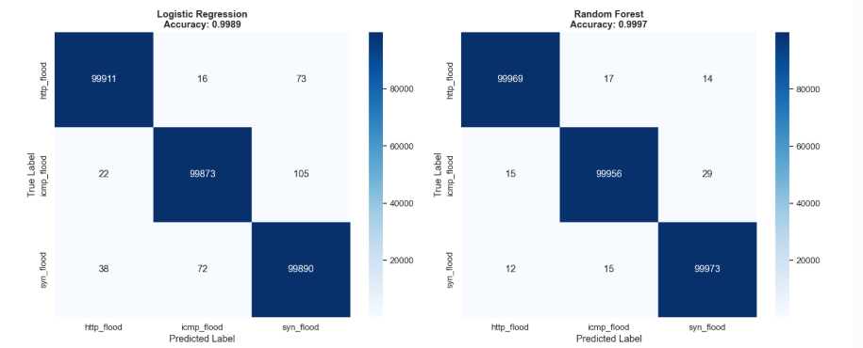
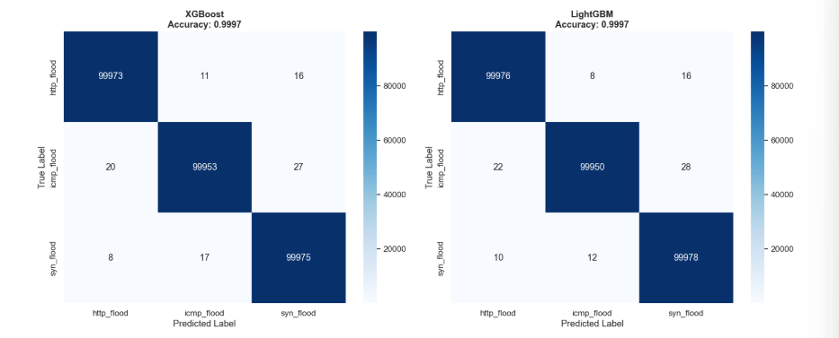
Insight:
- Majority predictions lie on diagonal
- Very low misclassification
ROC Curves
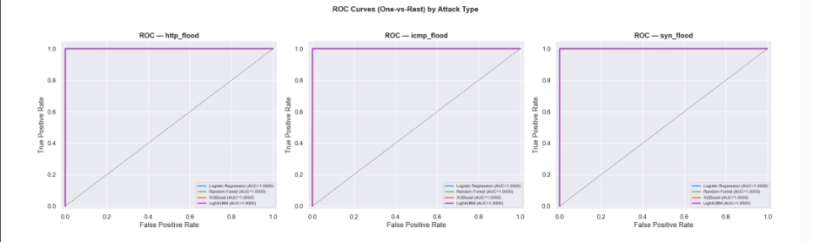

Insight:
- AUC ≈ 1.0 → excellent performance
Precision-Recall Curves
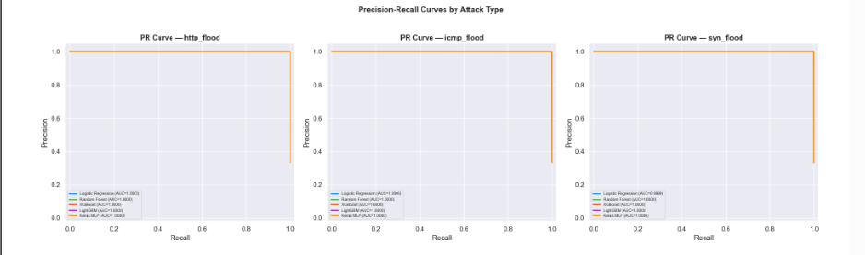
Insight:
- High precision and recall across all classes
Anomaly Detection (Isolation Forest)
- Normal: 1,350,001
- Anomaly: 149,999
Insight:
- Effective unsupervised detection
- HTTP flood shows highest anomalies
Key Observations
- Data cleaning significantly improved model performance
- Tree-based models performed best
- Clear separation between attack types
- Models achieved near-perfect classification

Real-World Applications
- Intrusion Detection Systems
- IoT Security Monitoring
- Smart Infrastructure Protection
- Real-time attack detection
Conclusion
This project demonstrates a complete data science pipeline for detecting DDoS attacks in IoT environments. From cleaning large-scale raw data to building high-performance machine learning models, the system achieves excellent accuracy and reliability. The results highlight the importance of preprocessing and model selection in cybersecurity applications.
Future Scope
- Real-time deployment
- Deep learning models (LSTM, CNN)
- Cloud integration
- Automated threat response
Key Achievements
- Processed 44.7M+ rows
- Built complete end-to-end pipeline
- Achieved ~99.9% accuracy
- Implemented multiple ML models
Technologies Used
- Python
- Pandas, NumPy
- Scikit-learn
- XGBoost, LightGBM
- TensorFlow/Keras
- Matplotlib, Seaborn

