TECHNICAL IMPLEMENTATION REPORT
Active Directory
& Group Policy Lab
Windows Server 2022 | corp.lab | Domain Services | File Services | Workstation Controls
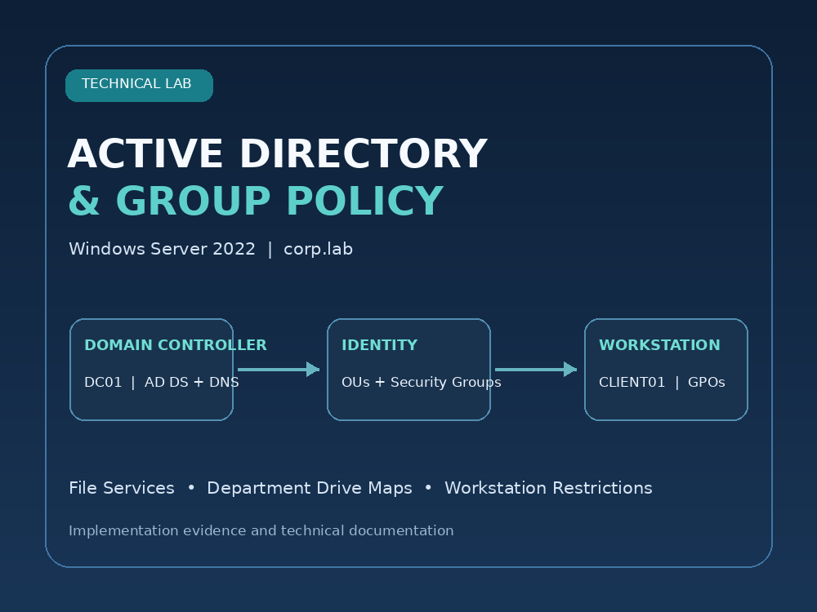
Prepared: 04 November 2026
Lab implementation record with configuration evidence and security review

1. Executive Summary
This project implements a small Windows domain environment using Windows Server 2022, Active Directory Domain Services, DNS, Group Policy, and SMB file sharing. The design separates users by department, assigns department security groups, maps department folders to drive letters, and applies domain account and workstation restrictions.
Project scope Domain: corp.lab | NetBIOS: CORP | Domain controller / file server label: DC01 | Domain client: CLIENT01

Delivered capabilities
- Created the corp.lab forest and verified the domain structure in Active Directory Users and Computers.
- Created Management, IT, HR, Finance, and Workstations OUs with representative users and security groups.
- Created the Corp Lab Data SMB share and four department folders.
- Configured department-specific drive mappings for H:, F:, I:, and M:.
- Configured domain password and account-lockout policies through the Default Domain Policy.
- Configured central workstation restrictions and an HR-specific desktop restriction policy.
- Captured client evidence for the sara.ahmed logon, HR H: drive, Control Panel restriction message, and CD/DVD access denial.
Evidence standard This report distinguishes policy configuration screens from observed client-side test results. A configured policy is not marked as passed unless client behavior is shown in the supplied evidence.

2. Environment and Logical Architecture
Component | Recorded value
Server platform | Windows Server 2022
Domain | corp.lab
NetBIOS | CORP
Domain controller / file server label | DC01
Domain client | CLIENT01
Share local path | C:\SHARED FOLDER\Corp Lab Data
Share UNC path | \\DC01\Corp Lab Data

The lab network was adjusted during troubleshooting. Because the supplied captures contain more than one network state, this report intentionally does not publish a fixed IPv4 address. Confirm the current IP, gateway, DNS server, and VMware network mode in the running VMs before reproducing the lab.
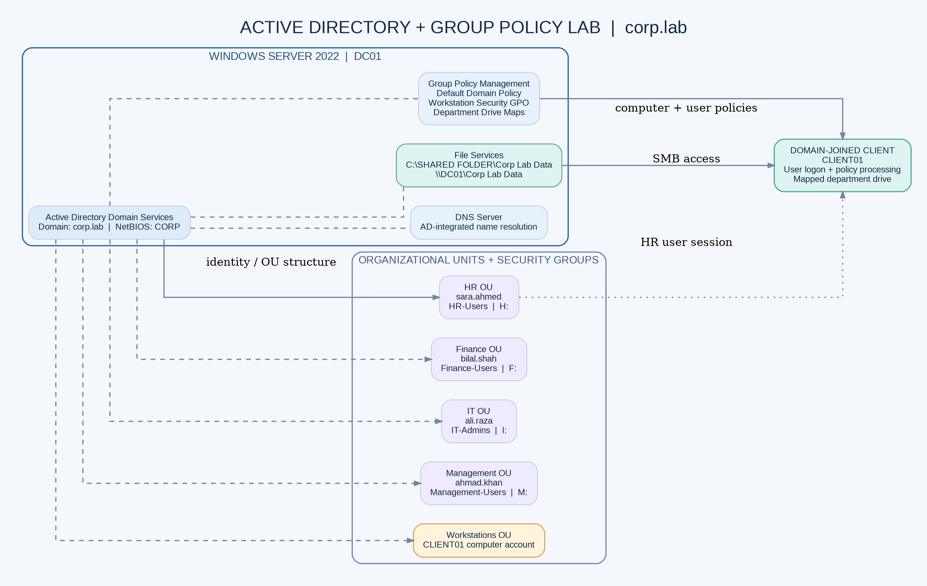
Figure 1. Logical domain, identity, file-service, and client-policy relationships.

3. Active Directory Design
The domain is organized by department. Departmental user accounts are placed in their respective OUs so user-based GPO links can be processed through the OU hierarchy.
Organizational Unit | Representative account / object | Security group
Management | ahmad.khan | Management-Users
IT | ali.raza | IT-Admins
HR | sara.ahmed | HR-Users
Finance | bilal.shah | Finance-Users
Workstations | CLIENT01 computer account | N/A

Design notes
- Use security groups to assign resource permissions rather than assigning permissions individually to each user.
- Keep user objects in the correct department OU. A GPO linked to an OU applies based on user/computer object location and security filtering, not merely because a user belongs to a matching group.
- Keep workstation computer accounts in the Workstations OU so computer-based policy scope can be controlled separately from user-based restrictions.

4. File Services and Department Drive Maps
The share root is hosted at C:\SHARED FOLDER\Corp Lab Data and published as Corp Lab Data. The department folders are Finance, HR DATA, IT, and Management.
Department | Folder / UNC target | Drive | Label
HR | \\DC01\Corp Lab Data\HR DATA | H: | HR Shared Drive
Finance | \\DC01\Corp Lab Data\Finance | F: | Finance Shared Drive
IT | \\DC01\Corp Lab Data\IT | I: | IT Shared Drive
Management | \\DC01\Corp Lab Data\Management | M: | Management Shared Drive

Drive-map design
The maps use User Configuration > Preferences > Windows Settings > Drive Maps. The configured preference uses the Update action, the department UNC path, a fixed drive letter, a descriptive label, and Reconnect. The HR H: drive is visible in the supplied client screenshot under sara.ahmed.
Permissions review The supplied share-permission screenshot shows Everyone with Full Control. The NTFS folder ACLs should remain the authoritative department boundary, but broad share permissions should be narrowed and the combined effective access tested.

5. Domain Account Policies
The Default Domain Policy screenshot records the following settings. They are reproduced as observed, not presented as a recommended universal baseline.
Password policy setting | Captured value
Enforce password history | 24 passwords remembered
Maximum password age | 50 days
Minimum password age | 1 day
Minimum password length | 5 characters
Password must meet complexity requirements | Enabled
Store passwords using reversible encryption | Disabled

Account lockout policy
Account lockout setting | Captured value
Account lockout threshold | 10 invalid logon attempts
Account lockout duration | 5 minutes
Reset account lockout counter after | 5 minutes
Allow Administrator account lockout | Enabled

Baseline improvement The captured minimum password length is 5 characters. Raise it to at least 12 characters (14 is a stronger lab target), then update the evidence and confirm the resulting password policy.

6. Group Policy Inventory
GPO | Link / target | Main purpose
Default Domain Policy | corp.lab domain | Password and account-lockout policy
GPO-HR-Drive-Mapping | HR OU | H: mapped to HR DATA
GPO-Finance-Drive-Mapping | Finance OU | F: mapped to Finance
GPO-IT-Drive-Mapping | IT OU | I: mapped to IT
GPO-Management-Drive-Mapping | Management OU | M: mapped to Management
GPO-HR-Desktop-Restrictions | HR OU | Prohibit access to Control Panel and PC settings
GPO-Domain-Workstation-Security | Linked at domain root in lab | Central removable-media and user/workstation restrictions

Central workstation restrictions
Policy / control | Recorded state | Evidence status
All Removable Storage classes: Deny all access | Enabled | Policy screen captured; USB client test not shown
CD and DVD: Deny read / write access | Configured | Client D: access denied captured
Turn off AutoPlay | Enabled; All drives | Policy screen captured
Prevent access to Command Prompt | Enabled | Policy screen captured; client test not shown
Prevent access to Registry Editor | Configured in working session | Separate client test not shown
Prohibit access to Control Panel and PC settings | Enabled | Policy screen and restriction message captured
Settings Page Visibility | Selected Settings pages hidden | Configured in working session; separate Settings test not shown
Prevent changing proxy settings | Enabled (legacy IE template) | Policy screen captured
PowerShell executable restriction | Configured in working session | Client test not shown
Remove Run command from Start | Configured in working session | Client test not shown

7. Validation Summary
The evidence package includes screenshots of the Active Directory structure, share creation and permissions, account policies, drive-map configuration, security restrictions, and the HR client session.
Validation item | Evidence-based result
Active Directory structure | corp.lab with departmental OUs and groups is visible.
SMB share | Corp Lab Data share is visible; broad Everyone share permission needs remediation.
Password / lockout settings | Configuration screens captured; values listed in this report.
HR domain logon | sara.ahmed session visible on CLIENT01.
HR H: drive | Mapped HR DATA network location visible in File Explorer.
Control Panel restriction | Windows Restrictions message captured.
CD/DVD access | D: access denied message captured.
USB / CMD / Registry / PowerShell / Run | Configuration evidence exists for some controls, but client-side pass evidence is not included.
Finance / IT / Management drive maps | GPO configuration screens are included; individual client tests are not shown.

Reporting rule Use “configured” for a setting visible in Group Policy Management Editor and “passed” only for an observed client-side behavior. This distinction makes the evidence accurate and defensible.

8. Security Review and Required Remediation

Critical: Always install with elevated privileges
One supplied Windows Installer policy screenshot shows Always install with elevated privileges set to Enabled. This setting can allow Windows Installer to run packages with elevated system permissions; it is not the same as blocking MSI installations.
- Set Always install with elevated privileges to Disabled in Computer Configuration > Policies > Administrative Templates > Windows Components > Windows Installer.
- Set the same policy to Disabled in User Configuration > Policies > Administrative Templates > Windows Components > Windows Installer.
- If the intended restriction is to prevent users from installing MSI packages, configure the distinct Disable Windows Installer policy with the intended option and verify the behavior.

Other improvements
- Increase the minimum password length from 5 characters to at least 12 (14 is a stronger lab target).
- Replace Everyone: Full Control at the SMB share level with narrower authenticated access; retain Administrators Full Control and enforce department-specific NTFS ACLs.
- Review the domain-root link of GPO-Domain-Workstation-Security. Consider separating computer controls for the Workstations OU from user restrictions for standard department users. Avoid unintended restrictions on domain controllers, administrators, and service accounts.
- Review the 10-attempt / 5-minute account lockout values and document the chosen threshold, lockout duration, and recovery approach.
Microsoft documents the risks of AlwaysInstallElevated and recommends avoiding it. References: Microsoft Learn, Windows Installer Best Practices; Microsoft Learn, Machine Policies.

9. Operational Checklist and Next Steps
- Correct AlwaysInstallElevated in both User and Computer Configuration.
- Increase the domain minimum password length and re-capture the policy screenshot.
- Tighten share-level permissions and verify HR, Finance, IT, and Management NTFS folder access.
- Review GPO link scope and ensure standard users are targeted without unnecessarily restricting administrators or domain controllers.
- Test USB, Command Prompt, Registry Editor, PowerShell, Run, and Settings separately on CLIENT01.
- Sign in as bilal.shah, ali.raza, and ahmad.khan to verify F:, I:, and M: respectively.
- Capture a final screenshot for every passed test and update Validation-Results.md.

10. Evidence Index
Screenshot | Content
01 | Server Manager and network details
02 | New forest / corp.lab deployment configuration
03 | Active Directory OUs and security groups
04 | Corp Lab Data share creation
05 | Share permissions and folder access settings
06 | Default Domain Policy password settings
07 | Account lockout policy and drive-map configuration
08 | Department drive-map GPOs
09 | Removable-storage and AutoPlay settings
10 | Command Prompt, Control Panel, and Windows Installer policies
11 | sara.ahmed logon, H: drive, and proxy policy
12 | Control Panel restriction and CD/DVD access denied

Appendix A - Configuration and Test Evidence
The following pages reproduce the supplied reference captures. Captions identify what each page supports; they do not imply that every policy shown was independently tested.

Appendix A.1 - Active Directory structure
Departmental OUs and the HR, IT, Finance, and Management security groups are visible.
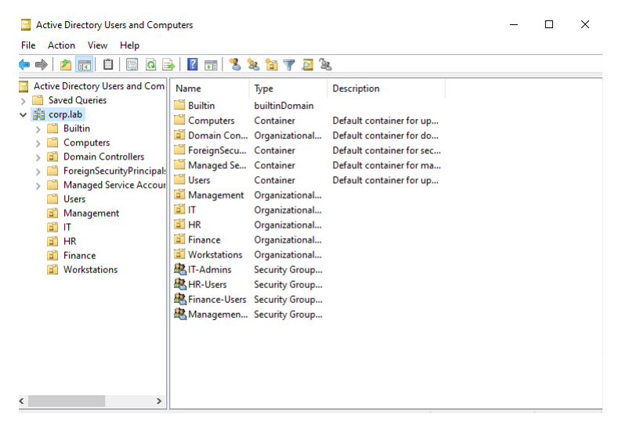

Appendix A.2 - SMB share creation
The Corp Lab Data share is created and the network UNC is shown.
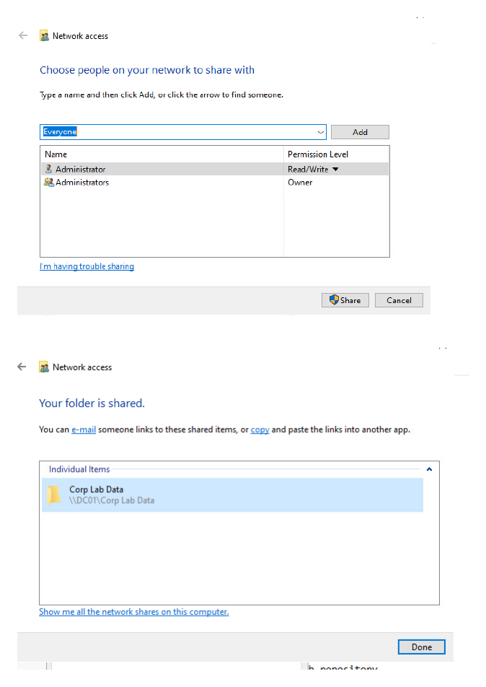

Appendix A.3 - Share permissions
The screenshot records Everyone and Administrators share permissions. Everyone Full Control is flagged for remediation.
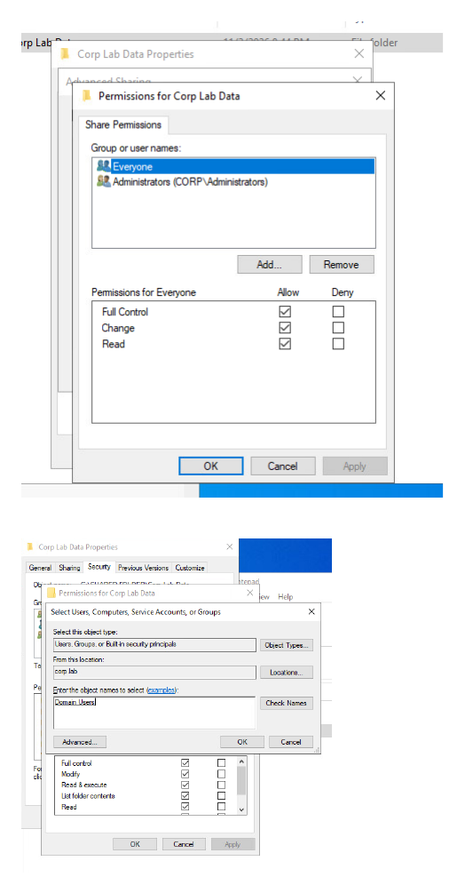

Appendix A.4 - Domain password policy
Captured password history, age, minimum length, complexity, and reversible-encryption settings.
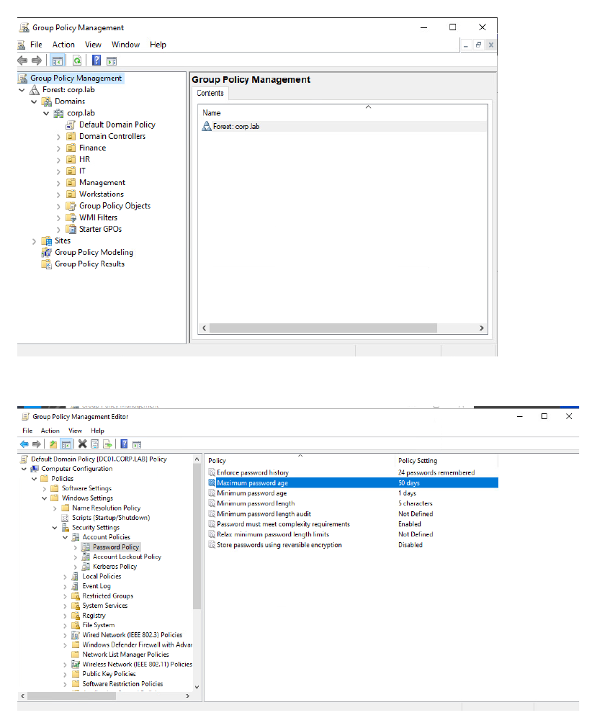

Appendix A.5 - Account lockout and HR drive-map setup
Captured lockout values and HR drive-map preference configuration.
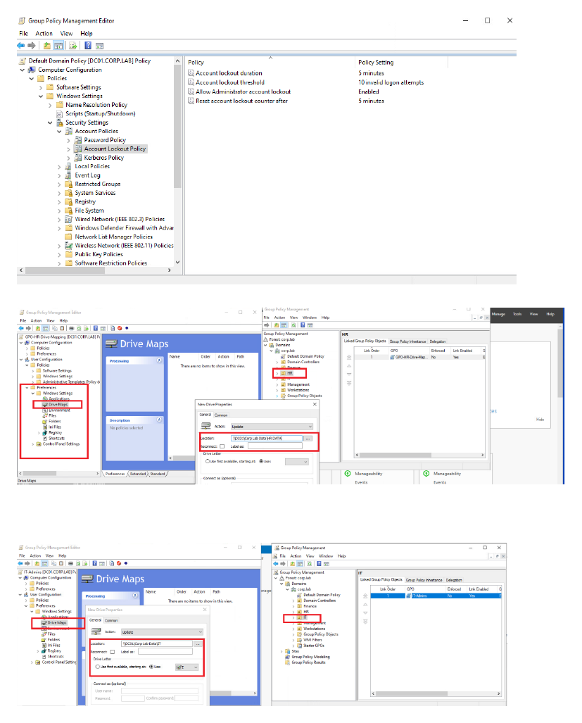

Appendix A.6 - Department drive-map GPOs
Management and Finance drive-map configuration and OU links.
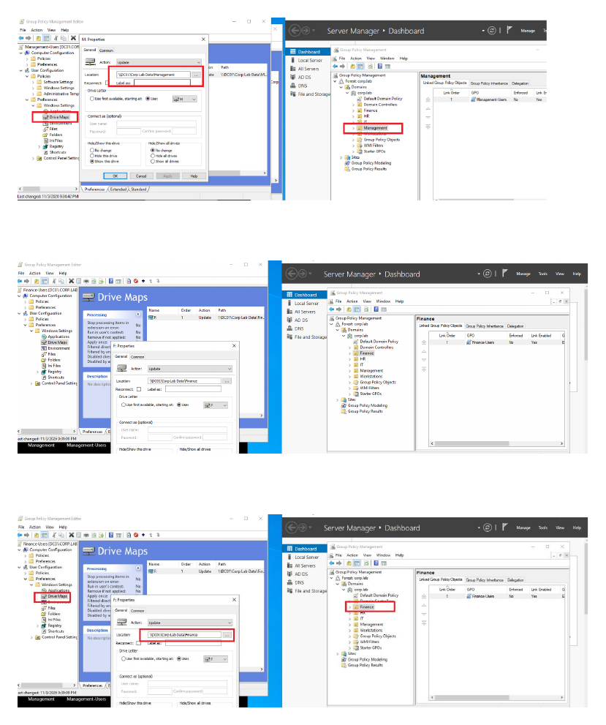

Appendix A.7 - Removable storage and AutoPlay
All removable storage deny access and AutoPlay disabled for all drives.
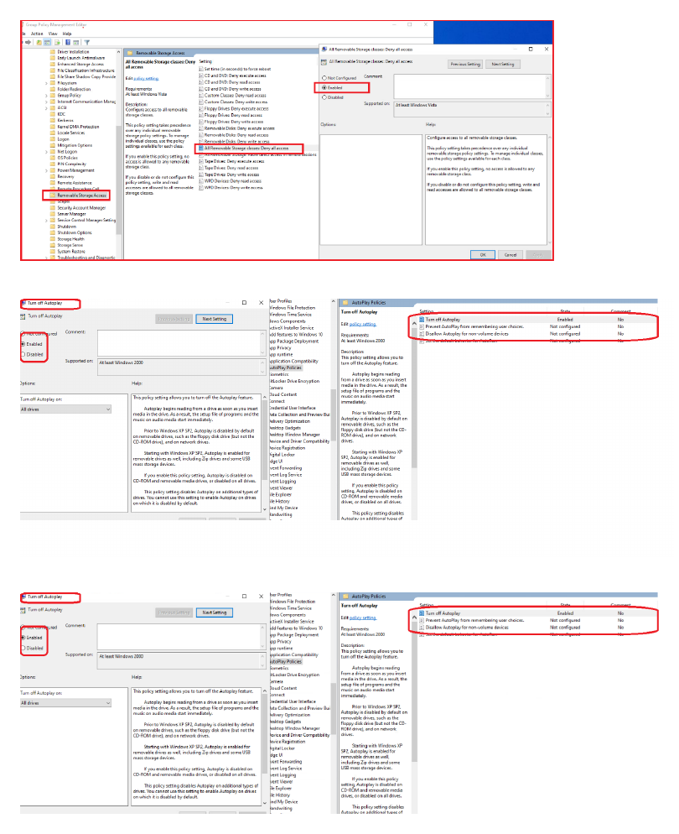

Appendix A.8 - Command Prompt, Control Panel, and Windows Installer
Shows restriction settings and the enabled Always install with elevated privileges setting that requires correction.
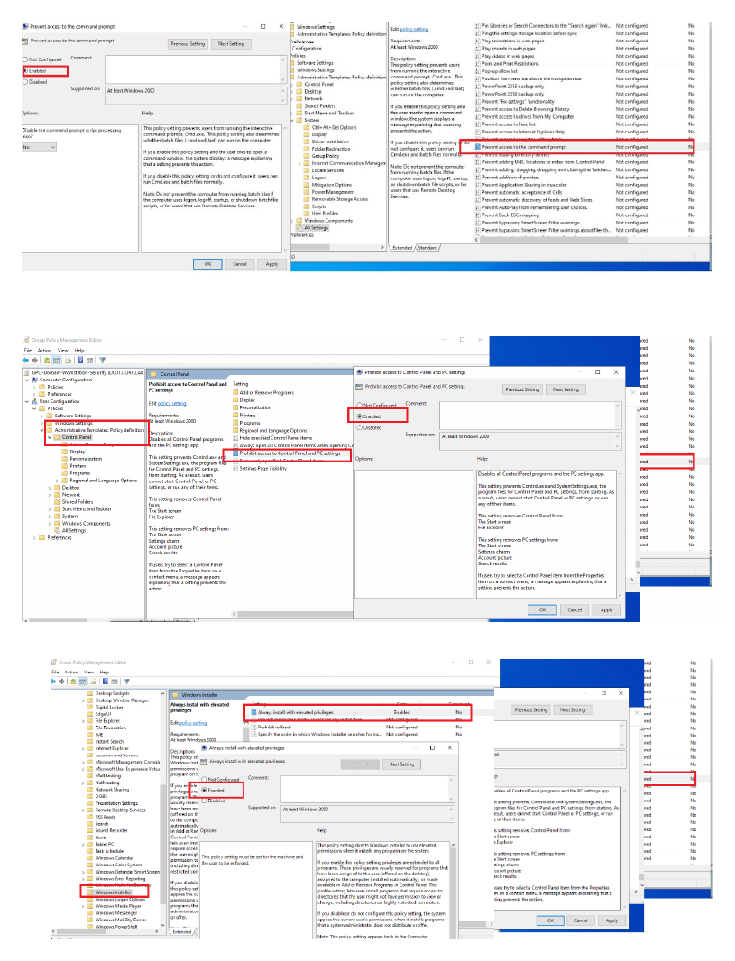

Appendix A.9 - HR session and H: drive
sara.ahmed session and the mapped HR DATA H: network location are visible.
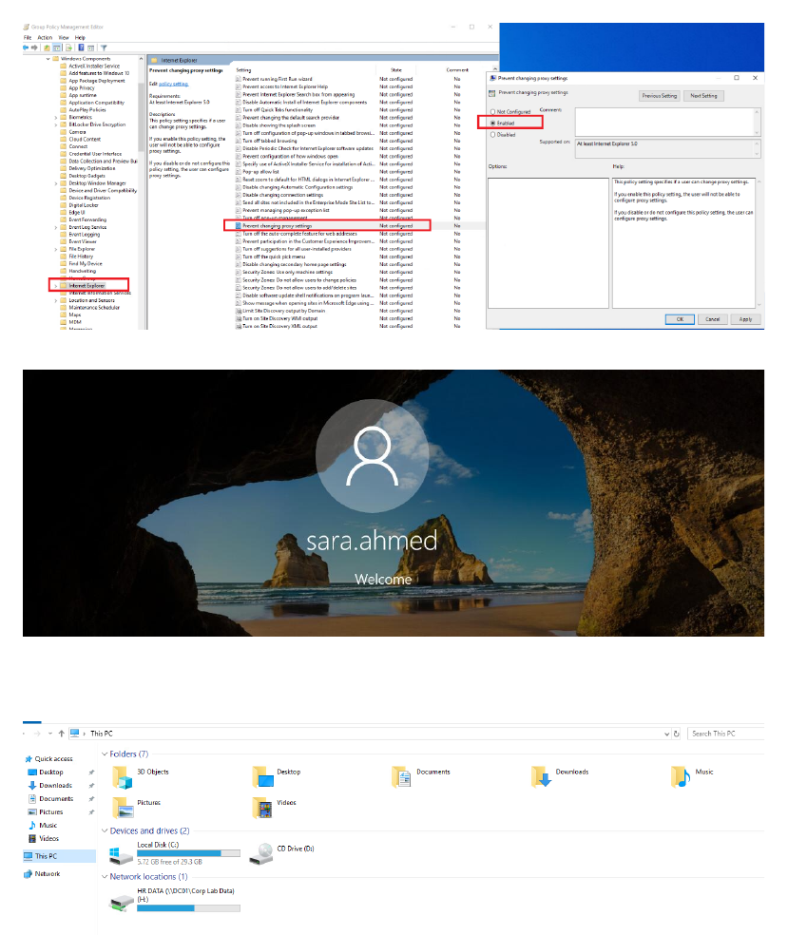

Appendix A.10 - Client restriction outcomes
Windows Restrictions message and CD/DVD D: access denied are captured.


