PROJECT OVERVIEW
Active Directory &
Group Policy Lab
Windows Server 2022 | corp.lab
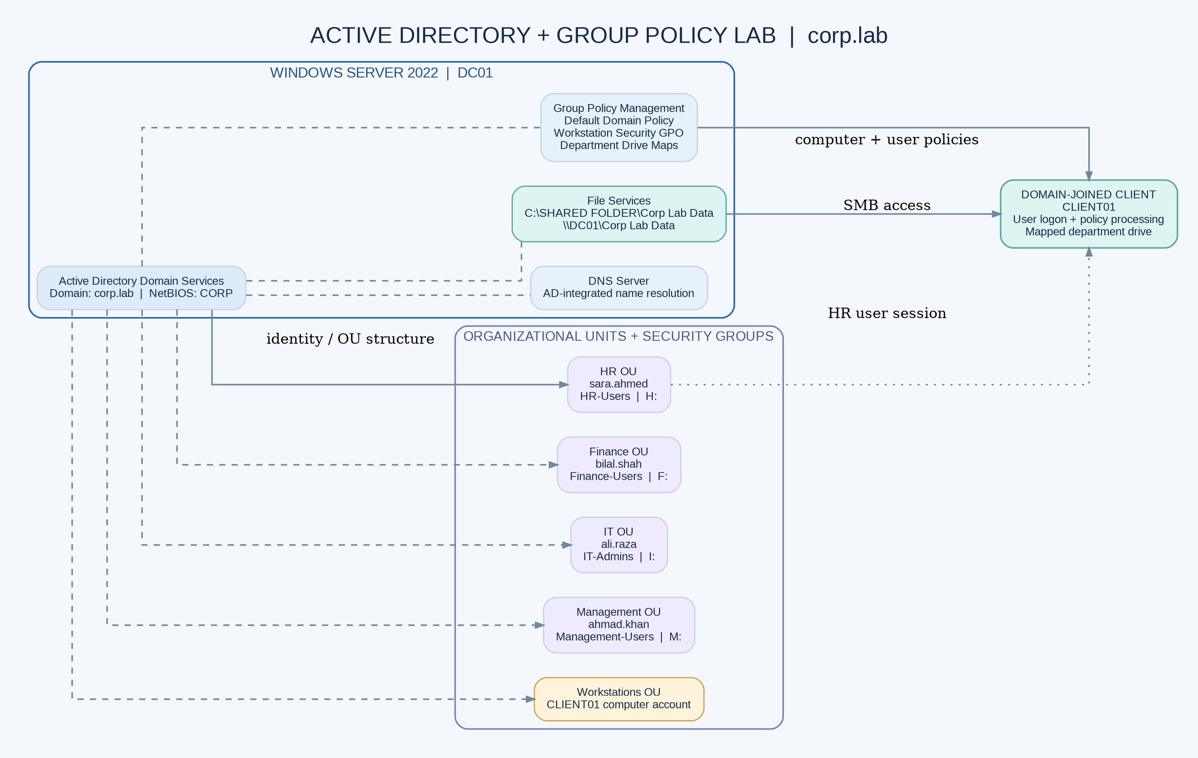

What the lab demonstrates
- Active Directory Domain Services and DNS for corp.lab.
- Departmental OUs, users, and security groups for HR, Finance, IT, and Management.
- SMB shared folders and H:, F:, I:, and M: department drive mappings.
- Domain password and account-lockout configuration.
- Central workstation restrictions through Group Policy.
- HR client evidence: domain logon, H: drive, Control Panel restriction message, and CD/DVD access denied.

Environment at a glance
Component | Value
Domain | corp.lab (NetBIOS CORP)
Server | Windows Server 2022 / DC01
Client | CLIENT01, domain joined
Share | \\DC01\Corp Lab Data
OUs | Management, IT, HR, Finance, Workstations
Security groups | Management-Users, IT-Admins, HR-Users, Finance-Users

Department drive map
User | Department | Drive
sara.ahmed | HR | H:
bilal.shah | Finance | F:
ali.raza | IT | I:
ahmad.khan | Management | M:

Validation captured
Outcome | Evidence
HR account logon | sara.ahmed session captured on CLIENT01
HR drive mapping | HR DATA visible as H:
Control Panel restriction | Windows Restrictions dialog captured
CD/DVD access | D: access denied captured

Security review note The evidence review identified items to correct before treating the lab as hardened: Always install with elevated privileges is enabled in one captured policy screen; the password minimum is 5 characters; and the share grants Everyone Full Control. See the full technical report for remediation.

Deliverables
The project package includes a technical implementation report, build runbook, validation matrix, security remediation review, logical architecture diagram, and numbered screenshot evidence. The environment is a personal lab demonstration, not a production or paid client deployment.

