USB Storage Access Control
Allow specific USB devices for specific users using Microsoft Intune, Entra ID groups and Defender Device Control

Implementation Guide & Architecture
Version 1.1 | October 2026

Contents

1. Overview
This guide explains how to block all USB removable storage on Windows devices managed by Microsoft Intune, and allow only approved USB drives for approved users. Access is controlled entirely through one security group – created either in Microsoft Entra ID (cloud) or in on-premises Active Directory (AD) and synced to Entra ID:
- User added to the group → the user can read/write the approved USB drive(s).
- User removed from the group → the USB drive is blocked for that user.
- Any USB drive that is not on the approved list → blocked for everyone.
The solution uses the Device Control profile in Intune (Endpoint security › Attack surface reduction), which is enforced on the device by Microsoft Defender Antivirus.
Note: USB control is NOT configured under the Intune Firewall policy. Windows Firewall controls network traffic only. USB/removable storage is controlled under Endpoint security › Attack surface reduction › Device Control.

2. Architecture
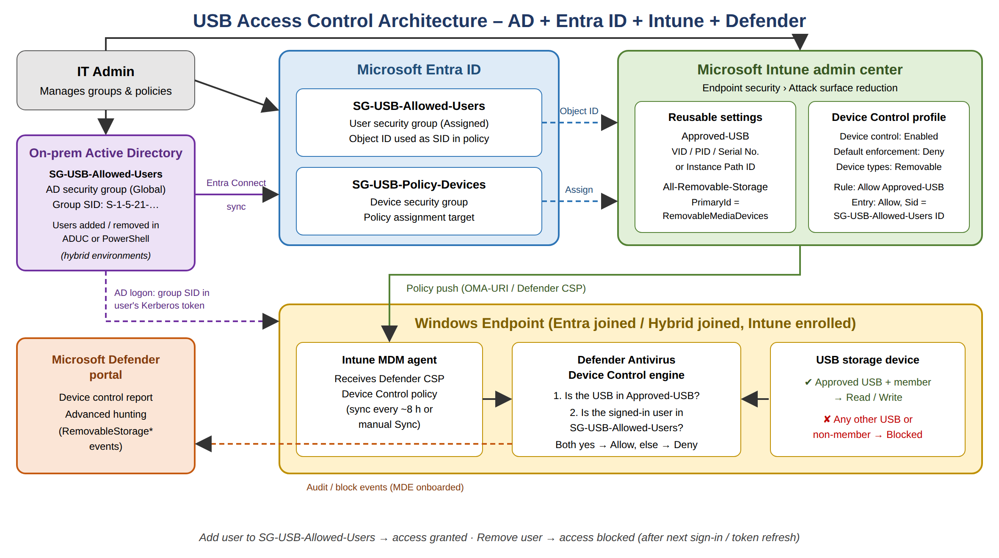
Figure 1 – Solution architecture

2.1 Components
Component | Role in the solution
On-premises Active Directory (optional) | For hybrid environments: holds the AD security group SG-USB-Allowed-Users. The group SID is placed in the user's Kerberos token at logon. Users are added/removed in ADUC or PowerShell.
Microsoft Entra Connect | Syncs the AD users and group to Entra ID so the same group can be seen and used in Intune.
Microsoft Entra ID | Holds the user group SG-USB-Allowed-Users (who may use USB) and device group SG-USB-Policy-Devices (where the policy is applied).
Microsoft Intune | Stores the Reusable settings (list of approved USB devices) and the Device Control profile (rules), and delivers them to devices.
Defender Antivirus (on device) | Device Control engine checks every USB storage access against the rules and allows or blocks it.
Microsoft Defender portal | Reports and Advanced hunting for allowed/blocked USB events (requires Defender for Endpoint onboarding).

2.2 Decision logic
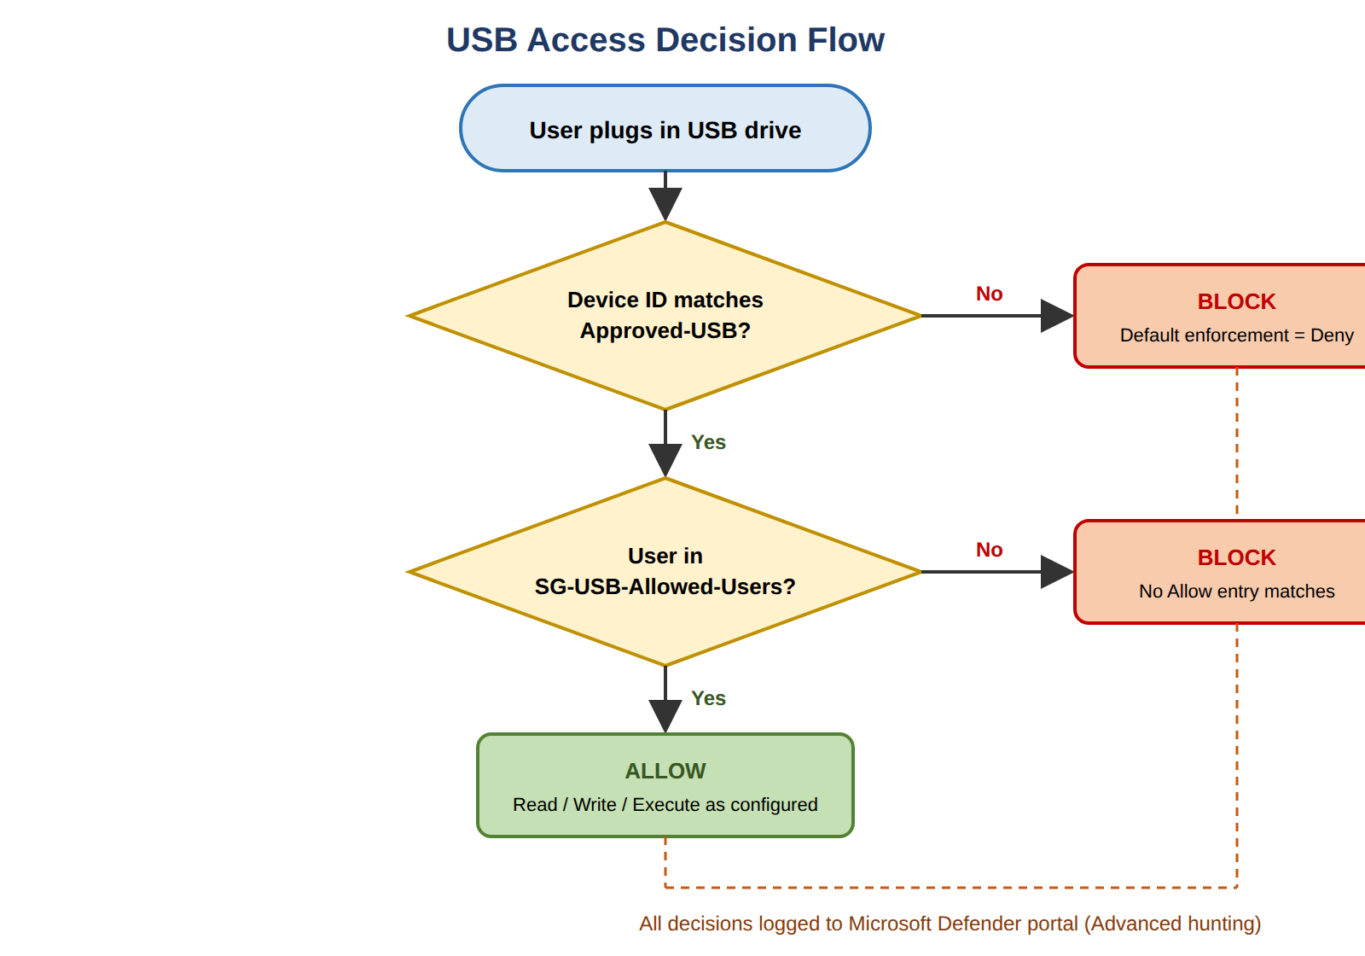
Figure 2 – How the device decides to allow or block a USB drive
Default enforcement is set to Deny, so anything not explicitly allowed is blocked. One Allow rule permits the approved USB devices, but only for users whose token contains the SG-USB-Allowed-Users group. This gives the "add to group = access, remove from group = no access" behaviour.

3. Prerequisites
Requirement | Details
Licensing | Microsoft 365 E3/E5, or Defender for Endpoint Plan 1/Plan 2 (or Defender for Business), plus Intune.
Operating system | Windows (Pro, Enterprise or Education edition).
Device join | Microsoft Entra joined or Hybrid Entra joined (domain joined to AD), and enrolled in Intune.
Active Directory (hybrid only) | On-premises AD domain with Microsoft Entra Connect (or Cloud Sync) syncing users and the USB group to Entra ID. RSAT Active Directory module for PowerShell on the admin PC.
Antivirus | Microsoft Defender Antivirus in active mode; anti-malware client 4.18.2103.3 or later (keep platform updates current).
Reporting (optional) | Devices onboarded to Microsoft Defender for Endpoint to see events in the Defender portal.
Admin roles | Account Operators / delegated group management rights in AD (hybrid); Groups Administrator (or User Administrator) in Entra ID; Intune Administrator or Endpoint Security Manager in Intune.

4. Step 1 – Create the groups (Entra ID or Active Directory)
Choose where the user group lives. Use Option A for cloud-only (Entra joined) environments and Option B when users sign in with on-premises AD accounts on hybrid joined devices. The device group (4.3) is always created in Intune/Entra ID.

4.1 Option A – Entra ID user group (cloud)
- Go to Microsoft Intune admin center (https://intune.microsoft.com) › Groups › New group.
- Group type: Security
- Group name: SG-USB-Allowed-Users
- Description: Members may use approved USB storage devices
- Membership type: Assigned
- Click Create. (You can add members now or later.)
- Open the group and copy the Object ID (e.g. 3f2c9a1e-....). You will paste it into the Device Control rule as the Sid.

4.2 Option B – Active Directory user group (hybrid)
Create the group in on-premises AD so that helpdesk teams can manage USB access with the tools they already use.
- On a domain controller or admin PC with RSAT, open Active Directory Users and Computers (ADUC).
- Browse to an OU that is synced by Entra Connect (e.g. OU=Groups,DC=contoso,DC=com) › right-click › New › Group.
- Group name: SG-USB-Allowed-Users Group scope: Global Group type: Security
- Open the group › Members tab › Add the users who need USB access.
- Open the group › Attribute Editor tab › copy objectSid (S-1-5-21-…). This AD SID is used in the Device Control rule for hybrid devices.
- Wait for Entra Connect sync (default every 30 minutes) or run a delta sync. The group then appears in Entra ID / Intune with its own Object ID.
The same steps in PowerShell:
Import-Module ActiveDirectory

# Create the group in a synced OU
New-ADGroup -Name "SG-USB-Allowed-Users" -GroupScope Global -GroupCategory Security `
-Path "OU=Groups,DC=contoso,DC=com" -Description "Approved USB storage users"

# Add / remove users
Add-ADGroupMember -Identity "SG-USB-Allowed-Users" -Members jdoe, asmith
Remove-ADGroupMember -Identity "SG-USB-Allowed-Users" -Members jdoe -Confirm:$false

# Get the group SID for the Device Control rule
(Get-ADGroup "SG-USB-Allowed-Users").SID.Value

# On the Entra Connect server – start a delta sync
Start-ADSyncSyncCycle -PolicyType Delta
Which SID to use? Hybrid joined device + AD user sign-in → use the AD group SID (S-1-5-21-…). Entra joined device → use the Entra group Object ID. If you have both device types, add two Allow entries in the same rule – one with each value (see 7.3).

4.3 Device group – where the policy applies
- Groups › New group › Security, name SG-USB-Policy-Devices, Membership type Assigned (or Dynamic Device).
- Add pilot devices first. After testing, either add all devices or assign the policy to "All devices".
Tip: The policy is assigned to DEVICES. The user restriction is done inside the rule using the user group Object ID (Sid). Do not assign the policy only to the user group.

5. Step 2 – Collect the IDs of the approved USB drives
Plug each approved USB drive into a Windows PC and collect its identifiers.

5.1 Using Device Manager
- Open Device Manager › Disk drives › right-click the USB drive › Properties › Details tab.
- Select "Device instance path" and copy the value, e.g. USBSTOR\DISK&VEN_SANDISK&PROD_ULTRA&REV_1.00\4C530001234567890123&0
- Select "Hardware Ids" if you want Vendor ID / Product ID values (VID_xxxx&PID_xxxx) from the parent USB device.

5.2 Using PowerShell
# Instance path of connected USB storage
Get-PnpDevice -PresentOnly | Where-Object { $_.InstanceId -like 'USBSTOR*' } |
Select-Object FriendlyName, InstanceId

# Model and serial number
Get-CimInstance Win32_DiskDrive | Where-Object InterfaceType -eq 'USB' |
Select-Object Model, PNPDeviceID, SerialNumber

5.3 Which ID to use
ID type | Example | Use when
Instance Path ID | USBSTOR\DISK&VEN_...\4C5300...&0 | Allow one exact physical drive (most specific; recommended).
Serial Number ID | 4C530001234567890123 | Allow one exact drive by serial number.
Vendor ID + Product ID (VID_PID) | 0781_5581 | Allow all drives of one company-issued model (e.g. all encrypted corporate USBs).
Primary ID | RemovableMediaDevices | Match all removable storage (used for audit rules).

Security note: VID/PID can be spoofed and allows every drive of that model. For tight control use Instance Path ID or Serial Number of company-issued (preferably hardware-encrypted) drives.

6. Step 3 – Create Reusable settings (approved USB list)
- Intune admin center › Endpoint security › Attack surface reduction › Reusable settings tab › + Add.
- Name: Approved-USB Description: Company approved USB drives
- Click + Add › Removable storage. Select the property (e.g. Instance path Id or Serial number Id) and paste the value. Add one line per approved drive.
- Set match type to "Match any" when you list several drives (a drive matching any one line is approved).
- Click Next › Review + create.
- (Optional, for auditing) Create a second reusable setting All-Removable-Storage with Primary Id = RemovableMediaDevices.

7. Step 4 – Create the Device Control policy

7.1 Create the profile
- Endpoint security › Attack surface reduction › + Create policy.
- Platform: Windows Profile: Device Control
- Name: WIN - Device Control - USB Allow Approved Users

7.2 Configuration settings
Setting | Value
Device Control Enabled | Device Control is enabled
Default Enforcement | Default Deny
Device types (secured devices) | Removable Media Devices (add CD/DVD, WPD (phones) if you also want to control them)
Allow Storage Card | Optional – configure per company policy

7.3 Rule 1 – Allow approved USB for allowed users
Under Device Control › Rules, click Edit instance / + Add and configure:
Field | Value
Name | Allow Approved-USB for SG-USB-Allowed-Users
Included Id | Approved-USB (reusable setting)
Excluded Id | (none)
Entry 1 – Type | Allow
Entry 1 – Access mask | Disk Read, Disk Write, Disk Execute, File Read, File Write, File Execute (choose Read only if users should only read)
Entry 1 – Options | None
Entry 1 – Sid | <Entra Object ID of SG-USB-Allowed-Users> (Entra joined devices)
Entry 2 – Type / Sid (hybrid) | Allow, same access mask, Sid = <AD group SID S-1-5-21-…> (hybrid joined devices with AD sign-in)
Entry 3 – Type (optional) | Audit Allowed, Options: Send event, Access: all – with the same Sid (for logging)

7.4 Rule 2 – Audit/notify blocked USB (optional, recommended)
Field | Value
Name | Audit Denied - All Removable Storage
Included Id | All-Removable-Storage
Entry – Type | Audit Denied
Entry – Options | Show notification and Send event
Entry – Access mask | All (Disk + File Read/Write/Execute)

The user sees a Windows notification when a USB is blocked, and the event is sent to the Defender portal.

7.5 Assignments
- Scope tags: as per your environment.
- Included groups: SG-USB-Policy-Devices (pilot). After successful testing, change to All devices.
- Excluded groups: optional break-glass / IT device group.
- Review + create.
Important: Default Deny blocks ALL removable storage on targeted devices for everyone not covered by an Allow rule. Always start with a small pilot group of devices.

8. Step 5 – Day-to-day access management
Action | How
Give a user USB access (Entra group) | Intune › Groups › SG-USB-Allowed-Users › Members › + Add members › select user.
Remove USB access (Entra group) | Same group › Members › select user › Remove.
Give a user USB access (AD group) | ADUC › SG-USB-Allowed-Users › Members › Add, or Add-ADGroupMember. Synced groups cannot be edited in Entra/Intune – always change them in AD.
Remove USB access (AD group) | ADUC › Members › Remove, or Remove-ADGroupMember.
Approve a new USB drive | Get its Instance path / Serial (Section 5) › Reusable settings › Approved-USB › add a line. No change to the profile is needed.
Retire a USB drive | Remove its line from Approved-USB.

Timing: Group membership is read from the user's sign-in token. After adding/removing a user, ask the user to sign out and sign back in (Entra token refresh can take up to ~1 hour; for AD groups the Kerberos token only updates at the next logon). For AD groups also allow time for Entra Connect sync (~30 min). Changes to the USB list arrive with the next Intune sync (Company Portal › Settings › Sync, or Intune › Devices › Sync).

Recommended process: user raises a request (ticket) › manager approval › IT adds the user to SG-USB-Allowed-Users. Review group membership monthly, or use Entra ID Access Reviews / time-bound membership (PIM for Groups) to remove access automatically.

9. Step 6 – Test and validate

9.1 Test matrix
User | USB drive | Expected | Result
Member of group | Approved USB | Allowed
Member of group | Non-approved USB | Blocked
Not a member | Approved USB | Blocked
Removed from group (after sign-out/in) | Approved USB | Blocked

9.2 Verify policy on the device
Get-MpComputerStatus | Select-Object DeviceControlState,
DeviceControlDefaultEnforcement, DeviceControlPoliciesLastUpdated

# Check the user token contains the group (Entra or AD group SID)
whoami /groups
Expected: DeviceControlState = Enabled, DeviceControlDefaultEnforcement = DefaultDeny, and a recent PoliciesLastUpdated time. In Intune, check the profile › Device status / Per setting status for errors.

10. Monitoring and reporting
Microsoft Defender portal (https://security.microsoft.com) › Reports › Device control, or Hunting › Advanced hunting:
DeviceEvents
| where ActionType == "RemovableStoragePolicyTriggered"
| extend F = parse_json(AdditionalFields)
| project Timestamp, DeviceName, InitiatingProcessAccountName,
Verdict = tostring(F.RemovableStoragePolicyVerdict),
Access = tostring(F.RemovableStorageAccess),
Policy = tostring(F.RemovableStoragePolicy),
Vendor = tostring(F.Vendor), Product = tostring(F.ProductName),
Serial = tostring(F.SerialNumber)
| order by Timestamp desc
Use this query to find blocked attempts, confirm allowed usage, and discover the IDs of drives users try to connect.

11. Troubleshooting
Problem | Check / Fix
All USB still work | Device not in assigned device group; policy not synced; Defender AV not active (third-party AV installed); check Get-MpComputerStatus.
Approved user is blocked | User not signed out/in after being added; wrong Object ID in Sid; drive ID typed incorrectly (copy exactly, including &0 at the end of instance path).
Removed user can still access | User has not signed out yet (old token). Force sign-out or restart the device.
Keyboard/mouse blocked | Device types should be limited to Removable Media Devices; HID devices are not affected by this profile.
Policy shows Error in Intune | Open Per setting status; usually invalid reusable setting value or an outdated Defender platform version.
AD user allowed in AD but blocked | Device is Entra joined (uses Entra token) but rule only has the AD SID – add an entry with the Entra Object ID too. Or the user has not logged off since being added (klist purge / sign out).
AD group not visible in Intune | Group is not in a synced OU or sync has not run – check Entra Connect scope and run Start-ADSyncSyncCycle -PolicyType Delta.

12. Rollback
- Quick rollback: change Default Enforcement to Default Allow, or remove the assignment from the profile.
- Devices revert after the next Intune sync (force a sync for urgent cases).

13. Best practices
- Pilot with IT devices first, then roll out in waves.
- Use company-issued, hardware-encrypted USB drives; approve by Instance Path ID or Serial Number.
- Grant Read-only where write is not needed to reduce data-leak risk.
- Keep a break-glass device group excluded from the policy.
- Review SG-USB-Allowed-Users membership regularly (Access Reviews / PIM for Groups for time-limited access).
- Keep Defender platform and engine updated; document every approved USB with owner and serial number.

