PHASE 0 | WEEKS 1-3
Module 0: FDE Role, Ethics and Field Safety
Complete Study and Lab Guide
Earn trust by making authority, evidence and safety visible before delivery pressure begins.
90 focused hours | Six synthetic scenarios | Five integrated labs
Version 1.0 | 19 August 2026 | Roadmap baseline 1.1
Designed for junior engineers preparing for customer-facing technical delivery

Contents
Select an entry in Word to jump to that section.
How to use this module pack
Module at a glance
Safe learning boundary
Repository setup and baseline verification
Part I: The FDE role and authority
What an FDE is
Role-boundary compass
Engagement authority and the charter
Stakeholders, decision rights and specialist routing
Part II: Privacy, ethics and responsible AI
Privacy reasoning without practising law
Data classification and lifecycle mapping
The PAUSE ethical decision record
Confidentiality, intellectual property and portfolio boundaries
Responsible AI at mobilisation
Part III: Evidence, communication and field safety
Two-axis evidence model
Evidence integrity and tamper detection
Constructive stop-work communication
Sustainable field practice
Study and lab sequence
Lab 1: Role-boundary case review
Lab 2: Fictional data inventory
Lab 3: Authority and stakeholder map
Lab 4: Ethical pressure exercise
Lab 5: Field-readiness pack
Module exit assessment
Retrieval practice
Mastery checklist
Command map
Glossary
Official primary sources

How to use this module pack
Outcome: By the end of Module 0 you will be able to enter a synthetic engagement with an explicit purpose, decision-rights map, data boundary, escalation path, evidence contract and sustainable field-working plan. You will also be able to stop or route work when those foundations are missing.
Read this guide alongside the learner evidence workbook and the runnable starter repository. The workbook gives you reusable forms. The repository checks structural completeness and seals evidence. Neither replaces human review, customer authority or specialist judgement.

The coordinated artefacts
Artefact | Audience | Use
Complete Study and Lab Guide | Learner | Concepts, procedures, examples, commands, lab acceptance and study questions.
Learner Evidence Workbook | Learner | Writable engagement, data, decision, field-safety and evidence forms.
Runnable Starter Repository ZIP | Learner | Six synthetic scenarios, ten templates, validators, evidence sealing and 30 baseline tests.
Assessor and Solutions Guide | Controlled | Administration, reference outcomes, fault controls, scoring, observation records and retest rules.
Controlled Fault Catalogue | Controlled | Machine-readable injection, reset, evidence and retest records. Do not distribute before assessment.
Fieldcraft companion | Optional learner and manager | Travel, site, workload, isolation, home-team connection and return-to-team practice.

Separation rule: The assessor guide and controlled fault catalogue must never be placed in the learner repository or shared assessment workspace. The learner may receive permitted catalogue identifiers and conceptual debrief information only after assessment.

A useful weekly rhythm
- Read the concept section and write a short explanation in your own words.
- Attempt the scenario before reading the worked example or discussion prompts.
- Use the repository to prepare a clean workspace and the workbook to capture reasoning.
- Ask a peer or assessor to challenge one assumption, authority claim or data boundary.
- Retain only approved evidence, verify its seal and write what remains Unproved.
- End each week with retrieval practice rather than rereading alone.

Module at a glance
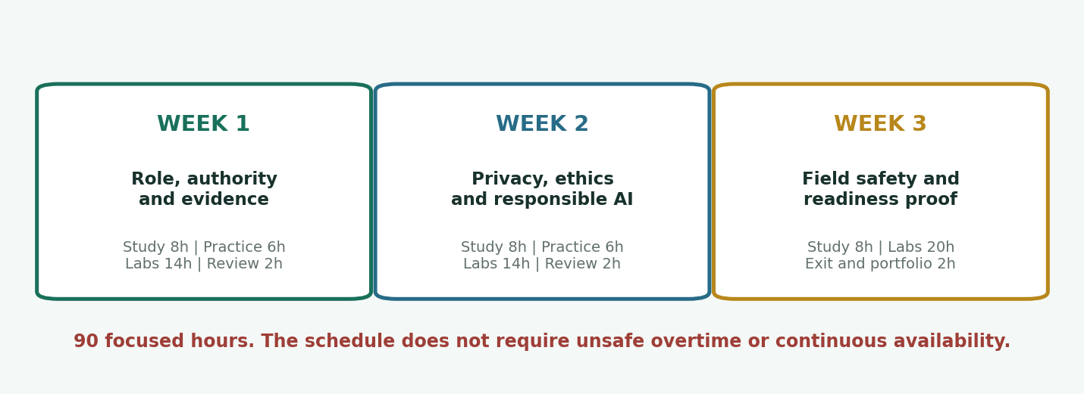
Module 0 three-week learning sequence
Component | Hours | What the time produces
Guided study | 24 | Role, authority, privacy, ethical reasoning, evidence and field-safety concepts.
Deliberate practice | 12 | Short classification, claim-labelling, stakeholder and stop-work drills.
Integrated labs | 48 | Five assessed artefact sequences using the FieldBridge scenarios.
Portfolio and exit | 6 | Sanitised readiness pack, 60-minute scenario and evidence review.
Total | 90 | Three weeks at 30 focused hours; no unsafe overtime is assumed.

Learning outcomes
- Distinguish the FDE role from software engineering, platform engineering, SRE, solutions engineering and consulting while recognising that titles vary by organisation.
- Create an engagement charter defining purpose, decision rights, data boundaries, escalation paths and stop-work conditions.
- Classify synthetic information, map its lifecycle and identify when privacy, security, legal or domain specialists must decide.
- Apply a repeatable ethical decision record to ambiguous or high-consequence requests, including AI-assisted workflows.
- State claims with one execution mode and one validation method, and refuse to present simulated evidence as customer or production proof.
- Establish safe field-working boundaries, site logistics, home-team contact, workload limits and escalation before deployment pressure begins.

Entry standard
You need basic terminal confidence, a text editor and permission to install or use Python through uv. You do not need cloud access, customer data, a legal background or previous field deployment. The technical repository is intentionally dependency-free so the learning remains about judgement and evidence.

Exit standard
Independent performance: In a 60-minute assessor scenario, explain the FDE boundary, identify at least one stop-work condition, route two specialist decisions correctly and defend each material claim's evidence labels without prompts. Pass at 75/100 or above and pass every critical criterion.

Safe learning boundary
Synthetic only: Use fictional organisations, generated records, .invalid domains and documentation address ranges. Do not reuse customer credentials, exports, screenshots, identifiers, configurations or stories, even if you believe they are harmless or anonymised.

Non-negotiable rules
- Do not access or test an external, employer, customer, provider or production system for this module.
- Do not open an undeclared file offered during a scenario. Establish provenance and authority first.
- Do not paste customer, employer or confidential information into an AI assistant or unapproved service.
- Do not make privacy, legal, clinical, financial, security-accreditation, workplace-safety or domain decisions unless that authority has been explicitly assigned and is lawful.
- Do not collect a secret and plan to blur it later. Exclude it from the evidence path at capture time.
- Stop when authority, data provenance, environment scope, field safety or evidence integrity cannot be reconciled with the charter.

What stop-work means
Stop-work is a controlled professional action. It does not mean disappearing, accusing a stakeholder or blocking progress without options. State the boundary, preserve the current safe state, name the missing decision or control, offer a bounded alternative and route the decision to its owner.
Trigger | Immediate action | Useful next step
Authority missing | Pause the affected work | Request written delegation or the accountable owner.
Data provenance unclear | Do not open, copy or import | Quarantine by process and request a synthetic substitute.
External system proposed | Decline access | Move the exercise to the authorised local fixture.
Unsafe hours or isolation | Stop or replan | Restore coverage, check-ins, transport and manager approval.
Evidence overclaim | Correct the wording | Show the actual mode, method, limitations and Unproved claims.
Specialist decision unowned | Record the block | Name the role required, deadline and impact of delay.

Repository setup and baseline verification
Where the ZIP comes from: The file FDE_Module_0_Runnable_Starter_Repository.zip is delivered with this guide. You do not create it. Save the ZIP and this guide in the same working folder, then extract a fresh copy for each clean attempt.
Published starter-repository SHA-256: 27019d567f040174b361c4979b0df5b77d2968766d10d0ce831b55248f9d1791

Windows PowerShell
New-Item -ItemType Directory -Force .\FDE-Module0 | Out-Null
Expand-Archive `
.\FDE_Module_0_Runnable_Starter_Repository.zip `
-DestinationPath .\FDE-Module0
Set-Location .\FDE-Module0\fde-module0-role-ethics-field-safety
uv --version
uv python install 3.14.6
uv sync --locked
uv run python .\tools\module0.py baseline
uv run python -m unittest discover -s tests -v
uv run python -m compileall -q .\tools .\tests

Bash or zsh
mkdir -p ./FDE-Module0
unzip ./FDE_Module_0_Runnable_Starter_Repository.zip -d ./FDE-Module0
cd ./FDE-Module0/fde-module0-role-ethics-field-safety
uv --version
uv python install 3.14.6
uv sync --locked
uv run python tools/module0.py baseline
uv run python -m unittest discover -s tests -v
uv run python -m compileall -q tools tests
If Python 3.14.6 is unavailable: Record the exact error and check the current official Python and uv guidance. Do not silently change the pinned baseline during an assessed attempt. An assessor may approve a supported 3.12-3.14 substitute because the repository uses only the standard library.

What baseline verification proves
Check | Pass condition | What it does not prove
uv sync --locked | The declared project resolves without changing uv.lock. | Customer readiness, legal compliance or specialist approval.
Repository baseline | Six indexed scenarios, ten templates and synthetic-boundary checks are internally consistent. | That your completed artefacts are correct.
30 supplied tests | Every named standard-library test passes. | Hidden assessment faults or human judgement.
Compile check | The utility and tests compile with the approved interpreter. | Production supportability or external-system access.
Evidence seal | Retained files match their recorded SHA-256 values. | That the claims are honest or the evidence was authorised.

Which 30 tests are supplied
Suite | Tests | Coverage
Bundle | 01-05 | Unique scenario index, matching IDs, .invalid domains, synthetic-only status and safe references.
Engagement charter | 06-10 | Complete charter, purpose, stop-work, production authority and reserved email checks.
Data inventory | 11-15 | Synthetic-only rows, purpose, deletion ownership and documentation address checks.
Ethical decision | 16-20 | Authority, evidence label, referral on stop and human authority for AI-related records.
Field-working plan | 21-25 | Home-team contact, bounded hours, lone-worker controls and employer-duty acknowledgement.
Evidence and controls | 26-30 | Accepted validation method, tamper detection, unsafe control rejection and reset-path containment.

The exact test names are visible in the repository under tests/. Hidden assessment criteria do not replace the published tests; they add changed constraints and observed judgement.

Repository map
fde-module0-role-ethics-field-safety/
README.md safety boundary and quick start
pyproject.toml / uv.lock dependency-free pinned project
scenarios/ six learner-visible synthetic briefs
templates/ ten readiness-pack templates
tools/module0.py prepare, validate, seal, verify, control, reset
tests/ 30 supplied baseline tests
docs/ evidence, cleanup, sources and lab boundary
work/ learner workspaces; ignored by Git
evidence/ sealed evidence; ignored by Git

Part I: The FDE role and authority

What an FDE is
A Forward Deployed Engineer works at the product-customer boundary. The role may include discovery, production-shaped software, integration, deployment, troubleshooting, enablement and product feedback. The distinguishing feature is not travel or urgent coding. It is accountable technical delivery in a customer context while preserving the product boundary and customer authority.
Titles vary: Some organisations use FDE, deployment strategist, solutions architect, resident engineer or professional services engineer for overlapping work. Treat the job description and engagement charter as evidence. Never infer authority from a title alone.
Role | Primary centre of gravity | Typical overlap with an FDE | Boundary to verify
Software engineer | Product or service code | Production changes, tests, reviews and release work | Customer discovery and deployment authority may be limited.
Platform engineer | Internal developer platform | Cloud, delivery, security and reliability capabilities | Customer outcome ownership and external integration may differ.
SRE | Reliability and production operations | Incident response, SLOs, observability and recovery | Product adaptation and commercial scope may sit elsewhere.
Solutions engineer or architect | Pre-sales design and technical fit | Discovery, demonstrations and architecture | Production implementation and ongoing ownership may be outside scope.
Consultant | Advice or implementation under an engagement | Workshops, delivery, change and stakeholder management | Core product authority and long-term code ownership may differ.
FDE | Customer outcome through governed product adaptation | All of the above when explicitly authorised | Never self-authorises specialist or customer decisions.

The delivery value chain
- Understand the user, workflow, outcome, constraints, affected people and decision authorities.
- Translate the real need into explicit acceptance, interfaces, data boundaries and delivery risks.
- Adapt or integrate the product without creating an unowned customer-specific fork.
- Deploy, operate, recover and communicate using evidence appropriate to the environment.
- Transfer capability and turn recurring field friction into traceable product feedback.
Module 0 focuses on the first condition for every later step: knowing what you may do, what you may contribute to, what another role must decide and when you must stop.

Role-boundary compass
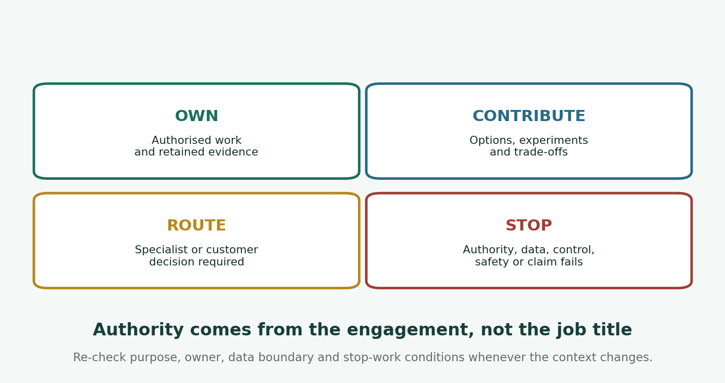
The FDE role-boundary compass
Position | Question | Evidence required
Own | Is this technical action explicitly assigned to me within the authorised environment? | Charter, task, access scope, acceptance and rollback or closure.
Contribute | Can I supply options, experiments or evidence while another role decides? | Decision owner, question, supplied evidence, limitations and due date.
Route | Does a specialist or customer authority need to interpret, approve or accept? | Named role, referral record, interim safe boundary and consequence of delay.
Stop | Would continuing exceed authority, expose data, bypass a control, create unsafe work or misstate evidence? | Trigger, preserved state, escalation and bounded next option.

Boundary drill
For each request, write Own, Contribute, Route or Stop. Then name the exact artefact or authority that could change your answer.
- Change a synthetic validation rule in the local repository. (Own)
- Approve a future retention period for customer records. (Stop)
- Recommend three ways to reduce data collection. (Contribute)
- Paste a customer's support ticket into a public AI assistant. (Stop)
- Draft a risk statement for the privacy adviser to review. (Contribute)
- Connect a laboratory laptop to an unlisted site switch. (Stop)

Engagement authority and the charter
Authority is specific. Access, technical capability, seniority, urgency, stakeholder confidence and prior practice do not create it. A useful charter converts an informal request into an operating boundary that can be reviewed when facts change.

Minimum charter content
Clause | Question answered | Failure if absent
Purpose and outcome | Why are we doing this and for whom? | Activity can become detached from value or lawful purpose.
Non-goals | What will not be attempted or claimed? | Demonstration scope quietly becomes production scope.
Decision rights | Who proposes, decides, accepts and operates? | The FDE or loudest stakeholder becomes accidental authority.
Environment | Which systems, accounts, networks and locations are authorised? | Reachability is mistaken for permission.
Data boundary | Which information may be collected, generated, used, retained and deleted? | Unreviewed data enters tools, logs or portfolios.
Stop-work | Which conditions require a pause? | Pressure is negotiated only after harm is possible.
Escalation | Who resolves privacy, security, legal, domain, safety and delivery questions? | Blocked decisions are hidden or guessed.
Review and expiry | When must the charter be revalidated? | Old authority is stretched over a changed purpose or topology.

Charter rule: If a changed request alters purpose, affected users, environment, data, identity, risk, cost, hours, location or acceptance, re-check the charter before proceeding. Small wording changes can conceal a material authority change.

Worked micro-example
A sponsor asks for a synthetic demonstration. Midway through, they offer a claimed anonymised export to make it realistic. The FDE should not inspect the file to decide whether it is safe. The data source, de-identification method, purpose, recipient, retention and decision authority are all outside the charter. Pause the import, preserve the synthetic path and route the question to the data owner and privacy adviser.

Stakeholders, decision rights and specialist routing
Stakeholder mapping becomes useful when it shows decision rights and consequences, not merely influence. Separate the person funding an outcome from the person who accepts an operational workflow, the person accountable for a control and the people affected by the result.
Stakeholder category | Questions to ask | Common mistake
Sponsor | What outcome and budget may you approve? Which decisions are outside your authority? | Assuming executive seniority covers privacy, safety or security controls.
End user or affected person | What work changes? What barriers, harms or loss of agency are possible? | Treating the buyer as the only user.
Operator | Who runs, supports, recovers and accepts the workflow? | Designing a result that depends on the FDE remaining onsite.
Product team | Which adaptation belongs in core, configuration or a temporary field layer? | Creating an unowned fork to satisfy one deadline.
Specialist | Which question requires your interpretation or approval, and what evidence do you need? | Sending a vague request with no decision deadline.
Legal, procurement or commercial | What contractual, IP, confidentiality and supplier terms control the work? | Treating an NDA as unlimited permission to use information.

A good specialist referral
- States one decision question rather than asking for a general review.
- Names the purpose, affected people, environment, data and deadline.
- Supplies the smallest relevant evidence and excludes secrets or unrelated customer detail.
- Distinguishes facts, assumptions, options and the FDE's recommendation.
- Records the authorised decision, conditions, review date and unresolved limitations.

Part II: Privacy, ethics and responsible AI

Privacy reasoning without practising law
Professional boundary: This module teaches issue recognition and evidence preparation. It does not teach you to declare a lawful basis, determine regulatory applicability, certify compliance or approve a privacy impact. Route those decisions to the accountable privacy or legal specialist.
Privacy work starts before collection. Ask what outcome requires information, whether less information can achieve it, who is affected, where information flows, who can access it, how long it is retained, how it is corrected or deleted and which jurisdiction or contract may apply.

Principles that travel well
Principle | Practical FDE question | Evidence you can prepare
Purpose limitation | What declared outcome requires this field or event? | Purpose-to-field trace and non-goals.
Data minimisation | Can the outcome be tested with fewer fields, generated data or a narrower time window? | Alternative considered and excluded fields.
Transparency | Can an affected person understand the use, decision and recourse? | Plain-language workflow and notice questions for review.
Accuracy and quality | How can errors be detected, corrected and propagated? | Quality rules, correction path and owner.
Storage limitation | When does each copy expire and who proves deletion? | Retention schedule, copy inventory and deletion evidence.
Security and confidentiality | Who needs access, through which path, and what appears in logs or prompts? | Access matrix, logging review and negative tests.
Accountability | Who decides, reviews and can demonstrate the controls? | Decision log, specialist referral and evidence manifest.

The Australian Privacy Principles, GDPR and sector rules differ in scope and legal effect. Use principles to ask better questions, then verify the actual jurisdiction, entity, information type, purpose, role and current law with authorised specialists.

Privacy threshold questions
- Is any information about an identified or reasonably identifiable person involved?
- Could supposedly anonymous information be linked, inferred or combined to identify someone?
- Has the collection purpose changed since the original authority or notice?
- Does a third party, cloud service, model provider or support channel receive the information?
- Is information crossing an organisational, tenant or national boundary?
- Could an automated decision significantly affect rights, access, safety, employment, finance or services?
- Can access, correction, deletion, audit, retention and breach response be demonstrated?
- Does the uncertainty require a privacy threshold assessment or formal impact assessment?

Data classification and lifecycle mapping
Classification labels are organisational decisions. In this module, use descriptive training labels and record uncertainty rather than inventing a universal scale. training synthetic means the record was generated for the exercise; it does not guarantee that every combination, free-text field or imported file is safe.
Term | Meaning for this module | Claim limit
Synthetic | Generated without copying a real person's record or customer event. | May still encode harmful scenarios or reveal product behaviour.
De-identified | Identifiers were removed or transformed under a stated method. | Do not assume re-identification risk is eliminated.
Pseudonymous | Direct identifiers were replaced while linkage may remain. | Often still personal data; specialist interpretation required.
Anonymous | Claim that a person is not reasonably identifiable under the applicable context. | High bar; the FDE does not self-declare it.
Confidential | Access or use is restricted by contract, policy, relationship or sensitivity. | An NDA does not grant any particular use or transfer.
Public | Authoritatively released for public use. | Public availability does not remove licence, context or ethical limits.

Lifecycle map
- Identify the asset, data subjects or synthetic personas and responsible owner.
- Record the purpose and minimum necessary fields.
- Trace source, transformation, model or service use, storage, logs, exports and recipients.
- Map access roles, jurisdictions, contracts, retention, deletion and correction paths.
- Mark uncertain classifications and specialist questions instead of guessing.
- Reconcile the map with the engagement charter and evidence capture plan.

The PAUSE ethical decision record
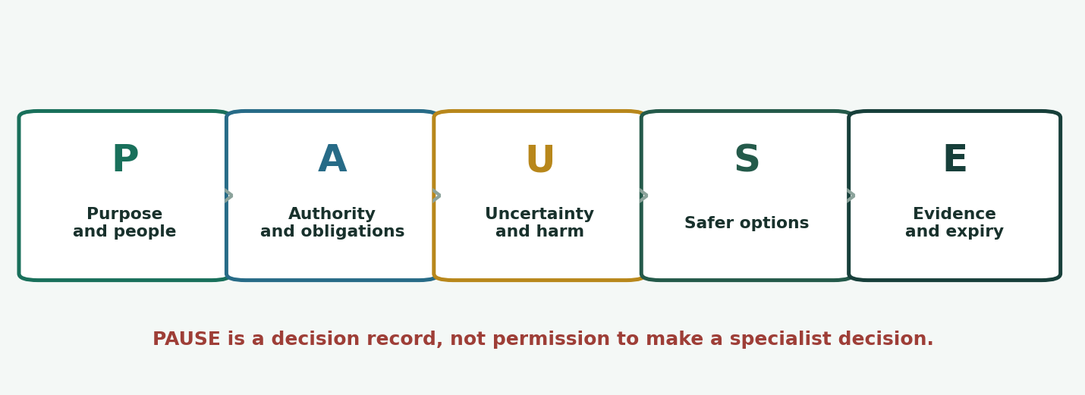
PAUSE ethical decision framework
Ethics is not a substitute for law or authority. It helps you surface affected people, harms, unequal impact, uncertainty and safer options before a request becomes a technical fait accompli.
Stage | Questions | Required record
Purpose and people | What outcome is sought? Who benefits, bears risk, lacks voice or may be excluded? | Purpose, affected people and accessibility or safety impact.
Authority and obligations | Who may decide? What charter, policy, contract, law or professional rule may apply? | Decision owner, source register and referral.
Uncertainty and harm | What is unknown? What could fail, be misused, discriminate, expose or lock in? | Assumptions, harms, reversibility and evidence gaps.
Safer options | Can data, scope, automation, access, duration or exposure be reduced? | Options, recommendation, rejected alternatives and guardrails.
Evidence and expiry | What is decided, by whom, for how long and on what evidence? | Decision, mode, method, limitations, owner and review trigger.

Pressure patterns to recognise
- Urgency is presented as authority: 'We will get approval later.'
- A reversible demonstration is described as production evidence.
- The most affected people are absent from the decision.
- A control owner is asked only after a workaround has been implemented.
- Privacy or safety is reframed as an individual preference rather than a system condition.
- A claimed anonymised dataset is offered without provenance or method.
- A public AI assistant is treated as a private scratchpad.
- The FDE is praised for being pragmatic when asked to accept unowned risk.

Confidentiality, intellectual property and portfolio boundaries
Confidentiality and intellectual property are controlled by law, contract and organisational policy. A non-disclosure agreement may define restrictions, but it does not automatically grant permission to collect, copy, reuse, publish, train a model on or include material in a portfolio. Ownership can also depend on employment and contractor terms.

Portfolio sanitisation rule
- Use only the programme's fictional organisations, generated data and reserved domains.
- Remove customer names, identifiers, screenshots, topology, costs, tickets, timelines and distinctive narrative details.
- Do not copy code, schemas, prompts, documents or configuration unless reuse rights are explicit.
- Describe your reasoning, method and general result rather than the customer's confidential context.
- Record the review and approval path for any externally shared artefact.
- When in doubt, create a clean synthetic reconstruction rather than redacting a customer artefact.
Legal referral: Ask a precise question: who owns the proposed artefact, what licence or contractual right applies, what confidential information remains, who may approve publication and what must be returned or deleted at engagement end?

Responsible AI at mobilisation
Module 0 does not build or evaluate a model. It establishes the authority and evidence conditions that later AI work requires. Before an AI-assisted workflow is proposed, decide whether the use is suitable, who is affected, who remains accountable, what data may be used and which claims remain unproved.
Question | Minimum mobilisation evidence | Stop or route trigger
Is AI suitable? | Problem definition, non-AI baseline and reason automation may help. | The model is selected before the need is understood.
Who is affected? | User and affected-person map, accessibility, recourse and potential unequal impact. | Only the buyer or operator is considered.
Who decides? | Named human authority for consequential actions and override. | The model or FDE becomes the de facto decision-maker.
Which data? | Approved purpose, fields, source, destination, retention and provider terms. | Customer data is proposed for an unapproved assistant.
What evidence? | Evaluation plan, version, limitations and Unproved claims. | Safety, fairness or accuracy is asserted without evaluation.
What failure path? | Fallback, incident, contestability and escalation owner. | No meaningful human review or recourse exists.

2026 source status: NIST AI RMF 1.0 remains the current published baseline but was under revision at the date of this guide. Record the exact framework and profile version used; do not cite 'NIST compliant' as a product property.

Part III: Evidence, communication and field safety

Two-axis evidence model
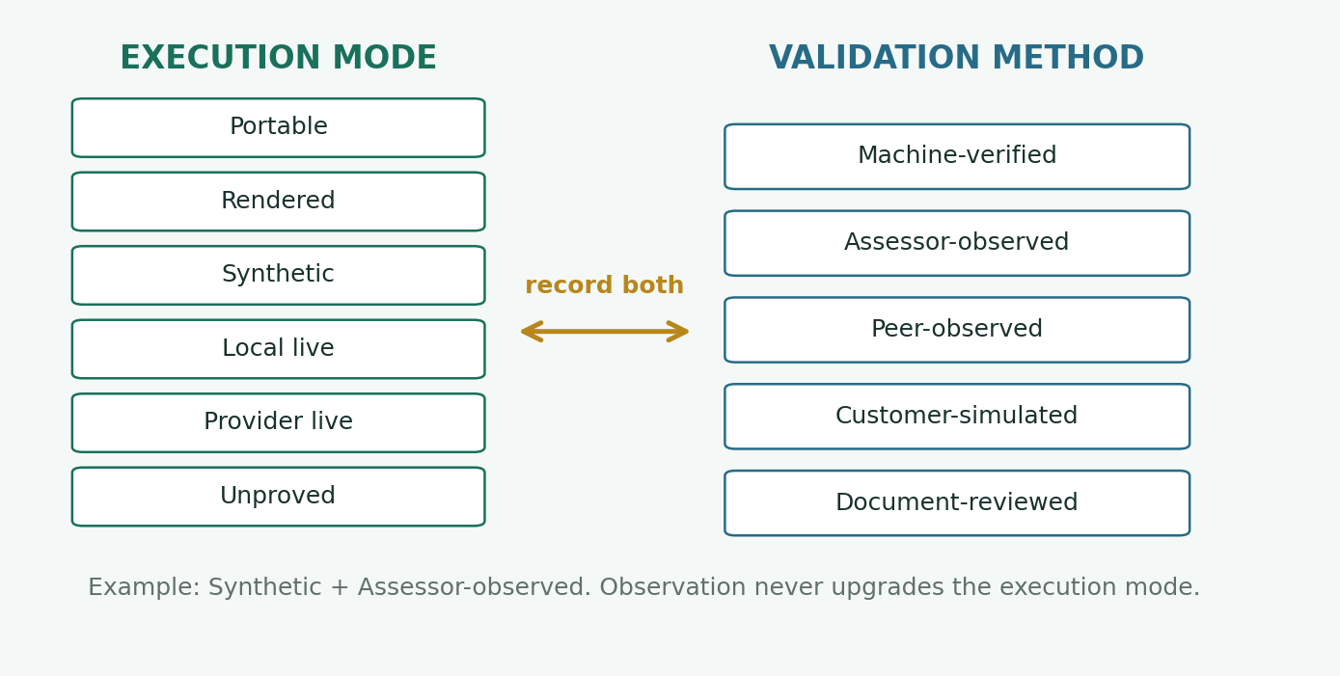
Execution modes and validation methods

Execution modes
Mode | Permitted claim | Module 0 example
Portable | Artefact is designed for declared environments; execution is not claimed. | A reusable charter template.
Rendered | A tool produced an inspectable result; no apply or live behaviour is claimed. | A generated evidence report not yet reviewed.
Synthetic | Behaviour was exercised with generated data or simulated dependencies. | A customer-simulated pressure exercise.
Local live | Behaviour ran in an owned local environment. | The validator and seal ran on your workstation.
Provider live | Behaviour ran in an authorised hosted or cloud environment. | Not required or authorised in Module 0.
Unproved | The claim remains an assumption, proposal or future validation. | Production privacy suitability or customer acceptance.

Validation methods
Method | What it establishes | Module 0 example
Machine-verified | A deterministic check evaluated a declared result. | 30 tests, workspace validation or SHA verification.
Assessor-observed | An authorised assessor directly observed performance. | Exit scenario and stop-work communication.
Peer-observed | A peer used a supplied observation form. | Rehearsed specialist referral or role explanation.
Customer-simulated | A facilitator in a controlled persona challenged or accepted the result. | Pressure, authority conflict or read-out.
Document-reviewed | A reviewer checked a retained artefact against criteria. | Charter, decision record or field-working plan.

No upgrade by observation: A synthetic scenario remains Synthetic even if an assessor watches it. A local validator remains Local live even if its output resembles a customer workflow. Record both axes and the limitation.

Evidence integrity and tamper detection
Useful evidence is authorised, relevant, reproducible, minimal, attributable and honest about limitations. A screenshot can support context, but it rarely proves a claim alone. Prefer machine-readable results, commands, checksums, logs, decision records and witnessed performance.

Evidence workflow
- Define the claim before collecting artefacts.
- Confirm the environment, data and capture method are authorised.
- Capture the smallest artefact set that can reproduce or review the claim.
- Redact at source and exclude secrets; never rely on later cosmetic editing.
- Record execution mode, validation method, verifier, timestamp and limitations.
- Seal the approved evidence directory and verify its SHA-256 record.
- Apply the retention and deletion plan, including temporary copies.
uv run python tools/module0.py validate --workspace work/current
uv run python tools/module0.py seal --workspace work/current --evidence evidence/current
uv run python tools/module0.py verify --evidence evidence/current
What a seal proves: The seal detects a later byte-level change to retained files. It does not prove that the file was authorised, truthful, correctly labelled or observed by the named person. Those claims need their own evidence.

Constructive stop-work communication
A good boundary statement is specific, calm and useful. Avoid legal conclusions, blame and vague appeals to policy. State what you can observe, the immediate risk, the missing authority or control and the safe next option.
Situation | Weak wording | Professional wording
Unapproved file | 'Compliance says no.' | 'This file is outside our synthetic-data inventory, and I cannot verify its provenance or authorised use. I will not open it. We can continue with the generated fixture while the data owner and privacy adviser decide.'
Overclaim | 'That is dishonest.' | 'Our evidence is Synthetic + Assessor-observed. I can say the workflow was demonstrated under those conditions, but production readiness and customer acceptance remain Unproved.'
Control bypass | 'Security will never allow it.' | 'The requested change bypasses a control owned by Security. I can present a bounded alternative and impact, but that owner must approve any exception before implementation.'
Unsafe hours | 'I am too tired.' | 'The proposed window exceeds the approved working-hours and lone-worker controls. I am stopping this session. We can resume with coverage, reliable check-ins and manager approval.'

A five-sentence escalation
- State the requested action and current boundary.
- Name the observable risk or unresolved decision without speculation.
- State what you are pausing, preserving or declining.
- Offer the safest bounded option that still advances the outcome.
- Name the accountable role, evidence needed and decision deadline.

Sustainable field practice
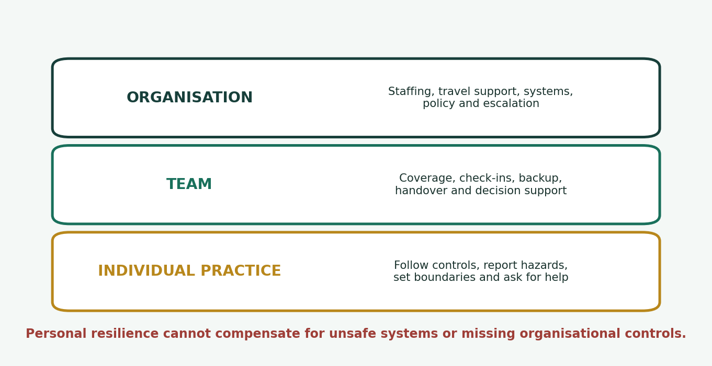
Sustainable field practice layers
Duty of care: Individual resilience does not replace an employer's duty of care, safe staffing, travel support, escalation processes or lawful workplace obligations. The field-working plan records conditions; it does not transfer organisational responsibility to the learner.

Before any site activity
- Purpose, site, dates, host, authorised environments and access window are confirmed.
- Destination advice, travel approval, insurance, health, visa or work-permission questions are handled by the authorised organisation and specialist.
- Working hours, on-call scope, time-zone coverage, handover and maximum consecutive hours are agreed.
- Home-team manager, site contact, backup contact and emergency path are tested.
- Remote or isolated work, transport, accommodation, accessibility and harassment risks are assessed and controlled.
- Only necessary, managed devices, accounts and data travel; loss and compromise procedures are known.
- Stop-work, missed check-in and safe-exit conditions are explicit.
- Return, access revocation, device review, decompression and product-learning briefing are scheduled.
Use the separate FDE Fieldcraft and Sustainable Deployment companion for detailed checklists, boundary phrases and manager prompts.

Study and lab sequence
Use a fresh work/<lab-name> directory for each lab. Do not place the assessor guide, fault catalogue or private control files in the learner repository. The commands below use Bash separators; PowerShell users may run each line separately and use backslashes in paths.

Lab 1: Role-boundary case review
Suggested time: 8 focused hours
Purpose: Practise deciding whether the FDE should own, contribute, route or stop across six varied customer scenarios.

Learning outcomes
- Explain organisation-specific role overlap
- Tie action to explicit authority
- Identify a useful safe next step

Repository commands
uv run python tools/module0.py list-scenarios
uv run python tools/module0.py prepare --scenario FDE0-S01 --workspace work/lab1

Procedure
- Read all six scenario files without editing them. For each, summarise the outcome, affected people, authorised environment and hard boundary.
- Classify at least four requests per scenario as Own, Contribute, Route or Stop. Name the evidence that supports the classification.
- Identify one plausible way the answer could change if the charter changed, and name who could authorise that change.
- Rehearse a three-minute explanation for a sponsor and a five-minute technical explanation for the delivery team.
- Ask a peer to challenge two classifications using the observation form in the workbook. Revise only when evidence changes.

Required artefacts
- Role-boundary comparison
- Six-scenario decision sheet
- Peer observation record
- One revised boundary explanation

Verification
- Every action cites an authority source or explicitly states that it is missing
- No role is treated as universally responsible
- Stop responses include a bounded next option
- Technical capability is not confused with permission

Evidence to retain
- Synthetic + Document-reviewed decision sheet
- Synthetic + Peer-observed role explanation
- Limitations and unanswered role questions
Stretch: Select a scenario from a domain you know well and list three assumptions your familiarity could tempt you to skip.

Lab 2: Fictional data inventory
Suggested time: 8 focused hours
Purpose: Map generated FieldBridge information from purpose through deletion and prepare precise specialist questions without making a legal conclusion.

Learning outcomes
- Separate synthetic, pseudonymous, de-identified and anonymous claims
- Apply data minimisation
- Map purpose, access, retention and deletion

Repository commands
uv run python tools/module0.py prepare --scenario FDE0-S02 --workspace work/lab2
# Edit work/lab2/data-inventory.csv and engagement-charter.json
uv run python tools/module0.py validate --workspace work/lab2

Procedure
- List every generated record, free-text field, log, attachment, export and evidence copy implied by the scenario.
- For each asset, record purpose, source, destination, access roles, retention, deletion owner and jurisdiction question.
- Challenge every field with three tests: necessary for the outcome, necessary for this learning stage and safe for the declared destination.
- Draw a simple lifecycle from generation to deletion. Include logs, model or service calls, evidence capture and temporary copies.
- Write three specialist referrals: one privacy, one security and one domain question. Supply facts and options without suggesting that the FDE decides.
- Run validation, correct machine-detectable gaps and document the remaining human-review questions.

Required artefacts
- Completed data inventory
- Lifecycle map
- Three specialist referrals
- Updated charter data boundary
- Validation transcript

Verification
- Every row is synthetic=true
- Purpose and deletion owner are explicit
- No real email, domain, IP address or identity appears
- Uncertain classification is recorded rather than guessed
- No legal conclusion is claimed

Evidence to retain
- Synthetic + Document-reviewed data inventory
- Local live + Machine-verified validation transcript
- Unproved jurisdiction and legal questions
Stretch: Remove one proposed field and explain how the workflow and evidence still achieve the intended outcome.

Lab 3: Authority and stakeholder map
Suggested time: 8 focused hours
Purpose: Turn stakeholder names into decision rights, affected-user needs, escalation paths and time-bounded specialist referrals.

Learning outcomes
- Separate sponsor, owner, approver, operator and affected person
- Expose authority conflicts
- Set review and expiry conditions

Repository commands
uv run python tools/module0.py prepare --scenario FDE0-S03 --workspace work/lab3
# Edit authority-matrix.csv, specialist-referrals.csv and risk-register.csv
uv run python tools/module0.py validate --workspace work/lab3

Procedure
- Map the people who fund, decide, accept, operate, support, are affected and supply specialist interpretation.
- Write one decision per authority-matrix row. Avoid labels such as 'approves everything'.
- For each decision, name what the FDE owns, what evidence is contributed, when escalation occurs and the consequence of delay.
- Add accessibility and absent-stakeholder questions. Identify who bears risk if their perspective is missing.
- Simulate two conflicting instructions. Use the matrix to decompose the conflict and preserve a safe interim position.
- Have a peer act as one stakeholder and observe whether your explanation is accurate, concise and non-adversarial.

Required artefacts
- Stakeholder map
- Authority matrix
- Conflict decision record
- Specialist referral log
- Observed explanation

Verification
- Accountable roles are named for material decisions
- The FDE role is specific and bounded
- Affected people are visible
- Missing authority produces a referral or stop
- Review dates and triggers are stated

Evidence to retain
- Synthetic + Customer-simulated conflict exercise
- Synthetic + Peer-observed explanation
- Document-reviewed authority matrix
Stretch: Re-run the exercise after moving one decision from the sponsor to the operator. Identify every artefact that must change.

Lab 4: Ethical pressure exercise
Suggested time: 10 focused hours
Purpose: Respond safely to pressure involving control bypass, evidence overclaim, unapproved data, AI assistance and accessibility.

Learning outcomes
- Use the PAUSE record under time pressure
- Offer safer alternatives
- Defend evidence labels and affected-user needs

Repository commands
uv run python tools/module0.py prepare --scenario FDE0-S04 --workspace work/lab4
# Complete both ethical-decision-record files
uv run python tools/module0.py validate --workspace work/lab4

Procedure
- Ask a facilitator to present four pressure requests, one at a time. Do not receive the controlled catalogue or reference response.
- For each request, state the purpose, affected people, authority, uncertainties, possible harms and immediate safe state aloud.
- Write two full PAUSE records. One must involve an AI-assisted workflow and name human decision authority.
- Offer at least two safer options, including one that advances the outcome without the disputed data or control change.
- Label every claim with a mode and method. Mark unsupported production, compliance, quality or safety statements Unproved.
- Deliver a five-sentence escalation. Invite the facilitator to challenge scope, urgency and authority.
- After debrief, revise the reasoning, not the history. Preserve the original observed record and append a learning note.

Required artefacts
- Two ethical decision records
- Four brief pressure-response notes
- Observed communication record
- Evidence claims and limitations
- Learning note

Verification
- No unapproved data or system is touched
- AI use names human authority and approved data boundary
- Safer options are practical
- Evidence is not overstated
- Accessibility is treated as a design and decision condition
- Escalation is specific and constructive

Evidence to retain
- Synthetic + Assessor-observed or Customer-simulated response
- Document-reviewed PAUSE records
- Unproved specialist and production conclusions
Stretch: Repeat one request with a different affected user and show how the same technical option can create a different ethical decision.

Lab 5: Field-readiness pack
Suggested time: 14 focused hours
Purpose: Integrate the charter, authority, data, ethics, safety and evidence artefacts into a coherent mobilisation decision for one synthetic engagement.

Learning outcomes
- Build a traceable readiness pack
- Define sustainable field conditions
- Seal and verify minimal evidence
- Present a decision-ready mobilisation read-out

Repository commands
uv run python tools/module0.py prepare --scenario FDE0-S06 --workspace work/lab5
# Complete every file in work/lab5
uv run python tools/module0.py validate --workspace work/lab5
uv run python tools/module0.py seal --workspace work/lab5 --evidence evidence/lab5
uv run python tools/module0.py verify --evidence evidence/lab5

Procedure
- Write the engagement charter, including purpose, non-goals, environment, data boundary, decision rights, review date and explicit stop-work conditions.
- Complete the authority matrix, data inventory, risk register, specialist referrals and two PAUSE records.
- Write a sustainable field-working plan covering site and home contacts, hours, on-call, check-ins, lone work, travel and site logistics, emergencies, harassment, wellbeing escalation and return briefing.
- Record at least four field observations and classify each as customer-specific, integration or documentation friction, reusable capability gap, product defect, operational or commercial constraint, or unvalidated observation.
- Create an evidence manifest. Use one mode and one validation method per claim and name the verifier or reviewer.
- Run machine validation. Correct structural defects without converting a machine pass into a specialist claim.
- Deliver a ten-minute mobilisation read-out: ready, ready with conditions, paused or declined. Include uncertainty and product implications.
- Seal and verify the approved artefact set, then apply the retention and cleanup checklist.

Required artefacts
- Complete readiness workspace
- Ten-minute read-out
- Observed communication record
- Validation transcript
- Sealed evidence directory
- Sanitised portfolio summary

Verification
- Every material decision has an owner
- Data and environment remain synthetic and local
- Field hours and support controls are plausible
- Stop-work conditions are testable
- Manifest claims match actual execution
- Evidence seal verifies
- Portfolio contains no customer-derived material

Evidence to retain
- Local live + Machine-verified validator and seal
- Synthetic + Assessor-observed read-out
- Document-reviewed readiness pack
- Unproved external, legal and production claims
Stretch: Ask the assessor to change one site, schedule or decision-rights constraint. Update every affected artefact and explain the change trace.

Module exit assessment
Format: A 60-minute supervised, synthetic scenario. You may use the learner guide, your notes, the unmodified starter repository and official primary sources. You may not use the controlled assessor guide, fault catalogue, another person's completed pack or a copied response.
Time | Activity | Required performance
0-10 min | Read and frame | State outcome, affected people, authority, data boundary, assumptions and immediate stop-work conditions.
10-25 min | Role and authority | Explain the FDE boundary and route one specialist decision with a useful referral.
25-40 min | Changed constraint | Apply PAUSE, preserve a safe state and offer a bounded option.
40-52 min | Evidence and field safety | Defend modes and methods; address hours, site, check-in and home-team controls.
52-60 min | Read-out | Give a clear readiness decision, limitations, next owners and review trigger.

Scoring
Programme area | Points | Module 0 evidence
Problem, outcome, acceptance and value | 15 | Purpose, affected people, measurable outcome, constraints, non-goals and decision authority.
Technical design and implementation | 25 | Coherent charter, authority, data and control design; repository use; changed-constraint traceability.
Security, privacy and safety | 15 | Synthetic boundary, minimisation, specialist routing, field conditions and stop-work.
Deployment, cost, operations and recovery | 15 | Mobilisation, field-operating plan, safe reset, evidence retention and cleanup. Cost is only bounded planning in this module.
Evidence and diagnosis | 15 | Falsifiable reasoning, mode and method accuracy, integrity, seal and limitations.
Communication, enablement and product learning | 15 | Observed audience fit, constructive escalation, field observations and reusable feedback.

Pass at 75/100 or above and pass every critical criterion. A retest uses a different scenario or controlled fault after targeted remediation.

Critical criteria
Code | Required Module 0 behaviour | Automatic-fail example
C1 | Authority, privacy and safety | Opens undeclared data, accesses an unauthorised system, bypasses a control or continues unsafe work.
C2 | Problem framing and acceptance | Cannot state purpose, affected people, success, non-goals or decision owner.
C3 | Technical correctness and security | Design permits material exposure, secret capture or an unsupported technical claim.
C4 | Rollback and recovery | Cannot preserve or restore the safe learning state, reset work or describe field withdrawal.
C5 | Evidence integrity and claim honesty | Fabricates, changes or mislabels evidence, or presents simulation as live proof.
C6 | Client enablement and product feedback | Leaves material ownership ambiguous or records customer-specific friction as a universal product fact.

Retrieval practice
1. Why does access not equal authority?
Answer: Access is a technical condition; authority is a scoped decision right granted by the engagement and applicable obligations.
2. What four positions make up the role-boundary compass?
Answer: Own, Contribute, Route and Stop.
3. Name three charter changes that require revalidation.
Answer: Any three of purpose, affected users, environment, data, identity, risk, cost, hours, location or acceptance.
4. What is the difference between an affected person and an end user?
Answer: An affected person may bear consequences without operating the system.
5. Why should a specialist referral ask one decision question?
Answer: A precise question exposes authority, evidence needed, timing and ownership; a general review hides the decision.
6. Does synthetic data automatically mean harmless data?
Answer: No. It can still encode harmful scenarios, expose product behaviour or be combined with unsafe material.
7. Why should an FDE not self-declare information anonymous?
Answer: Anonymity depends on context, linkage risk and applicable law; the authorised privacy or legal specialist decides.
8. What does purpose limitation change in a design?
Answer: It ties collection and use to a declared outcome and makes incompatible reuse a new decision.
9. What are the five PAUSE stages?
Answer: Purpose and people; Authority and obligations; Uncertainty and harm; Safer options; Evidence and expiry.
10. Why is a safer option part of an escalation?
Answer: It advances the outcome while preserving the disputed boundary and makes stop-work constructive.
11. What does an NDA not grant?
Answer: It does not automatically grant collection, use, transfer, publication, model-training or portfolio rights.
12. What must an AI-assisted workflow name before consequential use?
Answer: A human decision authority, approved data boundary, affected people, evaluation and failure or recourse path.
13. What are the six execution modes?
Answer: Portable, Rendered, Synthetic, Local live, Provider live and Unproved.
14. What are the five validation methods?
Answer: Machine-verified, Assessor-observed, Peer-observed, Customer-simulated and Document-reviewed.
15. Can assessor observation turn Synthetic into Provider live?
Answer: No. Validation method does not upgrade execution mode.
16. What does a SHA-256 evidence seal prove?
Answer: That retained file bytes still match the seal; it does not prove truth, authority or correct labelling.
17. Why should secrets be excluded at capture time?
Answer: Later blurring can leave copies, metadata or unredacted originals; prevention preserves the boundary.
18. Give the five parts of a constructive stop-work message.
Answer: Request and boundary; observable risk; paused or preserved state; safe option; accountable role and decision deadline.
19. Why is fatigue a system issue as well as an individual signal?
Answer: Staffing, hours, support, travel, isolation and escalation are organisational controls, not personal willpower.
20. What should happen after intensive field work?
Answer: Access and device review, evidence closure, recovery time, return briefing and product-learning capture.

Mastery checklist
- I can explain what an FDE owns and what remains a customer, product, security, privacy, legal, domain or safety decision.
- I can distinguish role title, technical access, capability and actual authority.
- I can define purpose, affected people, non-goals, acceptance and review triggers before implementation.
- I can write testable stop-work conditions and a constructive escalation path.
- I can map a synthetic data lifecycle, including logs, exports, evidence copies, retention and deletion.
- I can distinguish synthetic, de-identified, pseudonymous and anonymous claims without self-authorising a legal conclusion.
- I can use PAUSE to expose authority, uncertainty, harm, safer options and decision expiry.
- I can prevent confidential or customer-derived material from entering an AI tool, evidence archive or portfolio.
- I can label every material claim with one execution mode and one validation method.
- I can explain what machine validation and evidence sealing do and do not prove.
- I can pause unsafe work without becoming adversarial, vague or passive.
- I can establish working hours, on-call, check-in, site, travel, isolation, harassment and home-team boundaries.
- I can complete, validate, seal, verify and safely reset a Module 0 readiness workspace.
- I can present a readiness decision with limitations, owners and a review trigger in ten minutes.

Command map
Goal | Command
Check repository baseline | uv run python tools/module0.py baseline
List learner scenarios | uv run python tools/module0.py list-scenarios
Prepare a fresh workspace | uv run python tools/module0.py prepare --scenario FDE0-S01 --workspace work/current
Validate a completed pack | uv run python tools/module0.py validate --workspace work/current
Seal approved evidence | uv run python tools/module0.py seal --workspace work/current --evidence evidence/current
Verify the seal | uv run python tools/module0.py verify --evidence evidence/current
Remove one workspace | uv run python tools/module0.py reset --workspace work/current
Run all 30 tests | uv run python -m unittest discover -s tests -v
Run the packaged verification script | PowerShell: .\scripts\verify.ps1 | Bash: ./scripts/verify.sh

Assessor controls: The repository accepts an assessor-provided changed-constraint record through apply-control, but learners are not given control payloads or the fault catalogue before assessment. Never invent a control or use it to introduce real data or external access.

Glossary
Term | Programme meaning
Affected person | A person or group who may experience benefit, harm, exclusion or loss of agency, whether or not they operate the system.
Authority | A scoped right to decide, approve, accept or act, derived from the engagement and applicable obligations.
Decision right | A specific statement of who proposes, decides, accepts, operates or is consulted for one material question.
Engagement charter | The operating agreement for purpose, scope, environment, data, authority, escalation, stop-work, review and closure.
Evidence mode | One of six labels describing where or how the retained result was produced.
Validation method | How a result was checked: machine, assessor, peer, customer simulation or document review.
Field observation | A bounded observation recorded with evidence and classification; not automatically a universal product fact.
PAUSE record | A structured ethical decision record covering purpose, authority, uncertainty, safer options, evidence and expiry.
Specialist referral | A precise question routed to an accountable privacy, legal, security, domain, safety or other specialist.
Stop-work condition | A predefined circumstance that requires the learner to pause, preserve the safe state and escalate.
Synthetic | Generated training data or simulation, not evidence about a real customer or production environment.
Unproved | A claim or assumption that has not yet been validated with the required execution and review evidence.

Official primary sources
Currency rule: Sources were reviewed on 19 August 2026. Laws, guidance, organisational policies and product terms change. Confirm jurisdiction, version, applicability and decision authority before using them on an engagement.
Privacy Act 1988, current compilation. Official source - Federal Register of Legislation; current compilation C2026C00227 was effective 4 June 2026 at review time.
Australian Privacy Principles guidelines. Official source - OAIC consolidated guidance updated 13 May 2026; use the chapter relevant to the actual information lifecycle.
Guide to undertaking privacy impact assessments. Official source - OAIC advises early threshold assessment and proportional work; a PIA is not a substitute for accountable approval.
Privacy impact assessment tool. Official source - Official structured tool that can be adapted to the project's size, complexity and risk.
General Data Protection Regulation. Official source - Official EUR-Lex text; Article 5 is a useful principles reference, but applicability and lawful basis require authorised advice.
EDPB Guidelines 4/2019 on data protection by design and by default. Official source - Final European Data Protection Board guidance; confirm applicability and current local interpretation.
NIST AI Risk Management Framework. Official source - AI RMF 1.0 is the current published baseline but was being revised at review time; record the version used.
NIST Generative AI Profile. Official source - NIST AI 600-1 companion profile, updated 8 April 2026 at review time.
ACM Code of Ethics and Professional Conduct. Official source - Professional principles including avoiding harm, honesty, privacy and confidentiality; not a legal code.
Model Code of Practice: Managing psychosocial hazards at work. Official source - Safe Work Australia model guidance; legal effect depends on adoption in the relevant jurisdiction.
Remote and isolated work duties. Official source - Official overview of risk-management and effective-communication duties for remote or isolated work.
Right to disconnect. Official source - Fair Work Ombudsman general guidance, updated 18 June 2026; contracts, awards, agreements and circumstances matter.
Guidelines for enterprise mobility. Official source - Australian Signals Directorate guidance for travel devices and enterprise mobility; organisational policy remains controlling.
Smartraveller: Know before you go. Official source - Official Australian travel advice; check destination advice immediately before authorised travel.
IP Australia: Who owns intellectual property?. Official source - Official general information highlighting the importance of written terms and specialist advice.
IP Australia: Non-disclosure agreements. Official source - Official general introduction; agreement scope and enforceability require legal review.
Learning boundary: Use official sources to locate current requirements and formulate precise questions. Do not treat this guide, a checklist, a tool result or a framework mapping as legal advice, certification or specialist approval.

