**INTERNATIONAL ISLAMIC UNIVERSITY CHITTAGONG**



**Lab report-5**

**Course code: CSE-3636**

**Course Titlle : Artificial Intiligance Lab**

**Submitted To:**

**Md Safayet Hossen**

**Department of CSE**

**International Islamic University Chittagong**

**Submitted By:**

**Md.Riaz Ahmed**

**Id: C201060**

**Section: 6BM**

**Semester: 6th**

**Date of submission : 25/03/23**

**Lab report -5 : A\***

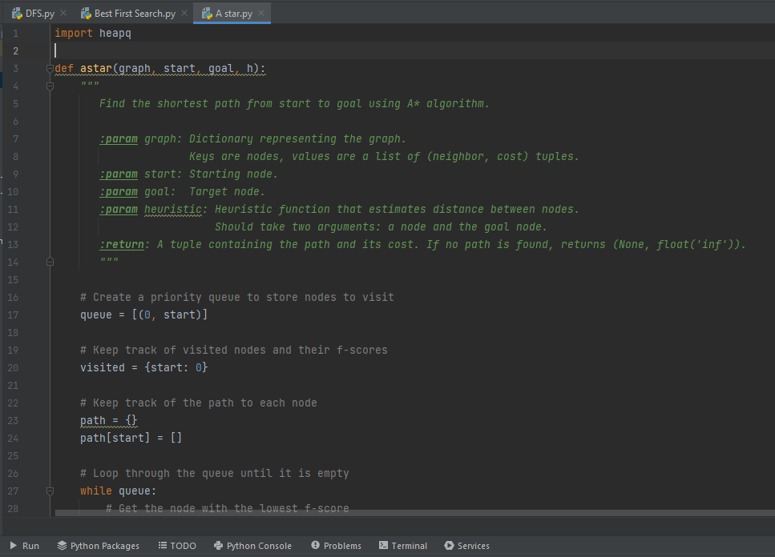

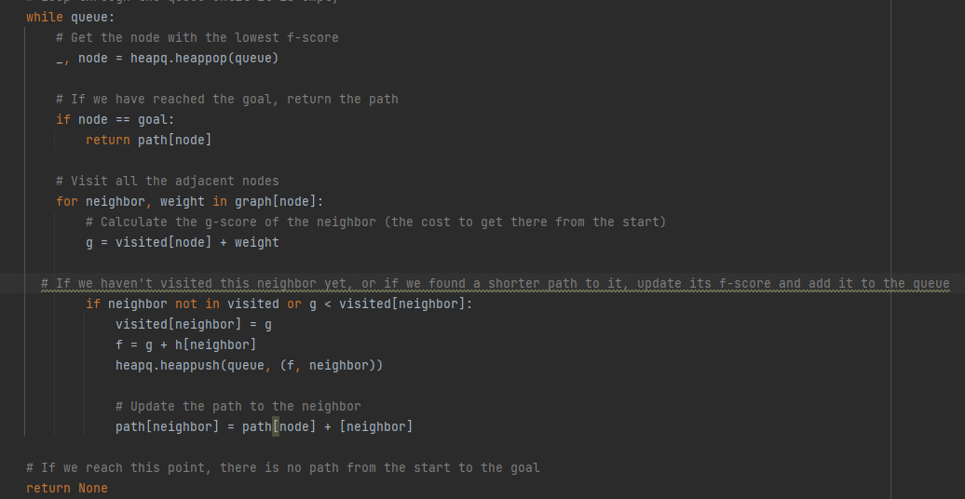

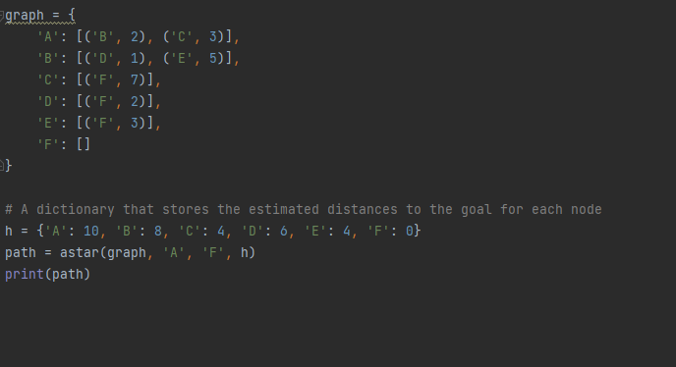

**Code:**

import heapq

def astar(graph, start, goal, h):

"""

Find the shortest path from start to goal using A* algorithm.

:param graph: Dictionary representing the graph.

Keys are nodes, values are a list of (neighbor, cost) tuples.

:param start: Starting node.

:param goal: Target node.

:param heuristic: Heuristic function that estimates distance between nodes.

Should take two arguments: a node and the goal node.

:return: A tuple containing the path and its cost. If no path is found, returns (None, float('inf')).

"""

# Create a priority queue to store nodes to visit

queue = [(0, start)]

# Keep track of visited nodes and their f-scores

visited = {start: 0}

# Keep track of the path to each node

path = {}

path[start] = []

# Loop through the queue until it is empty

while queue:

# Get the node with the lowest f-score

_, node = heapq.heappop(queue)

# If we have reached the goal, return the path

if node == goal:

return path[node]

# Visit all the adjacent nodes

for neighbor, weight in graph[node]:

# Calculate the g-score of the neighbor (the cost to get there from the start)

g = visited[node] + weight

# If we haven't visited this neighbor yet, or if we found a shorter path to it, update its f-score and add it to the queue

if neighbor not in visited or g < visited[neighbor]:

visited[neighbor] = g

f = g + h[neighbor]

heapq.heappush(queue, (f, neighbor))

# Update the path to the neighbor

path[neighbor] = path[node] + [neighbor]

# If we reach this point, there is no path from the start to the goal

return None

graph = {

'A': [('B', 2), ('C', 3)],

'B': [('D', 1), ('E', 5)],

'C': [('F', 7)],

'D': [('F', 2)],

'E': [('F', 3)],

'F': []

}

# A dictionary that stores the estimated distances to the goal for each node

h = {'A': 10, 'B': 8, 'C': 4, 'D': 6, 'E': 4, 'F': 0}

path = astar(graph, 'A', 'F', h)

print(path)

**Output:**

