**INTERNATIONAL ISLAMIC UNIVERSITY CHITTAGONG**



**Lab report-3**

**Course code: CSE-3636**

**Course Titlle : Artificial Intiligance Lab**

**Submitted To:**

**Md Safayet Hossen**

**Department of CSE**

**International Islamic University Chittagong**

**Submitted By:**

**Md.Riaz Ahmed**

**Id: C201060**

**Section: 6BM**

**Semester: 6th**

**Date of submission : 25/03/23**

**BFS and DFS:**

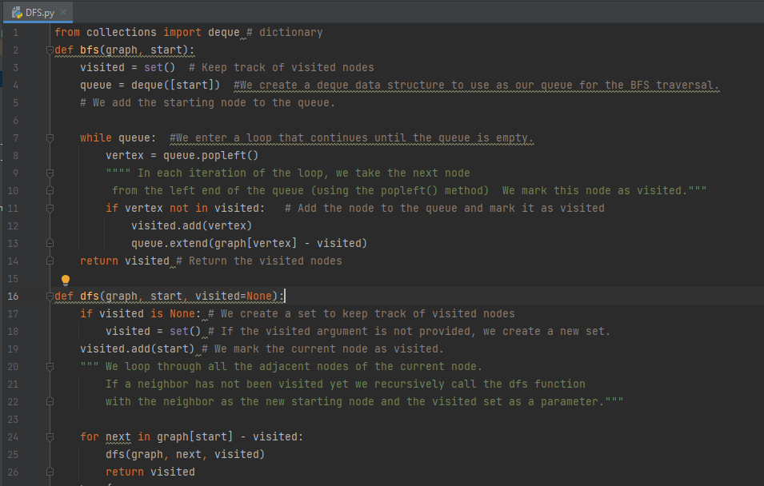

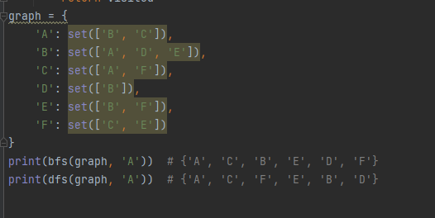

**Code:**

from collections import deque # dictionary

def bfs(graph, start):

visited = set() # Keep track of visited nodes

queue = deque([start]) #We create a deque data structure to use as our queue for the BFS traversal.

# We add the starting node to the queue.

while queue: #We enter a loop that continues until the queue is empty.

vertex = queue.popleft()

"""" In each iteration of the loop, we take the next node

from the left end of the queue (using the popleft() method) We mark this node as visited."""

if vertex not in visited: # Add the node to the queue and mark it as visited

visited.add(vertex)

queue.extend(graph[vertex] - visited)

return visited # Return the visited nodes

def dfs(graph, start, visited=None):

if visited is None: # We create a set to keep track of visited nodes

visited = set() # If the visited argument is not provided, we create a new set.

visited.add(start) # We mark the current node as visited.

""" We loop through all the adjacent nodes of the current node.

If a neighbor has not been visited yet we recursively call the dfs function

with the neighbor as the new starting node and the visited set as a parameter."""

for next in graph[start] - visited:

dfs(graph, next, visited)

return visited

graph = {

'A': set(['B', 'C']),

'B': set(['A', 'D', 'E']),

'C': set(['A', 'F']),

'D': set(['B']),

'E': set(['B', 'F']),

'F': set(['C', 'E'])

}

print(bfs(graph, 'A')) # {'A', 'C', 'B', 'E', 'D', 'F'}

print(dfs(graph, 'A')) # {'A', 'C', 'F', 'E', 'B', 'D'}

**Output:**

