Deen Associate Management System
Developed By
Muhammad Junaid Riaz
BSCS
Supervised By
Mr. Khawar Maqsood
Project Coordinator
Mr. Khawaja Tahir
Department of Computer Science
Federal Urdu University of Arts, Science & Technology, Islamabad
SESSION [2022-2026]

A Project Presented to
Federal Urdu University of Arts, Science & Technology
In Partial Fulfillment of the Requirement for the Degree
Bachelor of Computer Science
By
Muhammad Junaid Riaz
15th October, 2025
(Federal Urdu University of Arts, Science & Technology, Islamabad)

Declaration
I hereby declare that this software, neither as a whole nor as a part, has been copied from any source. I have developed this software and the accompanied report entirely on the basis of my personal efforts. If any part of this project is proved to be copied from any source, I will stand by the consequences. No portion of the work presented has been submitted in support of any application for any other degree or qualification of this or any other university or institute of learning.
Muhammad Junaid Riaz

Dedicated to my beloved parents, Teachers
And
The fellows

Acknowledgement
Thanks to Almighty Allah for giving me knowledge, power and strength to accomplish this task. I learned a lot while doing this project and this will certainly help me in my forthcoming life.
I am thankful to my supervisor Mr. Khawar Maqsood for his help and support in all phases of my project. His encouragement helped me during times of difficulty.
I would also like to thank the project coordinator and all of my teachers and friends for their support.
Muhammad Junaid Riaz

Project in Brief
Project Title Deen Associate Management System
Organization Federal Urdu University of Arts, Science & Technology, Islamabad
Client Deen Associate
Objectives
• Develop a digital platform to manage real-estate projects,
units, bookings, and payments.
• Provide separate admin and client interfaces for
transparent project and sales management.
• Automate installment schedules, employee management,
and finance reporting.
• Replace manual record keeping with a centralized web
application.
Undertaken By Muhammad Junaid Riaz
Supervised By Mr. Khawar Maqsood
Date Started 15th October, 2025
Date Completed 25 Jun, 2026
Technologies Used
• React.js
• TypeScript
• .NET 8 Web API
• Microsoft SQL Server
• JWT Authentication
System used Deen Associate Management System

ABSTRACT
DAMS
The Deen Associate Management System (DAMS) is a web-based real estate management platform designed for Deen Associate. It supports project publishing, unit inventory, customer booking requests, confirmed sales, installment tracking, payment receipts, employee attendance and salary management, and finance dashboards.
The system uses React for the frontend, .NET 8 Web API for the backend, and Microsoft SQL Server for data storage. JWT authentication and role-based access control protect admin and client operations.
By replacing manual spreadsheets and paper forms with a centralized application, DAMS improves transparency for customers and efficiency for administrators.

Revision History
Version | Description | Author | Date
1.0 | Management System Deen Associate  Project Proposal of | Muhammad Junaid Riaz | 2025  15th October,
1.1 | Specification  Software Requirement Project Analysis — | Muhammad Junaid Riaz | 30 Nov, 2025
1.2 | Design Phase | Muhammad Junaid Riaz | 30 Nov, 2025
1.3 | Domain Model | Muhammad Junaid Riaz | 2 Dec, 2025
1.4 | Model  Diagram and Relational Normalization, ER | Muhammad Junaid Riaz | 3 Dec, 2025
1.5 | Package Diagram | Muhammad Junaid Riaz | 20 Jun, 2026
1.6 | Class Diagram | Muhammad Junaid Riaz | 20 Jun, 2026
1.7 | Diagrams  System Sequence | Muhammad Junaid Riaz | 22 Jun, 2026
1.8 | Test Cases | Muhammad Junaid Riaz | 25 Jun, 2026
1.9 | User Manual | Muhammad Junaid Riaz | 25 Jun, 2026

Table of Contents
Chapter # 1 Introduction...............................................................................................15
Introduction..............................................................................................................16
1.1 Introduction:...............................................................................................................16 1.2 Problem Statement:......................................................................................................16 1.3 Proposed System:........................................................................................................16 1.4 Benefits of Proposed System:.......................................................................................16 1.5 Scope:........................................................................................................................17 1.6 Survey Analysis:.........................................................................................................17 1.7 Modules & Sub-Modules Description:...........................................................................18 1.8 Primary Actors............................................................................................................19 1.9 Tools & Techniques.....................................................................................................20 1.9.1 Front End:...........................................................................................................20
1.9.2 Back End:...........................................................................................................20
1.9.3 Deployment:.......................................................................................................20
1.10 Techniques:...............................................................................................................21 1.10.1 Process Model Approach Used:...........................................................................21
1.10.2 System Design Approach Used:..........................................................................21
1.11 Limitations:...............................................................................................................21 1.12 References:...............................................................................................................21 Chapter # 2 Analysis....................................................................................................21
2.1 Introduction................................................................................................................24 2.2 Scope.........................................................................................................................25 2.3 Definitions, Acronyms and Abbreviations......................................................................26 2.4 Overview....................................................................................................................26 2.5 Functional Requirements..............................................................................................27 2.6.1 Authentication Management......................................................................................27 2.6.1.1 Sign Up............................................................................................................27 2.6.1.2 Login...............................................................................................................27 2.6.1.3 Change Password..............................................................................................27 2.6.1.4 Forget Password...............................................................................................28 2.6.2 Staff Management.....................................................................................................28 2.6.2.1 Add Staff.........................................................................................................28

2.6.2.2 Edit Staff..........................................................................................................28 2.6.2.3 View Staff........................................................................................................28 2.6.2.4 Search Staff......................................................................................................28 2.6.2.5 Assign Staff to Project.......................................................................................29 2.6.3 Project Management..................................................................................................29 2.6.3.1 Add Project......................................................................................................29 2.6.3.2 Edit Project......................................................................................................29 2.6.3.3 View Project.....................................................................................................30 2.6.3.4 Search Project...................................................................................................30 2.6.4 Client Management...................................................................................................30 2.6.4.1 Add Client........................................................................................................30 2.6.4.2 Edit Client........................................................................................................31 2.6.4.3 View Client......................................................................................................31 2.6.4.4 Search Client....................................................................................................32 2.6.5 Booking Management...............................................................................................32 2.6.5.1 Add Booking....................................................................................................32 2.6.5.2 View Booking..................................................................................................32 2.6.5.3 Search Booking................................................................................................33 2.6.5.4 Cancel Booking................................................................................................33 2.6.5.5 Edit Booking....................................................................................................33 2.6.6 Construction Progress................................................................................................33 2.6.6.1 Add Progress....................................................................................................33 2.6.6.2 Edit Progress....................................................................................................34 2.6.6.3 View Progress..................................................................................................34 2.6.6.4 Upload Media...................................................................................................34 2.6.7 Notification System...................................................................................................34 2.6.7.1 Send Notification..............................................................................................34 2.6.7.2 View Notifications............................................................................................34 2.6.7.3 Manage Announcements....................................................................................35 2.6.8 Expense Management................................................................................................35 2.6.8.1 Add Expense....................................................................................................35 2.6.8.2 Edit Expense....................................................................................................35 2.6.8.3 Delete Expense.................................................................................................35 2.6.8.4 View Expenses.................................................................................................36 2.6.8.5 View Profit & Loss Report.................................................................................36 2.6.9 Income Management.................................................................................................36

2.6.9.1 Record Income.................................................................................................36 2.6.9.2 Edit Income......................................................................................................36 2.6.9.3 View Income Records.......................................................................................37 2.6.9.4 Filter Income....................................................................................................37 2.6.9.5 Income Summary Report...................................................................................37 2.6.10 System Interface.....................................................................................................37 2.6.10.1 Dashboard Overview.......................................................................................37 2.6.10.2 Access All Modules.........................................................................................37 2.6.10.3 Manage Users, Roles & Permissions.................................................................38 2.7 Non-Functional Requirements......................................................................................38 2.7.1 Security..............................................................................................................38 2.7.2 Usability.............................................................................................................38 2.7.3 Availability.........................................................................................................38 2.7.4 Performance........................................................................................................39 2.7.5 Accuracy............................................................................................................39 2.8 External Interface Requirements.............................................................................39
2.8.1 User Interface (UI)....................................................................................................40 2.8.2 Hardware Interfaces..................................................................................................40 2.8.3 Software Interfaces...................................................................................................40 2.8.4 Licensing Requirements............................................................................................40 CHAPTER #03 Design Phase......................................................................................42
USE CASE DIAGRAM.............................................................................................43
3.1 Use Case Diagram................................................................................................44 Fully Dressed Use Cases........................................................................................47
3.2 Fully Dressed Use Cases.......................................................................................48
UC-01 Sign up..................................................................................................................49 UC-02 login.....................................................................................................................50 UC-04 Forget Password.....................................................................................................51 UC-05 Add staff...............................................................................................................52 UC-06 View Staff.............................................................................................................53 UC-07 Edit staff................................................................................................................54 UC-08 Search staff............................................................................................................55 UC-09 Assign Staff to project............................................................................................56 UC-10 Add Project............................................................................................................57 UC-11 Edit Project............................................................................................................58

UC-12 View Project..........................................................................................................59 UC-13 Search Project........................................................................................................60 UC-14 Add client..............................................................................................................61 UC-15 Edit client.............................................................................................................62 UC-16 View client...........................................................................................................63 UC-17 Search client.........................................................................................................64 UC-18 Add Booking Request.............................................................................................65 UC-19 Approved / Reject Booking.....................................................................................66 UC-20 Search Booking......................................................................................................67 UC-21 Edit booking..........................................................................................................68 UC-22 Cancel booking......................................................................................................69 UC-23 Add Contruction progress.......................................................................................70 UC-24 Edit Contruction progress........................................................................................71 UC-25 View Contruction progress......................................................................................72 UC-26 Upload progress media...........................................................................................73 UC-27 Send Notification...................................................................................................74 UC-28 View Notification...................................................................................................75 UC-29 Add Expense..........................................................................................................76 UC-30 edit Expense..........................................................................................................77 UC-31 Delete Expense......................................................................................................78 UC-32 View Expense........................................................................................................79 UC-33 Profit & loss report.................................................................................................80 UC-34 Record Income.......................................................................................................81 UC-35 Edit Income...........................................................................................................82 UC-36 View Income Record..............................................................................................83 UC-37 Filter Income.........................................................................................................84 UC-38 Income Summary...................................................................................................85 UC-39 Manage user role &................................................................................................86 Design Phase..........................................................................................................90
3.3 Domain Model.....................................................................................................91 3.4 Package Diagram..................................................................................................93 3.5 System Sequence Diagram....................................................................................95
SSD 1: User Registration...................................................................................................95 SSD 2: User Login............................................................................................................95 SSD 3: Browse Projects.....................................................................................................95

SSD 4: Submit Booking Request........................................................................................95 SSD 5: Approve Booking Request......................................................................................95 SSD 6: Reject Booking Request.........................................................................................95 SSD 7: Create Walk-in Booking.........................................................................................95 SSD 8: Record Booking Amount Payment..........................................................................95 SSD 9: Generate Installment Plan.......................................................................................95 SSD 10: Record Installment Payment..................................................................................95 SSD 11: View Payment Receipt.........................................................................................95 SSD 12: Client My Projects...............................................................................................95 SSD 13: Cancel Booking...................................................................................................95 SSD 14: Mark Employee Attendance..................................................................................95 SSD 15: Generate Employee Salary....................................................................................95 SSD 16: Finance Dashboard...............................................................................................95 SSD 17: Add Manual Revenue...........................................................................................95 SSD 18: Add Expense.......................................................................................................95 3.6 ER Diagram.......................................................................................................114 3.7 Normalization....................................................................................................116
3.7.1 Table Role........................................................................................................119
3.7.2 Table User........................................................................................................119
3.7.3 Table Project.....................................................................................................120
3.7.4 Table Notification..............................................................................................120
3.7.5 Table Expense...................................................................................................121
3.7.6 Table Unit.........................................................................................................121
3.7.7 Table Booking...................................................................................................121
3.7.8 Table Income....................................................................................................122
3.7.9 Table Staff........................................................................................................122
3.7.10 Table Progress.................................................................................................122
3.7.11 Table Progress Media.......................................................................................123
3.8 Relational Model................................................................................................124 Chapter # 4 Construction...........................................................................................129
Class Diagram.......................................................................................................130
4.1 Class Diagram....................................................................................................131 4.2 Project Code.......................................................................................................133 4.3 Sample Queries..................................................................................................146 Chapter # 5 Testing....................................................................................................158

Test Case..............................................................................................................159
Chapter # 6 User Manual...........................................................................................203
User Manual..........................................................................................................204
6.1 Introduction..............................................................................................................205 6.1.1 User Roles..............................................................................................................205 6.1.1.1 Client (Customer)...........................................................................................205 6.1.1.2 Administrator.................................................................................................205 6.2 Getting Started..........................................................................................................206 6.2.1 Opening the Application.....................................................................................206 6.2.2 Registration and Login.......................................................................................206 6.2.3 Theme and Profile Controls................................................................................208 6.3 Client User Guide......................................................................................................208 6.4 Administrator User Guide...........................................................................................216 6.4.1 Booking Requests and Confirmed Bookings.........................................................217 6.4.2 Customers Module.............................................................................................220 6.4.3 Employees Module............................................................................................220 6.4.4 Finance Module.................................................................................................222 6.4.5 Project and Media Management..........................................................................224 6.5 Quick Reference — Who Can Access What.................................................................224 6.6 Tips and Troubleshooting...........................................................................................224

Chapter # 1 Introduction

Introduction
“Deen Associate Management System” is a complete digital platform designed to manage multiple real estate projects under the Deen Associate brand, including Urban Complex, Deen Villas, and Floria Heights. The purpose of the system is to streamline booking, client management, expense handling, and construction updates, ensuring transparency and efficiency between the admin and clients. The system provides a role-based access model, allowing both admins and clients to interact within a secure, scalable environment.
Problem Statement
As this project is being developed for an established real estate firm, the main goal is to provide an automated system that helps management handle all operations efficiently. Currently, “Deen Associate” manages bookings, client data, and financial records manually, which often leads to data inconsistency, delays, and inefficiency. Most real estate companies are now shifting toward digital management platforms to ensure transparency, accuracy, and real-time updates. However, “Deen Associate” still relies on traditional methods without a centralized database for projects, and progress tracking. While some competitors offer real estate management systems, many of them cover only basic functionalities like booking or client registration. Our proposed system will go beyond that by including modules for project management, client handling, expense management, and progress monitoring. The main objective is to automate daily operations, minimize manual errors, and enhance overall efficiency through a centralized and user-friendly platform.
Proposed System
“Deen Associate Management System” will provide a complete online solution for managing real estate operations efficiently. The project will include a web-based platform that automates daily business tasks such as project management, client registration, property booking, and progress monitoring. This system will make it easier for both management and clients to handle all activities through a single centralized portal. Clients will be able to view project details, book properties online, and track construction progress in real time. Admins will have access to tools for managing projects, updating progress reports, recording financial transactions, and generating analytical summaries.What sets this system apart from many other real estate management platforms is its focus on real-time updates, transparent financial tracking, and detailed project monitoring, which are often missing in traditional systems. Additionally, the system will feature modules forexpense management and reporting, helping Deen Associate reduce manual workload, prevent data inconsistencies, and enhance operational efficiency. The main goal is to enable 24/7 online accessibility, allowing both management and clients to interact seamlessly and ensuring a smooth, transparent, and modern real estate experience.
Benefits of proposed system
1.Deen Associate Management System is used to manage projects, clients, and financial records online.
2.Simple and user-friendly dashboard for Admin and Clients.
16

 |  | 4.Real-time updat 5.Secure JWT-bas 6.Transparent fina 7.Improved decisi 8.Admins can mo 9.Reduced manua 10.Scalable for futu  Primary Actors 1 Super Admin  2 Admin  3 client  Scope  The real estate industry and property booking s explore properties, ma estate companies are accuracy, efficiency, an provide real-time upda visits.The trend is mov data security, and transp value professionalism, Management System is based solution to mana With its scalable struct management modules, transformation in Pakis  Survey Analysis | es on construction prog ed authentication with r ncial tracking with auto on-making through ana nitor overall project per l errors and increased o ure modules like market  is rapidly evolving wit ystems. Clients today pr e bookings, and track shifting from manual d better client engagem tes, and easy access to ing toward smart real e arency. Our target mark convenience, and reliab designed to meet thes ge projects, client recor ure, the system can be helping Deen Associate tan’s real estate sector. | ress and project status. r ole-based access contro mated reporting feature lytical and visual dashb formance, and client ac perational efficiency.  ing, lead management,  h the growing adoption efer transparent, quick, progress online. As tec processes to automate ent. People now expec project details withou state managementthat e et includes both locala ility in property dealin e modern needs by offe ds, payments, expenses expanded to include m stay competitive and | l for data protection. s.  oards.  tivities.  and expense tracking.  of digital management and convenient ways to hnology advances, real d systems that ensure t digital platforms that t the need for physical mphasizes automation, nd overseas clients who gs. The Deen Associate ring an all-in-one web-, and progress tracking. arketing, staff, and lead aligned with the digital
 |  | Companies ➡️ | Zameen CRM  (zameencrm.com) | Aiksol360  (aiksol360.com) | Dean Associate
 |  | System Features ⬇️
 |  | Online Booking | ✔️ | ✔️ | ✔️
 |  | Unit Availability | ✔️ | ✔️ | ✔️
 |  | Project & Plaza Management | ✔️ | ✔️ | ✔️
 |  | Construction
 | 17

Client Notification System | ❌ | ✔️ | ✔️
Staff Management | ❌ | ✔️ | ✔️
Expense  Management | ✔️ | ✔️ | ✔️
Modules & Sub Modules
1.Security Management
1.1 Sign Up
1.2 Login
1.3 Change Password
1.4 Forget Password
1.5 Manage user role and profile
2.Staff Management
2.1 Add Staff
2.2 Edit Staff
2.3 View Staff
2.5 Assign Staff to Project
3.Project Management
3.1 Add Project
3.2 Edit Project
3.3 View Project
3.4 Search project
4.Client Management
4.1 Add Client
4.2 Edit Client
4.3 View Client
4.4 Search client
5.Booking Management
5.1 Add Booking
5.2 Edit Booking
5.3 View Booking
5.4 Cancel Booking
18

6.1 Add Progress
6.2 Edit Progress
6.3 View Progress
6.4 Upload Media
7.Notification System
7.1 Send Notifications
7.2 View Notification
8.Expense Management
8.1 Add Expense
8.2 Edit Expense
8.3 View Expense
8.4 Delete Expense
9.System Interface
9.1 Dashboard Overview
9.2 Access All Modules
10.Income Management
10.1 Add Income Record
10.2 Edit Income Record
10.3 View Income reocrd
10.4 Filter Income ( by project , date wise , client wise) 10.5 Income summary
Tools & Technologies
1.Frontend Tools
Angular 16 /React
2.Backend Tools
. NET 8 (Web API)
3.Database
SQL Server / Firebase
4.Authentication
JWT (JSON Web Token)
5.Hosting & Deployment
Azure / Firebase / Local Server
19

6.Technique
Web Application
System Design Approach
➢MVC Pattern
We will follow the N-tier design pattern to ensure better performance, maintainability, scalability and clear separation of concerns in our project.
➢UML (Unified Model Language)
Process Model Used
➢RUP (Rational Unified Process Model)
Limitations/Constraint
➢Must have a good internet connection.
➢For admin/employees, Login must be performed.
➢Hosting setup and authentication configuration needed.
➢“Dean Associate Management System” will be available only in Web Application. ➢Future modules will be integrated gradually.
References
- https://zameencrm.com
- https://aiksol360.com
20

CHAPTER #02 Analysis
21

Software Requirement Specification
FOR
Deen Associate Management System
Version 1.0
Proposed By
Muhammad Junaid Riaz
30 Nov, 2025
22

Revision History
Version | Description | Author | Date
1.0 | This document  contains SRS of  Deen Associate  Management System | Muhammad Junaid Riaz | 27th November 2025
23

Introduction
The real estate sector in Pakistan is rapidly transforming as businesses move from manual record-keeping to fully digital management systems. Clients today expect transparent, fast, and reliable ways to view project details, check property availability, book units, and track construction progress online. Deen Associate, which manages multiple projects such as Urban Complex, Deen Villas, and Floria Heights, currently handles most of its operations manually, including booking, client records, payment tracking, project progress updates, and staff coordination.Manual handling of such operations often leads to delays, errors, data loss, and reduced operational efficiency.
The Deen Associate Management System (DAMS) will be a complete web-based platform that automates all major real estate operations. The system will provide real-time project information, digital booking management, client handling, expense and income tracking, construction progress updates, and staff organization. By offering a centralized platform with role-based access, DAMS aims to improve transparency, reduce human errors, enhance user accessibility, and provide smooth, modern digital services to both clients and administrators.
Purpose
The purpose of this SRS is to define the detailed requirements, system behavior, and operational
boundaries for the Deen Associate Management System (DAMS). This document ensures that
all stakeholders—including project owners, supervisors, developers, and evaluators—share a
clear understanding of system goals and functionalities
The DAMS aims to:
• Provide a centralized platform for project, client, booking, and financial
managementSimplify room reservations, check-in/check-out, and payment processing
• Digitalize unit booking, availability tracking, and construction progress updatesOffer
secure access to users based on their roles
• Improve internal management through staff assignment and system-wide reportsOffer
secure login and role-based access to Admin, Super Admin, and Clients
• Support scalability for future modules such as marketing or lead management
This SRS will serve as a reference throughout the development, implementation and testing
phases
24

Scope
The Deen Associate Management System (DAMS) is designed for real estate companies that want to automate and centralize their business operations. This system will allow both administrators and clients to interact with the platform efficiently and securely. DAMS covers the entire workflow of Deen Associate, including project management, client handling, bookings, construction updates, staff management, expenses, and income.
The DBMS aims to:
· Provide a centralized online booking and management platform
· Provide online project and property management
· Allow clients and admins to manage bookings digitally
· Maintain client records with complete history
· Track construction progress with photos, videos, and stage-wise percentages
· Manage staff assignments and system roles
· Maintain transparent records of expenses and income
· Generate financial and operational reports
· Provide secure login using JWT authentication
· Reduce manual operations and shift Deen Associate toward complete digital automation
This SRS will serve as a reference throughout the development, implementation, and testing phases.
25

Definitions, Acronyms, and Abbreviations
  Term
  Definition

  DAMS
  DAMS Management System
  GUI
  Graphical User Interface
  RUP
  Rational Unified Process
  UML
  Unified Modeling Language
Presentation Layer, Business Logic Layer, and Data Access Layer

N-Tier
Architecture

Overview
This document outlines the complete requirements of the Deen Associate Management System, including purpose, scope, actors, constraints, functional requirements, and non-functional requirements. DAMS is designed to automate project management, client handling, property bookings, construction updates, staff assignment, and financial tracking. The system will use modern technologies such as Angular/React, .NET Web API, SQL Server, and JWT
authentication. The architecture will follow N-tier and the RUP process model to ensure scalability, maintainability, and high performance.
26

FUNCTIONAL REQUIREMENTS SPECIFICATION
Deen Associate Management System
1. SECURITY MANAGEMENT
1.1 Sign Up
SRS-1 | The system shall allow new users to register by entering required details such as name, email, contact number, password, role, and company name.
SRS-2 | The system shall validate all required fields before submission, including email format, password strength requirements, and valid phone number format.
SRS-3 | The system shall prevent duplicate user registrations by checking unique identifiers such as email and phone number.
SRS-4 | The system shall confirm successful registration with a success message and send a verification email to the user.
SRS-5 | The system shall implement email verification before account activation.
1.2 Login
SRS-6 | The system shall allow registered users to log in using their email and password.
SRS-7 | The system shall validate credentials and allow access only if they are correct.
SRS-8 | The system shall display an error message for incorrect login attempts.
SRS-9 | The system shall track login timestamps and log all authentication attempts for security audit purposes.
1.3 Change Password
SRS-10 | The system shall allow logged in users to change their password after providing the current password.
SRS-11 | The system shall validate the current password before allowing password change.
SRS-12 | The system shall validate the new password for strength requirements (minimum length, special characters, uppercase/lowercase).
SRS-13 | The system shall update the password in the database and confirm the change with a success message.
27

1.4 Forget Password
SRS-14 | The system shall allow users to reset their password by verifying their registered email address.
SRS-15 | The system shall send a secure, time limited code reset link to the user's email (valid for 5 minute ).
SRS-16 | The system shall allow users to create a new password after matching user entered code (from email sended by system)
SRS-17 | The system shall confirm the password reset with a success message and send a notification email.
2. STAFF MANAGEMENT
2.1 Add Staff
SRS-32 | The system shall allow administrators to add a new staff member by entering details such as name, email, contact number, designation, experience level, skills, and department.
SRS-33 | The system shall validate all required fields before submission, including proper phone number format and valid email.
SRS-34 | The system shall prevent duplicate staff entries by checking unique identifiers such as email or phone number.
SRS-35 | The system shall automatically assign a unique staff ID upon successful addition.
SRS-36 | The system shall confirm successful staff addition with a success message.
2.2 Edit Staff
SRS-37 | The system shall allow administrators to update staff details including name, contact number, designation, skills, department, and status.
SRS-38 | The system shall validate updated information before saving changes.
SRS-39 | The system shall maintain a history of changes made to staff records for audit purposes.
SRS-40 | The system shall confirm successful updates with a success message.
2.3 View Staff
SRS-41 | The system shall display a list of all active staff members with details such as staff ID, name, designation, contact number, department, and employment status.
SRS-42 | The system shall provide pagination options to navigate through large staff lists.
SRS-43 | The system shall allow viewing individual staff profiles with complete details including work history and assigned projects.
SRS-44 | The system shall display availability status of staff members.
2.4 Search Staff
28

 | designation, department, or skills.
SRS-46 | The system shall display search results in a clear list format with key staff details.
SRS-47 | The system shall indicate if no matching staff members are found.
SRS-48 | The system shall allow advanced search with multiple filter combinations.
2.5 Assign Staff to Project
SRS-49 | The system shall allow project managers to assign staff members to specific projects.
SRS-50 | The system shall display available staff based on skills required and current workload.
SRS-51 | The system shall update staff assignment status and associate the staff member with the project.
SRS-52 | The system shall prevent assigning staff to conflicting projects or exceed maximum workload limits.
SRS-53 | The system shall confirm successful assignment with a success message.
SRS-54 | The system shall allow administrators to view all staff-project assignments.
3. PROJECT MANAGEMENT
3.1 Add Project
SRS-55 | The system shall allow authorized users to add a new project by entering details such as project name, description, location, client name, start date, end date, budget, and project status.
SRS-56 | The system shall validate all required fields before submission, including logical date ranges (start date before end date).
SRS-57 | The system shall prevent duplicate project entries by checking project name and location.
SRS-58 | The system shall automatically assign a unique project ID upon successful addition.
SRS-59 | The system shall confirm successful project addition with a success message.
3.2 Edit Project
SRS-60 | The system shall allow authorized users to update project details including name, description, location, budget, timeline, and status.
SRS-61 | The system shall validate updated information before saving changes.
SRS-62 | The system shall maintain a complete history of all project modifications including timestamps and user who made changes.
SRS-63 | The system shall confirm successful updates with a success message.
3.3 View Project
29

 | name, location, client, budget, start date, end date, and status.
SRS-65 | The system shall provide filtering options by project status (Active, Completed, On-Hold, Cancelled).
SRS-66 | The system shall allow viewing detailed project information including assigned staff, current progress, expenses, and timeline.
SRS-67 | The system shall display project dashboard showing key metrics like budget utilization, timeline progress, and resource allocation.
3.4 Search Project
SRS-68 | The system shall allow users to search for projects using criteria such as project name, project ID, client name, location, or status.
SRS-69 | The system shall display search results in a clear list format with key project details.
SRS-70 | The system shall indicate if no matching projects are found.
SRS-71 | The system shall provide advanced search with date range filters and budget range filters.
4. CLIENT MANAGEMENT
4.1 Add Client
SRS-72 | The system shall allow authorized users to add a new client by entering details such as client name, contact person name, email, phone number, address, company registration number, and payment terms.
SRS-73 | The system shall validate all required fields before submission, including valid email format and phone number format.
SRS-74 | The system shall prevent duplicate client entries by checking unique identifiers such as email, phone number, or company registration number.
SRS-75 | The system shall automatically assign a unique client ID upon successful addition.
SRS-76 | The system shall confirm successful client addition with a success message.
4.2 Edit Client
SRS-77 | The system shall allow authorized users to update client details including contact person, email, phone number, address, and payment terms.
SRS-78 | The system shall validate updated information before saving changes.
SRS-79 | The system shall maintain a history of client information changes for audit purposes.
SRS-80 | The system shall confirm successful updates with a success message.
4.3 View Client
SRS-81 The system shall display a list of all clients with details such as client ID, name,
30

SRS-82 | The system shall allow viewing individual client profiles including associated projects, booking history, and transaction records.
SRS-83 | The system shall display client status (Active, Inactive, Blacklisted).
SRS-84 | The system shall provide pagination options for large client lists.
4.4 Search Client
SRS-85 | The system shall allow users to search for clients using criteria such as client name, client ID, email, phone number, or company name.
SRS-86 | The system shall display search results in a clear list format with key client details.
SRS-87 | The system shall indicate if no matching clients are found.
SRS-88 | The system shall allow advanced search with multiple filter combinations.
5. BOOKING MANAGEMENT
5.1 Add Booking
SRS-89 | The system shall allow users to create a new booking by selecting project, client, required resources, start date, end date, and booking purpose.
SRS-90 | The system shall validate all required fields and ensure logical date ranges before submission.
SRS-91 | The system shall check resource availability before confirming the booking.
SRS-92 | The system shall automatically assign a unique booking ID and generate confirmation details.
SRS-93 | The system shall confirm successful booking with a success message and send confirmation email to client.
5.2 View Booking
SRS-94 | The system shall display all bookings with details including booking ID, project name, client name, resource type, start date, end date, and booking status.
SRS-95 | The system shall provide pagination and sorting options for easier booking management.
SRS-96 | The system shall allow viewing detailed booking information including resource allocation and special requirements.
5.3 Search Booking
 | SRS-97 | The system shall allow users to search for bookings using criteria such as booking ID, project name, client name, date range, or status.
 | SRS-98 | The system shall display search results in a clear list format with key booking details.

5.4 Cancel Booking
SRS-100 | SRS-100 The system shall allow authorized users to cancel a booking within defined cancellation policies.
SRS-101 | SRS-101 The system shall update the booking status to "Cancelled" immediately.
SRS-102 | The system shall send cancellation notification email to the client with cancellation reason.
SRS-103 | The system shall trigger refund processing if applicable based on cancellation policy.
5.5 Edit Booking
SRS-104 | The system shall allow authorized users to modify booking details including dates, resources, and requirements.
SRS-105 | The system shall validate all changes before saving and check resource availability.
SRS-106 | The system shall maintain a history of booking modifications with timestamps and user details.
SRS-107 | SRS-107 The system shall send booking modification notification to the client.
6. CONSTRUCTION PROGRESS
6.1 Add Progress
SRS-108 | The system shall allow project managers to add progress updates by entering details such as project ID, progress percentage, status description, work completed,  challenges faced, and planned next steps.
SRS-109 | The system shall validate all required fields including progress percentage (0-100%) before submission.
SRS-110 | The system shall timestamp each progress entry automatically with current date and time.
SRS-111 | The system shall confirm successful progress addition with a success message.
6.2 Edit Progress
SRS-112 | The system shall allow project managers to update progress details including percentage, description, and status.
SRS-113 | SRS-113 The system shall validate updated information before saving changes.
SRS-114 | The system shall maintain revision history of all progress updates with previous values and modification timestamps.
SRS-115 | SRS-115 The system shall confirm successful updates with a success message.
6.3 View Progress
32

 | percentage, current status, and completion timeline.
SRS-117 | The system shall provide visual progress indicators (progress bars, charts) for better understanding.
SRS-118 | The system shall allow filtering progress records by project, date range, or status.
SRS-119 | The system shall display milestone tracking with planned vs actual completion dates.
6.4 Upload Media
SRS-120 | The system shall allow users to upload progress-related media including images and videos to project records.
SRS-121 | The system shall validate file types (JPG, PNG, MP4, MOV) and file size (maximum 50MB per file).
SRS-122 | The system shall organize uploaded media by project and date for easy retrieval.
SRS-123 | SRS-123 The system shall allow adding captions or descriptions to uploaded media.
SRS-124 | SRS-124 The system shall generate automatic thumbnails for image preview.
7. NOTIFICATION SYSTEM
7.1 Send Notification
SRS-125 | The system shall allow authorized users to send notifications to individual users or groups.
SRS-126 | The system shall support notification types including project updates, booking confirmations, attendance alerts, and payment reminders.
SRS-127 | The system shall deliver notifications via email, in-app messages, and SMS (if configured).
SRS-128 | The system shall validate recipient information before sending notifications.
SRS-129 | SRS-129 The system shall allow scheduling notifications for future delivery.
7.2 View Notifications
SRS-130 | The system shall display all received notifications in a notification center with timestamps and read/unread status.
SRS-131 | SRS-131 The system shall allow users to mark notifications as read or archive them.
SRS-132 | The system shall provide filtering options by notification type, date, or sender.
SRS-133 | SRS-133 The system shall maintain notification history for at least 90 days.
7.3 Manage Announcements
 | SRS-134 | The system shall allow administrators to create and publish announcements for all users or specific user groups.

SRS-136 | The system shall allow scheduling announcements for automatic publishing at specified dates and times.
SRS-137 | The system shall display announcements on dashboard and send as notifications to relevant users.
SRS-138 | The system shall allow administrators to track announcement read receipts and engagement.
8. EXPENSE MANAGEMENT
8.1 Add Expense
SRS-139 | The system shall allow authorized users to add expenses by entering details such as expense type (e.g., Materials, Labor, Equipment, Utilities, Transportation, Other), amount, date, related project, vendor/supplier, and description.
SRS-140 | The system shall validate all required fields including positive amount and logical date (not in future).
SRS-141 | The system shall allow attaching receipts or supporting documents to expense records.
SRS-142 | The system shall automatically assign a unique expense ID upon successful addition.
SRS-143 | The system shall confirm successful expense addition with a success message.
8.2 Edit Expense
SRS-144 | The system shall allow authorized users to update expense details including type, amount, date, and description.
SRS-145 | SRS-145 The system shall validate updated information before saving changes.
SRS-146 | The system shall maintain a complete audit trail of expense modifications with timestamps and user information.
SRS-147 | The system shall require additional approval if expense amount changes significantly (e.g., more than 20%).
SRS-148 | SRS-148 The system shall confirm successful updates with a success message.
8.3 Delete Expense
SRS-149 | The system shall allow administrators to delete expenses with proper authorization and approval workflow.
SRS-150 | The system shall require confirmation before permanently deleting an expense record.
SRS-150 | The system shall maintain soft delete records in archive for compliance and audit purposes.
SRS-152 | The system shall send notification to project manager when an expense is deleted.
34

SRS-153 | The system shall display all expenses with details such as expense ID, type, amount, date, project name, vendor, and status.
SRS-154 | SRS-154 The system shall provide pagination and sorting options for easier expense management.
SRS-155 | The system shall allow filtering expenses by expense type, date range, project, or amount range.
SRS-156 | The system shall display expense category breakdowns in visual format (pie charts, bar graphs).
8.5 View Profit & Loss Report
SRS-157 | The system shall allow users to generate profit and loss reports for selected date ranges and projects.
SRS-158 | The system shall calculate total revenue from all projects and bookings automatically.
SRS-159 | SRS-159 The system shall include all expenses (direct and indirect) in the P&L calculation.
SRS-160 | SRS-160 The system shall display net profit/loss with detailed breakdown by category.
SRS-161 | SRS-161 The system shall allow exporting P&L reports in PDF and Excel formats.
SRS-162 | The system shall provide comparison between planned budget and actual expenses.
9. INCOME MANAGEMENT
10.1 Record Income
SRS-163 | The system shall allow authorized users to record income by entering details such as income type (Project Billing, Service Charges, Deposits, Refunds), amount, date, related project/client, payment method, and description.
SRS-164 | The system shall validate all required fields including positive amount and logical date (not in future).
SRS-165 | The system shall link income records to specific projects and clients for tracking.
SRS-166 | The system shall automatically assign a unique income ID upon successful addition.
SRS-167 | The system shall confirm successful income recording with a success message.
10.2 Edit Income
SRS-168 | The system shall allow authorized users to update income details including type, amount, date, and description.
SRS-169 | SRS-169 The system shall validate updated information before saving changes.
SRS-170 | The system shall maintain complete modification history with timestamps and user information.
SRS-171 | SRS-171 The system shall confirm successful updates with a success message.
35

SRS-172 | The system shall display all income records with details such as income ID, type, amount, date, project/client name, and payment method.
SRS-173 | The system shall provide pagination and sorting options for easier management.
SRS-174 | The system shall allow viewing detailed income information including payment verification status and reconciliation details.
10.5 Filter Income
SRS-175 | The system shall allow filtering income records by income type, project, client, date range, payment method, or amount range.
SRS-176 | The system shall support advanced filtering with multiple criteria combinations.
SRS-177 | The system shall display filtered results with summary statistics (total amount, count of records).
SRS-178 | SRS-178 The system shall allow saving frequently used filters for quick access.
10.6 Income Summary Report
SRS-179 | The system shall generate comprehensive income summary reports for selected date ranges.
SRS-180 | The system shall calculate total received amount, pending amount, and payment status breakdown.
SRS-181 | The system shall display income breakdown by type, project, and client in visual format.
SRS-182 | SRS-182 The system shall allow comparing projected vs actual income.
SRS-183 | The system shall allow exporting income summary reports in PDF and Excel formats.
9. SYSTEM INTERFACE
9.1 Dashboard Overview
SRS-184 | The system shall display a comprehensive dashboard showing key metrics such as total projects, active projects, total staff, upcoming bookings, and total revenue.
SRS-185 | The system shall provide visual representations (charts, graphs, cards) of project status, budget utilization, and progress indicators.
SRS-186 | The system shall display recent activities including new bookings, completed projects, and recent expenses.
SRS-187 | The system shall allow customizing dashboard widgets based on user role and preferences.
SRS-188 | The system shall refresh dashboard data in real-time or at user-defined intervals.
9.2 Access All Modules
36

SRS-189 | The system shall provide a main navigation menu accessible from all pages allowing quick access to all modules.
SRS-190 | The system shall highlight the current active module in the navigation menu.
SRS-191 | The system shall display only modules and features that the user has permission to access based on their role.
SRS-192 | SRS-192 The system shall support breadcrumb navigation for easy back-tracking.
SRS-193 | The system shall provide search functionality to quickly navigate to specific modules or features.
9.3 Manage Users, Roles & Permissions
SRS-194 | The system shall allow administrators to view all system users with details including name, email, role, status, and last login.
SRS-195 | The system shall allow administrators to create, edit, and delete user accounts (with soft delete for audit trail).
SRS-196 | SRS-196 The system shall allow administrators to assign and change user roles.
SRS-197 | The system shall allow defining custom roles with granular permission control.
SRS-198 | SRS-198 The system shall allow administrators to enable/disable users or reset user passwords.
SRS-199 | The system shall maintain complete audit trail of user management actions including who made changes and when.
37

3.1 Security
Since the system uses JWT authentication and role-based access, no unauthorized user can access the data. Users must log in with valid credentials, and the system ensures that only authorized roles can perform specific actions.
3.2 Usability
The system interface is simple, user-friendly, and easy to navigate for Admin, Super Admin, and Clients. All modules are clearly named, and forms include validation messages to guide users.
3.3 Availability
The system will remain available at all times when deployed online. It can be downloaded, hosted, or modified as needed. It will remain accessible to users as long as the server is running.
3.4 Performance
The system uses modern technologies like .NET and Angular/React, which provide fast performance. However, speed may vary depending on user device performance, internet connection, and server resources.
3.5 Accuracy
Since the system is fully digital, all calculations (income, expenses, progress) will be accurate as long as correct data is entered. There will be no manual errors related to paperwork.
38

2.8 External Interface Requirements
39

External Interface Requirements
This section describes the external interface requirements of the Deen Associate Management System
(DAMS), including user interfaces, hardware interfaces, and licensing requirements.
User Interfaces
The system provides clean and simple user interfaces with separate dashboards for administrators, super
administrators, and clients. All modules such as Projects, Clients, Booking, Income, and Expenses are easily
accessible from the main menu.
User Interface (Client)
• Dashboard showing current bookings, project details, payment status, and notifications
• Project search and online booking request page
• Booking confirmation and booking history
• Payment receipts and pending dues alerts
• Profile management for updating personal information
• Notifications for booking, payment, or important notices
• Login, registration, and forgot password screens
Admin Interface
• Dashboard displaying new booking requests, confirmed bookings, customers, and finance summary
• Project and unit management (add/update projects, units, status, and media)
• Customer management panel
• Booking request review and confirmed booking management
• Installment and payment management
• Employee management, attendance, tasks, and salary panel
• Expense and manual income management
Super Admin Interface
• Full control over projects, units, staff, clients, bookings, payments, and finance
• Reporting and analytics for booking, payment, income, and expenses
• User role and profile management
• Role-based access management
Hardware Interfaces
40

The system requires a standard computer or laptop with basic input devices like keyboard and mouse. A
stable internet connection is required for accessing the online system.
• Standard computer, laptop, or tablet with keyboard and mouse or touch input
• Minimum recommended configuration: Intel Core i5 or equivalent processor, 8 GB RAM, 256 GB SSD
• Stable internet connection for accessing the web-based system
• Supported web browsers such as Google Chrome, Microsoft Edge, or Mozilla Firefox
• Optional printer for printing booking application forms and payment receipts
• Local or cloud server for hosting the backend API and SQL Server database
Licensing Requirements
The Deen Associate Management System will comply with software licenses used in development. Open
source or free tools will be used to ensure legality and cost-effectiveness.
Licensing Details
• Frontend: React.js MIT License (Open Source)
• Backend: .NET 8 Web API MIT License (Open Source)
• Database: Microsoft SQL Server (Commercial / Developer Edition)
• Authentication: JWT (JSON Web Token) (Open Standard)
• UI Styling: Tailwind CSS, Bootstrap Icons (Open Source)
• Development Tools: Visual Studio Code, Postman (Free to use)
• Hosting: Azure, local server, or compatible cloud hosting
Licensing Requirements Table
Software / Tool | Type | License Type | Usage | Remarks
React.js | Open Source | MIT License | Frontend Development | Free to use
.NET 8 Web API | Open Source | MIT License | Backend Development | Secure and scalable API
Microsoft SQL Server | Commercial / Developer | Microsoft Software License | Database Storage | Used for DAMS database
Tailwind CSS | Open Source | MIT License | UI Styling | For responsive design
Visual Studio Code | Open Source | MIT License | Code Editor | Free development environment
Postman | Freeware | Free | API Testing | Backend testing
Azure / Local | Cloud / Local | As per hosting plan | Deployment Environment | Production or development
41

CHAPTER #03 Design Phase
42

USE CASE DIAGRAM
FOR
Deen Associate Management System
Version 1.0
Prepared By
Muhammad Junaid Riaz
30 Nov, 2025
43

3.1 Use Case Diagram
44

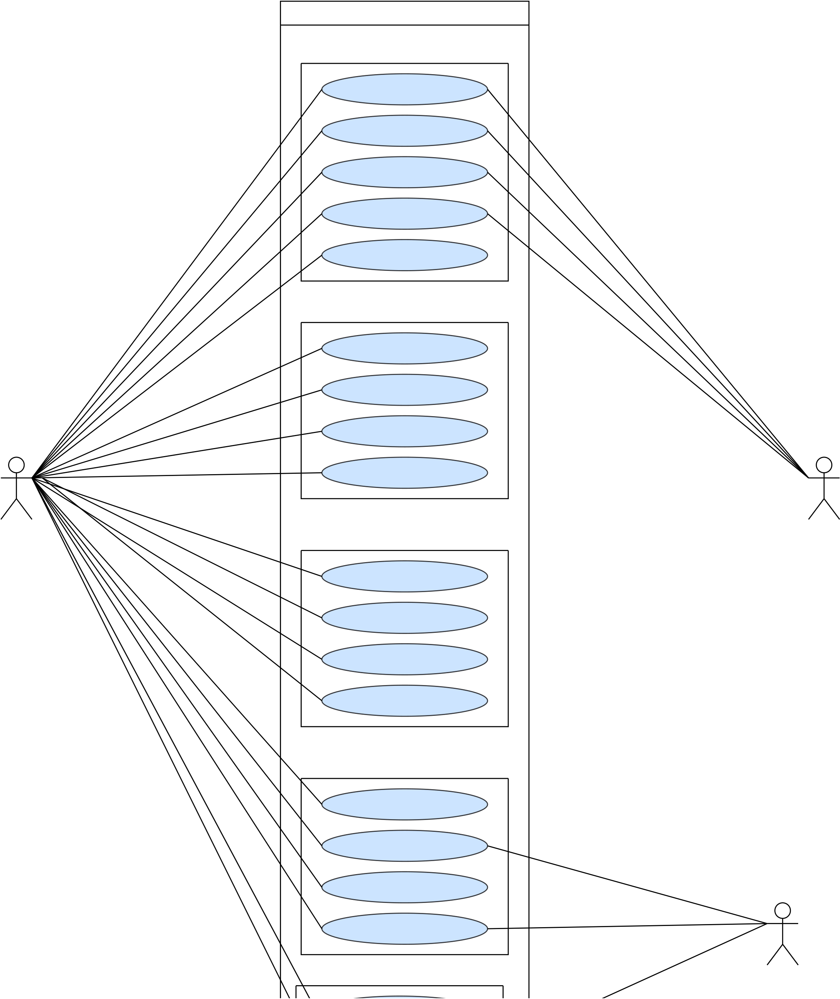
DMS
Security Managemet
Process Sign up
Process Login
Change Password
Forget Password
Manage user rule and
permission
Client Management
Add Client
Search Client
Edit User
View Clients
Admin | Staff Managemet | Clinet
Add Staff
Search Staff
Edit Staff
Assign to project
Project Managemet
Add Project
Search Project
Edit Project
View All Project
Notification System | Client
45

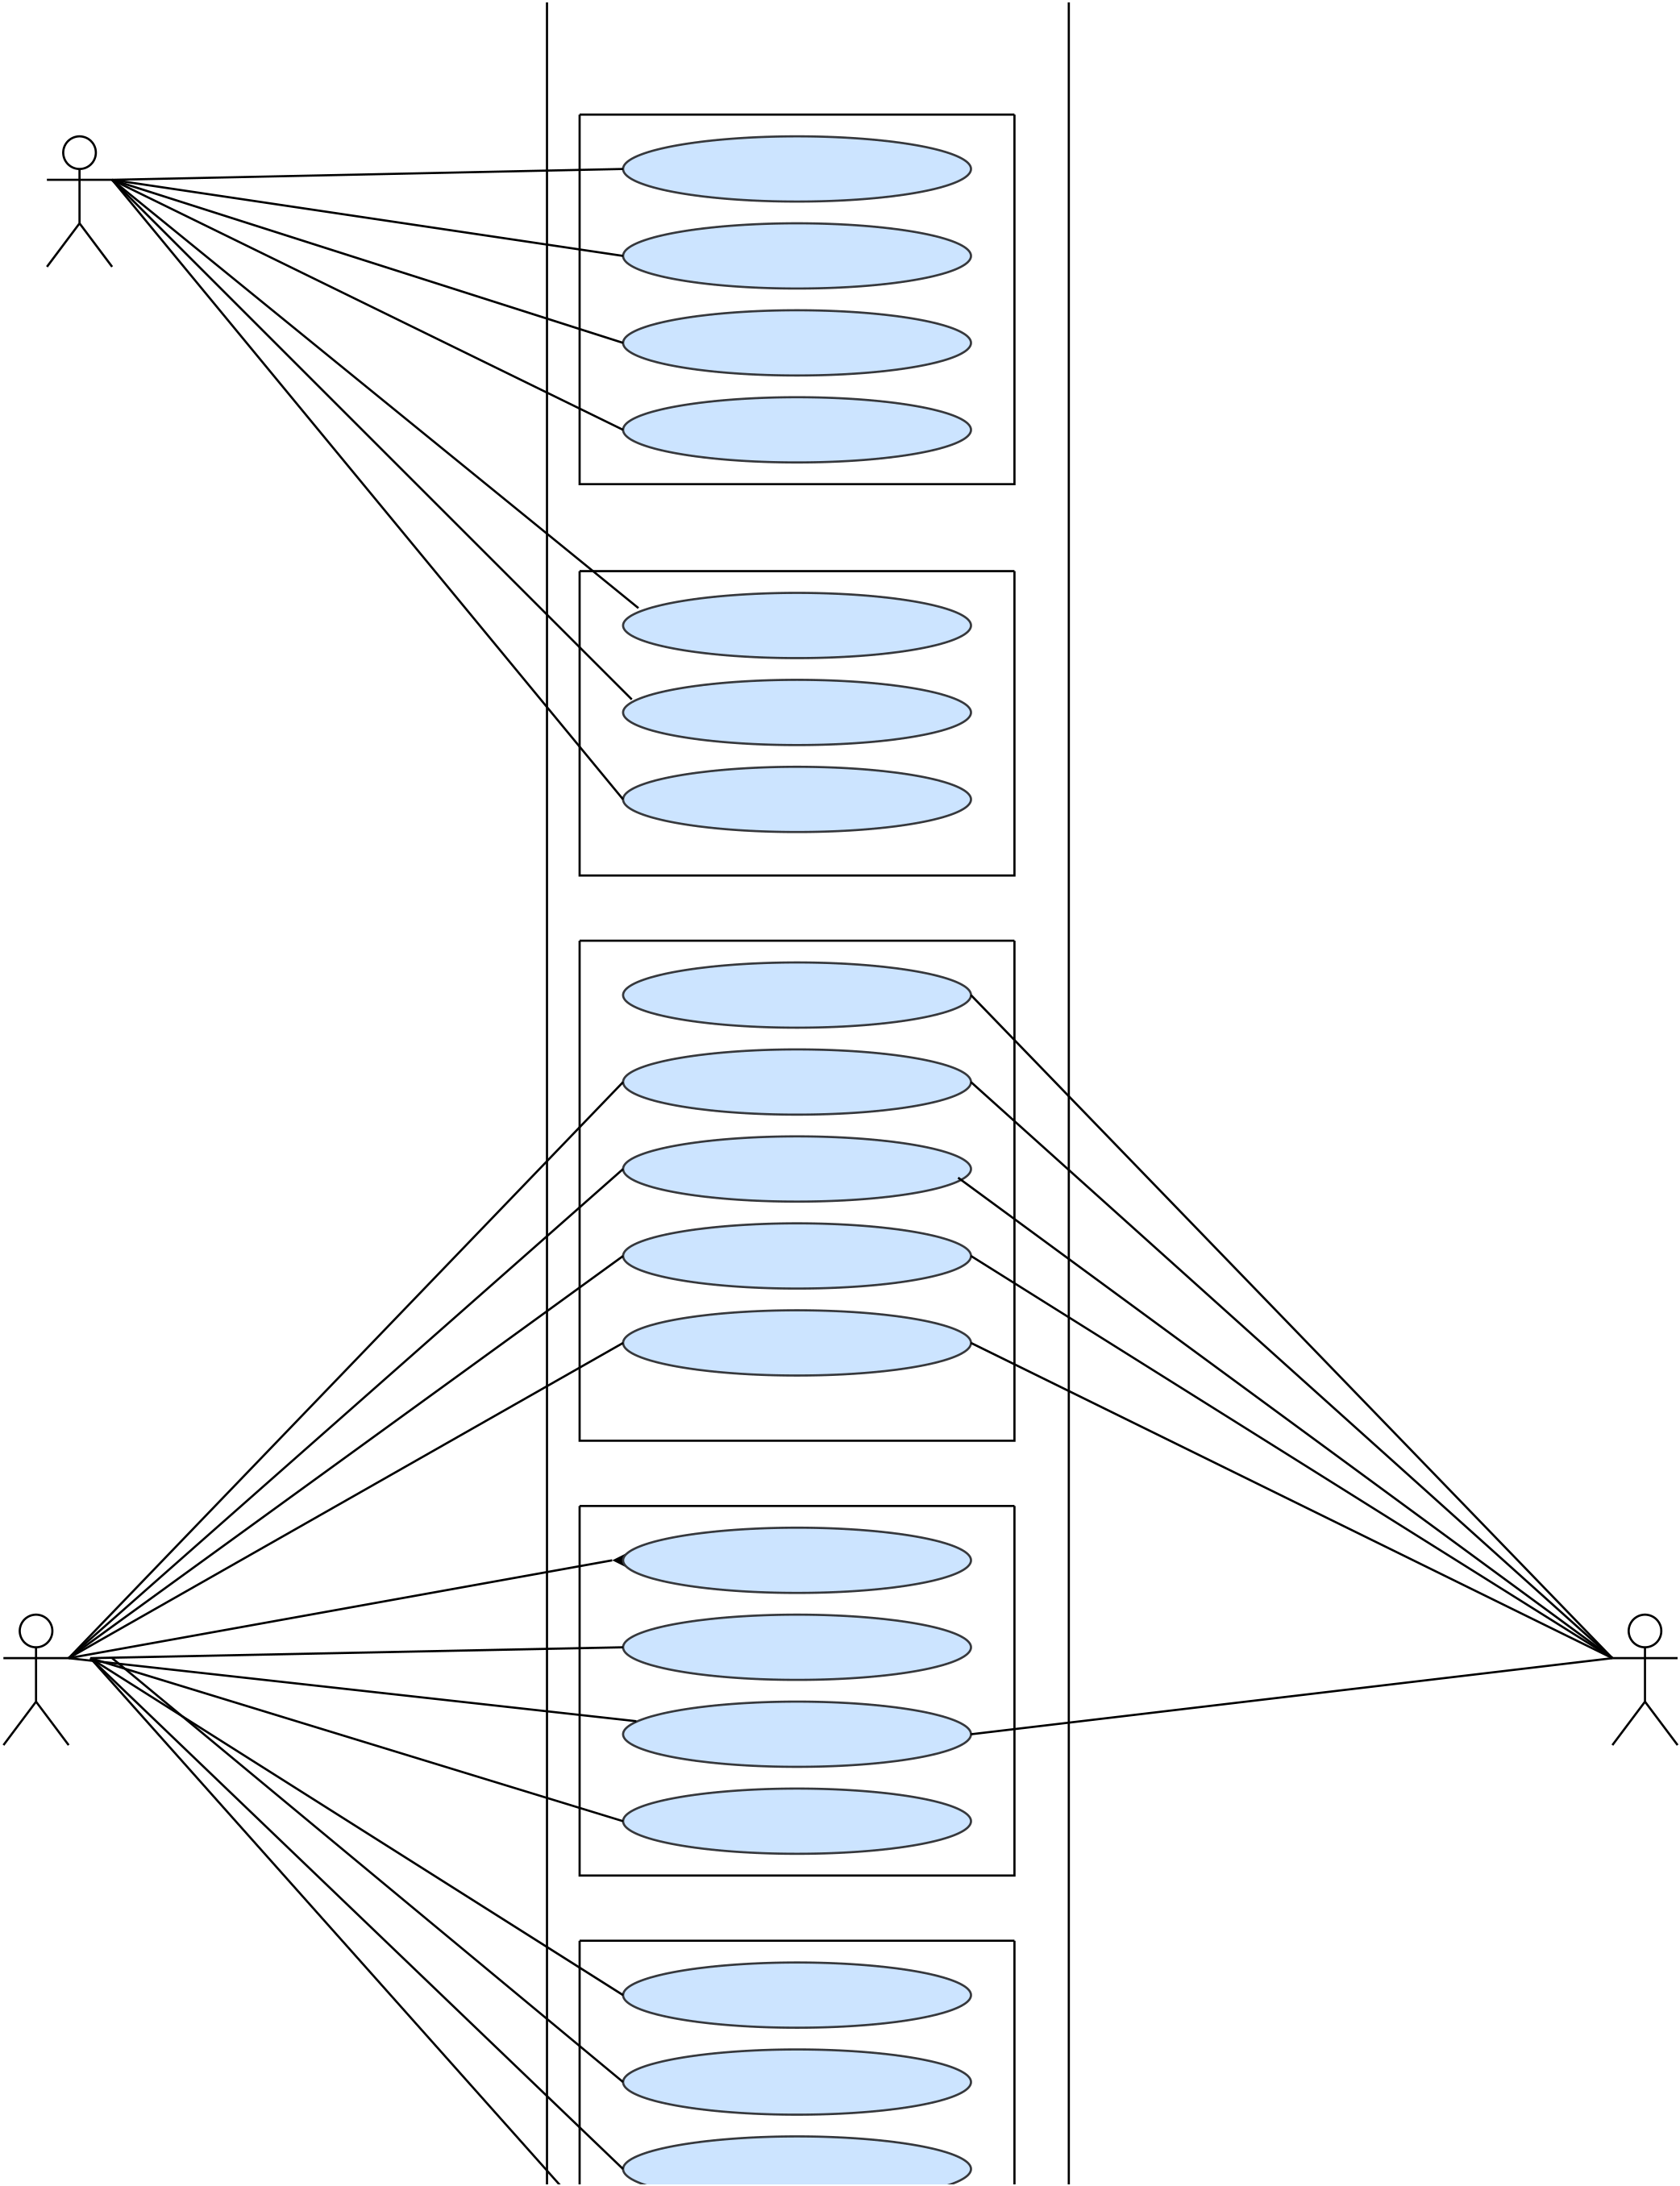
Income Management
Record Income
Edit Income
Admin
Filter Income
View Income Records
System Interfae
Dashboard Overview
Access all modules
Manage user, role &
permission
Booking Management
Add booking
Search booking
View Booking
Cancel booking
Edit Booking
Construction Progress
Add Progress
Edit Progress
View Progress
Admin Client
Upload Media
Expense Management
Add Expense
Search Expense
Update Expense
46

Fully Dressed Use Cases
FOR
Deen Associate Management System
Version 1.0
Proposed By
Muhammad Junaid Riaz
30 Nov, 2025
47

3.2 Fully Dressed Use Cases
48

Use case ID: | UC-01 | Use case Prepared on: | 30-Nov-25
Use case Name: | Sign up | Use case Prepared on: | 30-Nov-25
Use case Prepared by: M junaid Riaz |  | Use case Prepared on: | 30-Nov-25
Use case Description:
This use case describes how a new user registers an account in the system.
Primary Actors: Admin , Clinet
Stake Holders s New User:Wants to create an account to access the system.
Interest:
Pre-Condition: | 1.System must be in running state  2.Use must not be already registered
Main Success Scenario:
User Action |  | System Response
1 | User enters required registration information (name, email, phone, password, role).
 |  | 2 | System validates all fields (email format, password strength, phone format).
3 | 3 User submits form. | 4 | System checks for duplicate email or phone number.
 |  | 5 | System saves user information and generates verification email.
 |  | 6 | System should send varification code to user email and display success message.

Post-Condition: Extension Points / Alternative way: | User account is successfully created and verification email is sent.  1a. Email or phone # already exists  System displays: “Email already registered.”
1b.Invalid email or weak password
System displays: “Enter valid email / strong
password.”
1c. Any required field left blank
System will prompt to “Fill the blank fields”
Id. Email service down
System Dislays :“Varification email could not sent , Try again.”
Priority: High
Frequency: Less Frequently Use
Cross-Reference: SRS1, SRS2, SRS3, SRS4, SRS5
49

Use case ID: | UC-02 | Use case Prepared on: | 30-Nov-25
Use case Name: | login | Use case Prepared on: | 30-Nov-25
Use case Prepared by: M junaid Riaz |  | Use case Prepared on: | 30-Nov-25
Use case Description:
This use case describes how logged-in into the system.
Primary Actors: <Registered User>
Stake Holders s User:Wants to update password Securely
Interest:
Pre-Condition: | 1.User must be logged in  2.System must be operational
Main Success Scenario:
User Action |  | System Response
1 | User enters email and password.
 |  | 2 | System validates credentials.
 |  | 3 | System generates JWT token for authenticated session.
 |  | 4 | System logs timestamp and redirects user to dashboard.

Post-Condition:  Extension Points /  Alternative way: | User is successfully logged into the system and authenticated using JWT.  1a. Incorrect password:  System displays: “Invalid email or password.”
1b.Account not verified:
System displays: “Please verify your account first.”
Priority: High
Frequency: Very High
Cross-Reference: SRS6, SRS7, SRS8, SRS9
50

Use case ID: Use | UC-03 | Use case Prepared on: | 30-Nov-25
case Name: | Change Password | Use case Prepared on: | 30-Nov-25
Use case Prepared by: | M junaid Riaz | Use case Prepared on: | 30-Nov-25
Use case Description:
This use case describes how registered user can changed their password.
Primary Actors: <Registered User>
Stake Holders s User:Wants to update password Securely
Interest:
Pre-Condition: | 1. System must be in running state  2. Use must must be loggin
Main Success Scenario:
User Action |  | System Response
1 | User enters current password and new password.
 |  | 2 | . System validates current password.
 |  | 3 | System checks strength of new password.
4 | User confirms password change.
 |  | 5 | System updates password in database and shows success message.

Post-Condition: Extension Points / Alternative way: | Password is upadte successfully  1a. Wrong current password:  System displays: “Incorrect current password”
1b.Weak New Passsword:
System displays: “Please Enter Strong password (with
some suggestion from system)”
Priority: High
Frequency: Medium
Cross-Reference: SRS10, SRS11, SRS12, SRS13
51

Use case ID: | UC-04 | Use case Prepared on: | 30-Nov-25
Use case Name: | Forget Password | Use case Prepared on: | 30-Nov-25
Use case Prepared by: M junaid Riaz |  | Use case Prepared on: | 30-Nov-25
Use case Description:
This use case describes how to reset their password when they forget it.
Primary Actors: <Registered User>
Stake Holders s User:Wants to recover access to their account securely Interest:
Pre-Condition: | 1.User must have a registered email 2.System must be in running state.
Main Success Scenario:
User Action |  | System Response
1 | User clicks “Forget Password” and enters registered email.
 |  | 2 | System verifies that the email exists in the database.
 |  | 3 | System generates a secure, time-limited reset code/link (valid for 5 minutes).
 |  | 4 | System sends the reset code/link to the user's email.
5 | User enters the received code or opens the reset link.
 |  | 6 | System verifies the code and allows user to set a new password.
7 | User enters new password and submits
 |  | 8 | System validates new password strength and updates password.
 |  | 9 | System sends confirmation email and displays success message.

Post-Condition:  Extension Points /  Alternative way: | User has successfully reset their password and can now log in with the new password.  1a. User enters email not registered:  System displays: “Email not found”
1b.Email server fails to send reset link:
System displays: “Unable to send email , Try again”
3c. User enters wrong reset code:
System displays: “Invalid or expired code
52

Use case ID: | UC-05 | Use case Prepared on: | 01-Dec-25
Use case Name: | Add staff | Use case Prepared on: | 01-Dec-25
Use case Prepared by: M junaid Riaz |  | Use case Prepared on: | 01-Dec-25
Use case Description:
This use case describes how an admin add new staff member into the system.
Primary Actors: <Admin>
Stake Holders s Admin:Wants to add new staff with correct information
Interest:
Pre-Condition: | 1.System must be in running state  2.Admin must be logged in.
Main Success Scenario:
User Action |  | System Response
1 | Admin enters staff details (name, email, phone, designation, skills, department).
 |  | 2 | System validates required fields and formats.
 |  | 3 | System checks for duplicate staff using email/phone number.
 |  | 4 | System assigns unique staff ID and saves staff data.
 |  | 5 | System displays “Staff added successfully.”

Post-Condition:  Extension Points /  Alternative way: | Staff member successfully added into system  1a. Admin leaves any field blank :  System prompts “Fill the blank field.
1b.Admin enters invalid email/phone:
System prompts “Enter valid data.”
3a. Duplicate entry found :
System prompts “Staff already exists.”
Priority: High
Frequency: Medium
53

Use case ID: | UC-06 | Use case Prepared on: | 01-Dec-25
Use case Name: | View Staff | Use case Prepared on: | 01-Dec-25
Use case Prepared by: M junaid Riaz |  | Use case Prepared on: | 01-Dec-25
Use case Description:
This use case describes how an admin can see the list of all staff member.
Primary Actors: <Admin>
Stake Holders s Admin:Wants to view staff detail for management. Interest:
Pre-Condition: | 1.System must be in running state  2.Admin must be logged in.
Main Success Scenario:
User Action |  | System Response
1 | Admin navigates to “View Staff.”
 |  | 2 | System displays staff list with ID, name, designation, phone, and status.
 |  | 3 | Admin selects a staff member to view full profile.
 |  | 4 | System shows detailed staff profile.

Post-Condition: Extension Points / Alternative way:  Priority:  Frequency:  Cross-Reference: | Admin successfully views staff detail. 1a. No staff exists in the system:  System prompts “No staff available”.  High  Medium  SRS41, SRS42, SRS43, SRS44
54

Use case ID: | UC-07 | Use case Prepared on: | 01-Dec-25
Use case Name: | Edit staff | Use case Prepared on: | 01-Dec-25
Use case Prepared by: M junaid Riaz |  | Use case Prepared on: | 01-Dec-25
Use case Description:
This use case describes how an admin updates existing staff detail.
Primary Actors: <Admin>
Stake Holders s Admin:Wants to view staff detail for management.
Interest:
Pre-Condition: | 1.System in running  2.Admin must be logged in.
3.Staff record must exist.
Main Success Scenario:
User Action |  | System Response
1 | Admin selects staff to edit.
 |  | 2 | System loads staff information.
3 | Admin updates fields (contact, designation, skills, dept) |  | .
 |  | 4 | System validates updated information.
 |  | 5 | System saves updated data and shows success message

Post-Condition: Extension Points / Alternative way: | Staff information is updated.  1a. Staff not found:  System prompts “Staff not found”.
3a. Leaves blank:
System prompts “Fill empty black”.
3b. Invalid data format:
System prompts “Enter valid data”.
Priority: High
Frequency: Medium
Cross-Reference: SRS37, SRS38, SRS39, SRS40
55

Use case ID: | UC-08 | Use case Prepared on: | 01-Dec-25
Use case Name: | Search staff | Use case Prepared on: | 01-Dec-25
Use case Prepared by: M junaid Riaz |  | Use case Prepared on: | 01-Dec-25
Use case Description:
This use case describes how an admin search for an specific staff member.
Primary Actors: <Admin>
Stake Holders s Admin:Wants to serach for spefic staff memeber.
Interest:
Pre-Condition: | 1.System in running  2.Admin must be logged in.
Main Success Scenario:
User Action |  | System Response
1 | Admin enters search criteria (name, ID, designation, dept)
 |  | 2 | System verifies search input
 |  | 3 | .System displays matching staff list

Post-Condition: Extension Points / Alternative way: | Admin successfully view search result 1a. No matching staff:  System prompts “No staff found”.
3a. Empty input:
System prompts “Fill empty black”.
3b. Invalid data format:
System “Enter search value”.
Priority: Medium
Frequency: High
Cross-Reference: SRS45, SRS46, SRS47, SRS48
56

Use case ID: | UC-09 | Use case Prepared on: | 01-Dec-25
Use case Name: | Assign Staff to project | Use case Prepared on: | 01-Dec-25
Use case Prepared by: M junaid Riaz |  | Use case Prepared on: | 01-Dec-25
Use case Description:
This use case describes how an admin assign staff to a specific project.
Primary Actors: <Admin>
Stake Holders s Admin:Wants to assgin skilled and available staff.
Interest:
Pre-Condition: | 1.System in running  2.Admin must be logged in.
3.Staff and system must exits.
Main Success Scenario:
User Action |  | System Response
1 | Manager selects project for assignment.
 |  | 2 | System displays available staff based on skills and workload.
3 | Manager selects staff member and assigns to project. |  | .
 |  | 4 | System verifies availability.
 |  | 5 | System updates assignment and shows success message.

Post-Condition: Extension Points / Alternative way: | Staff member successfully assined to the selected project 1a. No available staff:  System prompts “No staff available”.
3a. staff already assigned:
System prompts “staff is already assined”.
3b. Leaves Blank:
System “Fill empty blank”.
Priority: High
Frequency: Medium
Cross-Reference: SRS49, SRS40, SRS51, SRS52,SRS53,SRS54.
57

Use case ID: | UC-10 | Use case Prepared on: | 01-Dec-25
Use case Name: | Add Project | Use case Prepared on: | 01-Dec-25
Use case Prepared by: M junaid Riaz |  | Use case Prepared on: | 01-Dec-25
Use case Description:
This use case describes how an admin add new project in the system.
Primary Actors: <Admin>
Stake Holders s Admin:Wants to create and register new project.
Interest:
Pre-Condition: | 1.System in running  2.Admin must be logged in.
Main Success Scenario:
User Action |  | System Response
1 | User enters project details (name, location, client, budget, start/end date, description).
 |  | 2 | System validates all required fields and checks date logic.
 |  | 3 | .System checks for duplicate project name or location.
 |  | 4 | System saves project and assigns a unique Project ID.
 |  | 5 | System displays “Project added successfully.”

Post-Condition: Extension Points / Alternative way: | A new project is added and stored in the system.  1a. Invalid date (End<start):  System prompts “Enter valid date”.
1b. Leaves Blank:
System “Fill empty blank”.
Priority: High
Frequency: Medium
Cross-Reference: SRS55, SRS56, SRS57, SRS58,SRS59,
58

Use case ID: | UC-11 | Use case Prepared on: | 01-Dec-25
Use case Name: | Edit Project | Use case Prepared on: | 01-Dec-25
Use case Prepared by: M junaid Riaz |  | Use case Prepared on: | 01-Dec-25
Use case Description:
This use case describes how an admin update an existing project.
Primary Actors: <Admin>
Stake Holders s Admin:Wants to updatre existing project..
Interest:
Pre-Condition: | 1.System in running  2.Admin must be logged in.
3.Project must be exists.
Main Success Scenario:
User Action |  | System Response
1 | User selects project to edit.
 |  | 2 | System loads all project details.
 | User updates fields (budget, timeline, description, status, etc.). | 3 | .System checks for duplicate project name or location.
 |  | 4 | System validates updated information.
 |  | 5 | System saves updates and displays success message.

Post-Condition: Extension Points / Alternative way: | Project data successfully updated.  1b. Project not found:  System prompts “Project does not found”.
1b. Invalid date (End<start):
System prompts “Enter valid date”.
1c. Leaves Blank:
System “Fill empty blank”.
Priority: High
Frequency: Medium
Cross-Reference: SRS60, SRS61, SRS62, SRS63
59

Use case ID: | UC-12 | Use case Prepared on: | 01-Dec-25
Use case Name: | View Project | Use case Prepared on: | 01-Dec-25
Use case Prepared by: M junaid Riaz |  | Use case Prepared on: | 01-Dec-25
Use case Description:
This use case describes how an admin see list or detail of Projects..
Primary Actors: <Admin>
Stake Holders s Admin:Wants to see the listing or detail of project. Interest:
Pre-Condition: | 1.System in running  2.Admin must be logged in.
3.Project must be exists.
Main Success Scenario:
User Action |  | System Response
1 | User navigates to “View Projects.”
 |  | 2 | System displays list of all projects with ID, name, location, status, dates, budget
3 | User selects a project to view in detail |  | ..
 |  | 4 | System shows full project details including staff assignments, expenses, timeline, and progress.

Post-Condition:  Extension Points /  Alternative way:  Priority:  Frequency:  Cross-Reference: | Admin successfully see the projects information.  1b. No project exist:  System prompts “No Project to found”.  Medium  High  SRS64, SRS65, SRS66, SRS67
60

Use case ID: | UC-13 | Use case Prepared on: | 01-Dec-25
Use case Name: | Search Project | Use case Prepared on: | 01-Dec-25
Use case Prepared by: M junaid Riaz |  | Use case Prepared on: | 01-Dec-25
Use case Description:
This use case describes how an admin search for specific proejct.
Primary Actors: <Admin>
Stake Holders s Admin:Wants to search for projects.
Interest:
Pre-Condition: | 3.System in running  4.Admin must be logged in.
Main Success Scenario:
User Action |  | System Response
1 | User enters search criteria (project ID, name, client, location, status).
 |  | 2 | System validates search input
 |  | 3 | System displays matching project list

Post-Condition: Extension Points / Alternative way:  Priority:  Frequency:  Cross-Reference: | Admin successfully search and flitered projects.  1b. No project matches Record:  System prompts “No Project found”.  Medium  High  SRS68, SRS69, SRS70, SRS71
61

Use case ID: | UC-14 | Use case Prepared on: | 01-Dec-25
Use case Name: | Add client | Use case Prepared on: | 01-Dec-25
Use case Prepared by: M junaid Riaz |  | Use case Prepared on: | 01-Dec-25
Use case Description:
This use case describes how an admin can add the new client into the system.
Primary Actors: <Admin>
Stake Holders s Admin:Wants to store complete and accurate information of new client. Interest:
Pre-Condition: | 5.System in running  6.Admin must be logged in.
Main Success Scenario:
User Action |  | System Response
1 | User enters client details (name, contact  person, phone, email, address, registration no., payment terms).
 |  | 2 | System validates all fields (email format, phone number).
 |  | 3 | System checks for duplicate client by email, phone, or registration number
 |  | 4 | System creates a unique Client ID and saves the client record
 |  | 5 | System shows “Client added successfully.”

Post-Condition: Extension Points / Alternative way:  Priority:  Frequency:  Cross-Reference: | A new client is successfully registered in the system.  1b. Left blacks:  System prompts “Fill the black field”.  High  Medium  SRS72, SRS73, SRS74, SRS75,SRS76
62

Use case ID: | UC-15 | Use case Prepared on: | 01-Dec-25
Use case Name: | Edit client | Use case Prepared on: | 01-Dec-25
Use case Prepared by: M junaid Riaz |  | Use case Prepared on: | 01-Dec-25
Use case Description:
This use case describes how an admin can update existing client in the system.
Primary Actors: <Admin>
Stake Holders s Admin:Wants to updates information of an existing client.
Interest:
Pre-Condition: | 1System in running  2Admin must be logged in.
3Client must be exists.
Main Success Scenario:
User Action |  | System Response
1 | User selects a client to edit.
 |  | 2 | System loads all existing client details
 |  | 3 | User modifies fields (email, contact person, phone, address, payment terms)
 |  | 4 | System validates updated data.
 |  | 5 | System saves updated client details and shows success message

Post-Condition:  Extension Points /  Alternative way: | Client information successfully updated.  1a. Left blacks:  System prompts “Fill the black field”.
1b. Invalid data:
System prompts “Enter valid data”.
Priority: High
Frequency: Medium
Cross-Reference: SRS77, SRS78, SRS79, SRS80
63

Use case ID: | UC-16 | Use case Prepared on: | 01-Dec-25
Use case Name: | View client | Use case Prepared on: | 01-Dec-25
Use case Prepared by: M junaid Riaz |  | Use case Prepared on: | 01-Dec-25
Use case Description:
This use case describes how an admin view list of client or profile of client.
Primary Actors: <Admin>
Stake Holders s Admin:Wants to updates information of an existing client. Interest:
Pre-Condition:
1 Admin must be logged in.
2 At least one client must be exists.
Main Success Scenario:
User Action |  | System Response
1 | User opens the “View Clients” page.
 |  | 2 | System displays a list of all clients with ID, name, email, phone, address, and status
3 | User selects a client to view details.
 |  | 4 | System shows full client profile including:  associated projects, booking history, status, and financial records

Post-Condition: Extension Points / Alternative way:  Priority:  Frequency:  Cross-Reference: | User successfully view client information.  1a. No client availabe:  System prompts “No client found”.  Medium  High  SRS81, SRS82, SRS83, SRS84
64

Use case ID: | UC-17 | Use case Prepared on: | 01-Dec-25
Use case Name: | Search client | Use case Prepared on: | 01-Dec-25
Use case Prepared by: M junaid Riaz |  | Use case Prepared on: | 01-Dec-25
Use case Description:
This use case describes how an admin search for a client using differnet filters.
Primary Actors: <Admin>
Stake Holders s Admin:Wants to Search specific client.
Interest:
Pre-Condition:
1.System must be running
2.Admin must be logged in.
Main Success Scenario:
User Action |  | System Response
1 | User enters search criteria (name, ID, email, phone, company).
 |  | 2 | System validates search input.
 |  | 3 | System returns matching clients in list format.

Post-Condition: Extension Points / Alternative way:  Priority:  Frequency:  Cross-Reference: | User view filtered list of client.  1a. Empty searc field:  System prompts “Enter search value”.  Medium  High  SRS85, SRS86, SRS87, SRS88
65

Use case ID: | UC-18 | Use case Prepared on: | 01-Dec-25
Use case Name: | Add Booking Request | Use case Prepared on: | 01-Dec-25
Use case Prepared by: M junaid Riaz |  | Use case Prepared on: | 01-Dec-25
Use case Description:
This use case describes how clients can add their request for booking..
Primary Actors: <Client>
Stake Holders s Admin:Wants to Search specific client.
Interest:
Pre-Condition:
1.System must be running
2.Admin must be logged in.
Main Success Scenario:
User Action |  | System Response
1 | Client selects a project and unit.
2 | Client fills booking request form.
 |  | 3 | System validates the form fields
 |  | 4 | System saves booking with status: Pending Approval.
 |  | 5 | System notifies Admin of the new booking request.
6 | Client see “booking request successfully submitted”.
Post-Condition: Bookig request is saved in system with pending status and admin will look on this.
Extension Points / 1a. Unit already booked:
Alternative way: System prompts “This unit is not available”.
1b. Client leaves required field empty:
System prompts “Please fill required field ”.
3a. Invalid data in form:
System display “Please Enter valid data”.
Priority: High
66

Use case ID: | UC-19 | Use case Prepared on: | 01-Dec-25
Use case Name: | Approved / Reject Booking | Use case Prepared on: | 01-Dec-25
Use case Prepared by: M junaid Riaz |  | Use case Prepared on: | 01-Dec-25
Use case Description:
This use case describes how admin reject ot accept ruquest of clinet and system notify user with booking status.
Primary Actors: Stake Holders s Interest: | <Admin>  Admin:Wants to verify booking detail before approval and avabality of unit.  Client: Want to cheack status of request .
Pre-Condition:
1.System must be running
2.Admin must be logged in.
3.Booking ruquest exists in “Pending” Status.
Main Success Scenario:
User Action |  | System Response
1 | Admin opens Pending Booking Requests.
2 | Admin selects a booking to review.
 |  | 3 | System displays full booking details.
4 | Admin chooses Approve/Reject.
 |  | 5 | System updates status to Approved or Rejected.
 |  | 6 | System sends notification to client.
 |  | 7 | Admin sees success confirmation.
Post-Condition: Booking status approved or rejected and client get notified.
Extension Points / 1a. Admin deos not select status:
Alternative way: System shows “Kindly select status for
request”.
1b. booking already processed:
System prompts “ This booking already
approved or rejected”.
67

Cross-Reference: | SRS100, SRS101, SRS102, SRS103 | Use case Prepared on: | 01-Dec-25
Use case ID: | UC-20 | Use case Prepared on: | 01-Dec-25
Use case Name: | Search Booking | Use case Prepared on: | 01-Dec-25
Use case Prepared by: M junaid Riaz |  | Use case Prepared on: | 01-Dec-25
Use case Description:
Admin searches booking using filters.
Primary Actors: Stake Holders s Interest: | <Admin>  Admin:Wants to verify booking detail before approval and avabality of unit.  Client: Want to cheack status of request .
Pre-Condition:
1.Admin logged in
Main Success Scenario:
User Action |  | System Response
1 | Admin enters search criteria (Booking ID, Client, Project, Status, Date Range).
 |  | 2 | System fetches and displays matched booking records.
Post-Condition: Search result successfully displayed
Extension Points / 1a. No matchching filter found:
Alternative way: System shows “NO result found”.
Priority: Medium
Frequency: Frequently used
Cross-Reference: SRS97, SR98,SRS99
68

Use case ID: | UC-21 | Use case Prepared on: | 02-Dec-25
Use case Name: | Edit booking | Use case Prepared on: | 02-Dec-25
Use case Prepared by: M junaid Riaz |  | Use case Prepared on: | 02-Dec-25
Use case Description:
Admin updates booking detial like dates , recourses or make some correction
Primary Actors: Stake Holders s Interest: | <Admin>  Admin:Wants to modify or correct booking details.  Client: Want to cheack status of request .
Pre-Condition:
1.Admin must be logged in.
2.Booking must be exists.
Main Success Scenario:
User Action |  | System Response
1 | Admin selects a booking to edit.
 |  | 2 | System displays editable booking form
3 | Admin updates fields.
4 | System validates updates.
 |  | 5 | System saves new booking details.
6 | System shows success message.
Post-Condition: Bookig detail updates successfully.
Extension Points / 3a. Invalid data entered:
Alternative way: System prompts “Enter valid dataf”.
4a. Recourse Unavailable:
System prompts “selected recourse is not
avalable”.
1a.Booking cancel:
System display “Please Enter valid data”.
69

Use case ID: | UC-22 | Use case Prepared on: | 02-Dec-25
Use case Name: | Cancel booking | Use case Prepared on: | 02-Dec-25
Use case Prepared by: M junaid Riaz |  | Use case Prepared on: | 02-Dec-25
Use case Description:
Admin updates booking detial like dates , recourses or make some correction
Primary Actors: Stake Holders s Interest: | <Admin> <Client>  Admin:Can cancel booking with respect to some policies or on client request. Client: Get notified on cancelling .
Pre-Condition:
1.Admin must be logged in.
2.Booking must be exists.
3.Booking msut not be already cancelled.
Main Success Scenario:
User Action |  | System Response
1 | Admin selects a booking to cancel.
 |  | 2 | 2. System shows booking details.
3 | Admin clicks Cancel Booking.
 |  | 4 | System updates booking to “Cancelled”.
 |  | 5 | System sends cancellation email to client.
6 | System displays success message
Post-Condition: Booking is cancelled.
Extension Points / 1a. Booking already Cancelled.
Alternative way: System prompts “Booking is already
cancelled”.
4a. Admin does not provide cancellation
reason:
System prompts “Provide cacellation reason”.
70

Use case ID: | UC-23 | Use case Prepared on: | 03-Dec-25
Use case Name: | Add Contruction progress | Use case Prepared on: | 03-Dec-25
Use case Prepared by: M junaid Riaz |  | Use case Prepared on: | 03-Dec-25
Use case Description:
This use case discribe how admin can upload progress of projects including discrition , task completed, issues or next plan
Primary Actors: Stake Holders s Interest: | <Admin>  Admin: Wants to upadte real time construction progress .  Wants to doucment work completed and next steps.
Pre-Condition:
1.Admin must be logged in.
2.Project must be exist in the system.
Main Success Scenario:
User Action |  | System Response
1 | User selects a project and opens Add Progress page.
 |  | 2 | System displays progress entry form.
3 | User enters progress percentage, description, work done, next steps.
 |  | 4 | System validates all inputs.
 |  | 5 | System saves progress entry and timestamps it.
6 | System shows success confirmation.
Post-Condition: A new construction progress entry is recorded and linked to the project.
Extension Points / 3a. Progress percentage exceeds limits (e.g., Alternative way: >100%).
System prompts “Progress must be between 0 -
100%”.
4a. Required field empty:
System prompts “Please fill all required
fields”.
71

Use case ID: | UC-24 | Use case Prepared on: | 03-Dec-25
Use case Name: | Edit Contruction progress | Use case Prepared on: | 03-Dec-25
Use case Prepared by: M junaid Riaz |  | Use case Prepared on: | 03-Dec-25
Use case Description:
User updates previously entered progress details such as percentage, status, description, challenges, or next steps.
Primary Actors: <Admin>
Stake Holders s Admin: Wants updated and accurate project information .
Interest:
Pre-Condition:
1.Admin must be logged in.
2.Project entry must exist.
Main Success Scenario:
User Action |  | System Response
1 | User selects a progress entry to edit.
 |  | 2 | System displays current progress details.
3 | User updates progress information.
 |  | 4 | System validates updated data.
 |  | 5 | System saves updated progress information.
6 | System shows success message.
Post-Condition: Progress entry is updated and previous version is stored in history.
Extension Points / 3a. Invalid progress value.
Alternative way: System prompts “Progress must be between 0 -100%”.
2a. Progress entry not found:
System prompts “Progress record dose not
exist”.
Priority: Medium
72

Use case ID: | UC-25 | Use case Prepared on: | 03-Dec-25
Use case Name: | View Contruction progress | Use case Prepared on: | 03-Dec-25
Use case Prepared by: M junaid Riaz |  | Use case Prepared on: | 03-Dec-25
Use case Description:
This use case describes how users view the construction progress of any project along with percentage, timeline,
and past updates.
Primary Actors: Stake Holders s Interest: | <Admin> <client>  Admin: Wants to oversee overall project development .  Client: Want transperacy about development status.
Pre-Condition:
1.Admin must be logged in.
2.Project must exist with progress entries.
Main Success Scenario:
User Action |  | System Response
1 | User opens project progress section.
 |  | 2 | System displays list of progress entries sorted by date.
3 | User selects any progress entry
 |  | 4 | System shows detailed progress including percentage, notes, media, timeline.
Post-Condition: Admin and client successfully views progress..
Extension Points / 1a. No progress recorded.
Alternative way: System prompts “No progress update for this
project”.
Priority: Medium
Frequency: Frequent
Cross-Reference: SRS116, SRS117, SRS118, SRS119
73

Use case ID: | UC-26 | Use case Prepared on: | 03-Dec-25
Use case Name: | Upload progress media | Use case Prepared on: | 03-Dec-25
Use case Prepared by: M junaid Riaz |  | Use case Prepared on: | 03-Dec-25
Use case Description:
User uploads construction-related images or videos for any progress update.
Primary Actors: Stake Holders s Interest: | <Admin>  Admin: Wants visual verification and trnsparacy . Client: Wants to see real progress visually.
Pre-Condition:
1.Admin must be logged in.
2.Project must exist with progress entries.
Main Success Scenario:
User Action |  | System Response
1 | User opens Upload Media option.
 |  | 2 | System shows upload interface.
3 | User selects images/videos.
 |  | 4 | System validates file type & size.
 |  | 5 | System uploads and attaches media to progress entry.
5 | System shows success message.
Post-Condition: Media is uploaded and linked with progress entry.
Extension Points / 4a. Invalid file format.
Alternative way: System prompts “Invalid file type. Allowed types: JPG, PNG, MP4”.
4b. File size to large.
System prompts “Maximum file size is
50MB”.
Priority: Medium
74

Use case ID: | UC-27 | Use case Prepared on: | 04-Dec-25
Use case Name: | Send Notification | Use case Prepared on: | 04-Dec-25
Use case Prepared by: M junaid Riaz |  | Use case Prepared on: | 04-Dec-25
Use case Description:
This use case describes how an Admin or Project Manager sends notifications to users regarding project updates,
reminders, or system alerts.
Primary Actors: Stake Holders s Interest: | <Admin>  Admin: Wants to quickly notify users about important updates. Client: Wants timely notifications about bookings, progress, updates.
Pre-Condition:
1.Admin must be logged in.
2.Recipient must be exist in system..
Main Success Scenario:
User Action |  | System Response
1 | User selects notification type & recipients
 |  | 2 | System displays notification form.
3 | User enters message content & clicks send.
 |  | 4 | System validates message and recipients.
 |  | 5 | System delivers notification via email/SMS/in-app (if configured).
5 | System shows “Notification Sent Successfully.”
Post-Condition: Notification is stored in the notification log.
Extension Points / 3a. Message field empty.
Alternative way: System prompts “Messge can not be empty”.
2a. No recipientes selected.
System prompts “Please select atleast one
recipient”.
Priority: High
Frequency: Frequent
75

Use case ID: | UC-28 | Use case Prepared on: | 04-Dec-25
Use case Name: | View Notification | Use case Prepared on: | 04-Dec-25
Use case Prepared by: M junaid Riaz |  | Use case Prepared on: | 04-Dec-25
Use case Description:
Users view all notifications received including updates, reminders, and announcements.
Primary Actors: Stake Holders s Interest: | <Admin>  Admin: Want to send and moniter all notification Client: Want to stay updated on project progress.
Pre-Condition:
1.Admin and client must be logged in.
Main Success Scenario:
User Action |  | System Response
1 | Admin open notification center or menu
 |  | 2 | System displays list of notification sorted by date.
3 | User Click on notification Center.
 |  | 4 | System show full detail of notification.
Post-Condition: Notification status change to read..
Extension Points / 1a. No notification available.
Alternative way: System prompts “No new notification”.
Priority: Medium
Frequency: High
Cross-Reference: SRS130, SRS131, SRS132, SRS133,
76

Use case ID: | UC-29 | Use case Prepared on: | 04-Dec-25
Use case Name: | Add Expense | Use case Prepared on: | 04-Dec-25
Use case Prepared by: M junaid Riaz |  | Use case Prepared on: | 04-Dec-25
Use case Description:
UThis use case discribe how admin add record of new expense including ammout, date , project and ammout.
Primary Actors: Stake Holders s Interest: | <Admin>  Admin: Want to track all company and proejct expense. Financail Team: Wants accurate financail data.
Pre-Condition:
1.Admin must be logged in.
Main Success Scenario:
User Action |  | System Response
1 | User opens “Add Expense” page.
 |  | 2 | System displays the expense form.
3 | User enters all details and uploads supporting documents.
 |  | 4 | System validates all required fields and file size/type.
 |  | 6 | System assigns a unique Expense ID and stores data.
 |  | 7 | System shows success message “Expense Added Successfully.”
Post-Condition: A new expense record is saved in the system
Extension Points / 3a. Missing required field.
Alternative way: System prompts “Please fill required field”.
3b. Invalid ammout.
System prompts “Please enter positive
ammount”.
Priority: High
Frequency: very frequent
Cross-Reference: SRS139, SRS140, SRS141, SRS142, SRS143
77

Use case ID: | UC-30 | Use case Prepared on: | 04-Dec-25
Use case Name: | edit Expense | Use case Prepared on: | 04-Dec-25
Use case Prepared by: M junaid Riaz |  | Use case Prepared on: | 04-Dec-25
Use case Description:
This use case discribe how admin can edit an existing expense entry.
Primary Actors: <Admin>
Stake Holders s Admin: Want to correct expense mistake.
Interest:
Pre-Condition:
1.Admin must be logged in.
2.Expense record must be exits.
Main Success Scenario:
User Action |  | System Response
1 | User searches and selects an expense to edit.
 |  | 2 | System displays current expense details.
3 | User updates fields and clicks “Save.”
 |  | 4 | System validates new values.
 |  | 5 | System stores updated expense and logs modification history.
 |  | 6 | System displays success message.
Post-Condition: Expense record update successfully.
Extension Points / 1a. Expense not found.
Alternative way: System prompts “Expense not found”.
3a. Invalid ammout.
System prompts “Please enter positive
ammount”.
Priority: High
Frequency: very frequent
Cross-Reference: SRS144, SRS145, SRS146, SRS147, SRS148
78

Use case ID: | UC-31 | Use case Prepared on: | 04-Dec-25
Use case Name: | Delete Expense | Use case Prepared on: | 04-Dec-25
Use case Prepared by: M junaid Riaz |  | Use case Prepared on: | 04-Dec-25
Use case Description: This use case discribe how admin can delete an existing expense entry.
Primary Actors: <Admin>
Stake Holders s Admin: Want to remove incorrct expense.
Interest:
Pre-Condition:
1.Admin must be logged in.
2.Expense record must be exits.
Main Success Scenario:
User Action |  | System Response
1 | User clicks “Delete Expense.”
 |  | 2 | System asks for confirmation.
3 | User confirms deletion.
 |  | 4 | System performs soft delete and moves record to archive.
 |  | 5 | System sends notification to project manager.
 |  | 6 | System shows success message.
Post-Condition: Expense marked as deleted and stored in archive.
Extension Points / 1a. Expense not found.
Alternative way: System prompts “Expense not found”.
.
Priority: Medium
Frequency: Less frequent
Cross-Reference: SRS149, SRS150, SRS151, SRS152
79

Use case ID: | UC-32 | Use case Prepared on: | 04-Dec-25
Use case Name: | View Expense | Use case Prepared on: | 04-Dec-25
Use case Prepared by: M junaid Riaz |  | Use case Prepared on: | 04-Dec-25
Use case Description: This use case describes how users view all expenses with filtering, sorting,
and detailed viewing.
Primary Actors: <Admin>
Stake Holders s Admin: Want to moniter overall expense.
Interest:
Pre-Condition:
1.Admin must be logged in.
Main Success Scenario:
User Action |  | System Response
1 | User opens “Expenses List.”
 |  | 2 | System displays expense table with pagination.
3 | User applies filters (type, date, project, amount).
 |  | 4 | System updates table based on filters.
 |  | 5 | System sends notification to project manager.
 |  | 6 | System shows success message.
Post-Condition: User views expense data successfully.
Extension Points / 1a. Expense not found.
Alternative way: System prompts “ No Expense records
found”.
.
80

Use case ID: | UC-33 | Use case Prepared on: | 04-Dec-25
Use case Name: | Profit & loss report | Use case Prepared on: | 04-Dec-25
Use case Prepared by: M junaid Riaz |  | Use case Prepared on: | 04-Dec-25
Use case Description: This use case describes how the system generates project-wise or date-range
P&L reports.
Primary Actors: <Admin>
Stake Holders s Admin:Wants insight into financial performance
Interest:
Pre-Condition:
1.Admin must be logged in.
2.Expense record data must be exist.
Main Success Scenario:
User Action |  | System Response
1 | User opens P&L Report.
 |  | 2 | System displays filter options (date range, project).
3 | User selects filters and clicks “Generate.”
 |  | 4 | System calculates total revenue and expenses.
 |  | 5 | System shows detailed P&L in charts + tables.
6 | User exports report.
 |  | 7 | System downloads PDF/Excel file.
Post-Condition: System downloads PDF/Excel file.
Extension Points / 1a. No financial data exists.
Alternative way: System prompts “ No financial data available
for selected period.”.
.
Priority: High
81

Use case ID: | UC-34 | Use case Prepared on: | 04-Dec-25
Use case Name: | Record Income | Use case Prepared on: | 04-Dec-25
Use case Prepared by: M junaid Riaz |  | Use case Prepared on: | 04-Dec-25
Use case Description: This use case describes how a user records a new income entry including
amount, type, project/client details, and payment method.
Primary Actors:  Stake Holders s Interest: | <Admin>  Admin: Wants to complete record of all income sources.  Finance Team: Wants accurate revenue records for reporting and reconciliation.
Pre-Condition:
1.Admin must be logged in.
Main Success Scenario:
User Action |  | System Response
1 | User opens the “Record Income” page.
 |  | 2 | System loads income entry form.
3 | User enters all details (type, amount, date, project/client, payment method).
 |  | 4 | System validates all fields.
5 | User clicks “Submit.”
 |  | 6 | System assigns unique income ID and stores data.
 |  | 7 | System shows success message “Income Recorded Successfully.”
Post-Condition: A new income entry is added to the system.
Extension Points / 3a. Missing mandatory field.
Alternative way: System prompts “ Please fill required field”.
3b. Invalid ammount.
System prompts “ Amount must be greater
than 0”.
Priority: High
82

Use case ID: | UC-35 | Use case Prepared on: | 04-Dec-25
Use case Name: | Edit Income | Use case Prepared on: | 04-Dec-25
Use case Prepared by: M junaid Riaz |  | Use case Prepared on: | 04-Dec-25
Use case Description: This use case describes how a user modifies an existing income entry and updates relevant fields.
Primary Actors:  Stake Holders s Interest: | <Admin>  Admin: Wants to correct income errors  Finance Team: Needs accurate revenue details.
Pre-Condition:
1.Admin must be logged in.
2.Income record must be exist already.
Main Success Scenario:
User Action |  | System Response
1 | User opens income list and selects an income to edit.
 |  | 2 | System displays existing income details.
3 | User updates required fields.
 |  | 4 | System validates updated information.
5 | User clicks “Save Changes.”
 |  | 6 | . System updates entry and logs modification history.
 |  | 7 | System shows success message.
Post-Condition: A new income entry is added to the system.
Extension Points / 3a. Invalid updated amount.
Alternative way: System prompts “ Amount must be greater than 0”.
Priority: Medium
Frequency: Moderate
Cross-Reference: SRS168, SRS169, SRS170, SRS171
83

Use case ID: | UC-36 | Use case Prepared on: | 04-Dec-25
Use case Name: | View Income Record | Use case Prepared on: | 04-Dec-25
Use case Prepared by: M junaid Riaz |  | Use case Prepared on: | 04-Dec-25
Use case Description: This use case describes how users view income records in a tabular, paginated
interface.
Primary Actors: <Admin>
Stake Holders s Admin: Wants to review income records.
Interest:
Pre-Condition:
1.Admin must be logged in.
2.Income record must be exist already.
Main Success Scenario:
User Action |  | System Response
1 | User opens the “Income Records” page.
 |  | 2 | System displays income table with pagination.
3 | User clicks an income record to view details.
 |  | 4 | System displays detailed income  information including payment status.
Post-Condition: User successfully views income details.
Extension Points / 1a. No record found.
Alternative way: System prompts “ No record available”.
Priority: Medium
Frequency: Frequent
Cross-Reference: SRS172, SRS173, SRS174
84

Use case ID: | UC-37 | Use case Prepared on: | 04-Dec-25
Use case Name: | Filter Income | Use case Prepared on: | 04-Dec-25
Use case Prepared by: M junaid Riaz |  | Use case Prepared on: | 04-Dec-25
Use case Description: This use case describes how users apply filters to income records to find specific
results.
Primary Actors: <Admin>
Stake Holders s Admin: Need customized filter data.
Interest:
Pre-Condition:
1.Admin must be logged in.
2.Income data must be exist .
Main Success Scenario:
User Action |  | System Response
1 | User opens income filter panel.
2 | User selects filters (date, project, client, income type, amount range). |  | .
 |  | 3 | System processes selected filters.
 |  | 4 | System displays filtered records and summary totals.
5 | User optionally saves filter configuration.
 |  | 6 | System saves filter for quick future use.
Post-Condition: Filtred income list amd summarized displayed.
Extension Points / 1a. No Matching record.
Alternative way: System prompts “ No record found”.
Priority: Medium
Frequency: Frequent
Cross-Reference: SRS175, SRS176, SRS177, SrS178
85

Use case ID: | UC-38 | Use case Prepared on: | 04-Dec-25
Use case Name: | Income Summary | Use case Prepared on: | 04-Dec-25
Use case Prepared by: M junaid Riaz |  | Use case Prepared on: | 04-Dec-25
Use case Description: This use case describes how users generate summary income reports for selected
date ranges.
Primary Actors: <Admin>
Stake Holders s Admin: Wants Performance summaruies.
Interest:
Pre-Condition:
1.Admin must be logged in.
2.Income record must be exist .
Main Success Scenario:
User Action |  | System Response
1 | User opens “Income Summary Report.”
 |  | 2 | .System displays report filter options.
3 | . User selects date range or project/client.
 |  | 4 | System calculates total received, pending, breakdowns, etc.
5 | User exports report.
 |  | 6 | System downloads PDF/Excel version.
Post-Condition: Summary report generated and optionally exported.
Extension Points / 1a. No Income data available.
Alternative way: System prompts “ No record found”.
Priority: High
86

Use case ID: | UC-39 | Use case Prepared on: | 11-Dec-25
Use case Name: | Manage user role & | Use case Prepared on: | 11-Dec-25
permission |  | Use case Prepared on: | 11-Dec-25
Use case Prepared by: M junaid Riaz |  | Use case Prepared on: | 11-Dec-25
Use case Description: This use case describes how an admin can assign or update the role or
permission.
Primary Actors: Stake Holders s Interest: | <Admin>  Admin: Wants to control and manage system access.  User: Should only access allowed access modules.
Pre-Condition:
1.Admin must be logged in.
2.Client or user record must be exist. .
Main Success Scenario:
User Action |  | System Response
1 | Admin opens “User Roles & Permissions” page.
 |  | 2 | System displays list of users with current roles.
3 | . Admin selects a user to modify
 |  | 4 | System loads user profile and editable role options
5 | Admin assigns a new role or updates permissions.
 |  | 6 | System validates role selection.
7 | Admin clicks “Save”.
 |  | 8 | System updates role/permissions and logs changes.
 |  | 9 | System shows “Role updated successfully.
87

Extension Points / 3a. user not found.
Alternative way: System prompts “ User record does not exits”.
Priority: High
Frequency: Moderate
Cross-Reference: SRS10, SRS11, SRS13,
88

89

Design Phase
FOR
Deen Associate Management System
Version 1.0
Prepared By
Muhammad Junaid Riaz
30 Nov, 2025
90

3.3 Domain Model
91

3.3 Domain Model
UML domain model (Larman): conceptual classes with key attributes, associations with multiplicity and names. No operations or navigability arrows.
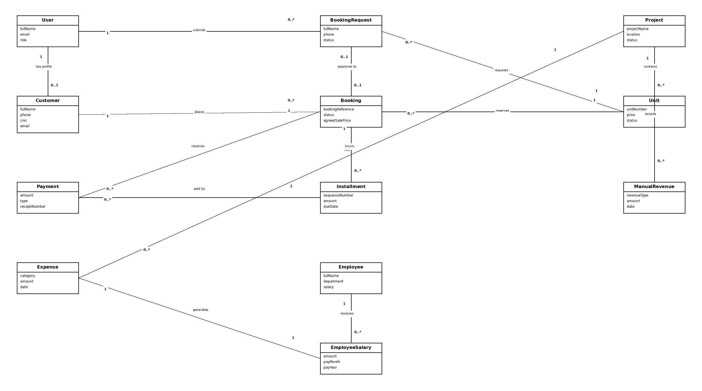
92

3.4 Package Diagram
93

3.4 Package Diagram
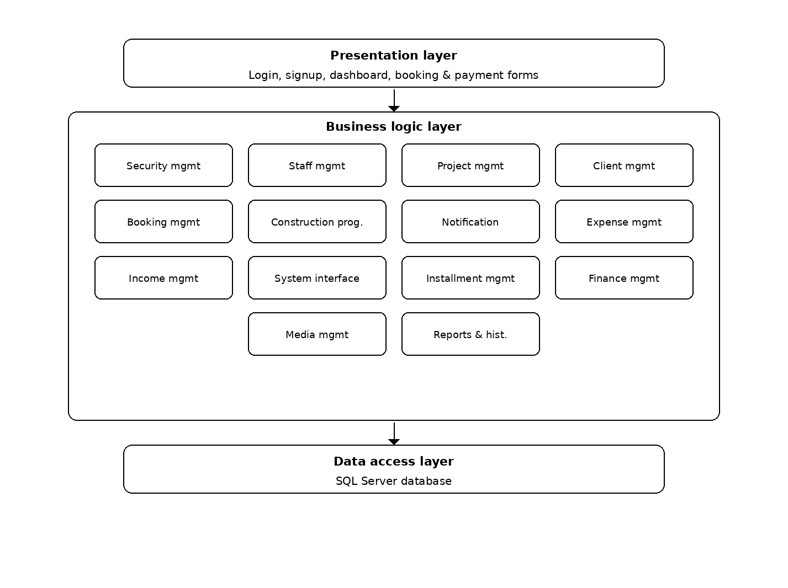
94

3.5 System Sequence Diagram
SSD 1: User Registration
SSD 2: User Login
SSD 3: Browse Projects
SSD 4: Submit Booking Request
SSD 5: Approve Booking Request
SSD 6: Reject Booking Request
SSD 7: Create Walk-in Booking
SSD 8: Record Booking Amount Payment
SSD 9: Generate Installment Plan
SSD 10: Record Installment Payment
SSD 11: View Payment Receipt
SSD 12: Client My Projects
SSD 13: Cancel Booking
SSD 14: Mark Employee Attendance
SSD 15: Generate Employee Salary
SSD 16: Finance Dashboard
SSD 17: Add Manual Revenue
SSD 18: Add Expense
95

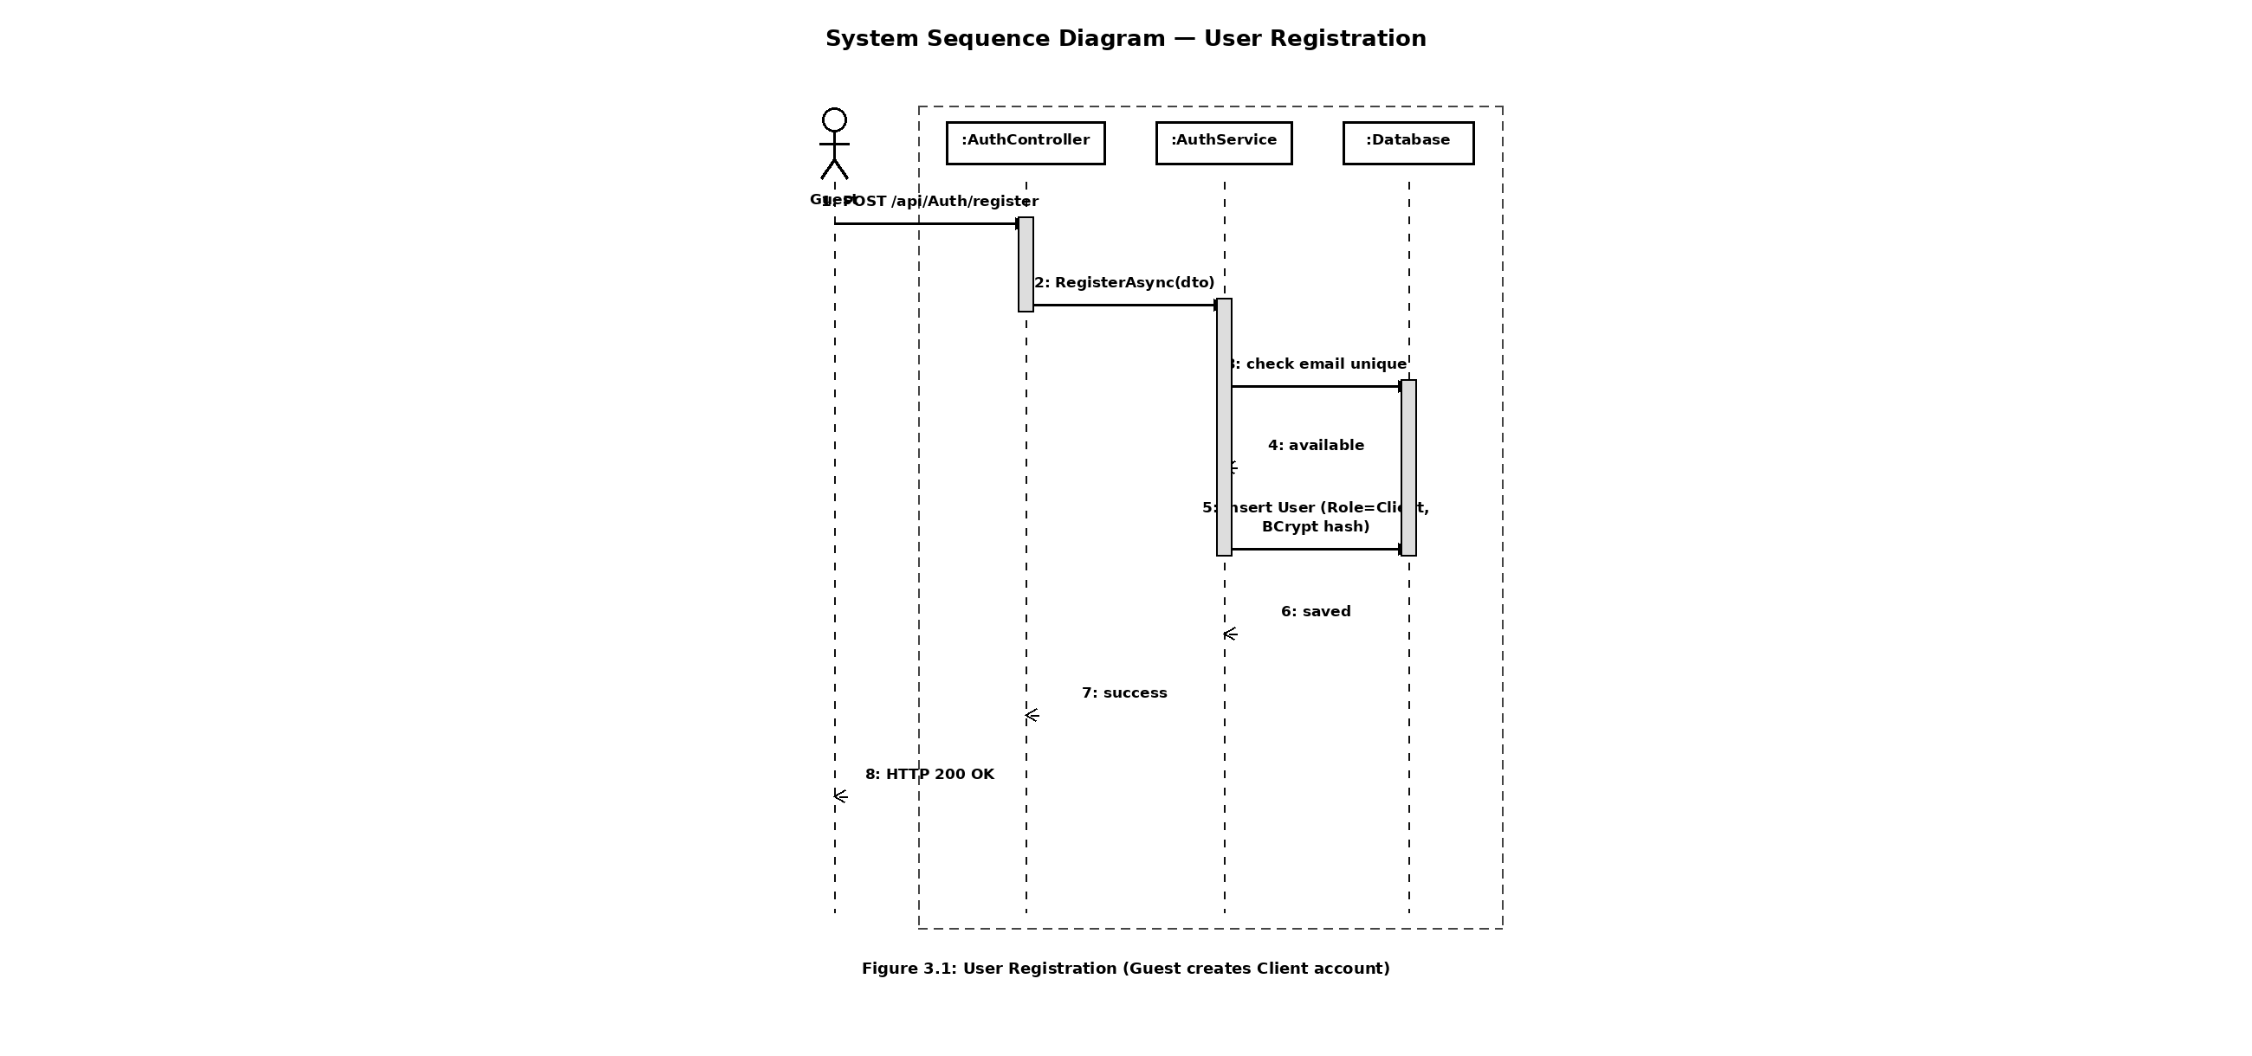
96

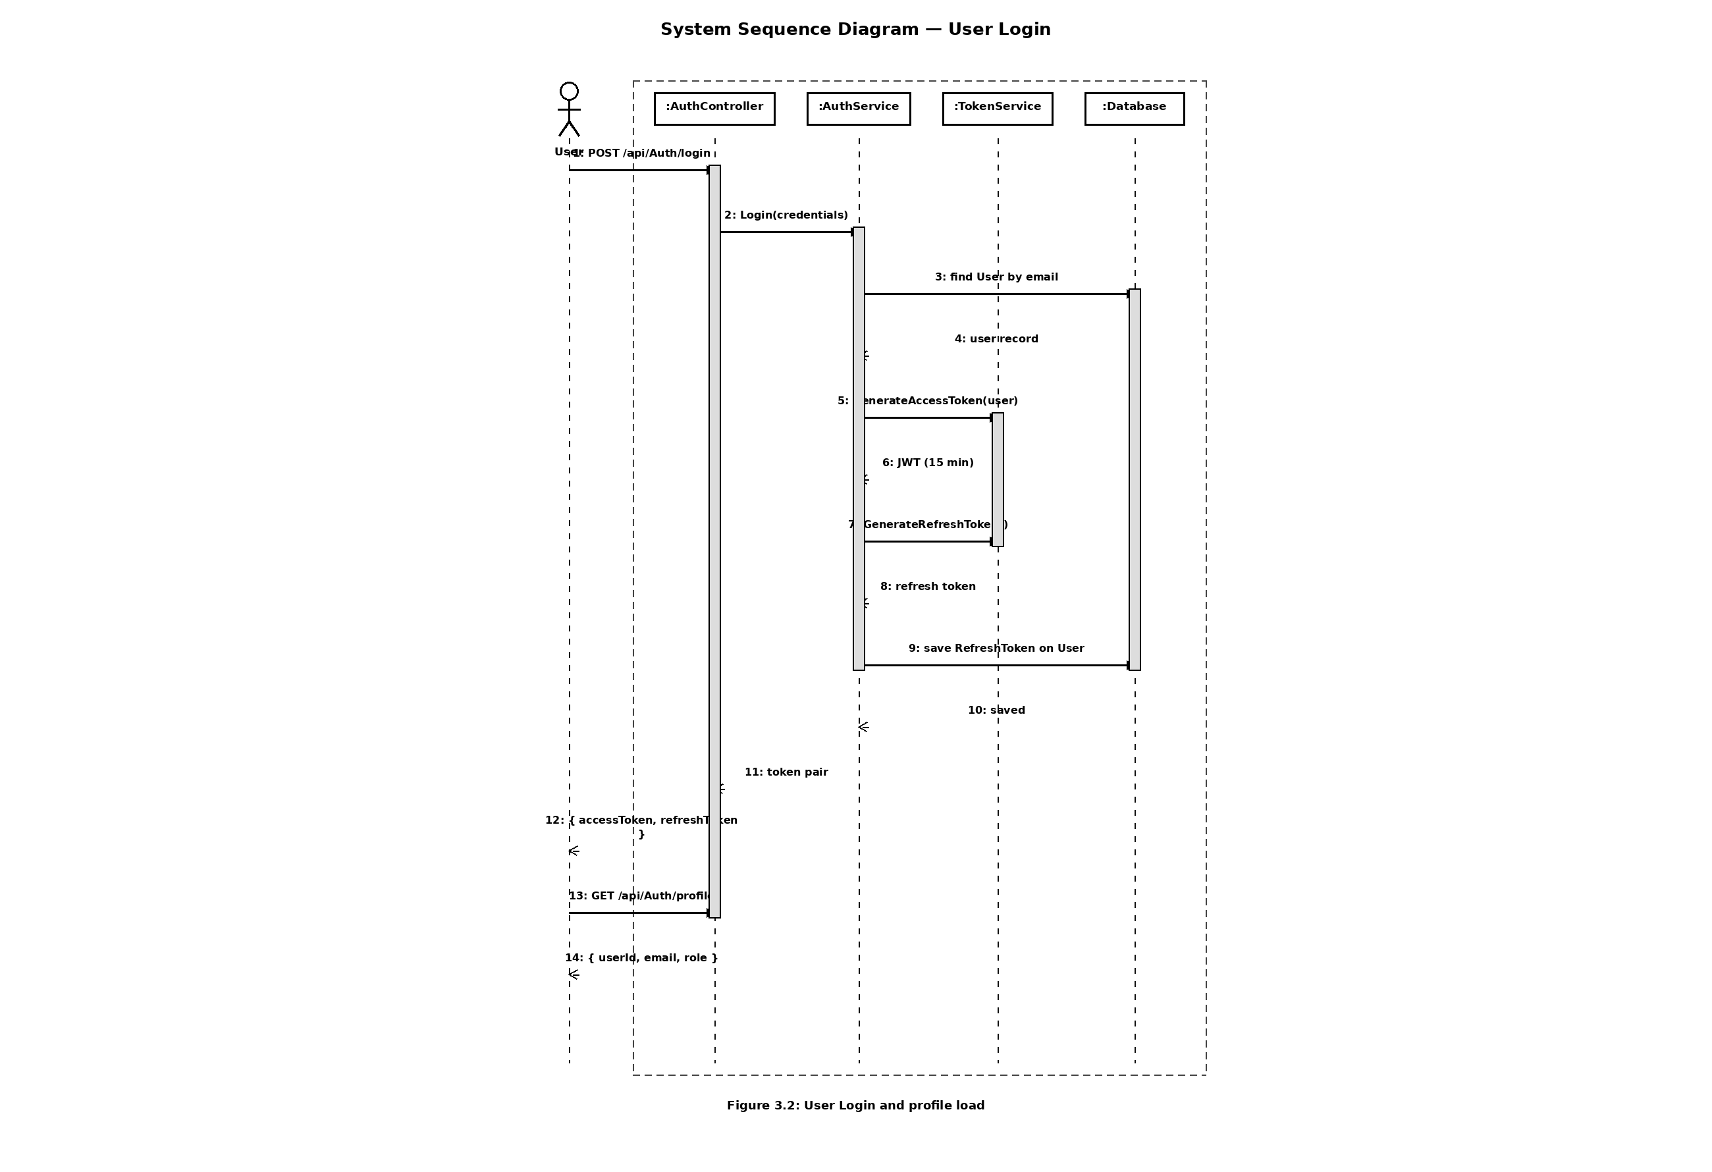
97

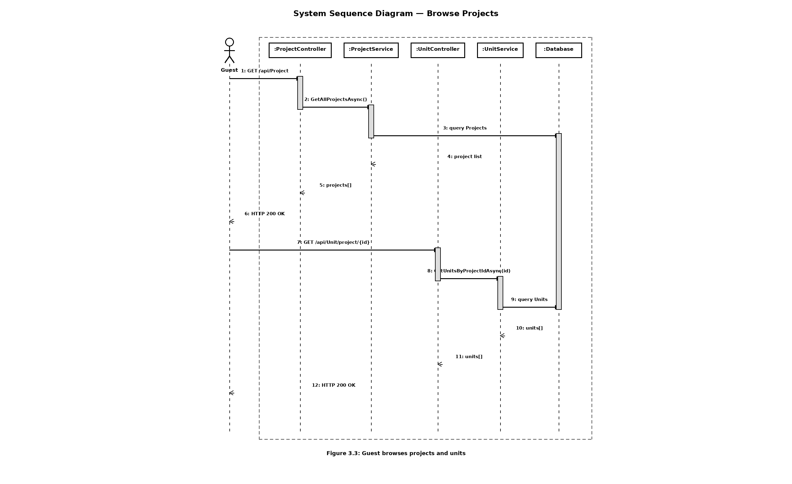
98

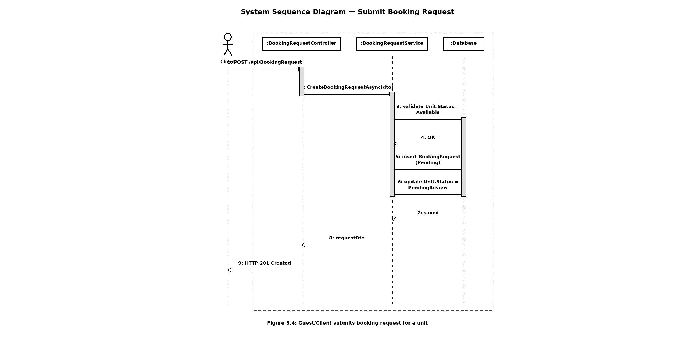
99

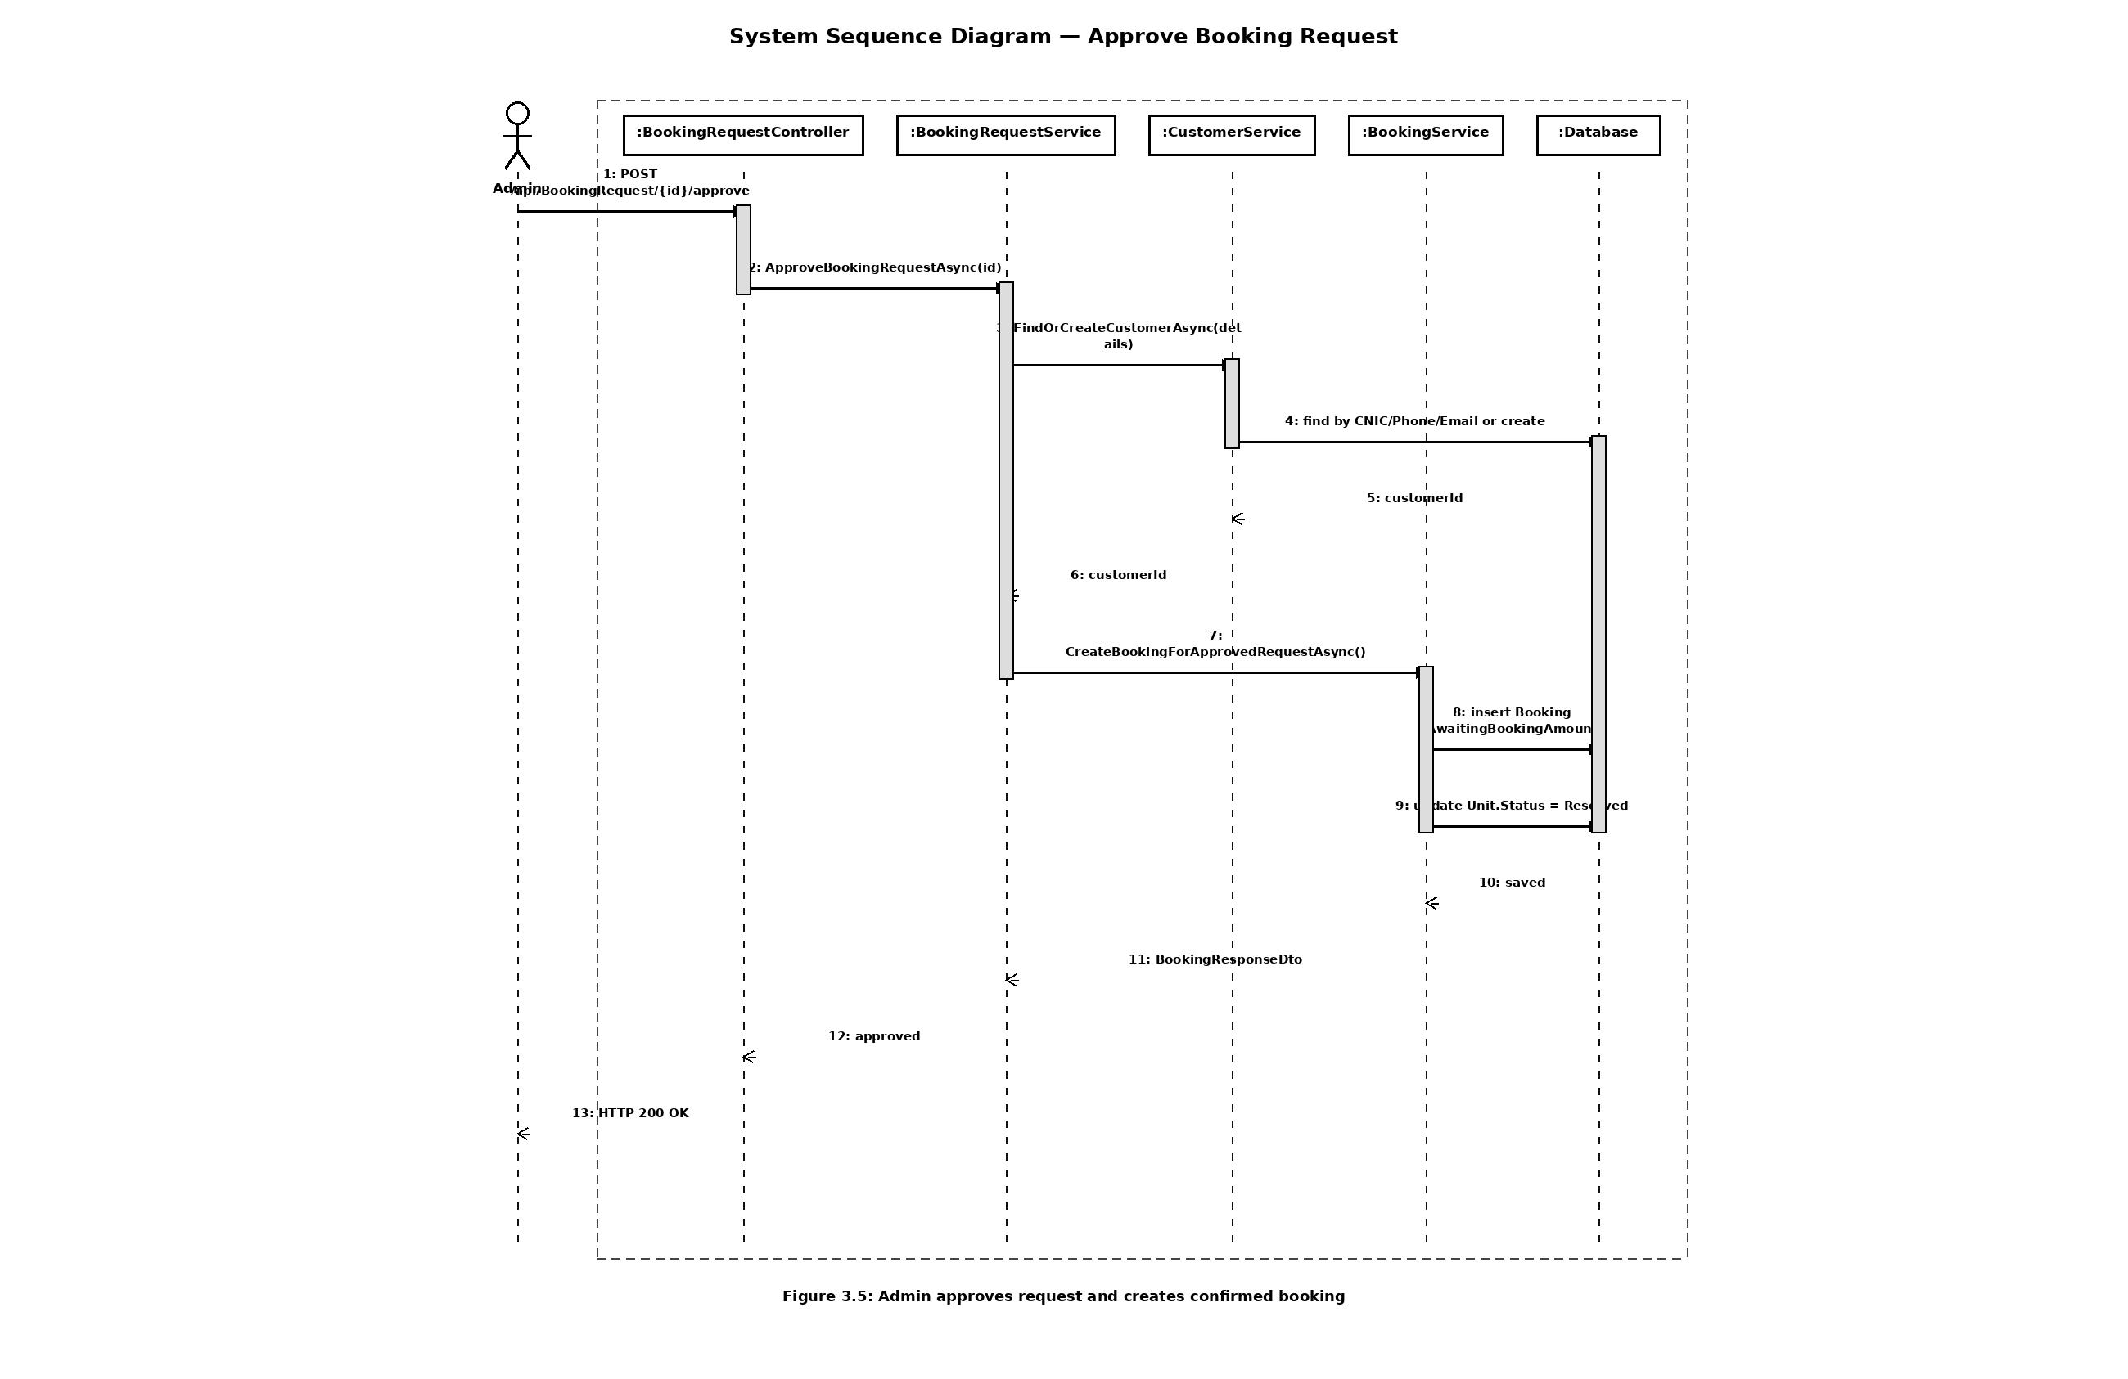
100

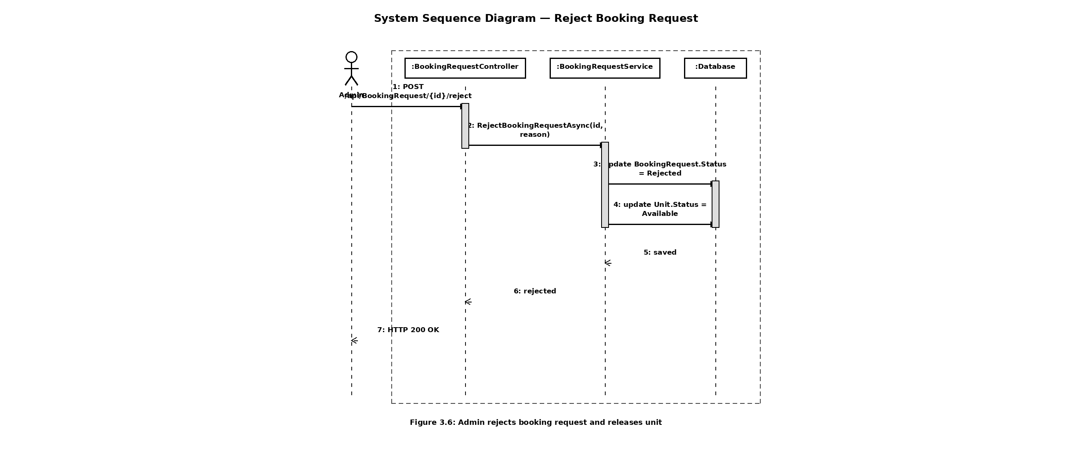
101

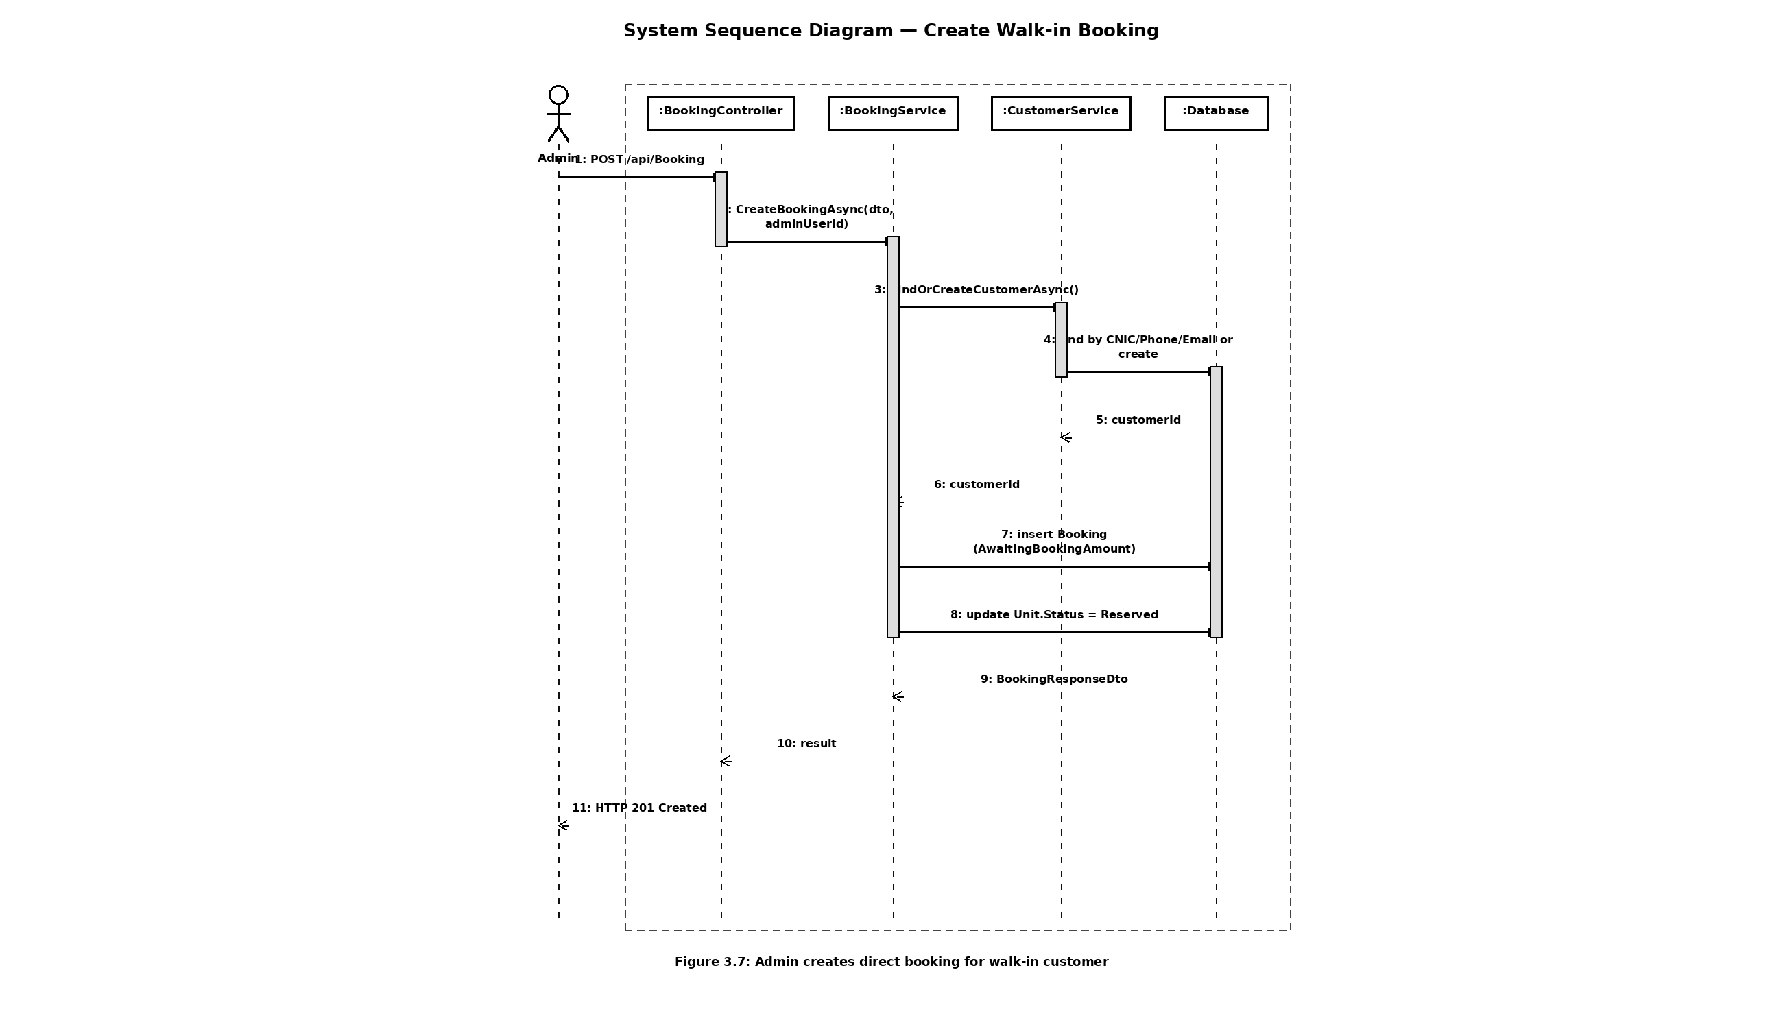
102

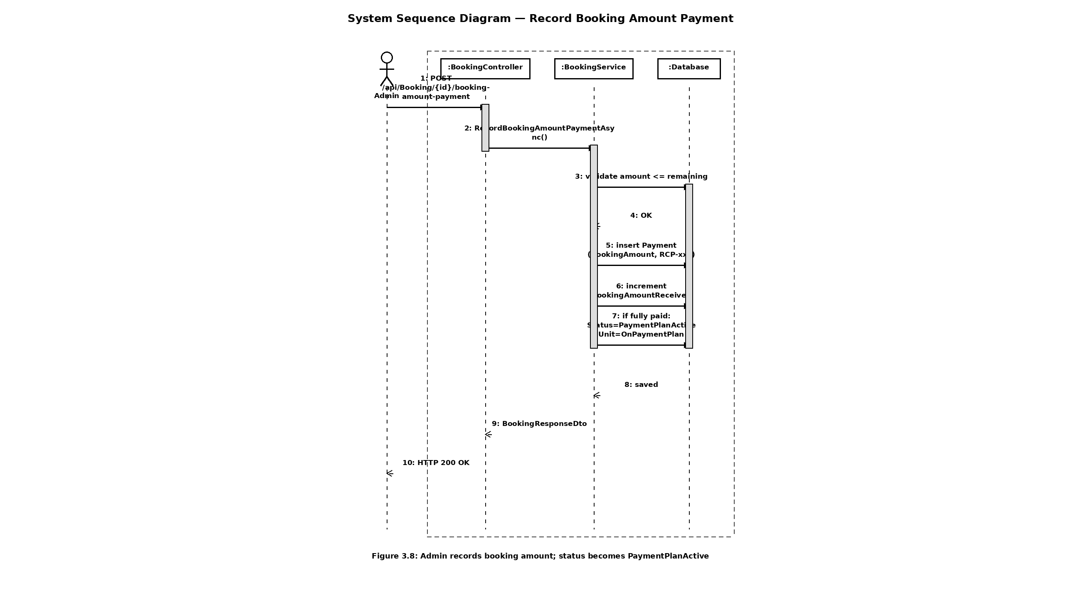
103

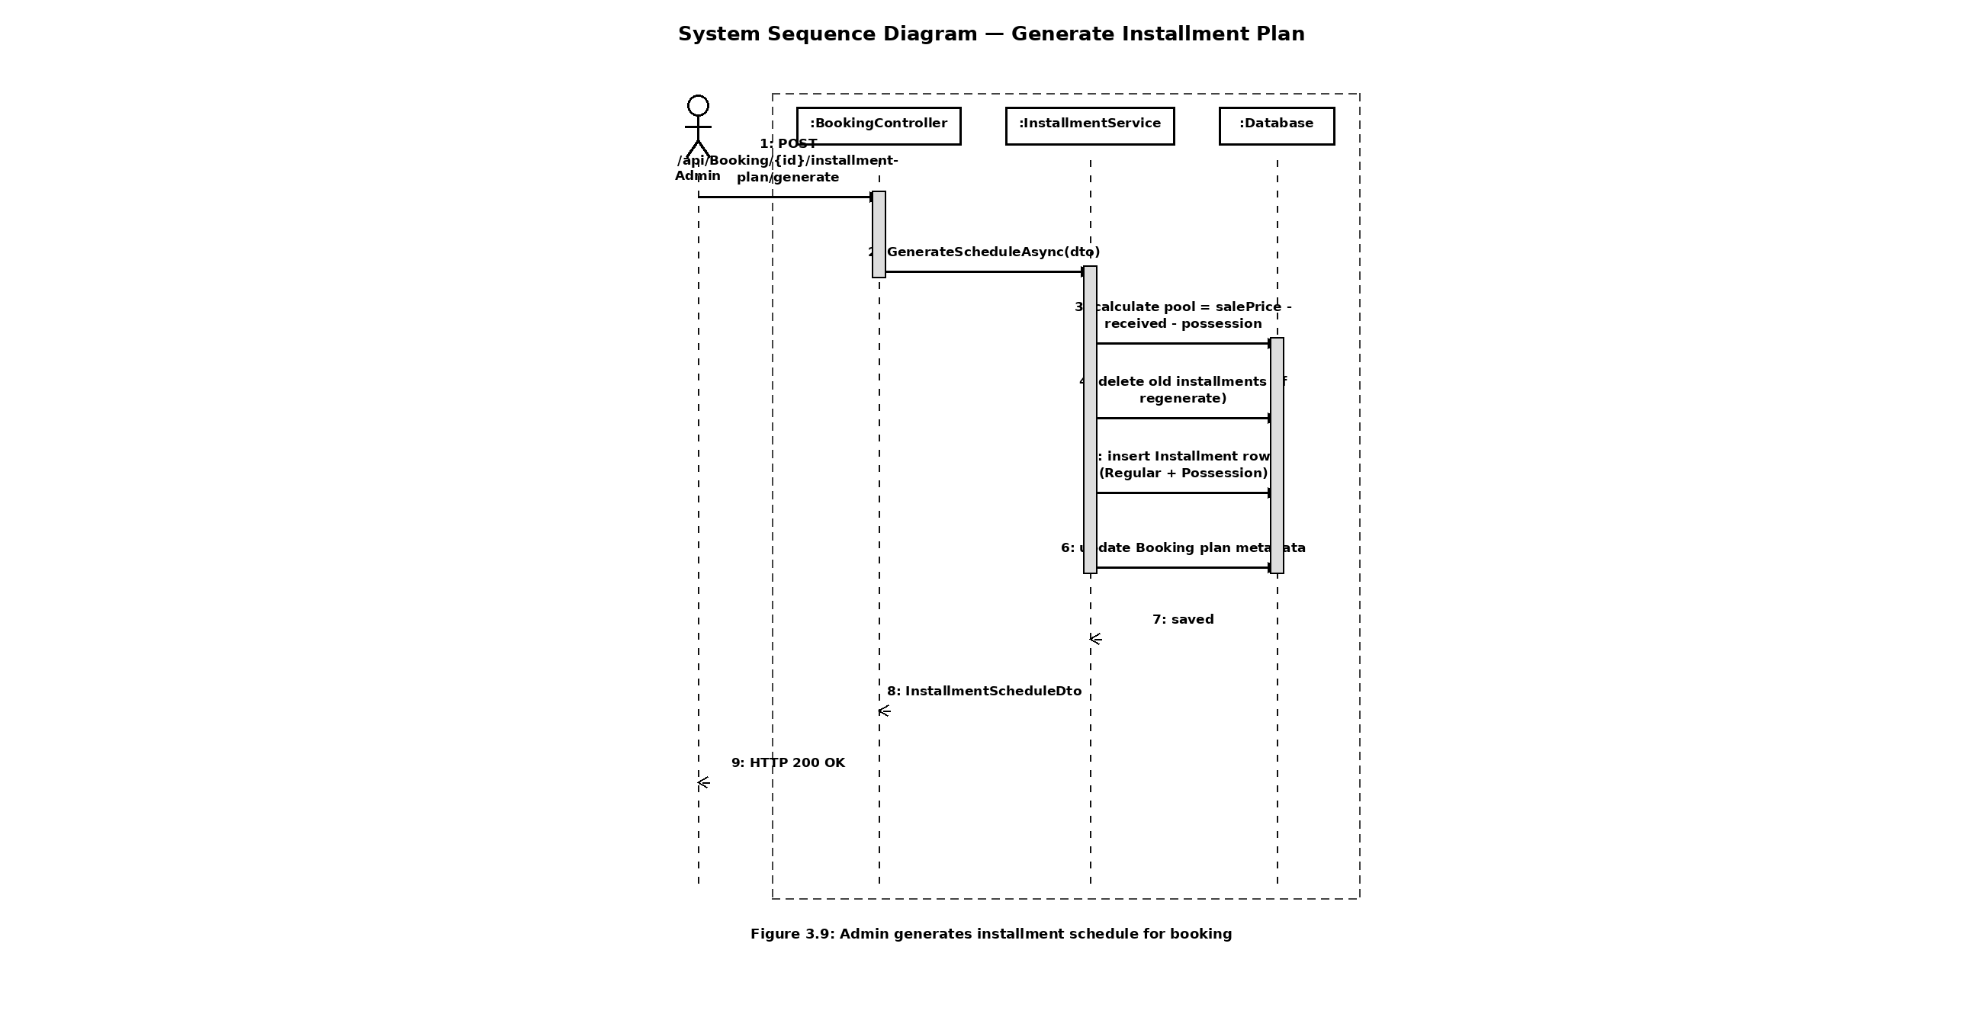
104

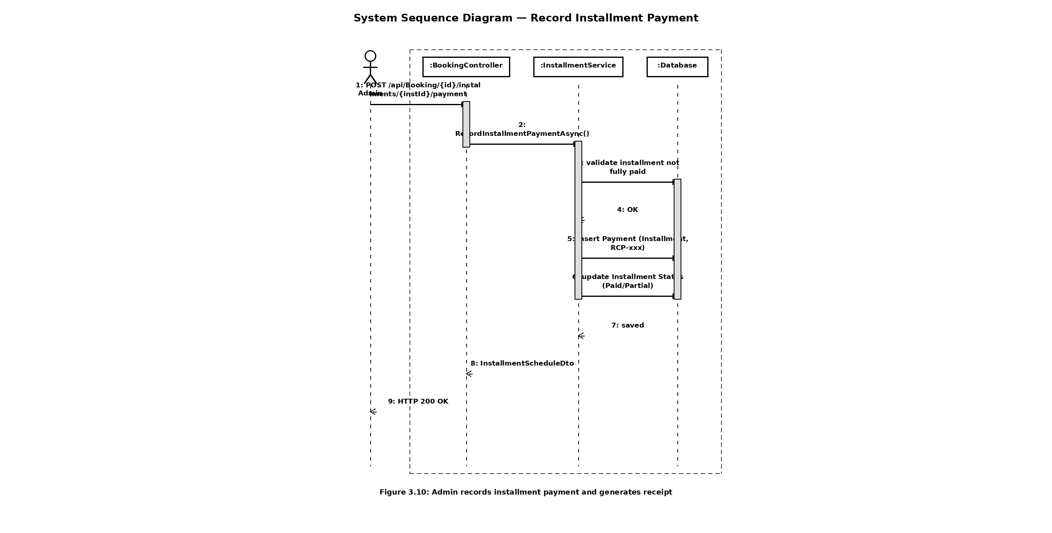
105

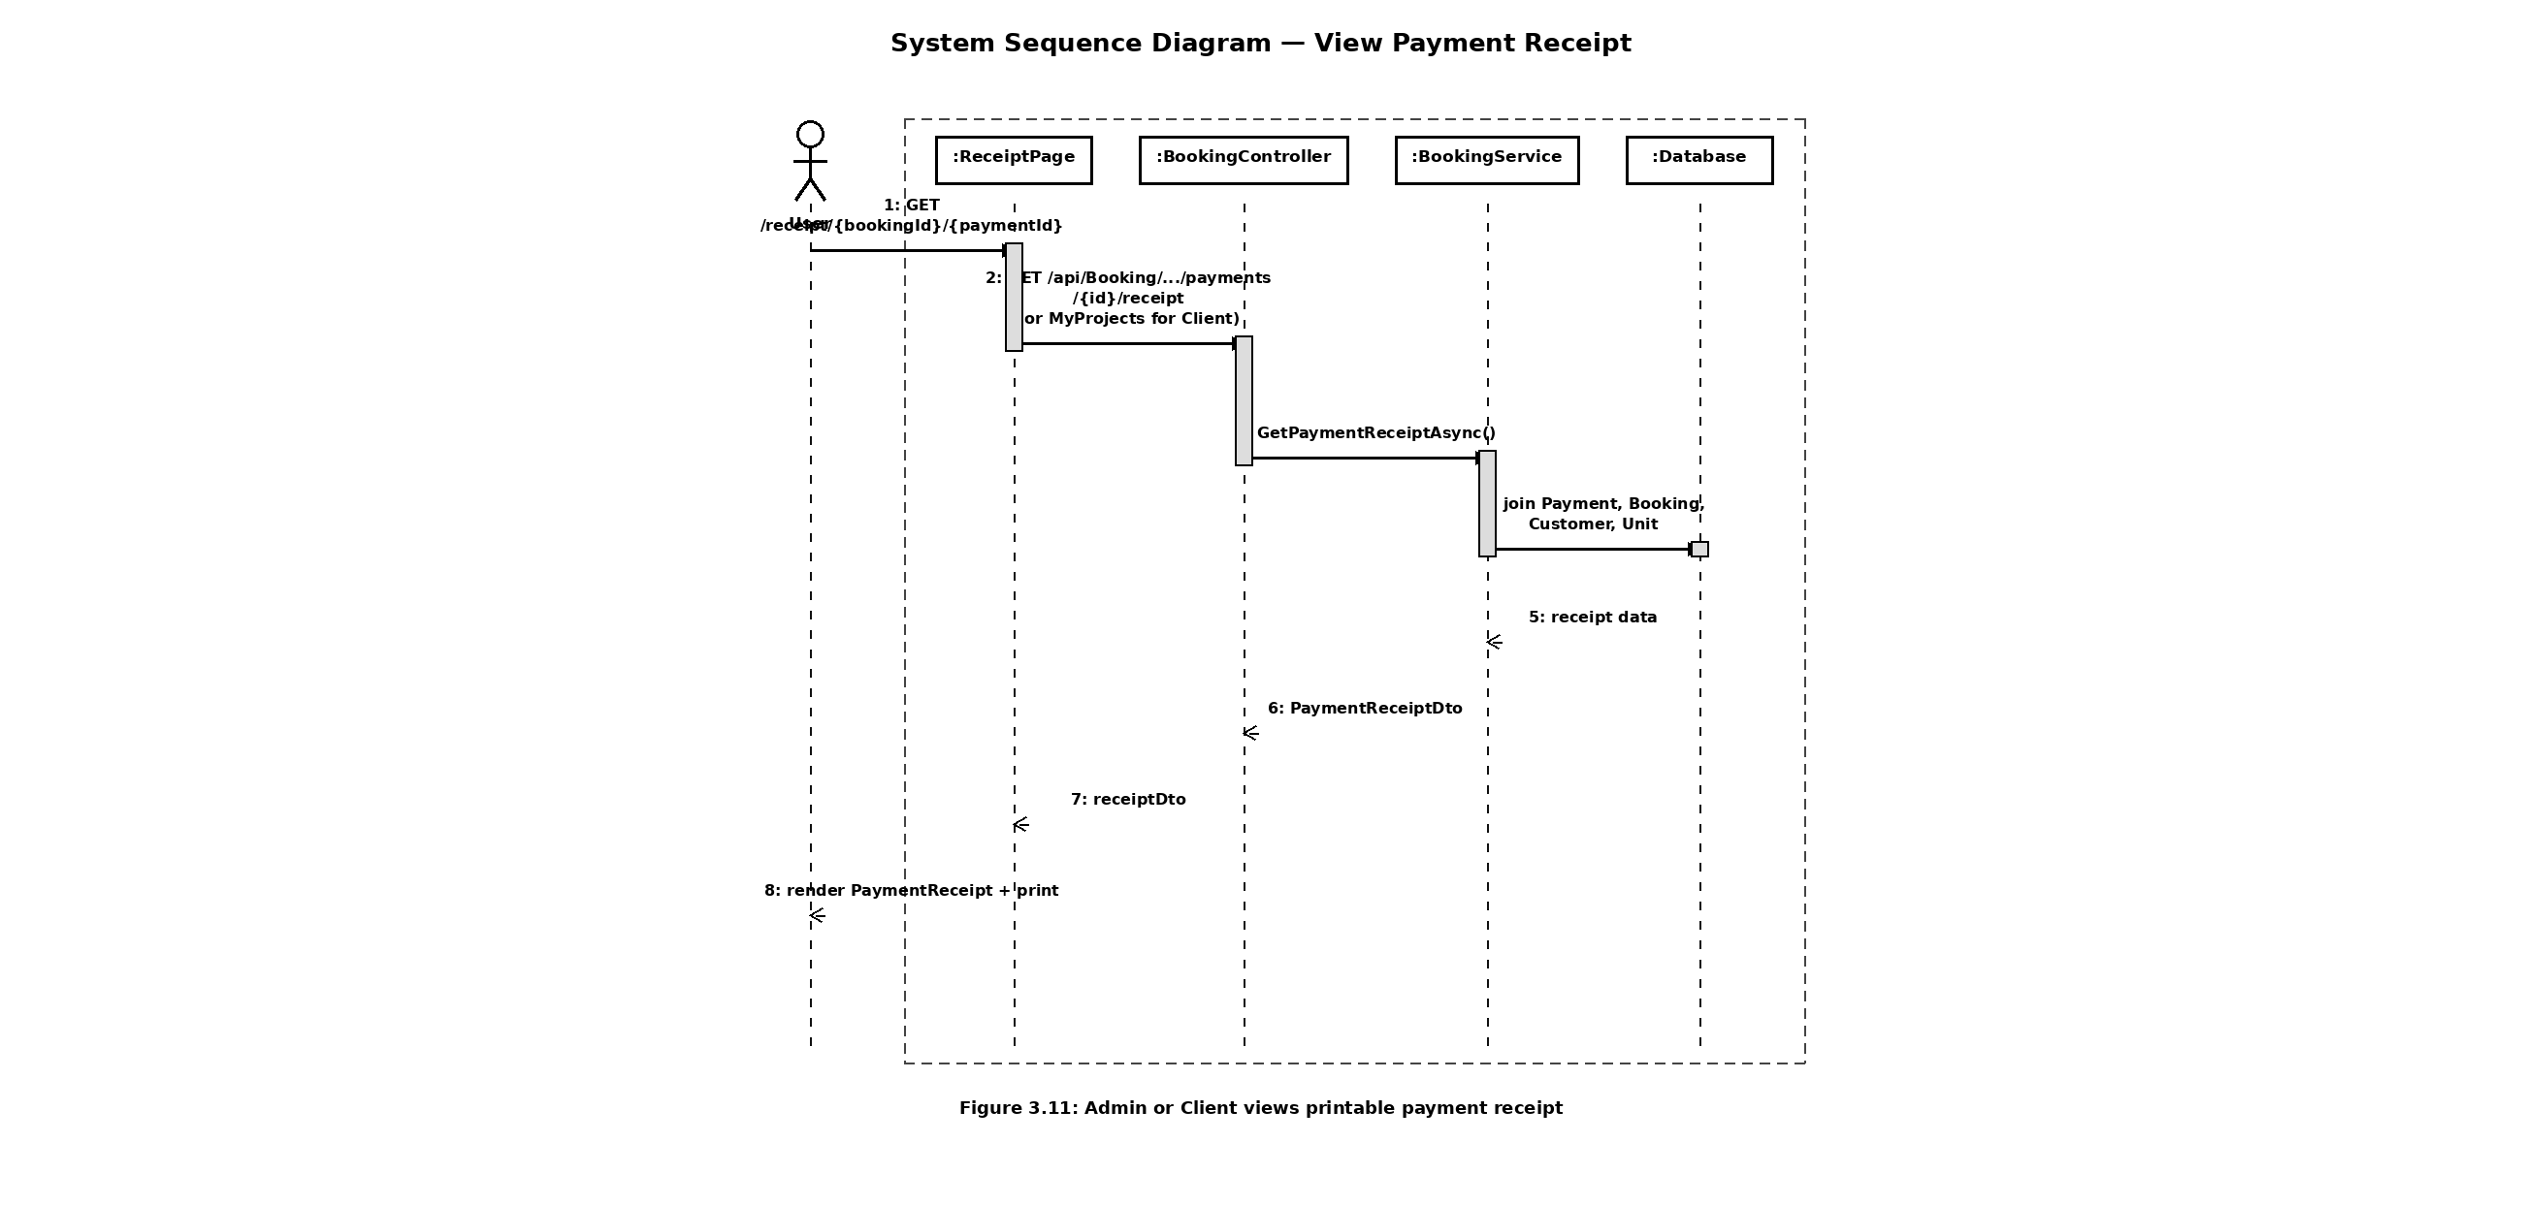
106

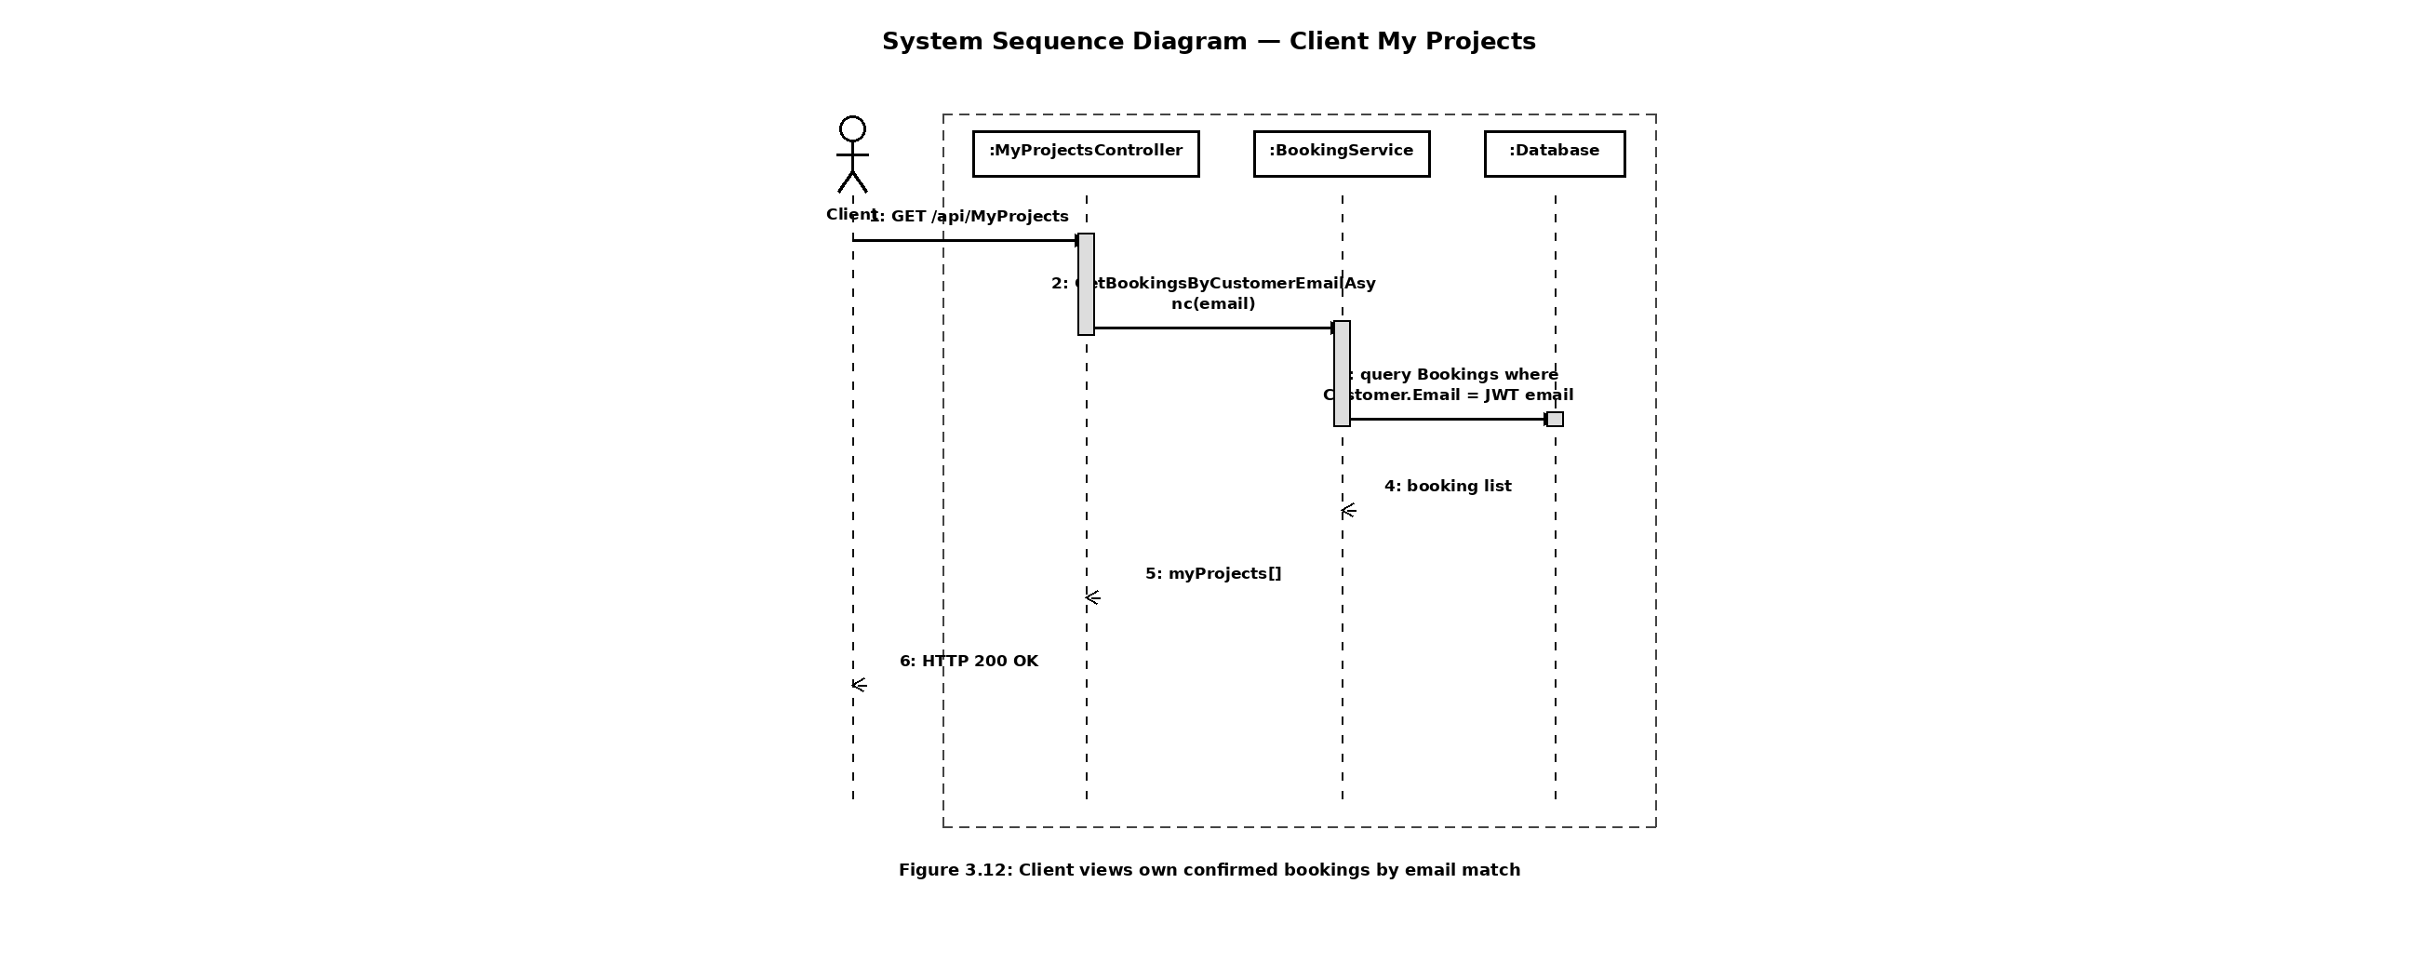
107

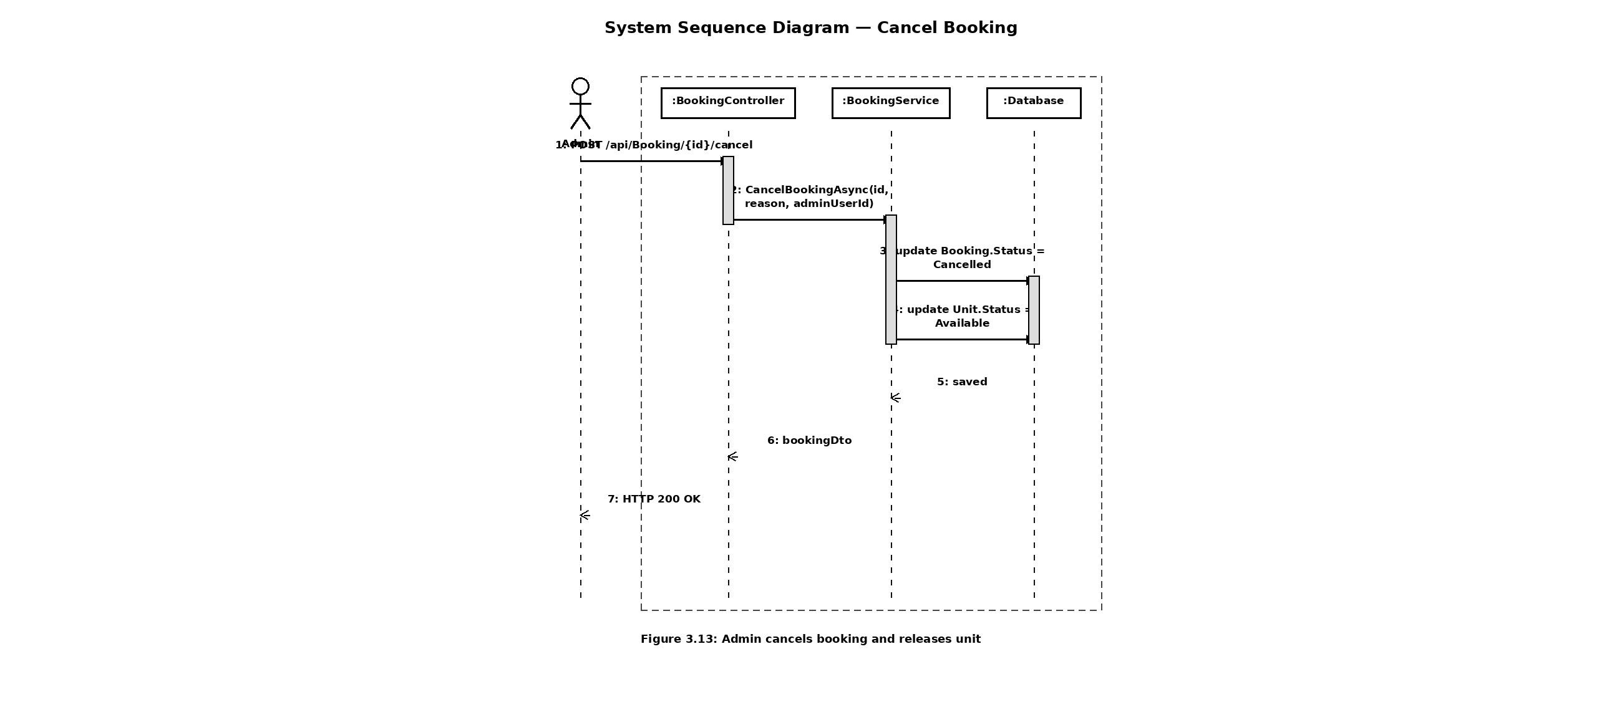
108

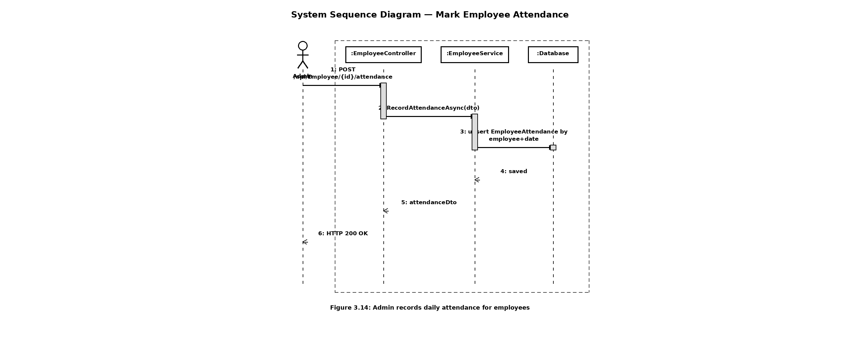
109

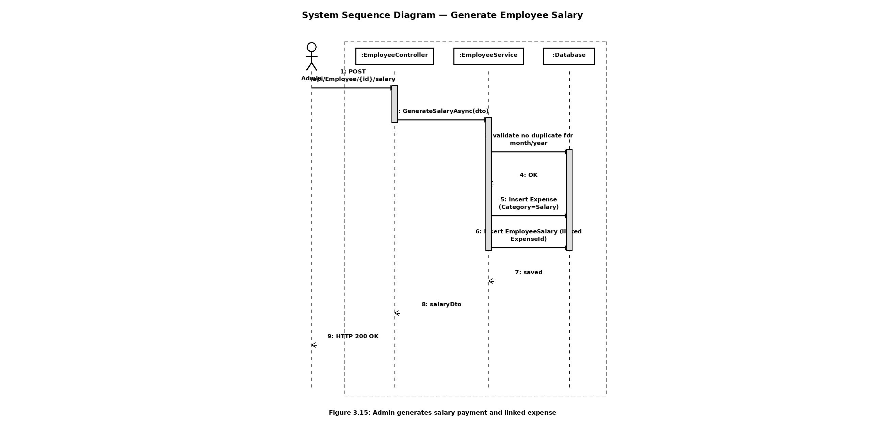
110

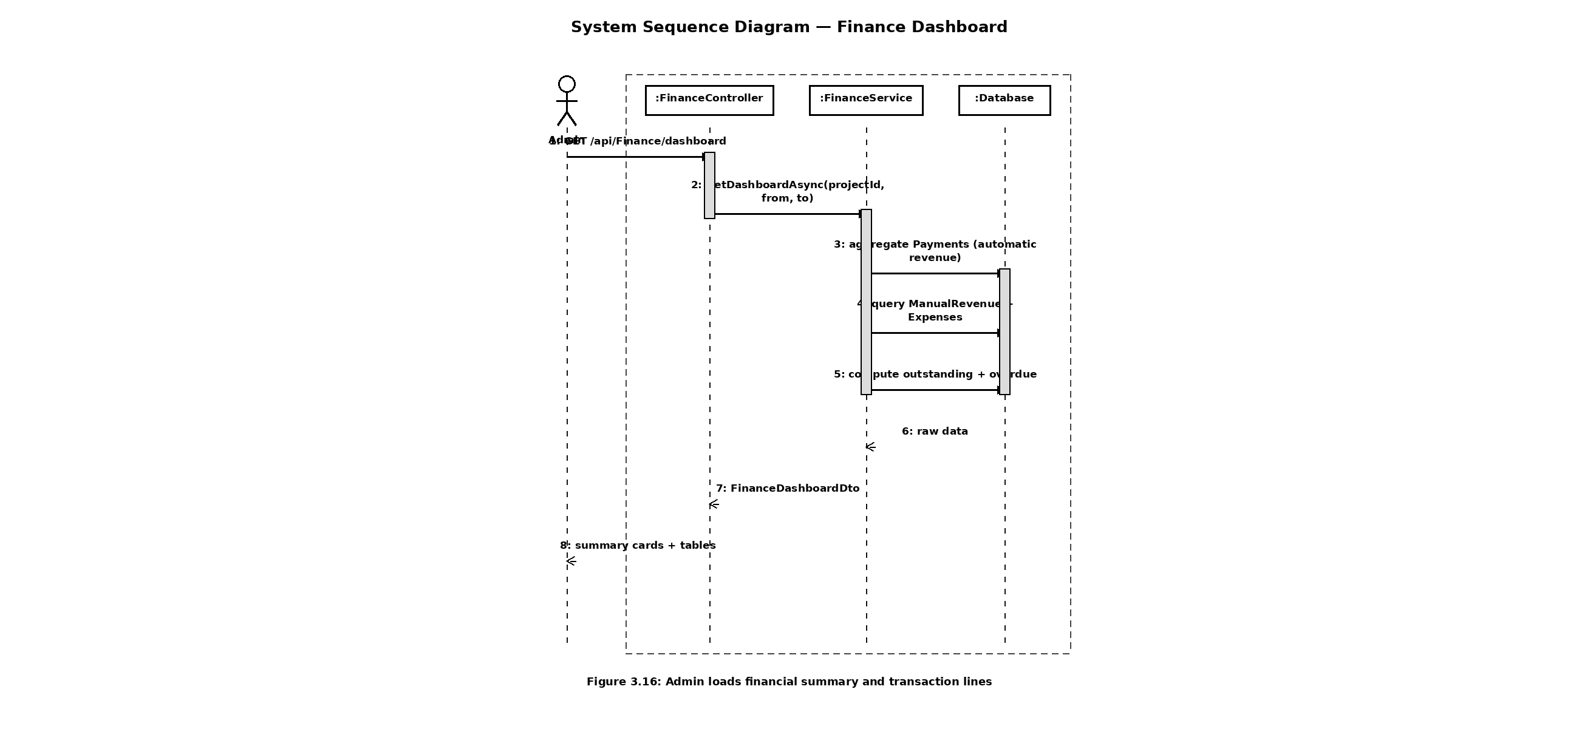
111

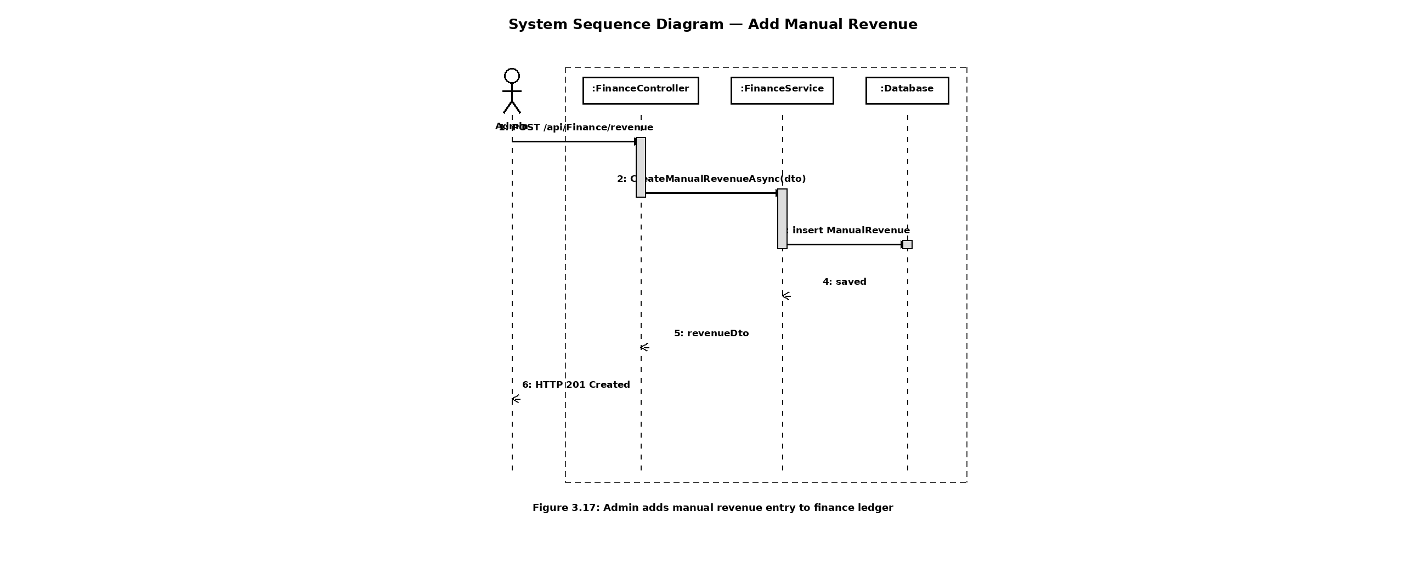
112

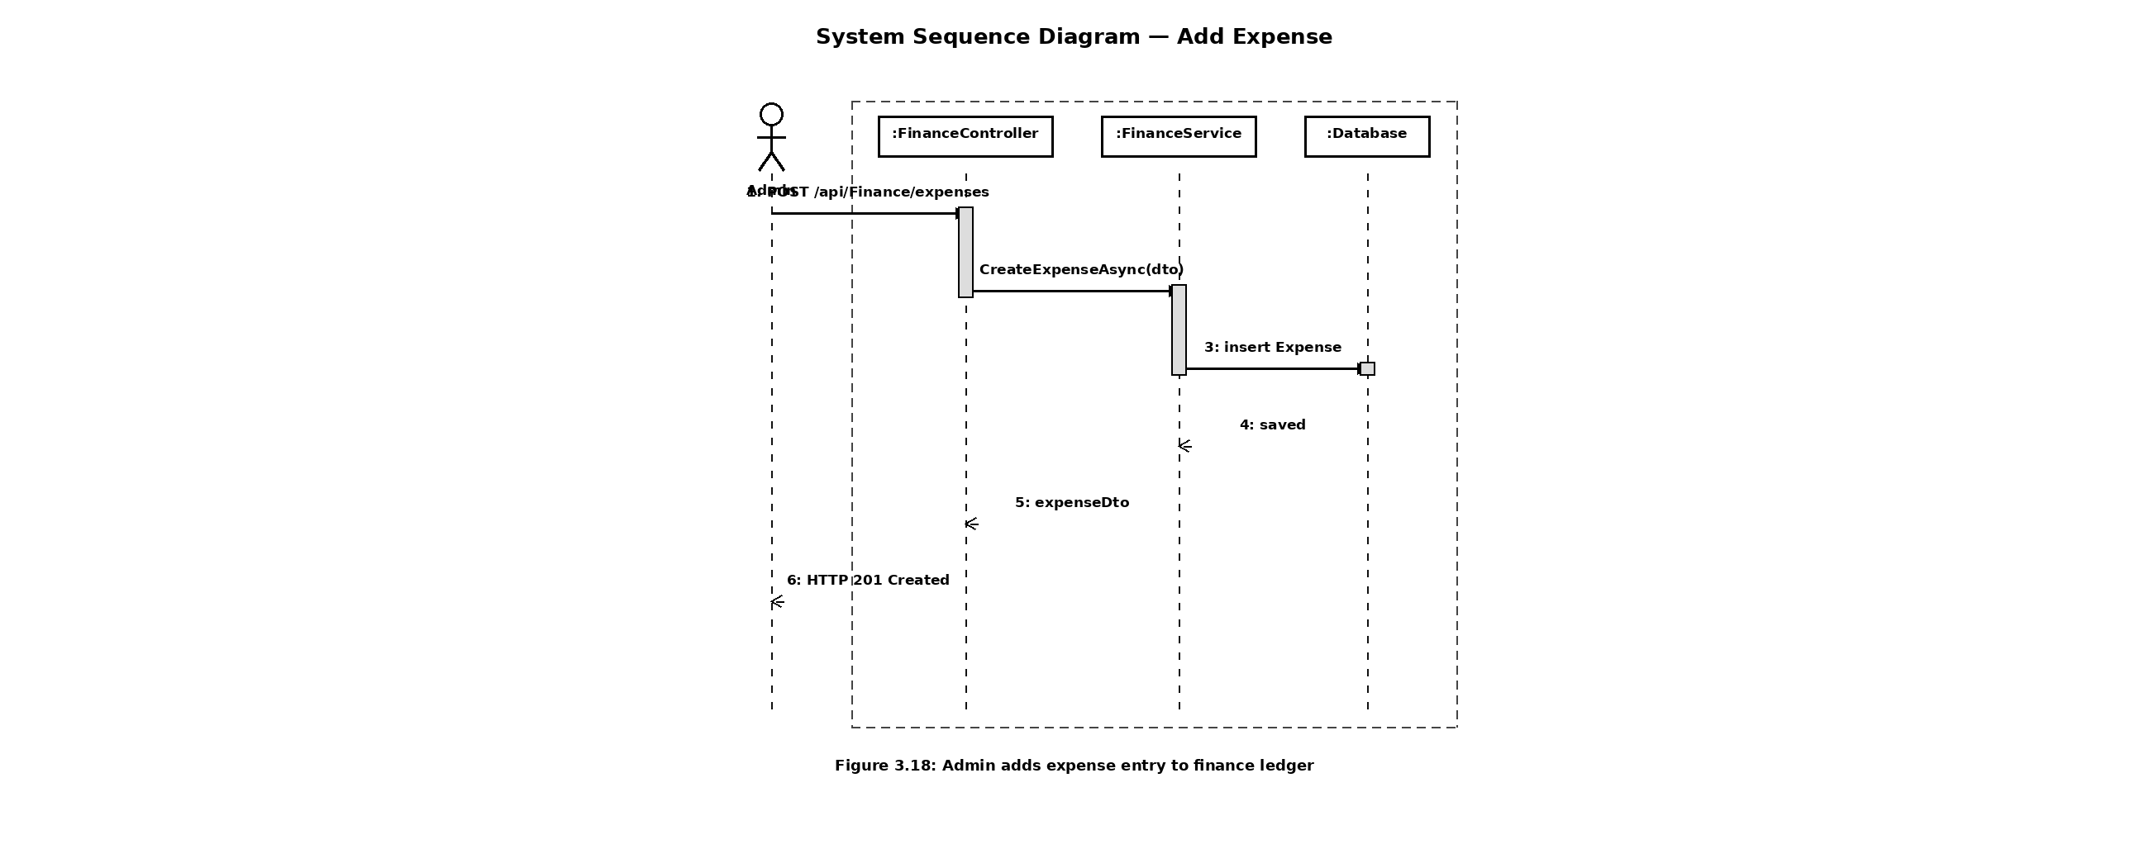
113

3.6 ER Diagram
114

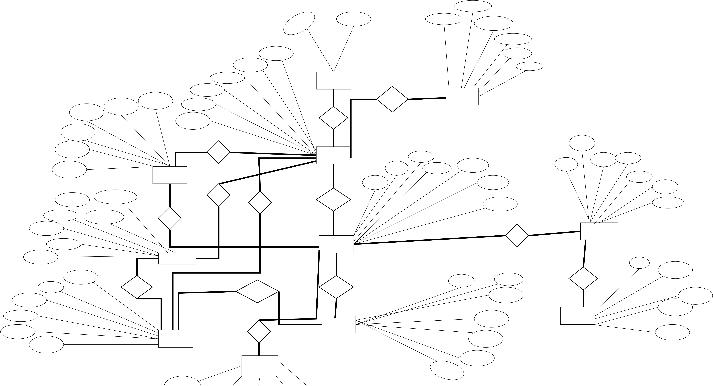
Sender_Id(User)
- - - - - - - - - - - - -
Role_Id | Notification_Id | Reciever_Id(User)
________ | _____________ | Reciever_Id(User)
- - - - - - - - -- - - -
Title
user_id | Created_at | Message | Date
_______ | Created_at | Message | Date
Rolw_Id
User_Id |  |  | M | amount | M | - - - - - - | 1 | Makes | 1 | 1 | 1 | Role | 1 | M | Location | Sends | 1 | Notifications | Has | Bookin_date |  | User_id | Progress_date
 |  |  |  |  |  | Full_Name
 |  |  |  |  |  |  |  |  |  |  |  | 1
 |  |  |  |  |  | EMail |  |  |  |  |  | Has | 1 | M | Location | or
 |  |  |  |  |  |  |  |  |  |  |  |  |  |  |  | Recieve
Expense_Id |  | - - - - - - - -
 |  |  |  |  |  | Created_at
_______
Expense_title
 |  |  |  |  |  |  |  |  |  |  |  | M
Expense_date |  |  | M | amount | Expense | Records |  |  |  |  |  | User | 1 | M | Location | satus | Project_Id | Starting_date | Has | Project_Id |  | User_id | Progress_date
 |  |  |  |  |  |  |  |  |  |  |  |  |  |  |  |  | _________
Project_Id |  |  |  |  |  |  |  |  |  |  |  |  |  |  |  |  |  |  |  |  |  | - - - - - - - | Progress_date
 |  |  |  |  |  |  |  |  |  |  |  |  |  |  |  |  |  |  |  | Discription | - - - - - - | - - - - - - - | Progress_date
 |  |  |  |  |  |  |  |  |  |  |  | 1
 |  |  |  |  |  |  |  |  |  |  |  |  |  |  |  |  | Project_name
 |  |  |  |  |  |  |  |  |  |  |  |  |  |  |  |  |  |  |  |  |  | Title | Progress_date
- - - - - -
 |  |  |  |  |  |  |  |  |  |  |  |  |  |  |  |  |  | Expec_comp_date
User_id(admin) |  |  | M | amount | M | Pays |  |  |  |  |  | Manages | 1 | M | 1 | satus | Project_name | Created_by | Has | Construction_progress |  | Media_id | Progress_date
 |  |  |  |  |  |  |  |  |  |  |  |  |  |  |  |  |  |  |  |  |  |  | Proress_Id
Income_date | - - - - - - - - - -
 |  |  |  |  |  |  |  |  |  |  |  |  |  |  |  |  |  |  |  |  |  |  | ________
 |  |  |  |  |  |  |  |  |  |  |  |  |  |  |  |  |  | - - - - - - - -
 |  |  |  |  | Incurs
Income_Id  ________ | User_id(client)  - - - - - - -
 |  |  |  |  |  |  |  |  |  |  |  | M
Bookind_Id
- - - - - -
 |  |  |  |  |  |  |  |  |  |  |  | Project |  |  |  |  |  |  |  | M |  | Media_id | ________
Project_Id
 |  |  | M | amount | Income
 |  |  |  |  |  |  |  |  |  |  |  |  |  |  |  |  |  |  |  | 1 |  | Media_id | ________
- - - - - - - -
Ammount
 |  |  |  |  |  |  |  |  |  |  |  |  |  |  |  |  |  |  |  |  |  | ______ | progress_id
- - - - - - - -
Unit_Id | Booking_Id | Bookin_date | Generate | 1 | M | Booking | M | Is booked via | 1 | Contains | M | Unit_id | Project_id | Includes | Media_url | Media_type
 |  |  |  |  |  |  |  |  |  |  |  |  | - - - - - - - - | Includes | Media_url | Media_type
 |  |  |  |  |  |  |  |  |  |  |  | ______
Unit_Id | ________ |  |  |  |  |  |  |  |  |  |  |  | unit_number | M | Media_url | Media_type
- - - - - -
User_Id | Status |  |  |  |  |  |  | Employs | 1 | Uint | M | ______ | Unit_type | Progress_Media | Uploaded_at | Media_type
- - - - - -
Total_price
 |  |  |  |  |  |  |  |  |  |  |  |  | Status | Progress_Media | Uploaded_at | Media_type
 |  |  |  |  |  |  |  | M
Size
Staff
115

Normalization
FOR
Deen Associate Management System
Version 1.0
Prepared By
Muhammad Junaid Riaz
3 Dec, 2025
116

3.7 Normalization
117

Revision History
Version | Description | Author | Date
1.0 | normalization of the system | Junaid Riaz | 27 – 12 - 2025
  This | covers | the
118

1.Table “Role”:
Role
Role_Id (pk) | Role_name
Table “Role” is already in 1NF,2NF and 3NF. No further normalization is required.
2.Table “ User”
User
User_Id(Pk) | Role_Id(Fk) | Full_name | email | Phone | password
Applying 1NF:-
“User”
User
User_Id(PK) | Role_Id(FK) | Full_name | Password
“User_email”
User_email
User_Id (PK) (FK) | email(PK)
119

“User_contact”
User_contact
User_Id (PK) (FK) | Contact_no(PK)
There are no partial or transitive dependencies in above tables; therefore, no further normalization is required.
3.Table “Project”
Project
Project_Id(PK) | User_Id(FK) | Project_name | location | Start_date | End_date | Satus
Since the Project table already satisfies the requirements of the higher normal forms, no additional normalization is necessary.
4.Table “ Notification”
Notification
Notification_Id(PK) | Sender_Id (FK) | Receiver_Id (FK) | Title | Message | Notification_Date
Since the Notification table already satisfies the requirements of the higher normal forms, no additional normalization is necessary.
120

5.Table “Expense”
Expense
Expense_Id(PK) | Project_Id(FK) | User_Id(FK) | Title | Date | Ammount
The Expense table is already normalized; therefore, no further normalization is required.
6.Table “Unit”
Unit
Unit_Id(PK) | Project_Id(FK) | Unit_type | Unit_number | Price | Size
Table “Unit” is already in 1NF, 2NF, and 3NF. No further normalization is required.
7.Table “Booking”
Booking
Booking_Id(PK) | Unit_Id(FK) | User_Id(FK) | Booking_date | Total_Price | Status
Table “Booking” is already in 1NF, 2NF, and 3NF. No further normalization is required.
121

8.Table “ Income”
Income
Income_Id(PK) | Booking_Id(FK) | Paid_b(FK) | Recorded_B(FK) | Income_date | Ammount
Table “Income” is already in 1NF, 2NF, and 3NF. No further normalization is required.
9.Table “Staff”
Staff
Staff_Id(PK) | Project_Id(FK) | Desination | salary | Joining_date
Table “Staff” is already in 1NF, 2NF, and 3NF. No further normalization is required.
10. Table “Progress”
Progress
Progress_Id(Pk) | Project_Id(FK) | Title | Discription | date
Table “Progress” is already in 1NF, 2NF, and 3NF. No further normalization is required.
122

11. Progress Media
Progress Media
Media_Id(PK) | Progress_Id(FK) | Type | Url | Date
Table “Progress_Media” is already in 1NF, 2NF, and 3NF.
No further normalization is required.
123

3.8 Relational Model
124

User
Attributes | Data Types | Constraints | Primary Key | Foreign Key
user_id | Int | Unique | Yes | Nill
role_Id | Int | Not null | No | Yes
full_name | Varchar(100) | Not null | No | No
password | Varchar(250) | Not null | No | No
Role
Attributes | Data Types | Constraints | Primary Key | Foreign Key
role_id | Int | Unique | Yes | Nill
role_name | Varchar(100) | Not null | No | Nill
User_email
Attributes | Data Types | Constraints | Primary Key | Foreign Key
user_id | Int | Not null | Yes | Yes
email | Varchar(100) | Not null | yes | Nill
User_Contact
Attributes | Data Types | Constraints | Primary Key | Foreign Key
user_id | Int | Not null | Yes | Yes
contact | Varchar(14) | Not null | yes | Nill
Project
 | Attributes | Data Types | Constraints | Primary Key | Foreign Key
 | project_id | Int | Unique | Yes | Nill
 | user_id | Int | Not null | NIll | yes
 | project_name | Varchar(100) | Not null | Nill | Nill
 | location | Varchar(150) | Not null | Nill | Nill
 | Start_date | Date | Not null | Nill | Nill
 | End_date | Date | Not null | Nill | Nill

User
Notification
Attributes | Data Types | Constraints | Primary Key | Foreign Key
Notification_id | Int | Not null,Unique | Yes | Nill
Sender_id | Int | Not null | NIll | yes
Reciever_id | Int | Not null | Nill | yes
title | Varchar(100) | Not null | Nill | Nill
message | Text | Not null | Nill | Nill
date | Date | Not null | Nill | Nill
Unit
Attributes | Data Types | Constraints | Primary Key | Foreign Key
unit_id | Int | Not null,Unique | Yes | Nill
project_id | Int | Not null | NIll | yes
unit_type | Varchar(50) | Not null | Nill | Nill
unit_number | Varchar(20) | Not null | Nill | Nill
price | Decimal(12,2) | Not null | Nill | Nill
size | Varchar(30) | Not null | Nill | Nill
Expense
Attributes | Data Types | Constraints | Primary Key | Foreign Key
Expense_id | Int | Not null,Unique | Yes | Nill
project_id | Int | Not null | NIll | yes
user_id | Int | Not null | Nill | yes
title | Varchar(100) | Not null | Nill | Nill
date | Date | Not null | Nill | Nill
amount | Decimal(12 , 2) | Not null | Nill | Nill
126

User
Booking
Attributes | Data Types | Constraints | Primary Key | Foreign Key
booking_id | Int | Not null,Unique | Yes | Nill
unit_id | Int | Not null | NIll | yes
user_id | Int | Not null | Nill | yes
status | Varchar(20) | Not null | Nill | Nill
date | Date | Not null | Nill | Nill
total_price | Decimal(12 , 2) | Not null | Nill | Nill
Staff
Attributes | Data Types | Constraints | Primary Key | Foreign Key
staff_id | Int | Not null,Unique | Yes | Nill
project_id | Int | Not null | NIll | yes
desination | Varchar(50) | Not null | Nill | Nill
Joining_date | Date | Not null | Nill | Nill
salary | Decimal(12 , 2) | Not null | Nill | Nill
Progress
Attributes | Data Types | Constraints | Primary Key | Foreign Key
progress_id | Int | Not null,Unique | Yes | Nill
project_id | Int | Not null | NIll | yes
title | Varchar(100) | Not null | Nill | Nill
discription | Text | Not null | Nill | Nill
date | Date | Not null | Nill | Nill
Progress Media
Attributes | Data Types | Constraints | Primary Key | Foreign Key
media_id | Int | Not null,Unique | Yes | Nill
progress_id | Int | Not null | NIll | yes
media_type | Varchar(100) | Not null | Nill | Nill
url | Varchar(100) | Not null | Nill | Nill
uploaded_date | Date | Not null | Nill | Nill
127

User
Income
Attributes | Data Types | Constraints | Primary Key | Foreign Key
income_id | Int | Not null,Unique | Yes | Nill
booking_id | Int | Not null | NIll | yes
paid_by | Int | Not null | Nill | yes
recorded_by | Int | Not null | Nill | yes
income_date | Date | Not null | Nill | Nill
amount | Decimal(12 , 2) | Not null | Nill | Nill
128

Chapter # 4
Construction
129

Class Diagram
FOR
Deen Associate Management System
Version 1.0
Prepared By
Muhammad Junaid Riaz
20 Jun, 2026
130

4.1 Class Diagram
131

Class Diagram
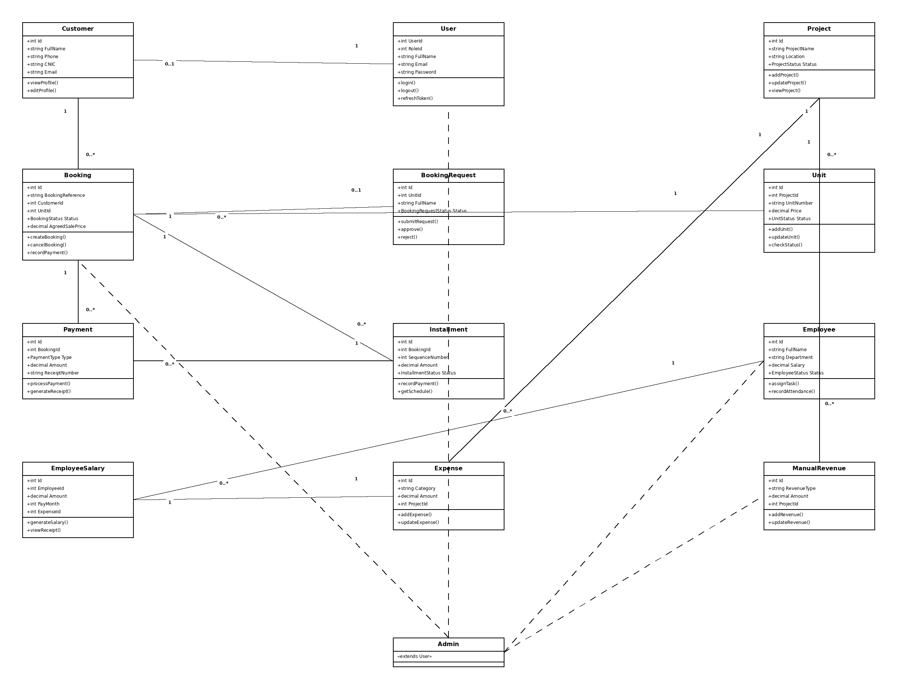
132

4.2 Project Code
133

Project Code
4.2.1 AuthController:
using Microsoft.AspNetCore.Mvc;
using Microsoft.AspNetCore.Authorization;
using DAMS.Application.DTOs.Auth;
using DAMS.Application.Interfaces;
using System.Security.Claims;
namespace DAMS.Api.Controllers
{
[ApiController]
[Route("api/[controller]")]
public class AuthController : ControllerBase
{
private readonly IAuthService _authService;
public AuthController(IAuthService authService)
{
_authService = authService;
}
}); | [HttpPost("register")]  public async Task<IActionResult> Register(RegisterRequestDto request) {  await _authService.RegisterAsync(request);  return Ok(new { message = "Registration completed successfully."  }
[HttpPost("login")]
public IActionResult Login(LoginRequestDto request)
{
var tokens = _authService.Login(request);
if (tokens == null)
return Unauthorized("Invalid credentials");
return Ok(tokens);
}
[Authorize]
[HttpGet("profile")]
public IActionResult Profile()
{
return Ok(new
{
userId = User.FindFirst(ClaimTypes.NameIdentifier)?.Value, email = User.FindFirst(ClaimTypes.Email)?.Value,
role = User.FindFirst(ClaimTypes.Role)?.Value
});
}
134

4.2.2 ProjectController:
using DAMS.Application.DTOs.ProjectDtos;
using DAMS.Application.Interfaces;
using Microsoft.AspNetCore.Authorization;
using Microsoft.AspNetCore.Mvc;
using System.Security.Claims;
namespace DAMS.Api.Controllers
{
[Route("api/[controller]")]
[ApiController]
public class ProjectController : ControllerBase
{
private readonly IProjectService _projectService;
public ProjectController(IProjectService projectService) {
_projectService = projectService;
}
[Authorize(Roles = "Admin")]
[HttpPost]
public async Task<IActionResult> CreateProject(CreateProjectDto dto) {
var adminId =
int.Parse(User.FindFirstValue(ClaimTypes.NameIdentifier)!);
var result = await _projectService.CreateProjectAsync(dto, adminId);
return Ok(result);
}
dto) | [Authorize(Roles = "Admin")]  [HttpPut("{id}")]  public async Task<IActionResult> UpdateProject(int id, UpdateProjectDto
dto) | { } | var result = await _projectService.UpdateProjectAsync(id, dto); return Ok(result);
[AllowAnonymous]
[HttpGet]
public async Task<IActionResult> GetAllProjects()
{
var result = await _projectService.GetAllProjectsAsync(); return Ok(result);
}
[AllowAnonymous]
[HttpGet("{id}")]
135

} | } | } | var result = await _projectService.GetProjectByIdAsync(id); if (result == null) return NotFound();  return Ok(result);
4.2.3 UnitController:
using Microsoft.AspNetCore.Mvc;
using Microsoft.AspNetCore.Authorization;
using DAMS.Application.Interfaces;
using DAMS.Application.DTOs.UnitDtos;
namespace DAMS.Api.Controllers
{
[Route("api/[controller]")]
[ApiController]
public class UnitController : ControllerBase
{
private readonly IUnitService _unitService;
public UnitController(IUnitService unitService)
{
_unitService = unitService;
}
[Authorize(Roles = "Admin")]
[HttpPost]
public async Task<IActionResult> Create(CreateUnitDto dto) {
var result = await _unitService.CreateUnitAsync(dto); return Ok(result);
}
[AllowAnonymous]
[HttpGet("{id:int}")]
public async Task<IActionResult> GetById(int id)
{
var result = await _unitService.GetUnitByIdAsync(id); if (result == null) return NotFound();
return Ok(result);
}
[Authorize(Roles = "Admin")]
[HttpPut("{id}")]
public async Task<IActionResult> Update(int id, UpdateUnitDto dto) {
var result = await _unitService.UpdateUnitAsync(id, dto); return Ok(result);
}
136

} | } | [HttpDelete("{id}")]  public async Task<IActionResult> Delete(int id) {  await _unitService.DeleteUnitAsync(id); return Ok("Unit deleted successfully"); }
4.2.4 CustomerController:
using DAMS.Application.DTOs.CustomerDtos;
using DAMS.Application.Interfaces;
using Microsoft.AspNetCore.Authorization;
using Microsoft.AspNetCore.Mvc;
using System.Security.Claims;
namespace DAMS.Api.Controllers
{
[Route("api/[controller]")]
[ApiController]
[Authorize(Roles = "Admin")]
public class CustomerController : ControllerBase
{
private readonly ICustomerService _customerService;
public CustomerController(ICustomerService customerService) {
_customerService = customerService;
}
[HttpPost]
public async Task<IActionResult> Create([FromBody] CreateCustomerDto dto)
{
var result = await _customerService.CreateCustomerAsync(dto, GetUserId());
return Ok(result);
}
[HttpGet]
public async Task<IActionResult> GetAll([FromQuery] string? search) {
var filter = new CustomerFilterDto { SearchTerm = search }; var result = await _customerService.GetCustomersAsync(filter); return Ok(result);
}
[HttpGet("{id:int}")]
public async Task<IActionResult> GetById(int id)
{
var result = await _customerService.GetCustomerByIdAsync(id);
137

} | return Ok(result);
[HttpPut("{id:int}")]
public async Task<IActionResult> Update(int id, [FromBody]
UpdateCustomerDto dto)
{
var result = await _customerService.UpdateCustomerAsync(id, dto); return Ok(result);
}
private int GetUserId() =>
int.Parse(User.FindFirstValue(ClaimTypes.NameIdentifier)!); }
}
4.2.5 BookingRequestController:
using DAMS.Application.DTOs.BookingRequestDtos;
using DAMS.Application.Interfaces;
using Microsoft.AspNetCore.Authorization;
using Microsoft.AspNetCore.Mvc;
using System.Security.Claims;
namespace DAMS.Api.Controllers
{
[Route("api/[controller]")]
[ApiController]
public class BookingRequestController : ControllerBase
{
private readonly IBookingRequestService _bookingRequestService;
[HttpPost]
public async Task<IActionResult> CreateBookingRequest([FromBody] CreateBookingRequestDto dto)
{
var result = await
_bookingRequestService.CreateBookingRequestAsync(dto, null);
return Ok(result);
}
[HttpGet]
[Authorize(Roles = "Admin")]
public async Task<IActionResult> GetBookingRequests()
{
var result = await
_bookingRequestService.GetBookingRequestsAsync(new BookingRequestFilterDto()); return Ok(result);
}
[HttpPost("{id:int}/approve")]
[Authorize(Roles = "Admin")]
138

{
var adminUserId =
int.Parse(User.FindFirstValue(ClaimTypes.NameIdentifier)!);
var result = await
_bookingRequestService.ApproveBookingRequestAsync(id, adminUserId); return Ok(result);
}
[HttpPost("{id:int}/reject")]
[Authorize(Roles = "Admin")]
public async Task<IActionResult> RejectBookingRequest(int id, [FromBody] RejectBookingRequestDto? dto)
{
var adminUserId =
int.Parse(User.FindFirstValue(ClaimTypes.NameIdentifier)!);
var result = await
_bookingRequestService.RejectBookingRequestAsync(id, adminUserId, dto?.RejectionReason);
return Ok(result);
}
}
}
4.2.6 BookingController:
using DAMS.Application.DTOs.BookingDtos;
using DAMS.Application.Interfaces;
using Microsoft.AspNetCore.Authorization;
using Microsoft.AspNetCore.Mvc;
using System.Security.Claims;
namespace DAMS.Api.Controllers
{
[Route("api/[controller]")]
[ApiController]
[Authorize(Roles = "Admin")]
public class BookingController : ControllerBase
{
private readonly IBookingService _bookingService;
[HttpPost]
public async Task<IActionResult> Create([FromBody] CreateBookingDto dto)
{
var result = await _bookingService.CreateBookingAsync(dto, GetUserId());
return Ok(result);
}
[HttpGet("{id:int}")]
public async Task<IActionResult> GetById(int id)
{
139

} | if (result == null) return NotFound(); return Ok(result);
[HttpPost("{id:int}/cancel")]
public async Task<IActionResult> Cancel(int id, [FromBody] CancelBookingDto? dto)
{
var result = await _bookingService.CancelBookingAsync(id, dto?.Reason, GetUserId());
return Ok(result);
}
[HttpPost("{id:int}/booking-amount-payment")]
public async Task<IActionResult> RecordBookingAmountPayment(int id, [FromBody] RecordBookingAmountPaymentDto dto)
{
var result = await
_bookingService.RecordBookingAmountPaymentAsync(id, dto, GetUserId()); return Ok(result);
}
private int GetUserId() =>
int.Parse(User.FindFirstValue(ClaimTypes.NameIdentifier)!); }
}
4.2.7 EmployeeController:
using DAMS.Application.DTOs.EmployeeDtos;
using DAMS.Application.Interfaces;
using Microsoft.AspNetCore.Authorization;
using Microsoft.AspNetCore.Mvc;
namespace DAMS.Api.Controllers
{
[Route("api/[controller]")]
[ApiController]
[Authorize(Roles = "Admin")]
public class EmployeeController : ControllerBase
{
private readonly IEmployeeService _employeeService;
dto) | [HttpPost]  public async Task<IActionResult> Create([FromBody] CreateEmployeeDto
dto) | { } | var result = await _employeeService.CreateEmployeeAsync(dto); return Ok(result);
[HttpGet]
140

{ null);  } | var result = await _employeeService.GetAllEmployeesAsync(null, return Ok(result);
[HttpPost("{employeeId:int}/attendance")]
public async Task<IActionResult> RecordAttendance(int employeeId, [FromBody] RecordAttendanceDto dto)
{
var result = await
_employeeService.RecordAttendanceAsync(employeeId, dto);
return Ok(result);
}
[HttpPost("{employeeId:int}/salary")]
public async Task<IActionResult> GenerateSalary(int employeeId, [FromBody] GenerateSalaryDto dto)
{
var result = await _employeeService.GenerateSalaryAsync(employeeId, dto, null);
return Ok(result);
}
}
}
4.2.8 FinanceController:
using DAMS.Application.DTOs.ExpenseDtos;
using DAMS.Application.DTOs.FinanceDtos;
using DAMS.Application.Interfaces;
using Microsoft.AspNetCore.Authorization;
using Microsoft.AspNetCore.Mvc;
using System.Security.Claims;
namespace DAMS.Api.Controllers
{
[Route("api/[controller]")]
[ApiController]
[Authorize(Roles = "Admin")]
public class FinanceController : ControllerBase
{
private readonly IFinanceService _financeService;
[HttpGet("dashboard")]
public async Task<IActionResult> GetDashboard()
{
var result = await _financeService.GetDashboardAsync(null, null, null);
return Ok(result);
}
141

public async Task<IActionResult> CreateExpense([FromBody] CreateExpenseDto dto)
{
var result = await _financeService.CreateExpenseAsync(dto, GetUserId());
return Ok(result);
}
[HttpPost("revenue")]
public async Task<IActionResult> CreateRevenue([FromBody]
CreateManualRevenueDto dto)
{
var result = await _financeService.CreateManualRevenueAsync(dto, GetUserId());
return Ok(result);
}
} | } | private int? GetUserId()  {  var claim = User.FindFirstValue(ClaimTypes.NameIdentifier); return int.TryParse(claim, out var id) ? id : null;  }
4.2.9 AuthService:
using DAMS.Application.DTOs.Auth;
using DAMS.Application.Interfaces;
using DAMS.Domain.Entities;
using DAMS.Infrastructure.Data;
using Microsoft.EntityFrameworkCore;
namespace DAMS.Application.Services
{
public class AuthService : IAuthService
{
private readonly AppDbContext _context;
private readonly ITokenService _tokenService;
public async Task RegisterAsync(RegisterRequestDto request) {
var normalizedEmail = request.Email.Trim().ToLowerInvariant(); var existingUser = await _context.Users
.FirstOrDefaultAsync(u => u.Email.ToLower() ==
normalizedEmail);
if (existingUser != null)
throw new Exception("Email already exists");
var clientRole = await _context.Roles
.FirstOrDefaultAsync(r => r.Role_name.ToLower() == "client");
142

{
FullName = request.FullName,
Email = normalizedEmail,
Password = BCrypt.Net.BCrypt.HashPassword(request.Password), RoleId = clientRole!.RoleId
};
} | _context.Users.Add(user);  await _context.SaveChangesAsync();
public AuthResponseDto? Login(LoginRequestDto request) {
var user = _context.Users.FirstOrDefault(u => u.Email == request.Email);
if (user == null) return null;
var isValid = BCrypt.Net.BCrypt.Verify(request.Password, user.Password);
if (!isValid) return null;
var role = _context.Roles.First(r => r.RoleId == user.RoleId); var accessToken = _tokenService.GenerateAccessToken(user, role.Role_name);
var refreshToken = _tokenService.GenerateRefreshToken();
user.RefreshToken = refreshToken;
user.RefreshTokenExpiresAt = DateTime.UtcNow.AddDays(15); _context.SaveChanges();
} | } | } | return new AuthResponseDto  {  AccessToken = accessToken, RefreshToken = refreshToken, ExpiresInMinutes = 15  };
4.2.10 BookingService:
using DAMS.Application.DTOs.BookingDtos;
using DAMS.Application.Interfaces;
using DAMS.Domain.Entities;
using DAMS.Domain.Enums;
using DAMS.Infrastructure.Data;
using Microsoft.EntityFrameworkCore;
namespace DAMS.Application.Services
{
public class BookingService : IBookingService
143

private readonly AppDbContext _context;
public async Task<BookingResponseDto>
CreateBookingAsync(CreateBookingDto dto, int adminUserId)
{
var unit = await _context.Units.FirstOrDefaultAsync(u => u.Id == dto.UnitId);
if (unit == null) throw new InvalidOperationException("Unit not found.");
if (unit.Status != UnitStatus.Available)
throw new InvalidOperationException("This unit is not available for booking.");
var booking = new Booking
{
CustomerId = dto.CustomerId!.Value,
UnitId = unit.Id,
Status = BookingStatus.AwaitingBookingAmount,
ListPrice = unit.Price,
AgreedSalePrice = dto.AgreedSalePrice ?? unit.Price, BookingAmountRequired = dto.BookingAmountRequired ?? 0m, CreatedByUserId = adminUserId,
CreatedAt = DateTime.UtcNow
};
} | _context.Bookings.Add(booking);  unit.Status = UnitStatus.Booked;  await _context.SaveChangesAsync();  return await GetResponseAsync(booking.Id);
public async Task<BookingResponseDto> CancelBookingAsync(int id, string? reason, int adminUserId)
{
var booking = await _context.Bookings.Include(b => b.Unit) .FirstOrDefaultAsync(b => b.Id == id);
if (booking == null) throw new InvalidOperationException("Booking not found.");
} | booking.Status = BookingStatus.Cancelled; booking.Unit.Status = UnitStatus.Available; await _context.SaveChangesAsync();  return await GetResponseAsync(booking.Id);
public async Task<BookingResponseDto> RecordBookingAmountPaymentAsync( int bookingId, RecordBookingAmountPaymentDto dto, int adminUserId) {
var booking = await _context.Bookings.FirstOrDefaultAsync(b => b.Id == bookingId);
if (booking == null) throw new InvalidOperationException("Booking not found.");
144

booking.Status = BookingStatus.PaymentPlanActive;
} | } | } | await _context.SaveChangesAsync();  return await GetResponseAsync(booking.Id);
145

Sample Queries
FOR
Deen Associate Management System
Version 1.0
Prepared By
Muhammad Junaid Riaz
20 Jun, 2026
146

Revision History
Version | Description | Author | Date
1.0 | This document contains sample database queries for Deen Associate Management System (DAMS). | Muhammad Junaid Riaz | 27th Novemb er, 2025
147

Sample Queries
This section presents sample queries used by the Deen Associate Management System (DAMS). The application implements these operations using Entity Framework Core (LINQ) in backend services. The SQL statements below show equivalent database operations against Microsoft SQL Server.
Query Summary Table
 | Query No. | Query Name | Service Method | API Endpoint
 | 1 | User Login Verification | AuthService.Login() | POST /api/Auth/login
 | 2 | Check Duplicate Email on Registration | AuthService.RegisterAsync() | POST /api/Auth/register
 | 3 | Insert New Client User | AuthService.RegisterAsync() | POST /api/Auth/register
 | 4 | Retrieve All Projects | ProjectService.GetAllProjects Async() | GET /api/Project
 | 5 | Retrieve Project by ID | ProjectService.GetProjectByI dAsync() | GET /api/Project/{id}
 | 6 | Retrieve Units by Project | UnitService.GetUnitsByProje ctIdAsync() | GET /api/Unit/project/{projectId}
 | 7 | Search and Filter Customers | CustomerService.GetCustome rsAsync() | GET /api/Customer?search=&source=&status=
 | 8 | Find Existing Customer (Deduplication) | CustomerService.FindOrCreat eCustomerAsync() | Used internally by BookingService / BookingRequestService
 | 9 | Insert Booking Request | BookingRequestService.Subm itBookingRequestAsync() | POST /api/BookingRequest
 | 10 | List Booking Requests (Admin) | BookingRequestService.GetB ookingRequestsAsync() | GET /api/BookingRequest?status=&projectId=&sea rch=
 | 11 | Approve Booking Request | BookingRequestService.Appr oveBookingRequestAsync() | POST /api/BookingRequest/{id}/approve
 | 12 | Create Walk-in Booking | BookingService.CreateBookin gAsync() | POST /api/Booking
 | 13 | List Bookings with  Search and Pagination | BookingService.GetBookings Async() | GET /api/Booking?status=&projectId=&search=
 | 14 | Client View Own  Bookings (My Projects) | BookingService.GetBookings ByCustomerEmailAsync() | GET /api/MyProjects
 | 15 | Record Booking Amount Payment | BookingService.RecordBooki ngPaymentAsync()  148 | POST /api/Booking/{id}/payments

Query No. | Query Name | Service Method | API Endpoint
16 | Retrieve Installment Schedule | InstallmentService.GetSchedu leAsync() | GET /api/Booking/{id}/installments
17 | Record Installment Payment | InstallmentService.RecordInst allmentPaymentAsync() | POST /api/Booking/{id}/installments/{installmentI d}/payment
18 | Finance Dashboard —Automatic Revenue | FinanceService.GetDashboard Async() | GET /api/Finance/dashboard?projectId=&from=&t o=
19 | Finance Dashboard —Manual Revenue | FinanceService.GetDashboard Async() | GET /api/Finance/dashboard?projectId=&from=&t o=
20 | Finance Dashboard —Expenses | FinanceService.GetDashboard Async() | GET /api/Finance/dashboard?projectId=&from=&t o=
21 | List Employees with Filters | EmployeeService.GetAllEmpl oyeesAsync() | GET /api/Employee?department=&status=
22 | Record Employee Attendance | EmployeeService.RecordAtte ndanceAsync() | POST /api/Employee/{id}/attendance
23 | Generate Employee Salary | EmployeeService.GenerateSal aryAsync() | POST /api/Employee/{employeeId}/salary
24 | Cancel Booking and Release Unit | BookingService.CancelBooki ngAsync() | POST /api/Booking/{id}/cancel
25 | Booking Request Statistics | BookingRequestService.GetB ookingRequestStatsAsync() | GET /api/BookingRequest/stats
149

Detailed Sample Queries
Query 1: User Login Verification
Description: Verify registered user credentials during login.
Service / Endpoint: AuthService.Login() | POST /api/Auth/login
Equivalent SQL Query:
SELECT u.UserId, u.FullName, u.Email, u.Password, r.Role_name FROM Users u
INNER JOIN Roles r ON u.RoleId = r.RoleId
WHERE u.Email = @Email;
Query 2: Check Duplicate Email on Registration
Description: Prevent duplicate client registration using the same email address.
Service / Endpoint: AuthService.RegisterAsync() | POST /api/Auth/register
Equivalent SQL Query:
SELECT UserId
FROM Users
WHERE LOWER(Email) = LOWER(@Email);
Query 3: Insert New Client User
Description: Register a new client user account with hashed password.
Service / Endpoint: AuthService.RegisterAsync() | POST /api/Auth/register
Equivalent SQL Query:
INSERT INTO Users (FullName, Email, Password, RoleId)
VALUES (@FullName, @Email, @HashedPassword, @ClientRoleId);
Query 4: Retrieve All Projects
Description: Fetch all real-estate projects for public listing and admin dashboard.
Service / Endpoint: ProjectService.GetAllProjectsAsync() | GET /api/Project
Equivalent SQL Query:
SELECT Id, ProjectName, Location, Description, StartingDate, ExpectedCompletionDate, Status, CreatedAt
FROM Projects
ORDER BY CreatedAt DESC;
Query 5: Retrieve Project by ID
Description: Fetch details of a single project.
150

Equivalent SQL Query:
SELECT Id, ProjectName, Location, Description, StartingDate, ExpectedCompletionDate, Status, CreatedAt
FROM Projects
WHERE Id = @ProjectId;
Query 6: Retrieve Units by Project
Description: List all units belonging to a selected project.
Service / Endpoint: UnitService.GetUnitsByProjectIdAsync() | GET /api/Unit/project/{projectId} Equivalent SQL Query:
SELECT Id, ProjectId, UnitNumber, UnitType, FloorNumber, Size, Price, Status FROM Units
WHERE ProjectId = @ProjectId
ORDER BY FloorNumber, UnitNumber;
Query 7: Search and Filter Customers
Description: Admin searches customers by name, phone, CNIC, or email with optional filters.
Service / Endpoint: CustomerService.GetCustomersAsync() | GET /api/Customer?search=&source=&status= Equivalent SQL Query:
SELECT c.*, COUNT(b.Id) AS BookingsCount
FROM Customers c
LEFT JOIN Bookings b ON b.CustomerId = c.Id
WHERE (@Source IS NULL OR c.Source = @Source)
AND (@Status IS NULL OR c.Status = @Status)
AND (
LOWER(c.FullName) LIKE '%' + LOWER(@SearchTerm) + '%' OR c.Phone LIKE '%' + @SearchTerm + '%'
OR c.CNIC LIKE '%' + @SearchTerm + '%'
OR LOWER(c.Email) LIKE '%' + LOWER(@SearchTerm) + '%' )
GROUP BY c.Id
ORDER BY c.CreatedAt DESC
OFFSET @Skip ROWS FETCH NEXT @PageSize ROWS ONLY;
Query 8: Find Existing Customer (Deduplication)
Description: Locate an existing customer by CNIC, then phone, then email before creating a new record. Service / Endpoint: CustomerService.FindOrCreateCustomerAsync() | Used internally by BookingService / BookingRequestService
Equivalent SQL Query:
SELECT TOP 1 Id FROM Customers WHERE CNIC = @CNIC;
-- if not found:
SELECT TOP 1 Id FROM Customers WHERE Phone = @Phone;
-- if not found:
151

Query 9: Insert Booking Request
Description: Client submits an online booking request for an available unit.
Service / Endpoint: BookingRequestService.SubmitBookingRequestAsync() | POST /api/BookingRequest
Equivalent SQL Query:
INSERT INTO BookingRequests
(UnitId, FullName, Phone, CNIC, Email, Address, Status, UserId, CreatedAt)
VALUES
(@UnitId, @FullName, @Phone, @CNIC, @Email, @Address, 'Pending', @UserId, GETUTCDATE());
Query 10: List Booking Requests (Admin)
Description: Admin views booking requests with project, unit, and status filters.
Service | / | Endpoint: | BookingRequestService.GetBookingRequestsAsync() | | | GET
/api/BookingRequest?status=&projectId=&search= |  |  |  | | | GET
Equivalent SQL Query:
SELECT br.*, u.UnitNumber, p.ProjectName
FROM BookingRequests br
INNER JOIN Units u ON br.UnitId = u.Id
INNER JOIN Projects p ON u.ProjectId = p.Id
WHERE (@Status IS NULL OR br.Status = @Status)
AND (@ProjectId IS NULL OR u.ProjectId = @ProjectId) ORDER BY br.CreatedAt DESC
OFFSET @Skip ROWS FETCH NEXT @PageSize ROWS ONLY;
Query 11: Approve Booking Request
Description: Admin approves a pending request, creates customer/booking, and marks unit as booked.
Service | / | Endpoint: | BookingRequestService.ApproveBookingRequestAsync() | | | POST
/api/BookingRequest/{id}/approve |  |  | BookingRequestService.ApproveBookingRequestAsync() | | | POST
Equivalent SQL Query:
UPDATE BookingRequests
SET Status = 'Approved', ReviewedByUserId = @AdminUserId, ReviewedAt = GETUTCDATE() WHERE Id = @BookingRequestId AND Status = 'Pending';
INSERT INTO Bookings (CustomerId, UnitId, BookingRequestId, Status, ...) VALUES (@CustomerId, @UnitId, @BookingRequestId, 'AwaitingBookingAmount', ...);
UPDATE Units SET Status = 'Booked' WHERE Id = @UnitId;
Query 12: Create Walk-in Booking
Description: Admin creates a booking directly for an available unit.
Service / Endpoint: BookingService.CreateBookingAsync() | POST /api/Booking
152

SELECT u.*, p.ProjectName
FROM Units u
INNER JOIN Projects p ON u.ProjectId = p.Id
WHERE u.Id = @UnitId AND u.Status = 'Available';
INSERT INTO Bookings
(CustomerId, UnitId, Status, AgreedSalePrice, BookingAmountRequired, CreatedByUserId, CreatedAt) VALUES
(@CustomerId, @UnitId, 'AwaitingBookingAmount', @AgreedSalePrice, @BookingAmountRequired, @AdminUserId, GETUTCDATE());
UPDATE Units SET Status = 'Booked' WHERE Id = @UnitId;
Query 13: List Bookings with Search and Pagination
Description: Admin retrieves bookings filtered by status, project, customer, or search term.
Service / Endpoint: BookingService.GetBookingsAsync() | GET /api/Booking?status=&projectId=&search= Equivalent SQL Query:
SELECT b.*, c.FullName, u.UnitNumber, p.ProjectName
FROM Bookings b
INNER JOIN Customers c ON b.CustomerId = c.Id
INNER JOIN Units u ON b.UnitId = u.Id
INNER JOIN Projects p ON u.ProjectId = p.Id
WHERE (@Status IS NULL OR b.Status = @Status)
AND (@ProjectId IS NULL OR u.ProjectId = @ProjectId)
AND (
LOWER(b.BookingReference) LIKE '%' + LOWER(@SearchTerm) + '%' OR LOWER(c.FullName) LIKE '%' + LOWER(@SearchTerm) + '%' OR LOWER(u.UnitNumber) LIKE '%' + LOWER(@SearchTerm) + '%' )
ORDER BY b.BookingDate DESC
OFFSET @Skip ROWS FETCH NEXT @PageSize ROWS ONLY;
Query 14: Client View Own Bookings (My Projects)
Description: Logged-in client views bookings linked to the same email as the JWT account. Service / Endpoint: BookingService.GetBookingsByCustomerEmailAsync() | GET /api/MyProjects Equivalent SQL Query:
SELECT b.*, c.FullName, u.UnitNumber, p.ProjectName
FROM Bookings b
INNER JOIN Customers c ON b.CustomerId = c.Id
INNER JOIN Units u ON b.UnitId = u.Id
INNER JOIN Projects p ON u.ProjectId = p.Id
WHERE LOWER(c.Email) = LOWER(@JwtEmail)
AND b.Status <> 'Cancelled'
ORDER BY b.BookingDate DESC;
Query 15: Record Booking Amount Payment
Description: Admin records initial booking amount payment and updates booking totals.
153

INSERT INTO Payments
(BookingId, Type, Amount, PaymentMethod, Reference, PaidAt, ReceiptNumber, CreatedByUserId) VALUES
(@BookingId, 'BookingAmount', @Amount, @PaymentMethod, @Reference, @PaidAt, @ReceiptNumber, @AdminUserId);
UPDATE Bookings
SET BookingAmountReceived = BookingAmountReceived + @Amount,
Status = CASE WHEN BookingAmountReceived + @Amount >= BookingAmountRequired THEN 'PaymentPlanActive' ELSE Status END
WHERE Id = @BookingId;
Query 16: Retrieve Installment Schedule
Description: Fetch installment plan rows for a booking.
Service / Endpoint: InstallmentService.GetScheduleAsync() | GET /api/Booking/{id}/installments Equivalent SQL Query:
SELECT i.*
FROM Installments i
INNER JOIN Bookings b ON i.BookingId = b.Id
WHERE b.Id = @BookingId
ORDER BY i.SequenceNumber;
Query 17: Record Installment Payment
Description: Admin records payment against a specific installment.
Service | / | Endpoint: | InstallmentService.RecordInstallmentPaymentAsync() | | | POST
/api/Booking/{id}/installments/{installmentId}/payment |  |  |  | | | POST
Equivalent SQL Query:
INSERT INTO Payments
(BookingId, InstallmentId, Type, Amount, PaymentMethod, Reference, PaidAt, ReceiptNumber) VALUES
(@BookingId, @InstallmentId, 'Installment', @Amount, @PaymentMethod, @Reference, @PaidAt, @ReceiptNumber);
UPDATE Installments
SET Status = CASE WHEN @RemainingAfterPayment <= 0 THEN 'Paid' ELSE 'PartiallyPaid' END WHERE Id = @InstallmentId;
Query 18: Finance Dashboard — Automatic Revenue
Description: Aggregate booking and installment payments as automatic revenue.
Service | / | Endpoint: | FinanceService.GetDashboardAsync() | | | GET
/api/Finance/dashboard?projectId=&from=&to= |  |  | FinanceService.GetDashboardAsync() | | | GET
Equivalent SQL Query:
154

SELECT p.PaidAt, p.Amount, p.Type, p.ReceiptNumber, b.BookingReference, c.FullName, pr.ProjectName
FROM Payments p
INNER JOIN Bookings b ON p.BookingId = b.Id
INNER JOIN Customers c ON b.CustomerId = c.Id
INNER JOIN Units u ON b.UnitId = u.Id
LEFT JOIN Projects pr ON u.ProjectId = pr.Id
WHERE b.Status <> 'Cancelled'
AND (@ProjectId IS NULL OR u.ProjectId = @ProjectId) AND (@FromDate IS NULL OR p.PaidAt >= @FromDate) AND (@ToDate IS NULL OR p.PaidAt < @ToDateExclusive);
Query 19: Finance Dashboard — Manual Revenue
Description: Retrieve manually entered project revenue records.
Service | / | Endpoint: | FinanceService.GetDashboardAsync() | | | GET
/api/Finance/dashboard?projectId=&from=&to= |  |  | FinanceService.GetDashboardAsync() | | | GET
Equivalent SQL Query:
SELECT mr.Id, mr.Date, mr.RevenueType, mr.Amount, mr.Reference, mr.Description, p.ProjectName
FROM ManualRevenues mr
LEFT JOIN Projects p ON mr.ProjectId = p.Id
WHERE (@ProjectId IS NULL OR mr.ProjectId = @ProjectId)
AND (@FromDate IS NULL OR mr.Date >= @FromDate)
AND (@ToDate IS NULL OR mr.Date < @ToDateExclusive);
Query 20: Finance Dashboard — Expenses
Description: Retrieve project and general expenses including salary expenses.
Service | / | Endpoint: | FinanceService.GetDashboardAsync() | | | GET
/api/Finance/dashboard?projectId=&from=&to= |  |  | FinanceService.GetDashboardAsync() | | | GET
Equivalent SQL Query:
SELECT e.Id, e.Date, e.Category, e.Amount, e.Vendor, e.Description, p.ProjectName
FROM Expenses e
LEFT JOIN Projects p ON e.ProjectId = p.Id
WHERE (@ProjectId IS NULL OR e.ProjectId = @ProjectId)
AND (@FromDate IS NULL OR e.Date >= @FromDate)
AND (@ToDate IS NULL OR e.Date < @ToDateExclusive);
Query 21: List Employees with Filters
Description: Admin retrieves employees filtered by department and status.
Service / Endpoint: EmployeeService.GetAllEmployeesAsync() | GET /api/Employee?department=&status= Equivalent SQL Query:
155

SELECT Id, FullName, Department, Salary, Status, JoinDate FROM Employees
WHERE (@Department IS NULL OR Department = @Department) AND (@Status IS NULL OR Status = @Status)
ORDER BY FullName;
Query 22: Record Employee Attendance
Description: Mark daily attendance for an employee on a selected date.
Service / Endpoint: EmployeeService.RecordAttendanceAsync() | POST /api/Employee/{id}/attendance Equivalent SQL Query:
SELECT Id FROM EmployeeAttendances
WHERE EmployeeId = @EmployeeId AND [Date] = @Date;
-- if not exists:
INSERT INTO EmployeeAttendances (EmployeeId, Date, Status, Notes, RecordedByUserId) VALUES (@EmployeeId, @Date, @Status, @Notes, @AdminUserId);
Query 23: Generate Employee Salary
Description: Create monthly salary record and linked expense entry.
Service / Endpoint: EmployeeService.GenerateSalaryAsync() | POST /api/Employee/{employeeId}/salary Equivalent SQL Query:
SELECT Id FROM EmployeeSalaries
WHERE EmployeeId = @EmployeeId AND PayMonth = @Month AND PayYear = @Year;
INSERT INTO Expenses (Category, Amount, Vendor, Date, ProjectId, CreatedByUserId) VALUES ('Salary', @Amount, @EmployeeName, @PayDate, @ProjectId, @AdminUserId);
INSERT INTO EmployeeSalaries (EmployeeId, Amount, PayMonth, PayYear, ExpenseId, PayDate) VALUES (@EmployeeId, @Amount, @Month, @Year, @ExpenseId, @PayDate);
Query 24: Cancel Booking and Release Unit
Description: Admin cancels an active booking and returns the unit to Available status. Service / Endpoint: BookingService.CancelBookingAsync() | POST /api/Booking/{id}/cancel Equivalent SQL Query:
UPDATE Bookings
SET Status = 'Cancelled', UpdatedAt = GETUTCDATE(), InternalNotes = @UpdatedNotes WHERE Id = @BookingId AND Status NOT IN ('Cancelled', 'PossessionGiven', 'SaleCompleted');
UPDATE Units
SET Status = 'Available', UpdatedAt = GETUTCDATE()
WHERE Id = @UnitId;
Query 25: Booking Request Statistics
156

Service | / | Endpoint: | BookingRequestService.GetBookingRequestStatsAsync() | | | GET
/api/BookingRequest/stats |  |  | BookingRequestService.GetBookingRequestStatsAsync() | | | GET
Equivalent SQL Query:
SELECT Status, COUNT(*) AS RequestCount
FROM BookingRequests
GROUP BY Status;
157

Chapter # 5
Testing
158

Test Case
FOR
Deen Associate Management System
Version 1.0
Prepared By
Muhammad Junaid Riaz
25 Jun, 2026
159

Test case ID: | TC-01 | Test Case Name: | Sign Up
Test Case  Description: | This test case describes that a new user can register an account in the Deen Associate Management System (DAMS).
Primary Actor: | <Admin> <Client>
Main success scenario:
User Action |  | System Response
1-
User opens the sign up form and enters name, email, phone, password, and role.
2-
System validates the fields and creates the account successfully.
3-
Steps repeat if another user registers.
Testing Requirement:
Testing Condition: | System must be in running state.  Email and phone must not already exist.
Input Data: | Name, email, phone, password, role
Expected Result: | User account is created successfully.
Actual Result: | User account is created successfully.
Priority: | High | Frequency: | Frequent
Test Acceptance: | Passed

Test case ID: | TC-02 | Test Case Name: | Login
Test Case  Description: | This test case describes that a registered user can log in in the Deen Associate Management System (DAMS).
160

Main success scenario:
User Action |  | System Response
1-
User enters email and password on the login page.
2-
System verifies credentials and redirects the user to the dashboard.
Testing Requirement:
Testing Condition: | System must be in running state.  User must have valid login credentials.
Input Data: | Email and password
Expected Result: | User is successfully logged into the system.
Actual Result: | User is successfully logged into the system.
Priority: | High | Frequency: | Frequent
Test Acceptance: | Passed

Test case ID: | TC-03 | Test Case Name: | Logout
Test Case  Description: | This test case describes that a logged-in user can log out in the Deen Associate Management System (DAMS).
Primary Actor: | <Admin> <Client>
Main success scenario:
User Action |  | System Response
1-
User clicks the Logout button.
 |  | 2-
161

 |  | page.
Testing Requirement:
Testing Condition: | System must be in running state.  User must be logged in.
Input Data: | Click Logout
Expected Result: | User is logged out successfully.
Actual Result: | User is logged out successfully.
Priority: | High | Frequency: | Frequent
Test Acceptance: | Passed

 | Test case ID: | TC-04 | Test Case Name: | Change Password
 | Test Case  Description: | This test case describes that a logged-in user can change password in the Deen Associate Management System (DAMS).
 | Primary Actor: | <Admin> <Client>
 | Main success scenario:
 | User Action |  | System Response
1-
User enters current password and new password.
2-
System validates the current password and updates the new password.
 | Testing Requirement:
 | Testing Condition: | System must be in running state.  User must be logged in.
 | Input Data: | Current password and new password  162

Expected Result: | Password is changed successfully.
Actual Result: | Password is changed successfully.
Priority: | High | Frequency: | Frequent
Test Acceptance: | Passed

 | Test case ID: | TC-05 | Test Case Name: | Forget Password
 | Test Case  Description: | This test case describes that a user can reset forgotten password in the Deen Associate Management System (DAMS).
 | Primary Actor: | <Admin> <Client>
 | Main success scenario:
 | User Action |  | System Response
1-
User enters registered email on forget password page.
2-
System sends reset instructions and allows password reset.
 | Testing Requirement:
 | Testing Condition: | System must be in running state.  Email must exist in the database.
 | Input Data: | Registered email address
 | Expected Result: | Password reset process completes successfully.
 | Actual Result: | Password reset process completes successfully.
 | Priority: | High | Frequency: | Frequent

Test case ID: | TC-06 | Test Case Name: | Add Project
Test Case  Description: | This test case describes that an admin can add a new project in the Deen Associate Management System (DAMS).
Primary Actor: | <Admin>
Main success scenario:
User Action |  | System Response
1-
Admin enters project name, location, description, and dates.
2-
System validates the data and saves the new project.
Testing Requirement:
Testing Condition: | System must be in running state.  Admin must be logged in.
Input Data: | Project name, location, description, dates
Expected Result: | New project is added successfully.
Actual Result: | New project is added successfully.
Priority: | High | Frequency: | Frequent
Test Acceptance: | Passed

 | Test case ID: | TC-07 | Test Case Name: | Update Project
 | Test Case  Description: | This test case describes that an admin can update project details in the Deen Associate Management System (DAMS).  164

Primary Actor: | <Admin>
Main success scenario:
User Action |  | System Response
1-
Admin selects a project and updates its details.
2-
System validates and saves the updated project information.
Testing Requirement:
Testing Condition: | System must be in running state.  Project must already exist.
Input Data: | Updated project details
Expected Result: | Project details are updated successfully.
Actual Result: | Project details are updated successfully.
Priority: | High | Frequency: | Frequent
Test Acceptance: | Passed

Test case ID: | TC-08 | Test Case Name: | View Project
Test Case  Description: | This test case describes that a user can view project details in the Deen Associate Management System (DAMS).
Primary Actor: | <Admin> <Client>
Main success scenario:
User Action |  | System Response
1-
User selects a project from the projects list.
 |  | 2-
165

Testing Requirement:
Testing Condition: | System must be in running state.
Input Data: | Project selection
Expected Result: | Project details are displayed correctly.
Actual Result: | Project details are displayed correctly.
Priority: | Medium | Frequency: | Frequent
Test Acceptance: | Passed

 | Test case ID: | TC-09 | Test Case Name: | Search Project
 | Test Case  Description: | This test case describes that an admin can search projects in the Deen Associate Management System (DAMS).
 | Primary Actor: | <Admin>
 | Main success scenario:
 | User Action |  | System Response
1-
Admin enters search criteria on the projects page.
2-
System displays matching projects in a list.
 | Testing Requirement:
 | Testing Condition: | System must be in running state.  Admin must be logged in.
 | Input Data: | Project name or location

Actual Result: | Matching projects are displayed.
Priority: | Medium | Frequency: | Less frequent
Test Acceptance: | Passed

 | Test case ID: | TC-10 | Test Case Name: | Upload Project Media
 | Test Case  Description: | This test case describes that an admin can upload project media in the Deen Associate Management System (DAMS).
 | Primary Actor: | <Admin>
 | Main success scenario:
 | User Action |  | System Response
1-
Admin selects image or video files for a project.
2-
System uploads and displays the media in the project gallery.
 | Testing Requirement:
 | Testing Condition: | System must be in running state.  Valid media format must be selected.
 | Input Data: | Project media file
 | Expected Result: | Project media is uploaded successfully.
 | Actual Result: | Project media is uploaded successfully.
 | Priority: | Medium | Frequency: | Frequent

Test case ID: | TC-11 | Test Case Name: | Add Unit
Test Case  Description: | This test case describes that an admin can add a unit to a project in the Deen Associate Management System (DAMS).
Primary Actor: | <Admin>
Main success scenario:
User Action |  | System Response
1-
Admin enters unit number, type, floor, size, price, and status.
2-
System validates and saves the new unit.
Testing Requirement:
Testing Condition: | System must be in running state.  Project must exist.
Input Data: | Unit details
Expected Result: | Unit is added successfully.
Actual Result: | Unit is added successfully.
Priority: | High | Frequency: | Frequent
Test Acceptance: | Passed

 | Test case ID: | TC-12 | Test Case Name: | Update Unit
 | Test Case  Description: | This test case describes that an admin can update unit details in the Deen Associate Management System (DAMS).

Main success scenario:
User Action |  | System Response
1-
Admin selects a unit and updates its information.
2-
System validates and saves the updated unit details.
Testing Requirement:
Testing Condition: | System must be in running state.  Unit must already exist.
Input Data: | Updated unit details
Expected Result: | Unit details are updated successfully.
Actual Result: | Unit details are updated successfully.
Priority: | High | Frequency: | Frequent
Test Acceptance: | Passed

 | Test case ID: | TC-13 | Test Case Name: | View Unit Status
 | Test Case  Description: | This test case describes that a user can view unit availability status in the Deen Associate Management System (DAMS).
 | Primary Actor: | <Admin> <Client>
 | Main success scenario:
 | User Action |  | System Response
1-
User opens a unit detail page.
2-
System displays unit status such as Available, Booked, or Sold.

Testing Condition: | System must be in running state.
Input Data: | Unit selection
Expected Result: | Unit status is displayed correctly.
Actual Result: | Unit status is displayed correctly.
Priority: | Medium | Frequency: | Frequent
Test Acceptance: | Passed

 | Test case ID: | TC-14 | Test Case Name: | Upload Unit Media
 | Test Case  Description: | This test case describes that an admin can upload unit media in the Deen Associate Management System (DAMS).
 | Primary Actor: | <Admin>
 | Main success scenario:
 | User Action |  | System Response
1-
Admin uploads images or videos for a selected unit.
2-
System stores and displays the unit media.
 | Testing Requirement:
 | Testing Condition: | System must be in running state.  Valid media format must be selected.
 | Input Data: | Unit media file

Actual Result: | Unit media is uploaded successfully.
Priority: | Medium | Frequency: | Frequent
Test Acceptance: | Passed

 | Test case ID: | TC-15 | Test Case Name: | Add Customer
 | Test Case  Description: | This test case describes that an admin can add a customer in the Deen Associate Management System (DAMS).
 | Primary Actor: | <Admin>
 | Main success scenario:
 | User Action |  | System Response
1-
Admin enters customer name, phone, CNIC, email, and address.
2-
System validates and saves the customer record.
 | Testing Requirement:
 | Testing Condition: | System must be in running state.  Phone or CNIC must be unique.
 | Input Data: | Customer details
 | Expected Result: | Customer is added successfully.
 | Actual Result: | Customer is added successfully.
 | Priority: | High | Frequency: | Frequent
 | Test Acceptance: | Passed  171

Test case ID: | TC-16 | Test Case Name: | Update Customer
Test Case  Description: | This test case describes that an admin can update customer information in the Deen Associate Management System (DAMS).
Primary Actor: | <Admin>
Main success scenario:
User Action |  | System Response
1-
Admin selects a customer and updates the details.
2-
System validates and saves the updated customer record.
Testing Requirement:
Testing Condition: | System must be in running state.  Customer must exist.
Input Data: | Updated customer details
Expected Result: | Customer information is updated successfully.
Actual Result: | Customer information is updated successfully.
Priority: | High | Frequency: | Frequent
Test Acceptance: | Passed

 | Test case ID: | TC-17 | Test Case Name: | View Customer
 | Test Case  Description: | This test case describes that an admin can view customer details in the Deen Associate Management System (DAMS).
 | Primary Actor: | <Admin>

User Action |  | System Response
1-
Admin selects a customer from the customer list.
2-
System displays customer profile and booking history.
Testing Requirement:
Testing Condition: | System must be in running state.
Input Data: | Customer selection
Expected Result: | Customer details are displayed correctly.
Actual Result: | Customer details are displayed correctly.
Priority: | Medium | Frequency: | Frequent
Test Acceptance: | Passed

Test case ID: | TC-18 | Test Case Name: | Search Customer
Test Case  Description: | This test case describes that an admin can search customers in the Deen Associate Management System (DAMS).
Primary Actor: | <Admin>
Main success scenario:
User Action |  | System Response
1-
Admin enters name, phone, or CNIC in search field.
2-
System displays matching customer records.
Testing Requirement:
Testing Condition: | System must be in running state.
173

Input Data: | Search keyword
Expected Result: | Matching customers are displayed.
Actual Result: | Matching customers are displayed.
Priority: | Medium | Frequency: | Less frequent
Test Acceptance: | Passed

 | Test case ID: | TC-19 | Test Case Name: | Submit Booking Request
 | Test Case  Description: | This test case describes that a client can submit a booking request in the Deen Associate Management System (DAMS).
 | Primary Actor: | <Client>
 | Main success scenario:
 | User Action |  | System Response
1-
Client selects a unit and fills the booking request form.
2-
System saves the request with Pending status.
 | Testing Requirement:
 | Testing Condition: | System must be in running state.  Client must be logged in.  Unit must be available.
 | Input Data: | Client details and unit selection
 | Expected Result: | Booking request is submitted successfully.
 | Actual Result: | Booking request is submitted successfully.  174

Priority: | High | Frequency: | Frequent
Test Acceptance: | Passed

Test case ID: | TC-20 | Test Case Name: | View Booking Requests
Test Case  Description: | This test case describes that an admin can view booking requests in the Deen Associate Management System (DAMS).
Primary Actor: | <Admin>
Main success scenario:
User Action |  | System Response
1-
Admin opens the booking requests page.
2-
System displays all pending and reviewed booking requests.
Testing Requirement:
Testing Condition: | System must be in running state.  Admin must be logged in.
Input Data: | Open booking requests page
Expected Result: | Booking requests are displayed correctly.
Actual Result: | Booking requests are displayed correctly.
Priority: | Medium | Frequency: | Frequent
Test Acceptance: | Passed

 | Test case ID: | TC-21 | Test Case Name: | Approve Booking Request

Description: | Associate Management System (DAMS).
Primary Actor: | <Admin>
Main success scenario:
User Action |  | System Response
1-
Admin reviews a pending booking request and clicks Approve.
2-
System updates request status and allows booking creation.
Testing Requirement:
Testing Condition: | System must be in running state.  Booking request must be pending.
Input Data: | Booking request ID
Expected Result: | Booking request is approved successfully.
Actual Result: | Booking request is approved successfully.
Priority: | High | Frequency: | Frequent
Test Acceptance: | Passed

 | Test case ID: | TC-22 | Test Case Name: | Reject Booking Request
 | Test Case  Description: | This test case describes that an admin can reject a booking request in the Deen Associate Management System (DAMS).
 | Primary Actor: | <Admin>
 | Main success scenario:

1-
Admin reviews a pending booking request and clicks Reject.
2-
System updates request status to rejected with reason.
Testing Requirement:
Testing Condition: | System must be in running state.  Booking request must be pending.
Input Data: | Booking request ID and rejection reason
Expected Result: | Booking request is rejected successfully.
Actual Result: | Booking request is rejected successfully.
Priority: | High | Frequency: | Frequent
Test Acceptance: | Passed

 | Test case ID: | TC-23 | Test Case Name: | Create Confirmed Booking
 | Test Case  Description: | This test case describes that an admin can create a confirmed booking in the Deen Associate Management System (DAMS).
 | Primary Actor: | <Admin>
 | Main success scenario:
 | User Action |  | System Response
1-
Admin selects customer, unit, and enters booking financial details.
2-
System creates the booking and generates booking reference.
 | Testing Requirement:

Input Data: | Customer, unit, and booking details
Expected Result: | Confirmed booking is created successfully.
Actual Result: | Confirmed booking is created successfully.
Priority: | High | Frequency: | Frequent
Test Acceptance: | Passed

 | Test case ID: | TC-24 | Test Case Name: | Update Booking
 | Test Case  Description: | This test case describes that an admin can update booking details in the Deen Associate Management System (DAMS).
 | Primary Actor: | <Admin>
 | Main success scenario:
 | User Action |  | System Response
1-
Admin opens a booking and updates financial or status details.
2-
System validates and saves the updated booking.
 | Testing Requirement:
 | Testing Condition: | System must be in running state.  Booking must exist.
 | Input Data: | Updated booking details
 | Expected Result: | Booking is updated successfully.  178

Actual Result: | Booking is updated successfully.
Priority: | High | Frequency: | Frequent
Test Acceptance: | Passed

Test case ID: | TC-25 | Test Case Name: | View Booking Details
Test Case  Description: | This test case describes that an admin can view booking details in the Deen Associate Management System (DAMS).
Primary Actor: | <Admin>
Main success scenario:
User Action |  | System Response
1-
Admin selects a booking from the bookings list.
2-
System displays booking, customer, unit, and payment details.
Testing Requirement:
Testing Condition: | System must be in running state.
Input Data: | Booking selection
Expected Result: | Booking details are displayed correctly.
Actual Result: | Booking details are displayed correctly.
Priority: | Medium | Frequency: | Frequent
Test Acceptance: | Passed
179

Test case ID: | TC-26 | Test Case Name: | Cancel Booking
Test Case  Description: | This test case describes that an admin can cancel a booking in the Deen Associate Management System (DAMS).
Primary Actor: | <Admin>
Main success scenario:
User Action |  | System Response
1-
Admin selects a booking and chooses Cancel Booking.
2-
System updates booking status to cancelled.
Testing Requirement:
Testing Condition: | System must be in running state.  Booking must be active.
Input Data: | Booking ID and cancellation reason
Expected Result: | Booking is cancelled successfully.
Actual Result: | Booking is cancelled successfully.
Priority: | High | Frequency: | Frequent
Test Acceptance: | Passed

 | Test case ID: | TC-27 | Test Case Name: | View Booking History
 | Test Case  Description: | This test case describes that a user can view booking history in the Deen Associate Management System (DAMS).
 | Primary Actor: | <Admin> <Client>

User Action |  | System Response
1-
User opens booking history or my projects page.
2-
System displays past and current booking records.
Testing Requirement:
Testing Condition: | System must be in running state.  User must be logged in.
Input Data: | Open booking history
Expected Result: | Booking history is displayed correctly.
Actual Result: | Booking history is displayed correctly.
Priority: | Medium | Frequency: | Frequent
Test Acceptance: | Passed

Test case ID: | TC-28 | Test Case Name: | Record Booking Amount Payment
Test Case  Description: | This test case describes that an admin can record booking amount payment in the Deen Associate Management System (DAMS).
Primary Actor: | <Admin>
Main success scenario:
User Action |  | System Response
1-
Admin opens a booking and records booking amount payment.
2-
System saves payment and updates booking amount received.
Testing Requirement:
181

 | Booking must exist.
Input Data: | Payment amount and method
Expected Result: | Booking amount payment is recorded successfully.
Actual Result: | Booking amount payment is recorded successfully.
Priority: | High | Frequency: | Frequent
Test Acceptance: | Passed

 | Test case ID: | TC-29 | Test Case Name: | Generate Installment Plan
 | Test Case  Description: | This test case describes that an admin can generate installment plan in the Deen Associate Management System (DAMS).
 | Primary Actor: | <Admin>
 | Main success scenario:
 | User Action |  | System Response
1-
Admin enters installment frequency, count, and start date.
2-
System generates installment schedule for the booking.
 | Testing Requirement:
 | Testing Condition: | System must be in running state.  Booking must be confirmed.
 | Input Data: | Installment plan details
 | Expected Result: | Installment plan is generated successfully.  182

Actual Result: | Installment plan is generated successfully.
Priority: | High | Frequency: | Frequent
Test Acceptance: | Passed

 | Test case ID: | TC-30 | Test Case Name: | Record Installment Payment
 | Test Case  Description: | This test case describes that an admin can record installment payment in the Deen Associate Management System (DAMS).
 | Primary Actor: | <Admin>
 | Main success scenario:
 | User Action |  | System Response
1-
Admin selects an installment and records payment.
2-
System updates installment status and booking payment totals.
 | Testing Requirement:
 | Testing Condition: | System must be in running state.  Installment must be pending.
 | Input Data: | Installment ID and payment amount
 | Expected Result: | Installment payment is recorded successfully.
 | Actual Result: | Installment payment is recorded successfully.
 | Priority: | High | Frequency: | Frequent
 | Test Acceptance: | Passed

Test case ID: | TC-31 | Test Case Name: | View Payment History
Test Case  Description: | This test case describes that an admin can view payment history in the Deen Associate Management System (DAMS).
Primary Actor: | <Admin>
Main success scenario:
User Action |  | System Response
1-
Admin opens payment history for a booking.
2-
System displays all booking and installment payments.
Testing Requirement:
Testing Condition: | System must be in running state.
Input Data: | Booking selection
Expected Result: | Payment history is displayed correctly.
Actual Result: | Payment history is displayed correctly.
Priority: | Medium | Frequency: | Frequent
Test Acceptance: | Passed

 | Test case ID: | TC-32 | Test Case Name: | Generate Payment Receipt
 | Test Case  Description: | This test case describes that an admin can generate payment receipt in the Deen Associate Management System (DAMS).
 | Primary Actor: | <Admin>
 | Main success scenario:

1-
Admin opens a recorded payment and views receipt.
2-
System displays printable receipt with receipt number.
Testing Requirement:
Testing Condition: | System must be in running state.  Payment must exist.
Input Data: | Payment ID
Expected Result: | Payment receipt is generated successfully.
Actual Result: | Payment receipt is generated successfully.
Priority: | Medium | Frequency: | Frequent
Test Acceptance: | Passed

 | Test case ID: | TC-33 | Test Case Name: | Print Application Form
 | Test Case  Description: | This test case describes that an admin can print application form in the Deen Associate Management System (DAMS).
 | Primary Actor: | <Admin>
 | Main success scenario:
 | User Action |  | System Response
1-
Admin opens application form for a booking.
2-
System displays printable official application form.
 | Testing Requirement:
 | Testing Condition: | System must be in running state.  Booking must exist.  185

Input Data: | Booking ID
Expected Result: | Application form is displayed correctly.
Actual Result: | Application form is displayed correctly.
Priority: | Medium | Frequency: | Less frequent
Test Acceptance: | Passed

 | Test case ID: | TC-34 | Test Case Name: | Add Employee
 | Test Case  Description: | This test case describes that an admin can add an employee in the Deen Associate Management System (DAMS).
 | Primary Actor: | <Admin>
 | Main success scenario:
 | User Action |  | System Response
1-
Admin enters employee name, job title, department, phone, and salary.
2-
System validates and saves the employee record.
 | Testing Requirement:
 | Testing Condition: | System must be in running state.
 | Input Data: | Employee details
 | Expected Result: | Employee is added successfully.
 | Actual Result: | Employee is added successfully.  186

Priority: | High | Frequency: | Frequent
Test Acceptance: | Passed

Test case ID: | TC-35 | Test Case Name: | Update Employee
Test Case  Description: | This test case describes that an admin can update employee details in the Deen Associate Management System (DAMS).
Primary Actor: | <Admin>
Main success scenario:
User Action |  | System Response
1-
Admin selects an employee and updates the details.
2-
System validates and saves updated employee information.
Testing Requirement:
Testing Condition: | System must be in running state.  Employee must exist.
Input Data: | Updated employee details
Expected Result: | Employee details are updated successfully.
Actual Result: | Employee details are updated successfully.
Priority: | High | Frequency: | Frequent
Test Acceptance: | Passed

 | Test case ID: | TC-36 | Test Case Name: | View Employee

Description: | Associate Management System (DAMS).
Primary Actor: | <Admin>
Main success scenario:
User Action |  | System Response
1-
Admin selects an employee from the employee list.
2-
System displays employee profile and related records.
Testing Requirement:
Testing Condition: | System must be in running state.
Input Data: | Employee selection
Expected Result: | Employee details are displayed correctly.
Actual Result: | Employee details are displayed correctly.
Priority: | Medium | Frequency: | Frequent
Test Acceptance: | Passed

Test case ID: | TC-37 | Test Case Name: | Assign Staff to Project
Test Case  Description: | This test case describes that an admin can assign staff to a project in the Deen Associate Management System (DAMS).
Primary Actor: | <Admin>
Main success scenario:
User Action |  | System Response
188

Admin assigns an employee to a selected project.
2-
System saves staff-project assignment successfully.
Testing Requirement:
Testing Condition: | System must be in running state.  Employee and project must exist.
Input Data: | Employee ID and project ID
Expected Result: | Staff is assigned to project successfully.
Actual Result: | Staff is assigned to project successfully.
Priority: | High | Frequency: | Frequent
Test Acceptance: | Passed

 | Test case ID: | TC-38 | Test Case Name: | Record Attendance
 | Test Case  Description: | This test case describes that an admin can record employee attendance in the Deen Associate Management System (DAMS).
 | Primary Actor: | <Admin>
 | Main success scenario:
 | User Action |  | System Response
1-
Admin records attendance status for an employee.
2-
System saves attendance record for the selected date.
 | Testing Requirement:
 | Testing Condition: | System must be in running state.  Employee must exist.

Expected Result: | Attendance is recorded successfully.
Actual Result: | Attendance is recorded successfully.
Priority: | Medium | Frequency: | Frequent
Test Acceptance: | Passed

 | Test case ID: | TC-39 | Test Case Name: | Assign Employee Task
 | Test Case  Description: | This test case describes that an admin can assign a task to an employee in the Deen Associate Management System (DAMS).
 | Primary Actor: | <Admin>
 | Main success scenario:
 | User Action |  | System Response
1-
Admin creates a task with title, description, and due date.
2-
System assigns the task to the selected employee.
 | Testing Requirement:
 | Testing Condition: | System must be in running state.  Employee must exist.
 | Input Data: | Task details
 | Expected Result: | Employee task is assigned successfully.
 | Actual Result: | Employee task is assigned successfully.  190

Priority: | Medium | Frequency: | Frequent
Test Acceptance: | Passed

Test case ID: | TC-40 | Test Case Name: | Update Task Status
Test Case  Description: | This test case describes that an admin can update employee task status in the Deen Associate Management System (DAMS).
Primary Actor: | <Admin>
Main success scenario:
User Action |  | System Response
1-
Admin opens a task and updates its status.
2-
System saves the updated task status.
Testing Requirement:
Testing Condition: | System must be in running state.  Task must exist.
Input Data: | Task ID and new status
Expected Result: | Task status is updated successfully.
Actual Result: | Task status is updated successfully.
Priority: | Medium | Frequency: | Frequent
Test Acceptance: | Passed

 | Test case ID: | TC-41 | Test Case Name: | Generate Salary
 | Test Case  Description: | This test case describes that an admin can generate employee salary in the Deen Associate Management System (DAMS).  191

Primary Actor: | <Admin>
Main success scenario:
User Action |  | System Response
1-
Admin selects employee and salary month/year.
2-
System generates salary record for the employee.
Testing Requirement:
Testing Condition: | System must be in running state.  Employee must exist.
Input Data: | Employee ID, month, year, amount
Expected Result: | Salary is generated successfully.
Actual Result: | Salary is generated successfully.
Priority: | High | Frequency: | Frequent
Test Acceptance: | Passed

 | Test case ID: | TC-42 | Test Case Name: | View Salary History
 | Test Case  Description: | This test case describes that an admin can view salary history in the Deen Associate Management System (DAMS).
 | Primary Actor: | <Admin>
 | Main success scenario:
 | User Action |  | System Response
1-
Admin opens salary history for an employee.

 |  | System displays past salary records.
Testing Requirement:
Testing Condition: | System must be in running state.
Input Data: | Employee selection
Expected Result: | Salary history is displayed correctly.
Actual Result: | Salary history is displayed correctly.
Priority: | Medium | Frequency: | Less frequent
Test Acceptance: | Passed

 | Test case ID: | TC-43 | Test Case Name: | Add Expense
 | Test Case  Description: | This test case describes that an admin can add an expense in the Deen Associate Management System (DAMS).
 | Primary Actor: | <Admin>
 | Main success scenario:
 | User Action |  | System Response
1-
Admin enters expense category, amount, vendor, and date.
2-
System validates and saves the expense record.
 | Testing Requirement:
 | Testing Condition: | System must be in running state.
 | Input Data: | Expense details

Actual Result: | Expense is added successfully.
Priority: | High | Frequency: | Frequent
Test Acceptance: | Passed

 | Test case ID: | TC-44 | Test Case Name: | Update Expense
 | Test Case  Description: | This test case describes that an admin can update an expense in the Deen Associate Management System (DAMS).
 | Primary Actor: | <Admin>
 | Main success scenario:
 | User Action |  | System Response
1-
Admin selects an expense and updates its details.
2-
System validates and saves the updated expense.
 | Testing Requirement:
 | Testing Condition: | System must be in running state.  Expense must exist.
 | Input Data: | Updated expense details
 | Expected Result: | Expense is updated successfully.
 | Actual Result: | Expense is updated successfully.
 | Priority: | Medium | Frequency: | Frequent
 | Test Acceptance: | Passed  194

Test case ID: | TC-45 | Test Case Name: | View Expense
Test Case  Description: | This test case describes that an admin can view expense records in the Deen Associate Management System (DAMS).
Primary Actor: | <Admin>
Main success scenario:
User Action |  | System Response
1-
Admin opens the finance or expense list page.
2-
System displays all expense records.
Testing Requirement:
Testing Condition: | System must be in running state.
Input Data: | Open expense list
Expected Result: | Expense records are displayed correctly.
Actual Result: | Expense records are displayed correctly.
Priority: | Medium | Frequency: | Frequent
Test Acceptance: | Passed

 | Test case ID: | TC-46 | Test Case Name: | Add Manual Income
 | Test Case  Description: | This test case describes that an admin can add manual income in the Deen Associate Management System (DAMS).
 | Primary Actor: | <Admin>  195

User Action |  | System Response
1-
Admin enters income type, amount, project, and date.
2-
System validates and saves the manual income record.
Testing Requirement:
Testing Condition: | System must be in running state.
Input Data: | Manual income details
Expected Result: | Manual income is added successfully.
Actual Result: | Manual income is added successfully.
Priority: | High | Frequency: | Frequent
Test Acceptance: | Passed

Test case ID: | TC-47 | Test Case Name: | View Finance Dashboard
Test Case  Description: | This test case describes that an admin can view finance dashboard in the Deen Associate Management System (DAMS).
Primary Actor: | <Admin>
Main success scenario:
User Action |  | System Response
1-
Admin opens the finance dashboard.
2-
System displays income, expense, and summary reports.
Testing Requirement:
Testing Condition: | System must be in running state.  Admin must be logged in.
196

Input Data: | Open finance dashboard
Expected Result: | Finance dashboard is displayed correctly.
Actual Result: | Finance dashboard is displayed correctly.
Priority: | Medium | Frequency: | Frequent
Test Acceptance: | Passed

 | Test case ID: | TC-48 | Test Case Name: | Browse Projects
 | Test Case  Description: | This test case describes that a client can browse available projects in the Deen Associate Management System (DAMS).
 | Primary Actor: | <Client>
 | Main success scenario:
 | User Action |  | System Response
1-
Client opens the projects page.
2-
System displays all available projects.
 | Testing Requirement:
 | Testing Condition: | System must be in running state.
 | Input Data: | Open projects page
 | Expected Result: | Projects are displayed correctly.
 | Actual Result: | Projects are displayed correctly.

Test Acceptance: | Passed

Test case ID: | TC-49 | Test Case Name: | View Project Details
Test Case  Description: | This test case describes that a client can view project details in the Deen Associate Management System (DAMS).
Primary Actor: | <Client>
Main success scenario:
User Action |  | System Response
1-
Client selects a project from the list.
2-
System displays project information and available units.
Testing Requirement:
Testing Condition: | System must be in running state.
Input Data: | Project selection
Expected Result: | Project details are displayed correctly.
Actual Result: | Project details are displayed correctly.
Priority: | Medium | Frequency: | Frequent
Test Acceptance: | Passed

 | Test case ID: | TC-50 | Test Case Name: | View My Projects
 | Test Case  Description: | This test case describes that a client can view my projects page in the Deen Associate Management System (DAMS).  198

Primary Actor: | <Client>
Main success scenario:
User Action |  | System Response
1-
Client opens the My Projects page.
2-
System displays projects and units linked to the client.
Testing Requirement:
Testing Condition: | System must be in running state.  Client must be logged in.
Input Data: | Open My Projects page
Expected Result: | Client projects are displayed correctly.
Actual Result: | Client projects are displayed correctly.
Priority: | Medium | Frequency: | Frequent
Test Acceptance: | Passed

Test case ID: | TC-51 | Test Case Name: | Manage User Role
Test Case  Description: | This test case describes that a super admin can manage user roles in the Deen Associate Management System (DAMS).
Primary Actor: | <Super Admin>
Main success scenario:
User Action |  | System Response
1-
Super Admin updates role for a system user.
2-
System saves the updated role and access permissions.
199

Testing Requirement:
Testing Condition: | System must be in running state.  Super Admin must be logged in.
Input Data: | User ID and role
Expected Result: | User role is updated successfully.
Actual Result: | User role is updated successfully.
Priority: | High | Frequency: | Less frequent
Test Acceptance: | Passed

 | Test case ID: | TC-52 | Test Case Name: | Invalid Login Attempt
 | Test Case  Description: | This test case describes that the system handles invalid login attempts in the Deen Associate Management System (DAMS).
 | Primary Actor: | <Admin> <Client>
 | Main success scenario:
 | User Action |  | System Response
1-
User enters incorrect email or password.
2-
System displays an invalid credentials error message.
 | Testing Requirement:
 | Testing Condition: | System must be in running state.
 | Input Data: | Invalid email or password

Actual Result: | Login is rejected and error message is shown.
Priority: | High | Frequency: | Frequent
Test Acceptance: | Passed

 | Test case ID: | TC-53 | Test Case Name: | Duplicate Email Registration
 | Test Case  Description: | This test case describes that the system prevents duplicate email registration in the Deen Associate Management System (DAMS).
 | Primary Actor: | <Admin> <Client>
 | Main success scenario:
 | User Action |  | System Response
1-
User tries to register with an email that already exists.
2-
System displays duplicate email error and blocks registration.
 | Testing Requirement:
 | Testing Condition: | System must be in running state.  Email must already exist.
 | Input Data: | Existing email address
 | Expected Result: | Duplicate registration is prevented.
 | Actual Result: | Duplicate registration is prevented.
 | Priority: | High | Frequency: | Less frequent
 | Test Acceptance: | Passed  201

Test case ID: | TC-54 | Test Case Name: | Duplicate Customer Entry
Test Case  Description: | This test case describes that the system prevents duplicate customer records in the Deen Associate Management System (DAMS).
Primary Actor: | <Admin>
Main success scenario:
User Action |  | System Response
1-
Admin tries to add a customer with existing phone or CNIC.
2-
System displays duplicate entry error and blocks save.
Testing Requirement:
Testing Condition: | System must be in running state.  Customer phone or CNIC must already exist.
Input Data: | Duplicate phone or CNIC
Expected Result: | Duplicate customer entry is prevented.
Actual Result: | Duplicate customer entry is prevented.
Priority: | High | Frequency: | Less frequent
Test Acceptance: | Passed
202

Chapter # 6
User Manual
203

User Manual
FOR
Deen Associate Management System
Version 1.0
Prepared By
Muhammad Junaid Riaz
25 Jun, 2026
204

User Manual
Deen Associate Management System (DAMS)
1. Introduction
The Deen Associate Management System (DAMS) is a web-based real estate management platform used to publish projects, manage property units, handle customer booking requests, confirm sales, track installment schedules, record payments, manage employees, and monitor company finances. The same application serves two primary audiences: clients (customers) who browse projects and track their own bookings, and administrators who operate the full back-office workflow.
This manual explains how to use DAMS screen by screen. Each section clearly states whether the screen is for clients, administrators, or both. Screens marked Shared are visible to visitors and logged-in users; admin-only screens require an account with the Admin role.
2. User Roles
2.1 Client (Customer)
A client account is created through self-registration. After login, the navigation bar shows Home, Projects, About, Contact, and My Projects. Clients can browse available units, submit booking requests, and—once a booking is confirmed—view their payment progress, installment schedule, application form, and receipts from My Projects.
• Browse projects and units without administrative controls.
• Submit booking requests for available units.
• Track confirmed bookings, payments, and documents in My Projects.
• Cannot access Requests, Bookings (admin list), Customers, Employees, or Finance.
2.2 Administrator
An administrator account has full operational access. After login, the navigation bar expands to include Requests, Bookings, Customers, Employees, and Finance in addition to the public pages. Admins review booking requests, confirm bookings, generate installment plans, record payments, print official forms and receipts, manage staff attendance and salaries, and maintain the finance ledger.
• Review and approve or reject booking requests.
• Create and manage confirmed bookings and installment schedules.• Record booking and installment payments with printable receipts.
205

• Upload and maintain project media and unit inventory.
3. Getting Started
3.1 Opening the Application
Open the application URL provided by your organization (for example, http://localhost:5173 during development). The home page introduces Deen Associate and provides quick links to Projects and Contact.
Home Page
Access level: Guest / Client / Admin (public landing page)
The home page welcomes users to Deen Associate and highlights the main entry points. Use View Projects to browse inventory, or Contact Us to reach the sales team. The top navigation remains available on every page.
• Open the application in a modern browser (Chrome, Edge, or Firefox recommended).• Click View Projects to browse available real estate projects.
• Use Log in or Sign Up in the top-right corner when you need an account.
Figure 1: Home Page
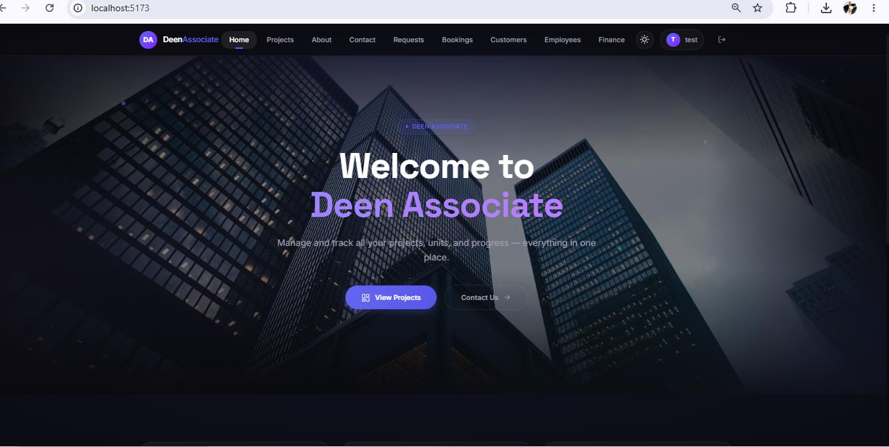
3.2 Registration and Login
New customers create a client account using Sign Up. Existing users sign in with Log in. Administrator accounts are typically created by system staff and are not available through public self-registration.
206

Access level: Guest → Client or Admin after successful authentication
The login dialog collects email and password. On success, the system stores a secure session
token and loads the navigation appropriate to the user's role.
• Click Log in on the navigation bar.
• Enter your registered email address and password.
• Submit the form to access role-based pages.
Figure 2: Login Dialog
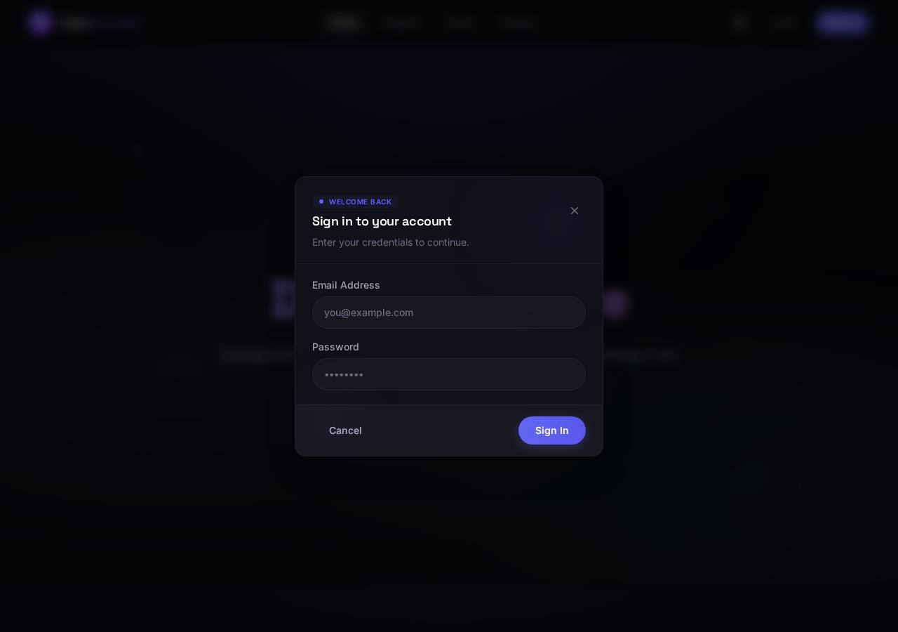
Sign Up Dialog
Access level: Guest → new Client account
The sign-up dialog creates a new customer account. Provide full name, email, and password.
After registration, return to Log in with the same credentials.
• Click Sign Up on the navigation bar.
• Enter full name, email, and password.
• Complete registration, then log in with the new account.
Figure 3: Sign Up Dialog
207

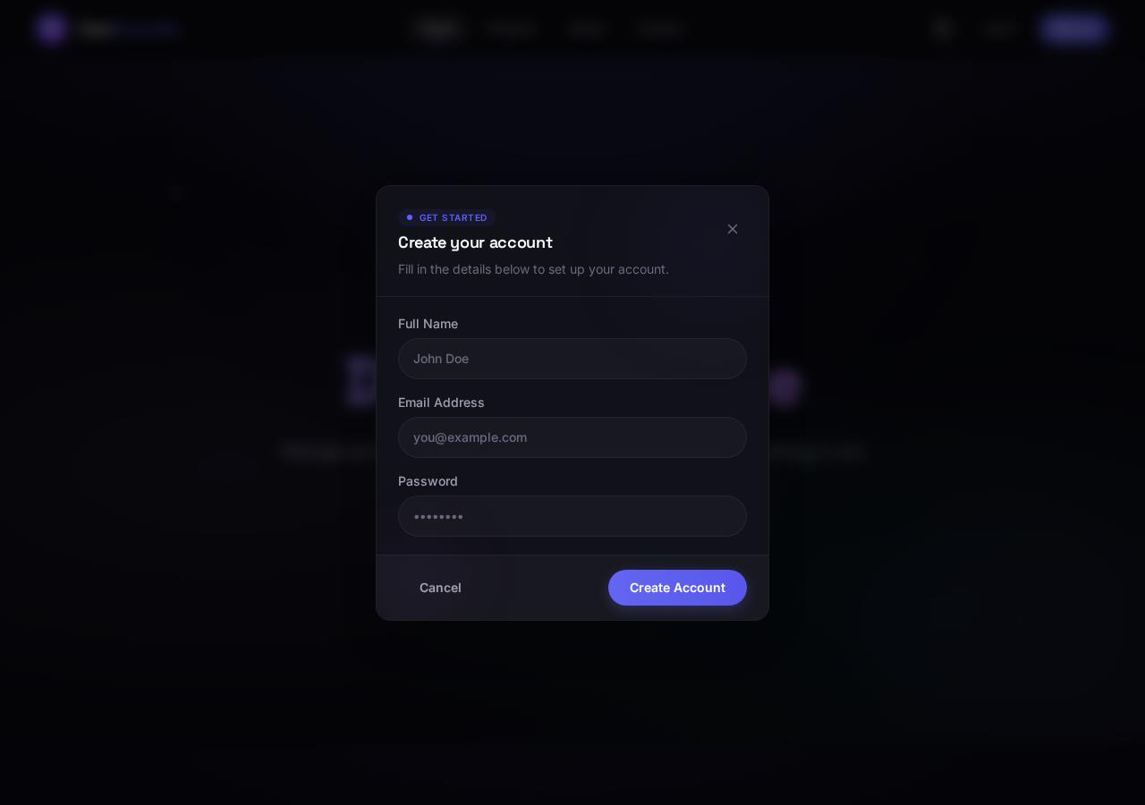
3.3 Theme and Profile Controls
The sun/moon icon in the navigation bar toggles light and dark mode. When logged in, the profile chip shows the account initial and email prefix; the adjacent button logs the user out.
4. Client User Guide
The following screens support the customer journey: discovering projects, reviewing units, submitting booking interest, and tracking confirmed purchases.
Projects Listing
Access level: Guest / Client / Admin (browse mode)
The Projects page lists all published developments. Each card shows the project name, location, status, and summary information. Select a project to open its detail view.
• Click Projects in the navigation bar.
• Review available developments and their current status.
• Open a project to inspect units and media.
Figure 4: Projects Listing
208

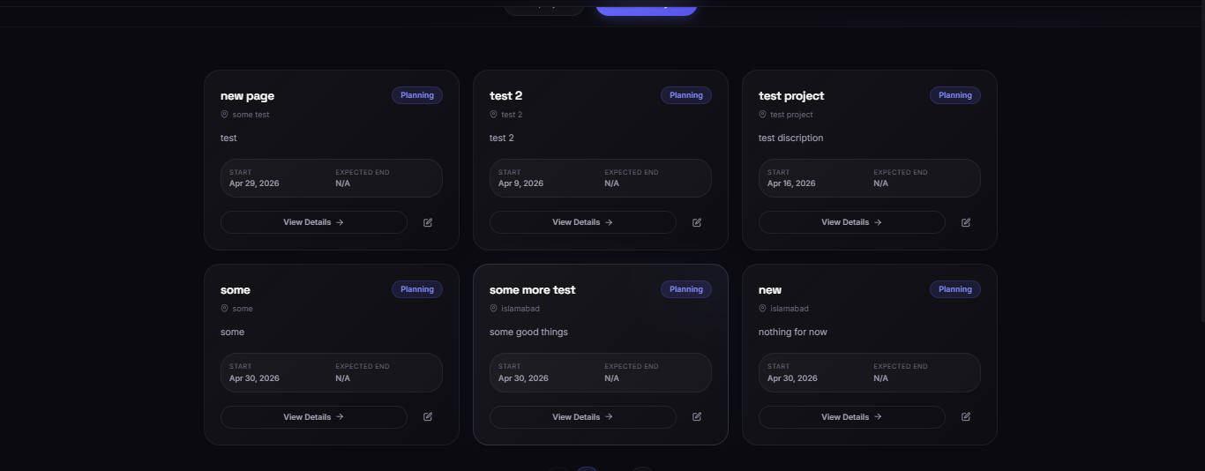
Project Detail — Overview Tab
Access level: Guest / Client / Admin
The Overview tab describes the selected project, including location, launch date, and current delivery stage on the timeline (Planning, Construction, Handover, Completed). This helps clients understand project progress before booking.
• Open a project from the Projects list.
• Read the About This Project section and metadata row.
• Review the Project Timeline to see the current stage.
Figure 5: Project Detail — Overview Tab
209

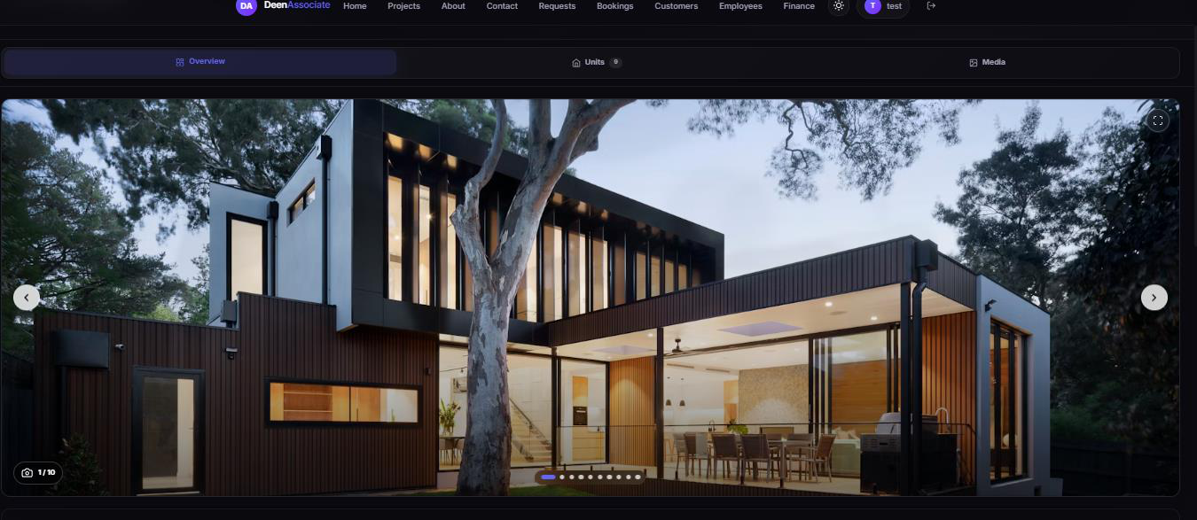
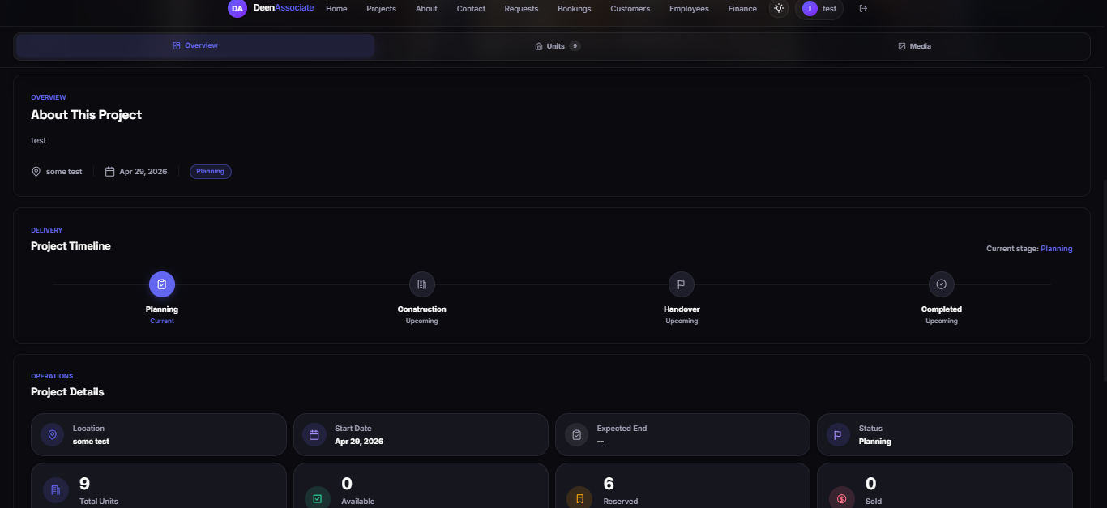
Project Detail — Units Tab
Access level: Guest / Client / Admin
The Units tab displays all units in the project as cards with photos, type, floor, area, and availability status (for example Available, Reserved, OnPaymentPlan). Clients use this screen to choose a unit before submitting a booking request.
• Switch to the Units tab on a project page.
• Use search and filters for type, status, floor, or sort order.
• Open a unit card to view full details and start a booking request.
Figure 6: Project Detail — Units Tab
210

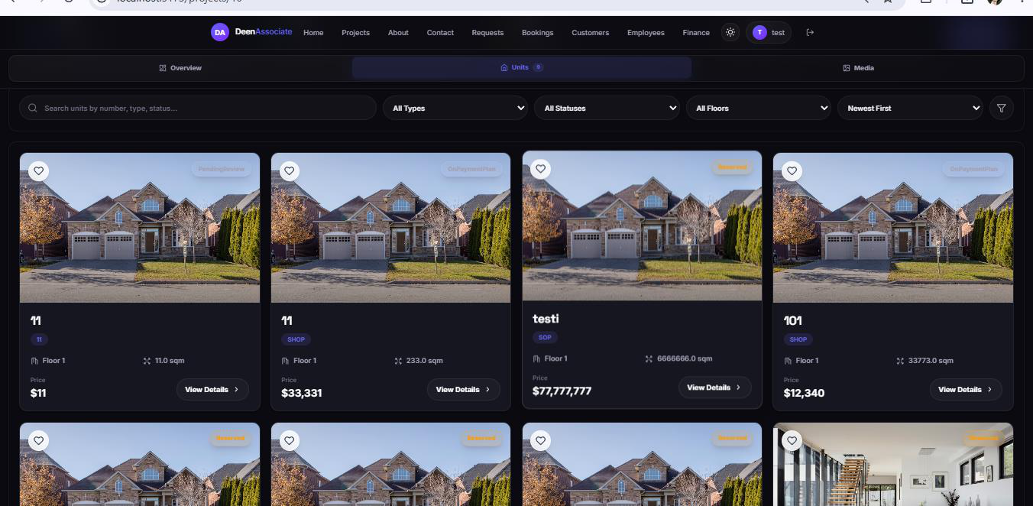
Project Detail — Media Tab
Access level: Guest / Client / Admin
The Media tab shows gallery images and uploaded files for the project. Clients use this section to
review marketing visuals, floor plans, or brochures before making a purchase decision.
• Switch to the Media tab.
• Browse uploaded gallery items and file details.
• Use carousel controls where available for full-size viewing.
Figure 7: Project Detail — Media Tab
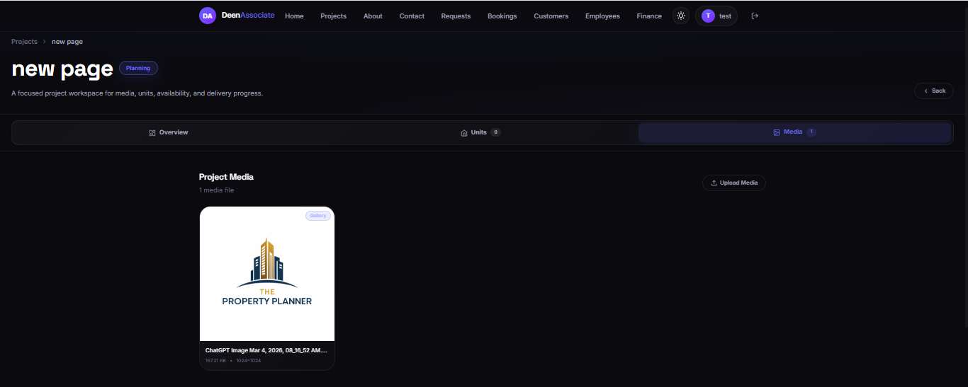
From a unit detail page, an authenticated client can submit a booking request. The request enters
the admin Requests queue for review. Once approved and converted into a confirmed booking,
211

My Projects
Access level: Client only
My Projects is the client dashboard for confirmed bookings. Each row or card shows booking
reference, project, unit, agreed price, booking amount progress, installment totals, and current
status (for example PaymentPlanActive).
• Log in with a client account.
• Click My Projects in the navigation bar.
• Select a booking to view payment history, schedule, forms, and receipts.
Administrators are redirected away from My Projects because they manage bookings from the
admin Bookings module instead.
Figure 8: My Projects
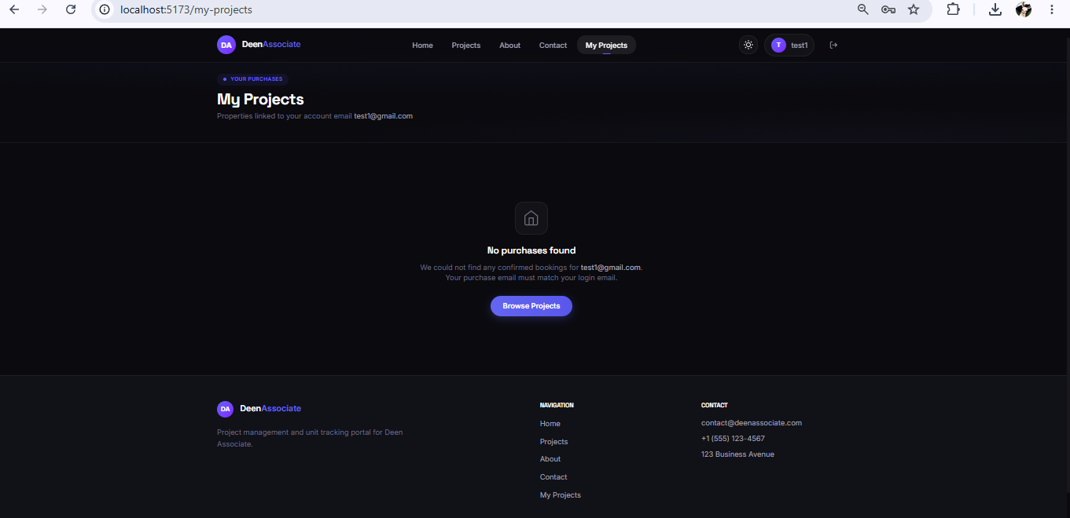
Application Form (Client View)
Access level: Client (own booking) · Admin (any booking)
The application form is the official customer record for a confirmed booking. It includes serial
number, date, unit details, applicant information, and next of kin fields. Clients access it from
their booking detail; administrators open it via Print Application Form on the admin booking
page.
• Open the booking from My Projects (client) or Confirmed Bookings (admin).
• Choose Print Application Form or the equivalent view action.
• Use Print / Save as PDF in the browser for a downloadable copy.
Figure 9: Application Form (Client View)
212

Payment Receipt (Client View)
Access level: Client (own payments) · Admin (all payments)
Every recorded payment generates a printable receipt with receipt number, amount in words,
payment type (Down Payment or Installment), mode of payment, and reference details. Clients
can open receipts linked to their bookings; administrators open them after recording a payment.
• Open the booking or installment history.
• Select the receipt for a completed payment.
• Print or save the receipt as PDF for your records.
Figure 10: Payment Receipt (Client View)
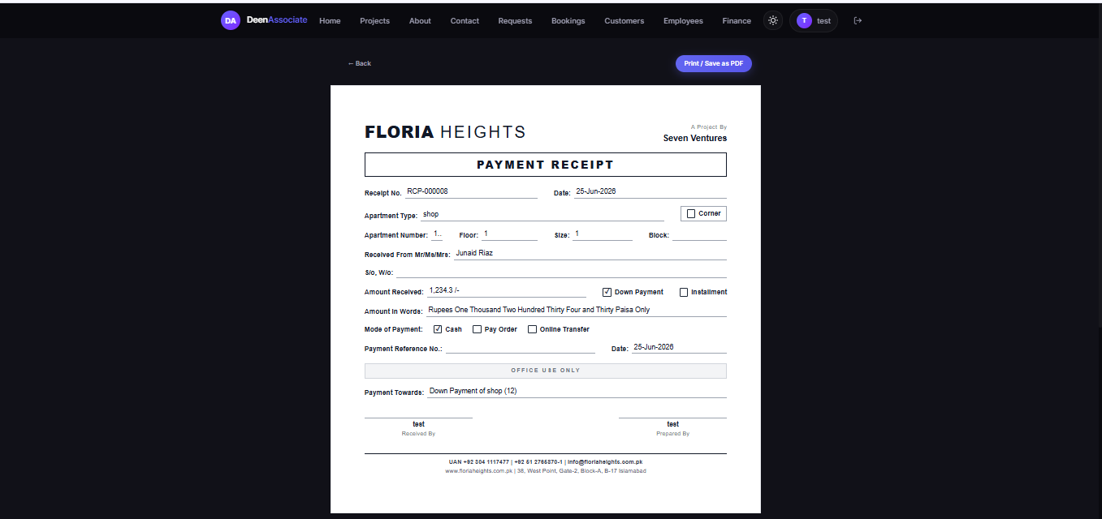
213

About and Contact Pages
Access level: Guest / Client / Admin (public information)
The About and Contact pages provide company information and a way to reach Deen Associate. These pages do not require login.
• Use About to read company background and mission content.
• Use Contact to find phone, email, or inquiry options.
Figure 11: About and Contact Pages
214

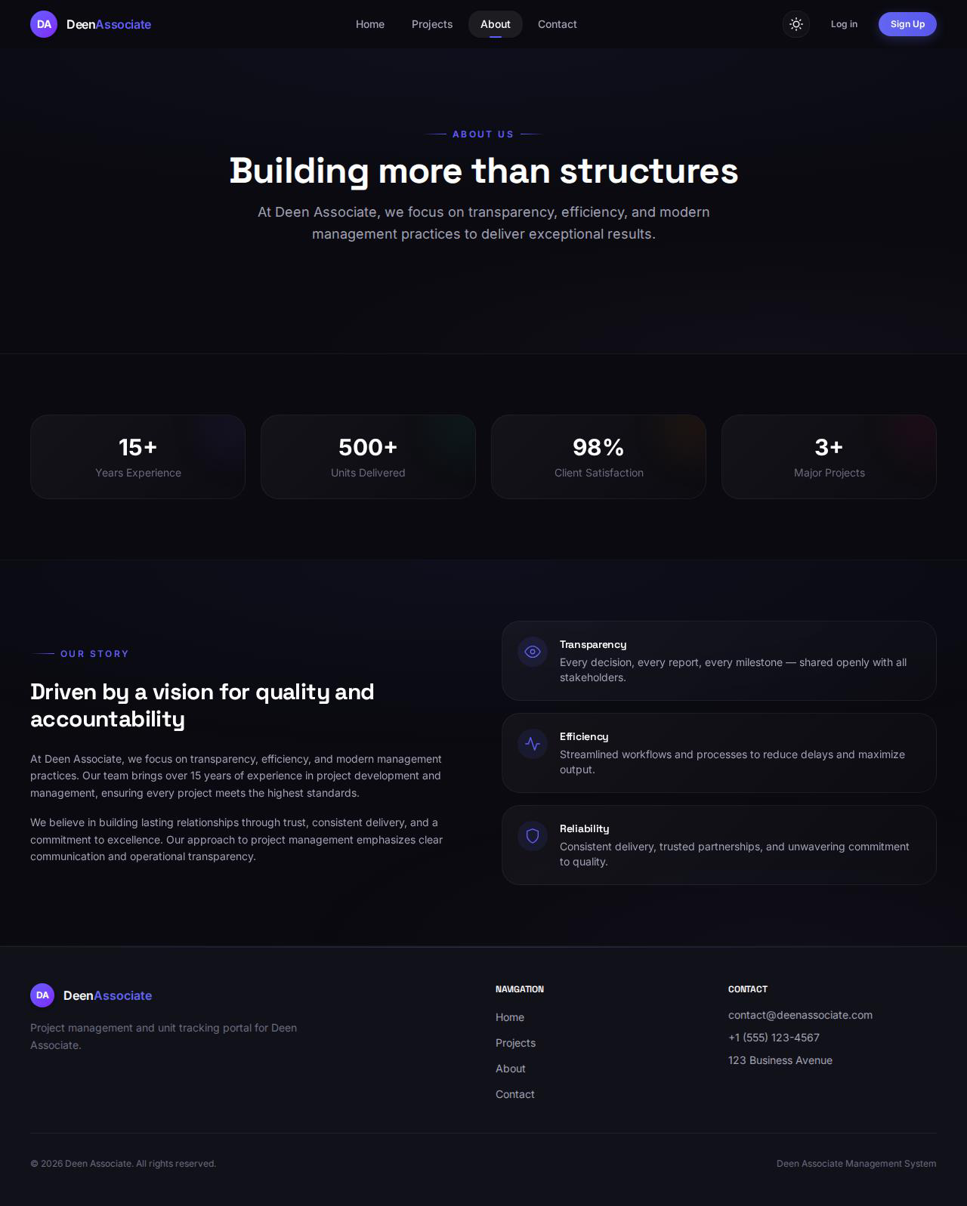
Figure 12: Contact Page
215

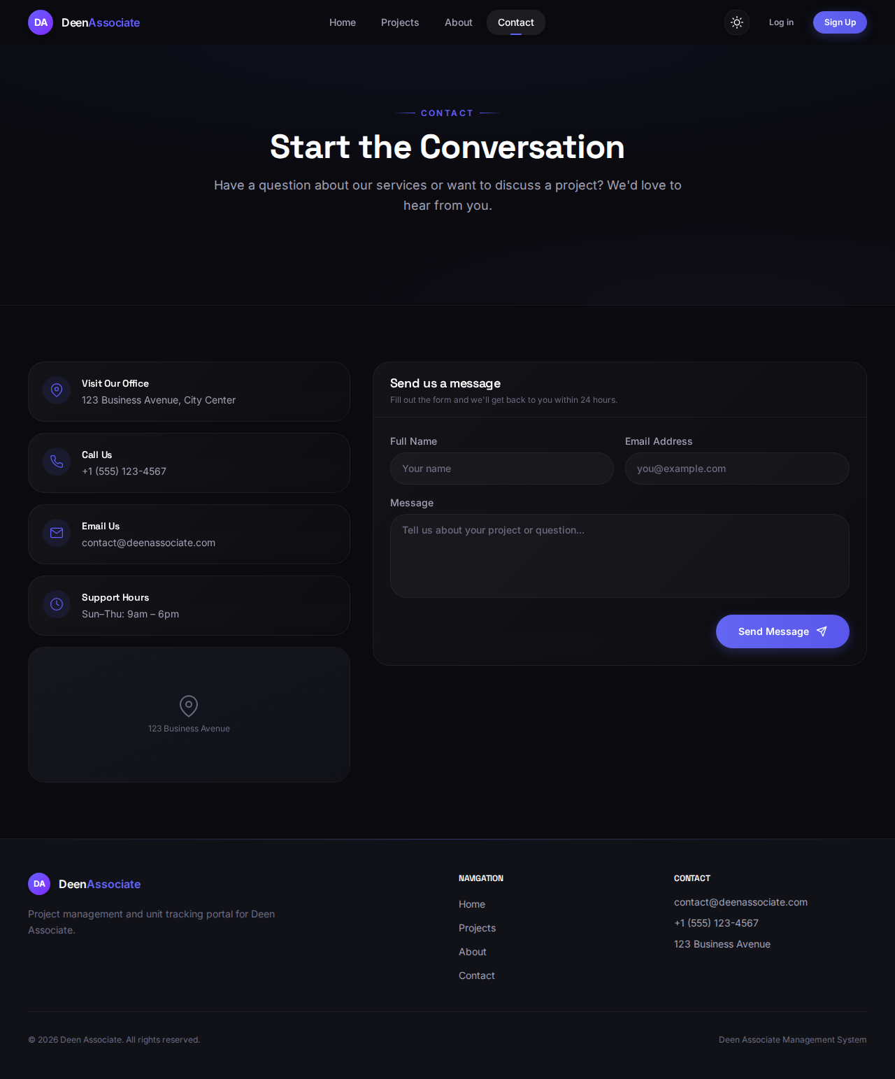
5. Administrator User Guide
Administrators use the expanded navigation bar to run daily operations. The sections below follow the typical workflow: requests → confirmed bookings → payments → documents → staff → finance.
216

5.1 Booking Requests and Confirmed Bookings
Requests lists incoming booking inquiries submitted by clients. After verification, an admin
approves the request and creates a confirmed booking. The Bookings module then tracks the full
financial lifecycle of that sale.
Confirmed Booking Detail and Installment Setup
Access level: Admin only
The booking detail page (example: BK-000007) is the control center for a confirmed sale.
Summary cards show agreed sale price, booking amount received/remaining, and installment
pool. The Regenerate Installment Plan section lets the admin negotiate final terms: sale price,
discount, frequency, number of installments, start date, and optional possession amount.
• Open Bookings and select a confirmed booking.
• Review financial summary cards at the top of the page.
• Enter or adjust plan fields in Regenerate Installment Plan.
• Check the preview line (for example, 12 installments × amount).
• Click Regenerate Schedule to rebuild the installment table.
• Use Print Application Form or Cancel Booking when needed.
The Payment Plan Active badge indicates an installment schedule is currently in force for the
booking.
Figure 13: Confirmed Booking Detail and Installment Setup
217

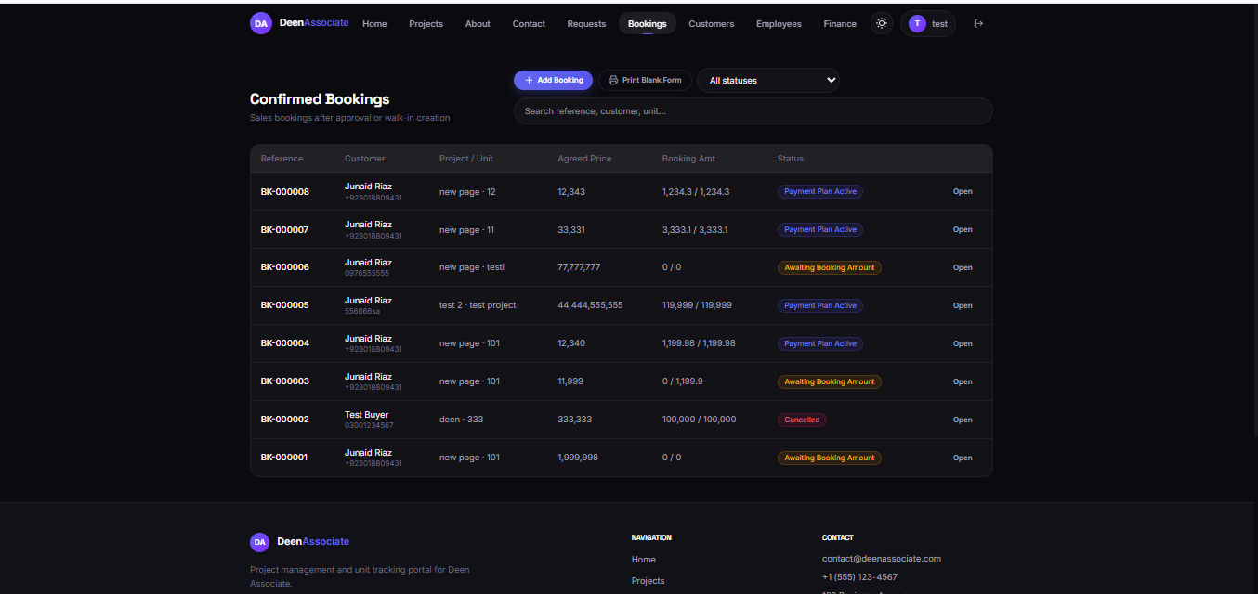
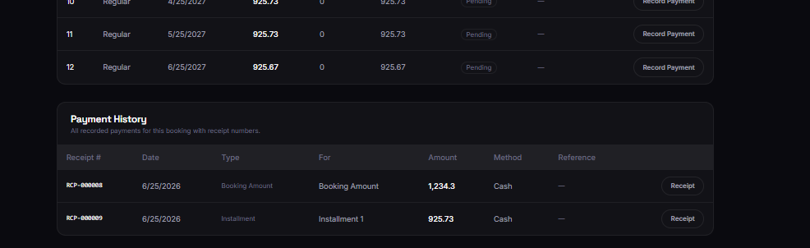
Installment Schedule
Access level: Admin only
After a plan is generated, the Installment Schedule table lists each installment with sequence
number, type, due date, amount, paid amount, remaining balance, status, and notes. The header
summarizes total, paid, and remaining amounts.
• Scroll to Installment Schedule on the booking detail page.
• Review due dates and pending or paid statuses.
• Click Record Payment on the row you are collecting.
Figure 14: Installment Schedule
218

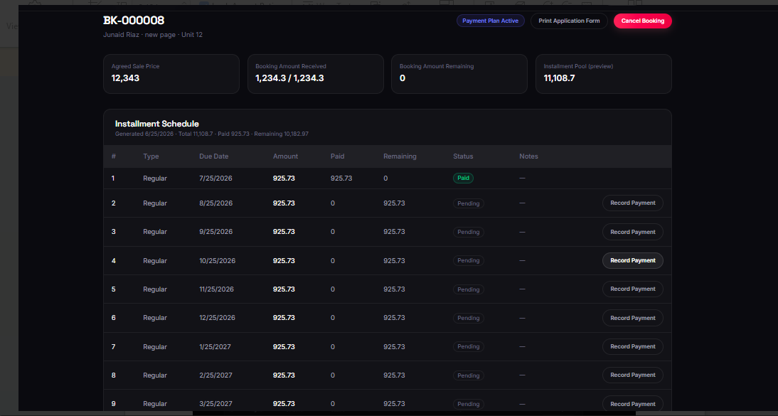
Record Installment Payment Dialog
Access level: Admin only
The Record Installment Payment dialog captures collection details: amount (defaults to
remaining balance), payment method (Cash, bank transfer, etc.), optional reference, payment
date, and notes. Saving updates the schedule and creates a receipt in the finance ledger.
• Click Record Payment on an installment row.
• Confirm or edit the amount and payment method.
• Enter reference and payment date if applicable.
• Click Record Payment to post the transaction.
• Open the generated receipt to print for the customer.
Figure 15: Record Installment Payment Dialog
219

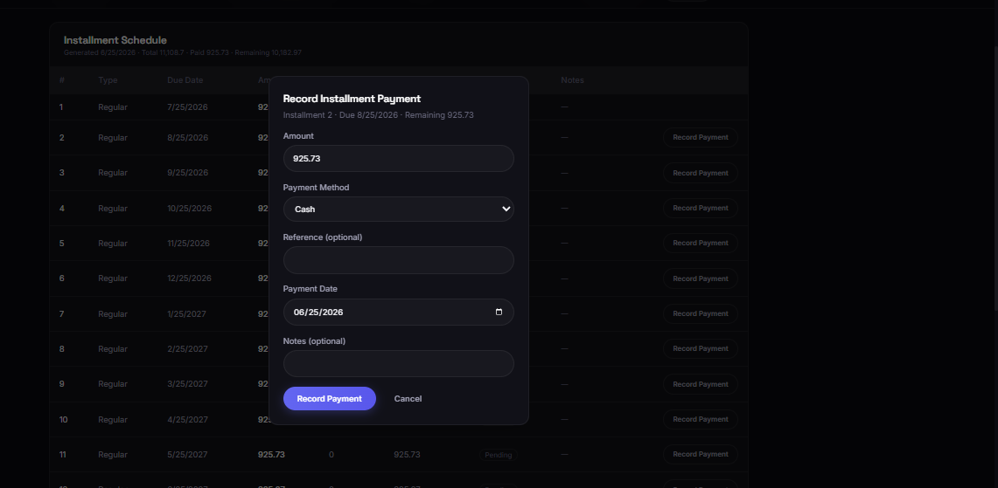
5.2 Customers Module
Customers stores registered client profiles linked to bookings. Administrators use this module to
review contact details, view booking history, and maintain customer records. Access it from the
Customers link in the admin navigation bar.
• Search customers by name, email, or phone.
• Open a customer to inspect linked bookings and profile fields.
• Use customer records when creating manual bookings or verifying identity.
5.3 Employees Module
Employees is an admin-only HR area with three tabs: Team, Attendance, and Salaries.
Employees — Team Tab
Access level: Admin only
The Team tab lists all employees with position, department, status, assignments, phone, and join
date. Use Add Employee to onboard staff and View Details to open a full profile.
• Click Employees in the navigation bar.
• Ensure the Team tab is selected.
• Search or filter by status and department.
• Add or open an employee record as needed.
Figure 16: Employees — Team Tab
220

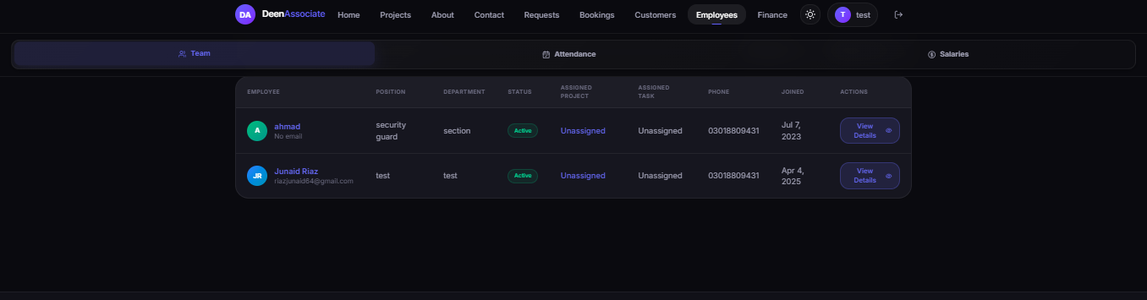
Employees — Attendance Tab
Access level: Admin only
The Attendance tab records daily presence. Select a date, mark each employee Present or Absent,
optionally capture a reason, then Save a row or Save All.
• Switch to the Attendance tab.
• Choose the attendance date.
• Mark Present or Absent for each employee.
• Click Save on a row or Save All to store the sheet.
Figure 17: Employees — Attendance Tab
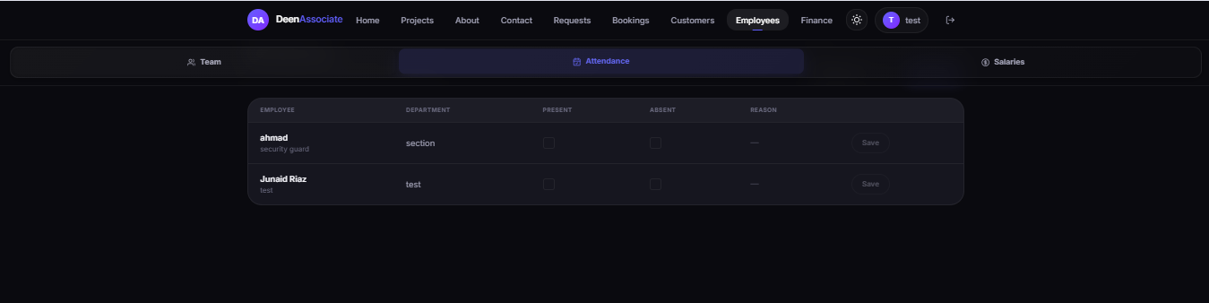
Employees — Salaries Tab
Access level: Admin only
The Salaries tab generates monthly payroll. Select the month, review each employee's salary,
mark Paid when disbursed, and View Receipt for processed salary payments. Salary payments
also appear in Finance as expense entries.
• Switch to the Salaries tab.
• Choose the payroll month.
• Confirm salary amounts (editable where permitted).
• Mark Paid and open the receipt after payment.
Figure 18: Employees — Salaries Tab
221

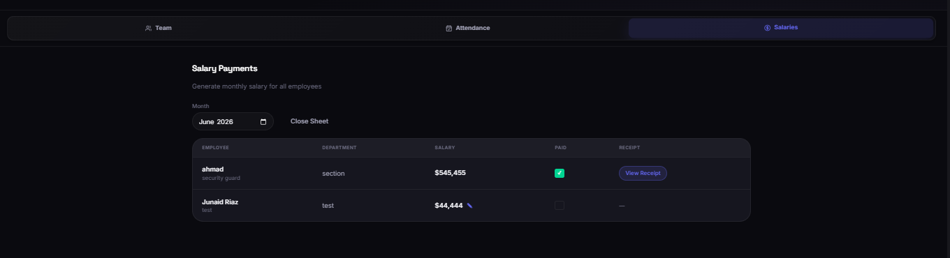
5.4 Finance Module
Finance gives administrators a company-wide view of revenue, expenses, profit, outstanding
receivables, and overdue installments. Revenue includes automatic entries from booking and
installment payments plus manually entered income.
Finance Dashboard — Revenue View
Access level: Admin only
The Revenue view shows summary cards and a detailed table. Automatic Payment rows link to
receipts (for example, RCP-000006). Manual Revenue rows can be edited or deleted.
• Click Finance in the navigation bar.
• Review Total Revenue, Expenses, Net Profit, Outstanding, and Overdue cards.
• Keep the Revenue tab selected to audit incoming money.
• Use Add Revenue for manual income not tied to a booking payment.
Figure 19: Finance Dashboard — Revenue View
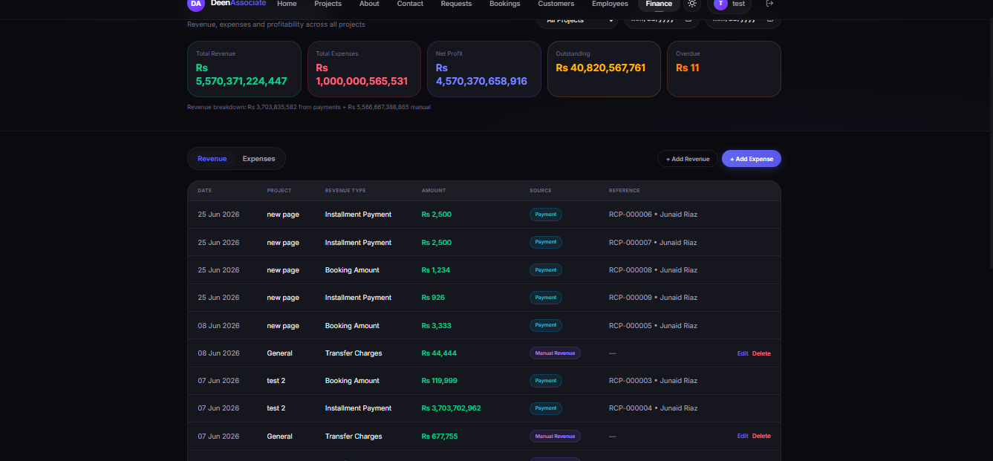
Add Manual Revenue Dialog
222

Manual revenue records non-booking income such as transfer charges, documentation fees, parking charges, or other project income. Select project (or General), revenue type, amount, date, and optional reference/description.
• On the Finance page, click Add Revenue.
• Choose project and revenue type.
• Enter amount and transaction date.
• Save to post the entry to the revenue ledger.
Figure 20: Add Manual Revenue Dialog
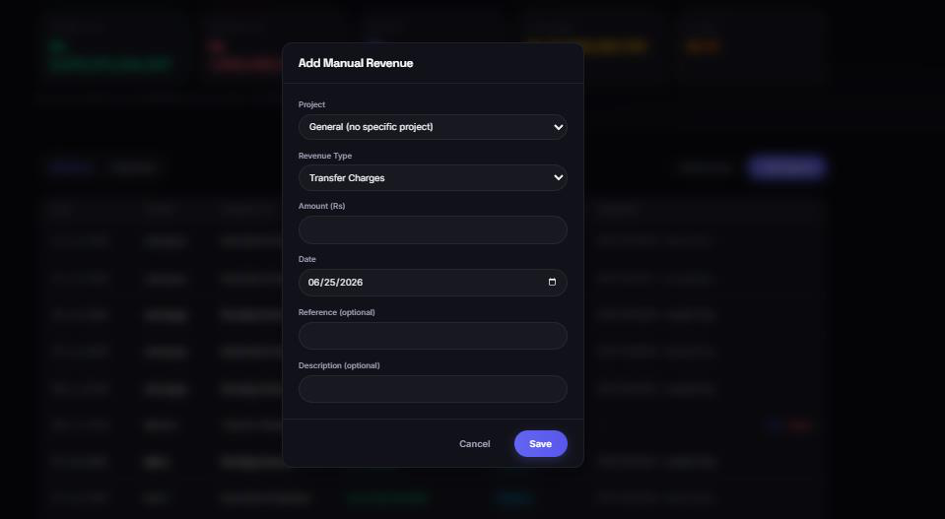
Finance Dashboard — Expenses View
Access level: Admin only
The Expenses view lists operational costs such as salaries and materials. Each row shows date, project, category, amount, description, and reference. Admins can Add Expense or edit/delete manual expense rows.
• Switch the Finance toggle to Expenses.
• Review categories and amounts.
• Click Add Expense for new costs.
• Use Edit or Delete on manual expense entries when corrections are required.
Figure 21: Finance Dashboard — Expenses View
223

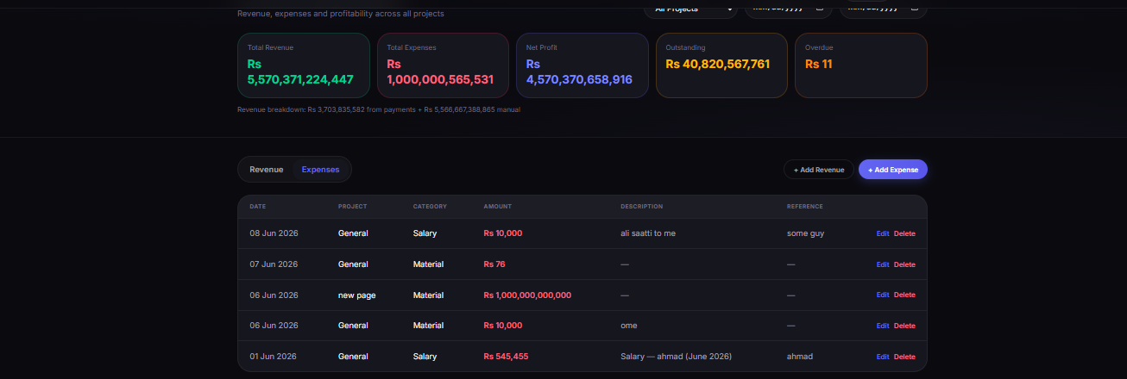
5.5 Project and Media Management
Administrators maintain project content through the same project detail pages clients use to browse, but with additional create/edit/upload capabilities available from admin workflows (project setup, unit inventory, and media uploads). The Overview, Units, and Media tabs shown in Section 4 also apply to admin maintenance—admins ensure descriptions, statuses, and gallery assets remain accurate for client-facing pages.
6. Quick Reference — Who Can Access What
Screen / Module | Guest | Client | Admin
Home, About, Contact | Yes | Yes | Yes
Projects & unit browsing | Yes | Yes | Yes
Sign Up / Log in | Yes | Yes | Yes
Submit booking request | No | Yes | Yes
My Projects | No | Yes | No
Requests | No | No | Yes
Bookings (admin list & detail) | No | No | Yes
Record installment payment | No | No | Yes
Customers | No | No | Yes
Employees | No | No | Yes
Finance | No | No | Yes
Application form & receipt (own booking) | No | Yes | Yes (all)
7. Tips and Troubleshooting
• If pages appear empty after login, confirm the backend API is running and the browser has network access.
• Clients who cannot see My Projects should verify the booking is confirmed and linked to their account.
224

• Use Print / Save as PDF for application forms and receipts rather than screenshots for official
records.
• Finance outstanding and overdue cards update when installment payments are recorded
against bookings.
• Log out from the profile menu when using a shared computer.
225

