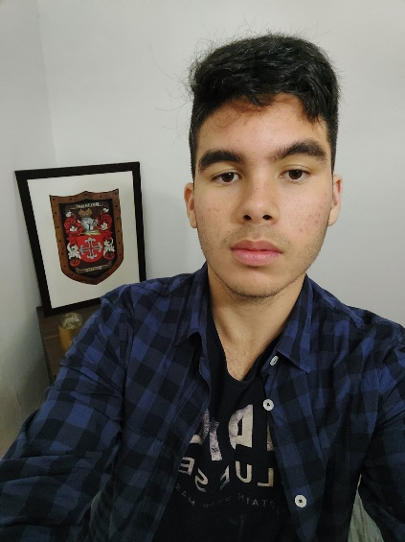

Renan Pereira

Front End Developer

Summary

I'm frontend developer trained as a technician in the management and programming of computer systems.

My specialty includes: **React, HTML, CSS, PHP, JS.**

Skill Highlights

|  |  |
| --- | --- |
| * Python * PHP * SQL * JS | * HTML * CSS * Flask * React |

Experience

**Database management**- 06/2022 to 07/2022

**Portimar**, Portugal

* My role in the company was to manage the database by implementing and filtering the company's data, portimar is a large company in the field of tourism.

**Web Developer** - 05/2023 to 06/2022

**ByBruno**, Portugal

* My role in this company was to be a web developer for several company sites, using AJAX, PHP, JS, Wordpress.

Education

Level 4 Technician: **Management and Programming of Computer Systems** - 2023

**School Manuel Teixeira Gomes**, PT

Certifications

Cs50x Havard (certificate):

Programming Languages: **JavaScript, HTML5, PHP, CSS, SQL, MySQL, Python, Flask**.

Contact

**Portfolio:**

<https://rib3ni.github.io/Portifolio>

**LinkedIn:**

<https://www.linkedin.com/in/renan-augusto-562251243/>

**GitHub:**

<https://github.com/rib3ni>

**Phone:**

+44 07564326865

**Address:**

**1 Ticehurst, Brighton**

**BN2 5PU**

**Email:**

[renanaugustolima@gmail.com](mailto:renanaugustolima@gmail.com)

Languages

English – B2

Portuguese – C2(Native Language)