CPU

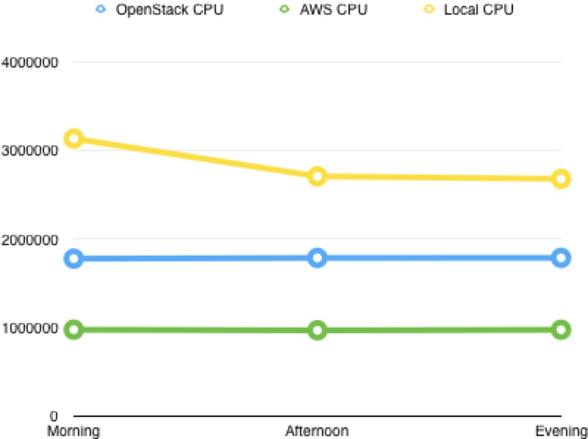

Memory

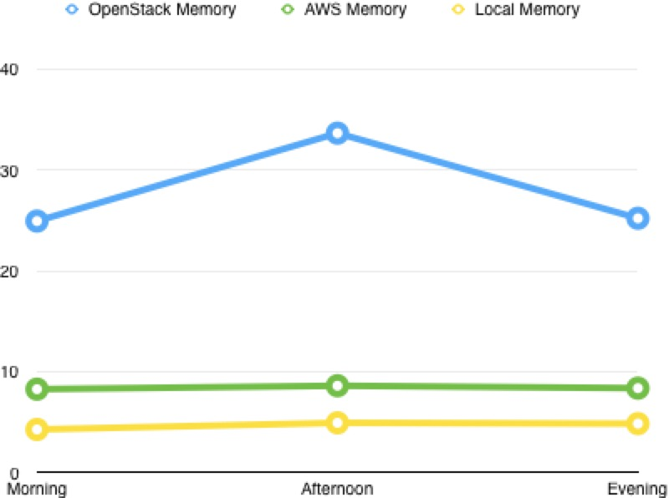

randread

rand reand&write

rand write

seq read

seq read&write

seq write