Create a React App from Scratch in 2021

Become a better coder by learning what create-react-app is doing under the hood.

Meg Shulmister
Follow
Feb 20 · 4 min read
You’ve worked on a few (or maybe a lot) of React projects but may have only started your own project by using create-react-app.
Create-react-app is great for beginners who just want to get their hands into some React code without going through the trouble of configuring the project with Webpack and Babel.
But you’re stronger now. You’re owning React….and now it’s time to soldier on by creating your project from the ground up. The “React” equivalent of building your car engine from scratch.
Fear not. You’ve got this.

Create project directory
First, create a new directory and cd into it.
mkdir my-app-from-scratch && cd my-app-from-scratch
Next, let’s initialize the app with npm to manage all our dependencies.
npm init -y
Great! Now you have your package.json file set up.

Install Dependencies
Next up, let’s install all the dependencies we’ll need for this application. Run this command and continue below for a breakdown of everything we just installed.
npm i webpack babel-loader @babel/preset-react @babel/core babel-preset-react html-webpack-plugin webpack-dev-server css-loader style-loader @babel/plugin-proposal-class-properties webpack-cli -D && npm i react react-dom -S
What we just installed:
- Webpack: bundles all our files into one file
- babel-loader: works with Webpack to transpile ES6+ into ES5 which is supported by older browsers
- @babel/preset-react: extends Babel support to JSX
- html-webpack-plugin: “simplifies the creation of HTML files to serve your Webpack bundles” -https://webpack.js.org/plugins/html-webpack-plugin/
- webpack-dev-server: allows you to use Webpack with a development server that provides live reloading.
- webpack-cli: “webpack CLI provides a flexible set of commands for developers to increase speed when setting up a custom Webpack project.” -https://www.npmjs.com/package/webpack-cli
- css-loader: allows Webpack to convert the CSS file into a JavaScript string.
- style-loader: inserts the JavaScript string into HTML dom.
- @babel/plugin-proposal-class-properties: “This plugin transforms static class properties as well as properties declared with the property initializer syntax” -https://www.npmjs.com/package/@babel/plugin-proposal-class-properties
- react: JavaScript library
- react-dom: “Serves as the entry point to the DOM and server renderers for React” -https://www.npmjs.com/package/react-dom

Add src directory and index.js file
mkdir src && cd src && touch index.js

Add file src/index.html
While still inside the src directory, type this command into the terminal:
touch index.html
Your file tree should currently look like this:
my-app-from-scratch/
┣ node_modules/
┣ src/
┣ index.html
┗ index.js
┣ package-lock.json
┗ package.json
Great!

Now let’s add some starter code
Inside of src/index.html add this code:
<!doctype html><html lang=”en”>
<head>
<meta charset=”utf-8">
<title>My React App from Scratch</title>
</head>
<body>
<div id=”app”></div>
</body>
</html>
Inside of src/index.js add this code:
import ReactDOM from ‘react-dom’;
import React from ‘react’;const App = () => {
return <h1>This is my React app!</h1>;
}ReactDOM.render(<App />, document.getElementById(‘app’));

Configure Webpack & Babel
Awesome. Now it’s time to rig up our Webpack and Babel configuration files. These files allow us to customize Webpack & Babel to handle things like JSX and CSS inside of our project.
In the root directory, type this into your terminal:
touch .babelrc && touch webpack.config.js
Your file tree should look like this:
my-app-from-scratch/
┣ node_modules/
┣ src/
┣ index.html
┗ index.js
┣ .babelrc
┣ package-lock.json
┣ package.json
┗ webpack.config.js
Inside of webpack.config.js add this code:
const HtmlWebPackPlugin = require(“html-webpack-plugin”);
const htmlPlugin = new HtmlWebPackPlugin({
template: “./src/index.html”,
filename: “./index.html”
});module.exports = {mode: ‘development’,
module: {
rules: [{
test: /\.js$/,
exclude: /node_modules/,
use: {
loader: “babel-loader”
}
},
{
test: /\.css$/,
use: [“style-loader”, “css-loader”]
}
]},
plugins: [htmlPlugin]
};
Inside of .babelrc add this code:
{
“presets”: [“@babel/preset-react”],
“plugins”: [“@babel/plugin-proposal-class-properties”]
}

Add ‘start’ script to package.json
Inside of package.json, add this code in scripts.
"start": "webpack serve --config webpack.config.js"
Your package.json file should look like this:
{
“name”: “my-app-from-scratch “,
“version”: “1.0.0”,
“description”: “”,
“main”: “webpack.config.js”,
“scripts”: {
“test”: “echo \”Error: no test specified\” && exit 1",
"start": "webpack serve --config webpack.config.js"
},
“keywords”: [],
“author”: “”,
“license”: “ISC”, “devDependencies”: {
“@babel/preset-react”: “⁷.12.13”,
“babel-core”: “⁶.26.3”,
“babel-loader”: “⁸.2.2”,
“babel-preset-react”: “⁶.24.1”,
“css-loader”: “⁵.0.2”,
“html-webpack-plugin”: “⁵.1.0”,
“style-loader”: “².0.0”,
“webpack”: “⁵.22.0”,
“webpack-cli”: “⁴.5.0”,
“webpack-dev-server”: “³.11.2”
},
“dependencies”: {
“react”: “¹⁷.0.1”,
“react-dom”: “¹⁷.0.1”
}
}

Test to see your app running in the browser
Now it’s time for our moment-of-truth to see all our hard work in action!
In the root directory terminal, run
npm run start
You should see your app running at http://localhost:8080/ in the browser.
https://javascript.plainenglish.io/create-a-react-app-from-scratch-in-2021-8e9948602e9c

Great work! You made a React application completely from scratch!
Resources:
https://webpack.js.org/
https://babeljs.io/

Sign up for Last Week in Plain English

By JavaScript in Plain English
Updates from the world of programming, and In Plain English. Always written by our Founder, Sunil Sandhu. Take a look.

Crie um novo React App
Use uma toolchain integrada para uma melhor experiência de usuário e desenvolvedor.
Esta página descreve algumas toolchains populares com React que ajudam em tarefas como:
- Escalar para muitos arquivos e componentes.
- Usar bibliotecas de terceiros através do npm.
- Detectar erros comuns cedo.
- Edição em tempo real de CSS e JS em desenvolvimento.
- Otimizar a saída para produção
As toolchains recomendadas nesta página não requerem configuração para começar.

Você Pode Não Precisar de Uma Toolchain
Se você não se depara com nenhum dos problemas descritos acima, ou se ainda não se sente confortável usando ferramentas JavaScript, considere simplesmente adicionar uma tag script numa página HTML, opcionalmente usando JSX.
Esta é a maneira mais fácil de integrar React a um site já existente. Você pode a qualquer momento adicionar à toolchain conforme achar útil.

Toolchains Recomendadas
A equipe React recomenda principalmente as seguintes soluções:
- Se você está aprendendo React ou criando um novo single-page app, use Create React App.
- Se você está fazendo um site renderizado no servidor (SSR) com Node.js, tente Next.js.
- Se você está fazendo um site estático orientado a conteúdo, experimente Gatsby.
- Se você está montando uma biblioteca de componentes ou integrando com um código-base existente, veja Toolchains Mais Flexíveis.

Create React App
Create React App é um ambiente confortável para aprender React, e é a melhor maneira de começar um single-page application em React.
Além de configurar seu ambiente de desenvolvimento para utilizar as funcionalidades mais recentes do JavaScript, ele fornece uma experiência de desenvolvimento agradável, e otimiza o seu app para produção. Será necessário ter Node >= 14.0.0 and npm >= 5.6 na sua máquina. Para criar um novo projeto, rode:
npx create-react-app my-app
cd my-app
npm start
Nota
npx na primeira linha não é erro de digitação — é um package runner que vem com npm 5.2+.
Create React App não lida com lógica de backend nem banco de dados. Ele apenas cria um build pipeline para o frontend, podendo portanto ser utilizado com qualquer backend de sua escolha. Por trás, Babel e Webpack estão sendo utilizados, mas não é necessário saber nada sobre eles.
Quando estiver pronto pra mandar pra produção, rode npm run build para criar e mandar o build otimizado de seu app para a pasta build. Você pode saber mais sobre o Create React App através de seu README e o Guia de Usuário.

Next.js
Next.js é um framework leve e popular para aplicações estáticas e renderizadas no servidor feito com React. Ele inclui soluções para estilização e roteamento prontas, e presume que esteja rodando Node.js como ambiente de servidor.
Aprenda Next.js através de seu guia oficial.

Gatsby
Gatsby é a melhor forma de criar sites estáticos usando React. Ele permite usar componentes React, porém produzindo HTML e CSS pré-renderizado para garantir a velocidade mais rápida possível de carregamento.
Aprenda Gatsby através de seu guia oficial e a galeria de starter kits.

Toolchains Mais Flexíveis
As seguintes toolchains oferecem mais flexibilidade e escolha. Nós as recomendamos para usuários mais experientes:
- Neutrino combina o poder do webpack com a simplicidade de presets, e inclui um preset para React apps e React components.
- Nx é um kit de ferramentas para o desenvolvimento de monorepo de stack completa, com suporte interno para o React, Next.js, Express, e mais.
- Parcel é um bundler de aplicativos web rápido e sem configuração que funciona com React.
- Razzle é um framework renderizado no servidor que não requer configuração, porém oferece mais flexibilidade que o Next.js.

Criando uma Toolchain do Zero
Uma build toolchain em JavaScript consiste tipicamente de:
- Um gerenciador de pacotes, como Yarn ou npm. Ele permite aproveitar de um vasto ecosistema de pacotes de terceiros, e facilmente instalar e atualizá-los.
- Um bundler, como webpack ou Parcel. Ele permite escrever código modular e empacotá-lo em pequenos pedaços para otimizar o tempo de carregamento.
- Um compilador como Babel. Ele nos permite escrever código JavaScript moderno que funcione até nos navegadores mais antigos.
Se você prefere criar a sua própria JavaScript toolchain do zero, dê uma olhada neste guia que recria algumas das funcionalidades do Create React App.
Não se esqueça de assegurar que sua toolchain customizada esteja corretamente configurada para produção.
https://pt-br.reactjs.org/docs/create-a-new-react-app.html

Create React App from Scratch like a Pro
#react #webpack #babel #webdev

Noob to Pro (6 Part Series)
1 Zero to Hero: Get started with Open Source Projects 2 Zero to Hero: Front End Developer Roadmap ... 2 more parts... 5 How Pros Get Rid of Relative Imports 6 DOMs Decoded: DOM, Shadow DOM & Virtual DOM
Creating a React App is a very difficult feat, even when you are an experienced developer. That led to the development of create-react-app, a Command Line Tool to streamline the process of creating a React app.
Using create-react-app comes with several added benefits such as rapid prototyping and making the development of React Apps accessible to beginners, but there are some disadvantages as well.
Since create-react-app aims to generate more or less an all-purpose app, leading to a lot of additional not-so-necessary dependencies for any given niche case. Another con for using create-react-app is customizing it might be a pain at times.
So let's dive into how to create your React Apps from scratch that allow you to customize the app to your heart's content

Step 0: Installing Node
This goes without saying, you need Node.js and npm or yarn (in this article I would be using npm). To test if you have them installed, run the following commands:
node -v
npm -v
In case you don't have them installed, I trust you with being able to install them, so I am moving on to the next step.

1. Initializing the project
Create a new folder and navigate into it. To initialize a node project use:
npm init
or if you are lazy like me, use:
npm init -y
and modify the generated package.json.

2. Installing dependencies
Now we would be adding the necessary Dependencies to our project.

1. React Dependencies
These are the only dependencies that are NOT dev dependencies
npm install react react-dom
Let's take a look at the libraries:
react: library we'll be working with.
react-dom: package to manage DOM elements.

2. Webpack Dependencies
Webpack is the most popular bundler in the world of Node.js. It bundles and even minifies the JavaScript files in the project.
npm install -save-dev webpack webpack-cli
Taking a look at the libraries:
webpack: the bundler.
webpack-cli: CLI for Webpack.

3. Webpack Loaders
Webpack needs loaders to preprocess files. They allow the user customize Webpack to bundle static resources beyond JavaScript.
npm install --save-dev babel-loader
For now, let's start with the absolutely necessary babel-loader (loader for Babel) and later add additional functionality based on need.

4. Babel Dependencies
Babel is a JavaScript compiler that converts (or rather transpiles) JavaScript ES6 to targeted version of JavaScript since not all browsers support ECMAScript 6 features. We would be using it to transpile the JSX code in our project to regular JavaScript that browsers can understand.
npm install --save-dev @babel/core @babel/preset-react
The dependencies:
@babel/core: Babel compiler core.
@babel/preset-react: package with a set of plugins used to support React features.
Phew! We are finally done with the dependencies!

3. Configuring Babel
To configure Babel, we need to add .babelrc in the root level of our project
{
"presets": [
"@babel/preset-react"
]
}

4. Configuring Webpack
Now its time to configure Webpack. Add the webpack.config.js at the root level of the project and add the following code:
const path = require("path");
const webpack = require("webpack");

module.exports = {
entry: "./src/index.js",
mode: "development",
output: {
filename: "bundle.js",
path: path.resolve("dist"),
publicPath: "/",
},
module: {
rules:[
{
test: /\.(js|jsx)$/,
exclude: /node_modules/,
use: "babel-loader"
},
],
},
}
And let’s see what all of this is doing:
- entry: The entry point for our application. In React, this is the file where we use our renderer.
- mode: The mode in which the application is being run (development or production).
- output: Informing Webpack where to put our bundled code and the name of the file.
- module: Informing Webpack how and when to use the loaders we installed. We’re using regex to tell each loader which file extensions to target.

5. HTML Body
Add an /public/index.html and the basic body:
<!DOCTYPE html>
<html lang="en">
<head>
<meta charset="UTF-8" />
<meta http-equiv="X-UA-Compatible" content="IE=edge" />
<meta name="viewport" content="width=device-width, initial-scale=1.0" />
<title>React From Scratch</title>
</head>
<body>
<div id="root"></div>

<!-- The bundle-name should be same as you defined in webpack config file -->
<script src="../dist/bundle.js"></script>
</body>
</html>

6. Creating the React App
Finally, we now start working on our app. Add /src/index.js (the entry point for the app mentioned in webpack.config.js)
import React from "react";
import ReactDOM from "react-dom";

import App from "./App"

ReactDOM.render(
<App />,
document.querySelector("#root")
);
and the App file /src/App.js
import React from "react";

export default function App() {
return (
<div>
<h1>React from Scratch</h1>
</div>
);
}

7. Adding Scripts
We are done making the app, but how do we run it?
Glad you asked. we need to add 2 scripts for ease of use:
"scripts": {
"build": "webpack --mode production",
"start": "webpack --mode development"
}
Now you can use npm run build or npm run start to bundle the React App and run the app from /public/index.html.

Conclusion
Now you too know how to Create an absolute basic React App from Scratch. YAY!

You can extend the functionality with additional plugins and loaders such as installing style-loader & css-loader and adding:
{
test: /\.css$/,
use: ['style-loader', 'css-loader']
}
in your webpack.config.js, you can implement CSS support in your React App
You can add webpack-dev-server to serve the website instead of opening the HTML file (and potentially more optimized start script), use HotModuleReplacementPlugin to enable Hot Reload and much more. The possibilities are endless. Now you can create React Apps that cater to your individual requirements.
All the best in your React Development journey! :)

Thanks for reading
Want to work together? Contact me on Upwork
Want to see what I am working on? Check out my GitHub
I am a freelancer who will start off as a Digital Nomad in mid-2022. Want to catch the journey? Follow me on Instagram
Follow my blogs for weekly new tidbits on Dev
FAQ
These are a few commonly asked questions I get. So, I hope this FAQ section solves your issues.
- I am a beginner, how should I learn Front-End Web Dev?
Look into the following articles:
  - Front End Development Roadmap
  - Front End Project Ideas
- Would you mentor me?
Sorry, I am already under a lot of workload and would not have the time to mentor anyone.

Zero to Hero: Get started with Open Source Projects
#opensource #beginners #tutorial #programming

Noob to Pro (6 Part Series)
1 Zero to Hero: Get started with Open Source Projects 2 Zero to Hero: Front End Developer Roadmap ... 2 more parts... 5 How Pros Get Rid of Relative Imports 6 DOMs Decoded: DOM, Shadow DOM & Virtual DOM
I had been super interested in contributing to Open Source Projects for a long time but didn't have any idea on how to get started. This article is for anyone who wants to get into Open Source Projects development but feels overwhelmed on how to start.

Prerequisite
You will need basic knowledge of git to follow along with this article. We will be focusing on Open Source Projects on GitHub, but the same skillset is transferable to any other git based site like GitLab.

Getting Started
- The first thing to do is Fork the repository you want to contribute to:
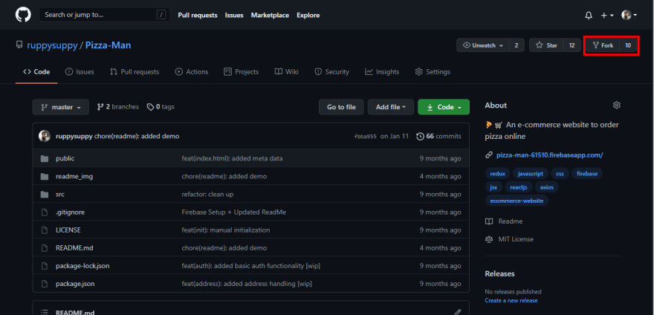
Now you have a copy of the repository in your GitHub account.
- Copy the clone link:
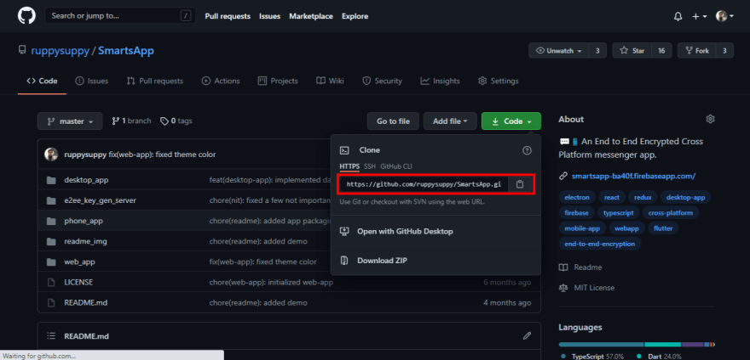
- Execute the command:

git clone <clone link>

- A copy of the repository will be created on your machine. Add Upstream remote, which is just a fancy name for the source repository, using:

git remote add <upstream remote name> <source repository clone link>

- Now you can modify the code. Make sure to commit all the changes you make.
- After committing changes, you can update the source repository using:

git push origin <branch name to push changes>

- Now you can create a Pull Request in the source repository and the maintainers would review and merge your code.

How to overcome the fear of starting?
Now that you know how to contribute to Open Source Projects, you might just want to jump right in and contribute to the largest projects on the planet. But I can assure you when you are about to open your first few Pull Request, Imposter Syndrome will hit you real hard with questions like "Would I be able to do this correctly?" and "What if I fail?". The only antidote to this fear is ACTION! If you are feeling unsure, contact the members of the organisation you want to contribute to, as most organisations use some platform like Discord to discuss about the contributions. One year ago I was exactly in your shoes, and now I do have a couple of contributions in some amazing repositories:
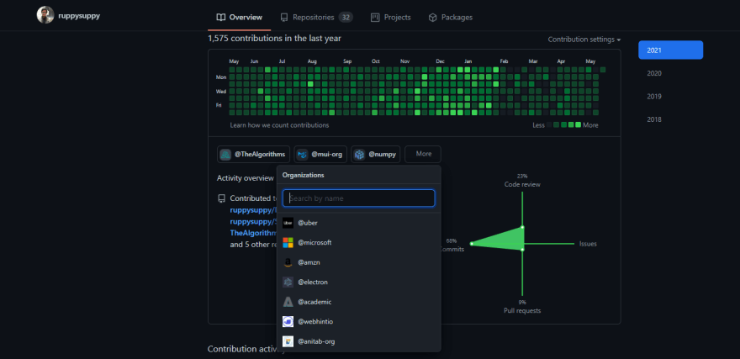
If you start on this journey and keep putting one foot in front of the other even when challenges and difficulties show up, you will make it! Best of Luck :)

Thanks for reading
Want to work together? Contact me on Upwork
Connect to me on:
- GitHub
- LinkedIn
- Portfolio

Noob to Pro (6 Part Series)
1 Zero to Hero: Get started with Open Source Projects 2 Zero to Hero: Front End Developer Roadmap ... 2 more parts... 5 How Pros Get Rid of Relative Imports 6 DOMs Decoded: DOM, Shadow DOM & Virtual DOM

