

In this post, I will share an example of how to implement jquery Datatables ajax in PHP and MySQL using PDO. If you have hundreds of thousands of records or even millions of records you don't want to load it at once to your HTML as we do in our previous example because it could slow your server performance. But using ajax you don't need to load all the records to your Datatable because it is paginated and you only show what we need.

Step 1: Create Table with MySQL
We will use the employee's table as an example with basic fields. See below table structure:
CREATE TABLE `employees` (
`id` int(10) NOT NULL,
`email` varchar(100) NOT NULL,
`first_name` varchar(100) NOT NULL,
`last_name` varchar(100) NOT NULL,
`address` varchar(250) NOT NULL
) ENGINE=InnoDB DEFAULT CHARSET=utf8mb4;

ALTER TABLE `employees`
ADD PRIMARY KEY (`id`);

ALTER TABLE `employees`
MODIFY `id` int(10) NOT NULL AUTO_INCREMENT, AUTO_INCREMENT=1;
COMMIT;

Step 2: PHP & MySQL Database Connection
Once your database and table are configured let's create a connection. See below:
<?php

$host = 'localhost';
$db = 'demos';
$user = 'root';
$password = '';

$dsn = "mysql:host=$host;dbname=$db;charset=UTF8";

try {
$conn = new PDO($dsn, $user, $password, [PDO::ATTR_ERRMODE => PDO::ERRMODE_EXCEPTION]);

} catch (PDOException $e) {
echo $e->getMessage();
}

As you can see our connection is coded with PDO.

Step 3: Index with Datatables
Now let's configure our HTML with Datatable and Ajax script. See below code:
<!DOCTYPE html>
<html>
<head>
<meta charset="utf-8">
<title>JQuery Datatable Example</title>

<link rel="stylesheet" type="text/css" href="https://cdn.datatables.net/1.11.3/css/jquery.dataTables.min.css">

<script type="text/javascript" src="https://code.jquery.com/jquery-3.5.1.js"></script>
<link href="https://cdn.jsdelivr.net/npm/bootstrap@5.0.2/dist/css/bootstrap.min.css" rel="stylesheet" integrity="sha384-EVSTQN3/azprG1Anm3QDgpJLIm9Nao0Yz1ztcQTwFspd3yD65VohhpuuCOmLASjC" crossorigin="anonymous">
<script type="text/javascript" src="https://cdn.datatables.net/1.11.3/js/jquery.dataTables.min.js"></script>

<script type="text/javascript">
$(document).ready(function() {
$('#jquery-datatable-ajax-php').DataTable({
'processing': true,
'serverSide': true,
'serverMethod': 'post',
'ajax': {
'url':'datatable.php'
},
'columns': [
{ data: 'email' },
{ data: 'first_name' },
{ data: 'last_name' },
{ data: 'address' }
]
});

} );
</script>
</head>
<body>

<div class="container mt-5">
<h2 style="margin-bottom: 30px;">jQuery Datatable Ajax PHP Example</h2>
<table id="jquery-datatable-ajax-php" class="display" style="width:100%">
<thead>
<tr>
<th>Email</th>
<th>Firstname</th>
<th>Lastname</th>
<th>Address</th>
</tr>
</thead>
</table>
</div>

</body>
</html>

Step 4: Our Datatables PHP & MySQL Code with PDO
Next, our code for our Datatables Ajax PHP and MySQL code using PDO.
<?php
// Database Connection
include 'connection.php';

// Reading value
$draw = $_POST['draw'];
$row = $_POST['start'];
$rowperpage = $_POST['length']; // Rows display per page
$columnIndex = $_POST['order'][0]['column']; // Column index
$columnName = $_POST['columns'][$columnIndex]['data']; // Column name
$columnSortOrder = $_POST['order'][0]['dir']; // asc or desc
$searchValue = $_POST['search']['value']; // Search value

$searchArray = array();

// Search
$searchQuery = " ";
if($searchValue != ''){
$searchQuery = " AND (email LIKE :email OR
first_name LIKE :first_name OR
last_name LIKE :last_name OR
address LIKE :address ) ";
$searchArray = array(
'email'=>"%$searchValue%",
'first_name'=>"%$searchValue%",
'last_name'=>"%$searchValue%",
'address'=>"%$searchValue%"
);
}

// Total number of records without filtering
$stmt = $conn->prepare("SELECT COUNT(*) AS allcount FROM employees ");
$stmt->execute();
$records = $stmt->fetch();
$totalRecords = $records['allcount'];

// Total number of records with filtering
$stmt = $conn->prepare("SELECT COUNT(*) AS allcount FROM employees WHERE 1 ".$searchQuery);
$stmt->execute($searchArray);
$records = $stmt->fetch();
$totalRecordwithFilter = $records['allcount'];

// Fetch records
$stmt = $conn->prepare("SELECT * FROM employees WHERE 1 ".$searchQuery." ORDER BY ".$columnName." ".$columnSortOrder." LIMIT :limit,:offset");

// Bind values
foreach ($searchArray as $key=>$search) {
$stmt->bindValue(':'.$key, $search,PDO::PARAM_STR);
}

$stmt->bindValue(':limit', (int)$row, PDO::PARAM_INT);
$stmt->bindValue(':offset', (int)$rowperpage, PDO::PARAM_INT);
$stmt->execute();
$empRecords = $stmt->fetchAll();

$data = array();

foreach ($empRecords as $row) {
$data[] = array(
"email"=>$row['email'],
"first_name"=>$row['first_name'],
"last_name"=>$row['last_name'],
"address"=>$row['address']
);
}

// Response
$response = array(
"draw" => intval($draw),
"iTotalRecords" => $totalRecords,
"iTotalDisplayRecords" => $totalRecordwithFilter,
"aaData" => $data
);

echo json_encode($response);

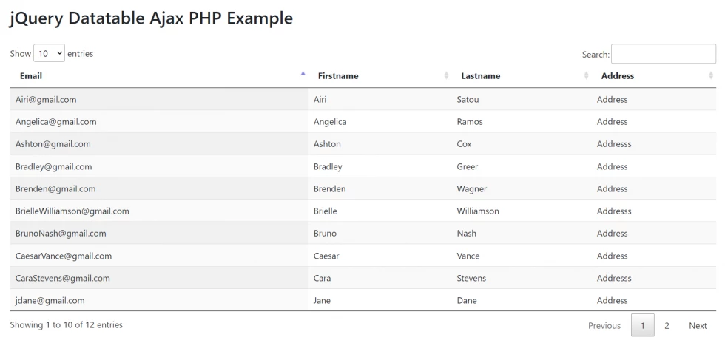
https://github.com/codeanddeploy/jquery-datatables-ajax-php-using-pdo-example

https://codeanddeploy.com/blog/php/jquery-datatables-ajax-php-and-mysql-using-pdo-example

How to Implement jQuery Datatable in PHP with MySQL
by Umesh Rana Leave a Comment

jQuery provides a very powerful feature which is called datatable. The datatable is an open-source plugin provided by the jQuery. Basically, in a bootstrap table or HTML table, there is no option to sort the data according to the column. No search option and no other options. Simply the table is used to display the data in the form of rows and columns. But, if you want to make your table to more flexible, attractive and the featured then this can be done using the jQuery datatable plugin. So, today, I’m here with a tutorial on the datatable implementation in PHP.
- 1 Datatable in PHP
- 2 Create Database
    - 2.0.1 Create Table
    - 2.0.2 Dumping Data For Products Table
- 3 Create Database Connection
- 4 Create a Class File
- 5 Implement DataTable PHP
- 6 Conclusion
  - 6.1 Share this:
  - 6.2 Like this:
  - 6.3 Related

Datatable in PHP
Mainly, the datatable provides various features which are not available in any other tables. It is an open-source library by the jQuery. It is mobile friendly and provides pagination, data sorting, searching, column order, etc. You can apply this jquery plugin on the bootstrap table which must have some records.
So, here, I’m going to create a project in which I will retrieve data from the database table. I am going to connect my application from the MySQL database. I have some records that I will fetch in a table.

Create Database
Open the phpMyAdmin and under the SQL section enter the below code for creating the database.
Create Database
CREATE DATABASE data_table;
Next, you will have to create a table. Here, I have created a table with the name products

Create Table
Create Table
CREATE TABLE `products` (
`product_id` int(11) PRIMARY KEY NOT NULL AUTO_INCREMENT,
`product_name` varchar(100) NOT NULL,
`sku` varchar(50) NOT NULL,
`brand` varchar(50) NOT NULL,
`quantity` int(11) NOT NULL,
`price_per_unit` varchar(50) NOT NULL,
`created_on` timestamp NOT NULL DEFAULT CURRENT_TIMESTAMP,
`updated_on` timestamp NOT NULL DEFAULT CURRENT_TIMESTAMP
) ENGINE=InnoDB DEFAULT CHARSET=latin1;
Dropdown Selection Filter in PHP Using jQuery Ajax
Recommended: Drag and Drop Multiple File Upload in PHP Using Dropzone js

Dumping Data For Products Table
Data in Table
--
-- Dumping data for table `products`
--

INSERT INTO `products` (`product_id`, `product_name`, `sku`, `brand`, `quantity`, `price_per_unit`, `created_on`, `updated_on`) VALUES
(1, 'Black Tea', 'BT101', 'Red Label', 43, '430', '2019-09-08 20:19:25', '2019-09-08 20:19:25'),
(2, 'Green Tea', 'BT102', 'Tata Tea', 54, '200', '2019-09-08 20:19:25', '2019-09-08 20:19:25'),
(3, 'Fruit Tea', 'BT103', 'Tata Tea', 25, '250', '2019-09-08 20:19:25', '2019-09-08 20:19:25'),
(4, 'Herbal Tea', 'BT104', 'Red Label', 36, '350', '2019-09-08 20:19:25', '2019-09-08 20:19:25'),
(5, 'White Tea', 'BT105', 'Tata Tea', 17, '453', '2019-09-08 20:19:25', '2019-09-08 20:19:25'),
(6, 'Oolong Tea', 'BT106', 'Tata Tea', 28, '640', '2019-09-08 20:19:25', '2019-09-08 20:19:25'),
(7, 'Rooibos Tea', 'BT107', 'Tata Tea', 18, '450', '2019-09-08 20:19:25', '2019-09-08 20:19:25'),
(8, 'Mad Angles', 'BT109', 'Bingo', 15, '207', '2019-09-08 20:19:25', '2019-09-08 20:19:25'),
(9, 'Black Tea', 'BT101', 'Red Label', 43, '430', '2019-09-08 20:33:40', '2019-09-08 20:33:40'),
(10, 'Green Tea', 'BT102', 'Tata Tea', 54, '200', '2019-09-08 20:33:40', '2019-09-08 20:33:40'),
(11, 'Fruit Tea', 'BT103', 'Tata Tea', 25, '250', '2019-09-08 20:33:40', '2019-09-08 20:33:40'),
(12, 'Herbal Tea', 'BT104', 'Red Label', 36, '350', '2019-09-08 20:33:40', '2019-09-08 20:33:40'),
(13, 'White Tea', 'BT105', 'Tata Tea', 17, '453', '2019-09-08 20:33:40', '2019-09-08 20:33:40'),
(14, 'Oolong Tea', 'BT106', 'Tata Tea', 28, '640', '2019-09-08 20:33:40', '2019-09-08 20:33:40'),
(15, 'Rooibos Tea', 'BT107', 'Tata Tea', 18, '450', '2019-09-08 20:33:40', '2019-09-08 20:33:40'),
(16, 'Mad Angles', 'BT109', 'Bingo', 15, '207', '2019-09-08 20:33:40', '2019-09-08 20:33:40');

Create Database Connection
Before moving to the data part, you will have to create a database connection. Create a new file with the name db-config.php then paste the below code. Now, as per your database name, username, and password don’t forget to replace the credentials.
db-config.php
// db-config.php

<?php

class DBController {

private $hostname = "localhost";

private $username = "root";

private $password = "root";

private $db = "data_table";

//create connection
public function connect() {

$conn = new mysqli($this->hostname, $this->username, $this->password, $this->db)or die("Database connection error." . $conn->connect_error);

return $conn;
}

// close connection
public function close($conn) {

$conn->close();

}
}
?>
PHP Import CSV File Data into MySQL Database with Preview

Create a Class File
I am going to follow the object-oriented principle for retrieving the data from the database table. Now, create a new file in your project directory in which, we will be writing the database query.
product-controller.php
// product-controller.php

<?php
class ProductsController {
// constructor
function __construct($conn) {
$this->conn = $conn;
}

// retrieving products data
public function index() {
$data = array();
$sql = "SELECT * FROM products";
$result = $this->conn->query($sql);
if($result->num_rows > 0) {
$data = mysqli_fetch_all($result, MYSQLI_ASSOC);
}
$db->close($conn);
return $data;
}
}
?>
Now, create a new file named index.php in which we, will create a bootstrap table. In this table, we’ll display the records which are retrieving through the above class file (product-controller.php).
index.php
// index.php

<?php
require_once './config/db-config.php';
require_once './controller/product-controller.php';
$db = new DBController();
$conn = $db->connect();
$dCtrl = new ProductsController($conn);
$products = $dCtrl->index();
?>

<!DOCTYPE html>
<html>
<head>
<title>Datatable Implementation in PHP</title>
<!-- Bootstrap 4 CSS -->
<link rel="stylesheet" href="https://maxcdn.bootstrapcdn.com/bootstrap/4.0.0/css/bootstrap.min.css">
</head>
<body>
<div class="container mt-5">
<div class="row">
<div class="col-xl-12 col-lg-12 col-md-12 col-12 m-auto">
<table class="table table-bordered table-hovered table-striped" id="productTable">
<thead>
<th> Product ID </th>
<th> Product Name </th>
<th> SKU </th>
<th> Brand </th>
<th> Quantity </th>
<th> Price/Unit </th>
</thead>
<tbody>
<?php
foreach($products as $product) : ?>
<tr>
<td> <?php echo $product['product_id']; ?> </td>
<td> <?php echo $product['product_name']; ?> </td>
<td> <?php echo $product['sku']; ?> </td>
<td> <?php echo $product['brand']; ?> </td>
<td> <?php echo $product['quantity']; ?> </td>
<td> <?php echo $product['price_per_unit']; ?> </td>
</tr>

<?php endforeach; ?>
</tbody>
</table>
</div>
</div>
</div>

<script src="https://code.jquery.com/jquery-3.2.1.slim.min.js"></script>
<script src="https://cdnjs.cloudflare.com/ajax/libs/popper.js/1.12.9/umd/popper.min.js"></script>
<script src="https://maxcdn.bootstrapcdn.com/bootstrap/4.0.0/js/bootstrap.min.js"></script>

<script type="text/javascript" charset="utf8" src="https://cdn.datatables.net/1.10.19/js/jquery.dataTables.js"></script>

</body>
</html>
When you will execute the above code, it will show you the result as below. Here, the data are showing in a single page no matter how much data you have in the database table. It will print all the data on a single page.
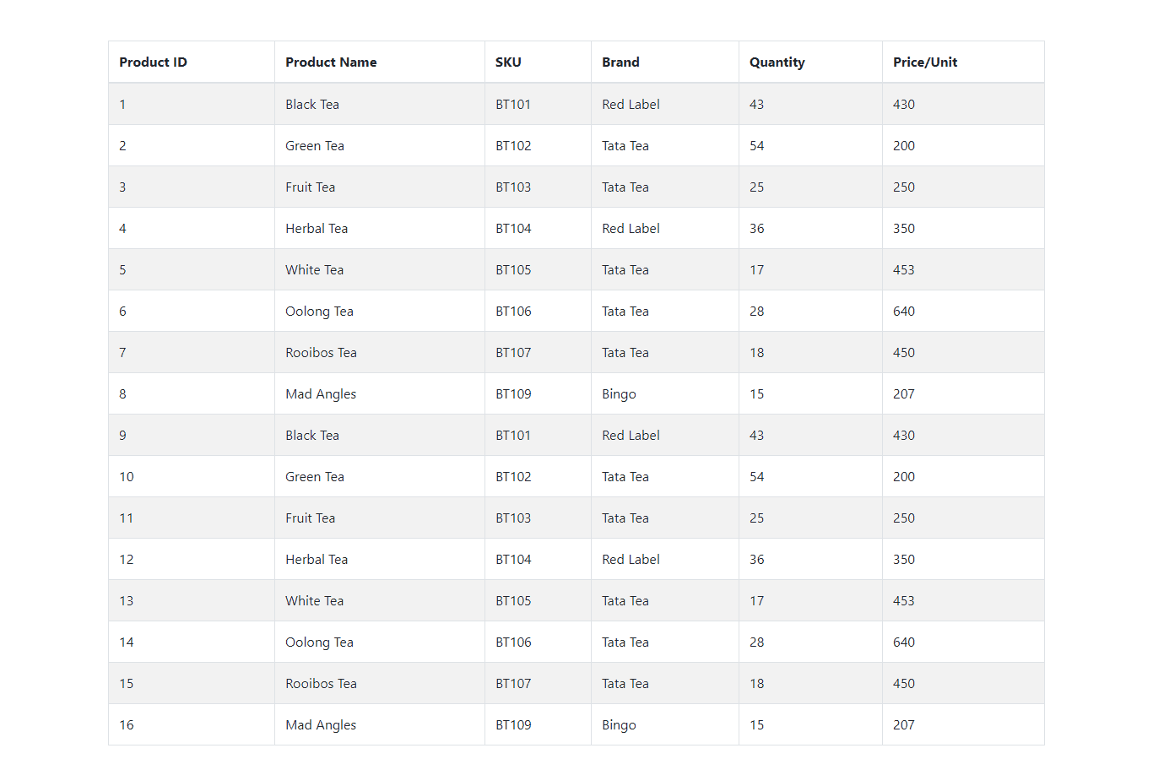Records in Table without DataTable
This would be a cause for the slow speed of the webpage if you will have a large number of data in your database. That’s why to overcome this, we use pagination which breaks the data into several pages.
Recommended: What is SQL Injection and How to Prevent it in PHP
PHP File Upload Using jQuery and Ajax

Implement DataTable PHP
Now, on the above table, I’m going to implement the datatable PHP. So first of all download the minified version of CSS and jQuery file from the official website https://datatables.net. You can use CDN too. I am going to use CDN here.
Datatable CDN
<!-- CDN CSS Datatable -->

<link rel="stylesheet" type="text/css" href="https://cdn.datatables.net/1.10.19/css/jquery.dataTables.css">

<!-- CDN jQuery Datatable -->
<script type="text/javascript" charset="utf8" src="https://cdn.datatables.net/1.10.19/js/jquery.dataTables.js"></script>
- Add the CSS between the opening and closing head tag of HTML.
- Also, add the jQuery CDN at the bottom before the end of the body tag.
- In the last step, add these two lines of script to apply the datatable in the HTML table.
// apply datatable in the HTML table
<script>
$(document).ready(function() {
$('#productTable').DataTable();
});
</script>
In the above code, I have started a script code with jQuery in which I have assigned the datatable in the HTML table with the id attribute.
So, after adding the above script and CDN the index.php the file will become as shown below.
index.php
<?php

require_once './config/db-config.php';
require_once './controller/product-controller.php';
$db = new DBController();
$conn = $db->connect();
$dCtrl = new ProductsController($conn);
$products = $dCtrl->index();
?>

<!DOCTYPE html>
<html>
<head>
<title>Datatable Implementation in PHP</title>
<!-- Bootstrap 4 CSS -->
<link rel="stylesheet" href="https://maxcdn.bootstrapcdn.com/bootstrap/4.0.0/css/bootstrap.min.css">

<link rel="stylesheet" type="text/css" href="https://cdn.datatables.net/1.10.19/css/jquery.dataTables.css">

</head>
<body>

<div class="container mt-5">
<div class="row">
<div class="col-xl-12 col-lg-12 col-md-12 col-12 m-auto">
<table class="table table-bordered table-hovered table-striped" id="productTable">
<thead>
<th> Product ID </th>
<th> Product Name </th>
<th> SKU </th>
<th> Brand </th>
<th> Quantity </th>
<th> Price/Unit </th>
</thead>

<tbody>

<?php
foreach($products as $product) : ?>

<tr>
<td> <?php echo $product['product_id']; ?> </td>
<td> <?php echo $product['product_name']; ?> </td>
<td> <?php echo $product['sku']; ?> </td>
<td> <?php echo $product['brand']; ?> </td>
<td> <?php echo $product['quantity']; ?> </td>
<td> <?php echo $product['price_per_unit']; ?> </td>
</tr>

<?php endforeach; ?>
</tbody>
</table>
</div>
</div>
</div>

<script src="https://code.jquery.com/jquery-3.2.1.slim.min.js"></script>
<script src="https://cdnjs.cloudflare.com/ajax/libs/popper.js/1.12.9/umd/popper.min.js"></script>
<script src="https://maxcdn.bootstrapcdn.com/bootstrap/4.0.0/js/bootstrap.min.js"></script>

<!-- CDN jQuery Datatable -->
<script type="text/javascript" charset="utf8" src="https://cdn.datatables.net/1.10.19/js/jquery.dataTables.js"></script>

</body>
</html>
<!-- Script --->
<script>
$(document).ready(function() {
$('#productTable').DataTable();
});
</script>
Now, after executing the above code, you can see the datatable has been applied to our existing table.
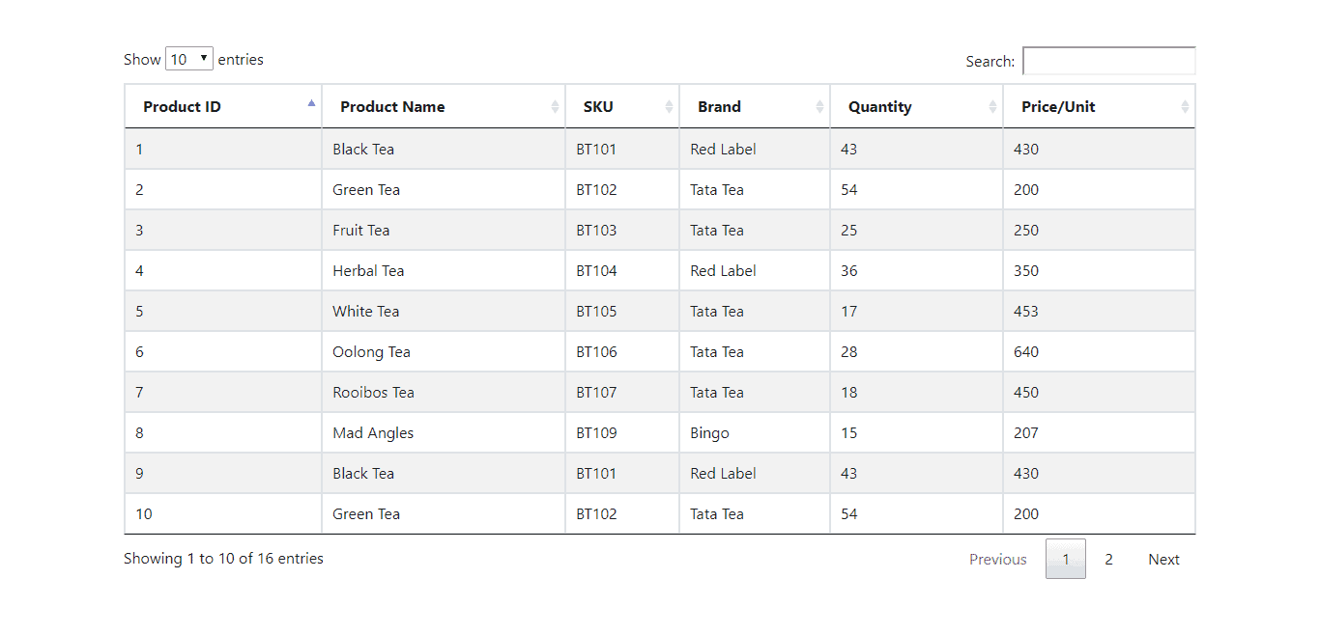
In the result of datatable, you will have the various features like pagination, the number of records to show, search specific record, the total number of records showing in the table, sorting the data in ascending and descending order.
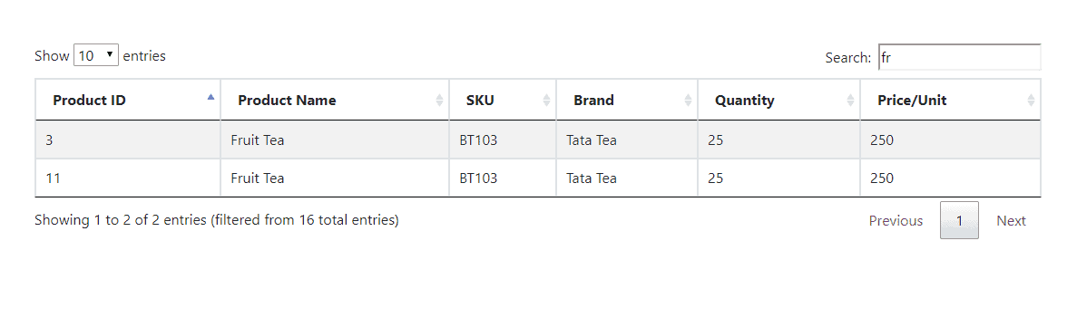
Download Source
https://programmingfields.com/datatable-in-php-with-mysql-database/

