Datatables Cliente com AJAX

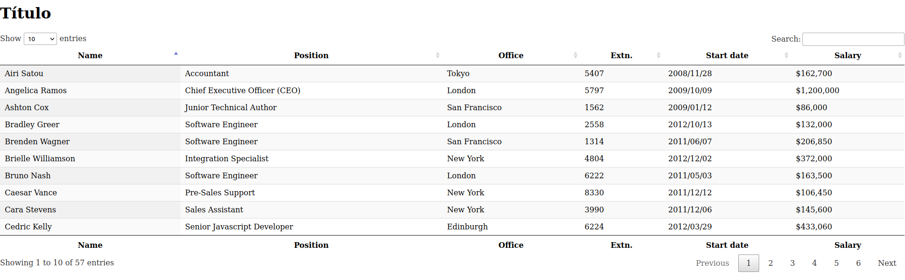

Requer servidor web para rodar

index.html

<!DOCTYPE html>
<html lang="pt-BR">
<head>
<meta charset="UTF-8">
<meta http-equiv="X-UA-Compatible" content="IE=edge">
<meta name="viewport" content="width=device-width, initial-scale=1.0">
<title>Título</title>
<link rel="stylesheet" href="https://cdn.datatables.net/1.11.4/css/jquery.dataTables.min.css">
<style>

</style>
</head>
<body>
<h1>Título</h1>
<script type="text/javascript" src="https://code.jquery.com/jquery-3.5.1.js"></script>
<script type="text/javascript" src="https://cdn.datatables.net/1.11.4/js/jquery.dataTables.min.js"></script>
<script type="text/javascript" src="app.js"></script>
<table id="example" class="display" style="width:100%">
<thead>
<tr>
<th>Name</th>
<th>Position</th>
<th>Office</th>
<th>Extn.</th>
<th>Start date</th>
<th>Salary</th>
</tr>
</thead>
<tfoot>
<tr>
<th>Name</th>
<th>Position</th>
<th>Office</th>
<th>Extn.</th>
<th>Start date</th>
<th>Salary</th>
</tr>
</tfoot>
</table>
<script>

</script>
</body>
</html>

ajax.txt

{
"data": [
[
"Tiger Nixon",
"System Architect",
"Edinburgh",
"5421",
"2011/04/25",
"$320,800"
],
[
"Garrett Winters",
"Accountant",
"Tokyo",
"8422",
"2011/07/25",
"$170,750"
],
…

ajax.js

$(document).ready(function() {
$('#example').DataTable( {
"ajax": './ajax.txt'
} );
} );

jQuery Datatable Ajax PHP PDO

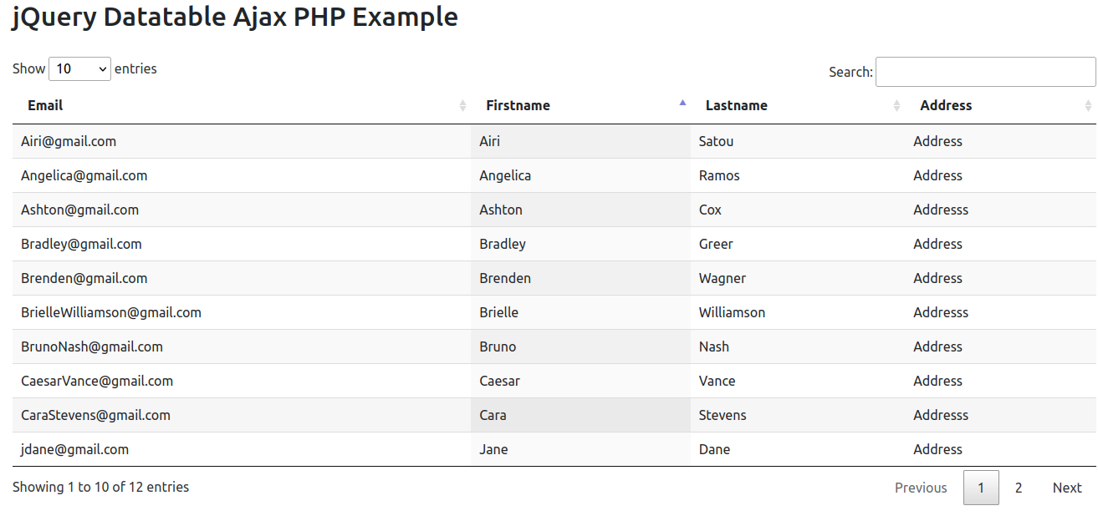
index.html

<!DOCTYPE html>
<html>
<head>
<meta charset="utf-8">
<title>JQuery Datatable Example</title>

<link rel="stylesheet" type="text/css" href="https://cdn.datatables.net/1.11.3/css/jquery.dataTables.min.css">

<script type="text/javascript" src="https://code.jquery.com/jquery-3.5.1.js"></script>
<link href="https://cdn.jsdelivr.net/npm/bootstrap@5.0.2/dist/css/bootstrap.min.css" rel="stylesheet" integrity="sha384-EVSTQN3/azprG1Anm3QDgpJLIm9Nao0Yz1ztcQTwFspd3yD65VohhpuuCOmLASjC" crossorigin="anonymous">
<script type="text/javascript" src="https://cdn.datatables.net/1.11.3/js/jquery.dataTables.min.js"></script>

<script type="text/javascript">
$(document).ready(function() {
$('#jquery-datatable-ajax-php').DataTable({
'processing': true,
'serverSide': true,
'serverMethod': 'post',
'ajax': {
'url':'datatable.php'
},
'columns': [
{ data: 'email' },
{ data: 'first_name' },
{ data: 'last_name' },
{ data: 'address' }
]
});

} );
</script>
</head>
<body>

<div class="container mt-5">
<h2 style="margin-bottom: 30px;">jQuery Datatable Ajax PHP Example</h2>
<table id="jquery-datatable-ajax-php" class="display" style="width:100%">
<thead>
<tr>
<th>Email</th>
<th>Firstname</th>
<th>Lastname</th>
<th>Address</th>
</tr>
</thead>
</table>
</div>

</body>
</html>

connection.php

<?php

$host = 'localhost';
$db = 'testes';
$user = 'root';
$password = 'root';

$dsn = "mysql:host=$host;dbname=$db;charset=UTF8";

try {
$conn = new PDO($dsn, $user, $password, [PDO::ATTR_ERRMODE => PDO::ERRMODE_EXCEPTION]);

} catch (PDOException $e) {
echo $e->getMessage();
}

datatable.php

<?php
// Database Connection
include 'connection.php';

// Reading value
$draw = $_POST['draw'];
$row = $_POST['start'];
$rowperpage = $_POST['length']; // Rows display per page
$columnIndex = $_POST['order'][0]['column']; // Column index
$columnName = $_POST['columns'][$columnIndex]['data']; // Column name
$columnSortOrder = $_POST['order'][0]['dir']; // asc or desc
$searchValue = $_POST['search']['value']; // Search value

$searchArray = array();

// Search
$searchQuery = " ";
if($searchValue != ''){
$searchQuery = " AND (email LIKE :email OR
first_name LIKE :first_name OR
last_name LIKE :last_name OR
address LIKE :address ) ";
$searchArray = array(
'email'=>"%$searchValue%",
'first_name'=>"%$searchValue%",
'last_name'=>"%$searchValue%",
'address'=>"%$searchValue%"
);
}

// Total number of records without filtering
$stmt = $conn->prepare("SELECT COUNT(*) AS allcount FROM employees ");
$stmt->execute();
$records = $stmt->fetch();
$totalRecords = $records['allcount'];

// Total number of records with filtering
$stmt = $conn->prepare("SELECT COUNT(*) AS allcount FROM employees WHERE 1 ".$searchQuery);
$stmt->execute($searchArray);
$records = $stmt->fetch();
$totalRecordwithFilter = $records['allcount'];

// Fetch records
$stmt = $conn->prepare("SELECT * FROM employees WHERE 1 ".$searchQuery." ORDER BY ".$columnName." ".$columnSortOrder." LIMIT :limit,:offset");

// Bind values
foreach ($searchArray as $key=>$search) {
$stmt->bindValue(':'.$key, $search,PDO::PARAM_STR);
}

$stmt->bindValue(':limit', (int)$row, PDO::PARAM_INT);
$stmt->bindValue(':offset', (int)$rowperpage, PDO::PARAM_INT);
$stmt->execute();
$empRecords = $stmt->fetchAll();

$data = array();

foreach ($empRecords as $row) {
$data[] = array(
"email"=>$row['email'],
"first_name"=>$row['first_name'],
"last_name"=>$row['last_name'],
"address"=>$row['address']
);
}

// Response
$response = array(
"draw" => intval($draw),
"iTotalRecords" => $totalRecords,
"iTotalDisplayRecords" => $totalRecordwithFilter,
"aaData" => $data
);

echo json_encode($response);

employees.sql

CREATE TABLE `employees` (
`id` int(10) NOT NULL,
`email` varchar(100) NOT NULL,
`first_name` varchar(100) NOT NULL,
`last_name` varchar(100) NOT NULL,
`address` varchar(250) NOT NULL
) ENGINE=InnoDB DEFAULT CHARSET=utf8mb4;

--
-- Dumping data for table `employees`
--

INSERT INTO `employees` (`id`, `email`, `first_name`, `last_name`, `address`) VALUES
(2, 'jdane@gmail.com', 'Jane', 'Dane', 'Address'),
(17, 'jdoe@gmail.com', 'John', 'Doe', 'Address'),
(18, 'test@gmail.com', 'Test', 'Test', 'Addresss'),
(20, 'Airi@gmail.com', 'Airi', 'Satou', 'Address'),
(21, 'Angelica@gmail.com', 'Angelica', 'Ramos', 'Address'),
(22, 'Ashton@gmail.com', 'Ashton', 'Cox', 'Addresss'),
(23, 'Bradley@gmail.com', 'Bradley', 'Greer', 'Address'),
(24, 'Brenden@gmail.com', 'Brenden', 'Wagner', 'Address'),
(25, 'BrielleWilliamson@gmail.com', 'Brielle', 'Williamson', 'Addresss'),
(26, 'BrunoNash@gmail.com', 'Bruno', 'Nash', 'Address'),
(27, 'CaesarVance@gmail.com', 'Caesar', 'Vance', 'Address'),
(28, 'CaraStevens@gmail.com', 'Cara', 'Stevens', 'Addresss');

--
-- Indexes for dumped tables
--

--
-- Indexes for table `employees`
--
ALTER TABLE `employees`
ADD PRIMARY KEY (`id`);

--
-- AUTO_INCREMENT for dumped tables
--

--
-- AUTO_INCREMENT for table `employees`
--
ALTER TABLE `employees`
MODIFY `id` int(10) NOT NULL AUTO_INCREMENT, AUTO_INCREMENT=29;
COMMIT;

