
Base Handbook
Chapter 2
Creating a Database
How to create a new database

Copyright
This document is Copyright © 2013–2015 by the LibreOffice Documentation Team. Contributors are listed below. You may distribute or modify it under the terms of either the GNU General Public License (http://www.gnu.org/licenses/gpl.html), version 3 or later, or the Creative Commons Attribution License (http://creativecommons.org/licenses/by/4.0/), version 4.0 or later.
All trademarks within this guide belong to their legitimate owners.

Contributors
Jochen Schiffers  Martin Fox | Robert Großkopf  Hazel Russman | Jost Lange  Jean Hollis Weber

Feedback
Please direct any comments or suggestions about this document to the Documentation Team’s mailing list: documentation@global.libreoffice.org
Note: Everything you send to a mailing list, including your email address and any other personal information that is written in the message, is publicly archived and cannot be deleted.

Acknowledgments
This chapter is based on an original German document and was translated by Martin Fox, Robert Großkopf, and Hazel Russman.

Publication date and software version
Published 20 December 2015. Based on LibreOffice 5.0.

Note for Mac users
Some keystrokes and menu items are different on a Mac from those used in Windows and Linux. The table below gives some common substitutions for the instructions in this chapter. For a more detailed list, see the application Help.
Windows or Linux | Mac equivalent | Effect
Tools > Options menu selection | LibreOffice > Preferences | Access setup options
Right-click | Control+click | Open a context menu
Ctrl (Control) | ⌘ (Command) | Used with other keys
F5 | Shift+⌘+F5 | Open the Navigator
F11 | ⌘+T | Open the Styles and Formatting window

Contents
Copyright 2
Contributors 2
Feedback 2
Acknowledgments 2
Publication date and software version 2
Note for Mac users 2
General notes on creating a database 4
Creating a new database using the internal HSQL engine 4
Accessing external databases 6
MySQL/MariaDB databases 6
Create a user and a database 6
Direct MySQL connection using an extension 7
MySQL connection via JDBC 7
MySQL connection via ODBC 7
Connecting to the MySQL database with the Connection Wizard 8
PostgreSQL 13
Creating a user and a database 13
Direct connection to Base 14
dBase databases 16
Spreadsheets 18
Thunderbird address book 19
Text tables 19
Text tables within an internal HSQLDB database 19
Text tables as a basis for a standalone database 22
Firebird 24
Creating a user and a database 24
Connecting to Firebird via JDBC 25
Firebird connection using ODBC 26
Subsequent editing of connection properties 26

General notes on creating a database
The basics of creating a database in LibreOffice are described in Chapter 8 of the Getting Started guide, Getting Started with Base.
The database component of LibreOffice, called Base, provides a graphical interface for working with databases. In addition, LibreOffice contains a version of the HSQL database engine. This HSQLDB database can be used by only a single user. The entire data set is stored in an ODB file that has no file locking mechanism when opened by a user.

Creating a new database using the internal HSQL engine
If a database with multiple users is not planned, or if the user wishes to gain some initial experience with a database, the internal database engine will suffice. It is possible at some later stage to transfer the database to an external HSQLDB environment, where multiple users can have concurrent access to the database on the HSQLDB server. This is described in the Appendix to this Handbook.
To create an internal database from the LibreOffice Start screen, clicking on the Database button; or, from anywhere in LibreOffice, use File > New > Database. The Database Wizard (Figure 1) opens.
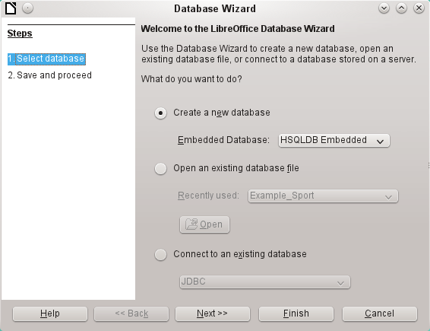
Figure 1: Step 1 of Database Wizard: Select database
Select the Create a new database option. By default, this is an embedded HSQLDB database. Since Base 4.2, an internal Firebird database is also available; however, it must be activated separately (see note on next page).
The other options serve to open an existing file or create a connection to an external database such as an address book or a MySQL database.
Choose Next>> to proceed to Step 2 of the Database Wizard (Figure 2).
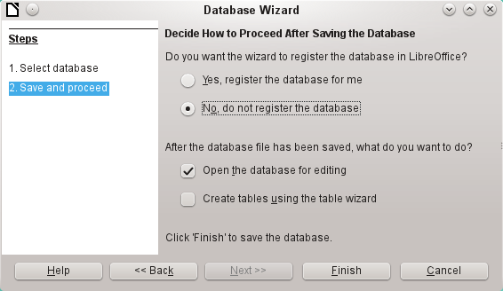
Figure 2: Step 2 of Database Wizard: Save and Proceed
A database registered with LibreOffice can be used by other components of LibreOffice, for example for mail merge letters in Writer. This registration can be done later. Therefore at this point, choose the option No, do not register the database.
Select the Open the database for editing option, and deselect the option to create tables using the table wizard. This handbook does not use the wizards for creating tables, queries, and so on.
Click Finish to save the database. A standard Save As dialog opens, requesting a name and location for the *.odb file, which is ready for the entry of records from the internal database, and the storage of queries, forms, and reports.
Unlike in the other parts of LibreOffice, the file is saved before you have made any visible entries.
Note | Since LibreOffice Version 4.2, an internal Firebird database has been available in addition to the internal HSQLDB one. To use this database, go to Tools > Options > LibreOffice > Advanced and select Optional (Unstable) Options.  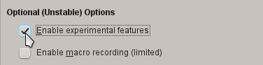  After this the internal Firebird database will appear in the Wizard below the internal HSQLDB.  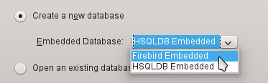
The embedded Firebird database in Version 5.0 still falls far short of its possibilities. SQL enhancements to HSQLDB are not yet implemented, and the creation of automatically incrementing values does not work yet.
HSQLDB is still the default database for all users in LibreOffice 5.0; the Firebird database is only for initial experiments. This Handbook therefore deals first with the internal HSQLDB. For the internal Firebird database, a comparison with HSQLDB for functions and data types is appended to the database examples.

Accessing external databases
An external database must exist before it can be accessed. If access to a database is desired, the database must be set up to allow network connections with a specific user name and password before external programs can connect to it.
When such a database is properly set up, a user may, depending on the available connection software (the database driver), create tables, input data, and query data.
Click on File > New > Database to open the Database Wizard and allow a connection to an existing database to be made. The list of available database types varies according to operating system and user interface, but the following should always be available:
- dBase
- JDBC
- MySQL
- ODBC
- Oracle JDBC
- PostgreSQL
- Spreadsheet
- Text
- as well as various types of address books.
The connection options vary according to the type of database selected. You can change the options after the *.odb file is created.
Some database types (for example, spreadsheets) do not allow new data to be entered. These are used only to search for or report on existing data. The descriptions in the following chapters deal exclusively with LibreOffice Base using the internal HSQLDB database. Most of the design work can be extended to databases that use MySQL, PostgreSQL, and so on.
Here are a couple of brief examples of how you can connect with an external database.

MySQL/MariaDB databases
Base can connect to MySQL and MariaDB databases by three methods. The simplest and fastest way is direct connection with the MySQL connector. The other two are connection using ODBC or JDBC.

Create a user and a database
After MySQL or MariaDB has been installed, do the following steps in the sequence described.
- The administrator account in MySQL is called root. Linux users should note that this is not the root user of the Linux operating system. The root user must be assigned a password directly after installation, if this was not done before installation.
mysql -u root -p
To begin with, no password is set, so just press Enter. An entry prompt appears:
mysql>
All the following entries are made at the MySQL console. The passwords can be different according to whether the prompt comes from the local computer (localhost) or a different computer which is acting as a MySQL server (host).
SET PASSWORD FOR root@localhost=PASSWORD('Password');
SET PASSWORD FOR root@host=PASSWORD('Password');
For Windows users, the second line reads:
SET PASSWORD FOR root@'%'=PASSWORD('Password');
- As a security measure, all current anonymous users are deleted.
DELETE FROM mysql.user WHERE User='';
DELETE FROM mysql.db WHERE User='';
FLUSH PRIVILEGES;
- A database called libretest is created.
CREATE DATABASE libretest;
- All rights to the libretest database are granted to the user lotest, who will log in with the password libre.
GRANT ALL ON libretest.* TO lotest IDENTIFIED BY 'libre';
Now the database is available and can be connected to as follows.

Direct MySQL connection using an extension
For MySQL databases, there are extensions for direct connection to Base. These extensions are called the MySQL connector.
For Base versions 4.1 and 4.2, there is an extension for Windows at http://extensions.libreoffice.org/extension-center/mysql-native-connector-for-libreoffice-4.x
For Base versions later than 4.1, there is an extension for Linux at http://extensions.libreoffice.org/extension-center/mysql-native-connector.
Caution   | These extensions have not been updated in over a year. They may or may not work correctly with Base 5.0.

MySQL connection via JDBC
General access to MySQL for versions of Base from 3.5 onwards is via JDBC or ODBC. To be able to use JDBC, it is necessary to install mysql-connector-java.jar. This Java Archive file is best copied into the same folder where the current java version used in LibreOffice is located. This is likely to be a subfolder like ...javapath.../lib/ext for a Linux installation.
Alternatively the appropriate folder containing the Java archive can be set through Tools > Options > Java > ClassPath.

MySQL connection via ODBC
To connect via ODBC, you must of course have ODBC software installed. Details of how to do this are not given here.
After installation of the software, it may happen that LibreOffice refuses the service because it can’t find the libodc.so library. In most systems, libodbc.so.2 will be present. You will need to make a link to this file in the same folder with the name libodbc.so.
In the odbcinst.ini and odbc.ini, which are necessary for the system, you need to make entries similar to the following:

odbinst.ini
[MySQL]
Description = ODBC Driver for MySQL
Driver = /usr/lib/libmyodbc5.so

odbc.ini
[MySQL-test]
Description = MySQL database test
Driver = MySQL
Server = localhost
Database = libretest
Port = 3306
Socket =
Option = 3
Charset = UTF8
In Linux systems these two files are located in the /etc/UnixODBC folder. If you do not enter the character set that you are going to use, there can be problems with umlauts even if the setup is the same in MySQL/MariaDB and in Base.
Details for the connection parameters can be found in the MySQL Handbook.

Connecting to the MySQL database with the Connection Wizard
To access an existing MySQL database with a direct connection, follow these steps.
At Step 1 of the Database Wizard, select Connect to an existing database. From the list of database formats on the pull-down menu (Figure 3), select MySQL. Click Next>>.
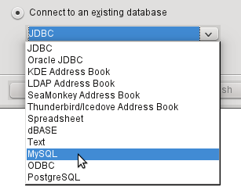
Figure 3: Connecting to an existing MySQL database
At Step 2 of the Database Wizard (Figure 4), you can choose to connect using ODBC or JDBC or directly. Connect using ODBC or JDBC if no native direct MySQL connector is installed or supported. If the extension for a direct connection is installed, Connect directly is the default option.
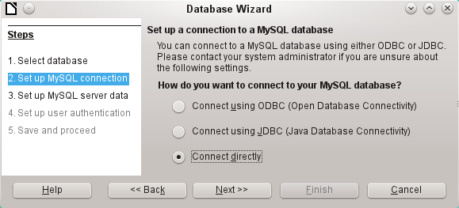
Figure 4: Step 2 of Database Wizard: Set up MySQL connection

Direct connection
Direct connection is best for both speed and functionality.
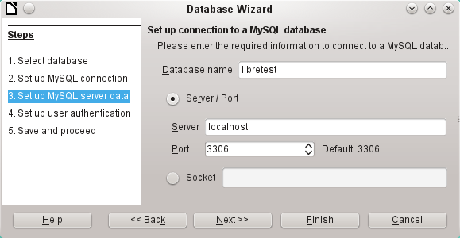
Figure 5: Step 3 of Database Wizard: Enter required information for the connection
The database name must be known. If the server is on the same computer as the user interface in which the database is to be created, you can select localhost as server. Otherwise you can use an IP address or, according to the network structure, the name of the computer or even an Internet address. It is thus possible for Base to access a database which is on someone’s home page.
When working with Base over the Internet, you need to be aware of how the connection is set up. Is the connection secure? How is the password transmitted?
Any database accessible over the Internet should be protected by a specific username with a password. This provides a direct way of testing whether the connection should go ahead. A corresponding user needs to be set up in MySQL or MariaDB for the named server.
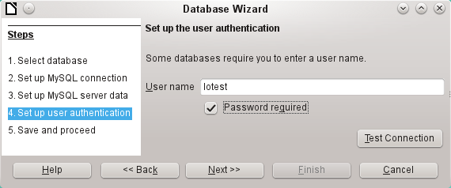
Figure 6: Step 4 of Database Wizard: Set up user authentication
Click the Test Connection button to launch authentication with the given user name. After entering the password, you are informed whether the connection was successful. If for example MySQL is not currently running, you will get an error message.
Note | On each subsequent occasion that the database file is accessed, the dialog below appears when you first access the MySQL database.  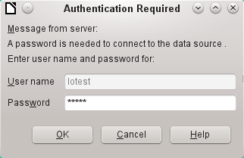
Click Next>> to display Step 5 of the Database Wizard (Figure 7). Select No, do not register the database and Open the database for editing. Click Finish.
In this example, the database will not be registered, as it is only being built for tests. Registration is only necessary if other programs such as Writer are to access the records, for example for a mail merge.
The wizard ends the connection setup by saving the database connection. The Base file is created and a view of the tables of the MySQL database is opened (Figure 8). The database tables are displayed under the name of the database itself.
At this stage the *.odb file contains only the connection information that will be read each time the database is launched, so that the tables in the MySQL database can be accessed.
Some drivers will show only the libretest database for which the connection was ordered. Other drivers also show other MySQL or MariaDB databases on the same server.
Even with drivers showing only one database, access to other tables for queries is possible if the database user (lotest in the above example) can access the records with their password. Unlike the previous native LibreOffice drivers, this one does not provide write access to other MySQL databases on the same server.
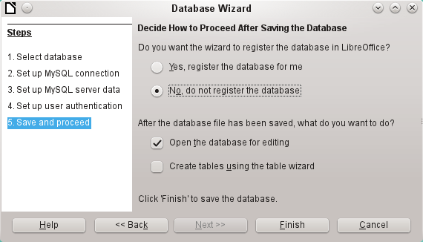
Figure 7: Step 5 of Database Wizard: Decide how to proceed after saving the database
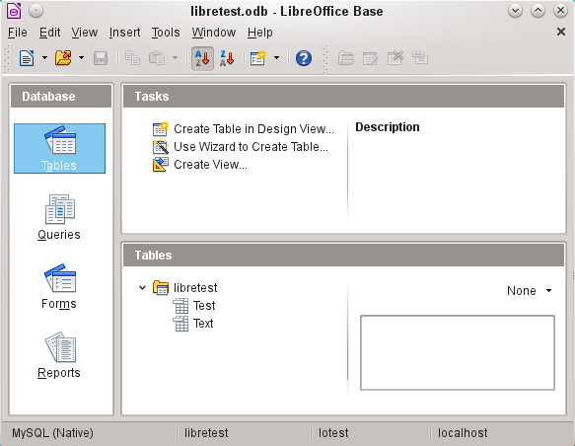
Figure 8: View of the open database file with table overview and in the footer of the designation of the driver used MySQL (Native), the database name libretest, the user of the database lotest and the server on which the database is running, namely localhost.
In contrast to Base’s internal database, queries in MySQL require the database name for defining the tables. For example:
... FROM "test"."Class" AS "Class" ...
It is necessary to give the combination of database name and table name an alternative name using “AS“.
Tables can be created and deleted in the database. Automatically incrementing values (AutoValues) work and can be selected at the table design stage. In MySQL, the values start at 1.

Connecting using ODBC
The first steps to making an ODBC connection are the same as for a direct connection. If an ODBC connection to MySQL is selected in the second step, the following page appears in the Database Wizard:
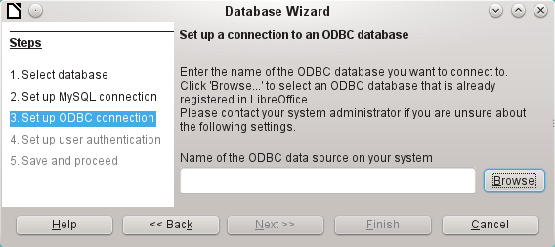
Figure 9: Setting up a connection to an ODBC database
The ODBC data source need not have the same name as the database in MySQL itself. Here you must enter the name that is listed in the odbc.ini file. The simplest way to do this is to read the name directly out of odbc.ini by using the Browse button.
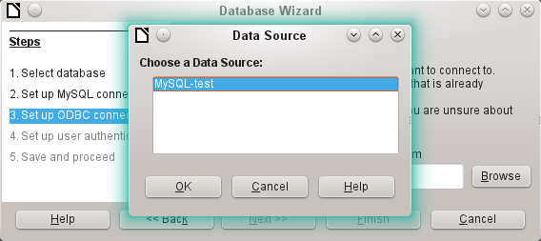
Figure 10: Choosing a data source
The name from the odbc.ini file appears. Here too, when you connect to a database, other tables on the MySQL server can be read quite easily.
Steps 4 and 5 are identical to those for a direct connection.

Connecting using JDBC
For a JDBC connection, the first steps are the same. The difference appears only with step 3:
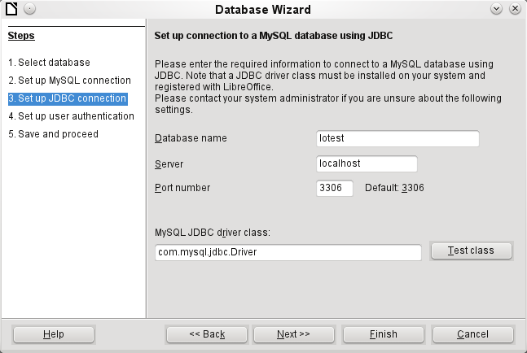
Figure 11: Setting up a connection using JDBC
The wizard asks for the same information as for a direct connection. The database name is the one used by MySQL itself.
The Test class button tests whether the archive mysql-connector-java.jar is accessible by Java. This archive must either be on the path of the chosen Java version, or directly embedded in LibreOffice.
All further steps are identical to the previous connections. Connections to other databases on the same MySQL server are again read-only.

PostgreSQL
LibreOffice has a direct driver for PostgreSQL databases, which is preinstalled. To ensure a secure connection, follow these brief instructions for the first steps after installing PostgreSQL.

Creating a user and a database
The following steps are necessary after installation using the package manager in OpenSUSE. You can assume similar ones in other operating systems.
- The postgres user must be assigned a password. This can be done using the operating system’s utility.
- The Postgre server must be launched by the administrator:
service postgresql start or rcpostgresql start.
- The postgres user logs in at the console with:
su postgres
- An unprivileged database user, here called lotest, is created with a password:
createuser -P lotest
- In order to allow the database user connecting to the database which is to be created, an entry in the /var/lib/pqsql/data/pg_hba.conf file must be changed. This file includes the methods used for identifying users at various levels. The method LibreOffice uses to communicate is the “password” method and not the “ident” method as set out initially in the file.
- The system user “postgres“ logs in with “psql“:
psql -d template1 -U postgres
- The system user creates the “libretest“ database:
CREATE DATABASE libretest;

Direct connection to Base
Choose the postgres entry in Step 1 of the wizard. To make the connection, give the database name (dbname) and the host. Under some circumstances, it is necessary to give the fully qualified hostname including the domain name.
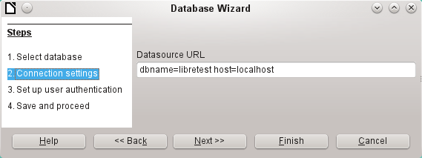
Figure 12: Setting up a direct connection
The user authentication (step 3) is exactly the same as for MySQL.
The Save As dialog (Figure 13) shows the various schemas in PostgreSQL. The only one that can actually be saved to is the public schema, unless extended rights have been granted to this user.
Note | If tables from the internal HSQLDB database are copied to PostgreSQL, the Import Wizard uses the simple table names from HSQLDB, for example Table1. However importing under this name will lead to errors. Instead the schema name must be prepended so that Table1 becomes public.Table1.
When tables are being created, Base might suggest data types which the current PostgreSQL installation cannot handle. For example, by default text fields are given the field type Text[character_data]. PostgreSQL cannot process this field type. Changing the type to Text[varchar] solves the problem.
The various schemas appear in the table view of PostgreSQL (Figure 14). In the public schema you can see a table called Name.
If the database is being opened for the first time, you will see a great many tables in the Information schema area. These tables, like those in the pg_catalog area, cannot be read or written to by the ordinary user. These different areas are called schemas in PostgreSQL. Users create new tables in the public schema.
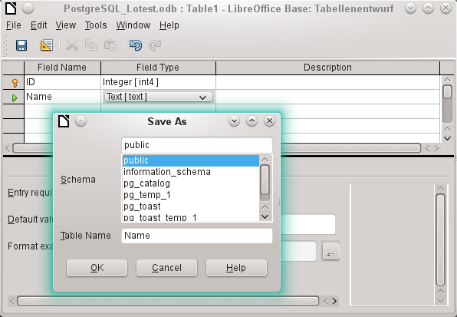
Figure 13: Saving to the public schema
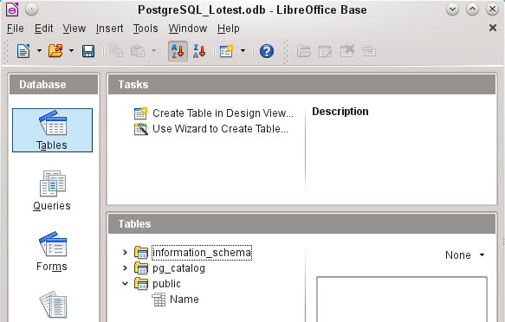
Figure 14: Table view of Postgre_SQL in LibreOffice Base

dBase databases
dBase databases have a format where all data is contained in separate, previously initialized tables. Links between the tables must be made in program code. Relations are not supported.
The dBase format is especially suitable for the exchange and extensive editing of data. In addition, spreadsheet calculations can directly access dBase tables.
dBase has no way to prevent the deletion of, for example, media in a library database that continue to be referenced in the media loans table.
Note | At present the only dBase databases that are recognized are those contained in files with the ending *.dbf in lower-case letters. Other endings such as *.DBF are not recognized. (Bug 46180)
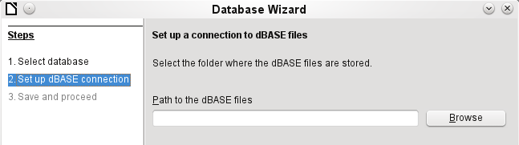
Figure 15: Setting up a connection to dBase files
The connection is made to a specific folder. All *.dbf files in this folder will be included and shown in the *.odb database and can be linked together using queries.
Tables in dBase have no primary key. They can in principle be described as corresponding to the worksheets in Calc.
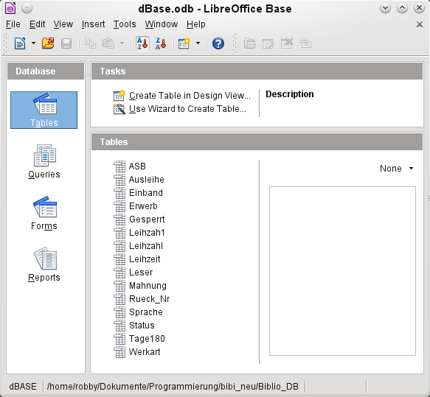
Figure 16: Tables in a dBase file
Tables can be created and will then be copied as new files in the folder previously selected.
The number of different field types for a new dBase table is clearly less than when the internal HSQLDB format is used. In the following figure there are still some field types with the same type name.
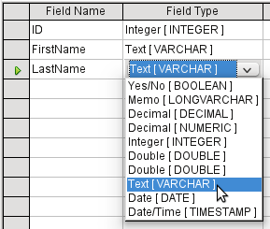
Figure 17: Field types for a new dBase table
Base takes over the coding of the operating system. Therefore old dBase files easily develop errors when special characters are imported. The character set can be corrected subsequently using Edit > Database > Properties > Advanced Settings.
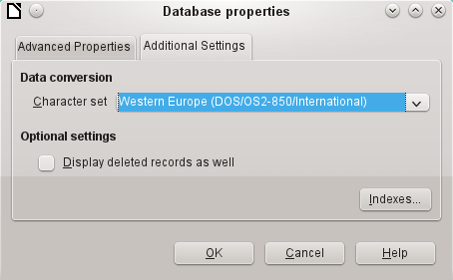
Figure 18: Correcting the character set
Note | The Import Wizard for dBase has problems with automatic recognition of numeric field types and Yes/No fields (Bug 53027). This may require you to make subsequent corrections.

Spreadsheets
Calc or Excel spreadsheets can also be used as the table source for databases. If, however, a Calc spreadsheet is used, no editing of the table data will be possible. If the Calc document is still open, it will be write protected.
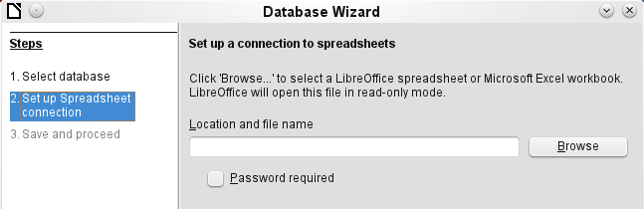
Figure 19: Setting up a connection to a spreadsheet
The only questions to be answered are the location of the spreadsheet file and whether or not it is password protected. Base then opens the spreadsheet and includes all worksheets in the document. The first row is used for the field names and the worksheet names become the table names.
Relationships between spreadsheets cannot be set up in Base, as Calc is not suitable for use as a relational database.

Thunderbird address book
The Wizard will automatically seek a connection to an address book, for example as used in Thunderbird. The Wizard will prompt for the location of the ODB file that will be produced.
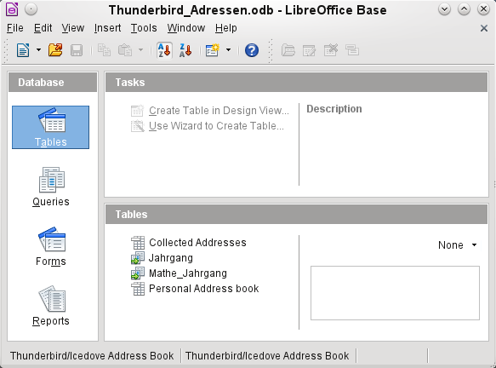
Figure 20: Tables in a Thunderbird address book
All tables are shown. As with Calc spreadsheets, the tables are not editable. Base uses the table data only for queries and mail merge applications.
Note | Since LibreOffice Version 4.*, only the Personal addresses file is read as an address book in Linux and Mac OS X. As a result, records which by default go in the Collected addresses are not accessible (Bug 64741).  This bug was removed in LibreOffice 4.2. However, collected groups are currently only visible as part of the Personal addresses. Groups from Collected addresses are not shown.

Text tables
In Base you can create a complete database by accessing text tables. Text tables can also be accessed from within an internal database.

Text tables within an internal HSQLDB database
The *.csv format is a common exchange format between databases. Records are stored in a form that can be read and modified by a simple text editor. Individual fields are separated by commas. If a field contains a text that includes a comma, the text fields are enclosed in double quotes. Each new record begins with a new line.
For example, the contents of an address book which is in a format not supported by any Base driver can either be imported via a *.csv file (using Calc as an intermediary if necessary) or the file is directly imported into the database as a text table. To be editable there, the *.csv file must include a field with unique values that can serve as a primary key.
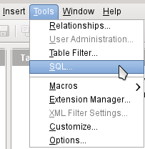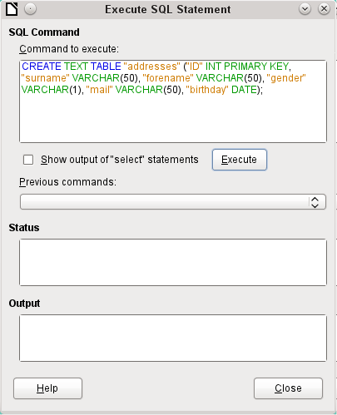
Figure 21: Creating a text table using Tools > SQL
A text table cannot be created using the graphical user interface. Instead you must use Tools > SQL to create a text table (see Figure 21). The fields in the text table must correspond in type and order to those that the text table makes available. For example the “ID” field must contain positive integers and the “Birth date” field must contain date values in the form Year – Month – Day.
The table is not directly visible in the user interface. If another enlargement is to follow, use View > Refresh tables to make the tables available. The table symbol indicates that this is not a “normal” database table.
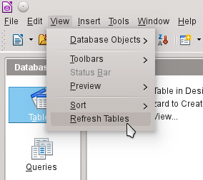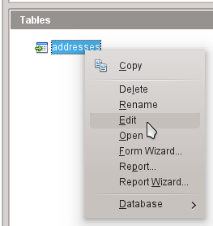
The table is opened for editing and the primary key field is changed to an automatically incrementing field.
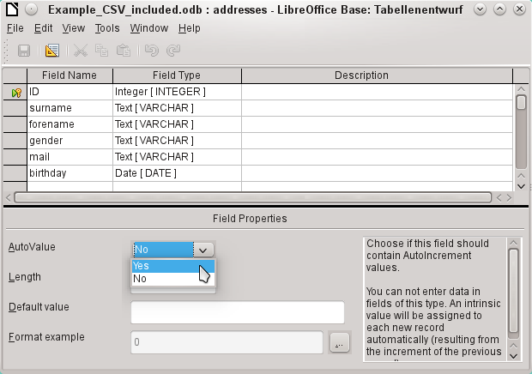
Figure 22: Editing a text table
Now we must make a connection to an external text table using using Tools → SQL. The text table lies in the same folder as the database itself.
SET TABLE "Addresses" SOURCE "Addresses.csv;encoding=UTF-8";
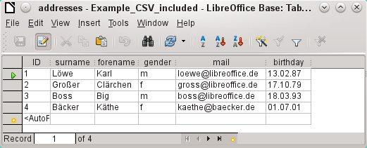
After this the text table is available for input in the normal way. But the following points should be noted:
- Text tables can be opened and edited simultaneously by external text programs. Loss of data cannot be excluded in these circumstances.
- Changes in records already written lead to the corresponding line in the original file being cleared and the new version added at the end of the table. The table view shown above presents four written lines with correctly sorted ID numbers. In the original file, the second record has been altered, leading to the following record sequence by ID: 1, blank line, 3, 4, 2.
When connecting to a text file, the following parameters are available.
SET TABLE "Addresses" SOURCE "Addresses.csv;ignore_first=false;all_quoted=true;encoding=UTF-8";
“ignore_first=true” would mean that the first line is not read in. This makes sense if the line contains only field headings. The internal default for HSQLDB is “false”.
By default, HSQLDB text fields are only placed in double quotes if they contain an internal comma, since the comma is the default field separator. If every field is to be quoted, set “all_quoted=true”.
For further parameters, see http://hsqldb.org/doc/guide/ch09.html#set_table_source-section.
SET TABLE "Addresses" READONLY TRUE;
prevents anything from being written into the table. The table is then available read-only like an address book from a mail program. Setting write protection separately is only necessary when a primary key has being set for the table.

Text tables as a basis for a standalone database
As in the previous example, *.csv files are used as a data source. Using Base, a folder containing the *.csv files is embedded as a data folder.
We begin by connecting to an existing database. Here the format Text has been selected.
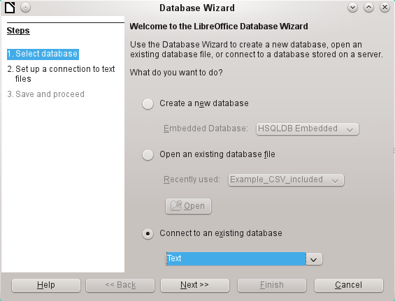
The path to the text files is looked up. In the folder, all files of the specified type will be listed later. For *.csv files, choose the second option.
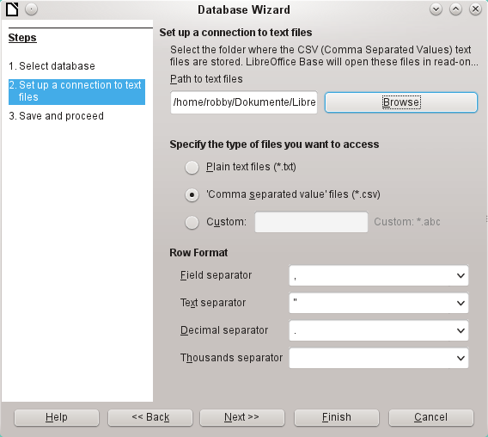
At this stage you can already see a clear warning that the files will be opened read-only with no write access.
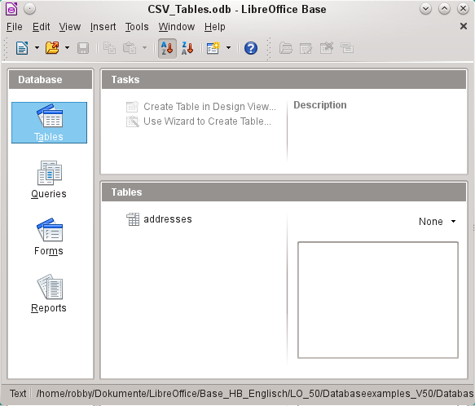
In the Table view, all the tables in the specified folder are shown by their filenames but without the filename suffix. The tasks for creating tables are not active. The tables themselves can be read but not written.
Access to the tables by queries is also limited to one table at a time and without the use of functions.
When such a database is used to search briefly in a *.csv file for records or to import a *.csv file into another database by using the copy function, it has fulfilled its purpose. The corresponding *.csv file is only moved into the specified folder and can be directly searched or copied. Such text databases are not suitable for more general use.

Firebird
Sometime the old HSQLDB version used for internal databases will be replaced by an internal Firebird database. In LibreOffice 4.2.*, the internal Firebird database can be selected only as an “experimental feature”. This is because not all its functions have yet been correctly integrated. However if you wish to see what Firebird can offer, here is the procedure for connecting to an external Firebird database.
As the documentation is not as comprehensive as for MySQL or PostgreSQL, here are the most important steps in installation.

Creating a user and a database
Linux provides Firebird packages through its package managers. After installation, the server must be set up. The following steps under OpenSUSE 12.3 link to a functioning Firebird database:
- Sysdba is the username for the administrative account. The default password is masterkey. This should be changed in a production environment.
- To change the password in a terminal:
gsec -user sysdba -pass masterkey -mo sysdba -pw newpassword
- To get to a functioning database you need administrator rights on the computer. The system user “firebird” must have a password assigned to it.
- The “firebird“ user logs on at the console:
su firebird
- A new user is created, shown here with the original default password for sdba:
gsec -user sysdba -pass masterkey -add lotest -pw libre
This creates a new user with the name “lotest” and the password “libre”.
- Next, still as superuser, create a database for the user. For this we use the auxiliary program isql-fb.
isql-fb
You see the following message:
Use CONNECT or CREATE DATABASE to specify a database
followed directly by the SQL> prompt. The appropriate entries are:
SQL> CREATE DATABASE 'libretest.fdb'
CON> user 'lotest' password 'libre';
If these tasks are carried out as the system administrator “root”, the database will not be assigned to the correct user when networked. The database must be entered as the “firebird” user in the “firebird” group. Otherwise the connection will not work later.

Connecting to Firebird via JDBC
First you will need to embed the Jar-archive into LibreOffice. However, there is no archive called firebird-*.jar. The current JDBC driver can be found at http://www.firebirdsql.org/en/jdbc-driver/. The driver name begins with Jaybird...
Copy the archive jaybird-full-2.2.8.jar (or whatever the current version is) out of the zip file and place it either in the Java path of the installation or import it directly into LibreOffice as an archive. See the corresponding section on MySQL.
The following parameters are important when installing JDBC:
JDBC URL jdbc:firebirdsql://host[:port]/<path_or_alias>
Driver bus name: org.firebirdsql.jdbc.FBDriver
In the above example this becomes the URL
jdbc:firebirdsql://localhost/libretest.fdb?charSet=UTF-8
If you do not specify the character set, you will get this error:
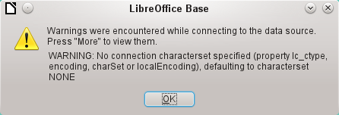
When creating tables, take care that the formatting of corresponding fields (“field properties”) agrees from the beginning. Otherwise LibreOffice will set the default format for all numeric values, which, strangely enough, is a currency.
Subsequent alteration of field properties in tables are not possible but you can enlarge the table or delete fields.

Firebird connection using ODBC
First you must download the appropriate ODBC driver from http://www.firebirdsql.org/en/odbc-driver/. This driver is usually a simple file called libOdbcFb.so. This file is usually placed in a generally accessible path in the system. It must be executable.
In the odbcinst.ini and odbc.ini files, which are necessary to the system, the following entries are required:

odbinst.ini
[Firebird]
Description = Firebird ODBC driver
Driver64 = /usr/lib64/libOdbcFb.so

odbc.ini
[Firebird-libretest]
Description = Firebird database libreoffice test
Driver = Firebird
Dbname = localhost:/srv/firebird/libretest.fdb
SensitiveIdentifier = Yes
In a Linux system, these two files are in the /etc/unixODBC folder. The variable SensitiveIdentifier must always be set to “Yes” so that entry into tables works when names and field definitions are not in upper case.
To create a connection from LibreOffice to the data source, see the chapter on "The ODBC connection".
Unfortunately the ODBC connection has very restricted functionality at present. LibreOffice crashes when you create tables. Entering a value into an integer field in 64-bit Linux produces an empty field (http://tracker.firebirdsql.org/browse/ODBC-141). Here the cooperation with the ODBC is at fault. The JDBC driver definitely functions better.

Subsequent editing of connection properties
Especially with connections to external databases, a connection may not function quite as desired. The character set may not be correct, or subforms may not function without errors, or something in the underlying parameters needs to be changed.
The following screenshots illustrate how you might change the connection parameters for an external PostgreSQL database.”
Under Edit > Database, you will find the choices “Properties”, “Connection type” and “Advanced settings”. Choose “Properties”.
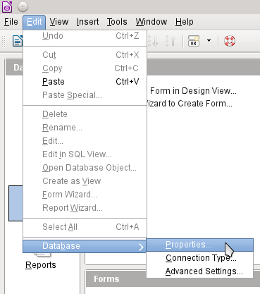
If the name of the data source has changed, it can be changed here. For an ODBC connection, the name by which the database is called up is set out in the odbc.ini file. The name is usually not quite the same as the actual database name in PostgreSQL.
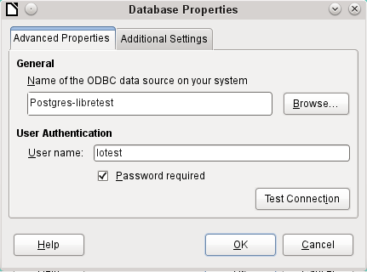
Is there a problem with the character set? These problems can be solved using the second tab of the dialog.
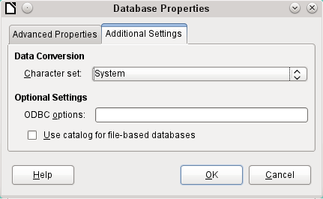
An additional special configuration of the driver is possible if a parameter should need to be implemented that is not currently in the odbc.ini file.
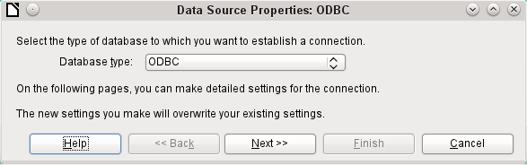
If the connection type is selected, the whole contact with the data source can be altered. The following steps are similar to those in the Database Wizard from step 2 onwards. So, for example, you can change from ODBC to JDBC or a direct connection with LibreOffice’s internal driver. This is useful if you are doing preliminary tests to determine which connection method is most suitable for a project.
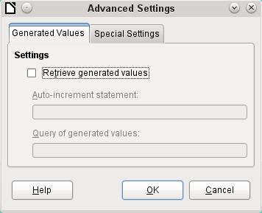
According to the database system, there are different commands to create automatically incrementing values. If you need to do something of this sort which is not currently possible with this driver, then you will need to do it by hand. This will require a command for creating an AutoValue field and also one to query the most recent value.
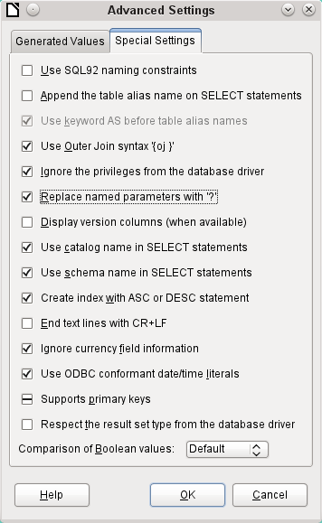
The special settings accessible through Tools > Database > Advanced settings affect the interaction of external databases with Base in various ways. Some settings are grayed out as they cannot be changed in the underlying database. In the above example Replace named parameters with ? has been checked. It has been shown that otherwise the transmission of values from a main form to a subform in PostgreSQL does not work. Only with this setting does the form construction in Chapter 4, Forms, in this handbook work correctly.

See the supplementary database for this handbook, Examples_CSV_import.odb
The “encoding=UTF-8” term works in many systems. In some cases you need to use “ansi” instead of “UTF-8”.

