

Calc as a simple database
Calc as a simple database :
A guide for users and Macro programmers
for version 2.x

Copyright
This document is Copyright © 2005 by its contributors as listed in the section titled Authors. You can distribute it and/or modify it under the terms of either the GNU General Public License, version 2 or later (http://www.gnu.org/licenses/gpl.html), or the Creative Commons Attribution License, version 2.0 or later (http://creativecommons.org/licenses/by/2.0/).
All trademarks within this guide belong to their legitimate owners.

Authors
Andrew Pitonyak

Feedback
Maintainer: Andrew Pitonyak [andrew@pitonyak.org]
Please direct any comments or suggestions about this document to:
authors@user-faq.openoffice.org or andrew@pitonyak.org

Acknowledgments

Publication date and software version
Published [dd MMM 2005]. Based on OpenOffice.org [2.0].

Version | Date | Description of Change
0.1 | October 22, 2005 | Initial version issued for comment
0.2 | September 3, 2006 | Small formatting changes.

Contents
Copyright i
Authors i
Feedback i
Acknowledgments i
Publication date and software version i
Introduction 1
Associating a range to a name 2
Named range 2
Database range 5
Sorting 7
Filters 8
Auto filters 8
Standard filters 9
Advanced filters 12
Manipulating filtered data 13
Calc functions similar to database functions 14
Count and sum cells that match conditions: COUNTIF and SUMIF 15
Ignore filtered cells using SUBTOTAL 16
Search a row or column using VLOOKUP, HLOOKUP, and LOOKUP 17
Use MATCH to find the index of a value in a range 19
ADDRESS returns a string with a cell's address 19
INDIRECT converts a string to a cell or range 20
OFFSET returns a cell or range offset from another 20
INDEX returns cells inside a specified range 22
Database specific functions 23
Conclusion 24

Introduction
A Calc document is a very capable database, providing sufficient functionality to satisfy the needs of many users. This document presents the capabilities of a Calc document that make it suitable as a database tool. Where applicable, the functionality is explained using both the GUI (Graphical User Interface) and macros.
Note | Although this document was initially created for macro programmers, the content should be accessible to all users. If you do not use macros, then skip these portions that deal with macros. On the other hand, if you want to learn more about macros, be certain to check out my book “OpenOffice.org Macros Explained”.
In a database, a record is a group of related data items treated as a single unit of information. Each item in the record is called a field. A table consists of records. Each record in a table has the same structure. A table can be visualized as a series of rows and columns. Each row in the table corresponds to a single record and each column corresponds to the fields. A spreadsheet in a Calc document is similar in structure to a database table. Each cell corresponds to a single field in a database record. For many people, Calc implements sufficient database functionality that no other database program or functionality is required.
While teaching, I used a spreadsheet as a grading program. Each row represented a single student. The columns represented the grades received on homework, labs, and tests (see Table 1). The strong calculation capability provided in a spreadsheet makes this an excellent choice.
Table 1. Simple grading spreadsheet
 | A | B | C | D | E | F | G
1 | Name | Test 1 | Test 2 | Quiz 1 | Quiz 2 | Average | Grade
2 | Andy | 95 | 93 | 93 | 92 | 93.25
3 | Betty | 87 | 92 | 65 | 73 | 79.25
4 | Bob | 95 | 93 | 93 | 92 | 93.25
5 | Brandy | 45 | 65 | 92 | 85 | 71.75
6 | Frank | 95 | 93 | 85 | 92 | 91.25
7 | Fred | 87 | 92 | 65 | 73 | 79.25
8 | Ilsub | 70 | 85 | 97 | 79 | 82.75
9 | James | 45 | 65 | 97 | 85 | 73
10 | Lisa | 100 | 97 | 100 | 93 | 97.5
11 | Michelle | 100 | 97 | 100 | 65 | 90.5
12 | Ravi | 87 | 92 | 86 | 93 | 89.5
13 | Sal | 45 | 65 | 100 | 92 | 75.5
14 | Ted | 100 | 97 | 100 | 85 | 95.5
15 | Tom | 70 | 85 | 93 | 65 | 78.25
16 | Whil | 70 | 85 | 93 | 97 | 86.25

TIP | Although the choice to associate a row to a record rather than a column is arbitrary, it is almost universal. In other words, you are not likely to hear someone refer to a column of data as a single database record.

Associating a range to a name
In a Calc document, a range refers to a contiguous group of cells containing at least one cell. You can associate a meaningful name to a range, which allows you to refer to the range using the meaningful name. You can create either a “database range”, which has some database-like functionality, or a “named range”, which does not. A name is usually associated with a range for one of three reasons:
- Associating a range with a name enhances readability by using a meaningful name.
- If a range is referenced by name in multiple locations, you can point the name to another location and all references point to the new location.
- Ranges associated to a name are shown in the navigator, which is available using the F5 key. The navigator allows for quick navigation to the associated ranges.

Named range
The most common usage of a named range is, as its name implies, to associate a range of cells to a meaningful name. For example, I created a range named “Scores”, and then I used the following equation: =SUM(Scores). To create a named range, select the range to define. Use Insert > Names > Define to open the Define Names dialog. Use the Define Names dialog to add and modify one named range at a time (see Figure 1).
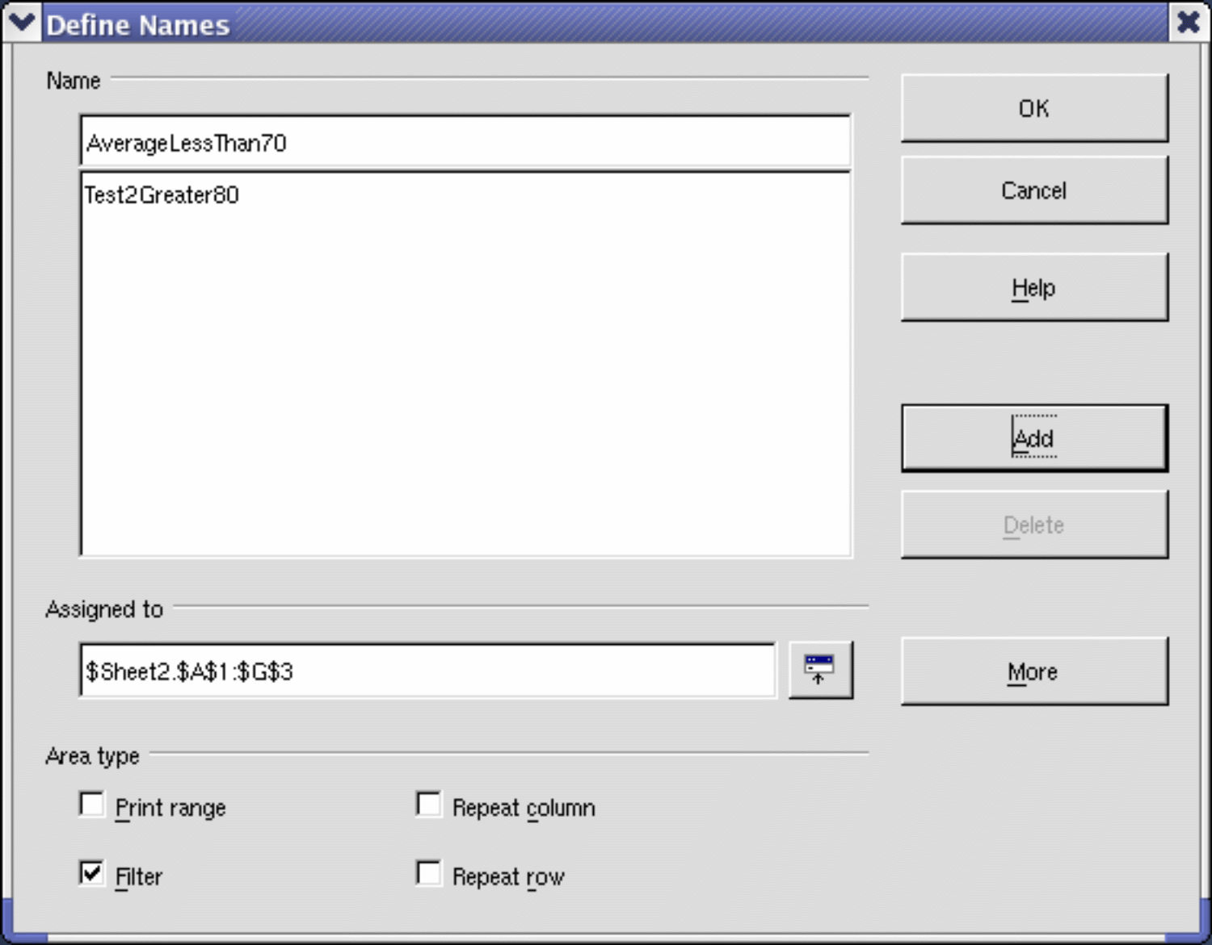Figure 1. Define a named range.
In a macro, a named range is accessed, created, and deleted using the NamedRanges property of a Calc document. Use the methods hasByName(name) and getByName(name) to verify and retrieve a named range. The method getElementNames() returns an array containing the names of all named ranges. The NamedRanges object supports the method addNewByname, which accepts four arguments; the name, content, position, and type. The macro in Listing 1 creates a named range, if it does not exist, that references a range of cells.
Listing 1. Create a named range that references $Sheet1.$B$3:$D$6.
Sub AddNamedRange()
Dim oRange ' The created range.
Dim oRanges ' All named ranges.
Dim sName$ ' Name of the named range to create.
Dim oCell ' Cell object.
Dim s$

sName$ = "MyNRange"
oRanges = ThisComponent.NamedRanges
If NOT oRanges.hasByName(sName$) Then
REM I can obtain the cell address by obtaining the cell
REM and then extracting the address from the cell.
Dim oCellAddress As new com.sun.star.table.CellAddress
oCellAddress.Sheet = 0 'The first sheet.
oCellAddress.Column = 1 'Column B.
oCellAddress.Row = 2 'Row 3.

REM The first argument is the range name.
REM The second argument is formula or expression to
REM use. The second argument is usually a string that
REM defines a range.
REM The third argument specifies the base address for
REM relative cell references.
REM The fourth argument is a set of flags that define
REM how the range is used, but most ranges use 0.
REM The fourth argument uses values from then
REM NamedRangeFlag constants (see Figure 3).
s$ = "$Sheet1.$B$3:$D$6"
oRanges.addNewByName(sName$, s$, oCellAddress, 0)
End If
REM Get a range using the created named range.
oRange = ThisComponent.NamedRanges.getByName(sName$)

REM Print the string contained in cell $Sheet1.$B$3
oCell = oRange.getReferredCells().getCellByPosition(0,0)
Print oCell.getString()
End Sub
The method addNewByname() accepts four arguments; the name, content, position, and type. The fourth argument to the method addNewByName() is a combination of flags that specify how the named range will be used (see Figure 3)—the most common value is 0, which is not a defined constant value.
Table 2. com.sun.star.sheet.NamedRangeFlag constants.
Value | Name | Description
1 | FILTER_CRITERIA | The range contains filter criteria.
2 | PRINT_AREA | The range can be used as a print range.
4 | COLUMN_HEADER | The range can be used as column headers for printing.
8 | ROW_HEADER | The range can be used as row headers for printing.

The third argument, a cell address, acts as the base address for cells referenced in a relative way. If the cell range is not specified as an absolute address, the referenced range will be different based on where in the spreadsheet the range is used. The relative behavior is illustrated in Listing 2, which also illustrates another usage of a named range—defining an equation. The macro in Listing 2 creates the named range AddLeft, which refers to the equation A3+B3 with C3 as the reference cell. The cells A3 and B3 are the two cells directly to the left of C3, so, the equation =AddLeft() calculates the sum of the two cells directly to the left of the cell that contains the equation. Changing the reference cell to C4, which is below A3 and B3, causes the AddLeft equation to calculate the sum of the two cells that are to the left on the previous row.
Listing 2. Create the AddLeft named range.
Sub AddNamedFunction()
Dim oSheet 'Sheet that contains the named range.
Dim oCellAddress 'Address for relative references.
Dim oRanges 'The NamedRanges property.
Dim oRange 'Single cell range.
Dim sName As String 'Name of the equation to create.

sName = "AddLeft"
oRanges = ThisComponent.NamedRanges
If NOT oRanges.hasByName(sName) Then
oSheet = ThisComponent.getSheets().getByIndex(0)
oRange = oSheet.getCellRangeByName("C3")
oCellAddress = oRange.getCellAddress()
oRanges.addNewByName(sName, "A3+B3", oCellAddress, 0)
End If
End Sub
TIP | Listing 2 illustrates two capabilities that are not widely known. A named range can define a function. Also, the third argument acts as the base address for cells referenced in a relative way.
Select the range containing the headers and the data and then use Insert > Names > Create to open the Create Names dialog (see Figure 2), which allows you to simultaneously create multiple named ranges based on the top row, bottom row, right column or left column. If you choose to create ranges based on the top row, one named range is created for each column header—the header is not included in the named range. Although the header is not included in the range, the text in the header is used to name the range.

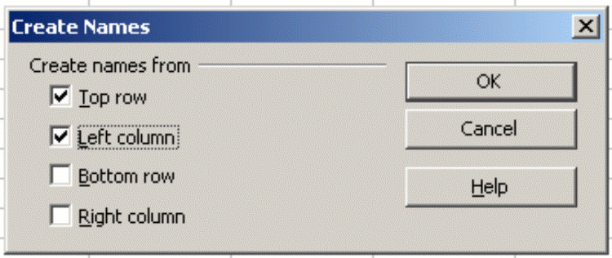Figure 2. Define a named range.
The macro in Listing 3 creates three named ranges based on the top row of a named range.
Listing 3. Create many named ranges.
Sub AddManyNamedRanges()
Dim oSheet 'Sheet that contains the named range.
Dim oAddress 'Range address.
Dim oRanges 'The NamedRanges property.
Dim oRange 'Single cell range.

oRanges = ThisComponent.NamedRanges
oSheet = ThisComponent.getSheets().getByIndex(0)
oRange = oSheet.getCellRangeByName("A1:C20")
oAddress = oRange.getRangeAddress()
oRanges.addNewFromTitles(oAddress, _
com.sun.star.sheet.Border.TOP)
End Sub
The constants in Table 3 determine the location of the headers when multiple ranges are created using the method addNewFromTitles().
Table 3. com.sun.star.sheet.Border constants.
Value | Name | Description
0 | TOP | Select the top border.
1 | BOTTOM | Select the bottom border.
2 | RIGHT | Select the right border.
3 | LEFT | Select the left border.

Caution   | It is possible to create multiple named ranges with the same name. Creating multiple ranges with a single command increases the likelihood that multiple ranges will be created with the same name—avoid this if possible.

Database range
Although a database range can be used as a regular named range, a database range also defines a range of cells in a spreadsheet to be used as a database. Each row in a range corresponds to a record and each cell corresponds to a field. You can sort, group, search, and perform calculations on the range as if it were a database.
A database range provides behavior that is useful when performing database related activities. For example, you can mark the first row as headings (see Figure 3). To create, modify, or delete a database range, use Data > Define Range to open the Define Data Range dialog .
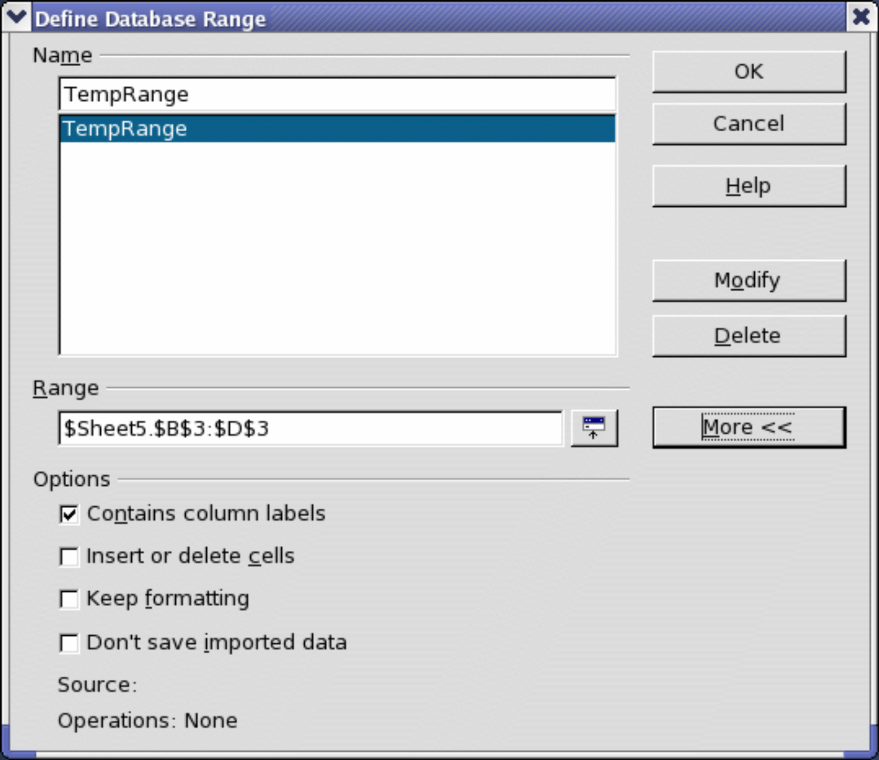Figure 3. Define a database range.
In a macro, a database range is accesses, created, and deleted from the DatabaseRanges property. The macro in Listing 4 creates a database range named “MyName” and sets the range to be used as an auto filter.
Listing 4. Create a database range and an auto filter.
Sub AddNewDatabaseRange()
Dim oRange 'DatabaseRange object.
Dim oAddr 'Cell address range for the database range.
Dim oSheet 'First sheet, which will contain the range.
Dim oDoc 'Reference ThisComponent with a shorter name.

oDoc = ThisComponent
If NOT oDoc.DatabaseRanges.hasByName("MyName") Then
oSheet = ThisComponent.getSheets().getByIndex(0)
oRange = oSheet.getCellRangeByName("A1:F10")
oAddr = oRange.getRangeAddress()
oDoc.DatabaseRanges.addNewByName("MyName", oAddr)
End If
oRange = oDoc.DatabaseRanges.getByName("MyName")
oRange.AutoFilter = True
End Sub

Sorting
The sorting mechanism in a Calc documents rearranges the data in the sheet. The first step in sorting data is to select the data that you want to sort. To sort the data in Table 1, select the cells from A1 to G16—if you include the column headers, indicate this in the sort dialog (see Figure 5). Use Data > Sort to open the Sort dialog (see Figure 4). You can only sort by three columns or rows at a time.
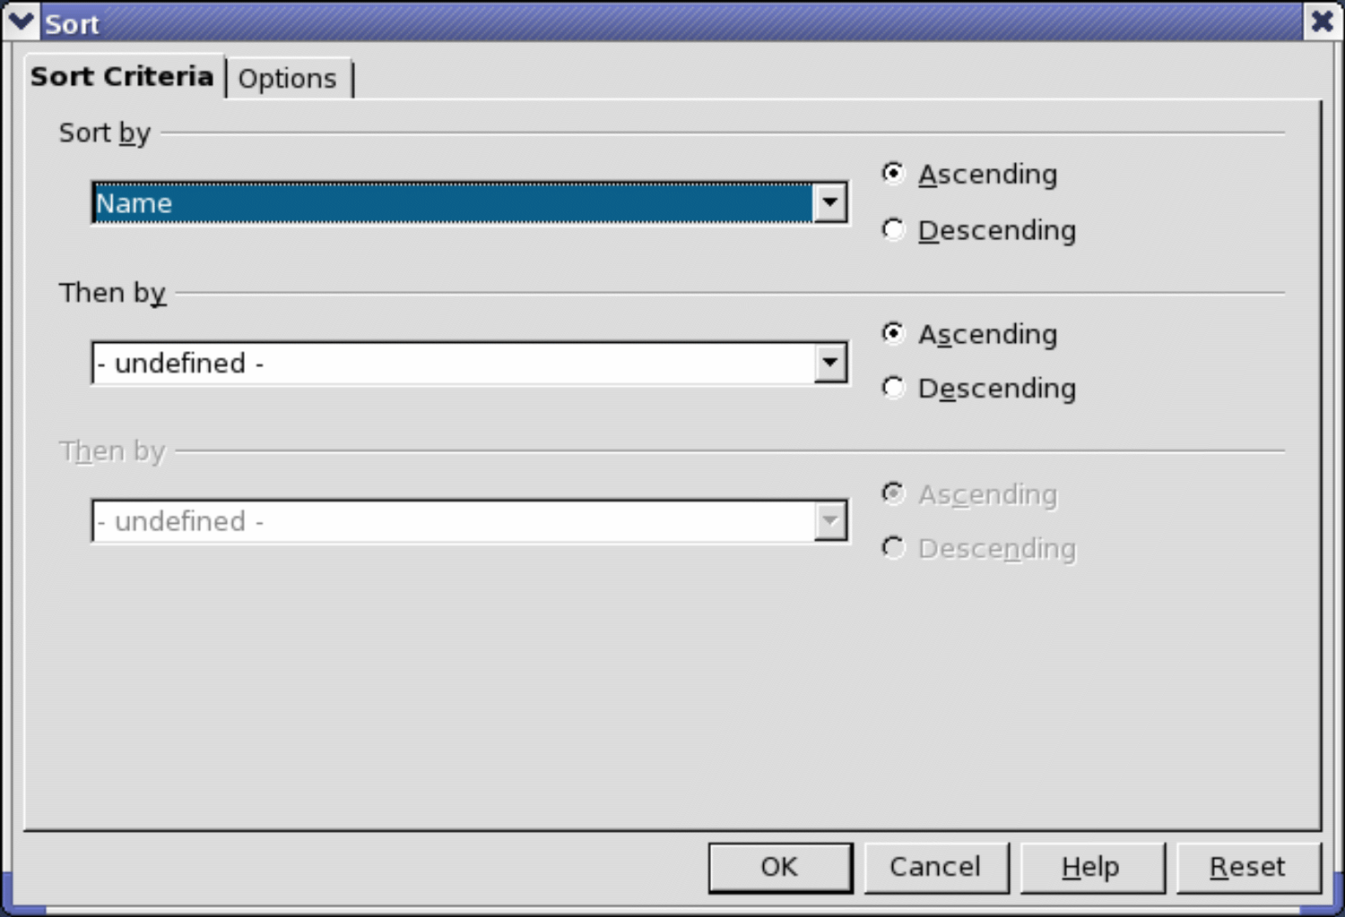Figure 4. Sort by the Name column.
Click on the Options tab (see Figure 5) to set the sort options. Check the “Range contains column labels” check box to prevent column headers from being sorted with the rest of the data. The Sort by list box in Figure 4 displays the columns using the column headers if the “Range contains column labels” check box in Figure 5 is checked. If the “Range contains column labels” check box is not checked, however, then the columns are identified by their column name; “Column A”, for example.
Normally, sorting the data causes the existing data to be replaced by the newly sorted data. The “copy sort results to” check box, however, causes the selected data to be left unchanged and a copy of the sorted data is copied to the specified location. You can either directly enter a target address (Sheet3.A1, for example) or select a predefined range.
Check the custom sort order check box to sort based on a predefined list of values. To set your own predefined lists, use Tools > Options > OpenOffice.org Calc > Sort Lists and then enter your own sort lists. Predefined sort lists are useful for sorting lists of data that should not be sorted alphabetically or numerically. For example, sorting days based on their name.
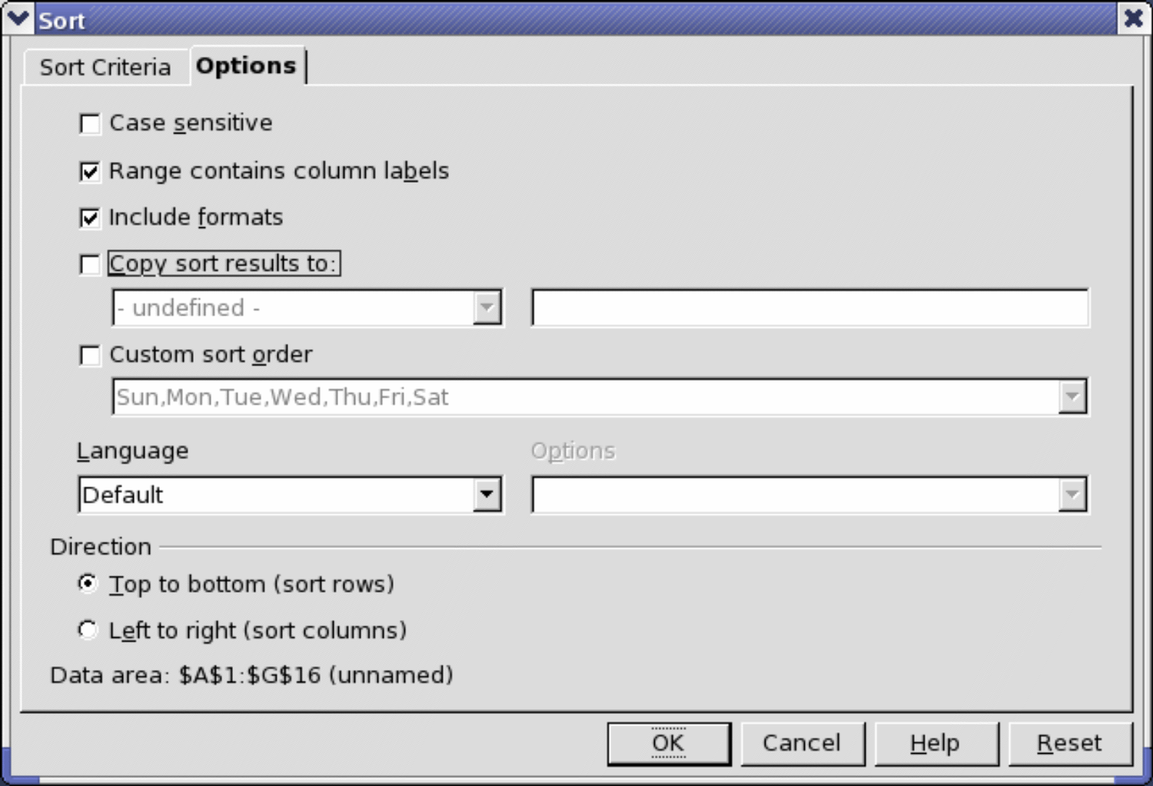Figure 5. Set sort options.
Caution | When a cell is moved during a sort operation, external references to that cell are not updated. If a cell that contains a relative reference to another cell is moved, the reference is relative to the new position when sorting is finished. Know the behavior of references during sorting and do not be alarmed, this is almost always what you want—because the reference is to the right or left in the same row. Also, I have not found a spreadsheet program that exhibits a different behavior for references while sorting

Filters
Use filters to limit the visible rows in a spreadsheet. Generic filters, common to all sorts of data manipulations, are automatically provided by the auto filter capability. You can also define your own filters.
Caution | After applying a filter, some rows are visible and some rows are not. If you select multiple rows in one operation, you will also select the invisible rows contained between the selected visible rows. Operations, such as delete, act on all of the selected rows. To avoid this problem, you must individually select each of the filtered rows using the control key.

Auto filters
Use auto filters to quickly create easily accessible filters found to be commonly used in many different types of applications. After creating an auto filter for a specific column, a combo box is added to the column. The combo box provides quick access to each of the auto filter types.
- The “all” auto filter causes all rows to be visible.
- The “Standard” auto filter opens the Standard Filter dialog and is the same as the standard filter.
- The “Top 10” auto filter displays the ten rows with the largest value. If the value 70 is in the top ten values, then all rows containing the value 70 in the filtered column are displayed. In other words, more than ten rows may be displayed.
- An auto filter entry is created for each unique entry in the column.
To create an auto filter, first select the columns to filter. For example, using the data in Table 1, select data in columns B and C. If you do not select the title rows, Calc asks if the title row or the current row should be used. Although you can place the auto filter in any row, only the rows below the auto filter are filtered. Use Data > Filter > AutoFilter to insert the auto filter combo box in the appropriate cell. Finally, use the drop-down arrow to choose an appropriate auto filter (see Figure 6).
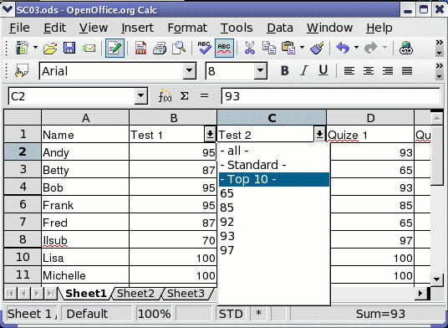Figure 6. Use an auto filter with column C.
Remove an auto filter by repeating the steps to create the auto filter—in other words, the menu option acts as a toggle to turn the auto filter on and off. When an auto filter is removed, the combo box is removed from the cell. The macro in Listing 4 demonstrates creating an auto filter for a range.

Standard filters
Use Data > Filter > Standard Filter to open Standard Filter dialog (see Figure 7) and limit the view based on 1 to 3 filter conditions. Use Data > Filter > Remove Filter to turn off the filter.
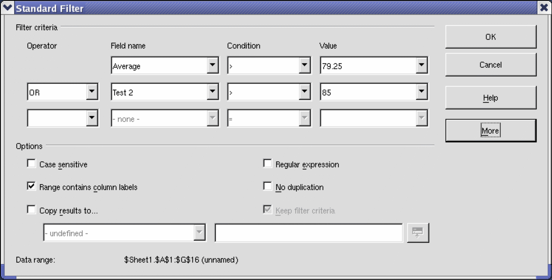Figure 7. Use the standard filter
The macro in Listing 5 creates a simple filter for the first sheet.
Listing 5. Create a simple sheet filter is in this chapter’s source code files as SC08.
Sub SimpleSheetFilter()
Dim oSheet ' Sheet that will contain the filter.
Dim oFilterDesc ' Filter descriptor.
Dim oFields(0) As New com.sun.star.sheet.TableFilterField

oSheet = ThisComponent.getSheets().getByIndex(0)

REM If argument is True, creates an empty filter
REM descriptor. If argument is False, create a
REM descriptor with the previous settings.
oFilterDesc = oSheet.createFilterDescriptor(True)

With oFields(0)
REM I could use the Connection property to indicate
REM how to connect to the previous field. This is
REM the first field so this is not required.
'.Connection = com.sun.star.sheet.FilterConnection.AND
'.Connection = com.sun.star.sheet.FilterConnection.OR

REM The Field property is the zero based column
REM number to filter. If you have the cell, you
REM can use .Field = oCell.CellAddress.Column.
.Field = 5

REM Compare using a numeric or a string?
.IsNumeric = True

REM The NumericValue property is used
REM because .IsNumeric = True from above.
.NumericValue = 80

REM If IsNumeric was False, then the
REM StringValue property would be used.
REM .StringValue = "what ever"

REM Valid operators include EMPTY, NOT_EMPTY, EQUAL,
REM NOT_EQUAL, GREATER, GREATER_EQUAL, LESS,
REM LESS_EQUAL, TOP_VALUES, TOP_PERCENT,
REM BOTTOM_VALUES, and BOTTOM_PERCENT
.Operator = com.sun.star.sheet.FilterOperator.GREATER_EQUAL
End With

REM The filter descriptor supports the following
REM properties: IsCaseSensitive, SkipDuplicates,
REM UseRegularExpressions,
REM SaveOutputPosition, Orientation, ContainsHeader,
REM CopyOutputData, OutputPosition, and MaxFieldCount.
oFilterDesc.setFilterFields(oFields())
oFilterDesc.ContainsHeader = True
oSheet.filter(oFilterDesc)
End Sub
When a filter is applied to a sheet, it replaces any existing filter for the sheet. Setting an empty filter in a sheet will therefore remove all filters for that sheet (see Listing 6).
Listing 6. Remove the current sheet filter.
Sub RemoveSheetFilter()
Dim oSheet ' Sheet to filter.
Dim oFilterDesc ' Filter descriptor.

oSheet = ThisComponent.getSheets().getByIndex(0)
oFilterDesc = oSheet.createFilterDescriptor(True)
oSheet.filter(oFilterDesc)
End Sub
Listing 7 demonstrates a more advanced filter that filters two columns and uses regular expressions. I noticed some unexpected behavior while working with Listing 7. Although you can create a filter descriptor using any sheet cell range, the filter applies to the entire sheet.
Listing 7. A simple sheet filter using two columns.
Sub SimpleSheetFilter_2()
Dim oSheet ' Sheet to filter.
Dim oRange ' Range to be filtered.
Dim oFilterDesc ' Filter descriptor.
Dim oFields(1) As New com.sun.star.sheet.TableFilterField

oSheet = ThisComponent.getSheets().getByIndex(0)
oRange = oSheet.getCellRangeByName("E12:G19")

REM If argument is True, creates an
REM empty filter descriptor.
oFilterDesc = oRange.createFilterDescriptor(True)

REM Setup a field to view cells with content that
REM start with the letter b.
With oFields(0)
.Field = 0 ' Filter column A.
.IsNumeric = False ' Use a string, not a number.
.StringValue = "b.*" ' Everything starting with b.
.Operator = com.sun.star.sheet.FilterOperator.EQUAL
End With

REM Setup a field that requires both conditions and
REM this new condition requires a value greater or
REM equal to 70.
With oFields(1)
.Connection = com.sun.star.sheet.FilterConnection.AND
.Field = 5 ' Filter column F.
.IsNumeric = True ' Use a number
.NumericValue = 70 ' Values greater than 70
.Operator = com.sun.star.sheet.FilterOperator.GREATER_EQUAL
End With

oFilterDesc.setFilterFields(oFields())
oFilterDesc.ContainsHeader = False
oFilterDesc.UseRegularExpressions = True
oSheet.filter(oFilterDesc)
End Sub

Advanced filters
An advanced filter supports up to eight filter conditions, as opposed to the three supported by the simple filter. The criteria for an advanced filter is stored in a sheet. The first step in creating an advanced filter is entering the filter criteria into the spreadsheet.
- Select an empty space in the Calc document. The empty space may reside in any sheet in any location in the Calc document.
- Duplicate the column headings from the area to be filtered into the area that will contain the filter criteria.
- Enter the filter criteria underneath the column headings (see Table 4). The criterion in each column of a row is connected with AND. The criteria from each row are connected with OR.
Table 4. Example advanced filter criteria
Name | Test 1 | Test 2 | Quiz 1 | Quiz 2 | Average | Grade
="Andy" |  | >80
 |  |  |  |  | <80

TIP | Define named ranges to reference your advanced filter criteria and any destination ranges for filtered data (see Figure 1). Each appropriately configured named range is available in drop down list boxes in the Advanced Filter dialog (see Figure 8).
After creating one or more sets of filter criteria, apply an advanced filter as follows:
- Select the sheet ranges that contain the data to filter.
- Use Data > Filter > Advanced Filter to open the Advanced Filter dialog (see Figure 8).
- Select the range containing the filter criteria and any other relevant options.
- Click OK.
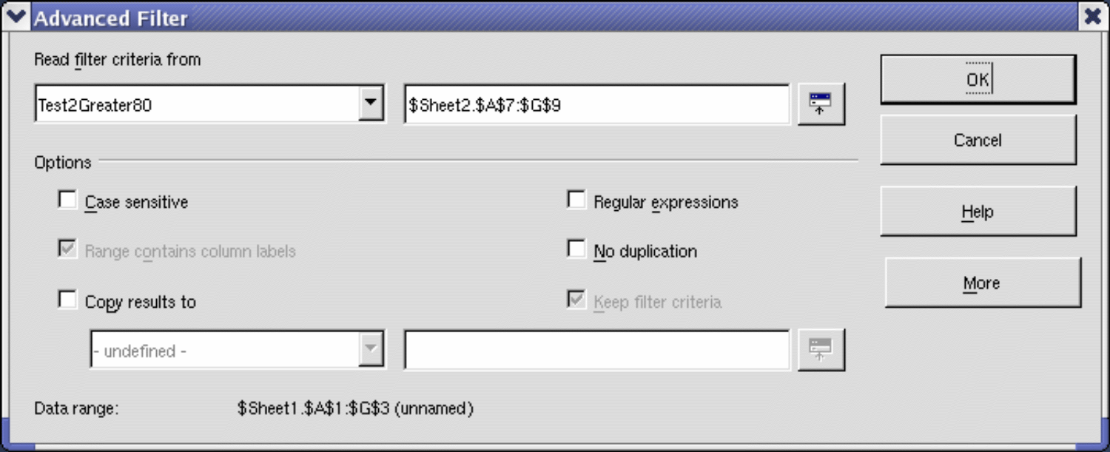Figure 8. Apply an advanced filter using a previously defined named range.
Applying an advanced filter using a macro is simple (see Listing 8). The cell range containing the filter criteria is used to create a filter descriptor, which is then used to filter the range containing the data.
Listing 8. Use an advanced filter.
Sub UseAnAdvancedFilter()
Dim oSheet 'A sheet from the Calc document.
Dim oRanges 'The NamedRanges property.
Dim oCritRange 'Range that contains the filter criteria.
Dim oDataRange 'Range that contains the data to filter.
Dim oFiltDesc 'Filter descriptor.

REM Range that contains the filter criteria
oSheet = ThisComponent.getSheets().getByIndex(1)
oCritRange = oSheet.getCellRangeByName("A1:G3")

REM You can also obtain the range containing the
REM filter criteria from a named range.
REM oRanges = ThisComponent.NamedRanges
REM oRange = oRanges.getByName("AverageLess80")
REM oCritRange = oRange.getReferredCells()

REM The data that I want to filter
oSheet = ThisComponent.getSheets().getByIndex(0)
oDataRange = oSheet.getCellRangeByName("A1:G16")

oFiltDesc = oCritRange.createFilterDescriptorByObject(oDataRange)
oDataRange.filter(oFiltDesc)
End Sub

Manipulating filtered data
Filtered data copied to a new location may be selected, modified, and deleted at will. Data that is not copied, however, requires special attention because rows that do not match the filter criteria are simply hidden. OpenOffice.org behaves differently depending on how the cells became hidden and what operation is done.
Cells may be hidden using an outline, data filter, or the hide command. When data is moved by dragging or using cut and paste, all of the cells are moved—including the hidden cells. When copying data, however, filtered data includes only the visible cells and data hidden using an outline or the hide command copies all of the data.

Calc functions similar to database functions
Although every Calc function can be used for database manipulation, the functions in Table 5 are more commonly used as such. Some functions names differ only by the letter appended at the end; AVERAGE and AVERAGEA, for example. Functions that do not end with the letter A operate only on numeric values and cells that contain text or are empty are ignored. The corresponding function whose name ends with the letter “A”, treats text values as a number with the value of zero; blank cells are still ignored.
Table 5. Functions frequently used as database functions.
Function | Description
AVERAGE | Return the average. Ignore empty cells and cells that contain text.
AVERAGEA | Return the average. The value of text is 0 and empty cells are ignored.
COUNT | Count the number of numeric entries, text entries are ignored.
COUNTA | Count the number of non-empty entries.
COUNTBLANK | Return the number of empty cells.
COUNTIF | Return the number of cells that meet the search criteria.
HLOOKUP | Search for a specific value across the columns in the first row of an array. Return the value from a different row in the same column.
INDEX | Return the content of a cell, specified by row and column number or an optional range name.
INDIRECT | Return the reference specified by a text string.
LOOKUP | Return the contents of a cell either from a one-row or one-column range or from an array.
MATCH | Search an array and return the relative position of the found item.
MAX | Return the maximum numeric value in a list of arguments.
MAXA | Return the maximum numeric value in a list of arguments. The value of text is 0.
MIN | Return the minimum numeric value in a list of arguments.
MINA | Return the minimum numeric value in a list of arguments. The value of text is 0.
MEDIAN | Return the median of a set of numbers.
MODE | Return the most common value in a data set. If there are several values with the same frequency, it returns the smallest value. An error occurs when a value doesn't appear twice.
OFFSET | Return the value of a cell offset by a certain number of rows and columns from a given reference point.
PRODUCT | Return the product of the cells.
STDEV | Estimate the standard deviation based on a sample.
STDEVA | Estimate the standard deviation based on a sample. The value of text is 0.
STDEVP | Calculate the standard deviation based on the entire population.
STDEVPA | Calculate the standard deviation based on the entire population.
SUBTOTAL | Calculate a specified function based on a subset created using AutoFilters.
SUM | Return the sum of the cells.
SUMIF | Calculate the sum for the cells that meet the search criteria.
VAR | Estimate the variance based on a sample.
VARA | Estimate the variance based on a sample. The value of text is 0.
VARP | Estimate the variance based on the entire population.
VARPA | Estimate the variance based on the entire population. The value of a text is 0.
VLOOKUP | Search for a specific value across the rows in the first column of an array. Return the value from a different column in the same row.

Most of the functions in Table 5 require no explanation, either because they are well understood (SUM, for example) or because if you need to use them then you know what they are (STDEV, for example). Unfortunately, some of the more useful functions are infrequently used because they are not well understood.

Count and sum cells that match conditions: COUNTIF and SUMIF
The COUNTIF and SUMIF functions calculate their values based on search criteria. The search criteria can be a number, expression, text string, or even a regular expression. The search criteria can be contained in a referenced cell or it can be included directly in the function call.
The COUNTIF function counts the number of cells in a range that match specified criteria. The first argument to COUNTIF specifies the range to search and second argument is the search criteria. represents data in a spreadsheet that is used to demonstrate the COUNTIF and SUMIF functions.
The COUNTIF function counts the number of cells in a range that match specified criteria. The first argument to COUNTIF specifies the range to search and second argument is the search criteria. Table 6 illustrates different search criteria using the COUNTIF function referencing the data shown in Table 1.
Table 6. Examples of search criteria for the COUNTIF and SUMIF functions.
Criteria Type | Function | Result | Description
Number | =COUNTIF(B1:C16; 95) | 3 | Find numeric values of 95.
Text | =COUNTIF(B1:C16; "95") | 3 | Find numeric or text values of 95.
Expression | =COUNTIF(B1:C16; ">95") | 6 | Find numeric values greater than 95.
Expression | =COUNTIF(B1:C16; 2*45+5) | 3 | Find only numeric values of 95.
Regular expression | =COUNTIF(B1:C16; "9.*") | 12 | Find numbers or text that start with 9.
Reference a cell | =COUNTIF(B1:C16; B3) | 3 | Find number or number and text depending on the data type in cell B3.
Regular expression | =SUMIF(A1:A16; "B.*"; B1:B16) | 227 | Sum Column B for names starting with the letter B.

The first two arguments for SUMIF serve the same purpose as the arguments for COUNTIF; the range that contains the cells to search and the search criteria. The third and final argument for SUMIF specifies the range to sum. For each cell in the search range that matches the search criteria, the corresponding cell in the sum range is added into the sum.

Ignore filtered cells using SUBTOTAL
The SUBTOTAL function applies a function (see Table 7) to a range of data, but it ignores cells hidden by a filter and cells that already contain a SUBTOTAL. For example, =SUBTOTAL(2, "B2:B16") counts the number of cells in B2:B16 that are not hidden by a filter.
Table 7. Function index for the SUBTOTAL function.
Function index | Function
1 | AVERAGE
2 | COUNT
3 | COUNTA
4 | MAX
5 | MIN
6 | PRODUCT
7 | STDEV
8 | STDEVP
9 | SUM
10 | VAR
11 | VARP

TIP | Do not forget that the SUBTOTAL function ignores cells that use the SUBTOTAL function. I have a spreadsheet that tracks investments. My retirement investments are grouped together with a subtotal. The same is true of my regular investments. I can use a single subtotal that includes the entire range without worrying about the subtotal cells.

Search a row or column using VLOOKUP, HLOOKUP, and LOOKUP
Use VLOOKUP to search the first column of a range and return the cell value in the specified column of the same row. For example, Table 1 contains rows of data. Use VLOOKUP to find the row that starts with “Bob” and return column C; =VLOOKUP("Frank"; A1:C5; 3; 1). The HLOOKUP function, on the other hand, searches the first row, rather than the first column, and the index causes values to be obtained down the column rather than across the row. The supported forms for VLOOKUP and HLOOKUP are as follows:
VLOOKUP(search_value; search_range; column_index)
VLOOKUP(search_value; search_range; column_index; st_order)
HLOOKUP(search_value; search_range; row_index)
HLOOKUP(search_value; search_range; row_index; sort_order)
For VLOOKUP, the first argument, search_value, identifies the value to find. The second argument, search_range, identifies the cells to search; only the first column is searched. The column_index identifies the column to return; a value of 1 returns the first column. The final column, sort_order, is optional. The default value for sort_order is 1, which specifies that the first column is sorted in ascending order; a value of 0 specifies that the data is not sorted. If the data is sorted in ascending order, a more efficient search routine is used. A non-sorted search requires an exact match, but a sorted search always returns a value if the searched text lies between the first and last values. Table 8 contains examples using the VLOOKUP function.
Table 8. VLOOKUP examples searching the data in Table 1.
Usage | Return | Comment
VLOOKUP("F.*"; A2:C9; 1; 0) | Frank | Return the first column of the first row that starts with the letter “F”.
VLOOKUP("F.*"; A2:C9; 1; 1) | Fred | Return the first column of the first row starting with “F”; this is faster because the data is known to be sorted in ascending order.
VLOOKUP("FRED"; A2:C9; 2; 0) | 87 | Return the second column of the first row that contains “FRED”.
VLOOKUP("FRED"; A2:C9; 2; 1) | 87 | Return the second column of the last row that contains “FRED”.
VLOOKUP("Fran"; A2:C9; 3; 0) | #N/A | The data is not sorted so an exact match must be made. No match exists so an error value is returned.
VLOOKUP("Fran"; A2:C9; 3; 1) | 65 | “Fran” does not exist, so return the third column of the row that should precede “Fran”.
VLOOKUP("Aaron"; A2:C9; 3; 1) | #N/A | “Aaron” comes before the first table entry so return an error with a sorted list.

Caution | The behavior for LOOKUP, HLOOKUP, VLOOKUP, and MATCH is the same in sorted range modes. When searching for a numerical value, string contents are ignored and do not terminate a search. When searching for a string value, the very first string is ignored if it does not match, because it could be a column header. Searches still assume that the range is sorted and return the last value less than or equal to the queried value—prior to version 2.0, the first match was returned. The search stops if a value greater than the value queried is encountered. If the data is not sorted the result may be arbitrary and incorrect.
The documentation for HLOOKUP and VLOOKUP state that the search range must contain more than one row or column, but it can. Although it appears as though neither the documentation, nor the implementation will change, my recommendation is that you avoid undocumented behavior and use the LOOKUP function instead. The search range for the LOOKUP function is a single sorted row or column. The LOOKUP function can accept two or three arguments as follows:
LOOKUP(search_value; search_range)
LOOKUP(search_value; search_range; return_range)
LOOKUP finds the search_value in the search range. If only two arguments are used, then the text contained in the cell that is found is returned. If the search value is not found, then the text “#N/A” is returned instead.
If three arguments are used, the third argument must be a single row or column containing the same number of cells as the search range. If the search value is found in the fourth cell in the search range, then the text from the fourth cell in the return range is returned. The return range may be the same range as the search range. The return range does not need to have the same orientation as the search range. In other words, the search range can be a row and the return range may be a column.
Caution | Although the search range for the LOOKUP function is documented as a single row or column, a range containing both rows and columns can be used. When both rows and columns are used, the first column is searched and a value from the last column is returned. It is dangerous to rely on behavior that is contrary to the documentation.

Use MATCH to find the index of a value in a range
MATCH searches a single row or column and returns the position that matches the search criteria. Use MATCH to find the index of a value in a range. The MATCH function is similar to the “LOOKUP” functions in that the search is not case sensitive and “#N/A” is returned if no match is found. The supported forms for MATCH are as follows:
=MATCH(search_value; search_range)
=MATCH(search_value; search_range; search_type)
The behavior of MATCH is controlled by the optional third argument, which supports values of -1, 0, and 1 (see Table 9). If omitted, the search type defaults to 1. Using =MATCH("Bob";A2:A16 ; 0) with the data in Table 1 returns the value 3 because Bob is in row 3—if you search the range A1:A16, then 4 is returned instead.
Table 9. Behavior of MATCH is based on the search type.
Type | Sorted | Regular Expressions | Returns
-1 | Descending | No | Return the index of first value that is larger or equal is.
0 | None | Yes | Return the index of the matched cell.
1 | Ascending | No | Return the index of last value that is smaller or equal is.

ADDRESS returns a string with a cell's address
Use ADDRESS to return a text representation of a cell address based on the row, column, and sheet; ADDRESS is frequently used with MATCH. The supported forms for ADDRESS are as follows:
ADDRESS(row; column)
ADDRESS(row; column; abs)
ADDRESS(row; column; abs; sheet)
The row and column are integer values where ADDRESS(1; 1) returns “$A$1”. The abs argument specifies which portion is considered absolute and which portion is considered relative (see Table 10); an absolute address is specified using the “$” character. The sheet is included as part of the address only If the sheet argument is used. The sheet argument is treated as a string. Using ADDRESS(MATCH("Bob";A1:A5 ; 0); 2) with the data in Table 8 returns “$B$2”.
Table 10. Values supported by the abs argument to ADDRESS.
Value | Description
1 | Use absolute addressing. This is the default value if the argument is missing or an invalid value is used. ADDRESS(2; 5; 1) returns “$E$2”.
2 | Use an absolute row reference and a relative column reference. ADDRESS(2; 5; 2; “Blah”) returns “Blah.E$2”.
3 | Use a relative row reference and an absolute column reference. ADDRESS(2; 5; 3) returns “$E2”.
4 | Use relative addressing. ADDRESS(2; 5; 4) returns “E2”.

TIP | Calc supports numerous powerful functions that are not discussed here. For example, the ROW, COLUMN, ROWS, and COLUMNS statements are not discussed; a curious person would investigate these functions.

INDIRECT converts a string to a cell or range
Use INDIRECT to convert a string representation of a cell or range address to a reference to the cell or range. Table 11 contains examples accessing data as shown in Table 8.
Table 11. Examples using INDIRECT.
Example | Comment
INDIRECT("A2") | Return cell A2, which contains “Bob”.
INDIRECT(G1) | If Cell G1 contains the text “A2”, then this returns “Bob”.
SUM(INDIRECT("B1:B5")) | Return the sum of the range “B1:B5”, which is 194.
INDIRECT(ADDRESS(2; 1)) | Returns the contents of cell “$A$2”, which is “Bob”.

OFFSET returns a cell or range offset from another
Use OFFSET to return a cell or range offset a specified number of rows and columns from a given reference point. The first argument, specifies the reference point. The second and third arguments specify the number of rows and columns to move from the reference point; in other words, where the new range starts. The OFFSET function has the following syntax:
OFFSET(reference; rows; columns)
OFFSET(reference; rows; columns; height)
OFFSET(reference; rows; columns; height; width)
TIP | If the width or height is included, the OFFSET function returns a range. If both the width and height are missing, a cell reference is returned.
If the height or width are missing, they default to 1. If the height is present, then a range reference is returned rather than a cell reference. Using values from Table 1, Listing 9 uses OFFSET to obtain the quiz scores for the student named Bob;
Listing 9. Complex example of OFFSET
=SUM(OFFSET(INDIRECT(ADDRESS(MATCH("Bob";A1:A16; 0); 4)); 0; 0; 1; 2))
In its entirety, Listing 9 is complex and difficult to understand. Table 12 isolates each function in Listing 9, providing an easy to understand explanation of how the example works.
Table 12. Breakdown of Listing 9.
Function | Description
MATCH("Bob";A1:A16; 0) | Returns 4 because Bob is the fourth entry in column A.
ADDRESS(4; 4) | Returns “$D$4”.
INDIRECT("$D$4") | Converts “$D$4” into a reference to the cell D4.
OFFSET($D$4; 0; 0; 1; 2) | Returns the range D4:E4.
SUM(D4:E4) | Returns the sum of Bob's quiz scores.

Although Listing 9 works as intended, it breaks easily and unexpectedly. Consider, for example, what happens if the range is changed to A2:A16. MATCH returns an offset into the provided range, so MATCH("Bob";A2:A16 ; 0) returns 3 rather than 4. ADDRESS(3; 4) returns “$D$3” rather than “$D$4” and Betty's quiz scores are returned instead of Bob's. Listing 10 uses a slightly different method to obtain Bob's quiz scores.
Listing 10. Better use of OFFSET
=SUM(OFFSET(A1; MATCH("Bob"; A1:A16; 0)-1; 3; 1; 2))
Table 13 contains a description of each function used in Listing 10. To help convince yourself that Listing 10 is better than Listing 9, replace A1 with A2 in both Listing 10 and Table 13 and notice that you still obtains Bob's quiz scores.
Table 13. Breakdown of Listing 10.
Function | Description
MATCH("Bob";A1:A16; 0)-1 | Returns 3 because Bob is the fourth entry in column A.
OFFSET(A1; 3; 3; 1; 2) | Returns the range D4:E4.
SUM(D4:E4) | Returns the sum of Bob's quiz scores.

TIP | The first argument to OFFSET can be a range so you can use a defined range name.

INDEX returns cells inside a specified range
INDEX returns the cells specified by a row and column number. The row and column number are relative to the upper left corner of the specified reference range. For example, using =INDEX(B2:D3; 1; 1) returns the cell B2. Table 14 lists shows the syntax for using the INDEX function.
Table 14. Syntax for INDEX.
Syntax | Description
INDEX(reference) | Return the entire range.
INDEX(reference; row) | Returns the specified row in the range.
INDEX(reference; row; column) | Returns the cell specified by row and column. A row and column of 1 returns the cell in the upper left corner of the range.
INDEX(reference; row; column; range) | A reference range can contain multiple ranges. The range argument specifies which range to use.

The INDEX function can return an entire range, a row, or a single column (see Table 14). the ability to index based on the start of the reference range provides some interesting uses. Using the values shown in Table 1, Listing 11 finds and returns Bob's quiz scores. Table 15 contains a listing of each function used in Listing 11.
Listing 11. Return Bob's quiz scores.
=SUM(OFFSET(INDEX(A2:G16; MATCH("Bob"; A2:A16; 0)); 0; 3; 1; 2))
Table 15. Breakdown of Listing 11.
Function | Description
MATCH("Bob";A2:A16; 0) | Returns 3 because Bob is the third entry in column A2:A16.
INDEX(A2:A16; 3) | Returns the A4:G4—the row containing Bob's quiz scores.
OFFSET(A4:G4; 0; 3; 1; 2) | Returns the range D4:E4.
SUM(D4:E4) | Returns the sum of Bob's quiz scores.

TIP | A simple range contains one contiguous rectangular region of cells. It is possible to define a multi-range that contains multiple simple ranges. If the reference consists of multiple ranges, you must enclose the reference or range name in parentheses.
If reference argument to the INDEX function is a multi-range, then the range argument specifies which simple range to use (see Table 16).
Table 16. Using INDEX with a multi-range.
Function | Returns
=INDEX(B2:G2; 1; 2) | 93
=INDEX(B5:G5; 1; 2) | 65
=INDEX((B2:G2;B5:G5); 1; 2) | 93
=INDEX((B2:G2;B5:G5); 1; 2; 1) | 93
=INDEX((B2:G2;B5:G5); 1; 2; 2) | 65

Database specific functions
Although every Calc function can be used for database manipulation, the functions in Table 17 are specifically designed for use as a database. The descriptions in Table 17 use the following terms interchangeably: row and record, cell and field, and database and all rows.
Table 17. Database functions in a Calc document.
Function | Description
DAVERAGE | Return the average of all fields that matches the search criteria.
DCOUNT | Count the number of records containing numeric data that match the search criteria.
DCOUNTA | Count the number of records containing text data that match the search criteria.
DGET | Return the contents of a field that matches the search criteria.
DMAX | Return the maximum content of a field that matches the search criteria.
DMIN | Return the minimum content of a field that matches the search criteria.
DPRODUCT | Return the product of the fields that matches the search criteria.
DSTDEV | Calculate the standard deviation using the fields that match the search criteria. The fields are treated as a sample.
DSTDEVP | Calculate the standard deviation using the fields that match the search criteria. The fields are treated as the entire population.
DSUM | Return the sum of all fields that matches the search criteria.
DVAR | Calculate the variance using the fields that match the search criteria. The fields are treated as a sample.
DVARP | Calculate the variance using the fields that match the search criteria. The fields are treated as the entire population.

The syntax for the database functions are identical.
DCOUNT(database; database field; search criteria)
The database argument is the cell range that defines the database. The cell range should contain the column labels (see Listing 12). The following examples, assume that the data from Table 1 is placed in “Sheet 1” and the filter criteria in Table 4 is placed in “Sheet 2”.
Listing 12. The database argument includes the headers.
=DCOUNT(A1:G16; "Test 2"; Sheet2.A1:G3)
The database field specifies the column on which the function operates after the search criteria is applied and the data rows are selected. The database field can be specified using the column header name or as an integer. If the column is specified as an integer, 0 specifies the entire data range, 1 specifies the first column, 2 specifies the second column, and so on. Listing 13 calculates the average test score for the rows that match the search criteria.
Listing 13. “Test 2” is column 3.
=DAVERAGE(A1:G16; "Test 2"; Sheet2.A1:G3)
=DAVERAGE(A1:G16; 3; Sheet2.A1:G3)
The search criteria is the cell range containing search criteria. The search criteria is identical to the advanced filters; criteria in the same row is connected by AND and criteria in different rows is connected by OR.

Conclusion
A Calc document provides sufficient database functionality to satisfy the needs of most people. The infrequently used database functions, such as OFFSET and INDEX, are worth the time to learn and they can save yourself time in the long run.

