How to Install LAMP Stack on CentOS 8
Introduction
The LAMP stack is a set of open-source software used for web application development. It consists of a Linux operating system, an Apache HTTP server, the MySQL database management system, and PHP programming language.
In this tutorial, learn how to install the LAMP stack on CentOS 8.
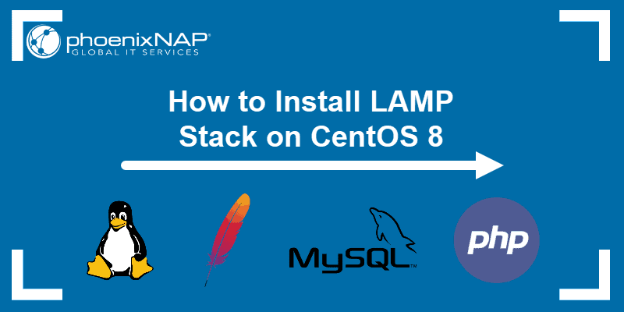
Prerequisites
- A server running CentOS 8 Linux
- A terminal window/command line (Search > terminal)
- A user account with sudo or root privileges
- The yum and RPM package managers, included by default
Follow the installation steps outlined below and install the required software in the specified order. As this guide is for CentOS 8 users, it skips the first layer of the stack (the Linux operating system), presuming it has already been installed.

Step 1: Update System Software Packages
Open a terminal window and update the package repository before installing new software:
sudo yum update

Step 2: Install Apache
1. Install Apache Web Services with the command:
sudo yum -y install httpd
2. Then, start the Apache service by running:
sudo systemctl start httpd.service
3. To verify Apache is running, open a web browser and navigate to the server’s public IP address. It should display the Apache Test Page, as in the image below.
Note: For additional details, refer to our article on how to install Apache on CentOS 8.

Step 3: Install MySQL
The third layer of the LAMP stack is MySQL or MariaDB. Both are open-source database management systems used for storing and managing data on your website.
In this example, the tutorial includes a MySQL installation. Alternatively, you can install MariaDB.
1. Start by adding the MySQL repository:
rpm -ivh https://dev.mysql.com/get/mysql80-community-release-el8-1.noarch.rpm
2. Check the repository by typing:
sudo yum repolist all |grep mysql | grep enabled
The output should display a list of the different MySQL options available.
3. Now, install MySQL:
sudo yum --disablerepo=AppStream install -y mysql-community-server
4. Then, enable the MySQL service and set it to start on boot:
sudo systemctl start mysqld
sudo systemctl enable mysqld
5. Check whether the service is running properly with the command:
sudo systemctl status mysql
The output should display the service is active (running).
Note: To easily manage MySQL databases, admins often opt to install PHPMyAdmin.

Step 4: Configure MySQL Security
The next step is to configure the basic MySQL security settings.
1. Start by displaying the temporary MySQL root password:
cat /var/log/mysqld.log | grep -i 'temporary password'
The system displays the temporary MySQL password.
2. Next, run the command:
sudo mysql_secure_installation
Provide the MySQL root password received in the previous step.
3. Then, enter and re-enter a new password, making sure it meets the standards for password strength.
4. After updating the password, you are prompted again to change the root password. To do so, type y and hit Enter.
5. The output displays the estimated strength of the password. Press y to continue with the password provided.
Answer the rest of the questions with y and Enter:
- Remove anonymous users? (y)
- Disallow root login remotely? (y)
- Remove test database and access to it? (y)
- Reload privilege tables now? (y)
With this, MySQL is secured.
Note: For an in-depth guide and additional instructions, please refer to How to Install MySQL on CentOS 8.

Step 5: Install PHP and Supporting Modules
Set up the final layer by installing the PHP programming language and the supporting modules for phpMyAdmin:
sudo yum -y install php php-pdo php-pecl-zip php-json php-common php-fpm php-mbstring php-cli php-mysqlnd wget upzip
Then, enable the PHP module to work with Apache by restarting the webserver:
sudo systemctl restart httpd.service

Step 6: Adjust the Firewall
If you have firewalld set up on CentOS, you need to adjust the configuration to allow Apache connections.
1. Open the firewall for HTTP traffic with the command:
sudo firewall-cmd --permanent --zone=public --add-service=http
2. Next, adjust it to allow HTTPS traffic as well:
sudo firewall-cmd --permanent --zone=public --add-service=https
3. Restart the firewall for the changes to take place:
sudo firewall-cmd --reload
4. Check to verify HTTP and HTTPS routes are now permanently open by running:
sudo firewall-cmd --permanent --list-all
The output should display http and https in the list of services.
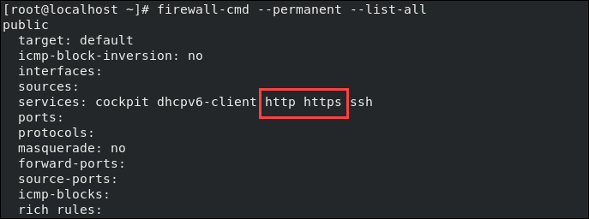

Step 7: Test PHP with Apache
Apache creates a web root file in the default website directory /var/www/html/. To check whether PHP is set up properly by running a test from this directory.
1. Create a info.php file inside the directory:
sudo vim /var/www/html/info.php
2. Then, add the following content:
<?php

phpinfo ();

?>
3. Save and exit the file.
4. Now, verify if PHP is working correctly. Open a web browser and navigate to the URL (replacing ip_address with the public IP of the server):
http://ip_address/info.php

The browser should display the content, as in the image below.
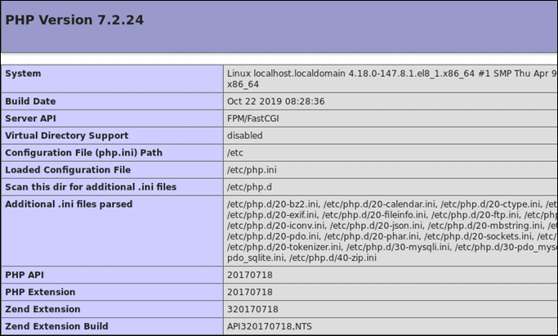
Note: Want more details about this open-source software bundle? Refer to What is a LAMP stack?
Conclusion
You should now have a working installation of LAMP Stack on your CentOS 8 system.
Next, explore other stack alternatives such as the XAMPP stack or the MEAN stack.

Was this article helpful?
YesNo

Share on TwitterShare on FacebookShare on LinkedIn

Share on Email



Sofija Simic
Sofija Simic is an aspiring Technical Writer at phoenixNAP. Alongside her educational background in teaching and writing, she has had a lifelong passion for information technology. She is committed to unscrambling confusing IT concepts and streamlining intricate software installations.

Next you should read

SysAdmin Web Servers
How to Install phpMyAdmin on CentOS 7
October 22, 2018

This guide is for users who have already configured a CentOS server...
Read more

SysAdmin Web Servers
What is a LAMP Stack?
January 6, 2022

The LAMP stack is a set of open source software used for web application...
Read more

SysAdmin Web Servers
How to Install Apache on CentOS 8
February 6, 2020

The Apache web server is widely used, especially as part of the LAMP stack...
Read more

MySQL
How to Install MySQL on CentOS 8
February 17, 2020

MySQL, the most widely used relational database management system can be...
Read more
- 

- Recent Posts
- lspci Command: What Is It and How to Use It
- How to List Installed Packages on Ubuntu
- How to Use the Linux history Command
- Podman vs Docker: Everything You Need to Know
- Linux File Command: How to Determine File Type in Linux
- Categories
- SysAdmin
- Virtualization
- DevOps and Development
- Security
- Backup and Recovery
- Bare Metal Servers
- Web Servers
- Networking
- Databases
- Company
- About Us
- GitHub
- Blog
- RFP Template
- Careers
- Products
- Colocation
- Servers
- Cloud Services
- Solutions
- Locations
- Connect
- Events
- Press
- Contact Us

- Live Chat
- Get a Quote
- Support | 1-855-330-1509
- Sales | 1-877-588-5918

- Privacy Policy
- GDPR
- Sitemap
© 2021 Copyright phoenixNAP | Global IT Services. All Rights Reserved.

https://phoenixnap.com/kb/how-to-install-lamp-stack-centos-8

How to install and configure a LAMP server on CentOS 8
Published on: 15 September 2021
Apache CentOS Hosting MySQL PHP

Contents
- How to install and configure a LAMP server on CentOS 8
  - Introduction
  - Pre-requisites
  - Installing the Apache Web Server
  - Installing the MariaDB database
  - Installing PHP
  - Final test of PHP functioning with Apache
  - Conclusions

Introduction
The acronym LAMP stands for Linux, Apache, MariaDB, PHP and refers to a series of open-source software that work in synergy to help you manage a web space to build apps with PHP.
Among the different software installed:
- Linux is the operating system
- Apache is the web server
- MariaDB manages persistent data in the database
- PHP manages the dynamics of processes in the web space.

Pre-requisites
To perform the procedure, use the privileges sudo but with user different from the administrator.

Installing the Apache Web Server
The first service to be installed is the webserver, to make your site accessible to visitors.
To do so, start by installing the httpd package, using the command:
$ sudo dnf install httpd
Confirm you want to install Apache by entering the character y.
Once the installation process is completed, start the server via the command:
$ sudo systemctl start httpd
The next step is to give Apache permissions from the firewall. To do so, use the command:
$ sudo firewall-cmd --permanent --add-service=http
By doing so, the firewall will enable HTTP connections on port 80. To verify the correct functioning of the changes applied, follow the procedure below:
Restart the firewall via
$ sudo firewall-cmd --reload
If everything went well, an output similar to the following should be seen:
public
target: default
icmp-block-inversion: no
interfaces:
sources:
services: cockpit dhcpv6-client http ssh
ports:
protocols:
masquerade: no
forward-ports:
source-ports:
icmp-blocks:
rich rules:

If the http protocol appears in the list of services, the enabling has been successful.
At this point, due to the unblocking of the firewall, the service offered can now be accessed by your web space simply by connecting to your public IP address or the chosen domain name.
In case of difficulty identifying the domain name or IP address of your webserver, just launch a command in the terminal:
$ ip addr show eth0 | grep inet | awk '{ print $2; }' | sed 's/\/.*$//'
The output of this command is a list of IP addresses to connect to via a web browser in order to locate the one on your server.
Through this other command, however, it can be seen which IP address is publicly accessible by external agents on the internet:
$ curl -4 icanhazip.com
By connecting to the IP address, the Apache landing page should be displayed as a confirmation that you are connected to the right server.
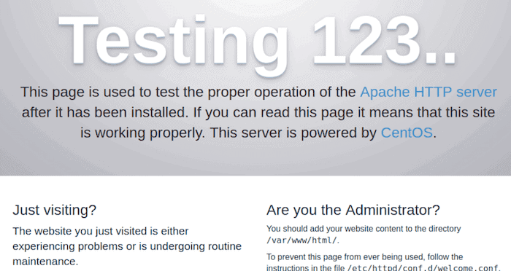

Installing the MariaDB database
Once the web server is running, it’s time to install the component that stores persistent data in a database. MariaDB is an excellent alternative to MySQL.
Start by running:
$ sudo dnf install mariadb-server
Once the installation is completed, just start the database server
$ sudo systemctl start mariadb
The MariaDB installation will entail a script to set good security criteria and allow you to customize other preferences. To do so, simply run the command:
$ sudo mysql_secure_installation
Through this script, a number of information and preferences necessary for a correct configuration of MariaDB (for example, the credentials of the root user) can be entered.
To log into MariaDB, just use the command :
$ sudo mysql
At this point, the new database can be created using the command:
CREATE DATABASE dbexample;
With this command, your first database will have been created.
Choose whether or not to assign privileges regarding individual databases to users of your server. To do so, use a command similar to the one in the example.
GRANT ALL ON dbexample.* TO userexample@'localhost' IDENTIFIED BY 'passwordexample' WITH GRANT OPTION;
To save the changes and make them effective in the open session, use the FLUSH command :
FLUSH PRIVILEGES;
To exit, finally use the exit command.
Now, proceed with the verification of the assigned privileges by logging in with the user for whom you created those privileges.
$ mysql -u userexample -p
Once the command is sent, you will be prompted for the password you previously set to access to the DBMS.
At this point, the database_example should be found in the list of available databases, which can be called up using the command:
SHOW DATABASES;
If the sample database is there, the user privilege verification will have been successful.

Installing PHP
At this point, it’s time to install the component for using the PHP code files to create the dynamic part of your web space that the end user will interact with.
To allow effective communication also with the database, install the php and php-mysqlnd packages, using the commands:
$ sudo dnf install php php-mysqlnd
Once the installation is completed, simply restart the entire Web Server to apply the changes and enable the PHP component.
$ sudo systemctl restart httpd

Final test of PHP functioning with Apache
Basically, the Apache settings are not to be touched, in order to allow correct operation with PHP. However, to avoid the inconvenience of having to run each command with the sudo prefix, the configuration file, located in the / var / www / html / directory, can be modified to allow one or more users to access the root folder.
With the command below, assign ownership of the file:
$ sudo chown -R userexample:groupexample /var/www/html/
With this command line, the ownership of the file will have been assigned to the user named userexample and the group groupexample.
Now, it's time to test the proper functioning of your web space by creating a PHP page.
To create a new file from the console, just use the command of your favorite text editor. (In the example, you will find used nano.)
$ nano /var/www/html/test.php
With this nano command, y a PHP file named test.php has been created and opened.
To test the correct functioning of PHP with Apache, just insert some PHP code in this file and connect to the corresponding page on your webserver.
Save and close the file using the command CTRL + X to nano.
To connect to the page, simply enter the IP address of your webserver and the name of the page you want to open. For instance, :
http://IP_ADDRESS/test.php
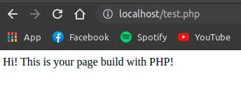
If you see the output specified in your test file correctly, your web space has been checked for proper functioning.

Conclusions
Well done! You should now have a web space to deploy PHP pages or full stack web applications for your visitors.
https://www.arubacloud.com/tutorial/how-to-install-and-configure-lamp-server-on-centos-8.aspx

