How to Install LAMP Stack on Debian 11/10/9
Gabriel Cánepa Categories Debian 4 Comments

On (August 14, 2021), the Debian project announced the availability of the new stable version (Debian 11) codenamed Bullseye.
With this release, the well-known and widely-used Debian 10 Buster gained old-stable status, which designates the previous stable repository. As it always happens with the release of a new stable version, Bullseye includes hundreds of new packages and updates to thousands of others.
Since Debian powers a large percentage of web servers all over the world, in this article we will explain how to install the LAMP stack in Debian 11 and also works on older Debian 10 and Debian 9 releases.
This will allow system administrators to set up brand new web servers on top of Bullseye using the recent updates to the distribution’s official repositories. It is assumed that you have installed Debian 11 minimal server on a bare metal, virtual machine, or VPS, or have upgraded from Debian 10 to Debian 11.

Installing LAMP in Debian
The “M” in LAMP stands for MariaDB or MySQL, the database server for the stack. Depending on your choice, you can install the database server and the other components (the Apache web server and PHP) as follows.

Install LAMP with MariaDB on Debian
# apt update && apt install apache2 mariadb-server mariadb-client mariadb-common php php-mysqli

Install LAMP with MySQL on Debian
# apt update && apt install apache2 mysql-server mysql-client mysql-common php php-mysqli

As a personal preference, I will use MariaDB in the rest of this article.
Once the installation is complete, let us make sure all the services are running. If so, the following commands.
# systemctl is-active apache2
# systemctl is-active mariadb
should return active for both. Otherwise, start both services manually:
# systemctl start {apache2,mariadb}

Securing MariaDB in Debian
Finally, before proceeding let’s use mysql_secure_installation to set up the password for the database root account, remove anonymous users, disallow root login remotely and remove test database.
# mysql_secure_installation

Testing LAMP on Debian
To begin, we are going to create and populate a sample database. Next, we will use a basic PHP script to retrieve a set of records from the database in JSON format.
Finally, we will use Firefox’s developer tools to verify the version of Apache being used. Although we could find out this same information with.
# apache2 -v

Server version: Apache/2.4.51 (Debian)
Server built: 2021-10-07T17:49:44
the reason why we’re using a script is to make sure all the components of the stack are working properly when bundled together.

Creating and Populating a Database
Let’s enter the MariaDB prompt with the following command.
# mysql -u root -p
and enter the password that was chosen in the previous section.
Now we will create a database named LibraryDB as follows:
MariaDB [(none)]> CREATE DATABASE LibraryDB;
and add two tables named AuthorsTBL and BooksTBL:
MariaDB [(none)]> USE LibraryDB;
CREATE TABLE AuthorsTBL (
AuthorID INT NOT NULL AUTO_INCREMENT,
FullName VARCHAR(100) NOT NULL,
PRIMARY KEY(AuthorID)
);

MariaDB [(none)]> CREATE TABLE BooksTBL (
BookID INT NOT NULL AUTO_INCREMENT,
AuthorID INT NOT NULL,
ISBN VARCHAR(100) NOT NULL,
Title VARCHAR(100) NOT NULL,
Year VARCHAR(4),
PRIMARY KEY(BookID),
FOREIGN KEY(AuthorID) REFERENCES AuthorsTBL(AuthorID)
);
For security reasons, we will create a special account to access our database:
MariaDB [(none)]> CREATE USER 'librarian'@'localhost' IDENTIFIED BY 'Today123';
MariaDB [(none)]> GRANT ALL PRIVILEGES ON LibraryDB.* TO 'librarian'@'localhost';
The last step now consists of populating the tables with Authors and Books:
MariaDB [(none)]> INSERT INTO AuthorsTBL (FullName) VALUES ('Paulo Coelho'), ('Isabel Allende'), ('Jorge Luis Borges');
MariaDB [(none)]> INSERT INTO BooksTBL (AuthorID, ISBN, Title, Year) VALUES
(1, '9788576653721', 'El alquimista', '1988'),
(1, '9780061194740', 'El peregrino', '1987'),
(2, '9789500720380', 'La casa de los espiritus', '1982'),
(3, '9789875666481', 'El Aleph', '1945');

Testing Database Connection with PHP Script
The following PHP script will first connect to the database and retrieve the records that match the query. If an error occurs, a descriptive message will be displayed so as to give us a hint on what’s wrong.
Save the following script as booksandauthors.php under /var/www/html:
<?php
// Show PHP version
echo "Current PHP version: " . phpversion() . "\r\n";

// Connect to database
$connection = mysqli_connect("localhost","librarian","Today123","LibraryDB") or die("Error " . mysqli_error($connection));

// SQL query
$sql = "SELECT A.ISBN, A.Title,
A.Year, B.FullName
FROM BooksTBL A JOIN AuthorsTBL B
ON A.AuthorID = B.AuthorID;";
$result = mysqli_query($connection, $sql) or die("Error " . mysqli_error($connection));

// Populate an array with the query results
$libraryarray = array();
while($row = mysqli_fetch_assoc($result))
{
$libraryarray[] = $row;
}

// Convert to JSON
echo json_encode($libraryarray);
?>
Change the ownership to www-data and add the appropriate permissions:
# chown www-data:www-data /var/www/html/booksandauthors.php
# chmod 600 /var/www/html/booksandauthors.php
Finally, open a web browser and point it to the URL where the script resides.
http://192.168.0.35/booksandauthors.php
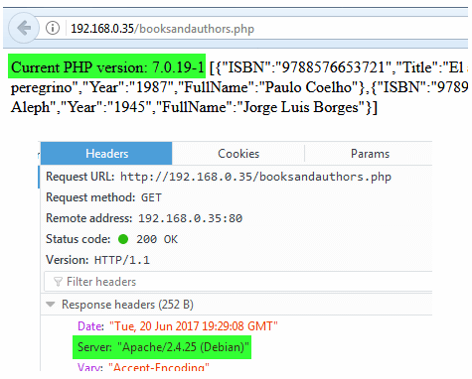
That’s it! In this article, we have explained how to install and test the LAMP stack on Debian 11. If you have questions or comments about this article, don’t hesitate to let us know by using the form below.
https://www.tecmint.com/install-lamp-in-debian/

How to install LAMP on Debian 10 (Buster)
Author: Vivek Gite Last updated: June 5, 2021 1 comment

How do I install a LAMP stack on Debian 10 (Buster)?
The LAMP is an acronym for software stack that includes Linux, Apache web server, MariaDB database (MySQL drop in replacement), and PHP web scripting language. A LAMP stack allows us hosting dynamic websites and popular apps such as MediaWiki, WordPress, and more. This page shows you how to install a LAMP stack on Debian Linux 10 (Buster) server.
Tutorial details
Difficulty level | Intermediate
Root privileges | Yes
Requirements | Debian 10 Linux server
Est. reading time | 8 minutes

Installing LAMP on Debian 10 (Buster)
- Updating the Debian Linux, run:
sudo -- sh -c 'apt update && apt upgrade'
- Install Apache, execute:
sudo apt install apache2
- Update the Firewall and open port 80 and 443, run:
sudo ufw allow in "WWW Full"
- Set up MariaDB:
sudo apt install mariadb-server
- Secure your MariaDB server, type:
sudo mysql_secure_installation
- PHP 7.3 installation:
sudo apt install php libapache2-mod-php php-gd php-mysql
- Test your LAMP setup
Let us see all steps in details. But, first log in to your remote server using the ssh command:
ssh user@server-ip
ssh -i ~/.ssh/aws-ec2-key admin@deb10-lmum1-box1

1. Updating the server
Make sure all packages are up-to-date, run the following apt command or apt-get command:
sudo apt update
sudo apt upgrade
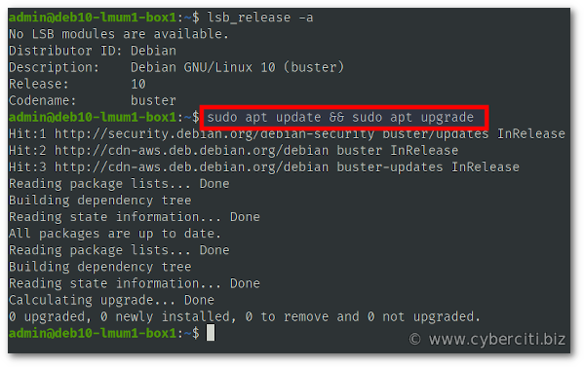
Make sure your server/VM is up to date with security patches

2. Installing Apache web server
Apache HTTP Server, also known as “Apache.” It is a web server famous for promoting the growth of the World Wide Web. Hence, we are going to install Apache on Debian 10, run:
sudo apt install apache2

Install Apache using apt command

How to start, stop, restart and get the status of Apache server
The syntax is as follows for the systemctl command:
sudo systemctl start apache2.service ## <-- Start the server ##
sudo systemctl restart apache2.service ## <-- Restart the server ##
sudo systemctl stop apache2.service ## <-- Stop the server ##
sudo systemctl reload apache2.service ## <-- Reload the server config ##
sudo systemctl status apache2.service ## <-- Get the server status ##

3. Update the Firewall and open port 80 and 443
It is important that you open TCP port 80 (www) and 443 (https) so that LAMP on Debian 10 works. Type the following commands:
sudo ufw allow www
sudo ufw allow https
sudo ufw status
Sample outputs:
Status: active

To Action From
-- ------ ----
22/tcp ALLOW Anywhere
80/tcp ALLOW Anywhere
443/tcp ALLOW Anywhere
22/tcp (v6) ALLOW Anywhere (v6)
80/tcp (v6) ALLOW Anywhere (v6)
443/tcp (v6) ALLOW Anywhere (v6)
Test it by typing your server’s IP or domain name:
http://server1.cyberciti.biz
http://your_public_IPv4_here

Apache 2 Debian Default Page in Action

Configure Apache
Edit the following file using a text editor such as vi/vim, nano, emacs and so on:
sudo vi /etc/apache2/mods-available/mpm_prefork.conf
My updated config file for EC2 with a 2 GB ram and 1 vCPU for running couple of WP sites:
# prefork MPM
# StartServers: number of server processes to start
# MinSpareServers: minimum number of server processes which are kept spare
# MaxSpareServers: maximum number of server processes which are kept spare
# MaxRequestWorkers: maximum number of server processes allowed to start
# MaxConnectionsPerChild: maximum number of requests a server process serves

<IfModule mpm_prefork_module>
StartServers 4
MinSpareServers 20
MaxSpareServers 40
MaxRequestWorkers 200
MaxConnectionsPerChild 4500
</IfModule>

# vim: syntax=apache ts=4 sw=4 sts=4 sr noet
Above settings should be adjusted as per your deployment’s needs. Finally, disable the Apache event module and enable httpd prefork, run:
sudo a2dismod mpm_event
sudo a2enmod mpm_prefork
To activate the new configuration, you need to run:
sudo systemctl restart apache2.service

How to create your first virtual hosts
Make a copy of the default Apache configuration for your domain called www.cyberciti.biz as follows using the cp command:
sudo cp -v /etc/apache2/sites-available/000-default.conf /etc/apache2/sites-available/www.cyberciti.biz.conf
Update /etc/apache2/sites-available/www.cyberciti.biz.conf as follows:
<Directory /var/www/cyberciti.biz/public_html>
Require all granted
</Directory>
<VirtualHost *:80>
ServerName cyberciti.biz
ServerAlias www.cyberciti.biz
ServerAdmin webmaster@cyberciti.biz
DocumentRoot /var/www/cyberciti.biz/public_html
ErrorLog ${APACHE_LOG_DIR}/www.cyberciti.biz_error.log
CustomLog ${APACHE_LOG_DIR}/www.cyberciti.biz_access.log combined
</VirtualHost>
Next, create a new directory to store HTML/PHP files for domain:
mkdir -vp /var/www/cyberciti.biz/public_html
Add a new Linux user, run:
sudo useradd -d /var/www/cyberciti.biz/ -s /usr/sbin/nologin -c 'www.cyberciti.biz user' cbzuser
sudo passwd -l cbzuser
Enable your site and disable default LAMP site:
sudo a2ensite www.cyberciti.biz
sudo a2dissite 000-default
Create a new html file named index.html:
vi /var/www/cyberciti.biz/public_html/index.html
Append HTML4/HTML5 code:
<html>
<head>
<title>www.cyberciti.biz on Debian 10</title>
</head>
<body>
<h2>www.cyberciti.biz</h2>
<p>This is a test LAMP server.</p>
<hr>
</body>
</html>
Save and close the file. Use the chown command and chmod command commands to set tight permissions on your Apache DocumentRoot:
sudo chown -R cbzuser:cbzuser /var/www/cyberciti.biz/
sudo chmod 0444 /var/www/cyberciti.biz/
sudo find /var/www/cyberciti.biz/ -type d -print0 | sudo xargs -0 -I {} chmod 0445 "{}"
To activate the new configuration, you need to run:
sudo systemctl reload apache2.service
Fire a web browser and test it:
http://www.cyberciti.biz

4. How to install MariaDB on Debian 10
Now you have a web server up and running along with your first virtual host too. It is time to install MariaDB, which is a drop-in replacement for MySQL server. Type the following apt command:
sudo apt install mariadb-server

Improve MariaDB installation security
Run mysql_secure_installation script:
sudo mysql_secure_installation
This script enables you to improve the security of your MariaDB installation in the following ways:
- You can set a password for root accounts.
- Delete root accounts that are accessible from outside the localhost.
- Remove anonymous-user accounts.
- Erase the test database, which by default can be accessed by anonymous users.

It is recommended that you select yes (y) for all questions.

How to create a MariaDB database and user/password
To create a database and grant your users permissions to use databases, run:
mysql -u root -p
Enter MariaDB’s root password when prompted. Create a database named ‘wpdb’ and grant your user permissions on it. Change the database name (wpdata) and username (wpuser)/change the password (wppassword):
CREATE DATABASE wpdb;
GRANT ALL ON wpdb.* TO 'wpuser' IDENTIFIED BY 'wppasword';
quit
Test new db and user/password combination:
mysql -u wpuser -p'wppasword' wpdb

Installing PHP 7.3 for your LAMP on Debian 10
PHP is the last part of the puzzle that makes it possible to produce dynamic webpages. PHP is also a popular web development engine for a LAMP stack. Therefore, let us install PHP:
sudo apt install php libapache2-mod-php

Patreon supporters only guides 🤓
- No ads and tracking
- In-depth guides for developers and sysadmins at Opensourceflare✨
- Join my Patreon to support independent content creators and start reading latest guides:
  - How to set up Redis sentinel cluster on Ubuntu or Debian Linux
  - How To Set Up SSH Keys With YubiKey as two-factor authentication (U2F/FIDO2)
  - How to set up Mariadb Galera cluster on Ubuntu or Debian Linux
  - A podman tutorial for beginners – part I (run Linux containers without Docker and in daemonless mode)
  - How to protect Linux against rogue USB devices using USBGuard
  - If your domain is not sending email, set these DNS settings to avoid spoofing and phishing
Join Patreon ➔

Finding and installing PHP modules
I am also going to install PHP modules that allows MySQL access and GD lib too:
sudo apt install php-mysql php-gd
One can get a list of all PHP modules using the combination of apt-cache command and grep command:
apt-cache search php | egrep 'module' | grep default
Sample outputs:
libapache2-mod-php - server-side, HTML-embedded scripting language (Apache 2 module) (default)
php-bcmath - Bcmath module for PHP [default]
php-bz2 - bzip2 module for PHP [default]
php-curl - CURL module for PHP [default]
php-dev - Files for PHP module development (default)
php-enchant - Enchant module for PHP [default]
php-gd - GD module for PHP [default]
php-gmp - GMP module for PHP [default]
php-imap - IMAP module for PHP [default]
php-interbase - Interbase module for PHP [default]
php-intl - Internationalisation module for PHP [default]
php-json - JSON module for PHP [default]
php-ldap - LDAP module for PHP [default]
php-mbstring - MBSTRING module for PHP [default]
php-mysql - MySQL module for PHP [default]
php-odbc - ODBC module for PHP [default]
php-pgsql - PostgreSQL module for PHP [default]
php-pspell - pspell module for PHP [default]
php-readline - readline module for PHP [default]
php-recode - recode module for PHP [default]
php-snmp - SNMP module for PHP [default]
php-soap - SOAP module for PHP [default]
php-sqlite3 - SQLite3 module for PHP [default]
php-sybase - Sybase module for PHP [default]
php-tidy - tidy module for PHP [default]
php-xml - DOM, SimpleXML, WDDX, XML, and XSL module for PHP [default]
php-xmlrpc - XMLRPC-EPI module for PHP [default]
php-zip - Zip module for PHP [default]
Restart Apache:
sudo systemctl restart apache2.service

Testing PHP instllation along with LAMP on Debian 10
Create a file named test.php as follows:
sudo vi /var/www/cyberciti.biz/public_html/test.php
Append the following code:
<?php
phpinfo();
?>
Save and close the file. Set permisions:
sudo chown -R cbzuser:cbzuser /var/www/cyberciti.biz/
sudo chmod 0444 /var/www/cyberciti.biz/
sudo find /var/www/cyberciti.biz/ -type d -print0 | sudo xargs -0 -I {} chmod 0445 "{}"
Open a webbrowser and type url:
http://your-ip/test.php
http://www.cyberciti.biz/test.php
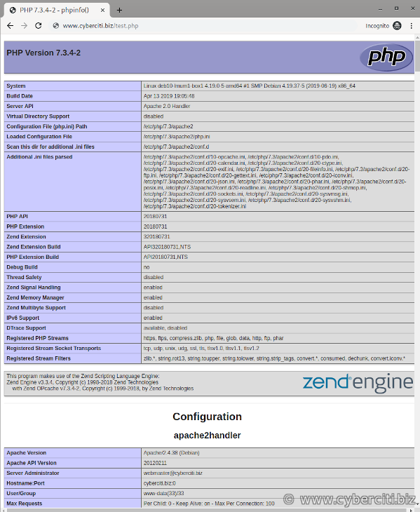
This page indicates that your PHP 7.3 is working correctly on a LAMP server. It is time you delete that page as it exposed sensitive information using the rm command:
sudo rm -v /var/www/cyberciti.biz/public_html/test.php

Conclusion
This guide explained how to install Linux, Apache, MariaDB, PHP (LAMP) stack on Debian Linux 10. For more information see this page here, here, and here.
https://www.cyberciti.biz/faq/how-to-install-lamp-on-debian-10-buster/

