Compose file

Reference and guidelines
These topics describe the Docker Compose implementation of the Compose format. Docker Compose 1.27.0+ implements the format defined by the Compose Specification. Previous Docker Compose versions have support for several Compose file formats – 2, 2.x, and 3.x. The Compose specification is a unified 2.x and 3.x file format, aggregating properties across these formats.

Compose and Docker compatibility matrix
There are several versions of the Compose file format – 2, 2.x, and 3.x. The table below provides a snapshot of various versions. For full details on what each version includes and how to upgrade, see About versions and upgrading.
This table shows which Compose file versions support specific Docker releases.
Compose file format | Docker Engine release
Compose specification | 19.03.0+
3.8 | 19.03.0+
3.7 | 18.06.0+
3.6 | 18.02.0+
3.5 | 17.12.0+
3.4 | 17.09.0+
3.3 | 17.06.0+
3.2 | 17.04.0+
3.1 | 1.13.1+
3.0 | 1.13.0+
2.4 | 17.12.0+
2.3 | 17.06.0+
2.2 | 1.13.0+
2.1 | 1.12.0+
2.0 | 1.10.0+
In addition to Compose file format versions shown in the table, the Compose itself is on a release schedule, as shown in Compose releases, but file format versions do not necessarily increment with each release. For example, Compose file format 3.0 was first introduced in Compose release 1.10.0, and versioned gradually in subsequent releases.
The latest Compose file format is defined by the Compose Specification and is implemented by Docker Compose 1.27.0+.

Compose documentation
- User guide
- Installing Compose
- Compose file versions and upgrading
- Sample apps with Compose
- Enabling GPU access with Compose
- Command line reference
fig, composition, compose, docker
https://docs.docker.com/compose/compose-file/

Overview of Docker Compose
Estimated reading time: 6 minutes
Accelerating new features in Docker Desktop
Docker Desktop helps you build, share, and run containers easily on Mac and Windows as you do on Linux. Docker handles the complex setup and allows you to focus on writing the code. Thanks to the positive support we received on the subscription updates, we’ve started working on Docker Desktop for Linux which is the second-most popular feature request in our public roadmap. If you are interested in early access, sign up for our Developer Preview program.
Looking for Compose file reference? Find the latest version here.
Compose is a tool for defining and running multi-container Docker applications. With Compose, you use a YAML file to configure your application’s services. Then, with a single command, you create and start all the services from your configuration. To learn more about all the features of Compose, see the list of features.
Compose works in all environments: production, staging, development, testing, as well as CI workflows. You can learn more about each case in Common Use Cases.
Using Compose is basically a three-step process:
- Define your app’s environment with a Dockerfile so it can be reproduced anywhere.
- Define the services that make up your app in docker-compose.yml so they can be run together in an isolated environment.
- Run docker compose up and the Docker compose command starts and runs your entire app. You can alternatively run docker-compose up using the docker-compose binary.
A docker-compose.yml looks like this:
version: "3.9" # optional since v1.27.0
services:
web:
build: .
ports:
- "8000:5000"
volumes:
- .:/code
- logvolume01:/var/log
links:
- redis
redis:
image: redis
volumes:
logvolume01: {}
For more information about the Compose file, see the Compose file reference.
Compose has commands for managing the whole lifecycle of your application:
- Start, stop, and rebuild services
- View the status of running services
- Stream the log output of running services
- Run a one-off command on a service

Compose documentation
- Installing Compose
- Getting started with Compose
- Get started with Django
- Get started with Rails
- Get started with WordPress
- Frequently asked questions
- Command line reference
- Compose file reference

Features
The features of Compose that make it effective are:
- Multiple isolated environments on a single host
- Preserve volume data when containers are created
- Only recreate containers that have changed
- Variables and moving a composition between environments

Multiple isolated environments on a single host
Compose uses a project name to isolate environments from each other. You can make use of this project name in several different contexts:
- on a dev host, to create multiple copies of a single environment, such as when you want to run a stable copy for each feature branch of a project
- on a CI server, to keep builds from interfering with each other, you can set the project name to a unique build number
- on a shared host or dev host, to prevent different projects, which may use the same service names, from interfering with each other
The default project name is the basename of the project directory. You can set a custom project name by using the -p command line option or the COMPOSE_PROJECT_NAME environment variable.
The default project directory is the base directory of the Compose file. A custom value for it can be defined with the --project-directory command line option.

Preserve volume data when containers are created
Compose preserves all volumes used by your services. When docker-compose up runs, if it finds any containers from previous runs, it copies the volumes from the old container to the new container. This process ensures that any data you’ve created in volumes isn’t lost.
If you use docker-compose on a Windows machine, see Environment variables and adjust the necessary environment variables for your specific needs.

Only recreate containers that have changed
Compose caches the configuration used to create a container. When you restart a service that has not changed, Compose re-uses the existing containers. Re-using containers means that you can make changes to your environment very quickly.

Variables and moving a composition between environments
Compose supports variables in the Compose file. You can use these variables to customize your composition for different environments, or different users. See Variable substitution for more details.
You can extend a Compose file using the extends field or by creating multiple Compose files. See extends for more details.

Common use cases
Compose can be used in many different ways. Some common use cases are outlined below.

Development environments
When you’re developing software, the ability to run an application in an isolated environment and interact with it is crucial. The Compose command line tool can be used to create the environment and interact with it.
The Compose file provides a way to document and configure all of the application’s service dependencies (databases, queues, caches, web service APIs, etc). Using the Compose command line tool you can create and start one or more containers for each dependency with a single command (docker-compose up).
Together, these features provide a convenient way for developers to get started on a project. Compose can reduce a multi-page “developer getting started guide” to a single machine readable Compose file and a few commands.

Automated testing environments
An important part of any Continuous Deployment or Continuous Integration process is the automated test suite. Automated end-to-end testing requires an environment in which to run tests. Compose provides a convenient way to create and destroy isolated testing environments for your test suite. By defining the full environment in a Compose file, you can create and destroy these environments in just a few commands:
docker-compose up -d
./run_tests
docker-compose down

Single host deployments
Compose has traditionally been focused on development and testing workflows, but with each release we’re making progress on more production-oriented features.
For details on using production-oriented features, see compose in production in this documentation.

Release notes
To see a detailed list of changes for past and current releases of Docker Compose, refer to the CHANGELOG.

Getting help
Docker Compose is under active development. If you need help, would like to contribute, or simply want to talk about the project with like-minded individuals, we have a number of open channels for communication.
- To report bugs or file feature requests: use the issue tracker on Github.
- To talk about the project with people in real time: join the #docker-compose channel on the Docker Community Slack.
- To contribute code or documentation changes: submit a pull request on Github.
documentation, docs, docker, compose, orchestration, containers
https://docs.docker.com/compose/

Compose file version 3 reference
Estimated reading time: 78 minutes

Reference and guidelines
These topics describe version 3 of the Compose file format. This is the newest version.

Compose and Docker compatibility matrix
There are several versions of the Compose file format – 1, 2, 2.x, and 3.x. The table below is a quick look. For full details on what each version includes and how to upgrade, see About versions and upgrading.
This table shows which Compose file versions support specific Docker releases.
Compose file format | Docker Engine release
Compose specification | 19.03.0+
3.8 | 19.03.0+
3.7 | 18.06.0+
3.6 | 18.02.0+
3.5 | 17.12.0+
3.4 | 17.09.0+
3.3 | 17.06.0+
3.2 | 17.04.0+
3.1 | 1.13.1+
3.0 | 1.13.0+
2.4 | 17.12.0+
2.3 | 17.06.0+
2.2 | 1.13.0+
2.1 | 1.12.0+
2.0 | 1.10.0+
In addition to Compose file format versions shown in the table, the Compose itself is on a release schedule, as shown in Compose releases, but file format versions do not necessarily increment with each release. For example, Compose file format 3.0 was first introduced in Compose release 1.10.0, and versioned gradually in subsequent releases.
The latest Compose file format is defined by the Compose Specification and is implemented by Docker Compose 1.27.0+.

Compose file structure and examples
Here is a sample Compose file from the voting app sample used in the Docker for Beginners lab topic on Deploying an app to a Swarm:
Example Compose file version 3
The topics on this reference page are organized alphabetically by top-level key to reflect the structure of the Compose file itself. Top-level keys that define a section in the configuration file such as build, deploy, depends_on, networks, and so on, are listed with the options that support them as sub-topics. This maps to the <key>: <option>: <value> indent structure of the Compose file.

Service configuration reference
The Compose file is a YAML file defining services, networks and volumes. The default path for a Compose file is ./docker-compose.yml.
Tip: You can use either a .yml or .yaml extension for this file. They both work.
A service definition contains configuration that is applied to each container started for that service, much like passing command-line parameters to docker run. Likewise, network and volume definitions are analogous to docker network create and docker volume create.
As with docker run, options specified in the Dockerfile, such as CMD, EXPOSE, VOLUME, ENV, are respected by default - you don’t need to specify them again in docker-compose.yml.
You can use environment variables in configuration values with a Bash-like ${VARIABLE} syntax - see variable substitution for full details.
This section contains a list of all configuration options supported by a service definition in version 3.

build
Configuration options that are applied at build time.
build can be specified either as a string containing a path to the build context:
version: "3.9"
services:
webapp:
build: ./dir
Or, as an object with the path specified under context and optionally Dockerfile and args:
version: "3.9"
services:
webapp:
build:
context: ./dir
dockerfile: Dockerfile-alternate
args:
buildno: 1
If you specify image as well as build, then Compose names the built image with the webapp and optional tag specified in image:
build: ./dir
image: webapp:tag
This results in an image named webapp and tagged tag, built from ./dir.
Note when using docker stack deploy
The build option is ignored when deploying a stack in swarm mode The docker stack command does not build images before deploying.

context
Either a path to a directory containing a Dockerfile, or a url to a git repository.
When the value supplied is a relative path, it is interpreted as relative to the location of the Compose file. This directory is also the build context that is sent to the Docker daemon.
Compose builds and tags it with a generated name, and uses that image thereafter.
build:
context: ./dir

dockerfile
Alternate Dockerfile.
Compose uses an alternate file to build with. A build path must also be specified.
build:
context: .
dockerfile: Dockerfile-alternate

args
Add build arguments, which are environment variables accessible only during the build process.
First, specify the arguments in your Dockerfile:
# syntax=docker/dockerfile:1

ARG buildno
ARG gitcommithash

RUN echo "Build number: $buildno"
RUN echo "Based on commit: $gitcommithash"
Then specify the arguments under the build key. You can pass a mapping or a list:
build:
context: .
args:
buildno: 1
gitcommithash: cdc3b19
build:
context: .
args:
- buildno=1
- gitcommithash=cdc3b19
Scope of build-args
In your Dockerfile, if you specify ARG before the FROM instruction, ARG is not available in the build instructions under FROM. If you need an argument to be available in both places, also specify it under the FROM instruction. Refer to the understand how ARGS and FROM interact section in the documentation for usage details.
You can omit the value when specifying a build argument, in which case its value at build time is the value in the environment where Compose is running.
args:
- buildno
- gitcommithash
Tip when using boolean values
YAML boolean values ("true", "false", "yes", "no", "on", "off") must be enclosed in quotes, so that the parser interprets them as strings.

cache_from
Added in version 3.2 file format
A list of images that the engine uses for cache resolution.
build:
context: .
cache_from:
- alpine:latest
- corp/web_app:3.14

labels
Added in version 3.3 file format
Add metadata to the resulting image using Docker labels. You can use either an array or a dictionary.
It’s recommended that you use reverse-DNS notation to prevent your labels from conflicting with those used by other software.
build:
context: .
labels:
com.example.description: "Accounting webapp"
com.example.department: "Finance"
com.example.label-with-empty-value: ""
build:
context: .
labels:
- "com.example.description=Accounting webapp"
- "com.example.department=Finance"
- "com.example.label-with-empty-value"

network
Added in version 3.4 file format
Set the network containers connect to for the RUN instructions during build.
build:
context: .
network: host
build:
context: .
network: custom_network_1
Use none to disable networking during build:
build:
context: .
network: none

shm_size
Added in version 3.5 file format
Set the size of the /dev/shm partition for this build’s containers. Specify as an integer value representing the number of bytes or as a string expressing a byte value.
build:
context: .
shm_size: '2gb'
build:
context: .
shm_size: 10000000

target
Added in version 3.4 file format
Build the specified stage as defined inside the Dockerfile. See the multi-stage build docs for details.
build:
context: .
target: prod

cap_add, cap_drop
Add or drop container capabilities. See man 7 capabilities for a full list.
cap_add:
- ALL

cap_drop:
- NET_ADMIN
- SYS_ADMIN
Note when using docker stack deploy
The cap_add and cap_drop options are ignored when deploying a stack in swarm mode

cgroup_parent
Specify an optional parent cgroup for the container.
cgroup_parent: m-executor-abcd
Note when using docker stack deploy
The cgroup_parent option is ignored when deploying a stack in swarm mode

command
Override the default command.
command: bundle exec thin -p 3000
The command can also be a list, in a manner similar to dockerfile:
command: ["bundle", "exec", "thin", "-p", "3000"]

configs
Grant access to configs on a per-service basis using the per-service configs configuration. Two different syntax variants are supported.
Note: The config must already exist or be defined in the top-level configs configuration of this stack file, or stack deployment fails.
For more information on configs, see configs.

Short syntax
The short syntax variant only specifies the config name. This grants the container access to the config and mounts it at /<config_name> within the container. The source name and destination mountpoint are both set to the config name.
The following example uses the short syntax to grant the redis service access to the my_config and my_other_config configs. The value of my_config is set to the contents of the file ./my_config.txt, and my_other_config is defined as an external resource, which means that it has already been defined in Docker, either by running the docker config create command or by another stack deployment. If the external config does not exist, the stack deployment fails with a config not found error.
Added in version 3.3 file format.
config definitions are only supported in version 3.3 and higher of the compose file format.
version: "3.9"
services:
redis:
image: redis:latest
deploy:
replicas: 1
configs:
- my_config
- my_other_config
configs:
my_config:
file: ./my_config.txt
my_other_config:
external: true

Long syntax
The long syntax provides more granularity in how the config is created within the service’s task containers.
- source: The identifier of the config as it is defined in this configuration.
- target: The path and name of the file to be mounted in the service’s task containers. Defaults to /<source> if not specified.
- uid and gid: The numeric UID or GID that owns the mounted config file within in the service’s task containers. Both default to 0 on Linux if not specified. Not supported on Windows.
- mode: The permissions for the file that is mounted within the service’s task containers, in octal notation. For instance, 0444 represents world-readable. The default is 0444. Configs cannot be writable because they are mounted in a temporary filesystem, so if you set the writable bit, it is ignored. The executable bit can be set. If you aren’t familiar with UNIX file permission modes, you may find this permissions calculator useful.
The following example sets the name of my_config to redis_config within the container, sets the mode to 0440 (group-readable) and sets the user and group to 103. The redis service does not have access to the my_other_config config.
version: "3.9"
services:
redis:
image: redis:latest
deploy:
replicas: 1
configs:
- source: my_config
target: /redis_config
uid: '103'
gid: '103'
mode: 0440
configs:
my_config:
file: ./my_config.txt
my_other_config:
external: true
You can grant a service access to multiple configs and you can mix long and short syntax. Defining a config does not imply granting a service access to it.

container_name
Specify a custom container name, rather than a generated default name.
container_name: my-web-container
Because Docker container names must be unique, you cannot scale a service beyond 1 container if you have specified a custom name. Attempting to do so results in an error.
Note when using docker stack deploy
The container_name option is ignored when deploying a stack in swarm mode

credential_spec
Added in version 3.3 file format.
The credential_spec option was added in v3.3. Using group Managed Service Account (gMSA) configurations with compose files is supported in file format version 3.8 or up.
Configure the credential spec for managed service account. This option is only used for services using Windows containers. The credential_spec must be in the format file://<filename> or registry://<value-name>.
When using file:, the referenced file must be present in the CredentialSpecs subdirectory in the Docker data directory, which defaults to C:\ProgramData\Docker\ on Windows. The following example loads the credential spec from a file named C:\ProgramData\Docker\CredentialSpecs\my-credential-spec.json.
credential_spec:
file: my-credential-spec.json
When using registry:, the credential spec is read from the Windows registry on the daemon’s host. A registry value with the given name must be located in:
HKLM\SOFTWARE\Microsoft\Windows NT\CurrentVersion\Virtualization\Containers\CredentialSpecs
The following example load the credential spec from a value named my-credential-spec in the registry:
credential_spec:
registry: my-credential-spec

Example gMSA configuration
When configuring a gMSA credential spec for a service, you only need to specify a credential spec with config, as shown in the following example:
version: "3.9"
services:
myservice:
image: myimage:latest
credential_spec:
config: my_credential_spec

configs:
my_credentials_spec:
file: ./my-credential-spec.json|

depends_on
Express dependency between services. Service dependencies cause the following behaviors:
- docker-compose up starts services in dependency order. In the following example, db and redis are started before web.
- docker-compose up SERVICE automatically includes SERVICE’s dependencies. In the example below, docker-compose up web also creates and starts db and redis.
- docker-compose stop stops services in dependency order. In the following example, web is stopped before db and redis.
Simple example:
version: "3.9"
services:
web:
build: .
depends_on:
- db
- redis
redis:
image: redis
db:
image: postgres
There are several things to be aware of when using depends_on:
- depends_on does not wait for db and redis to be “ready” before starting web - only until they have been started. If you need to wait for a service to be ready, see Controlling startup order for more on this problem and strategies for solving it.
- The depends_on option is ignored when deploying a stack in swarm mode with a version 3 Compose file.

deploy
Added in version 3 file format.
Specify configuration related to the deployment and running of services. The following
sub-options only takes effect when deploying to a swarm with docker stack deploy, and is ignored by docker-compose up and docker-compose run, except for resources.
version: "3.9"
services:
redis:
image: redis:alpine
deploy:
replicas: 6
placement:
max_replicas_per_node: 1
update_config:
parallelism: 2
delay: 10s
restart_policy:
condition: on-failure
Several sub-options are available:

endpoint_mode
Added in version 3.2 file format.
Specify a service discovery method for external clients connecting to a swarm.
- endpoint_mode: vip - Docker assigns the service a virtual IP (VIP) that acts as the front end for clients to reach the service on a network. Docker routes requests between the client and available worker nodes for the service, without client knowledge of how many nodes are participating in the service or their IP addresses or ports. (This is the default.)
- endpoint_mode: dnsrr - DNS round-robin (DNSRR) service discovery does not use a single virtual IP. Docker sets up DNS entries for the service such that a DNS query for the service name returns a list of IP addresses, and the client connects directly to one of these. DNS round-robin is useful in cases where you want to use your own load balancer, or for Hybrid Windows and Linux applications.
version: "3.9"

services:
wordpress:
image: wordpress
ports:
- "8080:80"
networks:
- overlay
deploy:
mode: replicated
replicas: 2
endpoint_mode: vip

mysql:
image: mysql
volumes:
- db-data:/var/lib/mysql/data
networks:
- overlay
deploy:
mode: replicated
replicas: 2
endpoint_mode: dnsrr

volumes:
db-data:

networks:
overlay:
The options for endpoint_mode also work as flags on the swarm mode CLI command docker service create. For a quick list of all swarm related docker commands, see Swarm mode CLI commands.
To learn more about service discovery and networking in swarm mode, see Configure service discovery in the swarm mode topics.

labels
Specify labels for the service. These labels are only set on the service, and not on any containers for the service.
version: "3.9"
services:
web:
image: web
deploy:
labels:
com.example.description: "This label will appear on the web service"
To set labels on containers instead, use the labels key outside of deploy:
version: "3.9"
services:
web:
image: web
labels:
com.example.description: "This label will appear on all containers for the web service"

mode
Either global (exactly one container per swarm node) or replicated (a specified number of containers). The default is replicated. (To learn more, see Replicated and global services in the swarm topics.)
version: "3.9"
services:
worker:
image: dockersamples/examplevotingapp_worker
deploy:
mode: global

placement
Specify placement of constraints and preferences. See the docker service create documentation for a full description of the syntax and available types of constraints, preferences, and specifying the maximum replicas per node
version: "3.9"
services:
db:
image: postgres
deploy:
placement:
constraints:
- "node.role==manager"
- "engine.labels.operatingsystem==ubuntu 18.04"
preferences:
- spread: node.labels.zone

max_replicas_per_node
Added in version 3.8 file format.
If the service is replicated (which is the default), limit the number of replicas that can run on a node at any time.
When there are more tasks requested than running nodes, an error no suitable node (max replicas per node limit exceed) is raised.
version: "3.9"
services:
worker:
image: dockersamples/examplevotingapp_worker
networks:
- frontend
- backend
deploy:
mode: replicated
replicas: 6
placement:
max_replicas_per_node: 1

replicas
If the service is replicated (which is the default), specify the number of containers that should be running at any given time.
version: "3.9"
services:
worker:
image: dockersamples/examplevotingapp_worker
networks:
- frontend
- backend
deploy:
mode: replicated
replicas: 6

resources
Configures resource constraints.
Changed in compose-file version 3
The resources section replaces the older resource constraint options in Compose files prior to version 3 (cpu_shares, cpu_quota, cpuset, mem_limit, memswap_limit, mem_swappiness). Refer to Upgrading version 2.x to 3.x to learn about differences between version 2 and 3 of the compose-file format.
Each of these is a single value, analogous to its docker service create counterpart.
In this general example, the redis service is constrained to use no more than 50M of memory and 0.50 (50% of a single core) of available processing time (CPU), and has 20M of memory and 0.25 CPU time reserved (as always available to it).
version: "3.9"
services:
redis:
image: redis:alpine
deploy:
resources:
limits:
cpus: '0.50'
memory: 50M
reservations:
cpus: '0.25'
memory: 20M
The topics below describe available options to set resource constraints on services or containers in a swarm.
Looking for options to set resources on non swarm mode containers?
The options described here are specific to the deploy key and swarm mode. If you want to set resource constraints on non swarm deployments, use Compose file format version 2 CPU, memory, and other resource options. If you have further questions, refer to the discussion on the GitHub issue docker/compose/4513.

Out Of Memory Exceptions (OOME)
If your services or containers attempt to use more memory than the system has available, you may experience an Out Of Memory Exception (OOME) and a container, or the Docker daemon, might be killed by the kernel OOM killer. To prevent this from happening, ensure that your application runs on hosts with adequate memory and see Understand the risks of running out of memory.

restart_policy
Configures if and how to restart containers when they exit. Replaces restart.
- condition: One of none, on-failure or any (default: any).
- delay: How long to wait between restart attempts, specified as a duration (default: 5s).
- max_attempts: How many times to attempt to restart a container before giving up (default: never give up). If the restart does not succeed within the configured window, this attempt doesn’t count toward the configured max_attempts value. For example, if max_attempts is set to ‘2’, and the restart fails on the first attempt, more than two restarts may be attempted.
- window: How long to wait before deciding if a restart has succeeded, specified as a duration (default: decide immediately).
version: "3.9"
services:
redis:
image: redis:alpine
deploy:
restart_policy:
condition: on-failure
delay: 5s
max_attempts: 3
window: 120s

rollback_config
Added in version 3.7 file format.
Configures how the service should be rollbacked in case of a failing update.
- parallelism: The number of containers to rollback at a time. If set to 0, all containers rollback simultaneously.
- delay: The time to wait between each container group’s rollback (default 0s).
- failure_action: What to do if a rollback fails. One of continue or pause (default pause)
- monitor: Duration after each task update to monitor for failure (ns|us|ms|s|m|h) (default 5s) Note: Setting to 0 will use the default 5s.
- max_failure_ratio: Failure rate to tolerate during a rollback (default 0).
- order: Order of operations during rollbacks. One of stop-first (old task is stopped before starting new one), or start-first (new task is started first, and the running tasks briefly overlap) (default stop-first).

update_config
Configures how the service should be updated. Useful for configuring rolling updates.
- parallelism: The number of containers to update at a time.
- delay: The time to wait between updating a group of containers.
- failure_action: What to do if an update fails. One of continue, rollback, or pause (default: pause).
- monitor: Duration after each task update to monitor for failure (ns|us|ms|s|m|h) (default 5s) Note: Setting to 0 will use the default 5s.
- max_failure_ratio: Failure rate to tolerate during an update.
- order: Order of operations during updates. One of stop-first (old task is stopped before starting new one), or start-first (new task is started first, and the running tasks briefly overlap) (default stop-first) Note: Only supported for v3.4 and higher.
Added in version 3.4 file format.
The order option is only supported by v3.4 and higher of the compose file format.
version: "3.9"
services:
vote:
image: dockersamples/examplevotingapp_vote:before
depends_on:
- redis
deploy:
replicas: 2
update_config:
parallelism: 2
delay: 10s
order: stop-first

Not supported for docker stack deploy
The following sub-options (supported for docker-compose up and docker-compose run) are not supported for docker stack deploy or the deploy key.
- build
- cgroup_parent
- container_name
- devices
- tmpfs
- external_links
- links
- network_mode
- restart
- security_opt
- userns_mode
Tip
See the section on how to configure volumes for services, swarms, and docker-stack.yml files. Volumes are supported but to work with swarms and services, they must be configured as named volumes or associated with services that are constrained to nodes with access to the requisite volumes.

devices
List of device mappings. Uses the same format as the --device docker client create option.
devices:
- "/dev/ttyUSB0:/dev/ttyUSB0"
Note when using docker stack deploy
The devices option is ignored when deploying a stack in swarm mode

dns
Custom DNS servers. Can be a single value or a list.
dns: 8.8.8.8
dns:
- 8.8.8.8
- 9.9.9.9

dns_search
Custom DNS search domains. Can be a single value or a list.
dns_search: example.com
dns_search:
- dc1.example.com
- dc2.example.com

entrypoint
Override the default entrypoint.
entrypoint: /code/entrypoint.sh
The entrypoint can also be a list, in a manner similar to dockerfile:
entrypoint: ["php", "-d", "memory_limit=-1", "vendor/bin/phpunit"]
Note
Setting entrypoint both overrides any default entrypoint set on the service’s image with the ENTRYPOINT Dockerfile instruction, and clears out any default command on the image - meaning that if there’s a CMD instruction in the Dockerfile, it is ignored.

env_file
Add environment variables from a file. Can be a single value or a list.
If you have specified a Compose file with docker-compose -f FILE, paths in env_file are relative to the directory that file is in.
Environment variables declared in the environment section override these values – this holds true even if those values are empty or undefined.
env_file: .env
env_file:
- ./common.env
- ./apps/web.env
- /opt/runtime_opts.env
Compose expects each line in an env file to be in VAR=VAL format. Lines beginning with # are treated as comments and are ignored. Blank lines are also ignored.
Set Rails/Rack environment
Note
If your service specifies a build option, variables defined in environment files are not automatically visible during the build. Use the args sub-option of build to define build-time environment variables.
The value of VAL is used as is and not modified at all. For example if the value is surrounded by quotes (as is often the case of shell variables), the quotes are included in the value passed to Compose.
Keep in mind that the order of files in the list is significant in determining the value assigned to a variable that shows up more than once. The files in the list are processed from the top down. For the same variable specified in file a.env and assigned a different value in file b.env, if b.env is listed below (after), then the value from b.env stands. For example, given the following declaration in docker-compose.yml:
services:
some-service:
env_file:
- a.env
- b.env
And the following files:
a.env
and
b.env
$VAR is hello.

environment
Add environment variables. You can use either an array or a dictionary. Any boolean values (true, false, yes, no) need to be enclosed in quotes to ensure they are not converted to True or False by the YML parser.
Environment variables with only a key are resolved to their values on the machine Compose is running on, which can be helpful for secret or host-specific values.
environment:
RACK_ENV: development
SHOW: 'true'
SESSION_SECRET:
environment:
- RACK_ENV=development
- SHOW=true
- SESSION_SECRET
Note
If your service specifies a build option, variables defined in environment are not automatically visible during the build. Use the args sub-option of build to define build-time environment variables.

expose
Expose ports without publishing them to the host machine - they’ll only be accessible to linked services. Only the internal port can be specified.
expose:
- "3000"
- "8000"

external_links
Link to containers started outside this docker-compose.yml or even outside of Compose, especially for containers that provide shared or common services. external_links follow semantics similar to the legacy option links when specifying both the container name and the link alias (CONTAINER:ALIAS).
external_links:
- redis_1
- project_db_1:mysql
- project_db_1:postgresql
Note
The externally-created containers must be connected to at least one of the same networks as the service that is linking to them. Links are a legacy option. We recommend using networks instead.
Note when using docker stack deploy
The external_links option is ignored when deploying a stack in swarm mode

extra_hosts
Add hostname mappings. Use the same values as the docker client --add-host parameter.
extra_hosts:
- "somehost:162.242.195.82"
- "otherhost:50.31.209.229"
An entry with the ip address and hostname is created in /etc/hosts inside containers for this service, e.g:

healthcheck
Configure a check that’s run to determine whether or not containers for this service are “healthy”. See the docs for the HEALTHCHECK Dockerfile instruction for details on how healthchecks work.
healthcheck:
test: ["CMD", "curl", "-f", "http://localhost"]
interval: 1m30s
timeout: 10s
retries: 3
start_period: 40s
interval, timeout and start_period are specified as durations.
Added in version 3.4 file format.
The start_period option was added in file format 3.4.
test must be either a string or a list. If it’s a list, the first item must be either NONE, CMD or CMD-SHELL. If it’s a string, it’s equivalent to specifying CMD-SHELL followed by that string.
# Hit the local web app
test: ["CMD", "curl", "-f", "http://localhost"]
As above, but wrapped in /bin/sh. Both forms below are equivalent.
test: ["CMD-SHELL", "curl -f http://localhost || exit 1"]
test: curl -f https://localhost || exit 1
To disable any default healthcheck set by the image, you can use disable: true. This is equivalent to specifying test: ["NONE"].
healthcheck:
disable: true

image
Specify the image to start the container from. Can either be a repository/tag or a partial image ID.
image: redis
image: ubuntu:18.04
image: tutum/influxdb
image: example-registry.com:4000/postgresql
image: a4bc65fd
If the image does not exist, Compose attempts to pull it, unless you have also specified build, in which case it builds it using the specified options and tags it with the specified tag.

init
Added in version 3.7 file format.
Run an init inside the container that forwards signals and reaps processes. Set this option to true to enable this feature for the service.
version: "3.9"
services:
web:
image: alpine:latest
init: true
The default init binary that is used is Tini, and is installed in /usr/libexec/docker-init on the daemon host. You can configure the daemon to use a custom init binary through the init-path configuration option.

isolation
Specify a container’s isolation technology. On Linux, the only supported value is default. On Windows, acceptable values are default, process and hyperv. Refer to the Docker Engine docs for details.

labels
Add metadata to containers using Docker labels. You can use either an array or a dictionary.
It’s recommended that you use reverse-DNS notation to prevent your labels from conflicting with those used by other software.
labels:
com.example.description: "Accounting webapp"
com.example.department: "Finance"
com.example.label-with-empty-value: ""
labels:
- "com.example.description=Accounting webapp"
- "com.example.department=Finance"
- "com.example.label-with-empty-value"

links
Warning
The --link flag is a legacy feature of Docker. It may eventually be removed. Unless you absolutely need to continue using it, we recommend that you use user-defined networks to facilitate communication between two containers instead of using --link.
One feature that user-defined networks do not support that you can do with --link is sharing environmental variables between containers. However, you can use other mechanisms such as volumes to share environment variables between containers in a more controlled way.
Link to containers in another service. Either specify both the service name and a link alias ("SERVICE:ALIAS"), or just the service name.
web:
links:
- "db"
- "db:database"
- "redis"
Containers for the linked service are reachable at a hostname identical to the alias, or the service name if no alias was specified.
Links are not required to enable services to communicate - by default, any service can reach any other service at that service’s name. (See also, the Links topic in Networking in Compose.)
Links also express dependency between services in the same way as depends_on, so they determine the order of service startup.
Note
If you define both links and networks, services with links between them must share at least one network in common to communicate.
Note when using docker stack deploy
The links option is ignored when deploying a stack in swarm mode

logging
Logging configuration for the service.
logging:
driver: syslog
options:
syslog-address: "tcp://192.168.0.42:123"
The driver name specifies a logging driver for the service’s containers, as with the --log-driver option for docker run (documented here).
The default value is json-file.
driver: "json-file"
driver: "syslog"
driver: "none"
Note
Only the json-file and journald drivers make the logs available directly from docker-compose up and docker-compose logs. Using any other driver does not print any logs.
Specify logging options for the logging driver with the options key, as with the --log-opt option for docker run.
Logging options are key-value pairs. An example of syslog options:
driver: "syslog"
options:
syslog-address: "tcp://192.168.0.42:123"
The default driver json-file, has options to limit the amount of logs stored. To do this, use a key-value pair for maximum storage size and maximum number of files:
options:
max-size: "200k"
max-file: "10"
The example shown above would store log files until they reach a max-size of 200kB, and then rotate them. The amount of individual log files stored is specified by the max-file value. As logs grow beyond the max limits, older log files are removed to allow storage of new logs.
Here is an example docker-compose.yml file that limits logging storage:
version: "3.9"
services:
some-service:
image: some-service
logging:
driver: "json-file"
options:
max-size: "200k"
max-file: "10"
Logging options available depend on which logging driver you use
The above example for controlling log files and sizes uses options specific to the json-file driver. These particular options are not available on other logging drivers. For a full list of supported logging drivers and their options, refer to the logging drivers documentation.

network_mode
Network mode. Use the same values as the docker client --network parameter, plus the special form service:[service name].
network_mode: "bridge"
network_mode: "host"
network_mode: "none"
network_mode: "service:[service name]"
network_mode: "container:[container name/id]"
Note
- This option is ignored when deploying a stack in swarm mode.
- network_mode: "host" cannot be mixed with links.

networks
Networks to join, referencing entries under the top-level networks key.
services:
some-service:
networks:
- some-network
- other-network

aliases
Aliases (alternative hostnames) for this service on the network. Other containers on the same network can use either the service name or this alias to connect to one of the service’s containers.
Since aliases is network-scoped, the same service can have different aliases on different networks.
Note
A network-wide alias can be shared by multiple containers, and even by multiple services. If it is, then exactly which container the name resolves to is not guaranteed.
The general format is shown here.
services:
some-service:
networks:
some-network:
aliases:
- alias1
- alias3
other-network:
aliases:
- alias2
In the example below, three services are provided (web, worker, and db), along with two networks (new and legacy). The db service is reachable at the hostname db or database on the new network, and at db or mysql on the legacy network.
version: "3.9"

services:
web:
image: "nginx:alpine"
networks:
- new

worker:
image: "my-worker-image:latest"
networks:
- legacy

db:
image: mysql
networks:
new:
aliases:
- database
legacy:
aliases:
- mysql

networks:
new:
legacy:

ipv4_address, ipv6_address
Specify a static IP address for containers for this service when joining the network.
The corresponding network configuration in the top-level networks section must have an ipam block with subnet configurations covering each static address.
If you’d like to use IPv6, you must first ensure that the Docker daemon is configured to support IPv6. See Enable IPv6 for detailed instructions. You can then access IPv6 addressing in a version 3.x Compose file by editing the /etc/docker/daemon.json to contain: {"ipv6": true, "fixed-cidr-v6": "2001:db8:1::/64"}
Then, reload the docker daemon and edit docker-compose.yml to contain the following under the service:
sysctls:
- net.ipv6.conf.all.disable_ipv6=0
The enable_ipv6 option is only available in a version 2.x Compose file. IPv6 options do not currently work in swarm mode.
An example:
version: "3.9"

services:
app:
image: nginx:alpine
networks:
app_net:
ipv4_address: 172.16.238.10
ipv6_address: 2001:3984:3989::10

networks:
app_net:
ipam:
driver: default
config:
- subnet: "172.16.238.0/24"
- subnet: "2001:3984:3989::/64"

pid
pid: "host"
Sets the PID mode to the host PID mode. This turns on sharing between container and the host operating system the PID address space. Containers launched with this flag can access and manipulate other containers in the bare-metal machine’s namespace and vice versa.

ports
Expose ports.
Note
Port mapping is incompatible with network_mode: host
Note
docker-compose run ignores ports unless you include --service-ports.

Short syntax
There are three options:
- Specify both ports (HOST:CONTAINER)
- Specify just the container port (an ephemeral host port is chosen for the host port).
- Specify the host IP address to bind to AND both ports (the default is 0.0.0.0, meaning all interfaces): (IPADDR:HOSTPORT:CONTAINERPORT). If HOSTPORT is empty (for example 127.0.0.1::80), an ephemeral port is chosen to bind to on the host.
Note
When mapping ports in the HOST:CONTAINER format, you may experience erroneous results when using a container port lower than 60, because YAML parses numbers in the format xx:yy as a base-60 value. For this reason, we recommend always explicitly specifying your port mappings as strings.
ports:
- "3000"
- "3000-3005"
- "8000:8000"
- "9090-9091:8080-8081"
- "49100:22"
- "127.0.0.1:8001:8001"
- "127.0.0.1:5000-5010:5000-5010"
- "127.0.0.1::5000"
- "6060:6060/udp"
- "12400-12500:1240"

Long syntax
The long form syntax allows the configuration of additional fields that can’t be expressed in the short form.
- target: the port inside the container
- published: the publicly exposed port
- protocol: the port protocol (tcp or udp)
- mode: host for publishing a host port on each node, or ingress for a swarm mode port to be load balanced.
ports:
- target: 80
published: 8080
protocol: tcp
mode: host
Added in version 3.2 file format.
The long syntax is new in the v3.2 file format.

profiles
profiles: ["frontend", "debug"]
profiles:
- frontend
- debug
profiles defines a list of named profiles for the service to be enabled under. When not set, the service is always enabled. For the services that make up your core application you should omit profiles so they will always be started.
Valid profile names follow the regex format [a-zA-Z0-9][a-zA-Z0-9_.-]+.
See also Using profiles with Compose to learn more about profiles.

restart
no is the default restart policy, and it does not restart a container under any circumstance. When always is specified, the container always restarts. The on-failure policy restarts a container if the exit code indicates an on-failure error. unless-stopped always restarts a container, except when the container is stopped (manually or otherwise).
restart: "no"
restart: always
restart: on-failure
restart: unless-stopped
Note when using docker stack deploy
The restart option is ignored when deploying a stack in swarm mode.

secrets
Grant access to secrets on a per-service basis using the per-service secrets configuration. Two different syntax variants are supported.
Note when using docker stack deploy
The secret must already exist or be defined in the top-level secrets configuration of the compose file, or stack deployment fails.
For more information on secrets, see secrets.

Short syntax
The short syntax variant only specifies the secret name. This grants the container access to the secret and mounts it at /run/secrets/<secret_name> within the container. The source name and destination mountpoint are both set to the secret name.
The following example uses the short syntax to grant the redis service access to the my_secret and my_other_secret secrets. The value of my_secret is set to the contents of the file ./my_secret.txt, and my_other_secret is defined as an external resource, which means that it has already been defined in Docker, either by running the docker secret create command or by another stack deployment. If the external secret does not exist, the stack deployment fails with a secret not found error.
version: "3.9"
services:
redis:
image: redis:latest
deploy:
replicas: 1
secrets:
- my_secret
- my_other_secret
secrets:
my_secret:
file: ./my_secret.txt
my_other_secret:
external: true

Long syntax
The long syntax provides more granularity in how the secret is created within the service’s task containers.
- source: The identifier of the secret as it is defined in this configuration.
- target: The name of the file to be mounted in /run/secrets/ in the service’s task containers. Defaults to source if not specified.
- uid and gid: The numeric UID or GID that owns the file within /run/secrets/ in the service’s task containers. Both default to 0 if not specified.
- mode: The permissions for the file to be mounted in /run/secrets/ in the service’s task containers, in octal notation. For instance, 0444 represents world-readable. The default in Docker 1.13.1 is 0000, but is be 0444 in newer versions. Secrets cannot be writable because they are mounted in a temporary filesystem, so if you set the writable bit, it is ignored. The executable bit can be set. If you aren’t familiar with UNIX file permission modes, you may find this permissions calculator useful.
The following example sets name of the my_secret to redis_secret within the container, sets the mode to 0440 (group-readable) and sets the user and group to 103. The redis service does not have access to the my_other_secret secret.
version: "3.9"
services:
redis:
image: redis:latest
deploy:
replicas: 1
secrets:
- source: my_secret
target: redis_secret
uid: '103'
gid: '103'
mode: 0440
secrets:
my_secret:
file: ./my_secret.txt
my_other_secret:
external: true
You can grant a service access to multiple secrets and you can mix long and short syntax. Defining a secret does not imply granting a service access to it.

security_opt
Override the default labeling scheme for each container.
security_opt:
- label:user:USER
- label:role:ROLE
Note when using docker stack deploy
The security_opt option is ignored when deploying a stack in swarm mode.

stop_grace_period
Specify how long to wait when attempting to stop a container if it doesn’t handle SIGTERM (or whatever stop signal has been specified with stop_signal), before sending SIGKILL. Specified as a duration.
stop_grace_period: 1s
stop_grace_period: 1m30s
By default, stop waits 10 seconds for the container to exit before sending SIGKILL.

stop_signal
Sets an alternative signal to stop the container. By default stop uses SIGTERM. Setting an alternative signal using stop_signal causes stop to send that signal instead.
stop_signal: SIGUSR1

sysctls
Kernel parameters to set in the container. You can use either an array or a dictionary.
sysctls:
net.core.somaxconn: 1024
net.ipv4.tcp_syncookies: 0
sysctls:
- net.core.somaxconn=1024
- net.ipv4.tcp_syncookies=0
You can only use sysctls that are namespaced in the kernel. Docker does not support changing sysctls inside a container that also modify the host system. For an overview of supported sysctls, refer to configure namespaced kernel parameters (sysctls) at runtime.
Note when using docker stack deploy
This option requires Docker Engine 19.03 or up when deploying a stack in swarm mode.

tmpfs
Added in version 3.6 file format.
Mount a temporary file system inside the container. Can be a single value or a list.
tmpfs: /run
tmpfs:
- /run
- /tmp
Note when using docker stack deploy
This option is ignored when deploying a stack in swarm mode with a (version 3-3.5) Compose file.
Mount a temporary file system inside the container. Size parameter specifies the size of the tmpfs mount in bytes. Unlimited by default.
- type: tmpfs
target: /app
tmpfs:
size: 1000

ulimits
Override the default ulimits for a container. You can either specify a single limit as an integer or soft/hard limits as a mapping.
ulimits:
nproc: 65535
nofile:
soft: 20000
hard: 40000

userns_mode
userns_mode: "host"
Disables the user namespace for this service, if Docker daemon is configured with user namespaces. See dockerd for more information.
Note when using docker stack deploy
The userns_mode option is ignored when deploying a stack in swarm mode.

volumes
Mount host paths or named volumes, specified as sub-options to a service.
You can mount a host path as part of a definition for a single service, and there is no need to define it in the top level volumes key.
But, if you want to reuse a volume across multiple services, then define a named volume in the top-level volumes key. Use named volumes with services, swarms, and stack files.
Changed in version 3 file format.
The top-level volumes key defines a named volume and references it from each service’s volumes list. This replaces volumes_from in earlier versions of the Compose file format.
This example shows a named volume (mydata) being used by the web service, and a bind mount defined for a single service (first path under db service volumes). The db service also uses a named volume called dbdata (second path under db service volumes), but defines it using the old string format for mounting a named volume. Named volumes must be listed under the top-level volumes key, as shown.
version: "3.9"
services:
web:
image: nginx:alpine
volumes:
- type: volume
source: mydata
target: /data
volume:
nocopy: true
- type: bind
source: ./static
target: /opt/app/static

db:
image: postgres:latest
volumes:
- "/var/run/postgres/postgres.sock:/var/run/postgres/postgres.sock"
- "dbdata:/var/lib/postgresql/data"

volumes:
mydata:
dbdata:
Note
For general information on volumes, refer to the use volumes and volume plugins sections in the documentation.

Short syntax
The short syntax uses the generic [SOURCE:]TARGET[:MODE] format, where SOURCE can be either a host path or volume name. TARGET is the container path where the volume is mounted. Standard modes are ro for read-only and rw for read-write (default).
You can mount a relative path on the host, which expands relative to the directory of the Compose configuration file being used. Relative paths should always begin with . or ...
volumes:
# Just specify a path and let the Engine create a volume
- /var/lib/mysql

# Specify an absolute path mapping
- /opt/data:/var/lib/mysql

# Path on the host, relative to the Compose file
- ./cache:/tmp/cache

# User-relative path
- ~/configs:/etc/configs/:ro

# Named volume
- datavolume:/var/lib/mysql

Long syntax
Added in version 3.2 file format.
The long form syntax allows the configuration of additional fields that can’t be expressed in the short form.
- type: the mount type volume, bind, tmpfs or npipe
- source: the source of the mount, a path on the host for a bind mount, or the name of a volume defined in the top-level volumes key. Not applicable for a tmpfs mount.
- target: the path in the container where the volume is mounted
- read_only: flag to set the volume as read-only
- bind: configure additional bind options
  - propagation: the propagation mode used for the bind
- volume: configure additional volume options
  - nocopy: flag to disable copying of data from a container when a volume is created
- tmpfs: configure additional tmpfs options
  - size: the size for the tmpfs mount in bytes
version: "3.9"
services:
web:
image: nginx:alpine
ports:
- "80:80"
volumes:
- type: volume
source: mydata
target: /data
volume:
nocopy: true
- type: bind
source: ./static
target: /opt/app/static

networks:
webnet:

volumes:
mydata:
Note
When creating bind mounts, using the long syntax requires the referenced folder to be created beforehand. Using the short syntax creates the folder on the fly if it doesn’t exist. See the bind mounts documentation for more information.

Volumes for services, swarms, and stack files
Note when using docker stack deploy
When working with services, swarms, and docker-stack.yml files, keep in mind that the tasks (containers) backing a service can be deployed on any node in a swarm, and this may be a different node each time the service is updated.
In the absence of having named volumes with specified sources, Docker creates an anonymous volume for each task backing a service. Anonymous volumes do not persist after the associated containers are removed.
If you want your data to persist, use a named volume and a volume driver that is multi-host aware, so that the data is accessible from any node. Or, set constraints on the service so that its tasks are deployed on a node that has the volume present.
As an example, the docker-stack.yml file for the votingapp sample in Docker Labs defines a service called db that runs a postgres database. It is configured as a named volume to persist the data on the swarm, and is constrained to run only on manager nodes. Here is the relevant snip-it from that file:
version: "3.9"
services:
db:
image: postgres:9.4
volumes:
- db-data:/var/lib/postgresql/data
networks:
- backend
deploy:
placement:
constraints: [node.role == manager]

domainname, hostname, ipc, mac_address, privileged, read_only, shm_size, stdin_open, tty, user, working_dir
Each of these is a single value, analogous to its docker run counterpart. Note that mac_address is a legacy option.
user: postgresql
working_dir: /code

domainname: foo.com
hostname: foo
ipc: host
mac_address: 02:42:ac:11:65:43

privileged: true

read_only: true
shm_size: 64M
stdin_open: true
tty: true

Specifying durations
Some configuration options, such as the interval and timeout sub-options for check, accept a duration as a string in a format that looks like this:
2.5s
10s
1m30s
2h32m
5h34m56s
The supported units are us, ms, s, m and h.

Specifying byte values
Some configuration options, such as the shm_size sub-option for build, accept a byte value as a string in a format that looks like this:
2b
1024kb
2048k
300m
1gb
The supported units are b, k, m and g, and their alternative notation kb, mb and gb. Decimal values are not supported at this time.

Volume configuration reference
While it is possible to declare volumes on the fly as part of the service declaration, this section allows you to create named volumes that can be reused across multiple services (without relying on volumes_from), and are easily retrieved and inspected using the docker command line or API. See the docker volume subcommand documentation for more information.
See use volumes and volume plugins for general information on volumes.
Here’s an example of a two-service setup where a database’s data directory is shared with another service as a volume so that it can be periodically backed up:
version: "3.9"

services:
db:
image: db
volumes:
- data-volume:/var/lib/db
backup:
image: backup-service
volumes:
- data-volume:/var/lib/backup/data

volumes:
data-volume:
An entry under the top-level volumes key can be empty, in which case it uses the default driver configured by the Engine (in most cases, this is the local driver). Optionally, you can configure it with the following keys:

driver
Specify which volume driver should be used for this volume. Defaults to whatever driver the Docker Engine has been configured to use, which in most cases is local. If the driver is not available, the Engine returns an error when docker-compose up tries to create the volume.
driver: foobar

driver_opts
Specify a list of options as key-value pairs to pass to the driver for this volume. Those options are driver-dependent - consult the driver’s documentation for more information. Optional.
volumes:
example:
driver_opts:
type: "nfs"
o: "addr=10.40.0.199,nolock,soft,rw"
device: ":/docker/example"

external
If set to true, specifies that this volume has been created outside of Compose. docker-compose up does not attempt to create it, and raises an error if it doesn’t exist.
For version 3.3 and below of the format, external cannot be used in conjunction with other volume configuration keys (driver, driver_opts, labels). This limitation no longer exists for version 3.4 and above.
In the example below, instead of attempting to create a volume called [projectname]_data, Compose looks for an existing volume simply called data and mount it into the db service’s containers.
version: "3.9"

services:
db:
image: postgres
volumes:
- data:/var/lib/postgresql/data

volumes:
data:
external: true
Deprecated in version 3.4 file format.
external.name was deprecated in version 3.4 file format use name instead.
You can also specify the name of the volume separately from the name used to refer to it within the Compose file:
volumes:
data:
external:
name: actual-name-of-volume
Note when using docker stack deploy
External volumes that do not exist are created if you use docker stack deploy to launch the app in swarm mode (instead of docker compose up). In swarm mode, a volume is automatically created when it is defined by a service. As service tasks are scheduled on new nodes, swarmkit creates the volume on the local node. To learn more, see moby/moby#29976.

labels
Add metadata to containers using Docker labels. You can use either an array or a dictionary.
It’s recommended that you use reverse-DNS notation to prevent your labels from conflicting with those used by other software.
labels:
com.example.description: "Database volume"
com.example.department: "IT/Ops"
com.example.label-with-empty-value: ""
labels:
- "com.example.description=Database volume"
- "com.example.department=IT/Ops"
- "com.example.label-with-empty-value"

name
Added in version 3.4 file format.
Set a custom name for this volume. The name field can be used to reference volumes that contain special characters. The name is used as is and will not be scoped with the stack name.
version: "3.9"
volumes:
data:
name: my-app-data
It can also be used in conjunction with the external property:
version: "3.9"
volumes:
data:
external: true
name: my-app-data

Network configuration reference
The top-level networks key lets you specify networks to be created.
- For a full explanation of Compose’s use of Docker networking features and all network driver options, see the Networking guide.
- For Docker Labs tutorials on networking, start with Designing Scalable, Portable Docker Container Networks

driver
Specify which driver should be used for this network.
The default driver depends on how the Docker Engine you’re using is configured, but in most instances it is bridge on a single host and overlay on a Swarm.
The Docker Engine returns an error if the driver is not available.
driver: overlay

bridge
Docker defaults to using a bridge network on a single host. For examples of how to work with bridge networks, see the Docker Labs tutorial on Bridge networking.

overlay
The overlay driver creates a named network across multiple nodes in a swarm.
- For a working example of how to build and use an overlay network with a service in swarm mode, see the Docker Labs tutorial on Overlay networking and service discovery.
- For an in-depth look at how it works under the hood, see the networking concepts lab on the Overlay Driver Network Architecture.

host or none
Use the host’s networking stack, or no networking. Equivalent to docker run --net=host or docker run --net=none. Only used if you use docker stack commands. If you use the docker-compose command, use network_mode instead.
If you want to use a particular network on a common build, use [network] as mentioned in the second yaml file example.
The syntax for using built-in networks such as host and none is a little different. Define an external network with the name host or none (that Docker has already created automatically) and an alias that Compose can use (hostnet or nonet in the following examples), then grant the service access to that network using the alias.
version: "3.9"
services:
web:
networks:
hostnet: {}

networks:
hostnet:
external: true
name: host
services:
web:
...
build:
...
network: host
context: .
...
services:
web:
...
networks:
nonet: {}

networks:
nonet:
external: true
name: none

driver_opts
Specify a list of options as key-value pairs to pass to the driver for this network. Those options are driver-dependent - consult the driver’s documentation for more information. Optional.
driver_opts:
foo: "bar"
baz: 1

attachable
Added in version 3.2 file format.
Only used when the driver is set to overlay. If set to true, then standalone containers can attach to this network, in addition to services. If a standalone container attaches to an overlay network, it can communicate with services and standalone containers that are also attached to the overlay network from other Docker daemons.
networks:
mynet1:
driver: overlay
attachable: true

enable_ipv6
Enable IPv6 networking on this network.
Not supported in Compose File version 3
enable_ipv6 requires you to use a version 2 Compose file, as this directive is not yet supported in Swarm mode.

ipam
Specify custom IPAM config. This is an object with several properties, each of which is optional:
- driver: Custom IPAM driver, instead of the default.
- config: A list with zero or more config blocks, each containing any of the following keys:
  - subnet: Subnet in CIDR format that represents a network segment
A full example:
ipam:
driver: default
config:
- subnet: 172.28.0.0/16
Note
Additional IPAM configurations, such as gateway, are only honored for version 2 at the moment.

internal
By default, Docker also connects a bridge network to it to provide external connectivity. If you want to create an externally isolated overlay network, you can set this option to true.

labels
Add metadata to containers using Docker labels. You can use either an array or a dictionary.
It’s recommended that you use reverse-DNS notation to prevent your labels from conflicting with those used by other software.
labels:
com.example.description: "Financial transaction network"
com.example.department: "Finance"
com.example.label-with-empty-value: ""
labels:
- "com.example.description=Financial transaction network"
- "com.example.department=Finance"
- "com.example.label-with-empty-value"

external
If set to true, specifies that this network has been created outside of Compose. docker-compose up does not attempt to create it, and raises an error if it doesn’t exist.
For version 3.3 and below of the format, external cannot be used in conjunction with other network configuration keys (driver, driver_opts, ipam, internal). This limitation no longer exists for version 3.4 and above.
In the example below, proxy is the gateway to the outside world. Instead of attempting to create a network called [projectname]_outside, Compose looks for an existing network simply called outside and connect the proxy service’s containers to it.
version: "3.9"

services:
proxy:
build: ./proxy
networks:
- outside
- default
app:
build: ./app
networks:
- default

networks:
outside:
external: true
Deprecated in version 3.5 file format.
external.name was deprecated in version 3.5 file format use name instead.
You can also specify the name of the network separately from the name used to refer to it within the Compose file:
version: "3.9"
networks:
outside:
external:
name: actual-name-of-network

name
Added in version 3.5 file format.
Set a custom name for this network. The name field can be used to reference networks which contain special characters. The name is used as is and will not be scoped with the stack name.
version: "3.9"
networks:
network1:
name: my-app-net
It can also be used in conjunction with the external property:
version: "3.9"
networks:
network1:
external: true
name: my-app-net

configs configuration reference
The top-level configs declaration defines or references configs that can be granted to the services in this stack. The source of the config is either file or external.
- file: The config is created with the contents of the file at the specified path.
- external: If set to true, specifies that this config has already been created. Docker does not attempt to create it, and if it does not exist, a config not found error occurs.
- name: The name of the config object in Docker. This field can be used to reference configs that contain special characters. The name is used as is and will not be scoped with the stack name. Introduced in version 3.5 file format.
- driver and driver_opts: The name of a custom secret driver, and driver-specific options passed as key/value pairs. Introduced in version 3.8 file format, and only supported when using docker stack.
- template_driver: The name of the templating driver to use, which controls whether and how to evaluate the secret payload as a template. If no driver is set, no templating is used. The only driver currently supported is golang, which uses a golang. Introduced in version 3.8 file format, and only supported when using docker stack. Refer to use a templated config for a examples of templated configs.
In this example, my_first_config is created (as <stack_name>_my_first_config)when the stack is deployed, and my_second_config already exists in Docker.
configs:
my_first_config:
file: ./config_data
my_second_config:
external: true
Another variant for external configs is when the name of the config in Docker is different from the name that exists within the service. The following example modifies the previous one to use the external config called redis_config.
configs:
my_first_config:
file: ./config_data
my_second_config:
external:
name: redis_config
You still need to grant access to the config to each service in the stack.

secrets configuration reference
The top-level secrets declaration defines or references secrets that can be granted to the services in this stack. The source of the secret is either file or external.
- file: The secret is created with the contents of the file at the specified path.
- external: If set to true, specifies that this secret has already been created. Docker does not attempt to create it, and if it does not exist, a secret not found error occurs.
- name: The name of the secret object in Docker. This field can be used to reference secrets that contain special characters. The name is used as is and will not be scoped with the stack name. Introduced in version 3.5 file format.
- template_driver: The name of the templating driver to use, which controls whether and how to evaluate the secret payload as a template. If no driver is set, no templating is used. The only driver currently supported is golang, which uses a golang. Introduced in version 3.8 file format, and only supported when using docker stack.
In this example, my_first_secret is created as <stack_name>_my_first_secret when the stack is deployed, and my_second_secret already exists in Docker.
secrets:
my_first_secret:
file: ./secret_data
my_second_secret:
external: true
Another variant for external secrets is when the name of the secret in Docker is different from the name that exists within the service. The following example modifies the previous one to use the external secret called redis_secret.

Compose File v3.5 and above
secrets:
my_first_secret:
file: ./secret_data
my_second_secret:
external: true
name: redis_secret

Compose File v3.4 and under
my_second_secret:
external:
name: redis_secret
You still need to grant access to the secrets to each service in the stack.

Variable substitution
Your configuration options can contain environment variables. Compose uses the variable values from the shell environment in which docker-compose is run. For example, suppose the shell contains POSTGRES_VERSION=9.3 and you supply this configuration:
db:
image: "postgres:${POSTGRES_VERSION}"
When you run docker-compose up with this configuration, Compose looks for the POSTGRES_VERSION environment variable in the shell and substitutes its value in. For this example, Compose resolves the image to postgres:9.3 before running the configuration.
If an environment variable is not set, Compose substitutes with an empty string. In the example above, if POSTGRES_VERSION is not set, the value for the image option is postgres:.
You can set default values for environment variables using a .env file, which Compose automatically looks for in project directory (parent folder of your Compose file). Values set in the shell environment override those set in the .env file.
Note when using docker stack deploy
The .env file feature only works when you use the docker-compose up command and does not work with docker stack deploy.
Both $VARIABLE and ${VARIABLE} syntax are supported. Additionally when using the 2.1 file format, it is possible to provide inline default values using typical shell syntax:
- ${VARIABLE:-default} evaluates to default if VARIABLE is unset or empty in the environment.
- ${VARIABLE-default} evaluates to default only if VARIABLE is unset in the environment.
Similarly, the following syntax allows you to specify mandatory variables:
- ${VARIABLE:?err} exits with an error message containing err if VARIABLE is unset or empty in the environment.
- ${VARIABLE?err} exits with an error message containing err if VARIABLE is unset in the environment.
Other extended shell-style features, such as ${VARIABLE/foo/bar}, are not supported.
You can use a $$ (double-dollar sign) when your configuration needs a literal dollar sign. This also prevents Compose from interpolating a value, so a $$ allows you to refer to environment variables that you don’t want processed by Compose.
web:
build: .
command: "$$VAR_NOT_INTERPOLATED_BY_COMPOSE"
If you forget and use a single dollar sign ($), Compose interprets the value as an environment variable and warns you:

Extension fields
Added in version 3.4 file format.
It is possible to re-use configuration fragments using extension fields. Those special fields can be of any format as long as they are located at the root of your Compose file and their name start with the x- character sequence.
Note
Starting with the 3.7 format (for the 3.x series) and 2.4 format (for the 2.x series), extension fields are also allowed at the root of service, volume, network, config and secret definitions.
version: "3.9"
x-custom:
items:
- a
- b
options:
max-size: '12m'
name: "custom"
The contents of those fields are ignored by Compose, but they can be inserted in your resource definitions using YAML anchors. For example, if you want several of your services to use the same logging configuration:
logging:
options:
max-size: '12m'
max-file: '5'
driver: json-file
You may write your Compose file as follows:
version: "3.9"
x-logging:
&default-logging
options:
max-size: '12m'
max-file: '5'
driver: json-file

services:
web:
image: myapp/web:latest
logging: *default-logging
db:
image: mysql:latest
logging: *default-logging
It is also possible to partially override values in extension fields using the YAML merge type. For example:
version: "3.9"
x-volumes:
&default-volume
driver: foobar-storage

services:
web:
image: myapp/web:latest
volumes: ["vol1", "vol2", "vol3"]
volumes:
vol1: *default-volume
vol2:
<< : *default-volume
name: volume02
vol3:
<< : *default-volume
driver: default
name: volume-local

Compose documentation
- User guide
- Installing Compose
- Compose file versions and upgrading
- Sample apps with Compose
- Command line reference
fig, composition, compose version 3, docker
https://docs.docker.com/compose/compose-file/compose-file-v3/

Overview of docker-compose CLI
Estimated reading time: 6 minutes
This page provides the usage information for the docker-compose Command.

Command options overview and help
You can also see this information by running docker-compose --help from the command line.
Define and run multi-container applications with Docker.

Usage:
docker-compose [-f <arg>...] [--profile <name>...] [options] [COMMAND] [ARGS...]
docker-compose -h|--help

Options:
-f, --file FILE Specify an alternate compose file
(default: docker-compose.yml)
-p, --project-name NAME Specify an alternate project name
(default: directory name)
--profile NAME Specify a profile to enable
--verbose Show more output
--log-level LEVEL DEPRECATED and not working from 2.0 - Set log level (DEBUG, INFO, WARNING, ERROR, CRITICAL)
--no-ansi Do not print ANSI control characters
-v, --version Print version and exit
-H, --host HOST Daemon socket to connect to

--tls Use TLS; implied by --tlsverify
--tlscacert CA_PATH Trust certs signed only by this CA
--tlscert CLIENT_CERT_PATH Path to TLS certificate file
--tlskey TLS_KEY_PATH Path to TLS key file
--tlsverify Use TLS and verify the remote
--skip-hostname-check Don't check the daemon's hostname against the
name specified in the client certificate
--project-directory PATH Specify an alternate working directory
(default: the path of the Compose file)
--compatibility If set, Compose will attempt to convert deploy
keys in v3 files to their non-Swarm equivalent

Commands:
build Build or rebuild services
bundle Generate a Docker bundle from the Compose file
config Validate and view the Compose file
create Create services
down Stop and remove containers, networks, images, and volumes
events Receive real time events from containers
exec Execute a command in a running container
help Get help on a command
images List images
kill Kill containers
logs View output from containers
pause Pause services
port Print the public port for a port binding
ps List containers
pull Pull service images
push Push service images
restart Restart services
rm Remove stopped containers
run Run a one-off command
scale Set number of containers for a service
start Start services
stop Stop services
top Display the running processes
unpause Unpause services
up Create and start containers
version Show the Docker-Compose version information
You can use Docker Compose binary, docker-compose [-f <arg>...] [options] [COMMAND] [ARGS...], to build and manage multiple services in Docker containers.

Use -f to specify name and path of one or more Compose files
Use the -f flag to specify the location of a Compose configuration file.

Specifying multiple Compose files
You can supply multiple -f configuration files. When you supply multiple files, Compose combines them into a single configuration. Compose builds the configuration in the order you supply the files. Subsequent files override and add to their predecessors.
For example, consider this command line:
docker-compose -f docker-compose.yml -f docker-compose.admin.yml run backup_db
The docker-compose.yml file might specify a webapp service.
webapp:
image: examples/web
ports:
- "8000:8000"
volumes:
- "/data"
If the docker-compose.admin.yml also specifies this same service, any matching fields override the previous file. New values, add to the webapp service configuration.
webapp:
build: .
environment:
- DEBUG=1
When you use multiple Compose files, all paths in the files are relative to the first configuration file specified with -f. You can use the --project-directory option to override this base path.
Use a -f with - (dash) as the filename to read the configuration from stdin. When stdin is used all paths in the configuration are relative to the current working directory.
The -f flag is optional. If you don’t provide this flag on the command line, Compose traverses the working directory and its parent directories looking for a docker-compose.yml and a docker-compose.override.yml file. You must supply at least the docker-compose.yml file. If both files are present on the same directory level, Compose combines the two files into a single configuration.
The configuration in the docker-compose.override.yml file is applied over and in addition to the values in the docker-compose.yml file.

Specifying a path to a single Compose file
You can use the -f flag to specify a path to a Compose file that is not located in the current directory, either from the command line or by setting up a COMPOSE_FILE environment variable in your shell or in an environment file.
For an example of using the -f option at the command line, suppose you are running the Compose Rails sample, and have a docker-compose.yml file in a directory called sandbox/rails. You can use a command like docker-compose pull to get the postgres image for the db service from anywhere by using the -f flag as follows: docker-compose -f ~/sandbox/rails/docker-compose.yml pull db
Here’s the full example:
docker-compose -f ~/sandbox/rails/docker-compose.yml pull db

Use -p to specify a project name
Each configuration has a project name. If you supply a -p flag, you can specify a project name. If you don’t specify the flag, Compose uses the current directory name. See also the COMPOSE_PROJECT_NAME environment variable.

Use --profile to specify one or more active profiles
Calling docker-compose --profile frontend up will start the services with the profile frontend and services without specified profiles. You can also enable multiple profiles, e.g. with docker-compose --profile frontend --profile debug up the profiles frontend and debug will be enabled.
See also Using profiles with Compose and the COMPOSE_PROFILES environment variable.

Set up environment variables
You can set environment variables for various docker-compose options, including the -f and -p flags.
For example, the COMPOSE_FILE environment variable relates to the -f flag, and COMPOSE_PROJECT_NAME environment variable relates to the -p flag.
Also, you can set some of these variables in an environment file.

Where to go next
- CLI environment variables
- Declare default environment variables in file
fig, composition, compose, docker, orchestration, cli, reference, docker-compose
https://docs.docker.com/compose/reference/

Use Docker Compose
Estimated reading time: 11 minutes
Docker Compose is a tool that was developed to help define and share multi-container applications. With Compose, we can create a YAML file to define the services and with a single command, can spin everything up or tear it all down.
The big advantage of using Compose is you can define your application stack in a file, keep it at the root of your project repo (it’s now version controlled), and easily enable someone else to contribute to your project. Someone would only need to clone your repo and start the compose app. In fact, you might see quite a few projects on GitHub/GitLab doing exactly this now.
So, how do we get started?

Install Docker Compose
If you installed Docker Desktop/Toolbox for either Windows or Mac, you already have Docker Compose! Play-with-Docker instances already have Docker Compose installed as well. If you are on a Linux machine, you will need to install Docker Compose.
After installation, you should be able to run the following and see version information.
docker-compose version

Create the Compose file
- At the root of the app project, create a file named docker-compose.yml.
- In the compose file, we’ll start off by defining the schema version. In most cases, it’s best to use the latest supported version. You can look at the Compose file reference for the current schema versions and the compatibility matrix.
version: "3.7"
- Next, we’ll define the list of services (or containers) we want to run as part of our application.
version: "3.7"

services:
And now, we’ll start migrating a service at a time into the compose file.

Define the app service
To remember, this was the command we were using to define our app container.
docker run -dp 3000:3000 \
-w /app -v "$(pwd):/app" \
--network todo-app \
-e MYSQL_HOST=mysql \
-e MYSQL_USER=root \
-e MYSQL_PASSWORD=secret \
-e MYSQL_DB=todos \
node:12-alpine \
sh -c "yarn install && yarn run dev"
If you are using PowerShell then use this command:
PS> docker run -dp 3000:3000 `
-w /app -v "$(pwd):/app" `
--network todo-app `
-e MYSQL_HOST=mysql `
-e MYSQL_USER=root `
-e MYSQL_PASSWORD=secret `
-e MYSQL_DB=todos `
node:12-alpine `
sh -c "yarn install && yarn run dev"
- First, let’s define the service entry and the image for the container. We can pick any name for the service. The name will automatically become a network alias, which will be useful when defining our MySQL service.
version: "3.7"

services:
app:
image: node:12-alpine
- Typically, you will see the command close to the image definition, although there is no requirement on ordering. So, let’s go ahead and move that into our file.
version: "3.7"

services:
app:
image: node:12-alpine
command: sh -c "yarn install && yarn run dev"
- Let’s migrate the -p 3000:3000 part of the command by defining the ports for the service. We will use the short syntax here, but there is also a more verbose long syntax available as well.
version: "3.7"

services:
app:
image: node:12-alpine
command: sh -c "yarn install && yarn run dev"
ports:
- 3000:3000
- Next, we’ll migrate both the working directory (-w /app) and the volume mapping (-v "$(pwd):/app") by using the working_dir and volumes definitions. Volumes also has a short and long syntax.
One advantage of Docker Compose volume definitions is we can use relative paths from the current directory.
version: "3.7"

services:
app:
image: node:12-alpine
command: sh -c "yarn install && yarn run dev"
ports:
- 3000:3000
working_dir: /app
volumes:
- ./:/app
- Finally, we need to migrate the environment variable definitions using the environment key.
version: "3.7"

services:
app:
image: node:12-alpine
command: sh -c "yarn install && yarn run dev"
ports:
- 3000:3000
working_dir: /app
volumes:
- ./:/app
environment:
MYSQL_HOST: mysql
MYSQL_USER: root
MYSQL_PASSWORD: secret
MYSQL_DB: todos

Define the MySQL service
Now, it’s time to define the MySQL service. The command that we used for that container was the following:
docker run -d \
--network todo-app --network-alias mysql \
-v todo-mysql-data:/var/lib/mysql \
-e MYSQL_ROOT_PASSWORD=secret \
-e MYSQL_DATABASE=todos \
mysql:5.7
If you are using PowerShell then use this command:
PS> docker run -d `
--network todo-app --network-alias mysql `
-v todo-mysql-data:/var/lib/mysql `
-e MYSQL_ROOT_PASSWORD=secret `
-e MYSQL_DATABASE=todos `
mysql:5.7
- We will first define the new service and name it mysql so it automatically gets the network alias. We’ll go ahead and specify the image to use as well.
version: "3.7"

services:
app:
# The app service definition
mysql:
image: mysql:5.7
- Next, we’ll define the volume mapping. When we ran the container with docker run, the named volume was created automatically. However, that doesn’t happen when running with Compose. We need to define the volume in the top-level volumes: section and then specify the mountpoint in the service config. By simply providing only the volume name, the default options are used. There are many more options available though.
version: "3.7"

services:
app:
# The app service definition
mysql:
image: mysql:5.7
volumes:
- todo-mysql-data:/var/lib/mysql

volumes:
todo-mysql-data:
- Finally, we only need to specify the environment variables.
version: "3.7"

services:
app:
# The app service definition
mysql:
image: mysql:5.7
volumes:
- todo-mysql-data:/var/lib/mysql
environment:
MYSQL_ROOT_PASSWORD: secret
MYSQL_DATABASE: todos

volumes:
todo-mysql-data:
At this point, our complete docker-compose.yml should look like this:
version: "3.7"

services:
app:
image: node:12-alpine
command: sh -c "yarn install && yarn run dev"
ports:
- 3000:3000
working_dir: /app
volumes:
- ./:/app
environment:
MYSQL_HOST: mysql
MYSQL_USER: root
MYSQL_PASSWORD: secret
MYSQL_DB: todos

mysql:
image: mysql:5.7
volumes:
- todo-mysql-data:/var/lib/mysql
environment:
MYSQL_ROOT_PASSWORD: secret
MYSQL_DATABASE: todos

volumes:
todo-mysql-data:

Run the application stack
Now that we have our docker-compose.yml file, we can start it up!
- Make sure no other copies of the app/db are running first (docker ps and docker rm -f <ids>).
- Start up the application stack using the docker-compose up command. We’ll add the -d flag to run everything in the background.
- docker-compose up -d
When we run this, we should see output like this:
Creating network "app_default" with the default driver
Creating volume "app_todo-mysql-data" with default driver
Creating app_app_1 ... done
Creating app_mysql_1 ... done
You’ll notice that the volume was created as well as a network! By default, Docker Compose automatically creates a network specifically for the application stack (which is why we didn’t define one in the compose file).
- Let’s look at the logs using the docker-compose logs -f command. You’ll see the logs from each of the services interleaved into a single stream. This is incredibly useful when you want to watch for timing-related issues. The -f flag “follows” the log, so will give you live output as it’s generated.
If you have run the command already, you’ll see output that looks like this:
mysql_1 | 2019-10-03T03:07:16.083639Z 0 [Note] mysqld: ready for connections.
mysql_1 | Version: '5.7.27' socket: '/var/run/mysqld/mysqld.sock' port: 3306 MySQL Community Server (GPL)
app_1 | Connected to mysql db at host mysql
app_1 | Listening on port 3000
The service name is displayed at the beginning of the line (often colored) to help distinguish messages. If you want to view the logs for a specific service, you can add the service name to the end of the logs command (for example, docker-compose logs -f app).
Tip: Waiting for the DB before starting the app
When the app is starting up, it actually sits and waits for MySQL to be up and ready before trying to connect to it. Docker doesn’t have any built-in support to wait for another container to be fully up, running, and ready before starting another container. For Node-based projects, you can use the wait-port dependency. Similar projects exist for other languages/frameworks.
- At this point, you should be able to open your app and see it running. And hey! We’re down to a single command!

See the app stack in Docker Dashboard
If we look at the Docker Dashboard, we’ll see that there is a group named app. This is the “project name” from Docker Compose and used to group the containers together. By default, the project name is simply the name of the directory that the docker-compose.yml was located in.
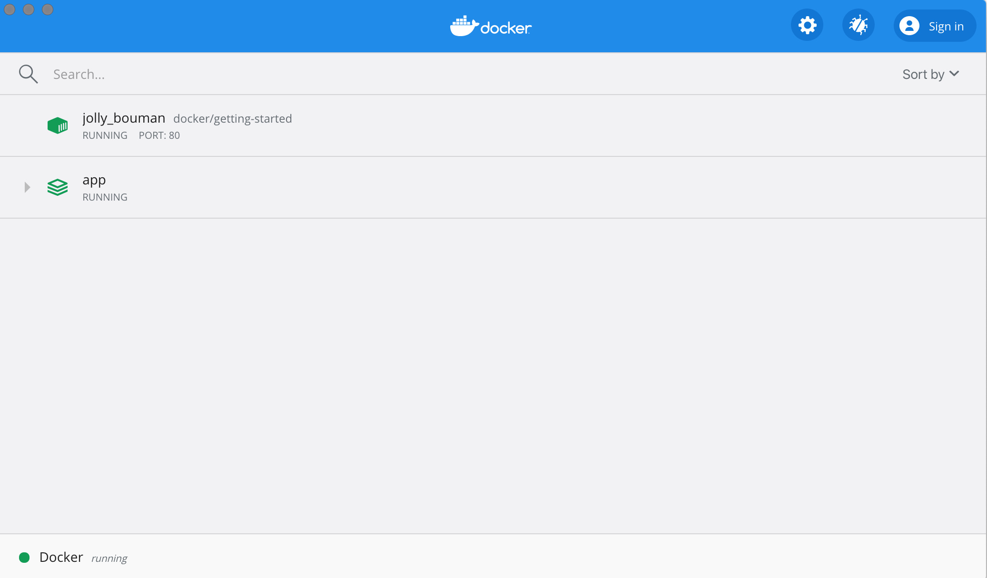
If you twirl down the app, you will see the two containers we defined in the compose file. The names are also a little more descriptive, as they follow the pattern of <project-name>_<service-name>_<replica-number>. So, it’s very easy to quickly see what container is our app and which container is the mysql database.
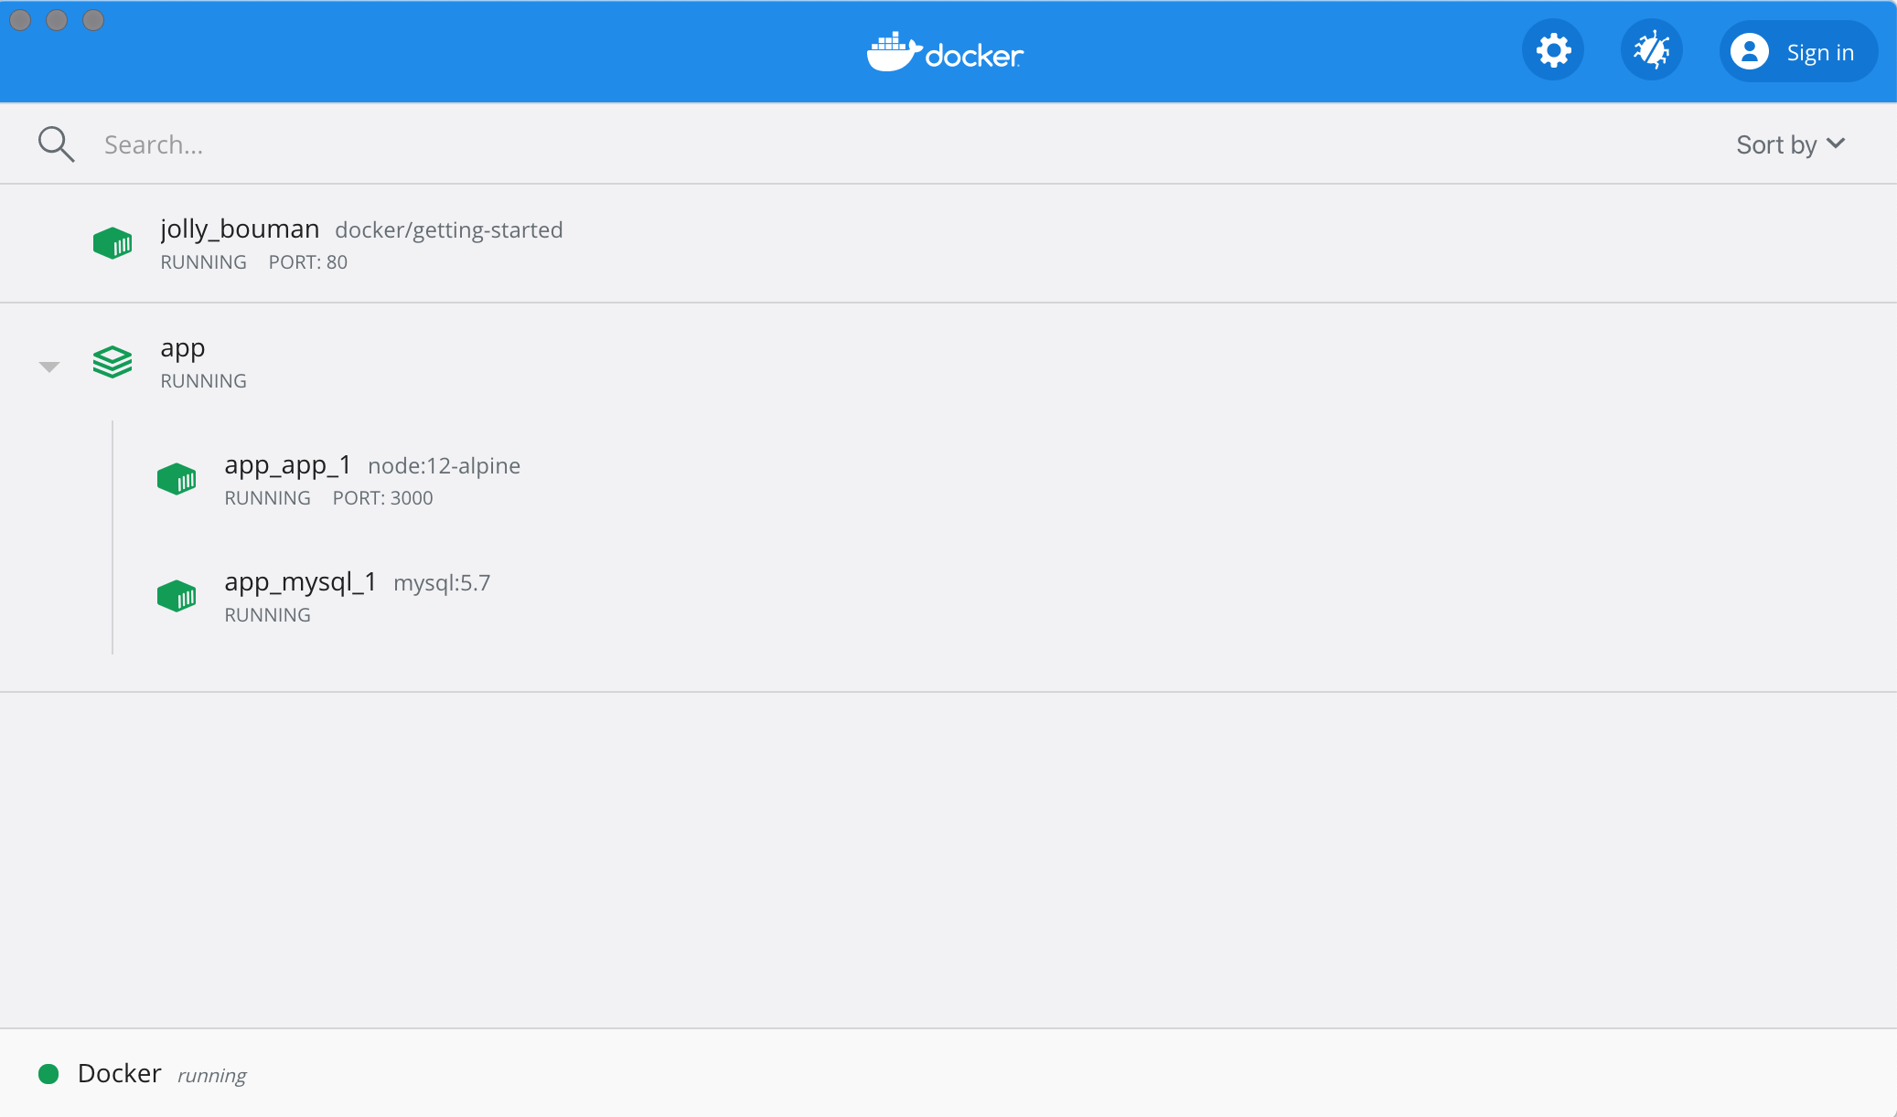

Tear it all down
When you’re ready to tear it all down, simply run docker-compose down or hit the trash can on the Docker Dashboard for the entire app. The containers will stop and the network will be removed.
Warning
Removing Volumes
By default, named volumes in your compose file are NOT removed when running docker-compose down. If you want to remove the volumes, you will need to add the --volumes flag.
The Docker Dashboard does not remove volumes when you delete the app stack.
Once torn down, you can switch to another project, run docker-compose up and be ready to contribute to that project! It really doesn’t get much simpler than that!

Recap
In this section, we learned about Docker Compose and how it helps us dramatically simplify the defining and sharing of multi-service applications. We created a Compose file by translating the commands we were using into the appropriate compose format.
At this point, we’re starting to wrap up the tutorial. However, there are a few best practices about image building we want to cover, as there is a big issue with the Dockerfile we’ve been using. So, let’s take a look!
get started, setup, orientation, quickstart, intro, concepts, containers, docker desktop

Get started with Docker Compose
Estimated reading time: 11 minutes
On this page you build a simple Python web application running on Docker Compose. The application uses the Flask framework and maintains a hit counter in Redis. While the sample uses Python, the concepts demonstrated here should be understandable even if you’re not familiar with it.

Prerequisites
Make sure you have already installed both Docker Engine and Docker Compose. You don’t need to install Python or Redis, as both are provided by Docker images.

Step 1: Setup
Define the application dependencies.
- Create a directory for the project:
mkdir composetest
- cd composetest
- Create a file called app.py in your project directory and paste this in:
import time

import redis
from flask import Flask

app = Flask(__name__)
cache = redis.Redis(host='redis', port=6379)

def get_hit_count():
retries = 5
while True:
try:
return cache.incr('hits')
except redis.exceptions.ConnectionError as exc:
if retries == 0:
raise exc
retries -= 1
time.sleep(0.5)

@app.route('/')
def hello():
count = get_hit_count()
return 'Hello World! I have been seen {} times.\n'.format(count)
In this example, redis is the hostname of the redis container on the application’s network. We use the default port for Redis, 6379.
Handling transient errors
Note the way the get_hit_count function is written. This basic retry loop lets us attempt our request multiple times if the redis service is not available. This is useful at startup while the application comes online, but also makes our application more resilient if the Redis service needs to be restarted anytime during the app’s lifetime. In a cluster, this also helps handling momentary connection drops between nodes.
- Create another file called requirements.txt in your project directory and paste this in:
flask
redis

Step 2: Create a Dockerfile
In this step, you write a Dockerfile that builds a Docker image. The image contains all the dependencies the Python application requires, including Python itself.
In your project directory, create a file named Dockerfile and paste the following:
# syntax=docker/dockerfile:1
FROM python:3.7-alpine
WORKDIR /code
ENV FLASK_APP=app.py
ENV FLASK_RUN_HOST=0.0.0.0
RUN apk add --no-cache gcc musl-dev linux-headers
COPY requirements.txt requirements.txt
RUN pip install -r requirements.txt
EXPOSE 5000
COPY . .
CMD ["flask", "run"]
This tells Docker to:
- Build an image starting with the Python 3.7 image.
- Set the working directory to /code.
- Set environment variables used by the flask command.
- Install gcc and other dependencies
- Copy requirements.txt and install the Python dependencies.
- Add metadata to the image to describe that the container is listening on port 5000
- Copy the current directory . in the project to the workdir . in the image.
- Set the default command for the container to flask run.
For more information on how to write Dockerfiles, see the Docker user guide and the Dockerfile reference.

Step 3: Define services in a Compose file
Create a file called docker-compose.yml in your project directory and paste the following:
version: "3.9"
services:
web:
build: .
ports:
- "8000:5000"
redis:
image: "redis:alpine"
This Compose file defines two services: web and redis.

Web service
The web service uses an image that’s built from the Dockerfile in the current directory. It then binds the container and the host machine to the exposed port, 8000. This example service uses the default port for the Flask web server, 5000.

Redis service
The redis service uses a public Redis image pulled from the Docker Hub registry.

Step 4: Build and run your app with Compose
- From your project directory, start up your application by running docker-compose up.
docker-compose up
oO0OoO0OoO0Oo Redis is starting oO0OoO0OoO0Oo
Redis version=4.0.1, bits=64, commit=00000000, modified=0, pid=1, just started
Warning: no config file specified, using the default config. In order to specify a config file use redis-server /path/to/redis.conf
WARNING: The TCP backlog setting of 511 cannot be enforced because /proc/sys/net/core/somaxconn is set to the lower value of 128.
Server initialized
WARNING you have Transparent Huge Pages (THP) support enabled in your kernel. This will create latency and memory usage issues with Redis. To fix this issue run the command 'echo never > /sys/kernel/mm/transparent_hugepage/enabled' as root, and add it to your /etc/rc.local in order to retain the setting after a reboot. Redis must be restarted after THP is disabled.
- Compose pulls a Redis image, builds an image for your code, and starts the services you defined. In this case, the code is statically copied into the image at build time.
- Enter http://localhost:8000/ in a browser to see the application running.
If you’re using Docker natively on Linux, Docker Desktop for Mac, or Docker Desktop for Windows, then the web app should now be listening on port 8000 on your Docker daemon host. Point your web browser to http://localhost:8000 to find the Hello World message. If this doesn’t resolve, you can also try http://127.0.0.1:8000.
You should see a message in your browser saying:
- 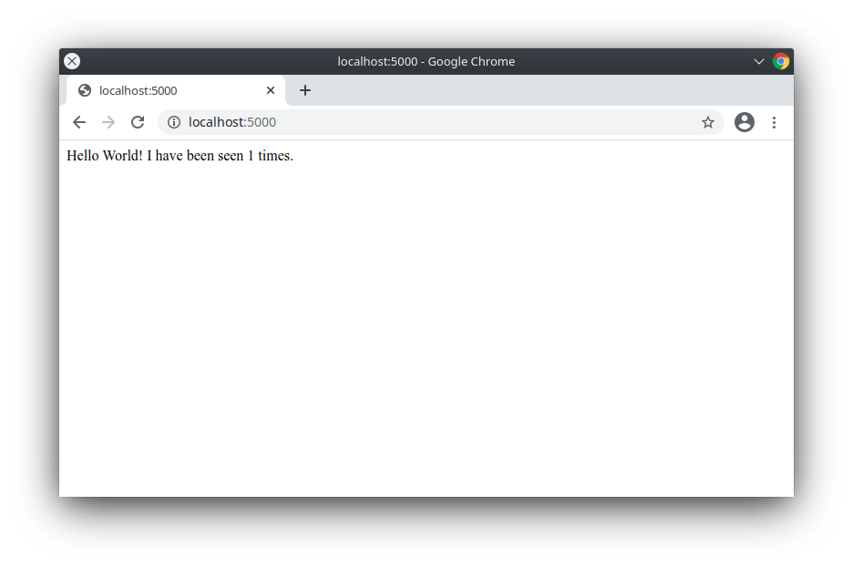
- Refresh the page.
The number should increment.
- 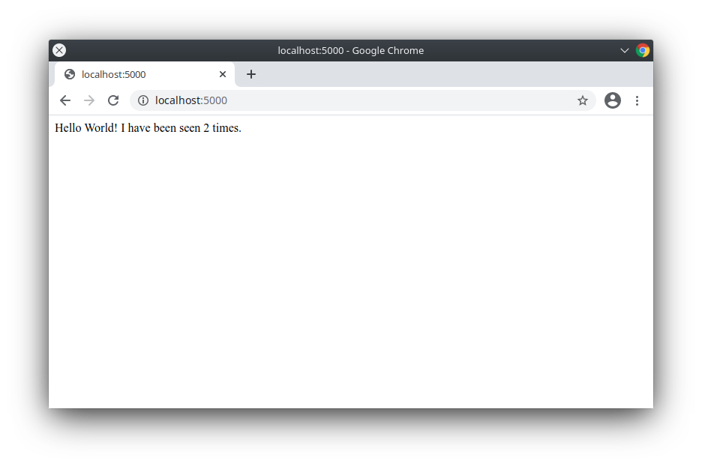
- Switch to another terminal window, and type docker image ls to list local images.
Listing images at this point should return redis and web.
docker image ls
- You can inspect images with docker inspect <tag or id>.
- Stop the application, either by running docker-compose down from within your project directory in the second terminal, or by hitting CTRL+C in the original terminal where you started the app.

Step 5: Edit the Compose file to add a bind mount
Edit docker-compose.yml in your project directory to add a bind mount for the web service:
version: "3.9"
services:
web:
build: .
ports:
- "8000:5000"
volumes:
- .:/code
environment:
FLASK_ENV: development
redis:
image: "redis:alpine"
The new volumes key mounts the project directory (current directory) on the host to /code inside the container, allowing you to modify the code on the fly, without having to rebuild the image. The environment key sets the FLASK_ENV environment variable, which tells flask run to run in development mode and reload the code on change. This mode should only be used in development.

Step 6: Re-build and run the app with Compose
From your project directory, type docker-compose up to build the app with the updated Compose file, and run it.
docker-compose up
Check the Hello World message in a web browser again, and refresh to see the count increment.
Shared folders, volumes, and bind mounts
- If your project is outside of the Users directory (cd ~), then you need to share the drive or location of the Dockerfile and volume you are using. If you get runtime errors indicating an application file is not found, a volume mount is denied, or a service cannot start, try enabling file or drive sharing. Volume mounting requires shared drives for projects that live outside of C:\Users (Windows) or /Users (Mac), and is required for any project on Docker Desktop for Windows that uses Linux containers. For more information, see File sharing on Docker for Mac, and the general examples on how to Manage data in containers.
- If you are using Oracle VirtualBox on an older Windows OS, you might encounter an issue with shared folders as described in this VB trouble ticket. Newer Windows systems meet the requirements for Docker Desktop for Windows and do not need VirtualBox.

Step 7: Update the application
Because the application code is now mounted into the container using a volume, you can make changes to its code and see the changes instantly, without having to rebuild the image.
Change the greeting in app.py and save it. For example, change the Hello World! message to Hello from Docker!:
return 'Hello from Docker! I have been seen {} times.\n'.format(count)
Refresh the app in your browser. The greeting should be updated, and the counter should still be incrementing.
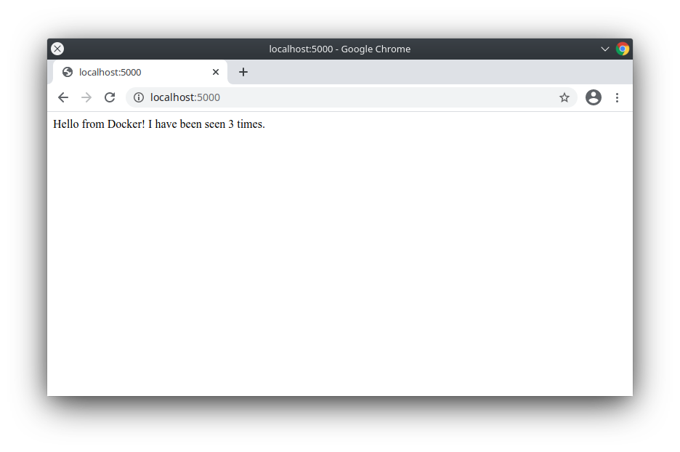

Step 8: Experiment with some other commands
If you want to run your services in the background, you can pass the -d flag (for “detached” mode) to docker-compose up and use docker-compose ps to see what is currently running:
docker-compose up -d
docker-compose ps
5000/tcp
The docker-compose run command allows you to run one-off commands for your services. For example, to see what environment variables are available to the web service:
docker-compose run web env
See docker-compose --help to see other available commands. You can also install command completion for the bash and zsh shell, which also shows you available commands.
If you started Compose with docker-compose up -d, stop your services once you’ve finished with them:
docker-compose stop
You can bring everything down, removing the containers entirely, with the down command. Pass --volumes to also remove the data volume used by the Redis container:
docker-compose down --volumes
At this point, you have seen the basics of how Compose works.

Where to go next
- Next, try the Sample apps with Compose
- Explore the full list of Compose commands
- Compose configuration file reference
- To learn more about volumes and bind mounts, see Manage data in Docker
documentation, docs, docker, compose, orchestration, https://docs.docker.com/compose/gettingstarted/

