Physics Engine 2.0
You can add Physics behavior to objects to make them move realistically, following the laws of physics. The extension uses Box2D, a fast and complete rigid bodies physics simulation library in the background.
The behavior is composed of three big concepts: the world that hold the bodies, the bodies themselves, and the joints that link bodies. All of them are explained in this reading.
Limitation: As stated above, the extension simulates rigid bodies physics, which means that bodies can't be deformed. Things like soft shapes, clothes, and fluids are not supported.
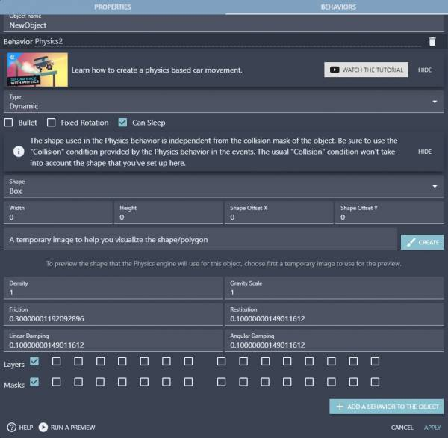

World
The world is the place where simulations run, bodies and joints are attached to a world to interact with other entities.
You don't have to care about placing objects in the world, objects using the Physics behavior automatically added to the world. Also, there can be only one world at a time. You can't run two independent simulations at the same time.
Like GDevelop scenes size, world size is infinite, so you don't have to care where your objects are. They will always follow the laws of physics.
The world has three properties:
- Gravity: Consists of two components (X and Y) and works like our gravity adding a force to every object, pushing them in the given direction. Objects support a gravity scale factor too, more on this in the bodies section.
- Timescale: It defines the scale of time the simulation will use. With a timescale = 0.5, the simulation will run at half the speed; with a timescale = 2, the simulation will be twice as fast, and if timescale = 0, the simulation will pause. Super useful for bullet time effects!
- Scale: GDevelop distances and sizes are defined in pixels, but the physics engine uses meters. A scale factor must be set (again, it has two components, scale X and Y) to make the conversion. The scale numbers mean how many pixels a meter is; for example, a scale of 50 means that a distance of 50 pixels in GDevelop is converted to 1 meter in the physics world.
The rule number one to decide the world scale is to choose it, so the size of your movable/dynamics objects falls in the range 0.1 - 10 meters; out of this range, the simulations will lose precision. For example, if you work with object sizes around 100×100 pixels, a world scale of 100 would be perfect, as it will make your bodies size to be approximately 1×1 meter. Static objects can be much longer, scaling up to 50 meters.

Bodies
Bodies are the life of the Physics extension; they define how your object will move, what its shape will be, how much it will bounce, and whether it will be able to rotate or move.
When you add the Physics behavior to an object, you can set the body configuration right from the IDE.
There are many options to play with, so they have been categorized below. .

Body Type
GDevelop supports three basic body types:
- Dynamic: The most common type, dynamic bodies, are affected by gravity, can collide with other active, static, and kinematic bodies. You can apply forces and impulses on them and modify their velocity as well. Almost anything that must move should be a dynamic body.
- Static: Static objects are not affected by gravity, and you can't move them using forces, impulses or modifying their velocity. They can collide with dynamic objects only, ignoring kinematics and other static bodies. They are meant to be used for static world geometry, as the ground, non-movable walls, and platforms.
- Kinematic: Kinematics are very specialized; they are a type of static body, so they won't be affected by gravity or forces or impulses, but you can move them by modifying their velocity. Kinematics collide with dynamic bodies only, but will not move as a result of this collision. Kinematic bodies are useful for simulating movable walls and platforms.
And some dynamic-related settings:
- Bullet: If set to true, the object will use a continuous-collision-detection algorithm, slightly reducing the performance but improving the response when moving very fast. Useful to correctly simulate… well… bullets (or any high-speed object), and reduce the chances for the bullets to go through thin objects.
Use this option on the objects that really need it; the performance impact, when used in every object that moves is not slight.
- Fixed Rotation: If set to true, the object won't be able to rotate. Imagine your player spinning each time it collides with a wall or while walking down a slope.
- Can Sleep: If set to true, the engine can improve the performance on objects that haven't moved in a while, putting them to sleep. It's just a performance setting and should not impact the simulation itself.
You can check if a body is sleeping using events conditions. If an object is sleeping, it means it has been in an equilibrium state for a while, useful to make balanced games.

Body Shape
Body shape options determine the body form and size, and, depending on the shape type, you have different options to set the dimensions:
- Box: An axis-aligned rectangle centered on the object; if custom width and height are not set, the object size is used.
- Circle: A circle centered on the object; if a custom radius is not set, it will be calculated as an average from the object width and height. If the object is in the form of a square, the result will be an inscribed circle inside the object bounding box.
- Edge: A thin line centered in the object; since this shape has no volume, it doesn't work well as a dynamic body. It's meant to be used for static geometry, as ground and platforms. If a custom length and angle are not set, the edge will be a horizontal line with length equal to the object width.
- Polygon: A custom shape through vertices. The polygon must be convex, and if this condition fails, the shape falls back to a default box. The number of vertices must be greater than or equal to 3 (otherwise, it can't be convex) and less than or equal to 8 (the maximum number of vertices supported per polygon): 3 ≤ Number of vertices ≤ 8.
In addition to custom shape type and dimension, the body shape supports two extra options:
- Offset: The offset has two components (X and Y) and can be used to move the shape from the object center.
- Scale: You can scale the shape too. It will scale the shape's custom dimensions and offset. If you don't use custom dimensions, you can use the box shape and let the width and height be equal to the object's original size; there's no need to change the shape scale as the scaling will be done automatically. If the shape type is a polygon, the scale will modify the vertices position too, and the scaling origin will be the Polygon Origin. If you set the polygon origin to Center and scale the shape down, the vertices will be scaled down to/in-direction-of the object's center.

Body Settings
Besides the type and shape, physics bodies have some extra settings that determine how the body will behave on collision, how the gravity will affect them and the energy they lose by air friction. Each setting is explained below:
- Density: Density determines the body mass. The general formula is density = mass/volume, but since there is no third dimension, we can safely assume it to be density = mass/area. Two bodies with the same density but different areas/sizes will have different mass, so you have to take the density into account when resizing objects.
Density can't be negative!
- Friction: Friction adds a force to the bodies in contact, in the direction opposite to their direction of movement. The higher the friction, the faster the objects will slow down on contact. To understand it better, a platform made of sand will have friction close to 1 (very high), while a platform made of ice, will have a friction factor close to zero.
Friction can't be negative!
When two objects are in contact, the total friction is calculated using the frictions of the colliding objects through the formula: friction = sqrt(frictionA * frictionB)
- Restitution: Restitution determines how much energy the object will keep or lose in each collision. A value of zero means the collisions will be perfectly inelastic, and the object won't bounce at all. While a restitution = 1 means the collisions will be perfectly elastic, and the object will jump with the same energy each time. Imagine a ball bouncing off the ground, and always reaching the same height. Values of restitution greater than 1 are valid but will make the object gain energy on each collision, and the simulation will probably run out of control.
Restitution can't be negative!
When two objects make contact, the total restitution is calculated using the restitutions of the colliding objects through the formula: restitution = max(restitutionA, restitutionB)
- Linear Damping: Linear damping reduces the object velocity all the time. The higher the value, the faster it slows down the objects. You can imagine it as the air viscosity, very high values would even simulate the object to move in liquid.
Although you can use any value, negative damping will make the object to gain velocity on each step, generating a non-physical behavior.
- Angular Damping: Angular damping is analogous to the linear damping, but instead of slowing down the object's linear velocity, it slows down the angular velocity, making the object to rotate slower each step.
Although you can use any value, negative damping will make the object to gain angular velocity on each step, generating a non-physical behavior.
- Gravity Scale: Gravity Scale is multiplied by the world gravity to determine the gravity applied to the object. Note that this is a number and not a vector; you can't change the orientation of the gravity, just the magnitude and sense. Any number is valid, some examples: If the gravity scale is 1, the gravity applied will be the world gravity; if it's 2, the gravity will be twice as strong for this object; if it's 0.5, the gravity will be twice as weak; if it's 0 the object won't be affected by gravity, and if it's -1, the gravity will be inverted.
You can use a negative gravity scale to invert the gravity for a specific object.

Collision Layers & Masks
Layers and masks are the way to filter collisions between objects.
- Layer: Logical group that an object can belong to. Objects can be a member of multiple layers.
- Mask: List of the layers that an object will collide with.
Physics collision layers are not related to layers that are used to place objects in a scene.
This system allows you to build up complex interactions between a variety of objects. Imagine you're building a zombie game, and you want your player to collide with the ground, and want the zombies to collide with the player and with the ground as well, but you don't want zombies to collide with other zombies, for such a case, you need collision filters.
How do filters work? There is just a single rule:
Two objects A and B can collide if any layer of A matches any mask of B, and any layer of B matches any mask of A
Here is a possible solution to the above zombie problem:
- Ground: Enable the first layer and the first and second masks.
- Player: Enable the first layer and the first and second masks.
- Zombie: Enable the second layer and the first mask only.
Object | Layer | Mask
Ground | 1 | 1, 2
Player | 1 | 1 ,2
Zombie | 2 | 1
Why does it work?
- Ground & Player: A ground layer matches a player mask (first), and a player layer matches a ground mask (first)
- Ground & Zombie: A ground layer matches a zombie mask (first), and a zombie layer matches a ground mask (second)
- Player & Zombie: A player layer matches a zombie mask (first), and a zombie layer matches a player mask (second)
- Zombie & Zombie: The zombie has only the second layer enabled, and only the first mask enabled, so zombies can't collide with each other.
Note that you have 16 layers and 16 masks available, and to solve our little problem, only two layers and masks were needed. By default, all physics objects will use layer 1 and mask 1.

Movement
After setting up your objects, it's time to start the simulation: gravity will begin to push things, objects will move and collide, but you can't interact with your game at all. It's time to move the objects by yourself, and to do that; you have to use the events system. Here are some useful actions to interact with the objects and move them in the way you want:
GDevelop built-in forces are not suited for the Physics behavior; to set the linear velocity, use the forces specific for physics or the physics actions.
- Forces: Forces change an object's movement and are meant to be used for some time to generate an appreciable effect. The velocity the object gains, when you apply on it a force depends on the force's magnitude and the object mass. A heavy object will move slower than a lighter one if the same force is applied on both the masses.
An application point must be set to add a force..
- Torques: Analogous of forces but for rotation. A torque will generate an angular acceleration on the object, making it rotate faster or slower along the time.
- Impulses: Like forces, but not depending on the time step, instead, adding an “amount” of velocity instantly. They're meant to be used a single time. An everyday use could simulate jumps: each time the jump button is pressed, add an impulse upwards.
An application point must be set to add an impulse.
- Angular Impulses: Analogous of impulses but for rotation. Change the rotation speed of an object instantly.
- Velocity: You can modify the velocity of an object directly. For example, you can make your character walk with constant speed and then change the velocity while a movement button is pressed.
- Angular Velocity: You can set the angular velocity (rotation speed) directly too.
You can change the position of the objects directly, but it will generate non-physical behaviors, at least until the new position is corrected. Objects don't teleport in real life, after all.
Note that forces and impulses need an application point; it's essential because it isn't the same to push a glass from the base (move the glass) than pushing it from the top edges (the glass will probably fall), or pushing a door from the knob than from the hinges.
If the application point is different than the object mass center, it will generate some kind of torque/rotation.
You can get an object mass center using the physics behavior expressions MassCenterX() and MassCenterY().

Controlling object movement with joints
Joints are restrictions given to the objects to make them follow extra rules of movement. Some joints make the objects rotate around a fixed point, others keep two objects together, complex ones simulate vehicle wheels limiting the distance between the bodies but allowing them to rotate freely.
Joint ID:
When you create a joint, you can pass a variable name; if you do it, GD will store the joint unique identification number (ID) in the given variable. Using the joint ID, you can modify it after the creation, check its values and remove it. Imagine you create a joint to stick a key to a rope attached to the roof; if you save the joint ID in a variable, then you can check if an object collides with the rope and remove the joint using the saved ID to make the key fall down.
A joint ID will be always a number greater than zero.
Usually, you will need two objects to define a joint (in the previous example, the rope and the key), but there are “exceptions,” check the explanation given in the Revolute joint if you want to know more.
Here is a list of properties, conditions, and actions common for all types of joints:
- Joint first/second object: Conditions that let you pick objects if they are the first or second object the joint is attached to.
- Joint first/second anchor X/Y: Expressions to get the position of the first or second object anchor point the joint is attached at.
- Joint reaction force/torque: Conditions and expressions to check the joint reaction force or torque; this value is a measure of how far away is the joint from its equilibrium state. If the joint reaction force is too high, it means the joint has been separated from the equilibrium position through a considerable force. Useful to make breakable joints.
- Remove joint: Action to remove the specified joint. If the joint is one of the gear joint children, the gear will be also removed. If any of the objects the joint is attached to is deleted, the joint will be deleted.
There are many kinds of joints, each one with unique behaviors and properties; they are listed below.
Make sure to create joints in events that run only once (for example, at the beginning of the scene). Creating joints every frame will create hundreds of joints in seconds, resulting in poor performance, non-physical behaviors, and possible crashes due to memory consumption.

Distance Joint
Distance joint tries to keep two objects separated by a given distance; the distance is calculated from the joint anchor points. The objects won't be at the given distance all the time but will tend to reach it, following an oscillator formula.
Settings:
- Length: The target distance, if a negative value is given, the distance between the objects when creating the joint is used.
- Damping ratio: The “friction” the objects will suffer, low values make the objects oscillate more, higher values reduce oscillations but objects will move slower.
- Frequency: How fast the objects will oscillate, lower values generate soft joints moving more gradually to reach the target distance, higher values simulate harder joints with objects moving very fast to reach the target.
Low damping ratio and frequency values will generate soft joints, with lots of oscillations before getting close to the target distance. In contrast, high values for both settings generate very rigid joints.

Revolute Joint
Revolute joints work like “pins” and are also known as “hinges,” they make the objects to rotate around a point. There are two types of revolute joints; in the end, they are almost the same, with a small difference:
- A revolute joint between two objects: It “pins” two objects, the objects will move together in a way so their anchor points overlap, and each object will rotate around their anchor point. Imagine that you pin two cards together and throw them, so they move and rotate freely around the pin.
- A revolute joint in a single object: Joints usually work between two objects; this is one of the exceptions. This joint needs a single object and its anchor point and pinpoints the object at the given fixed position. Think of it like pinning a note in a wall; the note can rotate around the pin but can't move.
In the single object version of the joint, the object is added as the second object in the joint. The first object is a hidden static body; this allows to use this type of joint in gears, which is explained in the gear joint section.
Here is the list of the settings specific for revolute joints:
- Angle limits: If enabled, the rotation will be restricted between the minimum and maximum angles. Note that both angles are relative to the first object.
- Reference angle: The angle between the objects that will be considered as zero. It offsets all the angle properties. If the reference angle is 15 degrees, asking for the current joint angle when the angle between the objects is 15 degrees in world coordinates will return 0, and set the maximum angle to 30 will set it to 45 (relative to the first object).
- Minimum angle: The minimum angle between the objects, relative to the first object. Must be lower than or equal to the maximum angle.
- Maximum angle: The maximum angle between the objects, relative to the first object. Must be greater than or equal to the minimum angle.
You can use revolute joints with angle limits to simulate articulations, in other words, ragdolls!
- Motor: If enabled, the joint will add torque to the second object to make it rotate without the need of an external force, like a motor. If you enable it, remember to set a motor speed and a maximum motor torque!
- Motor speed: The target motor speed, in degrees per second. This is the speed the second object will try to reach while rotating around the first object. Motor speed can be positive to rotate the object in a clockwise direction or negative to rotate it in the anticlockwise direction.
- Maximum motor torque: The maximum torque the motor can spend to reach the target motor speed must be positive.
Also, you can access the following values during simulation:
- Joint angle: The current angle between the objects, relative to the first object and affected by the reference angle.
- Joint speed: The current joint angular speed, i.e., the speed the second object is rotating around, relative to the first object rotation.
- Joint motor torque: The current motor torque, it can be lower than the maximum motor torque, as it's the required torque to reach the target motor speed.
Other uses for revolute joints can be: pinball levers, top-down doors, automated rotating machines as bridges.

Prismatic Joint
Prismatic joints work like “pistons” and are also known as “sliders.” They make objects to slide one over the other in a given axis. A good example is an elevator; the elevator moves in a vertical axis along a rail. The rail would be the first joint body and the elevator the second one. The axis would be an angle pointing up or down (-90 or 90 degrees).
Settings specific for prismatic joints:
- Axis angle: The angle that determines the movement direction, an axis angle of 0 means a horizontal movement. The value is given in world coordinates, but the axis will rotate following the first object direction (if you rotate your elevator rails, the elevator movement angle rotates too).
- Reference angle: As in revolute joints, this angle adds an offset to the axis, establishing a new “angle zero.” If the reference angle is 15, an axis angle of 15 in world coordinates (relative to the first object direction) will be treated as 0.
- Translation limits: If enabled, the second object movement will be limited between the given minimum and maximum translations.
- Minimum translation: The minimum position the second object can move from the first one. In our elevator example, the minimum translation would be the floor.
- Maximum translation: The maximum position the second object can move from the first one. In our elevator example, the roof.
The translation limits range must include the zero, a minimum translation of 5, and maximum translation of 10 (range [5, 10]) will be converted to the range [0, 10] to include the zero.
- Motor: If enabled, the joint will apply a force to the second object to reach a given motor speed. If you enable it, remember to set a motor speed and a maximum motor force!
- Motor speed: The target speed the motor will try to reach; if positive, the second object will move in the axis direction, and in the opposite direction if negative.
- Maximum motor force: The maximum amount of force the motor can spend to reach the target speed. It must be positive.
Also, you can access the below values during simulation:
- Joint translation: In the current translation, the second object has moved relative to the first.
- Joint speed: The current speed the second object is moving at, along the axis and relative to the first object speed.
- Joint motor force: The current force the motor is applying to the second object; this value can be lower than the maximum motor force as it's the force needed to reach the target motor speed.

Pulley joint
A pulley joint simple joint with a simple name. This joint makes the summation of the distances from each object to its ground position to be constant; it's a lot easier to understand using other words: it simulates a pulley :)
Imagine you have a box hanging 3 meters under a fixed point A and a circle hanging 2 meters under a fixed point B, both objects attached to the ends of the same rope. The rope has a constant length, so if you move the box up, now hanging just 1 meter under A, the circle has to move down the same distance, now 4 meters under B, this way the distance between the box and A plus the distance between the circle and B is always 5 meters:
distance(box, A) + distance(circle, B) = constant
Ratio:
Easy, no? Now the crazy part, this joint supports an extra setting: ratio. The ratio makes the rope to be more extensible on one of the sides than the other. It can make, for example, 1 meter of rope on the box side to be equivalent to 2 meters of rope on the circle side (ratio = 1/2 = 0.5).
Going back to our initial example: The box 3 meters under A, the circle 2 meters under B, but with a ratio = 0.5. Now, moving the box 2 meters upward will make the circle move 4 meters downward. The rope length is not constant, but:
distance(box, A) + ratio*distance(circle, B) = constant (Note that the first equation is a particular case of this one, with ratio = 1).
Also, please note that there is not a “rope” at all. The joint works with the distance between the objects and the anchor points only!
Here are the joint settings:
- First ground point: The fixed point the first object is attached (in the examples, point A).
- Second ground point: The fixed point the second object is attached (in the examples, point B).
- First length: The initial rope length between the first object and its ground point; if the value is negative or zero, the distance at the moment of creating the joint is used.
- Second length: The initial rope length between the second object and its ground point; if the value is negative or zero, the distance at the moment of creating the joint is used.
- Ratio: Explained above, the equivalence between the distance in each side. If the ratio is = 0.33, 1 meter on the first side is equivalent to 3 meters on the second side.

Gear Joint
This joint is very special; instead of joining two bodies directly, gears join two other joints, those child joints must be revolute or prismatic.
When two joints are linked through a gear joint, one of the joints movement makes the other joint move. For example, moving an object along the axis on a prismatic joint will cause the linked revolute joint to rotate and vice versa.
This joint is also very tricky! To get a gear to work, each child's joint's first body must be static, and the second body dynamic.
You can gear together two revolute joints, two prismatic joints, or a revolute and a prismatic, but always the first body of each of the joints must be static!
The first body of the gear child joints must be static; that's why the single object version of the revolute joint clarifies that the first body is a hidden static object
The gear joint settings:
- First joint: A revolute or prismatic joint will be linked to the second joint.
- Second joint: A revolute or prismatic joint will be linked to the first joint.
- Ratio: Like the pulley joint, gears support a “ratio”, and works in a similarly: If you link two revolute joints with a ratio = 0.33, each turn in the first revolute will be equivalent to three turns in the second one. But there is a difference against the pulley joint ratio: gears ratios can be negative, allowing a positive movement in one of the joints to generate a negative movement in the other. For example, when linking two revolute joints with a ratio = -1, clockwise rotation in a revolute joint will generate an anti-clockwise rotation in the other, much like a gear.
The necessary condition for the existence of a gear is the existence of the two child joints. If any of the two joints are deleted the gear will be automatically deleted too.

Mouse Joint
This joint is not necessarily related to the mouse, but it's very common. This joint moves an object towards a target position; if you update the target position continuously to target the mouse or a touch position, you can drag objects around.
Note that it's another exception from the other joints because it's a joint that requires a single body to work: the object that will be moved towards the target.
Settings for the mouse joint:
- Object: The object to move around, towards the target position.
- Target: The target point the object will try to reach. You can update it as many times as you want after creating the joint.
The initial target position (at the moment of creating the joint) is also used as the object anchor point, so make sure to set it!
- Maximum force: The maximum force the joint can apply on the object to reach the target position; the greater the force, the faster the object will move. It must be positive.
- Frequency: Works like the distance joint frequency, determining how fast the object will oscillate around the target.
- Damping ratio: Works like the distance joint damping ratio, slowing down the object along the time.
The mouse joint is not restricted to be used with the mouse only but accepts any world point as the target.

Wheel Joint
A very specified joint, when you need wheels, you'll want this joint, and it's hard to think of a case different than a vehicle's wheel where the best joint is the wheel joint.
Made to simulate vehicle wheels, this joint does only that, but does it very well!
You can think of the wheel joint as a revolute plus a prismatic joint:
The revolute joint is used to make the second object (the wheel) rotate, and, as the classic revolute joint, it supports a motor to simulate the vehicle motor, causing the wheel to rotate.
The prismatic joint function is to simulate the vehicle wheel suspension, and, as the classic prismatic joint, you can set the axis angle to define the wheel translation direction. Generally, the axis direction is vertical, but, for example, motorbikes have a front-wheel suspension direction different (and in some cases very far) from vertical.
The body that will work as the wheel has to be the second object in the joint.
Here are the wheel joint settings:
- Axis angle: Equivalent to the prismatic joint axis angle, it determines the direction of movement (or sliding) between the wheel and the first object.
- Frequency: The suspension frequency, equivalent to the distance joint frequency. Higher values will make the wheel oscillate faster.
- Damping ratio: Damping ration is the suspension damping, equivalent to the distance joint damping ratio. Higher value slows down the wheel movement at a higher rate.
- Motor: If enabled, the joint will add torque to the wheel (second object) to reach a given motor target speed. If you enable it, remember to set the motor speed and the maximum motor torque!
- Motor speed: The target angular speed the wheel will try to reach. It can be positive for clockwise rotation or negative for anti-clockwise rotation.
- Maximum motor torque: The maximum amount of torque the joint can apply to the wheel to reach the motor target speed. It must be positive.
And some extra values you can access during simulation:
- Joint translation: The current wheel translation along the suspension axis.
- Joint speed: The current wheel rotation speed.
- Joint motor torque: The current torque the joint is applying to the wheel, it can be lower than the maximum motor torque as it's the torque needed to reach the target speed.

Weld Joint
This joint is super basic; just tries to stick/glue two objects together and move them as if they were a single object.
You can use it to make breakable objects, but don't abuse! After all, the objects will be attached by soft joints. Sticking lots of objects with very different densities can lead to physically inaccurate results.
The weld joint-specific settings:
- Reference angle: The angle the second object will have, relative to the first object angle.
To stick the objects in the angle they are at the moment of creating the joint, use the relative angle between the objects as the reference angle: SecondObject.Angle() - FirstObject.Angle()
- Frequency: Works like the distance joint frequency, determining how fast the objects will oscillate to reach the rest position.
- Damping ratio: Works like the distance joint damping ratio, slowing down the objects along the time.

Rope Joint
Another simple joint. The rope joint makes two objects to be virtually linked with a rope; this way, they can't be separated by a distance greater than the rope length but can be in any distance below it.
As in the pulley joint, there is not a real rope; the joint just checks the distance between the objects and reacts if the distance is greater than the given length.
The only setting specific for the rope joint:
- Maximum length: It is the maximum distance between the objects. If the initial value is negative, the distance between the objects at the moment of creating the joint is used.

Friction Joint
Friction joint simulates friction in a Z-axis; it slows down the relative speed and/or the angular speed between two objects to simulate linear and angular friction.
If one of the objects is static, the friction joint can be used to correctly simulate friction in a top-down game, like a pool table or top-down racing games.
Friction joint settings:
- Maximum force: The maximum force the joint can apply to the objects; higher values generate higher linear friction.
- Maximum torque: The maximum torque the joint can apply to the objects; higher values generate higher angular friction.

Motor Joint
The motor joint has not much to do with real motors, at least not directly. When you link two objects with a motor joint, the objects will try to reach a target position and/or angle relative to the other object plus an offset.
Two things to take into account:
- The joint is not rigid; the objects can be far away from their target position or angle, a correction factor will tell how fast they will move and rotate to reach the rest pose.
For example, imagine one of these punching bag toys that always gets up again. You could simulate it using a motor joint, linking the ground and the bag; this way no matter how much you push the bag object, the joint will try to put it back in the original angle, but not automatically.
- Motor joints will stop if there are obstacles.
Going back to the punching bag example, if you push it with a big object to keep it on the ground, the motor joint won't be able to push it back, like in real life.
This joint doesn't use anchor points; the offset position must be set using the linear and angular offsets only. Accessing the anchor points of this joint will return the object's position.
The motor joint specific settings:
- Offset X/Y: The offset position for the second object, relative to the first one. To use the current object's position at the moment of creating the joints use SecondObject.X() - FirstObject.X() and SecondObject.Y() - FirstObject.Y()
- Offset angle: The angular offset for the second object relative to the first one. To use the current objects relative angle at the moment of creating the joints, use SecondObject.Angle() - FirstObject.Angle()
- Maximum force: The maximum force the joint can apply to the objects to move them to the target position. Higher values will move the objects faster, in case of being necessary. If this value is zero, there won't be a linear correction, and objects won't move to reach the target position.
- Maximum torque: The maximum torque the joint can apply to the objects to rotate them to the target angle. Higher values will rotate the objects faster, in case of being necessary. If this value is zero, there won't be an angular correction, and objects won't rotate to reach the target angle.
- Correction factor: How fast the objects have to move and rotate to reach the target position and angle. The higher the correction, the faster the objects will move and/or rotate. The correction is limited by the maximum amount of force and torque the joint can use.

Pathfinding
See Pathfinding behavior examples
Pathfinding behavior allows us to move objects to a selected destination as well as to flag items as obstacles. Objects that are flagged as obstacles will be avoided by the moving objects.

Step 1) Add "Pathfinding" behavior to objects that will travel
To add the Pathfinding behavior to an object, as usual, create the object. Then open the object's properties by right-clicking on the Objects list located on the right of the Scene Interface. Select “Edit object” from the popup list.
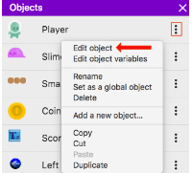
Now, select the behavior tab and click the “add behavior” button.
Next, we have two options to choose from:

“Pathfinding behavior” allows us to move the object to a destination while avoiding all objects that have the “Obstacle for Pathfinding”.
After we add the behavior to the object, we can customize a number of options. 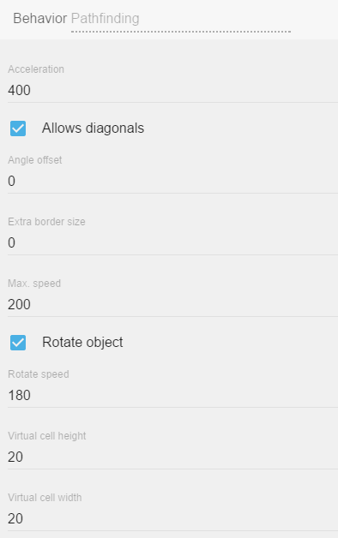
- acceleration: this is how fast our object is going to accelerate while moving on a path.
- allow diagonals: test whether or not the object can move in diagonals.
- angle offset: in case our sprite is facing the wrong direction we can set the angle offset
- extra border size: sets the border size around the object. This setting determines how close the object can move to the obstacles.
- max speed: maximum speed the object can move on the path.
- rotate object: if you don't want the object to rotate while moving on the path, disable the object's rotation.
- rotate speed: sets the speed of the object's rotation.
- virtual cell height and width: our path is generated using a virtual grid. We can change the size of the cells here, the smaller the cell size, the smoother the movement is going to be. A smaller cell size implies more calculations so try to still keep the size as large as possible.

Step 2: Add "Obstacle for Pathfinding" behavior to objects that should be avoided

By using the “Pathfinding obstacle behavior”, we can flag any object to be an obstacle. After we add the behavior to the object, we have two options to customize: 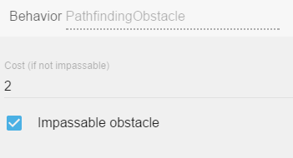
- impassable: if we enable this, the obstacle is going to be impassable. The moving object is going to avoid it at all cost.
- cost: if the obstacle is not impassable, we can set a cost for the obstacle. The moving object, when looking for the best possible path to a destination, is going to prefer to avoid the obstacle with high-cost values. For example, a river might have some cost. The moving object, if possible, will avoid it. However, if there is no other way around the river, or if the river has a lower cost compared to another area, the moving object will go through it (instead of climbing a mountain with a higher cost for example). And if we put crocodiles into the river and increase its cost, the moving object might decide to climb the mountains instead.

Step 3: Create an action to move the Pathfinding object
To initiate a pathfinding move, add the action “Move to a position” and specify the location you want the object to move to. It will move using the characteristics defined in the behavior properties. If you want to change how the object moves during the game, these properties can be changed using actions.
The “Move to a position” action only needs to be run once. If you run this action with no conditions, it will try to recalculate the path every frame and your object will NOT move. One way to make sure this action only runs once is to add a condition that makes sure the object pathfinder speed is 0.

Examples
See it in action! 🎮
Open these examples online.
General Path Finding Behavior
- Open example in GDevelop's web app

Path Finding Basics
- Open example in GDevelop's web app

Destroy outside screen behavior
I would rather see the Destroy outside screen behavior examples! Please take me there now.
This is one of the most simple, yet useful, behaviors. Add it to an object and then, whenever an instance of this object goes out of the bounds of the game scene/screen, this instance will be destroyed.
It's a simple way of ensuring that your game is not filled with garbage objects that could slow it down.

Add behavior to object
To add a behavior to an object, first open the object properties by right-clicking on the object that is located in the Objects list. Select “Edit object” from the popup list. Then select the Behaviors tab. Click the “add behavior” button.

Destroy when outside of screen

Once you have selected the destroy behavior from the list, it is going to eliminate the object whenever it is outside the screen. This behavior has no options to change and automatically applies to all instances of the object.

Examples
See it in action! 🎮
Open these examples online.
Outside the Screen Behavior
- Open example in GDevelop's web app

Destroy Bullets Outside Screen/Scene
- Open example in GDevelop's web app

Shooting Bullets Explanation
- Open example in GDevelop's web app
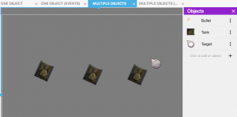

Platform and Platform character behaviors
See it in action! 🎮
I would rather see the Platform and Platform character behavior examples! Please take me there now.
With the simple click of a button, you can set up your game's “Platform” behavior as well as the platform character control!

Platform behavior
 As usual, create a new object. Select the object from the Scene “Objects” list by clicking on the “click to add an object” option. From the list that pops up, choose “edit object”. Select the “Platform” behavior from the list that is displayed. You can now turn your object into a platform. Once your object is defined as a “Platform”, your “Platform character” object can walk on it.
After selecting the “Platform” option, you will see the Platform behavior options list:
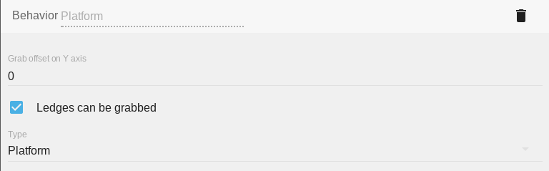

Platform type
By clicking on the platform behavior, you can choose from 3 different platform types.

- Platform: this is the default option. The default behavior sets the object as a traditional platform. The character can collide with the platform and/or walk on it.
- Jumpthru platform: by choosing this option, the character can collide with the platform and walk on it, but the character can also jump thru the platform from below.
- Ladder: as its name suggests, this option turns our object into a ladder. The character object cannot collide with the ladder object. It can not walk on the ladder object, but, when the character object overlaps the ladder object, the character is able to climb up and get down using the ladder object.

Grab the ledge
The ledge of our platform can be grabbed by default. “Grab the ledge” means that when the character object jumps close enough to the edge of the platform, the ledge can be grabbed. If you don't need this functionality, make sure this option is unticked/unchecked. If you do need it, make sure the box is ticked/checked. 
The offset of the grab can also be changed on the Y-axis. The offset option allows us to change the position of the grab to fit the animation of our character.

Platformer character behavior

By selecting the “Platformer character” from the list, we can turn our object into a “Platformer character” After selecting the “Platformer character” option, you will be presented with the Platformer character properties/parameters. 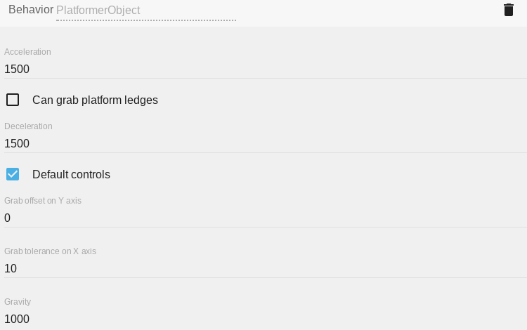
You may need to scroll to see all the options.
If a platformer character uses a custom collision mask, only the rectangular box around the collision mask will be used to keep the platformer away from platforms. This was done to optimize the performance of games that use this behavior.

Controls
The Platformer character behavior comes with default keys set to control the character. These keys are the arrow keys and the shift key. If you don't want to use the default controls, you need to turn off the default controls by unticking/unchecking the “Default controls” box under the “Platform character” options.

Grab the ledge
As with the Platform Behavior, we have the “Grab the ledge” option for the “Platformer character”. This option allows the character object to grab the ledge of the platforms. The option is disabled by default. To enable it, tick/check the box in the options list. 
If you decide to enable this option, the character can grab the ledge of all of the platforms provided that they too have this option enabled.
Again, as with the “Platform Behavior”, we can set the grab offset on the Y axis for the character. Unlike the Platform Behavior, we can also set the grab tolerance on the X-axis.
By changing the grab tolerance value, we can set how close the character needs to be to the platform in order to allow the character to grab the platform object.

Slope max angle
By changing this value, we can set the maximum angle of a slope that the player can climb. The default is 0. 0 default means the character can move only on a flat surface.

Speed and Gravity
By changing the corresponding values under the “Speed and Gravity” options, we can change how fast our character accelerates, decelerates, moves, falls and jumps. I believe these options are self-explanatory so I don't think they require much explanation. If you want to slow the character object down, you can decrease these values. If you want to speed the character object up, you can increase these values.
All the options here can also be changed using events at any time during the game.

Examples
See it in action! 🎮
Open these examples online.
Platformer Behavior
- Open example in GDevelop's web app
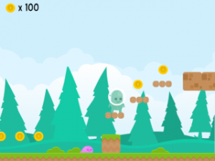

Parallax Scrolling Behavior
- Open example in GDevelop's web app
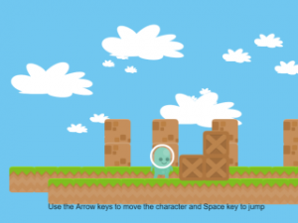

Draggable Object Behavior
See it in action! 🎮
I would rather see the Draggable object behavior examples! Please take me there now.
The draggable object behavior will make the object draggable with the mouse or by touching it on a touchscreen.

Add the Draggable behavior to an object
To add the Draggable behavior to an object, start with creating an object or open the object's properties by accessing the object in the Scene Objects list. Select “Edit object” from the popup list. Then select “Behaviors” and click the add behavior button.
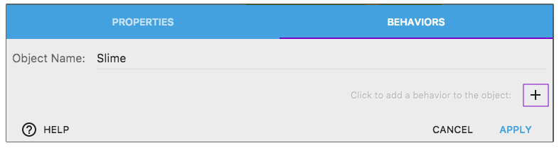
Choose the behavior in the list:

Properties and events
This behavior has no options to change. It automatically applies to the object(s) having it. Using the events, you can still disable or reactivate this behavior for some objects - if you want to enable the player to move only some objects or restrict this to be done during a particular moment.
Using events, you can also check if an object is being dragged:

Examples
See it in action! 🎮
Open these examples online.
Snap to Grid
- Open example in GDevelop's web app
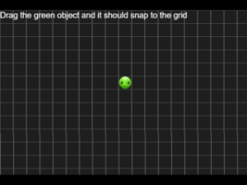

Shoot Bullet in Parabola Pattern (A parabola is a plane curve which is mirror-symmetrical and is approximately U-shaped. Basically, an object that shoots toward an object in a curved trajectory.)
- Open example in GDevelop's web app
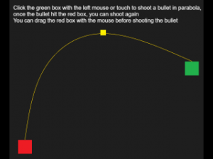

Save and Load
- Open example in GDevelop's web app
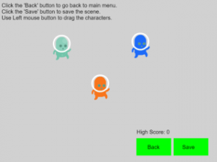

Path Finding Basics
- Open example in GDevelop's web app

Draggable Object Behavior
See it in action! 🎮
I would rather see the Draggable object behavior examples! Please take me there now.
The draggable object behavior will make the object draggable with the mouse or by touching it on a touchscreen.

Add the Draggable behavior to an object
To add the Draggable behavior to an object, start with creating an object or open the object's properties by accessing the object in the Scene Objects list. Select “Edit object” from the popup list. Then select “Behaviors” and click the add behavior button.
Choose the behavior in the list:
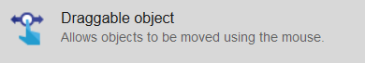

Properties and events
This behavior has no options to change. It automatically applies to the object(s) having it. Using the events, you can still disable or reactivate this behavior for some objects - if you want to enable the player to move only some objects or restrict this to be done during a particular moment.
Using events, you can also check if an object is being dragged:

Examples
See it in action! 🎮
Open these examples online.
Snap to Grid
- Open example in GDevelop's web app

Shoot Bullet in Parabola Pattern (A parabola is a plane curve which is mirror-symmetrical and is approximately U-shaped. Basically, an object that shoots toward an object in a curved trajectory.)
- Open example in GDevelop's web app

Save and Load
- Open example in GDevelop's web app

Path Finding Basics
- Open example in GDevelop's web app
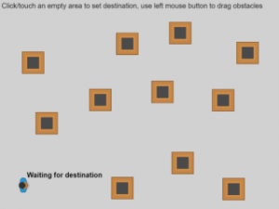

Anchor Behavior
You can anchor an object to the screen by using anchor behavior to pin its edges (bottom, left, right, or top) to the window edges. Once anchored, if the screen size changes, the distance between the edge of the object and the edge of the window will stay the same. This is useful for static UI/HUD objects.

Anchoring an object to the screen
To add an anchor to an object:
- Right-click on the object in the Objects Panel (or create a new object) and select Edit object.
- Click on the Behaviors tab.
- Click + to add a behavior to the object.
- Select Anchor.
- Set your anchor points and click Apply.
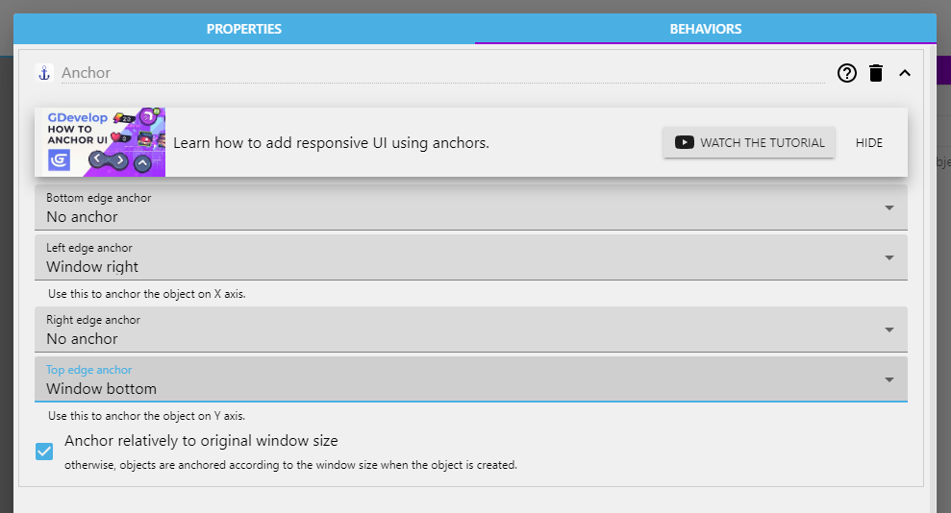

Behavior parameters

Edge anchor
You can choose to what the object will be anchored from 3 main options:
- None: No anchor will be applied to the selected edge.
- Window side: The distance between the object's edge and the selected window side is set so that it is the same for any window size.
- Proportional: The object's edge will always be set so that it is at the same proportion of the screen.
Note that setting anchors to opposite edges will stretch the object.

Tween behavior
Tweens (from inbetween) let you animate properties of an object over some time, like its position or size. This behavior comes with various easing effects used when interpolating between the start and end value to create cool effects like shaking user interface buttons or collectibles that slowly fade out after picking them up.
Visit easings.net to preview various easing effects.

Usage
To use the tween behavior, you need to add it to an object in the object editor. After that, you can add tweens to your object in the events sheet.
Tweens can be played in a sequence if you want to create more complex animations. This is called “chaining.” In the following example, the sprite starts playing a “Tween the scale” animation to shrink it down when it is clicked with the mouse. After the tween has finished, a new tween animation starts to scale it up again. This creates a loop, which makes the sprite pulsate for all eternity. A variation of this can also create platforms that move up and down or enemies patrolling between waypoints.

Conditions
Tween exists
- object: The object the animation should be applied to
- behavior: The tween behavior that is applied to the object
- identifier: A text (string) that is used to identify a tween animation on an object for later use
This condition checks if the given tween has been defined and returns true if it already exists.
Tween has finished playing
- object: The object the animation should be applied to
- behavior: The tween behavior that is applied to the object
- identifier: A text (string) that is used to identify a tween animation on an object for later use
This condition checks if the given tween has reached its end position and thus finished playing. Be aware that this condition will not work if you enable the “Destroy this object when tween finishes” setting on the tween action.
Tween is playing
- object: The object the animation should be applied to
- behavior: The tween behavior that is applied to the object
- identifier: A text (string) that is used to identify a tween animation on an object for later use
This condition checks if the given tween has been started and is currently playing.

Actions
Add object angle tween
- object: The object the animation should be applied to
- behavior: The tween behavior that is applied to the object
- identifier: A text (string) that is used to identify a tween animation on an object for later use
- to angle: The target angle that the object should reach
- easing: A predefined mathematical function to be used to calculate the value between start and end.
- duration: The time in milliseconds (ms) in which the tween animation will be played from start to end
- destroy this object when tween finishes: The object can be destroyed automatically when the tween reaches its end value.
This action starts an angle tween and rotates the object from its current angle to the target angle.
Add object color tween
- object: The object the animation should be applied to
- behavior: The tween behavior that is applied to the object
- identifier: A text (string) that is used to identify a tween animation on an object for later use
- to color: The target color to apply to the object's tint as a text (string) with values separated by semicolons. “255;255;255” means the original color of the sprite (no tint at all)
- easing: A predefined mathematical function to be used to calculate the value between start and end.
- duration: The time in milliseconds (ms) in which the tween animation will be played from start to end
- destroy this object when tween finishes: The object can be destroyed automatically when the tween reaches its end value.
This action starts a color tween and interpolates the object tint from its current color to the target color.
Add object opacity tween
- object: The object the animation should be applied to
- behavior: The tween behavior that is applied to the object
- identifier: A text (string) that is used to identify a tween animation on an object for later use
- to opacity: The target opacity to apply to the objects as a number between 0 (invisible) and 255 (completely visible)
- easing: A predefined mathematical function to be used to calculate the value between start and end.
- duration: The time in milliseconds (ms) in which the tween animation will be played from start to end
- destroy this object when tween finishes: The object can be destroyed automatically when the tween reaches its end value.
This action starts an opacity tween and interpolates the object's opacity from its current value to the target opacity.
Add object position tween
- object: The object the animation should be played applied to
- behavior: The tween behavior that is applied to the object
- identifier: A text (string) that is used to identify a tween animation on an object for later use
- to X: The target position on the X-axis that the object should reach
- to Y: The target position on the Y-axis that the object should reach
- easing: A predefined mathematical function to be used to calculate the value between start and end.
- duration: The time in milliseconds (ms) in which the tween animation will be played from start to end
- destroy this object when tween finishes: The object can be destroyed automatically when the tween reaches its end value.
This action starts a position tween and moves the object from its current position to the target position.
Add object position X tween
- object: The object the animation should be applied to
- behavior: The tween behavior that is applied to the object
- identifier: A text (string) that is used to identify a tween animation on an object for later use
- to X: The target position on the X-axis that the object should reach
- easing: A predefined mathematical function to be used to calculate the value between start and end.
- duration: The time in milliseconds (ms) in which the tween animation will be played from start to end
- destroy this object when tween finishes: The object can be destroyed automatically when the tween reaches its end value.
This action starts a tween for the object's X position and moves the object from its current X position to the target X position.
Add object position Y tween
- object: The object the animation should be played applied to
- behavior: The tween behavior that is applied to the object
- identifier: A text (string) that is used to identify a tween animation on an object for later use
- to Y: The target position on the Y-axis, that the object should reach
- easing: A predefined mathematical function to be used to calculate the value between start and end.
- duration: The time in milliseconds (ms) in which the tween animation will be played from start to end
- destroy this object when tween finishes: The object can be destroyed automatically when the tween reaches its end value.
This action starts a tween for the object's Y position and moves the object from its current Y position to the target Y position.
Add object scale tween
- object: The object the animation should be applied to
- behavior: The tween behavior that is applied to the object
- identifier: A text (string) that is used to identify a tween animation on an object for later use
- to scale X: The target scale on the X-axis that the object should reach. One is the original scale, two means double scale, and 0.5 is half scale.
- to scale Y: The target scale on the Y-axis, that the object should reach. One is the original scale, two means double scale, and 0.5 is half scale.
- easing: A predefined mathematical function to be used to calculate the value between start and end.
- duration: The time in milliseconds (ms) in which the tween animation will be played from start to end
- destroy this object when tween finishes: The object can be destroyed automatically when the tween reaches its end value.
This action starts a scale tween and scales the object from its current scale to the target scale.
Add object scale X tween
- object: The object the animation should be applied to
- behavior: The tween behavior that is applied to the object
- identifier: A text (string) that is used to identify a tween animation on an object for later use
- to scale X: The target scale on the X-axis, that the object should reach. 1 is the original scale, 2 means double scale and 0.5 is half scale.
- easing: A predefined mathematical function to be used to calculate the value between start and end.
- duration: The time in milliseconds (ms) in which the tween animation will be played from start to end
- destroy this object when tween finishes: The object can be destroyed automatically when the tween reaches its end value.
This action starts a tween for the object's X scale and scales the object from its current X scale to the target X scale.
Add object scale Y tween
- object: The object the animation should be applied to
- behavior: The tween behavior that is applied to the object
- identifier: A text (string) that is used to identify a tween animation on an object for later use
- to scale Y: The target scale on the Y-axis, that the object should reach. One is the original scale, two means double scale, and 0.5 is half scale.
- easing: A predefined mathematical function to be used to calculate the value between start and end.
- duration: The time in milliseconds (ms) in which the tween animation will be played from start to end
- destroy this object when tween finishes: The object can be destroyed automatically when the tween reaches its end value.
This action starts a tween for the object's Y scale and scales the object from its current Y scale to the target Y scale.
Add object variable tween
- object: The object the animation should be applied to
- behavior: The tween behavior that is applied to the object
- identifier: A text (string) that is used to identify a tween animation on an object for later use
- object variable: The variable holding the numeric value to be tweened
- from value: The start value (can be any numerical value)
- to value: The end value (can be any numerical value)
- easing: A predefined mathematical function to be used to calculate the value between start and end.
- duration: The time in milliseconds (ms) in which the tween animation will be played from start to end
- destroy this object when tween finishes: The object can be destroyed automatically when the tween reaches its end value.
This action starts a tween for an object's variable and interpolates the value from start to end.
Add text size tween
- object: The text object the animation should be applied to
- behavior: The tween behavior that is applied to the object
- identifier: A text (string) that is used to identify a tween animation on an object for later use
- to character size: The target character size of the text object.
- easing: A predefined mathematical function to be used to calculate the value between start and end.
- duration: The time in milliseconds (ms) in which the tween animation will be played from start to end
- destroy this object when tween finishes: The object can be destroyed automatically when the tween reaches its end value.
This action starts a tween for the text object's character size and resizes it from its current character size to the target size.
Warning: this tween causes the text to be recalculated each frame and can cause lag if used on lots of objects simultaneously.
Pause a tween
- object: The object the animation should be applied to
- behavior: The tween behavior that is applied to the object
- identifier: A text (string) that is used to identify a tween animation on an object for later use
This action pauses the given tween at its current value. The tween can later be resumed via the corresponding action.
Remove a tween
- object: The object the animation should be applied to
- behavior: The tween behavior that is applied to the object
- identifier: A text (string) that is used to identify a tween animation on an object for later use
This action removes the given tween from the object. Use this action when you want to chain tween animations to remove the old tween before starting the next one.
Warning: This instruction is crucial. If the condition “has finished playing” doesn't seem to trigger your chains, make sure to remove the previous tween before starting the new one.
Resume a tween
- object: The object the animation should be applied to
- behavior: The tween behavior that is applied to the object
- identifier: A text (string) that is used to identify a tween animation on an object for later use
This action resumes a previously paused tween.
Stop a tween
- object: The object the animation should be applied to
- behavior: The tween behavior that is applied to the object
- identifier: A text (string) that is used to identify a tween animation on an object for later use
- jump to end: Check “Yes” to immediately set the current value equals the end value or “No” to stop the tween in place
This action stops the given tween. Depending on the chosen value in “jump to end”, the property will be set to the end value in case of “Yes” or stay at its current value if “No” was chosen.

Expressions
Progress of a tween
- object: The object the animation should be applied to
- behavior: The tween behavior that is applied to the object
- identifier: A text (string) that is used to identify a tween animation on an object for later use
This expression returns the tween's current progress between the start value (0) and end value (1). If the tween's duration were, for example, 1000ms, it would return a progress of 0.5 after 500ms. Use this expression to chain tweens from multiple objects after a certain time has passed.

Examples
See it in action! 🎮
Open these examples online.
Tween Test
- Open example in GDevelop's web app

Tween Animations
- Open example in GDevelop's web app

Pairs
- Open example in GDevelop's web app

Custom behaviors: create your own behaviors with events
Behaviors are very useful to quickly add some pre-determined features to objects. They are easy to use and allow to add complex features to your objects without having to re-create everything with events, which can be cumbersome and would make the events sheet cluttered (even if groups, functions and external events can help).
In GDevelop, you can now create your own custom behaviors. Like the usual, built-in behaviors, they can be attached to objects. They will then interact with the object automatically. They can move the object, change its variables, change the animations (for Sprite objects), change the text (for text objects) and more generally, do anything that you can usually do with events.
If you want to see an example of how behaviors can be used in your game, read How to make a behavior for an object. It's a step by step explanation and a good guide about architecturing your game with behaviors.

Create a new behavior
Behaviors are grouped into “extensions”. They work similarly to extensions that you can write for GDevelop, except that they are entirely composed of functions or behaviors powered by events. You can see the list of all the extensions, the game has in the Project Manager, as well as add a new extension:

Click on the + button at the bottom to create a new extension. You can right click on it to rename it. It's a good idea to have functions and behaviors related to the same thing in a single extension.
Click on the extension in the list to open its editor. By default, there are no functions in the extensions. Add one by clicking on Add a new behavior, on the left:

The new behavior is added. You should rename it to give it a name according to what you want it to do. For example, if your behavior will be used to have an enemy move left and right on a platform, you can call it HorizontalMovement (only alphanumeric characters and underscores are allowed in names). If your behavior is automatically tracking damage and deletes objects that are too damaged, you could call it Destructible.
You should also edit the configuration of the behavior by doing a right click on it and choosing “Properties”. You can enter the description, the name displayed in the editor and specify if it should be restricted to some kind of objects:

Behaviors can also embed properties, which are number, strings or booleans that are stored inside the behavior. Check out the section below about how to add and use properties.

Add functions to your behavior
Click on the behavior in the list to see the list of functions composing the behavior. It will appear on the right side panel.

By default, a behavior is empty and does nothing. To add interactivity, you can add a new function (also called “method”). You'll be given the choice between some predefined functions, called lifecycle methods, or a custom function. Lifecycle methods will be called by the game engine automatically at some key moment during the game. Custom functions will be available as conditions, actions or expressions (like usual functions outside behaviors).

Lifecycle methods
Predefined lifecycle methods are as such:
- onCreated: events inside the function will be run when a new instance of an object with the behavior is created.
- onStepPreEvents: will be run every time a frame is rendering on the screen before the “traditional” events of the scene. Typically in most games, this is done 60 times per second. This is called for every single object having the behavior if the behavior is not deactivated.
- onDestroy: events that will be run when an instance of the object having the behavior is deleted (if multiple objects are removed at the same time, events will be run for each object). This is done even if the behavior is deactivated.
- onDeActivate: events that will be run once, after the behavior is deactivated on an object.
- onActivate: events that will be run once, after the behavior is activated again on an object.
- onStepPostEvents: events that will be run for every single object having the behavior, after the “traditional” events of the scene, if the behavior is not deactivated. Typically in most games, this is done 60 times per second. As possible, we recommend to prefer onStepPreEvents, to run your logic before events and give the events in the scene a chance to react to changes that happen on the objects.
This is an example of some events inside onStepPreEvents in the case of behavior that automatically deletes objects that are too damaged:

Custom action, condition or expression
If you choose to create a custom function for your behavior, you can then configure your function like a traditional function, by choosing if it's an action, condition or expression, entering a name, description and a sentence to be displayed in the events sheet.
For example, this creates a new action that can be used to add damage to the object:

Use the behavior on an object

1) Add the behavior to an object
Once your behavior is created, you can start attaching it to objects. The best part about this is that your event based behavior will be listed like any other “built-in behavior” that is bundled with GDevelop.
Here, you can see the “Destructible Object” behavior for example (that was created in the previous screenshots):

The custom behavior that you created is then displayed in the list of the behaviors attached to the object:

You can run the game and see that the events in “doStepPreEvents” function (or “doStepPostEvents”) will be executed. In the example of the Destructible behavior that was created, if the “Damage” variable is set to a number greater or equal to 100, the object will be destroyed automatically.
To test this, we've added the “Destructible” behavior to object “Platform”. Then, when using the debugger, we can inspect “Platform” instances and see that they have a “Damage” variable (set to 0). If we use the debugger (or an event) to set it to 100, the object is removed from the scene:

2) Use actions/conditions/expressions
Like any other “built-in behavior”, you can also use actions/conditions (or expressions) if you have declared functions as such in the behavior. For example, in the “Destructible” behavior, we created an action to cause some damage to the object. We can find it and use it in the events sheet:

It is displayed in the events sheet:
As you can see, this allows creating very expressive and easy-to-read events. You can then make the behavior more complex or reuse it on other objects.

Add and use properties in a behavior
What is interesting with behaviors is that they can hold information inside of them, much like variables of an object. These information are called properties. They can be a number, a string (text) or a boolean (which is like a virtual checkbox, either checked or unchecked).
You can use these properties to make your behavior customizable (for example, you can have the speed, an amount of damage, the life points, the power points, the mana, etc… as properties of your behavior - depending on what your behavior is doing).
To show and add properties to your behavior, edit it and click on the “Properties” tab. In this example, you can see a behavior called “Health”, that has properties to store the health of the object and the minimum time between two hits on the object:

Properties can be:
- Number, string (including a color or a choice from a list of options) or booleans (will be displayed as a checkbox).
- They can also be another required behavior - in which case the behavior you're editing will ensure the other specified behavior is present on objects using it. There is a dedicated section later on this page about this.
- They have a default value, that will be used if the value is not changed when adding the behavior to an object.
- They can be visible in the editor, when added to an object, or invisible.
- Finally, they have a label that will be displayed in the editor.

Use actions and conditions to manipulate the properties
Once you have created some properties on your behavior, conditions and actions will be automatically added in the events sheet. For each property, there will be a condition to compare its value, and an action for changing it. Strings and numbers will also have an expression to get their values.
If you rename your properties, the actions/conditions/expressions will be updated automatically.
These actions/conditions/expressions won't be usable from outside of the behavior. Properties are said to be “private”, they can only be manipulated by the behavior. If you want to have them modified by the scene events, create new actions/conditions for this in your behavior.

Behaviors using other behaviors as properties
It is possible for behaviors to use other “required behaviors” as properties. When this is the case, GDevelop will ensure that any object using your behavior will also use the other one. You can then use the behavior entered as a property inside the actions, conditions, expressions and the lifecycle functions of your own behavior.
This is an advanced feature that is helpful to create behaviors that are based on other. For example, you could make a behavior called “Platformer enemy” that is using the “Platformer object” behavior and adding specific actions, conditions and logic to make an enemy chase the player.
If you create a behavior and want to use this, just go to the properties of this behavior and add a new property. Choose the type “Required Behavior” for this property. You can then use this new behavior in the events of the behavior you just edited.
To use a behavior based on another, you don't need to do anything special! Just add it to your object as usual: any missing behavior will be added to your object, so you can start using it immediately.

A word about the advantages of behaviors
Creating your own behaviors has multiple advantages:
- Encapsulation: by adding logic inside a custom behavior, you can keep a clear events sheet, with fewer events so it's easier to read and maintain. Behaviors can have actions/conditions and expressions that run logic, so you don't have to repeat long instructions in the events sheet. You can just use the action/condition the behavior providing as you would normally do with any other behavior.
- Reusability: let's say that you created a behavior to have an enemy move and lose a life if hit by the player. If you want to create a slightly different enemy, but based on the same principles, you can create a new object, then add the same behavior with different properties. In a few clicks, you can have a new enemy in your game.
- Collaboration: let's say you are working in a team or would like to make your project open-source and invite people to contribute with new features and gameplay. Custom behavior makes it possible for anyone to design and create self-contained features and game logic that we can easily import into a project and used by anyone without prior knowledge required including level and game designers who don't normally work on game logic or at least prefer not to.
Encapsulation and reusability are core concepts in programming. In other game engines, like Unity, objects and behaviors might be named entities and components.

Examples/ideas for custom behaviors
You can imagine tons of different behaviors. Here are a few examples:
- A behavior to manage the health of an enemy or a boss.
  - There can be an action “Hit the object”, a condition “Is the object dead?”. The behavior will take care of updating the object variables to track the life of the enemy (for example, when the enemy is hit, you remove some life.
    - Then, life is regenerated progressively at each frame of the game) and the condition “Is the object dead?” will be able to check if the life reached 0 or not.
- Another idea can be to put the events to make an enemy move following a complex pattern on the screen inside a behavior.
  - You can add actions/conditions to change the movement, change the speed, etc… All of this will be in a behavior that can be added to any other object in a few clicks.
- A behavior can automatically update the Score in your game when enemies are destroyed, or items collected.
  - You can create a behavior that increases the “Score” variable when the object is destroyed. You can then create items, collectibles or enemies that have this behavior, and when they are collected or killed, the score will automatically increase.
New extensions are being created by the community all the time! If you are interested in helping with this, start by looking at the GDevelop Extension Team (on Trello). You can also start discussing your ideas for extensions on the GDevelop Discord channel named #extension.

