Platformer Tutorial, Part 1: Getting Started
This tutorial explains how to create a platformer game with GDevelop. If you've never created a game with GDevelop before, this is great place to begin.
You'll learn how to:
- Design a level with platforms, enemies, and collectible coins.
- Create a playable character that can move, jump, and kill enemies.
- Return the playable to checkpoints when they die.

Series
You are reading Part 1 of the Platformer Tutorial.
- Platformer Tutorial, Part 1
- Platformer Tutorial, Part 2
- Platformer Tutorial, Part 3
- Platformer Tutorial, Part 4
- Platformer Tutorial, Part 5
- Platformer Tutorial, Part 6
- Platformer Tutorial, Part 7
- Platformer Tutorial, Part 8

Step 1: Install GDevelop
If you haven't already, download and install GDevelop. You can find the full instructions on how to set up the software via the Getting Started page.

Step 2: Download the game's assets
The term assets refers to a game's audio and visual media, such as sound effects and sprites. Every game needs assets and, to make your life that little bit easier, this tutorial provides the assets you need to create the game.
You can download the assets via the following :
http://www.compilgames.net/dl/PlatformerTutorialResources.zip
You're also more than welcome to use different assets. Naturally though, the game you see in the screenshots will look different from the game you end up creating.

Step 3: Create a new project
In GDevelop, a project is a container for the game's assets and logic. In this tutorial, the terms “project” and “game” are used synonymously.
To create a project:
- Launch GDevelop.
- Select Create a new project.
- Choose a folder for the project.
- Select Empty game.
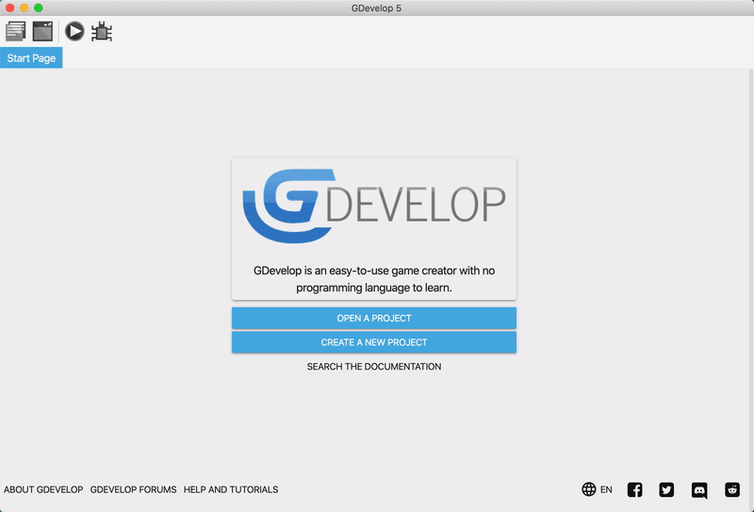

Step 4: Add a scene to the game
A game is made up of scenes. Typically, each scene is a different screen in the game. For example, the main menu, pause menu, and each level in a game would all be different scenes.
To add a scene to the game:
- Expand the Scenes panel (if it's not already expanded).
- Select Click to add a scene.
Then select the scene to open it.
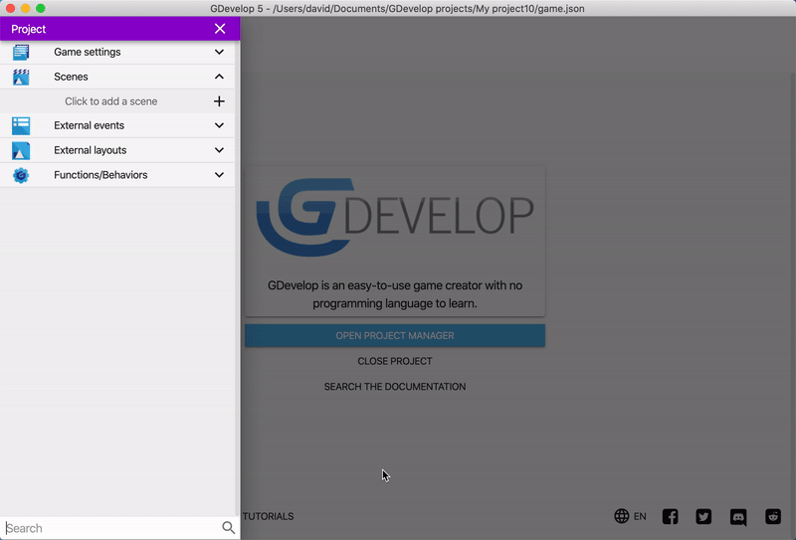
If you add multiple scenes to a project, the first scene in the list is the scene that GDevelop loads when the game starts.

Step 5: Add objects to the scene
A scene is made up of objects. Every thing the user sees or interacts with is an object, including the playable character, enemies, and parts of the environment.
GDevelop provides different types of objects that you can add to a game. Each type of object has unique features and use-cases. The most common type of object is the Sprite object, which lets you create a graphic that you can (optionally) choose to animate.
To create an object:
- In the Objects panel, click Add a new object.
- Select Sprite.
- In the Object name field, type “Cloud”.
- When the object editor opens, click Add an animation. Even though the label says Add an animation, Sprite objects don't have to be animated.
- Click Add a sprite.
- Select the “cloud2.png” asset.
- Select Apply.
Then drag one or more copies of the “Cloud” object into the scene.
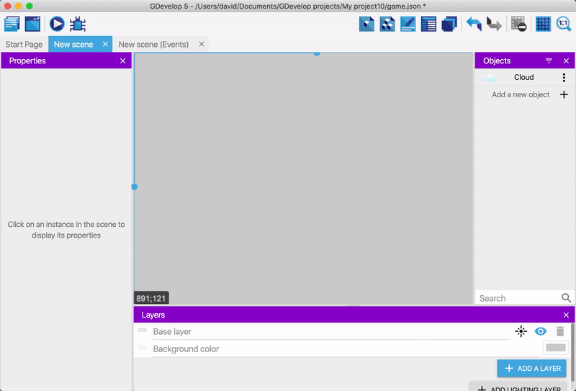
Each copy of an object that appears in a scene is referred to as an instance of that object.

Step 6: Change the background color
The white clouds don't look great on the grey background.
To change the background color of the scene:
- Right click the scene's background.
- Select Scene properties.
- Click Scene background color.
- Choose a nice shade of blue.
You can enter a hex (Ex: #00000) or a name of the color (Ex: Black)

Step 7: Preview the game
It's good to get into the habit of regularly previewing your games. Then, when something breaks, it's easier to figure out the problem.
To launch a preview of the game, click the Preview button in the toolbar.
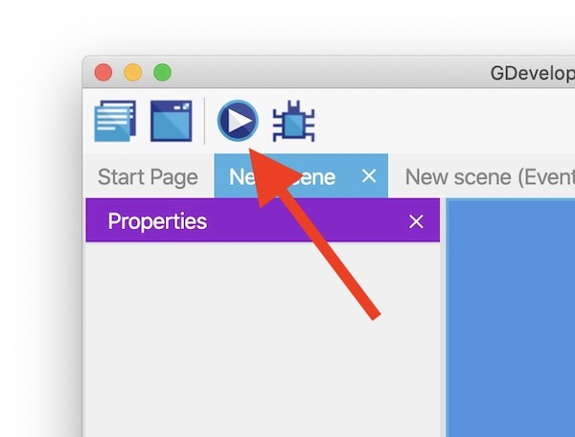
To stop the preview, close the preview window.

Step 8: Save the game
It's also good to get into the habit of regularly saving your games. You can save the game via the File menu or by using a keyboard shortcut:
- CTRL + S on Windows
- CMD + S on macOS

Next step
Read Platformer Tutorial, Part 2 and learn how to create a playable character.

Platformer Tutorial, Part 2: Create a Playable Character
This part of the tutorial explains how to add a playable character to the game.
You'll learn how to:
- Create an object that represents the playable character.
- Let the player control the object using the arrow keys.
- Follow the playable character with the camera.

Series
You are reading Part 2 of the Platformer Tutorial.
- Platformer Tutorial, Part 1
- Platformer Tutorial, Part 2
- Platformer Tutorial, Part 3
- Platformer Tutorial, Part 4
- Platformer Tutorial, Part 5
- Platformer Tutorial, Part 6
- Platformer Tutorial, Part 7
- Platformer Tutorial, Part 8

Step 1: Create an object
The first step is to create an object that represents the playable character. If you followed the first part of this tutorial, this should be a familiar process.
To create an object for the playable character:
- Create a Sprite object named “Player”.
- Use the “p1_stand.png” asset as the animation's only frame.
- Assign a name of “Idle” to the animation.
- Drag an instance of the object into the scene.
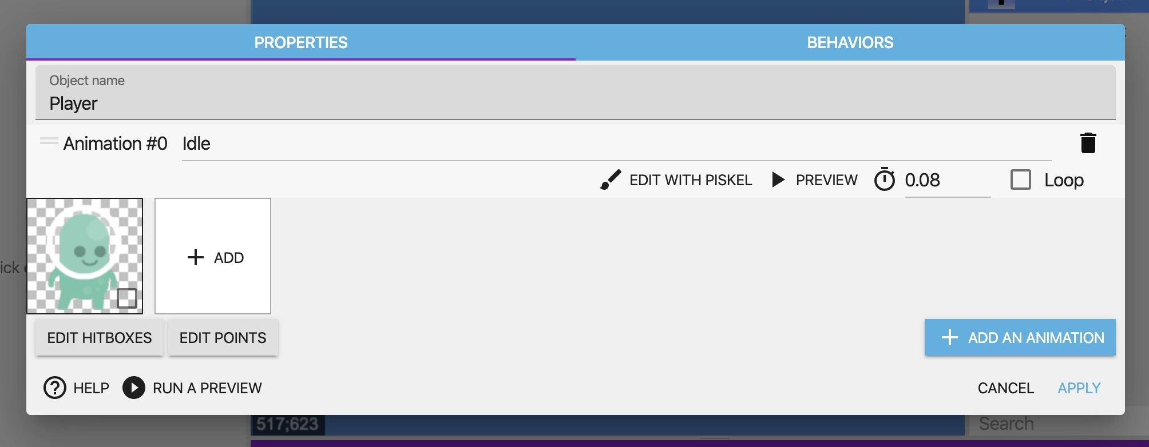
Platformer Tutorial, Part 4 explains how to animate the character.

Step 2: Add a behavior to the object
If you preview the game, you can't control the “Player” object. This is because, by default, objects don't do anything. To make objects do something, you need to assign one or more behaviors to them.
GDevelop comes with a large library of behaviors that you can add to objects in a matter of clicks. One of these behaviors is the Platformer character behavior, which lets you control an object as a playable character.
To add the Platformer character behavior to the object:
- Right click the Player object.
- Select Edit object.
- Switch to the Behaviors tab.
- Click Add a behavior to the object.
- Select Platformer character.
- Click Apply.
If you preview the game, you can control the player with the arrow keys. There's a side-effect though: an object with the Platformer character behavior is affected by gravity, so in this case, the playable character quickly fall out of the frame.
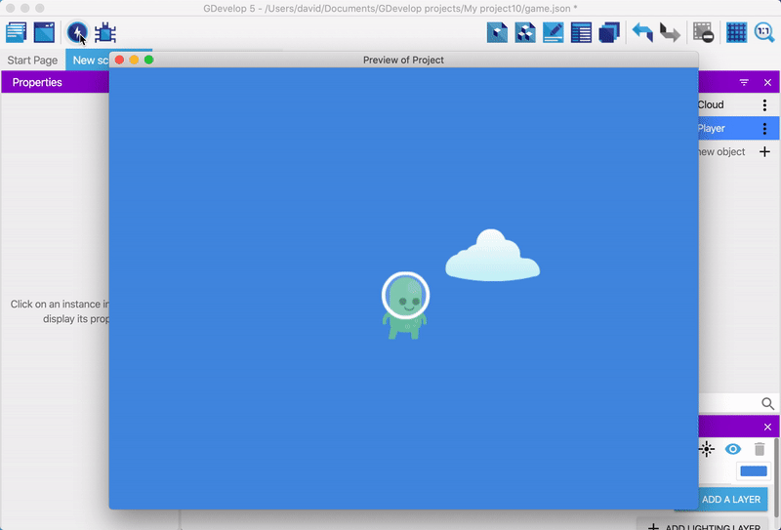

Step 3: Follow an object with the camera
To prevent the character from falling out of frame, the game needs platforms and a camera that follows the player. The next part of the tutorial is about platforms, so this section is about the camera.
To make the camera follow the player, you need to create an event. In GDevelop, events let you define cause and effect, so when something happens (cause) you can trigger something else to happen (effect).
Events are made up of two parts: conditions and actions. The condition is what determines when the event happens and the action is what happens when the event occurs.
GDevelop has a large library of conditions and actions that add all sorts of features to a game. A big part of learning GDevelop is discovering the available options. In this case, the game needs the Center the camera on an object action.
To add the Center the camera on an object action:
- Opens the Events editor.
- Click Add a new event.
- Without specifying a condition, click Add action. By not specifying a condition, the action runs in every frame. Therefore, if the game runs at 60 frames per second, the action runs 60 times per second.
- Click Other actions.
- Expand Layers and cameras.
- Select Center the camera on an object.
- Select the “Player” object.
- Click OK.
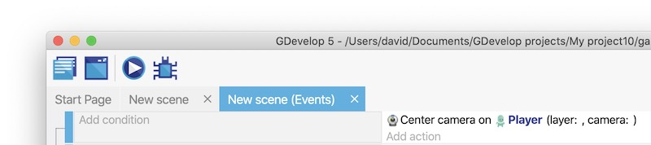
If you preview the game, the player still falls – there's still no platforms, after all – but the camera also follows the player. As a result, the player remains within the frame.
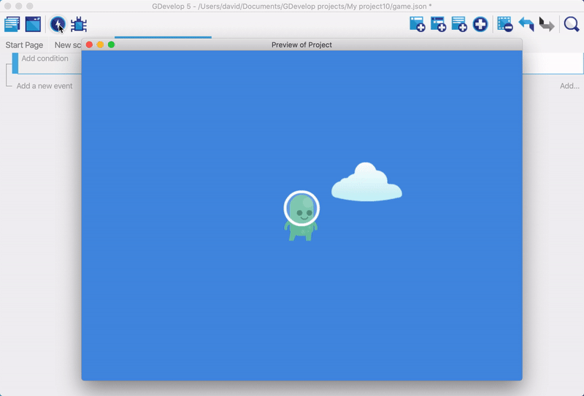

Next steps
Read Platformer Tutorial, Part 3

Platformer Tutorial, Part 3: Create Platforms
This part of the tutorial explains how to add platforms to the game. This provides the player with some solid ground to move across and jump between.
You'll learn how to:
- Create Tiled Sprite objects.
- Make a platform behave like a platform.

Series
You are reading Part 3 of the Platformer Tutorial.
- Platformer Tutorial, Part 1
- Platformer Tutorial, Part 2
- Platformer Tutorial, Part 3
- Platformer Tutorial, Part 4
- Platformer Tutorial, Part 5
- Platformer Tutorial, Part 6
- Platformer Tutorial, Part 7
- Platformer Tutorial, Part 8

Step 1: Create an object
The first step is to create an object for the platform. If you followed the first and second parts of this tutorial, this is a similar – but not identical – process.
The main difference is that this object needs to be a Tiled Sprite object. This type of object “displays an image repeated over an area.” It's ideal for something like platforms, which are typically constructed out of small, square images (also known as tiles).
To create an object for the platform:
- In the Objects panel, click Add a new object.
- Select Tiled Sprite.
- In the Object name field, type “GrassPlatform”.
- Click Select an image.
- Click Choose a new image.
- When the file chooser opens, select the “grassHalfMid” asset.
- Click Apply.
Then drag some instances of the object into the scene and vary the width of these instances to create platforms of different lengths.
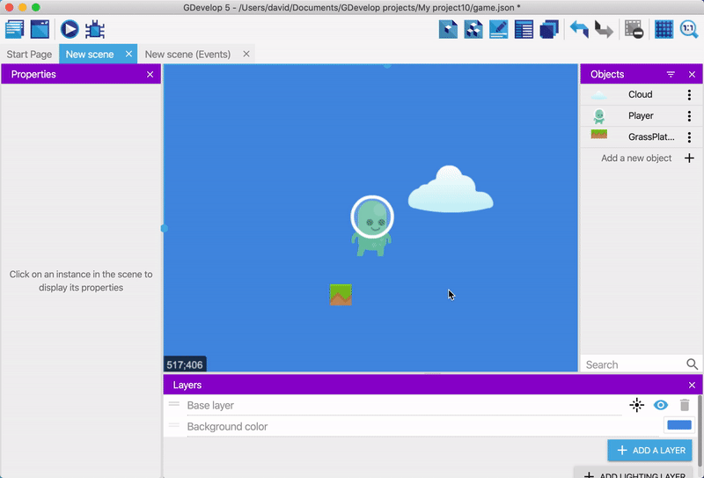

Step 2: Add a behavior to the object
Just adding a platform to the scene isn't enough. You also need to add a behavior to the object to make it something the playable character can walk on. Conveniently, GDevelop provides a behavior named Platform behavior that does this for you.
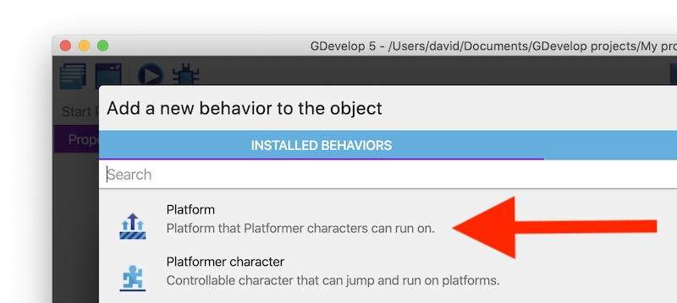
To add Platform behavior to the object:
- Open the Behaviors tab for the “GrassPlatform” object.
- Select Platform behavior.
- Click Apply.

If you preview the game, the player can move across the surface of the platform.
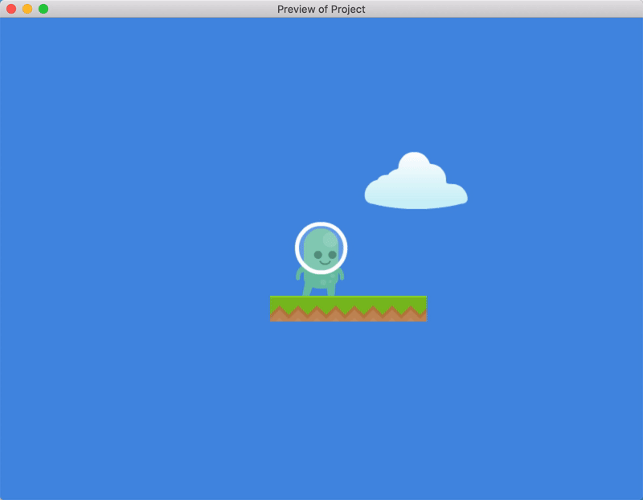

Step 3: Create a different type of platform
GDevelop also provides the Jumpthru platform behavior. This behavior creates a platform that the player can jump onto from beneath it. This adds more variety to the level.
To create a platform with the Jumpthru platform behavior:
- Create a Tiled sprite object named “SmallBridge”.
- Use the “bridgeLogs.png” asset as the object's image.
- Open the Behaviors tab.
- Select Platform behavior.
- From the Type dropdown, select Jumpthru platform.
- Click Apply.
Then drag some instances of the object into the scene.
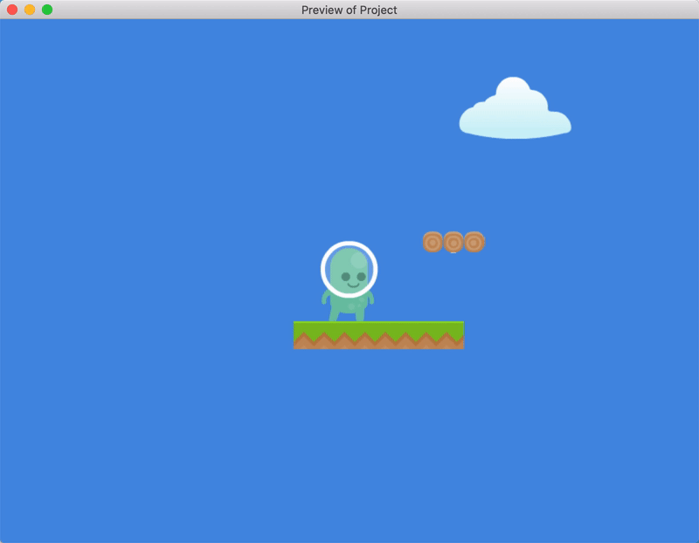

Next steps
Read Platformer Tutorial, Part 4.

Platformer Tutorial, Part 4: Animate the Playable Character
This part of the tutorial explains how to animate the playable character.
You'll learn how to:
- Add animations to an object.
- Use events to trigger animations.

Series
You are reading Part 4 of the Platformer Tutorial.
- Platformer Tutorial, Part 1
- Platformer Tutorial, Part 2
- Platformer Tutorial, Part 3
- Platformer Tutorial, Part 4
- Platformer Tutorial, Part 5
- Platformer Tutorial, Part 6
- Platformer Tutorial, Part 7
- Platformer Tutorial, Part 8

Step 1: Add a jumping animation to the player
In GDevelop, you can add animations to an object and trigger those animations when something happens (such as when a player jumps).

Add the "Jumping" animation to the "Player" object
To add a jumping animation to the “Player” object:
- In the Objects panel, right click the “Player” object.
- Select Edit object.
- Click Add an animation.
- Assign a name of “Jumping” to the animation.
- Click Add.
- From the file chooser, select the “p1_jump.png” asset.
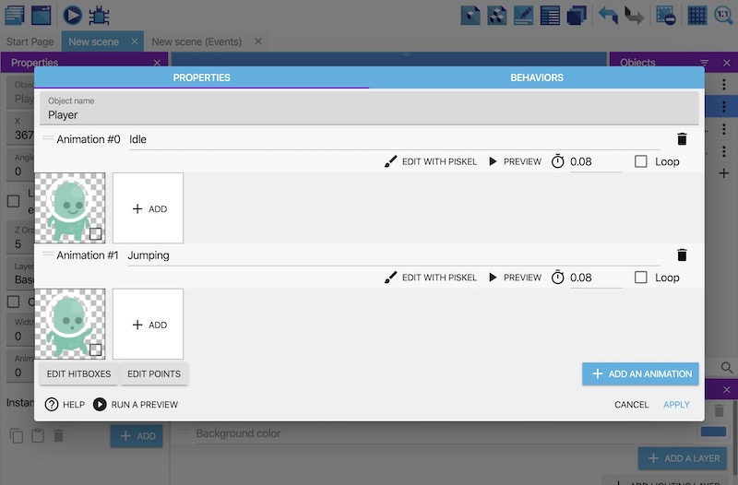
But while the animation is attached to the object, it won't play unless something triggers it.

Trigger the "Jumping" animation
To trigger the “Jumping” animation:
- Switch to the Events editor.
- Create a new event.
- Add the Is jumping condition to the “Player” object.
- Add the Change the animation (by name) action to the event.
- In the Animation name field, enter the name of the “Jumping” animation. You must wrap this name in double quotes (i.e. "Jumping").
- Click OK.
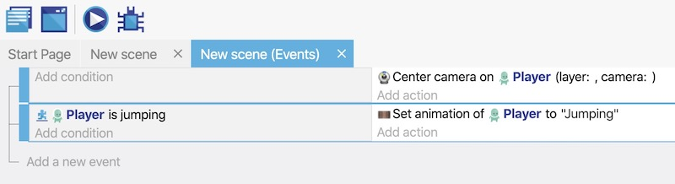
Based on these changes, jumping triggers the animation.
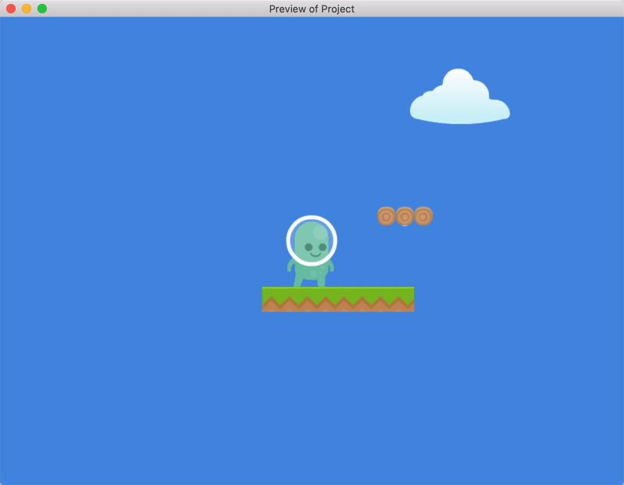

Step 2: Add an idle animation to the player
There's a problem with the jumping animation: it doesn't reset when the player has finished jumping. To fix this, trigger the “Idle” animation when the player returns to the platform.

Detect when the player is on the floor
GDevelop refers to the surface of a platform as the floor.
To detect when an object is on the floor:
- Create a new event.
- Add the Is on floor condition to the “Player” object.
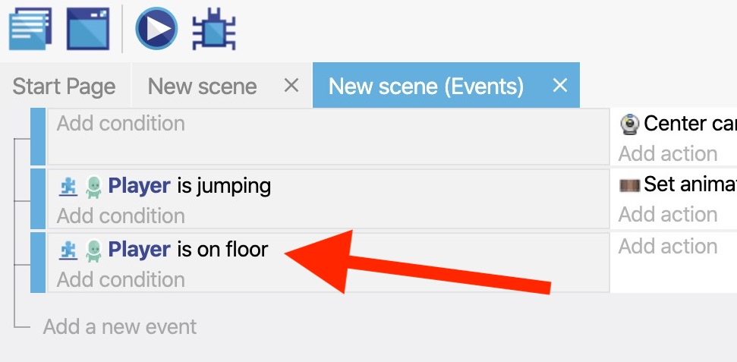

Detect when the player is not moving
It only makes sense to trigger the “Idle” animation when the player is still, since moving the player should trigger the “Running” animation (explained in the next step).
To detect when the player isn't moving:
- Add the Is moving condition to the “Player” object.
- Toggle the Invert condition option to the on position.
The Invert condition option inverts the way a condition works. This means the Is moving condition becomes the Is not moving condition.
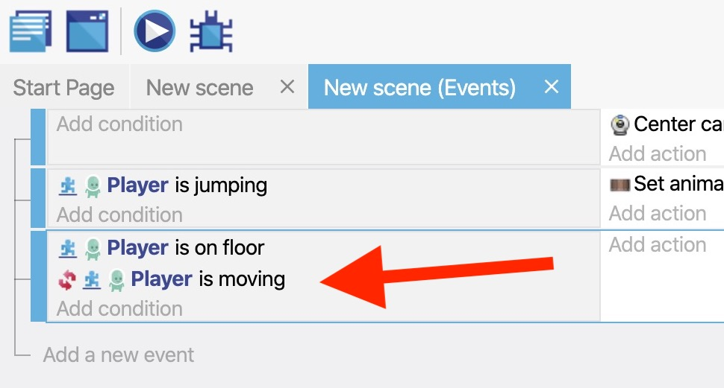

Trigger the "Idle" animation
When both of the previous conditions are met, trigger the object's “Idle” animation:
- Add the Change the animation (by name) action.
- In the Animation name field, enter the name of the “Idle” animation. You must wrap this name in double quotes (i.e. "Idle").
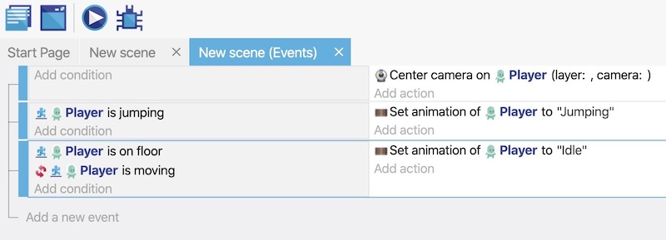
If you preview the game, the “Player” object resets to the “Idle” animation after jumping.
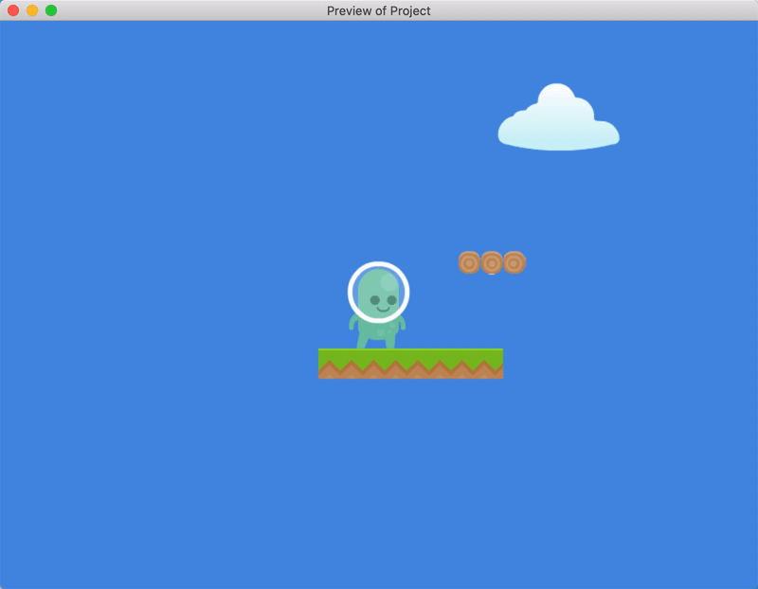

Step 3: Add a running animation to the player

Add the "Running" animation to the "Player" object
- Add an animation named “Running” to the “Player” object.
- From the file chooser, select all of the following assets: - p1walk03.png - p1walk04.png - p1walk05.png - p1walk06.png - p1_walk07.png
- Enable the Loop option. When enabled, the animation continually plays for as long as it's active (rather than playing once and stopping).
- Click Apply.
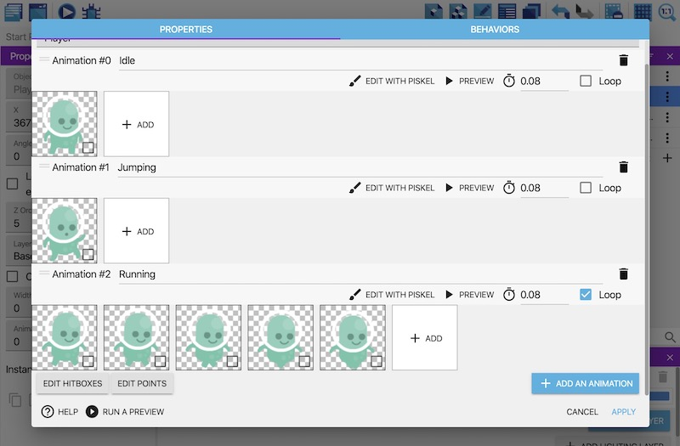

Trigger the "Running" animation
- Create a new event.
- Add the Is on floor condition to the “Player” object.
- Add the Is moving condition to the “Player” object.
- Add the Change the animation (by name) action to the event.
- In the Animation name field, enter the name of the “Running” animation. You must wrap this name in double quotes (i.e. "Running").
- Click OK.
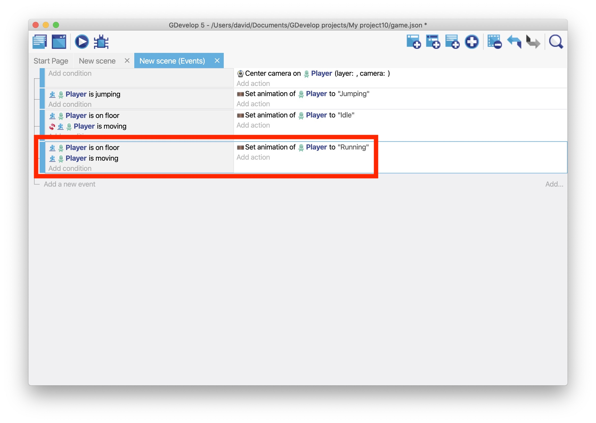
If you preview the game, the “Running” animation plays as the player moves.
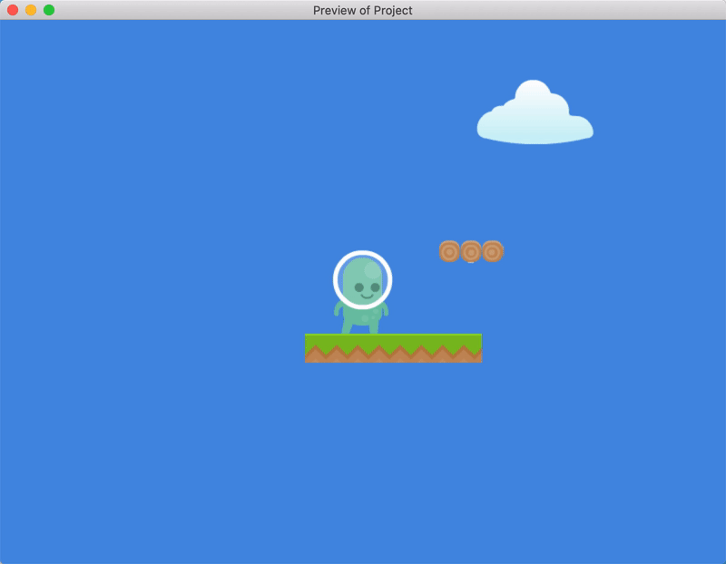

Next steps
Read Platformer Tutorial, Part 5.

Platformer Tutorial, Part 5: Add Collectible Coins to the Game
This part of the tutorial explains how to add collectible coins to the game.
You'll learn how to:
- Delete an object (and play a sound) when a player collides with it.
- Keep track of data with variables.
- Add text to a scene.

Series
You are reading Part 5 of the Platformer Tutorial.
- Platformer Tutorial, Part 1
- Platformer Tutorial, Part 2
- Platformer Tutorial, Part 3
- Platformer Tutorial, Part 4
- Platformer Tutorial, Part 5
- Platformer Tutorial, Part 6
- Platformer Tutorial, Part 7
- Platformer Tutorial, Part 8

Step 1: Create a collectible coin
The first step is to create a coin that the player can collect. You can break this step into two parts: creating an object for the coin and then making the coin collectible by using an event to detect when the player collides with it.

Create an object for the coin
- Create an object named “Coin”.
- For the object's image, use the “coin.png” asset.
- Drag one or more instances of the object into the scene.
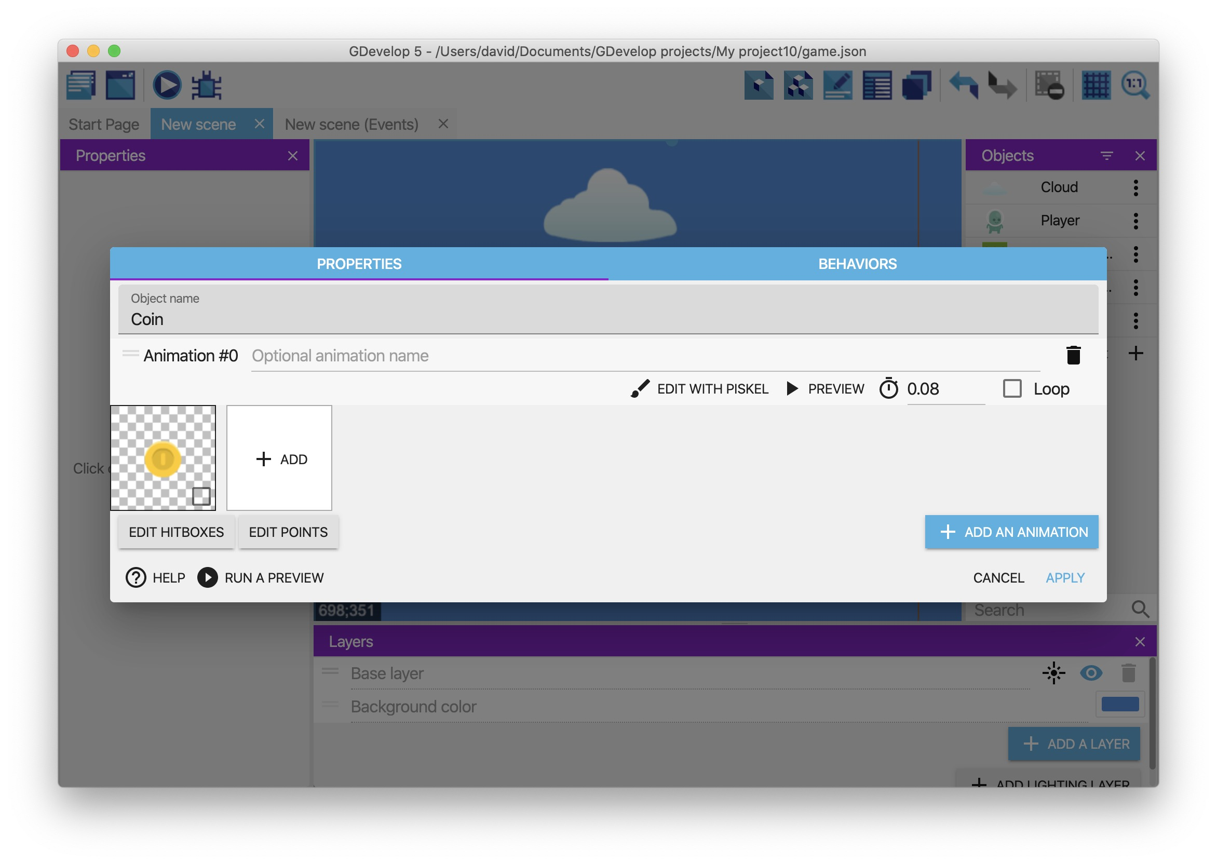
To duplicate a coin that's already in the scene, hold down the CTRL key (or CMD on macOS). Then select and drag an instance of the coin.

Make the coin collectible
- Create a new event.
- Add a Collision condition to the event that checks if the “Player” object has collided with the “Coin” object.
- Add a Delete an object action to the event and configure the action to delete the “Coin” object.
- Add a Play a sound action to the event that plays a sound effect when the player collects a coin. (You can use the “coin.wav” asset for the sound effect.)
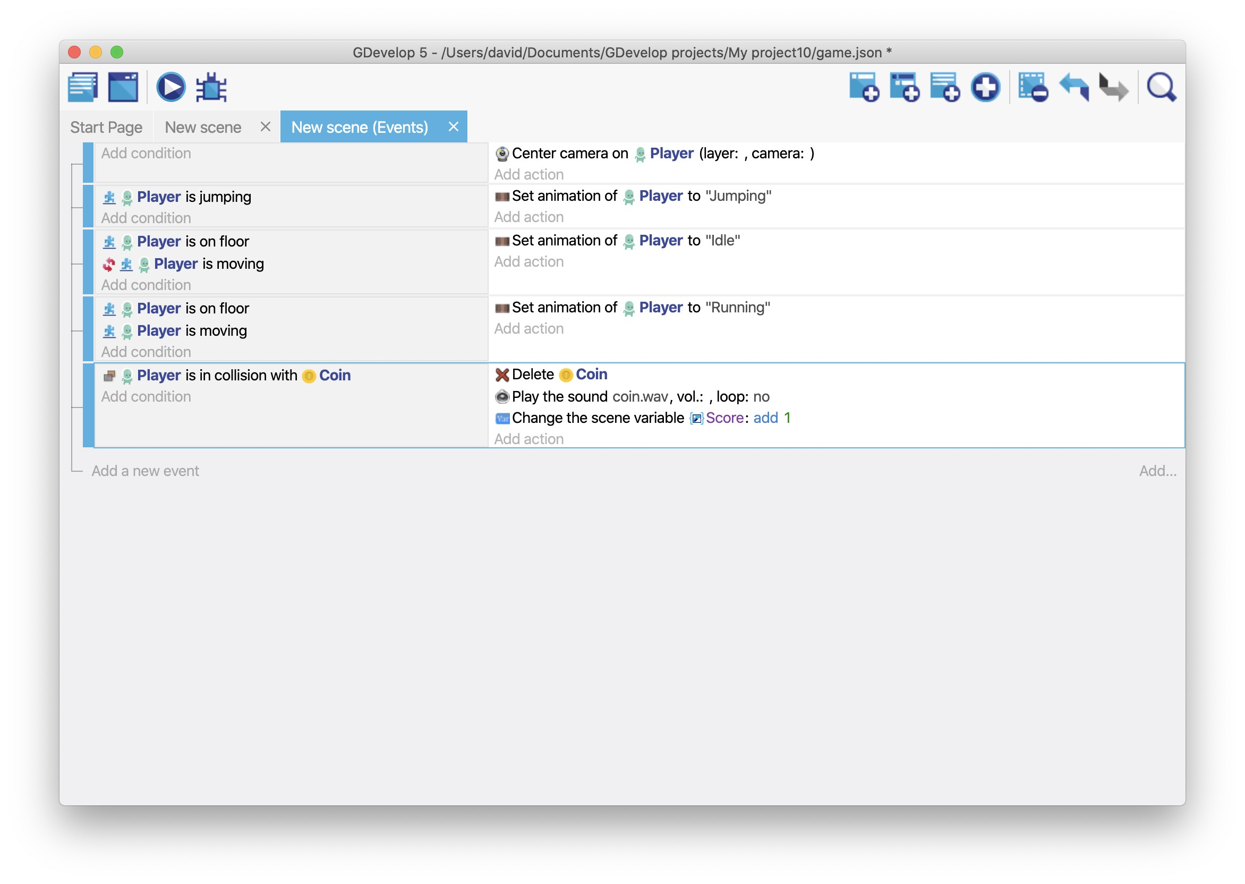
If you preview the game, colliding with a coin deletes the coin and plays a sound.
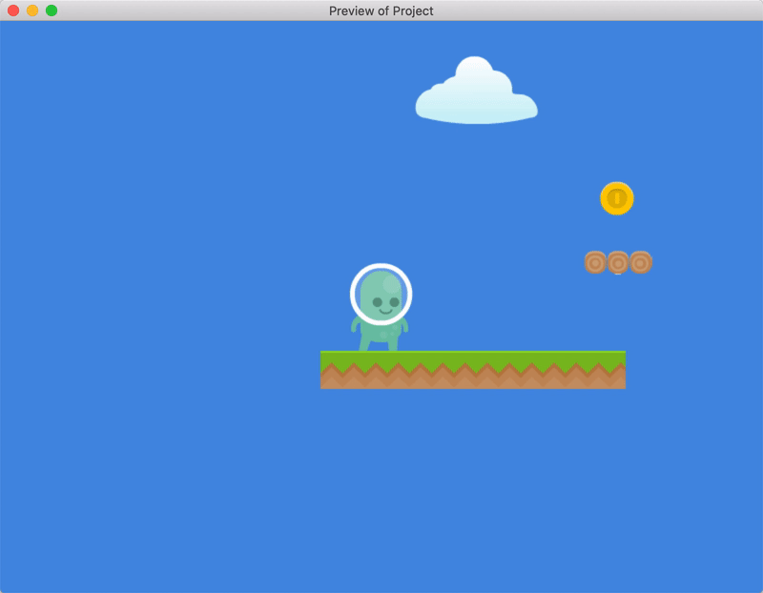

Step 2: Keep track of the collected coins
Every time a user collects a coin, the game needs to keep track of the number of coins the player has collected. To do this, the game needs a variable.
A variable is a container that can store data. If you've ever done algebra, then you're familiar with variables, as letters like “x” and “y” are often used as variables.
In GDevelop, there are three types of variables:
- Object variables
- Scene variables
- Global variables
An explanation of each variable type is beyond the scope of this tutorial, but the differences are explored in Scope of variables. In this case, scene variables are the most relevant. These are variables that exist for the duration of a scene.
To create a scene variable that tracks the number of collected coins:
- Add a Value of a scene variable action to the previously created event.
- In the Variable field, type “Score”. This is a name for the variable.
- From the Modification's sign dropdown, select + (add).
- In the Value field, type “1” (without the double quotes).
- Click OK.
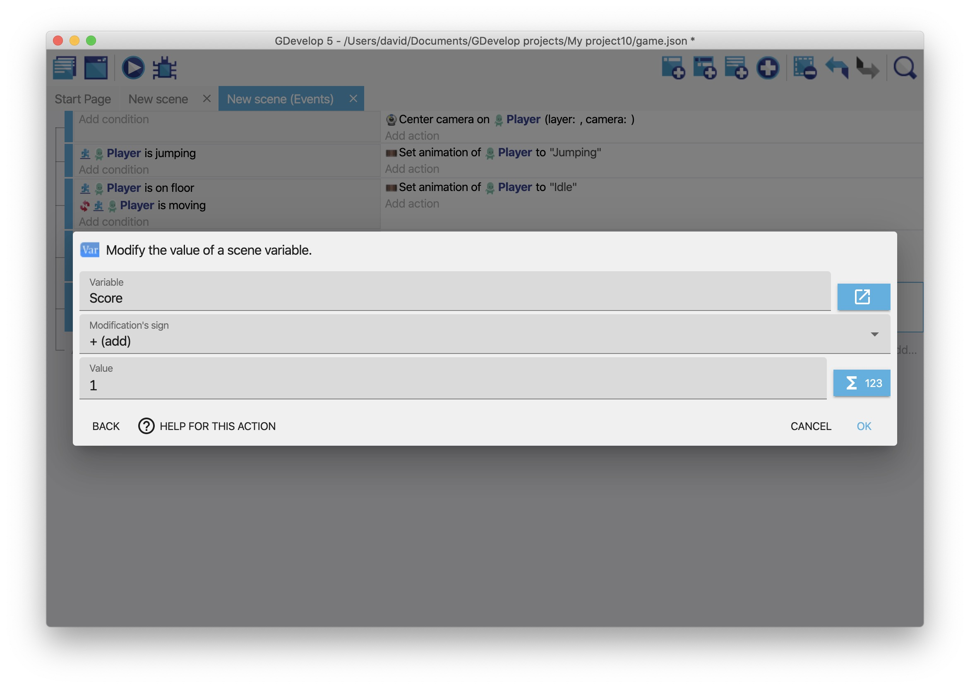
This keeps track of the number of coins collected by the player, but this number doesn't (yet) appear on the screen.

Step 3: Display the number of collected coins
To display the number of collected coins, the game needs an object to that renders text and an event that updates the value of that text.

Create an object that renders text
- Create a Text object named “Score”.
- In the Initial text to display field, type “Score: 0”. This is the default text to display within the object.
- Click Apply.
- Drag an instance of the object into the scene.
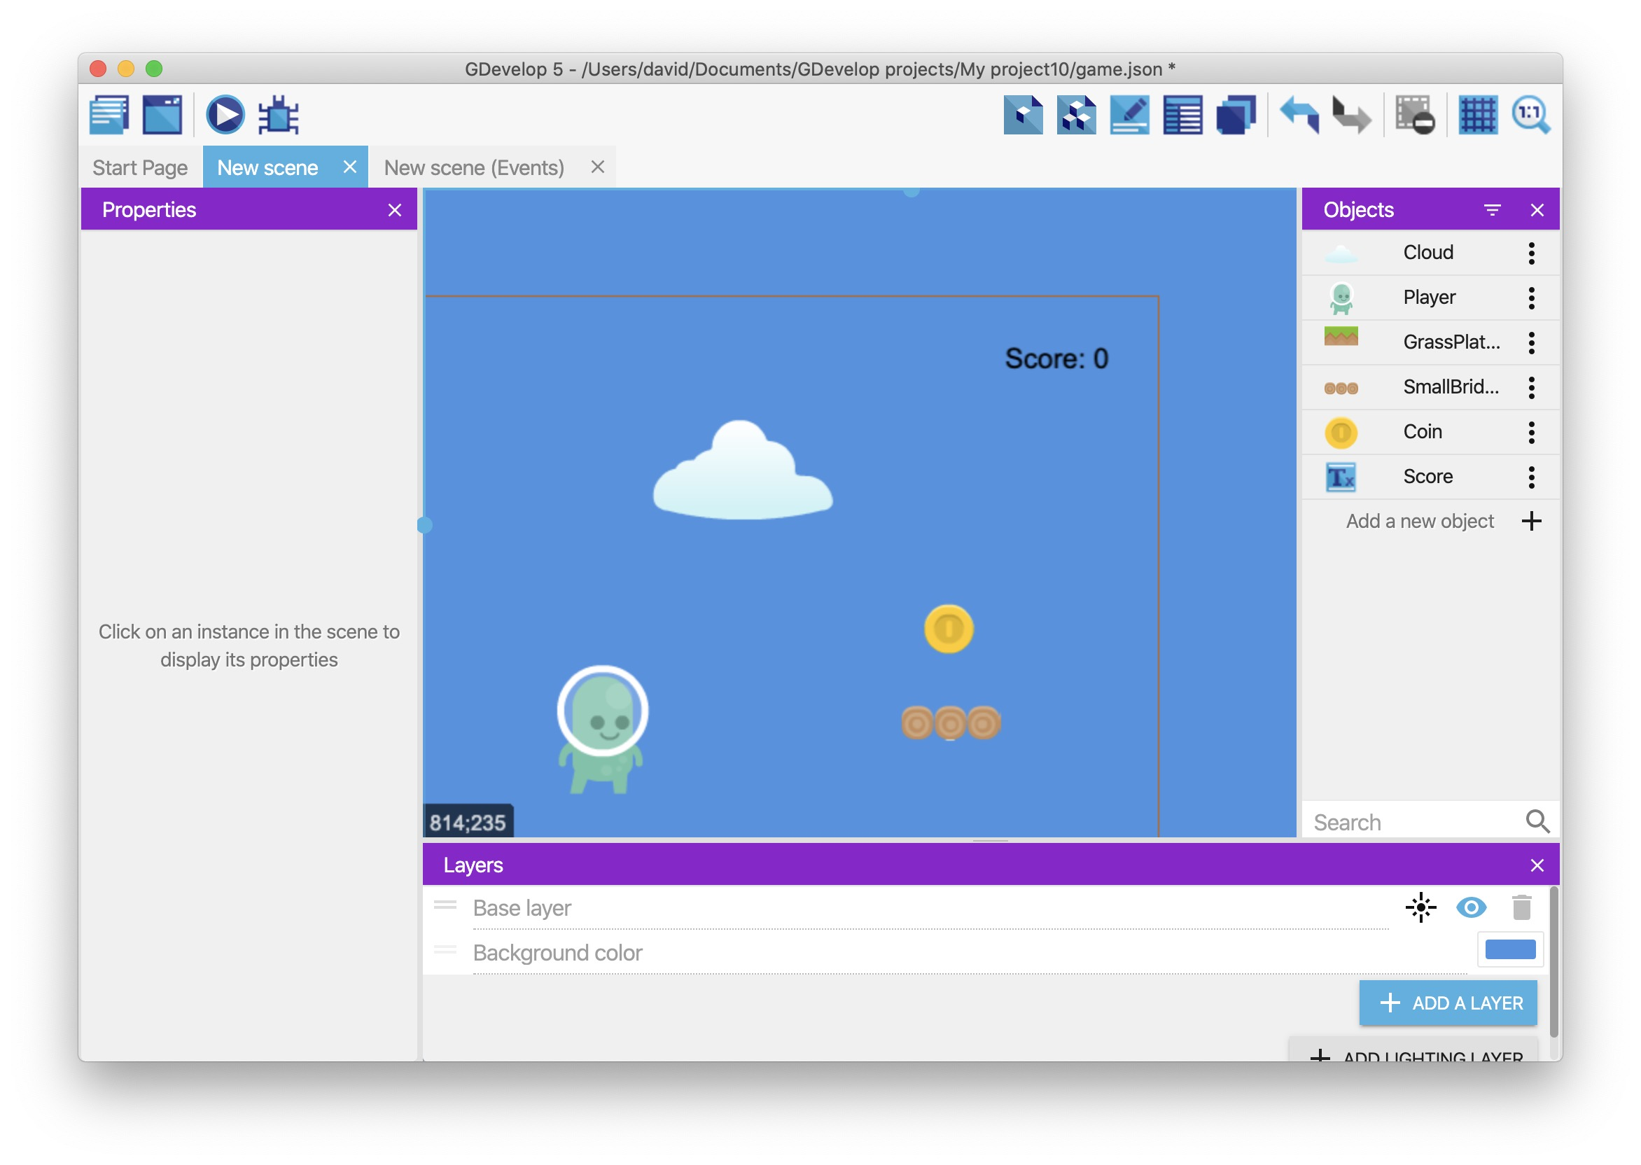

Update the "Score" object with the number of collected coins
Before you can update the rendered text with the number of collected coins, it's important to have a broad understanding of expressions.
In GDevelop, expressions are similar to spreadsheet formulas or functions in a programming language. You can pass a value into an expression and receive a value.
For example, the Variable expression can retrieve the value of the “Score” variable:
Variable(Score)
Because the “Score” variable contains a number, this expression returns a number. You can convert that number into a string with the ToString expression:
ToString(Variable(Score))
Expressions are one of the most advanced – and one of the most powerful – concepts in GDevelop, so don't worry if it takes some time to wrap your head around them. The trick is to follow the tutorials and use the expressions. Practical experience is key.
To update the “Score” object with the number of collected coins:
- Create a new event.
- Without specifying a condition, add the Modify the text action to the “Score” object. Because a condition isn't specified, this action runs in every frame. This ensures that the displayed score is always accurate.
- From the Modification's sign dropdown, select = (set).
- In the Value field, type "Score: " + ToString(Variable(Score)). This value uses the ToString and Variable expressions to convert the number of collected coins into a string. It also uses the + operator to combine two strings into a single string.
- Click OK.
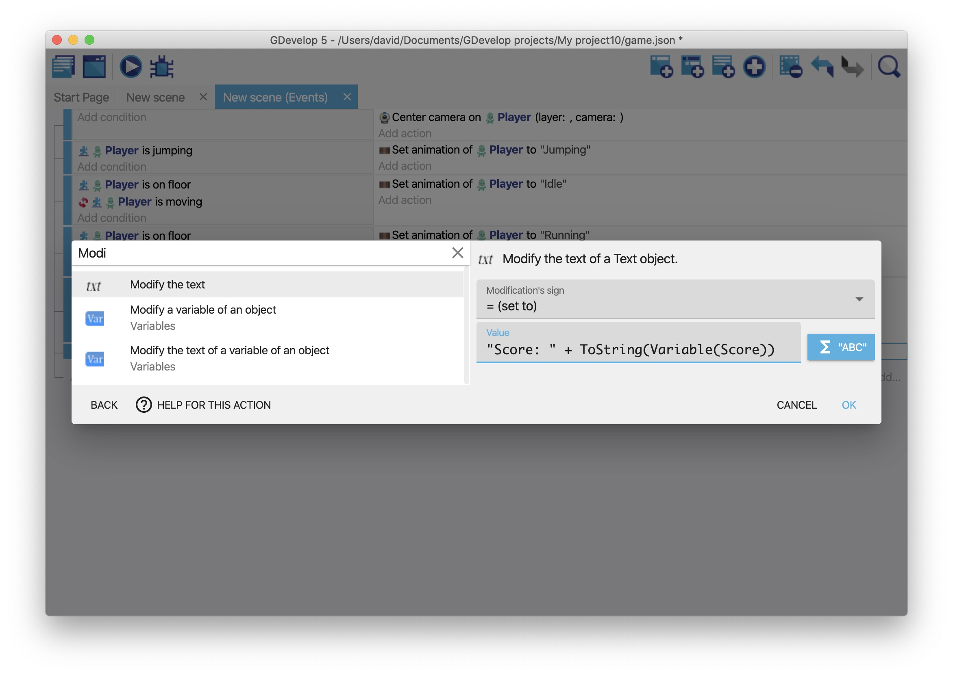
If you preview the game, the number of collected coins appears on the screen.
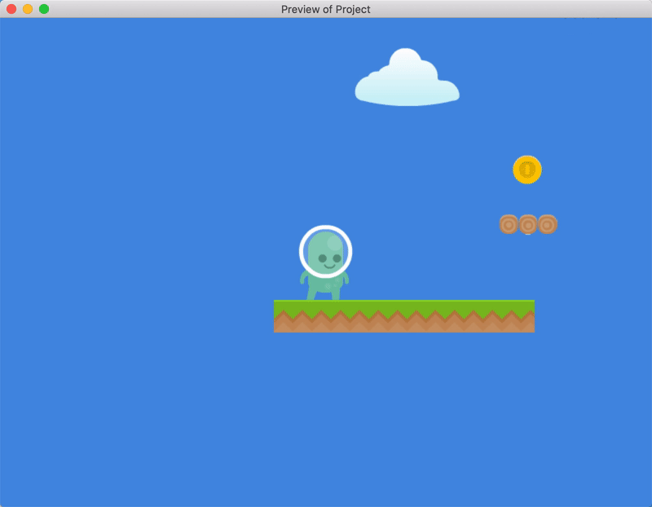
You can find more expressions in the expression editor by clicking on the blue icon next to the value fields:
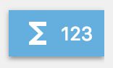
When you click the blue icon, you can search all the available expressions sorted into categories.
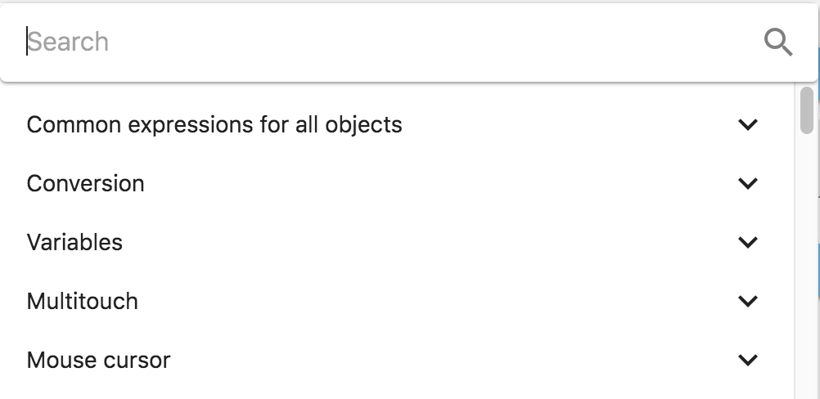

Move the text to a different layer
There's a problem with the “Score” object: the number of collected coins is only visible if the player is standing in certain positions.
To fix this, move the “Score” object to a different layer:
- Click the Open the layers editor icon.
- Click Add a layer.
- For the name of the layer, type “UI”.
- Select the “Score” object.
- From the Layer dropdown, select “UI”.
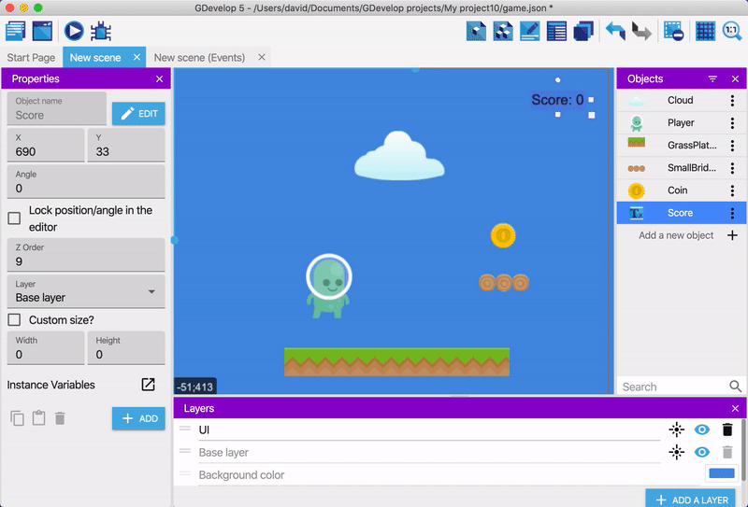
If you preview the game, the score remains in a fixed position.
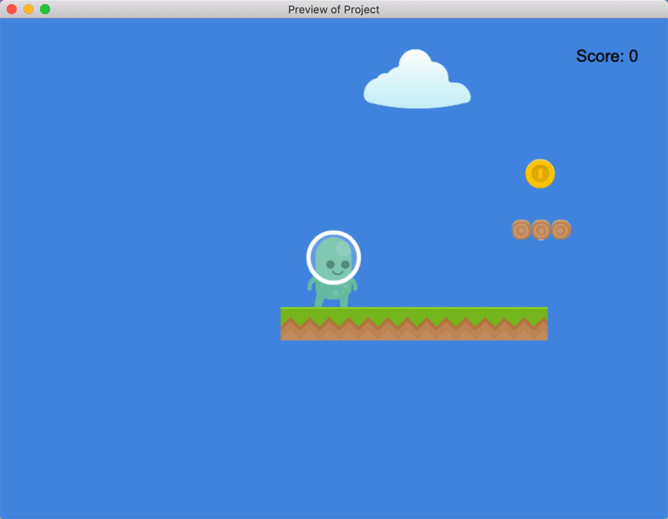

Next step
Read Platformer Tutorial, Part 6.

Platformer Tutorial, Part 6: Add Enemies to the Game
This part of the tutorial explains how to add enemies to the game that can move back and forth along a set route. The next part of the tutorial explains how the player can kill – and be killed by – these enemies.

Series
You are reading Part 6 of the Platformer Tutorial.
- Platformer Tutorial, Part 1
- Platformer Tutorial, Part 2
- Platformer Tutorial, Part 3
- Platformer Tutorial, Part 4
- Platformer Tutorial, Part 5
- Platformer Tutorial, Part 6
- Platformer Tutorial, Part 7
- Platformer Tutorial, Part 8

Step 1: Create an object for the enemy
- Create a Sprite object named “Slime”.
- Add an animation to the object that uses the following assets: - slimeWalk1.png - slimeWalk2.png
- Enable the Loop option.
- Drag an instance of the object into the scene.
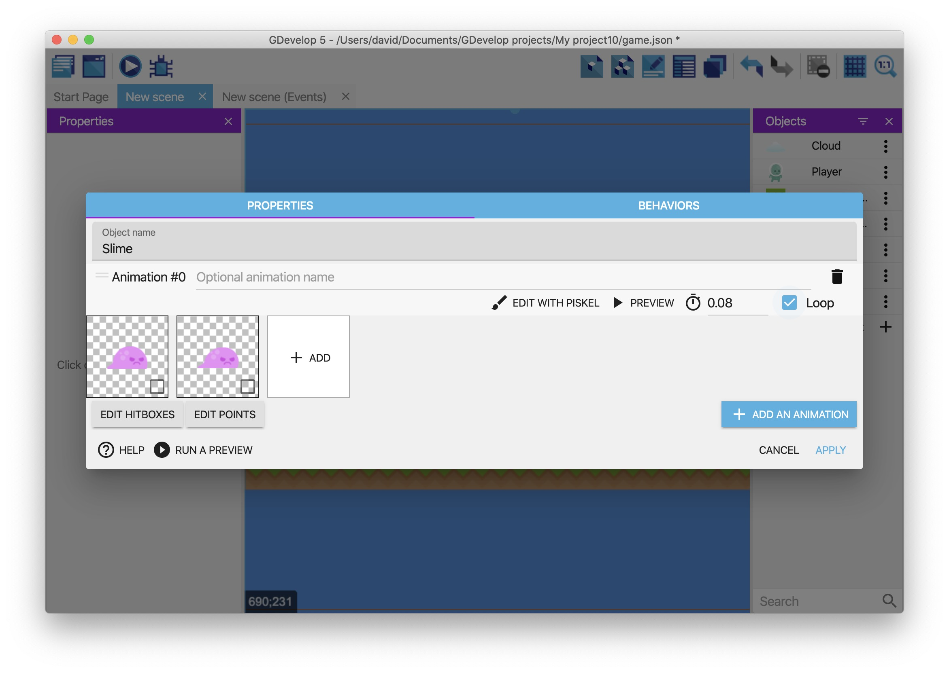
If you preview the game, an animated enemy appears on screen.
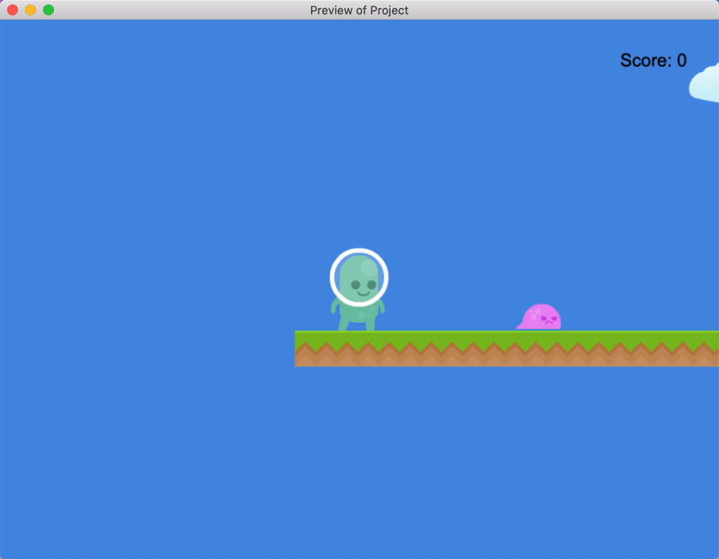

Step 2: Move the enemy to the right
The previous part of this tutorial mentioned that there were three types of variables:
- Object
- Scene
- Global
An object variable is tied to a specific object. This means the variable holds a value that is only available to – and only relevant to – the associated object.
To add an object variable to the “Slime” object:
- Right click the “Slime” object.
- Select Edit object variables.
- Add a variable named “direction” with a value of “right”. This is the default value of the variable.
- Click Apply.
This “direction” variable keeps track of the enemy's current direction. In a later step, you'll be able to change the direction of the enemy by changing the value of the variable.
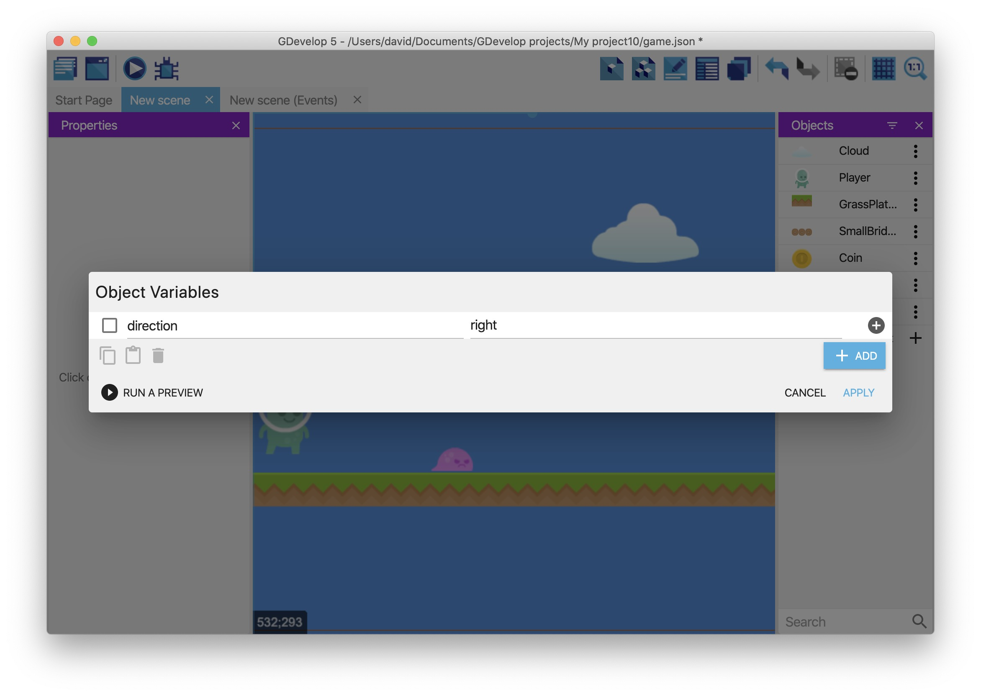
To move the enemy to the right, create an event:
- Open the Events editor.
- Create a new event.
- Add the Text of an object's variable condition to the “Slime” object.
- In the Variable field, type “direction”.
- In the Sign of the test field, select = (equal to).
- In the Value to compare field, type “right” (including the quotation marks).
- Click OK.
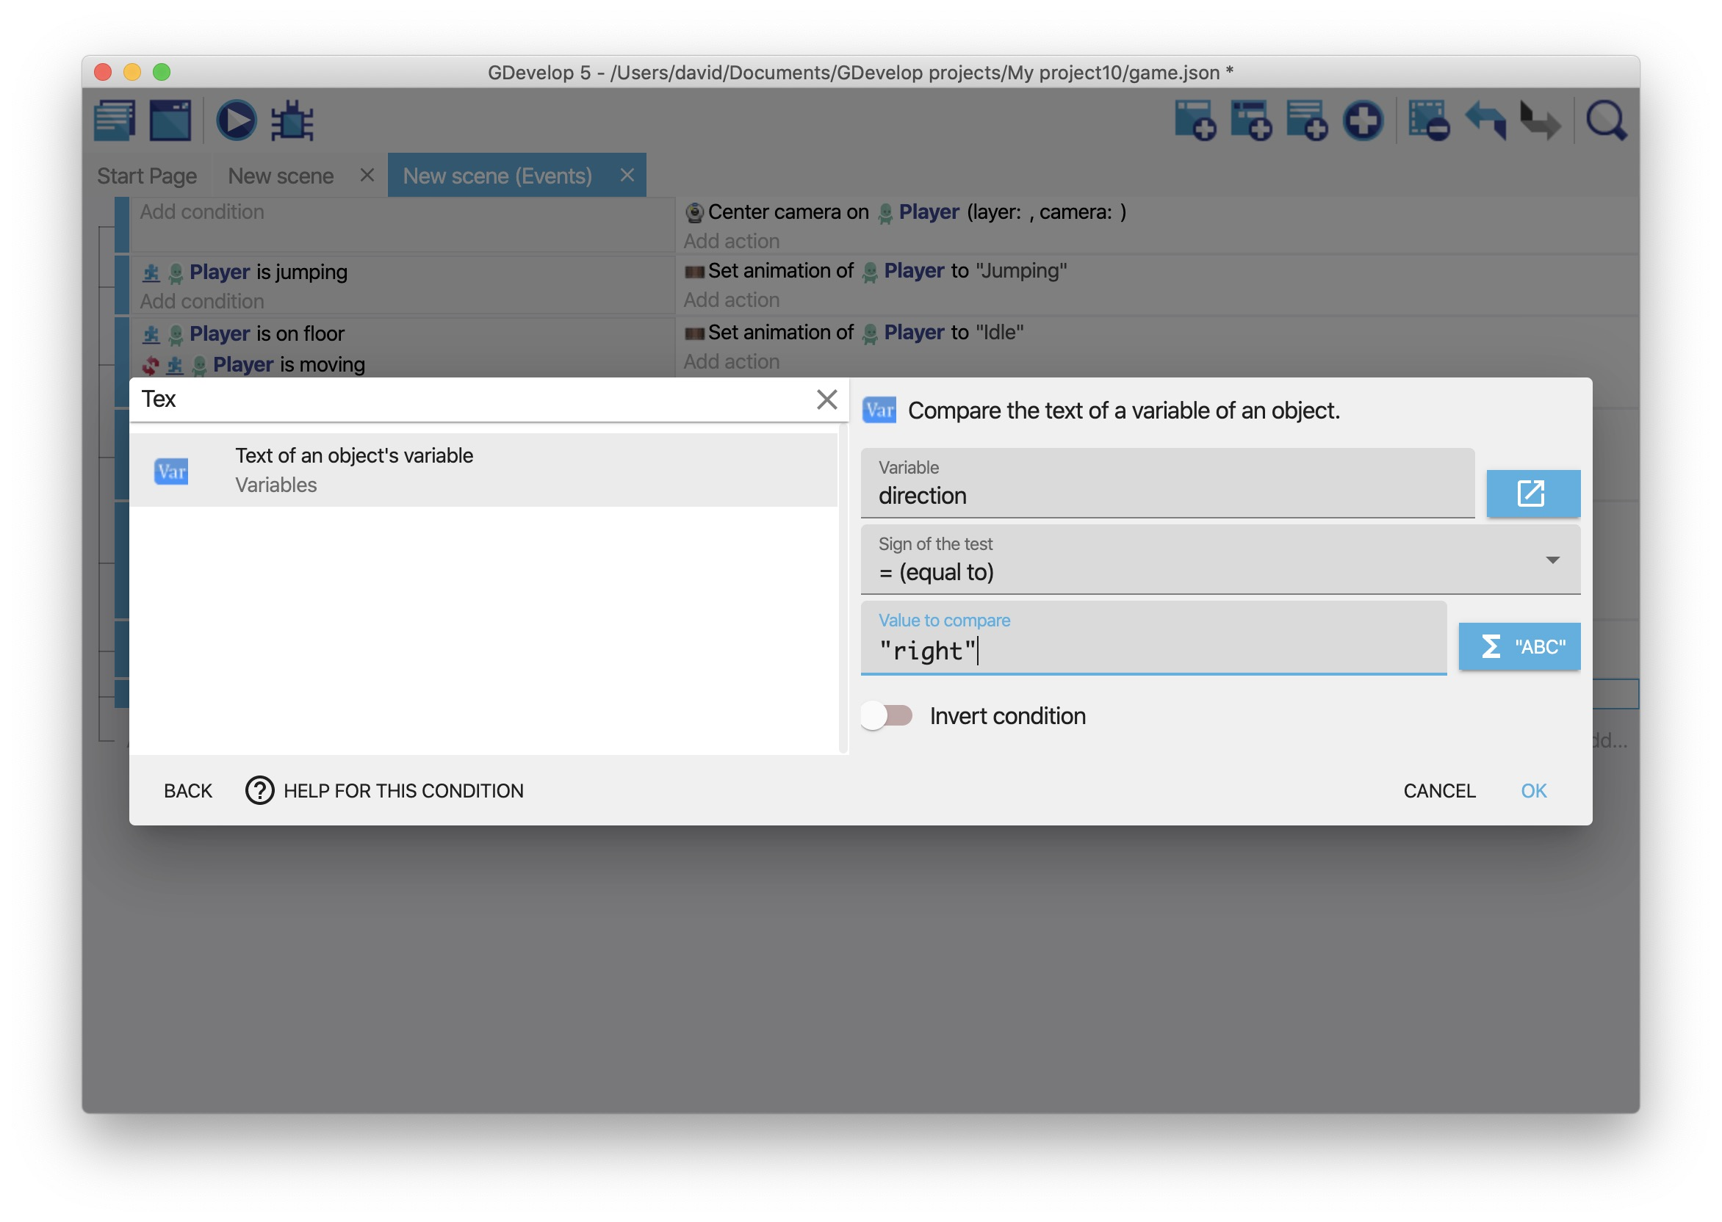
Then add an action to the event:
- Add the Add a force (angle) action to the event.
- In the Object field, select “Slime”.
- In the Angle field, type “0”.
- In the Speed field, type “100”.
- Enable the Instant option.
- Click OK.
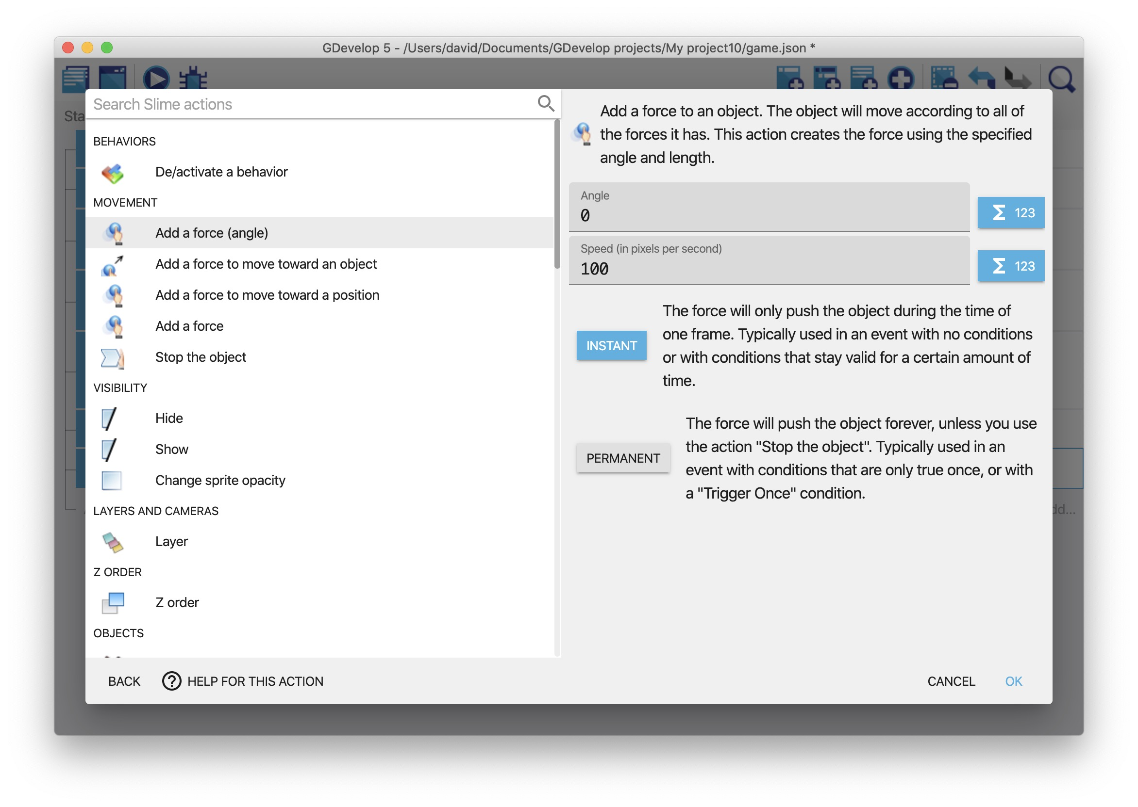
This is what the complete event looks like:
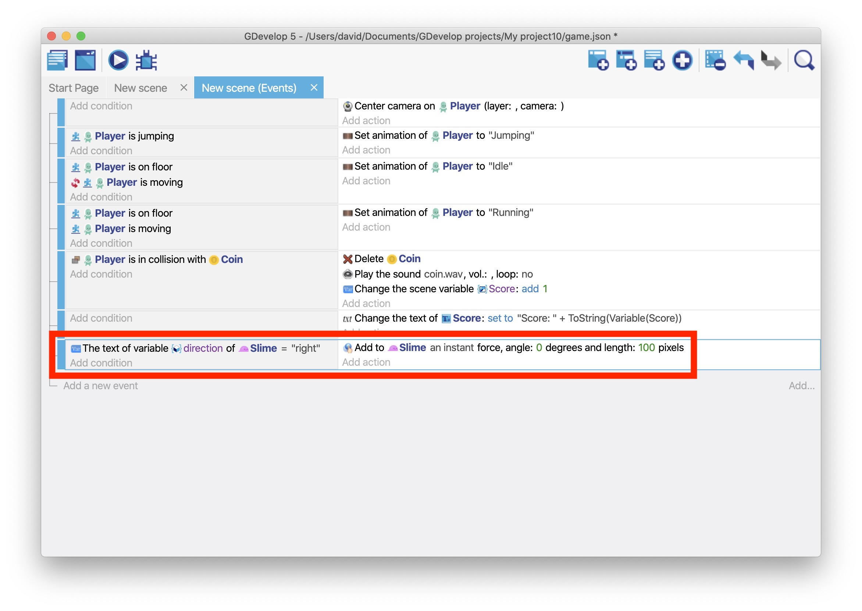
Based on this event, while the value of the “direction” variable is “right”, the “Slime” object moves right. Because the object never changes direction though, it inevitably falls off the edge of the platform.
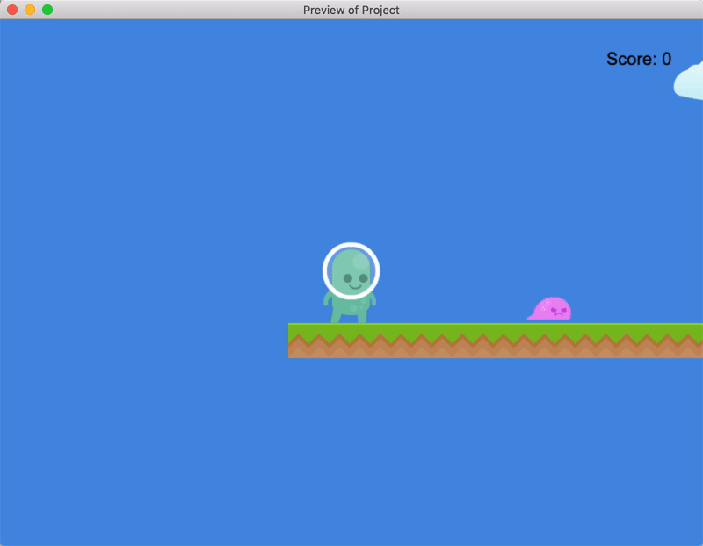

Step 3: Change the enemy's direction
To make the enemy change direction, add two invisible objects to the scene – one called “Left” and one called “Right” – and place them on other side of the enemy.
Then, when the enemy collides with one of the objects, you can flip them around and move them in the other direction. This creates the illusion of the enemy following a set route.
This step focuses on creating the “Left” object. When the enemy collides with this object, they'll change direction from left to right. (The step that follows focuses on the “Right” object.)

Create the "Right" object
- Create a Sprite object named “Left”.
- As the default sprite, use the “left.png” asset.
- Drag an instance of object into the scene (to the right of the enemy).
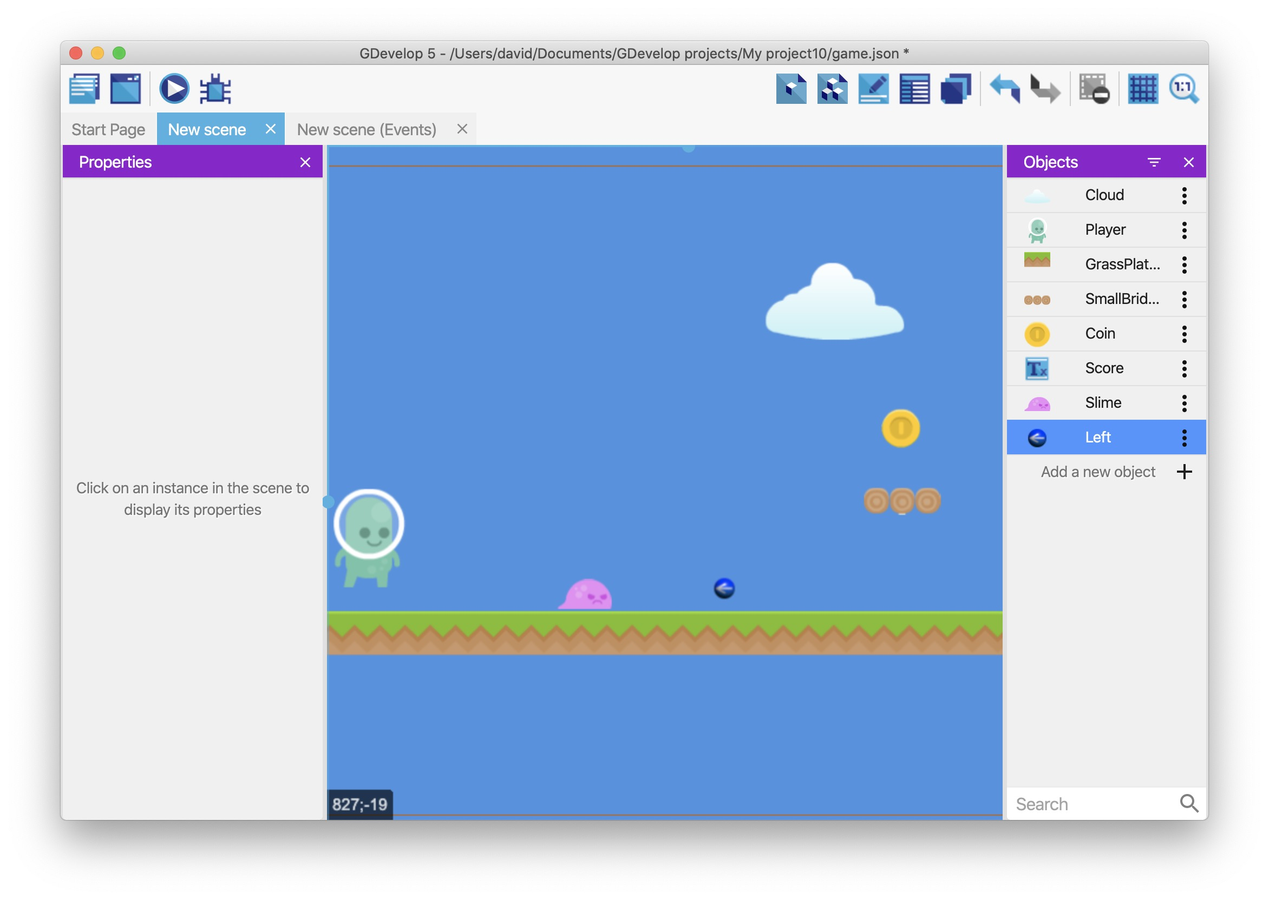

Detect when the enemy collides with the "Left" object
- Create a new event.
- Add a Collision condition that checks if the “Slime” object is colliding with the “Left” object.
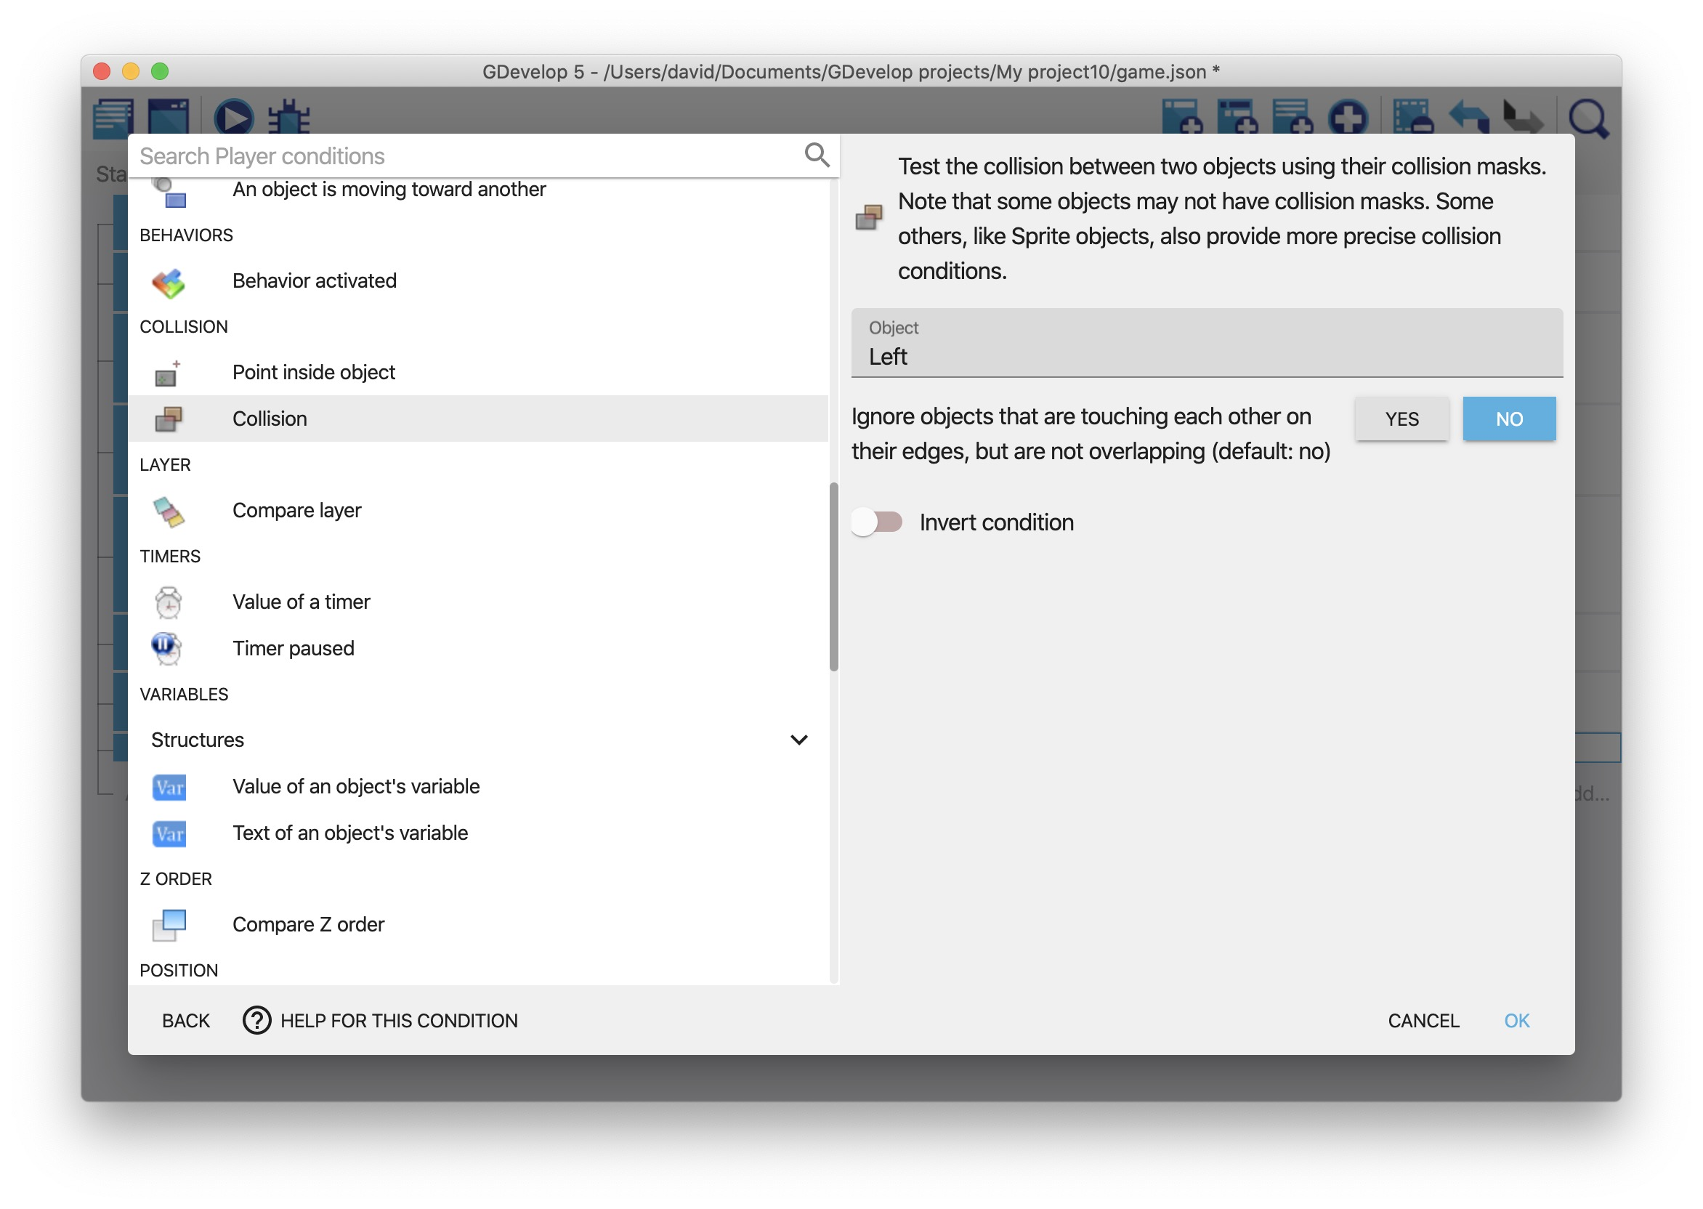

Change the value of the "direction" variable
- Add the Modify the text of a variable of an object action to the event.
- In the Variable field, type “direction”.
- From the Modification's sign dropdown, select = (set to).
- In the Value field, type “left” (with quotation marks).
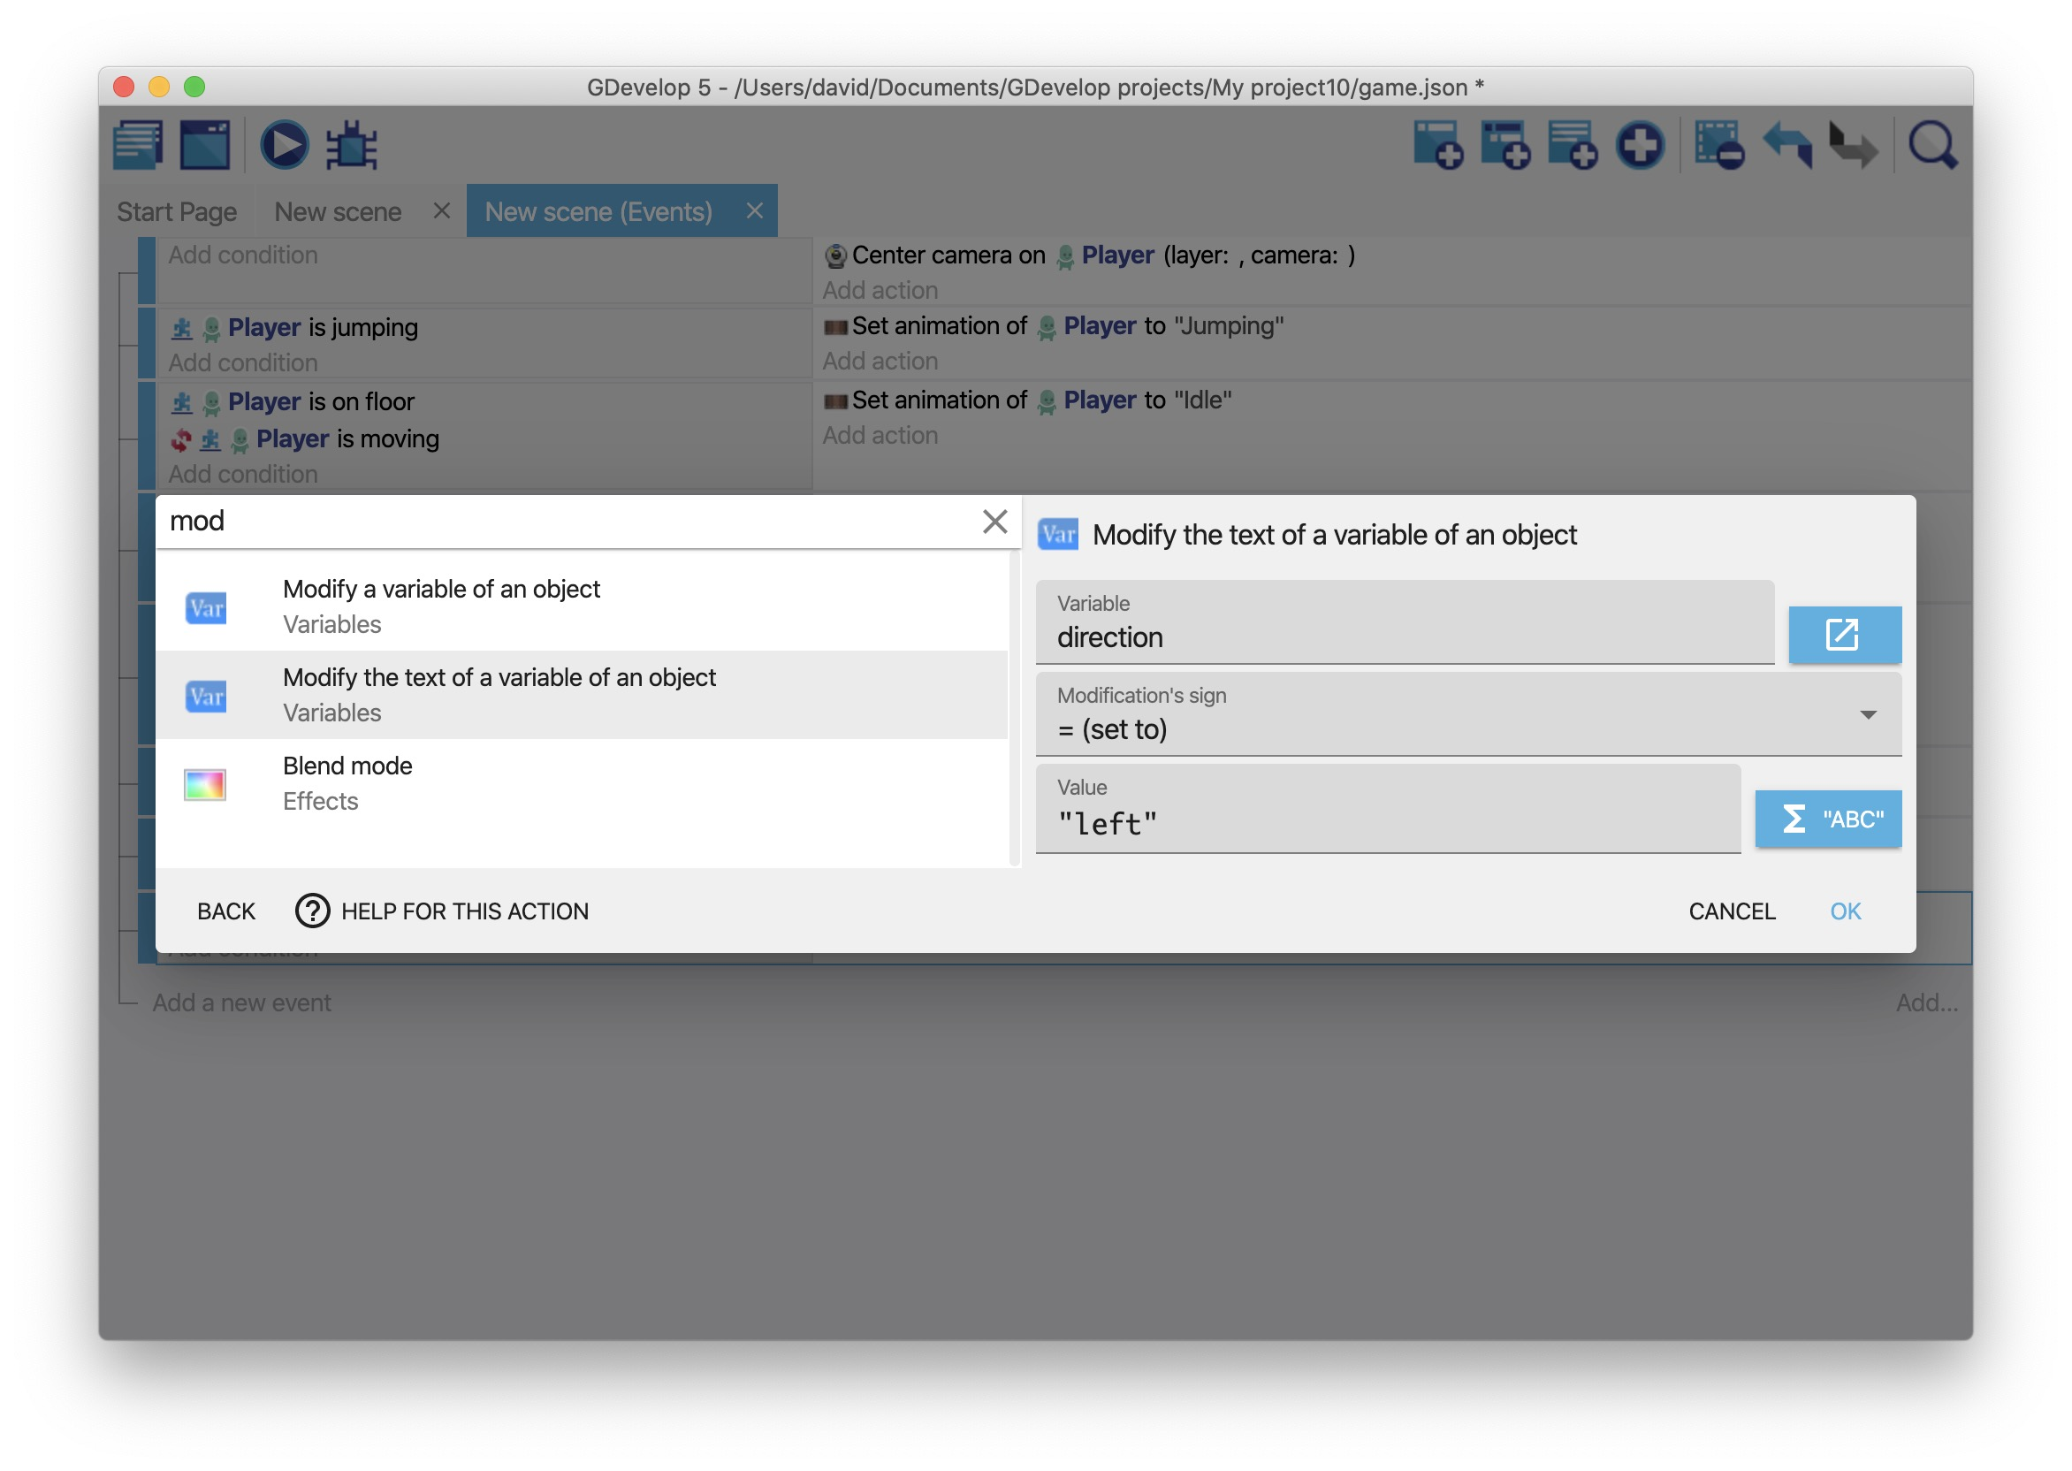

Flip the "Slime" object
- Add the Flip the object horizontally action to the event.
- Set the Activate flipping option as Yes.
This ensures that the “Slime” object changes and faces a different direction, rather than just changing directions.

Change the enemy's direction
- Add the Add a force (angle) action to the event.
- In the Object field, select “Slime”.
- In the Angle field, type “180”.
- In the Speed field, type “100”.
- Enable the Instant option.
- Click OK.
If you preview the game, the enemy changes direction when they collide with the “Left” object.
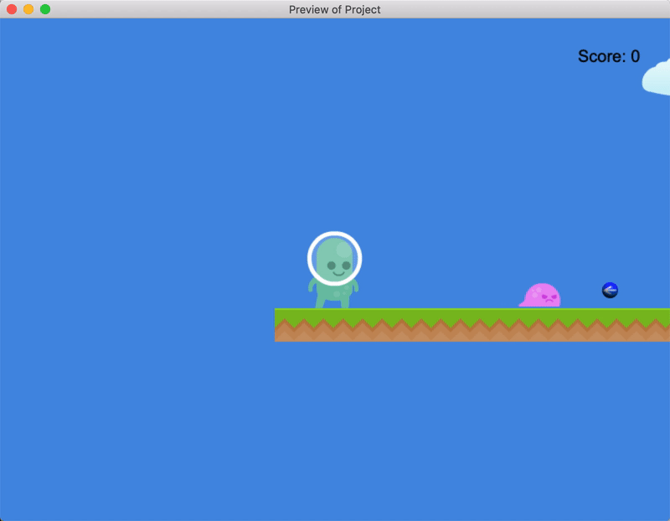

Hide the "Left" object
- Create a new event.
- Add the At the beginning of the scene condition to the event.
- Add the Hide action to the “Left” object.
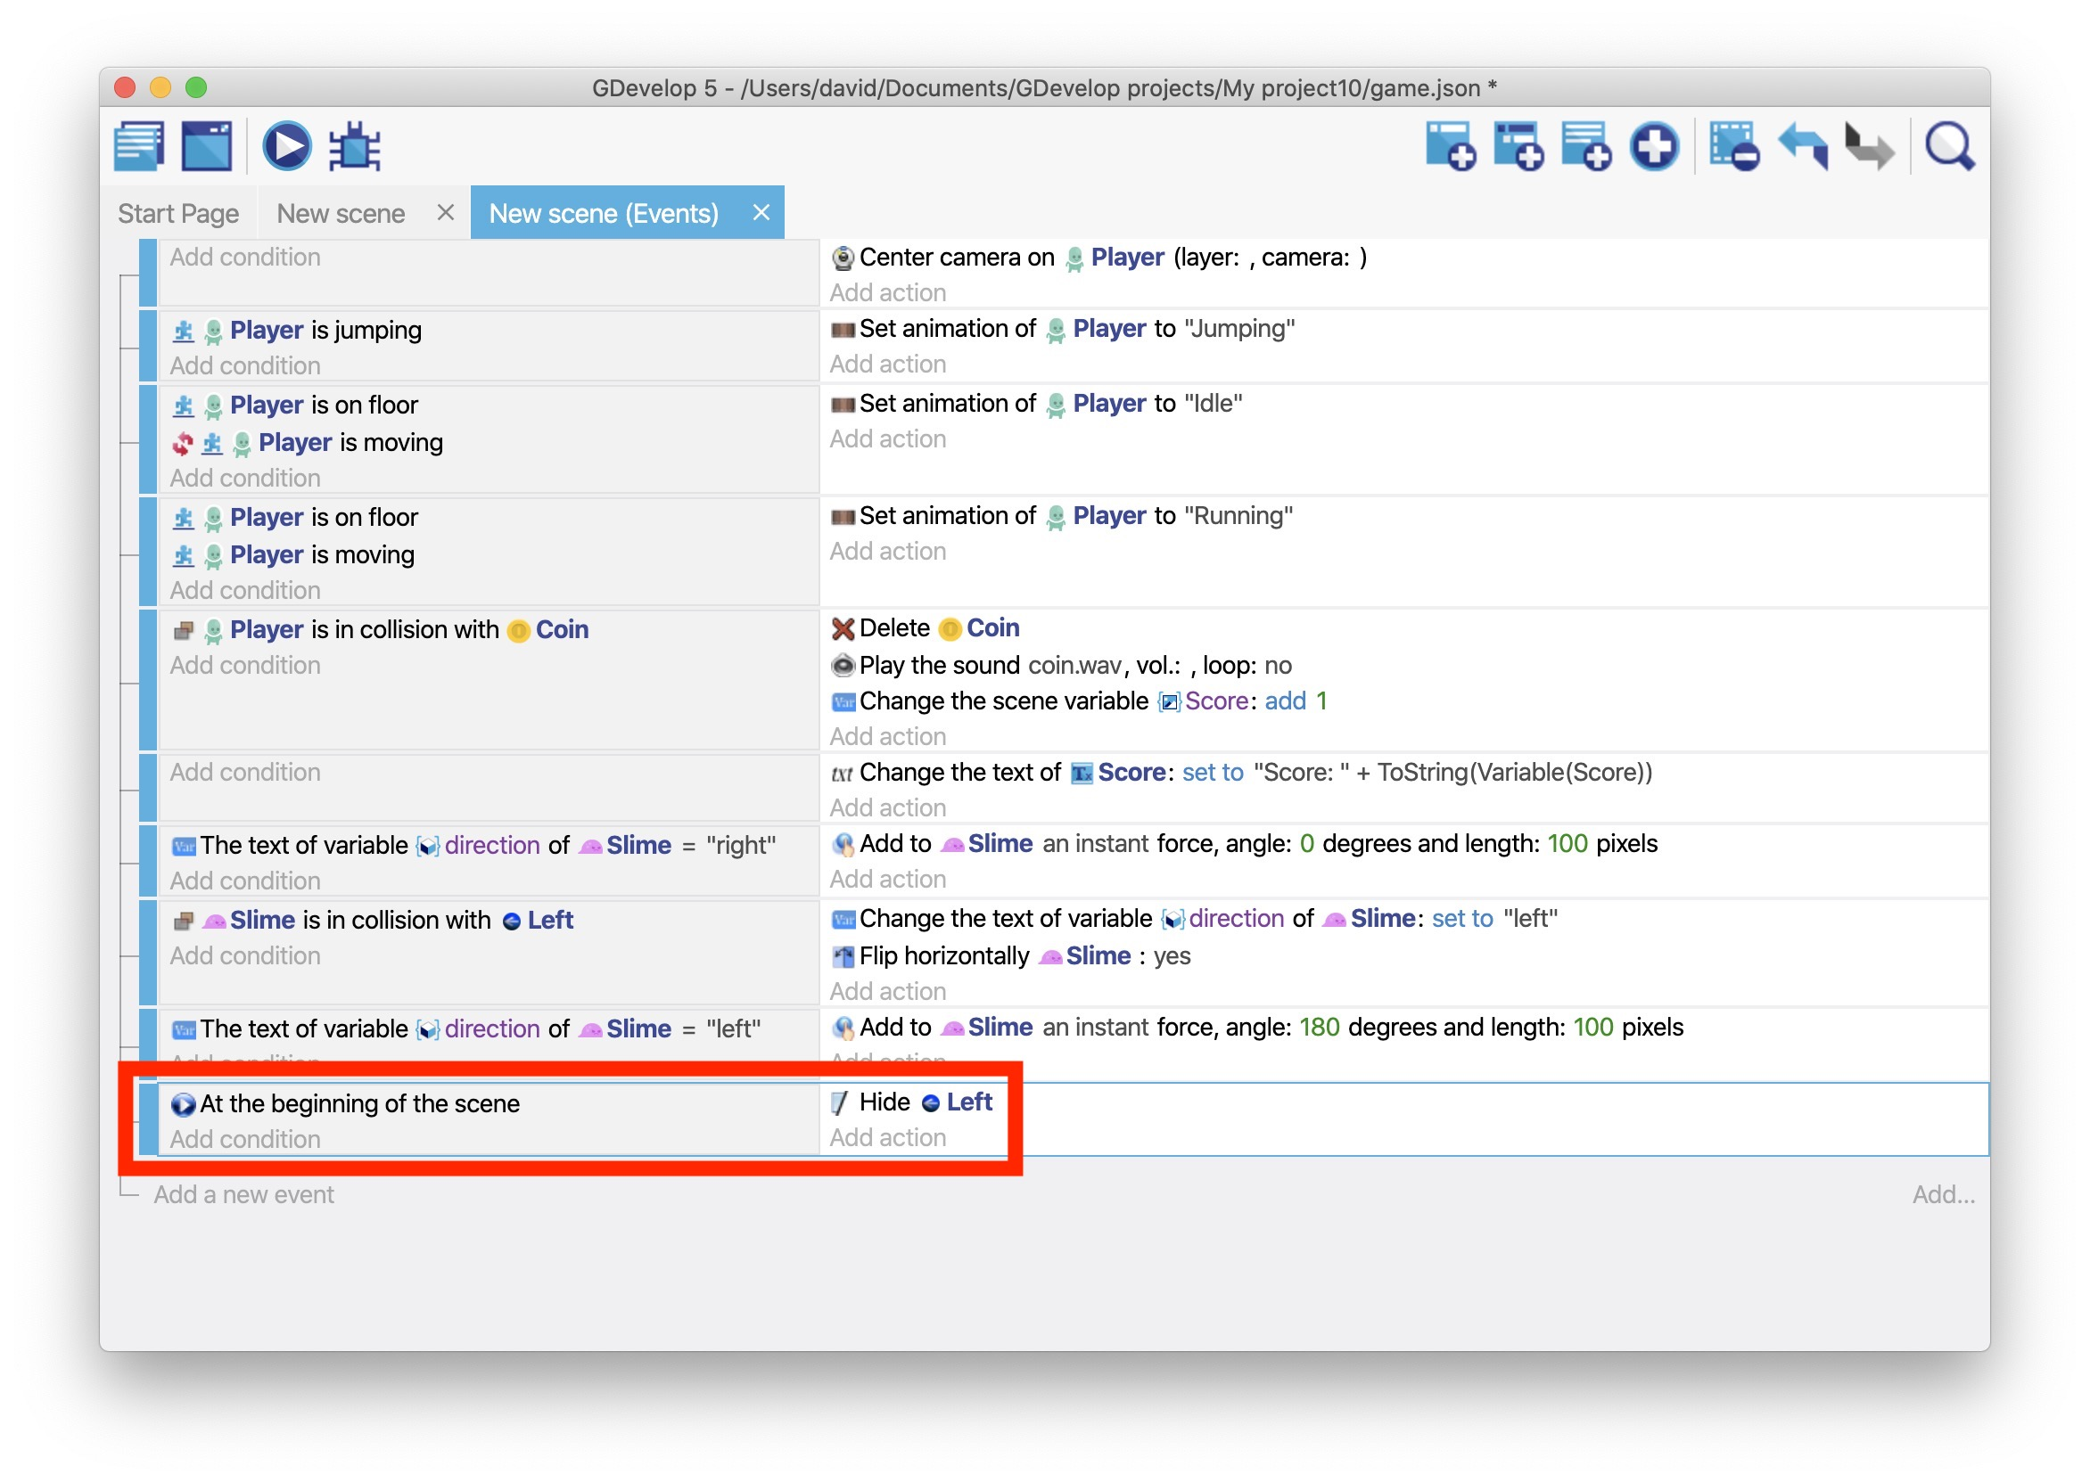
If you preview the game, the enemy appears to change direction by their own “choice”.
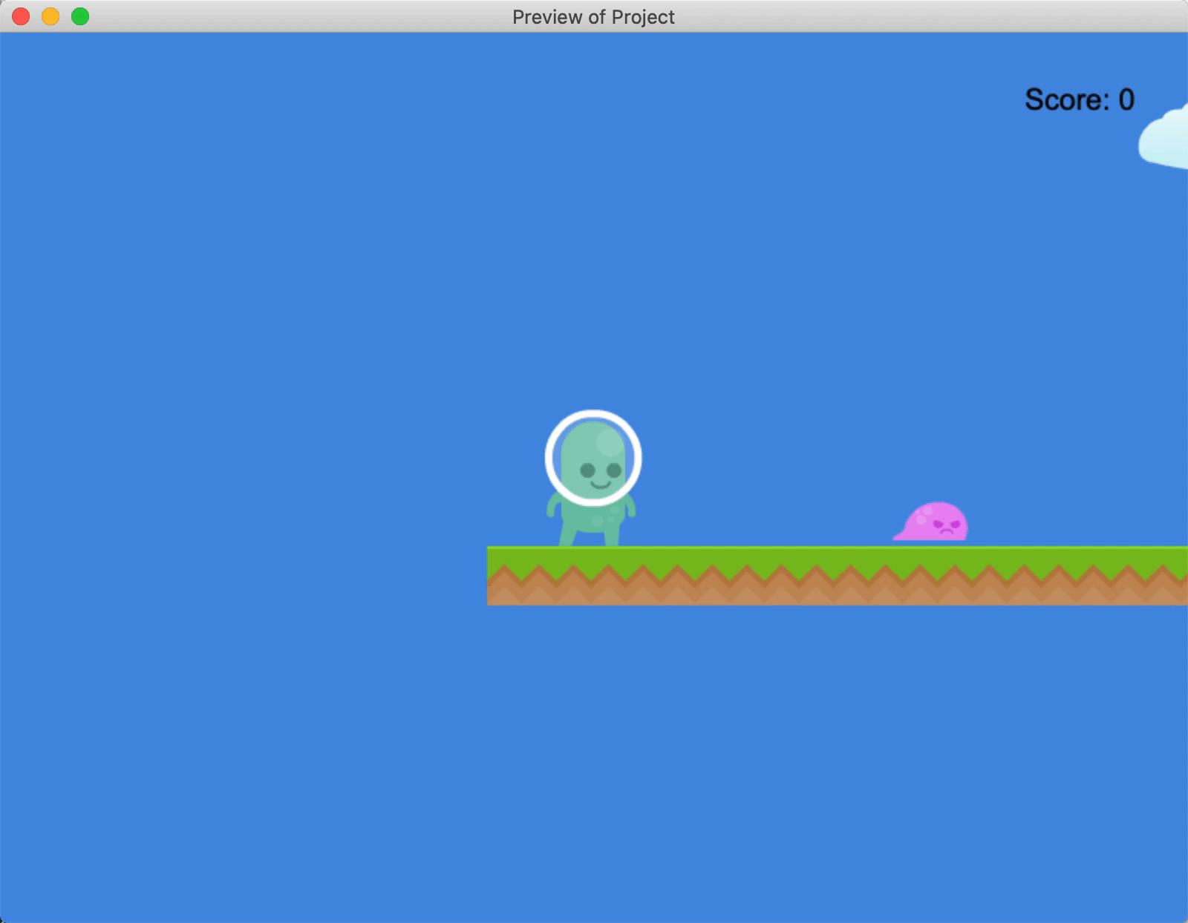

Step 4: Change the enemy's direction (again)
After the enemy collides with the “Left” object, they start moving right and never stop moving right. To ensure they change direction again, create an object named “RIght”. This object should be the same as the “Left” object, except for the following details:
- Use the “right.png” asset.
- When the “Player” object collides with the “Slime” object, set the “direction” variable to “right”.
- For the Flip the object horizontally action, set Activate flipping to No.
Then drag an instance of the “Right” object into the scene, to the left of the enemy.
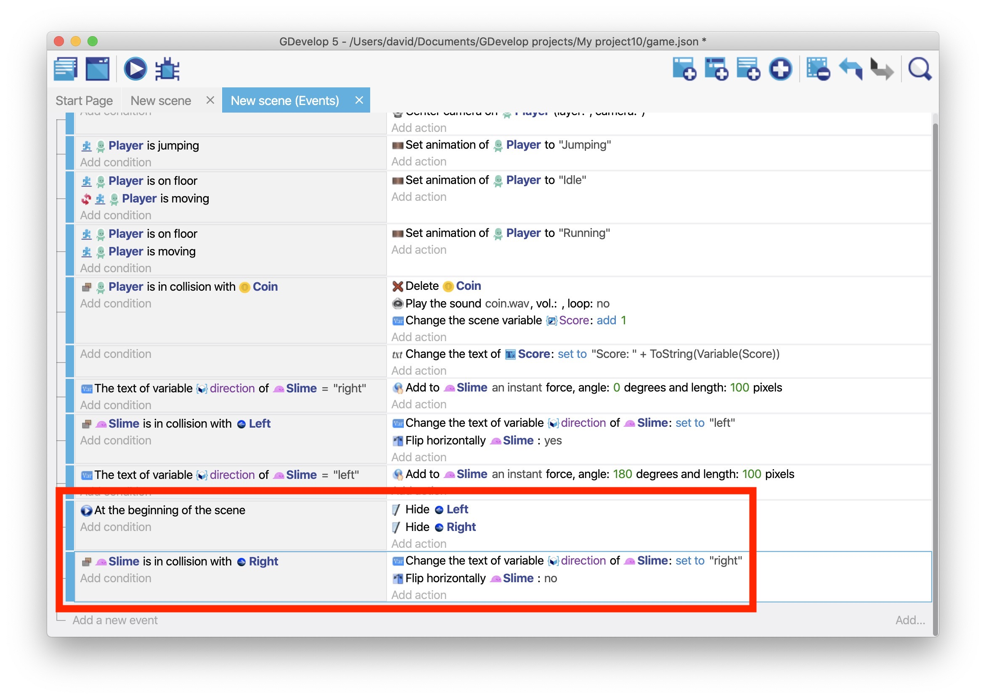
If you preview the game, the enemy moves back and forth between the invisible markers.
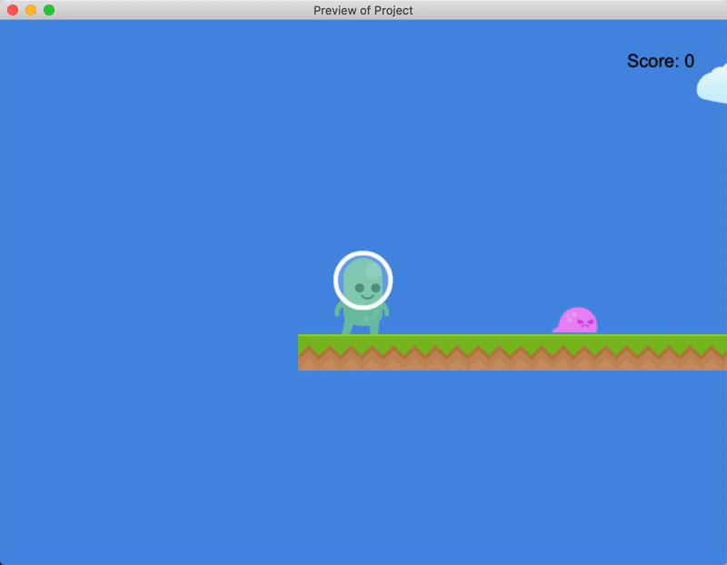

Next step
Read Platformer Tutorial, Part 7.

Platformer Tutorial, Part 7: Make Enemies Kill the Player (and the Player Kill the Enemies)
This part of the tutorial explains how the player can kill – and be killed by – the game's enemies.

Series
You are reading Part 7 of the Platformer Tutorial.
- Platformer Tutorial, Part 1
- Platformer Tutorial, Part 2
- Platformer Tutorial, Part 3
- Platformer Tutorial, Part 4
- Platformer Tutorial, Part 5
- Platformer Tutorial, Part 6
- Platformer Tutorial, Part 7
- Platformer Tutorial, Part 8

Step 1: Kill the player
When the player collides with an enemy, the player should die. An easy way to “kill” the player is to delete the “Player” object if it collides with an enemy.
To delete the “Player” object if it collides with an enemy:
- Create a new event.
- Add a Collision condition that checks if the “Player” object is colliding with the “Slime” object.
- Add the Is on floor condition to the “Player” object. This ensures that the player only dies if they're on the platform (i.e. not jumping).
- Add the Delete an object action to the event that deletes the “Player” object.
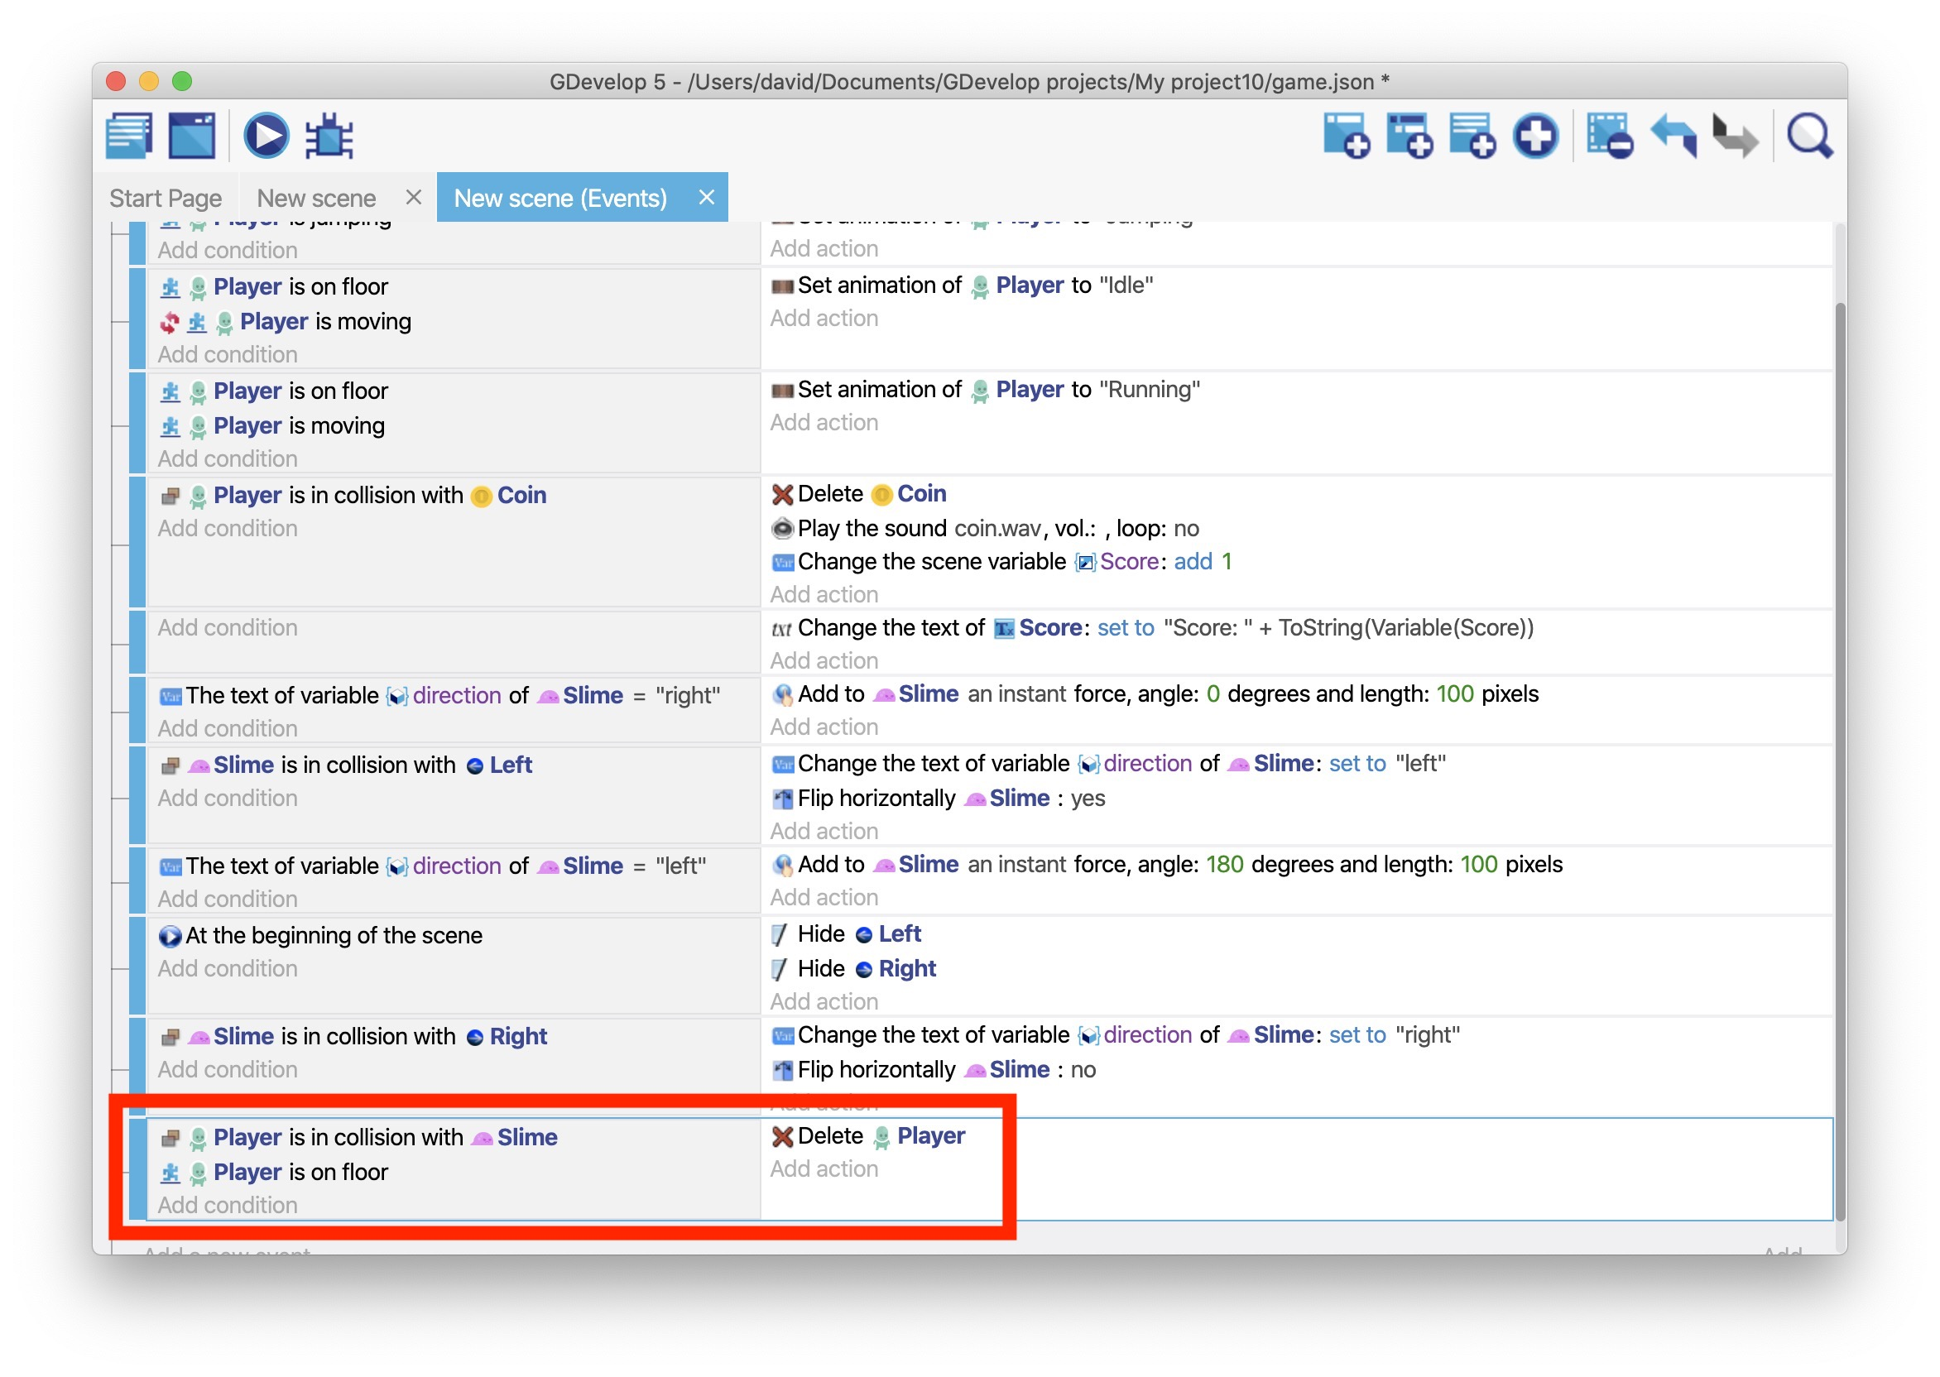
If you preview the game, running into the enemy will kill you.
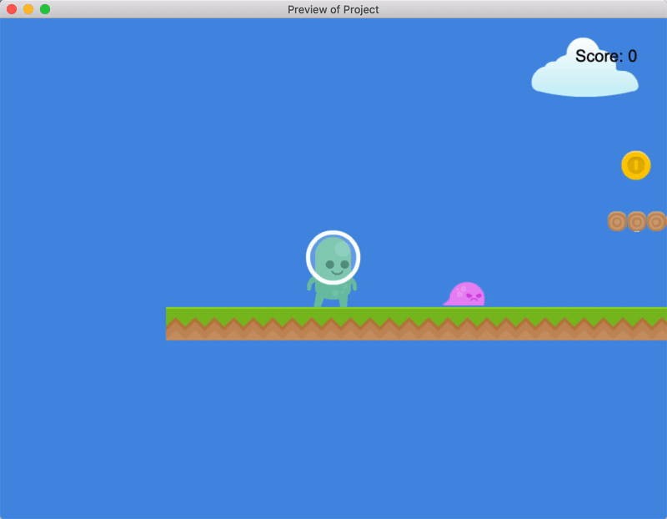

Step 2: Kill the enemy
If a player jumps on an enemy, the enemy should die. Similar to the previous step, “death” in this case means deleting the “Slime” object.
To delete the “Slime” object when a player jumps on it:
- Create a new event.
- Add a Collision condition that checks if the “Player” object is colliding with the “Slime” object.
- Add the Is falling condition to the “Player” object. This ensures that the enemy only dies if the player is jumping (i.e. not on the platform).
- Add the Delete an object action to the event that deletes the “Slime” object.
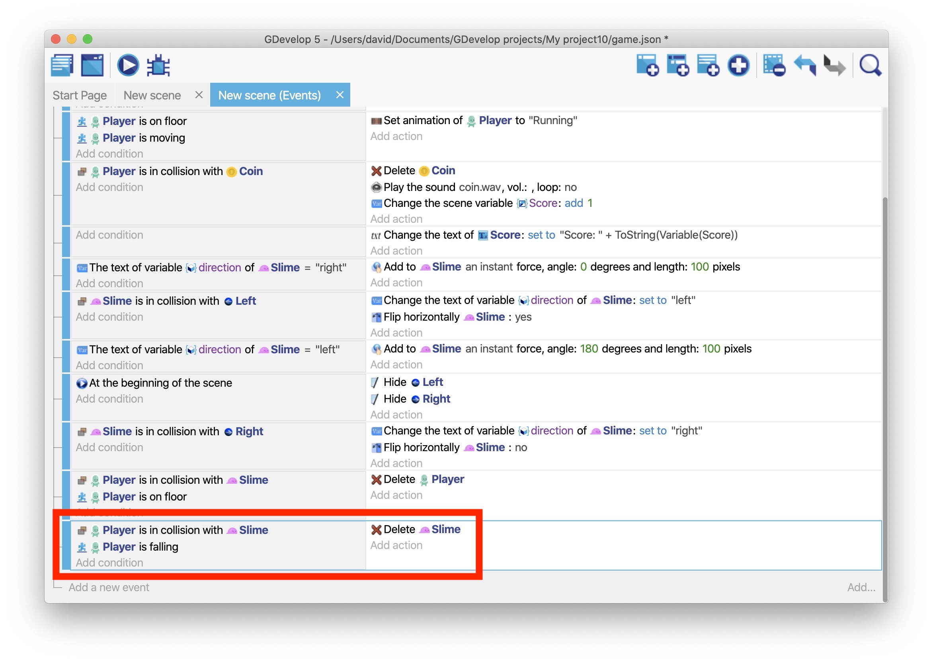
If you preview the game, you can jump on the enemy to kill them.
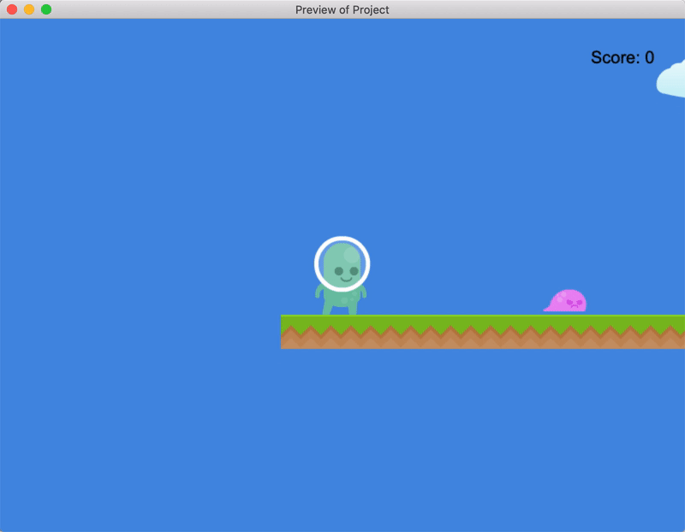

(Optional) Step 3: Bounce on the enemy's head
In a lot of platforming games, when the player jumps on an enemy, the player bounces on the enemy's head. This is makes killing an enemy feel more fluid.
To make the player bounce on the enemy's head:
- Add the Allow again jumping action to the “Player” object.
- Add the Simulate jump key press action to the “Player” object.
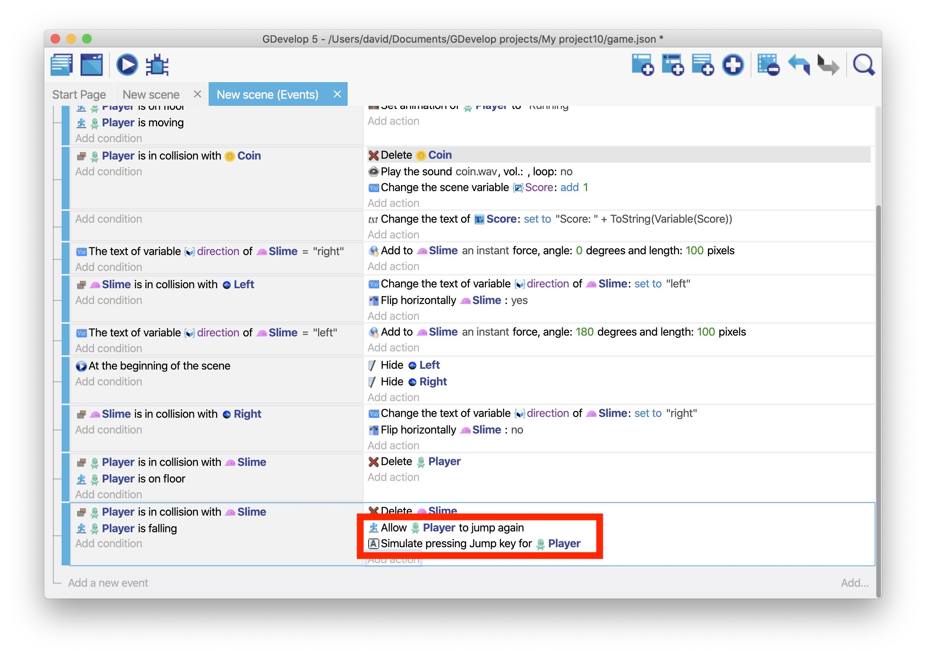
If you preview the game, you'll bounce on the enemy's head when killing them.
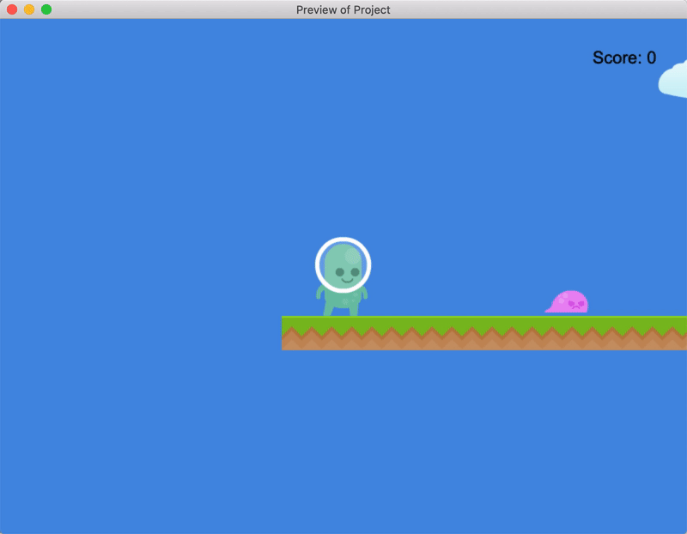

Next step
Read Platformer Tutorial, Part 8.

Platformer Tutorial, Part 8: Add Checkpoints to the Game
This part of the tutorial explains how to add checkpoints to the game. Then, when the player dies, they'll be sent to the most recent checkpoint.

Series
You are reading Part 8 of the Platformer Tutorial.
- Platformer Tutorial, Part 1
- Platformer Tutorial, Part 2
- Platformer Tutorial, Part 3
- Platformer Tutorial, Part 4
- Platformer Tutorial, Part 5
- Platformer Tutorial, Part 6
- Platformer Tutorial, Part 7
- Platformer Tutorial, Part 8

Step 1: Create an object for the checkpoint
The first step is to create a “Checkpoint” object. By this point in the tutorial, this should be a familiar process. If you need a refresher though, refer to Objects.
To create an object for the checkpoint:
- Create a Sprite object named “Checkpoint”.
- Use the “bush.png” asset as the image for the checkpoint.
- Drag one or more instances of the object into the scene.

Step 2: Save the player's coordinates when they reach a checkpoint
When the player reaches a checkpoint, you can use variables to save the coordinates of that checkpoint. Then, when the player dies, you can send them back to those coordinates.
You can access the X and Y coordinates of an object with the following syntax:
ObjectName.X()
ObjectName.Y()
These statements are both examples of expressions.
To save the coordinates of the “Player” object when they reach a checkpoint:
- Create a new event.
- Create a Collision condition that checks if the “Player” object has collided with the “Checkpoint” object.
- Create a Value of a scene variable action that creates a “CheckpointX” variable with a value of Checkpoint.X().
- Create a Value of a scene variable action that creates a “CheckpointY” variable with a value of Checkpoint.Y().
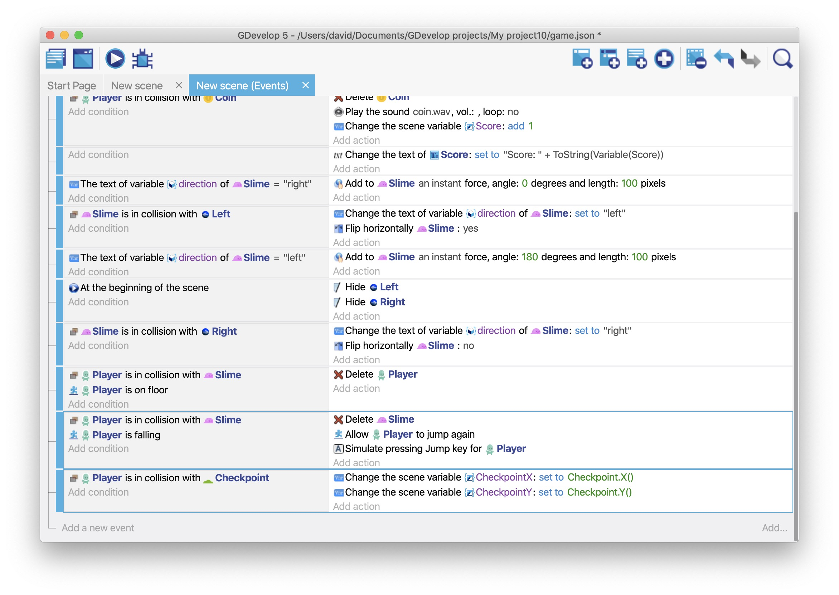

Step 3: Send the player to the previous checkpoint
When the “Player” object collides with the “Slime” object, the Delete an object action deletes the “Player” object from the scene. But since the game has checkpoints now, it doesn't make sense to delete the “Player” object.
To send the “Player” object back to the previous checkpoint:
- Remove the Delete an object action.
- Create a Position of an object action for the “Player” object.
- For each of the Modification's sign fields, select = (set to).
- Set the X position coordinate to Variable(CheckpointX).
- Set the Y position coordinate to Variable(CheckpointY).
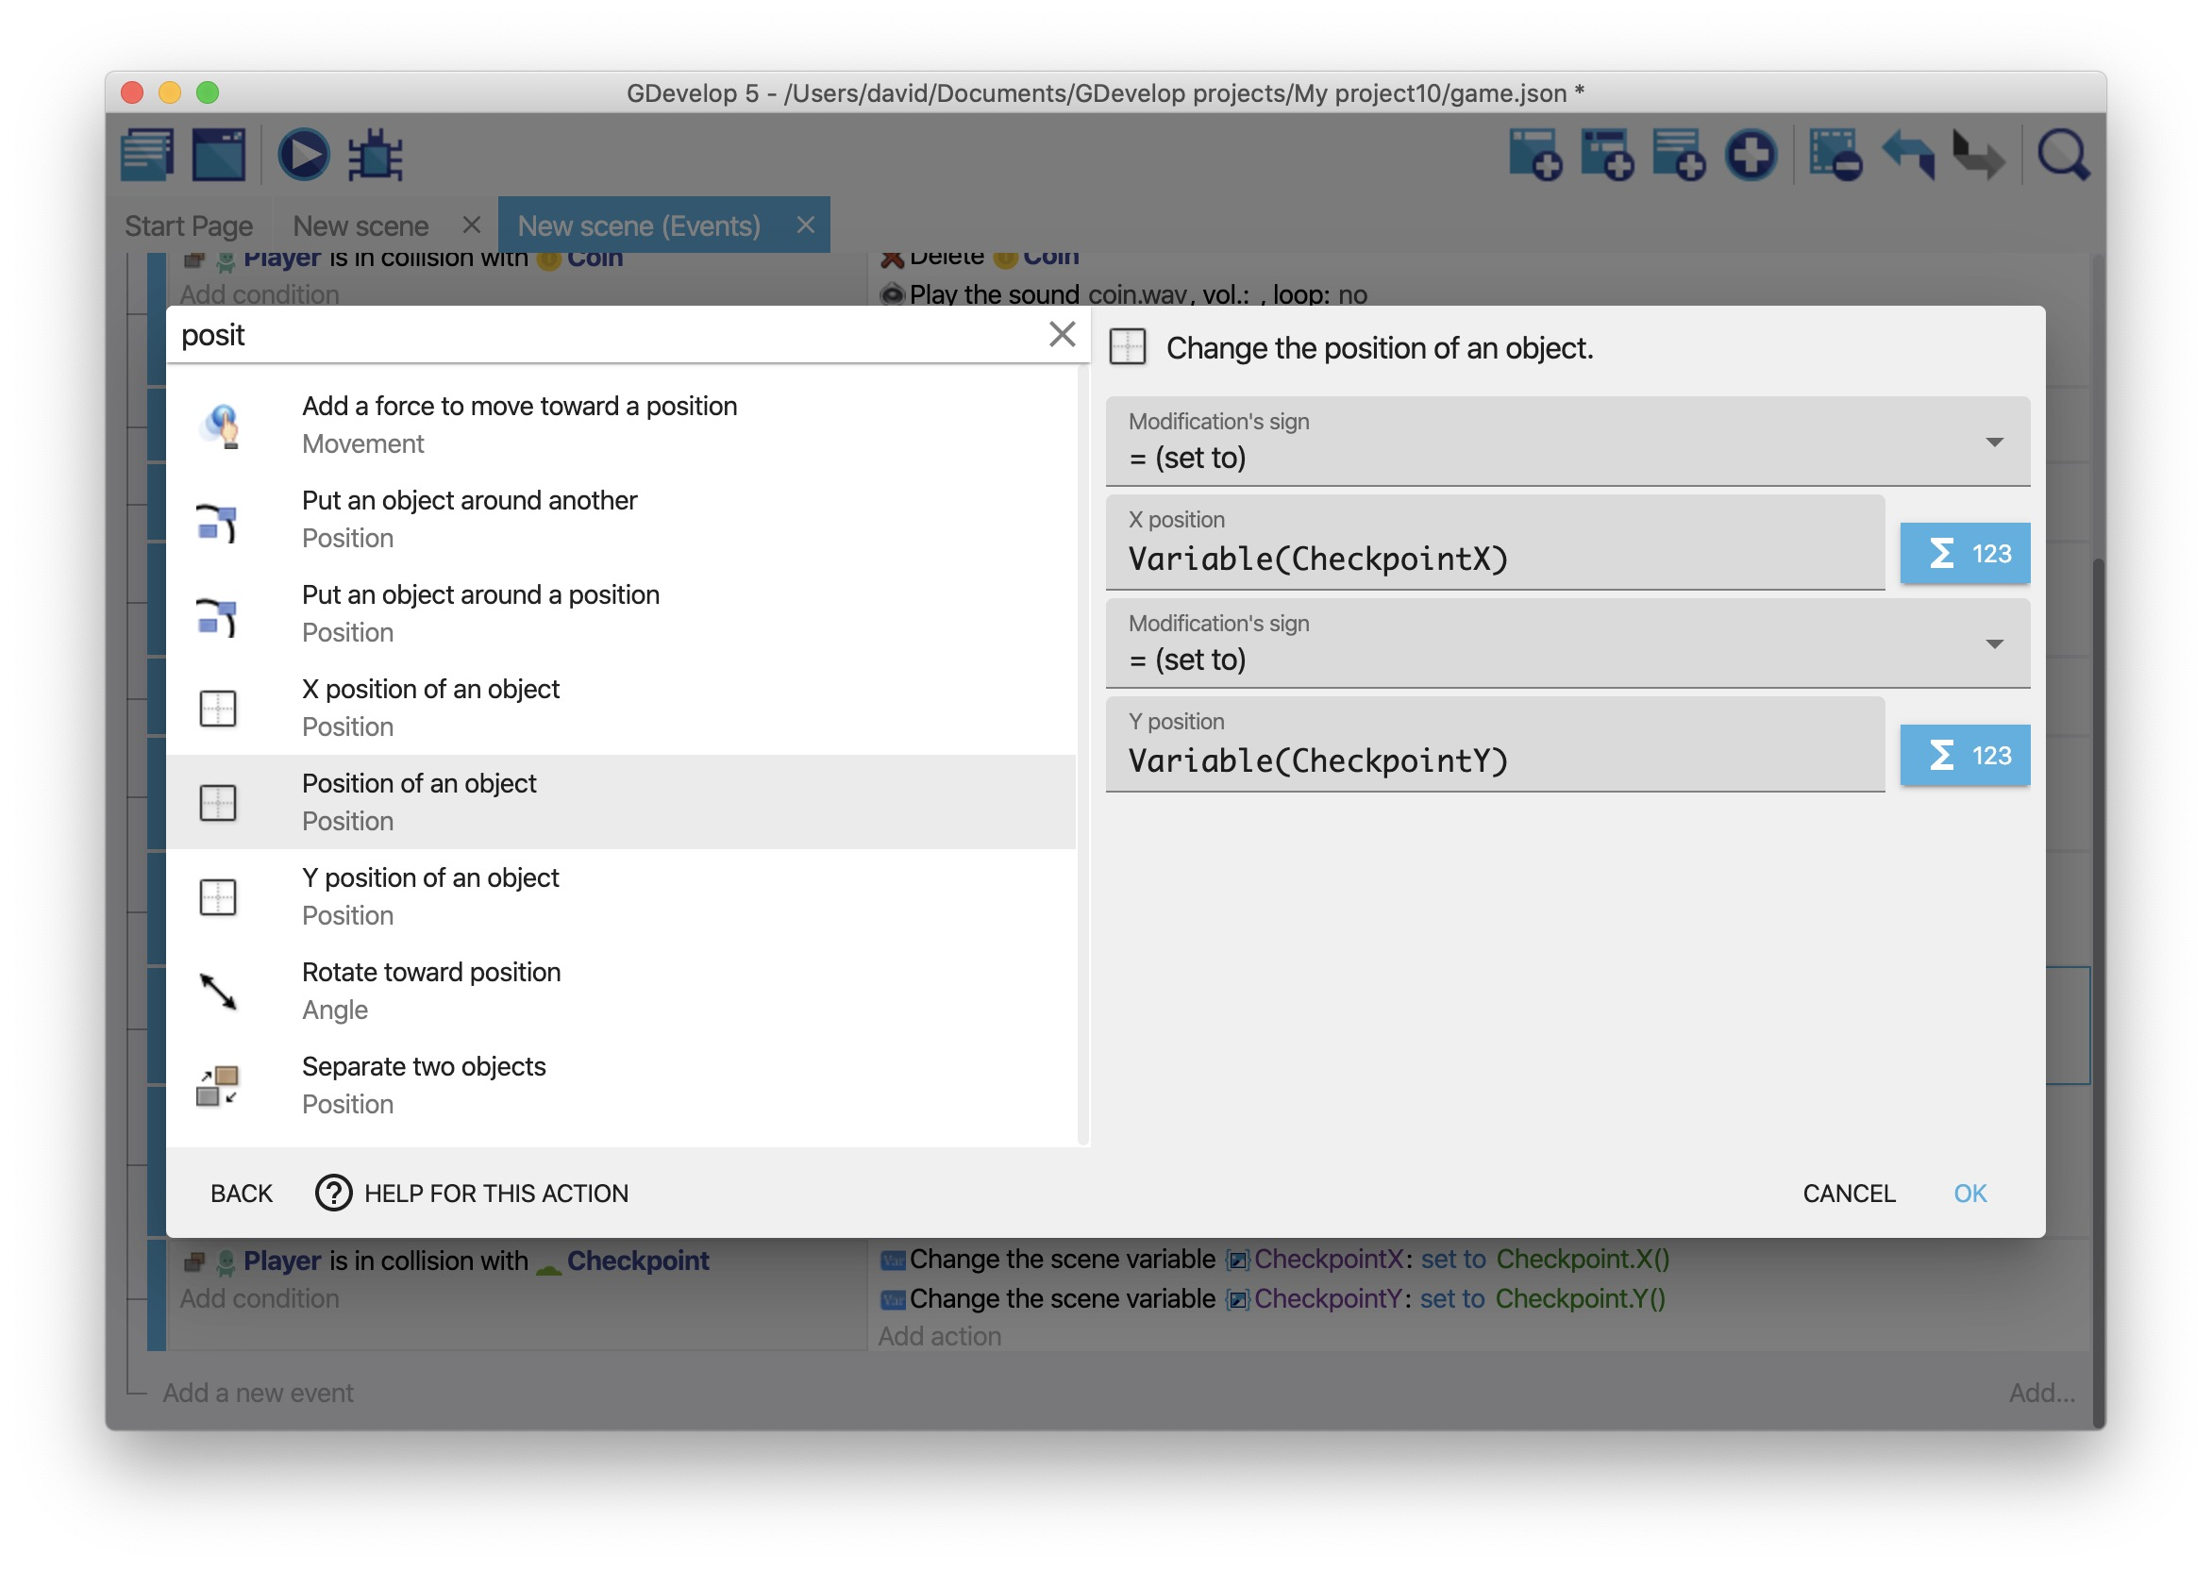
If you preview the game, dying after reaching a checkpoint sends you back to the checkpoint.
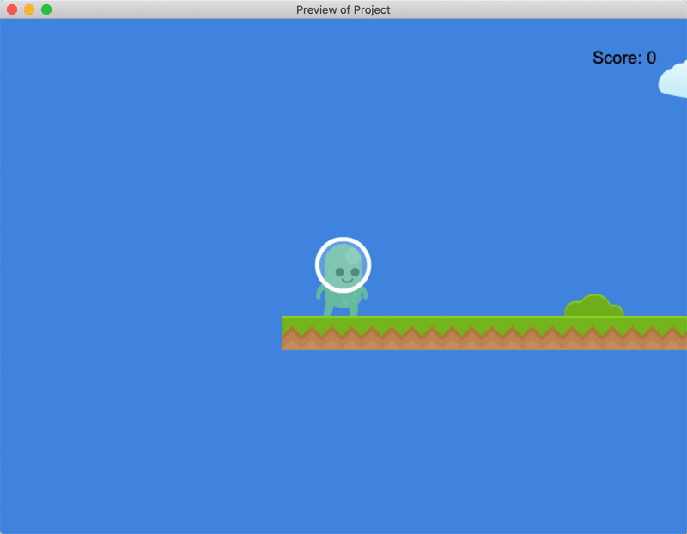

Step 4: Set the player's default coordinates
The CheckpointX and CheckpointY variables don't exist until the player reaches a checkpoint, so if a player dies before reaching a checkpoint, GDevelop sends the player back to the default coordinates of “0,0”.
This may cause a problem if:
- Something else exists at the default coordinates (such as an enemy).
- There isn't a platform beneath the default coordinates.
To fix this, set the value of the CheckpointX and CheckpointY variables to the initial coordinates of the “Player” object. Then the default coordinates are defined by where you place the “Player” object in the Scene editor.
To set the default coordinates:
- Create a new event.
- Add the At the beginning of the scene condition to the event.
- Create a Value of a scene variable action that creates a “CheckpointX” variable with a value of Player.X().
- Create a Value of a scene variable action that creates a “CheckpointY” variable with a value of Player.Y().}}
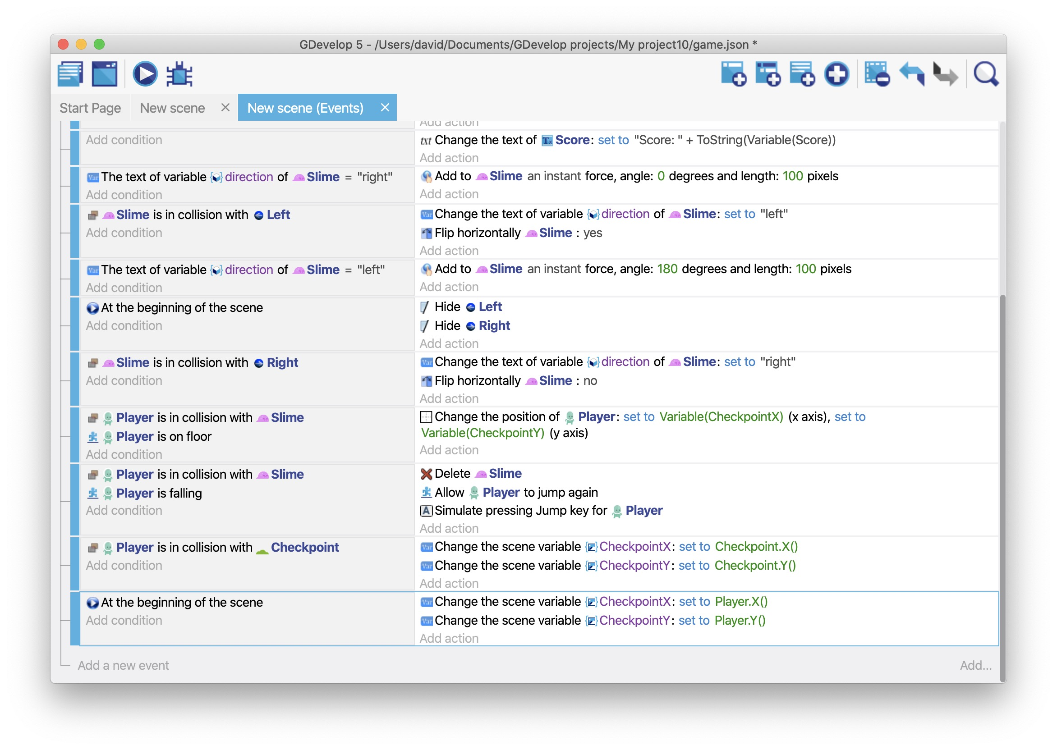

Next steps
You've reached the end of this tutorial. Congratulations!
From here, either dive into another tutorial, such as the Geometry Monster tutorial, or continue playing around with your platforming game. Based on what you've learned, how unique can you make it?
https://wiki.gdevelop.io/gdevelop5/tutorials/platformer/part-8

