Resources
You can find the resource manager at Project manager → Game settings → Resources.
When you click on Resources, a window is opened where you can set edit and control the resources, all the resources in this new windows will be exported during the export of the game.
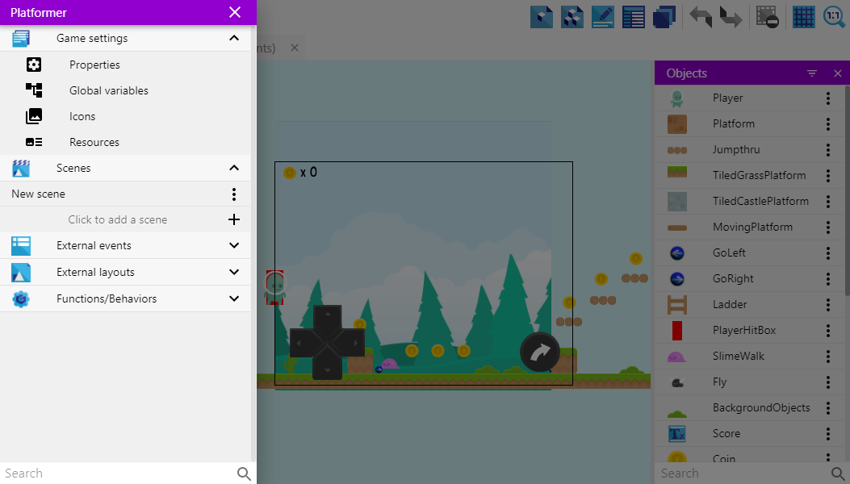

Interface
The changes you might have made (Ex: added a new object to the project, added new animations, etc… ) might not instantly apply to the resources tab if you have it opened. Reopen it to apply the changes
When the Resources window appears, you will see an interface similar to the one given below:
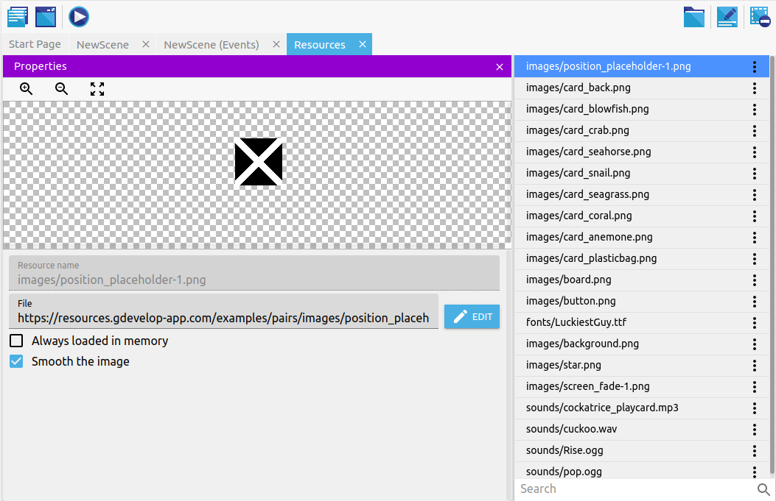
There you can see the properties panel (On the left). And the list of resources that the project uses (On the Right).
The toolbar is updated with some button, on the top-right.

- You can open the project folder with the button on the left. The .json file, assets (images, fonts, audio files) are located in the project folder.
- Toggle the properties panel visible on the left part of the screen.
- Remove the selected resource by clicking the button on the right.

Properties
Gdevelop allows you to edit and control the resources and how they are rendered in the project in the left part of the screen.

Editing the file path
File path is the location where the resource is located in your computer, the file path is relative to the project folder.
Click edit and a file chooser will open, letting you change the file path and choose another file. After you have chosen the file, that file will be used instead of the old one.

A file path can be an , this will be requested and loaded at the startup of the game.

Smoothing
You can sometimes see blurry images, especially when they are scaled. You can disable/enable image smoothing by toggling the option Smooth the image (Great for pixel art games)

- Sprite with smoothing enabled:

- Sprite with smoothing disabled:

Always loaded in memory
Currently the Always loaded in memory option is not yet supported. All the resources (except audio) are always loaded at the startup of the game during the loading.

Preload as sound/music
This allows you to preload audio files as music/sound, making them start quickly as you don't have to wait for the audio to load

Some other options/tools
To use them, click on the 3 dot icon near a resource.

Renaming
Allows you to rename the resources. The name is the path to the resource by default. You may need to re-open the resource manager to apply the changes to the UI.

Removing
Removes the selected resource from the project.
Removing a resource only removes it from the game, it doesn't delete the file from the project folder, you will have to do it manually

Open the file
Lets you open the selected resource in a player/viewer (Uses the default software for that file type on your system)

Locate file
Opens the selected resource in the file manager of your system.

Copy file path
Copy the file path to the clipboard, you can then paste it somewhere else.

Scan for images/audio/fonts/videos
There might be files that are present in the project folder, but not used by your project. You can add those files by using this. It scans the project folder and adds them to your project.

Remove unused images/audio/fonts
This will remove all the resources that are not being used by your project. These might be the resources that are not used by an object, etc..
Removing a resource only removes it from the game, it doesn't delete the file from the project folder, you will have to do it manually

Remove resources with Invalid paths
Sometimes resources might have a red text indicating that the file path to that resource is invalid.
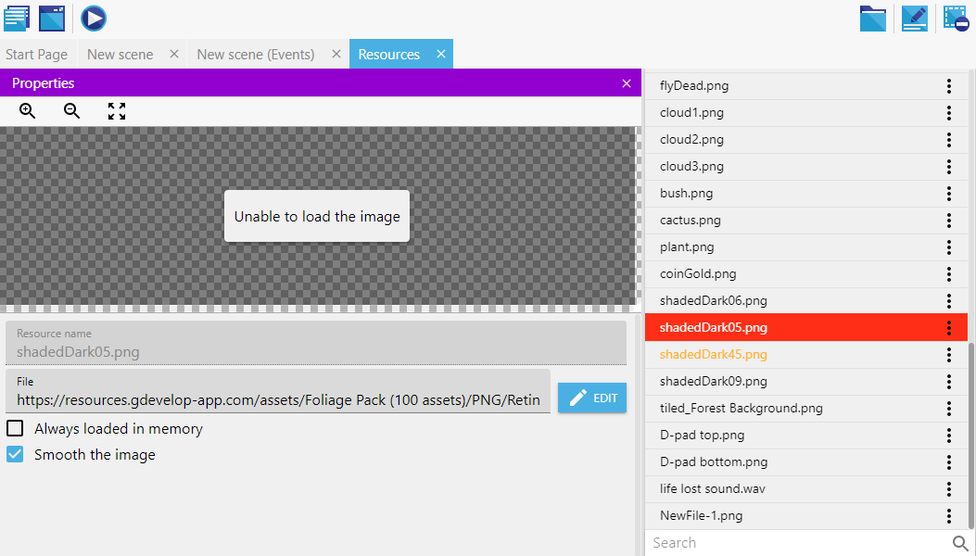
You can remove all resources with invalid paths using this.
Sometimes the text might be yellow, that might be indicating that the resource itself has malfunctioned.

