How to Use IndexedDB – Database Guide for Beginners
Victor Yakubu

The modern browser has given us a number of options when it comes to storing data on the client-side. Aside from storing data, browser databases allow us to retrieve that data.
Based on your application's needs, you can choose from the different browser storage options out there to enhance your users' experience when they use your applications.
One of these browser storage options is IndexedDB. I used IndexedDB for the first time a couple of months ago. Before using it, I went through articles and videos on various implementations of it. So I thought it would be nice to write about it based on my understanding of how it works.
So basically in this article, I will be talking about what IndexedDB is, its advantages, and how it works.

What is a Database?
These days, data are everywhere. Data can be any information such as your age, location, what you've recently purchased from an online site, and so on. Data can be in the form of videos, images, files or even text.
Companies need to be able to store and process that data effectively, and they use databases for this purpose.
Now, a database is simply where you store data – it's that simple. So if you open an excel sheet, for example, and populate it with data, that is considered a database.
The purpose of storing data in a database is to make it easy to access. This lets you modify it, protect it, and also analyze it to get as many insights as you can.

Types of Databases
There are mainly two types of database out there. Depending on your needs you'll want to try both out on you journey:

Relational Databases
In a relational database, data is stored in a collection of tables. These tables are connected to one another.
Examples of relational databases include Oracle, PostgreSQL, MySQL, Microsoft SQL Server, and so on.

Non-Relational Databases
In a non-relational database, data is stored in collections. There are no tables, columns, or rows and the data are not connected to one another.
Under non-relational databases, there are different categories: key-value databases, Document Databases, graph databases, wide column databases, search engine databases, and more.
Examples of non-relational database include Redis, MongoDB, Neo4j, Cassandra, and others, our very own IndexedDB is also a non-relational database.
In this article we won't cover databases themselves in-depth, as it is not the primary purpose. But Dionysia Lemonaki has a more detailed article on relational and non-relational databases which you can check out here to learn more.
It's exciting to know that IndexedDB, which we will be talking about here, is a database that is available on all modern browsers. But, IndexedDB is not the only browser storage option available to you. There's also local storage, session storage, cookies, Web SQL, and cache storage.
You might already be familiar with these options, but if you are not, I encourage you to read more about them.

What is Browser Storage? How is it Different from Server Storage?
Browser storage is also referred to as client-side storage. It simply means storage that's located on a user's browser.
Just like server-side storage (which allows you to store data on a database called the backend) where you are able to communicate with the database using lines of code, client-side storage uses the same principle.
But keep in mind that client-side storage is not a substitute for server-side storage. Client-side storage a mainly used to enhance the user's experience.
A simple example is when you log in to a platform for the first time. The server-side storage handles authentication and necessary authorizations, and the client-side storage makes it possible for you to visit that platform after a few hours and continue from your previous state without having to send a request to the backend.
And then, whenever you need to log in after some time, the client-side storage saves your login details, and auto-fills them in. All that will be required from you is to click the login button.
Server-side can be written and accessed using any number of programming languages depending on your preference – like Python, Ruby, C#, PHP and JavaScript (NodeJS). For the client-side, you'll mostly use JavaScript to access and communicate with the browser storage.
Alright, now let's learn about IndexedDB.

What is IndexedDB?
Above we talked about non-relational databases and their different types. We also mentioned key-value databases as one of these types, right? Well, IndexedDB is an example of a key-value database.

What is a Key-Value Database?
A key-value database means that all the data stored must be assigned to a key. It is one of the less complicated non-relational databases, at least in my opinion.
A key value database associates a key to a value. The key serves as a unique identifier for that value, which means that you can keep track of that value using the key.
If your app needs to fetch data constantly, key-value databases use really efficient and compact index structures to quickly and reliably locate values by their keys. Using the key you are able to not only retrieve the value stored, but also delete, update, and replace the value.
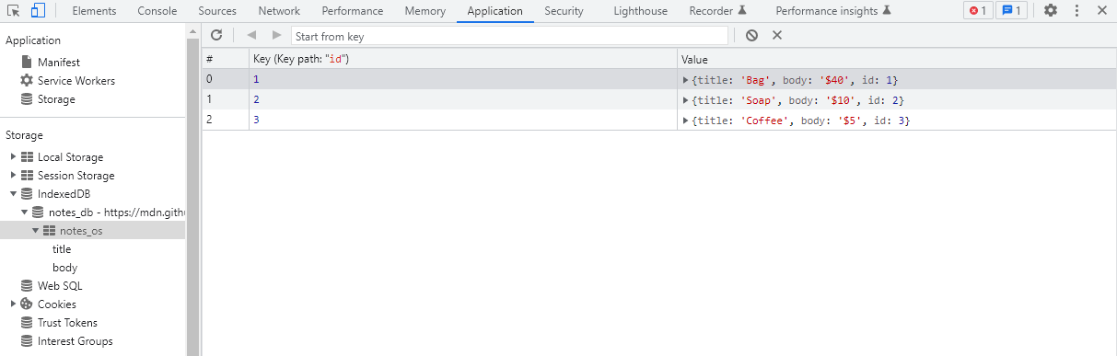key-value database
Okay, I believe you understand what key-value database is all about now? let's continue talking about IndexedDB.

Advantages of IndexedDB
So we have all these browser storage options available to us, which is a great thing because we can choose one based on our needs. And each option has different capabilities.
So it's important to know how each works and their capabilities so you can choose the right one for your use case.
That being said, IndexedDB has the following advantages:
- IndexedDB is asynchronous, meaning it does not stop the user interface from rendering while the data loads.
- It allows you to categorise your data using object stores.
- It allows you to store large amounts of data.
- It supports objects like videos, images, and so on – any object that supports a structured clone algorithm.
- It supports database transactions and versioning.
- It has great performance.
- The database is private to an origin.
- It is supported on all modern browsers.

Use Cases of IndexedDB
Aside from knowing how IndexedDB works, it's also important to know when you should use it.
- To store user-generated content: An example of user generated content is filling out an application form. While still in the process of completing the form, a user can leave it and come back some time later to complete the form without losing their initial data inputs.
- To store application state: When a user first loads a website or application, you can use IndexedDB to store these initial states. These can be log in authentications, API requests, or any other state needed before the UI is rendered. So when next the user visits the site, the load speed increases because the application has state already stored. This means that it renders the UI faster.
- For an application that works offline: Users can edit and add data while the application is offline. IndexedDB will process and empty these operations in a synchronization queue when the application comes online.

How IndexedDB Works
Now to the main part of this article: learning how IndexedDB works. We will be using the flowchart below, and we will go over the various events and paths one after the other and the associated JavaScript code to properly explain them.
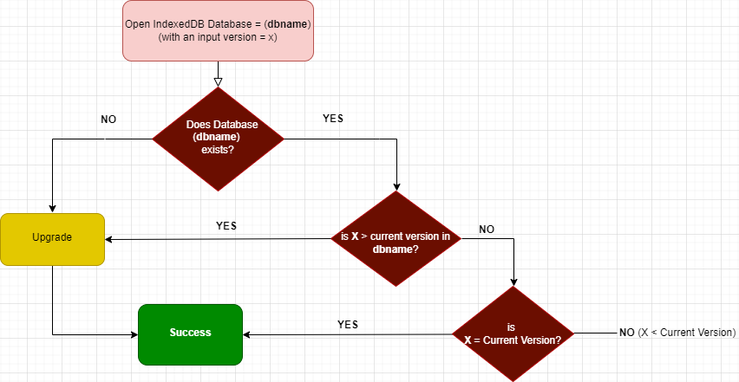

Path 1: What to do if the database does not exist
When you create a new database in IndexedDB this is the path it will follow. This path is pretty straightforward:
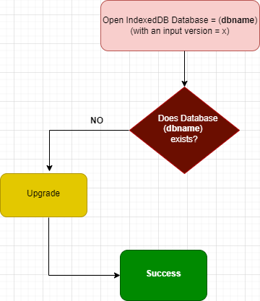
An important thing to note is that, when creating a Database, you will have to give the database a name and a version (you determine any version to give the database).
Also, when you create a database for the first time, version 1 is automatically assigned to it even without you stating a version.
Now, let's explain the flowchart above. When you create a database, it checks if a database with that name (dbname) exists already.
If it doesn't exist, it will proceed to call the upgrade event. When the upgrade event gets called, you can then upgrade the structure of the database. When the upgrade event block runs successfully, it will then call the success event.
const request = indexedDB.open('myDatabase', 1);

//upgrade event
request.onupgradeneeded = () => {
alert("upgrade needed")
}

//on success
request.onsuccess = () => {
alert("success is called")
}

Path 2: What to do if the database exists but has a new version greater than the previous version
Now we'll look at the second path. When a new database is created, it first checks to see if the database already exists.
If a database with the same name exists, it then checks the version to see if the version is greater than the previous version. If it is, it then calls the upgrade event where you can modify the structure of the database. And after that is done, it calls the success event.
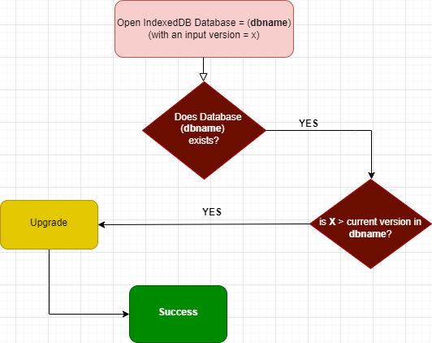
Following the explanation above, now let's look at the code below.
Let's assume we had already created a database with the name "myDatabase". Since the database name is the same as the one we previously created, it then moves to check the version. The previous version was "version 1". Since we changed the version to "version 2" and since version 2 > version 1, it will then execute the modification inside the onupgradeneeded function.
const request = indexedDB.open('myDatabase', 2);

//upgrade event
request.onupgradeneeded = () => {
alert("upgrade needed")
}

//on success
request.onsuccess = () => {
alert("success is called")
}

Path 3: What to do if the database exists, but the version is less than the current version
Following the flowchart below, if the database already exists, and the version is less than the current version, it then moves to check if the version is the same as the current version.
There are two possible outcome here: first, if the version is the same as the current version it calls the success event, i.e. no update will be made, the database stays the same, no error is thrown. Second, if the version is less that the current version, it fails and throws an error.
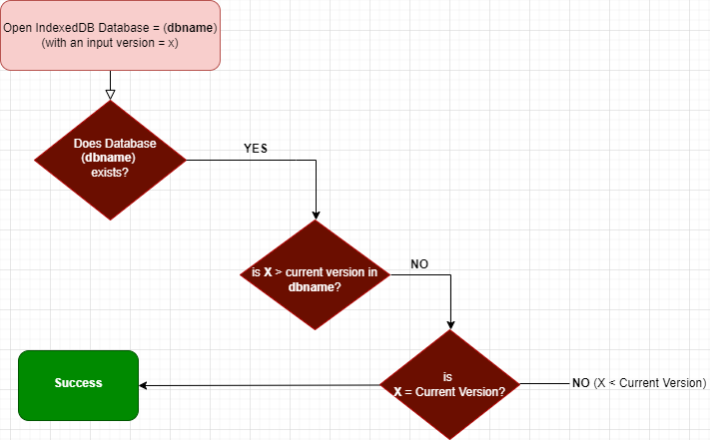

How to create an Object Store and Transaction in IndexedDB
- Object Store: Is a collection of objects inside a database, a database can have different object stores. considering the code below, myDatabase is the database created, while myDatabaseStore is the object store created inside the database. The object store can be used to store any form of data. I used the code below to explain how to create an object store.
let db;

const openRequest = indexedDB.open('myDatabase', 1);

openRequest.onupgradeneeded = function (e) {
db = e.target.result;
console.log('running onupgradeneeded');
const storeOS = db.createObjectStore('myDatabaseStore', {keyPath: "name"});

};
openRequest.onsuccess = function (e) {
console.log('running onsuccess');
db = e.target.result;
};
openRequest.onerror = function (e) {
console.log('onerror! doesnt work');
};

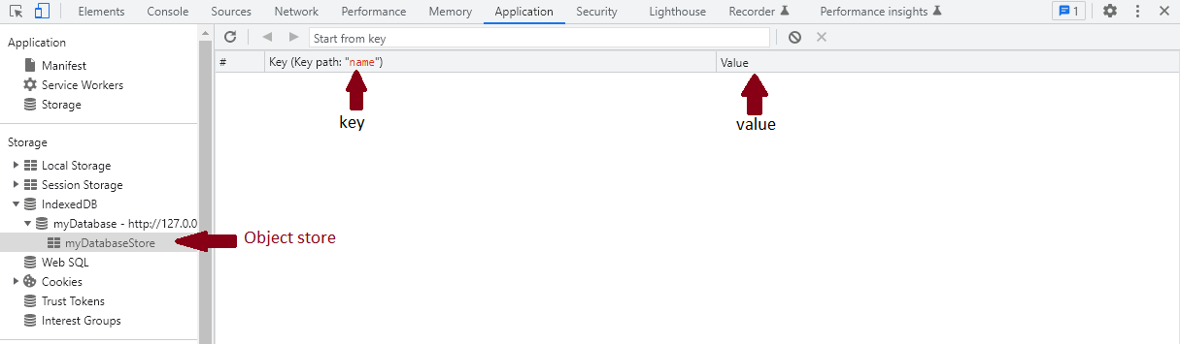
- Transaction: A transaction is a sequence of task wrapper together. For a transaction to be successful, all the task wrapped into it must pass, if one fails, none will pass. If that happens, no update will be made to the database. Transaction has methods, properties and events you can explore. In the code below, I was able to add item to the object store by wrapping it in a transaction.
let db;

const openRequest = indexedDB.open('myDatabase', 2);

openRequest.onupgradeneeded = function (e) {
db = e.target.result;
console.log('running onupgradeneeded');
const storeOS = db.createObjectStore('myDatabaseStore', {keyPath: "name"});

};
openRequest.onsuccess = function (e) {
console.log('running onsuccess');
db = e.target.result;
addItem();
};
openRequest.onerror = function (e) {
console.log('onerror! doesnt work');
console.dir(e);
};

function addItem() {
const item = {
name: 'banana',
price: '$2.99',
description: 'It is a purple banana!',
created: new Date().getTime(),
};
const tx = db.transaction("myDatabaseStore", "readwrite");
const store = tx.objectStore('myDatabaseStore');
store.add(item);
}
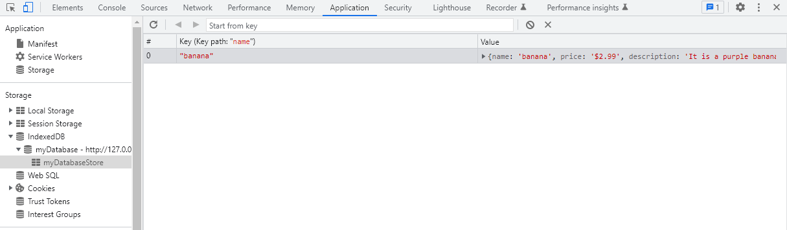

Conclusion
IndexedDB is a very powerful client-side storage option that developers can use to provide a better user experience for their websites or applications. It helps you reduce the time it takes to load data from a website or application that your users visit frequently.
If you haven't built something with IndexedDB, I encourage you to try it out. This article did not cover how to do that, but there I materials online that will guide you. Building stuff will help you appreciate IndexeDB more.
I hope you enjoyed reading it as I enjoyed writing it.
Relevant Documentation on IndexedDB:
- www.w3.org/IndexedDB
- developer.mozilla.org/IndexedDB
https://www.freecodecamp.org/news/how-indexeddb-works-for-beginners/

JavaScript IndexedDB

Summary: in this tutorial, you’ll learn about the IndexedDB and how to use it to persistently store data inside the browser.

What is indexedDB
IndexedDB is a large-scale object store built into the browser.
The IndexedDB allows you to persistently store the data using key-value pairs.
The values can be any JavaScript type including boolean, number, string, undefined, null, date, object, array, regex, blob, and files.

Why indexedDB
IndexedDB allows you to create web applications that can work both online and offline.
It’s useful for applications that store a large amount of data and don’t need a persistent internet connection.
For example, Google Docs uses the IndexedDB to store the cached documents in the browser and synchronizes with the server once in a while. This allows Google Docs to increase performance while enhancing user experiences.
And you’ll find other types of applications that heavily use IndexedDB like online notepads, quizzes, todo lists, code sandboxes, and CMS.

IndexedDB structure
The following picture illustrates the structure of the IndexedDB:
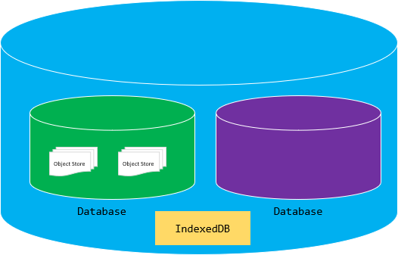

Databases
A database is the highest level of IndexedDB. A database contains one or more object stores.
The IndexedDB can have one or more databases. Generally, you’ll create one database per web application.

Object stores
An object store is a bucket that you can use to store the data and associated indexes. It’s conceptually equivalent to the tables in SQL databases.
An object store contains the records stored as key-value pairs.

Indexes
Indexes allow you to query data by the properties of the objects.
Technically, you create indexes on object stores, which are called parent object stores.
For example, if you store the contact information, you may want to create indexes on email, first name, and last name so that you can query the contacts by these properties.

Basic IndexedDB concepts
The following briefly introduces the basic concepts in the IndexedDB:

1) IndexedDB databases store key-value pairs
Unlike localStorage and sessionStorage, the values stored in the IndexedDB can be complex structures like objects and blob.
Also, keys can be the properties of these objects or can be binary objects.
For quick searching and sorting, you can create indexes that use any property of the objects.

2) IndexedDB is transactional
Every read from and write to the IndexedDB databases always happens in a transaction.
The transactional model ensures the data integrity in case users open the web application in two tabs/windows at the same time and perform the read from and write to the same database.

3) IndexedDB API is mostly asynchronous
IndexedDB operations are asynchronous. It uses DOM events to notify you when an operation completes and the result is available.

4) IndexedDB is a NoSQL system
The IndexedDB is a NoSQL system. In other words, it doesn’t use SQL to query data. Instead, it uses the query that returns a cursor. Then, you can use the cursor to iterate the result set.

5) IndexedDB follows the same-origin policy
An origin is a domain, protocol, and port of a URL of the document where the code executes. For example https://www.javascripttutorial.net:
- domain: javascripttutorial.net
- protocol: https
- port: 443
The https://www.javascripttutorial.net/dom/ and https://www.javascripttutorial.net/ are the same origin because they have the same domain, protocol, and port.
However, the http://www.javascripttutorial.net/ and https://www.javascripttutorial.net/ aren’t the same origin since they have different protocols and ports:
 | https://www.javascripttutorial.net | http://www.javascripttutorial.net
Protocol | https | http
Port | 443 | 80
IndexedDB adheres to the same-origin policy. It means that each origin has its own set of databases. And one origin cannot access databases from other origins.

Basic IndexedDB operations
The following describes the basic operations on the IndexedDB databases such as
- Opening a connection to a database.
- Inserting an object into the object store.
- Reading data from the object store.
- Using a cursor to iterate over a result set.
- Deleting an object from the object store.
Before opening a connection to a database in the IndexedDB, let’s create the project structure first.

1) Create the project structure
First, create a new folder called indexeddb folder. Inside the indexeddb folder, create another subfolder called js.
Second, create the index.html in the indexeddb folder, app.js in the js folder.
Third, place the <script> tag that links to the app.js file in the index.html file like this:
<!DOCTYPE html>
<html lang="en">
<head>
<meta charset="UTF-8">
<meta name="viewport" content="width=device-width, initial-scale=1.0">
<title>IndexedDB</title>
</head>
<body>
<script src="js/app.js"></script>
</body>
</html>
Code language: HTML, XML (xml)
In app.js, you’ll place all the JavaScript code in an IIFE.
(function () {
// all the code will be here
// ...
})();
Code language: JavaScript (javascript)

1) Check if the IndexedDB is supported
The following code checks if a web browser supports the IndexedDB:
if (!window.indexedDB) {
console.log(`Your browser doesn't support IndexedDB`);
return;
}
Code language: JavaScript (javascript)
Since most modern web browsers support the IndexedDB, this may not be necessary anymore.

2) Open a database
To open a connection to a database, you use the open() method of the window.indexedDB:
const request = indexedDB.open('CRM', 1);
Code language: JavaScript (javascript)
The open() method accepts two arguments:
- The database name (CRM)
- The database version (1)
The open() method returns a request object which is an instance of the IDBOpenDBRequest interface.
When you call the open() method, it can succeed or fail. To handle each case, you can assign the corresponding event handler as follows:
request.onerror = (event) => {
console.error(`Database error: ${event.target.errorCode}`);
};

request.onsuccess = (event) => {
// add implementation here
};
Code language: JavaScript (javascript)

3) Create object stores
When you open the database for the first time, the onupgradeneeded event will trigger.
If you open the database for the second time with a version higher than the existing version, the onupgradeneeded event also triggers.
For the first time, you can use the onupgradeneeded event handler to initialize the object stores and indexes.
For example, the following onupgradeneeded event handler creates the Contacts object store and its index.
// create the Contacts object store and indexes
request.onupgradeneeded = (event) => {
let db = event.target.result;

// create the Contacts object store
// with auto-increment id
let store = db.createObjectStore('Contacts', {
autoIncrement: true
});

// create an index on the email property
let index = store.createIndex('email', 'email', {
unique: true
});
};
Code language: JavaScript (javascript)
How it works.
- First, get the IDBDatabase instance from the event.target.result and assign it to the db variable.
- Second, call the createObjectStore() method to create the Contacts object store with the autoincrement key. It means that the IndexedDB will generate an auto-increment number starting at one as the key for every new object inserted into the Contacts object store.
- Third, call the createIndex() method to create an index on the email property. Since the email is unique, the index should also be unique. To do so, you specify the third argument of the createIndex() method { unique: true }.

4) Insert data into object stores
Once you open a connection to the database successfully, you can manage data in the onsuccess event handler.
For example, to add an object to an object store, you follow these steps:
- First, open a new transaction.
- Second, get an object store.
- Third, call the put() method of the object store to insert a new record.
- Finally, close the connection to the database once the transaction completes.
The following insertContact() function inserts a new contact into the Contacts object store:
function insertContact(db, contact) {
// create a new transaction
const txn = db.transaction('Contacts', 'readwrite');

// get the Contacts object store
const store = txn.objectStore('Contacts');
//
let query = store.put(contact);

// handle success case
query.onsuccess = function (event) {
console.log(event);
};

// handle the error case
query.onerror = function (event) {
console.log(event.target.errorCode);
}

// close the database once the
// transaction completes
txn.oncomplete = function () {
db.close();
};
}
Code language: JavaScript (javascript)
To create a new transaction, you call the transaction() method of the IDBDatabase object.
You can open a transaction in one of two modes: readwrite or readonly. The readwrite mode allows you to read data from and write data to the database while the readonly mode allows you to only read data from the database.
It’s a good practice to open a readonly transaction if you need to read data from a database only.
After defining the insertContact() function, you can call it in the onsuccess event handler of the request to insert one or more contacts like this:
request.onsuccess = (event) => {
const db = event.target.result;

insertContact(db, {
email: 'john.doe@outlook.com',
firstName: 'John',
lastName: 'Doe'
});

insertContact(db, {
email: 'jane.doe@gmail.com',
firstName: 'Jane',
lastName: 'Doe'
});
};
Code language: JavaScript (javascript)
Now, if you open the index.html file in the web browser, the code in the app.js will execute to:
- Create the CRM database in the IndexedDB.
- Create the Contacts object store in the CRM database.
- Insert two records into the object store.
If you open the devtools on the web browser, you’ll see the CRM database with the Contacts object store. And in the Contacts object store, you’ll see the data there as shown in the following picture:
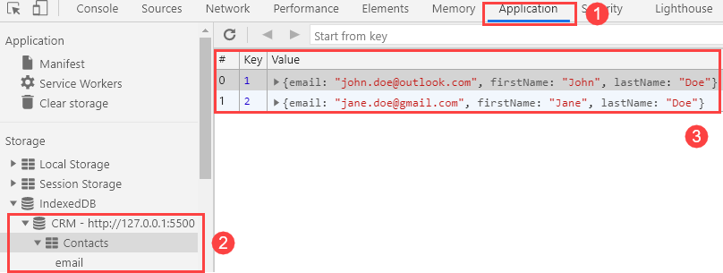

5) Read data from the object store by key
To read an object by its key, you use the get() method of the object store. The following getContactById() function finds a contact by an id:
function getContactById(db, id) {
const txn = db.transaction('Contacts', 'readonly');
const store = txn.objectStore('Contacts');

let query = store.get(id);

query.onsuccess = (event) => {
if (!event.target.result) {
console.log(`The contact with ${id} not found`);
} else {
console.table(event.target.result);
}
};

query.onerror = (event) => {
console.log(event.target.errorCode);
}

txn.oncomplete = function () {
db.close();
};
};
Code language: JavaScript (javascript)
When you call the get() method of the object store, it returns a query that will execute asynchronously.
Because the query can succeed or fail, you need to assign the onsuccess and onerror handlers to handle each case.
If the query succeeded, you’ll get the result in the event.target.result. Otherwise, you’ll get an error code via event.target.errorCode.
The following code closes the connection to the database once the transaction completes:
txn.oncomplete = function () {
db.close();
};
Code language: JavaScript (javascript)
Actually, the database connection is closed only when all the transactions are completed.
The following calls the getContactById() in the onsuccess event handler to get the contact with id 1:
request.onsuccess = (event) => {
const db = event.target.result;
getContactById(db, 1);
};
Code language: JavaScript (javascript)
Output:
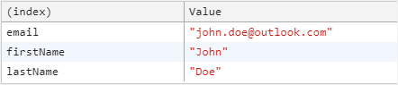

6) Read data from the object store by an index
The following defines a new function called getContactByEmail() that uses the email index to query data:
function getContactByEmail(db, email) {
const txn = db.transaction('Contacts', 'readonly');
const store = txn.objectStore('Contacts');

// get the index from the Object Store
const index = store.index('email');
// query by indexes
let query = index.get(email);

// return the result object on success
query.onsuccess = (event) => {
console.log(query.result); // result objects
};

query.onerror = (event) => {
console.log(event.target.errorCode);
}

// close the database connection
txn.oncomplete = function () {
db.close();
};
}
Code language: JavaScript (javascript)
How it works.
- First, get the email index object from the Contacts object store.
- Second, use the index to read the data by calling the get() method.
- Third, show the result in the onsuccess event handler of the query.
The following illustrates how to use the getContactByEmail() function in the onsuccess event handler:
request.onsuccess = (event) => {
const db = event.target.result;
// get contact by email
getContactByEmail(db, 'jane.doe@gmail.com');
};
Code language: JavaScript (javascript)
Output:
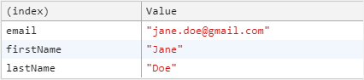

7) Read all data from an object store
The following shows how to use a cursor to read all the objects from the Contacts object store:
function getAllContacts(db) {
const txn = db.transaction('Contacts', "readonly");
const objectStore = txn.objectStore('Contacts');

objectStore.openCursor().onsuccess = (event) => {
let cursor = event.target.result;
if (cursor) {
let contact = cursor.value;
console.log(contact);
// continue next record
cursor.continue();
}
};
// close the database connection
txn.oncomplete = function () {
db.close();
};
}
Code language: JavaScript (javascript)
The objectStore.openCursor() returns a cursor used to iterate over an object store.
To iterate over the objects in an object store using the cursor, you need to assign an onsuccess handler:
objectStore.openCursor().onsuccess = (event) => {
//...
};
Code language: JavaScript (javascript)
The event.target.result returns the cursor. To get the data, you use the cursor.value property.
The cursor.continue() method advances the cursor to the position of the next record in the object store.
The following calls the getAllContacts() in the onsuccess event handler to show all data from the Contacts object store:
request.onsuccess = (event) => {
const db = event.target.result;
// get all contacts
getAllContacts(db);
};
Code language: JavaScript (javascript)
Output:

8) Delete a contact
To delete a record from the object store, you use the delete() method of the object store.
The following function deletes a contact by its id from the Contacts object store:
function deleteContact(db, id) {
// create a new transaction
const txn = db.transaction('Contacts', 'readwrite');

// get the Contacts object store
const store = txn.objectStore('Contacts');
//
let query = store.delete(id);

// handle the success case
query.onsuccess = function (event) {
console.log(event);
};

// handle the error case
query.onerror = function (event) {
console.log(event.target.errorCode);
}

// close the database once the
// transaction completes
txn.oncomplete = function () {
db.close();
};
}
Code language: JavaScript (javascript)
And you can call the deleteContact() function in the onsuccess event handler to delete the contact with id 1 as follows:
request.onsuccess = (event) => {
const db = event.target.result;
deleteContact(db, 1);
};
Code language: JavaScript (javascript)
If you run the code, you’ll find that the contact with id 1 will be deleted.

Put it all together
The following shows the complete app.js file:
(function () {
// check for IndexedDB support
if (!window.indexedDB) {
console.log(`Your browser doesn't support IndexedDB`);
return;
}

// open the CRM database with the version 1
const request = indexedDB.open('CRM', 1);

// create the Contacts object store and indexes
request.onupgradeneeded = (event) => {
let db = event.target.result;

// create the Contacts object store
// with auto-increment id
let store = db.createObjectStore('Contacts', {
autoIncrement: true
});

// create an index on the email property
let index = store.createIndex('email', 'email', {
unique: true
});
};

// handle the error event
request.onerror = (event) => {
console.error(`Database error: ${event.target.errorCode}`);
};

// handle the success event
request.onsuccess = (event) => {
const db = event.target.result;

// insert contacts
// insertContact(db, {
// email: 'john.doe@outlook.com',
// firstName: 'John',
// lastName: 'Doe'
// });

// insertContact(db, {
// email: 'jane.doe@gmail.com',
// firstName: 'Jane',
// lastName: 'Doe'
// });

// get contact by id 1
// getContactById(db, 1);

// get contact by email
// getContactByEmail(db, 'jane.doe@gmail.com');

// get all contacts
// getAllContacts(db);

deleteContact(db, 1);

};

function insertContact(db, contact) {
// create a new transaction
const txn = db.transaction('Contacts', 'readwrite');

// get the Contacts object store
const store = txn.objectStore('Contacts');
//
let query = store.put(contact);

// handle success case
query.onsuccess = function (event) {
console.log(event);
};

// handle the error case
query.onerror = function (event) {
console.log(event.target.errorCode);
}

// close the database once the
// transaction completes
txn.oncomplete = function () {
db.close();
};
}

function getContactById(db, id) {
const txn = db.transaction('Contacts', 'readonly');
const store = txn.objectStore('Contacts');

let query = store.get(id);

query.onsuccess = (event) => {
if (!event.target.result) {
console.log(`The contact with ${id} not found`);
} else {
console.table(event.target.result);
}
};

query.onerror = (event) => {
console.log(event.target.errorCode);
}

txn.oncomplete = function () {
db.close();
};
};

function getContactByEmail(db, email) {
const txn = db.transaction('Contacts', 'readonly');
const store = txn.objectStore('Contacts');

// get the index from the Object Store
const index = store.index('email');
// query by indexes
let query = index.get(email);

// return the result object on success
query.onsuccess = (event) => {
console.table(query.result); // result objects
};

query.onerror = (event) => {
console.log(event.target.errorCode);
}

// close the database connection
txn.oncomplete = function () {
db.close();
};
}

function getAllContacts(db) {
const txn = db.transaction('Contacts', "readonly");
const objectStore = txn.objectStore('Contacts');

objectStore.openCursor().onsuccess = (event) => {
let cursor = event.target.result;
if (cursor) {
let contact = cursor.value;
console.log(contact);
// continue next record
cursor.continue();
}
};
// close the database connection
txn.oncomplete = function () {
db.close();
};
}

function deleteContact(db, id) {
// create a new transaction
const txn = db.transaction('Contacts', 'readwrite');

// get the Contacts object store
const store = txn.objectStore('Contacts');
//
let query = store.delete(id);

// handle the success case
query.onsuccess = function (event) {
console.log(event);
};

// handle the error case
query.onerror = function (event) {
console.log(event.target.errorCode);
}

// close the database once the
// transaction completes
txn.oncomplete = function () {
db.close();
};

}
})();
Code language: JavaScript (javascript)

Summary
- The IndexedDB is a large-scale object stored in web browsers.
- The IndexedDB stores data as key-value pairs. The values can be any data including simple and complex ones.
- The IndexedDB consists of one or more databases. Each database has one or more object stores. Typically, you create a database in the IndexedDB per web application.
- The IndexedDB is useful for web applications that don’t require a persistent internet connection, especially for applications that work both online and offline.
https://www.javascripttutorial.net/web-apis/javascript-indexeddb/

Build a basic web app with IndexedDB
IndexedDB is a NoSQL database that you can use on every major browser to store lots of data and query it like you would in a database like MongoDB. If you’re making a web app or browser extension that stores lots of data and you want many ways to query those data, IndexedDB is where it’s at!
In this tutorial, we’re going to make a simple no-frameworks sticky note web app as an overview of the concepts you should know working with IndexedDB. For a more in-depth look, Mozilla Developer Network’s Using IndexedDB is another great overview, and I also recommend this tutorial from FreeCodeCamp, which focuses more on the API methods.
You can find the code for this tutorial at https://github.com/andyhaskell/indexeddb-tutorial and if you have questions on it, you can find me on Twitter at @AndyHaskell2013 and on askquestions.tech at canteloupeantelope!

Why should I use IndexedDB in my web app?
Like I said up top, two advantages of IndexedDB over local storage are:
- No size limit; if your app works with lots of data, more than the few megabytes you get with local and session storage, IndexedDB lets you store loads of data.
- Structured storage; you can store objects in IndexedDB object stores and query for those objects by their fields.
These are also advantages you can get storing data on servers, so if your project has a backend, you can always just store your data there. But if you’re making an offline-first web app or one without a backend, IndexedDB is a great choice for your stack. For example, I’m working on an browser extension to make a graph of your tabs for a visual, interactive web history. For that I wanted to be able to store a lot of tabs, retrieve them in chronological order, and the app has no web backend, so IndexedDB is a perfect fit!

Making our database
Okay let’s start making our app! To start, make a folder named indexeddb-tutorial, and in a file named db.js, add this code, which will make our database!
let db;
let dbReq = indexedDB.open('myDatabase', 1);dbReq.onupgradeneeded = function(event) {
// Set the db variable to our database so we can use it!
db = event.target.result;
// Create an object store named notes. Object stores
// in databases are where data are stored.
let notes = db.createObjectStore('notes', {autoIncrement: true});
}dbReq.onsuccess = function(event) {
db = event.target.result;
}dbReq.onerror = function(event) {
alert('error opening database ' + event.target.errorCode);
}
To run the JavaScript, put this code in a file named index.html and open it in Chrome:
<!DOCTYPE html>
<html>
<head><title>IndexedDB note store</title></head>
<body>
<div id="app"><h1>Coming soon</h1></div>
<script src="db.js"></script>
</body>
</html>
Now in Chrome, go to developer tools, click the application tab, and then click IndexedDB in the left bar, you can see that the database was created!
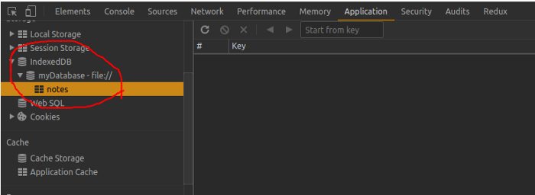
Cool! We have a database named myDatabase, and there’s an object store (a collection of items, similar to a SQL table or a collection in MongoDB) named notes. But that seemed like a lot of code for just creating the database and store. So what’s going on there?
In the first couple lines
let db;
let dbReq = indexedDB.open('myDatabase', 1);
We open version 1 of a database named myDatabase, but indexedDB.open doesn’t return a database, it returns a request for a database because IndexedDB is an asynchronous API. IndexedDB code runs behind the scenes so if we do something like store thousands of items, the rest of your web app won’t stop running its JavaScript waiting for that to complete. So in the rest of the code we listen for when ourdatabase is ready for us with event listeners:
dbReq.onupgradeneeded = function(event) {
db = event.target.result;
let notes = db.createObjectStore('notes', {autoIncrement: true});
}
myDatabase didn’t previously exist, so it’s automatically created and then the onupgradeneeded event fires. In an onupgradeneeded callback, and only in that callback, we can create a database’s object stores. So first, with db = event.target.result, we set the variable db to hold our database. Then, we create one object store named notes.
dbReq.onsuccess = function(event) {
db = event.target.result;
}
onsuccess fires after onupgradeneeded completes and it also fires if we refresh the page and open the database again. So there too, we run db = event.target.result to get our database so we can use it.
dbReq.onerror = function(event) {
alert('error opening database ' + event.target.errorCode);
}
Finally, if something goes wrong on any IndexedDB request, its onerror event fires so you can handle the error however you see fit. We’re just going to do an alert.

Put some data into the database
Well we’ve got our database, but we can’t do much with it without data. Let’s add a sticky note!
function addStickyNote(db, message) {
// Start a database transaction and get the notes object store
let tx = db.transaction(['notes'], 'readwrite');
let store = tx.objectStore('notes'); // Put the sticky note into the object store
let note = {text: message, timestamp: Date.now()};
store.add(note); // Wait for the database transaction to complete
tx.oncomplete = function() { console.log('stored note!') }
tx.onerror = function(event) {
alert('error storing note ' + event.target.errorCode);
}
}
To see this in action, let’s put some call to the function into our dbReq.onsuccess:
dbReq.onsuccess = function(event) {
db = event.target.result; // Add some sticky notes
addStickyNote(db, 'Sloths are awesome!');
addStickyNote(db, 'Order more hibiscus tea');
addStickyNote(db, 'And Green Sheen shampoo, the best for sloth fur algae grooming!');
}
Now refresh index.html in your browser, go to Application > IndexedDB in developer tools again, click on the object store, and let’s see our data!
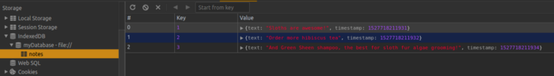
Now we have some data stored! And as you can see, our sticky notes in the notes object store are stored as JavaScript objects. So what was going on in that code?
let tx = db.transaction(['notes'], 'readwrite');
let store = tx.objectStore('notes');
First we start a transaction on our database to write data to our notes object store, and then we retrieve that object store from the transaction.
let note = {text: message, timestamp: Date.now()};
store.add(note);
We represent the sticky note as a JavaScript object and store it in the object store with store.add.
tx.oncomplete = function() { console.log('stored note!') }
tx.onerror = function(event) {
alert('error storing note ' + event.target.errorCode);
}
Finally, just like our open database request, this transaction has event listeners; we listen for when storing the note finishes or where an errror happens with the transaction’s oncomplete and onerror listeners.
Something else worth noting about our sticky notes is that each one has a number for its Key that counts up. So if you stored another note after those three, its key would be 4. Where did those numbers come from? In IndexedDB, all objects in an object store have a key identifying them, and when we created the object store with the line
let notes = db.createObjectStore('notes', {autoIncrement: true});
the autoIncrement option says that we want every object in the store to have a key that counts up. You can also make object stores with string keys if it makes more sense to store and retrieve objects by a unique name (for example a UUID could be a string key for an object store, or if you had an object store of sloths, you could identify each sloth by a string encoding of the tone of their squeak as the key).

Now let’s add this addStickyNote function to our actual web app; we need a text box to submit notes to, so in the <body> tag add these tags:
<!DOCTYPE html>
<html>
<head><title>IndexedDB note store</title></head>
<body>
<div id="app">
<div id="textbox">
<textarea id="newmessage"></textarea>
<button onclick="submitNote()">Add note</button>
</div>
</div>
<script src="db.js"></script>
</body>
</html>
And add this function to db.js that runs every time a user submits a note:
function submitNote() {
let message = document.getElementById('newmessage');
addStickyNote(db, message.value);
message.value = '';
}
Now get rid of the call to addStickyNote in dbReq.onsuccess and then if we go to index.html, we’ll see notes being stored in IndexedDB when we click submit!
Before we go on and I show you how to retrieve the data so we can display it, though, let’s take a detour to talk about a central concept to working with IndexedDB, transactions!

Transactions are king in IndexedDB
As you saw in our last example, to access our notes object store we had to run db.transaction to create a transaction, which is a set of one or more requests to the database. Everything in IndexedDB happens through transactions. So storing a sticky note, opening the database, and retrieving your notes are all requests that happen inside transactions.
You can have more than one request in the same transaction too, for example if you’re storing many items in the same object store, all of the store.add requests can be made in the same transaction, like:
function addManyNotes(db, messages) {
let tx = db.transaction(['notes'], 'readwrite');
let store = tx.objectStore('notes'); for (let i = 0; i < messages.length; i++) { // All of the requests made from store.add are part of
// the same transaction
store.add({text: messages[i], timestamp: Date.now()}); } tx.oncomplete = function() {console.log('transaction complete')};
}
Just like requests have onsuccess and onerror event handlers, transactions have oncomplete, onerror, and onabort event handlers we can use for responding to a transaction completing, erroring, or being rolled back.
But what exactly are we getting out of putting every request in a transaction? Remember that IndexedDB is an asynchronous API, so it’s possible to have many requests going on at the same time. Say we had a sticky note in the note store that said “Sloths are awesome”, and we made one request to make the note all-caps and another to add an exclamation point to the note. Without transactions, we could end up with a situation like this:
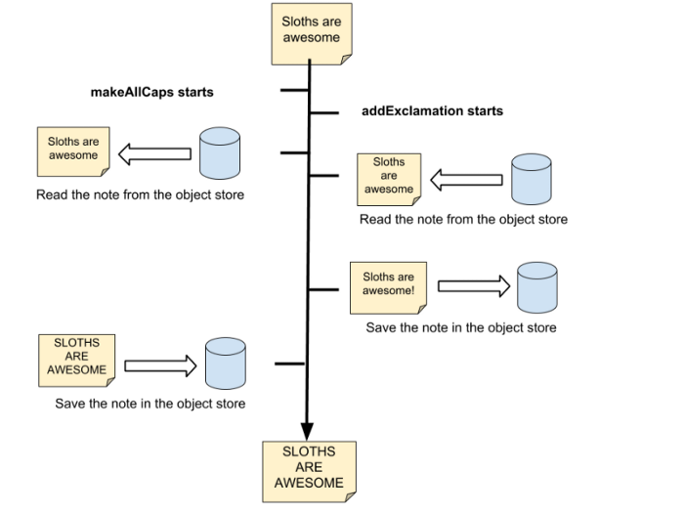
We start the makeAllCaps and addExclamation actions and both of them retrieve the unmodified “Sloths are awesome” note. addExclamation saves the note with an exclamation point first. makeAllCaps takes longer and it saves the note “SLOTHS ARE AWESOME”, with no exclamation point. The makeAllCaps update completely wipes out the update from addExclamation!
With transactions, though, we get concurrency control. Only one transaction can create, modify, or delete items in an object store at a time, so what really happens looks more like this:
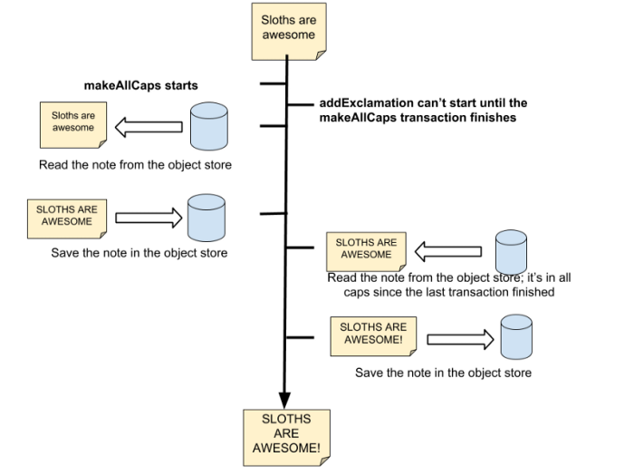
The makeAllCaps transaction starts first, but since addExclamation uses the same object store as makeAllCaps, it does not start until makeAllCaps finishes. So makeAllCaps finishes, addExclamation reads the note in all caps, and then both edits go through! 🎉
That also means if a road was an object store and a streetsweeper and a line painter were running without transactions, the line painter might paint before the streetsweeper moved a branch and you’d get this:

But with transactions, the streetsweeper can sweep branches out of the road and the line painter can paint lines so sloths can safely go for a bike ride!

Before we move on, one other thing to know is that transactions on the same object store only happen one-at-a-time if they’re modifying data; in other words they’rereadwrite transactions, which are created like this:
let tx = db.transaction(['notes', 'someOtherStore'], 'readwrite');
Here we make a transaction that’s readwrite and say that it affects notes and someOtherStore. Since it’s readwrite, it can’t start until any other transaction touching either of those object stores is done.
While readwrite transactions are one at a time, there are also readonly transactions; you can have as many of them as you want talking to the same object store simultaneously since we don’t need to keep them from messing with each other’s data! You make them like this:
// These transactions can all do their thing at the same time!
let tx = db.transaction(['notes', 'someOtherStore'], 'readonly');
let tx2 = db.transaction(['notes'], 'readonly');
let tx3 = db.transaction(['someOtherStore'], 'readonly');

Retrieving data and displaying your sticky notes
Now that we know how transactions work and how readonly transactions work, let’s retrieve the sticky notes from the note store so we can display them. If we’re getting just one item from our database, we would use an object store’s get method, like this:
// Set up an object store and transaction
let tx = db.transaction(['notes'], 'readonly');
let store = tx.objectStore('notes');// Set up a request to get the sticky note with the key 1
let req = store.get(1);// We can use the note if the request succeeds, getting it in the
// onsuccess handler
req.onsuccess = function(event) {
let note = event.target.result; if (note) {
console.log(note);
} else {
console.log("note 1 not found")
}
}// If we get an error, like that the note wasn't in the object
// store, we handle the error in the onerror handler
req.onerror = function(event) {
alert('error getting note 1 ' + event.target.errorCode);
}
We make a transaction, request the note in the note store with the key 1 to get our request, and then we either use the retrieved note in the request’s onsuccess handler, or we handle an error in the onerror handler if we get an error. Note that if the sticky note does not exist, onsuccess still fires, but event.target.result will be undefined.
The pattern feels similar to the handler we had for opening the database; we start the request, then get the result in the onsuccess handler or handle an error in the onerror handler. But we want to display all the notes, so we need to get all of them, and for that we use a cursor.
Retrieve all the items in the object store with a cursor has this funky syntax:
function getAndDisplayNotes(db) {
let tx = db.transaction(['notes'], 'readonly');
let store = tx.objectStore('notes'); // Create a cursor request to get all items in the store, which
// we collect in the allNotes array
let req = store.openCursor();
let allNotes = [];
req.onsuccess = function(event) {
// The result of req.onsuccess is an IDBCursor
let cursor = event.target.result; if (cursor != null) { // If the cursor isn't null, we got an IndexedDB item.
// Add it to the note array and have the cursor continue!
allNotes.push(cursor.value);
cursor.continue(); } else { // If we have a null cursor, it means we've gotten
// all the items in the store, so display the notes we got
displayNotes(allNotes); }
} req.onerror = function(event) {
alert('error in cursor request ' + event.target.errorCode);
}
}
We create a readonly transaction on the notes object store, we get the store, and then with the store.openCursor() method, we get a request, which means once again we’re working with its results with its onsuccess and onerror handlers to handle the results.
Inside the onsuccess handler, the event’s result is an IDBCursor containing the key of the sticky note the cursor is holding, as well as the sticky note itself as the cursor’s value.
let cursor = event.target.result;if (cursor != null) {
allNotes.push(cursor.value);
cursor.continue();
} else {
In the if statement, if the cursor isn’t null, that means we have another sticky note, so we add the cursor’s value to our array of notes and continue retrieving notes by calling cursor.continue().
} else {
displayNotes(allNotes);
}
But if the cursor is null, there are no more notes to retrieve, so we display the notes by passing them to a displayNotes function.
Hmm, this cursor.continue() thing feels kind of like a while loop, but there’s no looping or control flow going on. So how exactly are we looping? This line will give you a hint:
req.onsuccess = function(event) {
It turns out every time you call cursor.continue(), an event fires and sends the cursor with the next item to the onsuccess handler. So in each onsuccess, we collect another sticky note, until we get an onsuccess where the cursor is null. That’s how we iterate with cursors.
Now to display these notes, in index.html, after the textbox div, add a div below the text box to store our sticky notes:
<div id="notes"></div>
And in db.js add this function to display the notes:
function displayNotes(notes) {
let listHTML = '<ul>';
for (let i = 0; i < notes.length; i++) {
let note = notes[i];
listHTML += '<li>' + note.text + ' ' +
new Date(note.timestamp).toString() + '</li>';
}
document.getElementById('notes').innerHTML = listHTML;
}
That function just converts each note to an <li> tag and displays them as a list with old-school JavaScript.
Now that we have a function to display all the sticky notes, let’s add it in a couple places. We’ll want to be able to see all our sticky notes when we first open the app, so when the database first opens, we should have a call to getAndDisplayNotes in dbReq.onsuccess:
dbReq.onsuccess = function(event) {
db = event.target.result;
getAndDisplayNotes(db);
}
And when you add a sticky note, you should be able to see it right away, so in addStickyNote, let’s change the transaction oncomplete callback to call getAndDisplayNotes:
tx.oncomplete = function() { getAndDisplayNotes(db); }
Now reopen the page in Chrome and try adding some more notes. It should look something like this!
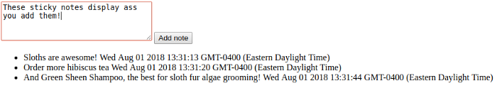
Now for one last thing, let’s make a mode to see the newest notes first and see why this is called IndexedDB!

Indices, putting the indexed in IndexedDB
We’ve got this sticky note store and we’re storing notes with timestamps, so it should make sense that we should be able to retrieve all sticky notes for a time range (like 5–10 minutes ago, or all the notes from a given day) or be able to retrieve them with the newest ones first, right?
Well we can, but to be able to query by the timestamp field, we need to give that field in the notes object store an index. Once we have that index, we can query by it. But remember that any changes to the structure of a database need to happen inside a database request’s onupgradeneeded handler, so we need to up the version of our database to create the index, like this:
// We update the version of the database to 2 to trigger
// onupgradeneeded
let dbReq = indexedDB.open('myDatabase', 2);dbReq.onupgradeneeded = function(event) {
db = event.target.result; // Create the nores object store, or retrieve it if it
// already exists.
let notes;
if (!db.objectStoreNames.contains('notes')) {
notes = db.createObjectStore('notes', {autoIncrement: true});
} else {
notes = dbReq.transaction.objectStore('notes');
} // If there isn't already a timestamp index, make one so we
// can query notes by their timestamps
if (!notes.indexNames.contains('timestamp')) {
notes.createIndex('timestamp', 'timestamp');
}
}
First, we update the version of our database to 2, which indicates that the structure of the database is changing, so we need an onupgradeneeded event:
let dbReq = indexedDB.open('myDatabase', 2);
Now we have a version upgrade where the notes object store already exists, so we check if there’s already a notes store with db.objectStoreNames:
if(!db.objectStoreNames.contains('notes'))
and if there’s already one, we retrieve it with dbReq.transaction.objectStore:
notes = dbReq.transaction.objectStore('notes');
Finally, we add an index with createIndex:
if (!notes.indexNames.includes('timestamp')) {
notes.createIndex('timestamp', 'timestamp');
}
The first parameter is the name of our index, and the second is the index’s keyPath. An index is actually itself an object store, so all items in an index have a key, so if you give an index the keyPath timestamp, then the timestamp of each object in the object store will be its key.
Additionally, there is an optional third options object parameter. Say our notes had titles and we wanted to require that a note could not be stored if it had the same title as another note. We could do that by creating a unique title index like this:
notes.createIndex('title', 'title', {unique: true})
To see our new index, once you update onupgradeneeded, refresh index.html in Chrome (you may need to X out of Chrome to see the change), go to Developer Tools > Application > IndexedDB again, and you should be able to see your notes object store:
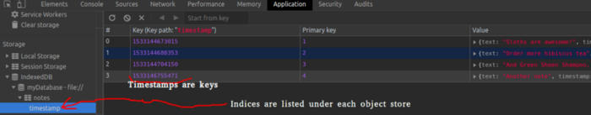
As you can see, the notes are now listed by their timestamps as their primary keys. And in fact, as an object store, an index has the same get and openCursor methods that a regular object store would. For example we could request the first note with a call to:
tx.objectStore('notes').index('timestamp').get(1533144673015)
Now that we’ve got a cool new index, let’s add a mode to our web app to flip the order we display notes in. First, in db.js, add a global bool variable:
let reverseOrder = false;
Then in getAndDisplayNotes, we just need to update our request:
let tx = db.transaction(['notes'], 'readonly');
let store = tx.objectStore('notes');// Retrieve the sticky notes index to run our cursor query on;
// the results will be ordered by their timestamp
let index = store.index('timestamp');
// Create our openCursor request; if we're going in reverse, then
// specify the direction as prev, otherwise, we specify it as next
let req = index.openCursor(null, reverseOrder ? 'prev' : 'next');
In store.index(), we retrieve the timestamp with the name we request, just like how we retrieve an object store from the transaction. Now we can define a cursor request to get back our notes ordered by the timestamp.
index.openCursor has two optional parameters. The first one, if it isn’t null, lets us specify the range of items we want to retrieve. For example, if we only wanted the sticky notes from the past hour, we could do:
let anHourAgoInMS = Date.now() - 60 * 60 * 1000;// IDBKeyRange is a global variable for defining ranges to query
// indices on
let keyRange = IDBKeyRange.lowerBound(anHourAgoInMS)
let req = index.openCursor(keyRange, 'next')
The second parameter is the order we want to retrieve items in, which can be 'prev' or 'next', so we specify our direction with:
reverseOrder ? 'prev' : 'next'
Finally, let’s see this in action; in index.html, add another button for flipping the order of the notes we display:
function flipNoteOrder(notes) {
reverseOrder = !reverseOrder;
getAndDisplayNotes(db);
}
And in index.html, add one more button for flipping the order of the notes
<button onclick="flipNoteOrder()">Flip note order</button>
And if you refresh Chrome, your flip button should now work!
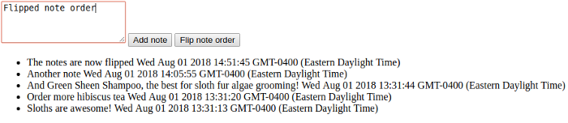
Cool! Now we can change the order we see notes in! Now you’ve seen the basics of IndexedDB. There are other functionalities we didn’t see in action, like deleting objects, storing binary data in IndexedDB, and multi-field indices, but this should be a good starting point for building web apps with IndexedDB.
As you could see though, the basic IndexedDB API, though powerful, doesn’t really have an ergonomic feel to it. I don’t know about you, but to me, these on event listeners feel inconvenient to reason about, and those handlers also took some thinking my first time figuring out how to give IndexedDB code test coverage. So in my next tutorial, I’ll show how to refactor this code to be clearer and more testable! Until next time,
https://medium.com/@AndyHaskell2013/build-a-basic-web-app-with-indexeddb-8ab4f83f8bda

