How to Add Modules to the Joomla Control Panel
Written by Steve Burge
Published: 08 February 2019

It's possible to customize the Joomla admin area for your users.
In particular, it can be useful to customize the control panel that users see when they first login.
Here's how to modify the Joomla admin area to show the information that you or your client require:
- Go to Extensions > Modules
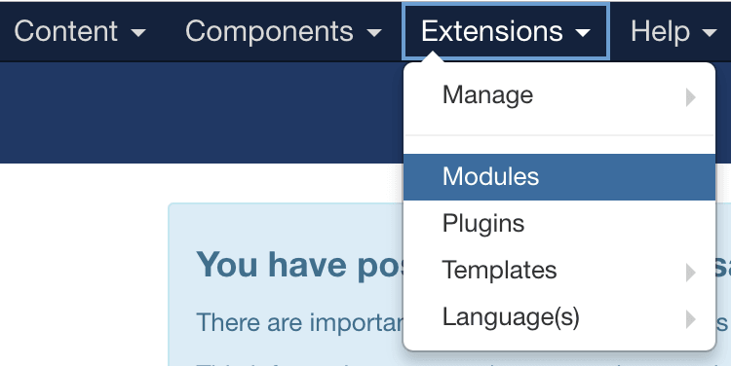
- In the dropdown menu, choose "Administrator" instead of "Site":
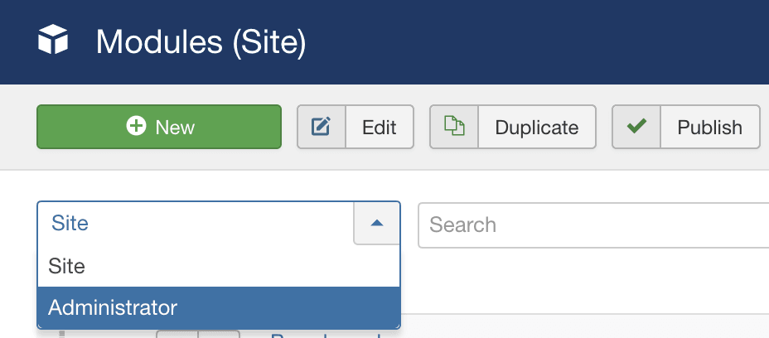
- Click the green "New" button.
- Choose the module you want to add for your users. I'm going to choose "Custom":
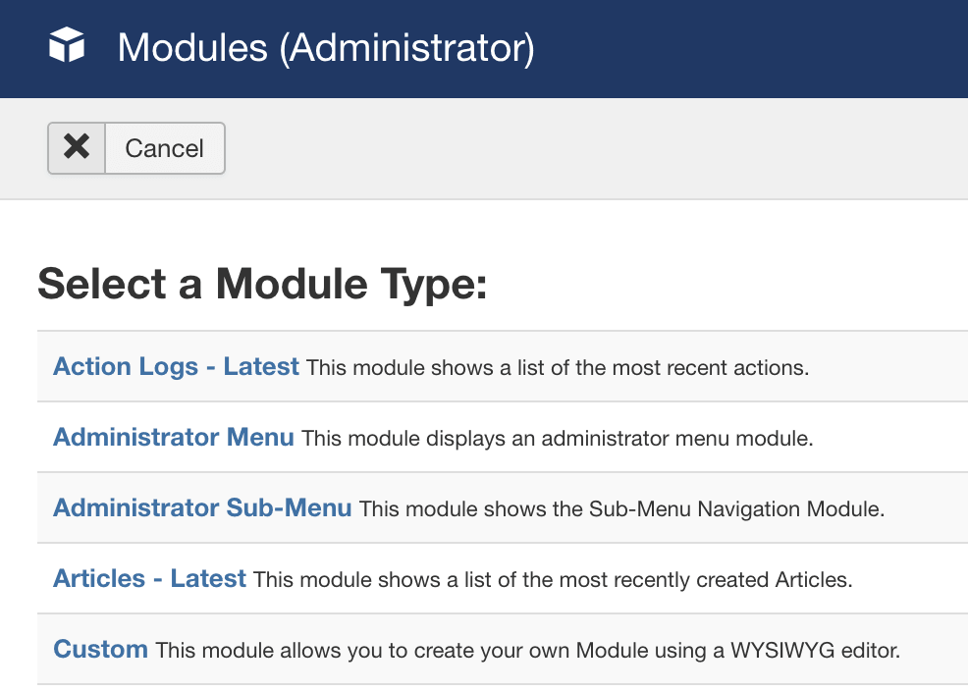
- Create your module as you would normally do:
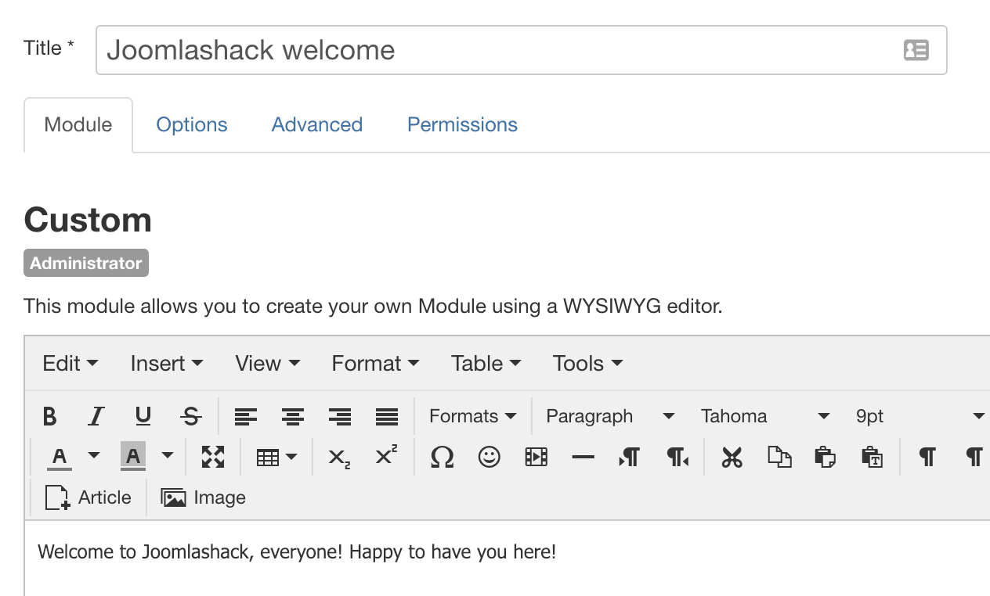
- For the position, look for options available. In this example, I'm going to choose "cpanel".
- If you want the module to appear high up on the screen, set a number such as "1" or "2" for "Order". This post has more on reordering items in Joomla.
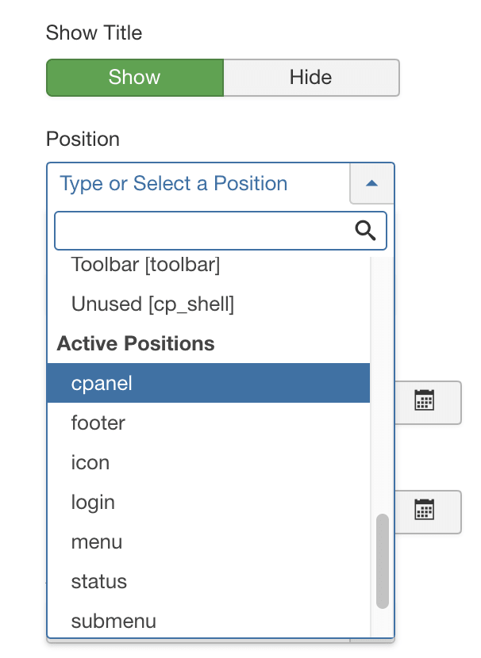
- Save the module.
- Your new module will appear on the control panel:
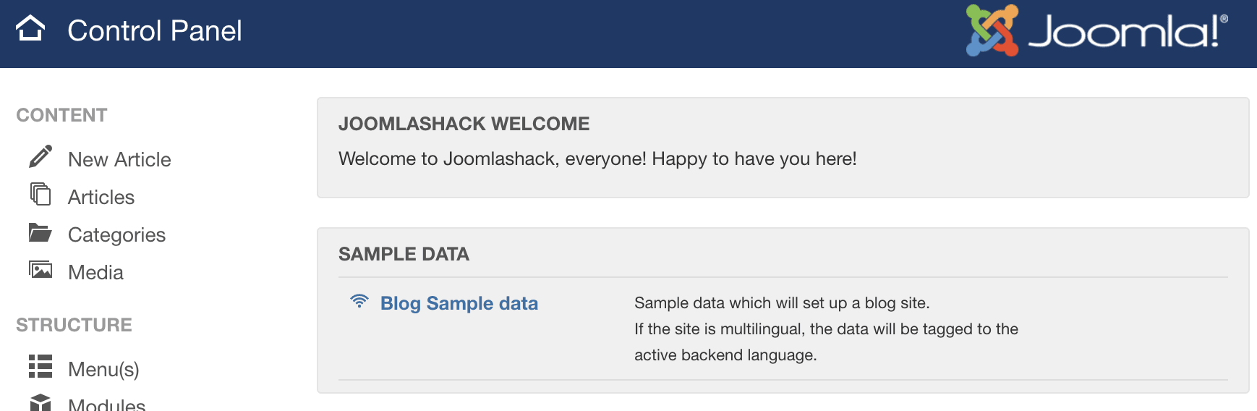

Comments (1)


- 
federweb Friday, 11 January 2019
thanks!

Join Joomlashack
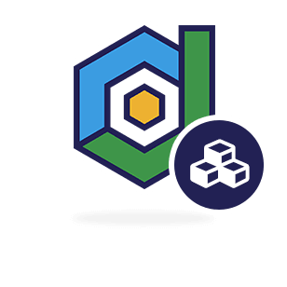
Get all our extensions, templates and training for one low price. It's the best deal in Joomla!
Join Joomlashack for one low price!

Popular Joomla Posts
- How to Change Joomla's Date and Time Format
- How to Solve Common Joomla Installation Problems
- How to Display a Search Module in a Joomla Menu
- How to Create Template Overrides for Joomla Articles
- How to Use Joomla's Privacy and GDPR Features
- How to Create Custom Administrator Menus in Joomla
- How to Add Font Awesome Icons to Joomla Menu Links
- How to Remove the Pagination Numbers from Joomla

Please share our posts
You are welcome to translate, re-use and modify any Joomlashack post.
All we ask is that you link back to our original tutorial and that you don't use them commercially.
Full license details.
https://www.joomlashack.com/blog/joomla/modules-control-panel/

