Teams
- Introduction
- Team Creation
  - Actions
  - Views / Pages
- Inspecting User Teams
  - The Current Team
  - The Team Object
- Member Management
  - Member Management Actions
  - Member Management Views / Pages
  - Invitations
- Roles / Permissions
  - Authorization
  - Combining Team Permissions With API Permissions

# Introduction
If you installed Jetstream using the --teams option, your application will be scaffolded to support team creation and management.
Jetstream's team features allow each registered user to create and belong to multiple teams. By default, every registered user will belong to a "Personal" team. For example, if a user named "Sally Jones" creates a new account, they will be assigned to a team named "Sally's Team". After registration, the user may rename this team or create additional teams.
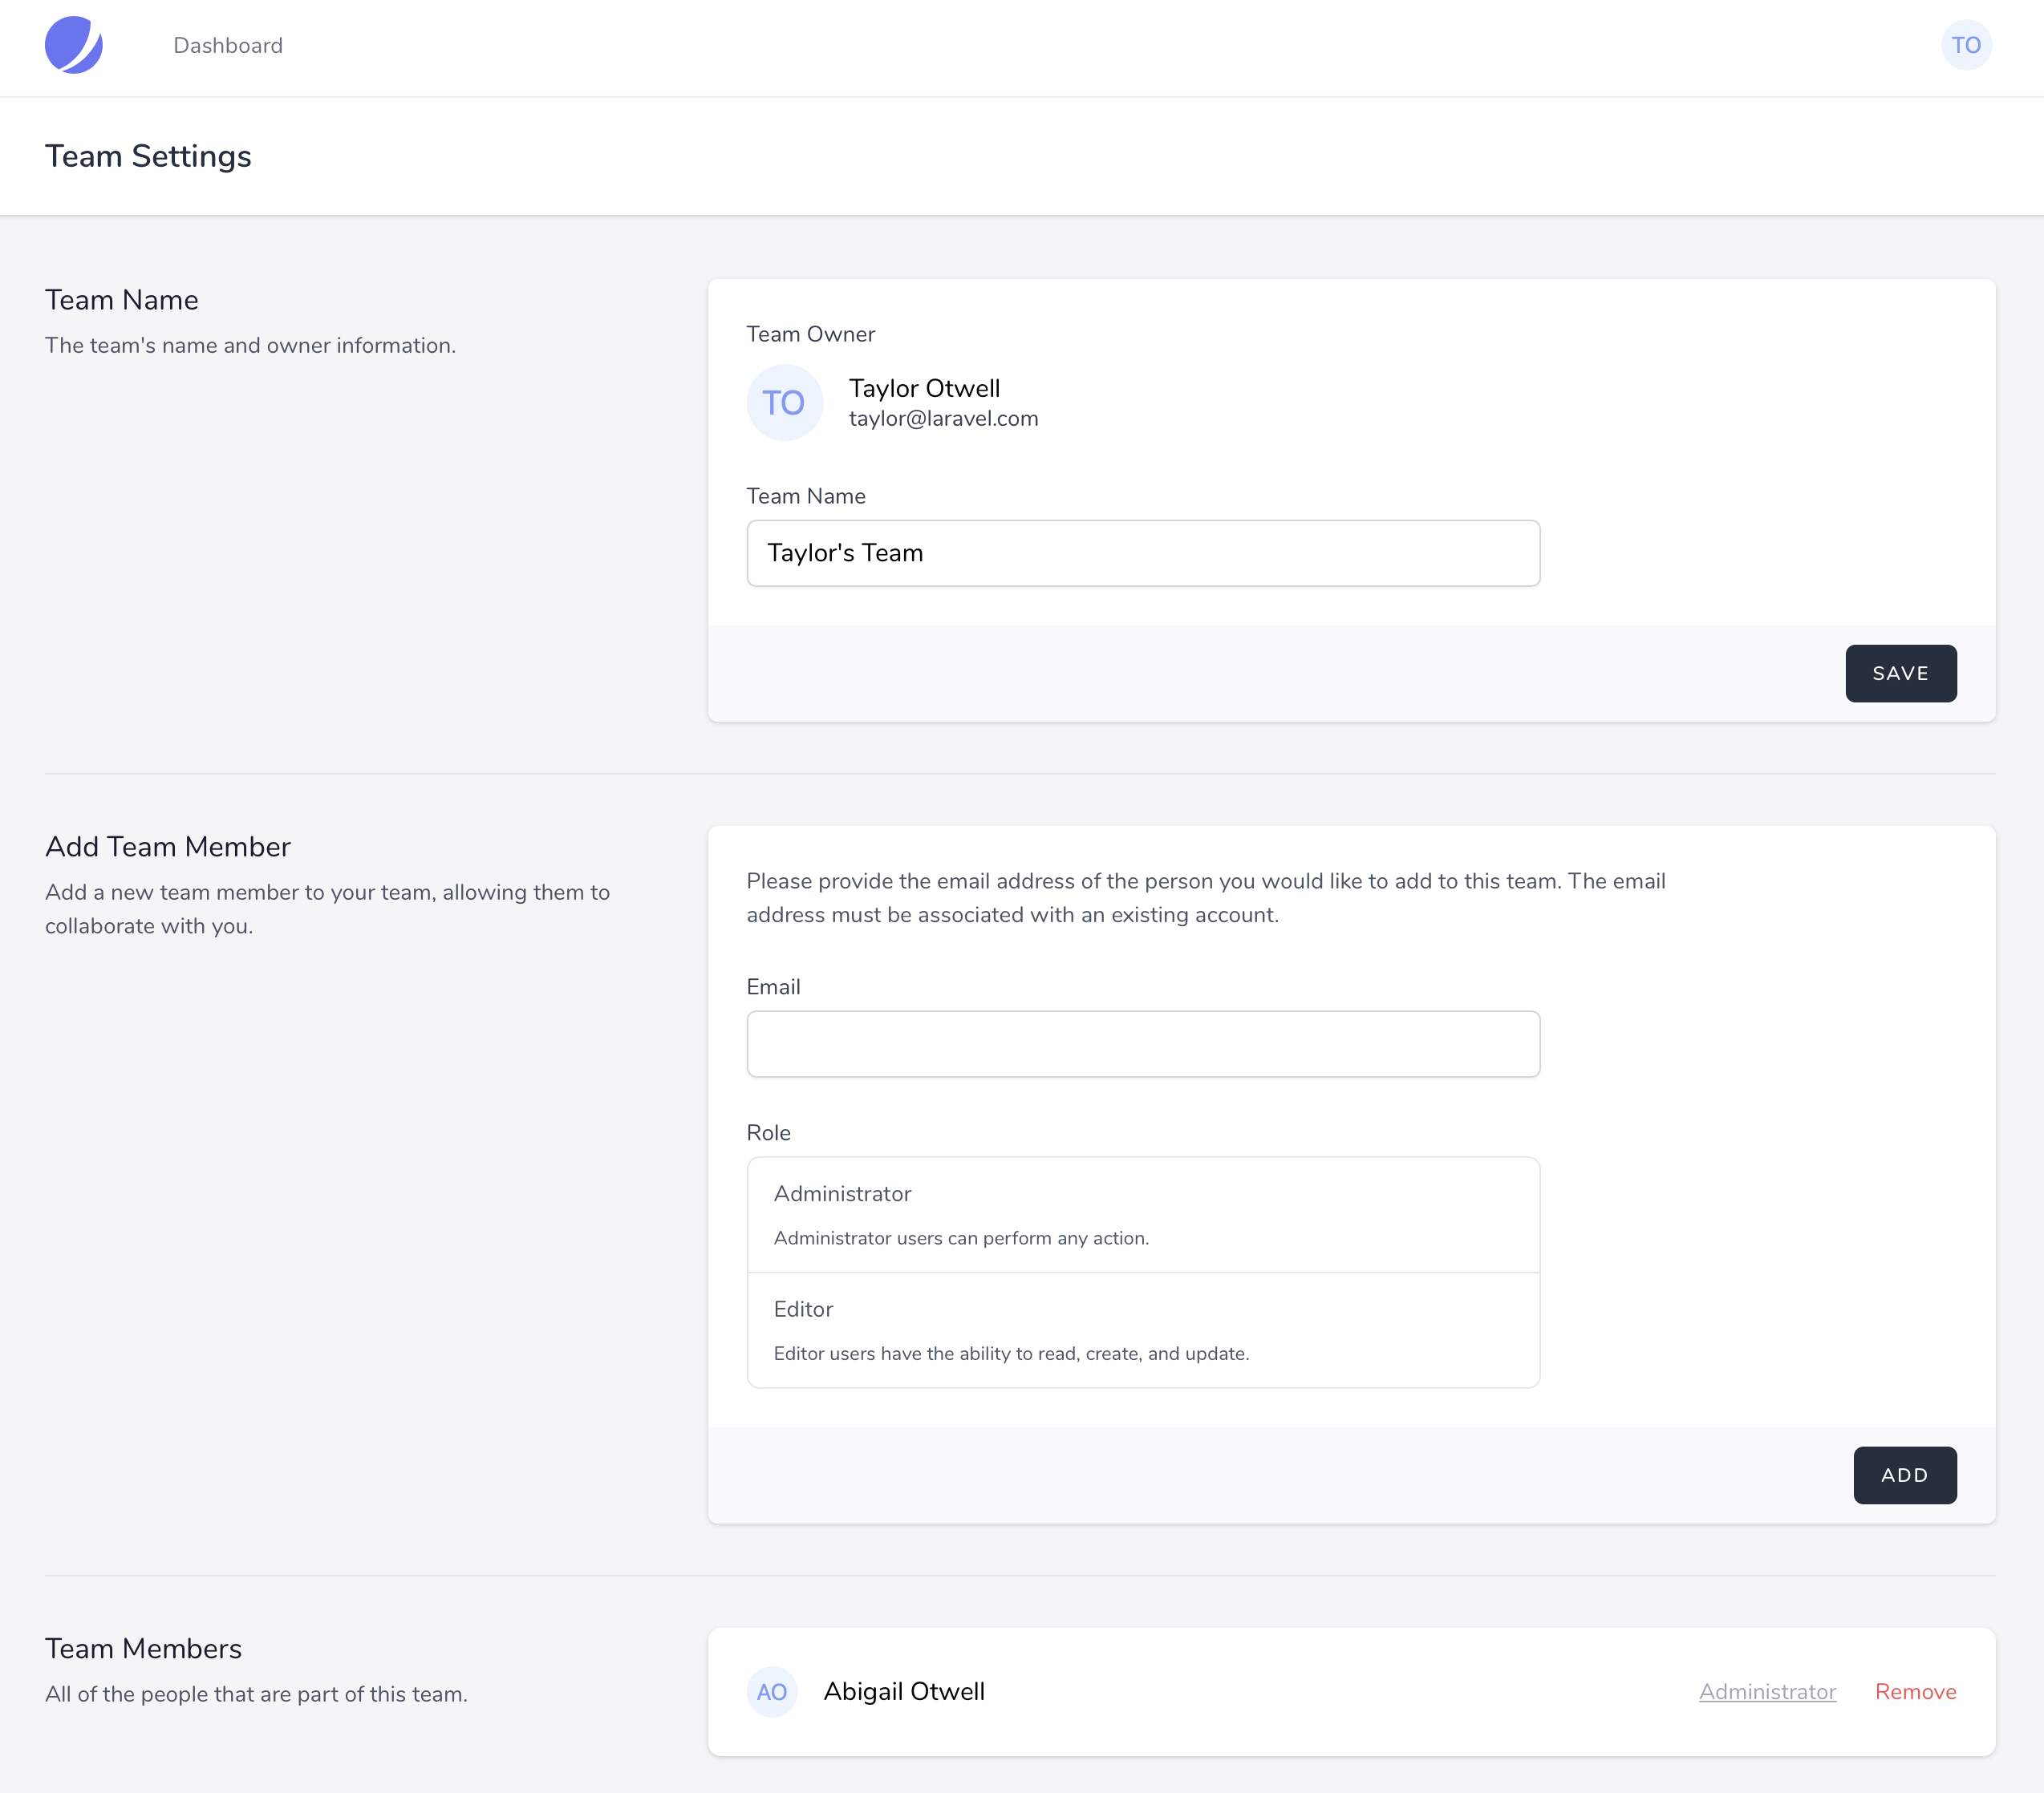
Jetstream Teams
Jetstream's team scaffolding and opinions may not work for every application. If it doesn't work for your use case, feel free to create a non-team based Jetstream application and manually add team functionality to your application based on your own needs.

# Team Creation
The team creation view is accessed via the top-right user navigation dropdown menu.

# Actions
Like many other Jetstream features, team creation and deletion logic may be customized by modifying the relevant action classes within your app/Actions/Jetstream directory. These actions include CreateTeam, UpdateTeamName, and DeleteTeam. Each of these actions is invoked when their corresponding task is performed by the user in the application's UI. You are free to modify these actions as required based on your application's needs.

# Views / Pages
When using the Livewire stack, the team creation view is displayed using the resources/views/teams/create-team-form.blade.php Blade template. When using the Inertia stack, this view is displayed using the resources/js/Pages/Teams/CreateTeamForm.vue template. Additional input fields that are specified on the team creation forms will be provided to the App\Actions\Jetstream\CreateTeam action class when the user creates a team.

# Inspecting User Teams
Information about a user's teams may be accessed via the methods provided by the Laravel\Jetstream\HasTeams trait. This trait is automatically applied to your application's App\Models\User model during Jetstream's installation. This trait provides a variety of helpful methods that allow you to inspect a user's teams:
// Access a user's currently selected team...
$user->currentTeam : Laravel\Jetstream\Team

// Access all of the team's (including owned teams) that a user belongs to...
$user->allTeams() : Illuminate\Support\Collection

// Access all of a user's owned teams...
$user->ownedTeams : Illuminate\Database\Eloquent\Collection

// Access all of the teams that a user belongs to but does not own...
$user->teams : Illuminate\Database\Eloquent\Collection

// Access a user's "personal" team...
$user->personalTeam() : Laravel\Jetstream\Team

// Determine if a user owns a given team...
$user->ownsTeam($team) : bool

// Determine if a user belongs to a given team...
$user->belongsToTeam($team) : bool

// Get the role that the user is assigned on the team...
$user->teamRole($team) : \Laravel\Jetstream\Role

// Determine if the user has the given role on the given team...
$user->hasTeamRole($team, 'admin') : bool

// Access an array of all permissions a user has for a given team...
$user->teamPermissions($team) : array

// Determine if a user has a given team permission...
$user->hasTeamPermission($team, 'server:create') : bool

# The Current Team
Every user within a Jetstream application has a "current team". This is the team that the user is actively viewing resources for. For example, if you are building a calendar application, your application would display the upcoming calendar events for the user's current team.
You may access the user's current team using the $user->currentTeam Eloquent relationship. This relationship may be used to scope your other Eloquent queries by the user's current team:
use App\Models\Calendar;

return Calendar::where(
'team_id', $request->user()->currentTeam->id
)->get();
Switching Teams
A user may switch their current team via the "team switcher" menu available within the Jetstream navigation bar.

# The Team Object
The team object that is accessed via $user->currentTeam or Jetstream's other team-related Eloquent queries provides a variety of useful methods for inspecting the team's attributes and relationships:
// Access the team's owner...
$team->owner : App\Models\User

// Get all of the team's users, including the owner...
$team->allUsers() : Illuminate\Database\Eloquent\Collection

// Get all of the team's users, excluding the owner...
$team->users : Illuminate\Database\Eloquent\Collection

// Determine if the given user is a team member...
$team->hasUser($user) : bool

// Determine if the team has a member with the given email address...
$team->hasUserWithEmail($emailAddress) : bool

// Determine if the given user is a team member with the given permission...
$team->userHasPermission($user, $permission) : bool

# Member Management
Team members may be added and removed from a team via Jetstream's "Team Settings" view. By default, only team owners can manage team membership. This restriction is defined in the App\Policies\TeamPolicy class. Naturally, you are free to modify this policy as you see fit.

# Member Management Actions
Like the customization process for other Jetstream features, team member addition logic may be customized by modifying the App\Actions\Jetstream\AddTeamMember action class. The class' add method is invoked with the currently authenticated user, the Laravel\Jetstream\Team instance, the email address of the user being added to the team, and the role (if applicable) of the user being added to the team.
This action is responsible for validating that the user can actually be added to the team and then adding the user to the team. You are free to customize this action based on the needs of your particular application.
Team member removal may be customized by modifying the App\Actions\Jetstream\RemoveTeamMember action class.

# Member Management Views / Pages
When using the Livewire stack, the team member manager view is displayed using the resources/views/teams/team-member-manager.blade.php Blade template. When using the Inertia stack, this view is displayed using the resources/js/Pages/Teams/TeamMemberManager.vue template. Generally, these templates should not require customization.

# Invitations
By default, Jetstream will simply add any existing application user that you specify to your team. However, many applications choose to send invitation emails to users that are invited to teams. If the user does not have an account, the invitation email can instruct them to create an account and accept the invitation. Or, if the user already has an account, they can accept or ignore the invitation.
Thankfully, Jetstream allows you to enable team member invitations for your application with just a few lines of code. To get started, pass the invitations option when enabling the "teams" feature for your application. This may be done by modifying the features array of your application's config/jetstream.php configuration file:
use Laravel\Jetstream\Features;

'features' => [
Features::termsAndPrivacyPolicy(),
Features::profilePhotos(),
Features::api(),
Features::teams(['invitations' => true]),
Features::accountDeletion(),
],
Once you have enabled Jetstream's invitations feature, users that are invited to teams will receive an invitation email with a link to accept the team invitation. Users will not be full members of the team until the invitation is accepted.

# Invitation Actions
When a user is invited to the team, your application's App\Actions\Jetstream\InviteTeamMember action will be invoked with the currently authenticated user, the team that the new user is invited to, the email address of the invited user, and, optionally, the role that should be assigned to the user once they join the team. You are free to review this action or modify it based on the needs of your own application.
Laravel Mail
Before using the team invitation feature, you should ensure that your Laravel application is configured to send emails
. Otherwise, Laravel will be unable to send team invitation emails to your application's users.

# Roles / Permissions
Each team member added to a team may be assigned a given role, and each role is assigned a set of permissions. Role permissions are defined in your application's App\Providers\JetstreamServiceProvider class using the Jetstream::role method. This method accepts a "slug" for the role, a user-friendly role name, the role permissions, and a description of the role. This information will be used to display the role within the team member management view.
For example, imagine we are building a server management application such as Laravel Forge
. We might define our application's team roles like so:
Jetstream::defaultApiTokenPermissions(['read']);

Jetstream::role('admin', 'Administrator', [
'server:create',
'server:read',
'server:update',
'server:delete',
])->description('Administrator users can perform any action.');

Jetstream::role('support', 'Support Specialist', [
'server:read',
])->description('Support specialists can read server information.');
Team API Support
When Jetstream is installed with team support, available API permissions are automatically derived by combining all unique permissions available to roles. Therefore, a separate call to the Jetstream::permissions method is unnecessary.

# Authorization
Of course, you will need a way to authorize that incoming requests initiated by a team member may actually be performed by that user. A user's team permissions may be inspected using the hasTeamPermission method available via the Laravel\Jetstream\HasTeams trait.
There is typically not a need to inspect a user's role. You only need to inspect that the user has a given granular permission. Roles are simply a presentational concept used to group granular permissions. Typically, you will execute calls to this method within your application's authorization policies
:
return $user->hasTeamPermission($server->team, 'server:update');

# Combining Team Permissions With API Permissions
When building a Jetstream application that provides both API support and team support, you should verify an incoming request's team permissions and API token permissions within your application's authorization policies. This is important because an API token may have the theoretical ability to perform an action while a user does not actually have that action granted to them via their team permissions:
/**
* Determine whether the user can update a flight.
*
* @param \App\Models\User $user
* @param \App\Models\Flight $flight
* @return bool
*/
public function view(User $user, Flight $flight)
{
return $user->belongsToTeam($flight->team) &&
$user->hasTeamPermission($flight->team, 'flight:view') &&
$user->tokenCan('flight:view');
}
https://jetstream.laravel.com/2.x/features/teams.html

Creating a Multi-User To-Do Application with Laravel JetStream
#php #showdev #tutorial #webdev
 Erika Heidi ・Updated on ・9 min read
Laravel is a modern PHP framework that allows developers to build web applications of all sizes. With a plethora of supporting packages and extensions that compose its ecosystem, Laravel has become a popular choice for enabling developers to focus on their app features rather than spending time on tasks that are part of the application bootstrap.
In addition to the built-in features that come with the framework, some extensions can highly speed up development time - that is the case with the new Laravel JetStream. Quoting the official docs:
Laravel Jetstream is a beautifully designed application scaffolding for Laravel. Jetstream provides the perfect starting point for your next Laravel application and includes login, registration, email verification, two-factor authentication, session management, API support via Laravel Sanctum, and optional team management.
In this tutorial, I'll share what I've learned in the last week while working on a hackaton project with Laravel + JetStream. We'll build a simple to-do application using Livewire actions under a secured area.

1. Environment Setup
First, you'll need to get Laravel installed on your local machine or development environment. Here are a few resources that can help you setting that up:
- How to Install and Run Laravel with LEMP on Ubuntu
- How to Install and Run Laravel on containers with Docker Compose
If you already have a working PHP development environment with Composer, you can create a brand new Laravel application with:
composer create-project --prefer-dist laravel/laravel mytodo
In addition to that, you'll need NPM to install the modules required by Jetstream / Livewire. To install it on a local Linux-based development environment, run:
curl -sL https://deb.nodesource.com/setup_14.x | bash - && \
apt-get install -yq nodejs build-essential
If you're using a Docker-based setup, you can include the following line to your Dockerfile to get NPM installed:
# Install NPM for Livewire
RUN curl -sL https://deb.nodesource.com/setup_14.x | bash - && \
apt-get install -yq nodejs build-essential
Full Dockerfile for reference
Once you have a working Laravel installation that you can access from your browser, you can proceed with the rest of this tutorial.

2. Installing Jetstream
With a working Laravel installation up and running, the next step is to install Jetstream with Composer. In case you are running this with Docker Compose, don't forget to prefix the next commands with docker-compose exec app:
composer require laravel/jetstream
Set up Jetstream to use Livewire:
php artisan jetstream:install livewire
Next, install and build the NPM dependencies:
npm install && npm run dev
Finally, migrate the database so that all required tables are created:
php artisan migrate
You should now be able to access your application and register a new user at /register. Login is available at /login. After registering a user and logging in, you'll be redirected to your application dashboard:
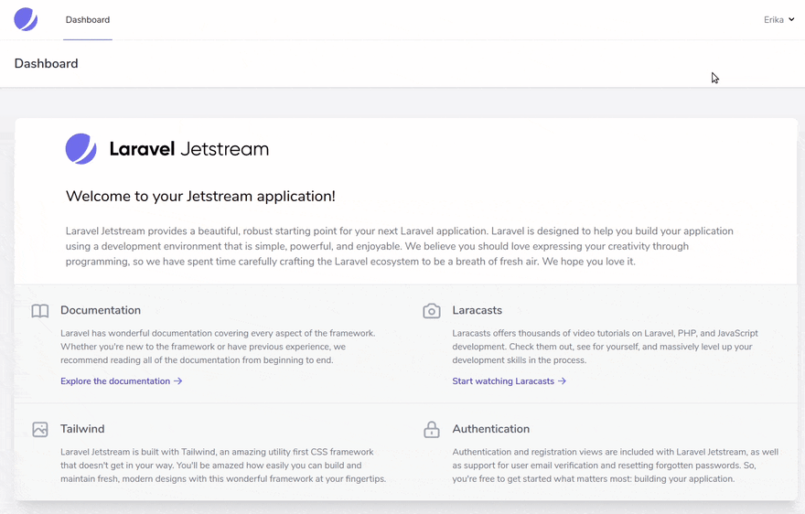
On the top right corner, you'll find the "profile" section, which contains your user settings including 2fa configuration.

2. Creating a Database Migration for the to-do list
We'll need a table to hold our to-do items. This will require a model and a database migration. You can use the following helper artisan command to create a new model:
docker-compose exec app php artisan make:model TodoItem
docker-compose exec app php artisan make:migration create-todo-items-table
To minimize complexity, we'll create a simple table with no foreign keys / relationships. If you plan on deploying this application to production, however, you should make sure list items are linked to the user who created them, since the registration form is open by default.
Replace the contents of the generated migration file with the following migration class:
<?php

use Illuminate\Database\Migrations\Migration;
use Illuminate\Database\Schema\Blueprint;
use Illuminate\Support\Facades\Schema;

class CreateTodoItemTable extends Migration
{
/**
* Run the migrations.
*
* @return void
*/
public function up()
{
Schema::create('todo_items', function (Blueprint $table) {
$table->id();
$table->string('description');
$table->boolean('done')->default(false);
$table->timestamps();
});
}

/**
* Reverse the migrations.
*
* @return void
*/
public function down()
{
Schema::dropIfExists('todo_items');
}
}
You'll need to run the migrations now with:
php artisan migrate

3. Creating a New Dashboard Section
Now comes the most interesting part of the work, and also the most challenging, since the gap between getting the initial setup ready and understanding all the components that are installed is quite steep - unless you are used to things like Livewire and TailwindCSS, which I wasn't at first.
Jetstream uses both Blade Components and Livewire components, which might result in confusion for some people. From my short experience figuring all this out, I believe the included Blade components are mostly structural so you can go ahead and create your new dashboard pages using Livewire. This will allow you to integrate javascript actions without writing a single JS line!
We'll create a new section within the dashboard to manage the todo items. Copy the dashboard view to use as base for your new page:
cp resources/views/dashboard.blade.php resources/views/todo.blade.php
Next, create two Livewire components: todo.show and todo.form:
php artisan make:livewire todo.show
php artisan make:livewire todo.form
If you check your application folders now, you'll find a new Livewire directory inside app/Http. These are the component controllers. The generated views are located at resources/views/livewire/todo.
These components will be rendered through the new todo.blade.php. Open that file now and replace the x-jet-welcome section with a Livewire tag to render the show component. We'll also include the form component at the top. This is how the updated view will look like:
#resources/views/todo.blade.php
<x-app-layout>
<x-slot name="header">
<h2 class="font-semibold text-xl text-gray-800 leading-tight">
{{ __('My To-Do List') }}
</h2>
</x-slot>

<div>
<div class="max-w-7xl mx-auto py-10 sm:px-6 lg:px-8">
@livewire('todo.form')
</div>
</div>

<div class="py-12">
<div class="max-w-7xl mx-auto sm:px-6 lg:px-8">
<div class="bg-white overflow-hidden shadow-xl sm:rounded-lg">
@livewire('todo.show')
</div>
</div>
</div>
</x-app-layout>
Also, update the resources/views/navigation-dropdown.blade.php file to include your new section. This is how my updated Navigation Links code looks like:
#resources/views/navigation-dropdown.blade.php
...
<!-- Navigation Links -->
<div class="hidden space-x-8 sm:-my-px sm:ml-10 sm:flex">
<x-jet-nav-link href="{{ route('dashboard') }}" :active="request()->routeIs('dashboard')">
{{ __('Dashboard') }}
</x-jet-nav-link>

<x-jet-nav-link href="{{ route('dashboard-todo') }}" :active="request()->routeIs('dashboard-todo')">
{{ __('To-Do List') }}
</x-jet-nav-link>
</div>
...
Now add a new protected route to routes/web.php. I just copied the dashboard route and updated accordingly:
Route::middleware(['auth:sanctum', 'verified'])->get('/dashboard/todo', function () {
return view('todo');
})->name('dashboard-todo');
If you go to your dashboard now, you should see the new link in the navigation menu. It will show a blank page, since we didn't customize our components yet:
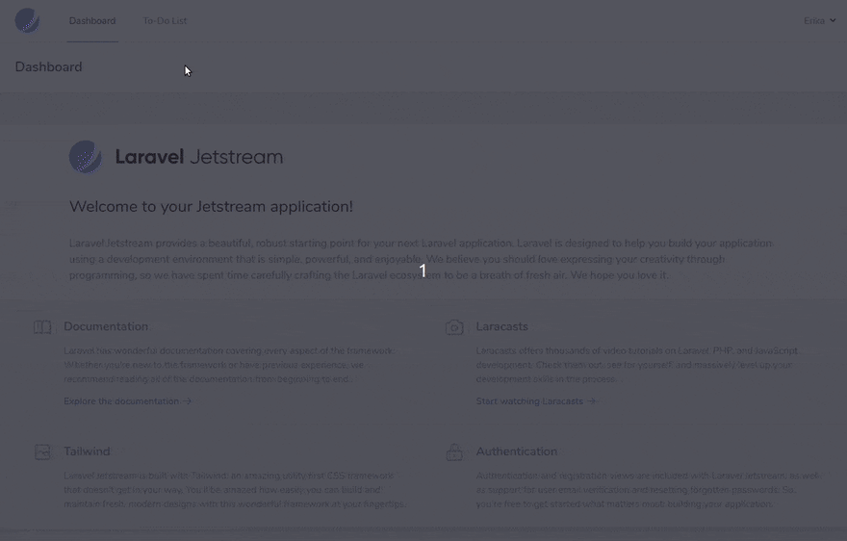
Next, we'll customize our components.

4. Creating to-do item form and listing items in the dashboard
To include new items in the list, we'll need to create a form. The bad news is that there isn't a command to bootstrap that for you, but the good news is that you can use the included profile forms at resources/views/profile as base for your work.
Open the resources/views/livewire/todo/form.blade.php file and replace the content with the following:
#resources/views/livewire/todo/form.blade.php
<x-jet-form-section submit="createItem">
<x-slot name="title">
{{ __('Create New To-Do Item') }}
</x-slot>

<x-slot name="description">
{{ __('Create a new item in your to-do list.') }}
</x-slot>

<x-slot name="form">
<div class="col-span-6 sm:col-span-4">
<x-jet-label for="description" value="{{ __('Item Description') }}" />
<x-jet-input id="description" type="text" class="mt-1 block w-full" wire:model.defer="description" autocomplete="description" />
<x-jet-input-error for="description" class="mt-2" />
</div>
</x-slot>

<x-slot name="actions">
<x-jet-action-message class="mr-3" on="saved">
{{ __('Saved.') }}
</x-jet-action-message>

<x-jet-button>
{{ __('Save') }}
</x-jet-button>
</x-slot>
</x-jet-form-section>
The form is ready, but we still need to set up the action that will handle this form. Open the app/Http/Livewire/Todo/Form.php file and update it to include a createItem method:
#app/Http/Livewire/Todo/Form.php
<?php

namespace App\Http\Livewire\Todo;

use App\Models\TodoItem;
use Livewire\Component;

class Form extends Component
{
public $description;

protected $rules = [
'description' => 'required|min:6'
];

public function render()
{
return view('livewire.todo.form');
}

public function createItem()
{
$this->validate();

$item = new TodoItem();
$item->description = $this->description;
$item->save();

$this->emit('saved');
}
}
Update the "show" component controller to inject the To-Do items in the view, after obtaining them with an Eloquent call. We have also implemented here an event listener that will be triggered when a new item is saved, to refresh the list of items:
#app/Http/Livewire/Todo/Show.php
<?php

namespace App\Http\Livewire\Todo;

use App\Models\TodoItem;
use Livewire\Component;

class Show extends Component
{
protected $listeners = ['saved'];

public function render()
{
$list = TodoItem::all()->sortByDesc('created_at');

return view('livewire.todo.show', [ 'list' => $list ]);
}

public function saved()
{
$this->render();
}
}

Update the "show" component view to list the items with a @foreach loop:
#resources/views/livewire/todo/show.blade.php
<div>
<table class="table-auto w-full">
<thead>
<tr>
<th class="px-4 py-2">Item</th>
<th class="px-4 py-2">Status</th>
</tr>
</thead>
<tbody>
@foreach ($list as $item)
<tr @if($loop->even)class="bg-grey"@endif>
<td class="border px-4 py-2">{{ $item->description }}</td>
<td class="border px-4 py-2">@if($item->done)Done @else To Do @endif</td>
</tr>
@endforeach
</tbody>
</table>

</div>

5. Creating Livewire actions to update and delete items
Last but not least, we need to be able to delete items and mark them as "done" (or "undone"). We can implement these quite easily using Livewire actions.
First, update your Todo/Show component controller to include three short methods: markAsDone, markAsToDo, and deleteItem:
#app/Http/Livewire/Todo/Show.php
<?php

namespace App\Http\Livewire\Todo;

use App\Models\TodoItem;
use Livewire\Component;

class Show extends Component
{
protected $listeners = ['saved'];

public function render()
{
$list = TodoItem::all()->sortByDesc('created_at');

return view('livewire.todo.show', [ 'list' => $list ]);
}

public function saved()
{
$this->render();
}

public function markAsDone(TodoItem $item)
{
$item->done = true;
$item->save();
}

public function markAsToDo(TodoItem $item)
{
$item->done = false;
$item->save();
}

public function deleteItem(TodoItem $item)
{
$item->delete();
}
}

Finally, update your view to include operational buttons for those actions:
#resources/views/livewire/todo/show.blade.php
<div>
<table class="table-auto w-full">
<thead>
<tr>
<th class="px-4 py-2">Item</th>
<th class="px-4 py-2">Status</th>
<th class="px-4 py-2">Actions</th>
</tr>
</thead>
<tbody>
@foreach ($list as $item)
<tr @if($loop->even)class="bg-grey"@endif>
<td class="border px-4 py-2">{{ $item->description }}</td>
<td class="border px-4 py-2">@if($item->done)Done @else To Do @endif</td>
<td class="border px-4 py-2">
@if($item->done)
<button wire:click="markAsToDo({{ $item->id }})" class="bg-red-100 text-red-600 px-6 rounded-full">
Mark as "To Do"
</button>
@else
<button wire:click="markAsDone({{ $item->id }})" class="bg-gray-800 text-white px-6 rounded-full">
Mark as "Done"
</button>
@endif

<button wire:click="deleteItem({{ $item->id }})" class="bg-red-100 text-red-600 px-6 rounded-full">
Delete Permanently
</button>
</td>
</tr>
@endforeach
</tbody>
</table>

</div>

And ta-da! Just as that, without writing any actual Javascript, you have dynamic components that call external controllers and refresh automatically. This is my favorite part of it all!
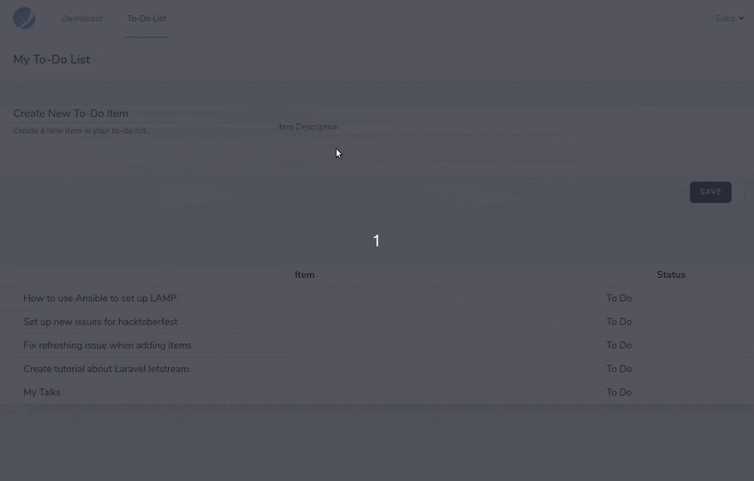

Where to Go from Here
After this initial experimentation, you might want to dive deeper into Livewire and TailwindCSS, in order to customize the appearance of your application as well as implement more complex actions and views.
If you are new to Laravel and want to improve this demo application to make it fully functional, a good experiment is to update the todo items migration and Eloquent model to include a foreign key to the user who owns that item. Then, update the show action accordingly to filter only items for that logged in user.
Quick Links:
- Laravel Documentation
- Livewire Documentation
- TailwindCSS Documentation
Feel free to leave a comment if you have questions, I am still figuring these things out but I hope to write more about Laravel and Jetstream ;)
https://dev.to/erikaheidi/creating-a-multi-user-to-do-application-with-laravel-jetstream-2p1k

Managing users and teams in Laravel
Published on – 2 minute read
If you're building a product, for example a SaaS as a side project, you might come to a point where you need more than the basic Authentication handling from Laravel.
For me, this happened when working on FileHero. We decided that we need "Teams" - like Bitbucket or Slack. Users can be assigned to multiple teams, team owners can invite more team members, delete other members and maybe have access to other features in your application.
So you start writing your models, controllers and repositories. You add relations to your authenticating model. You need to take care of handling the invites. You need to add the ACL related stuff and so on and so forth.
As every good programmer is lazy - and to quote Bill Gates:
'I choose a lazy person to do a hard job. Because a lazy person will find an easy way to do it.'
I started working on a new Laravel package with a catchy name - Teamwork.
So initially it all started to become more of a personal package as I didn't want to write the whole team management code for the next project again.

Then came Laracon #
So I was happily developing my package, posted it to Twitter and Reddit where Taylor Otwell replied and said it's a cool package.
So I thought: Great - I'm on the right track.
A few days later, I was watching Taylor Otwell's keynote at Laracon US and he was presenting "Laravel Spark" - where the alpha version was released today.

So long story short: Spark itself has integrated Team management. But - you can't only use the Team management from Spark. So that's where Teamwork comes in again.

Avengers Assemble! #
Using a User to Team association with Teamwork is really easy. Just let your Authenticable Model use the UserHasTeam trait.
<?php namespace App;

use Mpociot\Teamwork\Traits\UserHasTeams;

class User extends Model {

use UserHasTeams; // Add this trait to your model
}
This allows you to handle everything related to teams.
Some examples:

Add a Team to a User #
$team = Team::create([
"name" => "Internal team"
]);

Auth::user()->attachTeam( $team );

Get the user teams #
// Get all teams of the User
Auth::user()->teams

// Get all teams which the user "owns"
Auth::user()->ownedTeams

Inviting others #
The best team is of no avail if you're the only team member.
To invite other users to your teams, use the Teamwork facade.
Teamwork::inviteToTeam( $email, $team, function( $invite )
{
// Send email to user / let them know that they got invited
});

Future #
That's the basic usage of my package. I hope you like it and can use it on your next project!
I would really love to get your feedback on the package and if you're already using Teamwork please let me know!

