Laravel 9 User Roles and Permissions Tutorial
O aplicativo do livro começou com este tutorial.
Hi Dev,
Here, I will show you how to work laravel 9 roles and permissions tutorial. We will use laravel 9 spatie user roles and permissions tutorial. you can understand the concept of laravel 9 spatie/laravel-permission. you will learn laravel 9 acl tutorial. Here, Creating a basic example of laravel 9 user roles and permissions tutorial step by step.
we are using spatie GitHub package for roles and permissions in laravel 9 application. just follow bellow step to create acl in laravel 9.
Spatie role permission composer package provides a way to create ACL in laravel 9. they provide how to assign role to user, how to assign permission to user and how to assign permission assign to roles. I will write step by step creating roles and permissions in laravel 9 application.
I also posted on tutorial for ACL User Roles and Permissions using entrust package, you can see here : Laravel - User Roles and Permissions (ACL) using entrust package.

Roles and Permissions through you can create several types of users with different role and permission, i mean some user have only see listing of items module, some user can also edit items modules, for delete and etc.
In this examples i created three modules as listed bellow:
User Management
Role Management
Product Management
After register user, you don't have any roles, so you can edit your details and assign admin role to you from User Management. After that you can create your own role with permission like role-list, role-create, role-edit, role-delete, product-list, product-create, product-edit, product-delete. you can check with assign new user and check that.
You need to just follow few step and you will get full example of ACL:
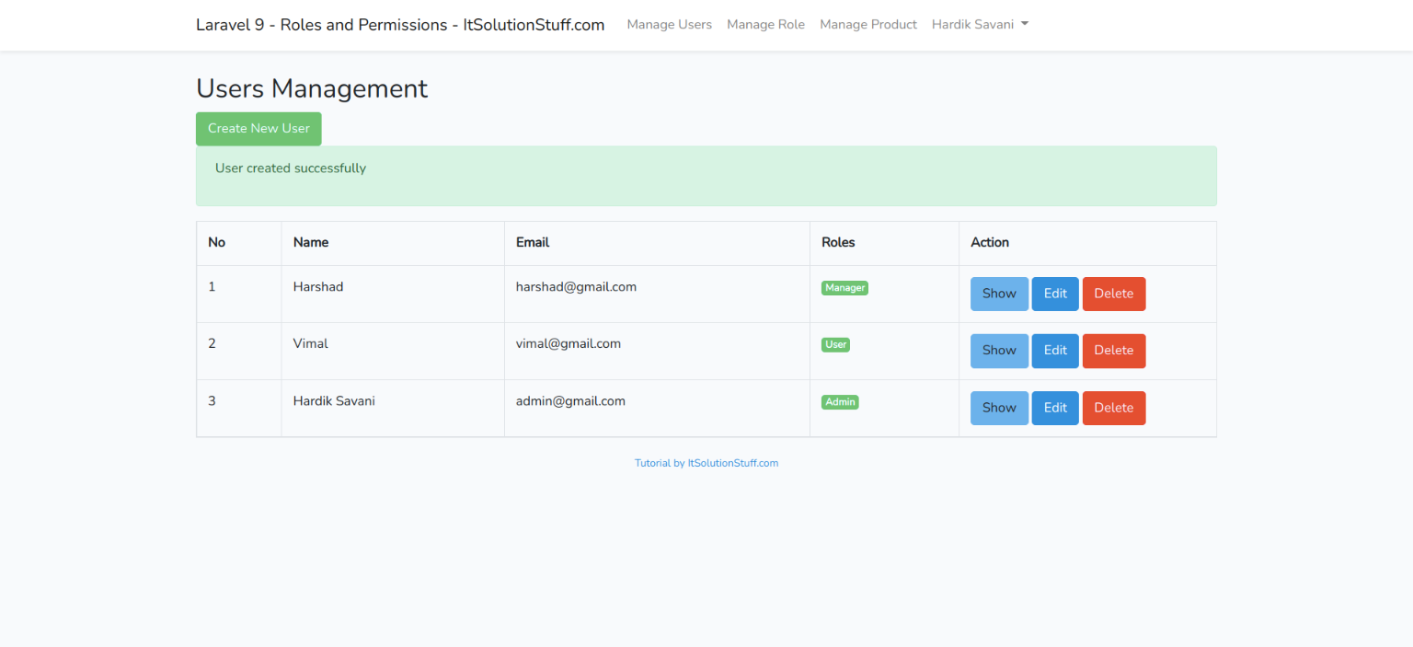

List Role:
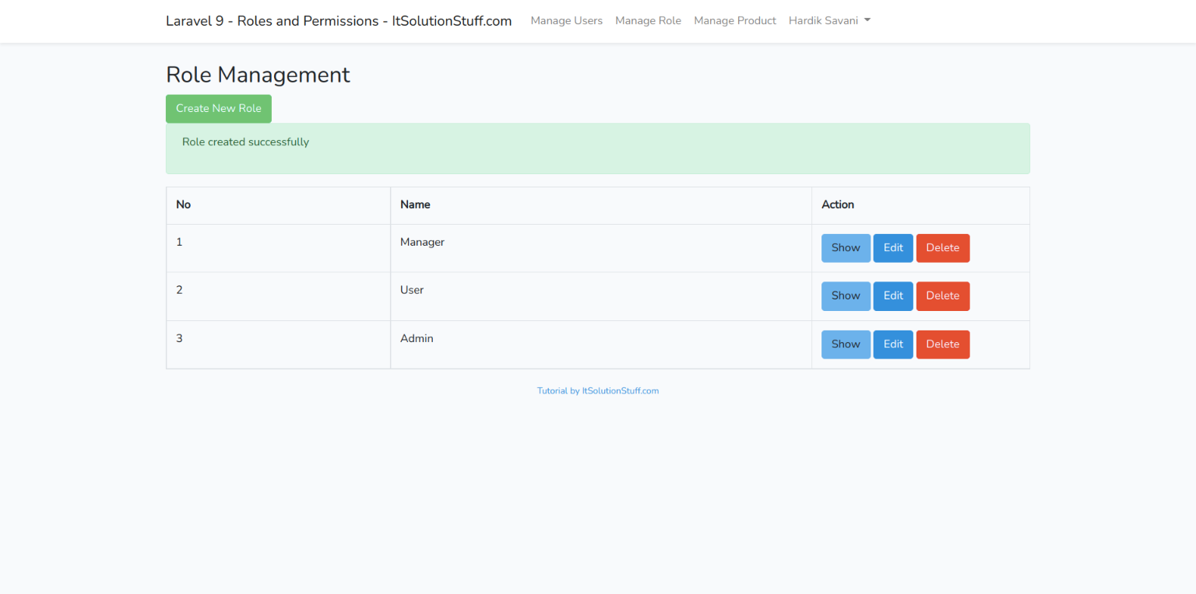
Create Role:
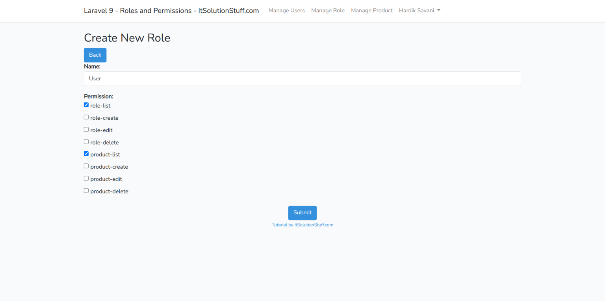
Create User:
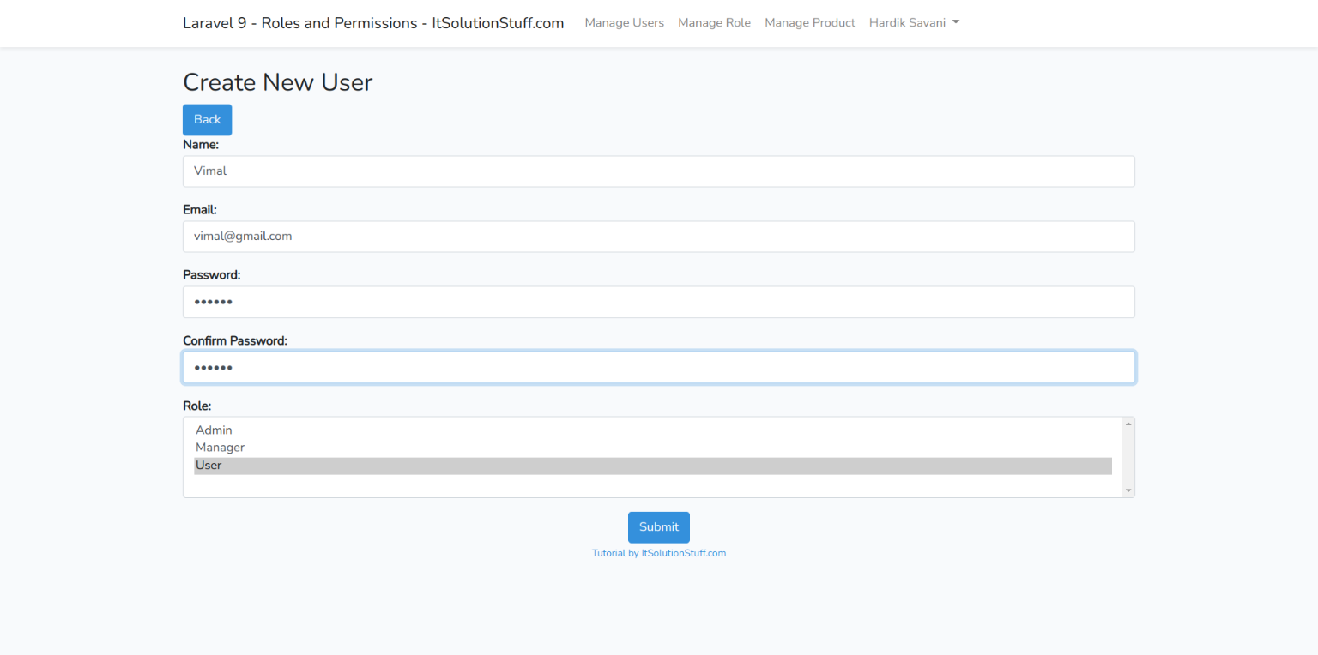
List Product:
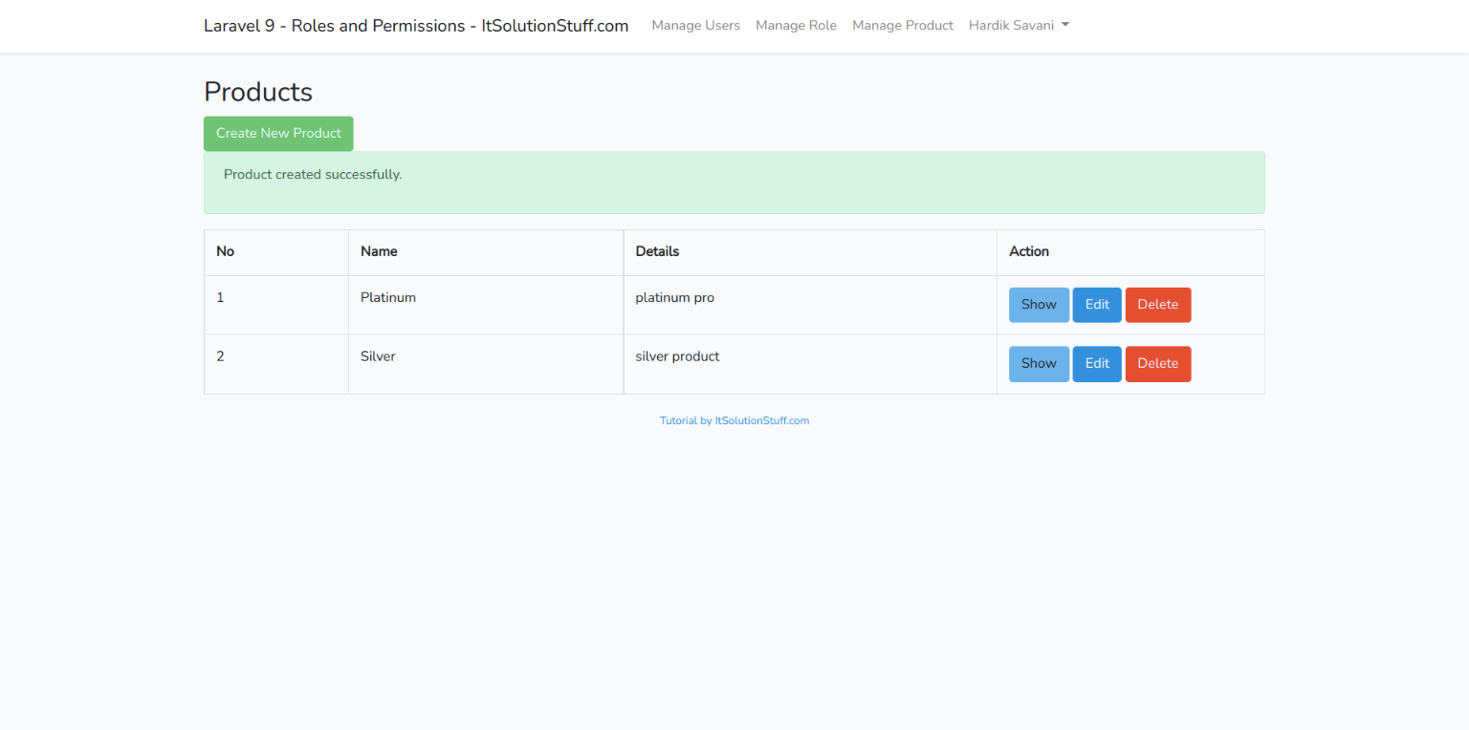
Step 1: Laravel 9 Installation
We are going from scratch so, If you haven't installed laravel in your system then you can run bellow command and get fresh Laravel project.
composer create-project laravel/laravel example-app
Step 2: Install Composer Packages
Now we require to install Spatie package for ACL, that way we can use it's method. Also we will install form collection package. So Open your terminal and run bellow command.
composer require spatie/laravel-permission
composer require laravelcollective/html
We can also custom changes on Spatie package, so if you also want to changes then you can fire bellow command and get config file in config/permission.php and migration files.
php artisan vendor:publish --provider="Spatie\Permission\PermissionServiceProvider"

Now you can see permission.php file and one migrations. so you can run migration using following command:
php artisan migrate
Read Also: Laravel 9 Ajax Form Validation Example
Step 3: Create Product Migration
In this step we have to create three migration for products table as using bellow command:
php artisan make:migration create_products_table
products table:
<?php

use Illuminate\Database\Migrations\Migration;
use Illuminate\Database\Schema\Blueprint;
use Illuminate\Support\Facades\Schema;

return new class extends Migration
{
/**
* Run the migrations.
*
* @return void
*/
public function up()
{
Schema::create('products', function (Blueprint $table) {
$table->id();
$table->string('name');
$table->text('detail');
$table->timestamps();
});
}

/**
* Reverse the migrations.
*
* @return void
*/
public function down()
{
Schema::dropIfExists('products');
}
};
Now run migration:
php artisan migrate
Step 4: Create Models
In this step we have to create model for User and Product table, so if you get fresh project then you have User Model have so just replace code and other you should create.
app/Models/User.php
<?php

namespace App\Models;

use Illuminate\Contracts\Auth\MustVerifyEmail;
use Illuminate\Database\Eloquent\Factories\HasFactory;
use Illuminate\Foundation\Auth\User as Authenticatable;
use Illuminate\Notifications\Notifiable;
use Laravel\Sanctum\HasApiTokens;
use Spatie\Permission\Traits\HasRoles;

class User extends Authenticatable
{
use HasApiTokens, HasFactory, Notifiable, HasRoles;

/**
* The attributes that are mass assignable.
*
* @var array
*/
protected $fillable = [
'name',
'email',
'password',
];

/**
* The attributes that should be hidden for serialization.
*
* @var array
*/
protected $hidden = [
'password',
'remember_token',
];

/**
* The attributes that should be cast.
*
* @var array
*/
protected $casts = [
'email_verified_at' => 'datetime',
];
}
app/Models/Product.php
<?php

namespace App\Models;

use Illuminate\Database\Eloquent\Factories\HasFactory;
use Illuminate\Database\Eloquent\Model;

class Product extends Model
{
use HasFactory;

/**
* The attributes that are mass assignable.
*
* @var array
*/
protected $fillable = [
'name', 'detail'
];
}
Step 5: Add Middleware
Spatie package provide it's in-built middleware that way we can use it simply and that is display as bellow:
role
permission
So, we have to add middleware in Kernel.php file this way :
app/Http/Kernel.php
....
protected $routeMiddleware = [
....
'role' => \Spatie\Permission\Middlewares\RoleMiddleware::class,
'permission' => \Spatie\Permission\Middlewares\PermissionMiddleware::class,
'role_or_permission' => \Spatie\Permission\Middlewares\RoleOrPermissionMiddleware::class,
]
....
Step 6: Create Authentication
You have to follow few step to make auth in your laravel 9 application.
First you need to install laravel/ui package as like bellow:
composer require laravel/ui
Here, we need to generate auth scaffolding in laravel 9 using laravel ui command. so, let's generate it by bellow command:
php artisan ui bootstrap --auth
Now you need to run npm command, otherwise you can not see better layout of login and register page.
Install NPM:
npm install
Run NPM:
npm run dev
Step 7: Create Routes
We require to add number of route for users module, products module and roles module. In this this route i also use middleware with permission for roles and products route, so add route this way:
routes/web.php
<?php

use Illuminate\Support\Facades\Route;

use App\Http\Controllers\HomeController;
use App\Http\Controllers\RoleController;
use App\Http\Controllers\UserController;
use App\Http\Controllers\ProductController;

/*
|--------------------------------------------------------------------------
| Web Routes
|--------------------------------------------------------------------------
|
| Here is where you can register web routes for your application. These
| routes are loaded by the RouteServiceProvider within a group which
| contains the "web" middleware group. Now create something great!
|
*/

Route::get('/', function () {
return view('welcome');
});

Auth::routes();

Route::get('/home', [HomeController::class, 'index'])->name('home');

Route::group(['middleware' => ['auth']], function() {
Route::resource('roles', RoleController::class);
Route::resource('users', UserController::class);
Route::resource('products', ProductController::class);
});
Step 8: Add Controllers
In this step we have add three controller for users module, products module and roles module so you can create three controller like as bellow:
app/Http/Controllers/UserController.php
<?php

namespace App\Http\Controllers;

use Illuminate\Http\Request;
use App\Http\Controllers\Controller;
use App\Models\User;
use Spatie\Permission\Models\Role;
use DB;
use Hash;
use Illuminate\Support\Arr;

class UserController extends Controller
{
/**
* Display a listing of the resource.
*
* @return \Illuminate\Http\Response
*/
public function index(Request $request)
{
$data = User::orderBy('id','DESC')->paginate(5);
return view('users.index',compact('data'))
->with('i', ($request->input('page', 1) - 1) * 5);
}

/**
* Show the form for creating a new resource.
*
* @return \Illuminate\Http\Response
*/
public function create()
{
$roles = Role::pluck('name','name')->all();
return view('users.create',compact('roles'));
}

/**
* Store a newly created resource in storage.
*
* @param \Illuminate\Http\Request $request
* @return \Illuminate\Http\Response
*/
public function store(Request $request)
{
$this->validate($request, [
'name' => 'required',
'email' => 'required|email|unique:users,email',
'password' => 'required|same:confirm-password',
'roles' => 'required'
]);

$input = $request->all();
$input['password'] = Hash::make($input['password']);

$user = User::create($input);
$user->assignRole($request->input('roles'));

return redirect()->route('users.index')
->with('success','User created successfully');
}

/**
* Display the specified resource.
*
* @param int $id
* @return \Illuminate\Http\Response
*/
public function show($id)
{
$user = User::find($id);
return view('users.show',compact('user'));
}

/**
* Show the form for editing the specified resource.
*
* @param int $id
* @return \Illuminate\Http\Response
*/
public function edit($id)
{
$user = User::find($id);
$roles = Role::pluck('name','name')->all();
$userRole = $user->roles->pluck('name','name')->all();

return view('users.edit',compact('user','roles','userRole'));
}

/**
* Update the specified resource in storage.
*
* @param \Illuminate\Http\Request $request
* @param int $id
* @return \Illuminate\Http\Response
*/
public function update(Request $request, $id)
{
$this->validate($request, [
'name' => 'required',
'email' => 'required|email|unique:users,email,'.$id,
'password' => 'same:confirm-password',
'roles' => 'required'
]);

$input = $request->all();
if(!empty($input['password'])){
$input['password'] = Hash::make($input['password']);
}else{
$input = Arr::except($input,array('password'));
}

$user = User::find($id);
$user->update($input);
DB::table('model_has_roles')->where('model_id',$id)->delete();

$user->assignRole($request->input('roles'));

return redirect()->route('users.index')
->with('success','User updated successfully');
}

/**
* Remove the specified resource from storage.
*
* @param int $id
* @return \Illuminate\Http\Response
*/
public function destroy($id)
{
User::find($id)->delete();
return redirect()->route('users.index')
->with('success','User deleted successfully');
}
}
app/Http/Controllers/ProductController.php
<?php

namespace App\Http\Controllers;

use App\Models\Product;
use Illuminate\Http\Request;

class ProductController extends Controller
{
/**
* Display a listing of the resource.
*
* @return \Illuminate\Http\Response
*/
function __construct()
{
$this->middleware('permission:product-list|product-create|product-edit|product-delete', ['only' => ['index','show']]);
$this->middleware('permission:product-create', ['only' => ['create','store']]);
$this->middleware('permission:product-edit', ['only' => ['edit','update']]);
$this->middleware('permission:product-delete', ['only' => ['destroy']]);
}
/**
* Display a listing of the resource.
*
* @return \Illuminate\Http\Response
*/
public function index()
{
$products = Product::latest()->paginate(5);
return view('products.index',compact('products'))
->with('i', (request()->input('page', 1) - 1) * 5);
}

/**
* Show the form for creating a new resource.
*
* @return \Illuminate\Http\Response
*/
public function create()
{
return view('products.create');
}

/**
* Store a newly created resource in storage.
*
* @param \Illuminate\Http\Request $request
* @return \Illuminate\Http\Response
*/
public function store(Request $request)
{
request()->validate([
'name' => 'required',
'detail' => 'required',
]);

Product::create($request->all());

return redirect()->route('products.index')
->with('success','Product created successfully.');
}

/**
* Display the specified resource.
*
* @param \App\Product $product
* @return \Illuminate\Http\Response
*/
public function show(Product $product)
{
return view('products.show',compact('product'));
}

/**
* Show the form for editing the specified resource.
*
* @param \App\Product $product
* @return \Illuminate\Http\Response
*/
public function edit(Product $product)
{
return view('products.edit',compact('product'));
}

/**
* Update the specified resource in storage.
*
* @param \Illuminate\Http\Request $request
* @param \App\Product $product
* @return \Illuminate\Http\Response
*/
public function update(Request $request, Product $product)
{
request()->validate([
'name' => 'required',
'detail' => 'required',
]);

$product->update($request->all());

return redirect()->route('products.index')
->with('success','Product updated successfully');
}

/**
* Remove the specified resource from storage.
*
* @param \App\Product $product
* @return \Illuminate\Http\Response
*/
public function destroy(Product $product)
{
$product->delete();

return redirect()->route('products.index')
->with('success','Product deleted successfully');
}
}
app/Http/Controllers/RoleController.php
<?php

namespace App\Http\Controllers;
use Illuminate\Http\Request;
use App\Http\Controllers\Controller;
use Spatie\Permission\Models\Role;
use Spatie\Permission\Models\Permission;
use DB;

class RoleController extends Controller
{
/**
* Display a listing of the resource.
*
* @return \Illuminate\Http\Response
*/
function __construct()
{
$this->middleware('permission:role-list|role-create|role-edit|role-delete', ['only' => ['index','store']]);
$this->middleware('permission:role-create', ['only' => ['create','store']]);
$this->middleware('permission:role-edit', ['only' => ['edit','update']]);
$this->middleware('permission:role-delete', ['only' => ['destroy']]);
}

/**
* Display a listing of the resource.
*
* @return \Illuminate\Http\Response
*/
public function index(Request $request)
{
$roles = Role::orderBy('id','DESC')->paginate(5);
return view('roles.index',compact('roles'))
->with('i', ($request->input('page', 1) - 1) * 5);
}

/**
* Show the form for creating a new resource.
*
* @return \Illuminate\Http\Response
*/
public function create()
{
$permission = Permission::get();
return view('roles.create',compact('permission'));
}

/**
* Store a newly created resource in storage.
*
* @param \Illuminate\Http\Request $request
* @return \Illuminate\Http\Response
*/
public function store(Request $request)
{
$this->validate($request, [
'name' => 'required|unique:roles,name',
'permission' => 'required',
]);

$role = Role::create(['name' => $request->input('name')]);
$role->syncPermissions($request->input('permission'));

return redirect()->route('roles.index')
->with('success','Role created successfully');
}
/**
* Display the specified resource.
*
* @param int $id
* @return \Illuminate\Http\Response
*/
public function show($id)
{
$role = Role::find($id);
$rolePermissions = Permission::join("role_has_permissions","role_has_permissions.permission_id","=","permissions.id")
->where("role_has_permissions.role_id",$id)
->get();

return view('roles.show',compact('role','rolePermissions'));
}

/**
* Show the form for editing the specified resource.
*
* @param int $id
* @return \Illuminate\Http\Response
*/
public function edit($id)
{
$role = Role::find($id);
$permission = Permission::get();
$rolePermissions = DB::table("role_has_permissions")->where("role_has_permissions.role_id",$id)
->pluck('role_has_permissions.permission_id','role_has_permissions.permission_id')
->all();

return view('roles.edit',compact('role','permission','rolePermissions'));
}

/**
* Update the specified resource in storage.
*
* @param \Illuminate\Http\Request $request
* @param int $id
* @return \Illuminate\Http\Response
*/
public function update(Request $request, $id)
{
$this->validate($request, [
'name' => 'required',
'permission' => 'required',
]);

$role = Role::find($id);
$role->name = $request->input('name');
$role->save();

$role->syncPermissions($request->input('permission'));

return redirect()->route('roles.index')
->with('success','Role updated successfully');
}
/**
* Remove the specified resource from storage.
*
* @param int $id
* @return \Illuminate\Http\Response
*/
public function destroy($id)
{
DB::table("roles")->where('id',$id)->delete();
return redirect()->route('roles.index')
->with('success','Role deleted successfully');
}
}
Step 9: Add Blade Files
In this step, we need to create following files as like listed bellow:
Theme Layout
app.blade.php
Users Module
index.blade.php create.blade.php edit.blade.php show.blade.php
Roles Module
index.blade.php create.blade.php edit.blade.php show.blade.php
Product Module
index.blade.php create.blade.php edit.blade.php show.blade.php
So, let's create following files:
resources/views/layouts/app.blade.php
<html lang="{{ app()->getLocale() }}">
<head>
<meta charset="utf-8">
<meta http-equiv="X-UA-Compatible" content="IE=edge">
<meta name="viewport" content="width=device-width, initial-scale=1">
<!-- CSRF Token -->
<meta name="csrf-token" content="{{ csrf_token() }}">
<title>{{ config('app.name', 'Laravel 9 User Roles and Permissions Tutorial') }}</title>
<!-- Scripts -->
<script src="{{ asset('js/app.js') }}" defer></script>
<!-- Fonts -->
<link rel="dns-prefetch" href="https://fonts.gstatic.com">
<link href="https://fonts.googleapis.com/css?family=Raleway:300,400,600" rel="stylesheet" type="text/css">
<!-- Styles -->
<link href="{{ asset('css/app.css') }}" rel="stylesheet">
</head>
<body>
<div id="app">
<nav class="navbar navbar-expand-md navbar-light navbar-laravel">
<div class="container">
<a class="navbar-brand" href="{{ url('/') }}">
Laravel 9 User Roles and Permissions - ItSolutionStuff.com
</a>
<button class="navbar-toggler" type="button" data-toggle="collapse" data-target="#navbarSupportedContent" aria-controls="navbarSupportedContent" aria-expanded="false" aria-label="Toggle navigation">
<span class="navbar-toggler-icon"></span>
</button>

<div class="collapse navbar-collapse" id="navbarSupportedContent">
<!-- Left Side Of Navbar -->
<ul class="navbar-nav mr-auto"></ul>
<!-- Right Side Of Navbar -->
<ul class="navbar-nav ml-auto">
<!-- Authentication Links -->
@guest
<li><a class="nav-link" href="{{ route('login') }}">{{ __('Login') }}</a></li>
<li><a class="nav-link" href="{{ route('register') }}">{{ __('Register') }}</a></li>
@else
<li><a class="nav-link" href="{{ route('users.index') }}">Manage Users</a></li>
<li><a class="nav-link" href="{{ route('roles.index') }}">Manage Role</a></li>
<li><a class="nav-link" href="{{ route('products.index') }}">Manage Product</a></li>
<li class="nav-item dropdown">
<a id="navbarDropdown" class="nav-link dropdown-toggle" href="#" role="button" data-toggle="dropdown" aria-haspopup="true" aria-expanded="false" v-pre>
{{ Auth::user()->name }} <span class="caret"></span>
</a>
<div class="dropdown-menu" aria-labelledby="navbarDropdown">
<a class="dropdown-item" href="{{ route('logout') }}"
onclick="event.preventDefault();
document.getElementById('logout-form').submit();">
{{ __('Logout') }}
</a>
<form id="logout-form" action="{{ route('logout') }}" method="POST" style="display: none;">
@csrf
</form>
</div>
</li>
@endguest
</ul>
</div>
</div>
</nav>
<main class="py-4">
<div class="container">
@yield('content')
</div>
</main>
</div>
</body>
</html>
resources/views/users/index.blade.php
@extends('layouts.app')
@section('content')
<div class="row">
<div class="col-lg-12 margin-tb">
<div class="pull-left">
<h2>Users Management</h2>
</div>
<div class="pull-right">
<a class="btn btn-success" href="{{ route('users.create') }}"> Create New User</a>
</div>
</div>
</div>
@if ($message = Session::get('success'))
<div class="alert alert-success">
<p>{{ $message }}</p>
</div>
@endif
<table class="table table-bordered">
<tr>
<th>No</th>
<th>Name</th>
<th>Email</th>
<th>Roles</th>
<th width="280px">Action</th>
</tr>
@foreach ($data as $key => $user)
<tr>
<td>{{ ++$i }}</td>
<td>{{ $user->name }}</td>
<td>{{ $user->email }}</td>
<td>
@if(!empty($user->getRoleNames()))
@foreach($user->getRoleNames() as $v)
<label class="badge badge-success">{{ $v }}</label>
@endforeach
@endif
</td>
<td>
<a class="btn btn-info" href="{{ route('users.show',$user->id) }}">Show</a>
<a class="btn btn-primary" href="{{ route('users.edit',$user->id) }}">Edit</a>
{!! Form::open(['method' => 'DELETE','route' => ['users.destroy', $user->id],'style'=>'display:inline']) !!}
{!! Form::submit('Delete', ['class' => 'btn btn-danger']) !!}
{!! Form::close() !!}
</td>
</tr>
@endforeach
</table>
{!! $data->render() !!}
<p class="text-center text-primary"><small>Tutorial by ItSolutionStuff.com</small></p>
@endsection
resources/views/users/create.blade.php
@extends('layouts.app')
@section('content')
<div class="row">
<div class="col-lg-12 margin-tb">
<div class="pull-left">
<h2>Create New User</h2>
</div>
<div class="pull-right">
<a class="btn btn-primary" href="{{ route('users.index') }}"> Back</a>
</div>
</div>
</div>
@if (count($errors) > 0)
<div class="alert alert-danger">
<strong>Whoops!</strong> There were some problems with your input.<br><br>
<ul>
@foreach ($errors->all() as $error)
<li>{{ $error }}</li>
@endforeach
</ul>
</div>
@endif
{!! Form::open(array('route' => 'users.store','method'=>'POST')) !!}
<div class="row">
<div class="col-xs-12 col-sm-12 col-md-12">
<div class="form-group">
<strong>Name:</strong>
{!! Form::text('name', null, array('placeholder' => 'Name','class' => 'form-control')) !!}
</div>
</div>
<div class="col-xs-12 col-sm-12 col-md-12">
<div class="form-group">
<strong>Email:</strong>
{!! Form::text('email', null, array('placeholder' => 'Email','class' => 'form-control')) !!}
</div>
</div>
<div class="col-xs-12 col-sm-12 col-md-12">
<div class="form-group">
<strong>Password:</strong>
{!! Form::password('password', array('placeholder' => 'Password','class' => 'form-control')) !!}
</div>
</div>
<div class="col-xs-12 col-sm-12 col-md-12">
<div class="form-group">
<strong>Confirm Password:</strong>
{!! Form::password('confirm-password', array('placeholder' => 'Confirm Password','class' => 'form-control')) !!}
</div>
</div>
<div class="col-xs-12 col-sm-12 col-md-12">
<div class="form-group">
<strong>Role:</strong>
{!! Form::select('roles[]', $roles,[], array('class' => 'form-control','multiple')) !!}
</div>
</div>
<div class="col-xs-12 col-sm-12 col-md-12 text-center">
<button type="submit" class="btn btn-primary">Submit</button>
</div>
</div>
{!! Form::close() !!}
<p class="text-center text-primary"><small>Tutorial by ItSolutionStuff.com</small></p>
@endsection
resources/views/users/edit.blade.php
@extends('layouts.app')
@section('content')
<div class="row">
<div class="col-lg-12 margin-tb">
<div class="pull-left">
<h2>Edit New User</h2>
</div>
<div class="pull-right">
<a class="btn btn-primary" href="{{ route('users.index') }}"> Back</a>
</div>
</div>
</div>
@if (count($errors) > 0)
<div class="alert alert-danger">
<strong>Whoops!</strong> There were some problems with your input.<br><br>
<ul>
@foreach ($errors->all() as $error)
<li>{{ $error }}</li>
@endforeach
</ul>
</div>
@endif
{!! Form::model($user, ['method' => 'PATCH','route' => ['users.update', $user->id]]) !!}
<div class="row">
<div class="col-xs-12 col-sm-12 col-md-12">
<div class="form-group">
<strong>Name:</strong>
{!! Form::text('name', null, array('placeholder' => 'Name','class' => 'form-control')) !!}
</div>
</div>
<div class="col-xs-12 col-sm-12 col-md-12">
<div class="form-group">
<strong>Email:</strong>
{!! Form::text('email', null, array('placeholder' => 'Email','class' => 'form-control')) !!}
</div>
</div>
<div class="col-xs-12 col-sm-12 col-md-12">
<div class="form-group">
<strong>Password:</strong>
{!! Form::password('password', array('placeholder' => 'Password','class' => 'form-control')) !!}
</div>
</div>
<div class="col-xs-12 col-sm-12 col-md-12">
<div class="form-group">
<strong>Confirm Password:</strong>
{!! Form::password('confirm-password', array('placeholder' => 'Confirm Password','class' => 'form-control')) !!}
</div>
</div>
<div class="col-xs-12 col-sm-12 col-md-12">
<div class="form-group">
<strong>Role:</strong>
{!! Form::select('roles[]', $roles,$userRole, array('class' => 'form-control','multiple')) !!}
</div>
</div>
<div class="col-xs-12 col-sm-12 col-md-12 text-center">
<button type="submit" class="btn btn-primary">Submit</button>
</div>
</div>
{!! Form::close() !!}
<p class="text-center text-primary"><small>Tutorial by ItSolutionStuff.com</small></p>
@endsection
resources/views/users/show.blade.php
@extends('layouts.app')
@section('content')
<div class="row">
<div class="col-lg-12 margin-tb">
<div class="pull-left">
<h2> Show User</h2>
</div>
<div class="pull-right">
<a class="btn btn-primary" href="{{ route('users.index') }}"> Back</a>
</div>
</div>
</div>
<div class="row">
<div class="col-xs-12 col-sm-12 col-md-12">
<div class="form-group">
<strong>Name:</strong>
{{ $user->name }}
</div>
</div>
<div class="col-xs-12 col-sm-12 col-md-12">
<div class="form-group">
<strong>Email:</strong>
{{ $user->email }}
</div>
</div>
<div class="col-xs-12 col-sm-12 col-md-12">
<div class="form-group">
<strong>Roles:</strong>
@if(!empty($user->getRoleNames()))
@foreach($user->getRoleNames() as $v)
<label class="badge badge-success">{{ $v }}</label>
@endforeach
@endif
</div>
</div>
</div>
@endsection
resources/views/roles/index.blade.php
@extends('layouts.app')
@section('content')
<div class="row">
<div class="col-lg-12 margin-tb">
<div class="pull-left">
<h2>Role Management</h2>
</div>
<div class="pull-right">
@can('role-create')
<a class="btn btn-success" href="{{ route('roles.create') }}"> Create New Role</a>
@endcan
</div>
</div>
</div>
@if ($message = Session::get('success'))
<div class="alert alert-success">
<p>{{ $message }}</p>
</div>
@endif
<table class="table table-bordered">
<tr>
<th>No</th>
<th>Name</th>
<th width="280px">Action</th>
</tr>
@foreach ($roles as $key => $role)
<tr>
<td>{{ ++$i }}</td>
<td>{{ $role->name }}</td>
<td>
<a class="btn btn-info" href="{{ route('roles.show',$role->id) }}">Show</a>
@can('role-edit')
<a class="btn btn-primary" href="{{ route('roles.edit',$role->id) }}">Edit</a>
@endcan
@can('role-delete')
{!! Form::open(['method' => 'DELETE','route' => ['roles.destroy', $role->id],'style'=>'display:inline']) !!}
{!! Form::submit('Delete', ['class' => 'btn btn-danger']) !!}
{!! Form::close() !!}
@endcan
</td>
</tr>
@endforeach
</table>
{!! $roles->render() !!}
<p class="text-center text-primary"><small>Tutorial by ItSolutionStuff.com</small></p>
@endsection
resources/views/roles/create.blade.php
@extends('layouts.app')
@section('content')
<div class="row">
<div class="col-lg-12 margin-tb">
<div class="pull-left">
<h2>Create New Role</h2>
</div>
<div class="pull-right">
<a class="btn btn-primary" href="{{ route('roles.index') }}"> Back</a>
</div>
</div>
</div>
@if (count($errors) > 0)
<div class="alert alert-danger">
<strong>Whoops!</strong> There were some problems with your input.<br><br>
<ul>
@foreach ($errors->all() as $error)
<li>{{ $error }}</li>
@endforeach
</ul>
</div>
@endif
{!! Form::open(array('route' => 'roles.store','method'=>'POST')) !!}
<div class="row">
<div class="col-xs-12 col-sm-12 col-md-12">
<div class="form-group">
<strong>Name:</strong>
{!! Form::text('name', null, array('placeholder' => 'Name','class' => 'form-control')) !!}
</div>
</div>
<div class="col-xs-12 col-sm-12 col-md-12">
<div class="form-group">
<strong>Permission:</strong>
<br/>
@foreach($permission as $value)
<label>{{ Form::checkbox('permission[]', $value->id, false, array('class' => 'name')) }}
{{ $value->name }}</label>
<br/>
@endforeach
</div>
</div>
<div class="col-xs-12 col-sm-12 col-md-12 text-center">
<button type="submit" class="btn btn-primary">Submit</button>
</div>
</div>
{!! Form::close() !!}
<p class="text-center text-primary"><small>Tutorial by ItSolutionStuff.com</small></p>
@endsection
resources/views/roles/edit.blade.php
@extends('layouts.app')
@section('content')
<div class="row">
<div class="col-lg-12 margin-tb">
<div class="pull-left">
<h2>Edit Role</h2>
</div>
<div class="pull-right">
<a class="btn btn-primary" href="{{ route('roles.index') }}"> Back</a>
</div>
</div>
</div>
@if (count($errors) > 0)
<div class="alert alert-danger">
<strong>Whoops!</strong> There were some problems with your input.<br><br>
<ul>
@foreach ($errors->all() as $error)
<li>{{ $error }}</li>
@endforeach
</ul>
</div>
@endif
{!! Form::model($role, ['method' => 'PATCH','route' => ['roles.update', $role->id]]) !!}
<div class="row">
<div class="col-xs-12 col-sm-12 col-md-12">
<div class="form-group">
<strong>Name:</strong>
{!! Form::text('name', null, array('placeholder' => 'Name','class' => 'form-control')) !!}
</div>
</div>
<div class="col-xs-12 col-sm-12 col-md-12">
<div class="form-group">
<strong>Permission:</strong>
<br/>
@foreach($permission as $value)
<label>{{ Form::checkbox('permission[]', $value->id, in_array($value->id, $rolePermissions) ? true : false, array('class' => 'name')) }}
{{ $value->name }}</label>
<br/>
@endforeach
</div>
</div>
<div class="col-xs-12 col-sm-12 col-md-12 text-center">
<button type="submit" class="btn btn-primary">Submit</button>
</div>
</div>
{!! Form::close() !!}
@endsection
<p class="text-center text-primary"><small>Tutorial by ItSolutionStuff.com</small></p>
resources/views/roles/show.blade.php
@extends('layouts.app')
@section('content')
<div class="row">
<div class="col-lg-12 margin-tb">
<div class="pull-left">
<h2> Show Role</h2>
</div>
<div class="pull-right">
<a class="btn btn-primary" href="{{ route('roles.index') }}"> Back</a>
</div>
</div>
</div>
<div class="row">
<div class="col-xs-12 col-sm-12 col-md-12">
<div class="form-group">
<strong>Name:</strong>
{{ $role->name }}
</div>
</div>
<div class="col-xs-12 col-sm-12 col-md-12">
<div class="form-group">
<strong>Permissions:</strong>
@if(!empty($rolePermissions))
@foreach($rolePermissions as $v)
<label class="label label-success">{{ $v->name }},</label>
@endforeach
@endif
</div>
</div>
</div>
@endsection
resources/views/products/index.blade.php
@extends('layouts.app')
@section('content')
<div class="row">
<div class="col-lg-12 margin-tb">
<div class="pull-left">
<h2>Products</h2>
</div>
<div class="pull-right">
@can('product-create')
<a class="btn btn-success" href="{{ route('products.create') }}"> Create New Product</a>
@endcan
</div>
</div>
</div>
@if ($message = Session::get('success'))
<div class="alert alert-success">
<p>{{ $message }}</p>
</div>
@endif
<table class="table table-bordered">
<tr>
<th>No</th>
<th>Name</th>
<th>Details</th>
<th width="280px">Action</th>
</tr>
@foreach ($products as $product)
<tr>
<td>{{ ++$i }}</td>
<td>{{ $product->name }}</td>
<td>{{ $product->detail }}</td>
<td>
<form action="{{ route('products.destroy',$product->id) }}" method="POST">
<a class="btn btn-info" href="{{ route('products.show',$product->id) }}">Show</a>
@can('product-edit')
<a class="btn btn-primary" href="{{ route('products.edit',$product->id) }}">Edit</a>
@endcan
@csrf
@method('DELETE')
@can('product-delete')
<button type="submit" class="btn btn-danger">Delete</button>
@endcan
</form>
</td>
</tr>
@endforeach
</table>
{!! $products->links() !!}
<p class="text-center text-primary"><small>Tutorial by ItSolutionStuff.com</small></p>
@endsection
resources/views/products/create.blade.php
@extends('layouts.app')
@section('content')
<div class="row">
<div class="col-lg-12 margin-tb">
<div class="pull-left">
<h2>Add New Product</h2>
</div>
<div class="pull-right">
<a class="btn btn-primary" href="{{ route('products.index') }}"> Back</a>
</div>
</div>
</div>
@if ($errors->any())
<div class="alert alert-danger">
<strong>Whoops!</strong> There were some problems with your input.<br><br>
<ul>
@foreach ($errors->all() as $error)
<li>{{ $error }}</li>
@endforeach
</ul>
</div>
@endif
<form action="{{ route('products.store') }}" method="POST">
@csrf
<div class="row">
<div class="col-xs-12 col-sm-12 col-md-12">
<div class="form-group">
<strong>Name:</strong>
<input type="text" name="name" class="form-control" placeholder="Name">
</div>
</div>
<div class="col-xs-12 col-sm-12 col-md-12">
<div class="form-group">
<strong>Detail:</strong>
<textarea class="form-control" style="height:150px" name="detail" placeholder="Detail"></textarea>
</div>
</div>
<div class="col-xs-12 col-sm-12 col-md-12 text-center">
<button type="submit" class="btn btn-primary">Submit</button>
</div>
</div>
</form>
<p class="text-center text-primary"><small>Tutorial by ItSolutionStuff.com</small></p>
@endsection
resources/views/products/edit.blade.php
@extends('layouts.app')
@section('content')
<div class="row">
<div class="col-lg-12 margin-tb">
<div class="pull-left">
<h2>Edit Product</h2>
</div>
<div class="pull-right">
<a class="btn btn-primary" href="{{ route('products.index') }}"> Back</a>
</div>
</div>
</div>
@if ($errors->any())
<div class="alert alert-danger">
<strong>Whoops!</strong> There were some problems with your input.<br><br>
<ul>
@foreach ($errors->all() as $error)
<li>{{ $error }}</li>
@endforeach
</ul>
</div>
@endif
<form action="{{ route('products.update',$product->id) }}" method="POST">
@csrf
@method('PUT')
<div class="row">
<div class="col-xs-12 col-sm-12 col-md-12">
<div class="form-group">
<strong>Name:</strong>
<input type="text" name="name" value="{{ $product->name }}" class="form-control" placeholder="Name">
</div>
</div>
<div class="col-xs-12 col-sm-12 col-md-12">
<div class="form-group">
<strong>Detail:</strong>
<textarea class="form-control" style="height:150px" name="detail" placeholder="Detail">{{ $product->detail }}</textarea>
</div>
</div>
<div class="col-xs-12 col-sm-12 col-md-12 text-center">
<button type="submit" class="btn btn-primary">Submit</button>
</div>
</div>
</form>
<p class="text-center text-primary"><small>Tutorial by ItSolutionStuff.com</small></p>
@endsection
resources/views/products/show.blade.php
@extends('layouts.app')
@section('content')
<div class="row">
<div class="col-lg-12 margin-tb">
<div class="pull-left">
<h2> Show Product</h2>
</div>
<div class="pull-right">
<a class="btn btn-primary" href="{{ route('products.index') }}"> Back</a>
</div>
</div>
</div>
<div class="row">
<div class="col-xs-12 col-sm-12 col-md-12">
<div class="form-group">
<strong>Name:</strong>
{{ $product->name }}
</div>
</div>
<div class="col-xs-12 col-sm-12 col-md-12">
<div class="form-group">
<strong>Details:</strong>
{{ $product->detail }}
</div>
</div>
</div>
@endsection
<p class="text-center text-primary"><small>Tutorial by ItSolutionStuff.com</small></p>
Step 10: Create Seeder For Permissions and AdminUser
In this step we will create seeder for permissions, Right now we have fixed permission so we create using seeder as listed bellow, but if you can add more permission as you want:
1.role-list
2.role-create
3.role-edit
4.role-delete
5.product-list
6.product-create
7.product-edit
8.product-delete
So, first create seeder using bellow command:
php artisan make:seeder PermissionTableSeeder
And put bellow code in PermissionTableSeeder seeder this way:
database/seeders/PermissionTableSeeder.php
<?php

namespace Database\Seeders;

use Illuminate\Database\Console\Seeds\WithoutModelEvents;
use Illuminate\Database\Seeder;
use Spatie\Permission\Models\Permission;

class PermissionTableSeeder extends Seeder
{
/**
* Run the database seeds.
*
* @return void
*/
public function run()
{
$permissions = [
'role-list',
'role-create',
'role-edit',
'role-delete',
'product-list',
'product-create',
'product-edit',
'product-delete'
];

foreach ($permissions as $permission) {
Permission::create(['name' => $permission]);
}
}
}
After this we have to run bellow command for run PermissionTableSeeder seeder:
php artisan db:seed --class=PermissionTableSeeder
Now let's create new seeder for creating admin user.
php artisan make:seeder CreateAdminUserSeeder
database/seeders/CreateAdminUserSeeder.php
<?php

namespace Database\Seeders;

use Illuminate\Database\Console\Seeds\WithoutModelEvents;
use Illuminate\Database\Seeder;
use App\Models\User;
use Spatie\Permission\Models\Role;
use Spatie\Permission\Models\Permission;

class CreateAdminUserSeeder extends Seeder
{
/**
* Run the database seeds.
*
* @return void
*/
public function run()
{
$user = User::create([
'name' => 'Hardik Savani',
'email' => 'admin@gmail.com',
'password' => bcrypt('123456')
]);

$role = Role::create(['name' => 'Admin']);

$permissions = Permission::pluck('id','id')->all();

$role->syncPermissions($permissions);

$user->assignRole([$role->id]);
}
}
php artisan db:seed --class=CreateAdminUserSeeder
Run Laravel App:
All the required steps have been done, now you have to type the given below command and hit enter to run the Laravel app:
php artisan serve
Now, Go to your web browser, type the given URL and view the app output:
http://localhost:8000/products
Now you can login with following credential:
Email: admin@gmail.com
Password: 123456
Now you can run and check.
You can also download code from git:
I hope it can help you...
https://github.com/savanihd/Laravel-9-roles-and-permissions

https://www.itsolutionstuff.com/post/laravel-9-user-roles-and-permissions-tutorialexample.html

