Unity3D
https://unity3d.com/get-unity/download
https://unity3d.com/get-unity/update

Como instalar o Unity 3d no Linux
Confira abaixo as duas formas de instalar o Unity 3d no Linux: a primeira permite instalar em qualquer distribuição, e a segunda no Ubuntu e derivados.

Como instalar o Unity 3d no Linux, em qualquer distribuição
Para instalar o Unity 3d no Linux, faça o seguinte:
Passo 1. Abra um terminal;
Passo 2. Use o comando abaixo para baixar o programa. Se o link estiver desatualizado, acesse essa página, baixe a última versão e salve-o com o nome unity.sh:
wget https://beta.unity3d.com/download/6e9a27477296/UnitySetup-2018.3.0f2 -O unity3d
Passo 3. Depois de baixado, dê permissão de execução ao programa, com o comando abaixo;
chmod +x unity3d
Passo 4. Execute o instalador do Unity 3D dando um duplo clique nele ou usando o comando abaixo;
sudo ./unity3d
Passo 5. Siga as instruções do instalador e em pouco tempo o programa estará instalado em seu sistema.

Como instalar o Unity 3d no Linux Ubuntu, Debian e derivados
A Unity Technologies fornece um instalador oficial para a versão de 64 bits do Ubuntu em formato DEB. Por conta disso, usuários de distribuições Linux baseadas no Ubuntu (de 64 bits) possam também fazer uso do pacote DEB fornecido, e talvez consigam instalar em seus sistemas.
Para instalar o Unity 3d no Linux Ubuntu, Debian e derivados, basta baixar o pacote DEB, disponível nessa link, e dar um duplo clique sobre ele. Depois, confirme a instalação e aguarde terminar o processo.
Se preferir, você também pode fazer o seguinte:
Passo 1. Abra um terminal;
Passo 2. Confira se o seu sistema é de 32 bits ou 64 bits, para isso, use o seguinte comando no terminal:
uname -m
Passo 3. Se seu sistema é de 64 bits, use o comando abaixo para baixar o programa. Se o link estiver desatualizado, acesse essa página, baixe a última versão e salve-o com o nome unity-editor.deb:
wget http://beta.unity3d.com/download/2b451a7da81d/unity-editor_amd64-2017.2.0xb6Linux.deb -O unity-editor.deb
Passo 4. Agora instale o programa com o comando:
sudo dpkg -i unity-editor.deb
Passo 5. Caso seja necessário, instale as dependências do programa com o comando:
sudo apt-get install -f
Passo 6. Se depois você precisar desinstalar o Unity 3d, use o comando abaixo;
sudo apt-get remove unity-editor
Pronto! Agora, quando quiser iniciar o programa, digite unity no Dash (ou em um terminal, seguido da tecla TAB).

Como usar o Unity 3d no Linux para criar jogos
Para saber como usar o Unity 3d no Linux para criar jogos, assista os vídeos abaixo:
%CODE1%
%CODE2%
Hub
https://forum.unity.com/forums/unity-hub.142/
For Linux - Download Unity 2021.1.3
https://unity3d.com/get-unity/update

System requirements
OS: Windows 7 SP1+, 8, 10, 64-bit versions only; Mac OS X 10.12+; Ubuntu 16.04, 18.04, and CentOS 7.
GPU: Graphics card with DX10 (shader model 4.0) capabilities.

A maneira preferida de instalar o Unity no Linux é primeiro instalar o Unity Hub.
Arquivo de instalação do Unity Hub:
https://public-cdn.cloud.unity3d.com/hub/prod/UnityHub.AppImage
Você pode instalar a versão preferida do Unity na seção Instalações do aplicativo Unity Hub. Ele fará o download e instalará automaticamente para você.
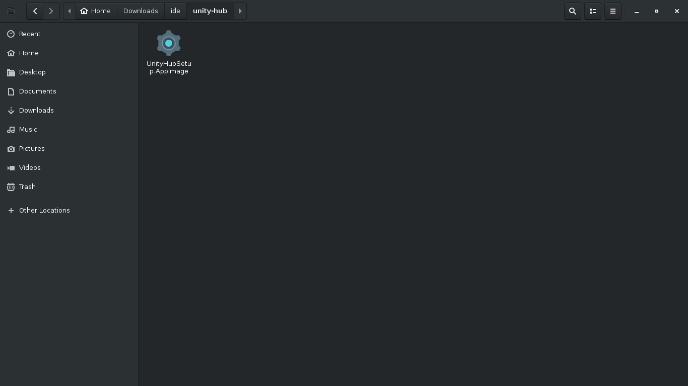
Fonte :
https://www.linuxdeveloper.space/install-unity-linux/

A última versão .deb era realmente o Unity 2017.2.1f1. Depois disso, toda a outra versão entrou como extensão .sha. Na verdade, a versão .deb instala automaticamente todas as dependências necessárias. Mas agora você precisa instalar as dependências primeiro.
Instale as dependências
sudo apt install gconf-service lib32gcc1 lib32stdc++6 libasound2 libc6 libc6-i386\
libcairo2 libcap2 libcups2 libdbus-1-3 libexpat1 libfontconfig1 libfreetype6 libgcc1\
libgconf-2-4 libgdk-pixbuf2.0-0 libgl1-mesa-glx libglib2.0-0 libglu1-mesa libgtk2.0-0\
libnspr4 libnss3 libpango1.0-0 libstdc++6 libx11-6 libxcomposite1 libxcursor1\
libxdamage1 libxext6 libxfixes3 libxi6 libxrandr2 libxrender1 libxtst6 zlib1g debconf npm
Também recomendo instalar o essencial da compilação
sudo apt install build-essential
Depois disso, acesse este link Unity no Linux: notas de versão e problemas conhecidos - Unity Forum
Clique nos links de download .html da versão do Unity desejada e selecione o assistente de download do Linux.
Após a instalação, você pode simplesmente clicar duas vezes no arquivo de instalação ou executá-lo usando a linha de comando:
cd Downloads
./UnitySetup*
https://qastack.com.br/ubuntu/1077816/how-to-install-unity3d-on-ubuntu-18-04

System requirements for Unity 2020 LTS
This page outlines the minimum system requirements you need to run Unity 2020LTS on all supported platforms.
- Unity Editor system requirements
- Unity Player system requirements
  - Mobile
  - Console
  - Desktop
  - Stadia
  - Server platform
  - Web platforms
  - XR plaform
    - Oculus
    - Windows Mixed Reality
    - Magic Leap
    - ARCore
    - ARKit
  - Other requirements

Unity Editor system requirements
This section lists the minimum requirements to run the Unity Editor. Actual performance and rendering
quality may vary depending on the complexity of your project.
Minimum requirements | Windows | macOS | Linux (Support in Preview)
Operating system version | Windows 7 (SP1+) and Windows 10, 64-bit versions only. | High Sierra 10.13+ | Ubuntu 20.04, Ubuntu 18.04, and CentOS 7
CPU | X64 architecture with SSE2 instruction set support | X64 architecture with SSE2 instruction set support | X64 architecture with SSE2 instruction set support
Graphics API | DX10, DX11, and DX12-capable GPUs | Metal-capable Intel and AMD GPUs | OpenGL 3.2+ or Vulkan-capable, Nvidia and AMD GPUs.
Additional requirements | Hardware vendor officially supported drivers | Apple officially supported drivers | Gnome desktop environment running on top of X11 windowing system, Nvidia official proprietary graphics driver or AMD Mesa graphics driver. Other configuration and user environment as provided stock with the supported distribution (Kernel, Compositor, etc.)
 | For all operating systems, the Unity Editor is supported on workstations or laptop form factors, running without emulation, container or compatibility layer.

Unity Player system requirements
This section lists the minimum requirements to build and run the Unity Player. Actual performance and rendering quality may vary depending on the complexity of your project.

Mobile
Operating system | Android | iOS | tvOS
Version | 4.4 (API 19)+ | 11+ | 11+
CPU | ARMv7 with Neon Support (32-bit) or ARM64 | A7 SoC+ | A8 SoC+
Graphics API | OpenGL ES 2.0+, OpenGL ES 3.0+, Vulkan | Metal | Metal
Additional requirements | 1GB+ RAM.  Supported hardware devices must meet or exceed Google’s Android Compatibility Definition (Version 9.0) limited to the following Device Types:  1. Handheld (Section 2.2)  2. Television (Section 2.3)  3. Tablets (Section 2.6)  Hardware must natively be running Android OS. Android within a Container or Emulator is not supported.  For Development: Android SDK (10/API 29), Android NDK (r19) and OpenJDK, which are installed by default with Unity Hub | For development: Mac computer running minimum macOS 10.12.6 and Xcode 9.4 or higher. | Apple TV 4th generation+

Console
For PlayStation 4
(including PS VR), Xbox One
and Nintendo Switch, see the Unity for console section on the Unity Multiplatform page.

Desktop
Operating system | Windows | Universal Windows Platform | macOS | Linux
Operating system version | Windows 7 (SP1+) and Windows 10 | Windows 10, Xbox One, HoloLens | High Sierra 10.13+ | Ubuntu 20.04, Ubuntu 18.04, and CentOS 7
CPU | x86, x64 architecture with SSE2 instruction set support. | x86, x64 architecture with SSE2 instruction set support, ARM, ARM64. | x64 architecture with SSE2. | x64 architecture with SSE2 instruction set support.
Graphics API | DX10, DX11, DX12 capable. | DX10, DX11, DX12 capable GPUs. | Metal capable Intel and AMD GPUs | OpenGL 3.2+, Vulkan capable.
Additional requirements | Hardware vendor officially supported drivers.  For development: IL2CPP scripting backend requires Visual Studio 2015 with C++ Tools component or later and Windows 10 SDK. | Hardware vendor officially supported drivers.  For development: Windows 10 (64-bit), Visual Studio 2015 with C++ Tools component or later and Windows 10 SDK. | Apple officially supported drivers.  For development: IL2CPP scripting backend requires Xcode. Targeting Apple Silicon with IL2CPP scripting backend requires macOS Catalina 10.15.4 and Xcode 12.2 or newer. | Gnome desktop environment running on top of X11 windowing system  Other configuration and user environment as provided stock with the supported distribution (such as Kernel or Compositor)  Nvidia and AMD GPUs using Nvidia official proprietary graphics driver or AMD Mesa graphics driver.
 | For all operating systems, the Unity Player is supported on workstations, laptop or tablet form factors, running without emulation, container or compatibility layer.

Stadia
Unity developers interested in bringing games to the Stadia platform should start by applying for development resources on Google’s Stadia developer website.

Server platform
Operating system | Windows | macOS | Linux
Operating system version | Windows 7 (SP1+) and Windows 10, running on workstation and rack form factors, without emulation or compatibility layer. | High Sierra 10.13+ running on workstation and rack form factors, without emulation or compatibility layer. | Ubuntu 20.04, Ubuntu 18.04, and CentOS 7, running on workstation and rack form factors, without emulation or compatibility layer.
CPU | x86, x64 architecture with SSE2 instruction set support. | x64 architecture with SSE2 instruction set support. | x64 architecture with SSE2 instruction set support.
GPU | No explicit GPU support.
Additional requirements | Hardware vendor officially supported drivers.

WebGL
Operating system running browsers | Windows, macOS, and Linux
Hardware | Workstation and laptop form factors.
Additional requirements | Versions of Chrome, Firefox or Safari that are:  - WebGL 1.0 or 2.0 capable  - HTML 5 standards compliant  - 64-bit  - WASM capable

XR platform system requirements
To enable XR
and properly configure your Unity project, follow the steps outlined in the XR plugin architecture page.

Oculus
Hardware | Oculus Rift/Rift S | Oculus Quest | Oculus Quest 2
Operating system version | Windows 10 | Android
CPU | See Oculus specifications | ARM 64-bit (Snapdragon 835) | ARM 64-bit (Snapdragon XR2)
GPU | See Oculus specifications
Graphics API | DX11 | OpenGL ES 3.0, Vulkan*
Additional requirements | *Vulkan support for Oculus Quest is an experimental feature.  More information can be found in the Oculus XR Plugin package documentation.

Windows Mixed Reality
Hardware | WMR Immersive (VR) | HoloLens | HoloLens 2
Operating system version | Windows 10 RS4 | Embedded Windows 10
CPU | Intel 64-bit | Intel Atom | ARM 64-bit  (Snapdragon 850)
Graphics API | DX11

Magic Leap
Operating system | Magic Leap One
Operating system version | Lumin OS
CPU | See Magic Leap specifications
GPU | See Magic Leap specifications
Graphics API | OpenGL ES 3.2+

ARCore
Operating system | Android phones
Operating system version | 7
CPU | ARM 64-bit
Graphics API | OpenGL ES
Additional requirements | Latest supported SDK Version: ARCore 1.18

ARKit
Operating system | iPhone and iPad
Operating system version | iOS 11
CPU | A9+
Graphics API | Metal
Additional requirements | Latest supported SDK Version: ARKit 3.5

Other system requirements notes
For any Unity Editor or Player supporting Windows 7, note that Microsoft support for Windows 7 expired after January 14th 2020.

https://docs.unity3d.com/Manual/index.html
https://docs.unity3d.com/Manual/UnityManual.html

https://docs.unity3d.com/Manual/OfflineDocumentation.html

Instalar pelo prompt do windows
https://docs.unity3d.com/Manual/InstallingUnity.html

Unity Hub
The Unity Hub is a standalone application that streamlines the way you find, download, and manage your Unity Projects and installations. In addition, you can manually add versions of the Editor that you have already installed on your machine to your Hub.
You can use the Hub to:
- Manage your Unity account and Editor licenses.
- Create your Project, associate a default version of the Unity Editor with the Project, and manage the installation of multiple versions of the Editor.
- Launch different versions of Unity from your Project view.
- Manage and select Project build targets without launching the Editor.
- Run two versions of Unity at the same time. Note that to prevent local conflicts and other odd scenarios, you should only open a Project in one Editor instance at a time.
- Add components to existing installations of the Editor. When you download a version of the Editor through Unity Hub, you can find and add additional components (such as specific platform support, Visual Studio, offline docs and Standard Assets) either during initial install or at a later date.
- Use Project Templates to jump-start the creation process for common Project types. Unity’s Project Templates provide default values for common settings when you create a new Project. Project Templates preset batches of settings for a target game type or level of visual fidelity. For more information, see Project Templates.
For information on installing the Unity Hub, see Installing Unity using the Hub.

Installing the Unity Hub
The Unity Hub is a management tool that you can use to manage all of your Unity Projects and installations. Use the Hub to manage multiple installations of the Unity Editor along with their associated components, create new Projects, and open existing Projects.
To install the Unity Hub for Windows, macOS, and Linux visit Download Unity on the Unity website.
Unity officially supports the following Linux distributions:
- Ubuntu 16.04
- Ubuntu 18.04
- CentOS 7
Note: If Unity Hub fails to launch while you are using Linux, you might need to give UnityHub.AppImage executable permissions. To do this:
- Open your terminal.
- Go to the directory where UnityHub.AppImage is. This will be the Unity Hub directory.
- Run chmod +x UnityHub.AppImage.
To install and use the Unity Editor, you must have a Unity Developer Network (UDN) account. If you already have an account, sign in, choose your licenses type, and proceed to the Installing the Unity Editor section.
If you do not have an account, follow the prompts to create one. You can choose to create a Unity ID or use one of the social sign-ins. For more information on accounts and subscriptions, see Unity Organizations.

Installing the Unity Editor
To install the Editor:
- Click the Installs tab. The default install locations are:
Windows:
C:\Program Files\Unity\Hub\Editor
Mac:
/Applications/Unity/Hub/Editor
Linux:
~/Unity/Hub/Editor
Note: If you want to change the default installation location, follow these steps:
  - From the top right corner of the Hub window, click the Gear icon.
  - In the Editor Folder Location dialog box, enter the new installation location and click Done.
- Click the Add button and select a specific version of the Editor.
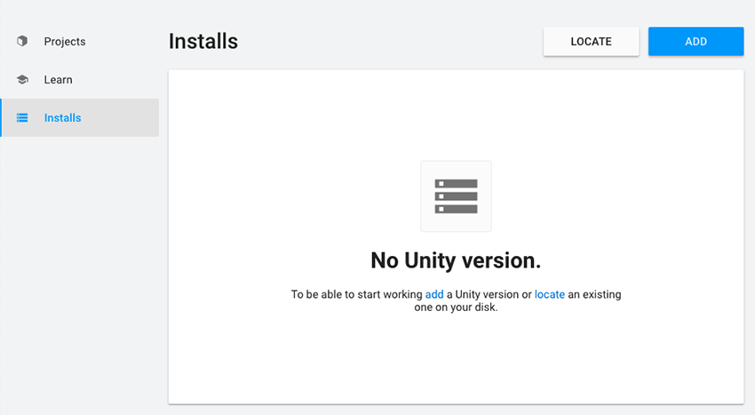
- Click the Next button and select the modules you want to install with the Editor. If you don’t install a component now, you can add it later if you need to. When you’ve selected all the modules you need, click Done.
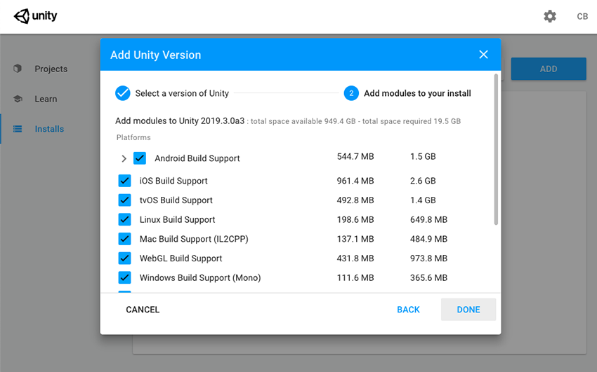
If you are installing multiple Editor versions, the first installation starts as soon as the download is complete. Other selected versions download simultaneously and queue to start when the current installation finishes.
The Hub displays the installation location of each Editor under the corresponding version label.
To add modules to an Editor, locate its files, or uninstall it, click the three dots next to that Editor version.
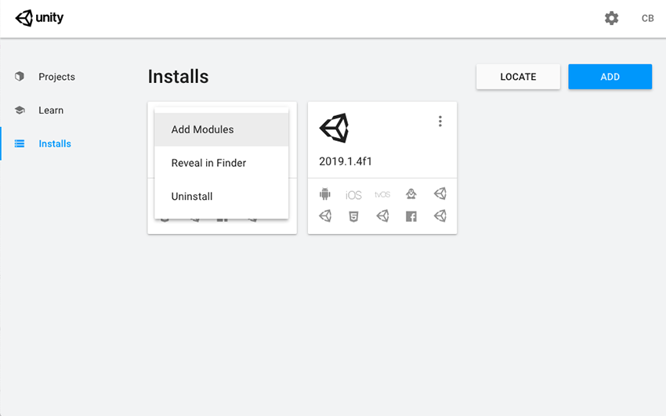

Adding existing instances of the Editor to the Hub
You can add instances of the Editor to the Hub that you installed outside of the Hub.
- Click the Installs tab.
- Click the Locate button to find existing installations of the Editor.
- In the file dialog, navigate to the location of the Editor installation and select the Unity executable. On MacOS this is Unity.app. On Windows this is Unity.exe.
On Windows, the typical location of the Unity.exe is:
C:\Program Files\Unity\Editor\Unity.exe
Or
C:\Program Files\Unity<version>\Editor\Unity.exe
On macOS, the typical location of the Unity.app is:
/Applications/Unity/Hub/Editor/<version>/Unity.app
On Linux, the typical location of the Unity executable file is:
/home/<username>/Unity/Hub/Editor/<version>/Unity
- Click the Select Editor button.
To remove the Editor from the Hub, click the three dots next to the Editor version. Removing an Editor that you added in this manner does not uninstall it or modify it in any way.

Troubleshooting for Linux
If Unity fails to start, you might need to install a missing dependency
. On Ubuntu-based distributions, use:
sudo apt install libgconf-2-4
On CentOS, you might need to install the mesa-libGLU dependency. Use:
sudo yum install mesa-libGLU

Support for Editor versions prior to 2017.1
Sign-in status is not shared for pre–2017.1 versions of the Editor opened through the Hub. Performing tasks such as Manage License, Open Project, Create Project, and Sign in opens the Unity Launcher instead of the Hub.
If you attempt to use the Unity Hub to open an Editor version 5 or earlier and you do not have an appropriate license file, the Editor will hang on the splash screen.
To avoid this issue, run the Editor directly, external to the Unity Hub, and the Editor will load correctly even if the license file is not detected.

Using the Unity Installer to install the Unity Editor
The Unity installer is a small executable program (approximately 1 MB in size) that lets you select which components of the Unity Editor you want to download and install.
To install previous versions of the Unity Editor using the Installer, visit the Unity download archive. The archive page provides Unity Installer download links for all released versions of the Editor.
For additional information on installing the Editor using the Installer, see the 2018.3 version of the Unity Manual.

- Hub design updated in Unity 2019.1
- Linux now available from the Hub in Unity 2019.1 onwards

Adding modules to the Unity Editor
Use the Unity Hub to add additional components to installations of the Editor that you originally installed using the Hub.
- Open the Hub.
- Select Installs.
- Find the Editor you want to add the components to.
- Click the three dots to the right of the version label, then select Add Modules. (NOTE: If you didn’t install the Editor via the Hub, you will not see this option. To enable this option, install the Editor via the Hub.)
- In the Add Modules dialog, locate the module to add and tick its checkbox.
- When you have selected all the modules to add, select Done.

Licenses and Activation
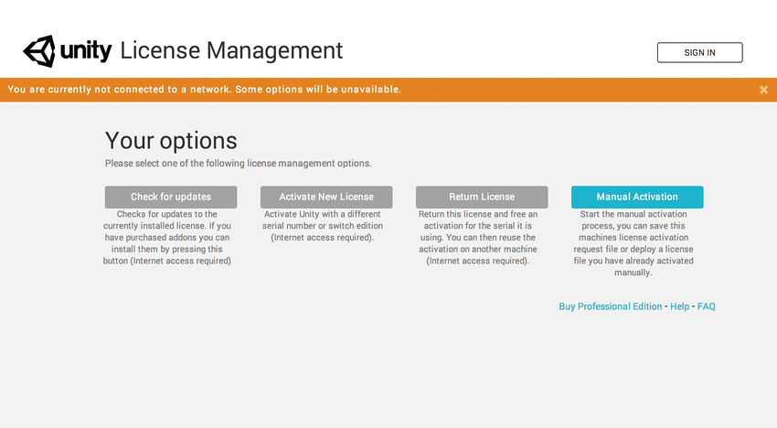
This section covers license activation and managing your Unity license. See the License FAQ page for help on common licensing questions.

https://learn.unity.com/

Como instalar o Unity 3D Game Editor no Debian (ou no Ubuntu)
Como instalar o Unity 3D game engine no Debian e no Ubuntu.
Este artigo mostra, ainda, como corrigir um erro na inicialização do aplicativo.

- Autor do post
- Por Elias Praciano
- Data de publicação
- 19/01/2016
- 9 comentários em Como instalar o Unity 3D Game Editor no Debian (ou no Ubuntu)

O Unity 3D Game Editor é uma das engines mais populares na criação de jogos no mundo.
A versão de que tratamos, neste post, trata-se de uma versão experimental (de acordo com os desenvolvedores).
- Existe um post mais atualizado sobre a instalação deste software aqui.

Por um lado, é muito bom ter uma engine destas disponível em um ambiente poderoso e estável como o Linux — na verdade, não vejo sentido em se trabalhar com desenvolvimento em uma máquina Windows. No Mac, ainda vai… :p (minha opinião)
Por outro, saiba que alguns recursos ainda não estarão disponíveis — suporte a importação de modelos de aplicativos de terceiros, só para citar um exemplo.

Neste post vou explicar como instalar o Unity, como resolver alguma possível complicação e, por fim, demonstrar um método alternativo de instalação do aplicativo (você escolhe).

O que esperar do Unity para Linux
Descrito como uma “plataforma de desenvolvimento flexível e poderosa para criação de jogos multi-plataforma”, o Unity é desenvolvido pela Unity Technologies — e o pacote de instalação traz um editor gratuito (mas não é código aberto ou open source).
A decisão sobre se vale a pena prosseguir a partir desta versão prévia do software para Linux depende de uma série de fatores — tais como a receptividade da comunidade de desenvolvedores de jogos Linux, a quantidade e a escala de dificuldade de problemas levantados pela comunidade e, por fim, o quanto pesa dar suporte a esta versão para Linux.
O trabalho para dar suporte ao Linux runtime do Unity 3D, lançado em 2012 (também como uma prévia), foi muito pouco.
Portanto, faz sentido esperar que este esforço de agora frutifique.
Como sempre, usar as versões beta, testar exaustivamente, dar feedback para os desenvolvedores e incentivar outras pessoas a fazer o mesmo é a melhor forma de impulsionar qualquer software.

Como instalar o Unity 3D Game Editor
Você deve baixar o pacote .DEB e em seguida fazer a instalação — o processo é o mesmo no Debian e em todas as distros derivadas dele (o que inclui o Ubuntu, Mint etc.)
Clique no botão abaixo, para baixar o pacote oficial do Unity 3D:
Download
Note que se trata de uma versão para sistemas 64 bits.
Após o download, abra um terminal e faça a instalação com o dpkg:

sudo dpkg --install unity-editor-5.1.0f3+2015082501_amd64.deb
_

Se quiser desinstalar, posteriormente, use o seguinte comando:
sudo dpkg --purge unity-editor

Para iniciar o Unity, procure por “unity” no Dash ou dispare-o do termnal:
/opt/Unity/Editor/Unity &

Como corrigir erro na inicialização do Unity 3D
Nas versões preliminares do Unity, um erro tem impedido que o aplicativo inicie.
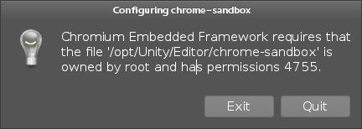
Traduzindo, ele informa que o Framework em questão requer que o arquivo /opt/Unity/Editor/chrome-sandbox tenha permissões 4755.
Isto é muito fácil de resolver. Basta seguir as instruções da própria mensagem para alterar as permissões do arquivo:

sudo chmod 4755 /opt/Unity/Editor/chrome-sandbox

Após esta alteração já será possível executar o editor.

Instalação alternativa do Unity 3D
Existe uma outra forma (não oficial) de instalar o aplicativo editor, através do Agnostic Installer.
Este processo também é bastante simples, embora seja um pouco mais cru (e também um pouco mais demorado).
Comece por baixar o script de instalação abaixo:
Download
Quando terminar o download, altere as permissões do arquivo baixado e execute-o, como superusuário:
chmod aug+x unity-editor-installer-5.1.0f3+2015082501.sh
sudo unity-editor-installer-5.1.0f3+2015082501.sh

Installer for Unity 5.1.0f3
Press Enter to begin extracting to ./unity-editor-5.1.0f3
Unpacking Unity 5.1.0f3 ...
Extraction complete. Run ./unity-editor-5.1.0f3/Editor/Unity to begin

Agora, já é possível rodar o aplicativo:
./unity-editor-5.1.0f3/Editor/Unity

Divirta-se!

Compartilhe o conhecimento!
- Facebook
- Twitter
- Telegram
- WhatsApp
- Reddit
- E-mail
- Mais

Posts relacionados
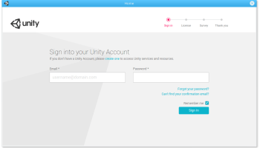

Como instalar o Unity 3D Editor 5.6 beta game engine para Linux
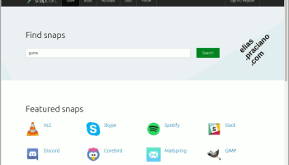

Instale o suporte ao snap no Debian, ainda hoje.
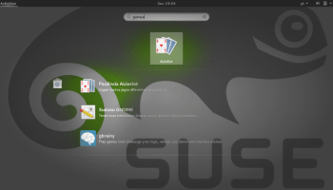

Gestão de pacotes na CLI do openSUSE
- Tags
- desenvolvimento, framework, games, Instalação, jogos, Unity


Por Elias Praciano
Autor de tecnologia (livre, de preferência), apaixonado por programação e astronomia.
Fã de séries, como "Rick and Morty" e "BoJack Horseman".
Me siga no Twitter e vamos trocar ideias!
https://elias.praciano.com/2016/01/como-instalar-o-unity-3d-game-editor-no-debian-ou-no-ubuntu/

https://www.techrepublic.com/article/how-to-install-the-unity-editor-on-linux/

https://diolinux.com.br/linux/unity-3d-engine-linux-download.html

O Unity3D está sendo lançado através de um "Download Helper" agora. As instruções para usá-lo são as seguintes:

Vá para o Thread de lançamento do Unity-on-Linux e vá para a última página. A última postagem conterá a versão mais recente. Até o momento desta postagem, essa é essa . Baixe.
Torne esse download executável. Por exemplo,chmod +x UnitySetup-2018.2.7f1

Instale os pré-requisitos via

sudo apt install libgtk2.0-0 libsoup2.4-1 libarchive13 libpng16-16 libgconf-2-4 lib32stdc++6 libcanberra-gtk-module

Execute o instalador.

~/Downloads/UnitySetup-2018.2.7f1

Eu gosto de colocá-lo na /optpasta uma vez instalada e criar um link para que eu possa iniciá-lo na linha de comando.

cd
sudo mv Unity-2018.2.7f1 /opt/Unity3D
sudo ln -s /opt/Unity3D/Editor/Unity /usr/bin/unity3d

Feito isso, você pode digitar unity3dpara iniciar o Editor do Unity3D.
— Thecal714
fonte
Mas isso não é recomendado, pois o unity eliminou os pacotes debian posteriormente e todas as versões do unity 2018 precisam ser instaladas da maneira acima, o Unity Hub também não está disponível no pacote deb.

