PHPCS

Coding Standard Tutorial
Greg Sherwood edited this page · 6 revisions

In this tutorial, we will create a new coding standard with a single sniff. Our sniff will prohibit the use of Perl style hash comments.

Creating the Coding Standard Directory
All sniffs in PHP_CodeSniffer must belong to a coding standard. A coding standard is a directory with a specific sub-directory structure and a ruleset.xml file, so we can create one very easily. Let's call our coding standard MyStandard. Run the following commands to create the coding standard directory structure:
$ mkdir MyStandard
$ mkdir MyStandard/Sniffs
As this coding standard directory sits outside the main PHP_CodeSniffer directory structure, PHP_CodeSniffer will not show it as an installed standard when using the -i command line argument. If you want your standard to be shown as installed, create the MyStandard directory inside the PHP_CodeSniffer install:
$ cd /path/to/PHP_CodeSniffer/src/Standards
$ mkdir MyStandard
$ mkdir MyStandard/Sniffs
The MyStandard directory represents our coding standard. The Sniffs sub-directory is used to store all the sniff files for this coding standard.
Now that our directory structure is created, we need to add our ruleset.xml file. This file will allow PHP_CodeSniffer to ask our coding standard for information about itself, and also identify this directory as one that contains code sniffs.
$ cd MyStandard
$ touch ruleset.xml
The content of the ruleset.xml file should be the following:
<?xml version="1.0"?>
<ruleset name="MyStandard">
<description>A custom coding standard.</description>
</ruleset>
The ruleset.xml can be left quite small, as it is in this example coding standard. For information about the other features that the ruleset.xml provides, see the Annotated ruleset.

Creating the Sniff
A sniff requires a single PHP file that must be placed into a sub-directory to categorise the type of check it performs. It's name should clearly describe the standard that we are enforcing and must end with Sniff.php. For our sniff, we will name the PHP file DisallowHashCommentsSniff.php and place it into a Commenting sub-directory to categorise this sniff as relating to commenting. Run the following commands to create the category and the sniff:
$ cd Sniffs
$ mkdir Commenting
$ touch Commenting/DisallowHashCommentsSniff.php
It does not matter what sub-directories you use for categorising your sniffs. Just make them descriptive enough so you can find your sniffs again later when you want to modify them.
Each sniff must implement the PHP_CodeSniffer\Sniffs\Sniff interface so that PHP_CodeSniffer knows that it should instantiate the sniff once it's invoked. The interface defines two methods that must be implemented; register and process.

The register and process Methods
The register method allows a sniff to subscribe to one or more token types that it wants to process. Once PHP_CodeSniffer encounters one of those tokens, it calls the process method with the PHP_CodeSniffer\Files\File object (a representation of the current file being checked) and the position in the stack where the token was found.
For our sniff, we are interested in single line comments. The token_get_all method that PHP_CodeSniffer uses to acquire the tokens within a file distinguishes doc comments and normal comments as two separate token types. Therefore, we don't have to worry about doc comments interfering with our test. The register method only needs to return one token type, T_COMMENT.

The Token Stack
A sniff can gather more information about a token by acquiring the token stack with a call to the getTokens method on the PHP_CodeSniffer\Files\File object. This method returns an array and is indexed by the position where the token occurs in the token stack. Each element in the array represents a token. All tokens have a code, type and a content index in their array. The code value is a unique integer for the type of token. The type value is a string representation of the token (e.g., 'T_COMMENT' for comment tokens). The type has a corresponding globally defined integer with the same name. Finally, the content value contains the content of the token as it appears in the code.

Reporting Errors
Once an error is detected, a sniff should indicate that an error has occurred by calling the addError method on the PHP_CodeSniffer\Files\File object, passing in an appropriate error message as the first argument, the position in the stack where the error was detected as the second, a code to uniquely identify the error within this sniff and an array of data used inside the error message. Alternatively, if the violation is considered not as critical as an error, the addWarning method can be used.

DisallowHashCommentsSniff.php
We now have to write the content of our sniff. The content of the DisallowHashCommentsSniff.php file should be the following:
<?php
/**
* This sniff prohibits the use of Perl style hash comments.
*
* PHP version 5
*
* @category PHP
* @package PHP_CodeSniffer
* @author Your Name <you@domain.net>
* @license https://github.com/squizlabs/PHP_CodeSniffer/blob/master/licence.txt BSD Licence
* @link http://pear.php.net/package/PHP_CodeSniffer
*/

namespace PHP_CodeSniffer\Standards\MyStandard\Sniffs\Commenting;

use PHP_CodeSniffer\Sniffs\Sniff;
use PHP_CodeSniffer\Files\File;

class DisallowHashCommentsSniff implements Sniff
{

/**
* Returns the token types that this sniff is interested in.
*
* @return array(int)
*/
public function register()
{
return array(T_COMMENT);

}//end register()

/**
* Processes this sniff, when one of its tokens is encountered.
*
* @param \PHP_CodeSniffer\Files\File $phpcsFile The current file being checked.
* @param int $stackPtr The position of the current token in the
* stack passed in $tokens.
*
* @return void
*/
public function process(File $phpcsFile, $stackPtr)
{
$tokens = $phpcsFile->getTokens();
if ($tokens[$stackPtr]['content']{0} === '#') {
$error = 'Hash comments are prohibited; found %s';
$data = array(trim($tokens[$stackPtr]['content']));
$phpcsFile->addError($error, $stackPtr, 'Found', $data);
}

}//end process()

}//end class

?>
By default, PHP_CodeSniffer assumes all sniffs are designed to check PHP code only. You can specify a list of tokenizers that your sniff supports, allowing it to be used wth PHP, JavaScript or XML files, or any combination of the three. You do this by setting the $supportedTokenizers member variable in your sniff. Adding the following code to your sniff will tell PHP_CodeSniffer that it can be used to check both PHP and JavaScript code:
/**
* A list of tokenizers this sniff supports.
*
* @var array
*/
public $supportedTokenizers = array(
'PHP',
'JS',
);

Results
Now that we have defined a coding standard, let's validate a file that contains hash comments. The test file we are using has the following contents:
<?php

# Check for valid contents.
if ($obj->contentsAreValid($array)) {
$value = $obj->getValue();

# Value needs to be an array.
if (is_array($value) === false) {
# Error.
$obj->throwError();
exit();
}
}

?>
When PHP_CodeSniffer is run on the file using our new coding standard, 3 errors will be reported:
$ phpcs --standard=/path/to/MyStandard test.php

FILE: test.php
--------------------------------------------------------------------------------
FOUND 3 ERROR(S) AFFECTING 3 LINE(S)
--------------------------------------------------------------------------------
3 | ERROR | Hash comments are prohibited; found # Check for valid contents.
7 | ERROR | Hash comments are prohibited; found # Value needs to be an array.
9 | ERROR | Hash comments are prohibited; found # Error.
--------------------------------------------------------------------------------
Note that we pass the absolute path to our coding standard directory on the command line because our standard is not installed inside the main PHP_CodeSniffer directory structure. If you have created your standard inside PHP_CodeSniffer, you can simply pass the name of the standard:
$ phpcs --standard=MyStandard Test.php
https://github.com/squizlabs/PHP_CodeSniffer/wiki/Coding-Standard-Tutorial

Coding Standard Tutorial
Coding Standard Tutorial – A guide to writing your own code sniffs

Introduction
In this tutorial, we will create a new coding standard with a single sniff. Our sniff will prohibit the use of Perl style hash comments.

Creating the Coding Standard Directory
All sniffs in PHP_CodeSniffer must belong to a coding standard. A coding standard is a directory with a specific sub-directory structure and a ruleset.xml file, so we can create one very easily. Let's call our coding standard MyStandard. Run the following commands to create the coding standard directory structure:

$ mkdir MyStandard
$ mkdir MyStandard/Sniffs

As this coding standard directory sits outside the main PHP_CodeSniffer directory structure, PHP_CodeSniffer will not show it as an installed standard when using the -i command line argument. If you want your standard to be shown as installed, create the MyStandard directory inside the PHP_CodeSniffer install:

$ cd /path/to/PHP_CodeSniffer/CodeSniffer/Standards
$ mkdir MyStandard
$ mkdir MyStandard/Sniffs

The MyStandard directory represents our coding standard. The Sniffs sub-directory is used to store all the sniff files for this coding standard.
Now that our directory structure is created, we need to add our ruleset.xml file. This file will allow PHP_CodeSniffer to ask our coding standard for information about itself, and also identify this directory as one that contains code sniffs.

$ cd MyStandard
$ touch ruleset.xml

The content of the ruleset.xml file should be the following:
<?xml version="1.0"?>
<ruleset name="MyStandard">
<description>A custom coding standard.</description>
</ruleset>
The ruleset.xml can be left quite small, as it is in this example coding standard. For information about the other features that the ruleset.xml provides, see the annotated ruleset.xml.

Creating the Sniff
A sniff requires a single PHP file. It's name should clearly describe the standard that we are enforcing and must end with Sniff.php. For our sniff, we will name the PHP file DisallowHashCommentsSniff.php and place it into a Commenting sub-directory to categorise this sniff as relating to commenting. Run the following commands to create the category and the sniff:

$ cd Sniffs
$ mkdir Commenting
$ touch Commenting/DisallowHashCommentsSniff.php

It does not matter what sub-directories you use for categorising your sniffs. Just make them descriptive enough so you can find your sniffs again later when you want to modify them.
Each sniff must implement the PHP_CodeSniffer_Sniff interface so that PHP_CodeSniffer knows that it should instantiate the sniff once it's invoked. The PHP_CodeSniffer_Sniff interface defines two methods that must be implemented; register() and process().

The register() and process() Methods
The register() method allows a sniff to subscribe to one or more token types that it wants to process. Once PHP_CodeSniffer encounters one of those tokens, it calls the process() method with the PHP_CodeSniffer_File object (a representation of the current file being checked) and the position in the stack where the token was found.
For our sniff, we are interested in single line comments. The token_get_all() method that PHP_CodeSniffer uses to acquire the tokens within a file distinguishes doc comments and normal comments as two separate token types. Therefore, we don't have to worry about doc comments interfering with our test. The register() method only needs to return one token type, T_COMMENT.

The Token Stack
A sniff can gather more information about a token by acquiring the token stack with a call to the getTokens() method on the PHP_CodeSniffer_File object. This method returns an array and is indexed by the position where the token occurs in the token stack. Each element in the array represents a token. All tokens have a code, type and a content index in their array. The code value is a unique integer for the type of token. The type value is a string representation of the token (e.g., 'T_COMMENT' for comment tokens). The type has a corresponding globally defined integer with the same name. Finally, the content value contains the content of the token as it appears in the code.
Some tokens have more indexes than those described above. Have a look in the PHP/CodeSniffer/File.php class comment for a full list of token indexes.

Reporting Errors
Once an error is detected, a sniff should indicate that an error has occurred by calling the addError() method on the PHP_CodeSniffer_File object, passing in an appropriate error message as the first argument, the position in the stack where the error was detected as the second, a code to uniquely identify the error within this sniff and an array of data used inside the error message. Alternatively, if the violation is considered not as critical as an error, the addWarning() method can be used.

DisallowHashCommentsSniff.php
We now have to write the content of our sniff. The content of the DisallowHashCommentsSniff.php file should be the following:
<?php
/**
* This sniff prohibits the use of Perl style hash comments.
*
* PHP version 5
*
* @category PHP
* @package PHP_CodeSniffer
* @author Your Name <you@domain.net>
* @license http://matrix.squiz.net/developer/tools/php_cs/licence BSD Licence
* @version SVN: $Id: coding-standard-tutorial.xml,v 1.9 2008-10-09 15:16:47 cweiske Exp $
* @link http://pear.php.net/package/PHP_CodeSniffer
*/
/**
* This sniff prohibits the use of Perl style hash comments.
*
* An example of a hash comment is:
*
* <code>
* # This is a hash comment, which is prohibited.
* $hello = 'hello';
* </code>
*
* @category PHP
* @package PHP_CodeSniffer
* @author Your Name <you@domain.net>
* @license http://matrix.squiz.net/developer/tools/php_cs/licence BSD Licence
* @version Release: @package_version@
* @link http://pear.php.net/package/PHP_CodeSniffer
*/
class MyStandard_Sniffs_Commenting_DisallowHashCommentsSniff implements PHP_CodeSniffer_Sniff
{
/**
* Returns the token types that this sniff is interested in.
*
* @return array(int)
*/
public function register()
{
return array(T_COMMENT);
}//end register()
/**
* Processes the tokens that this sniff is interested in.
*
* @param PHP_CodeSniffer_File $phpcsFile The file where the token was found.
* @param int $stackPtr The position in the stack where
* the token was found.
*
* @return void
*/
public function process(PHP_CodeSniffer_File $phpcsFile, $stackPtr)
{
$tokens = $phpcsFile->getTokens();
if ($tokens[$stackPtr]['content']{0} === '#') {
$error = 'Hash comments are prohibited; found %s';
$data = array(trim($tokens[$stackPtr]['content']));
$phpcsFile->addError($error, $stackPtr, 'Found', $data);
}
}//end process()
}//end class
?>
By default, PHP_CodeSniffer assumes all sniffs are designed to check PHP code only. You can specify a list of tokenizers that your sniff supports, allowing it to be used wth PHP, JavaScript or XML files, or any combination of the three. You do this by setting the $supportedTokenizers member variable in your sniff. Adding the following code to your sniff will tell PHP_CodeSniffer that it can be used to check both PHP and JavaScript code:
<?php
/**
* A list of tokenizers this sniff supports.
*
* @var array
*/
public $supportedTokenizers = array(
'PHP',
'JS',
);
?>

Results
Now that we have defined a coding standard, let's validate a file that contains hash comments.
The test file we are using has the following contents:
<?php
# Check for valid contents.
if ($obj->contentsAreValid($array)) {
$value = $obj->getValue();
# Value needs to be an array.
if (is_array($value) === false) {
# Error.
$obj->throwError();
exit();
}
}
?>
When PHP_CodeSniffer is run on the file using our new coding standard, 3 errors will be reported:
$ phpcs --standard=/path/to/MyStandard test.php
FILE: test.php
--------------------------------------------------------------------------------
FOUND 3 ERROR(S) AFFECTING 3 LINE(S)
--------------------------------------------------------------------------------
3 | ERROR | Hash comments are prohibited; found # Check for valid contents.
7 | ERROR | Hash comments are prohibited; found # Value needs to be an array.
9 | ERROR | Hash comments are prohibited; found # Error.
--------------------------------------------------------------------------------

Note that we pass the absolute path to our coding standard directory on the command line because our standard is not installed inside the main PHP_CodeSniffer directory structure. If you have created your standard inside PHP_CodeSniffer, you can simply pass the name of the standard:

$ phpcs --standard=MyStandard Test.php

Annotated ruleset.xml
Annotated ruleset.xml – A sample ruleset.xml file that describes all features of the format

Introduction
PHP_CodeSniffer allows developers to design their own coding standards by creating a simple ruleset XML file that both pulls in sniffs from existing standards and customises them for the developer's needs. This XML file can be named anything you like, as long as it has an xml extension and complies to the ruleset.xml format. The file can be stored anywhere, making it perfect for placing under version control with a project's source code and unit tests.
Once created, a ruleset file can be used with the --standard command line argument. In the following example, PHP_CodeSniffer will use the coding standard defined in a custom ruleset file called custom_ruleset.xml:
Using a custom ruleset file
$ phpcs --standard=/path/to/custom_ruleset.xml test.php

The Annotated Sample File
The following sample file documents the ruleset.xml format and shows you the complete range of features that the format supports. The file is designed for documentation purposes only and is not a working coding standard.
<?xml version="1.0"?>
<ruleset name="Custom Standard">

<!--
The name attribute of the ruleset tag is displayed
when running PHP_CodeSniffer with the -v command line
argument. The description tag below is not displayed anywhere
except in this file, so it can contain information for
developers who may change this file in the future.
-->
<description>A custom coding standard</description>

<!--
You can hard-code ignore patterns directly into your
custom standard so you don't have to specify the
patterns on the command line.

The following two tags are equivalent to the command line
argument: --ignore=*/tests/*,*/data/*
-->
<exclude-pattern>*/tests/*</exclude-pattern>
<exclude-pattern>*/data/*</exclude-pattern>

<!--
Include all sniffs in the PEAR standard. Note that the
path to the standard does not have to be specified as the
PEAR standard exists inside the PHP_CodeSniffer install
directory.
-->
<rule ref="PEAR"/>

<!--
Include all sniffs in an external standard directory. Note
that we have to specify the full path to the standard's
directory because it does not exist inside the PHP_CodeSniffer
install directory.
-->
<rule ref="/home/username/standards/mystandard"/>

<!--
Include everything in another ruleset.xml file. This is
really handy if you want to customise another developer's
custom standard. They just need to distribute their single
ruleset file to allow this.
-->
<rule ref="/home/username/standards/custom.xml"/>

<!--
Include all sniffs in the Squiz standard except one. Note that
the name of the sniff being excluded is the code that the sniff
is given by PHP_CodeSniffer and is based on the file name and
path of the sniff class. You can display these codes using the
-s command line argument when checking a file.
-->
<rule ref="Squiz">
<exclude name="Squiz.PHP.CommentedOutCode"/>
</rule>

<!--
Include some specific sniffs from the Generic standard.
Note again that the name of the sniff is the code that
PHP_CodeSniffer gives it.
-->
<rule ref="Generic.CodeAnalysis.UnusedFunctionParameter"/>
<rule ref="Generic.Commenting.Todo"/>
<rule ref="Generic.ControlStructures.InlineControlStructure"/>

<!--
Here we are including a specific sniff but also changing
the error message of a specific message inside the sniff.
Note that the specific code for the message, which is
CommentFound in this case, is defined by the sniff developer.
You can display these codes by using the -s command line
argument when checking a file.

Also note that this message has a variable inside it,
which is why it is important that sniffs use a printf style
format for their error messages.

We also drop the severity of this message from the
default value (5) so that it is hidden by default. It can be
displayed by setting the minimum severity on the PHP_CodeSniffer
command line. This is great if you want to use some messages
only in code reviews and not have them block code commits.
-->
<rule ref="Generic.Commenting.Todo.CommentFound">
<message>Please review this TODO comment: %s</message>
<severity>3</severity>
</rule>

<!--
Here we change two messages from the same sniff. Note how the
codes are slightly different because the sniff developer has
defined both a MaxExceeded message and a TooLong message. In the
case of this sniff, one is used for warnings and one is used
for errors.
-->
<rule ref="Generic.Files.LineLength.MaxExceeded">
<message>Line contains %s chars, which is longer than the max limit of %s</message>
</rule>
<rule ref="Generic.Files.LineLength.TooLong">
<message>Line longer than %s characters; contains %s characters</message>
</rule>

<!--
Some sniffs have public member vars that allow you to
customise specific elements of the sniff. In the case of
the Generic LineLength sniff, you can customise the limit
at which the sniff will throw warnings and the limit at
which it will throw errors.

The rule below includes the LineLength sniff but changes the
settings so the sniff will show warnings for any line longer
than 90 chars and errors for any line longer than 100 chars.
-->
<rule ref="Generic.Files.LineLength">
<properties>
<property name="lineLimit" value="90"/>
<property name="absoluteLineLimit" value="100"/>
</properties>
</rule>

<!--
Another useful example of changing sniff settings is
to specify the end of line character that your standard
should check for.
-->
<rule ref="Generic.Files.LineEndings">
<properties>
<property name="eolChar" value="\r\n"/>
</properties>
</rule>

<!--
Boolean values should be specified by using the strings
"true" and "false" rather than the integers 0 and 1.
-->
<rule ref="Generic.Formatting.MultipleStatementAlignment">
<properties>
<property name="maxPadding" value="8"/>
<property name="ignoreMultiLine" value="true"/>
<property name="error" value="true"/>
</properties>
</rule>

<!--
If you want to completely disable an error message in a sniff
but you don't want to exclude the whole sniff, you can
change the severity of the message to 0. In this case, we
want the Squiz DoubleQuoteUsage sniff to be included in our
standard, but we don't want the ContainsVar error message to
ever be displayed.
-->
<rule ref="Squiz.Strings.DoubleQuoteUsage.ContainsVar">
<severity>0</severity>
</rule>

<!--
There is a special internal error message produced by PHP_CodeSniffer
when it is unable to detect code in a file, possible due to
the use of short open tags even though php.ini disables them.
You can disable this message in the same way as sniff messages.

Again, the code here will be displayed in the PHP_CodeSniffer
output when using the -s command line argument while checking a file.
-->
<rule ref="Internal.NoCodeFound">
<severity>0</severity>
</rule>

<!--
You can also hard-code ignore patterns for specific sniffs,
a feature not available on the command line.

The code here will hide all messages from the Squiz DoubleQuoteUsage
sniff for files that match either of the two exclude patterns.
-->
<rule ref="Squiz.Strings.DoubleQuoteUsage">
<exclude-pattern>*/tests/*</exclude-pattern>
<exclude-pattern>*/data/*</exclude-pattern>
</rule>

<!--
You can also be more specific and just exclude some messages.

The code here will just hide the ContainsVar error generated by the
Squiz DoubleQuoteUsage sniff for files that match either of the two
exclude patterns.
-->
<rule ref="Squiz.Strings.DoubleQuoteUsage.ContainsVar">
<exclude-pattern>*/tests/*</exclude-pattern>
<exclude-pattern>*/data/*</exclude-pattern>
</rule>

</ruleset>

Improving PHP Code Quality with PHP CodeSniffer
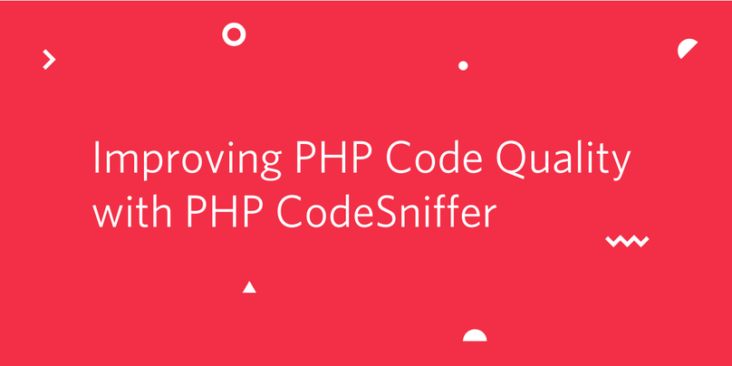
As a project grows, it becomes necessary to maintain and enforce some defined standards for the code. Such standards help achieve uniformity, readability, and maintainability, irrespective of the engineer that wrote the code. For a PHP project, one of the best ways to enforce such standards is PHP_CodeSniffer (or PHPCS for short).
PHPCS is a tool that helps detect violations of pre-defined coding standards. It also includes an additional tool that can automatically correct those violations.

Prerequisites
To complete this tutorial you will only need Composer globally installed.

About the project
PHPCS is framework-agnostic, but for simplicity, we will be using it with a simple Laravel project. The project, called “Twilio Greeter”, displays a list of common greetings depending on the language chosen by the user. You can view the complete source code here.
The project files that are of interest to us are:
- PROJECT_ROOT/app/Http/Controllers/WelcomeController.php: Our main controller has an index method which retrieves the preferred language from the GET parameter and sends the data to the view for rendering.
- PROJECT_ROOT/resources/views/welcome.blade.php: Displays the list passed into it from the WelcomeController.
- PROJECT_ROOT/routes/web.php: Our project routes file
You can learn more about how the above files work and Laravel in general from the official Laravel documentation.

Setting up the project
Clone our greeter app and change into the project directory with:
$ git clone https://github.com/idoqo/twilio-greeter && cd twilio-greeter
Next, run
$ composer install
to install the project dependencies and
$ php artisan serve
to start the server. Our application is now accessible at http://localhost:8000.

Installing PHPCS
Since it’s desirable to run the PHPCS CLI as a stand-alone command, we will install it globally with the following command:
$ composer global require "squizlabs/php_codesniffer=*"
You can check your installation with:
$ phpcs
NOTE: If you get an error similar to “command not found”, ensure you place the Composer bin folder in your PATH (usually $HOME/.config/composer/vendor/bin for Linux and $HOME/.composer/vendor/bin for MacOS).

Our Preferences
Our application works fine after cloning, but the coding style could use some improvements. PHPCS supports lots of coding standards out of the box such as PSR12, PSR2, PEAR, and Zend. You can also create your own rules if they are all found wanting.
For our use case, we want some rules such as:
- Visibility of all properties/methods must be explicitly declared (PHP defaults to public visibility if none is provided).
- Opening and closing braces for methods should be on a separate line.
- Function calls that span multiple lines should have only one argument per line e.g
<?php

$message->send(

$arg1,

$arg2,

$arg3

);
Fortunately for us, our preferences are conventional and have been covered by the PSR12 standard, so we will just go ahead and use the PSR12 as our base configuration.

Configuring PHPCS for our Project
To start, let’s create a new file called phpcs.xml in our project root directory with:
$ touch phpcs.xml
and add the following:
<?xml version="1.0"?>

<ruleset name="PHP_CodeSniffer">

<description>PHPCS configuration file.</description>
<!-- check all files in the app directory, feel free to add more files with:
<file>FOLDER NAME</file>
-->
<file>app</file>

<!-- exclude our migrations directory from the violation check-->
<exclude-pattern>*/migrations/*</exclude-pattern>

<!-- ignore warnings and display ERRORS only -->
<arg value="np"/>

<!-- Our base rule: set to PSR12-->
<rule ref="PSR12"/>

</ruleset>
The code above has been commented to provide some explanation, but you can look up the PHPCS wiki to see the different options you can provide.

Running our first test
At this point, our project is ready and we can test for violations now. In the root directory, run:
$ phpcs
If all went well, you should see an output similar to:
.............E.......... 24 / 24 (100%)

FILE: /home/PATH_TO_PROJECT/twilio-greeter/app/Http/Controllers/WelcomeController.php

--------------------------------------------------------------------------------------------------------------

FOUND 5 ERRORS AFFECTING 3 LINES

--------------------------------------------------------------------------------------------------------------

1 | ERROR | [x] Header blocks must be separated by a single blank line

8 | ERROR | [ ] Visibility must be declared on method "showGreetings"

8 | ERROR | [x] Opening brace should be on a new line

18 | ERROR | [ ] Visibility must be declared on method "greetings"

18 | ERROR | [x] Opening brace should be on a new line

--------------------------------------------------------------------------------------------------------------

PHPCBF CAN FIX THE 3 MARKED SNIFF VIOLATIONS AUTOMATICALLY

--------------------------------------------------------------------------------------------------------------

Time: 208ms; Memory: 6MB

Fixing as we go.
The report above included the files and the line number in which we went against the rules. For instance, we need to specify the method visibility on line 8 and move the opening brace on line 18 to a new line.
A quick way out would be to run:
$ phpcbf
in the project directory and PHPCS will automatically try to fix the violations marked with [x], but let’s attempt to fix them ourselves.
From our report, the only file we need to clean up is app/Http/Controllers/WelcomeController.php so open it and make the following corrections. First, we add a blank line between line 1 and 2 so it looks like the following:
<?php

namespace App\Http\Controllers;

...
Then, we specify the visibility for the showGreetings method and move the opening brace to a new line, so replace:
function showGreetings(Request $request){

...
with:
public function showGreetings(Request $request)
{

...
Finally, we mark our greetings method as private (since we don’t need to call it outside of the WelcomeController class). We’ll also move it’s opening brace to a new line too as follows. Replace:
function greetings($language) {

...

With:
private function greetings($language)
{

...
NOTE: The clean version of the project is on the tidied branch and you can view it by checking out the tidied branch like so:
$ git checkout tidied
Now, run phpcs again and our errors should have disappeared.

Conclusion
Code guidelines help to reduce the cognitive load required to work in a project with multiple developers, and PHPCodeSniffer does a good job of ensuring adherence to pre-set standards. If you’re looking to build your own custom rules, the existing rulesets are a good place to start.
I hope you enjoyed the post and if there are any issues or questions, please feel free to reach out to me via Email or on Github.

Additional Reading
To further your education, check out the related topics:
- Set Up PHP CodeSniffer for Local Development
- Debugging Your Twilio Application
- How to set up your PHP development environment
https://www.twilio.com/blog/improving-php-code-quality-php-codesniffer-phpcs-laravel

Set Up PHP CodeSniffer for Local Development
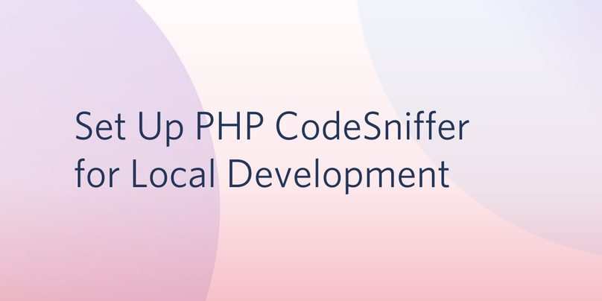
PHP_CodeSniffer (PHPCS) is a tool that validates your code against a set of predefined standards and ensures that such standards are maintained across the team. This tutorial will walk you through automating those validations during development by setting up PHPCS on Sublime Text, Visual Studio Code, and PHPStorm.
Note: The accompanying sample project is available at https://github.com/idoqo/twilio-greeter. You can also download the phpcs.xml to use in your existing project.

Prerequisites
Completing this tutorial requires the following prerequisites:
- Composer installed
- Either Sublime Text, VS Code, or PHPStorm installed

Installing PHP Code Sniffer
All of the editors below require PHPCS to be pre-installed, and since we plan to use it across projects, we will install it globally with the following command:
$ composer global require "squizlabs/php_codesniffer=*"
You can check your installation with:
$ phpcs
Note: If you get an error similar to command not found, ensure that you place the Composer bin folder in your PATH (usually $HOME/.config/composer/vendor/bin for Linux and $HOME/.composer/vendor/bin for MacOS).

Setting up PHPCS with Sublime Text
The Sublime Text package repository has two plugins that can be used to interface with PHPCS: SublimeLinter-phpcs and Phpcs. We are going to use the standalone Phpcs plugin as it offers more configuration options.
Launch package control with (Shift+Ctrl+P or Shift+Cmd+P). Select “Package Control: Install package” from the popup menu and search for “Phpcs”. The top result is what we are looking for as shown in the image below:
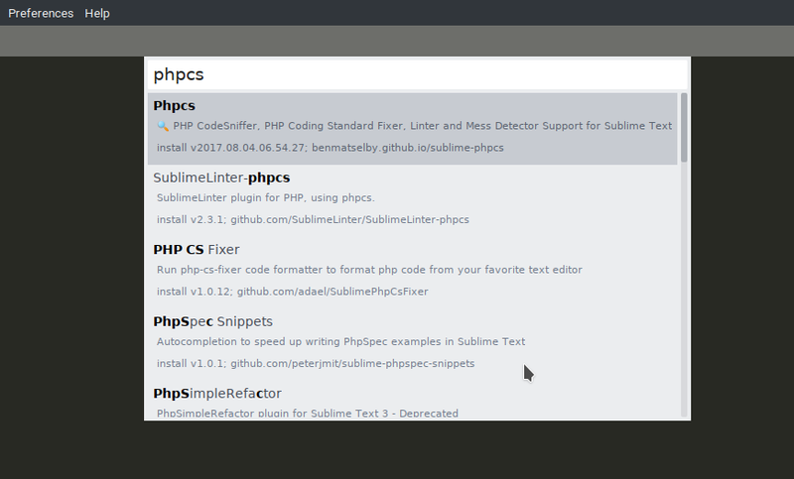
Next, we will set up the package configuration file by going to Preferences > Package Settings > Settings - User from the Menu Bar, paste the code block below into the newly created phpcs.sublime-settings and save it.
{
// full path to our phpcs binary,
// replace "YOUR_HOME_DIRECTORY" with the path to your home folder
"phpcs_php_path": "/home/idoko/.config/composer/vendor/bin/phpcs",

// run phpcs on every PHP file after we save it.
// you can ignore folders by excluding them in the phpcs.xml config file
"phpcs_execute_on_save": true,

// mark lines that have violated the rules
"phpcs_show_gutter_marks": true,

// ignore blade templates, you can add more file extensions in the array
// Do not execute for twig files
"extensions_to_blacklist": ["blade.php"],

// you can even pass additional arguments to phpcs
"phpcs_additional_args": {
"-n": ""
},
}
For a complete list of all the possible config options, you can look up the example settings in the plugin source code.
The next time you modify a PHP file and save, PHPCS should run automatically and report any violations that occur in the popup menu.

Setting up PHPCS with Visual Studio Code
Using PHPCS on VS Code is relatively easy as the vscode-phpcs plugin does a lot of heavy-lifting for us. To install the plugin:
- Open the Quick Open dialog on VS Code (with Ctrl+P or Cmd+P)
- Type “ext install phpcs” to find the extension and
- Click the cloud icon to install.
Once installed, restart VS Code and the plugin will automatically search your global composer path for a PHPCS installation. Note that it also searches your project root for existing rulesets (which is the purpose of the phpcs.xml file in our sample project).
Now, open a PHP file you want to sniff. Red lines should appear in all the places with violations as shown below:
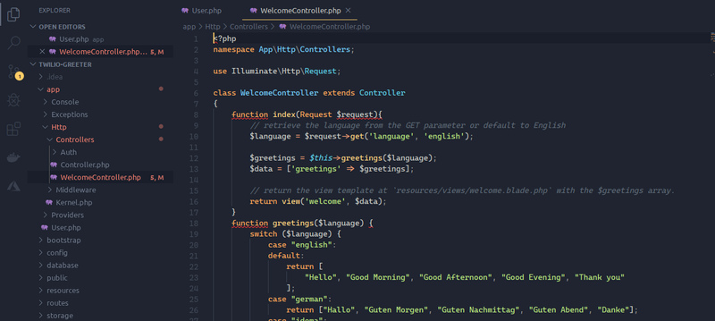

Setting up PHPCS with PHPStorm
PHPStorm natively supports code inspection with PHP_CodeSniffer, though configuring it is quite some work.
First, launch the Settings dialog (Ctrl+Alt+S) and navigate to Languages & Frameworks > PHP > Quality Tools. Expand the PHP Code Sniffer on the Quality Tools page and select Local from the Configuration dropdown. Click the “three dots button” beside the dropdown highlighted below:
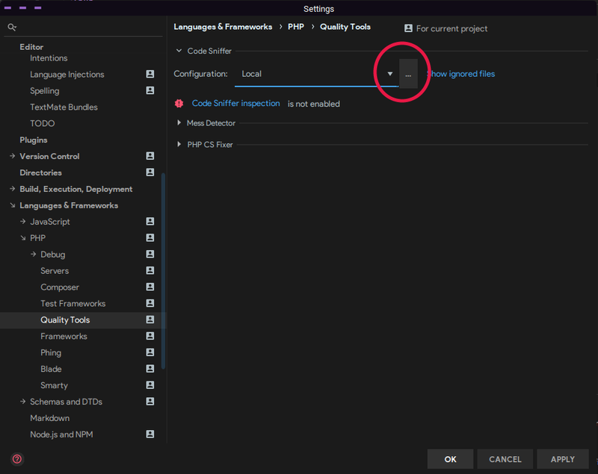
Specify the full path of the PHPCS executable in the new dialog that opens (which is $YOUR_COMPOSER_BIN_PATH/phpcs). You can click the Validate button to confirm it’s working and click “Apply” when you are done.
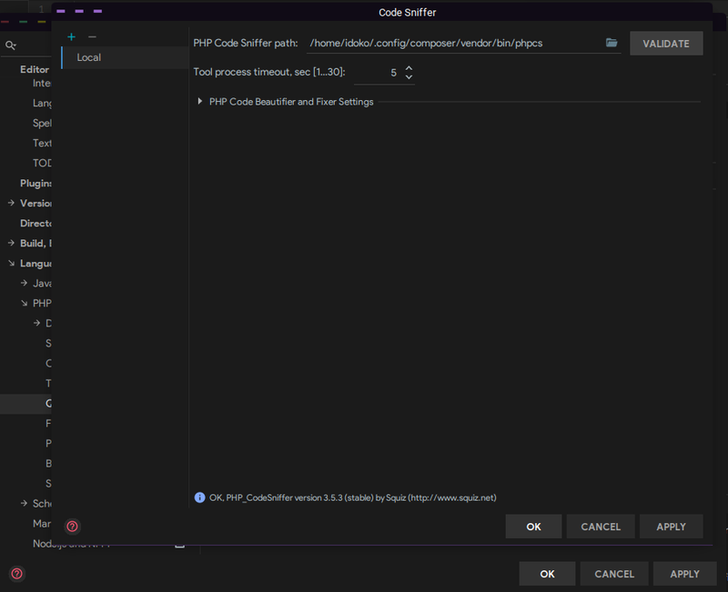
You should now see a different error on the Quality Tools page telling you that CodeSniffer inspection is not enabled.
Code inspections are how PHPStorm detects (and corrects) problems such as dead code, misspellings, and of course, code style violations in your project.
In the Settings dialog, go to Editor > Inspections. From the inspections screen, expand the PHP | Quality tools node and enable “PHP CodeSniffer validation”.
In the configuration pane that is now enabled, select “Custom” from the “Coding standard” dropdown, locate the ruleset configuration (phpcs.xml in our project directory), and apply your changes.
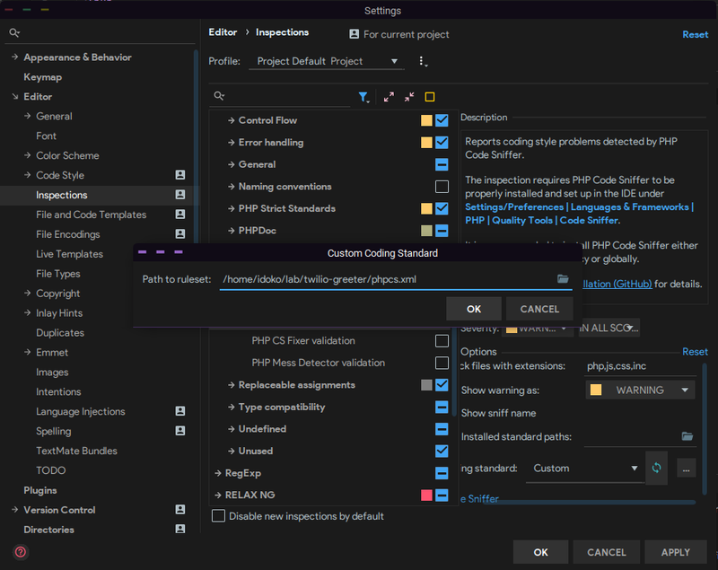
This way we can specify our preferences in the phpcs.xml file and have it applied across our project (irrespective of the tool we are using). Our code is now automatically being checked against our preferred standard and errors originating from PHPCS will be prefixed with phpcs.
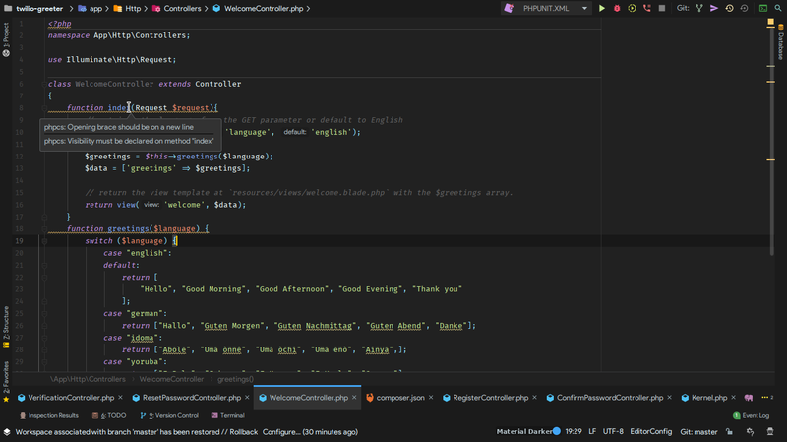

Conclusion
PHP Code Sniffer helps achieve uniformity of code styles and having your editor automatically check for violations goes a long way in improving the quality of your codebase.
I hope you enjoyed the post and if there are issues or questions, please feel free to reach out to me via Email or on Github.
https://www.twilio.com/blog/set-up-php-codesniffer-local-development-sublime-text-php-storm-vs-code

A guide to using PHP CodeSniffer
By Lorna Mitchell
Technology engineering
PHP Code Sniffer (PHPCS) is a package for syntax checking, available from PEAR. It can check code against defined rules covering anything from whitespace through doc comments to variable naming conventions and beyond. In this article we'll look at getting started with PHPCS, using it to syntax check our files, and then onto creating rules and defining standards.

Installing PHPCS
There are two main ways of installing PHPCS: directly, or via PEAR. Using the PEAR repositories is recommended and adapts to all the various platforms. It's also probably very familiar to all PHP developers!
The alternative is to use the method available for your system – for example my Ubuntu system had an Aptitude package called php-codesniffer which installed this functionality for me.
To use the PEAR method you simply need to update your PEAR repository and then type:
pear install PHP_CodeSniffer
Now we have the package installed, it's time to take a look at what it can do for us.

Using PHPCS
PHPCS is a command-line utility which can output varying levels of detail and evaluate one file, a whole directory, or a pattern match of target files. Its output is a list of flaws found, with an error message and line number supplied.
By default PHPCS comes pre-installed with a number of coding standard definitions. To see which definitions are available for checking, use the -i switch:
phpcs -i
The installed coding standards are MySource, PEAR, Squiz, PHPCS and Zend
This shows some default coding standards including the PHPCS standard, the Zend standard (used by Zend Framework and many other projects), and the widely-known PEAR standard.
It's possible to build on and adapt these existing standards to fit in with the coding standards used by a particular project and this subject will be explored further later in the article. The various standards have different requirements for code standards and as such we can evaluate a simple file against a couple of different standards to see some immediate differences.
Take the following code sample:
_id);
return $ingredients;
}
}
?>
Validating this class code against the Zend standard, we use the following syntax:
phpcs --standard=Zend recipe.class.php

FILE: /home/lorna/phpcs/recipe.class.php
--------------------------------------------------------------------------------
FOUND 3 ERROR(S) AND 0 WARNING(S) AFFECTING 3 LINE(S)
--------------------------------------------------------------------------------
10 | ERROR | Variable "prep_time" is not in valid camel caps format
13 | ERROR | Spaces must be used to indent lines; tabs are not allowed
17 | ERROR | A closing tag is not permitted at the end of a PHP file
--------------------------------------------------------------------------------
However the Zend standards don't require some elements which other standards do, for example the PEAR standards expect capitalised class names and opening function braces to be on new lines, and this is evident if we validate the same recipe.class.php file against the PEAR standard instead.
We use the same syntax as before but changing the --standard switch to PEAR:
FILE: /home/lorna/phpcs/recipe.class.php
--------------------------------------------------------------------------------
FOUND 8 ERROR(S) AND 0 WARNING(S) AFFECTING 5 LINE(S)
--------------------------------------------------------------------------------
2 | ERROR | Missing file doc comment
3 | ERROR | Class name must begin with a capital letter
3 | ERROR | Missing class doc comment
6 | ERROR | Protected member variable "_id" must not be prefixed with an
| | underscore
12 | ERROR | Missing function doc comment
12 | ERROR | Opening brace should be on a new line
13 | ERROR | Line indented incorrectly; expected at least 8 spaces, found 1
13 | ERROR | Spaces must be used to indent lines; tabs are not allowed
--------------------------------------------------------------------------------
We can go through our class and alter it to conform with these standards, the changes are mostly semantic but especially on large codebases, consistency and familiarity are absolutely key to facilitate easier maintenance and readability by developers. There are a few easy things we can fix in our code to have PHPCS standards show fewer warnings.
Here is the updated class file:
<?php

class Recipe
{

protected $id;

public $name;

public $prep_time;

function getIngredients()
{
$ingredients = Ingredients::fetchAllById($this->_id);
return $ingredients;
}
}
?>
The small tweaks to the class are small enough to almost insignificant, in fact a programmer glancing over one class or the other would probably have to glance again to be able to spot the differences. The clearest way to compare the files I think is using the diff file between the two versions:
3c3
< class recipe
---
> class Recipe
6c6
< protected $_id;
---
> protected $id;
12,13c12,14
< function getIngredients() {
< $ingredients = Ingredients::fetchAllById($this->_id);
---
> function getIngredients()
> {
> $ingredients = Ingredients::fetchAllById($this->_id);
Now if we re-check the file against the PEAR standards you can see that only the missing PHPDocumentor comments are listed as problems with the file:
FILE: /home/lorna/phpcs/recipe.class.php
--------------------------------------------------------------------------------
FOUND 3 ERROR(S) AND 0 WARNING(S) AFFECTING 3 LINE(S)
--------------------------------------------------------------------------------
2 | ERROR | Missing file doc comment
3 | ERROR | Missing class doc comment
12 | ERROR | Missing function doc comment
--------------------------------------------------------------------------------
To get our code to correctly validate we can then add the comments expected by PHPDocumentor. There are some great tutorials around for working with this tool, but the best place to start is on their homepage at http://www.phpdoc.org/.
Here's the class with the comments added:
<?php

/**
* Recipe class file
*
* PHP Version 5.2
*
* @category Recipe
* @package Recipe
* @author Lorna Jane Mitchell <lorna@ibuildings.com>
* @license http://opensource.org/licenses/gpl-license.php GNU Public License
* @link http://example.com/recipes
*/

/**
* Recipe class
*
* The class holding the root Recipe class definition
*
* @category Recipe
* @package Recipe
* @author Lorna Jane Mitchell <lorna@ibuildings.com>
* @license http://opensource.org/licenses/gpl-license.php GNU Public License
* @link http://example.com/recipes/recipe
*/
class Recipe
{

protected $id;

public $name;

public $prep_time;

/**
* Get the ingredients
*
* This function calls a static fetching method against the Ingredient class
* and returns everything matching this recipe ID
*
* @return array An array of Ingredient objects
*/
function getIngredients()
{
$ingredients = Ingredient::fetchAllByRecipe($this->id);
return $ingredients;
}
}
?>

What's inside the machine
PHPCS works on the basis of tokenising the contents of a file and then validating those against a given set of rules. The tokenising step splits down PHP into a series of building blocks, and the rules are able to check all sorts of things against it. So if we were to tokenise the function we included in the class file at the start, we'd get something that looks like this:
Array
(
[0] => Array
(
[0] => 367
[1] => <?php

[2] => 1
)

[1] => Array
(
[0] => 370
[1] =>

[2] => 2
)

[2] => Array
(
[0] => 333
[1] => function
[2] => 3
)

[3] => Array
(
[0] => 370
[1] =>
[2] => 3
)

[4] => Array
(
[0] => 307
[1] => getIngredients
[2] => 3
)

[5] => (
[6] => )
[7] => Array
(
[0] => 370
[1] =>
[2] => 3
)

[8] => {
[9] => Array
(
[0] => 370
[1] =>

[2] => 3
)

[10] => Array
(
[0] => 309
[1] => $ingredients
[2] => 4
)
... (truncated)
The output is truncated because of the sheer size of it, even when examined with print_r rather than var_dump. The tokenising is actually functionality that's available to us in PHP itself - the get_all_tokens() method which accepts a string. The function file_get_contents was used to retrieve the contents of the file as the argument to get_all_tokens and what you see above is the print_r output of that.
There's a great deal of information here, which isn't really readable by us (180 lines is generated in total, from a 2-line function) as there is so much of it, but we can process the output and have PHPCS check it against a set of rules.

Making the rules
To understand how we can create our own standards definitions, let's take a look at the existing standards that ship with PHPCS. These differ in location between different platforms, depending where PEAR puts them.
For me, on an ubuntu installation, they're in /usr/share/php/PHP/CodeSniffer/Standards. All the standards extend from the base CodingStandard.php in this directory.
This defines two simple methods: getIncludedSniffs() and getExcludedSniffs(). These allow us to use existing standard definitions and simply add and remove individual standards to make a standard that works for us.
These 'sniffs' are atomic rules covering anything from line length to variable naming to spotting 'code smells' such as unreachable code or badly formatted loops. Each coding standard has its own 'Sniffs' directory and anything included in here is automatically part of the standard. However each standard can also draw on the sniffs in other standards, and there are a great set of 'starter' sniffs, used in most of the standards, which are included with PHPCS in the Generic directory.
To get a feel for sniffs and how they inherit, let's take a look at a real standard. The PEAR standard is in the PEAR directory and the class file is PEARCodingStandard.php (this extension is nothing if not methodical!).
The class looks like this:
<?php
/**
* PEAR Coding Standard.
*
* PHP version 5
*
* @category PHP
* @package PHP_CodeSniffer
* @author Greg Sherwood <gsherwood@squiz.net>
* @author Marc McIntyre <mmcintyre@squiz.net>
* @copyright 2006 Squiz Pty Ltd (ABN 77 084 670 600)
* @license http://matrix.squiz.net/developer/tools/php_cs/licence BSD Licence
* @version CVS: $Id: PEARCodingStandard.php,v 1.6 2007/08/02 23:18:31 squiz Exp $
* @link http://pear.php.net/package/PHP_CodeSniffer
*/

if (class_exists('PHP_CodeSniffer_Standards_CodingStandard', true) === false) {
throw new PHP_CodeSniffer_Exception('Class PHP_CodeSniffer_Standards_CodingStandard not found');
}

/**
* PEAR Coding Standard.
*
* @category PHP
* @package PHP_CodeSniffer
* @author Greg Sherwood <gsherwood@squiz.net>
* @author Marc McIntyre <mmcintyre@squiz.net>
* @copyright 2006 Squiz Pty Ltd (ABN 77 084 670 600)
* @license http://matrix.squiz.net/developer/tools/php_cs/licence BSD Licence
* @version Release: 1.1.0
* @link http://pear.php.net/package/PHP_CodeSniffer
*/
class PHP_CodeSniffer_Standards_PEAR_PEARCodingStandard extends PHP_CodeSniffer_Standards_CodingStandard
{

/**
* Return a list of external sniffs to include with this standard.
*
* The PEAR standard uses some generic sniffs.
*
* @return array
*/
public function getIncludedSniffs()
{
return array(
'Generic/Sniffs/Formatting/MultipleStatementAlignmentSniff.php',
'Generic/Sniffs/Functions/OpeningFunctionBraceBsdAllmanSniff.php',
'Generic/Sniffs/NamingConventions/UpperCaseConstantNameSniff.php',
'Generic/Sniffs/PHP/LowerCaseConstantSniff.php',
'Generic/Sniffs/PHP/DisallowShortOpenTagSniff.php',
'Generic/Sniffs/WhiteSpace/DisallowTabIndentSniff.php',
);

}//end getIncludedSniffs()

}//end class
?>
This class is showing that there are some sniffs included from the Generic directory as well as those specific to this standard. Looking at the Sniffs for PEAR we see that they have the following:
./Classes:
ClassDeclarationSniff.php

./Commenting:
ClassCommentSniff.php FileCommentSniff.php FunctionCommentSniff.php InlineCommentSniff.php

./ControlStructures:
ControlSignatureSniff.php InlineControlStructureSniff.php

./Files:
IncludingFileSniff.php LineEndingsSniff.php LineLengthSniff.php

./Functions:
FunctionCallArgumentSpacingSniff.php FunctionCallSignatureSniff.php ValidDefaultValueSniff.php

./NamingConventions:
ValidClassNameSniff.php ValidFunctionNameSniff.php ValidVariableNameSniff.php

./WhiteSpace:
ScopeClosingBraceSniff.php ScopeIndentSniff.php
These are in addition to the included Generic sniffs we saw listed earlier. There's a lot of detail in these various standards and I strongly recommend you take a look at them yourself since covering them all in any depth would make rather a long article. We will take a look at the Functions sniffs used by PEAR though as these standards are well-known and easy to understand.

Function Sniffs for the pear standard
The PEARCodingStandard class includes the sniff Generic/Sniffs/Functions/OpeningFunctionBraceBsdAllmanSniff.php.
A closer look in this Generic/Sniffs/Functions directory reveals there is also a standard called OpeningFunctionBraceKernighanRitchieSniff.php. This is a little piece of computer science history, there are two schools of thought on where the opening brace should go when a function is declared.
Brian Kernighan and Dennis Ritchie (who invented Unix and C between them) advocated having it on the same line as the function declaration whereas the BSD style, championed by Eric Allman (creator of sendmail), has it on the following line. PEAR famously uses the on-a-new-line style which is why the OpeningFunctionBraceBsdAllmanSniff is used in the PEAR standard.
Now we've finished our history lesson, let's dive in and take a look at this sniff. All sniffs take two arguments: one with all the tokens of the file in it, and one indicating where in the token stack actually triggered this function call.
<?php
/**
* Generic_Sniffs_Methods_OpeningMethodBraceBsdAllmanSniff.
*
* PHP version 5
*
* @category PHP
* @package PHP_CodeSniffer
* @author Greg Sherwood <gsherwood@squiz.net>
* @author Marc McIntyre <mmcintyre@squiz.net>
* @copyright 2006 Squiz Pty Ltd (ABN 77 084 670 600)
* @license http://matrix.squiz.net/developer/tools/php_cs/licence BSD Licence
* @version CVS: $Id: OpeningFunctionBraceBsdAllmanSniff.php,v 1.8 2008/05/05 03:59:12 squiz Exp $
* @link http://pear.php.net/package/PHP_CodeSniffer
*/

/**
* Generic_Sniffs_Functions_OpeningFunctionBraceBsdAllmanSniff.
*
* Checks that the opening brace of a function is on the line after the
* function declaration.
*
* @category PHP
* @package PHP_CodeSniffer
* @author Greg Sherwood <gsherwood@squiz.net>
* @author Marc McIntyre <mmcintyre@squiz.net>
* @copyright 2006 Squiz Pty Ltd (ABN 77 084 670 600)
* @license http://matrix.squiz.net/developer/tools/php_cs/licence BSD Licence
* @version Release: 1.1.0
* @link http://pear.php.net/package/PHP_CodeSniffer
*/
class Generic_Sniffs_Functions_OpeningFunctionBraceBsdAllmanSniff implements PHP_CodeSniffer_Sniff
{

/**
* Registers the tokens that this sniff wants to listen for.
*
* @return void
*/
public function register()
{
return array(T_FUNCTION);

}//end register()

/**
* Processes this test, when one of its tokens is encountered.
*
* @param PHP_CodeSniffer_File $phpcsFile The file being scanned.
* @param int $stackPtr The position of the current token in the
* stack passed in $tokens.
*
* @return void
*/
public function process(PHP_CodeSniffer_File $phpcsFile, $stackPtr)
{
$tokens = $phpcsFile->getTokens();

if (isset($tokens[$stackPtr]['scope_opener']) === false) {
return;
}

$openingBrace = $tokens[$stackPtr]['scope_opener'];

// The end of the function occurs at the end of the argument list. Its
// like this because some people like to break long function declarations
// over multiple lines.
$functionLine = $tokens[$tokens[$stackPtr]['parenthesis_closer']]['line'];
$braceLine = $tokens[$openingBrace]['line'];

$lineDifference = ($braceLine - $functionLine);

if ($lineDifference === 0) {
$error = 'Opening brace should be on a new line';
$phpcsFile->addError($error, $openingBrace);
return;
}

if ($lineDifference > 1) {
$ender = 'line';
if (($lineDifference - 1) !== 1) {
$ender .= 's';
}

$error = 'Opening brace should be on the line after the declaration; found '.($lineDifference - 1).' blank '.$ender;
$phpcsFile->addError($error, $openingBrace);
return;
}

// We need to actually find the first piece of content on this line,
// as if this is a method with tokens before it (public, static etc)
// or an if with an else before it, then we need to start the scope
// checking from there, rather than the current token.
$lineStart = $stackPtr;
while (($lineStart = $phpcsFile->findPrevious(array(T_WHITESPACE), ($lineStart - 1), null, false)) !== false) {
if (strpos($tokens[$lineStart]['content'], $phpcsFile->eolChar) !== false) {
break;
}
}

// We found a new line, now go forward and find the first non-whitespace
// token.
$lineStart = $phpcsFile->findNext(array(T_WHITESPACE), $lineStart, null, true);

// The opening brace is on the correct line, now it needs to be
// checked to be correctly indented.
$startColumn = $tokens[$lineStart]['column'];
$braceIndent = $tokens[$openingBrace]['column'];

if ($braceIndent !== $startColumn) {
$error = 'Opening brace indented incorrectly; expected '.($startColumn - 1).' spaces, found '.($braceIndent - 1);
$phpcsFile->addError($error, $openingBrace);
}

}//end process()

}//end class

?>
Read as much or as little of the above listing as interests you. Personally I think this is a nice example of checking the brace position, formatting the error messages nicely, and also checking the indent is correct since we've figured out where everything is anyway.
This sniff handles function declarations spread over multiple lines and also checks that the brace is on the very next line rather than simply checking it exists after some whitespace. It's certainly doing some thorough checking, and much more easily and quickly than we would be able to do it by hand, either on our own code or via peer review.
While we're on the subject of function structure, let's also examine the PEAR-specific sniffs for functions.
They are:
- FunctionCallArgumentSpacingSniff.php
- FunctionCallSignatureSniff.php
- ValidDefaultValueSniff.php
Can you guess what each of the sniffs does? They're good examples of adding continuity to your code, I won't replicate their actual contents here but I'd definitely recommend taking a look at them, especially if you're considering writing standards of your own.
They each enforce some element of good practice when declaring functions, warning you when arguments without default values are placed after those with defaults, for example. They also look at spacing around the brackets and the arguments in function declarations (PEAR doesn't allow spaces around brackets but requires them between arguments, after the comma).
Continuity like this makes code easy to read because its laid out in a way your brain expects.

Final thoughts on coding standards
Coding standards can be seen as a timewaster, a hurdle, another piece of paperwork invented by business to keep a hard-working developer from delivering all he can.
Certainly attempting to code in an unfamiliar standard without the support of a tool such as PHPCS is difficult to achieve, if it's even possible. Because I work with many different codebases, belonging to clients, to open source projects, and of my own, I see many different standards and have to code in a number of standards and sometimes all within one day!
I can't hold the detail in my head but a tool like PHPCS means I am always generating code which is useful for my collaborators on a project, whether they are clients, friends, or even myself at a later date, and I can do it without really having to think too hard about it once I've taken the time to get this tool in place.
PHPCS is most useful when it is painlessly built into our existing development lifecycle and tools. There are integrations for this tool against most editors and it can easily be added as an SVN hook or as a step in your continuous integration process. Having the barrier to usage of this tool as low as possible makes it more likely that, as developers, we'll make use of its features throughout our projects.
This module is available through PEAR and I would like to thank the authors of all the extensions there who work so hard to make their code available and maintain it for others to us, with special thanks to Greg Sherwood, who is the maintainer of the PHP_CodeSniffer package in PEAR.
https://inviqa.com/blog/using-php-codesniffer

Getting Started With PHP CodeSniffer
PHP
People often develop different coding styles, but it is good if we can all get on the "same page" to make collaboration easier. Hence the desire for coding standards such as PSR-2. PHP CodeSniffer is a tool that can automatically detect violations of the standards you configure, and sometimes automatically fix them. This is especially useful for open source projects where anybody might be making a contribution, but you want a consistent look.

Install CodeSniffer
There are many ways to install the CodeSniffer tool. Since I just want to install it permanently to my machine and use across projects, I would either install through Pear, or using the Ubuntu packages as shown below. However, you could have it as a dependency of your project with composer if you wanted to.

Using Pear
- Install pear.
- Run the following command to install the toll through pear.
sudo pear install PHP_CodeSniffer
Copy

Ubuntu 16.04 - Native Packages
Ubuntu 16.04 users should also be able to install it with:
sudo apt install php-codesniffer
Copy

Configuration
Different people had different styles of programming. E.g. do you have your { on the same line as an if statement or not? The CodeSniffer tool needs to be configured to take this into accoun.
Add a configuration to your project called phpcs.xml, which will define your project's coding standards. If you just want to use PSR2, then you can just download this example:
wget https://raw.githubusercontent.com/squizlabs/PHP_CodeSniffer/master/src/Standards/PSR2/ruleset.xml
mv ruleset.xml phpcs.xml
Copy
If you use Zend coding standard, I believe this file may be of use instead.

Usage
Once you have created your phpcs.xml file, you can run the codesniffer against the files in the current working directory with:
phpcs .
Copy
Alternatively, if you just wish to evaluate a single file, then run:
phpcs /path/to/file
Copy

Output
Once you have run the tool, you should get a chunk of output for each file like so:
FILE: /path/to/my/file.php
---------------------------------------------------------------------------------------------
FOUND 5 ERRORS AND 1 WARNING AFFECTING 6 LINES
---------------------------------------------------------------------------------------------
10 | ERROR | [x] Expected 1 space after comma in function call; 4 found
19 | ERROR | [x] Whitespace found at end of line
20 | ERROR | [x] Whitespace found at end of line
21 | WARNING | [ ] Line exceeds 120 characters; contains 165 characters
29 | ERROR | [x] Whitespace found at end of line
70 | ERROR | [x] TRUE, FALSE and NULL must be lowercase; expected "true" but found "TRUE"
---------------------------------------------------------------------------------------------
PHPCBF CAN FIX THE 5 MARKED SNIFF VIOLATIONS AUTOMATICALLY
---------------------------------------------------------------------------------------------

Automatically Fixing Issues
You will notice the following line from the example output:
PHPCBF CAN FIX THE 5 MARKED SNIFF VIOLATIONS AUTOMATICALLY
Well that sounds awesome*, lets do it!
PHPCBF stands for PHP Code Beautifier and can be run just like the previous command:
phpcbf /path/to/file/or/folder
Copy

Conclusion
I hope you find this tool useful. It will certainly help prevent "styling wars" by keeping everyone on the same page. Going further, you may be interested in this post to find out about a "PHP Mess Detector" (phpmd) and an alternative to CodeSniffer called "PHP Coding Standards Fixer" (php-cs-fixer).

References
- dev.to - How to master your code through your project lifecycle (1/2)
- https://www.youtube.com/watch?v=tKih3UZuwXw
https://blog.programster.org/getting-started-with-php-codesniffer

