Tutorial: Using Xdebugger with PHP & VSCode to Debug
- Practices
- Coding and Tutorial
- Framework and Libraries
- Enterprises
By Samiksha Gupta Feb 15, 2020

Submit guest post

If you want to deliver quality software, debugging has to be an indispensable part of your software development.
While .net and java developers often have Integrated Development Environments (IDEs) that encompass complete debugging support, PHP developers may feel overlooked. And even though some would argue that there are a few commercial applications that help with debugging PHP, those are expensive and OS-dependent.
Fortunately, there are a few open-source tools out there that give PHP developers a similar debugging experience as that of an expensive IDE. VSCode is one of them. It can work with a number of languages and when configured correctly, can prove efficient in the debugging process.
This blog will guide you on how to set up the PHP xDebug module to work in conjunction with VSCode, ensuring enablement of full-on functional debugging across your application.

How To Configure PHP For Using XDebug
First and foremost, you would require to install VSCode and PHP 7.0 version. Take into account that you would need a web server as well to run the PHP, so install it beforehand. Once the pre-requisites are met, make note of your PHP module directory, for example, mine is set to ‘C:\wampp\php\ext‘. This is where the XDebug module will reside.
Follow the below steps to configure PHP for using XDebug module-
Step 1-
Create an index.php file in the root directory of your web server, and append the following code to it-
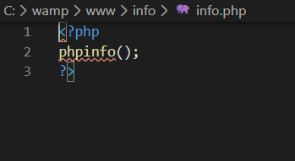

Run the info.php file in a browser, for instance, Google Chrome. This will translate the following information as showcased in the picture below-

Post loading this, you have to follow below sub-steps-
1. Download php_xdebug-2.6.0-7.0-vc14.dll
2. Move the download file to C:\wamp\php\ext
3. Edit php.ini of wamp and add the line
zend_extension=C:\wamp\bin\php\php7.3.5\ext\php_xdebug-2.8.0-7.3-vc15-x86_64.
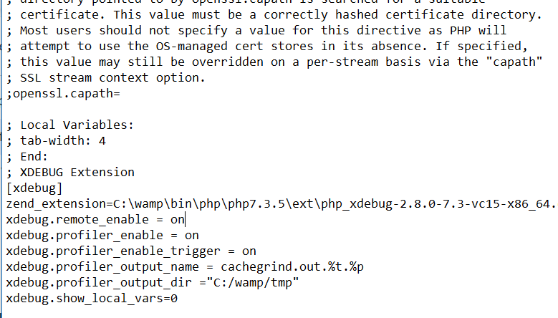
After this, restart the wamp server-
- Enable remote_enable & remote_autostart. Activate these without any fail otherwise, xDebug won’t be implemented successfully even if either the browser or as singular script launch.
- Save the changes
- Restart the web-server again

Configuring VSCode to use PHP XDebug
Learn how to configure VSCode to use PHP XDebug feature and simplify your work-
Step 1: Install the PHP Debug extension. You can do so by selecting the extensions tab or CTRL+SHIFT+X in VSCode and searching for ‘PHP Debug’
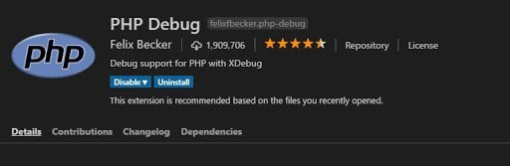
Step 2: Next, click on the Debug tab on the left-hand pane. A drop-down menu will pop from which you have to select “Add Configuration” (as shown in pic).
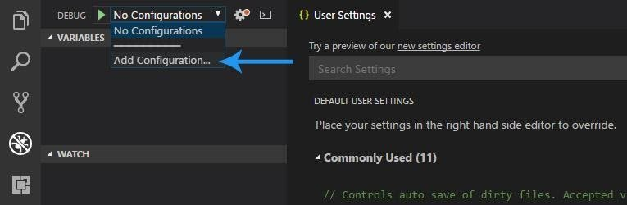
Following this, click on the “PHP’ option again from the drop-down menu.
Once you have successfully implemented the above steps, you will see that VSCode will be created to launch. The json file will also be present within your root directory inside the VSCode folder.
However, there will be one more step left to ensure that the script execution works correctly.
Specify the runtimeExecutable which is the path to your PHP.exe interpreter. For example. Mine looks like the following-
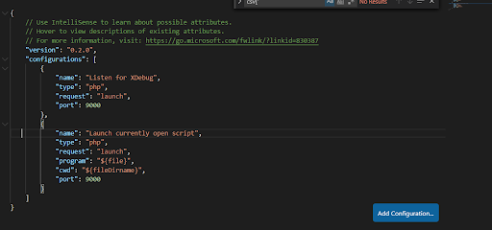
Move ahead and save the launch.json file.

Step 3
After completing step 1 and 2 successfully, you’ll be able to implement the “Launch currently open script” feature, which as its name suggest, will help you debug a single script without having to worry about a browser.
In addition, if you want to be capable enough to debug a script as a user do usually, (using a browser), this is always worth putting effort into.
The only requisite for it is an xDebug Helper, which is a Google Chrome extension, available for free. You can easily find this extension by navigating through the Google Chrome Web Store. Look out for the following steps-
- Go to the following URL https://chrome.google.com/webstore/category/extensions
- Search for ‘xDebug Helper’ and install the extension (with a green ladybug in the logo)
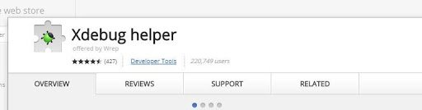
That’s it! Your VSCode is now all set to debug your code.

How To Debug the code using Xdebug
As both debug methods are set up, we need to learn how to use them.
The first thing would be to use the “Launch currently open script” method.
- Go to any .php file, and add some breakpoints to your code (Shortcut - F9 on the keyboard).
- Make sure that ‘Launch currently open script’ is already selected in the Debug drop-down in the top left of the debug window.
- Press F5 to start the debug process.
- You will see the debugger break at the first breakpoint. See the pictures below for reference-
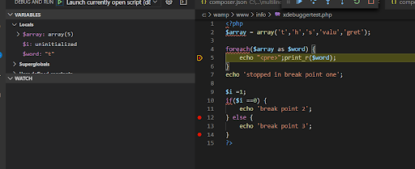
Listen for xDebug Method
Now, let’s go through the ‘Listen for xDebug method” which takes the browser into account.
- Open a .php file, for example, here, the xdebuggertest.php file, inside the info folder of the root directory.
- Add some code and add some breakpoints. Use the F9 shortcut key to add breakpoints.
- Change the Debug select option to ‘Listen for xDebug’.
- Press F5 to start the debugger.
- Open Chrome and navigate to your index.php file, in my case its http://localhost/info/xdebuggertest.php
- Click the new XDebug Helper extension and click the Debug option.
- You will notice that helper icon has turned turn green (See image below)
- Finally, refresh the page in the browser to let VSCode react and start the debugging process.
- Go back into VSCode and you will see that it has stopped at the breakpoint.
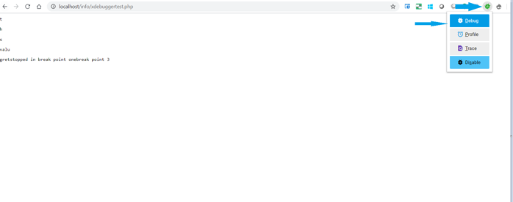

Wrapping up
Without debugging, you can’t figure out what’s wrong with your code. Thus, it is a good practice to set up your debugging environment before initiating the code write-up process, because, in case you are developing a complex application that contains thousands of lines of code, you will certainly need a PHP debugger - to find errors and warning signs way ahead of delivery time.

Happy debugging!
https://www.srijan.net/blog/tutorial-using-xdebugger-with-php-vscode-to-debug

Step Into Step-through Debugging
All Insights

Elliott Foster
December 5, 2013
- Development
Share this Page
How many times have you been stuck on a difficult problem that required lots of debugging? Hours go by and you make incremental progress on the solution. Finally, eureka, you’ve cracked it. On to the pull request! To your dismay it gets shot down immediately because of this
print_r($some_var);
or this
console.log(some_var);
or, science forbid, this
alert(some_var);
What if I told you you were doing it wrong?

Let’s do it right
Print statements are a very simple way to debug your code. They’re great, if I need something quick I’ll still drop one in. I’ll even remember to remove them later, usually… Their biggest drawback though is that they limit your view into what’s actually going on in your program, both in the variables that you’ve printed and how the program flows before and after your print statement.
If you want to really understand what’s going on in your program at a given point in time you need to be using a step-through debugger. Step-through debuggers are commonplace among compiled languages but for whatever reason in web development, at least in my experience, they haven’t seemed to catch on. This needs to change.
Why, you ask? Let’s look at how a step-through debugger works. A debugger attaches itself to the program’s process and listens for events. If your program isn’t throwing any exceptions or forcing any breakpoints the program will execute as normal.
There are some common features of step-through debuggers which I’ll be referencing in the rest of this blog post, here’s a list:
- Breakpoint – A line number of interest in your program. When the debugger is running it halts execution of the program at this line.
- Call stack – A list of functions in the debugger that explains how the program got to where it currently is. Think of this as a live stack trace, without the exception.
- Continue – An action to take in the debugger that will continue execution until the next breakpoint is reached or the program exits.
- Step over – An action to take in the debugger that will step over a given line. If the line contains a function the function will be executed and the result returned without debugging each line.
- Step into – An action to take in the debugger. If the line does not contain a function it behaves the same as “step over” but if it does the debugger will enter the called function and continue line-by-line debugging there.
- Step out – An action to take in the debugger that returns to the line where the current function was called.
Breakpoints are the key though, consider this (contrived) example:
/** * Returns an array of random numbers up to *size*. * * @param {int} size * The size of the random array to return. * * @return {array} * Array of random integers. */ function loop(size) { var ary = [] var min = 0; for (var max = 1; max <= size; max++) { var rand = Math.floor(Math.random() * (max - min + 1) + min) ary.push(rand); } return ary; } var max = 100; var min = 1; var size = Math.floor(Math.random() * (max - min + 1) + min); var res = loop(size); console.log('Created an array with ' + res.length + ' results.'); console.log(res.join(', '));
1  2  3  4  5  6  7  8  9  10  11  12  13  14  15  16  17  18  19  20  21  22  23  24  25  26  27  28 | /**  * Returns an array of random numbers up to *size*.  *  * @param {int} size  * The size of the random array to return.  *  * @return {array}  * Array of random integers.  */  function loop(size) {  var ary = []  var min = 0;  for (var max = 1; max <= size; max++) {  var rand = Math.floor(Math.random() * (max - min + 1) + min)  ary.push(rand);  }  return ary;  }  var max = 100;  var min = 1;  var size = Math.floor(Math.random() * (max - min + 1) + min);  var res = loop(size);  console.log('Created an array with ' + res.length + ' results.');  console.log(res.join(', '));

Suppose we’re interested in the value of size before we enter the loop function. Sure we could print there, but what if we’re also interested in what happens after the value is created? Using a step-through debugger we can follow the execution path of the program and track our variable – and any other in-scope variables – as the program is running. It’s easier to show this than to write about it, so check this out:
We’ll start by adding a breakpoint at line 21 (22 in the debugger since node-inspector wraps our code in an IIFE). When the program is started it will immediately pause at this line. The first action we’ll take is to step over this line so the value is instantiated. In the debugger you’ll see that the size variable is listed with the value 78.
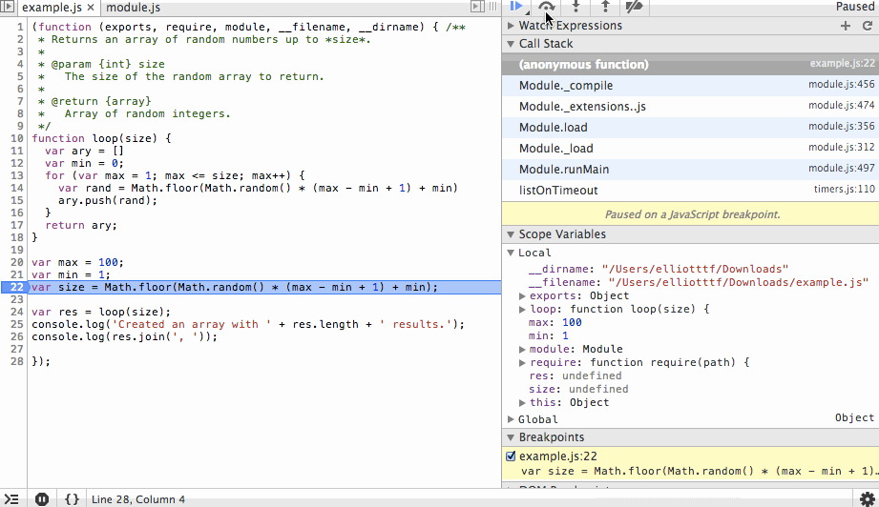
The next action we’ll take is to step into the loop function and step over the ary and min variable instantiations. You’ll see the initial values being set in the scope variables list as we step over each line.
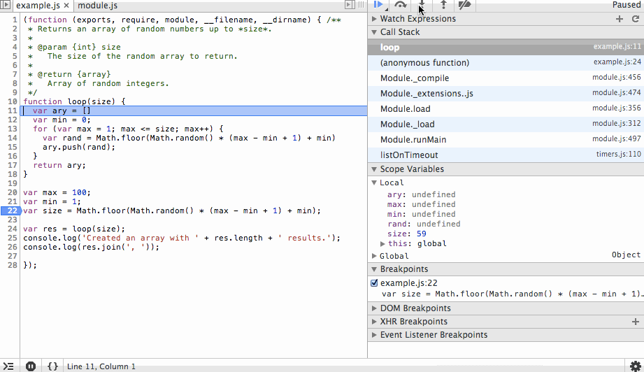
Next we’ll step through the for loop. You’ll notice the ary array is growing with random values and that on each step we can see the value of rand before it is appended to the array. We’ll add a new breakpoint at the end of the array and continue to that point so we don’t have to step through each iteration of the loop.
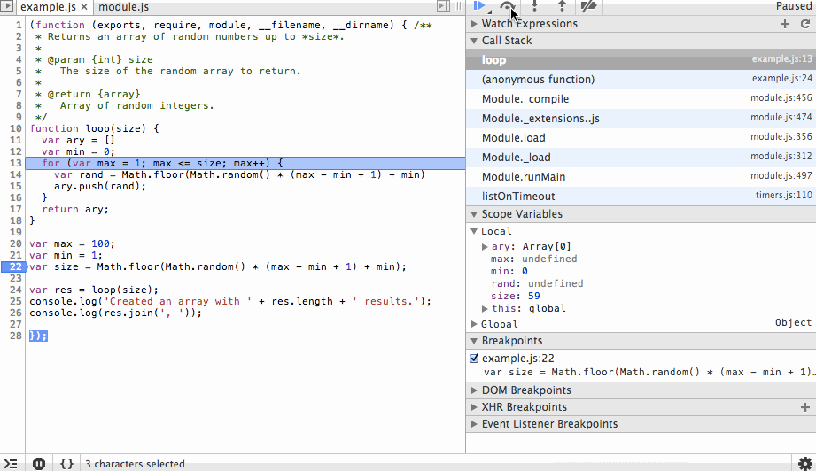
Finally we’ll step back out, in this case stepping over or in would produce the same result since we’ve reached the end of the function, but why not go ahead and use our one remaining action? After we review the results we’ll continue to the end. The process that the debugger is connected to will exit cleanly and the debugging session will end.
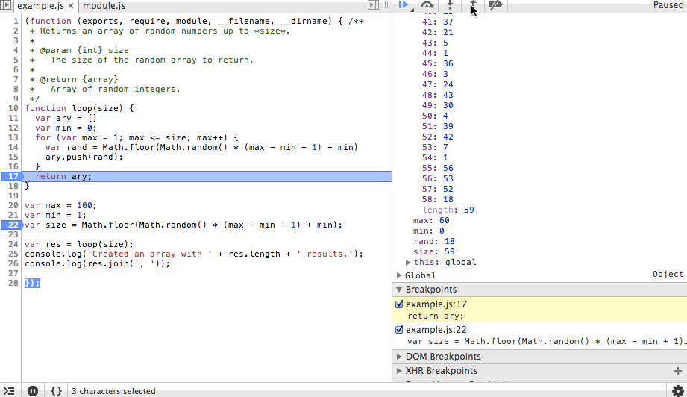
This is obviously a very simple example of how a step-through debugger works but hopefully it’s clear how powerful this can be.
To take this one step further, when you start dealing with nested function calls the call stack list will display the current function you are executing and the functions that were called to get you here. You can step back out to any one of those functions and observe the scope of variables, etc that existed when the function was called. So now not only can you get a snapshot of where things are currently and where they are going, you can also see what things looked like in the past that led the program here. This is huge for debugging complex code or just learning how someone else’s code works!

Ok, I’m sold, now what?
There are two major components for step-through debugging that are common regardless of what type of code you’re debugging:
- A process that is sending debug information.
- A debugger that is listening for debug information.
Typically you start a process for debugging by adding some conditional flags. I’ll cover the programming languages we work with the most at Four Kitchens here, but the process is going to be the same for pretty much everything.
For PHP you need to install xdebug on your server and add a xdebug.ini config file like this:
zend_extension=/usr/lib/php5/20090626/xdebug.so
xdebug.remote_enable=1
xdebug.remote_host=10.1.0.1
xdebug.remote_port=9000
xdebug.remote_autostart=1
The config variables are described in detail in the xdebug documentaion so I won’t go into them here, but take note of the remote_port and remote_autostart variables. These tell PHP to send debug info to port 9000 and to begin in “debug mode” as soon as a PHP process starts.
Similarly, in node.js you can start a process in debug mode as follows:
node --debug app.js
or
node --debug-brk app.js
to halt on the first line of your script.
The next step is configuring the debugger. If you use an IDE like eclipse this is often baked in. Since – according to my fellow web chefs – I’m a vim using masochist, I use stand-alone debuggers for PHP MacGDBP and node.js node-inspector. MacGDBP isn’t the best debugger I’ve ever used but it gets the job done. Node-inspector is a great tool and because its interface is chrome dev tools it’s very familiar. If you’re not using dev tools node-inspector is a great segue into using them. (If you’re not using chrome dev tools or similar for step-through debugging your front end JavaScript, guess what… you’re doing that wrong too!)
You’ll need to match the debugger’s port up with whatever your process is running with: 9000 in our PHP example and 5858 for node.js by default.
After that’s configured you should be all set to start stepping through your code and will never be burdened by cleaning up debug print statements again! I can’t tell you how much time I’ve saved by doing all of my debugging this way. Simple problems like misspelled variables or minor logic issues literally pop out at you when you’re stepping through. Obscure pieces of code that you wrote months ago come back to haunt you in minutes, not hours. The code you write is more robust all around. I hope you found this post useful and will kick print statements and start stepping through your code!
https://www.fourkitchens.com/blog/article/step-step-through-debugging/

A Detailed Guide to PHP Debugging
Phil Vuollet Developer Tips, Tricks & Resources
If you use PHP or you find yourself “adopting” a PHP app (like I did a few years ago), you must know how to debug PHP.
In this detailed guide to PHP debugging, you’ll see some debugging techniques that apply to almost any programming language. But don’t worry. I’ll get into the specifics that apply to PHP, from the basics all the way to fully integrated debugging techniques. Let’s start with a basic technique in PHP debugging: outputting and logging values.
Tip: Find application errors and performance problems instantly with Stackify Retrace
Troubleshooting and optimizing your code is easy with integrated errors, logs and code level performance insights.

Outputting values
When you need a simple way to debug programs and you have no other options, you can usually output values. Sometimes this means doing a var_dump or logging a whole series of events.
It’s useful to have debug logging in your program. In PHP, you can use various loggers to log debug messages. When the program is run in debug mode or the log level is set to debug, these messages will end up in your stdout, stderr, or log files. The logs will fill up pretty quickly in “debug mode,” so you only want to turn it on temporarily. But I’m getting ahead of myself here. Let me backup to some simple ways to output values.

Dumping variables to stdout
The var_dump function is one way to see what’s happening in your PHP program. It’ll dump a variable value to stdout. There are other functions you can use for debugging through outputs. Here are a few and how they’ll help you:
- var_dump ($var) dumps the variable type and value to stdout.
- print_r ($var) prints the variable value in human-readable form to stdout.
- get_defined_vars() gets all the defined variables including built-ins and custom variables (print_r to view them).
- debug_zval_dump ($var) dumps the variable with its reference counts. This is useful when there are multiple paths to update a single reference.
- debug_print_backtrace() prints a backtrace that shows the current function call-chain.
- debug_backtrace() gets the backtrace. You can print_r, log it to a file, or send it to a logging endpoint asynchronously.
Here’s sample code that exercises each of these useful debugging functions:
<?php
$myVar = "hello world!";

var_dump($myVar);
print_r($myVar);

$allVars = get_defined_vars();
print_r($allVars);
debug_zval_dump($allVars);

function sayHello($hello) {
echo $hello;
debug_print_backtrace();
}

sayHello($myVar);
?>
These functions are a quick way to debug your PHP code. You can see them in action in this Paiza. Each function has a purpose and can be useful for debugging.

Switching error reporting level
PHP has a few ways to configure error reporting. You can use the php.ini file, if you have access to it. Otherwise, you might use the htaccess configuration. If you can’t use configuration files, you have the option of changing the values via a script. This is possible, but think about how you would change modes after deploying your application.
A combination of settings will get you the right levels of error logging. You’ll want to consider the following settings:
- error_reporting sets the level of logging. E_NOTICE is useful during development since it will tell you about defects such as unassigned variables.
- display_errors tells PHP if and where to display error messages.
- display_startup_errors should only be used when debugging.
- log_errors and error_log work together to send errors to a log file. Do this in production rather than displaying them to end users.
The PHP manual spells out these settings in more detail and provides more information I could ever fit in this section. But even with the best logging settings, you still need to monitor for errors.

Monitoring error logs
It’s one thing to log errors—that’s almost a given. It’s a whole other thing to take action when errors are logged. First, you have to know about the errors. Unless you have all day and night to hover over the logs, you will not know when something bad is happening!
The best thing you can do is send your PHP logs to a service that will handle a few key things for you:
- Log aggregation. You want to see all your logs in one place. If you can centralize your logs and metrics across instances, that’s even better! You’d be able to spot trouble wherever it happens.
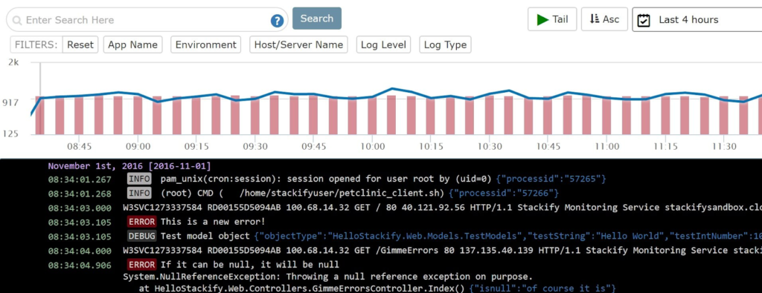
- Alerting. There’s nothing better than automation. If you’re a programmer, you know what I mean! You’ll want to automate almost anything if you can. Alerting is a way to send alerts automatically to a group email (better than an individual for continuity) when there’s a problem. This can be a server issue or errors hitting your logs. It should be configurable and you should have control over the configuration.
- Traces in your logs. What’s a trace? It’s not just a stack dump that lets you see what was going on when an error happened. It’s also a way to track performance, which is often a sign or a cause of a bug.
- Deduplication of log entries. When a bug causes an error, it can fill up the logs pretty quickly. Just combing through the logs with hundreds or thousands of the same entry is a showstopper. Deduplication takes away the pain!
You can configure many of the PHP logging utilities to work with Stackify Retrace by following this guide. Retrace works with PHP, and it does all of these things for you. Plus, it automatically collects lightweight traces—and only when it should.
Sure, Retrace is a great tool for detecting bugs! But once you detect them, fix them. Often that means attaching a debugger. Let’s get into that next!

Stepping through code
Now we will talk about debugging by stepping through code. This is what many of us developers think of when we see “debugging.” It’s a common way to debug code (remove defects that cause errors). With a web app or website, debugging is often two-pronged.
Once notified about an error that’s been logged, we can debug if needed. With enough detail in the logs, this should be easy. We might not even have to use a debugger. Often, the less use one, the better. But if you do, here’s how to tackle that!

PHP debugging tools
You can debug PHP using one of many debugging tools to attach a debugger client. PhpStorm works with debug utilities like Xdebug and ZendDebugger.
Being a polyglot, I need an IDE that supports multiple languages, so I’m opting for VS Code these days. I’ve used Xdebug with Visual Studio in the past, so let’s see how we can set it up with VS Code.
The debug server setup is the same, but each client (IDE or CLI) will have a slightly different setup. See, the debug server (a Zend extension) opens a port, and the client communicates with the server through that port. It’s just a matter of configuration and installing the right components.
Here are the steps I’m taking on this journey:
- Check for PHP extensions in VS Code. There are plenty! The top of the list looks like this:
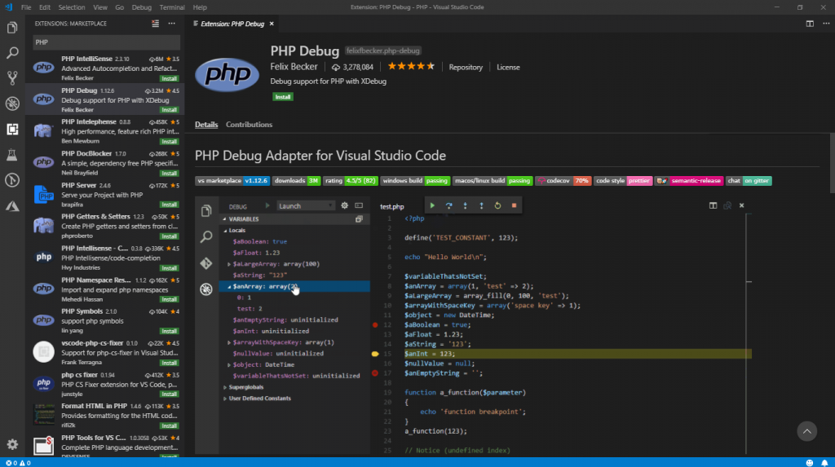And in case you’re missing it, PHP IntelliSense is on top with over six million downloads, followed by PHP Debug, with over three million.
- Install the PHP Debug extension.
- Click “reload” to reload VS Code.
- Install Xdebug. The PHP Debug extension for VS Code is only an integration to Xdebug. I have PHP 7.0 installed, so I must get the right version of Xdebug from the download page. The following script will help:
<?php
phpinfo();
?>
I’m looking for the PHP version, compiler version, architecture, and PHP Extension Build so I can download the correct version. I have x86, VC14, NTS (Non-thread-safe). This version came with WordPress for IIS. I’m working on a Windows machine. If you’re on a Linux box, you won’t face these same issues… just compile the source code for Xdebug!
- Now I have the right version, I will put it in the PHP/ext directory.
- Next, I need to configure PHP to use the extension and allow remote debugging. I’ll add the following configuration to the php.ini file that’s listed in PHP Info:
; set the extension path
zend_extension="C:/Program Files (x86)/PHP/v7.0/ext/php_xdebug-2.6.1-7.0-vc14-nts.dll"
; allow remote debugging
[XDebug]
xdebug.remote_enable = 1
xdebug.remote_autostart = 1
This’ll set up the PHP server to use XDebug. The steps here are the same no matter what IDE you use. Xdebug opens an HTTP port so that your debugger can attach. The client still needs to be configured to attach and use the debugging protocol. I will run through that part now.
- Finally, I will configure VS Code to connect to Xdebug. There are a few simple steps and then attaching is automatic. I’ll break this out into its own section since there are a few steps.

Configuring your IDE
After installing Xdebug, you still need to configure your IDE to attach to the debugger. In VS Code, this means adding a debug configuration. Fortunately, this is automatic at this point. It’s just a few simple steps:
- Switch to the debug view.
- Click the gear to bring up the languages menu.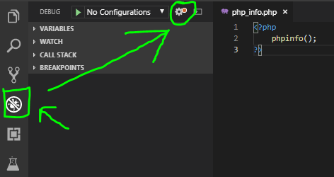
- Select PHP. VS Code will generate the default configuration.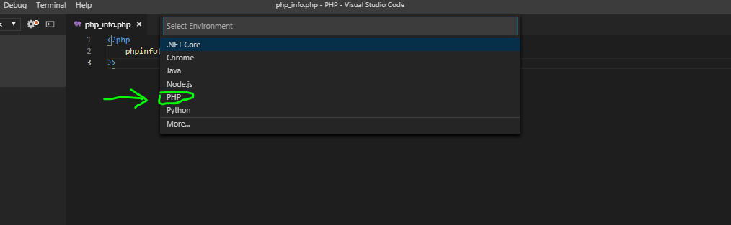
- Reload the PHP server. I’ve installed another extension called “PHP Server” that makes this simple. Use the context menu (right-click) to control the PHP server as shown in the screenshot below.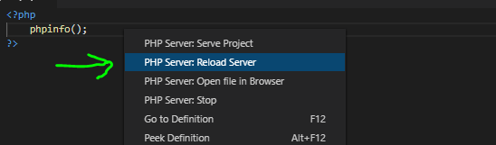
This should put our IDE in a state that’s ready to attach to Xdebug. Communications with the debugger happen through a TCP port on the debug server. Xdebug uses the DBGp protocol through port 9000 by default.
Now we’re configured, let’s look at the mechanics of a debug session. Next, we’ll cover how to get into a debug session, how to set breakpoints, and how to step through, into, and over functions. It’s the best part!

Attaching and stepping into debugging
And now, the moment you’ve been waiting for: step-through debugging. We’ve already configured our environment for debugging. We’ve installed a debugging extension (specifically Xdebug), and we’ve configured our IDE (VS Code, in my case). Now it’s time to attach to the debugger.

Attaching a debugger
The PHP Debug extension for VS Code generated a launch.json file. That file goes into a .vscode directory in the root of the project. Here’s what it generated:
{
// Use IntelliSense to learn about possible attributes.
// Hover to view descriptions of existing attributes.
// For more information, visit: https://go.microsoft.com/fwlink/?linkid=830387

"version": "0.2.0",
"configurations": [
{
"name": "Listen for XDebug",
"type": "php",
"request": "launch",
"port": 9000
},
{
"name": "Launch currently open script",
"type": "php",
"request": "launch",
"program": "${file}",
"cwd": "${fileDirname}",
"port": 9000
}
]
}
It’s adding two launch configurations. Those are available in the debug view. We can either attach to a running server or launch a new one with the current script. Since I have phpinfo running already, I’ll start there by choosing Listen for XDebug to attach to that server.
Once you’re attached, you will see the debug toolbar.
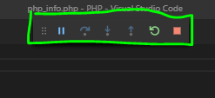
Most debuggers have a similar control mechanism. This allows you to start, stop, step, and restart your debugger. Since we see a stop and pause icon, we’re attached and ready, so let’s get stepping!

Stepping through code
Stepping through code is as much an art as it is science. The first thing you need to do is set up a breakpoint where you think you have an issue. I’ll usually plug one in just before so I can see what’s happening as we step into the problem code. Let’s set one in the phpinfo script just to get things rolling.

Setting breakpoints
Usually, clicking in the left margin will set a breakpoint on the nearest line. You can also set your cursor on the line and hit F9. If you’ve got multiple functions calls on the same line, that’s a way to ensure the breakpoint is on the right one. A red dot should appear in the left margin. This shows a breakpoint. It should also be listed in the “breakpoints” component. Here’s an image to clarify:
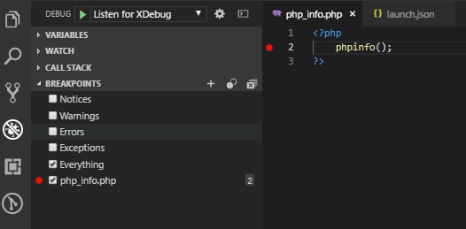
Note: we’re still in the Debug view. I set a single breakpoint. Now, when I right-click the red breakpoint circle in the margin next to the code, you can choose Edit breakpoint… to set up conditions if you need to. Conditions are useful, especially if you have an entire collection but only one element is causing an issue. I use conditionals all the time!
Besides conditional breakpoints, you have the option to log a message and break after a certain number of hits. The latter is useful when you have code that repeats without a specific unique value to trigger a break on. For example, you might have code to render components in a collection of components. If the 13th component causes a catastrophe, you can just set the hit count to 13. I’ve had to count manually too many times to see the value in this feature!
With at least one breakpoint set, you’re ready to step through your code.

Stepping through code
Stepping through code is a complex operation. It’s simple to control, but there’s a lot going on. The debugger will evaluate variables, you can set watches on variables, and you have access to the call stack. Once the debugger is paused on a breakpoint (or by manually hitting the pause button/pressing F6) you’re ready to step through the code.
Use this script to follow along:
<?php
phpinfo();

function step_over_me() {
echo 'stepping over me';
}

function step_into_me() {
step_over_me();
}

for ($i=0; $i < 100; $i++) {
step_into_me();
}

?>
You can step into functions (F11), step out of functions (Shift + F11), and step over functions (F10). You should get used to using the function keys to drive your debugging sessions; they’ll go a lot smoother if you do!
Some languages allow you to go backward in time. PHP doesn’t, but that’s OK. It’s a scripting language, and that would cause issues with declarations, anyway. Let’s step through this script by using F10.
Place a breakpoint on the phpinfo line. With your PHP server serving the page and your debugger attached, reload the web page. If all goes well, your debugger will light up and pause on that line.
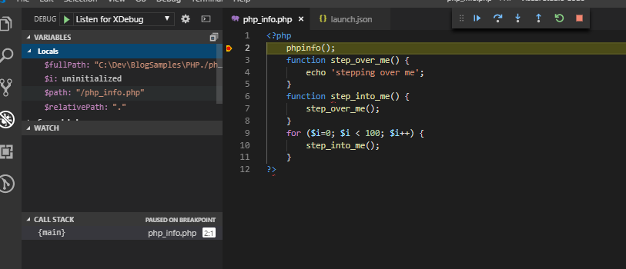
Congratulations! You now have an active debug session. Follow these steps to move along through the code:
- Press F10 a few times and watch the debugger step through the code.
- When you get into the loop, step into a method with F11.
- Once you’re inside the method, you can use Shift + F11 to step back out. All the code will still run—it’s just that your debugger won’t follow those parts.
- You can use F5 to get out of the loop and continue to the end (or the next breakpoint, if there is one).
TIP: Browser debuggers use F8 to continue since F5 is already mapped to a page reload. This little mismatch can trip you up when you switch between browser tools and your IDE.

Skipping a loop
It’s easy to skip a loop. Just set a breakpoint just past the loop and use F5 to skip ahead to that point.
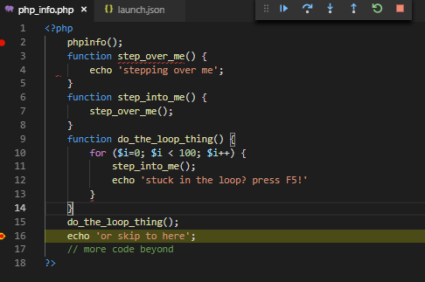
Often, you want to step into the loop at least once before you pass it by. Use F11 to step into it. Wrap loops in functions so you can step out with Shift + F11 and not lose a beat!
There’s another option, if it’s available to you. It’s run to cursor, and it does what it sounds like. Just place your cursor somewhere past the loop and use this option to jump to that point.
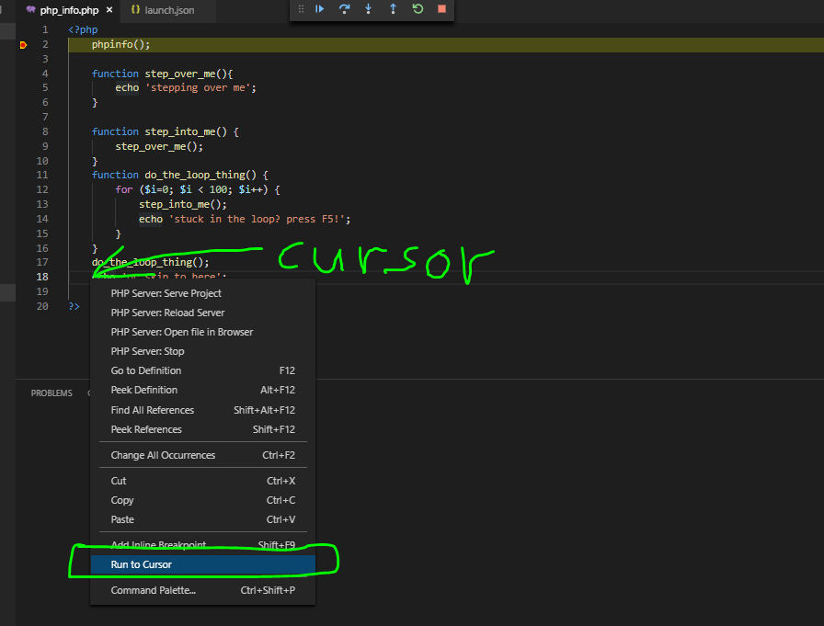
The debugger will run from its current position to the cursor when I select this option. Notice that there’s no keyboard shortcut for it, unfortunately.

Checking variables
One key benefit of debugging is that you can check variables as you step through the code. Most IDEs include a way to check local and global variables. Also, you can watch variables so you don’t have to hunt them down in Locals or Superglobals.
You can also watch expressions! This is great when you want to see how a complex expression inside an if statement will evaluate. Just copy the expression into a watch and you can track the result as values change.
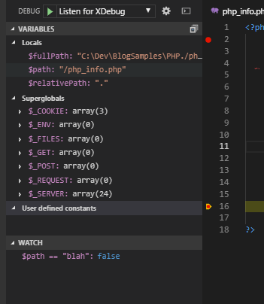
I’ve added the following watch expression: $path == “blah”. In VS Code, you can highlight an expression in the code and open the context menu to watch the expression.
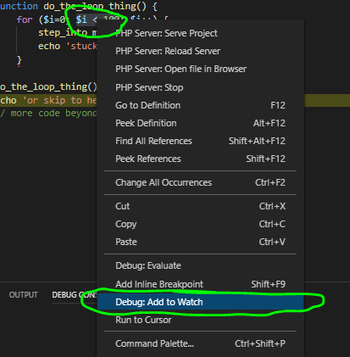
I’ve highlighted $i < 100 to add it to my watch expressions. You can also evaluate any expression in the debug console!

Evaluating in debug console
You can evaluate expressions in the debug console too. If you need to check something once, it’s better to evaluate it in the console.
Open the debug console and enter the expression.
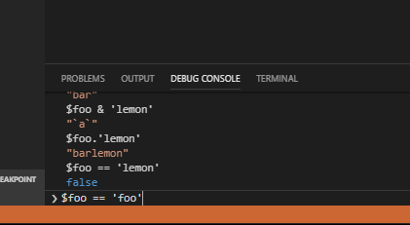
You can also check the context menu for an option to evaluate the selected expression. Here are things you can do in the debug console:
- Set new variables.
- Change variable values.
- Execute functions (in most cases).
- Evaluate expressions (e.g., $i == 55).
These frequently come in handy for debugging!

Wrapping things up
We’ve covered a lot in this post. It’s enough to get you started with PHP debugging. This is a highly in-depth topic, but the best way to learn is by doing. Practice debugging until you’ve mastered the technique, and you’ll earn a reputation as a bug exterminator extraordinaire!
https://stackify.com/php-debugging-guide/

How to Use Xdebug for Advanced PHP Debugging
#
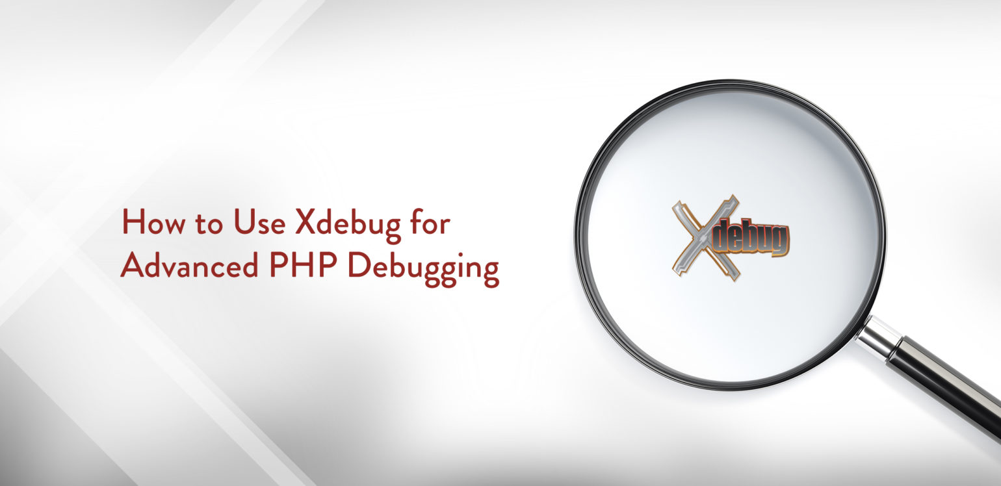
You could just debug your PHP code using functions such as error_log, print, and var_dump, (and to be honest we’ve all done it, a lot!), but sometimes they just aren’t enough, and can actually slow you down while developing.
There must be a better way, surely?! Enter Xdebug, the rather awesome debugging and profiling tool for PHP.
In this post, I’ll take you through why Xdebug is amazing, getting it setup, how to use it, get the most out of it it, and some neat advanced uses all to make your life easier.
You can thank me later (in the comments) 

How Xdebug Changed My Life
A few years ago I didn’t know debuggers existed, had never heard of Xdebug, and was quite happy using a function I’d cobbled together pinched from Stack Overflow in all my WordPress sites for debugging:
if ( ! function_exists( '_log' ) ) {
function _log( $message ) {
if ( WP_DEBUG === true ) {
if ( is_array( $message ) || is_object( $message ) ) {
error_log( print_r( $message, true ) );
} else {
error_log( $message );
}
}
}
}
It was all I thought I needed until someone introduced me to Xdebug and my life changed. Excuse the hyperbole, but it happened!
When you are debugging using functions like error_log, you are only outputting the variables you define, which might not be what you need. For example, while troubleshooting some code, you add the function somewhere to debug a variable. You refresh your page and/or repeat the action so the debug line is executed, and then check your error log to look at the output. If this doesn’t give you any insight to the cause of the problem at hand, then you need to go back and add more debug lines to the code. Rinse and repeat.
Xdebug allows you to break during code execution and inspect all the variables in scope during a request. This means you have all you need to troubleshoot during only one iteration of this cycle. This can save a huge amount of time when tracking down issues, and helps make your development workflow more efficient.

Troubleshooting++ with Xdebug
Xdebug really shines when trying to troubleshoot a problem whose cause is completely unknown to you. If you know your function is broken, logging lines inside it is great and works well. But strange problem-causing behavior could be coming from anywhere in a project, like a plugin or WordPress core itself. How the hell do you track that down?
Xdebug’s breakpoints allow you to pause code at any point, which means the best thing to do is to break early and follow the code execution through with Xdebug (more on that later) until you spot something gone awry. To save time, you can progressively move breakpoints further along in the execution until you get closer to the potential issue, instead of breaking on code already analyzed as not the cause of the issue.
When you find the issue, you can actually change the values of variables on the fly after they have been assigned, so you can test potential fixes to the issue while debugging in the same request.

Debug Driven Development
Another great use of Xdebug is proactively during development itself, instead of reacting to issues with existing code. Think of this like Test Driven Development (TDD) but using the debugger first instead writing tests. I’m not even sure if Debug Driven Development (DDD) is a widely used term, but for me, I’ve used Xdebug to help me write new code in a couple of ways:
- Inspect existing arrays, objects, and class instances to find the data available to me in code, so I can use it in new code I write
- Immediately debug a newly-written piece of code to test it is working as expected
This isn’t something I do all the time, but Xdebug gives me this insight when I need it.

Installing Xdebug
Hopefully the benefits I’ve detailed have got you wanting to use Xdebug and you’re ready for some installation steps.
I’ve put together a list of the most common local environments with some handy links to getting Xdebug installed on them:
- MAMP
- MAMP Pro
- VVV
- Local By Flywheel
- Valet
- Desktop Server
Do you work with a different local environment and need some guidance? Let us know in the comments.

PhpStorm Integration
News flash: I love PhpStorm! And guess what? PhpStorm has an awesome integration with Xdebug and is simple to set up. Other editors and Integrated Development Environments (IDEs) with Xdebug support are available.

Start Debugging
Once you’ve installed Xdebug and configured PhpStorm, you can start interactively debugging your code. This is done by setting breakpoints at certain lines of your code and telling PhpStorm to listen for incoming connections. When PHP executes a line that has a breakpoint on it, Xdebug will step in and pause execution allowing you to gain valuable insight to all that is happening during execution:
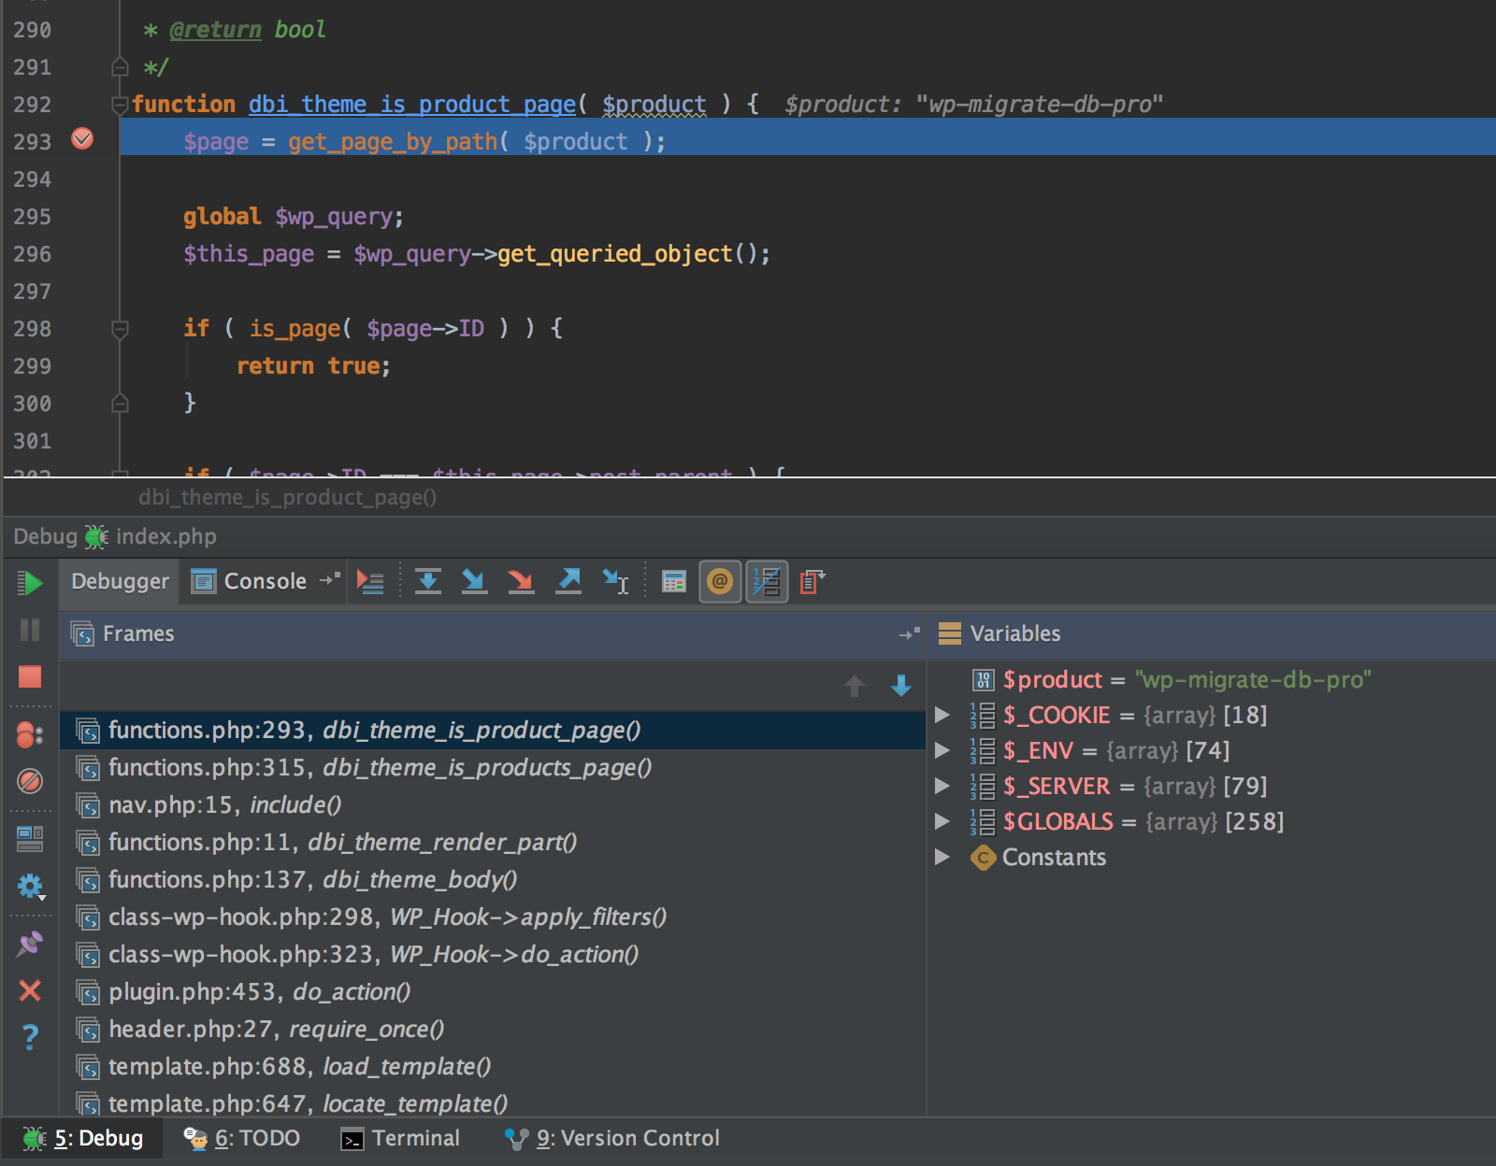
The sidebar of the debug panel has various buttons for controlling the execution of the code. Here they are top down as they appear in the screenshot:
- Resume Program – continue with the PHP execution
- Pause Program – not available during debugging
- Stop – halt the execution
- View Breakpoints – bring up a window of all the breakpoints set in all files of the project
- Mute Breakpoints – deactivate the breakpoints during execution (good for just finishing the request without breaking any further)
- Restore Layout – resets the default view of the Debug panel
- Settings – tweak the debugger display
- Pin Tab – always show the Debug panel
- Close – close the panel and choose to disconnect the debugger from the connection or terminate it completely
- Help – links to JetBrain’s online help docs for the Debug panel
The top bar of the panel controls how the debugger traverses the code so you can inspect different parts of the codebase:
- Show Execution Point – jumps back to where the program is broken
- Step Over – execute and move to the next line of the file
- Step Into – if the next line has one or more functions, move the debugger into those to step through
- Force Step Into – step into a function that is marked as skipped
- Step Out – move the debugger out of the current function back to the function that called it
- Run to Cursor – execute all the way to the line the cursor is on
- Evaluate Expression – execute PHP while the debugger is running (think of this like Chrome’s JS console)
- Show Values Addresses – displays the memory address of objects
- Hide Empty Superglobals Variables – removes some noise from the variables list
- Add Method to Skip List – mark method to be skipped next time
Breakpoints are added by clicking in the left-hand gutter of the code, along the line you want at which you want to break. PhpStorm also allows you to set conditional breakpoints, where you add PHP logic to control when a breakpoint actually fires:
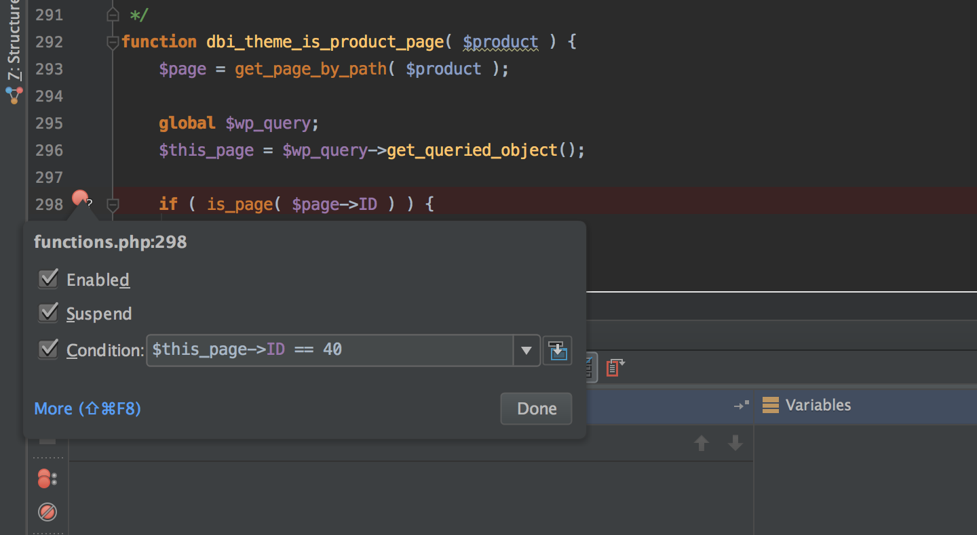
When troubleshooting, it is often helpful to inspect and watch the value of a variable all the way through the execution of a request to see when it changes. PhpStorm allows you to add variables to a list that it watches and displays in a separate ‘Watches’ panel, away from all the noise of the main ‘Variables’ panel. You can watch a variable by either right-clicking the variable in the file during debugging and selecting ‘Add to Watches’ or doing the same from the variable in the ‘Variables’ panel:
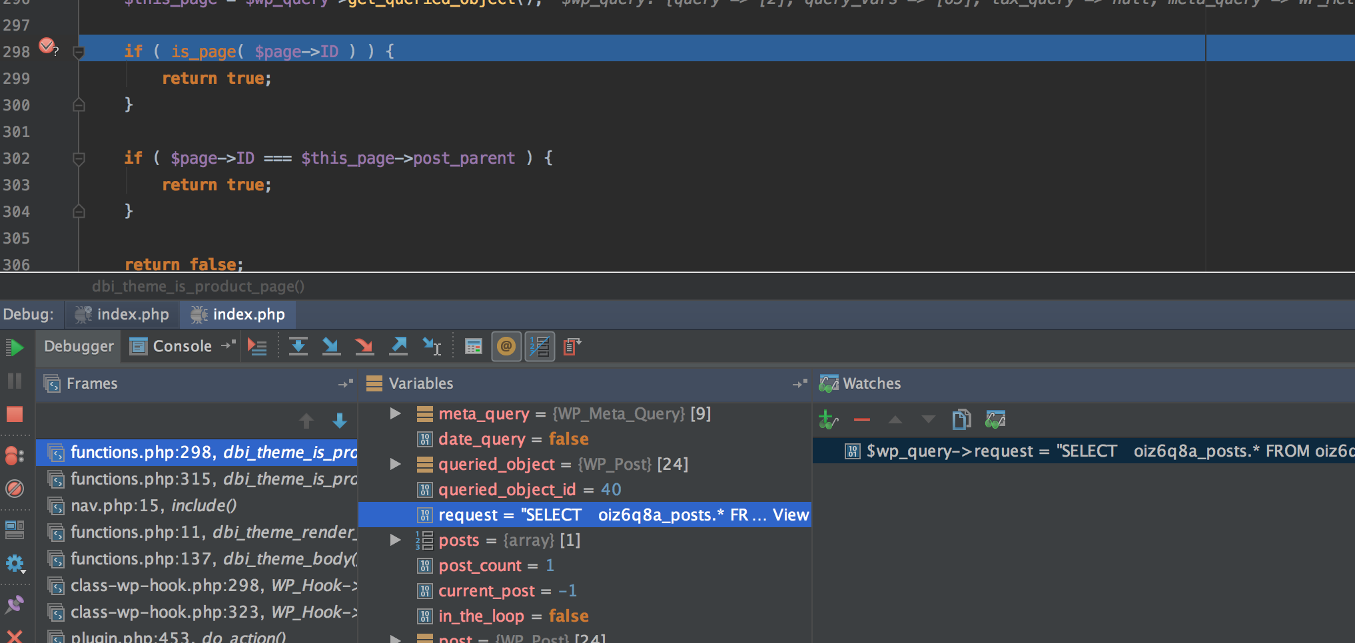

Stack Trace
Enabling Xdebug gives you, by default, an extended stack trace for any errors, notices or warnings that are written to the PHP log:
[26-Jul-2017 16:06:21 UTC] PHP Notice: Trying to get property of non-object in /Applications/MAMP/htdocs/deliciousbrains.com/public_html/content/themes/deliciousbrains/functions.php on line 302
[26-Jul-2017 16:06:21 UTC] PHP Stack trace:
[26-Jul-2017 16:06:21 UTC] PHP 1. {main}() /Applications/MAMP/htdocs/deliciousbrains.com/public_html/index.php:0
[26-Jul-2017 16:06:21 UTC] PHP 2. require() /Applications/MAMP/htdocs/deliciousbrains.com/public_html/index.php:3
[26-Jul-2017 16:06:21 UTC] PHP 3. require_once() /Applications/MAMP/htdocs/deliciousbrains.com/public_html/wp/wp-blog-header.php:19
[26-Jul-2017 16:06:21 UTC] PHP 4. include() /Applications/MAMP/htdocs/deliciousbrains.com/public_html/wp/wp-includes/template-loader.php:74
[26-Jul-2017 16:06:21 UTC] PHP 5. get_header($name = *uninitialized*) /Applications/MAMP/htdocs/deliciousbrains.com/public_html/content/themes/deliciousbrains/404.php:2
[26-Jul-2017 16:06:21 UTC] PHP 6. locate_template($template_names = *uninitialized*, $load = *uninitialized*, $require_once = *uninitialized*) /Applications/MAMP/htdocs/deliciousbrains.com/public_html/wp/wp-includes/general-template.php:45
[26-Jul-2017 16:06:21 UTC] PHP 7. load_template($_template_file = *uninitialized*, $require_once = *uninitialized*) /Applications/MAMP/htdocs/deliciousbrains.com/public_html/wp/wp-includes/template.php:647
[26-Jul-2017 16:06:21 UTC] PHP 8. require_once() /Applications/MAMP/htdocs/deliciousbrains.com/public_html/wp/wp-includes/template.php:688
[26-Jul-2017 16:06:21 UTC] PHP 9. do_action($tag = *uninitialized*, $arg = *uninitialized*) /Applications/MAMP/htdocs/deliciousbrains.com/public_html/content/themes/deliciousbrains/header.php:27
[26-Jul-2017 16:06:21 UTC] PHP 10. WP_Hook->do_action($args = *uninitialized*) /Applications/MAMP/htdocs/deliciousbrains.com/public_html/wp/wp-includes/plugin.php:453
[26-Jul-2017 16:06:21 UTC] PHP 11. WP_Hook->apply_filters($value = *uninitialized*, $args = *uninitialized*) /Applications/MAMP/htdocs/deliciousbrains.com/public_html/wp/wp-includes/class-wp-hook.php:323
[26-Jul-2017 16:06:21 UTC] PHP 12. dbi_theme_body(*uninitialized*) /Applications/MAMP/htdocs/deliciousbrains.com/public_html/wp/wp-includes/class-wp-hook.php:298
[26-Jul-2017 16:06:21 UTC] PHP 13. dbi_theme_render_part($part = *uninitialized*, $args = *uninitialized*) /Applications/MAMP/htdocs/deliciousbrains.com/public_html/content/themes/deliciousbrains/functions.php:137
[26-Jul-2017 16:06:21 UTC] PHP 14. include() /Applications/MAMP/htdocs/deliciousbrains.com/public_html/content/themes/deliciousbrains/functions.php:11
[26-Jul-2017 16:06:21 UTC] PHP 15. dbi_theme_is_products_page() /Applications/MAMP/htdocs/deliciousbrains.com/public_html/content/themes/deliciousbrains/parts/nav/nav.php:15
[26-Jul-2017 16:06:21 UTC] PHP 16. dbi_theme_is_product_page($product = *uninitialized*) /Applications/MAMP/htdocs/deliciousbrains.com/public_html/content/themes/deliciousbrains/functions.php:315
The extended stack trace is helpful on its own, but, coupled with PhpStorm, you get a dynamic view of the trace when debugging. This dynamic view gives you an interactive history of what code has been executed up to the breakpoint or current point of the execution:
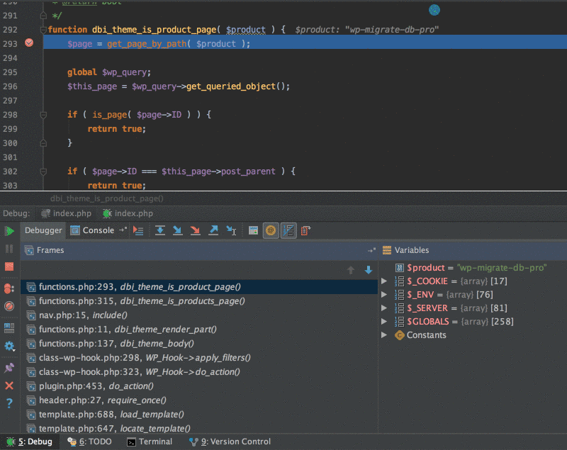
Because I rely on wp-content/debug.log or the PHP error_log to alert me to issues, but I use PhpStorm to see the stack trace, I end up disabling the extended (and very noisy) stack trace in the log by putting this in my wp-config.php file:
if ( function_exists( 'xdebug_disable' ) ) {
xdebug_disable();
}

Advanced Use
Mastered the basics? Ready for more? Here are some advanced ways you can use Xdebug to improve your development workflows.

Profiling
When you really need to investigate performance issues with your code or website, one of the best tools we’ve found is Blackfire, which we’ve written about before. But Xdebug also profiles for you and PhpStorm can interpret the results, which is great as it means you never have to leave PhpStorm! 
To enable the profiler, simply edit your php.ini file to add or uncomment these lines in the Xdebug section:
xdebug.profiler_enable=1
xdebug.profiler_output_dir="/Applications/MAMP/tmp"
Then Xdebug will create a profile log file for each execution of your code. Remember to disable the profiler when you’re done so you don’t fill your hard drive with log files! Alternatively set the output directory to the /tmp directory for your OS.
These logs can then be analyzed in PhpStorm by navigating to Tools > Analyze Xdebug Profiler Snapshot and selecting the log file. The visualization isn’t as in-depth as Blackfire or using something like KCachegrind but it is still is a great way to analyze bottlenecks in your code:
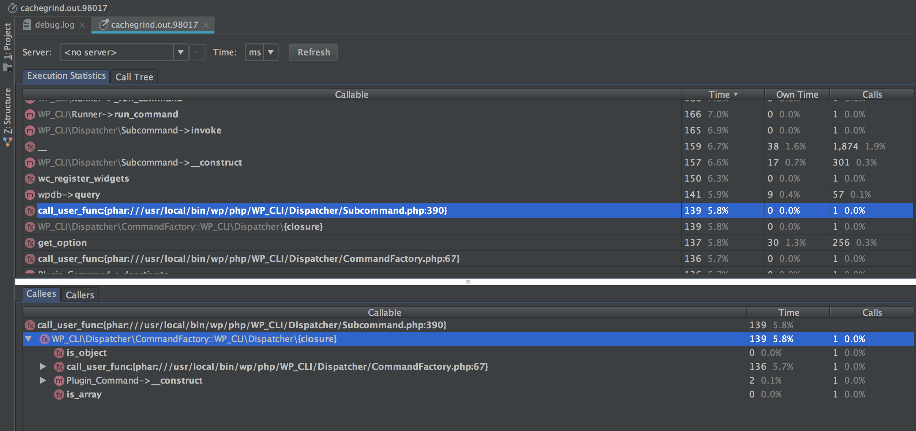

Remote Debugging via SSH
You can troubleshoot bugs only if you can recreate them on your development environment. Of course when it comes to running a website, we recommend having your development environment as close to production as possible, and you debug on a near-as-possible copy of the production database, but sometimes bugs and oddities will only happen on production. No one wants to start messing around on a live site, editing files to add logging lines. Don’t worry PhpStorm and Xdebug have you covered!
You can install Xdebug on a remote server and debug the code execution locally using Xdebug and PhpStorm. This feature is a lifesaver and suprisingly simple to set up. Just make sure to turn off Xdebug when you are finished, so your site’s performance isn’t impacted by Xdebug unnecessarily.

Conclusion
I hope this has been a good introduction to how powerful and valuable using a debugger like Xdebug is for your development workflow. For me, it is a huge time saver and I couldn’t imagine developing without it in my toolbox.
Do you use Xdebug or another debugger? Have I missed any awesome features or do you have any tips? Let me know in the comments below.
https://deliciousbrains.com/xdebug-advanced-php-debugging/

Debugging
One of the key features of Visual Studio Code is its great debugging support. VS Code's built-in debugger helps accelerate your edit, compile and debug loop.
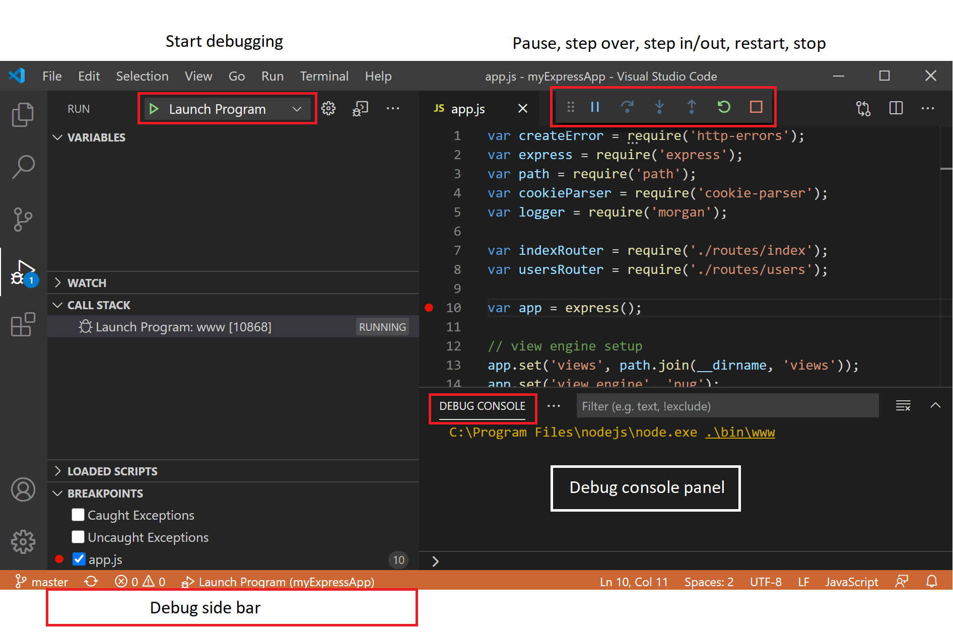

Debugger extensions#
VS Code has built-in debugging support for the Node.js runtime and can debug JavaScript, TypeScript, or any other language that gets transpiled to JavaScript.
For debugging other languages and runtimes (including PHP, Ruby, Go, C#, Python, C++, PowerShell and many others), look for Debuggers extensions in our VS Code Marketplace or select Install Additional Debuggers in the top-level Run menu.
Below are several popular extensions which include debugging support:
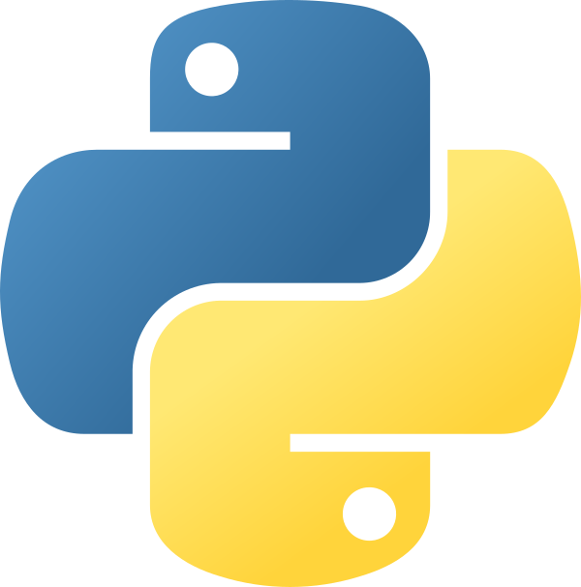
Python
28.4M
ms-python
Linting, Debugging (multi-threaded, remote), Inte...
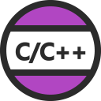
C/C++
15.8M
ms-vscode
C/C++ IntelliSense, debugging, and code browsing.

C#
9.5M
ms-dotnettools
C# for Visual Studio Code (powered by OmniSharp).
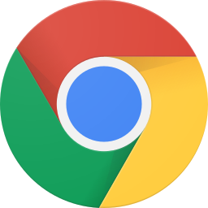
Debugger for Chrome
6.9M
msjsdiag
Debug your JavaScript code in the Chrome browser,...
Tip: The extensions shown above are dynamically queried. Select an extension tile above to read the description and reviews to decide which extension is best for you.

Start debugging#
The following documentation is based on the built-in Node.js debugger, but most of the concepts and features are applicable to other debuggers as well.
It is helpful to first create a sample Node.js application before reading about debugging. You can follow the Node.js walkthrough to install Node.js and create a simple "Hello World" JavaScript application (app.js). Once you have a simple application set up, this page will take you through VS Code debugging features.

Run view#
To bring up the Run view, select the Run icon in the Activity Bar on the side of VS Code. You can also use the keyboard shortcut Ctrl+Shift+D.
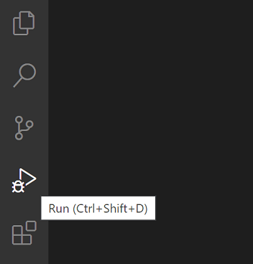
The Run view displays all information related to running and debugging and has a top bar with debugging commands and configuration settings.
If running and debugging is not yet configured (no launch.json has been created), VS Code shows the Run start view.

Run menu#
The top-level Run menu has the most common run and debug commands:
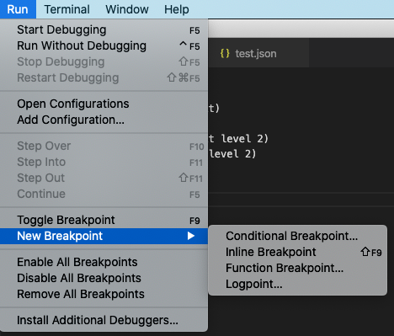

Launch configurations#
To run or debug a simple app in VS Code, select Run and Debug on the Debug start view or press F5 and VS Code will try to run your currently active file.
However, for most debugging scenarios, creating a launch configuration file is beneficial because it allows you to configure and save debugging setup details. VS Code keeps debugging configuration information in a launch.json file located in a .vscode folder in your workspace (project root folder) or in your user settings or workspace settings.
To create a launch.json file, click the create a launch.json file link in the Run start view.
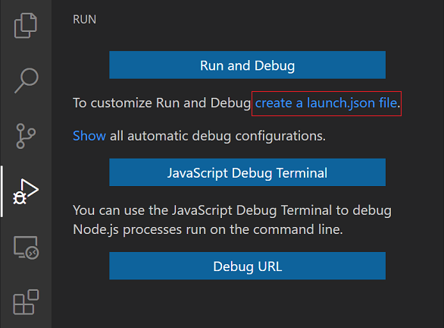
VS Code will try to automatically detect your debug environment, but if this fails, you will have to choose it manually:
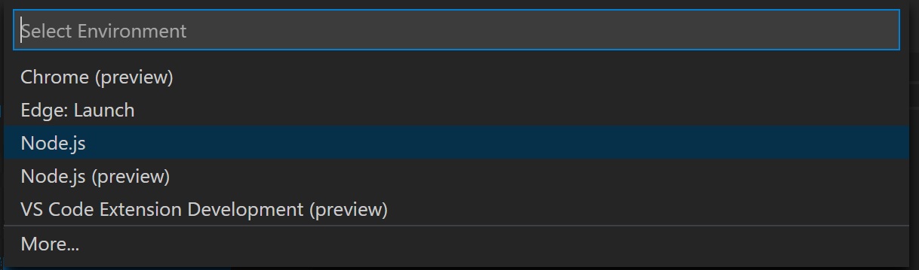
Here is the launch configuration generated for Node.js debugging:
{
"version": "0.2.0",
"configurations": [
{
"type": "node",
"request": "launch",
"name": "Launch Program",
"skipFiles": ["<node_internals>/**"],
"program": "${workspaceFolder}\\app.js"
}
]
}
If you go back to the File Explorer view (Ctrl+Shift+E), you'll see that VS Code has created a .vscode folder and added the launch.json file to your workspace.
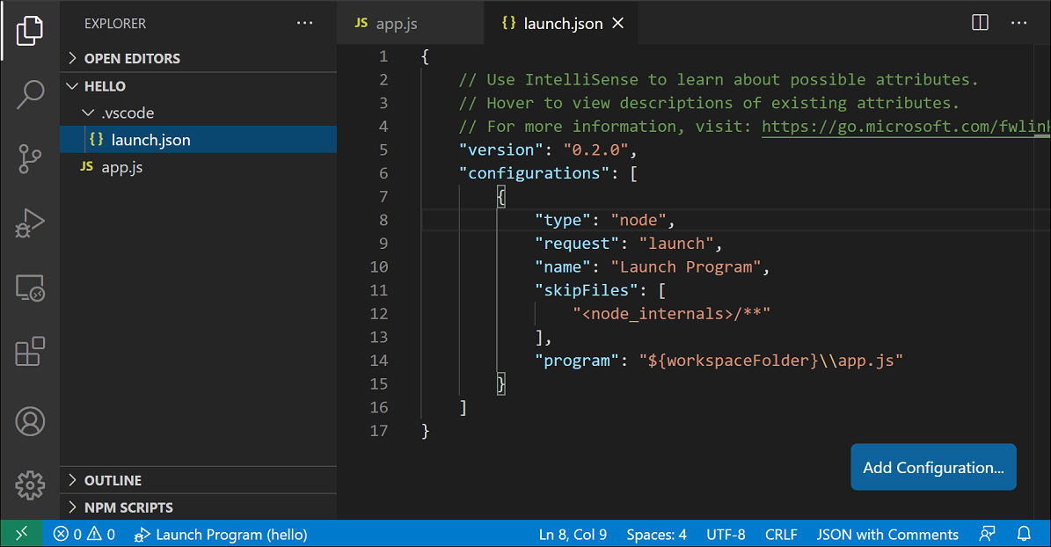
Note: You can debug a simple application even if you don't have a folder open in VS Code, but it is not possible to manage launch configurations and set up advanced debugging. The VS Code Status Bar is purple if you do not have a folder open.
Note that the attributes available in launch configurations vary from debugger to debugger. You can use IntelliSense suggestions (Ctrl+Space) to find out which attributes exist for a specific debugger. Hover help is also available for all attributes.
Do not assume that an attribute that is available for one debugger automatically works for other debuggers too. If you see green squiggles in your launch configuration, hover over them to learn what the problem is and try to fix them before launching a debug session.
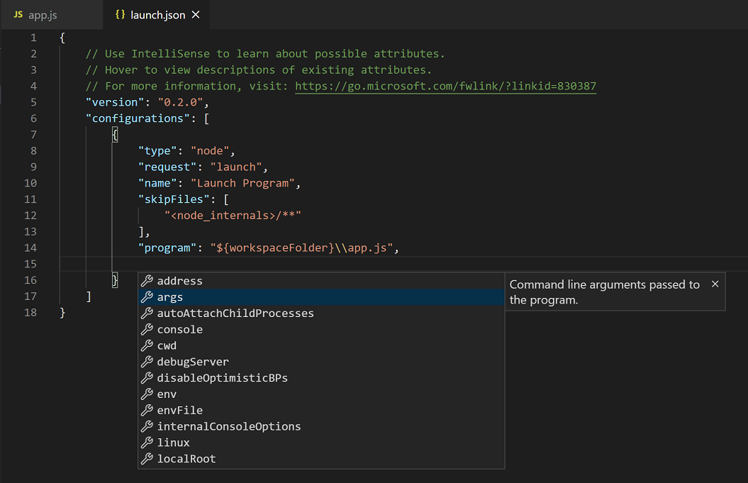
Review all automatically generated values and make sure that they make sense for your project and debugging environment.

Launch versus attach configurations#
In VS Code, there are two core debugging modes, Launch and Attach, which handle two different workflows and segments of developers. Depending on your workflow, it can be confusing to know what type of configuration is appropriate for your project.
If you come from a browser Developer Tools background, you might not be used to "launching from your tool," since your browser instance is already open. When you open DevTools, you are simply attaching DevTools to your open browser tab. On the other hand, if you come from a server or desktop background, it's quite normal to have your editor launch your process for you, and your editor automatically attaches its debugger to the newly launched process.
The best way to explain the difference between launch and attach is to think of a launch configuration as a recipe for how to start your app in debug mode before VS Code attaches to it, while an attach configuration is a recipe for how to connect VS Code's debugger to an app or process that's already running.
VS Code debuggers typically support launching a program in debug mode or attaching to an already running program in debug mode. Depending on the request (attach or launch), different attributes are required, and VS Code's launch.json validation and suggestions should help with that.

Add a new configuration#
To add a new configuration to an existing launch.json, use one of the following techniques:
- Use IntelliSense if your cursor is located inside the configurations array.
- Press the Add Configuration button to invoke snippet IntelliSense at the start of the array.
- Choose Add Configuration option in the Run menu.
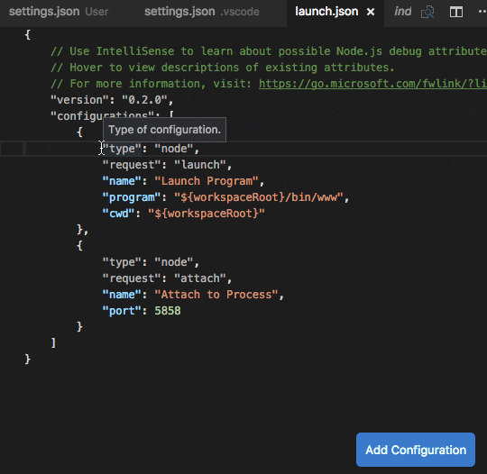
VS Code also supports compound launch configurations for starting multiple configurations at the same time; for more details, please read this section.
In order to start a debug session, first select the configuration named Launch Program using the Configuration drop-down in the Run view. Once you have your launch configuration set, start your debug session with F5.
Alternatively you can run your configuration through the Command Palette (Ctrl+Shift+P), by filtering on Debug: Select and Start Debugging or typing 'debug ', and selecting the configuration you want to debug.
As soon as a debugging session starts, the DEBUG CONSOLE panel is displayed and shows debugging output, and the Status Bar changes color (orange for default color themes):
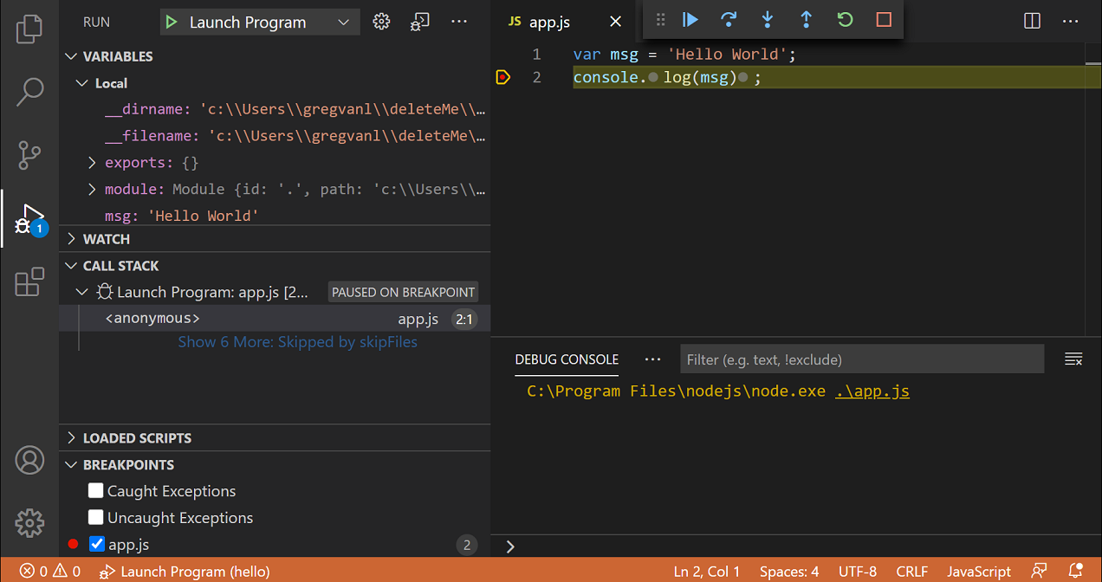
In addition, the debug status appears in the Status Bar showing the active debug configuration. By selecting the debug status, a user can change the active launch configuration and start debugging without needing to open the Run view.
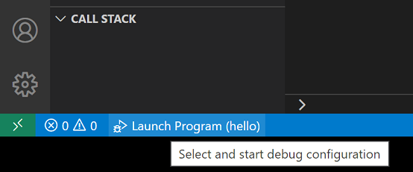

Debug actions#
Once a debug session starts, the Debug toolbar will appear on the top of the editor.

- Continue / Pause F5
- Step Over F10
- Step Into F11
- Step Out Shift+F11
- Restart Ctrl+Shift+F5
- Stop Shift+F5
Tip: Use the setting debug.toolBarLocation to control the location of the debug toolbar. It can either be the default floating, docked to the Run view or hidden. A floating debug toolbar can be dragged horizontally and also down to the editor area.

Run mode#
In addition to debugging a program, VS Code supports running the program. The Debug: Run (Start Without Debugging) action is triggered with Ctrl+F5 and uses the currently selected launch configuration. Many of the launch configuration attributes are supported in 'Run' mode. VS Code maintains a debug session while the program is running, and pressing the Stop button terminates the program.
Tip: The Run action is always available, but not all debugger extensions support 'Run'. In this case, 'Run' will be the same as 'Debug'.

Breakpoints#
Breakpoints can be toggled by clicking on the editor margin or using F9 on the current line. Finer breakpoint control (enable/disable/reapply) can be done in the Run view's BREAKPOINTS section.
- Breakpoints in the editor margin are normally shown as red filled circles.
- Disabled breakpoints have a filled gray circle.
- When a debugging session starts, breakpoints that cannot be registered with the debugger change to a gray hollow circle. The same might happen if the source is edited while a debug session without live-edit support is running.
The Reapply All Breakpoints command sets all breakpoints again to their original location. This is helpful if your debug environment is "lazy" and "misplaces" breakpoints in source code that has not yet been executed.
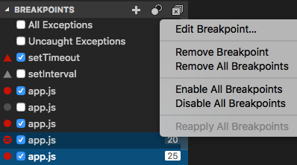
Optionally breakpoints can be shown in the editor's overview ruler by enabling the setting debug.showBreakpointsInOverviewRuler:
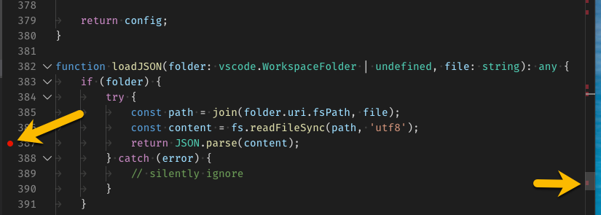

Logpoints#
A Logpoint is a variant of a breakpoint that does not "break" into the debugger but instead logs a message to the console. Logpoints are especially useful for injecting logging while debugging production servers that cannot be paused or stopped.
A Logpoint is represented by a "diamond" shaped icon. Log messages are plain text but can include expressions to be evaluated within curly braces ('{}').
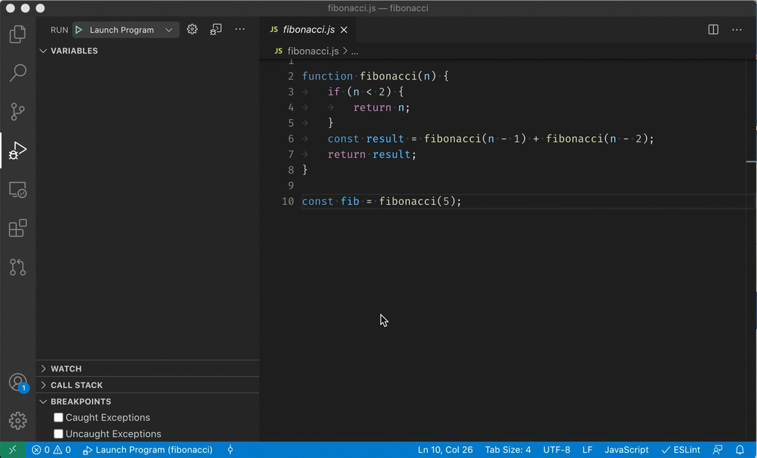
Just like regular breakpoints, Logpoints can be enabled or disabled and can also be controlled by a condition and/or hit count.
Note: Logpoints are supported by VS Code's built-in Node.js debugger, but can be implemented by other debug extensions. The Python and Java extensions, for example, support Logpoints.

Data inspection#
Variables can be inspected in the VARIABLES section of the Run view or by hovering over their source in the editor. Variable values and expression evaluation are relative to the selected stack frame in the CALL STACK section.
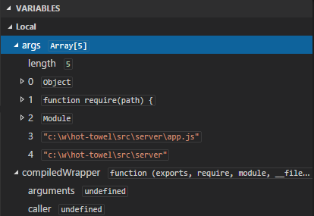
Variable values can be modified with the Set Value action from the variable's context menu.
Variables and expressions can also be evaluated and watched in the Run view's WATCH section.
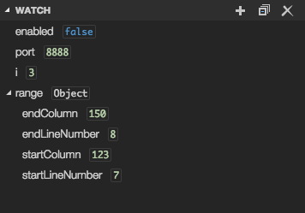
Variable names and values can be filtered by typing while the focus is on the VARIABLES section
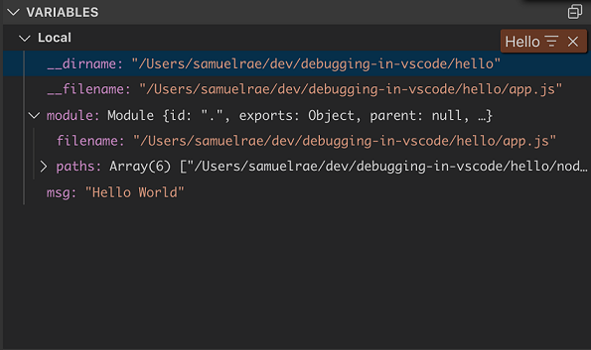

Launch.json attributes#
There are many launch.json attributes to help support different debuggers and debugging scenarios. As mentioned above, you can use IntelliSense (Ctrl+Space) to see the list of available attributes once you have specified a value for the type attribute.
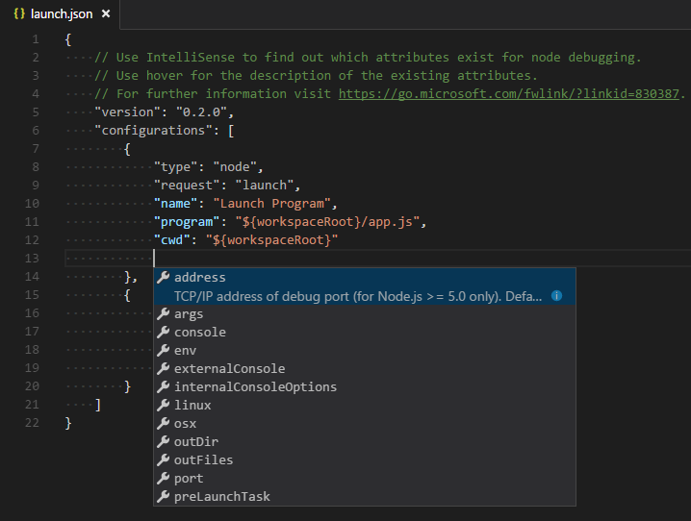
The following attributes are mandatory for every launch configuration:
- type - the type of debugger to use for this launch configuration. Every installed debug extension introduces a type: node for the built-in Node debugger, for example, or php and go for the PHP and Go extensions.
- request - the request type of this launch configuration. Currently, launch and attach are supported.
- name - the reader-friendly name to appear in the Debug launch configuration drop-down.
Here are some optional attributes available to all launch configurations:
- presentation - using the order, group, and hidden attributes in the presentation object you can sort, group, and hide configurations and compounds in the Debug configuration dropdown and in the Debug quick pick.
- preLaunchTask - to launch a task before the start of a debug session, set this attribute to the label of a task specified in tasks.json (in the workspace's .vscode folder). Or, this can be set to ${defaultBuildTask} to use your default build task.
- postDebugTask - to launch a task at the very end of a debug session, set this attribute to the name of a task specified in tasks.json (in the workspace's .vscode folder).
- internalConsoleOptions - this attribute controls the visibility of the Debug Console panel during a debugging session.
- debugServer - for debug extension authors only: this attribute allows you to connect to a specified port instead of launching the debug adapter.
- serverReadyAction - if you want to open a URL in a web browser whenever the program under debugging outputs a specific message to the debug console or integrated terminal. For details see section Automatically open a URI when debugging a server program below.
Many debuggers support some of the following attributes:
- program - executable or file to run when launching the debugger
- args - arguments passed to the program to debug
- env - environment variables (the value null can be used to "undefine" a variable)
- envFile - path to dotenv file with environment variables
- cwd - current working directory for finding dependencies and other files
- port - port when attaching to a running process
- stopOnEntry - break immediately when the program launches
- console - what kind of console to use, for example, internalConsole, integratedTerminal, or externalTerminal

Variable substitution#
VS Code makes commonly used paths and other values available as variables and supports variable substitution inside strings in launch.json. This means that you do not have to use absolute paths in debug configurations. For example, ${workspaceFolder} gives the root path of a workspace folder, ${file} the file open in the active editor, and ${env:Name} the environment variable 'Name'. You can see a full list of predefined variables in the Variables Reference or by invoking IntelliSense inside the launch.json string attributes.
{
"type": "node",
"request": "launch",
"name": "Launch Program",
"program": "${workspaceFolder}/app.js",
"cwd": "${workspaceFolder}",
"args": ["${env:USERNAME}"]
}

Platform-specific properties#
Launch.json supports defining values (for example, arguments to be passed to the program) that depend on the operating system where the debugger is running. To do so, put a platform-specific literal into the launch.json file and specify the corresponding properties inside that literal.
Below is an example that passes "args" to the program differently on Windows:
{
"version": "0.2.0",
"configurations": [
{
"type": "node",
"request": "launch",
"name": "Launch Program",
"program": "${workspaceFolder}/node_modules/gulp/bin/gulpfile.js",
"args": ["myFolder/path/app.js"],
"windows": {
"args": ["myFolder\\path\\app.js"]
}
}
]
}
Valid operating properties are "windows" for Windows, "linux" for Linux and "osx" for macOS. Properties defined in an operating system specific scope override properties defined in the global scope.
Please note that the type property can not be placed inside a platform-specific section, because type indirectly determines the platform in remote debugging scenarios, and that would result in a cyclic dependency.
In the example below debugging the program always stops on entry except on macOS:
{
"version": "0.2.0",
"configurations": [
{
"type": "node",
"request": "launch",
"name": "Launch Program",
"program": "${workspaceFolder}/node_modules/gulp/bin/gulpfile.js",
"stopOnEntry": true,
"osx": {
"stopOnEntry": false
}
}
]
}

Global launch configuration#
VS Code supports adding a "launch" object inside your User settings. This "launch" configuration will then be shared across your workspaces. For example:
"launch": {
"version": "0.2.0",
"configurations": [{
"type": "node",
"request": "launch",
"name": "Launch Program",
"program": "${file}"
}]
}

Advanced breakpoint topics#

Conditional breakpoints#
A powerful VS Code debugging feature is the ability to set conditions based on expressions, hit counts, or a combination of both.
- Expression condition: The breakpoint will be hit whenever the expression evaluates to true.
- Hit count: The 'hit count' controls how many times a breakpoint needs to be hit before it will 'break' execution. Whether a 'hit count' is respected and the exact syntax of the expression vary among debugger extensions.
You can add a condition and/or hit count when creating the breakpoint (with the Add Conditional Breakpoint action) or when modifying an existing one (with the Edit Breakpoint action). In both cases, an inline text box with a drop-down menu opens where you can enter expressions:
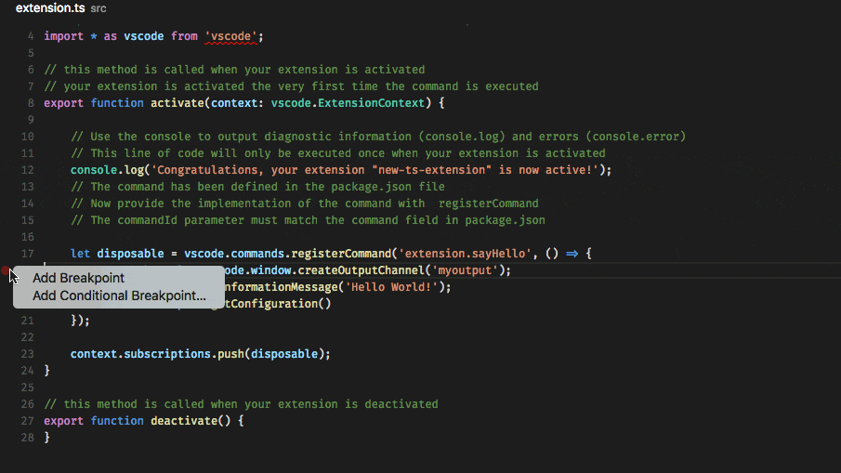
If a debugger does not support conditional breakpoints, the Add Conditional Breakpoint action will be missing.

Inline breakpoints#
Inline breakpoints will only be hit when the execution reaches the column associated with the inline breakpoint. This is particularly useful when debugging minified code which contains multiple statements in a single line.
An inline breakpoint can be set using Shift+F9 or through the context menu during a debug session. Inline breakpoints are shown inline in the editor.
Inline breakpoints can also have conditions. Editing multiple breakpoints on a line is possible through the context menu in the editor's left margin.

Function breakpoints#
Instead of placing breakpoints directly in source code, a debugger can support creating breakpoints by specifying a function name. This is useful in situations where source is not available but a function name is known.
A function breakpoint is created by pressing the + button in the BREAKPOINTS section header and entering the function name. Function breakpoints are shown with a red triangle in the BREAKPOINTS section.

Data breakpoints#
If a debugger supports data breakpoints they can be set from the VARIABLES view and will get hit when the value of the underlying variable changes. Data breakpoints are shown with a red hexagon in the BREAKPOINTS section.

Debug Console REPL#
Expressions can be evaluated with the Debug Console REPL (Read-Eval-Print Loop) feature. To open the Debug Console, use the Debug Console action at the top of the Debug pane or use the View: Debug Console command (Ctrl+Shift+Y). Expressions are evaluated after you press Enter and the Debug Console REPL shows suggestions as you type. If you need to enter multiple lines, use Shift+Enter between the lines and then send all lines for evaluation with Enter. Debug Console input uses the mode of the active editor, which means that the Debug Console input supports syntax coloring, indentation, auto closing of quotes, and other language features.
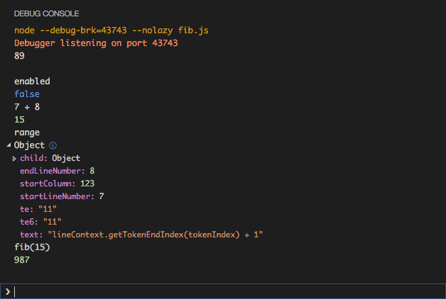
Note: You must be in a running debug session to use the Debug Console REPL.

Redirect input/output to/from the debug target#
Redirecting input/output is debugger/runtime specific, so VS Code does not have a built-in solution that works for all debuggers.
Here are two approaches you might want to consider:
- Launch the program to debug ("debug target") manually in a terminal or command prompt and redirect input/output as needed. Make sure to pass the appropriate command line options to the debug target so that a debugger can attach to it. Create and run an "attach" debug configuration that attaches to the debug target.
- If the debugger extension you are using can run the debug target in VS Code's Integrated Terminal (or an external terminal), you can try to pass the shell redirect syntax (for example "<" or ">") as arguments.
Here's an example launch.json configuration:
{
"name": "launch program that reads a file from stdin",
"type": "node",
"request": "launch",
"program": "program.js",
"console": "integratedTerminal",
"args": ["<", "in.txt"]
}
This approach requires that the "<" syntax is passed through the debugger extension and ends up unmodified in the Integrated Terminal.

Multi-target debugging#
For complex scenarios involving more than one process (for example, a client and a server), VS Code supports multi-target debugging.
Using multi-target debugging is simple: after you've started a first debug session, you can just launch another session. As soon as a second session is up and running, the VS Code UI switches to multi-target mode:
- The individual sessions now show up as top-level elements in the CALL STACK view.
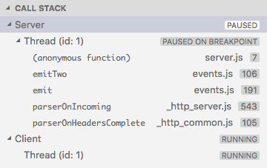
- The debug toolbar shows the currently active session (and all other sessions are available in a drop-down menu).
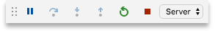
- Debug actions (for example, all actions in the debug toolbar) are performed on the active session. The active session can be changed either by using the drop-down menu in the debug toolbar or by selecting a different element in the CALL STACK view.

Compound launch configurations#
An alternative way to start multiple debug sessions is by using a compound launch configuration. A compound launch configuration lists the names of two or more launch configurations that should be launched in parallel. Optionally a preLaunchTask can be specified that is run before the individual debug sessions are started.
{
"version": "0.2.0",
"configurations": [
{
"type": "node",
"request": "launch",
"name": "Server",
"program": "${workspaceFolder}/server.js"
},
{
"type": "node",
"request": "launch",
"name": "Client",
"program": "${workspaceFolder}/client.js"
}
],
"compounds": [
{
"name": "Server/Client",
"configurations": ["Server", "Client"],
"preLaunchTask": "${defaultBuildTask}"
}
]
}
Compound launch configurations are displayed in the launch configuration drop-down menu.

Remote debugging#
VS Code does not itself support remote debugging: this is a feature of the debug extension you are using, and you should consult the extension's page in the Marketplace for support and details.
There is, however, one exception: the Node.js debugger included in VS Code supports remote debugging. See the Node.js Debugging topic to learn how to configure this.

Automatically open a URI when debugging a server program#
Developing a web program typically requires opening a specific URL in a web browser in order to hit the server code in the debugger. VS Code has a built-in feature "serverReadyAction" to automate this task.
Here is an example of a simple Node.js Express application:
var express = require('express');
var app = express();

app.get('/', function(req, res) {
res.send('Hello World!');
});

app.listen(3000, function() {
console.log('Example app listening on port 3000!');
});
This application first installs a "Hello World" handler for the "/" URL and then starts to listen for HTTP connections on port 3000. The port is announced in the Debug Console and typically the developer would now type http://localhost:3000 into their browser application.
The serverReadyAction feature makes it possible to add a structured property serverReadyAction to any launch config and select an "action" to be performed:
{
"type": "node",
"request": "launch",
"name": "Launch Program",
"program": "${workspaceFolder}/app.js",

"serverReadyAction": {
"pattern": "listening on port ([0-9]+)",
"uriFormat": "http://localhost:%s",
"action": "openExternally"
}
}
Here the pattern property describes the regular expression for matching the program's output string that announces the port. The pattern for the port number is put into parenthesis so that it is available as a regular expression capture group. In this example, we are extracting only the port number, but it is also possible to extract a full URI.
The uriFormat property describes how the port number is turned into a URI. The first %s is substituted by the first capture group of the matching pattern.
The resulting URI is then opened outside of VS Code ("externally") with the standard application configured for the URI's scheme.
Alternatively, the action can be set to debugWithChrome. In this case, VS Code starts a Chrome debug session for the URI (which requires that the Debugger for Chrome extension is installed). In this mode, a webRoot property can be added that is passed to the Chrome debug session.
To simplify things a bit, most properties are optional and we use the following fallback values:
- pattern: "listening on.* (https?://\\S+|[0-9]+)" which matches the commonly used messages "listening on port 3000" or "Now listening on: https://localhost:5001".
- uriFormat: "http://localhost:%s"
- webRoot: "${workspaceFolder}"
And here the serverReadyAction feature in action:

Next steps#
To learn about VS Code's Node.js debugging support, take a look at:
- Node.js - Describes the Node.js debugger, which is included in VS Code.
- TypeScript - The Node.js debugger also supports TypeScript debugging.
To see tutorials on the basics of Node.js debugging, check out these videos:
- Intro Video - Debugging - Showcases the basics of debugging.
- Getting started with Node.js debugging - Shows how to attach a debugger to a running Node.js process.
To learn about debugging support for other programming languages via VS Code extensions:
- C++
- Python
- Java
To learn about VS Code's task running support, go to:
- Tasks - Describes how to run tasks with Gulp, Grunt and Jake, and how to show errors and warnings.
To write your own debugger extension, visit:
- Debugger Extension - Uses a mock sample to illustrate the steps required to create a VS Code debug extension.

Common questions#

What are the supported debugging scenarios?#
Debugging of Node.js-based applications is supported on Linux, macOS, and Windows out of the box with VS Code. Many other scenarios are supported by VS Code extensions available in the Marketplace.

I do not see any launch configurations in the Run view drop-down. What is wrong?#
The most common problem is that you did not set up launch.json or there is a syntax error in that file. Alternatively, you might need to open a folder, since no-folder debugging does not support launch configurations.

