Getting Started with PHPUnit in Laravel

Introduction
PHPUnit is one of the oldest and most well-known unit testing packages for PHP. It is primarily designed for unit testing, which means testing your code in the smallest components possible, but it is also incredibly flexible and can be used for a lot more than just unit testing.
PHPUnit includes a lot of simple and flexible assertions that allow you to easily test your code, which works really well when you are testing specific components. It does mean, however, that testing more advanced code such as controllers and form submission validation can be a lot more complicated.
To help make things easier for developers, the Laravel PHP framework includes a collection of application test helpers, which allow you to write very simple PHPUnit tests to test complex parts of your application.
The purpose of this tutorial is to introduce you to the basics of PHPUnit testing, using both the default PHPUnit assertions and the Laravel test helpers. The aim is for you to be confident in writing basic tests for your applications by the end of the tutorial.

Prerequisites
This tutorial assumes that you are already familiar with Laravel and know how to run commands within the application directory (such as php artisan commands). We will be creating a couple of basic example classes to learn how the different testing tools work, and as such, it is recommended that you create a fresh application for this tutorial.
If you have the Laravel installer set up, you can create a new test application by running:
$ laravel new phpunit-tests
Alternatively, you can create a new application by using Composer directly:
$ composer create-project laravel/laravel --prefer-dist phpunit-tests
Other installation options can also be found in the Laravel documentation.

Creating a New Test
The first step when using PHPUnit is to create a new test class. The convention for test classes is that they are stored within ./tests/ in your application directory. Inside this folder, each test class is named as <name>Test.php. This format allows PHPUnit to find each test class—it will ignore anything that does not end in Test.php.
In a new Laravel application, you will notice two files in the ./tests/ directory:
- Feature/ExampleTest.php and Unit/ExampleTest.php : The ExampleTest.php is an example test class that includes a basic test case using the application testing helpers – ignore it for now.
- TestCase.php: The TestCase.php file is a bootstrap file for setting up the Laravel environment within our tests. This allows us to use Laravel facades in tests and provides the framework for the testing helpers, which we will look at shortly.
To create a new test class, we can either create a new file manually or run the helpful Artisan make:test command provided by Laravel.
In order to create a test class called BasicTest, we just need to run this artisan command:
$ cd phpunit-test
$ php artisan make:test BasicTest
Laravel will create a basic test class that looks like this:
<?php
# test/Feature/BasicTest.php

namespace Tests\Feature;

use Illuminate\Foundation\Testing\RefreshDatabase;
use Illuminate\Foundation\Testing\WithFaker;
use Tests\TestCase;

class BasicTest extends TestCase
{
/**
* A basic feature test example.
*
* @return void
*/
public function testExample()
{
$response = $this->get('/');

$response->assertStatus(200);
}
}
The most important thing to notice here is the test prefix on the method name. Like the Test suffix for class names, this test prefix tells PHPUnit what methods to run when testing. If you forget the test prefix, then PHPUnit will ignore the method.
Before we run our test suite for the first time, it is worth pointing out the default phpunit.xml file that Laravel provides. PHPUnit will automatically look for a file named phpunit.xml or phpunit.xml.dist in the current directory when it is run. This is where you configure the specific options for your tests.
There is a lot of information within this file, however, the most important section, for now, is the testsuite directory definition:
<?xml version="1.0" encoding="UTF-8"?>

. . .

<testsuites>
<testsuite name="Unit">
<directory suffix="Test.php">./tests/Unit</directory>
</testsuite>

<testsuite name="Feature">
<directory suffix="Test.php">./tests/Feature</directory>
</testsuite>
</testsuites>

. . .

</phpunit>
This tells PHPUnit to run the tests it finds in the ./tests/Unit and ./tests/Feature directories, which, as we have previously learned, are the convention for storing tests.
Now that we have created a base test, and are aware of the PHPUnit configuration, it is time to run our tests for the first time.
You can run your PHPUnit tests by running the phpunit command:
$ ./vendor/bin/phpunit
You should see something similar to this as the output:
PHPUnit 8.5.2 by Sebastian Bergmann and contributors.

... 3 / 3 (100%)

Time: 91 ms, Memory: 16.00 MB

OK (3 tests, 3 assertions)
Now that we have a working PHPUnit setup, it is time to move onto writing a basic test.

Writing a Basic Test
To help cover the basic assertions that PHPUnit provides, we will first create a basic class that provides some simple functionality.
Create a new file in your ./app/ directory called Box.php, and copy this example class:
<?php
# app/Box.php

namespace App;

class Box
{
/**
* @var array
*/
protected $items = [];

/**
* Construct the box with the given items.
*
* @param array $items
*/
public function __construct($items = [])
{
$this->items = $items;
}

/**
* Check if the specified item is in the box.
*
* @param string $item
* @return bool
*/
public function has($item)
{
return in_array($item, $this->items);
}

/**
* Remove an item from the box, or null if the box is empty.
*
* @return string
*/
public function takeOne()
{
return array_shift($this->items);
}

/**
* Retrieve all items from the box that start with the specified letter.
*
* @param string $letter
* @return array
*/
public function startsWith($letter)
{
return array_filter($this->items, function ($item) use ($letter) {
return stripos($item, $letter) === 0;
});
}
}
Next, open your ./tests/Feature/BasicTest.php class (that we created earlier), and remove the testExample method that was created by default. You should be left with an empty class.
We will now use seven of the basic PHPUnit assertions to write tests for our Box class. There are many assertions available, but the most common are:
- assertTrue()
- assertFalse()
- assertEquals()
- assertNull()
- assertContains()
- assertCount()
- assertEmpty()
- assertStatus()

assertTrue() and assertFalse()
assertTrue() and assertFalse() allow you to assert that a value is equated to either true or false. This means they are perfect for testing methods that return boolean values. In our Box class, we have a method called has($item), which returns true or false when the specified item is in the box or not.
To write a test for this in PHPUnit, we can do the following:
<?php
# test/Feature/BasicTest.php

# Import Box class
use App\Box;

. . .

# Test function for Box class
public function testBoxContents()
{
$box = new Box(['toy']);
$this->assertTrue($box->has('toy'));
$this->assertFalse($box->has('ball'));
}
Note how we only pass a single parameter into the assertTrue() and assertFalse() methods, and it is the output of the has($item) method.
If you run the ./vendor/bin/phpunit command now, you will notice the output includes:
OK (3 tests, 4 assertions)
This means our tests have passed.
If you swap the assertFalse() for assertTrue() and run the phpunit command again, the output will look like this:
PHPUnit 8.5.2 by Sebastian Bergmann and contributors.

.F. 3 / 3 (100%)

Time: 86 ms, Memory: 16.00 MB

There was 1 failure:

1) Tests\Feature\BasicTest::testBoxContents
Failed asserting that false is true.

/home/tom/r/start-phpunit/phpunit-tests/tests/Feature/BasicTest.php:29

FAILURES!
Tests: 3, Assertions: 4, Failures: 1.
This tells us that the assertion on line 29 failed to assert that a false value was true as we switched the assertFalse() for assertTrue().
Swap it back, and re-run PHPUnit. The tests should again pass, as we have fixed the broken test.

assertEquals() and assertNull()
Next, we will look at assertEquals(), and assertNull().
assertEquals() is used to compare the actual value of the variable to the expected value. We want to use it to check if the value of the takeOne() function is an item that is currently in the box. As the takeOne() method returns a null value when the box is empty, we can use assertNull() to check for that too.
Unlike assertTrue(), assertFalse(), and assertNull(), assertEquals() takes two parameters. The first being the expected value, and the second being the actual value.
We can implement these assertions in our class as follows:
<?php
# tests/Feature/BasicTest.php

. . .

public function testTakeOneFromTheBox()
{
$box = new Box(['torch']);
$this->assertEquals('torch', $box->takeOne());

// Null, now the box is empty
$this->assertNull($box->takeOne());
}

. . .
Run the phpunit command, and you should see:
OK (4 tests, 6 assertions)

assertContains(), assertCount(), and assertEmpty()
Finally, we have three assertions that work with arrays, which we can use to check the startsWith($item) method in our Box class. assertContains() asserts that an expected value exists within the provided array, assertCount() asserts the number of items in the array matches the specified amount, and assertEmpty() asserts that the provided array is empty.
We can implement tests for these like this:
<?php
# tests/Feature/BasicTest.php

. . .

public function testStartsWithALetter()
{
$box = new Box(['toy', 'torch', 'ball', 'cat', 'tissue']);

$results = $box->startsWith('t');

$this->assertCount(3, $results);
$this->assertContains('toy', $results);
$this->assertContains('torch', $results);
$this->assertContains('tissue', $results);

// Empty array if passed even
$this->assertEmpty($box->startsWith('s'));
}

. . .
Save and run your tests again:
OK (5 tests, 11 assertions)
Congratulations, you have just fully tested the Box class using seven of the basic PHPUnit assertions. You can do a lot with these simple assertions, and most of the other, more complex, assertions that are available still follow the same usage pattern.

Testing Your Application
Unit testing each component in your application works in a lot of situations and should definitely be part of your development process, however, it isn’t all the testing you need to do. When you are building an application that includes complex views, navigation, and forms, you will want to test these components too. This is where Laravel’s test helpers make things just as easy as unit testing simple components.
We previously created a new test file and we skipped the ./tests/Feature/ExampleTest.php file. Open it now, and it should look something like this:
<?php
# tests/Feature/ExampleTest.php

namespace Tests\Feature;

use Illuminate\Foundation\Testing\RefreshDatabase;
use Tests\TestCase;

class ExampleTest extends TestCase
{
/**
* A basic test example.
*
* @return void
*/
public function testBasicTest()
{
$response = $this->get('/');

$response->assertStatus(200);
}
}
We can see the test in this case, it is very simple. Without any prior knowledge of how the test helpers work, we can assume it means something like this:
- when I visit / (webroot)
- I should get an HTTP status code 200 (OK)
If you open your web browser to our application:
$ php artisan serve
Navigate to http://localhost:8000. You should see a splash screen with “Laravel” on the webroot. Given that this test has been passing PHPUnit, it is safe to say that our translation of this example test is correct.
This test is ensuring that the web page rendered at the / path returns successfully. A simple check like this may not seem like much, but if there is critical information your website needs to display, a simple test like this may prevent you from deploying a broken application if a change somewhere else causes the page to no longer display the right information.

assertSee() and assertDontSee()
Let’s write our own test now, and take it one step further.
Edit the routes file located at routes/web.php. Add the following route below the Welcome route:
<?php
# routes/web.php

. . .

Route::get('/alpha', function () {
return view('alpha');
});
For the sake of this tutorial, we will go for a Greek alphabet themed route.
Next, create the view template at ./resources/views/alpha.blade.php, and save some basic HTML with the Alpha keyword:
<!DOCTYPE html>
<html lang="{{ str_replace('_', '-', app()->getLocale()) }}">
<head>
<meta charset="utf-8">
<meta name="viewport" content="width=device-width, initial-scale=1">
<title>Alpha</title>
</head>
<body>
<h1>This is the Alpha page</h1>
</body>
</html>
Now open it in your browser to ensure it is working as expected with: php artisan serve. Go to http://localhost:8000/alpha, and it should display a friendly “This is the Alpha page.” message.
Now that we have the template, we will create a new test. Run the make:test command:
$ php artisan make:test AlphaTest
Then edit the test, using the example test as a guide, but we also want to ensure that our “alpha” page does not mention “beta”. To do this, we can use the assertDontSee() assertion, which does the opposite of assertSee().
This means we can do a simple test, replace the testExample function in test/Feature/AlphaTest.php with this one:
<?php
# test/Feature/AlphaTest.php

. . .

public function testExample()
{
$response = $this->get('/alpha');

$response->assertStatus(200);
$response->assertSee('Alpha');
$response->assertDontSee('Beta');
}

. . .
Save it and run PHPUnit (./vendor/bin/phpunit), and it should all pass, with the status line looking something like this:
OK (7 tests, 17 assertions)

Writing Tests First
A great thing about tests is that you can use the Test-Driven Development (TDD) approach, and write your tests first. After writing your tests, you run them and see that they fail, then you write the code that satisfies the tests to make everything pass again. So, let’s do that for the next page.
First, make a BetaTest class using the make:test artisan command:
$ php artisan make:test BetaTest
Next, update the test case so it is checking the /beta route for “Beta”. Edit test/Feature/BetaTest.php:
<?php
# tests/Feature/BetaTest.php

. . .

public function testExample()
{
$response = $this->get('/beta');

$response->assertStatus(200);

$response->assertSee('Beta');
$response->assertDontSee('Alpha');
}

. . .
Now, run the test using ./vendor/bin/phpunit. The result should be a slightly unfriendly error message, that looks like this:
$ ./vendor/bin/phpunit
PHPUnit 8.5.2 by Sebastian Bergmann and contributors.

.....F. 7 / 7 (100%)

Time: 206 ms, Memory: 18.00 MB

There was 1 failure:

1) Tests\Feature\BetaTest::testExample
Expected status code 200 but received 404.
Failed asserting that false is true.

/home/tom/r/start-phpunit/phpunit-tests/vendor/laravel/framework/src/Illuminate/Foundation/Testing/TestResponse.php:185
/home/tom/r/start-phpunit/phpunit-tests/tests/Feature/BetaTest.php:20

FAILURES!
Tests: 7, Assertions: 14, Failures: 1.
We now have an expectation for a missing route. Let’s create it.
First, edit the ./routes/web.php file to create the new /beta route:
<?php
# routes/web.php

. . .

Route::get('/beta', function () {
return view('beta');
});

. . .
Next, create the view template at ./resources/views/beta.blade.php:
<!DOCTYPE html>
<html lang="{{ str_replace('_', '-', app()->getLocale()) }}">
<head>
<meta charset="utf-8">
<meta name="viewport" content="width=device-width, initial-scale=1">
<title>Beta</title>
</head>
<body>
<h1>This is the Beta page</h1>
</body>
</html>
Now, run PHPUnit again, and the result should be back to green.
$ ./vendor/bin/phpunit
PHPUnit 8.5.2 by Sebastian Bergmann and contributors.

....... 7 / 7 (100%)

Time: 101 ms, Memory: 18.00 MB

OK (7 tests, 16 assertions)
We have now implemented our new page using Test Driven Development by writing the test first.

Laravel Dusk
Laravel Dusk is a browser testing toolset that was introduced in Laravel 5.4. It allows us to run tests directly in a Google Chrome browser, making our tests more real and reliable.
With Dusk we can simulate user interactions, click on links, make assertions, and execute JavaScript among many other things.
As mentioned before, Dusk uses Google Chrome, so you’ll need to make sure you have it installed first (Chromium may not work). Alternatively, you can use other browsers with Selenium.
Install the Dusk components:
$ composer require --dev laravel/dusk
$ php artisan dusk:install
This will install all the required components, including a Google ChromeDriver and an example test at test/Browser/ExampleTest.php.
Next, we need to start the application, preferably on a different port, so it doesn’t conflict with our development environment. Create a Dusk-only environment file:
$ cp .env .env.dusk.local
Open the new file .env.dusk.local and change the port number, for example, we’ll use port 8010:
# .env.dusk.local

. . .

APP_URL=http://localhost:8010

. . .
Start the application on the same port:
$ php artisan serve --port=8010 &
Run the example test:
$ php artisan dusk

PHPUnit 8.5.2 by Sebastian Bergmann and contributors.

. 1 / 1 (100%)

Time: 554 ms, Memory: 16.00 MB

OK (1 test, 1 assertion)

clickLink() and assertPathIs()
Dusk also provides a helper to allow the test to click a link that exists on the page (clickLink()), as well as a way to check what the resulting page is (assertPathIs()).
Let’s use these two helpers to implement links between the Alpha and Beta pages.
First, let’s create new Browser-only tests:
$ php artisan dusk:make AlphaTest
$ php artisan dusk:make BetaTest
Open test/Browser/AlphaTest.php and replace the testExample method with this one:
<?php
# test/Browser/AlphaTest.php

. . .

public function testExample()
{
$this->browse(function (Browser $browser) {
$browser->visit('/alpha')
->assertSee('Alpha')
->clickLink('Next')
->assertPathIs('/beta');
});
}

. . .
The new test will click the ‘Next’ link found on the “alpha” page to go to the “beta” page.
You can run the test suite now, but as expected it will fail as we haven’t updated our HTML yet.
Next, we will update the test/Browser/BetaTest.php to do similar:
<?php
# test/Browser/BetaTest.php

. . .

public function testExample()
{
$this->browse(function (Browser $browser) {
$browser->visit('/beta')
->assertSee('Beta')
->clickLink('Previous')
->assertPathIs('/alpha');
});
}

. . .
Next, let’s update our HTML templates to add Next and Previous links.
Edit resources/views/alpha.blade.php:
<!DOCTYPE html>
<html lang="{{ str_replace('_', '-', app()->getLocale()) }}">
<head>
<meta charset="utf-8">
<meta name="viewport" content="width=device-width, initial-scale=1">
<title>Alpha</title>
</head>
<body>
<h1>This is the Alpha page</h1>
<a href="/beta">Next</a>
</body>
</html>
Then edit resources/views/beta.blade.php:
<!DOCTYPE html>
<html lang="{{ str_replace('_', '-', app()->getLocale()) }}">
<head>
<meta charset="utf-8">
<meta name="viewport" content="width=device-width, initial-scale=1">
<title>Beta</title>
</head>
<body>
<h1>This is the Beta page</h1>
<a href="/alpha">Previous</a>
</body>
</html>
Save the files and run Dusk again:
$ php artisan dusk
PHPUnit 8.5.2 by Sebastian Bergmann and contributors.

... 3 / 3 (100%)

Time: 1.45 seconds, Memory: 18.00 MB

OK (3 tests, 5 assertions)
We have now tested our new pages, including the Next/Previous links between them.
Read More: 7 Continuous Integration Tools for PHP Laravel Developers

Continuous Integration for PHPUnit on Semaphore
Testing is a daily part of every developer’s routine. Continuous Integration (CI) is a software development practice in which test the application on every change. Teams that use CI can merge changes into the main branch several times a day, reducing the chance of conflicts and improving software quality.
We can add Semaphore CI/CD to our project in just a few minutes. We’ll only need:
- GitHub: A GitHub account for the code.
- Semaphore: A Semaphore account. You can get it for free using the TRY it Free button on the top-right corner.
- Git: Git to push the code to GitHub.

Push Code to GitHub
The first thing to do it to upload our examples to GitHub:
- Create a new repository on GitHub.
- Leave all the options unchecked. Click on the Create Repository button:
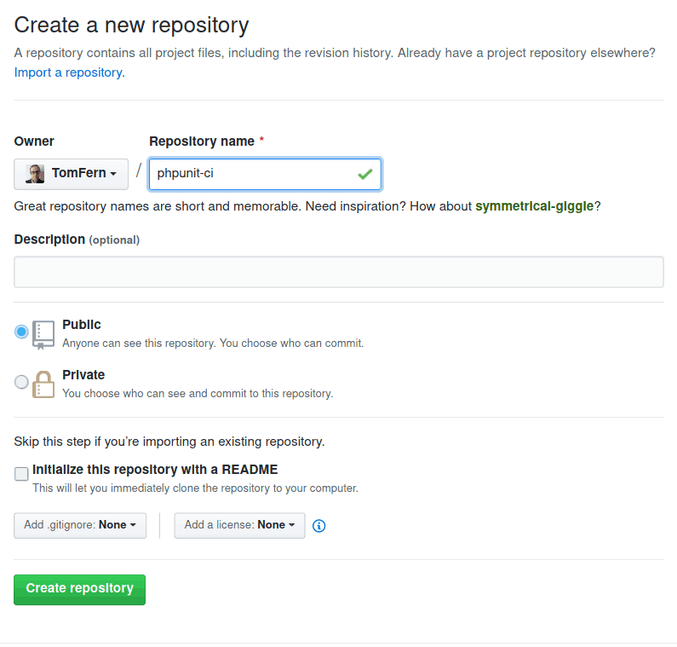
- Copy the URL of your new repository:
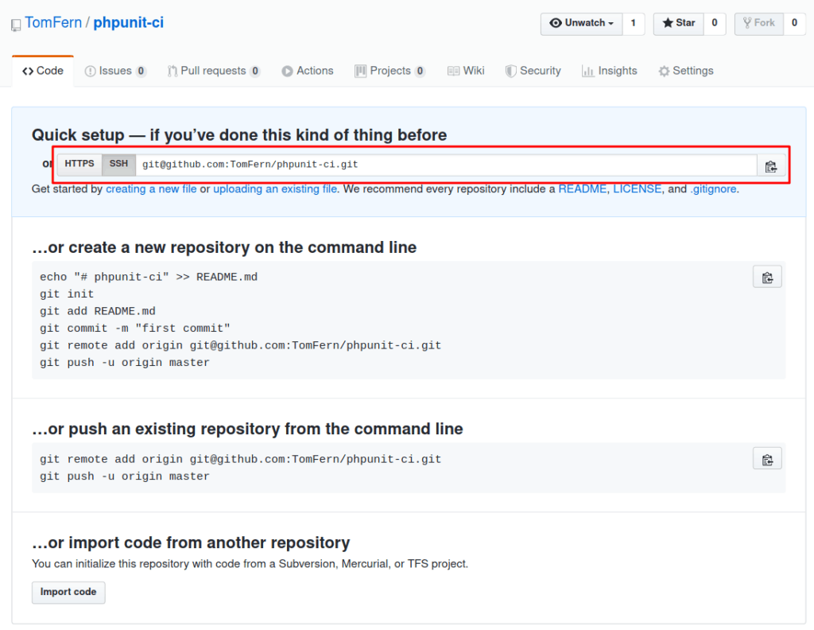
- Push your code to GitHub:
$ git init
$ git remote add origin YOUR_REPOSITORY_URL
$ git add -A
$ git add --force .env.dusk.local
$ git commit -m "initial commit"
$ git push origin master

Create a CI Pipeline
A pipeline represents a series of processes that operate on our code. Each time the code is updated, each time a commit happens or a branch merged, the code enters the pipeline and is submitted to a series of tests. A good CI pipeline will provide a short feedback cycle that helps to weed out errors faster.
To create a pipeline for the project:
- In Semaphore, use the + (plus sign) button next to Projects to add the repository:
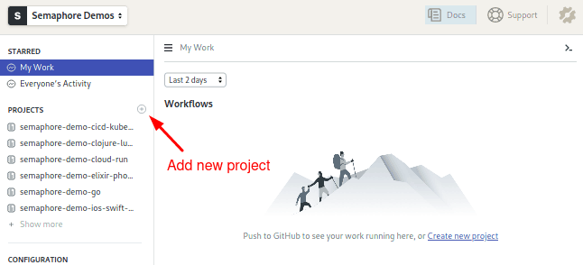
- Find your repository and click on Choose:
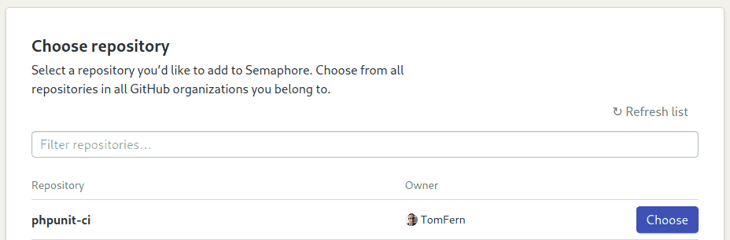
- Select the Laravel starter workflow:
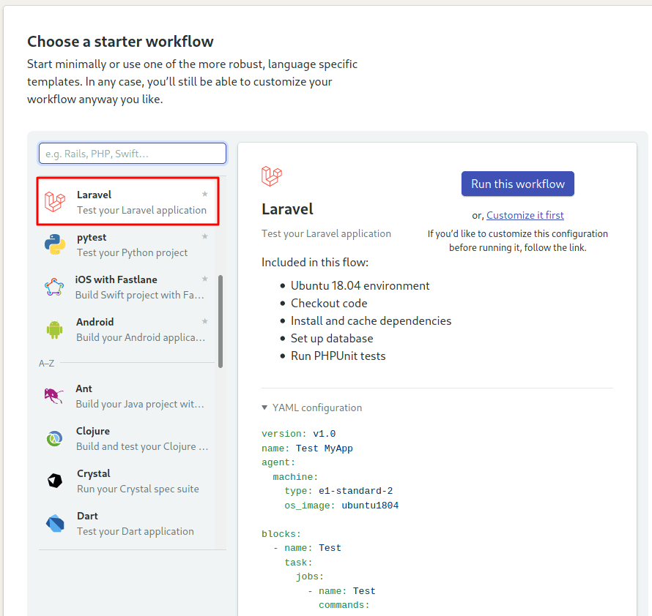
- Click on Customize it first. We need to make a few tweaks in the pipeline before it runs.
We get the Workflow Builder screen, we can always open it using the Edit Workflow button on the top-right corner:
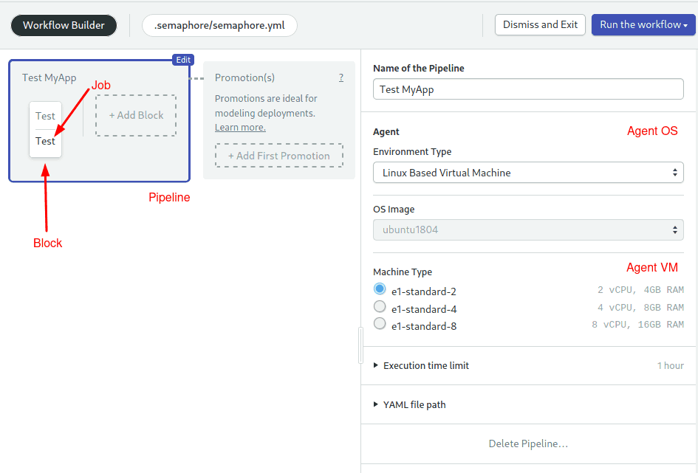
- Pipeline: A pipeline has a specific objective, e.g. build. Pipelines are made of blocks that are executed from left to right.
- Agent: The agent is the virtual machine that powers the pipeline. We have three machine types to choose from. The machine runs an optimized Ubuntu 18.04 image with build tools for many languages.
- Block: blocks group jobs with a similar purpose. Jobs in a block are executed in parallel and have similar commands and configurations. Once all jobs in a block complete, the next block begins.
- Job: jobs define the commands that do the work. They inherit their configuration from their parent block.
Let’s finish up setting up the initial pipeline:
- Click on the Test block.
- Open the Environment Variables section, add the following variable using the +Add env_var link: APP_ENV = local. We need to clearly state that this is not a production environment, otherwise Dusk will refuse to run.
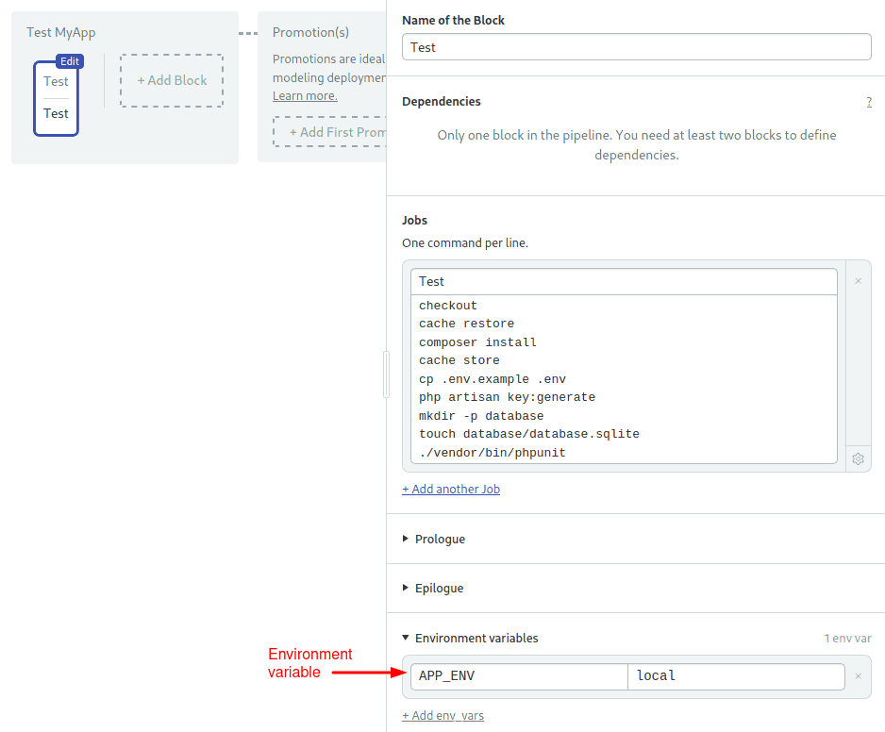
- Click on Run the Workflow and then Start:
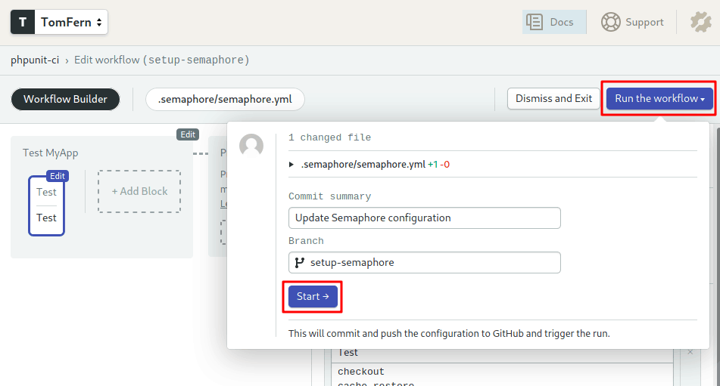
The pipeline starts immediately:
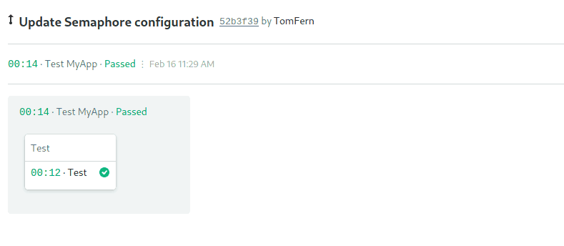

Optimizing the Pipeline
The started pipeline can be further optimized by:
- Storing the composer modules in the cache, so they don’t have to be downloaded every time.
- Separating the install and test steps into two blocks.
- Running the Laravel Dusk browser tests.
Let’s modify the pipeline to run faster, we’ll use this opportunity to learn more about Semaphore:
- Use the Edit Workflow button to open the workflow builder again.
- Click on the test block and rename it to “Install”
- Rename the job to “Composer”
- Replace the commands in the job with the following:
sem-version php 7.4
checkout
cache restore
composer install
npm install
cache store
We’re using some of the many Semaphore toolbox commands:
- checkout: this is a Semaphore built-in command that clones the GitHub repository into the CI environment.
- sem-version: activates a particular version for a language. Semaphore supports most current PHP versions.
- cache: To speed up jobs, Semaphore provides the cache tool. You can run store and restore to your preserve downloaded modules in Semaphore’s cache. The cache automatically figures out which files and directories should be stored.
Now we can re-add the test block:
- Use the +Add Block dotted line button to create a new block.
- Set the name of the block to “Test”
- Open the Environment Variable section and add the variable: APP_ENV = local
- Open the Prologue section. The prologue is executed before each job in the block. Type the following commands:
sem-version php 7.4
checkout
cache restore
cp .env.example .env
php artisan key:generate
mkdir -p database
touch database/database.sqlite
- Set the name of the job to “phpunit”
- Type the following commands in the job:
./vendor/bin/phpunit
- Click on Add job to create a new job in the Test block. Set its name to “dusk”.
- Type the following commands in the dusk job. We need to install the Chrome Web Driver that matches the version of Google Chrome in Semaphore, which currently is version 79:
php artisan dusk:chrome-driver 79
php artisan serve --env=.env.dusk.local --port=8010 &
php artisan dusk
- Use Run the Workflow and then Start to try the new pipeline:
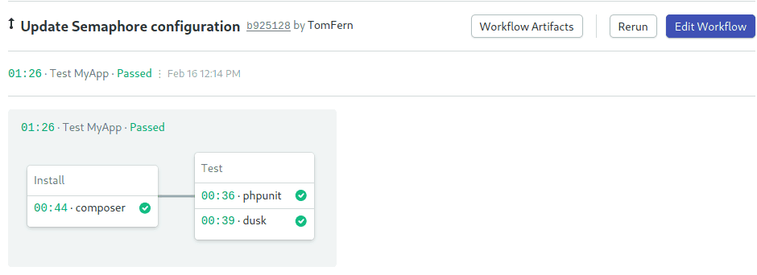
This optimized pipeline is a solid foundation for your Laravel projects.

Next Reads
Don’t miss these great tutorials on PHP, Laravel and Continuous Integration:
- 7 Continuous Integration Tools for PHP Laravel Developers
- Dockerizing a PHP Application
- Semapore PHP support page

Conclusion
You should notice a common theme across all of the tests that we have written in this tutorial: they are all incredibly simple. This is one of the benefits of learning how to use the basic test assertions and helpers, and trying to use them as much as possible. The simpler you can write your tests, the easier your tests will be to understand and maintain.
Once you have mastered the PHPUnit assertions we have covered in this tutorial, you can find a lot more in the PHPUnit documentation. They all follow the same basic pattern, but you will find that you keep coming back to the basic assertions for most of your tests.
Laravel’s test helpers are a fantastic compliment to the PHPUnit assertions, and make testing your application templates easy. That said, it is important to recognize that, as part of our tests, we only checked the critical information – not the entire page. This keeps the tests simple, and allows the page content to change as the application changes. If the critical content still exists, the test still passes, and everyone is happy.
https://semaphoreci.com/community/tutorials/getting-started-with-phpunit-in-laravel

PHP - Getting Started PHPUnit test with simple example
By Hardik Savani | February 12, 2017 | Category : PHP

PHPUnit is a one type of unit testing framework for PHP language. In todays PHPUnit is very popular for testing. Most of site owner want to implement PHPUnit test because that way we can simply test using command. Without testing our website will never be good to publish. But if you don't know about PHPUnit and no idea how to start so just follow bellow example for scratch.
I will give you very simple example of PHPUnit and how it works from scratch. I make quick easy example with phpunit command. We have to create two file like as listed bellow:
1)MyTest.php
2)MyTestTests.php
Before start example make sure you have installed PHP. So you have to just follow bellow files to complete example.
Download PHPUnit
wget https://phar.phpunit.de/phpunit.phar
php phpunit.phar --version
Create MyTest.php File
<?php
class MyTest
{
public function add($a, $b)
{
return $a + $b;
}
}
Create MyTestTests.php File
<?php
require 'MyTest.php';
use PHPUnit\Framework\TestCase;
class MyTestTests extends TestCase
{
private $mytest;
protected function setUp()
{
$this->mytest = new MyTest();
}
protected function tearDown()
{
$this->mytest = NULL;
}
public function testAdd()
{
$result = $this->mytest->add(1, 3);
$this->assertEquals(4, $result);
}
}
Now we are ready to run bellow simple example by following example:
Read Also: PHP - Bootstrap autocomplete tokenfield with Ajax Example
php phpunit.phar MyTestTests.php
You will be find this way result:
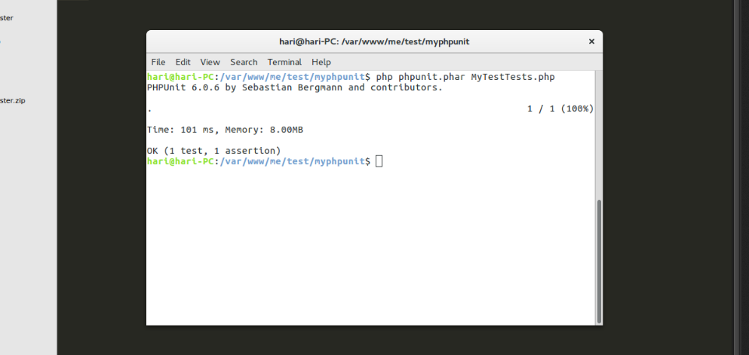
I hope it can help you...
https://www.itsolutionstuff.com/post/php-getting-started-phpunit-test-with-simple-exampleexample.html

PHPUnit Tutorial For Beginners
Rana Ahsan 4 Comments



Sharing is caring!
I am using PHPUnit for quite sometime now. Though was thinking few times to write about it, but it didn’t happen till now. In fact, this is my first tutorial on testing as well. The official documentation/getting started guide is already quite good for starting. However, I personally find it a little insufficient in several cases and could be little hard to start with as a beginner. Thus, I am writing this PHPUnit tutorial to explain it as easily possible with my preferred/recommended way to start using PHPUnit. Also, though this is a beginners level tutorial on phpunit, I assume you know/have sound concept about what unit testing is!

Alternative To PHPUnit:
There is another simpletest for PHP, which you can checkout as well if you want. However, though I haven’t practically used it yet, but seems it doesn’t have as much support/flexibility as PHPUnit. Also, even being PHPUnit unofficial, still it’s almost being used everywhere, so sticking with it is a good idea, I guess.

Installing PHPUnit:
It is possible to get PHPUnit installed for per project basis or system wide as well. I personally prefer per project basis most. Lets installed this way using composer:
1  2  3  4  5 | {  "require": {  "phpunit/phpunit": "dev-master"  }  }

Even if you are not using composer for you project, you can have it there without affecting anything else and use its CLI comfortably. In case you are not familiar with composer, get it installed easily on your system, copy the above JSON to a file named ‘composer.json’ on your project directory and run ‘composer update’ command. And you should be done.
Now, to verify the installation, use your terminal/command line tool and go to your project directory. Then run the following command:
1  2  3  4  5  6  7  8 | $./vendor/bin/phpunit  PHPUnit 4.1.3 by Sebastian Bergmann.  Usage: phpunit [options] UnitTest [UnitTest.php]  phpunit [options] <directory>  Code Coverage Options:  ..............

If all OK, you should get some output as like above.

Initial PHPUnit Configuration:
Well, it’s not mandatory to maintain a configuration file. You can run specific PHPUnit class/method right from your CLI . However, I like, prefer and will strongly recommend to have a configuration file with all details so that you can just run “phpunit” command and it itself take care of the rest.
Yes, if there is a configuration file named ‘phpunit.xml’, it’s automatically read by the library and act accordingly. A sample configuration file is as below:
01  02  03  04  05  06  07  08  09  10  11  12  13  14  15  16  17  18  19  20  21  22 | <?xml version="1.0" encoding="UTF-8"?>  <phpunit bootstrap="./tests/bootstrap.php"  convertWarningsToExceptions="true"  convertNoticesToExceptions="true"  convertErrorsToExceptions="true"  backupStaticAttributes="false"  processIsolation="false"  stopOnFailure="false"  backupGlobals="false"  syntaxCheck="false"  colors="true">  <testsuites>  <testsuite name="HelloWorld Test Suite">  <directory>./tests/</directory>  <file>./path/to/file.php</file>  </testsuite>  </testsuites>  <php>  <var name="SOME_CONSTANT_CONFIG" value="Test Value" />  </php>  </phpunit>

Above is a very simple XML configuration. As you can see, you can specify directories where your test files are. You can specify individual files as well. Also, here you can categorize tests into separate test suit as well. Then you can just run one specific suit from CLI.

PHPUnit HelloWorld Test Case:
Lets create a test to try out. It’s good to have tests on a separate dedicated directory, usually named as ‘tests’. Create a single php file named ‘HelloWorldTest’ and put below content in it:
1  2  3  4  5  6  7 | class HelloWorldTest extends \PHPUnit_Framework_TestCase  {  function testHelloWorld()  {  $this->assertTrue(true);  }  }

Just to tell you one thing here, remember, a phpunit test method name always start with ‘test’ and then rest of the name goes one. Any method that doesn’t start with ‘test’ will be ignored by phpunit.
For this first test, remove the bootstrap option from XML configuration(as we don’t have any now). And run the following command:
1 | $./vendor/bin/phpunit

If all are OK, you should see something like as below:
1  2  3  4  5  6  7  8  9 | PHPUnit 4.3-g39989b7 by Sebastian Bergmann.  Configuration read from /path/to/phpunit.xml  .  Time: 793 ms, Memory: 2.50Mb  OK (1 test, 1 assertion)

As you can see, in summary output, it shows the most necessary information in brief like, how many tests(each test method is considered as single test, however a single test can include as many assertion as you need) ran. how much time/memory it took etc.

Understanding Assertion:
Assertion is the process of verifying an expected output to an actual output. This is something like this – you will provide set of input(s) to a unit of functionality(usually a specific method) in your application. Then you verify whether your desired output is same as the actual output the method returning to you. If yes, it passes the test, otherwise it fells.
There are several built-in assert* methods(which are standards on unit tests of other programming language as well) that you will be using to compare value your application is returning to the value you are expecting. Lets say, your application has a class that checks whether a user is logged in or not. This could be written in PHPUnit as below:
1  2  3  4 | function testAuthorized()  {  $this->assertTrue(Auth::isLoggedIn());  }

In similar way you can compare two values as well:
1  2  3  4  5 | function testPHPUnitMethod()  {  $company = CompanyModel::getByName("companyName");  $this->assertEqual(50, $company->noOfEmployee());  }

There are lots of other assertions available which you can use to compare almost anything you might need.

Initialization/Destruction:
Well, it might happen that, you have several test cases that need to do several common steps at the beginning. To make a common generalization of such situations, phpunit comes up with built-in support for ‘setUp’ and ‘tearDown’ method, which you can write
to do common initialization and destruction mechanisms. Example shown below:
01  02  03  04  05  06  07  08  09  10 | public function setUp()  {  $this->db->ClearDatabase();  $this->session->start();  }  public function tearDown()  {  $this->session->destroy();  }

Final Words:
As a getting started point, hopefully this small PHPUnit tutorial should be enough, I guess. However, if you are not clear about anything or if you think some other information will be helpful to add, please let me know via comment and I will try to add them soon. Also, I am willing to write more on this later on. Happy coding
https://codesamplez.com/development/phpunit-tutorial-beginners

Getting started with phpunit

Remarks#
This section provides an overview of what phpunit is, and why a developer might want to use it.
It should also mention any large subjects within phpunit, and link out to the related topics. Since the Documentation for phpunit is new, you may need to create initial versions of those related topics.

Versions#
Version | Support ends | Supported in those PHP versions | Release date
5.4 | 2016-08-05 | PHP 5.6, PHP 7. | 2016-06-03
4.8 | 2017-02-03 | PHP 5.3, PHP 5.4, PHP 5.5, and PHP 5.6. | 2015-08-07

Create first PHPUnit test for our class#
Imagine that we have a class Math.php with logic of calculating of fiobanacci and factorial numbers. Something like this:
<?php
class Math {
public function fibonacci($n) {
if (is_int($n) && $n > 0) {
$elements = array();
$elements[1] = 1;
$elements[2] = 1;
for ($i = 3; $i <= $n; $i++) {
$elements[$i] = bcadd($elements[$i-1], $elements[$i-2]);
}
return $elements[$n];
} else {
throw new
InvalidArgumentException('You should pass integer greater than 0');
}
}

public function factorial($n) {
if (is_int($n) && $n >= 0) {
$factorial = 1;
for ($i = 2; $i <= $n; $i++) {
$factorial *= $i;
}
return $factorial;
} else {
throw new
InvalidArgumentException('You should pass non-negative integer');
}
}
}

The simplest test#
We want to test logic of methods fibonacci and factorial . Let's create file MathTest.php into the same directory with Math.php . In our code we can use different assertions. The simplest code will be something like this (we use only assertEquals and assertTrue ):
<?php
require 'Math.php';

use PHPUNIT_Framework_TestCase as TestCase;
// sometimes it can be
// use PHPUnit\Framework\TestCase as TestCase;

class MathTest extends TestCase{
public function testFibonacci() {
$math = new Math();
$this->assertEquals(34, $math->fibonacci(9));
}

public function testFactorial() {
$math = new Math();
$this->assertEquals(120, $math->factorial(5));
}

public function testFactorialGreaterThanFibonacci() {
$math = new Math();
$this->assertTrue($math->factorial(6) > $math->fibonacci(6));
}
}

We can run this test from console with command phpunit MathTest and output will be:
PHPUnit 5.3.2 by Sebastian Bergmann and contributors.

... 3 / 3 (100%)

Time: 88 ms, Memory: 10.50Mb

OK (3 tests, 3 assertions)

Using dataProviders#
A test method can accept arbitrary arguments. These arguments are to be provided by a data provider method. The data provider method to be used is specified using the @dataProvider annotation. :
<?php
require 'Math.php';

use PHPUNIT_Framework_TestCase as TestCase;
// sometimes it can be
// use PHPUnit\Framework\TestCase as TestCase;

class MathTest extends TestCase {
/**
* test with data from dataProvider
* @dataProvider providerFibonacci
*/
public function testFibonacciWithDataProvider($n, $result) {
$math = new Math();
$this->assertEquals($result, $math->fibonacci($n));
}

public function providerFibonacci() {
return array(
array(1, 1),
array(2, 1),
array(3, 2),
array(4, 3),
array(5, 5),
array(6, 8),
);
}
}

We can run this test from console with command phpunit MathTest and output will be:
PHPUnit 5.3.2 by Sebastian Bergmann and contributors.

...... 6 / 6 (100%)

Time: 97 ms, Memory: 10.50Mb

OK (6 tests, 6 assertions)

<?php
require 'Math.php';
use PHPUNIT_Framework_TestCase as TestCase;
// sometimes it can be
// use PHPUnit\Framework\TestCase as TestCase;

Test exceptions#
We can test whether an exception is thrown by the code under test using method expectException() . Also in this example we add one failed test to show console output for failed tests.
<?php
require 'Math.php';
use PHPUNIT_Framework_TestCase as TestCase;
// sometimes it can be
// use PHPUnit\Framework\TestCase as TestCase;

class MathTest extends TestCase {
public function testExceptionsForNegativeNumbers() {
$this->expectException(InvalidArgumentException::class);
$math = new Math();
$math->fibonacci(-1);
}

public function testFailedForZero() {
$this->expectException(InvalidArgumentException::class);
$math = new Math();
$math->factorial(0);
}
}

We can run this test from console with command phpunit MathTest and output will be:
PHPUnit 5.3.2 by Sebastian Bergmann and contributors.

.F 2 / 2 (100%)

Time: 114 ms, Memory: 10.50Mb

There was 1 failure:

1) MathTest::testFailedForZero
Failed asserting that exception of type "InvalidArgumentException" is thrown.

FAILURES!
Tests: 2, Assertions: 2, Failures: 1.

SetUp and TearDown#
Also PHPUnit supports sharing the setup code. Before a test method is run, a template method called setUp() is invoked. setUp() is where you create the objects against which you will test. Once the test method has finished running, whether it succeeded or failed, another template method called tearDown() is invoked. tearDown() is where you clean up the objects against which you tested.
<?php
require 'Math.php';

use PHPUNIT_Framework_TestCase as TestCase;
// sometimes it can be
// use PHPUnit\Framework\TestCase as TestCase;

class MathTest extends TestCase {
public $fixtures;
protected function setUp() {
$this->fixtures = [];
}

protected function tearDown() {
$this->fixtures = NULL;
}

public function testEmpty() {
$this->assertTrue($this->fixtures == []);
}
}

More info#
There are much more great opportunities of PHPUnit which you can use in your test. For more info see in official manual

Example of PHPUNIT with APItest using Stub And Mock#
Class for which you will create unit test case. class Authorization {
/* Observer so that mock object can work. */
public function attach(Curl $observer)
{
$this->observers = $observer;
}

/* Method for which we will create test */
public function postAuthorization($url, $method) {

return $this->observers->callAPI($url, $method);
}

}
Now we did not want any external interaction of our test code thus we need to create a mock object for callAPI function as this function is actually calling external url via curl. class AuthorizationTest extends PHPUnit_Framework_TestCase {
protected $Authorization;

/**
* This method call every time before any method call.
*/
protected function setUp() {
$this->Authorization = new Authorization();
}

/**
* Test Login with invalid user credential
*/
function testFailedLogin() {

/*creating mock object of Curl class which is having callAPI function*/
$observer = $this->getMockBuilder('Curl')
->setMethods(array('callAPI'))
->getMock();

/* setting the result to call API. Thus by default whenver call api is called via this function it will return invalid user message*/
$observer->method('callAPI')
->will($this->returnValue('"Invalid user credentials"'));

/* attach the observer/mock object so that our return value is used */
$this->Authorization->attach($observer);

/* finally making an assertion*/
$this->assertEquals('"Invalid user credentials"', $this->Authorization->postAuthorization('/authorizations', 'POST'));
}

}
Below is the code for curl class(just a sample) class Curl{ function callAPI($url, $method){
//sending curl req
}

}

Minimal example test#
Given a simple PHP class:
class Car
{
private $speed = 0;

public getSpeed() {
return $this->speed;
}

public function accelerate($howMuch) {
$this->speed += $howMuch;
}
}

You can write a PHPUnit test which tests the behavior of the class under test by calling the public methods and check whether they function as expected:
class CarTest extends PHPUnit_Framework_TestCase
{
public function testThatInitalSpeedIsZero() {
$car = new Car();
$this->assertSame(0, $car->getSpeed());
}

public function testThatItAccelerates() {
$car = new Car();
$car->accelerate(20);
$this->assertSame(20, $car->getSpeed());
}

public function testThatSpeedSumsUp() {
$car = new Car();
$car->accelerate(30);
$car->accelerate(50);
$this->assertSame(80, $car->getSpeed());
}
}

Important parts:
- Test class needs to derive from PHPUnit_Framework_TestCase.
- Each test function name should start with the prefix 'test'
- Use $this->assert... functions to check expected values.

Mocking classes#
The practice of replacing an object with a test double that verifies expectations, for instance asserting that a method has been called, is referred to as mocking.
Lets assume we have SomeService to test.
class SomeService
{
private $repository;
public function __construct(Repository $repository)
{
$this->repository = $repository;
}

public function methodToTest()
{
$this->repository->save('somedata');
}
}

And we want to test if methodToTest really calls save method of repository. But we don't want to actually instantiate repository (or maybe Repository is just an interface).
In this case we can mock Repository .
use PHPUnit\Framework\TestCase as TestCase;

class SomeServiceTest extends TestCase
{
/**
* @test
*/
public function testItShouldCallRepositorySavemethod()
{
// create an actual mock
$repositoryMock = $this->createMock(Repository::class);

$repositoryMock->expects($this->once()) // test if method is called only once
->method('save') // and method name is 'save'
->with('somedata'); // and it is called with 'somedata' as a parameter

$service = new SomeService($repositoryMock);
$service->someMethod();
}
}

https://riptutorial.com/phpunit

Getting Started with Unit Testing a Laravel API using PHPUnit
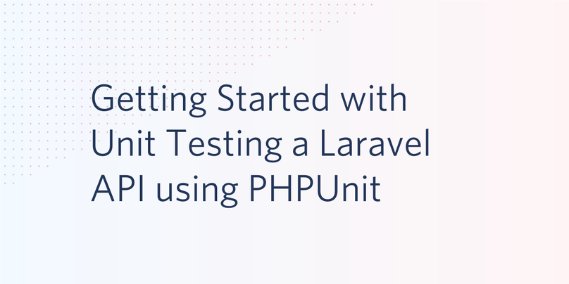
Performing unit, automated feature, and API endpoint testings are considered as some of the best practices to ensure proper implementation of specified software requirements, because they help guarantee the success of such applications. Testing, by all means, tends to give you a 100 percent assurance that any incremental changes and newly implemented features in your project won’t break the app. This practice is often referred to as Test-driven Development.
Laravel, as one of the popular PHP frameworks was built with testing in mind and comes with a testing suite named PHPUnit. PHPUnit is a testing framework built to enhance PHP developers’ productivity during development. It is primarily designed for testing PHP code in the smallest possible components known as unit testing, but also flexible enough to be used beyond unit testing.
In this tutorial, we will take a test-driven development approach and learn how to test the endpoints of a Laravel API project. We will start by writing tests, expecting them to fail. Afterward, we will write the code to make our tests pass. By the time we are done, you will have learned how to carry out basic testing and be confident enough to apply this knowledge on your new or existing Laravel API projects.

Prerequisites
Basic knowledge of building applications with Laravel will be of help in this tutorial. Also, you need to ensure that you have installed Composer globally to manage dependencies.

Getting Started
Our Laravel API will be used to create a list and display details of top tech CEOs in the world. This is similar to what we built in a previous post. To get started as quickly as possible, download the starter project that contains the structures that enable our application to work as specified.
To begin, run the following command to download the starter project using Git:
$ git clone https://github.com/yemiwebby/laravel-api-testing-starter.git
Next, move into the new project’s folder and install all its dependencies:
// move into the new folder
$ cd laravel-api-testing-starter

//install dependencies
$ composer install
This sample project already contains the following:
- User and CEO Models with respective fillable properties
- Controllers, migration files, as well as an API route contained in the routes/api.php file. And finally,
- Laravel Passport installed and configured to work with the project. Read this article to learn more about securing the Laravel API.
Next, create a .env file at the root of the project and populate it with the content found in the .env.example file. You can do this manually or by running the command below:
$ cp .env.example .env
Now generate the Laravel application key for this project with:
$ php artisan key:generate
You can now run the application with php artisan serve and proceed to http://localhost:8000 to view the homepage:
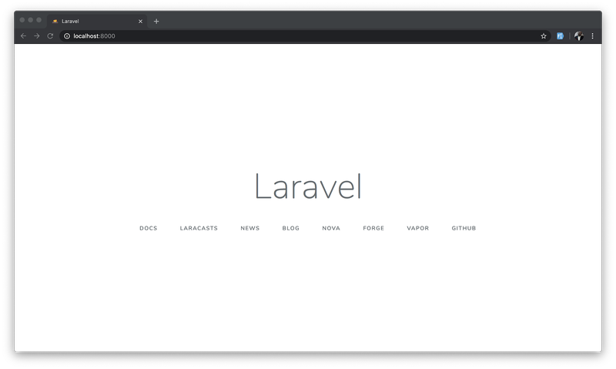
There is not much to see here as this is just a default page for a newly installed Laravel project.

Setting Up the Database
To get started with testing, you need to set up your testing database. In this tutorial, we will keep things simple by using an in-memory SQLite database. It gives the advantage of improved speed for our test scripts.
Create a test.sqlite file in the database folder. This file will be used to interact with our testing database and maintain a separate configuration from the main database. Next, replace the database environment variables from .env.testing in your .env file.
DB_CONNECTION=sqlite
DB_HOST=null
DB_PORT=null
DB_DATABASE=database/test.sqlite
DB_USERNAME=null
DB_PASSWORD=null
Each test requires migrations. We will need to run migrations before each test to properly build the database for each test. Let’s configure that by opening your base TestCase class located in tests/TestCase.php file and update it as shown below:

<?php

namespace Tests;

use Illuminate\Foundation\Testing\DatabaseMigrations;
use Illuminate\Foundation\Testing\TestCase as BaseTestCase;
use Illuminate\Support\Facades\Artisan;

abstract class TestCase extends BaseTestCase
{
use CreatesApplication, DatabaseMigrations;

public function setUp(): void
{
parent::setUp();
Artisan::call('passport:install');
}
}
Here we included the DatabaseMigrations trait and then added an Artisan call to install passport.
Lastly, use the following command to run PHPUnit from the terminal:
$ vendor/bin/phpunit
You will see the results as shown below:
PHPUnit 8.5.4 by Sebastian Bergmann and contributors.

.. 2 / 2 (100%)

Time: 2.03 seconds, Memory: 24.00 MB

OK (2 tests, 2 assertions)

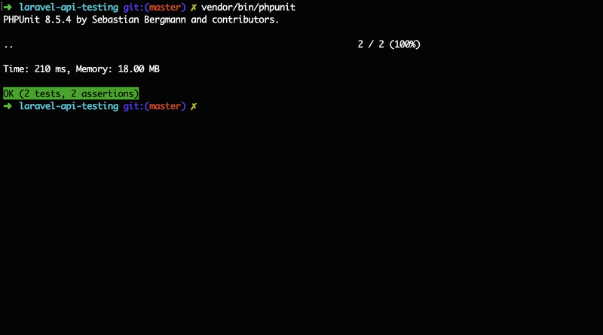
The output above showed that two tests were run successfully. These were the default tests that came installed with Laravel. We will make modifications in a bit.
To make the command for running the PHPUnit relatable, open composer.json file and add the test command to the scripts section as shown below:
{
...
"scripts": {
...,
"test": [
"vendor/bin/phpunit"
]
}
}
Henceforth, the test command will be available as composer test.

Create CEO factory
Factories in Laravel make use of the Faker PHP library to conveniently generate random data for testing. Since Laravel comes preloaded with a factory definition for User class. We will run the following command to generate one for the CEO class:
$ php artisan make:factory CEOFactory
This will create a new file named CEOFactory.php within the database/factories folder. Open this new file and paste the following content in it:
<?php

/** @var \Illuminate\Database\Eloquent\Factory $factory */

use App\CEO;
use Faker\Generator as Faker;

$factory->define(CEO::class, function (Faker $faker) {
return [
'name' => $faker->name,
'company_name' => $faker->unique()->company,
'year' => $faker->year,
'company_headquarters' => $faker->city,
'what_company_does' => $faker->sentence
];
});
We have specified the fields for our CEO table and used the Faker library to generate the correct format of random data for all the fields.

Writing our First Test
Let’s start writing our test as mentioned earlier. Before that, delete the two example test files within tests/Feature and tests/Unit folders respectively.
We will begin by writing a test for the authentication process. This includes Registration and Login. We already have a controller created for that purpose within the API folder. So create the AuthenticationTest file with:
$ php artisan make:test AuthenticationTest
This will create the AuthenticationTest.php file inside the test/Feature folder. Open the new file and replace its contents with:
<?php

namespace Tests\Feature;

use App\User;
use Tests\TestCase;

class AuthenticationTest extends TestCase
{
public function testRequiredFieldsForRegistration()
{
$this->json('POST', 'api/register', ['Accept' => 'application/json'])
->assertStatus(422)
->assertJson([
"message" => "The given data was invalid.",
"errors" => [
"name" => ["The name field is required."],
"email" => ["The email field is required."],
"password" => ["The password field is required."],
]
]);
}

public function testRepeatPassword()
{
$userData = [
"name" => "John Doe",
"email" => "doe@example.com",
"password" => "demo12345"
];

$this->json('POST', 'api/register', $userData, ['Accept' => 'application/json'])
->assertStatus(422)
->assertJson([
"message" => "The given data was invalid.",
"errors" => [
"password" => ["The password confirmation does not match."]
]
]);
}

public function testSuccessfulRegistration()
{
$userData = [
"name" => "John Doe",
"email" => "doe@example.com",
"password" => "demo12345",
"password_confirmation" => "demo12345"
];

$this->json('POST', 'api/register', $userData, ['Accept' => 'application/json'])
->assertStatus(201)
->assertJsonStructure([
"user" => [
'id',
'name',
'email',
'created_at',
'updated_at',
],
"access_token",
"message"
]);
}
}
From the file above, the following tests were written:
- testRequiredFieldsForRegistration: This test ensures that all required fields for the registration process are filled accordingly.
- testRepeatPassword: This mandates a user to repeat passwords. The repeated password must match the first one for this test to pass.
- testSuccessfulRegistration: Here, we created a user, populated with dummy data to ensure that users can sign up successfully.
Now use the following command to run our test using PHPUnit:
$ composer test
You will see results as below:
> vendor/bin/phpunit
PHPUnit 8.5.4 by Sebastian Bergmann and contributors.

FFF 3 / 3 (100%)

Time: 259 ms, Memory: 18.00 MB

There were 3 failures:

1) Tests\Feature\AuthenticationTest::testRequiredFieldsForRegistration
Expected status code 422 but received 500.
Failed asserting that 422 is identical to 500.

/Users/yemiwebby/tutorial/twilio/testing/laravel-api-testing/vendor/laravel/framework/src/Illuminate/Testing/TestResponse.php:185
/Users/yemiwebby/tutorial/twilio/testing/laravel-api-testing/tests/Feature/AuthenticationTest.php:14

2) Tests\Feature\AuthenticationTest::testRepeatPassword
Expected status code 422 but received 500.
Failed asserting that 422 is identical to 500.

/Users/yemiwebby/tutorial/twilio/testing/laravel-api-testing/vendor/laravel/framework/src/Illuminate/Testing/TestResponse.php:185
/Users/yemiwebby/tutorial/twilio/testing/laravel-api-testing/tests/Feature/AuthenticationTest.php:34

3) Tests\Feature\AuthenticationTest::testSuccessfulRegistration
Expected status code 201 but received 500.
Failed asserting that 201 is identical to 500.

/Users/yemiwebby/tutorial/twilio/testing/laravel-api-testing/vendor/laravel/framework/src/Illuminate/Testing/TestResponse.php:185
/Users/yemiwebby/tutorial/twilio/testing/laravel-api-testing/tests/Feature/AuthenticationTest.php:53

FAILURES!
Tests: 3, Assertions: 3, Failures: 3.
Script vendor/bin/phpunit handling the test event returned with error code 1
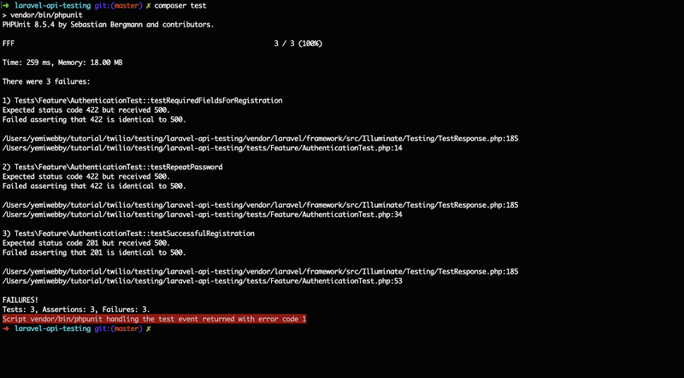
This is expected as we are yet to implement the feature. Now let’s write the code to make our test pass. Open app/Http/Controllers/API/Auth/AuthController.php and use the following content for it:

<?php

namespace App\Http\Controllers\API\Auth;

use App\Http\Controllers\Controller;
use App\User;
use Illuminate\Http\Request;

class AuthController extends Controller
{
public function register(Request $request)
{
$validatedData = $request->validate([
'name' => 'required|max:55',
'email' => 'email|required|unique:users',
'password' => 'required|confirmed'
]);

$validatedData['password'] = bcrypt($request->password);

$user = User::create($validatedData);

$accessToken = $user->createToken('authToken')->accessToken;

return response([ 'user' => $user, 'access_token' => $accessToken, 'message' => 'Register successfully'], 201);
}
}
Now run composer test. At this point, our test should pass.

Test the Login Endpoint
Update the AuthenticationTest.php file by adding more methods as shown here:
<?php

namespace Tests\Feature;

use App\User;
use Tests\TestCase;

class AuthenticationTest extends TestCase
{
...

public function testMustEnterEmailAndPassword()
{
$this->json('POST', 'api/login')
->assertStatus(422)
->assertJson([
"message" => "The given data was invalid.",
"errors" => [
'email' => ["The email field is required."],
'password' => ["The password field is required."],
]
]);
}

public function testSuccessfulLogin()
{
$user = factory(User::class)->create([
'email' => 'sample@test.com',
'password' => bcrypt('sample123'),
]);

$loginData = ['email' => 'sample@test.com', 'password' => 'sample123'];

$this->json('POST', 'api/login', $loginData, ['Accept' => 'application/json'])
->assertStatus(200)
->assertJsonStructure([
"user" => [
'id',
'name',
'email',
'email_verified_at',
'created_at',
'updated_at',
],
"access_token",
"message"
]);

$this->assertAuthenticated();
}
}
Here we also created a test to ensure that the required fields are not left empty by the user using the testMustEnterEmailAndPassword() method. Within the testSuccessfulLogin() method, we created a dummy user to ascertain that the user is authenticated successfully.
We can now go ahead and run the test again using composer test. You guessed it, this will fail once more. To ensure that the test passes, update the AuthController.php file as follows:
// app/Http/Controllers/API/Auth/AuthController.php
<?php

namespace App\Http\Controllers\API\Auth;

use App\Http\Controllers\Controller;
use App\User;
use Illuminate\Http\Request;

class AuthController extends Controller
{
...

public function login(Request $request)
{
$loginData = $request->validate([
'email' => 'email|required',
'password' => 'required'
]);

if (!auth()->attempt($loginData)) {
return response(['message' => 'Invalid Credentials']);
}

$accessToken = auth()->user()->createToken('authToken')->accessToken;

return response(['user' => auth()->user(), 'access_token' => $accessToken, 'message' => 'Login successfully'], 200);

}
}
In total, we have written five different, important tests. Some of the tested cases include the status and the json() structure of the response from the API. In the next section, we will create the sets of tests for CEO endpoints.

Writing Tests for the CEO Endpoints
In this section, we will start by creating a new test file to house the test scripts for the CEO endpoints. Use the following command for that purpose:
$ php artisan make:test CEOTest
The preceding command will create a new test file named CEOTest.php file within the tests/Feature folder. Open it and replace its contents with the following:
<?php

namespace Tests\Feature;

use App\CEO;
use App\User;
use Tests\TestCase;

class CEOTest extends TestCase
{
public function testCEOCreatedSuccessfully()
{
$user = factory(User::class)->create();
$this->actingAs($user, 'api');

$ceoData = [
"name" => "Susan Wojcicki",
"company_name" => "YouTube",
"year" => "2014",
"company_headquarters" => "San Bruno, California",
"what_company_does" => "Video-sharing platform"
];

$this->json('POST', 'api/ceo', $ceoData, ['Accept' => 'application/json'])
->assertStatus(201)
->assertJson([
"ceo" => [
"name" => "Susan Wojcicki",
"company_name" => "YouTube",
"year" => "2014",
"company_headquarters" => "San Bruno, California",
"what_company_does" => "Video-sharing platform"
],
"message" => "Created successfully"
]);
}

public function testCEOListedSuccessfully()
{

$user = factory(User::class)->create();
$this->actingAs($user, 'api');

factory(CEO::class)->create([
"name" => "Susan Wojcicki",
"company_name" => "YouTube",
"year" => "2014",
"company_headquarters" => "San Bruno, California",
"what_company_does" => "Video-sharing platform",
]);

factory(CEO::class)->create([
"name" => "Mark Zuckerberg",
"company_name" => "FaceBook",
"year" => "2004",
"company_headquarters" => "Menlo Park, California",
"what_company_does" => "The world's largest social network",
]);

$this->json('GET', 'api/ceo', ['Accept' => 'application/json'])
->assertStatus(200)
->assertJson([
"ceos" => [
[
"id" => 1,
"name" => "Susan Wojcicki",
"company_name" => "YouTube",
"year" => "2014",
"company_headquarters" => "San Bruno, California",
"what_company_does" => "Video-sharing platform"
],
[
"id" => 2,
"name" => "Mark Zuckerberg",
"company_name" => "FaceBook",
"year" => "2004",
"company_headquarters" => "Menlo Park, California",
"what_company_does" => "The world's largest social network"
]
],
"message" => "Retrieved successfully"
]);
}
}
This may look somewhat daunting, but it is similar to the tests we wrote earlier. Let’s break it down. We created two different methods:
- testCEOCreatedSuccessfully: To test that we can create a CEO record using the appropriate data.
- testCEOListedSuccessfully: Here we ensure that the list of created CEOs can be retrieved and returned as a response.
Unlike the AuthenticationTest, the CEOTest was written for endpoints that are protected by a middleware named auth:api. To ensure that the newly created dummy user is authenticated before accessing the endpoints, we used $this->actingAs($user, 'api') to authenticate and authorize such user to have access to carry out any of the CRUD (create, read, update and delete) activities.
Now run the test again using composer test. You will see that it fails again. By now, I am sure you understand why this wasn’t successful. Just in case you’re still learning the logic of these tests, we need to populate the CEOController.php file with the appropriate code to make the test pass.

Update the CEOController
Navigate to the app/Http/Controllers/API/CEOController.php file and use the following content for it:

<?php

namespace App\Http\Controllers\API;

use App\CEO;
use App\Http\Controllers\Controller;
use App\Http\Resources\CEOResource;
use Illuminate\Http\Request;
use Illuminate\Support\Facades\Validator;

class CEOController extends Controller
{
/**
* Store a newly created resource in storage.
*
* @param \Illuminate\Http\Request $request
* @return \Illuminate\Http\Response
*/
public function store(Request $request)
{
$data = $request->all();

$validator = Validator::make($data, [
'name' => 'required|max:255',
'company_name' => 'required|max:255',
'year' => 'required|max:255',
'company_headquarters' => 'required|max:255',
'what_company_does' => 'required'
]);

if($validator->fails()){
return response(['error' => $validator->errors(), 'Validation Error']);
}

$ceo = CEO::create($data);

return response([ 'ceo' => new CEOResource($ceo), 'message' => 'Created successfully'], 201);
}

public function index()
{
$ceos = CEO::all();

return response([ 'ceos' => CEOResource::collection($ceos), 'message' => 'Retrieved successfully'], 200);
}
}
Here, we created methods to store the records of a new CEO and also retrieve the list of CEOs from the database respectively. You can run the test again and discover it passes this time.
Lastly, let’s add more tests to retrieve, update, and also delete the details of a particular CEO. Open the CEOTest.php file and add the following methods:
<?php

namespace Tests\Feature;

use App\CEO;
use App\User;
use Tests\TestCase;

class CEOTest extends TestCase
{
...

public function testRetrieveCEOSuccessfully()
{
$user = factory(User::class)->create();
$this->actingAs($user, 'api');

$ceo = factory(CEO::class)->create([
"name" => "Susan Wojcicki",
"company_name" => "YouTube",
"year" => "2014",
"company_headquarters" => "San Bruno, California",
"what_company_does" => "Video-sharing platform"
]);

$this->json('GET', 'api/ceo/' . $ceo->id, [], ['Accept' => 'application/json'])
->assertStatus(200)
->assertJson([
"ceo" => [
"name" => "Susan Wojcicki",
"company_name" => "YouTube",
"year" => "2014",
"company_headquarters" => "San Bruno, California",
"what_company_does" => "Video-sharing platform"
],
"message" => "Retrieved successfully"
]);
}

public function testCEOUpdatedSuccessfully()
{
$user = factory(User::class)->create();
$this->actingAs($user, 'api');

$ceo = factory(CEO::class)->create([
"name" => "Susan Wojcicki",
"company_name" => "YouTube",
"year" => "2014",
"company_headquarters" => "San Bruno, California",
"what_company_does" => "Video-sharing platform"
]);

$payload = [
"name" => "Demo User",
"company_name" => "Sample Company",
"year" => "2014",
"company_headquarters" => "San Bruno, California",
"what_company_does" => "Video-sharing platform"
];

$this->json('PATCH', 'api/ceo/' . $ceo->id , $payload, ['Accept' => 'application/json'])
->assertStatus(200)
->assertJson([
"ceo" => [
"name" => "Demo User",
"company_name" => "Sample Company",
"year" => "2014",
"company_headquarters" => "San Bruno, California",
"what_company_does" => "Video-sharing platform"
],
"message" => "Updated successfully"
]);
}

public function testDeleteCEO()
{
$user = factory(User::class)->create();
$this->actingAs($user, 'api');

$ceo = factory(CEO::class)->create([
"name" => "Susan Wojcicki",
"company_name" => "YouTube",
"year" => "2014",
"company_headquarters" => "San Bruno, California",
"what_company_does" => "Video-sharing platform"
]);

$this->json('DELETE', 'api/ceo/' . $ceo->id, [], ['Accept' => 'application/json'])
->assertStatus(204);
}

}
The above written tests were used to target the records of a particular CEO by passing a unique id as a parameter to the api/ceo endpoints using the appropriate HTTP verbs (i.e GET, PATCH, DELETE).
Next, we will update the CEOController file to ensure that the new tests pass as well. Open the app/Http/Controllers/API/CEOController.php and include the following methods:
<?php

namespace App\Http\Controllers\API;

use App\CEO;
use App\Http\Controllers\Controller;
use App\Http\Resources\CEOResource;
use Illuminate\Http\Request;
use Illuminate\Support\Facades\Validator;

class CEOController extends Controller
{
...

/**
* Display the specified resource.
*
* @param \App\CEO $ceo
* @return \Illuminate\Http\Response
*/
public function show(CEO $ceo)
{
return response([ 'ceo' => new CEOResource($ceo), 'message' => 'Retrieved successfully'], 200);

}

/**
* Update the specified resource in storage.
*
* @param \Illuminate\Http\Request $request
* @param \App\CEO $ceo
* @return \Illuminate\Http\Response
*/
public function update(Request $request, CEO $ceo)
{

$ceo->update($request->all());

return response([ 'ceo' => new CEOResource($ceo), 'message' => 'Updated successfully'], 200);
}

/**
* Remove the specified resource from storage.
*
* @param \App\CEO $ceo
* @return \Illuminate\Http\Response
* @throws \Exception
*/

public function destroy(CEO $ceo)
{
$ceo->delete();

return response(['message' => 'Deleted'], 204);
}
}
The methods created here will retrieve, update, and delete the records of a CEO from the database.
We can now run the test command for the last time using composer test and you will see the following output:
> vendor/bin/phpunit
PHPUnit 8.5.4 by Sebastian Bergmann and contributors.

.......... 10 / 10 (100%)

Time: 915 ms, Memory: 32.00 MB

OK (10 tests, 35 assertions)

Conclusion
In this tutorial, we were able to use a test-driven development approach to write a couple of tests for the endpoints in our Laravel API project. You will further appreciate test-driven development when you discover that once you keep adding more features, the new implementations do not in any way interrupt the functioning of your existing codebase.
The complete codebase for the tutorial can be found here on GitHub. You can explore, add more tests, and write the code that will enable your test to pass accordingly.
Olususi Oluyemi is a tech enthusiast, programming freak, and a web development junkie who loves to embrace new technology.
- Twitter: https://twitter.com/yemiwebby
- GitHub: https://github.com/yemiwebby
- Website: https://yemiwebby.com.ng/
https://www.twilio.com/blog/unit-testing-laravel-api-phpunit

