Object Oriented Programming in PHP

Advertisements

Previous Page
Next Page
We can imagine our universe made of different objects like sun, earth, moon etc. Similarly we can imagine our car made of different objects like wheel, steering, gear etc. Same way there is object oriented programming concepts which assume everything as an object and implement a software using different objects.

Object Oriented Concepts
Before we go in detail, lets define important terms related to Object Oriented Programming.
- Class − This is a programmer-defined data type, which includes local functions as well as local data. You can think of a class as a template for making many instances of the same kind (or class) of object.
- Object − An individual instance of the data structure defined by a class. You define a class once and then make many objects that belong to it. Objects are also known as instance.
- Member Variable − These are the variables defined inside a class. This data will be invisible to the outside of the class and can be accessed via member functions. These variables are called attribute of the object once an object is created.
- Member function − These are the function defined inside a class and are used to access object data.
- Inheritance − When a class is defined by inheriting existing function of a parent class then it is called inheritance. Here child class will inherit all or few member functions and variables of a parent class.
- Parent class − A class that is inherited from by another class. This is also called a base class or super class.
- Child Class − A class that inherits from another class. This is also called a subclass or derived class.
- Polymorphism − This is an object oriented concept where same function can be used for different purposes. For example function name will remain same but it take different number of arguments and can do different task.
- Overloading − a type of polymorphism in which some or all of operators have different implementations depending on the types of their arguments. Similarly functions can also be overloaded with different implementation.
- Data Abstraction − Any representation of data in which the implementation details are hidden (abstracted).
- Encapsulation − refers to a concept where we encapsulate all the data and member functions together to form an object.
- Constructor − refers to a special type of function which will be called automatically whenever there is an object formation from a class.
- Destructor − refers to a special type of function which will be called automatically whenever an object is deleted or goes out of scope.

Defining PHP Classes
The general form for defining a new class in PHP is as follows −
<?php
class phpClass {
var $var1;
var $var2 = "constant string";

function myfunc ($arg1, $arg2) {
[..]
}
[..]
}
?>
Here is the description of each line −
- The special form class, followed by the name of the class that you want to define.
- A set of braces enclosing any number of variable declarations and function definitions.
- Variable declarations start with the special form var, which is followed by a conventional $ variable name; they may also have an initial assignment to a constant value.
- Function definitions look much like standalone PHP functions but are local to the class and will be used to set and access object data.

Example
Here is an example which defines a class of Books type −
<?php
class Books {
/* Member variables */
var $price;
var $title;

/* Member functions */
function setPrice($par){
$this->price = $par;
}

function getPrice(){
echo $this->price ."<br/>";
}

function setTitle($par){
$this->title = $par;
}

function getTitle(){
echo $this->title ." <br/>";
}
}
?>
The variable $this is a special variable and it refers to the same object ie. itself.

Creating Objects in PHP
Once you defined your class, then you can create as many objects as you like of that class type. Following is an example of how to create object using new operator.
$physics = new Books;
$maths = new Books;
$chemistry = new Books;
Here we have created three objects and these objects are independent of each other and they will have their existence separately. Next we will see how to access member function and process member variables.

Calling Member Functions
After creating your objects, you will be able to call member functions related to that object. One member function will be able to process member variable of related object only.
Following example shows how to set title and prices for the three books by calling member functions.
$physics->setTitle( "Physics for High School" );
$chemistry->setTitle( "Advanced Chemistry" );
$maths->setTitle( "Algebra" );

$physics->setPrice( 10 );
$chemistry->setPrice( 15 );
$maths->setPrice( 7 );
Now you call another member functions to get the values set by in above example −
$physics->getTitle();
$chemistry->getTitle();
$maths->getTitle();
$physics->getPrice();
$chemistry->getPrice();
$maths->getPrice();
This will produce the following result −
Physics for High School
Advanced Chemistry
Algebra
10
15
7

Constructor Functions
Constructor Functions are special type of functions which are called automatically whenever an object is created. So we take full advantage of this behaviour, by initializing many things through constructor functions.
PHP provides a special function called __construct() to define a constructor. You can pass as many as arguments you like into the constructor function.
Following example will create one constructor for Books class and it will initialize price and title for the book at the time of object creation.
function __construct( $par1, $par2 ) {
$this->title = $par1;
$this->price = $par2;
}
Now we don't need to call set function separately to set price and title. We can initialize these two member variables at the time of object creation only. Check following example below −
$physics = new Books( "Physics for High School", 10 );
$maths = new Books ( "Advanced Chemistry", 15 );
$chemistry = new Books ("Algebra", 7 );

/* Get those set values */
$physics->getTitle();
$chemistry->getTitle();
$maths->getTitle();

$physics->getPrice();
$chemistry->getPrice();
$maths->getPrice();
This will produce the following result −
Physics for High School
Advanced Chemistry
Algebra
10
15
7

Destructor
Like a constructor function you can define a destructor function using function __destruct(). You can release all the resources with-in a destructor.

Inheritance
PHP class definitions can optionally inherit from a parent class definition by using the extends clause. The syntax is as follows −
class Child extends Parent {
<definition body>
}
The effect of inheritance is that the child class (or subclass or derived class) has the following characteristics −
- Automatically has all the member variable declarations of the parent class.
- Automatically has all the same member functions as the parent, which (by default) will work the same way as those functions do in the parent.
Following example inherit Books class and adds more functionality based on the requirement.
class Novel extends Books {
var $publisher;

function setPublisher($par){
$this->publisher = $par;
}

function getPublisher(){
echo $this->publisher. "<br />";
}
}
Now apart from inherited functions, class Novel keeps two additional member functions.

Function Overriding
Function definitions in child classes override definitions with the same name in parent classes. In a child class, we can modify the definition of a function inherited from parent class.
In the following example getPrice and getTitle functions are overridden to return some values.
function getPrice() {
echo $this->price . "<br/>";
return $this->price;
}

function getTitle(){
echo $this->title . "<br/>";
return $this->title;
}

Public Members
Unless you specify otherwise, properties and methods of a class are public. That is to say, they may be accessed in three possible situations −
- From outside the class in which it is declared
- From within the class in which it is declared
- From within another class that implements the class in which it is declared
Till now we have seen all members as public members. If you wish to limit the accessibility of the members of a class then you define class members as private or protected.

Private members
By designating a member private, you limit its accessibility to the class in which it is declared. The private member cannot be referred to from classes that inherit the class in which it is declared and cannot be accessed from outside the class.
A class member can be made private by using private keyword infront of the member.
class MyClass {
private $car = "skoda";
$driver = "SRK";

function __construct($par) {
// Statements here run every time
// an instance of the class
// is created.
}

function myPublicFunction() {
return("I'm visible!");
}

private function myPrivateFunction() {
return("I'm not visible outside!");
}
}
When MyClass class is inherited by another class using extends, myPublicFunction() will be visible, as will $driver. The extending class will not have any awareness of or access to myPrivateFunction and $car, because they are declared private.

Protected members
A protected property or method is accessible in the class in which it is declared, as well as in classes that extend that class. Protected members are not available outside of those two kinds of classes. A class member can be made protected by using protected keyword in front of the member.
Here is different version of MyClass −
class MyClass {
protected $car = "skoda";
$driver = "SRK";

function __construct($par) {
// Statements here run every time
// an instance of the class
// is created.
}

function myPublicFunction() {
return("I'm visible!");
}

protected function myPrivateFunction() {
return("I'm visible in child class!");
}
}

Interfaces
Interfaces are defined to provide a common function names to the implementers. Different implementors can implement those interfaces according to their requirements. You can say, interfaces are skeletons which are implemented by developers.
As of PHP5, it is possible to define an interface, like this −
interface Mail {
public function sendMail();
}
Then, if another class implemented that interface, like this −
class Report implements Mail {
// sendMail() Definition goes here
}

Constants
A constant is somewhat like a variable, in that it holds a value, but is really more like a function because a constant is immutable. Once you declare a constant, it does not change.
Declaring one constant is easy, as is done in this version of MyClass −
class MyClass {
const requiredMargin = 1.7;

function __construct($incomingValue) {
// Statements here run every time
// an instance of the class
// is created.
}
}
In this class, requiredMargin is a constant. It is declared with the keyword const, and under no circumstances can it be changed to anything other than 1.7. Note that the constant's name does not have a leading $, as variable names do.

Abstract Classes
An abstract class is one that cannot be instantiated, only inherited. You declare an abstract class with the keyword abstract, like this −
When inheriting from an abstract class, all methods marked abstract in the parent's class declaration must be defined by the child; additionally, these methods must be defined with the same visibility.
abstract class MyAbstractClass {
abstract function myAbstractFunction() {
}
}
Note that function definitions inside an abstract class must also be preceded by the keyword abstract. It is not legal to have abstract function definitions inside a non-abstract class.

Static Keyword
Declaring class members or methods as static makes them accessible without needing an instantiation of the class. A member declared as static can not be accessed with an instantiated class object (though a static method can).
Try out following example −
<?php
class Foo {
public static $my_static = 'foo';

public function staticValue() {
return self::$my_static;
}
}

print Foo::$my_static . "\n";
$foo = new Foo();

print $foo->staticValue() . "\n";
?>

Final Keyword
PHP 5 introduces the final keyword, which prevents child classes from overriding a method by prefixing the definition with final. If the class itself is being defined final then it cannot be extended.
Following example results in Fatal error: Cannot override final method BaseClass::moreTesting()
<?php

class BaseClass {
public function test() {
echo "BaseClass::test() called<br>";
}

final public function moreTesting() {
echo "BaseClass::moreTesting() called<br>";
}
}

class ChildClass extends BaseClass {
public function moreTesting() {
echo "ChildClass::moreTesting() called<br>";
}
}
?>

Calling parent constructors
Instead of writing an entirely new constructor for the subclass, let's write it by calling the parent's constructor explicitly and then doing whatever is necessary in addition for instantiation of the subclass. Here's a simple example −
class Name {
var $_firstName;
var $_lastName;

function Name($first_name, $last_name) {
$this->_firstName = $first_name;
$this->_lastName = $last_name;
}

function toString() {
return($this->_lastName .", " .$this->_firstName);
}
}
class NameSub1 extends Name {
var $_middleInitial;

function NameSub1($first_name, $middle_initial, $last_name) {
Name::Name($first_name, $last_name);
$this->_middleInitial = $middle_initial;
}

function toString() {
return(Name::toString() . " " . $this->_middleInitial);
}
}
In this example, we have a parent class (Name), which has a two-argument constructor, and a subclass (NameSub1), which has a three-argument constructor. The constructor of NameSub1 functions by calling its parent constructor explicitly using the :: syntax (passing two of its arguments along) and then setting an additional field. Similarly, NameSub1 defines its non constructor toString() function in terms of the parent function that it overrides.
NOTE − A constructor can be defined with the same name as the name of a class. It is defined in above example.
https://www.tutorialspoint.com/php/php_object_oriented.htm

PHP OOP Introduction
Object-Oriented Programming is the coolest thing in PHP!

What is Object-Oriented Programming?
Object-Oriented Programming, also known as OOP is a special way of programming. It is considered to be more powerful and fast for certain tasks than the normal way of programming in PHP. OOP helps you to create and manage tasks easily.
Some advantages of OOP:
- Easy to manage
- Easy to use
- Prevents repetition
- Fast and efficient
OOP is harder to understand compared to other programming techniques. But, if you understand the following 4 terms you are almost done!
- Class
- Object
- Properties
- Methods (or Functions)
In OOP, a task or topic is handled by one class.

What is a Class?
The first term we find in OOP is class. A class is a blueprint. It is a piece of code describing how to manage a topic or task in the way we want.
For instance, a class is like a blueprint of a house.

Classes in OOP PHP
You can build more than one house from a blueprint. In the same way, you can create more Objects from a class.

What is an Object?
An Object is an instance of a class. It is like a house built from the blueprint. You can build more than one object from a class like creating multiple houses from a blueprint.
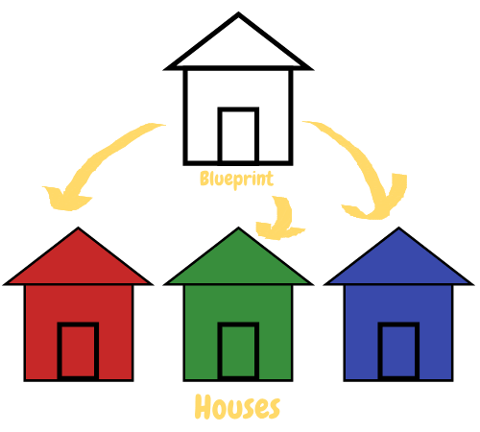
Objects in OOP PHP
Each house can have its own color, floor tiles, home equipment and more. In the same way, different objects can have different properties.

What are Properties?
Properties are variables of an object. They are the values associated with the object. They describe the appearance of the Object.
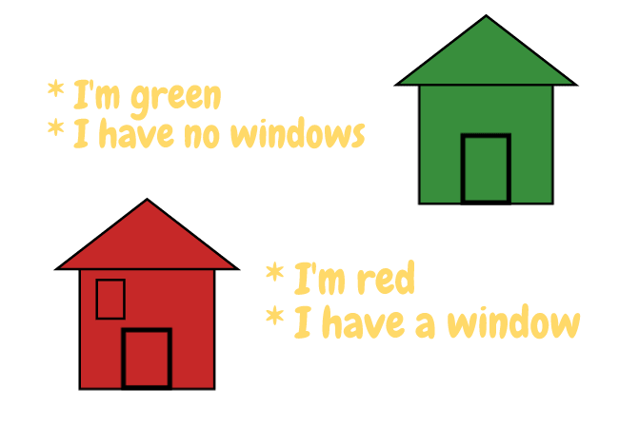
Properties in OOP PHP
Properties can be added, changed, removed. Some can also be read-only.
Color is a property of our house.
We can also perform actions on our house (like changing the color).

What are Methods?
Methods are actions that are performed on Objects. Changing the color of my house is a method performed on my house object.
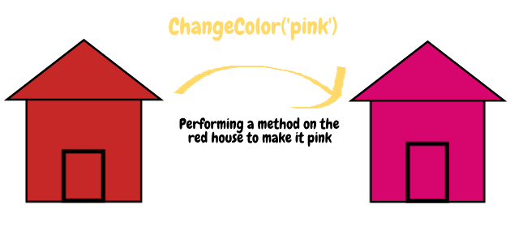
Methods in OOP PHP

What we learned about OOP
- Create the blueprint (Class)
- Create my house from the blueprint (Object)
- Add color, width, height, floor tiles, etc. to the house (Properties)
- Change the color when you need to change it (Methods)

About the PHP Object Oriented Programming Tutorial for Beginners
This tutorial has been written for beginners in Object-Oriented Programming. Each chapter is described with graphical illustrations and example codes. Therefore, you will understand and remember more.
Also, this tutorial is designed not only to gain your knowledge on Object-Oriented programming but also to make a sense in your mind where OOP is useful and where we should use it and not.
In the next chapters, we will learn how to use the above concepts in a practical way.
https://tutorials.supunkavinda.blog/php/oop-intro

PHP OOP Classes
A class is a piece of code describing what we need to save (properties) and what kind of operations we need to perform with that saved data (methods).
In the last chapter, we saw this image describing that class is like a blueprint. If you are going to build a house, you will need a blueprint. Then, you create your house. In Object-Oriented Programming, considering a class as a blueprint is the easiest way to understand what is it for.
Classes in OOP PHP
Programmatically, a class is a code that is written to handle a specific task. This is your blueprint. You can build multiple houses from this blueprint, but, all of them will have the same properties (with different values) and the same methods. Let's see how to write a class in PHP.

PHP Declaring Classes
The class keyword followed by the class name is used to declare a class.

<?php
class House {
// code
}

Here, class says to PHP that you are going to write a class. House is the name of your class.
All the code of the class will be written inside the braces. In this way, you can wrap all the data and functions of a task inside one class. For instance, in our house class, we can save data like color and functions like change color in the class. You will learn how to do that in the next chapters.

Naming a Class
The name you use for a class ("House" in the above example),
- Should not be a PHP reserved word.
- Should start with a letter or underscore.
- Can have letters, numbers or underscores after the first character.

Best Practices for Naming Classes
- Start the class name with an uppercase character.
- If you have more than one word, capitalize each word's first letter (ex: TowerHouse, LongHouse, CourtyardHouse)
Using these standards improves the readability of your code. But, those are just standards. If another way works for you, simply use that. You will learn about these standards in a later chapter.

Class Properties and Methods
As you have seen, a class can have properties and methods. In the next chapters, we will learn how to add those into a class to create a meaningful class.

PHP OOP Properties
Properties are variables
Classes can have variables within it. Those variables are called properties. A property is a normal PHP variable which is in any data type (integer, string, array, object, etc).
In classes, before declaring a variable, we should add the visibility keyword to define where the variable is available. You will learn more about this later. For now, keep in mind that adding the public keyword in front of the variable will make the variable available everywhere.

<?php
class House {
public $primaryColor = 'black';
public $secondaryColors = [
'bathroom' => 'white',
'bedroom' => 'light pink',
'kitchen' => 'light blue'
];
public $hasPool = false;
public $extra;
}

As in the above example, we can declare any type of variable as a property. We can add default values for those properties. (Black is the default for $primaryColor) Also, note that the property $extra does not have a default value.
Remind the blueprint explanation. A blueprint can have default widths and heights in it. But, also some houses will need some additional features that are not defined in the blueprint. So, those additional features do not have a default value. But, they can be added to a house. (Ex: Having a pool)

Conclusion
In this chapter, we learned how to declare a property in a class.
In the next chapter, you will learn how to create objects from classes (different houses from a blueprint).

PHP OOP Objects
If the class was a blueprint, objects are houses.
We can create multiple objects from a class. These objects are called instances of the class. This process is called instantiation.
Here's our house class we wrote in the last chapters.

<?php
class House {
public $primaryColor = 'black';
public $secondaryColors = [
'bathroom' => 'white',
'bedroom' => 'light pink',
'kitchen' => 'light blue'
];
public $hasPool = false;
public $extra;
}

After the class declaration, you can create instances from it.

$myHouse = new House();
$friendHouse = new House();

Now each object is created having the default values of the class. You can check it by echoing the color of each object.

echo $myHouse -> primaryColor;
echo $friendHouse -> primaryColor;

Both would echo out the default value black.
-> is the object operator, which is used to access properties and methods of an object.
Tip: When accessing properties and methods of an object through the object operator, the dollar sign $ is not used with the property or method name.
It is considered as a bad practice to directly accessing properties from outside the class with ->. Getter methods are the recommendation. More details on later chapters.
You can also change the default property values of the class to make each house unique.

$myHouse -> primaryColor = 'red';
$friendHouse -> primaryColor = 'yellow';

Now, the color of my house is red and the color of my friend's house is yellow.

What is the difference between classes and objects?
- A class is a structure with default values and methods (Blueprint for a house).
- Multiple objects can be created from a class. (Houses built from the blueprint)
- Each object has all the properties and methods defined in the class, but they can have different property values.

PHP OOP Methods
Methods are used to perform actions.
In Object Oriented Programming in PHP, methods are functions inside classes. Their declaration and behavior are almost similar to normal functions, except their special uses inside the class.
Let's remind the role of a function.
- First, we declare the function
- Then we call it (Optionally we can send arguments into the function)
- Some process is done inside the function
- Then we return something from the function (Optional)

How to declare a method?
Let's declare a method inside a class named Example class to echo out a simple string that we give.

<?php
class Example {
public function echo($string) {
echo $string;
}
}

We use the public keyword to make the method available inside and outside the class. You will learn more about this in the visibility chapter.

How to call a method?

$example = new Example();
$example -> echo('Hello World');

Result: Hello World
Explained:
- First, we create an object ($example) from the class Example
- Next, we call the method echo with -> (object operator) and () (parentheses)
- The parentheses contain the arguments as usual
The thing you need to understand is that we call methods on objects, not classes.

Changing a property value using methods
Let's implement the things we learned in the above example to our House class. Now we are going to change the color of the house. For ease, all the properties are removed from the House class, except $primaryColor.
By default the color of the house is black. We need to change it to another one.

<?php
class House {
public $primaryColor = 'black';
public function changeColor($color) {
$this -> primaryColor = $color;
}
}

// creates an object from the class
$myHouse = new House();

# black (default value)
echo $myHouse -> primaryColor;

// change the color of the house
$myHouse -> changeColor('white');

# white
echo $myHouse -> primaryColor;

In this example, we have used $this keyword. The next chapter describes more about it.

PHP OOP $this Keyword
$this refers to the current object.
$this is a pseudo-variable (also a reserved keyword) which is only available inside methods. And, it refers to the object of the current method.
Let's create a House class with one property (color). Then, create an object from it.

<?php
class House {
public $color = 'black';
}
$house = new House();

Where to use $this?
How can we change the value of $color? Take some time and think.
There are two ways.
- Outside the class. We can directly change the value of a property from outside of the class.

$house -> color = 'white';

- Inside the class. We can define a method in the class and call it to change the value of its own property.

public function changeColor() {
$this -> color = 'white';
}

$house -> changeColor();

In the second way, we use $this variable to access the current object. Here, the current object is the object saved in $house.

More Examples
Let's play with the $this pseudo-variable.
Here we will create two houses and assign names and colors to them. Then, we will echo it out.
- Create the House class

<?php
class House {
public $name;
public $color;
public function setData($name, $color) {
$this -> name = $name;
$this -> color = $color;
}
public function echoData() {
echo "The color of the {$this -> name} is {$this -> color}";
}
}

- Create two objects from it

$blackHouse = new House();
$whiteHouse = new House();

- Call the setData method with two arguments

$blackHouse -> setData("John's House", "black");
$whiteHouse -> setData("Pearl's House", "white");

- Call the echoData to echo out a descriptive phrase

$blackHouse -> echoData();
echo '<br>';
$whiteHouse -> echoData();

Here's the full code.

PHP OOP $this Keyword Example

<?php
class House {
public $name;
public $color;
public function setData($name, $color) {
$this -> name = $name;
$this -> color = $color;
}
public function echoData() {
echo "The color of the {$this -> name} is {$this -> color}";
}
}

$blackHouse = new House();
$whiteHouse = new House(); // this is a small house, not america's one ;)

$blackHouse -> setData("John's House", "black");
$whiteHouse -> setData("Pearl's House", "white");

$blackHouse -> echoData();
echo '<br>';
$whiteHouse -> echoData();

Conclusion
We could access the current object with $this keyword. But, we needed to run two steps of code to create a object ($house = new House()) and set its data ($house -> setData(...)). What if we could set the data when we create the object? We can run a constructor function when the object is created. You can learn more in the next chapter.

PHP OOP Constructors and Destructors
- Constructors: Constructors are called when an object is created from a class.
- Destructors: Destructors are called when an object destructs. Usually, it is when the script ends.

Constructors
A constructor is a public method which is named as __construct.

class Example {
public function __construct() {
// your constructor function
echo "Hello World";
}
}

The __construct() method will be called once when you create an object from the class.

$example = new Example(); // will echo "Hello World"

Let's re-create the example in the previous lesson using a constructor. Our __construct() method will have two arguments, $name and $color. These arguments should be sent when we create the object.

PHP Constructor Example

<?php
class House {
public $name;
public $color;
public function __construct($name, $color) {
$this -> name = $name;
$this -> color = $color;
}
public function echoData() {
echo "The color of the {$this -> name} is {$this -> color}";
}
}
$blackHouse = new House("John's House", "black");
$blackHouse -> echoData();

The __construct() method should always have public visibility

Tip: When you don't have a constructor...
When you don't have a constructor (or you have a constructor without arguments), you can create the object from the class without parentheses.

$house = new House;

But, if you have a constructor with arguments, you should send the values for those arguments when you create it.

Destructor
A destructor is called when the object is destructed or the script is stopped or exited.

PHP Destructor Example

<?php
class House {
public $name;
public $color;
public function __construct($name, $color) {
$this -> name = $name;
$this -> color = $color;
}
public function __destruct() {
echo "The color of the {$this -> name} is {$this -> color}";
}
}
$blackHouse = new House("John's House", "black");

In the above example, the __destruct() method will be called at the end of the execution of the script.
Note: The __desctructor method will only be called when the current PHP script is fully executed by reaching the last line of it, or by exiting it using exit() or die() functions.

Conclusion
In the real world, constructors and destructs are very useful. In the upcoming chapters, we will be using these methods very often.

PHP OOP Visibility

The Definition of Visibility in OOP
Visibility of a class member (property, method or constant) is where it can be accessed. (Eg: inside the class, outside the class)
Properties, methods, and constants can be declared with visibility.

Types of Visibility
- Public - Can be accessed from everywhere
- Private - Can only be accessed within the class
- Protected - Can be accessed by the class declared it and by the classes that inherit the above declared class.
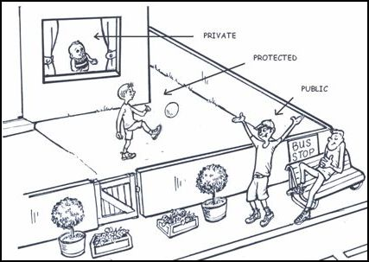
PHP OOP Visibility (Source: stackoverflow.com)

Public vs Private
Consider the following example.

class Example {
public $name;
private $age;
}
$example = new Example;

Here we have two properties $name and $age. We have added public and private keywords to each property respectively.
What does this do? Adding public or private will change the visibility of the property.
A public property can be accessed everywhere. (Within the class and from the outside)

$example -> name; // this is valid

A private property can only be accessed by the class that defines the property.

$example -> age; // this is invalid - will thow an error

Public Visibility
A public property or method can be declared adding the public keyword in front of its declaration. (If you followed the previous chapters, you will remember that we used this.)

class Example {
public $property = 'property'; // a public property
public function myMethod() { // a public method
echo 'Hello';
}
}

A method declared without a visibility keyword will be public.

class Example {
function myMethod() {
// a public method
}
}

Properties cannot be declared without a visibility keyword.

PHP Public Visibility

<?php
class User {
public $name = 'Hyvor';
public function changeName($name) {
$this -> name = $name;
}
}
$user = new User();
// Accesing public property from outside
echo $user -> name;
echo '<br>'; // a line break

// Accessing public method from outside
$user -> changeName('Hyvor Developer');
echo $user -> name;

Private Visibility
A private property or method can be declared adding the private keyword in front of its declaration.

class Example {
private $property = 'property'; // a private property
private function privateMethod() { // a private method
echo $this -> property; // this is valid
}
}

A private class member can only be accessed from the methods in the class.
Assume that you have a private property $name in the User class. Any method inside the class has access to this property. But, you cannot access it from outside the class. See this example:

class User {
private $name = 'Hyvor'; // a private property
public function echoName() { // a private method
echo $this -> name; // this is valid
}
}
$user = new User();
$user -> echoName(); // valid
echo $user -> name; // this will show an error

Protected Visibility
A protected property or method can be declared adding the protected keyword in front of its declaration.

class Example {
protected $property = 'This is a protected property';
protected function myMethod() {
// I'm protected!
}
}

Protected properties and methods can be accessed by,
- The class which declared the variable
- The classes which *inherits the above declared class
* Note: You will learn more about inheriting in the next chapters. Just remember that inheriting is another interesting concept in object-oriented programming.
In these examples, we learned how to declare properties and methods with visibility. As in the first paragraph in this tutorial, class constants also have visibility. We will learn more about that in the class constants chapter.

Why Visibility is Important?
There are two reasons.
- To validate and restrict data
- To keep private things private

1. To validate and restrict data
In the real world, the quality of information is essential. In programming, the same thing exists.
We should validate the data in both setting and getting. Let's see an example.

PHP Usage of Visibility

<?php
class House {
// color of the house
private $color;
// only these colors are allowed
private $allowedColors = [
'black', 'blue', 'red', 'green'
];
public function setColor($color) {
// Black to black (lowercase)
$color = strtolower($color);
if ( in_array( $color, $this -> allowedColors ) ) {
// if $color is in the $allowedColors array
// we can set the color property
$this -> color = $color;

}
}
public function getColor() {
if ($this -> color) {
// if color is set
return $this -> color;
} else {
// show an error message
return 'No color is set. May be you have set a color which is not allowed';
}
}
}

// Example 1
$house1 = new House();
$house1 -> setColor('black');
echo $house1 -> getColor();

echo '<br>'; // a HTML line break to make it readable

$house2 = new House();
$house2 -> setColor('yellow'); // a not allowed color
echo $house2 -> getColor();

In this example, we have validated the data when both setting and getting. Here is the reason:
Directly setting a property should be avoided. To set a property a public method should be used. Here we have declared the setColor($color) method for it. In this way, we can also validate the color before setting it.
Directly getting an object property is considered a bad practice. To prevent it, we have made the color property private. The correct (and recommended) way to get the color property is by calling a public method. (getColor())
Tip: When creating setter and getter functions to get a property, using the model "get + property name" and "set + property name" is effective. It will make it easier to understand by you later when you are reading your code again.
Ex: setColor() and getColor() methods in the above example.

2. To keep private things private
Consider the above House class. Think that you have a method to paint the house. This method should be public to access from outside.
Also, this method can use methods like "take the brush", "mix the paint", "start painting" to make the process easier. These methods can be declared inside the same class. But, do we need "take the brush" method to be accessed from the outside? No, we don't. So, we keep it private.

class House {
public function paint($color) {
// calling private methods
$this -> takeBrush();
$this -> mixPaint($color);
$this -> startPainting();
}
private function takeBrush {...}
private function mixPaint($color) {...}
private function startPainting() {...}
}

Conclusion
In this chapter, we learned about the visibility keywords (public, private, protected) and how to use them with properties and methods. Also, we learned why visibility is useful.
While going through this lesson you put two things into your TODO list: Inheritance and Class Constants. Next chapters will explain to you more about those concepts.

PHP OOP Inheritance

The Concept of Inheritance
In Object-Oriented Programming, when a class derives from another class, it is called inheritance.
The derived class is the child, and the other class which the child derived from is the parent class. (Sometimes they are called sub class and super class respectively)
In another way, the child class extends the parent class.
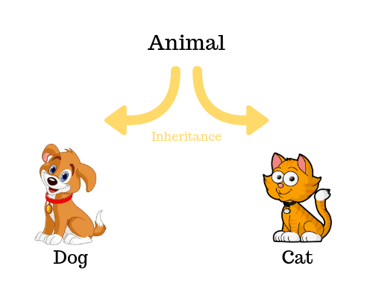
PHP OOP Inheritance
The child class inherits all the public and protected properties and methods from the parent class. Additionally, it can have its own properties and methods.
Note: A child class can also be inherited by another class.
The later-explained concepts like abstraction and interfaces are based on inheritance.
In PHP, the extends keyword is used to declare an inherited class. See the example.

Inheriting Example
As in the above image, dog and cat are animals. They have common behaviors all the animals have, and also their own behaviors.
Let's create Person class as the parent and Tom class as the child. (You know Tom is a person)
class Tom extends Person {...} is the syntax for the child class.

PHP Inheritance Example

<?php
class Person {
public $name;
public $age;
public function __construct($name, $age) {
$this -> name = $name;
$this -> age = $age;
}
public function introduce() {
echo "My name is {$this -> name}. My age is {$this -> age}";
}
}
/* Tom is inherited from Person */
class Tom extends Person {
# __construct() is inherited
# introduce() is inherited
public function sayHello() {
echo "Hello, World <br>";
}
}
$tom = new Tom('Tom', 29);
$tom -> sayHello();
$tom -> introduce();

Note these things in the example
- We inherited the Tom class from the Person class.
- Even we didn't define the __construct() and introduce() methods in the Tom class, we could use it because of inheritance.
- Also, we could add new methods to the Tom class (sayHello()).
- $name and $age were inherited as they are public properties.

Using Protected Visibility
We discussed the public and private visibility with several examples in the visibility chapter, but protected visibility was not fully described.
The main usage of protected is in inheritance. Protected variables are only available in:
- The class where it is defined
- The classes which inherit the defined class
By declaring a property or method protected, you can restrict it to the above-mentioned two classes.

PHP Protected Visibility for Inheritance

<?php
class ParentClass {
protected $protectedProperty = 'Protected';
private $privateProperty = 'Private';
protected function protectedMethod() {
echo $this -> protectedProperty;
}
private function privateMethod() {
// cannot call this function
// from Child
}
}
class Child extends ParentClass {
public function doSomething() {
$this -> protectedMethod();
// invalid
// $this -> privateMethod();
}
}
$child = new Child();
$child -> doSomething();

// all of following are invalid (only public visibility is accessible from outside)
// echo $child -> protectedProperty;
// echo $child -> privateProperty;
// $child -> protectedMethod();
// $child -> privateMethod();

Overriding Inherited Methods
The inherited methods can be overridden by redefining the method with the same name.

PHP Overriding Inherited Methods

<?php
class Person {
public $name;
public $age;
public function __construct($name, $age) {
$this -> name = $name;
$this -> age = $age;
}
public function introduce() {
echo "My name is {$this -> name}. My age is {$this -> age}";
}
}
class Tom extends Person {
public $school;
// overriden method
public function __construct($name, $age, $school) {
$this -> name = $name;
$this -> age = $age;
$this -> school = $school;
}
public function introduce() {
echo "My name is {$this -> name}. My age is {$this -> age}. My school is {$this -> school}";
}
}
$tom = new Tom('Tom', 29, 'Foothill School');
$tom -> introduce();

In the above example, we have overridden the __construct() and introduce() methods.

Calling the Parent's Methods
From the child class, we can call parent's methods using the parent keyword and :: (Scope Resolution Operator).
The Scope Resolution Operator is a special syntax in PHP which is used in some cases of OOP. We will see it more in the upcoming chapters.
Let's make a little change to our code. Here we will call the parent's constructor method from the child class.

parent::__construct();

Here's the updated code.

PHP Calling Parent's Methods

<?php
class Person {
public $name;
public $age;
public function __construct($name, $age) {
$this -> name = $name;
$this -> age = $age;
}
public function introduce() {
echo "My name is {$this -> name}. My age is {$this -> age}";
}
}
class Tom extends Person {
public $school;
public function __construct($name, $age, $school) {
# $this -> name and $this -> age will be set by the parent's constructor
parent::__construct($name, $age);
$this -> school = $school;
}
public function introduce() {
echo "My name is {$this -> name}. My age is {$this -> age}. My school is {$this -> school}";
}
}
$tom = new Tom('Tom', 29, 'Foothill School');
$tom -> introduce();

When you override parent's methods, you cannot use $this -> methodName to refer to the parent's method as it now refers to the method of the child class. So, parent::methodName can be used.

Using the Final Keyword
There are two uses of the final keyword.

1. Preventing Class Inheritance

final class NonParent {
// class code
}
// will throw an error
class Child extends NonParent {...}

2. Preventing Method Overriding

class ParentClass {
final public function myMethod() {

}
}
class Child extends ParentClass {
// Fatal Error: Overriding final methods
public function myMethod() {

}
}

Why Inheritance?
Inheritance is an extremely useful concept in Object-Oriented Programming which allows us to prevent code duplication and manage big tasks easily.
In the next chapters, we will learn about some concepts that are based on
Keep in mind! If you are a beginner, you may have a hard time learning next few chapters (until Traits). The question you will get is that when to use those concepts. To understand that, of course, you will need some real-world experience in programming with OOP.
We will be learning some real-world projects at the end of this course.

PHP OOP Abstract Classes and Methods
When the parent class
- Knows what to do and
- Need its child class to do some tasks
it can let its child classes to do the task. This is an abstraction.

PHP OOP Abstract Classes
Now you understand abstract classes are something going with inheritance.
Abstract classes have abstract methods in it which they need their children (child classes) to override when inheriting.

Declaring Abstract Classes
The abstract keyword is used to define an abstract class.

<?php
abstract class ParentClass { /* ... */ }

Declaring Abstract Methods
When you prepend the abstract keyword to a method's declaration it becomes an abstract method. And, remember, abstract methods do not have a body. Therefore, curly brackets {} are not used.

<?php
abstract class ParentClass {
abstract public function myMethod1();
abstract protected function myMethod2($name, $age);
abstract protected function myMethod3() : int;
}

Abstract method's visibility can either be public or protected, but not private.

The Abstraction Rules
When a child class is inherited from an abstract class, the following rules apply.
- The child class should override (redeclare) all the abstract methods.
- The arguments for methods should be the same as the abstract method.
For instance, in the above example, myMethod2 has two arguments: $name and $age. The method myMethod2 in the child class should have the same arguments.

public function myMethod2($name, $age) {...}

- The child class can have arguments with default values where the abstract class hasn't defined.

public function myMethod2($name, $age, $country = 'USA') {...}

- If the abstract class uses type hinting (type declaration for return values), the child class should use the same.
For instance, the myMethod3 in the above abstract class hints int. So, the child's method hints the same.

public function myMethod3() : int {...}

- The visibility of the child's method should be the same as the parent's or less restricted.
Abstract Method's Visibility | Child Method's Visibility
Public | Public
Protected | Protected or Public
- Objects cannot be created from abstract classes.

Abstract classes can have non-abstract methods
Non-abstract methods can be defined in an abstract class. Those methods will work as the same as normal methods we had in inheritance.

<?php
abstract class ParentClass {
abstract public function myMethod1();
public function myMethod2() {
echo "Hello World";
}
}

Remember! This is the main difference between abstract classes and interfaces. Abstract classes can have real methods while interfaces can only have method declarations.

Examples of Abstract Classes in PHP OOP
Let's improve the example we created in the last chapter with the new things we learned in this chapter.
Parent Abstract Class

<?php
abstract class Person {
public $name;
public function __construct($name) {
$this -> name = $name;
}
abstract public function greet() : string;
}

Explanation: In the parent class, the __construct method and $name property are declared. So, the child class will automatically have them. But, greet() is a method that should be defined in all the child classes and they should return a string.
Child Classes

<?php
class Programmer extends Person {
public function greet() : string {
return "Hello World from " . $this -> name;
}
}
class Student extends Person {
public function greet() : string {
return "Howdy! I'm " . $this -> name;
}
}
class Teacher extends Person {
public function greet() :string {
return "Good morning dear students";
}
}

Now we can create objects from the child classes.
The Objects

<?php
$programmer = new Programmer('John');
echo $programmer -> greet();

$student = new Student('Doe');
echo $student -> greet();

$teacher = new Teacher('Mary');
echo $teacher -> greet();

Full Code

PHP OOP Abstract Classes Example

<?php
abstract class Person {
public $name;
public function __construct($name) {
$this -> name = $name;
}
abstract public function greet() : string;
}
class Programmer extends Person {
public function greet() : string {
return "Hello World from " . $this -> name;
}
}
class Student extends Person {
public function greet() : string {
return "Howdy! I'm " . $this -> name;
}
}
class Teacher extends Person {
public function greet() :string {
return "Good morning dear students";
}
}
$programmer = new Programmer('John');
echo $programmer -> greet();
echo "<br>";

$student = new Student('Doe');
echo $student -> greet();
echo "<br>";

$teacher = new Teacher('Mary');
echo $teacher -> greet();
echo "<br>";

Conclusion
Abstract classes are important when you strictly need child classes to define a method. In most cases, abstraction is used when the parent class is inherited by multiple child classes which have almost the same behaviors.
What stakoverflow says,
"Use an abstract class when you want to force developers working in your system (yourself included) to implement a set numbers of methods and you want to provide some base methods that will help them develop their child classes."
Also, abstraction is the basis of interfaces which we will discuss in the next chapter.

PHP OOP Interfaces
Interfaces allow you to specify what methods a class should implement.
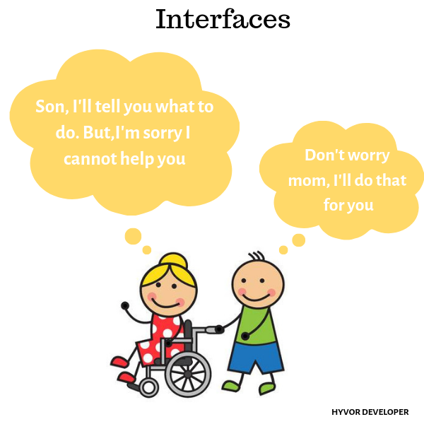
PHP OOP Interfaces
If you know what are abstract classes, you already know interfaces. There is only a little difference between those. Therefore, we will learn interfaces comparing to abstract classes.

Why Interfaces?
When you need to let a class to compulsorily implement some methods in it, you can use interfaces. This is a good practice when creating real-world web applications in PHP.
If you need to support the child classes by adding some non-abstract method, you should use abstract classes. Otherwise, interfaces would be your choice.

Declaring Interfaces
Interfaces are declared using the Interface keyword.

<?php
Interface MyFirstInterface { /* ... */ }

Only Abstract Methods
An interface can only have method signatures. It means that all the methods cannot have a body - only the declaration.
And, all the methods must have public visibility.

<?php
Interface MyInterface {
public function myMethod1();
public function myMethod2($name, $age);
public function myMethod3() : int;
}

Implements Keyword
Unlike abstract classes, we use the implements keyword to implement an interface in a child class.

<?php
class MyClass implements MyInterface { /* ... */ }

After implementing an interface in a class, all the abstract methods in the interface should be declared in the class.
All the abstraction rules apply when using interfaces. Here's the link to the rules if you don't remember them.
As all the abstract methods in an interface have public visibility, all the methods in the class that implements the abstract methods should have public visibility.

Interface Example
Let's recreate the example we created in the last chapter using interfaces. Now, you will understand the difference between interfaces and abstract classes.
Interface

Interface Person {
public function __construct($name);
public function greet() : string;
}

Implemented Class

class Programmer implements Person {
public $name;
public function __construct($name) {
$this -> name = $name;
}
public function greet() : string {
return "Hello World from " . $this -> name;
}
}

Full Code

PHP Interface Example

<?php
Interface Person {
public function __construct($name);
public function greet() : string;
}

class Programmer implements Person {
public $name;
public function __construct($name) {
$this -> name = $name;
}
public function greet() : string {
return "Hello World from " . $this -> name;
}
}
$programmer = new Programmer('John');
echo $programmer -> greet();

Implementing Multiple Interfaces
A class can implement multiple interfaces separated by commas in the declaration (After the implements keyword). If you do that, you have to declare all the abstract methods within the class.

PHP Implementing Multiple Interfaces

<?php
Interface MyInterface1 {
public function myMethod1();
}
Interface MyInterface2 {
public function myMethod2();
}
class MyClass implements MyInterface1, MyInterface2 {
public function myMethod1() {
echo "Hello ";
}
public function myMethod2() {
echo "World";
}
}
$obj = new MyClass();
$obj -> myMethod1();
$obj -> myMethod2();

Extends + Implements
A class can extend a class and also implement one or more interfaces.

PHP Extending and Implementing

<?php
Interface MyInterface {
public function write();
}
class ParentClass {
public $name;
public function __construct($name) {
$this -> name = $name;
}
}
class ChildClass extends ParentClass implements MyInterface {
function write() {
echo $this -> name;
}
}
$child = new ChildClass('Hyvor');
$child -> write();

Remember, you can only extend one class even you could implement multiple interfaces.

Extending Interfaces
Interfaces can also extend interfaces.

PHP Extending Interfaces

<?php
Interface MyInterface1 {
public function myMethod1();
}
Interface MyInterface2 extends MyInterface1 {
public function myMethod2();
}
class MyClass1 implements MyInterface1 {
# only this method is needed
public function myMethod1() {}
}
class MyClass2 implements MyInterface2 {
# both myMethod1 and myMethod2 should be declared
public function myMethod1() {}
public function myMethod2() {}
}

PHP OOP Traits
A class in PHP can only have single inheritance. Traits are there to solve the problem.

About Traits
- Used to declare methods that can be used in multiple classes.
- Reduces code duplication.
- Cannot be instantiated (create objects from).
- Can have methods and abstract methods.
- Methods can be in any visibility.

Declaring Traits
In PHP, traits are declared using the Trait keyword.

Trait MyTrait { ... }

Using Traits in Classes
To use a trait in a class, the trait name should be written inside the classes with the use keyword.

class MyClass {
use MyTrait;
}

Traits Example
Let's create two traits and use them in a class to see how they are working.
Tip: Use comma-separated names of traits to use multiple of them in a class.

PHP Traits Example

<?php
Trait Hello {
public function hello() {
echo "Hello";
}
}
Trait World {
public function world() {
echo "World";
}
}
class MyClass {
use Hello, World;
}
$obj = new MyClass();
$obj -> hello();
$obj -> world();

Here's what happened:
- First we declared two traits, Hello and World.
- Then we created our class, MyClass
- By using two traits in the class, all the methods in traits will be available in the class.
- Therefore, it was possible to call $obj -> hello() and $obj -> world() methods.
If there was another classes that you need to use the hello() function in, you can simply use the Hello trait in those classes. This reduces code duplication as there's no need to redeclare the same method again and again.
Also, you would notice that we used two traits in the above example. If you used inheritance for this, extending multiple classes is not possible.
The weirdest part for a beginner in OOP is that there are several ways to do the same thing. The talent is figuring out the best way. To gain that skill, you will need a good knowledge on these concepts, also some real-world experience.
If you consider the above example, you can use all of these to create it: inheritance, abstraction, interfaces, and traits. Interfaces would not be the choice as you will need to declare the method again and again. If inheritance and abstraction is used, you will need to either inherit two times or have the both methods in the same parent class. So, traits would be the best choice in this case.
In the same way, you will get into the problem what to use in a certain situation. You should answer using your knowledge and experience.

PHP OOP Constants
Constants are pieces of information stored in the computer's memory which cannot be changed once assigned.
Class Constants are constants that are declared within classes.

Declaring Class Constants
The const keyword is used to declare a class constant. The class constant should be declared inside the class definition. No $ (dollar sign) used.

<?php
class Welcome {
const GREET = 'Hello World';
}

The recommendation is to name constants in all uppercase and with underscore (_) separators. Ex: CONSTANT, MY_CONSTANT.
Note that constants does not have a visibility modifier.

Accessing Class Constants
There are two ways to access class constants.
- Inside the class: The self keyword and Scope Resolution Operator (::) is used to access class constants from the methods in a class.

public function greet() {
echo self::GREET;
}

- Outside the class: The class name and constant name is used to access a class constant from outside a class.

echo Welcome::GREET;

PHP Class Constants

<?php
class Welcome {
const GREET = 'Hello World';
public function greet() {
echo self::GREET;
}
}
$welcome = new Welcome();
$welcome -> greet();

echo "<br>";
echo Welcome::GREET;

Why Class Constants?
Class constants are useful when you need to declare some constant data (which does not change) within a class.

PHP OOP Static
In all the previous chapters, we created objects from classes before accessing methods and properties of it.
Static Methods and Properties can be accessed without instantiating. (Without creating objects)

Static Methods
Static methods can be called directly without needing an instance of the class (an object). And, $this pseudo-variable is not available inside static methods.
Static methods and properties can be considered as escaping from Object-Oriented Programming.

Static Methods - Declaration
The static keyword is used to declare static methods.
A visibility modifier may be added before the static keyword. If there's no visibility declaration, the visibility will be public. The same rules we learned in the visibility chapter are applied for each visibility.

class MyClass {
public static function myStaticMethod() {
echo "Hyvor!";
}
}

Static Methods - Accessing
- Static methods can be accessed from outside the class using the class name and Scope Resolution Operator (::). (Only if the visibility is public)

MyClass::myStaticMethod();

Example:

PHP Static Methods Example

<?php
class Hyvor {
public static function getDevSiteDomain() {
return 'Hyvor Developer';
}
}
echo Hyvor::getDevSiteDomain();

- Static methods can be called from methods of other classes in the same way. To do this visibility of the static method should be public.

class OtherClass {
public function myMethod() {
# visibility of myStaticMethod should be is public
MyClass::myStaticMethod();
}
}

- But, to access a static method from child classes of the class where the static method is declared, visibility of the static method can be protected.

class OtherClass extends MyClass {
public function myMethod() {
# visibility of myStaticMethod should be is public or protected
MyClass::myStaticMethod();
# or
parent::myStaticMethod();
}
}

The parent keyword inside a child class refers to its parent class.
Example:

PHP Static Methods with Inheritance Example

<?php
class Hyvor {
protected static function getCompanyName() {
return 'Hyvor, Inc.';
}
}
class HyvorAuth extends Hyvor{
public $companyName;
public function __construct() {
$this -> companyName = parent::getCompanyName();
}
}
$hyvorAuth = new HyvorAuth;
echo $hyvorAuth -> companyName;

// ERROR will be thrown
// echo Hyvor::getCompanyName();

- Note that we can call static methods from non-static methods (In the above example, we call Hyvor::getCompanyName() from HyvorAuth class's constructor method).
And, as Hyvor::getCompanyName() is a protected method, you can only be accessed by its child classes.
- Static methods can be accessed from the methods in the same class using the self keyword and ::.

class MyClass {
public static function myStaticMethod() {
echo "Hyvor!";
}
public function myMethod() {
self::myStaticMethod();
}
}

Static Methods - Example

PHP Static Methods Example

<?php
class MyClass {
public static function callMe() {
echo "Hyvor!";
}
public function __construct() {
self::callMe();
}
}
MyClass::callMe();
echo "<br>";
new MyClass();

As you see in the above example, a class can have both static and non-static methods.

Static Properties
Static properties are properties that can be used without instantiating (or creating objects from classes).

Static Properties - Declaring

class MyClass {
public static $myStaticProperty = 'Hyvor';
}

Static Properties - Accessing
Accessing static properties are done in the same way as static methods. The same visibility rules apply.

Static Properties - Example

PHP Static Properties Example

<?php
class MyClass {
public static $name = 'Hyvor';
public function __construct() {
echo 'We are ' . self::$name;
}
}
echo MyClass::$name . '<br>';
MyClass::$name = 'Hyvor Developer';
new MyClass();

Here's the explanation.
- In the class, we declare a static property named $name and the constructor function.
- Then, we echo the $name from outside the class. (Line break added for a handy output)
- Then, we change the value of the $name static property. Changing the value of a static property is done in the same way as normal variables.
- Finally, we create a new instance from MyClass. So, the constructor function will be called. We access the static $name from the constructor using the self keyword and ::
self:: is available when you call a non-static method. But, $this is not available when you call a static method.

Why Static Methods and Properties?
Static methods and properties are widely used in PHP, especially to provide additional support for classes. Most of the time static methods are used to declare Helper and Utility functions. So, why not use normal functions for that? Truly, Object-Oriented concept gives you more ability to organize and recall your functions. One of the strongest features in OOP is autoloading, which we will learn later. Therefore, having your helper or utility functions inside a class lets you easily access them.
Here's an example usage of static methods in a class.

Usage of Static Methods in a Class

<?php
class User {
public $firstname;
public $lastname;

/**
* @param string $firstname - Firstname of the user
* @param string $lastname - Lastname of the user
*/
public function __construct($firstname, $lastname) {
$this -> firstname = self::filterName($firstname);
$this -> lastname = self::filterName($lastname);
}

/**
* @param string $name - name to filter
* @return string - filtered name
*/
static function filterName($name) {
// remove surrounding whitespaces
$name = trim($name);
// remove non-latin and non-number characters
$name = preg_replace('/[^a-zA-Z0-9]/', '', $name);

return $name;
}
}
$user = new User('Michael ', '$Jackson');
echo $user -> firstname . ' ' . $user -> lastname;

Here's a little explanation
- We have a class named User to handle user's data.
- Both first name and last name should be filtered in the same way. As the filtering method, filterName() does not need to access $this, we can simply make it a static method.
- Next thing, take a look at the comments! Those are very descriptive and well-organized. Those types of comments are called PHP DocBlocks. Most of PHP developers tend to use this standard to write better comments. It is just a standard, not a rule, but this standard gives you more benefits. You can learn more about DocBlocks here.
Now you understand that a class can be fully static (all the methods are static). Or, you can add some static methods to a class to extend the functionalities of it as the above example.

PHP OOP Namespaces
Namespaces allow you to have multiple classes with the same name.

Explanations

Explanation 1
Assume that we have a variable named $title in the global scope of a PHP script. Inside a function, we have another variable with the same name $title, and we assign and change values of it within the function. But, the global variable remains unchanged. This is variable scope. In the same way, classes can be namespaced to give it scope.

Explanation 2
Assume that you are creating an open-source PHP library to send emails and you share that with the developer community. Your library has a class named Email. Then, a developer downloads your library. But, if he already had a class called Email, Name Collision occurs. You will need to rename those classes or use a smarter solution: Namespaces.

Explanation 3 - The Simplest
Two people can be named "Jack". We can separate them by their surname. In the same way, two classes can have the same name. We can separate them by namespacing.

What can namespaces do?
- Namespaces can prevent name collision
- Namespaces can make our code more organized
You will learn how to do both of this in this chapter.

Why Namespaces in PHP?
In PHP, you cannot have two classes with the same name. If you need two classes to handle your blog users and app users, you will need to name those: Blog_User and App_User. But, those prefixes are hard to manage.
Namespaces can be used to simplify the process and make it more organized. Namespaces give you more control.

Namespaces and File Structure
The concept of defining and calling namespaces is similar to the normal file structure in our operating systems.
Think namespaces as folders and files as classes.
- The /lib/math folder can have multiple files in it, numbers.php, calculus.php and so on. But, no multiple files with the same name.
- To access numbers.php from the calculus.php file, you can directly refer to numbers.php
- The /lib/physics folder can also have multiple files, mechanics.php, electromagnetism.php and more. Also, you can have numbers.php in /lib/physics even it exists in the /lib/math folder.
- Inside the physics folder, if you use numbers.php directly it will refer to /lib/physics/numbers.php
- Inside the physics folder, if you needed to refer the numbers.php which exists in the /lib/math folder, you will need to use /lib/math/numbers.php
Namespaces work in the same way.

Global Namespace
When you declare a class (or function or constant) without a namespace it can be called "an item in the global namespace".

How to Define Namespaces?
The namespace keyword followed by the namespace name is used to declare a namespace in PHP.

<?php
namespace MyApp;

Namespace name should be a valid PHP identifier. Namespace declaration should be the first thing in a PHP file. (with exception of declare keyword).
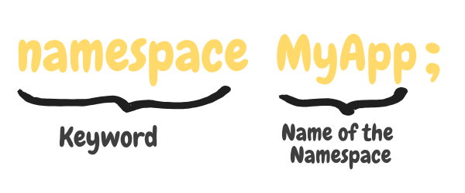
Declaring PHP Namespaces
Any valid PHP code can be in a namespace, but only classes, interfaces, constants, and functions are affected. Even it is possible to have multiple namespaces in the same file, it is not recommended.

Creating and Accessing Namespaced Classes
One special thing to remember throughout this tutorial: PHP is always relative to the current namespace.
If we add the namespace declaration at the top of a PHP file, all the classes, functions and constants will be items of that namespace.
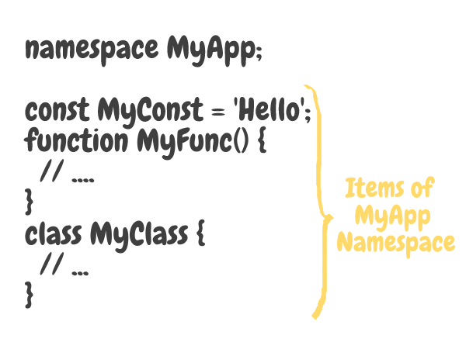
Items of Namespaces
Let's create a file named Math.php and add the following code.
Math.php

<?php
namespace Math;

function add($a, $b) {
return $a + $b;
}
const PI = 3.14;

class Geometry {
static function getCircleArea($radius) {
return PI * $radius ** 2;
}
}

- First, we declare the namespace. (So, all the classes, interfaces, constants and function below it will be items of that namespace)
- Then, we declared a normal function.
- Then, a class constant.
- Then, a class.
Here comes the interesting part. Let's create another file called usage.php and access the above Math namespace's items (functions, constants, and classes).
usage.php

<?php
// includes the Math.php file
// It's like you had all the code of Math.php written here
include_once 'Math.php';

echo Math\add(2,3); // 5
echo Math\PI; // 3.14
echo Math\Geometry::getCircleArea(10); // 314.15

The \ character is used to go a level down in namespaces.

Sub-Namespaces
In an operating system, folders can contain folders. In the same way, namespaces can contain namespaces. They are called sub-namespaces.

<?php
namespace Math\Geometry;

// ... your geometry classes

Hereafter, we will only be using classes in namespaces. (No more functions and constants as this is the OOP section in this tutorial)

Recommended Structure for Namespaces
We will learn all the recommendations for Object-Oriented programming in PHP in a later chapter. But, here we will learn how to structure your namespaces as it is really important to know.
It is recommended to map namespaces with local directories of your computer. See this example:
- Assume you have your project in the /var/www folder.
- To make it clean, we will have our PHP class files in /var/www/src folder.
- Each namespace will have a directory named as the same name as the namespace. (Match the letter case)
- So, the folder representing Math namespace will be /var/www/src/Math.
- Each class should be in a single PHP file (with .php) and one PHP class file should only contain one class definition.
Ex: Math\Addition => /var/www/src/Math/Addition.php
- Sub-Namespaces should have their own folders to contain classes. For example, the classes of Math\Geometry sub-namespace should be in the folder /var/www/src/Math/Geometry
These are recommendations. Not rules. You can follow them if you like.

Example - Math Namespace
Let's understand more by doing. In this example, we will be creating a namespace named Math and add sub-namespaces, classes into it. Here's the structure.
- Main namespace: Math
- One Subnamespaces: Math\Geometry (To handle geometry)
- Two Classes: Math\Constants (To save frequently used constants) and Math\Geometry\Circle (To handle circle)
Here's the final structure of our project.

/src
/Math
/Geometry
Circle.php
Constants.php

Math/Constants.php

<?php
namespace Math;

class Constants {
const PI = 3.14159;
}

Math/Geometry/Circle.php

<?php
namespace Math\Geometry;

class Circle {
public $radius;
public function __construct($radius) {
$this -> radius = $radius;
}
public function getDiameter() {
return $this -> radius * 2;
}
public function getArea() {
// (pi)(r^2)
return \Math\Constants::PI * $this -> radius ** 2;
}
public function getCircumference() {
// 2(pi)(r)
return 2 * \Math\Constants::PI * $this -> radius;
}
}

In Circle.php, we used \Math\Constants::PI to refer the constant in Constants.php file. This is because PHP is always relative to the current namespace. When a namespace starts with a backslash (\), the name will be resolved relative to the global namespace.
- If we used Constants::PI in Circle.php, it would refer \Math\Geometry\Constants::PI.
- If we used Math\Constants::PI (without starting backslash) in Circle.php, it it will refer to \Math\Geometry\Math\Constants::PI
Simply, class names are relative to the current namespace. Starting backslash (\) is used to go back to the start. Relative namespaces aren't currently supported in PHP. (../Constants::PI is not supported)
Finally, let's use our classes in index.php (which should be in the root folder of your project)

<?php
include_once 'src/Math/Constants.php';
include_once 'src/Math/Geometry/Circle.php';

$circle = new Math\Geometry\Circle(10);

echo $circle -> getDiameter(); // 20
echo $circle -> getArea(); // 314.159
echo $circle -> getCircumference(); // 62.8318

- First, We included the class files.
- Then, used the Math\Geometry\Circle class and its methods.
Important to note that index.php is in the global namespaces as it is not in any namespace.

Using "use" in Namespaces to Import
The use keyword can be used to import a class to the current scope.
If you add the following code in your index.php, Math\Geometry\Circle class will be imported to the current scope.

<?php
use Math\Geometry\Circle;

$circle = new Circle(10); // as Circle class is now in this namespace

You can import both namespaces and classes

<?php
use Math\Geometry; // importing an namespace
use Math\Geometry\Circle; // importing a class

You can nickname (or alias) the imports
There are two places to use nicknames (or aliases) for importing classes.
- When you already have a class named the same name as the importing class
- When you need a more convenient (or easy) name for the importing class
The as keyword is used for nicknaming.

<?php
use Math\Geometry\Circle as Circ;

$circle = new Circ(10);

Changing the previous example
Let's change our index.php of the previous example adding use statements to import the class.

<?php
// ... import statements

use Math\Geometry\Circle;
$circle = new Circle(10);

// ... calling methods

As we did not have an as keyword, the imported class could be referred to using Circle. We can also import the Circle class with a nickname.

<?php
use Math\Geometry\Circle as C;
$circle = new C(10);

Wait! It is not a good practice to use names like C. Always use descriptive names.
Here's a task for you: Use use as in the Circle.php and replace the \Math\Constants::PI with a short name.

Organizing Code with Namespaces
One of the main uses of namespaces is for organizing codes. Let's assume that you are creating an open-source library.
- You will need to prevent name collision. So, it's better to add all the classes into a namespace. (Named as your name or library's name).
- Group similar classes into a subnamespace.
- Use the folder structure which we learned early correctly.

Conclusion
In this tutorial, we learned what are namespaces, why do we use them, and how to use them. Namespaces make your project more structured and easy to manage when used correctly. You can use your own way to do that, but follow the recommendations as most of the developers do that.
Did you notice something annoying? If we had a large number of files to include, do we need to include them at the top of each page? Thousands of include statements in a single file? No, we will be discussing a smarter solution for this in the next chapter: Autoloading.

https://tutorials.supunkavinda.blog/php/oop-intro

PHP Classes and Objects
In this tutorial you will learn how to write code in object-oriented style in PHP.

What is Object Oriented Programming
Object-Oriented Programming (OOP) is a programming model that is based on the concept of classes and objects. As opposed to procedural programming where the focus is on writing procedures or functions that perform operations on the data, in object-oriented programming the focus is on the creations of objects which contain both data and functions together.
Object-oriented programming has several advantages over conventional or procedural style of programming. The most important ones are listed below:
- It provides a clear modular structure for the programs.
- It helps you adhere to the "don't repeat yourself" (DRY) principle, and thus make your code much easier to maintain, modify and debug.
- It makes it possible to create more complicated behavior with less code and shorter development time and high degree of reusability.
The following sections will describe how classes and objects work in PHP.
Tip: The idea behind Don't Repeat Yourself (DRY) principle is reducing the repetition of code by abstracting out the code that are common for the application and placing them at a single place and reuse them instead of repeating it.

Understanding Classes and Objects
Classes and objects are the two main aspects of object-oriented programming. A class is a self-contained, independent collection of variables and functions which work together to perform one or more specific tasks, while objects are individual instances of a class.
A class acts as a template or blueprint from which lots of individual objects can be created. When individual objects are created, they inherit the same generic properties and behaviors, although each object may have different values for certain properties.
For example, think of a class as a blueprint for a house. The blueprint itself is not a house, but is a detailed plan of the house. While, an object is like an actual house built according to that blueprint. We can build several identical houses from the same blueprint, but each house may have different paints, interiors and families inside, as shown in the illustration below.
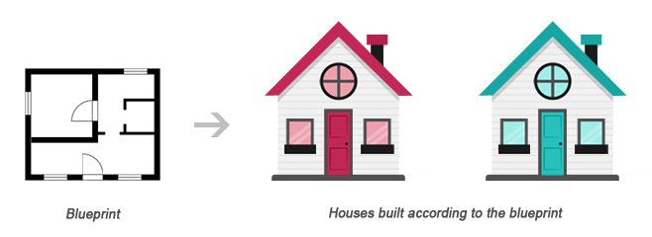
A class can be declared using the class keyword, followed by the name of the class and a pair of curly braces ({}), as shown in the following example.
Let's create a PHP file named Rectangle.php and put the following example code inside it so that our class code should be separated from rest of the program. We can then use it wherever it's needed by simply including the Rectangle.php file.

Example
Download
<?php
class Rectangle
{
// Declare properties
public $length = 0;
public $width = 0;

// Method to get the perimeter
public function getPerimeter(){
return (2 * ($this->length + $this->width));
}

// Method to get the area
public function getArea(){
return ($this->length * $this->width);
}
}
?>
The public keyword before the properties and methods in the example above, is an access modifier, which indicates that this property or method is accessible from anywhere. We will learn more about this a little later in this chapter.
Note: Syntactically, variables within a class are called properties, whereas functions are called methods. Also class names conventionally are written in PascalCase i.e. each concatenated word starts with an uppercase letter (e.g. MyClass).
Once a class has been defined, objects can be created from the class with the new keyword. Class methods and properties can directly be accessed through this object instance.
Create another PHP file name test.php and put the following code inside it.

Example
Run this code »
<?php
// Include class definition
require "Rectangle.php";

// Create a new object from Rectangle class
$obj = new Rectangle;

// Get the object properties values
echo $obj->length; // 0utput: 0
echo $obj->width; // 0utput: 0

// Set object properties values
$obj->length = 30;
$obj->width = 20;

// Read the object properties values again to show the change
echo $obj->length; // 0utput: 30
echo $obj->width; // 0utput: 20

// Call the object methods
echo $obj->getPerimeter(); // 0utput: 100
echo $obj->getArea(); // Output: 600
?>
The arrow symbol (->) is an OOP construct that is used to access contained properties and methods of a given object. Whereas, the pseudo-variable $this provides a reference to the calling object i.e. the object to which the method belongs.
The real power of object oriented programming becomes evident when using multiple instances of the same class, as shown in the following example:

Example
Run this code »
<?php
// Include class definition
require "Rectangle.php";

// Create multiple objects from the Rectangle class
$obj1 = new Rectangle;
$obj2 = new Rectangle;

// Call the methods of both the objects
echo $obj1->getArea(); // Output: 0
echo $obj2->getArea(); // Output: 0

// Set $obj1 properties values
$obj1->length = 30;
$obj1->width = 20;

// Set $obj2 properties values
$obj2->length = 35;
$obj2->width = 50;

// Call the methods of both the objects again
echo $obj1->getArea(); // Output: 600
echo $obj2->getArea(); // Output: 1750
?>
As you can see in the above example, calling the getArea() method on different objects causes that method to operate on a different set of data. Each object instance is completely independent, with its own properties and methods, and thus can be manipulated independently, even if they're of the same class.

Using Constructors and Destructors
To make the object-oriented programming easier, PHP provides some magic methods that are executed automatically when certain actions occur within an object.
For example, the magic method __construct() (known as constructor) is executed automatically whenever a new object is created. Similarly, the magic method __destruct() (known as destructor) is executed automatically when the object is destroyed. A destructor function cleans up any resources allocated to an object once the object is destroyed.

Example
Run this code »
<?php
class MyClass
{
// Constructor
public function __construct(){
echo 'The class "' . __CLASS__ . '" was initiated!<br>';
}

// Destructor
public function __destruct(){
echo 'The class "' . __CLASS__ . '" was destroyed.<br>';
}
}

// Create a new object
$obj = new MyClass;

// Output a message at the end of the file
echo "The end of the file is reached.";
?>
The PHP code in the above example will produce the following output:
The class "MyClass" was initiated!
The end of the file is reached.
The class "MyClass" was destroyed.
A destructor is called automatically when a scripts ends. However, to explicitly trigger the destructor, you can destroy the object using the PHP unset() function, as follow:

Example
Run this code »
<?php
class MyClass
{
// Constructor
public function __construct(){
echo 'The class "' . __CLASS__ . '" was initiated!<br>';
}

// Destructor
public function __destruct(){
echo 'The class "' . __CLASS__ . '" was destroyed.<br>';
}
}

// Create a new object
$obj = new MyClass;

// Destroy the object
unset($obj);

// Output a message at the end of the file
echo "The end of the file is reached.";
?>
Now, the PHP code in the above example will produce the following output:
The class "MyClass" was initiated!
The class "MyClass" was destroyed.
The end of the file is reached.
Tip: PHP automatically clean up all resources allocated during execution when the script is finished, e.g. closing database connections, destroying objects, etc.
Note: The __CLASS__ is a magic constant which contains the name of the class in which it is occur. It is empty, if it occurs outside of the class.

Extending Classes through Inheritance
Classes can inherit the properties and methods of another class using the extends keyword. This process of extensibility is called inheritance. It is probably the most powerful reason behind using the object-oriented programming model.

Example
Run this code »
<?php
// Include class definition
require "Rectangle.php";

// Define a new class based on an existing class
class Square extends Rectangle
{
// Method to test if the rectangle is also a square
public function isSquare(){
if($this->length == $this->width){
return true; // Square
} else{
return false; // Not a square
}
}
}

// Create a new object from Square class
$obj = new Square;

// Set object properties values
$obj->length = 20;
$obj->width = 20;

// Call the object methods
if($obj->isSquare()){
echo "The area of the square is ";
} else{
echo "The area of the rectangle is ";
};
echo $obj->getArea();
?>
The PHP code in the above example will produce the following output:
The area of the square is 400
As you can see in the above example, even though the class definition of Square doesn't explicitly contain getArea() method nor the $length and $width property, instances of the Square class can use them, as they inherited from the parent Rectangle class.
Tip: Since a child class is derived from a parent class, it is also referred to as a derived class, and its parent is called the base class.

Controlling the Visibility of Properties and Methods
When working with classes, you can even restrict access to its properties and methods using the visibility keywords for greater control. There are three visibility keywords (from most visible to least visible): public, protected, private, which determines how and from where properties and methods can be accessed and modified.
- public — A public property or method can be accessed anywhere, from within the class and outside. This is the default visibility for all class members in PHP.
- protected — A protected property or method can only be accessed from within the class itself or in child or inherited classes i.e. classes that extends that class.
- private — A private property or method is accessible only from within the class that defines it. Even child or inherited classes cannot access private properties or methods.
The following example will show you how this visibility actually works:

Example
Download
<?php
// Class definition
class Automobile
{
// Declare properties
public $fuel;
protected $engine;
private $transmission;
}
class Car extends Automobile
{
// Constructor
public function __construct(){
echo 'The class "' . __CLASS__ . '" was initiated!<br>';
}
}

// Create an object from Automobile class
$automobile = new Automobile;

// Attempt to set $automobile object properties
$automobile->fuel = 'Petrol'; // ok
$automobile->engine = '1500 cc'; // fatal error
$automobile->transmission = 'Manual'; // fatal error

// Create an object from Car class
$car = new Car;

// Attempt to set $car object properties
$car->fuel = 'Diesel'; // ok
$car->engine = '2200 cc'; // fatal error
$car->transmission = 'Automatic'; // undefined
?>

Static Properties and Methods
In addition to the visibility, properties and methods can also be declared as static, which makes them accessible without needing an instantiation of the class. Static properties and methods can be accessed using the scope resolution operator (::), like this: ClassName::$property and ClassName::method().
A property declared as static cannot be accessed via the object of that class though a static method can be, as demonstrated in the following example:

Example
Download
<?php
// Class definition
class HelloClass
{
// Declare a static property
public static $greeting = "Hello World!";

// Declare a static method
public static function sayHello(){
echo self::$greeting;
}
}
// Attempt to access static property and method directly
echo HelloClass::$greeting; // Output: Hello World!
HelloClass::sayHello(); // Output: Hello World!

// Attempt to access static property and method via object
$hello = new HelloClass;
echo $hello->greeting; // Strict Warning
$hello->sayHello(); // Output: Hello World!
?>
The keyword self in the above example means "the current class". It is never preceded by a dollar sign ($) and always followed by the :: operator (e.g. self::$name).
The self keyword is different from the this keyword which means "the current object" or "the current instance of a class". The this keyword is always preceded by a dollar sign ($) and followed by the -> operator (e.g. $this->name).
Note: Since static methods can be called without an instance of a class (i.e. object), the pseudo-variable $this is not available inside the method declared as static.
We hope you've understood the basic concepts of object-oriented programming by now. You'll find more examples on OOP in PHP and MySQL database section.
https://www.tutorialrepublic.com/php-tutorial/php-classes-and-objects.php

PHP Object Oriented Programming (OOPs) concept Tutorial with Example
ByPaul Jackson
Updated

What is OOPs?
Object Oriented is an approach to software development that models application around real world objects such as employees, cars, bank accounts, etc. A class defines the properties and methods of a real world object. An object is an occurrence of a class.
The three basic components of object orientation are;
- Object oriented analysis – functionality of the system
- Object oriented designing – architecture of the system
- Object oriented programming – implementation of the application

Object Oriented Programming Principles
The three major principles of OOP are;
- Encapsulation – this is concerned with hiding the implementation details and only exposing the methods. The main purpose of encapsulation is to;
- Reduce software development complexity – by hiding the implementation details and only exposing the operations, using a class becomes easy.
- Protect the internal state of an object – access to the class variables is via methods such as get and set, this makes the class flexible and easy to maintain.
- The internal implementation of the class can be changed without worrying about breaking the code that uses the class.
- Inheritance – this is concerned with the relationship between classes. The relationship takes the form of a parent and child. The child uses the methods defined in the parent class. The main purpose of inheritance is;
- Re-usability– a number of children, can inherit from the same parent. This is very useful when we have to provide common functionality such as adding, updating and deleting data from the database.
- Polymorphism – this is concerned with having a single form but many different implementation ways. The main purpose of polymorphism is;
- Simplify maintaining applications and making them more extendable.

OOPs Concepts in PHP
PHP is an object oriented scripting language; it supports all of the above principles. The above principles are achieved via;
- Encapsulation – via the use of “get” and “set” methods etc.
- Inheritance – via the use of extends keyword
- Polymorphism – via the use of implements keyword
Now that we have the basic knowledge of OOP and how it is supported in PHP, let us look at examples that implement the above principles

What is UML?
Unified Modeling Language UML is a technique used to design and document object oriented systems.
UML produces a number of documents, but we will look at the class diagram which is very important to object oriented php programming.

Class Diagram Example
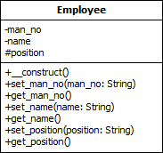
Class Diagram Key
- The Upper box contains the class name
- The middle box contains the class variables
- The lower box contains the class methods
- The minus (-) sign means private scope
- The plus (+) sign means public scope
- The hash (#) sign means protected scope

How to Create a class in PHP
The class keyword is used to define a class in PHP. Below are the rules for creating a class in PHP.
- The class name should start with a letter
- The class name cannot be a PHP reserved word
- The class name cannot contain spaces
Let’s say we want to create a class for representing animals.
We will start with identifying the features that are common to all animals.
- All animals belong to a family such as a herbivore, carnival, etc.
- All animals eat food
The diagram below shows the diagram for the animal
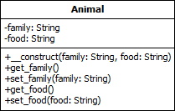
Let’s now code our animal class
<?php
class Animal
{
private $family;
private $food;
public function __construct($family, $food)
{
$this->family = $family;
$this->food = $food;
}
public function get_family()
{
return $this->family;
}
public function set_family($family)
{
$this->family = $family;
}
public function get_food()
{
return $this->food;
}
public function set_food($food)
{
$this->food = $food;
}
}
?>
HERE,
- “private $family, $food” means the variables cannot be accessed directly outside the class (Encapsulation).
- “public function __construct($family…)” is the php constructor method. This function is called whenever an instance of the class has been created. In this case, we are setting the family and food.
- “public function get…()” is the method used to access the family or food value (Encapsulation)
- “public function set…()” is the method used to set the family or food value (Encapsulation)

How implement Inheritance in PHP
We will work with a cow and a lion. Both the cow and lion inherit from the Animal class.
The class diagram below shows the relationships.
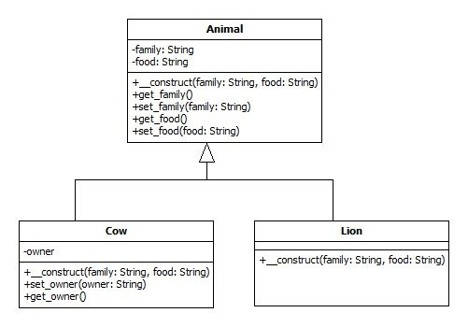
Note the cow inherits from the animal class and defines its own variable and methods too.
Let’s now code the Cow class
<?php
class Cow extends Animal
{
private $owner;
public function __construct($family, $food)
{
parent::__construct($family, $food);
}
public function set_owner($owner)
{
$this->owner = $owner;
}
public function get_owner()
{
return $this->owner;
}
}
?>
Let’s now code the Lion class
<?php
class Lion extends Animal
{
public function __construct($family, $food)
{
parent::__construct($family, $food);
}
}
?>
HERE,
- “class … extends Animal” makes the cow and lion use methods from the Animal class (Inheritance).

How to Create object of the class
The Animal, Cow, and Lion classes should all be in the same directory for simplicity’s sake.
Let’s now create the application that uses our classes.
PHP Class Example
<?php
require 'Animal.php';
require 'Cow.php';
require 'Lion.php';
$cow = new Cow('Herbivore', 'Grass');
$lion = new Lion('Canirval', 'Meat');
echo '<b>Cow Object</b> <br>';
echo 'The Cow belongs to the ' . $cow->get_family() . ' family and eats ' . $cow->get_food() . '<br><br>';
echo '<b>Lion Object</b> <br>';
echo 'The Lion belongs to the ' . $lion->get_family() . ' family and eats ' . $lion->get_food();
?>

Testing our application
Let’s now view our application in a web browser
. 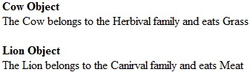
Fantastic right! Let’s now look at the third principle of OOP, polymorphism.
Let’s say we want to develop an application that connects to different database engines such as MySQL and SQL Server but use the same uniform interface.
We can create an interface that defines the standard methods and an abstract class that implements the common methods.
- Interface – it is similar to a class. It only defines the methods and parameters.
- Abstract class – it is a class that cannot be used to create an object directly. Its purpose is to provide partial or whole implementations of common methods.
The class diagram below illustrates the relationship among our abstract class, interface, and implementation classes.
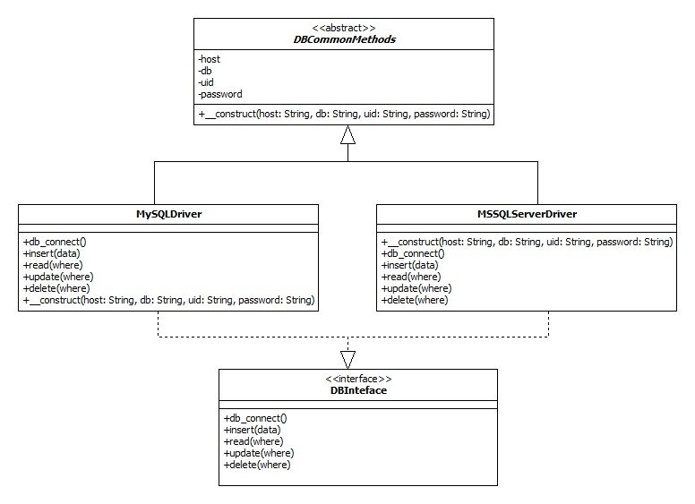
Let’s now create our abstract class

<?php
abstract class DBCommonMethods
{
private $host;
private $db;
private $uid;
private $password;
public function __construct($host, $db, $uid, $password)
{
$this->host = $host;
$this->db = $db;
$this->uid = $uid;
$this->password = $password;
}
}
?>
HERE,
- “abstract class” means the class cannot be used directly to php create object
- “$host,$db…” are class variables common to all implementations
- “function __construct(…)” is the php class constructor method that sets the common variables values at initialization
Let’s now create the interface that contains the standard methods which will be implemented differently depending on the database engine.
<?php
interface DBInterface
{
public function db_connect();
public function insert($data);
public function read($where);
public function update($where);
public function delete($where);
}
?>
HERE,
- “interface” is the keyword for creating interfaces
- “public function…(…)” are the standard methods that should be implemented
Let’s now create the concrete classes that will extend the DBCommonMethods class and extend the DBInterface interface. MySQLDriver.php
<?php class MySQLDriver extends
DBCommonMethods implements DBInterface { public function __construct($host, $db, $uid, $password)
{
parent::__construct($host, $db, $uid, $password); }
public function db_connect() { //connect code goes here }
public function delete($where) { //delete code goes here }
public function insert($data) { //insert code goes here }
public function read($where) { //read code goes here }
public function update($where) { //update code goes here }
} ?>
MSSQLServerDriver.php
<?php
class MSSQLServerDriver extends
DBCommonMethods implements DBInterface { public function __construct($host, $db, $uid, $password)
{
parent::__construct($host, $db, $uid, $password); }
public function db_connect() { //connect code goes here }
public function delete($where) { //delete code goes here }
public function insert($data) { //insert code goes here }
public function read($where) { //read code goes here }
public function update($where) { //update code goes here }
} ?>
HERE,
- “class … extends DBCommonMethods” use the methods in the DBCommonMethods
- “… implements DBInterface” ensures that the class provides standard methods regardless of the database driver used.
Usage of the above code The code using the above class would look like this
<?php $db = new MySQLDriver($host,$db,$uid,$password); ?>
Or
<?php $db = new MSSQLServerDriver ($host,$db,$uid,$password); ?>
The rest of the code would be the same for both drivers such as;
<?php
$db->db_connect();
$db->insert($data);
?>

Summary
- Object Oriented Programming OOP is a powerful technical that models applications after real world objects
- A class is a representation of real world objects with properties and methods
- The three basic principles of OOP are;
- Encapsulation
- Inheritance
- Polymorphism
https://www.guru99.com/object-oriented-programming.html

