YAD

yad --title "Customised title here" --entry --text " Are you <b>really</b> sure you want to add an entry?" --width=300 --center --button="gtk-cancel:252" --button="gtk-ok:0"
You can do this with yad, which you can install from the Software Centre. You can run:
yad --title "Customised title here" --entry --text " Are you <b>really</b> sure you want to add an entry?" --width=300 --center --button="gtk-cancel:252" --button="gtk-ok:0"

To make this usable we need to get any data that was inputted and check which button was pressed. This does it:
data=$(yad --title "Customised title here" --entry --text " Are you <b>really</b> sure you want to add an entry?" --width=300 --center --button="gtk-cancel:252" --button="gtk-ok:0");rc=$?; [[ $rc = 252 ]] && data="";echo $data
For help on yad type yad --help-all or man yad but I found practical examples are easier to adapt. There are some here.

Introduction
Here is set of examples demonstrate how to use yad in shell scripts.

Logout dialog
Show logout dialog.
Additional software:
- wmctrl (http://tripie.sweb.cz/utils/wmctrl/)

code:
1  2  3  4  5  6  7  8  9  10  11  12  13  14  15  16  17  18  19  20  21  22  23  24  25  26  27  28  29  30  31  32  33  34 | #! /bin/bash  action=$(yad --width 300 --entry --title "System Logout" \  --image=gnome-shutdown \  --button="Switch User:2" \  --button="gtk-ok:0" --button="gtk-close:1" \  --text "Choose action:" \  --entry-text \  "Power Off" "Reboot" "Suspend" "Logout")  ret=$?  [[ $ret -eq 1 ]] && exit 0  if [[ $ret -eq 2 ]]; then  gdmflexiserver --startnew &  exit 0  fi  case $action in  Power*) cmd="sudo /sbin/poweroff" ;;  Reboot*) cmd="sudo /sbin/reboot" ;;  Suspend*) cmd="sudo /bin/sh -c 'echo disk > /sys/power/state'" ;;  Logout*)  case $(wmctrl -m | grep Name) in  *Openbox) cmd="openbox --exit" ;;  *FVWM) cmd="FvwmCommand Quit" ;;  *Metacity) cmd="gnome-save-session --kill" ;;  *) exit 1 ;;  esac  ;;  *) exit 1 ;;  esac  eval exec $cmd

Run dialog
Run dialog with history, URI recognition and run-in-xterm functions
Additional software:
- xterm
- perl

code:
1  2  3  4  5  6  7  8  9  10  11  12  13  14  15  16  17  18  19  20  21  22  23  24  25  26  27  28  29  30  31  32  33  34  35  36  37  38  39 | #! /bin/bash  XTERM="xterm"  # create history file  mkdir -p ${XDG_CACHE_HOME:-$HOME/.cache}/  HISTFILE=${XDG_CACHE_HOME:-$HOME/.cache}/ix-run.history  touch $HISTFILE  # create and run dialog  TITLE="Run command"  TEXT="\nEnter command to execute:\n"  rcmd=$('yad --width=500 --center --window-icon="gtk-execute" --name="${0##*/}" --title="$TITLE" --text="$TEXT" --image="gtk-execute" --entry --editable --rest="$HISTFILE")  [[ -z "$rcmd" ]] && exit 0  # run command  case $rcmd in  http://*|https://*|ftp://*)  xdg-open $rcmd &  ;;  mailto://*)  xdg-email $rcmd &  ;;  man://*)  eval $XTERM -e "man ${rcmd#man://}" &  ;;  telnet*|ssh*)  eval $XTERM -e "$rcmd" &  ;;  *)  eval $rcmd &  ;;  esac  # add command to history  grep -q -F "$rcmd" $HISTFILE || sed -i "1 i $rcmd" $HISTFILE  exit 0

Autostart editor
Edit content of $HOME/.config/autostart.

code:
1  2  3  4  5  6  7  8  9  10  11  12  13  14  15  16  17  18  19  20  21  22  23  24  25  26  27  28  29  30  31  32  33  34 | #! /bin/bash  config_dir=${XDG_CONFIG_HOME:-$HOME/.config}  results=$(mktemp --tmpdir autostart.XXXXXXXXXX)  for f in $config_dir/autostart/*.desktop; do  grep -m 1 -e '^[[:blank:]]*Exec' $f | cut -d = -f 2  grep -m 1 -e '^[[:blank:]]*Name' $f | cut -d = -f 2  grep -m 1 -e '^[[:blank:]]*Comment' $f | cut -d = -f 2  done | yad --width=500 --height=300 --title="Autostart editor" --image="gtk-execute" \  --text="Add/remove autostart items" --list --editable --print-all \  --multiple --column="Command" --column="Name" --column="Description" > $results  if [[ ${PIPESTATUS[1]} -eq 0 ]]; then  rm -f $config_dir/autostart/*.desktop  i=0  cat $results | while read line; do  eval $(echo $line | awk -F'|' '{printf "export NAME=\"%s\" COMMENT=\"%s\" COMMAND=\"%s\"", $2, $3, $1}')  cat > $config_dir/autostart/$i$NAME.desktop << EOF  [Desktop Entry]  Encoding=UTF-8  Name=$NAME  Comment=$COMMENT  Exec=$COMMAND  StartupNotify=true  Terminal=false  EOF  $((i++))  done  unset NAME COMMENT COMMAND  fi  rm -f $results  exit 0

Graphical frontend for su(1)
Run program as a different user (root by default). Ask password if needed
Additional software:
- empty (http://empty.sourceforge.net/)

code:
1  2  3  4  5  6  7  8  9  10  11  12  13  14  15  16  17  18  19  20  21  22  23  24  25  26  27  28  29  30  31  32  33  34  35  36  37  38  39  40  41  42  43  44  45  46  47  48  49  50  51  52 | #! /bin/bash  # some defaults  user="root"  suargs="-p"  force="no"  # parse commandline  if [[ $# -eq 0 ]]; then  echo "Usage: ${0##*/} [-f] [-u user] [--] "  exit 1  fi  OPTIND=1  while getopts u: opt; do  case "$opt" in  f) force="yes" ;;  u) user="$OPTARG" ;;  esac  done  shift $((OPTIND - 1))  cmd="$*"  if [[ $force != "no" ]]; then  # check for sudo  sudo_check=$(sudo -H -S -- echo SUDO_OK 2>&1 &)  if [[ $sudo_check == "SUDO_OK" ]]; then  eval sudo $cmd  exit $?  fi  fi  # get password  pass=$(yad --class="GSu" \  --title="Password" \  --text="Enter password for user <b>$user</b>:" \  --image="dialog-password" \  --entry --hide-text)  [[ -z "$pass" ]] && exit 1  # grant access to xserver for specified user  xhost +${user}@ &> /dev/null  # run command  fifo_in="$(mktemp -u --tmpdir gsu.empty.in.XXXXXXXXX)"  fifo_out="$(mktemp -u --tmpdir gsu.empty.out.XXXXXXXXX)"  LC_MESSAGES=C empty -f -i $fifo_in -o $fifo_out su $suargs $user -c "$cmd"  [[ $? -eq 0 ]] && empty -w -i $fifo_out -o $fifo_in "word:" "$pass\n"  exit $?

https://sourceforge.net/p/yad-dialog/wiki/browse_pages/

#! /bin/bash

find_cmd='@sh -c "run_find \"%1\" \"%2\" \"%3\" \"%4\" \"%5\""'

export fpipe=$(mktemp -u --tmpdir find.XXXXXXXX)
mkfifo "$fpipe"
#exec 3<> "$fpipe"

fkey=$(($RANDOM * $$))

function run_find
{
echo "6:@disable@"
if [[ $2 != TRUE ]]; then
ARGS="-name '$1'"
else
ARGS="-regex '$1'"
fi
if [[ -n "$4" ]]; then
d1=$(date +%j --date="${4//.//}")
d2=$(date +%j)
d=$(($d1 - $d2))
ARGS+=" -ctime $d"
fi
if [[ -n "$5" ]]; then
ARGS+=" -exec grep -E '$5' {} \;"
fi
ARGS+=" -printf '%p\n%s\n%M\n%TD %TH:%TM\n%u/%g\n'"
eval find "$3" $ARGS > "$fpipe"
echo "6:$find_cmd"
}
export -f run_find

yad --plug="$fkey" --tabnum=1 --form --field="Name" '*' --field="Use regex:chk" '' --field="Directory:dir" '' \
--field="Newer than:dt" '' --field="Content" '' --field="gtk-find:fbtn" "$find_cmd" &

cat "$fpipe" | yad --plug="$fkey" --tabnum=2 --list --dclick-action="xdg-open" \
--column="Name" --column="Size:num" --column="Perms" --column="Date" --column="Owner" \
--search-column=1 --expand=column=1 &

yad --paned --key="$fkey" --button="gtk-close:1" --width=700 --height=500 --title="Find files" --window-icon="find"

rm -f "$fpipe"

Introduction
This script demostrate the usage of notebook dialog. Three tabs with different settings of gtk+-2.0

Details
1  2  3  4  5  6  7  8  9  10  11  12  13  14  15  16  17  18  19  20  21  22  23  24  25  26  27  28  29  30  31  32  33  34  35  36  37  38  39  40  41  42  43  44  45  46  47  48  49  50  51  52  53  54  55  56  57  58  59  60  61  62  63  64  65  66  67  68  69  70  71  72  73  74  75  76  77  78  79  80  81  82  83  84  85  86  87  88  89  90  91  92  93  94  95  96  97  98  99  100  101  102  103  104  105  106  107  108  109  110  111  112  113  114  115  116  117  118  119  120  121  122  123  124  125  126  127  128  129  130  131  132  133  134  135  136  137  138  139  140  141  142  143  144  145  146  147  148  149  150  151  152  153  154  155  156  157  158  159  160  161  162  163  164  165  166  167  168  169  170  171  172  173  174  175  176  177  178  179  180  181  182  183  184  185  186  187  188  189  190  191  192  193  194  195  196  197  198  199  200  201  202  203  204  205  206  207  208  209  210  211 | #! /bin/sh  # -*- mode: sh -*-  #  # Author: Victor Ananjevsky <ananasik@gmail.com>, 2013  #  KEY="12345"  res1=$(mktemp --tmpdir iface1.XXXXXXXX)  res2=$(mktemp --tmpdir iface2.XXXXXXXX)  res3=$(mktemp --tmpdir iface3.XXXXXXXX)  rc_file="${XDG_CONFIG_HOME:-$HOME/.config}/gtk-2.0/gtkrc"  # parse rc file  PARSER='  BEGIN { FS="="; OFS="\n"; }  /^gtk-theme-name/ {printf "GTKTHEME=%s\n", $2}  /^gtk-key-theme-name/ {printf "KEYTHEME=%s\n", $2}  /^gtk-icon-theme-name/ {printf "ICONTHEME=%s\n", $2}  /^gtk-cursor-theme-name/ {printf "CURSORTHEME=%s\n", $2}  /^gtk-toolbar-style/ {printf "TBSTYLE=%s\n", $2}  /^gtk-toolbar-icon-size/ {printf "TBICONSIZE=%s\n", $2}  /^gtk-button-images/ {printf "BUTTONIMAGE=%s\n", ($2 == 1) ? "TRUE" : "FALSE"}  /^gtk-menu-images/ {printf "MENUIMAGE=%s\n", ($2 == 1) ? "TRUE" : "FALSE"}  /^gtk-font-name/ {printf "FONTDESCR=%s\n", $2}  /^gtk-xft-antialiasing/ {printf "ANTIALIASING=%s\n", ($2 == 1) ? "TRUE" : "FALSE"}  /^gtk-xft-hinting/ {printf "HINTING=%s\n", ($2 == 1) ? "TRUE" : "FALSE"}  /^gtk-xft-hintstyle/ {printf "HINTSTYLE=%s\n", $2}  /^gtk-xft-rgba/ {printf "RGBA=%s\n", $2}  /^gtk-color-scheme/ {printf "COLORSCHEME=%s\n", $2}  '  eval $(sed -r "s/[ \t]*=[ \t]*/=/" $rc_file | awk "$PARSER")  # create list of gtk themes  themelist=  keythemelist="Default"  for d in /usr/share/themes/*; do  theme=${d##*/}  if [[ -e $d/gtk-2.0/gtkrc ]]; then  [[ $themelist ]] && themelist="$themelist!"  [[ $theme == $GTKTHEME ]] && theme="^$theme"  themelist+="$theme"  fi  if [[ -e $d/gtk-2.0-key/gtkrc ]]; then  [[ $theme == $KEYTHEME ]] && theme="^$theme"  keythemelist+="!$theme"  fi  done  # create list of icon and cursor themes  iconthemelist="Default"  cursorthemelist="Default"  for d in /usr/share/icons/*; do  theme=${d##*/}  if [[ -e $d/index.theme ]]; then  [[ $theme == $ICONTHEME ]] && theme="^$theme"  iconthemelist+="!$theme"  fi  if [[ -d $d/cursors ]]; then  [[ $theme == $CURSORTHEME ]] && theme="^$theme"  cursorthemelist+="!$theme"  fi  done  # create toolbar styles list  tbstylelist="Icons only"!  [[ $TBSTYLE == GTK_TOOLBAR_TEXT ]] && tbstylelist+="^"  tbstylelist+="Text only"!  [[ $TBSTYLE == GTK_TOOLBAR_BOTH ]] && tbstylelist+="^"  tbstylelist+="Text below icons"!  [[ $TBSTYLE == GTK_TOOLBAR_BOTH_HORIZ ]] && tbstylelist+="^"  tbstylelist+="Text beside icons"  # create list of toolbar icons sizes  tbiconsizelist="Menu"!  [[ $TBSTYLE == GTK_ICON_SIZE_SMALL_TOOLBAR ]] && tbiconsizelist+="^"  tbiconsizelist+="Small toolbar"!  [[ $TBSTYLE == GTK_ICON_SIZE_LARGE_TOOLBAR ]] && tbiconsizelist+="^"  tbiconsizelist+="Large toolbar"!  [[ $TBSTYLE == GTK_ICON_SIZE_BUTTON ]] && tbiconsizelist+="^"  tbiconsizelist+="Buttons"!  [[ $TBSTYLE == GTK_ICON_SIZE_DND ]] && tbiconsizelist+="^"  tbiconsizelist+="DND"!  [[ $TBSTYLE == GTK_ICON_SIZE_DIALOG ]] && tbiconsizelist+="^"  tbiconsizelist+="Dialog"  # theme page  yad --plug=$KEY --tabnum=1 --form --separator='\n' --quoted-output \  --field="GTK+ theme::cb" "$themelist" \  --field="GTK+ key theme::cb" "$keythemelist" \  --field="Icons theme::cb" "$iconthemelist" \  --field="Cursor theme::cb" "$cursorthemelist" \  --field="Toolbar style::cb" "$tbstylelist" \  --field="Toolbar icon size::cb" "$tbiconsizelist" \  --field="Button images:chk" "$BUTTONIMAGE" \  --field="Menu images:chk" "$MENUIMAGE" > $res1 &  # create list of hinting styles  hintstylelist="None"!  [[ $HINTSTYLE == hintslight ]] && hintstylelist+="^"  hintstylelist+="Slight"!  [[ $HINTSTYLE == hintmedium ]] && hintstylelist+="^"  hintstylelist+="Medium"!  [[ $HINTSTYLE == hintfull ]] && hintstylelist+="^"  hintstylelist+="Full"  # create list of rgba types  rgbalist="None"!  [[ $RGBA == rgb ]] && rgbalist+="^"  rgbalist+="RGB"!  [[ $RGBA == gbr ]] && rgbalist+="^"  rgbalist+="BGR"!  [[ $RGBA == vrgb ]] && rgbalist+="^"  rgbalist+="VRGB"!  [[ $RGBA == vgbr ]] && rgbalist+="^"  rgbalist+="VBGR"  # fonts page  yad --plug=$KEY --tabnum=2 --form --separator='\n' --quoted-output \  --field="Font::fn" "$FONTDESCR" --field=":lbl" "" \  --field="Use antialiasing:chk" "$ANTIALIASING" \  --field="Use hinting:chk" "$HINTING" \  --field="Hinting style::cb" "$hintstylelist" \  --field="RGBA type::cb" "$rgbalist" > $res2 &  # parse color scheme  eval $(echo -e $COLORSCHEME | tr ';' '\n' | sed -r 's/:(.*)$/="\1"/')  # colors page  yad --plug=$KEY --tabnum=3 --form --separator='\n' --quoted-output \  --field="Foreground::clr" $fg_color \  --field="Background::clr" $bg_color \  --field="Text::clr" $text_color \  --field="Base::clr" $base_color \  --field="Selected fore::clr" $selected_fg_color \  --field="Selected back::clr" $selected_bg_color \  --field="Tooltip fore::clr" $tooltip_fg_color \  --field="Tooltip back::clr" $tooltip_bg_color > $res3 &  # run main dialog  yad --notebook --key=$KEY --tab="Theme" --tab="Fonts" --tab="Colors" \  --title="Interface settings" --image=gnome-settings-theme \  --width=400 --image-on-top --text="Common interface settings"  # recreate rc file  if [[ $? -eq 0 ]]; then  eval TAB1=($(< $res1))  eval TAB2=($(< $res2))  eval TAB3=($(< $res3))  echo -e "\n# This file was generated automatically\n" > $rc_file  echo "gtk-theme-name = \"${TAB1[0]}\"" >> $rc_file  [[ ${TAB1[1]} != Default ]] && echo "gtk-key-theme-name = \"${TAB1[1]}\"" >> $rc_file  [[ ${TAB1[2]} != Default ]] && echo "gtk-icon-theme-name = \"${TAB1[2]}\"" >> $rc_file  [[ ${TAB1[3]} != Default ]] && echo "gtk-cursor-theme-name = \"${TAB1[3]}\"" >> $rc_file  echo >> $rc_file  case ${TAB1[4]} in  "Icons only") echo "gtk-toolbar-style = GTK_TOOLBAR_ICONS" >> $rc_file ;;  "Text only") echo "gtk-toolbar-style = GTK_TOOLBAR_TEXT" >> $rc_file ;;  "Text below icons") echo "gtk-toolbar-style = GTK_TOOLBAR_BOTH" >> $rc_file ;;  "Text beside icons") echo "gtk-toolbar-style = GTK_TOOLBAR_BOTH_HORIZ" >> $rc_file ;;  esac  case ${TAB1[5]} in  "Menu") echo "gtk-toolbar-icon-size = GTK_ICON_SIZE_MENU" >> $rc_file ;;  "Small toolbar") echo "gtk-toolbar-icon-size = GTK_ICON_SIZE_SMALL_TOOLBAR" >> $rc_file ;;  "Large toolbar") echo "gtk-toolbar-icon-size = GTK_ICON_SIZE_LARGE_TOOLBAR" >> $rc_file ;;  "Buttons") echo "gtk-toolbar-icon-size = GTK_ICON_SIZE_BUTTON" >> $rc_file ;;  "DND") echo "gtk-toolbar-icon-size = GTK_ICON_SIZE_DND" >> $rc_file ;;  "Dialog") echo "gtk-toolbar-icon-size = GTK_ICON_SIZE_DIALOG" >> $rc_file ;;  esac  echo >> $rc_file  echo -n "gtk-button-images = " >> $rc_file  [[ ${TAB1[6]} == TRUE ]] && echo 1 >> $rc_file || echo 0 >> $rc_file  echo -n "gtk-menu-images = " >> $rc_file  [[ ${TAB1[7]} == TRUE ]] && echo 1 >> $rc_file || echo 0 >> $rc_file  echo >> $rc_file  echo -e "gtk-font-name = \"${TAB2[0]}\"\n" >> $rc_file  echo -n "gtk-xft-antialiasing = " >> $rc_file  [[ ${TAB2[2]} == TRUE ]] && echo 1 >> $rc_file || echo 0 >> $rc_file  echo -n "gtk-xft-hinting = " >> $rc_file  [[ ${TAB2[3]} == TRUE ]] && echo 1 >> $rc_file || echo 0 >> $rc_file  if [[ ${TAB2[4]} != $"None" ]]; then  case ${TAB2[4]} in  "Slight") echo 'gtk-xft-hintstyle = "hintslight"' >> $rc_file ;;  "Medium") echo 'gtk-xft-hintstyle = "hintmedium"' >> $rc_file ;;  "Full") echo 'gtk-xft-hintstyle = "hintful"' >> $rc_file ;;  esac  fi  if [[ ${TAB2[5]} != $"None" ]]; then  case ${TAB2[5]} in  "RGB") echo 'gtk-xft-rgba = "rgb"' >> $rc_file ;;  "BGR") echo 'gtk-xft-rgba = "bgr"' >> $rc_file ;;  "VRGB") echo 'gtk-xft-rgba = "vrgb"' >> $rc_file ;;  "VBGR") echo 'gtk-xft-rgba = "vbgr"' >> $rc_file ;;  esac  fi  echo >> $rc_file  echo "gtk-color-scheme = \"fg_color:${TAB3[0]};bg_color:${TAB3[1]};text_color:${TAB3[2]};base_color:${TAB3[3]};selected_fg_color:${TAB3[4]};selected_bg_color:${TAB3[5]};tooltip_fg_color:${TAB3[6]};tooltip_bg_color:${TAB3[7]}\"" >> $rc_file  echo -e "\n# Custom settings\ninclude \"$rc_file.mine\"" >> $rc_file  fi  # cleanup  rm -f $res1 $res2 $res3

Introduction
A little shell wrapper for use yad with zenity-based scripts
Just place following code to your startup files (~/.xprofile, ./bash_profile or same)
This is just a proof of concept, not a fully-worked solution!

Code
function zenity ()
{
local ARGS
ARGS=
for a in "$@"; do
case $a in
--info) ARGS="$ARGS --image=gtk-dialog-info" ;;
--question) ARGS="$ARGS --image=gtk-dialog-question" ;;
--warning) ARGS="$ARGS --image=gtk-dialog-warning" ;;
--error) ARGS="$ARGS --image=gtk-dialog-error" ;;
*) ARGS="$ARGS $a"
esac
done
eval set -- $ARGS
yad $@
}
export -f zenity

Uma breve apresentação do YAD (Yet Another Dialog)
Colaboração: Julio Cezar Neves
Data de Publicação: 06 de setembro de 2018
Ainda tem tempo para você se inscrever no curso sobre Programação Shell Linux do Prof. Julio Neves.
Saiba mais e faça sua inscrição

Uma breve apresentação do YAD (Yet Another Dialog)
Mermão, se você gosta de usar a interface a caractere, lhe aconselho a instalar o yad (Yet Another Dialog) com urgência. O yad é um fork do zenity, só que muuuuuito mais incrementado. Para termos uma pequena ideia, pois este artigo é só um ensaio, nele você pode:
- Inserir imagens nos diálogos;
- Criar formulários com alto grau de complexidade;
- Criar quantos botões quiser e customizá-los quanto aos nome e aos códigos de retorno quando clicados;
- Criar diálogos drag'n drop;
- Criar diálogos com ícones de atalho
- Criar diálogos com barras de progresso múltiplas (muito legal para instalação. Uma serviria para o progresso de cada arquivo e outra para o progresso geral);
- E muito mais...
Vamos logo aos exemplos para acabar com a encheção de saco:
Saida=$(yad --form --image logo-dicas-l.png --image-on-top \
--title "Dicas-L/Livra-TE ensino profissional" --text \
"Demo do YAD para Livra-TE/Dicas-L"\
--field Nome 'Juliana' \
--field Nascimento:DT 01/01/2000 \
--field "Há quantos anos usa Linux:NUM" '1!0..25!1' \
--field "Sites preferidos:CB" \
'BR-Linux!^Dicas-l!Viva o Linux!Outros' \
--field "Vou passar a usar o yad:CHK" TRUE \
--field "Vou continuar usando zenity:CHK")
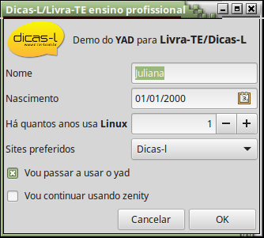
Clicando nas caixas deste formulário, você verá que:
- No campo Nascimento, a opção :DT abriria um calendário com a data 01/01/2000 previamente selecionada;
- No campo Há quanto tempo usa Linux, aumentaria ou diminuiria os números pois a opção :NUM define uma SpinBox, da qual se informa: Valor Inicial!ValorMínimo..ValorMáximo!Incremento;
- No campo Sites Preferidos, a opção :CB gera uma ComboBox com os valores especificados como Valor1!Valor2!...!Valorn. Ainda sobre este campo convém chamar a atenção para um circunflexo (^) antes de Dicas-l. Isso faz com que este seja o valor default.
Repare que o código é autoexplicativo e extremamente simples e veja ainda que o yad aceita todas as facilidades de formatação oferecidas pelo GTK. Nesse exemplo usei as tags <b> e <big> da linguagem Pango Markup do GTK. Poderia ter trocado também cores do texto, fazer sub ou super escrito, itálico, ...
Deixando os campos com seus valores default, as linhas a seguir mostram o conteúdo da variável $Saida e uma forma rápida de separar os campos em variáveis.
$ echo $Saida
Juliana|01/01/2000|1|Dicas-l|TRUE|FALSE|
O separador é a barra vertical (|), então vamos trocar $IFS para fazer uma leitura rápida. Note que dessa forma $IFS será alterado somente para executar o read, voltando ao seu valor default após a instrução.
$ IFS='|' read Nome Nascimento HaQtoTempo Sites Yad Zenity <<< "$Saida"
$ echo $Nome ^ $Nascimento ^ $HaQtoTempo ^ $Sites ^ $Yad ^ $Zenity
Juliana ^ 01/01/2000 ^ 1,000000 ^ BR-Linux ^ TRUE ^ FALSE
Como você pode ver, em Shell é tudo muito complicado. Em uma linha monto um formulário (sim, foi em uma linha, pois a contrabarra (\) foi usada para poder quebrar a linha e facilitar o entendimento) e em outra linha (a do read) passei todos os valores lidos para as respectivas variáveis. Ou seja, tudo foi feito em duas linhas somente.
Também podemos customizar botões, veja:
$ yad --width 300 --entry --title "System Logout" \
--image=gnome-shutdown \
--button="_Switch User:2" \
--button="gtk-ok:0" --button="gtk-close:1" \
--text "Choose action:" \
--entry-text \
"Power Off" "Reboot" "Suspend" "Logout"
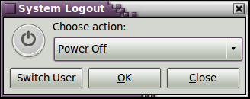
Duas coisas a destacar neste exemplo:
- A opção --entry-text gerou uma ComboBox com os valores passados;
- Podemos especificar não só os botões, como também os seus códigos de retorno ($?) para serem analisados por um comando case que viria logo a seguir.
Então pessoal, tem muito mais coisas para contar acerca do yad, porém temos uma limitação de espaço e por isso temos de ficar por aqui.
Para de ler este artigo e saia correndo para instalar o yad e colocar uma cara bonita nos seus scripts. Na vida real, não adianta nada ter um corpinho lindo, se a cara é feia... ;)
Se você já instalou o yad e deseja ver uma coisa inusitada, execute a linha a seguir e clique em qualquer ícone:
$ yad --icons --read-dir=/usr/share/applications \
--width 670 --height 400 --no-buttons
SuShellso!! ;)
https://www.dicas-l.com.br/arquivo/uma_breve_apresentacao_do_yad__yet_another_dialog_.php

YAD - Yet Another Dialog
Colaboração: Júlio Cezar Neves
Data de Publicação: 19 de outubro de 2017
Sou fã de carteirinha do Shell e frequentemente preciso melhorar a interface de um script com o usuário. Para isso, invariavelmente usava o Zenity que é extremamente fácil e melhora muito a apresentação.
Minha satisfação como o Zenity só não era total porque todos que conhecem um pouquinho de GTK 2, sabem que se pode tirar muito mais dessa linguagem do que o Zenity tira. Sempre esperei que a qualquer momento o gnome lançaria uma nova versão deste software que seria arrasadora, viria com todos os incrementos que eu (e acho que todos) aguardavam.
Estava enganado, acompanhei o lançamento de diversas revisões do software mas elas simplesmente tratavam bugs e apresentação. Infelizmente nada de inovação. Porém um dia descobri o YAD.
YAD significa Yet Another Dialog, mas sua tradução do russo é "veneno" (e essa é a inspiração de seu ícone) e se define como um fork do Zenity. Porém o YAD, distancia-se um pouco dele por não utilizar bibliotecas descontinuadas como libglade ou gnome-canvas. Utiliza somente o GTK 2, o que lhe dá uma maior portabilidade dentro do ambiente *n?x.
Poderia defini-lo como um Zenity com muitos aperfeiçoamentos, como botões customizados, diálogos adicionais, menu pop-up no ícone do notification (sim é o mesmo notification do Zenity, porém mais incrementado), diálogo para montar formulários complexos e muito mais.
Este artigo não é para mostrar como se instala, isso eu sei que vocês sabem se virar. O que quero é mostrar algumas (infelizmente muito poucas) novidades que o YAD traz para trabalharmos com interface GUI em Shell. Vamos ao que interessa:
Este é um dos poucos exemplos que achei pela internet e está no wiki do YAD (http://code.google.com/p/yad/wiki/Examples). Lá ele coloca o código completo para dar shutdown, reboot, ... Mas aqui executaremos somente a parte do YAD direto na linha de comandos.
$ yad --width 300 --entry --title "System Logout" \
--image=gnome-shutdown \
--button="_Switch User:2" \
--button="gtk-ok:0" --button="gtk-close:1" \
--text "Choose action:" \
--entry-text \
"Power Off" "Reboot" "Suspend" "Logout"
Aqui você pode ver uma ComboBox, diversos botões (um deles customizado) e um código extremamente simples. Repare que após a declaração do nome de cada botão, tem um :N, onde N é o valor que retorna em $? quando este botão for clicado. Simples, não?
Um outro exemplo usando o diálogo --form:
$ yad --form --title "Dicas-l de Rubens Queiroz" \
--text "Informe sua preferência sobre frutas" \
--image Frutas.jpg \
--field "Excolha uma fruta:CB" \
--field Outra
--field "Qtas vc come?:NUM" \
--field "Arquivo:FL" \
--field "Como e chupo o caroço:CHK" \
'Pera!Uva!Maçã!Manga' \
"" \
'1!10!1'
Com certeza você sabe que as contrabarras foram colocadas somente para tornar o texto mais visível e fácil de comentar, mas poderia ter sido escrito em somente uma linha.
O diálogo --form permite que eu use uma opção --field que aceita um monte de modificadores. Aqui usei, na ordem, :CB, nenhum, :NUM, :FL e :CHK que são, respectivamente, ComboBox, Entrada de texto, SpinBox numérico, Seletor de arquivos e uma CheckBox e para finalizar passei os valores das 3 primeiras. Veja o que gerou:
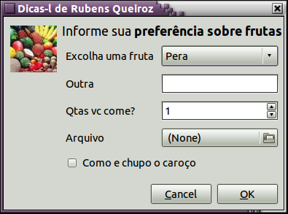
Ainda quero fazer uns comentários:
Repare no título (--text) que usei tags de formatação;
Veja a facilidade de colocar qualquer imagem no diálogo usando a opção --image;
Especifiquei os textos do ComboBox separando-os com um ponto de exclamação (!). Este é o default, mas pode ser alterado;
O campo Outra, por não ter tido nenhum valor especificado assume que é uma simples entrada de dados.
O campo Qtas vc come? É um SpinBox e seu valor foi especificado com Mínimo!Máximo!Incremento.
Quando o campo Arquivo for clicado, abrirá um super diálogo para seleção de arquivo;
O campo Arquivo e o CheckBox não foram inicializados por serem os últimos e por isso poderem assumir seus valores default (Nome e FALSE, respectivamente).
Fora esses pequenos exemplos ainda existem muitos outros diálogos que não foram implementados no Zenity como diálogos drag'ndrop, diálogos com ícones para escolha de aplicativos, dialogo para escolha de fonte, diálogo para escolha de cores, ? E mesmo muitos dos diálogos existentes no Zenity, no YAD passam a ter mais opções.
Para finalizar, experimente fazer:
$ ls -l | yad --text-info --fontname "mono 10" --width 600 --height 300
$ ls -l | zenity --text-info --width 600 --height 300
e veja a falta que a opção --fontname faz no Zenity.
Só para clarear o que falei, existe um diálogo --fonte para escolha de fontes e uma opção --fontname para especificar qual fonte um determinado diálogo usará. Agora, para finalizar mesmo vou mostrar o exemplo anterior, porém com escolha da fonte:
#! /bin/bash
# Exemplo de uso dos diálogos --font
#+ e --text-info

Fonte=$(yad --font --title "Escolha de fontes" \
--text "Escolha uma fonte
Dê preferência a fontes monoespacejadas" \
--height=300 --width 600) || exit 1

ls -l | eval yad --text-info \
--width=600 --height 300 \
--title \"Listagem do diretório $PWD\" \
--fontname \'$Fonte\'
Espero que você instale o YAD e teste esses exemplos que dei. Tenho certeza que você se amarrará no software.

Sobre o autor

Júlio Cézar Neves

O 4º UNIX do mundo nasceu na Cidade Maravilhosa, mais precisamente na Cobra Computadores, onde à época trabalhava o Julio. Foi paixão à 1ª vista! Desde então, (1980) atua nessa área como especialista em Sistemas Operacionais e linguagens de programação. E foi por essa afinidade que quando surgiu o Linux foi um dos primeiros a estudá-lo com profundidade e adotá-lo como Sistema Operacional e filosofia de vida. É autor dos livros Programação Shell Linux, 11ª edição e Bombando o Shell.

Baixando o audio dos vídeos do youtube - YAD
Colaboração: Alexandre Martins
Data de Publicação: 10 de dezembro de 2012
Estou aqui mais uma vez para fazer mais uma contribuição interessante. Bom trata-se de uma espécie de um "A tube Catcher", porém para linux e usando o YAD como interface do script.
Requisitos: Ter instalado o pacote YAD versão acima da 0.16.0 (esta que foi usada no script). Ter também o pacote youtube-dl, mas esse não se preocupem, pois o script checa se este ultimo está instalado e o instala se necessário.
Restrições: Funciona apenas no KDE, por causa de apenas 2 comandinhos o "kdesudo" e o "kdialog". Os usuarios de Gnome, LXDE e demais, fiquem a vontade para fazer possíveis ajustes.
Explicando o script: Ao executar o script, o mesmo testa a instalação do pacote youtube-dl (responsável por baixar os vídeos, caso não esteja instalado, o kdesudo aparecerá na tela pedindo sua senha para a instalação do pacote). Em seguida é verificado a existência de um diretório chamado tmp dentro do diretório Música do usuário. Caso não exista, o mesmo será criado. Após isso aparecerá uma pequena janela com 2 campos, "URL" (URL do vídeo do youtube) e "Nome da Música" (Nome que queira dar a música referente a URL - nome sem extensão). A partir daí é com o youtube-dl, ele baixa o vídeo em baixa resolução (download mais rápido) e salva temporariamente no diretório tmp, em seguida começa a extrair o áudio adicionando o nome da musica inserido pelo usuário seguido da extensão ".mp3" (padrão de conversão). Ao terminar esse processo, a barra de progresso some, o áudio extraído é movido para o diretório Música e surge uma mensagem de conclusão na barra de tarefas. Eu ainda não realizei testes em outros vídeos como o vimeo pro exemplo...fique a vontade para realizar esses testes. Espero que gostem!
#!/bin/bash
#Por Alexandre Martins

dpkg -l | grep youtube-dl
if [ "$?" != "0" ]
then
kdesudo apt-get install youtube.dl
fi

if [ ! -e "/$HOME/Música/tmp" ]
then
mkdir -p /$HOME/"Música"/tmp
cd /$HOME/"Música"/tmp
fi

saida=$( \
yad --form \
--title="YouTube to MP3" \
--width=300 \
--height=100 \
--field="URL: " "" \
--field="Nome da Música:" "" \
)

url=$(echo "$saida" | cut -d "|" -f1)
music=$(echo "$saida" | cut -d "|" -f2)

if [ "$url" != "" ]
then
if [ "$music" != "" ]
then

youtube-dl -f 5 --extract-audio $url | \
bar=$(yad --progress \
--title "Processando..." \
--width="300" \
--progress-text="Baixando e Convertendo..." \
--pulsate \
--auto-close \
--no-buttons \
--auto-kill)

mv *.mp3 $HOME/"Música"/"$music.mp3"
kdialog --passivepopup "ArrancaMP3 - $music.mp3 concluído"

fi
fi
Técnico em Informática, Estudante em análise de sistemas e pesquisador no mundo GNU/Linux.

Calculadora programada com AD (Yet Another Dialoging shell programming)
Colaboração: Julio Cezar Neves
Data de Publicação: 16 de Agosto de 2013
Acho que nunca foi feita uma linguagem de programação tão sucinta quanto o Shell. Apesar disso, em tempos de mouse e telas coloridas, realmente ele deixava um pouco a desejar porque lhe faltavam essas habilidades, apesar de terem sido várias as tentativas, como (só para citar algumas): Zenity, Dialog, Kdialog, Xdialog, Gdialog, ...
Surge agora, um novo projeto que é um fork do Zenity e chama-se YAD (Yet Another Dialoging shell programing). Em seu pouco tempo de vida ele já tem mais do dobro das facilidades oferecidas pelo Zenity, seu predecessor, e é capaz de montar praticamente todas as interfaces com os usuários em um único formulário, definido pela opção --form.
A intenção desse artigo não é ensinar a instalar o YAD, ou como usá-lo. O que quero deixar muito claro, é a sua qualidade da apresentação, como é fácil e sucinto usá-lo e a sua abrangência de uso. Assim sendo, vamos logo a um exemplo que usa somente um de seus 15 diálogos possíveis.
O diálogo que usaremos é o --form que, somente ele, aceita 19 tipos de opções de caixas distintas isto é, dentro de um formulário, podemos definir ComboBoxes, CheckBoxes, campo escondido (senha), SpinBoxes, caixas para seleção de arquivos, para seleção de fontes, para seleção de cores, caixas de texto multilinha, ...
Vejamos um exemplo de um formulário que é formado somente por botões, e um mostrador, já que nossa intenção é fazer uma calculadora. O exemplo é formado por 2 programas. O primeiro, calc.yad, faz a camada de apresentação e o segundo, calc.sh, põe o bash para trabalhar, para fazer a camada de negócio, ou seja, a lógica da calculadora.
Veja o produto final:
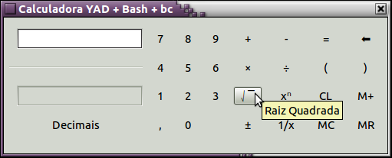
UAUUU! Com um acabamento desses isso não pode ser Shell! Mas é sim. Shell + YAD + bc. O trio trilha troços trufados! ;)
Pela figura, você pode ver que montamos uma apresentação plana, mas que ganha relevo quando o mouse se superpõe a um botão (mouse over). Pode-se notar também que é possível introduzir dicas (tips) na definição de cada botão. Vejamos o código:
$ cat calc.yad
#!/bin/bash
# Calculadora usando Bash, bc e yad

> ~/.mem # Será usado como memória
trap 'rm ~/.mem; exit' 0 2 3 15
yad --form --columns 8 --width 500 --no-buttons \
--title "Calculadora YAD + Bash + bc" \
--field='' '' --field :LBL '' \
--field :RO 'Casas decimais' \
--field 'Decimais!Ajusta a precisão \
do cálculo':BTN "@calc.s h '' PR" \
--field=7:BTN "@echo 1:%1\7" \
--field=4:BTN "@echo 1:%1\4" \
--field=1:BTN "@echo 1:%1\1" \
--field=,:BTN "@echo 1:%1\," \
--field=8:BTN "@echo 1:%1\8" \
--field=5:BTN "@echo 1:%1\5" \
--field=2:BTN "@echo 1:%1\2" \
--field=0:BTN "@echo 1:%1\0" \
--field=9:BTN "@echo 1:%1\9" \
--field=6:BTN "@echo 1:%1\6" \
--field=3:BTN "@echo 1:%1\3" \
--field '!Enche linguiça':BTN '' \
--field=+:BTN "@echo 1:%1\+" \
--field=:BTN "@echo 1:%1\x" \
--field='??!Raiz Quadrada':BTN \
'@./calc.sh '%1' RQ %3' \
--field='±!Troca sinal':BTN \
"@./calc.sh '%1' +-" \
--field=-:BTN "@echo 1:%1\-" \
--field=÷:BTN "@echo 1:%1\/" \
--field='x?!Potenciação':BTN "@echo 1:%1\^" \
--field='1/x!Inverte':BTN \
'@./calc.sh '%1' 1X %3' \
--field==:BTN '@./calc.sh '%1' = %3' \
--field=\(:BTN "@echo 1:%1\(" \
--field='CL!Limpa':BTN "@echo 1:" \
--field='MC!Limpa memória':BTN \
"@./calc.sh '' MC" \
--field=\?:BTN "@./calc.sh %1 AP" \
--field=\):BTN "@echo 1:%1\)" \
--field='M+!Adiciona à memória':BTN " \
@./calc.sh '%1' M+ %3" \
--field='MR!Trás conteúdo da memória':BTN \
"@./calc.sh '%1' MR"
Como vocês viram o formulário é somente um composto de um diálogo --form com diversos campos do tipo botão (:BTN). As contrabarras no fim da cada linha são para informar ao Shell que a linha não terminou e o texto continua na linha seguinte. Se não as tivesse usado, teria de escrever todo o comando em uma única linha e aí ficaria muito difícil de explicá-lo, de lê-lo e principalmente de depurá-lo.
No início do script, criei um arquivo chamado .mem no diretório home, em seguida montei uma trap para removê-lo quando o programa terminasse ou fosse (ex)terminado. ;) e a partir de então foi somente mais um comando yad, onde destaco:
Diretiva | Função
--form | que define que o diálogo com o operador será via um formulário;
--columns | que especifica a quantidade de colunas do formulário;
--width | para determinar a largura mínima;
--no-button | Para que o yad não adicione os botões padrão (Default) ao diálogo (OK e Cancelar)
--field | que define o nome, o tipo, as dicas e a ação de cada campo do formulário.
Como todos os demais campos são do tipo botão (:BTN), vamos entender como se comportam começando pela sua sintaxe:
—field ROTULO[!DICA]:BTN CMD
Onde:
ROTULO | é o que vem escrito no botão;
DICA | é uma ajuda que aparece em uma etiqueta popup;
:BTN | isso que o define como um campo botão;
CMD | comando que será executado quando o botão for clicado.
Se CMD começar com um arroba (@), é sinal que vou usar outros campos do formulário. Se nessa linha houver um %N, onde N é um numérico, ele será trocado pelo conteúdo do campo N (enésimo campo). Para mandar um valor para o campo M, onde M também é um número, ele deve ser mencionado com M:. Resumindo: %N recebe valor do enésimo campo e M: coloca o valor no emésimo campo.
Para entender melhor, veja esses exemplos:
$ yad --form --field _Botão:BTN 'ls -l'
Nesse caso quando Botão for clicado, mandará a saída do "ls -l" para a tela. O sublinha (_) antes do B, faz com que ele apareça sublinhado no formulário e <ALT>+<B> passa a ser a sua tecla de atalho.
$ yad --form --field '':TXT '' \
--field Botão:BTN "@echo 1:$(ls)"
Desta vez, foi criado mais um campo no formulário, este do tipo :TXT. Esse tipo de campo é para receber textos multilinhas. Nesse caso, como CMD começava com arroba (@), o 1:$(ls), diz para a saída do ls ser feita no primeiro campo (1:).
$ yad --form --field "Arquivo:FL" '' \
--field '1ª Linha:TXT' '' \
--field 'Mostre 1ª linha:BTN' "@./aux '%1'"
Neste último caso, temos um campo para seleção de arquivo (:FL), um do tipo texto multilinha (:TXT) e outro do tipo botão (:BTN). Esse último, quando clicado, chama o programa aux, (@./aux) passando o arquivo selecionado no primeiro campo (%1). Veja que aux também é um script e que ele verifica se o arquivo passado existe e, caso afirmativo, lista sua primeira linha. Veja só o aux; é um scriptizinho xexelento:
$ cat aux
[ -f $1 ] &&
echo 2:$(head -1 $1) ||
echo 2:$1 não é arquivo
Bem já vimos as diversas formas de trabalhar com botões, mas há algum tempo mandei para a Dicas-L um artigo que explicava o uso de botões no YAD. Se você se interessou pelo tema, pode vê-lo aqui. Então vamos voltar ao código da nossa calculadora: repare que existem somente dois tipos de ação com os campos do tipo botão:

1º tipo de ação:
—field=7:BTN "@echo 1:%1\7"
Especifica um botão cujo rótulo é 7 e que vai enviar para o campo 1 (1:), que é o mostrador, o valor do próprio campo 1 (%1) concatenado com 7. A contrabarra (\) antes do 7 é inócua pois é para o Shell e usei-a para separar o 1 do 7 de modo a não ser interpretado como o 17º campo (%17).

2º tipo de ação:
—field='M+!Adiciona à memória':BTN " \
@./calc.sh '%1' M+ %3"
Agora o rótulo do botão é M+. !Adiciona à memória será a dica que aparecerá em um diálogo popup quando o mouse estiver sobre este botão e executa o programa calc.sh passando 3 parâmetros:
%1 | O conteúdo do primeiro campo (mostrador);
M+ | O programa calc.sh executa diversas ações diferentes, de acordo com o ponto do qual ele foi chamado. Esse parâmetro (que é um literal) serve para que calc.sh saiba que tem que incrementar o conteúdo da memória;
%3 | O conteúdo do 3º campo, que é um somente leitura (Read Only - :RO) que guarda a precisão em decimais arbitrada pelo usuário.
Vejamos agora o programa calc.sh:
$ cat calc.sh
#!/bin/bash

Prec=$(expr $3 + 0 2> /dev/null) || Prec=0
case $2 in
=) Conta=$(tr 'x,' '*.' <<< "$1")
echo 1:$(echo "scale=$Prec; $Conta" |
bc | tr . ,) ;;
RQ) Conta=$(tr 'x,' '*.' <<< "$1")
echo 1:$(echo "scale=$Prec; sqrt ($Conta)" |
bc | tr . ,) ;;
1X) Conta=$(tr 'x,' '*.' <<< "$1")
echo 1:$(echo "scale=$Prec; 1/($Conta)" | \
bc | tr . ,) ;;
M+) Num=$([ -s ~/.mem ] && cat ~/.mem || echo 0)
Conta=$(tr , . <<< "$1")
bc <<< "$Conta + $Num" > ~/.mem ;;
MR) echo 1:$(cat ~/.mem) ;;
MC) > ~/.mem ;;
AP) echo 1:${1%?} ;;
PR) IFS='|' read lx lx Dec lx <<< \
"$(yad --form --columns 4 \
--title "Decimais" \
--field "\tInforme precisão":LBL '' \
--field "\tentre 0 e 9 decimais":LBL '' \
--field '' '' --field :LBL '' \
--field 1:BTN '@echo 3:1'
--field 4:BTN '@echo 3:4' \
--field 7:BTN '@echo 3:7' \
--field :BTN '' \
--field 2:BTN '@echo 3:2' \
--field 5:BTN '@echo 3:5' \
--field 8:BTN '@echo 3:8' \
--field 0:BTN '@echo 3:0' \
--field 3:BTN '@echo 3:3' \
--field 6:BTN '@echo 3:6' \
--field 9:BTN '@echo 3:9' \
--field :BTN '' --button OK)"
echo 3:$Dec ;;
+-) Conta=$(tr , . <<< "$1")
echo 1:$(echo "-1 * $Conta" | bc | tr . ,) ;;
*) echo 1:$1
esac
Se você não se assustar e prestar atenção, verá que este é um programa bastante simples, já que é basicamente um só case. Vou porém fazer alguns destaques:
O comando tr aparece com grande frequência isso se dá basicamente porque o mostrador da calculadora exibe virgula (,), sinal de dividir (÷), entre outros, que é necessário trocá-los antes para o bc entender e após, para que o resultado seja exibido de forma com vírgula decimal.
A linha de comando yad que se encontra neste programa, monta outro teclado para que o usuário possa escolher a precisão dos cálculos (quantidade de decimais)
Todos os itens do case que mandam a saída para o mostrador, terminam fazendo um echo 1:..., ou seja quando o calcula.yad recebe este valor, manda-o para o campo 1 que é o mostrador. A exceção é o comando yad que captura a precisão. Ela termina com um echo 3:$Dec, para que a quantidade de decimais ($Dec) escolhida pelo usuário seja enviada para o campo 3 da calculadora, que é um campo somente de leitura e foi criado para exibir este valor.
Espero que tenha sido claro na minha explicação, de forma a permitir que você compreenda que belíssima ferramenta é o YAD.
Júlio Cezar Neves é engenheiro de produção da UFRJ, pós-graduado em informática pelo IBAM, Analista de Suporte de Sistemas desde 1969. Ex-diretor de Informática do IplanRIO, órgão de TI da Prefeitura Municipal do Rio de Janeiro. É autor do livro "Programação Shell - Linux", uma das melhores publicações nacionais de programação shell, já em sua 9ª edição. Além disto, mantém também o site http://www.julioneves.com , que oferece um material completo sobre programação shell.
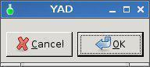

Last updated 04 May 2016
Yet Another Dialog - YAD is a simple tool for developing Graphical User Interfaces.
It's similar to Zenity but with lot more functionality.
It's a single binary and only about 144k for the Fatdog64 version, about 150k for tahrpup.
It will integrate with bash and gtkdialog scripts.
In it's simplest form, type yad in a terminal to get:

This help has been developed in the same order as yad's internal help.
Type yad --help-all to see all command line help.
Unfortunately this help does not provide enough information to use yad
to it's full potential. This is why I developed this tutorial.
I hope you find it usefull.
Code is highlighted in blue, warnings in red and Tips in magenta.
Comments and examples can be sent to smokey01@internode.on.net
Cheers
Smokey01 (Grant)
If you type yad --help-all > /root/yad-help.txt into a terminal it will make
a text file containing the built-in help.
Tip: I like to use Notecase to develop Help manuals because it's easy to use, has a nice interface and keeps all the data in one file. The file is actually HTML compliant which means you can view the file in your browser. Just make a copy of yad.ncd and call it yad.html.
All of the images in the file are saved as base64 format. If you wish to make a copy of any of the images, right mouse click and select Save Picture.
I generally keep a copy of this file at dttp://smokey01.com/yad
It may not be formatted all that well in the browser as I've desingned it for Notecase
but the information can easily be found with CTRL-F.
Credits
Thanks to the following contributors participating on the
Puppy Linux Forum: in order of appearance.
smokey01
CatDude
rg66
Geoffrey
L18L
kjdixo
slavvo67
mikeb
stemsee
seaside
Bert
rcrsn51
step
Argolance
Victor Ananjevsky (YAD Creator)
Resources
Get the latest copy of this YAD help here.
Where to obtain a copy of YAD?
https://sourceforge.net/projects/yad-dialog/
Once you have downloaded the source code it needs to
be compiled. You need to have the development tools loaded.
In Puppy Linux, simply load the Devx.
Once you have downloaded the source code which should
look something like yad-0.36.0.tar.xz. Extract it and open
a terminal in the extracted directory.
type the following commands, one at a time:
./configure --prefix=/usr
make
make install
You don't actually need to type make install. Simply copy
the yad binary to one of your bins, EG: /usr/bin
You can make the yad binary smaller by stripping it.
strip --strip-unneeded yad
That's it, you're ready to use Yad.
Another good place to get some help about Yad is:
https://groups.google.com/forum/#!forum/yad-common
Also on the Puppy lInux forums at:
http://murga-linux.com/puppy/viewtopic.php?t=97458
General Options
This is where you will find the general options which contain the majority of commands
that you would likely use on a daily basis.
Each of the options are explained below in the sub menus.
In each case I will try to provide an example and some form of output.
This will allow you to cut & paste the code to save you some time and
also see the result of the command.
--title
A custom title can be added to the bar by adding the --title option.
yad --title "This is my title"
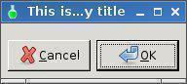
You will notice all the text in the default dialog does not fit.
To make the dialog wider, use the --width option.
--window-icon=ICONPATH
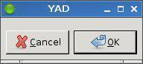

This allows you to choose your own icon.
You may choose one from the available icons in gtk-dialog such as:
yad --window-icon=gtk-yes
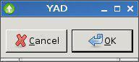

Which will give you a green ball on the title bar.
You can also select your own icon by defining the path to it.
yad --window-icon=/root/up.png

Of course for this to work the icon file must be available.
--width=WIDTH
To make the dialog a bit wider add the --width option
yad --title "This is my title" --width=200

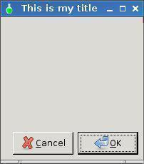

--height=HEIGHT
There is also a height option.
yad --title "This is my title" --width=200 --height=200
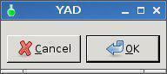

--geometry=WxH+X+Y
This command allows you to set the Width and Height and where on the screen to place the dialog.
For example: Suppose you want to create a dialog 400 pixel wide,
400 pixels high dialog at location X in pixels 512 and Y at 384 pixels.
If your screen resolution was 1024 x 768 then the top left corner of your 400 x 400 dialog should be in the centre of your screen.
yad --geometry=400x400+512+384
Now if you wanted the centre of your dialog to be in the centre of your screen you would type:
yad --geometry=400x400
Simply leave off the X and Y coordinates. X=horizontal, Y=vertical.
Just remember, there are minimum defaults. You can't make the dialog smaller than the default size.
Try yad --geometry 1x1

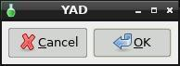

As you can see it's clearly bigger than 1x1.
Be careful though, because it will let you define a much bigger dialog than your screen size.
If you try yad --geometry 3000x3000 your complete screen will be consumed unless your screen size is bigger than 3000x3000.
Press the Enter Key to return to normality.
--timeout
The --timeout command closes the dialog after a specified time.
yad --timeout=10 will automatically close the dialog after 10 seconds.
You can press Enter, click on Ok or Cancel to close it quicker.
--timeout-indicator=POS
This will display a dialog and also a countdown progress bar, very cool.
yad --timeout=10 --timeout-indicator=top
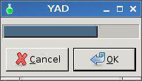
You need to use the --timeout command with the --timeout-indicator
You will find many commands depend on others as you work through the tutorial.
--text=TEXT
Place text on the dialog.
yad --text="Good Morning"
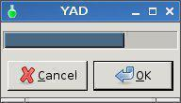

--text-align
To justify text use --text-align=TYPE where type can be left, right or center.
yad --text="Good Morning" --text-align=center
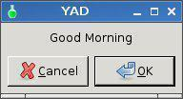

You need to use the --text-align command with --text command.
--image=IMAGE
This will allow you to place an image in your dialog box.
yad --image /root/iow2.jpg
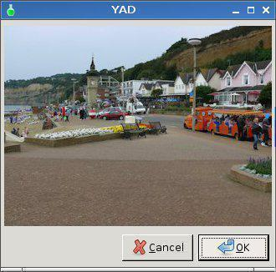
--image-on-top
--image-on-top Show image above the main widget
yad --image=info --text="widget is right of image" --entry
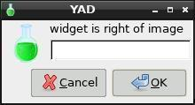
yad --image=info --image-on-top --text="widget is bottom of image" --entry
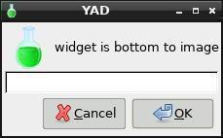

It has nothing to do with the dialog having focus like --on-top
--icon-theme=THEME
--icon-theme=THEME Use specified icon theme instead of default
Mmm still struggling with this
--expander=TEXT
--expander=TEXT shows hidden text.
yad --entry --expander="click here to show entry"
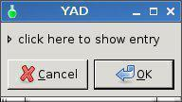

Click on the twistie to show hidden entry box.
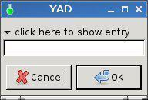
Whatever you type is parsed like the script below.
#!/bin/sh
ANSWER=`yad --entry --expander="click here to show entry"`
yad --text="You typed $ANSWER in the entry box"
--button=NAME:ID
This command allows you to add your own buttons to the dialog.
Let's create three button. We will call them Floppy, Preferences and Information.
yad --button=gtk-floppy:0 --button=gtk-preferences:0 --button=gtk-info:0
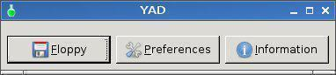

It retrieves the default gtkdialog icons.
To see what is available paste the below into a script.
#! /bin/bash
export MAIN_DIALOG='
<vbox>
<frame Stock>
<tree rules_hint="true" exported_column="1">
<height>400</height><width>250</width>
<label>Stock ID</label>
<item stock="gtk-dialog-authentication">gtk-dialog-authentication</item>
<item stock="gtk-dialog-info">gtk-dialog-info</item>
<item stock="gtk-dialog-warning">gtk-dialog-warning</item>
<item stock="gtk-dialog-error">gtk-dialog-error</item>
<item stock="gtk-dialog-question">gtk-dialog-question</item>
<item stock="gtk-dnd">gtk-dnd</item>
<item stock="gtk-dnd-multiple">gtk-dnd-multiple</item>
<item stock="gtk-about">gtk-about</item>
<item stock="gtk-add">gtk-add</item>
<item stock="gtk-apply">gtk-apply</item>
<item stock="gtk-bold">gtk-bold</item>
<item stock="gtk-cancel">gtk-cancel</item>
<item stock="gtk-cdrom">gtk-cdrom</item>
<item stock="gtk-clear">gtk-clear</item>
<item stock="gtk-close">gtk-close</item>
<item stock="gtk-color-picker">gtk-color-picker</item>
<item stock="gtk-convert">gtk-convert</item>
<item stock="gtk-connect">gtk-connect</item>
<item stock="gtk-copy">gtk-copy</item>
<item stock="gtk-cut">gtk-cut</item>
<item stock="gtk-delete">gtk-delete</item>
<item stock="gtk-directory">gtk-directory</item>
<item stock="gtk-disconnect">gtk-disconnect</item>
<item stock="gtk-edit">gtk-edit</item>
<item stock="gtk-execute">gtk-execute</item>
<item stock="gtk-file">gtk-file</item>
<item stock="gtk-find">gtk-find</item>
<item stock="gtk-find-and-replace">gtk-find-and-replace</item>
<item stock="gtk-floppy">gtk-floppy</item>
<item stock="gtk-fullscreen">gtk-fullscreen</item>
<item stock="gtk-goto-bottom">gtk-goto-bottom</item>
<item stock="gtk-goto-first">gtk-goto-first</item>
<item stock="gtk-goto-last">gtk-goto-last</item>
<item stock="gtk-goto-top">gtk-goto-top</item>
<item stock="gtk-go-back">gtk-go-back</item>
<item stock="gtk-go-down">gtk-go-down</item>
<item stock="gtk-go-forward">gtk-go-forward</item>
<item stock="gtk-go-up">gtk-go-up</item>
<item stock="gtk-harddisk">gtk-harddisk</item>
<item stock="gtk-help">gtk-help</item>
<item stock="gtk-home">gtk-home</item>
<item stock="gtk-index">gtk-index</item>
<item stock="gtk-indent">gtk-indent</item>
<item stock="gtk-info">gtk-info</item>
<item stock="gtk-unindent">gtk-unindent</item>
<item stock="gtk-italic">gtk-italic</item>
<item stock="gtk-jump-to">gtk-jump-to</item>
<item stock="gtk-justify-center">gtk-justify-center</item>
<item stock="gtk-justify-fill">gtk-justify-fill</item>
<item stock="gtk-justify-left">gtk-justify-left</item>
<item stock="gtk-justify-right">gtk-justify-right</item>
<item stock="gtk-leave-fullscreen">gtk-leave-fullscreen</item>
<item stock="gtk-missing-image">gtk-missing-image</item>
<item stock="gtk-media-forward">gtk-media-forward</item>
<item stock="gtk-media-next">gtk-media-next</item>
<item stock="gtk-media-pause">gtk-media-pause</item>
<item stock="gtk-media-play">gtk-media-play</item>
<item stock="gtk-media-previous">gtk-media-previous</item>
<item stock="gtk-media-record">gtk-media-record</item>
<item stock="gtk-media-rewind">gtk-media-rewind</item>
<item stock="gtk-media-stop">gtk-media-stop</item>
<item stock="gtk-network">gtk-network</item>
<item stock="gtk-new">gtk-new</item>
<item stock="gtk-no">gtk-no</item>
<item stock="gtk-ok">gtk-ok</item>
<item stock="gtk-open">gtk-open</item>
<item stock="gtk-paste">gtk-paste</item>
<item stock="gtk-preferences">gtk-preferences</item>
<item stock="gtk-print">gtk-print</item>
<item stock="gtk-print-preview">gtk-print-preview</item>
<item stock="gtk-properties">gtk-properties</item>
<item stock="gtk-quit">gtk-quit</item>
<item stock="gtk-redo">gtk-redo</item>
<item stock="gtk-refresh">gtk-refresh</item>
<item stock="gtk-remove">gtk-remove</item>
<item stock="gtk-revert-to-saved">gtk-revert-to-saved</item>
<item stock="gtk-save">gtk-save</item>
<item stock="gtk-save-as">gtk-save-as</item>
<item stock="gtk-select-color">gtk-select-color</item>
<item stock="gtk-select-font">gtk-select-font</item>
<item stock="gtk-sort-ascending">gtk-sort-ascending</item>
<item stock="gtk-sort-descending">gtk-sort-descending</item>
<item stock="gtk-spell-check">gtk-spell-check</item>
<item stock="gtk-stop">gtk-stop</item>
<item stock="gtk-strikethrough">gtk-strikethrough</item>
<item stock="gtk-undelete">gtk-undelete</item>
<item stock="gtk-underline">gtk-underline</item>
<item stock="gtk-undo">gtk-undo</item>
<item stock="gtk-yes">gtk-yes</item>
<item stock="gtk-zoom-100">gtk-zoom-100</item>
<item stock="gtk-zoom-fit">gtk-zoom-fit</item>
<item stock="gtk-zoom-in">gtk-zoom-in</item>
<item stock="gtk-zoom-out">gtk-zoom-out</item>
</tree>
</frame>
<hbox>
<button cancel></button>
<button ok></button>
</hbox>
</vbox>
'
gtkdialog --program=MAIN_DIALOG
Icons
Entering the following in a terminal:
Using the following command works fine:
yad --button=gtk-ok:0
However, sometimes the icons don't show, for example:
yad --button=gtk-color-picker:0
To use the gtk-color-picker icon and many others you need to use the separator
but it needs to be escaped. Note the \ before the !
yad --button=Colours\!gtk-color-picker:0
When using the same commands in a script, escaping the ! is not required.
--no-buttons
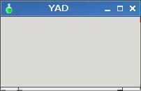
As it says, this will create a dialog without any buttons.
yad --no-buttons --width=200 --height=100

I added the --width and --height commands or the dialog would have been very small.
It's actually the buttons on the default dialog that set the width.
Example:
yad --no-buttons
Not very attractive.
--no-markup
--no-markup Don't use pango markup language in dialog's text
Not sure what this means
--borders=NUMBER
This sets the width of the border around the dialog.
yad --borders=100 --text="Wow, that's a wide border"
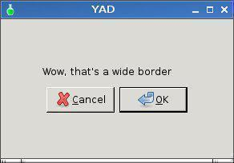
--always-print-result
Haven't worked this one out yet.
--selectable-labels
This allows you to select the text from a dialog. The default in no select.
yad --text="nah nah you can't select me"
yad --text="Ah ooh, now you can" --selectable-labels
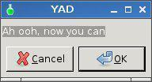

This means you can copy and paste from the dialog.
--sticky
Makes the GUI visible on all desktops.
--fixed
The --fixed command removed the ability to resize the dialog.
Note the resizing handles have disappeared.
yad --fixed
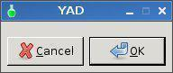

--on-top
Places the dialog on top of other windows.
#!/bin/sh
yad --title="ON-TOP" \
--text="I'm a window that is always on top of (in the foreground of)
other windows, even if you select them, I won't disappear.
Specially handy for dragging stuff from other windows to here." \
--on-top
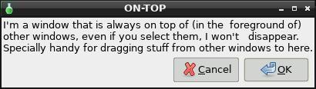

Here s an example of --on-top 'window above other windows always except
when full screen such as video etc'.
Also an example of: --skip-taskbar This prevents the script showing in the
task bar.
#!/bin/sh
yad --geometry=100x100 --on-top --text="Drag-n-drop directory or files here \nThey will be added to ref list" --no-buttons --skip-taskbar --dnd --cmd echo $1 | sed 's/^.......//' >> /root/references.txt
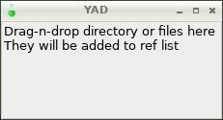
--center
This is an easy way to position the dialog in the centre of your screen.
yad --center
--mouse
This will place the dialog at the position where your mouse cursor is.
yad --mouse
--undecorated
This command removed the title bar and borders from the dialog.
yad --undecorated
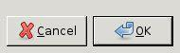

If you do --no-buttons and --undecorated like this:
yad --no-buttons --undecorated
You will have trouble closing the dialog unless you use a --timeout=5
yad --no-buttons --undecorated --timeout=5 --text="Look ma no buttons and borders"
yad --no-buttons --undecorated --timeout=5 --text="Look ma no buttons and borders"
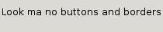

--skip-taskbar
As it says. It doesn't show the dialog in the task bar.
Yes, I know this may be confusing so here is a shot of my task bar with and without the
--skip-taskbar command.
yad --skip-taskbar
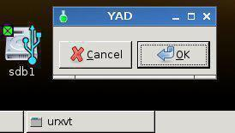

yad
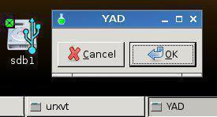
--kill-parent
I think this kills the parent if it's been spawned.
More experimenting required.
--print-xid
--print-xid Print X Window Id to the stderr
More research required
Calendar options
This will display a calendar showing the current Day, Month and Year.
yad --calendar
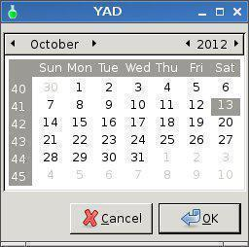

It will also show the date selected so you can parse it to something else.
You can capture the date as a variable like this and parse to to another dialog:
#!/bin/sh
THEDATE=`yad --calendar`
yad --text="You chose $THEDATE"
--day=DAY
yad --calendar --day=20 sets the 20th day of the current month.
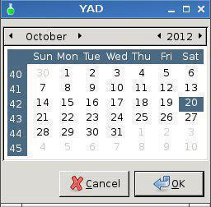

--month=MONTH

yad --calendar --month=2 sets the month of the current year and day.
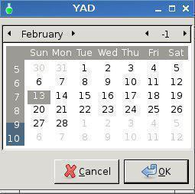
--year=YEAR
yad --calendar --year=2012 sets the month of the current year and day.
Houston we have a problem. The year switch doesn't appear to work in Fatdog.
yad --calendar --year=2012
Bring up the current date not 2012 as you would expect.
However this works:
yad --calendar --year=2012 --month=2 --day=21
--date-format=PATTERN
yad --calendar will produce the following output of the current day month and year:
25/01/15
yad --calendar --date-format=%d%m%y
Output will be: 250115
--details=FILENAME
Not sure what this does.
Color selection options
--fore and --back works only for --text-info dialog
The --text-info command reads it's data from an external file.
--init-color=COLOR
Initial colour
yad --color --init-color=red
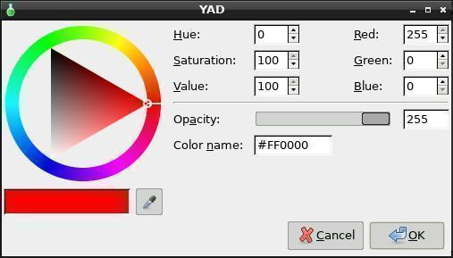
or
yad --color --init-color=#008080
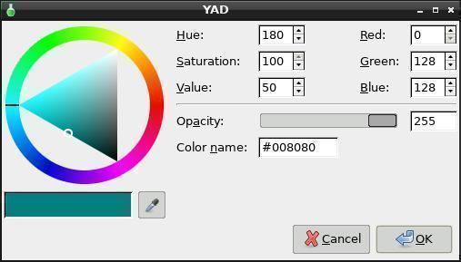
Output: #008080
--palette=FILENAME
--extra
Drag & Drop options
This will make the GUI able to Drag and Drop.
When you drop a file on the GUI it will output the filepath.
yad --dnd

After dropping a file on the dialog you get this:
file:///root/yad.jpg
Pipe it to sed to get a proper path:
yad --dnd | sed 's/^.......//'
/root/Desktop/tmp
You can also drag and drop multiple files onto the gui.
Here is an example of a md5sum check.
Create the script below and make it executable.
Execute the script, drop files onto it and press OK.
#!/bin/sh
v=`yad --text="Drop your file(s) here:" --dnd | sed 's/^.......//'`
o=`md5sum $v`
yad --width=500 --height=200 --title="MD5SUM Check" --text="$o"
The first GUI looks like this:
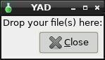
After you drop the files and click Close you get:
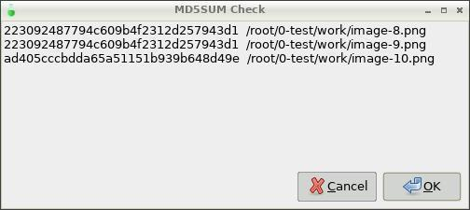
Another method is to create the script below. Drag it to your desktop
then drag and drop files onto the script. If you drop more than one
file at a time you will have to close the top GUI to see the next one.
The script is designed for single file drops.
#!/bin/sh
killall yad
for i in "$@"; do
case "${i}" in
*)
o=`md5sum "${i}"`
yad --title="CheckSum Calculator" --form --field="" "$o" --no-buttons --geometry=550x50+500+0
;;
esac
done
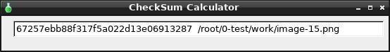

--tooltip
You can use tooltips on this option by simply adding --tooltip. Adding this command alone is not enough. You see, --tooltip steals the text from the --text command so you need to do something like this:
yad --dnd --text "This is a tooltip" --tooltip
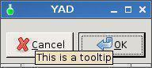

You should also notice the text is no longer displayed on the dialog.
If you remove --tooltip from the command, EG:
yad --dnd --text "This is a tooltip"
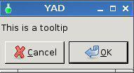
The text has returned.
--command=CMD
This is a very nice feature.
This provides the ability to drop a file or files onto the dialog then
call an application or a script and do something with it.
Lets assume we want to drop a few graphic files onto the dialog
then open them in your default graphics viewer. Let's also assume you viewer is viewnior.
Copy and paste the following script to your text editor and make the file executable.
#!/bin/sh
ANSWER=`yad --text="Drag graphics files here" --dnd --tooltip`
viewnior $ANSWER
When you run this script, it will popup a dialog. If you hover your mouse over
it you will see the tooltip. Now drag and drop one or many graphic files on the dialog.
When you click on the Ok button Viewnior will open and display your graphic files.
Text entry options
Show an entry dialog.
yad --entry
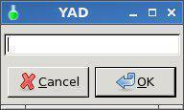

--entry-label=TEXT
Add a label to the entry dialog.
yad --entry --entry-label="Label"
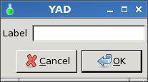

You need to use both the --entry and --entry-label=TEXT commands.
--entry-text=TEXT
Now we will add to the previous example and add --entry-text.
yad --entry --entry-label="Label" --entry-text="Type here"
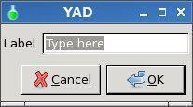
You can also add the --text command to the dialog and center it.
yad --text-align=center --text="Hello" --entry --entry-label=Label --entry-text="Type here"
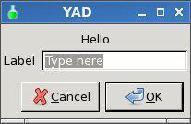
When you press enter the "Type here" or whatever text you entered will be parsed. To capture the parsed input you can set the entire dialog to a variable like this:
#!/bin/sh
INPUTTEXT=`yad --text-align=center --text="Hello" --entry --entry-label=Label --entry-text="Type here"`
yad --text="You entered: $INPUTTEXT"
Markup
The text accepts markup the GUI height and width.
#!/bin/sh
yad --title="Golf Club" --height=200 --width=400 --text="<span foreground='blue'><b><big><big>Please enter your details:</big></big></b></span>" \
--form \
--field="<b><big><big>Golflink Number</big></big></b>" \
--field="<b><big><big>Score</big></big></b>" \
As you can see the text is now bigger.
--hide-text=TEXT
This command allows you to hide the text when you type. EG: Passwords or similar.
yad --text-align=center --text="Hello" --entry --entry-label=Label --entry-text="Type here" --hide-text
If you omit the --entry-text="Type here" the entry box will be blank.
yad --text-align=center --text="Hello" --entry --entry-label=Label --hide-text
You will also notice that you don't need to add any text to the --hide-text command.
--completion
The --completion command searches the data in the script and matches it against your input. Run the script and type b into the entry box. You will be given a choice of three words beginning with b.
#!/bin/sh
yad --title="--completion" --completion \
--entry="Name:" "" \
"Abba" "Bark" "Bungy Boy" "Billy" "Charlie" "Delta" "Echo" | while read line; do
ENTRY=`echo $line | awk -F',' '{print $1}'`
echo $ENTRY
done
Now after typing b
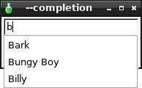
Whatever you choose will become the output.
--numeric
yad --entry --numeric
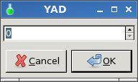
Uses a spin button for text entry and won't allow character entry.
Entering data can be manually typed in.
There are 6 decimal points. EG: 100.000000
--editable
I haven't worked this one out yet.
Can edit the text.
--licon=IMAGE
yad --entry --licon=/usr/local/lib/X11/pixmaps/home48.png
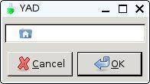
Notice the icon justified to the left of the entry box.
--licon-action=CMD
yad --entry --licon=/usr/local/lib/X11/pixmaps/home48.png --licon-action=rox
Click on the rox icon in the entry field to launch rox.
--ricon=IMAGE
yad --entry --ricon=/usr/local/lib/X11/pixmaps/home48.png
If the icon cannot be found the yad icon will be used.
Notice the icon justified to the right of the entry box.
--ricon-action=CMD
yad --entry --ricon=/usr/local/lib/X11/pixmaps/home48.png --ricon-action=rox
Click on the rox icon in the entry field to launch rox.
File selection options
yad --file will invoke the file select dialog
As you can see the dialog is a bit small to display text. Try increasing width and height.
yad --width=500 --height=400 --file
--filename=FILENAME
The file selection options need to be prefixed by yad --file EG:
yad --file --filename=/root/hello.txt --width=400 (/root/hello.txt must exist)
This will select /root/hello.txt
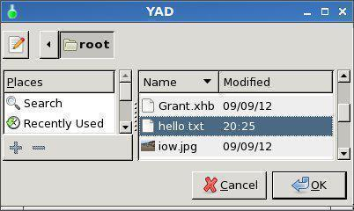
Notice the file hello.txt is already selected.
--multiple
This option will allow you to select multiple files at the same time.
yad --file --multiple --width=600 --height=400
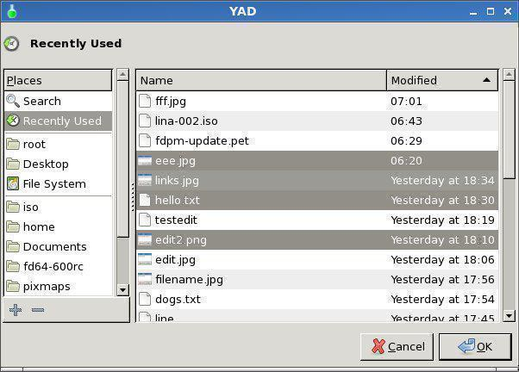
Use the Ctrl or Shift keys when selecting.
It's all well and good being able to bring up a file select dialog but it needs to be able to parse the
information selected.
One way is to assign the file selection dialog to a variable like:
CHOOSEFILE=`yad --file --width=600 --height=400`
To see how it works try selecting a graphics file in a script like this:
#!/bin/sh
CHOOSEFILE=`yad --file --width=600 --height=400`
viewnior $CHOOSEFILE
Make sure you make the script executable. In Rox, right click on the file, select Permission and
then click on the Yes button.
Note the little mark before yad ` and after 400` this is called a backtick, it's the key under the Esc key.
--directory
The --directory command is used to select a directory/folder.
yad --file --directory --width=600 --height=400
Only directories will be displayed, not files.
--save
yad --file --directory --save --width=600 --height=400
This provides a way to save a file. If you type hello.txt in the name field and click on the root
directory, then press OK the output will be: /root/hello.txt
--separator=SEPARATOR
--confirm-overwrite=[TEXT]
--file-filter=NAME | PATTERN1 PATTERN2 ...
The --file-filter command will filter the files.
If you only want to display jpg and png files then:
yad --width=600 --height=400 --file --file-filter "Graphic files | *.jpg *.png"
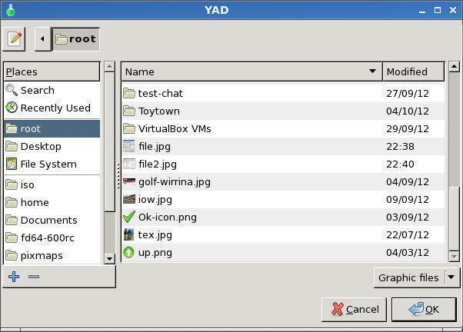
Directories will also be displayed along with jpg and png files.
Font selection options
yad --font will invoke the font dialog.
Output in the terminal is:
Sans 10
If you were to select the Bold Style then:
Sans Bold 10
To pass the three, (Family, Style, Size) separately, you
might need to do something like this:
#!/bin/sh
yad --font | while read line; do
STL=`echo $line | grep -o "Bold\|Italic\|Oblique\|Condensed\|Medium"` #Might need to add more styles
STYLE=`echo $STL`
SIZE=`echo $line | awk '{print $NF}'`
if [ "$STYLE" = "" ]; then
NAME=`echo $line | awk -F"$SIZE" '{print $1}'`
else
NAME=`echo $line | awk -F"$STYLE" '{print $1}'`
fi
echo $NAME $STYLE $SIZE
done
--fontname=FONTNAME
This command sets the font type.
You can also specify bold, italic, and size. Note the quotes.
yad --width=250 --text-info < hello.txt --fontname="Serif bold italic 20"
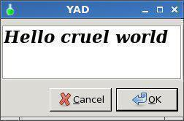
--preview=TEXT
The --preview command allows you to set the preview text
yad --font --preview "This is the preview text"
The = symbol after preview is optional.
Form options
http://www.thelinuxrain.com/articles/multiple-item-data-entry-with-yad
http://rpm.pbone.net/index.php3/stat/45/idpl/17003956/numer/1/nazwa/yad
holidays=$(echo "Gold Coast,Bali,Phuket,Sydney,other")
yad --title="My YAD Test" --text="Please enter your details:" \
--image="/usr/share/icons/phone.png" \
--form --date-format="%-d %B %Y" --separator="," --item-separator="," \
--field="First Name" \
--field="Last Name" \
--field="Status":RO \
--field="Date of birth":DT \
--field="Last holiday":CBE \
--field="List your 3 favourite foods:":TXT \
"" "" "All round good guy" "Click calendar icon" "$holidays"
--field=LABEL[:TYPE]
Add field to form (TYPE - H, RO, NUM, CHK, CB, CBE, FL, SFL, MFL, DIR, CDIR, MDIR, FN,
DT, CLR, BTN, LBL or TXT)
This is a simple form using the --field widget.
yad --form --field=LABEL
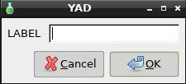
At the top of this page you will see many different field types.
Lets work our way through them one by one.
H - Hidden
The Type: H Hides the text, like a password.
yad --form --field=LABEL:H
When you click on the OK button the text is revealed in the CLI (Command Line Interface).
smokey01|
Notice the | (pipe) at the end of smokey01, this is called a seperator.
More about thas later.
RO - Read Only
You might have guessed Type:RO mean Read Only. But if you run the following command:
yad --form --field=LABEL:RO
You won't see any text so we need to add some default text like this:
yad --form --field=LABEL:RO "Default Text"
Now you can see some text but it's greyed out.
NUM - Number
Type:NUM is for Numbers. Only numbers can be entered into this field.
yad --form --field=LABEL:NUM
Notice it has a spin box on the right hand side. This can be used to increase or decrease the value.
To make this a bit more useful we can set a default number, lets make it 10.
yad --form --field=LABEL:NUM "10"
To control a Minimum and Maximum number, say 0.0 - 20.0:
yad --form --field="Number:NUM" 0\!0..20\!1\!1
Notice the '\' escape characters. These are not required in a script but are from the CLI.
I will provide a script example at the end of the form options.
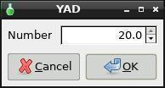
I hear you ask, what about fractions. Lets set the Minimum to 0.0 and the
Maximum to 100.0 with 0.5 increments.
yad --form --field="Number:NUM" 0\!0..100\!0.05\!2
CHK - Check Box
Type CHK places a check box in the form.
yad --form --field="Number:CHK"
Checked returns True, Unchecked returns False.
CB - Combo Box
Field Type CB refers to Combo Box. Once again note the escape '\' characters.
yad --form --field="ComboBox:CB" One\!Two\!Three
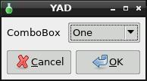
CBE - Combo Box Editable
Field Type CBE means the Combo Box is Editable. In other words
you can add data on the fly by typing.
yad --form --field="ComboBox:CBE" One\!Two\!Three
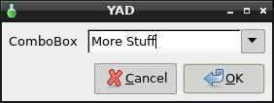
You are not restricted to the three choices.
When you press OK in the above example
More Stuff| is returned.
CE - Entry with Completion
The field Type CE completes a string from matching data. In the example below
There are a number of vehicle makes. If you type h in the entry box you will
be given a choice of vehicles listed that begin with h EG: Holden and Honda.
Run the script, you will get the idea.
#!/bin/sh
yad --title="Vehicle Makes" --form --field ':CE' 'Holden!Ford!Toyota!Honda!Fiat!Mitsubishi!Nissan!Aston Martin!Rolls Royce!Jaguar!Renault!Bentley!Citroen'
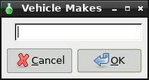
Then type in h and you're given two choices.
FL - Folder List
Field type FL means Folder List.
yad --form --field="Folder List:FL"
Notice (None) is displayed, this is because a path was
not specified. Lets add a path to /root:
yad --form --field="Folder List:FL" /root
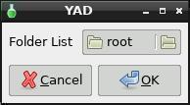
SFL - Select File List
Field Type SFL means select a file from a list.
yad --form --field="Folder List:SFL" /root
Now you can drill down through the folders, starting
at /root, and select a file. The output will be the full
/path/filename|
MFL - Multiple File List
Field Type MFL allows you to select multiple files. You need to
hold the CTRL key while left mouse clicking to do so.
yad --form --field="Folder List:MFL" /root
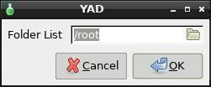
The dialog looks the same as SFL however, when you select
multiple files the /path/filenames are separated by a '!'
/root/cruise0002.jpg!/root/cruise0003.jpg!/root/cruise0004.jpg|
As you can see I selected three files.
DIR - Directory Structure
Field Type DIR display a basic directory structure.
yad --form --field="Folder List:DIR" /root
CDIR - Select/Create Folders
Field Type CDIR is used to select or create folders.
yad --form --field="CDIR:CDIR" /root
MDIR - Select Folders
Field MDIR is used to select folders only.
yad --form --field="MDIR:MDIR" /root
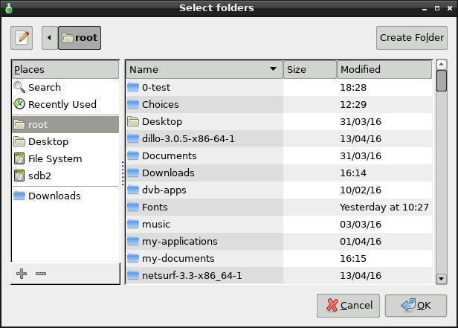
FN - Font Dialog
Field FN is used to display a Font Picker.
yad --form --field="Font::FN"
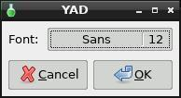
When you click on the Font Button:
Tip: Did you notice "Font::FN" in the command?
The first colon is added to the Label and the second defines the field type.
DT - Date Picker
Field DT provides a Date Picker
yad --form --field="Date::DT"
Notice the little Calendar in the right of the field.
When you click on it, you get a Calendar.
Select the date and click on OK. The following is returned:
20/04/16|
CLR - Color Picker
Field CLR provides a colour Picker.
yad --form --field="Color::CLR"
You can set a default colour by adding the Hex code:
yad --form --field="Color::CLR" "#F507D0"
Click the Button to open the Colour Selector.
To make a selection you must click on the triangle and press enter.
Clicking on the wheel just moves the triangle.
Tip: In the Color name field you can type recognised names like teal to select a colour.
There are hundreds defined so this may be an easier way to choose your colour.
BTN - Field Button
Field BTN is for making Buttons.
yad --form --field="Button::BTN"
Now a button wouldn't be much use if it didn't
do something. Now we add a command so it
will open your default image viewer.
yad --form --field="Image Viewer::BTN" defaultimageviewer
LBL or TXT
Field Type LBL means Label and TXT means Text.
Tip: Whatever you put inside the quotes before the colon becomes the Label.
yad --form --field="This is a Label Maaate:LBL"
Something similar with the TXT type.
yad --form --field="Text::TXT" "This is a Text box where you can display various information."
Form Example
This code was written as a GUI for 01micko's wonderful little CLI wallpaper maker.
The Code can be obtained here.
#!/bin/sh
#Written by Smokey01
#20 April 2016
#Requires YAD and 01micko's mkwallpaper
yad --title="Make Wallpaper" --form --separator="," \
--field="Name:" "Slacko630" \
--field="Label:" "Slacko-6.3.0" \
--field="Font::FN" "Sans 50" \
--field="Format::CB" "png!svg" \
--field="Width:" "1024" \
--field="Height:" "768" \
--field="Embossed::CB" "Yes!No" \
--field="Gradient Offset::NUM" 0!0..1!0.05!2 \
--field="Gradient Angle::NUM" 0!0..20!0.05!2 \
--field="Colour::CLR" "#008080" \
"" "" "" "" "" "" "" "" "" "" | while read line; do
IMAGENAME=`echo $line | awk -F',' '{print $1}'`
LABELNAME=`echo $line | awk -F',' '{print $2}'`
FONT=`echo $line | awk -F',' '{print $3}'`
FORMAT=`echo $line | awk -F',' '{print $4}'`
WIDTH=`echo $line | awk -F',' '{print $5}'`
HEIGHT=`echo $line | awk -F',' '{print $6}'`
EMBOSSED=`echo $line | awk -F',' '{print $7}'`
OFFSET=`echo $line | awk -F',' '{print $8}'`
ANGLE=`echo $line | awk -F',' '{print $9}'`
COLOUR=`echo $line | awk -F',' '{print $10}'`
echo $NAME $LABEL $FONT $FORMAT $WIDTH $HEIGHT $EMBOSSED $OFFSET $ANGLE $COLOUR
# Convert the colour string xxxxxx to xx xx xx RGB
multi="0.003906"
red=`echo $COLOUR | cut -c2-3`
green=`echo $COLOUR | cut -c4-5`
blue=`echo $COLOUR | cut -c6-7`
# Convert colour string to decimal
fred="$((16#$red))"
fgreen="$((16#$green))"
fblue="$((16#$blue))"
# Scale the decimal numbers to 01micko's range
r=$(echo "$fred * $multi" | bc)
g=$(echo "$fgreen * $multi" | bc)
b=$(echo "$fblue * $multi" | bc)
# Separate font type from size
FONTY=`echo $FONT | awk '{ $NF = ""; print $0}'`
SIZEY=`echo $FONT | rev | cut -d' ' -f1 | rev`
# Run mkwallpaper, 01micko's cli application
mkwallpaper -n "$IMAGENAME" -l "$LABELNAME" -f "$FONTY" -p $FORMAT -x $WIDTH -y $HEIGHT -s $SIZEY -k $EMBOSSED -o "$OFFSET" -z "$r $g $b" -a $ANGLE
# Fixed a minor bug in the SVG format. Change pt to px to make sizing work properly .
sed -i 's/pt/px/g' /usr/share/backgrounds/"$IMAGENAME.svg"
# Display wallpaper
defaultimageviewer /usr/share/backgrounds/$IMAGENAME.$FORMAT
done
This is what it looks like.
--align=TYPE
Set alignment of fields labels (left, center or right)
#!/bin/sh
yad --form --align=right \
--field="Label Aligned Right":LBL \
Label aligned right. Left and Center is also possible.
--columns=NUMBER
Set number of columns in form.
#!/bin/sh
yad --form --columns=2 \
--field="Firstname:" "Billy" \
--field="Age:" "21" \
--field="Lastname:" "Bloggs" \
--field="Sex::"CB "Male!Female" \
Notice the order of the fields counting from top to bottom. The first two
fields are on the left while 3rd and 4th fields are on the right.
--separator=SEPARATOR
The default --separator is the | symbol, also known as a pipe.
#!/bin/sh
yad --form \
--field="Firstname:" "Billy" \
--field="Lastname:" "Bloggs" \
When you run the above script in a terminal you get this:
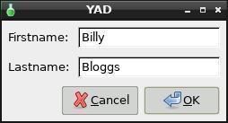
Then click OK you get this Output:
Billy|Bloggs|
Notice the pipes after Billy and Bloggs. This may be fine but what
if you wanted spaces between Billy and Bloggs.
This is where you use the --separator command after the --form
command. Let's add --separator=" " to the original script.
#!/bin/sh
yad --form --separator=" " \
--field="Firstname:" "Billy" \
--field="Lastname:" "Bloggs" \
The GUI looks the same but look at the output when OK is pressed.
Output: Billy Bloggs
--item-separator=SEPARATOR
Set the separator character for combobox or scale data.
You may have noticed on the --columns command I used a CB (Combo Box)
We want to add a few items to the CB so we need to use a separator character
to separate them. The default character is the exclamation mark !
#!/bin/sh
yad --form \
--field="Sex::"CB "Male!Female!Other" \
Output: Make|
Now lets be bold and change both default separators,
the --separator and --item-separator.
#!/bin/sh
yad --form --separator=" " --item-separator="," \
--field="Sex::"CB "Male,Female,Other" --item-separator="," \
The GUI looks the same but the CB choices are now separated by
a comma instead of an exlamation mark and the pipe has disappeared
from the end of the output. I selected Other and clicked on OK.
Output: Other
--date-format=PATTERN
Set the format for the returned date.
Run this script in a terminal:
#!/bin/sh
yad --form --separator=" " --date-format="%-d %B %Y" \
--field="Date:":DT \
Click on the little calendar, choose a date, click OK
then click OK again.
Output: 26 April 2016
Here are some date and time format codes in alphabetical order:
%% a literal %
%a locale's abbreviated weekday name (Sun..Sat)
%A locale's full weekday name, variable length (Sunday..Saturday)
%b locale's abbreviated month name (Jan..Dec)
%B locale's full month name, variable length (January..December)
%c locale's date and time (Sat Nov 04 12:02:33 EST 1989)
%d day of month (01..31)
%D date (mm/dd/yy)
%e day of month, blank padded ( 1..31)
%h same as %b, locale's abbreviated month name (Jan..Dec)
%H hour :24 hour(00..23)
%I hour :12 hour(01..12)
%j day of year (001..366)
%k hour :24 hour(00..23)
%l hour :12 hour(01..12)
%m month (01..12)
%M minute (00..59)
%n a newline
%p locale's AM or PM
%r Time, 12-hour (hh:mm:ss [AP]M)
%s Seconds since 1970-01-01 00:00:00, (a GNU extension)
Note that this value is defined by the localtime system
call. It isn't changed by the '--date' option.
%S second (00..60)
%t a horizontal tab
%T Time, 24-hour (hh:mm:ss)
%U Week number of year with Sunday as first day of week (00..53)
%V Week number of year with Monday as first day of week (01..53)
If the week containing January 1 has four or
more days in the new year, then it is considered week 1;
otherwise, it is week 53 of the previous year, and the next week
is week 1. Similar to ISO 8601 (but not 100% compliant.)
%w day of week (0..6); 0 represents Sunday
%W week number of year with Monday as first day of week (00..53)
%x locale's date representation (mm/dd/yy)
%X locale's time representation (%H:%M:%S)
%y last two digits of year (00..99)
%Y year (1970...)
%z RFC-822 style numeric timezone (-0500) (a nonstandard extension)
This value reflects the current time zone.
Is not changed by the --date option.
%Z Time offset from UTC (-07) This generally consists of Time Zone+DST
Is not changed by the --date option.
Icons box options
--read-dir=DIRECTORY
--compact
--generic
--stdin
--item-width
--term=PATTERN
Use specified pattern for launch command in terminal (default: xterm -e %s)
--sort-by-name
--descend
List options
You can do some very cool things with the --list command.
yad --list --column=Name --column=Nickname --column=Age William Bill 40 Richard Dick 69
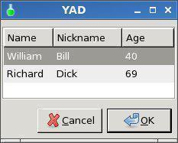
Lets have a look at a really simple but useful shopping List example.
First create a text file called /root/shopping.list
In this list type or copy the following data:
true
milk
false
bread
false
eggs
false
butter
false
tomato soupg
false
flour
false
steak
false
sausages
false
carrots
true
beans
Here is the yad program that reads the file and lets you select the items.
yad --height=300 --list --checklist --column=Buy --column=Item < /root/shopping.list
This is good but maybe you need to print the list so you can take it to the shop.
yad --button=gtk-print:0 --button=gtk-cancel:0 --height=300 --list --checklist --column=Buy --column=Item < /root/shopping.list > /root/printlist --print-column=2 --separator= && yad --print --add-preview --filename=/root/printlist
As you can see the OK button has been replaced with a Print button.
When you click on print, the Print dialog is invoked. You can Print Preview then Print the list if you wish.
--no-headers
Don't show column headers.
You need to use --column with the --list command but you don't have to display the headers.
yad --list --no-headers --column=Name --column=Nickname --column=Age William Bill 40 Richard Dick 69
--column=COLUMN[:TYPE]
Set the column header (TYPE - TEXT, NUM, FLT, CHK, IMG or TIP)
--column=STRING[:TYPE] Set the column header. TYPE may be:
TEXT type is default (default)
NUM for integers
FLT for double values.
CHK checkboxes are a boolean columns.
RD radio toggle are a boolean columns.
IMG may be path to image or icon name from currnet GTK+ icon theme.Size of
icons may be set in config file. Image field prints as empty value.
HD type means a hidden column. Such columns are not displayes in the list,
only in output.
TIP is used for define tooltip column.
yad --list --column=Age:num --column=Select:chk --column=Comment:text 22 true Good
--checklist
Use check boxes for first column
yad --checklist --list --column=Tick --column=Name --column=Nickname --column=Age false William Bill 40 false Richard Dick 69
--radiolist
Alias to checklist (deprecated)
No longer used. --radiolist will use --checklist.
yad --radiolist --list --column=Tick --column=Name --column=Nickname --column=Age false William Bill 40 false Richard Dick 69
--separator=SEPARATOR
Set output separator character. The default is "|"
yad --checklist --list --column=Tick --column=Name --column=Nickname --column=Age false William Bill 40 false Richard Dick 69
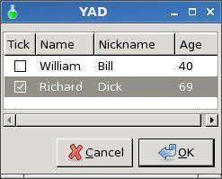
When you select Richard and click on OK, this is the output you get:
TRUE|Richard|Dick|69
Now if you add --separator=, to the command list:
yad --checklist --list --separator=, --column=Tick --column=Name --column=Nickname --column=Age false William Bill 40 false Richard Dick 69
Your output is:
TRUE,Richard,Dick,69,
--multiple
Allow multiple rows to be selected
When using the --checklist command you can select multiple rows. If you don't want a checklist then you need to use the --multiple command to select multiple rows.
Note: you also need to change the columns from 4 to 3 from the previous example and remove the false data.
yad --list --multiple --column=Name --column=Nickname --column=Age William Bill 40 Richard Dick 69
You do need to hold the shift or Ctrl key when selecting the row.
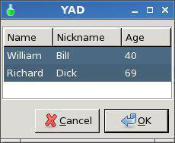
--editable
Allow changes to text.
yad --list --editable --column=Name --column=Nickname --column=Age William Bill 40 Richard Dick 69
You can edit each of the fields. When you click on OK the changes will be parsed.
Richard|George|69|
--print-all
Print all data from list
yad --list --print-all --column=Name --column=Nickname --column=Age William Bill 40 Richard Dick 69
The --print-all command will parse all rows although I have only selected one.
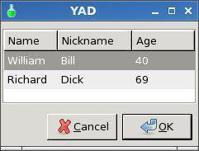
William|Bill|40|
Richard|Dick|69|
--ellipsize=TYPE
Set ellipsize mode for text columns (TYPE - NONE, START, MIDDLE or END)
yad --list --ellipsize=end --column=Name --column=Nickname --column=Age William Bill 40 Richard Dick 69
--print-column=NUMBER
Print a specific column. By default or if 0 is specified will be printed all columns
--hide-column=NUMBER
Hide a specific column
--expand-column=NUMBER
Set the column expandable by default. 0 sets all columns expandable
--search-column=NUMBER
Set the quick search column. Default is first column. Set it to 0 for disable searching
--limit=NUMBER
Set the limit of rows in list
--dclick-action=CMD
Set double-click action.
This command will allow you to double click on a list item and have it perform an action.
yad --title="--dclick-action=CMD" --width=300 --height=200 --separator=" " --list --dclick-action="viewnior" --column=Name /root/0-test/work/image-1.png /root/0-test/work/image-2.png /root/0-test/work/image-3.png /root/0-test/work/image-4.png
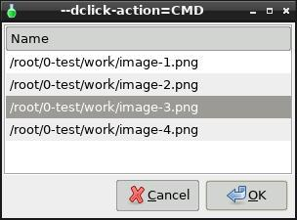
Output: /root/0-test/work/image-3.png
Rather than using viewnior (image viewer), Rox would be a btter choice as it understands
mime-type and will open the appropriate application for the data file.
--regex-search
Use regex in search
Multi progress bars options
Here is an excellent example of multiple progress bars. It will only show the drives that are
currently mounted.
eval exec yad --title="xdf" --image=drive-harddisk --text="Disk\ usage:" --buttons-layout=end --width=650 --multi-progress \
$(df -hT $1 | tail -n +2 | awk '{printf "--bar=\"<b>%s</b> (%s - %s) [%s/%s]\" %s ", $7, $1, $2, $4, $3, $6}')
--bar=LABEL[:TYPE]
Add the progress bar (TYPE - NORM, RTL or PULSE)
--vertical
Show vertical bars
Notification icon options
--command=CMD
Set left-click action
--listen
Listen for commands on stdin
--separator=SEPARATOR
Set separator character for menu values
--item-separator=SEPARATOR
Set separator character for menu items
Print dialog options
yad --print --filename=FILENAME
To print a file called dogs.txt do:
yad --print --filename=/root/dogs.txt
This will invoke the print dialog ready to print the file dogs.txt.
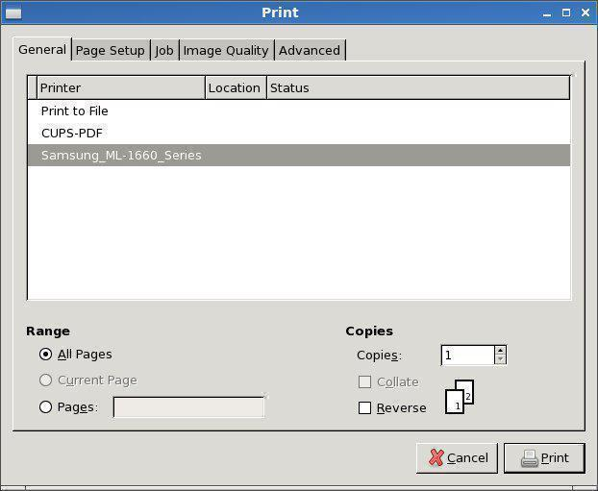
--filename=FILENAME
Source filename to print command.
The yad --print command does nothing alone.
You must add --filename=/PATH/FILENAME
yad --print --filename=/root/dogs.txt
will load the file /root/dogs.txt into the print dialog.
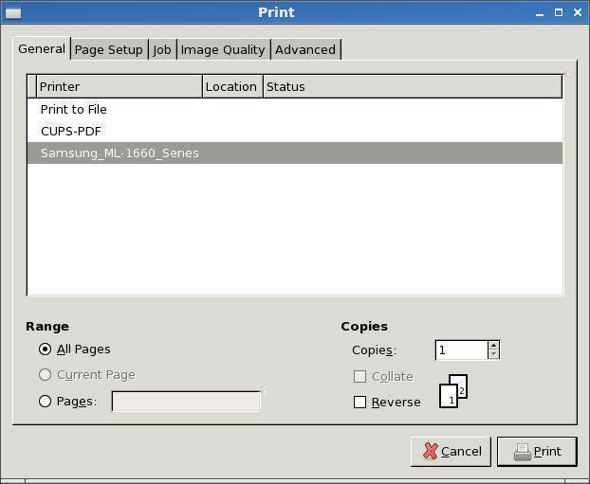
--type=TYPE
Set source type (TYPE - TEXT, IMAGE or RAW)
yad --print --filename=/root/iow.jpg --type=image --preview
--add-preview does not work with --type=raw but it will print.
yad --print --filename=/root/iow.pdf --type=raw
--headers
Add headers to pages.
The following command will add a Preview button to the print dialog, and add a header which will show the path/filename and page number.
yad --print --add-preview --headers --filename=/root/dogs.txt
This is what it looks like when viewed in evince when previewing.
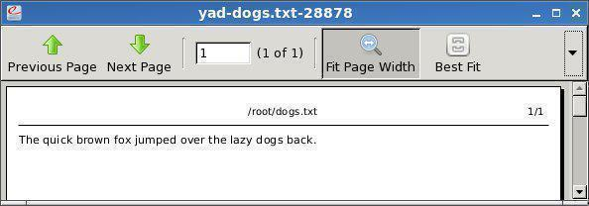
--add-preview
Enable preview in print dialog.
yad --print --add-preview --filename=/root/dogs.txt
Adds a Print Preview button to the print dialog.
--fontname=FONTNAME
Use specified font
Progress options
--progress-text=TEXT
Set progress text
--percentage=PERCENTAGE
Set initial percentage
--pulsate
Pulsate progress bar
--auto-close
Dismiss the dialog when 100% has been reached
--auto-kill
Kill parent process if cancel button is pressed
--rtl
Right-To-Left progress bar direction
Scale options
--value=VALUE
Set initial value
--min-value=VALUE
Set minimum value
--max-value=VALUE
Set maximum value
--step=VALUE
Set step size
--page=VALUE
Set paging size
--print-partial
Print partial values
--hide-value
Hide value
--vertical
Show vertical scale
--invert
Invert direction
--mark=NAME:VALUE
Add mark to scale (may be used multiple times)
Text information options
yad --text-info is used for displaying information.
You will notice there is no =TEXT option.
yad --text-info="Doesn't work"
yad --text-info < /root/my-documents/clipart/README-clipart.txt does
providing the file "README-clipart.txt" exists.
It reads the information from a file and displays it in the --text-info box.
--fore=COLOR
Use specified color for text.
You can change the text color by using the --fore command.
yad --text-info --fore=red but you have to generate text to display.
Lets create a simple text file called hello.txt in /root
Inside the text file type "Good morning"
Now read the file into the --text-info dialog like:
yad --text-info --fore=red < hello.txt
You can load quite a large text file and scroll bars will be added when required.
--back=COLOR
Use a specified color for background.
The background colour can also be changed like:
yad --text-info --back=cyan < hello.txt
Now lets try white text on a red background.
yad --text-info --back=red --fore=white < hello.txt
--fontname=FONTNAME
It's also possible to use a different font.
The font must be available, however.
yad --text-info --back=red --fore=white < hello.txt --fontname=Monospace
Now for a few undocumented features.
Lets add italic, size and bold.
yad --text-info --back=red --fore=white < hello.txt --fontname=" Monospace bold italic 20"
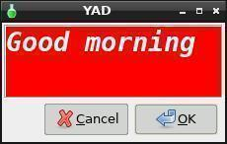
Nice....
--wrap
Enable text wrapping.
Create a text file called dogs.txt. In the file type "The quick brown fox jumped over the lazy dogs back."
yad --text-info --wrap < dogs.txt
Notice how the text is wrapped in the dialog box.
--justify=TYPE
Set justification (TYPE = left, right, center or fill)
You can also justify the text. Let's try justifying the text to the right.
yad --text-info --wrap --justify=right < dogs.txt
Now center.
yad --text-info --wrap --justify=center < dogs.txt
Finally, fill.
yad --text-info --wrap --justify=fill < dogs.txt
--margins=SIZE
Set text margins.
yad --text-info --wrap --margins=20 < dogs.txt
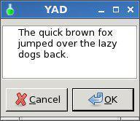
I added --wrap so you could see margins on both sides.
--tail
Autoscroll to end of text.
If you load a text file it will scroll through the text to the end of the file.
If it's a long file it will scroll too fast to read it.
It's a handy way to get to the end of a file.
--filename=FILENAME
Open a file in the --text-info dialog.
yad --text-info --filename=/root/hello.txt
yad --text-info < /root/hello.txt will achieve the same result.
Good morning is the contents of the hello.text file.
--editable
Allow changes to the text.
yad --text-info --editable < /root/hello.txt
Now add sunshine after morning.
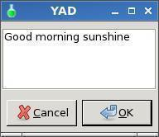
When you click OK, the following will be displayed:
Good morning sunshine#
Press the Enter key and you will be returned to the prompt.
Now lets make it do something a little more useful.
Write the following script, save it as testedit, then make it executable.
#!/bin/sh
# Created by smokey01
yad --text-info --editable < /root/hello.txt > /root/hello2.txt
rm /root/hello.txt
cp /root/hello2.txt /root/hello.txt
rm /root/hello2.txt
Now run testedit to have some fun.
If you don't want to edit the hello2.txt file just click OK.
If you click Cancel button the text in the file will be removed.
--show-uri
Make URI clickable
Create a file called links.txt in /root
Type http://www.smokey01.com/menu in the file and save the file.
yad --text-info --width=250 < /root/links.txt --show-uri
Now click on the link to go to the website.
Miscellaneous options
--about
yad --about displays the yad about dialog.
--version
yad --version displays the yad version like:
0.36.1 (GTK+ 2.24.27)
Notebook
Notebook is a complex dialog which swallow other dialogs in his tabs. Dialogs identifies by unique key (integer) and must be runs in a special plug mode (--plug option). Following example runs notebook dialog with two tabs, first has a simple text and second is an entry dialog.
Copy and paste the following into a terminal.
yad --plug=12345 --tabnum=1 --text="first tab with text" &> res1 &yad --plug=12345 --tabnum=2 --text="second tab" --entry &> res2 &yad --notebook --key=12345 --tab="Tab 1" --tab="Tab 2"
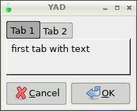 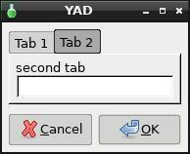
GTK+ Options
--class=CLASS
Program class as used by the window manager
--name=NAME
Program name as used by the window manager
--screen=SCREEN
X screen to use
--sync
Make X calls synchronous
--gtk-module=MODULES
Load additional GTK+ modules
--g-fatal-warnings
Make all warnings fatal
Application Options:
--rest=FILENAME
Load extra arguments from file
--calendar
Display calendar dialog
--color
Display color selection dialog
--color-selection
Alias for --color
--dnd
Display drag-n-drop box
--entry
Display text entry or combo-box dialog
--file
Display file selection dialog
--file-selection
Alias for --file
--font
Display font selection dialog
--font-selection
Alias for --font
--form
Display form dialog
--icons
Display icons box dialog
--list
Display list dialog
--multi-progress
Display multi progress bars dialog
--notebook
Display notebook dialog
--notification
Display notification
--paned
Display paned dialog
--picture
Display picture dialog
--print
Display printing dialog
--progress
Display progress indication dialog
--scale
Display scale dialog
--text-info
Display text information dialog
--display=DISPLAY
X display to use
Functions
This is an example of a script with two functions in a form. The function command
is not required but it can be used for clarity if you wish. Notice the difference between
example one and two.
#! /bin/bash
function on_click () {
yad --about
}
export -f on_click
function help () {
yad --text=" This is help file. "
}
export -f help
yad --title "Functions" --form --separator="" \
--button=gtk-ok:"bash -c on_click" \
--button=gtk-help:"bash -c help" \
--button=gtk-quit:0 \
The first function calls the About Dialog from the OK
button and the second function displays some help
when clicking on the Help button.
Functions can also be called without using the --form command.
#! /bin/bash
on_click () {
yad --about
}
export -f on_click
help () {
yad --text=" This is help file. "
}
export -f help
yad --title "Functions" --button=gtk-ok:"bash -c on_click" --button=gtk-help:"bash -c help" --button=gtk-quit:0
To make the line a bit shorter on a simple GUI you can do this:
#! /bin/bash
on_click () {
yad --about
}
export -f on_click
help () {
yad --text=" This is help file. "
}
export -f help
yad --title "Functions" \
--button=gtk-ok:"bash -c on_click" \
--button=gtk-help:"bash -c help" \
--button=gtk-quit:0 \
Variables
Although YAD can produce output from it's many functions, it's a little more challenging
to export this infomation into variables than can be used with external applications.
The following script creates the GUI below.
#!/bin/sh
names=$(echo "Bill,George,Jack,Joe")
occupation=$(echo "Doctor,Dentist,Butcher,Baker,Candlestick Maker,Other")
yad --title="Names" \
--form --separator="," --item-separator="," \
--field="Names:":CB \
--field="Occupation:":CBE \
--field="Comments:":TXT \
"$names" "$occupation" "Type your comments here"
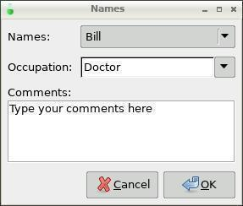
When you run the script and just press OK
you receive the following output when viewing
in a terminal:
Bill,Doctor,Type your comments here,
#!/bin/sh
names=$(echo "Bill,George,Jack,Joe")
occupation=$(echo "Doctor,Dentist,Butcher,Baker,Candlestick Maker,Other")
yad --title="Names" \
--form --separator="," --item-separator="," \
--field="Names:CB" \
--field="Occupation:CBE" \
--field="Comments:TXT" \
"$names" "$occupation" "Type your comments here" | while read line; do
NAME=`echo $line | awk -F',' '{print $1}'`
OCCUPATION=`echo $line | awk -F',' '{print $2}'`
COMMENT=`echo $line | awk -F',' '{print $3}'`
echo "(The selected name) (Selected occupation) (Comments)"
echo
echo
echo $NAME $OCCUPATION $COMMENT
done
Or
#!/bin/sh
names=$(echo "Bill,George,Jack,Joe")
occupation=$(echo "Doctor,Dentist,Butcher,Baker,Candlestick Maker,Other")
yad --title="Names" \
--form --separator="," --item-separator="," \
--field="Names:CB" \
--field="Occupation:CBE" \
--field="Comments:TXT" \
"$names" "$occupation" "Type your comments here" > /tmp/config
NAME=`cat /tmp/config | awk -F',' '{print $1}'`
OCCUPATION=`cat /tmp/config | awk -F',' '{print $2}'`
COMMENT=`cat /tmp/config | awk -F',' '{print $3}'`
#echo $NAME $OCCUPATION $COMMENT #this would have to be run first to work properly with copy/paste into term, in a script it works ok
echo "(The selected name) (Selected occupation) (Comments)"
echo
echo
echo $NAME $OCCUPATION $COMMENT
Or
#!/bin/sh
names=$(echo "Bill,George,Jack,Joe")
occupation=$(echo "Doctor,Dentist,Butcher,Baker,Candlestick Maker,Other")
yad --title="Names" \
--form --separator="," --item-separator="," \
--field="Names:CB" \
--field="Occupation:CBE" \
--field="Comments:TXT" \
"$names" "$occupation" "Type your comments here" | while read line; do
echo "NAME='`echo $line | awk -F',' '{print $1}'`'" > /tmp/config
echo "OCCUPATION='`echo $line | awk -F',' '{print $2}'`'" >> /tmp/config
echo "COMMENT='`echo $line | awk -F',' '{print $3}'`'" >> /tmp/config
done
Examples
EXAMPLES
Display a file selector with the title Select a file to remove. The file selected is returned on standard output.
yad --title="Select a file to remove" --file-selection
Display a text entry dialog with the title Select Host and thetext Select the host you would like to flood-ping. The enteredtext is returned on standard output.
yad --title "Select Host" --entry --text "Select the host you would like to flood-ping"
Display a dialog, asking Microsoft Windows has been found! Wouldyou like to remove it?. The return code will be 0 (true in shell)if YES is selected, and 1 (false) if NO is selected.
yad --image "dialog-question" --title "Alert" --button=gtk-yes:0 --button=gtk-no:1 --text "Microsoft Windows has been found! Would you like to remove it?"
Show the search results in a list dialog with the title Search Resultsand the text Finding all header files....
find . -name '*.h' | yad --list --title "Search Results" --text "Finding all header files.." --column "Files"
Show an icon in the notification area
yad --notification --image=update.png --text "System update necessary!" --command "xterm -e apt-get upgrade"
Display a weekly shopping list in a check list dialog with Apples and Oranges pre selected
yad --list --checklist --column "Buy" --column "Item" TRUE Apples TRUE Oranges FALSE Pears FALSE Toothpaste
Display a progress dialog while searching for all the postscript files in your home directory
find $HOME -name '*.ps' | yad --progress --pulsate
A file filter to only select sfs files with multiple select.
yad --title="Select a file to remove" --file-selection --file-filter="*.sfs"
Display a box with all of the installed desktop applications
yad --icons --read-dir=/usr/share/applications
yad --title="SFS Combiner v1" --text-align=center --text "Drag and drop your .sfs files here." --dnd | sed 's/^.......//' > /root/files
Use background and foreground colours, change font and font size.
echo Ship | yad --text-info "Ship" --fontname="Monospace Italic 30" --fore=red --back=green --justify=left --wrap
yad --text-info --back=red --fore=white < hello.txt --fontname="Monospace bold italic 20"
lxsplit -j file.avi.001 &
while pkill -0 lxsplit; do
echo running
sleep 0.5
done | yad --progress --pulsate --auto-close --auto-kill --button gtk-cancel:1
WD="/mnt/home/create-wd"
mkdir "$WD"
http://www.thelinuxrain.com/articles/multiple-item-data-entry-with-yad
Searching - look4
This is a simple example of a GUI for the find command. It makes it easy to search for
filenames using wildcards, between two dates and between two file sizes.
#!/bin/sh
#Written by smokey01
#04 May 2016
help () {
yad --window-icon="gtk-find" --center --title="Look4 Help" --text="
This is a simple little GUI made with
YAD to help drive the find command.
All fields must be populated or the GUI
will not return any results.
If you believe you should have received
results but didn't, try widening the
date and or size parameters.
Double click on results to open the file.
Requires YAD-0.36.2 or later.
Enjoy. smokey01
"
}
export -f help
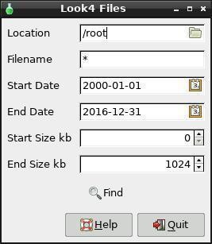

look () {
loc=${1}
name=${2}
startdate=${3}
enddate=${4}
startsize=${5}
endsize=${6}
find $loc -name "$name" -newermt "$startdate" ! -newermt "$enddate" -size +$startsize"k" ! -size +$endsize"k" | yad --width=600 --height=400 --separator=" " --window-icon="gtk-find" --title "Search Results" --center --column "Files" --list --dclick-action="rox"
}
export -f look
yad --window-icon="gtk-find" --title="Look4 Files" --center --form --separator=" " --date-format="%Y-%m-%d" \
--field="Location:":MDIR "/root" \
--field="Filename:" "*" \
--field="Start Date:":DT "2000-01-01" \
--field="End Date:":DT "2016-12-31" \
--field="Start Size KB:":NUM "0" \
--field="End Size KB:":NUM "1024" \
--field="Find!gtk-find:BTN" 'bash -c "look %1 %2 %3 %4 %5 %6"' \
--button=gtk-help:'bash -c help' \
--button=gtk-quit:0
http://smokey01.com/yad/

In this article I walk through the steps that get the yad, gtkdialog and geany installed and tested.
This is the next article in a series of articles on gtkdialog, “gtkdialog Exploration – articles and examples”, which can be found at https://blogs.czapski.id.au/2017/04/gtkdialog-exploration.

Pre-Requisites
This article assumes that the Virtual Box Machine Image created in accordance with the instructions in the blog article to be found at https://blogs.czapski.id.au/2016/10/configure-virtual-box-virtual-machine-and-install-centos-6-8-base-image is available but it is expected that pretty much any VirtualBox Linux disk will do just as well so long as it supports yad and gtkdialog.
For convenience I posted the export of the VirtualBox image which would have been built if the reader followed all the articles in the series “Build a Linux-based Infrastructure Solution Demonstration Series” to date, that is to the 8th of March 2017. The link to the main article is https://blogs.czapski.id.au/2016/10/build-a-linux-based-infrastructure-solution-demonstration-series.
In this article I am discussing how yad and gtkdialog can be obtained and installed on CentOS 6.8. yad because I use it for simple OK/Cancel dialog boxes and gtkdialog because I use it for the applications with reasonably sophisticated functionality for which yad would be too cumbersome to use.

Install yad
Download yad from https://sourceforge.net/projects/yad-dialog/, build and install.
cd ~/Downloads
wget https://downloads.sourceforge.net/project/yad-dialog/yad-0.38.2.tar.xz
tar xvf yad-0.38.2.tar.xz
cd yad-0.38.2
autoreconf -ivf
export CFLAGS="$CFLAGS -DPACKAGE_URL='\"http://yad-dialog.sf.net/\"'"
./configure
make
sudo make install
Is there help?
man yad
A simple information dialogue can be constructed as follows:
cat <<-'EODECK' > /tmp/yad01.sh
templateFile=/tmp/xml/GIndProv_template_request.xml
if [ ! -f ${templateFile} ]; then
yad --title="Required XML Template does not exist" --text="Required XML Template\n${templateFile}\ndoes not exist - aborting" \
--center --image="gtk-dialog-error" --window-icon="gtk-dialog-error" --width=500 --height=100 --button="gtk-ok:0"
exit;
fi
EODECK

/bin/sh /tmp/yad01.sh
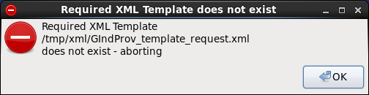
A more sophisticated dialog might look like this:
cat <<-'EODECK' > /tmp/yad_find_patient.sh
#!/bin/bash

fnUpdateFieldsSBR() {
echo "3:${title:-MR}"
echo "4:${lastName:-Smith}"
echo "5:${gender:-Male}"
echo "6:${ssn:-123456789}"

echo "11:${firstName:-John}"
echo "12:${suffix:-III}"
echo "13:${dob:-10/10/1978}"
}
export -f fnUpdateFieldsSBR

yad \
--center \
--title="Find Patient by EUID" \
--text="<span size=\"xx-large\">Find Patient Details by EUID</span>\n" \
--form \
--width=550 \
--borders=5 \
--columns=2 \
--date-format="%m/%d/%Y" \
--align=right \
--field="Enterprise Unique ID" "${USAPatXEUIDX:-0001234567}" \
--field="Demographics:LBL" "" \
--field="Title:RO" "" \
--field="Last Name:RO" "" \
--field="Sex:RO" "" \
--field="Social Security Number:RO" "" \
--field="Options:LBL" "" \
--field="Show XML Request?:CHK" "FALSE" \
\
--field " Search!gtk-find:FBTN" "@bash -c \"fnUpdateFieldsSBR \"%16\" \"%8\" \"%1\" \" " \
--field=":LBL" "" \
--field="First Name:RO" "" \
--field="Suffix:RO" "" \
--field="Date of Birth:RO" "" \
--field=".:LBL" "." \
--field=":LBL" "" \
--field="Show XML Response?:CHK" "FALSE" \
\
--dialog-sep \
--button="Quit!gtk-quit:0"

EODECK
/bin/sh /tmp/yad_find_patient.sh
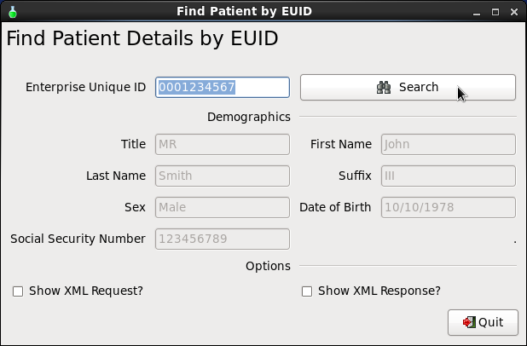

Install gtkdialog
Download gtkdialog from https://centos.pkgs.org/6/epel-x86_64/gtkdialog-0.8.3-8.el6.x86_64.rpm.html
# get and install the package
cd ~/Downloads
wget http://dl.fedoraproject.org/pub/epel/6/x86_64//gtkdialog-0.8.3-8.el6.x86_64.rpm
sudo yum localinstall -y gtkdialog-0.8.3-8.el6.x86_64.rpm

# get and install soruces for examples and documentation
wget https://fossies.org/linux/privat/old/gtkdialog-0.8.3.tar.gz
cd ~/
tar xvf ./Downloads/gtkdialog-0.8.3.tar.gz
Try a few examples provided in the source distribution to get some notion of what can be accomplished with gtkdialog:
~/gtkdialog-0.8.3/examples/menu/menu
~/gtkdialog-0.8.3/examples/comboboxentry/comboboxentry_advanced
~/gtkdialog-0.8.3/examples/button/button_attributes
~/gtkdialog-0.8.3/examples/notebook/notebook_advanced
Take a look at reference and other documentation:
firefox file:///home/demo/gtkdialog-0.8.3/doc/reference/window.html &
firefox http://gtk.php.net/manual/en/html/gdk/gdk.enum.windowtypehint.html &

Install geany
Download and install geany editor – it beats the gedit and other free alternatives in my opinion
cd ~/Downloads
wget http://download.geany.org/geany-1.24.1.tar.gz

tar xvf geany-1.24.1.tar.gz
cd geany-1.24.1
./autogen.sh
make
sudo make install
Test:
cp -v /home/demo/gtkdialog-0.8.3/examples/window/window /tmp/gtk_window.sh
geany /tmp/gtk_window.sh &
Inspect the code in geany and press F5 to execute it.
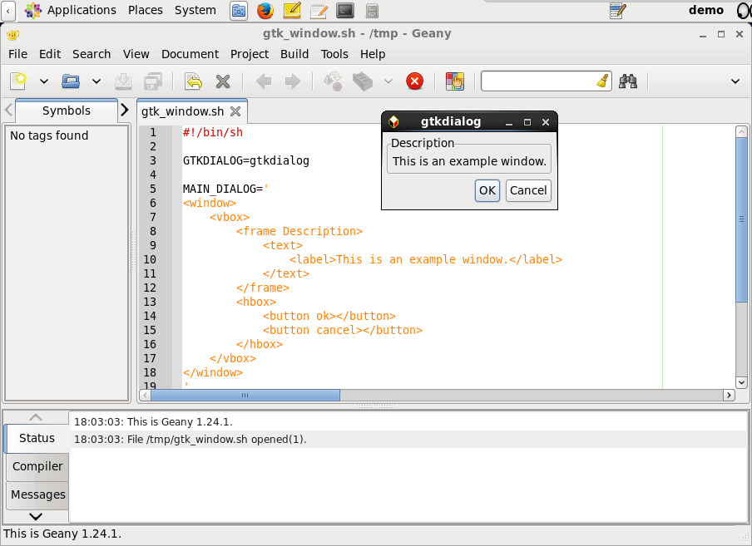

gtkdialog hello world
Create a modified script and experiment with the various settings of the window attributes
cat <<-'EODECK' > /tmp/gtk_window.sh
#!/bin/bash
GTKDIALOG=gtkdialog

MAIN_DIALOG='
<window \
decorated="true" \
allow-grow="true" \
allow-shrink="true" \
default-height="200" \
default-width="400" \
resizable="true" xx-resizable="overrides default-height and default-width if set to false" \
deletable="true" xx-deletable="this keep (default) or remove the close button from the window title bar" \
icon-name="gtk-refresh" \
modal="false" \
skip-pager-hint="true" \
skip-taskbar-hint="false" \
title="My First Window" \
window-position="1" \
border-width="5" xx-border-width="is an inherited GtkContainer property - see object hierarchy at https://developer.gnome.org/gtk2/2.24/GtkWindow.html#GtkWindow.object-hierarchy" \
sensitive="true" xx-sensitive="is an inherited GtkWidget property that disables everything inside the window - see obect hierarchy" \
tooltip-markup="This is a <b>window tooltip</b>" xx-tooltip-markup="is inherited from GtkWidget" \
>
<vbox>
<frame Description >
<text>
<label>This is an example window.</label>
</text>
</frame>
<hbox>
<button ok></button>
<button cancel></button>
</hbox>
</vbox>
</window>
'
export MAIN_DIALOG
case $1 in
-d | --dump) echo "$MAIN_DIALOG" ;;
*) $GTKDIALOG --program=MAIN_DIALOG ;;
esac
EODECK

/tmp/gtk_window.sh
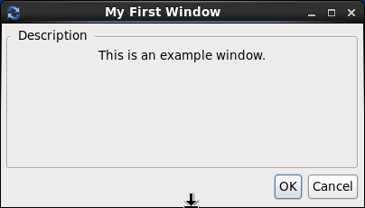
Experiment with the setting of the Window object attributes and see what effect the changes have on the appearance and behaviour of the window.
There is plenty more that can be done with gtkdialog. I intend to write more articles on this topic as the time goes by. This article provides the tooling for these later articles.

Configure Virtual Box Virtual Machine and Install CentOS 6.8 Base Image
By Czapski Michael Demo Building Add comments

Introduction
Please see the article “Build a Linux-based Infrastructure Solution Demonstration Series” for rationale, introduction and links to articles in this series.
In this article I am configuring a Virtual Box Machine Image and installing and configuring the CentOS 6.8 OS and the Virtual Box Guest Additions. At the end of the process there will be a Virtual Box Machine Image with CentOS 6.8 installed, snapshot taken and image ready for further work.
All future articles in this series will assume that the image created this way is the baseline for further work.

Host Assumptions
I assume that the demonstration image is built as a Virtual Box 5.x virtual machine image and that the Virtual Box Host environment is Windows 7. This is not a hard requirement but merely an explanation of the Windows’isms which necessarily creep into this document, particularly when it comes to downloading distribution packages prior to image creation.
I assume that you installed the Oracle VirtualBox software on your chosen host, Windows 7 in my case, and are in position to create Virtual Machine Image using the CentOS 6.8 iso as a starting point.

Download assumptions
I assume that the platform from which the image will be created is Windows 7 and that the Windows directory to which packages will be downloaded is
O:\DemoBuilding\Distros
If you are working your way through this series and use either a different host OS or a different download file location then make appropriate adjustments.

Downloading Software Packages
All packages which I am using are, as far as I am aware, free to download. It is your responsibility to ensure that you have the right to download and use the software which I am discussing in this document.
Instructions for downloading, installing and configuring the software packages are provided when the package is first used.

Create and Configure baseline CentOS 6.8 VM Image

Download CentOS 6 Update 8
CentOS, https://wiki.centos.org, is a RedHat-like Linux distribution, available free of charge for any use as far as I can tell.
Download the CentOS 6.8 distribution from the nearest mirror, http://isoredirect.centos.org/centos/6/isos/x86_64/. For me this is http://centos.mirror.digitalpacific.com.au/6.8/isos/x86_64/.
I choose to download the two DVD iso images, CentOS-6.8-x86_64-bin-DVD1.iso and CentOS-6.8-x86_64-bin-DVD2.iso to my distribution packages directory
O:\DemoBuilding\Distros
http://centos.mirror.digitalpacific.com.au/6.8/isos/x86_64/CentOS-6.8-x86_64-bin-DVD1.iso
http://centos.mirror.digitalpacific.com.au/6.8/isos/x86_64/CentOS-6.8-x86_64-bin-DVD2.iso

Create and configure VM Image using the GUI (command line version next section)
Start the VirtualBox Management UI – for me
"C:\Program Files\Oracle\VirtualBox\VirtualBox.exe"
Verify the location to which virtual machine files will be written and change as appropriate.
Choose Machine –> New
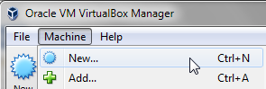
Name the image “demo”, configure the following settings:
Type: Linux
Version: Other Linux (64-bit) – I am assuming that you have a 64 bit machine if not adjust accordingly
Memory Size: 4096 MB – that should be sufficient for what I have in mind. Increase as needed.
Check “Create a Virtual Hard Disk Now”
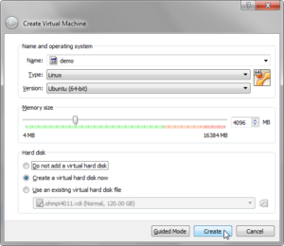
Click Create
Define name and location of the new hard disk – I prefer to keep all my VM files in the same place, which will happen if I correctly configure the location to which the files will go to by default.
Complete the dialogue box as follows:
File location: name – this assumes that the default location for the virtual disk file is used
File Size: 120MB
Check “VDI”
Check “Dynamically Allocated”
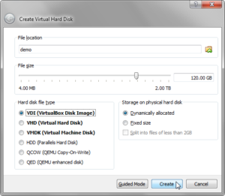
Click Create
Right-click the name of the new Virtual Box machine and choose Settings
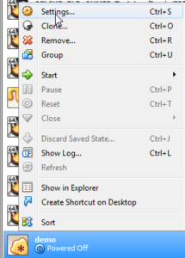
In “General”–>”Advanced” change “Shared Clipboard” and “Drag and Drop” to “bidirectional”
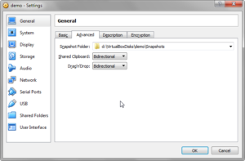
System–>Motherboard–>Boot Order: Uncheck Floppy
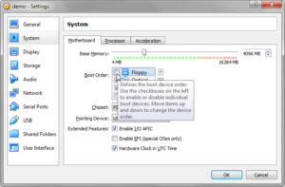
System–>Processor–>Processors: set a 1 less than the number of processors on your machine or some other number less than the total number of processors, possibly with the execution cap of less than 100% if you set this to the number of processors.
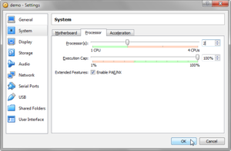
Display–>Screen: set Video Memory to 128MB and enable 3D acceleration
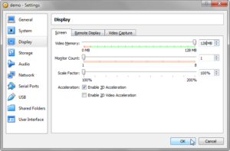
Storage –> Storage –> Controller: IDE –> demo.vdi: Check solid state drive if your vdi file is on a solid state drive (highly recommended for performance of your VM)
Storage –> Storage –> Controller: IDE –> Empty –> Optical Drive: select Choose Virtual Optical Drive File…, then navigate to the location of the CentOS 6.8 DVD 1 iso and select it: O:\DemoBuilding\Distros\CentOS-6.8-x86_64-bin-DVD1.iso
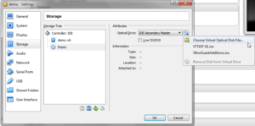
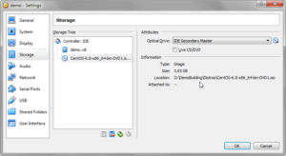
Network –> Adapter 1: Confirm that you have NAT network selected and if not select it. We want to be able to update the image or get missing packages over the Internet
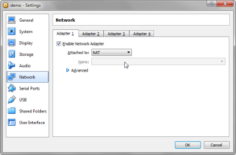
Shared Folders –> Shared Folders –> Folder List: click Add new Shared Folder (+) icon, navigate to the location to which you downloaded the CentOS iso distribution disks and choose that folder. Check the Auto-mount checkbox and click OK
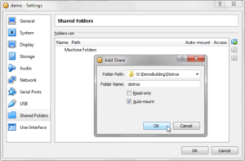
User Interface –> Check “Show at top of screen”
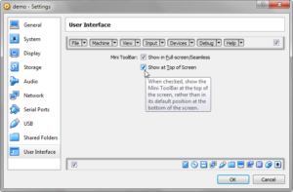
Click OK to finish configuration
Boot the VM with the CentOS DVD 1 iso in the optical drive by selecting the new “demo” image in the Virtual Box Manager tree and clicking “Start”, or following the right-click menu selections over the “demo” image
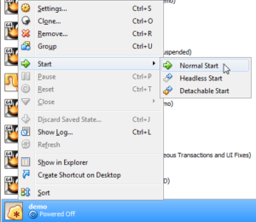

Create and configure VM using command line (instead of the GUI – above)
If you configured the VM using the GUI following the steps in the previous section then you don’t need to execute the command in this section. If you skipped the previous section because you want to configure the VM using the command line, carry on.
I used some of the material in http://superuser.com/questions/741734/virtualbox-how-can-i-add-mount-a-iso-image-file-from-command-line
With the VM not started, in the DOS Box / CMD window, execute the following commands:
set VBM="C:\Program Files\Oracle\VirtualBox\VBoxManage.exe"

@create and register bare VM
%VBM% createvm --name "demo" --ostype "RedHat_64" --register

@rem Execute the following to determine where the files are going and make sure to use that directory path in creating thwe disk
%VBM% showvminfo "demo" | find "Config file:"

@rem set the disk file location and name
set diskFile=d:\VirtualBoxDisks\demo\demo.vdi

%VBM% storagectl "demo" --name IDE --add ide --controller PIIX4 --portcount 2 --bootable on
%VBM% createhd --filename %diskFile% --size 120000
%VBM% storageattach "demo" --storagectl "IDE" --port 0 --device 0 --type hdd --medium %diskFile%

%VBM% modifyvm "demo" --clipboard bidirectional
%VBM% modifyvm "demo" --boot1 dvd
%VBM% modifyvm "demo" --boot2 disk
%VBM% modifyvm "demo" --boot3 none
%VBM% modifyvm "demo" --boot4 none
%VBM% modifyvm "demo" --cpus 3
%VBM% modifyvm "demo" --cpuexecutioncap 100
%VBM% modifyvm "demo" --memory 4096
%VBM% modifyvm "demo" --vram 128
%VBM% modifyvm "demo" --accelerate3d on
%VBM% modifyvm "demo" --rtcuseutc on
%VBM% modifyvm "demo" --paravirtprovider default
%VBM% modifyvm "demo" --mouse ps2
%VBM% modifyvm "demo" --usb on
%VBM% modifyvm "demo" --usbehci on
%VBM% modifyvm "demo" --nic1 nat
%VBM% modifyvm "demo" --nicspeed1 10000000
%VBM% modifyvm "demo" --macaddress1 auto
%VBM% sharedfolder add "demo" --name "distros" --hostpath "O:\DemoBuilding\Distros" --automount
%VBM% setextradata "demo" "GUI/MiniToolBarAlignment" "Top"

@rem mount the iso image for installation
%VBM% storageattach "demo" --storagectl IDE --port 1 --device 0 --type dvddrive --medium "O:\DemoBuilding\Distros\CentOS-6.8-x86_64-bin-DVD1.iso"
Boot the VM with the CentOS DVD 1 iso in the optical drive
%VBM% startvm "demo"

Install CentOS 6.8
When you bot the VM after it is created the installation process will start. You will need to have the 1st iso mounted, which it will be if you followed the steps above. If you choose the options I chose below you will need to mount the 2nd iso to mount as well so make sure you have both before you start.
Make sure that the “Install or upgrade an existing system” is selected and press “Enter”
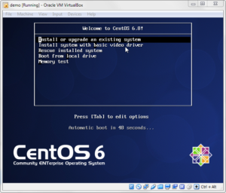
Skip media testing
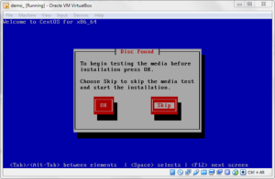
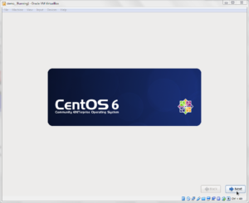
- Next
Choose “English (English)” language (if you choose another language you will need to make such changes in the instructions as will be necessary to compensate for the fact that this guide is written in English for an English language OS)
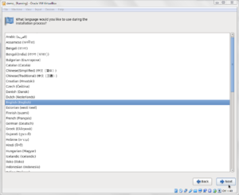
- Next
Choose US English keyboard
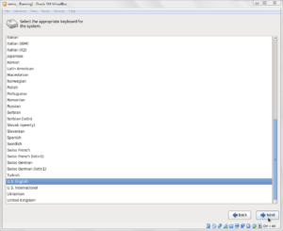
- Next
Choose Basic Storage Device
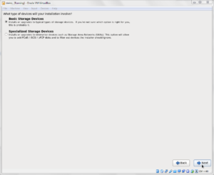
- Next
Click “Yes, discard any data”
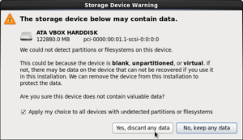
Enter “demo.demodomain.org” into the “Host” box and click the “Configure Network” button
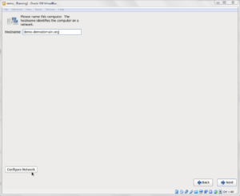
Choose “System eth0” and click Edit
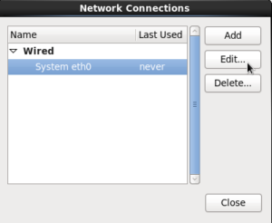
Check “Connect Automatically” and click “Apply”
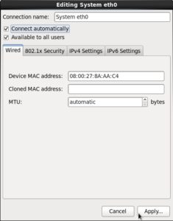
Click Close
- Next
Choose your timezone – Mine is Sydney/Australia
- Next
Set root password to welcome1 (or whatever you prefer and will remember)
- Next
Choose “Create custom layout”
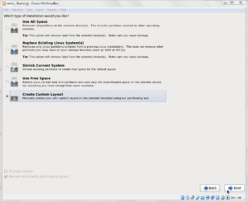
- Next
Select “Hard Drives –> sda –> Free” node in the node tree and click “Create”
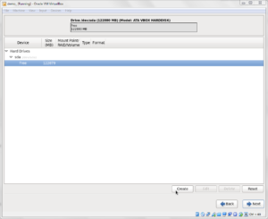
Select “Standard partition” and click “Create”
Change “File System Type” to “swap”
Set “Size (MB)” to 8192
Ensure “Fixed Size” is selected then click “OK”
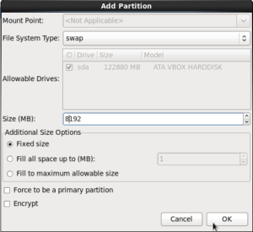
Select “Hard Drives –> sda –> Free” node in the node tree and click “Create”
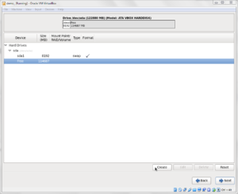
Select “Standard partition” and click “Create”
Enter “/” for “Mount Point”
Retain “File System Type” of “ext4”
Check “Fill to maximum allowable size” and Click “Create”
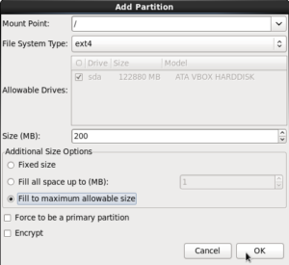
- Next
Click “Format”
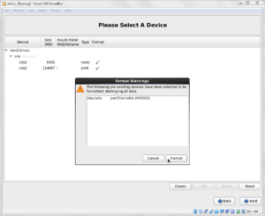
Click “Write changes to disk”
Accept “Install boot loader on /dev/sda”
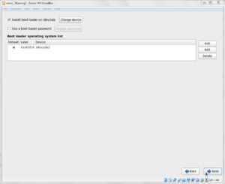
- Next
Choose “Software Development Workstation”
Select “Customize Now”
- Next
Applications –>
Uncheck: “TeX Support” and “Technical Writing”
Select “Graphics Support Tools”, click “Optional Packages”, select “ImageMagick”, “Close”
Base System –>
Uncheck: Directory Client, Java Platform, Network File System Client, Performance Tools, Printing Client
Check: Compatibility Libraries
Databases –>
Check: MySQL Database Client, click “Optional Packages”, select MySQL Python, mysql-connector-java, mysql-connector-odbc, click “Close”
Check MySQL Database Server
Desktops –>
Check KDE Desktop (all checkboxes will be checked)
Select “Fonts”, click “Optional Packages”, uncheck all the fonts that you will not need, amd check “bitmap-lucida” and “bitmap-fixed”
Servers –> Check CIFS File Server
Virtualization –> uncheck all options
- Next
Installation will now proceed, with 1529 packages to be installed
- Reboot
Click Forward
Click Forward
Username: demo
Password: welcome1
Click Forward
Check date and time and click Forward
Click Finish
Log in as use demo/welcome1

Install Virtual Box Guest Additions
Pull down the “Devices” menu of the running Virtual Box Image and choose “Insert Guest Additions CD image…”
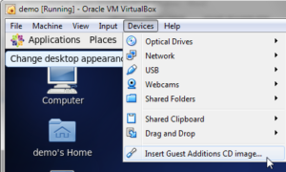
Click “OK” when the dialogue box opens
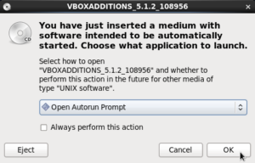
Click “Run”
Provide root password welcome1 and click “Authenticate”
Observe feedback in the terminal window the installer opens
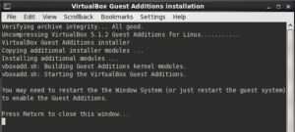
Press Return/Enter to close the window.
Right-click on the VBOXADDITIONS… icon on the Desktop and choose “Eject”
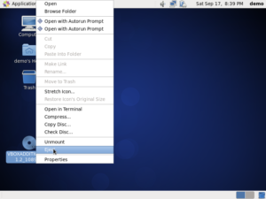
Reboot the image: System -> Shutdown -> Reboot
Shut down the image and snapshot
"C:\Program Files\Oracle\VirtualBox\VBoxManage.exe" snapshot "demo" take "v1.0.0 Baseline - CentOS 6.8 Installed" --description "v1.0.0 Baseline - CentOS 6.8 Installed"

Configure the VM Image for screen resolution and other things
Assume that the VBoxManage.exe is installed in a default location, that the host is a Windows host and that the name of the VM image is “demo”.
In a command / terminal window of the host machine, while the VM is running, execute the following (or similar command if your host is not Windows) to see what your Virtual Box configuration is.
"c:\Program Files\Oracle\VirtualBox\VBoxManage.exe" showvminfo "demo"
With the VM running execute the following (or similar command if your host is not Windows) to set non-standard video modes and memory pre-allocation.
"C:\Program Files\Oracle\VirtualBox\VBoxManage.exe" setextradata "demo" "CustomVideoMode1" "1440x900x32"
"C:\Program Files\Oracle\VirtualBox\VBoxManage.exe" setextradata "demo" "CustomVideoMode2" "1366x768x32"
"C:\Program Files\Oracle\VirtualBox\VBoxManage.exe" setextradata "demo" "CustomVideoMode2" "1920x1080x32"
"C:\Program Files\Oracle\VirtualBox\VBoxManage.exe" setextradata "demo" "CustomVideoMode2" "1720x1000x32"
"C:\Program Files\Oracle\VirtualBox\VBoxManage.exe" setextradata "demo" "CustomVideoMode2" "1600x836x32"
This too needs the VM to be running
"C:\Program Files\Oracle\VirtualBox\VBoxManage.exe" controlvm "demo" setvideomodehint 1440 900 32
"C:\Program Files\Oracle\VirtualBox\VBoxManage.exe" controlvm "demo" setvideomodehint 1366 768 32
"C:\Program Files\Oracle\VirtualBox\VBoxManage.exe" controlvm "demo" setvideomodehint 1920 1280 32
"C:\Program Files\Oracle\VirtualBox\VBoxManage.exe" controlvm "demo" setvideomodehint 1720 1000 32
"C:\Program Files\Oracle\VirtualBox\VBoxManage.exe" controlvm "demo" setvideomodehint 1600 836 32
"C:\Program Files\Oracle\VirtualBox\VBoxManage.exe" setextradata "demo" VBoxInternal/RamPreAlloc 1
Shut down the VM
With the VM shut down execute the following (or similar command if your host is not Windows) to set the speed of the NIC
"C:\Program Files\Oracle\VirtualBox\VBoxManage.exe" modifyvm "demo" --nicspeed1 10000000
Boot the VM
For working in “comfort”
"C:\Program Files\Oracle\VirtualBox\VBoxManage.exe" setextradata "demo" "CustomVideoMode2" "1600x836x32"
The one below needs VM running
"C:\Program Files\Oracle\VirtualBox\VBoxManage.exe" startvm "demo"
"C:\Program Files\Oracle\VirtualBox\VBoxManage.exe" controlvm "demo" setvideomodehint 1600 836 32Shut the image down and use the Virtual Box Manager to take a Snapshot of the image. Name the snapshot "v1.0.0 Installed CentOS 6.8 and Virtual Box Guest Additions"
Shut the image down and use the Virtual Box Manager to take a Snapshot of the image. Name the snapshot “v1.0.0 Installed CentOS 6.8 and Virtual Box Guest Additions”
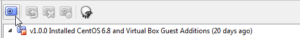
This is it. The image is ready for further work.

Apresentando o Yad - "zenity melhorado"
Autor: Raimundo Alves Portela <rai3mb at gmail.com>
Data: 04/06/2011

Apresentando o Yad

Nesse artigo vou mostrar uma maravilhosa ferramenta para GUI (Interface Gráfica com o Usuário), que acabou de sair do forno, o Yad, um fork do Zenity que vem com diversas melhorias, dentre elas a possibilidade de fazer formulários, melhorando a interação do usuário com nossos scripts em shell.
O bichinho é tão recente que nem o manual cobre todas as opções disponíveis, cito um exemplo mais adiante no uso de diálogo para selecionar fontes.
O autor do Yad é o ucraniano Victor Ananjevsky, e a página do projeto pode ser encontrada no:
- http://code.google.com/p/yad/
Mesmo nessa página ainda há pouca informação sobre o uso do Yad, o melhor lugar que achei no momento é o manual dele (man yad) :-).
Caso forem buscar informações, pouca coisa ainda está disponível, o manual está datado em “Marth 24, 2011”, e ainda tem o fato de Yad ser o nome de uma ferramenta “...usada em para apontar o texto durante a leitura do Torá...” (Fonte: http://en.wikipedia.org/wiki/Yad). Então ao buscar informações, busque por 'yad fork zenity' vai ser mais fácil.
Ok, vamos em frente pois no artigo pretendo mostrar vários recursos do Yad, com um pequeno exemplo de cada um.

Instalação
Baixe a versão mais recente do Yad no link abaixo:
- http://code.google.com/p/yad/downloads
Descompacte:
tar –Jxf arquivo.tar.xz
Instale:
./configure
$ sudo make
$ sudo make install
Pode acontecer dele reclamar de alguma dependência, aqui no meu Debian, reclamou do libgtk2, basta instalar com:
sudo apt-get install libgtk2.0-dev
Após instalar, podemos testar com:
yad
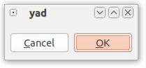
Prontinho, vamos à parte divertida e viciante, programar :-)

Possibilidades e Exemplos de Uso
A sintaxe básica é :
yad [--tipo-dialogo] [--options]
Abaixo mostro exemplo com os tipos de diálogo:
--calendar (calendário)
--color (paleta de cores)
--entry (entrada de dados)
--icons (mostra uma caixa com ícones de atalho para aplicações)
--file (diálogo para selecionar arquivos)
--font (diálogo para seleção de fontes)
--form (aeeeeeee formulários)
--list (diálogo com ítens em lista)
--notification (mostra um ícone da barra de notificação do sistema)
--progress (diálogo de progresso)
--text-info (mostra o conteúdo de um arquivo texto)
--scale (diálogo para seleção de valor, usando uma escala)
Vamos lá, para cada um dos exemplos coloco o script e depois algumas imagens da sua execução.
--calendar:
Mostra um calendário permitindo selecionar a data e envia o valor para a saída padrão
Exemplo:
#!/bin/bash
# uso do yad com --calendar
# mostra um calendário iniciando com o dia 20/05/2011
# guarda o valor selecionar na variável $DATA
DATA=$(\
yad --calendar \
--day=20 \
--month=5 \
--year=2011 \
--date-format=%d\/%m\/%Y \
--title=Calendario \
--center \ # disposição do diálogo na tela
)
# mostra um diálogo informando a $DATA selecionada
yad --title="AVISO" \ --text="Você selecionou a data $DATA"
#.EOF
Salve com o nome de "calendar.sh", dê permissão de execução:
chmod +x calendar.sh
Execute:
./calendar.sh
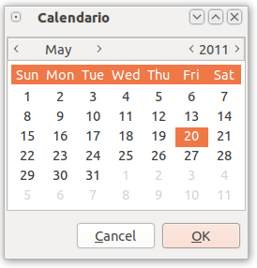
Após selecionar uma data:
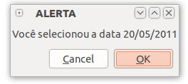

Exemplo com yad --color
yad --color:
Diálogo de seleção de cores, permite selecionar uma determinada cor usando a paleta de cores, editando diretamente por código, etc. Bom para saber o código de uma cor específica.
Exemplo:
!/bin/bash
# uso do yad - com color
# permite selecionar determinada cor numa paleta de cores
# e envia o valor para a saída padrão, no caso armazenei na variável $COR
COR=$(\
yad --color \
--init-color="#FFFFFF" \ #cor que inicialmente fica selecionada na paleta de cores.
--palette \
)
yad --title="YAD COM COLOR" \
--text="Você selecionou a cor $COR"
#.EOF
Salve com o nome de "color.sh", dê permissão de execução:
chmod +x color.sh
Execute:
./color.sh
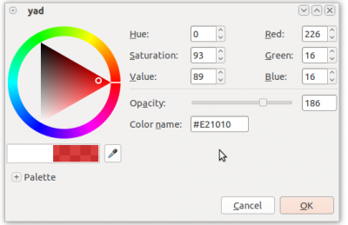
Após selecionar uma cor:
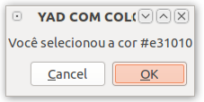

Exemplos 1

Exemplo com yad --entry
yad --entry:
Diálogo de entrada de texto, onde podemos fazer entrada de dados, modificando a forma como essa entrada será feita, podendo ser do tipo senha(password), texto e número.
#!/bin/bash
# yad com --entry
# recebe valores e armazena em variáveis
NOME=$(\
yad --entry \
--entry-label="Nome" \
--entry-text="seu nome aqui" \
--completion \
--editable \
--title="USO DO YAD COM --entry" \
--width="300" \
)
SENHA=$(\
yad --entry \
--entry-label="Senha" \
--entry-text="123456" \
--completion \
--editable \
--hide-text \#senha – esconde o texto digitado apresentando apenas um “.” ponto
--title="USO DO YAD COM --entry" \
--width="300" \
)
yad --title="YAD COM --entry" \
--text="Nome: $NOME, Senha: $SENHA" \
--width="300" \
--height="100"
#.EOF
Salve com o nome de entry.sh, dê permissão de execução:
chmod +x entry.sh
Execute:
./entry.sh
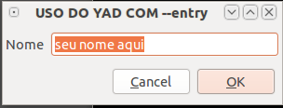
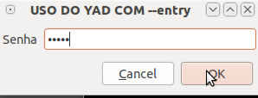
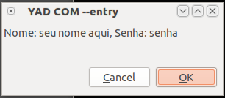

Exemplo com yad --icons
yad --icons:
Diálogo que mostra uma caixa com os ícones de atalho (formato .desktop).
Exemplo:
#!/bin/bash
# yad com icons
# mostra os ícones das aplicações instaladas no seu sistema
# você pode abrir uma aplicação clicando no ícone correspondente
yad --icons \
--read-dir="/usr/share/applications" \
--width="600" \
--height="500"
#.EOF
Salve com o nome de icons.sh, dê permissão de execução:
chmod +x icons.sh
Execute:
./icons.sh
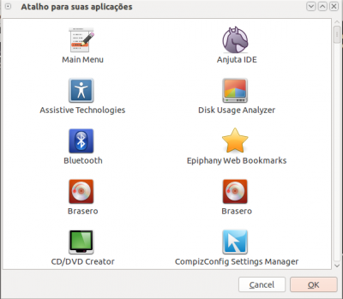
Após clicar duas vezes em um ícone ele abre aplicação correspondente:
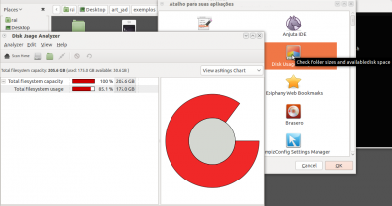

Exemplo com yad --file
yad --file:
Dialogo que permite selecionar um arquivo/diretório, retornando o caminho do mesmo.
Exemplo:
#!/bin/bash
# yas com file
# permite selecionar um arquivo/diretório através de caixa de diálogo
# retorna o caminho do arquivo/diretório, deixando a nós o critério de fazer
# o que quiser com ele, nesse caso só vou mostrar o tamanho
ARQUIVO=$(\
yad --file \
--directory \
--title="Selecione um diretório para ver seu tamanho" \
--width="500" \
--height="300" \
)
TAMANHO=$(du -sh $ARQUIVO | cut -d"/" -f 1)
yad --title="Tamanho do diretório" \
--text="Tamanho do diretório $ARQUIVO = $TAMANHO" \
--width="400" \
--height="100" \
--button=gtk-ok:0
# a opcao button=gtk-ok:0 - mostra apenas o botao de ok no dialog
# e seu código de retorno é 0 (zero)
#.EOF
Salve com o nome de "file.sh", dê permissão de execução:
chmod +x file.sh
Execute:
./file.sh
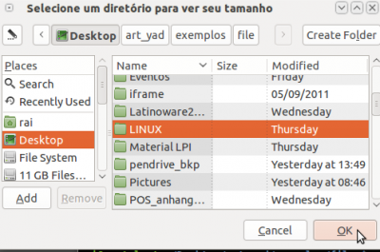
Após selecionar o diretório ele mostra o tamanho do mesmo:
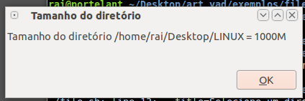

Exemplo com yad --font
yad --font:
Mostra um diálogo para seleção de fontes.
Exemplo: (detalhe o manual não mostra que podemos colocar o tamanho da fonte depois do nome, descobrir testando mesmo).
#!/bin/bash
# yad com font
# mostra um diálogo de seleção de fonte
# retorna o nome da fonte selecionada e tamanho selecionado, gravando num html
RESULTADO=$(\
yad --font \
--fontname="Ubuntu",14 \
--preview="Texto para exemplo do uso de fonte yad é 10 :-) " \
--title="Selecione uma fonte" \
)
# usa expressão regular para pegar apenas o texto
FONTE=$(echo $RESULTADO | grep -o '[[:alpha:]]*')
# usa expressão regular para pegar apenas o tamanho da fonte, 2 digitos
TAMANHO=$(echo $RESULTADO | egrep -o '[0-9]{2}')
# grava o resultado num arquivo html para fazer um teste um pouco útil :-)
echo "texto com a fonte $FONTE e TAMANHO $TAMANHO " > arq_teste.htm
# abre o firefox para fazer um teste
firefox file://$PWD/arq_teste.htm
#.EOF
Salve com o nome de "font.sh", dê permissão de execução:
chmod +x font.sh
Execute:
./font.sh
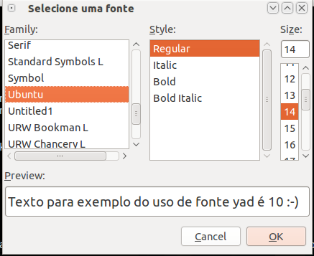
Após selecionar a fonte e tamanho, abre um página do Firefox com o resultado:
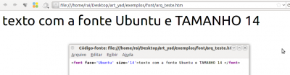

Exemplo com yad --form
yad --form;
Uma das novidades que mais gostei: FORMULÁRIOS, não dava pra fazer isso no Zenity, e limitava as entradas do usuário tendo que aprensetar várias telas para coletar dados, o que não é muito prático.
Exemplo:
#!/bin/bash
# yad com FORMULARIOS, que bacana, tem algumas novidades aprecie com calma
HOJE=$(date +%d/%m/%Y)
touch $HOME/cad_usuario.txt
VAR_FORM=$( \
yad --form \
--title="CADASTRO DE USUÁRIOS" \
--width=400 \
--height=400 \
--image="accessories-text-editor" \
--field="Cadastrando em":RO "$HOJE" \
--field="Nome:" "" \
--field="Sexo":CB Masculino!Feminino \
--field="Login:" "$USER" \
--field="Senha:":H "123456"\
--field="Ler livro sobre:":RO "" \
--field="Programação":CHK FALSE \
--field="Redes":CHK FALSE \
--field="Linux":CHK TRUE \
--field="Quantos Filhos:":NUM 0!0..10!1 \
--field="Foto:":FL "$HOME/Pictures" \
--field="Salvar dados em:":DIR "$HOME" \
--field="Cor preferida:":CLR "#00DDDD" \
)
DATA=$(echo "$VAR_FORM" | cut -d"|" -f 1)
NOME=$(echo "$VAR_FORM" | cut -d"|" -f 2)
SEXO=$(echo "$VAR_FORM" | cut -d"|" -f 3)
LOGIN=$(echo "$VAR_FORM" | cut -d"|" -f 4)
SENHA=$(echo "$VAR_FORM" | cut -d"|" -f 5)
#notem que pulei o campo 6, pois o mesmo nao retorna valor útil para nós
LIVRO_PROGRAMACAO=$(echo "$VAR_FORM" | cut -d"|" -f 7)
LIVRO_REDES=$(echo "$VAR_FORM" | cut -d"|" -f 8)
LIVRO_LINUX=$(echo "$VAR_FORM" | cut -d"|" -f 9)
QTD_FILHOS=$(echo "$VAR_FORM" | cut -d"|" -f 10)
FOTO=$(echo "$VAR_FORM" | cut -d"|" -f 11)
SALVAR_EM=$(echo "$VAR_FORM" | cut -d"|" -f 12)
COR=$(echo "$VAR_FORM" | cut -d"|" -f 13)
# repare que o campo $QTD_FILHOS retorna um valor no formato 0.000000
# vc pode usar uma expressão regular, ou o cut, para capturar apenas os digitos antes do .
QTD_FILHOS=$(echo $QTD_FILHOS | cut -d"." -f 1)
#apenas vou mostrar os campos e valores de retorno em um html
DADOS_USUARIO="<table border=1><br/>
<tr><th>CAMPO</th><th>VALOR</th></tr>
<tr><td>DATA</td><td>$DATA</td></tr>
<tr><td>NOME</td><td>$NOME</td></tr>
<tr><td>SEXO</td><td>$SEXO</td></tr>
<tr><td>LOGIN</td><td>$LOGIN</td></tr>
<tr><td colspan=2 align=center>LIVROS</td></tr>
<tr><td>PROGRAMACAO</td><td>$LIVRO_PROGRAMACAO</td></tr>
<tr><td>REDES</td><td>$LIVRO_REDES</td></tr>
<tr><td>LINUX</td><td>$LIVRO_LINUX</td></tr>
<tr><td>QTD_FILHOS</td><td>$QTD_FILHOS</td></tr>
<tr><td>FOTO</td><td><img src='$FOTO' /></td></tr>
<tr><td>DIRETORIO</td><td>$SALVAR_EM</td></tr>
<tr><td>COR</td><td bgcolor='$COR'></td></tr>
</table>"
echo $DADOS_USUARIO > cad_usuario.htm
firefox cad_usuario.htm
#.EOF
Salve com o nome de form.sh, der permissão de execução:
chmod +x form.sh
Execute:
./form.sh
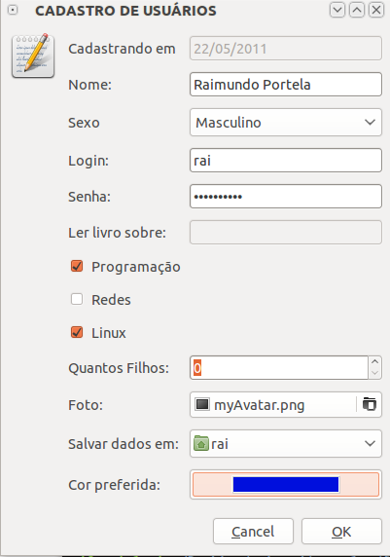
Após preencher o formulário:
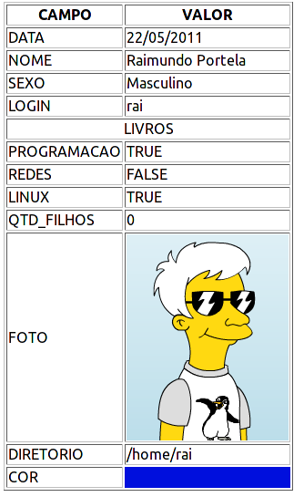

Exemplos 2

Exemplo com yad --list
yad --list:
Mostra um diálogo do tipo lista de seleção.
Exemplo:
Fiz um pequeno exemplo que usa uma lista com uma coluna do tipo texto e outra do tipo imagem
#!/bin/bash
# yas com list
# Permite ao escolher uma pernonalista na lista e ver detalhes sobre ela na internet :-)
# Tem uma coluna com o nome e outra com a imagem da personalidade, se alguem
# copiar esse script, vai aparecer os nomes, mas não as imagens :-), pois elas no meu
# disco, é apenas um exemplo
show_list() {
ESCOLHIDO=$( \
yad --list \
--title="Detalhes sobre Personalidades" \
--column="ID":NUM \
--column="PERSONALIDADE":TEXT \
--column="FOTO":IMG \
--print-column=1 \
--hide-column=1 \
--width="300" \
--height="400" \
--button="Sair":1 \
--button="Ver detalhes":0 \
1 "rai3mb :-)" "myAvatar.png" \
2 "Linus Torvalds" "linus.png" \
3 "Richard Stallman" "stallman.png" \
4 "Mad Dog" "maddog.png" \
)
# ver se o usuário clicou em 'sair' or no 'x' da janela
ACAO="$?"
test "$ACAO" -eq "1" || test "$ACAO" -eq "252"
if [ "$?" -eq "0" ]; then
exit
fi
#captura apenas o numero da opcao selecionada
ESCOLHIDO=$(echo $ESCOLHIDO | egrep -o '^[0-9]')
# de acordo com a opcao selecionada, abre o firefox com detalhes da personalidade
case "$ESCOLHIDO" in
1)
firefox http://www.vivaolinux.com.br/perfil/verPerfil.php?login=rai3mb
show_list
;;
2)
firefox http://pt.wikipedia.org/wiki/Linus_Torvalds
show_list
;;
3)
firefox http://pt.wikipedia.org/wiki/Stallman
show_list
;;
4)
firefox http://pt.wikipedia.org/wiki/Jon_Hall
show_list
;;
*)
yad --image="face-angry" \
--title="Alerta" \
--text "Você não selecionou uma personalidade!" \
--button="Voltar e Selecionar"
show_list
;;
esac
}
show_list
#.EOF
Salve com o nome de list.sh, dê permissão de execução:
chmod +x list.sh
Execute:
./list.sh
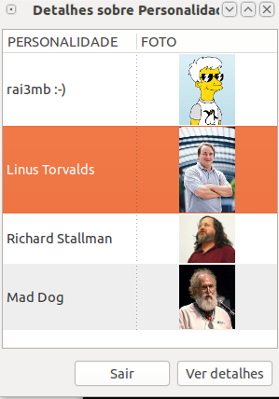
Após selecionar uma personalidade:
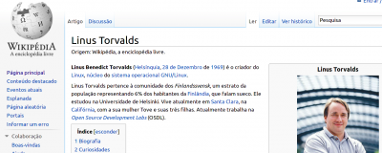

Exemplo com yad --notification
yad --notification:
Mostra um ícone na área de notificação do sistema, podemos colocar um texto a ser mostrado quando o mouse estiver em cima dele, e uma ação para executar ao clicar.
Exemplo:
#!/bin/bash
# yad com --notification
# mostra uma notificação no painel, na área de notificação
# neste exemplo verifico a hora e uma tarefa associada a mesma
HORA=$(date +%H)
if [ "$HORA" -lt 06 ]; then
FAIXA="1"
else
if [ "$HORA" -lt 12 ]; then
FAIXA="2"
else
if [ "$HORA" -lt 18 ]; then
FAIXA="3"
else
if [ "$HORA" -le 24 ]; then
FAIXA="4"
fi
fi
fi
fi
case "$FAIXA" in
1)
MSG="Bom sonhos...."
;;
2)
MSG="Bom dia \o/"
;;
3)
MSG="Boa tarde"
;;
4)
MSG="Aproveite o fim do dia"
;;
esac
yad --notification \
--image="appointment-soon" \
--text "$MSG - clique para atualizar o sistema" \
--command "gnome-terminal --command='sudo apt-get upgrade'"
#.EOF
Salve com o nome de "notification.sh", dê permissão de execução:
chmod +x notification.sh
Execute:
./notification.sh
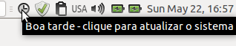
Após clicar, abre um Gnome-terminal e pede a senha pra depois atualizar:
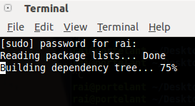

Exemplo com yad --progress
yad --progress:
Mostra um diálogo de progresso.
#!/bin/bash
# yad com --progress
# mostra uma barra de progresso para determinada ação, sendo que ler linha a linha
# dar entrada padrão
# neste exemplo busco arquivos .png na basta /home do usuário
find $HOME -name '*.png' | \
yad --progress \
--title "Progresso da busca" \
--width="300" \
--progress-text="Buscando imagens PNG" \
--pulsate \
--auto-close \
--auto-kill # mata o processo anterior caso usuario clique em cancelar
#.EOF
Salve com o nome de "progress.sh", dê permissão de execução:
chmod +x progress.sh
Execute:
./progress.sh
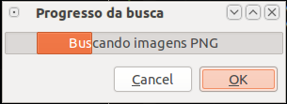

Conclusão

Exemplo com yad --text-info
yad --text-info:
Mostra diálogo com informações sobre texto.
Exemplo:
#!/bin/bash
# yad com --text-info
# exemplo para selecionar um arquivo e ver seu conteúdo (editá-lo se desejar)
ARQUIVO=$(\
yad --file \
--filename="$HOME/" \
--title="Selecione um arquivo" \
--width="500" \
--height="400" \
)
# testa se o usuário quer cancelou
ACAO="$?"
test "$ACAO" -eq "1" || test "$ACAO" -eq "252"
if [ "$?" -eq 0 ]; then
exit
fi
# filename - nome do arquivo, editable - permite edição, fore - cor do texto
# back - cor do fundo, fontname - fonte a ser usada, justify - alinhamento do texto
# margins - tamanho da margem, tail - barra de rolagem
MOD_ARQUIVO=$( \
yad --text-info \
--title="Visualizando o arquivo $ARQUIVO" \
--filename="$ARQUIVO" \
--editable \
--fore="#00FF00" \
--back="#000000" \
--fontname="Ubuntu" \
--justify="left" \
--margins="2" \
--tail \
--width="500" \
--height="400" \
--button="Cancelar":1 \
--button="Salvar":0 \
)
# testa se o usuário quer cancelou
ACAO="$?"
test "$ACAO" -eq "1" || test "$ACAO" -eq "252"
if [ "$?" -eq 0 ]; then
exit
fi
# salva as modificações no arquivo
echo $MOD_ARQUIVO \n > $ARQUIVO
#.EOF
Salve com o nome de "text_info.sh", dê permissão de execução:
chmod +x text_info.sh
Execute:
./text_info.sh
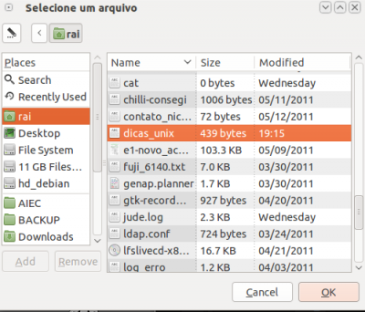
Após selecionar o arquivo:
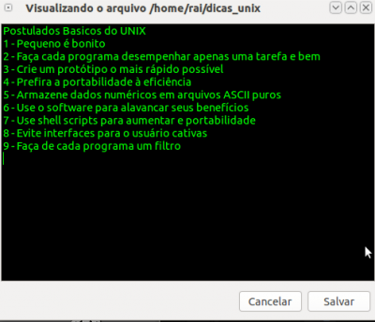

Exemplo com yad --scale
yad --scale:
Mostra um diálogo de escala.
#!/bin/bash
# yad com --scale
# neste exemplo uso o scale para permitir escolher o tamanho da imagem numa pagina html
#armazena o valor escolhido na escala
VALOR=$(\
yad --scale \
--title="Escolha o tamanho da imagem" \
--value="100" \
--min-value="100" \
--max-value="500" \
--step="50" \
)
#grava o conteúdo a ser gravado em uma pagina html com o tamanho da imagem escolhido
CONTEUDO="Vux
Todos os direitos reservados ao VOL :$
echo $CONTEUDO > scale.htm
#abre o arquivo no firefox
firefox scale.htm
#.EOF
Salve com o nome de "scale.sh", dê permissão de execução:
chmod +x scale.sh
Execute:
./scale.sh
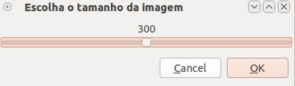
Após selecionar:

Mais um teste:
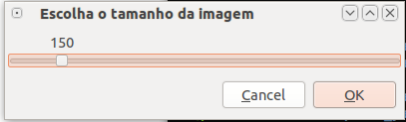
Após selecionar:


Conclusões e Agradecimentos
Estou adorando conhecer o Yad, espero que a comunidade goste também, quanto mais pessoas apoiarem esse projeto, seja usando, seja divulgando, mais temos chances que ele se torne padrão futuramente nas distribuições mais usadas, como Ubuntu.
As possibilidades com o Yad são várias, depende apenas da criatividade, meus exemplos foram apenas demonstrativos. No site do projeto, temos alguns exemplos bem interessantes, inclusive um do brasileiro Julio Neves, que aliás foi quem tive o prazer de conversar rapidinho nos corredores do CONSEGI 2011, e durante a conversa o Julio me falou sobre o Yad, então fiquei curioso e essa curiosidade resultou nesse trabalho :-)
O Julio Neves apresentou uma palestra sobre o Yad no CONSEGI, não pude assistir pois estava ajudando no Install Fest pela manhã e à tarde ia trabalhar.
- Yad uma nova e inovadora interface gui - consegi.gov.br
Obrigado Julio Neves e Parabéns Victor Ananjevsky, o Yad é muito maravilhoso!!!!
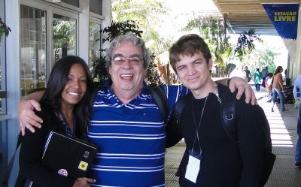
https://www.vivaolinux.com.br/artigos/impressora.php?codigo=12713

The bash code
Here is the bash code to make the sample YAD insert/edit/delete records template. Note extra coding is still needed to read in the file and add processing logic for the "Run" command. Additional coding is probably required to support file names with embedded spaces but that hasn't been tested yet.
#!/bin/bash

# NAME: websync
# PATH: $HOME/bin
# DESC: Provide list of files and corresponding website addresses.

# DATE: Mar 25, 2017.

# NOTE: Uses yad which is fork of zenity which is GUI fork of dialog.

# TODO: Add local file date modified. Add Answer last revision date.
# Add question title.
# Add file word count, or size, or ignore as irrelevant?
# Add answer word count if file word count is displayed.
# Add answer up votes.
# Scan directory to add all files. ("Populate" button)
# Initialize $ListArr[@] < /home/$USER/bin/.websync
# Use "|" as ListArr delimeter or (double quotes?) for file names with spaces

# Must have the yad package.
command -v yad >/dev/null 2>&1 || { echo >&2 "yad package required but it is not installed. Aborting."; exit 99; }

# Must have the zenity package.
command -v zenity >/dev/null 2>&1 || { echo >&2 "yad package required but it is not installed. Aborting."; exit 99; }

RenumberListArr () {
# This is called after inserting or deleting records.
# Record numbers may not be sequential because user can sort on any column
# Record nubmers must be unique as they are used to find the correct record in ListArr array.
# Matching on "file name" or any other field is impossible because there may be duplicate names.

# Define variables for easy reading and fewer code line changes when expanding
RecArrCnt=5
ListArrCnt=${#ListArr[@]}

i=1 # First element (0) is "false", followed by record number element (1)
j=1 # Record numbers start at 1

while [ $i -lt $ListArrCnt ] ; do
ListArr[$i]=$j
j=$(($j + 1))
i=$(($i + $RecArrCnt))
# echo "Renumber i: $i j: $j"
done

}

OLDIFS="$IFS"
IFS="|"
ListArr=()

# TODO: Replace this section with IFS=' ' read -ra CfgArr < /home/$USER/bin/.websync

ListArr=("${ListArr[@]}" false "1" "/usr/local/bin/display-auto-brightness" "Different")
Modified=$(stat "/usr/local/bin/display-auto-brightness" | grep "Modify:"| cut -f2 -d" ")
echo "Modified: $Modified" # File modified date is a future list array new field
ListArr=("${ListArr[@]}" "http://askubuntu.com/questions/894460/automatically-adjust-display-brightness-based-on-sunrise-and-sunset/894470#894470")
ListArr=("${ListArr[@]}" false "2" "/usr/local/bin/sun-hours" "Matches")
ListArr=("${ListArr[@]}" "http://askubuntu.com/questions/894460/automatically-adjust-display-brightness-based-on-sunrise-and-sunset/894470#894470")
ListArr=("${ListArr[@]}" false "3" "/etc/cron.daily/sun-hours" "Matches")
ListArr=("${ListArr[@]}" "http://askubuntu.com/questions/894460/automatically-adjust-display-brightness-based-on-sunrise-and-sunset/894470#894470")
ListArr=("${ListArr[@]}" false "4" "/home/rick/.conkyrc" "Matches")
ListArr=("${ListArr[@]}" "http://askubuntu.com/questions/894460/automatically-adjust-display-brightness-based-on-sunrise-and-sunset/894470#894470")
ListArr=("${ListArr[@]}" false "5" "/usr/local/bin/auto-brightness-config" "Matches")
ListArr=("${ListArr[@]}" "http://askubuntu.com/questions/894460/automatically-adjust-display-brightness-based-on-sunrise-and-sunset/894470#894470")
ListArr=("${ListArr[@]}" false "6" "/etc/cron.d/display-auto-brightness" "Matches")
ListArr=("${ListArr[@]}" "http://askubuntu.com/questions/894460/automatically-adjust-display-brightness-based-on-sunrise-and-sunset/894470#894470")
ListArr=("${ListArr[@]}" false "7" "/home/rick/bin/indicator-sysmonitor-display" "Different")
ListArr=("${ListArr[@]}" "http://askubuntu.com/questions/882419/can-bash-display-in-systray-as-application-indicator/882420#882420")

TransCount=0 # Number of Inserts, Edits and Deletes

# Read Only Status column: Recalc, Different, Matches, Bad File, No Address, Bad Address
# Debugging: --hide-column=2 hides Read Only record number column for normal operation

while true ; do

# adjust width & height below for your screen 900x600 default for 1920x1080 HD screen
# also adjust font="14" below if blue title text is too small or too large
Record=(`yad \
--title "websync - Compare local scripts to those published on internet." --list \
--text '<span foreground="blue" font="14"> \
Click column heading to sort.\
Select record before clicking: Insert / Edit / Delete</span>' \
--width=1200 --height=600 --center --radiolist -separator="$IFS" \
--button="Insert before":10 --button="Edit":20 --button="Delete":30 --button="Run":40 \
--button="Cancel ALL":50 --button="Save":60 --search-column=3 \
--column "Select" --column "Record number" --hide-column=2 --column "File Name" \
--column "Status" --column " Website Address" \
"${ListArr[@]}"`)
Action=$?

RecSelected=false
RecArr=()
i=0

# Button values 1 and 3 don't work for returning selected record for some reason???
# Button values 11, 13 and 15 don't work either. 12, 14 and 16 work.
# Therefore use Button values (10, 20, 30...) for readability.
for Field in "${Record[@]}" ; do
RecSelected=true
RecArr[i++]=$Field
done

# Define variables for easy reading and fewer code line changes when expanding
RecArrCnt=5
ListArrCnt=${#ListArr[@]}

# Error checking
if [[ $Action == 10 ]] || [[ $Action == 20 ]] || [[ $Action == 30 ]] ; then
if [[ $RecSelected == false ]] ; then
zenity --error --text 'You must select a record before clicking: Insert / Edit / Delete.'
continue
fi
fi

# Insert before || or Edit ?
if [[ $Action == 10 ]] || [[ $Action == 20 ]] ; then

RecArr[3]="Recalc"
# --text="Set fields and click OK to update"
# Note if there is a space at end of line, next line generates invalid command error from yad
NewRecArr=(`yad --width=900 --height=300 --title="Link file to Website Address" \
--form --center \
--field="File name":FL --field="Status":RO \
--field="Website Address":TXT \
${RecArr[2]} ${RecArr[3]} ${RecArr[4]}`)
ret=$?

# Cancel =252, OK = 0
# OK & Insert operation?
if [[ $ret == 0 ]] && [[ $Action == 10 ]]; then
# Create new list entry and renumber
((TransCount++)) # Update number of changes
let i=1 # Base 0 array, record number is second field

while [ $i -lt $ListArrCnt ] ; do
if [ ${ListArr[$i]} -eq ${RecArr[1]} ]; then
# We have matching record number to insert before
NewArr+=( false )
NewArr+=( "${ListArr[$i]}" )
NewArr+=( "${NewRecArr[0]}" )
NewArr+=( "${NewRecArr[1]}" )
NewArr+=( "${NewRecArr[2]}" )
fi
let j=$(( $i-1 ))
let k=$(( $j+$RecArrCnt ))
while [ $j -lt $k ] ; do
NewArr+=( "${ListArr[$j]}" )
j=$(($j + 1))
done
let i=$(($i + $RecArrCnt)) # Next list array entry to copy
done
ListArr=("${NewArr[@]}")
unset NewArr
RenumberListArr

# OK & Edit operation?
elif [[ $ret == 0 ]] && [[ $Action == 20 ]]; then
# Update array entry
((TransCount++))
let i=1
while [ $i -lt $ListArrCnt ] ; do
if [ ${ListArr[$i]} -eq ${RecArr[1]} ]; then
# We have matching record number
ListArr[++i]="${NewRecArr[0]}"
ListArr[++i]="New"
ListArr[++i]="${NewRecArr[2]}"
let i=$(($ListArrCnt + 1)) # force exit from while loop
else
let i=$(($i + $RecArrCnt)) # Check next entry
fi
done
fi

# Delete record?
elif [[ $Action == 30 ]] ; then
# --text="click OK to confirm delete"
# Note if there is a space at end of a script line, the next line generates
# "invalid command error from yad
yad --width=900 --height=300 --title="Do you really want to delete this record?" \
--text '<span foreground="blue" font="14">Click OK to confirm delete.</span>' \
--form --center \
--field="File name":RO --field="Status":RO \
--field="Website Address":RO \
${RecArr[2]} ${RecArr[3]} ${RecArr[4]}
ret=$?

# Cancel =252, OK = 0
if [[ $ret == 0 ]] ; then
# Delete record from list array and renumber
((TransCount++))
let i=1
while [ $i -lt $ListArrCnt ] ; do
if [ ${ListArr[$i]} -eq ${RecArr[1]} ]; then
# We have matching record number
j=$(($i - 1))
k=$(($j + $RecArrCnt))
while [ $j -lt $k ] ; do
unset 'ListArr[$j]'
j=$(($j + 1))
done
for i in "${!ListArr[@]}"; do
NewArr+=( "${ListArr[$i]}" )
done
ListArr=("${NewArr[@]}")
unset NewArr
let i=$(($ListArrCnt + 1)) # force exit from while loop
else
let i=$(($i + $RecArrCnt)) # Check next entry
fi
done
RenumberListArr
else
continue # cancel changes.
fi

# Run update process?
elif [[ $Action == 40 ]] ; then
continue # TODO: Run

# Cancel all changes?
elif [[ $Action == 50 ]] || [[ $Action == 252 ]] ; then
# Cancel ALL || or X the window or Escape
if [[ $TransCount -gt 0 ]] ; then
zenity --question --text "You have made $TransCount change(s). Do you really want to cancel?"
rc=$?
if [[ $rc -eq 0 ]] ; then
exit
fi
else
exit
fi

# Save changes?
elif [[ $Action == 60 ]] ; then
# Save
echo ${ListArr[@]} > ~/bin/.websync
exit
else
zenity --error --text "~/bin/websync - Unknown button return code: $Action"
exit
fi

done # End of while loop

IFS="$OLDIFS"

exit

Summary
Hopefully this saves others lots of time getting their own record management system going using bash and yad. Of course more bullet proof and probably faster methods can be done using Python or C but that probably comes at the expense of more lines of code and higher learning curve.
At the end of the day this project is targeted at those that want to learn more about bash and what can be accomplished in a bash-only environment.
Perhaps AskUbuntu is the wrong forum for posting this and Stack Overflow or Unix & Linux forums might be better Stack Exchange candidates. I look forward to comments on that as I'm really not sure the best place.
Of course I always look forward to general comments and constructive criticisms as well :)
https://itectec.com/ubuntu/ubuntu-bash-template-to-use-zenity-or-yad-to-insert-edit-delete-records-in-a-file-or-database/

Productivity Sauce
Mar 12, 2012 GMT
Dmitri Popov
If you want to add a dash of GUI goodness to your Bash scripts, you have several options. You can use Zenity or Kdialog to quickly add simple dialogs and message boxes to Bash scripts. However, both tools are rather limited, and for a more complex GUI design you might want to give YAD a try. If you are using Ubuntu, you can install YAD from the WebUpd8 PPA. Of course, you can compile YAD from source using the standard ./configure; make; make install routine.
YAD can be used to add simple and advanced GUI elements to a Bash script with relative ease. For example, I need to resize photos I post on Google+ almost daily, so I whipped up a simple Bash script sprinkled with YAD GUI elements:
#!/bin/bash

imageFile=$(yad --file --title="Select the image file")

dialog=$(yad --title "Bash Resize" --form --field="Resize parameter" --field="Quality")

size=$(echo $dialog | awk 'BEGIN {FS="|" } { print $1 }')
quality=$(echo $dialog | awk 'BEGIN {FS="|" } { print $2 }')

convert "$imageFile" -resize "$size" -quality "$quality"% "$imageFile"

yad --title="Status" --width=300 --button="gtk-ok:0" --text="All done. Yay!"
The imageFile=$(yad --file --title="Select the image file") statement creates a file selection dialog, while dialog=$(yad --title "Bash Resize" --form --field="Resize parameter" --field="Quality") creates a simple form containing two fields: Resize parameter and Quality. The output generated by the dialog box looks like this: 1600x || 95. So it's necessary to break it into separate values, which is done using awk (if there is a better way to do that, please do let me know). The obtained values are then passed to the convert tool which does the rest.
This is just a very simple example of YAD's capabilities and you can find other examples on the project's website.
« previous post next post »

Comments

yad
lonestar
size=${dialog%|*}
quality=${dialog#*|}
but ... why do you use '|' as a seperator? why not ',' or ':' or space or whatever? (at least something that will not interfer with the shell - to _my_ simple mind, '|' is somewhat 'loaded' though it works ok for this little example
5
+50
I am not totally sure what you mean, but if I understand it correctly you want something like this:
#!/bin/bash

yad --text="Execute the file?" --button="Execute" --button="Edit"

case $? in
0)thunar "$1"
;;
1)gedit $1
;;
esac
I found a link (ubuntuusers.de), but it is in German. There are a few code examples and pictures though, that might help. And you can always translate it with google.
I would have written this as a comment if I could, but I am not yet allowed to. Hope it helps.

2
I happened to write this a few days ago for a question of my own (Bash template to use zenity (or yad) to insert / edit / delete records in a file or database) and thought it was worth sharing:
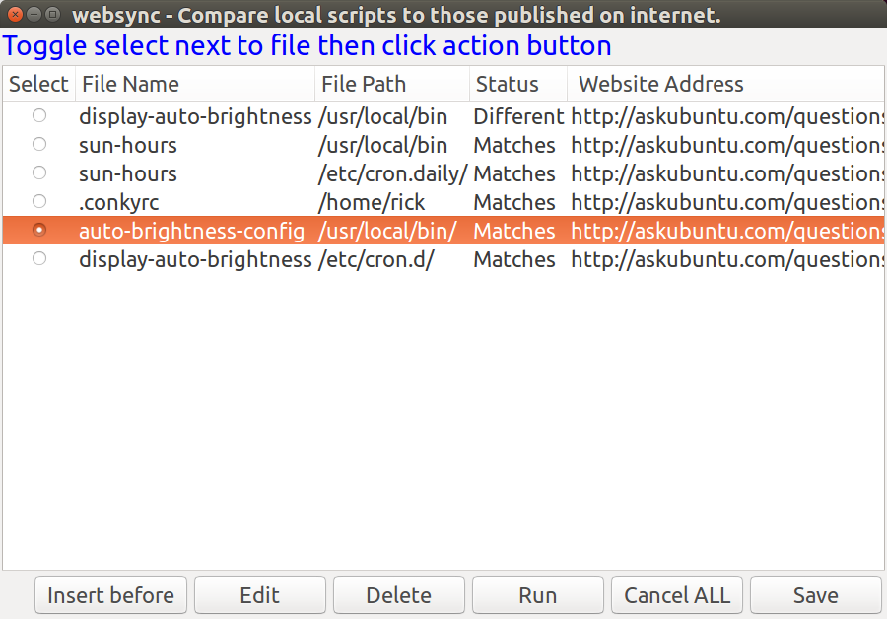
Notice the six buttons on the screen and how they are handled in the code below (sorry still a work in progress). An important note is when using custom buttons to always trap default return codes like 252 for Escape and Windows close (clicking X).
while true ; do

Record=(`yad \
--title "websync - Compare local scripts to those published on internet." --list \
--text '<span foreground="blue" font="14">Toggle select next to file then click action button</span>' \
--width=900 --height=600 --center --radiolist -separator="$IFS" --no-click \
--button="Insert before":1 --button=Edit:2 --button=Delete:3 --button=Run:4 \
--button="Cancel ALL":5 --button=Save:6 --search-column=3 \
--column "Select" --column "Record number" --hide-column=2 --column "File Name" \
--column "Status" --column " Website Address" \
"${choices[@]}"`)
Action=$?

RecSelected=false
RecArr=()
i=0

# With radio list only one choice is possible
for Field in "${Record[@]}" ; do
RecSelected=true
RecArr[i]=$Field
# echo "RecArr $i ${RecArr[$i]}"
((i++))
done

echo "button: $Action"#
# Note: When X closes window or Escape pressed 252 is returned.

# Insert before || or Edit ?
if [[ $Action == 1 ]] || [[ $Action == 2 ]] ; then
RecArr[3]="New"
# --text="Set fields and click OK to update"
# Note if there is a space at end of line, next line generates invalid command error from yad
yad --width=600 --height=400 --title="Link file to Website Address" \
--form --center \
--field="Record Number":RO --field="File name":FL --field="Status":RO \
--field="Website Address":TXT \
${RecArr[1]} ${RecArr[2]} ${RecArr[3]} ${RecArr[4]}
ret=$?

# Cancel =252, OK = 0
if [[ $ret == 0 ]] ; then
# Update array and renumber
: # noop
else
continue # cancel changes.
fi

elif [[ $Action == 3 ]] ; then
: # Delete
elif [[ $Action == 4 ]] ; then
: # Run
elif [[ $Action == 5 ]] || [[ $Action == 252 ]] ; then
# Cancel ALL || or X the window or Escape
exit
elif [[ $Action == 6 ]] ; then
# Save
exit
else
zenity --error --text "~/bin/websync - Unknown button return code: $Action"
fi

done # End of while loop

yad > exemples de scripts

  - Logout dialog
  - Run dialog
  - Autostart editor
  - Graphical frontend for su
  - Discussion
  - Tips on getting user input
    - User-checking the input in YAD
  - Scripting a fancy chooser for recently used files
  - Multiple-item data entry with YAD
  - UN AUTRE

Logout dialog
#! /bin/bash
action=$( yad --width 300 --entry --title "System Logout" \
--image=gnome-shutdown --button="Switch User:2" --button="gtk-ok:0" --button="gtk-close:1" \
--text "Choose action:" --entry-text "Power Off" "Reboot" "Suspend" "Logout" )
ret=$?

[[ $ret -eq 1 ]] && exit 0

if [[ $ret -eq 2 ]] ; then
gdmflexiserver --startnew &
exit 0
fi

case $action in
Power*) cmd="sudo /sbin/poweroff" ;;
Reboot*) cmd="sudo /sbin/reboot" ;;
Suspend*) cmd="sudo /bin/sh -c 'echo disk > /sys/power/state'" ;;
Logout*)
case $(wmctrl -m | grep Name) in
*Openbox) cmd="openbox --exit" ;;
*FVWM) cmd="FvwmCommand Quit" ;;
*Metacity) cmd="gnome-save-session --kill" ;;
*) exit 1 ;;
esac
;;
*) exit 1 ;;
esac

eval exec $cmd

Run dialog
#! /bin/bash

XTERM="xterm"

# create history file
mkdir -p ${XDG_CACHE_HOME:-$HOME/.cache}/
HISTFILE=${XDG_CACHE_HOME:-$HOME/.cache}/ix-run.history
touch $HISTFILE

# create and run dialog
TITLE="Run command"
TEXT="\nEnter command to execute:\n"
rcmd=$( 'yad --width=500 --center --window-icon="gtk-execute" --name="${0##*/}" --title="$TITLE" \
--text="$TEXT" --image="gtk-execute" --entry --editable --rest="$HISTFILE" )

[[ -z "$rcmd" ]] && exit 0

# run command
case $rcmd in
http://*|https://*|ftp://*)
xdg-open $rcmd &
;;
mailto://*)
xdg-email $rcmd &
;;
man://*)
eval $XTERM -e "man ${rcmd#man://}" &
;;
telnet*|ssh*)
eval $XTERM -e "$rcmd" &
;;
*)
eval $rcmd &
;;
esac

# add command to history
grep -q -F "$rcmd" $HISTFILE || sed -i "1 i $rcmd" $HISTFILE

exit 0

Autostart editor
#! /bin/bash

config_dir=${XDG_CONFIG_HOME:-$HOME/.config}
results=$(mktemp --tmpdir autostart.XXXXXXXXXX)

for f in $config_dir/autostart/*.desktop; do
grep -m 1 -e '^[[:blank:]]*Exec' $f | cut -d = -f 2
grep -m 1 -e '^[[:blank:]]*Name' $f | cut -d = -f 2
grep -m 1 -e '^[[:blank:]]*Comment' $f | cut -d = -f 2
done | yad --width=500 --height=300 --title="Autostart editor" --image="gtk-execute" \
--text="Add/remove autostart items" --list --editable --print-all \
--multiple --column="Command" --column="Name" --column="Description" > $results

if [[ ${PIPESTATUS[1]} -eq 0 ]]; then
rm -f $config_dir/autostart/*.desktop
i=0
cat $results | while read line; do
eval $(echo $line | awk -F'|' '{printf "export NAME=\"%s\" COMMENT=\"%s\" COMMAND=\"%s\"", $2, $3, $1}')
cat > $config_dir/autostart/$i$NAME.desktop << EOF
[Desktop Entry]
Encoding=UTF-8
Name=$NAME
Comment=$COMMENT
Exec=$COMMAND
StartupNotify=true
Terminal=false
EOF
$((i++))
done
unset NAME COMMENT COMMAND
fi

rm -f $results
exit 0

Graphical frontend for su
#! /bin/bash

# some defaults
user="root"
suargs="-p"
force="no"

# parse commandline
if [[ $# -eq 0 ]]; then
echo "Usage: ${0##*/} [-f] [-u user] [--] "
exit 1
fi

OPTIND=1
while getopts u: opt; do
case "$opt" in
f) force="yes" ;;
u) user="$OPTARG" ;;
esac
done
shift $((OPTIND - 1))

cmd="$*"

if [[ $force != "no" ]]; then
# check for sudo
sudo_check=$(sudo -H -S -- echo SUDO_OK 2>&1 &)
if [[ $sudo_check == "SUDO_OK" ]]; then
eval sudo $cmd
exit $?
fi
fi

# get password
pass=$(yad --class="GSu" --text="password for <b>$user</b>:" --image="dialog-password" --entry --hide-text)
[[ -z "$pass" ]] && exit 1

# grant access to xserver for specified user
xhost +${user}@ &> /dev/null

# run command
fifo_in="$(mktemp -u --tmpdir gsu.empty.in.XXXXXXXXX)"
fifo_out="$(mktemp -u --tmpdir gsu.empty.out.XXXXXXXXX)"

LC_MESSAGES=C empty -f -i $fifo_in -o $fifo_out su $suargs $user -c "$cmd"
[[ $? -eq 0 ]] && empty -w -i $fifo_out -o $fifo_in "word:" "$pass\n"

exit $?

Discussion
combo-boxes and spin buttons to form dialog

By default, initial value should be the first entry in the list.
To get a little complicate, add another option says "init-val". This option can either be some value to be added to the existing list as initial value or a number specifying the location of initial value in existing list. Examples:

yad --entry "one" "two" "three" #"one" is initial value
yad --entry "one" "two" "three" --init-val "zero" #"zero" is initial value
yad --entry "one" "two" "three" --init-val 1 #"two" is initial value (count start from 0)

yad --form --field="combo:CB" 'test1!test2!test3' give you what you want
here is the simple form like a .desktop entry editor
yad --title="Desktop entry editor" --text="Simple desktop entry editor" \
--form --field="Type:CB" --field="Name" --field="Generic name" \
--field="Comment" --field="Command:FL" --field="Icon" \
--field="In termianl:CHK" --field="Startup notify:CHK" \
"Application!URI" "Name" "Generic name" "This is the comment" \
"/usr/bin/yad" "yad" FALSE TRUE
I have tried to use yad in those situations:
$ yad --form --field="Label:DIR" --item-separator="\$" \
--field="labelys:CB" 'DATA$data$basta' /home/xbg|(null)| <<- in this situation CB flag does not works < WHY?
$ yad --form --item-separator="\$" --field="labelys:CB" 'DATA$data$basta' basta|
you miss data for first field
yad --form --field="Label:DIR" --item-separator="\$" --field="labelys:CB" $HOME 'DATA$data$basta'
would works…
by default yad prints result only for buttons with even return codes. for changing this behavior add --always-print-result option.
make a checkbox (:CHK) be checked by default :by settings initial values in extra arguments :
yad --form --field entry1 --field check1:chk --field entry2 --field check2:chk '' true '' false
in above example first check entry will be activated

Tips on getting user input

User-checking the input in YAD
-editable Suppose the user has entered data in a form dialog like the one below, which defaults to the pipe character (|) as separator for output items. The example dialog is contained in a BASH script called ‘demo’:

#!/bin/bash
yad --form --field="Nom" --field="Prénom" --field="Date de naissance (JJ/MM/AAAA)"

—> retour : Bloggs|Fred|456/12/1985|

Hop hop hop. le jour est 456. No problem, we can help him by offering a confirmation dialog in which his previous entries are editable. First we’ll send the output of the YAD form dialog to a temp file, then extract each of the data entries from that file with the cut command, using the pipe character as delimiter (-d’|’):

#!/bin/bash
yad --form --field="Nom" --field="Prénom" --field="Date de naissance (JJ/MM/AAAA)" > /tmp/entries
nom=$(cut -d'|' -f1 < /tmp/entries)
prenom=$(cut -d'|' -f2 < /tmp/entries)
naissance=$(cut -d'|' -f3 < /tmp/entries)

Puis, we’ll echo those entries back into a YAD ‘text-info’ dialog with the -editable option, storing the edited (or not) result in a variable:

#!/bin/bash
yad --form --field="Nom" --field="Prénom" --field="Date de naissance (JJ/MM/AAAA)" > /tmp/entries
nom=$(cut -d'|' -f1 < /tmp/entries)
prenom=$(cut -d'|' -f2 < /tmp/entries)
naissance=$(cut -d'|' -f3 < /tmp/entries)
final=$( echo -e "Nom:\t$nom\nPrenom:\t$prenom\nDate:\t$naissance" \
| yad --text-info --editable --width="300" --height="200" --text="Tout est OK ?")

Editing is done by Mr Bloggs:

YAD va retourner tous les caractères (\n et \t compris). Mais, nous avons output in a variable, we can replace the tab and newline characters with a single space simply by echoing the variable (echo $final):

Last name: Bloggs Firs name: Fred Date of birth: 16/12/1985

and we can remove the entry-prompts and replace spaces with pipes using sed commands:

foo="Last name: Bloggs Firs name: Fred Date of birth: 16/12/1985"
echo $foo
Last name: Bloggs Firs name: Fred Date of birth: 16/12/1985
echo $foo | sed 's/[A-Z][a-z]*: /|/g'
|Bloggs |Fred |16/12/1985
echo $foo | sed 's/[A-Z][a-z]*: /|/g;s/^|//'
Bloggs |Fred |16/12/1985
echo $foo | sed 's/[A-Z][a-z]*: /|/g;s/^|//;s/ |/|/g'
Bloggs|Fred|16/12/1985

The finished script is shown below; it includes a ‘get me out of here!’ cancel for the text-info dialog:

#!/bin/bash
yad --form --field="Nom" --field="Prénom" --field="Date de naissance (JJ/MM/AAAA)" > /tmp/entries
nom=$(cut -d'|' -f1 < /tmp/entries)
prenom=$(cut -d'|' -f2 < /tmp/entries)
naissance=$(cut -d'|' -f3 < /tmp/entries)
final=$( echo -e "Nom:\t$nom\nPrenom:\t$prenom\nDate:\t$naissance" \
| yad --text-info --editable --width="300" --height="200" --text="Tout est OK ?")

if [[ $? == 1 ]] ; then
rm /tmp/entries
exit
else [[ $? == 0 ]]
echo $final | sed 's/[A-Z][a-z]*: /|/g;s/^|//;s/ |/|/g'
rm /tmp/entries
fi

exit

Scripting a fancy chooser for recently used files
Afficher les 10 derniers fichiers modifiés en ordre chronologique inverse, avec deux fichiers sélectionnés :

Voici le code :

#! /bin/bash

find ~ ! -path $HOME/'\.*' -and ! -path $HOME/'Mail*' -type f -mtime -2 \
| xargs ls -l --time-style=long-iso \
| awk '{print $6,$7,$8}' \
| sort -rk1,1 -rk2,2 \
| head \
| tr ' ' '\t' > /tmp/raw

paste <(awk -F/ '{print $NF}' /tmp/raw) /tmp/raw > /tmp/table10

choices=$(awk -F"\t" '{print "<b>"$1"</b>\n<span color=\"green\">"$2" — "$3"</span>"}' /tmp/table10 \
| yad --list --multiple --column=File --separator="" --width=300 --height=600 --center \
--ellipsize=middle --title="Recent Files")

if [[ -z $choices ]]; then
rm /tmp/raw /tmp/table10 && exit 0
else
echo "$choices" \
| sed 's/<b>\(.*\)<\/b>/\1/' \
| while read line; do xdg-open $(awk -v OPEN="$line" '$1 ~ OPEN {print $4}' /tmp/table10); done
fi

rm /tmp/raw /tmp/table10

exit 0

EXPLICATIONS

find ~ ! -path $HOME/’\.*’ -and ! -path $HOME/’Mail*’ -type f -mtime -2

find cherche dans le rép /home/moi (~) des fichiers (type -f) modifiés les deux dernières 24 heurs (-mtime -2). Excluant (!) les fichiers ou dossiers cachés (commençant par .) et les fichiers du rép Mail

La liste est envoyée dans xargs qui renvoie chaque fichier dans un ls avec comme option une sortie en ‘long listing format’ (-l) et le format de date ISO 8601 (--time-style=long-iso) :

-rw-r--r-- 1 moi moi 456 2015-08-10 19:51 /home/moi/projets/test/contacts

On récupère la date (6ème colonne), l’heure (7ème) et le chemin complet (8ème) grâce à AWK :awk ‘{print $6,$7,$8}’
La date devient donc le 1er champs, l’heure le 2ème et le chemin le 3ème.
sort -rk1,1 -rk2,2 on trie avec la date en ordre inverse, puis on affiche les 10 premiers : head.
tr pour remplacer les espaces par des tabulations.
Le résultat est enregistré dans /tmp/raw

On récupère le nom du fichier (AWK avec / comme séparateur de champs -F/ ) et afficher le dernier champs ($NF) de chaque ligne.

The extracted filenames are then joined to each line in the temp file with the paste command (line 10) with a tab as default separator, and the result is saved to a new temp file, /tmp/table10:

The table /tmp/table10 is now the working file for the chooser dialog, which I build with YAD. I want the YAD dialog to display each filename in bold, and under each filename the modification date and time in green (no special reason, just suits my color sense). To do this I tweak the text of each line in /tmp/table10 with AWK, adding the old-fashioned HTML markup for bold font (<b>) and a newline (line 12), and this time telling AWK that the field separator is a tab (-F"\t"). When I pipe the marked-up lines to YAD, YAD reads the markup as Pango markup and displays the text the way I want (see first illustration, above).
The other YAD options I use (lines 13 and 14) set the size and position of the dialog, its type (list) and the output separator (none), and allow me to make multiple selections from the list (--multiple). YAD also allows me to set where the ellipsis (…) goes in filenames too long for the width of the dialog (see 6th file in list in first illustration, above). Note that YAD only outputs the selected line in the dialog (the filenames), not the entire line as piped from AWK.
The selections I make are saved in the variable ‘choices’ (line 12). If I decide to cancel or close the YAD window, the script deletes my temp files and exits (lines 16 and 17). If I OK the selections, ‘choices’ is echoed (line 19) to sed to remove the bolding markup from the filename (line 20).
In line 21 I again use AWK, this time in a while loop. As each line with its selected filename is read by BASH, AWK looks for that filename in the first field in /tmp/table10. When it finds the line with that filename, AWK prints the full path to that file, which is the 4th field in the line (see above). For each selected filename, the full path is now passed to xdg-open, which opens the file with the default application for that file type.
The script then deletes the temp files and exits, leaving me with the selected files open on my desktop.

Multiple-item data entry with YAD
yad --form --field="Last name"

yad --title="" --text="coucou" --image="/home/moi/monImage.svg" --form --field="Nom"

yad --width=400 --title="" --text="coucou" --image="/chemin/vers/image.svg" --form --field="nom" --field="prénom"

le retour sera de la forme : monNom|monPrenom|
pour changer le séparateur de données --separator="\t" (pour une tabulation par exemple)

combo box

Les choix sont séparés par des !. For example, for the field --field="Last holiday":CB we might specify ‘un!deux!trois‘.
On peut choisir le caractère de séparation par une virgule par exemple : --item-separator="," et alors mes données seront ‘un,deux,trois‘.

On doit renseigner les champs également avant le Select (par "" pour dire vide) :

yad --width=400 --text="coucou" --form --field="nom" --field="prenom" --field="Last holiday":CB "" "" 'un!deux!trois'

I can choose ‘other’, delete it and type in ‘Melbourne’:

Probably the most useful combo box trick is that the combo box list can be read from a variable, keeping the code clearer:

holidays=$(echo "Gold Coast,Bali,Phuket,Sydney,other")
yad --width=400 --title="" --text="coucou" --image="/chemin/image.svg" \
--form --item-separator="," --field="nom" --field="prénom" --field="Last holiday":CBE "" "" "$holidays"

The last field I’ll add to the form is a multi-line text entry one, of type :TXT. Note below that I’ve also added another field ‘placeholder’ in the last line of the code for the new, last field:

holidays=$(echo "Gold Coast,Bali,Phuket,Sydney,other")
yad --width=400 --title="" --text="coucou" --image="/chemin/image.svg" --form --item-separator="," \
--field="nom" --field="prenom" --field="Last holiday":CBE --field="Liste":TXT "" "" "$holidays" ""

return Smith|Jack|8 September 1991|Melbourne|Mum’s bangers and mash\nLamb curry\nHawaiian-style pizza|

In other words, the newlines in the entered, multi-line text are reported by YAD as newline characters (\n).

Yet another nice feature of YAD is shown in the image below, which comes from one of my scripts to manage scientific data.

NOTE : the first three fields are grayed-out? The entries in these three fields come from other dialogs and were fed to this YAD dialog as the variables genus, species and event. Here are the relevant parts of the code:

yad --form --separator='\t' --field="Genus":RO --field="Species":RO --field="Event code":RO \
...
$genus $species $event "" 'ANIC!AusMus!NMV!QldMus!QVMAG!SAM!WAM!other' "" "" 'R. Mesibov!other' "" "" ""

UN AUTRE
I have a large list of directories in an array. I perform CRUD operations on the array. Each time the array is displayed with yad it starts at top of array. I would like to position the list to the last array entry accessed. I’ve set the first field to true but it only shows as selected and doesn’t position the list to that section of array.
I’ve tried piping the directory name into yad (it’s searchable on column 2) by trying:
echo "$DirName" | Record=(`yad --list ... `)
and
Record=(`yad --list ... `) <<< "$DirName"
The complete code is:
Record=(`yad --list --radiolist --separator="|" --grid-lines=hor \
--title="bafman - Born Again File Manager - $DirCnt Directories" \
--text="Navigate to directory and double-click or space bar to use:\
Tag files / Edit comments / Hide Dir buttons." \
--width=1200 --height=800 --center --no-markup \
--button="Tag files":$ButnTag --button="Run command":$ButnCommand \
--button="Edit comments":$ButnComment \
--button="Add Dir":$ButnAdd --button="Hide Dir":$ButnHide \
--button="Update Dirs":$ButnUpdate --button="$VariableCloseText":$ButnCancel \
--button="Save":$ButnSave \
--wrap-width=800 --wrap-cols=2 --dclick-action \
--ellipsize=START --ellipsize-cols=8 \
--search-column=2 --column "Select" \
--column "Searchable Directory Name (just start typing)" \
--column "Modified":HD --column "Owner":HD --column "Status":HD \
--column "File Cnt":NUM --column "File Sizes":SZ --column "Comment...":TXT \
--column "Tag Cnt":NUM --column "Tag Sizes":SZ \
"${DirsArr[@]}"`)
Action=$?
Above code is called in while loop as directories are added, hidden, edited and tagged.
The "Comments…" column doesn’t --ellipsize properly and displays full width. I think it was working correctly so I must have done something to break it. I’ve tried all the START, NONE, MIDDLE and END options but the column is still width of longest element.
To summarize:
1) Is it possible to position yad --list to specific section of array?
2) Why are comments not being ellipsized?
If I understood this, you want to add new rows without closing the list dialog.
I made this little script as an example. You can add folders to the list several times by clicking on "Add Folders" button.
This is only an example not ment for too many folders. :) Just a few to see how you can add more data to the list.
#!/bin/bash

test -e /tmp/yadpipe03 && rm -f /tmp/yadpipe03

# Named pipe initialization
export PIPE_03=/tmp/yadpipe03
mkfifo $PIPE_03
exec 3<> $PIPE_03

function load_data
{
DIRS="$(yad --file --multiple --width=800 --height=600 --directory --title="Select Folders")"

OIFS=$IFS
IFS="|"

[[ ! -z "$DIRS" ]] && YAD_DATA=($(for DIR in "$DIRS" ; do echo "$DIR" ; done ))

IFS=$OIFS

for DATA in "${YAD_DATA[@]}";do
echo True # Adds "True" for the checklist column
echo "${DATA}"
done
}
export -f load_data

function clear_all
{
echo -e '\f'
}
export -f clear_all

# Main Dialog
Record=($(yad --list --checklist --separator="|" --grid-lines=hor \
--width=1200 --height=800 --center --title="Nafman" --text="Example" \
--column "Select" --column "Folder" \
--button="Add Folders!gtk-add":'bash -c "load_data > $PIPE_03"' \
--button="Clear!gtk-clear":'bash -c "clear_all > $PIPE_03"' \
--button="OK!gtk-ok":0 \
--listen --print-all < $PIPE_03))
Action=$?

echo ${Record[@]}
http://ti1.free.fr/index.php/yad-creer-des-fenetres-pour-des-scripts-bash/

http://ti1.free.fr/index.php/categorie/yad/

yad > le sélecteur de polices

  - PRÉVISUALISATION
yad --font

sortie renvoyée : Sans 10

Si le Bold (Gras) est sélectionné : sortie > Sans Bold 10

PRÉVISUALISATION
yad --font --preview="voici mon texte de prévisualisation"

Pour passer les trois (Family, Style, Size) séparément :

#!/bin/sh
yad --font | while read line; do
STL=`echo $line | grep -o "Bold\|Italic\|Oblique\|Condensed\|Medium"` #Might need to add more styles
STYLE=`echo $STL`
SIZE=`echo $line | awk '{print $NF}'`
if [ "$STYLE" = "" ]; then
NAME=`echo $line | awk -F"$SIZE" '{print $1}'`
else
NAME=`echo $line | awk -F"$STYLE" '{print $1}'`
fi
echo $NAME $STYLE $SIZE
done

yad > le sélecteur de fichier

  - GENERALITES
    - Pré-sélection du fichier
    - multi sélection
    - Récupération de la sélection
  - NE SÉLECTIONNER QUE CERTAINS FICHIERS
    - que des répertoires
    - que certaines extensions
  - SAUVEGARDER UN FICHIER

GENERALITES
yad --file

Pré-sélection du fichier
yad --file --filename=/root/hello.txt --width=400

multi sélection
yad --file --multiple --width=600 --height=400

Utiliser CTRL ou SHIFT pour choisir les fichiers.

Récupération de la sélection
CHOIXDESFICHIERS=`yad --file --width=600 --height=400`

Voici un exemple :

#!/bin/sh
CHOIX=`yad --file --width=600 --height=400`
viewnior $CHOIX

NE SÉLECTIONNER QUE CERTAINS FICHIERS

que des répertoires
yad --file --directory --width=600 --height=400

que certaines extensions
--file-filter=NAME | PATTERN1 PATTERN2 …

yad --width=600 --height=400 --file --file-filter="Graphic files | *.jpg *.png"

SAUVEGARDER UN FICHIER
yad --file --directory --save --width=600 --height=400

--separator=SEPARATOR

--confirm-overwrite=[TEXT]

--multiple Allow selection of multiple filenames in file selection dialog.

--directory Activate directory-only selection.

--save Activate save mode.

--separator=STRING Specify separator character when returning multiple filenames.

--confirm-overwrite[=TEXT] Confirm file selection if filename already exists. Optional argument is a text for confirmation dialog.

--quoted-output Output values will be shell-style quoted.

yad > le sélecteur de couleurs

yad --color

--init-color=COLOR couleur initiale

yad --color --init-color=#008080

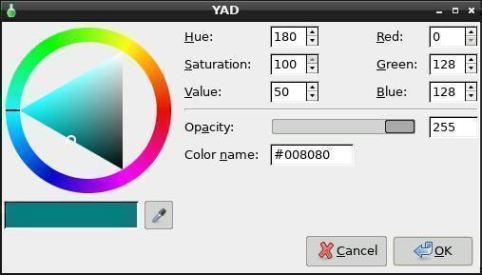

Sortie : #008080

--gtk-palette Show system palette inside color dialog.

--extra Show extra information about color in returned string.

--alpha Add opacity to output color string.

--palette[=FILENAME] Show palette and set predefined colors from given filename. By default used /etc/X11/rgb.txt.

--expand-palette Expander for list of user-defined colors will be initially opened.

--mode=MODE Set output color mode (hex ou rgb) Default is hex. HEX = #rrggbbaa, RGB = rgba(r, g, b, a). opacity have values from 0.0 to 1.0.

yad > fenêtre de Drag’n'Drop

  - md5sum
Par défaut, la fenêtre de Drag’n'Drop se présente ainsi :

yad --dnd

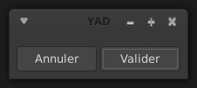

Après y avoir déposer le(s) fichier(s), yad retourne en sortie : file:///chemin/fichier

Faire un pipe vers sed pour avoir le chemin correct (on supprime les 7 premiers caractères) :

yad --dnd | sed 's/^.......//'
/root/Desktop/tmp

Pour afficher un texte d’invite :

yad --text="Déposez vos fichiers ici :" --dnd

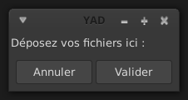

md5sum
#!/bin/sh
v=`yad --text="Déplacer vos fichiers ici" --dnd | sed 's/^.......//'`
o=`md5sum $v`
yad --width=500 --height=200 --title="MD5SUM Check" --text="$o"

Autre méthode :

#!/bin/sh
killall yad
for i in "$@"; do
case "${i}" in
*)
o=`md5sum "${i}"`
yad --title="CheckSum Calculator" --form --field="" "$o" --no-buttons --geometry=550x50+500+0
;;
esac
done

--command=CMD Run command when data received. Data strings pass to command as an argument. By default data just prints to stdout.

yad > les calendriers

  - RÉCUPÉRER LA DATE
    - format de sortie
    - liste des formats de sortie
  - PRÉSÉLECTIONNER UNE DATE
    - le jour
    - cumulé
yad --calendar

RÉCUPÉRER LA DATE
#!/bin/sh
THEDATE=`yad --calendar`
yad --text="Date sélectionnée : $THEDATE"

format de sortie
la sortie sera normalement de cette forme : 25/01/15

Pour changer le format de sortie :

yad --calendar --date-format=%d%m%y
250115

liste des formats de sortie
%% a literal %
%a locale’s abbreviated weekday name (Sun..Sat)
%A locale’s full weekday name, variable length (Sunday Saturday)
%b locale’s abbreviated month name (Jan Dec)
%B locale’s full month name, variable length (January December)
%c locale’s date and time (Sat Nov 04 12:02:33 EST 1989)
%d day of month (01..31)
%D date (mm/dd/yy)
%e day of month, blank padded ( 1..31)
%h same as %b, locale’s abbreviated month name (Jan..Dec)
%H hour :24 hour(00..23)
%I hour :12 hour(01..12)
%j day of year (001..366)
%k heure :24 heures (00..23)
%l heure :12 heures (01..12)
%m month (01..12)
%M minute (00..59)
%n a newline
%p locale’s AM or PM
%r Time, 12-hour (hh:mm:ss [AP]M)
%s Seconds since 1970-01-01 00:00:00, (a GNU extension)
Note that this value is defined by the localtime system
call. It isn’t changed by the ‘--date’ option.
%S second (00..60)
%t a horizontal tab
%T Time, 24-hour (hh:mm:ss)
%U numéro de la semaine. Avec Dimanche comme premier jour de la semaine (00..53)
%V numéro de la semaine. Avec Lundi comme premier jour de la semaine (01..53). If the week containing January 1 has four or more days in the new year, then it is considered week 1; otherwise, it is week 53 of the previous year, and the next week is week 1.
%w day of week (0..6); 0 represents Sunday
%W week number of year with Monday as first day of week (00..53)
%x locale’s date representation (mm/dd/yy)
%X locale’s time representation (%H:%M:%S)
%y last two digits of year (00..99)
%Y year (1970)
%Z Time offset from UTC (-07) This generally consists of Time Zone+DST

PRÉSÉLECTIONNER UNE DATE

le jour
yad --calendar --day=20

yad --calendar --month=2

yad --calendar --year=2012

cumulé
yad --calendar --year=2012 --month=2 --day=21

--show-weeks Show the week numbers at the left side of calendar.

--details=FILENAME Read days description from FILENAME. File with days details must be in following format:
<date> <description> date field is date in format, specified with --date-format option. description is a string with date details, which may include Pango markup.

yad > mise en forme et aspect des fenêtres

  - TITRE
    - icône à gauche du titre
  - GÉOMÉTRIE
    - largeur - hauteur
    - centrer
    - position de la souris
  - TEXTE
    - Centrer le texte

TITRE
-title Donner une titre à la fenêtre

Ne pas afficher la barre des titres (et sans bordure) :

yad --undecorated

icône à gauche du titre
--window-icon=/chemin/vers/image

GÉOMÉTRIE
--geometry=WxH+X+Y pour Largeur Hauteur Horizontal Vertical.

Exemple : une boite de 400 pixels de côté positionné à 512 pixels horizontalement et 384 pixels verticalement :

yad --geometry=400x400+512+384

ou juste

yad --geometry=400x400

largeur - hauteur
--width=WIDTH --height=HEIGHT

centrer
yad --center

position de la souris
Pour placer la boite de dialogue là où se trouve la souris.

yad --mouse

TEXTE

Centrer le texte
yad --text="coucou" --text-align=center

NOTE : il faut obligatoirement utiliser --text avec --text-align

yad > les Fonctions

  - FONCTIONS
  - VARIABLES

FONCTIONS
yad --button=gtk-ok:"bash -c on_click" --button=gtk-help:"bash -c help" --button=gtk-quit:0

Pour appeler des fonctions dans un script :

#! /bin/bash

on_click(){
yad --about
}
export -f on_click

help(){
yad --text=" This is help file. "
}
export -f help

yad --button=gtk-ok:"bash -c on_click" --button=gtk-help:"bash -c help" --button=gtk-quit:0

VARIABLES
Pour exporter des variables, la tâche est un peu compliquée :

#!/bin/sh
names=$(echo "Waters,Gilmour,Wright,Mason")
occupation=$(echo "Basse,Guitare,Claviers,Drums")
yad --form --separator="," --item-separator="," --field="Qui:":CB --field="Quoi:":CBE --field="Blabla:":TXT \
"$names" "$occupation" "qui fait quoi ?"

Si on appuie sur OK, le retour sera > Waters,Basse,qui fait quoi ?,

#!/bin/sh
names=$(echo "Waters,Gilmour,Wright,Mason")
occupation=$(echo "Basse,Guitare,Claviers,Drums")
yad --form --separator="," --item-separator="," --field="qui:CB" --field="quoi:CBE" --field="blabla:TXT" \
"$names" "$occupation" "Type your comments here" | while read LL ; do
NAME=`echo $LL | awk -F',' '{print $1}'`
OCCUPATION=`echo $LL | awk -F',' '{print $2}'`
COMMENT=`echo $LL | awk -F',' '{print $3}'`
echo "(The selected name) (Selected occupation) (Comments)"
echo
echo $NAME $OCCUPATION $COMMENT
done

Ou :

#!/bin/sh
names=$(echo "Waters,Gilmour,Wright,Mason")
occupation=$(echo "Basse,Guitare,Claviers,Drums")
yad --form --separator="," --item-separator="," --field="qui:CB" --field="quoi:CBE" --field="blabla:TXT" \
"$names" "$occupation" "Type your comments here" > /tmp/config
NAME=`cat /tmp/config | awk -F',' '{print $1}'`
OCCUPATION=`cat /tmp/config | awk -F',' '{print $2}'`
COMMENT=`cat /tmp/config | awk -F',' '{print $3}'`
#echo $NAME $OCCUPATION $COMMENT #to be run first to work properly with copy/paste into term, in a script it works ok
echo "(The selected name) (Selected occupation) (Comments)"
echo
echo $NAME $OCCUPATION $COMMENT

Ou :

#!/bin/sh
names=$(echo "Waters,Gilmour,Wright,Mason")
occupation=$(echo "Basse,Guitare,Claviers,Drums")
yad --form --separator="," --item-separator="," --field="qui:CB" --field="quoi:CBE" --field="blabla:TXT" \
"$names" "$occupation" "Type your comments here" | while read LL ; do
echo "NAME='`echo $LL | awk -F',' '{print $1}'`'" > /tmp/config
echo "OCCUPATION='`echo $LL | awk -F',' '{print $2}'`'" >> /tmp/config
echo "COMMENT='`echo $LL | awk -F',' '{print $3}'`'" >> /tmp/config
done

yad > les formulaires et les saisies

  - GENERALITES
    - Récupération de la saisie
  - FORMULAIRE
  - TYPES DE DONNÉES
    - password
    - nombres
  - AUTO-COMPLETION
  - ICONES
  - EXPANDER
    - H - Hidden : mot de passe
    - RO - Read Only
    - NUM - Numéeique
    - CHK - Check Box
    - CB - Combo Box
    - CBE - Combo Box Editable
    - CE - Entry with Completion
    - FL - Folder List
    - SFL - Select FileList
    - MFL - Multiple File List
    - DIR - Directory
    - CDIR - Select/Create Folders
    - MDIR - Select Folders Only
    - FN - Font Dialog
    - DT - Date Picker
    - CLR - Color Picker
    - BTN - Bouton
    - LBL : label - TXT : texte

GENERALITES
yad --entry

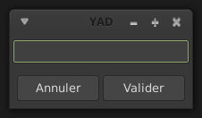

yad --entry --entry-label="blabla"

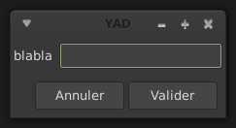

yad --entry --entry-label="blabla" --entry-text="toto"

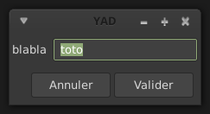

yad --text-align=center --text="foobar" --entry --entry-label="blabla" --entry-text="toto"

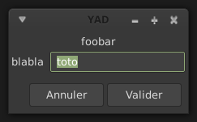

Récupération de la saisie
#!/bin/sh
INPUTTEXT=`yad --entry --entry-label="saisie"`
yad --text="Vous avez saisi : $INPUTTEXT"

FORMULAIRE
#!/bin/sh
~$ yad --height=150 --width=300 --text="<span foreground='yellow'><b><big>mon <big>texte</big></big></b></span>" \
--form --field="<b><big>Prem</big></b>" --field="<b><big>Deuz</big></b>"

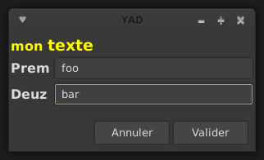

TYPES DE DONNÉES

password
yad --entry --entry-label=password --hide-text

nombres
yad --entry --numeric

Uses a spin button for text entry and won’t allow character entry. Entering data can be manually typed in.
There are 6 decimal points. EG: 100.000000

AUTO-COMPLETION
--completion
searches the data in the script and matches it against your input.

#!/bin/sh
yad --completion --entry="Name:" "" \
"Pink Floyd" "King Crimson" "Portishead" "Primus" "Beatles" | while read line; do
ENTRY=`echo $line | awk -F',' '{print $1}'`
echo $ENTRY
done

Now after typing b

ICONES
yad --entry --licon=/usr/local/lib/X11/pixmaps/home48.png

Notice the icon justified to the left of the entry box.

yad --entry --licon=/usr/local/lib/X11/pixmaps/home48.png --licon-action=rox

Click on the rox icon in the entry field to launch rox.

yad --entry --ricon=/usr/local/lib/X11/pixmaps/home48.png

Notice the icon justified to the right of the entry box.

yad --entry --ricon=/usr/local/lib/X11/pixmaps/home48.png --ricon-action=rox

Click on the rox icon in the entry field to launch rox.

EXPANDER
yad --entry --expander="click here to show entry"

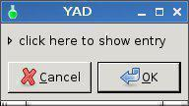 ——>

Whatever you type is parsed like the script below.

#!/bin/sh
ANSWER=`yad --entry --expander="click here to show entry"`
yad --text="You typed $ANSWER in the entry box"

--entry-label=STRING Set the entry label text.

--entry-text=STRING Set the initial entry text or default item in combo-box.

--hide-text Hide the entry text.

--completion Use completion instead of combo-box.

--complete=TYPE Use specific type for extended completion. TYPE can be any for match any of typed words, all for match all of typed words or regex when typed text treats as regular expression.

--editable Allow make changes to text in combo-box.

--numeric Use spin button instead of text entry. Additional parameters in command line treats as minimum and maximum values, step value and precisions (in that order). All this values are optional. Default range is from 0 to 65535 with step 1.

--float-precision=NUMBER Set precision of floating point numbers. By default precision is three digits after point.

--licon=IMAGE Set an icon on a left side of entry.

--licon-action=CMD Specify a command which will be run when the left icon clicked. Output of command will be set as entry text.

--ricon=IMAGE Set an icon on a right side of entry.

--ricon-action=CMD Specify a command which will be run when the right icon clicked. Output of command will be set as entry text.

--num-output Output index of active element instead of text for combo-box entry. Any extra data specified in command line adds as an items of combo-box entry, except of numeric mode.

If icon specified and icon action is not given, click on icon just clear the entry. Numeric fields will ignore the icons.

--fontname=FONTNAME This command sets the font type : yad --width=250 --text-info < hello.txt --fontname="Serif bold italic 20″

Form options
http://www.thelinuxrain.com/articles/multiple-item-data-entry-with-yad
http://rpm.pbone.net/index.php3/stat/45/idpl/17003956/numer/1/nazwa/yad

holidays=$(echo "Gold Coast,Bali,Phuket,Sydney,other")
yad --title="" --text="coucou" --image="/image/phone.png" --form --date-format="%-d %B %Y" --separator="," --item-separator="," \
--field="Nom" --field="Prénom" --field="Status":RO --field="Date":DT --field="Last holiday":CBE --field="Liste:":TXT \
"" "" "All round good guy" "Click calendar icon" "$holidays"

--field=LABEL[:TYPE] (TYPE - H, RO, NUM, CHK, CB, CBE, FL, SFL, MFL, DIR, CDIR, MDIR, FN, DT, CLR, BTN, LBL ou TXT)

Par défaut, le type du champ est une saisie simple.

yad --form --field=LABEL

H - Hidden : mot de passe
yad --form --field=LABEL:H

sortie > monmotdepass|

RO - Read Only
yad --form --field=LABEL:RO "Default Text"

NUM - Numéeique
yad --form --field=LABEL:NUM

yad --form --field=LABEL:NUM "10"

To control a Minimum and Maximum number, say 0.0 - 20.0:

yad --form --field="Number:NUM" 0\!0..20\!1\!1

NOTE : ‘\‘ escape characters. These are not required in a script but are from the CLI.

Lets set the Minimum to 0.0 and the Maximum to 100.0 with 0.5 increments.

yad --form --field="Number:NUM" 0\!0..100\!0.05\!2

CHK - Check Box
yad --form --field="Number:CHK"

Checked returns True, Unchecked returns False.

CB - Combo Box
note the escape ‘\’ characters.

yad --form --field="ComboBox:CB" One\!Two\!Three

CBE - Combo Box Editable
Combo Box is Editable. In other words you can add data on the fly by typing.

yad --form --field="ComboBox:CBE" One\!Two\!Three

When you press OK in the above example More Stuff| is returned.

CE - Entry with Completion
completes a string from matching data. In the example below There are a number of vehicle makes. If you type h in the entry box you will be given a choice of vehicles listed that begin with h EG: Holden and Honda.

yad --title="Vehicle Makes" --form --field ':CE' 'Toyota!Honda!Fiat!Mitsubishi!Nissan!Bentley!Citroen'

—>

FL - Folder List
yad --form --field="Folder List:FL"

Notice (None) is displayed, this is because a path was not specified. Lets add a path to /root:

yad --form --field="Folder List:FL" /root

SFL - Select FileList
select a file from a list.

yad --form --field="Folder List:SFL" /root

Now you can drill down through the folders, starting at /root, and select a file. Sortie > /path/filename|

MFL - Multiple File List
to select multiple files. You need to hold the CTRL key while left mouse clicking to do so.

yad --form --field="Folder List:MFL" /root

The dialog looks the same as SFL however, when you select multiple files the /path/filenames are separated by a ‘!’
/root/cruise0002.jpg!/root/cruise0003.jpg!/root/cruise0004.jpg|
As you can see I selected three files.

DIR - Directory
display a basic directory structure.

yad --form --field="Folder List:DIR" /root

CDIR - Select/Create Folders
yad --form --field="CDIR:CDIR" /root

MDIR - Select Folders Only
yad --form --field="MDIR:MDIR" /root

FN - Font Dialog
yad --form --field="Font::FN"

When you click on the Font Button:

Tip: Did you notice "Font::FN" in the command? The first colon is added to the Label and the second defines the field type.

DT - Date Picker
yad --form --field="Date::DT"

Notice the little Calendar in the right of the field. When you click on it, you get a Calendar. Select the date and click on OK. The following is returned: 20/04/16|

CLR - Color Picker
yad --form --field="Color::CLR" "#F507D0"
#F507D0 couleur par défaut

NOTE : In the Color name field you can type recognised names like teal to select a colour.

BTN - Bouton
yad --form --field="Button::BTN"

Now we add a command so it will open your default image viewer.
yad --form --field="Image Viewer::BTN" defaultimageviewer

LBL : label - TXT : texte
NOTE : Whatever you put inside the quotes before the colon becomes the Label.

yad --form --field="This is a Label Maaate:LBL"

Something similar with the TXT type.

yad --form --field="Text::TXT" "This is a Text box where you can display various information."

Form Example This code was written as a GUI for 01micko’s wonderful little CLI wallpaper maker.

#!/bin/sh
yad --title="Make Wallpaper" --form --separator="," \
--field="Name:" "Slacko630" \
--field="Label:" "Slacko-6.3.0" \
--field="Font::FN" "Sans 50" \
--field="Format::CB" "png!svg" \
--field="Width:" "1024" \
--field="Height:" "768" \
--field="Embossed::CB" "Yes!No" \
--field="Gradient Offset::NUM" 0!0..1!0.05!2 \
--field="Gradient Angle::NUM" 0!0..20!0.05!2 \
--field="Colour::CLR" "#008080" \
"" "" "" "" "" "" "" "" "" "" | while read line; do
IMAGENAME=`echo $line | awk -F',' '{print $1}'`
LABELNAME=`echo $line | awk -F',' '{print $2}'`
FONT=`echo $line | awk -F',' '{print $3}'`
FORMAT=`echo $line | awk -F',' '{print $4}'`
WIDTH=`echo $line | awk -F',' '{print $5}'`
HEIGHT=`echo $line | awk -F',' '{print $6}'`
EMBOSSED=`echo $line | awk -F',' '{print $7}'`
OFFSET=`echo $line | awk -F',' '{print $8}'`
ANGLE=`echo $line | awk -F',' '{print $9}'`
COLOUR=`echo $line | awk -F',' '{print $10}'`
echo $NAME $LABEL $FONT $FORMAT $WIDTH $HEIGHT $EMBOSSED $OFFSET $ANGLE $COLOUR
# Convert the colour string xxxxxx to xx xx xx RGB
multi="0.003906"
red=`echo $COLOUR | cut -c2-3`
green=`echo $COLOUR | cut -c4-5`
blue=`echo $COLOUR | cut -c6-7`
# Convert colour string to decimal
fred="$((16#$red))"
fgreen="$((16#$green))"
fblue="$((16#$blue))"
# Scale the decimal numbers to 01micko's range
r=$(echo "$fred * $multi" | bc)
g=$(echo "$fgreen * $multi" | bc)
b=$(echo "$fblue * $multi" | bc)
# Separate font type from size
FONTY=`echo $FONT | awk '{ $NF = ""; print $0}'`
SIZEY=`echo $FONT | rev | cut -d' ' -f1 | rev`
# Run mkwallpaper, 01micko's cli application
mkwallpaper -n "$IMAGENAME" -l "$LABELNAME" -f "$FONTY" -p $FORMAT -x $WIDTH -y $HEIGHT -s $SIZEY -k $EMBOSSED \
-o "$OFFSET" -z "$r $g $b" -a $ANGLE
# Fixed a minor bug in the SVG format. Change pt to px to make sizing work properly .
sed -i 's/pt/px/g' /usr/share/backgrounds/"$IMAGENAME.svg"
# Display wallpaper
defaultimageviewer /usr/share/backgrounds/$IMAGENAME.$FORMAT
done

--align=TYPE alignement des champs (left, center ou right)

yad --form --align=right --field="Label Aligned Right":LB

--columns=NUMBER nombre de colonnes.

yad --form --columns=2 --field="Prénom:" "Billy" --field="Age:" "21" --field="Nom:" "Bloggs" --field="Sex::"CB "Male!Female"

NOTE : l’ordonnance des champs va de haut en bas.

--separator=SEPARATOR

Par défaut le séparateur est |

yad --form --field="Firstname:" "Billy" --field="Lastname:" "Bloggs"

Sortie > Billy|Bloggs|

yad --form --separator="@" --field="Firstname:" "Billy" --field="Lastname:" "Bloggs"

Sortie > Billy@Bloggs@

--item-separator=SEPARATOR Set the separator character for combobox or scale data.

You may have noticed on the --columns command I used a CB (Combo Box). We want to add a few items to the CB so we need to use a separator character to separate them. The default character is the exclamation mark !

yad --form --field="Sex::"CB "Male!Female!Other"

Output: Make|

Now lets be bold and change both default separators, the --separator and --item-separator.

yad --form --separator=" " --item-separator="," --field="Sex::"CB "Male,Female,Other" --item-separator=","

The GUI looks the same but the CB choices are now separated by a comma instead of an exlamation mark and the pipe has disappeared from the end of the output. I selected Other and clicked on OK. Output: Other

--date-format=PATTERN Set the format for the returned date.

yad --form --separator=" " --date-format="%-d %B %Y" --field="Date:":DT

Click on the little calendar, choose a date, click OK. then click OK again. Output: 26 April 2016

Icons box options

--read-dir=DIRECTORY
--compact
--generic
--stdin
--item-width
--term=PATTERN Use specified pattern for launch command in terminal (default: xterm -e %s)
--sort-by-name --descend

--field=LABEL[:TYPE] Add field to form.
Type may be H, RO, NUM, CHK, CB, CBE, CE, FL, SFL, DIR, CDIR, FN, MFL, MDIR, DT, SCL, CLR, BTN, FBTN, LBL or TXT.
H - hidden field type. All characters are displayed as the invisible char.
RO - field is in read-only mode.
NUM - field is a numeric. Initial value format for this field is VALUE[!RANGE[!STEP![PREC]]], where RANGE must be in form MIN..MAX. `!’ is a default item separator. PREC is a precision for decimals.
CHK - checkbox field. Initial value is a case insensitive boolean constant (TRUE or FALSE).
CB - combo-box field. Initial value is a list VAL1!VAL2!…. The separator is the same as in NUM field. Value started with `^’ threats as default for combo-box.
CBE - editable combo-box field. Initial value same as for combo-box.
CE - entry with completion. Initial value same as for combo-box.
FL - file selection button.
SFL - field for create file.
DIR - directory selection button.
CDIR - field for create folder.
FN - font selection button. Initial value same as in font dialog.
MFL - select multiple files. Value of this field is a list of files separated by item-separator.
MDIR - select multiple folders. Value of this field is a list of folders separated by item-separator.
DT - date field.
SCL - scale field. Value of this field in a range 0..100.
CLR - color selection button. Output values for this field generates in the same manner as for color dialog.
BTN - button field. Label may be in form text in a form LABEL[!ICON[!TOOLTIP]] where ‘!‘ is an item separator. LABEL is a text of button label or gtk stock id. ICON is a buttons icon (stock id or file name).
TOOLTIP is an optional text for popup help string. Initial value is a command which is running when button is clicked. A special sympols %N in command are replaced by value of field N. If command starts with @, the output of command will be parsed and lines started with number and colon will be treats as a new field values. A quoting style for value when sh -c is used - a single quotes around command and double quotes around -c argument
FBTN - same as button field, but with full relief of a button.
LBL - text label. If field name is empty, horizontal separator line will be shown.
TXT - multiline text entry. This field is always occupy all of form width.Without type field will be a simple text entry.
--align=TYPE Set alignment of field labels. Possible types are left, center or right. Default is left. --columns=NUMBER Set number of columns in form. Fields will be placed from top to bottom. --separator=STRING Set output separator character. Default is `|’.
--focus-field=NUMBER Set focused field.
--cycle-read Cycled reading of stdin data. Sending FormFeed character clears the form. This symbol may be sent as echo -e ‘\f’.
--item-separator=STRING Set separator character for combo-box or scale values. Default is `!’.
--date-format=PATTERN Set the format for the date fields (same as in calendar dialog).
--float-precision=NUMBER Set precision of floating point numbers. By default precision is three digits after point. --complete=TYPE Use specific type for extended completion. TYPE can be any for match any of typed words, all for match all of typed words or regex when typed text treats as regular expression.
--scroll Make form scrollable.
--quoted-output Output values will be in shell-style quotes.
--output-by-row Output field values row by row if several columns is specified.
--num-output Output index of active element instead of text for combo-box fields. Additional data in command line interprets as a default values for form fields. A special value @disabled@ makes corresponding field inactive. If no extra arguments specified in a command line, data will be readed from stdin, one value per line. Cycled reading means that for N fields N+1 value will replace the first field. Empty values are skipped when reading from stdin.

yad > les boutons

  - ORDRE DES BOUTONS
  - POSITION
    - alignement horizontal
    - Boutons verticaux
  - AUCUN BOUTON
  - TEXTE ET ICÔNES
  - COMMANDES
    - retour d’une commande comme texte d’un bouton
    - lancer une commande sur un bouton
  - LISTE DES ICÔNES DISPONIBLES
--command=CMD Set left-click action
--listen Listen for commands on stdin
--separator=SEPARATOR Set separator character for menu values
--item-separator=SEPARATOR Set separator character for menu item

YAD (ici, ici et ici),

—
Boutons par défaut

yad --text "coucou"

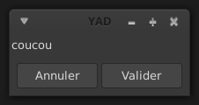

boutons spécifiques :

yad --text "coucou" --button=gtk-no:1 --button=gtk-yes:0

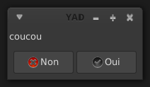

ORDRE DES BOUTONS
L’ordre des boutons est l’ordre dans lequel on les appelle : Oui à gauche de Non :

yad --text "coucou" --button=gtk-yes:0 --button=gtk-no:1

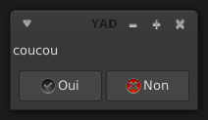

POSITION

alignement horizontal
--buttons-layout= (center, edge, spread, start, et end (par défaut) ) :

yad --text "coucou et blabla et blabla et pis tout ça" --button=gtk-no:1 --button=gtk-yes:0 --buttons-layout=center

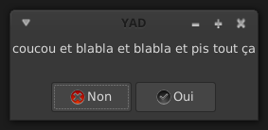

yad --text "coucou et blabla et blabla et pis tout ça" --button=gtk-no:1 --button=gtk-yes:0 --buttons-layout=edge

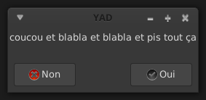

yad --text "coucou et blabla et blabla et pis tout ça" --button=gtk-no:1 --button=gtk-yes:0 --buttons-layout=spread

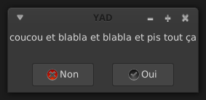

Boutons verticaux
La boite de formulaire (form) permet un agencement vertical en utilisant le type de champs BTN.

NOTE : Dans ce cas, la boite de dialogue restera ouverte tant qu’on ne la fermera pas manuellement.
Il est donc préférable d’utiliser la méthode avec le code && exit 0.

Pour fermer la fenêtre après un clic et renvoyer un code retour :

animal=$( yad --no-buttons --form \
--field="PINK FLOYD":BTN ' bash -c "echo pink floyd ; kill -USR2 $YAD_PID" ' \
--field="RADIOHEAD":BTN ' bash -c "echo radiohead ; kill -USR2 $YAD_PID" ' \
--field="FUGAZI":BTN ' bash -c "echo fugazi ; kill -USR2 $YAD_PID" '
)
echo "$animal"

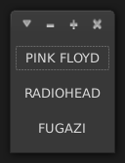

AUCUN BOUTON
yad --text "voili voilou" --no-buttons

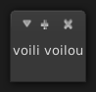

TEXTE ET ICÔNES
gtk-yes et gtk-no indiquent à YAD ce qu’il doit afficher. Les icônes disponibles se trouvent à /usr/share/icons

yad --button=gtk-print:1 --button=gtk-quit:1 --button=gtk-dialog-error:1

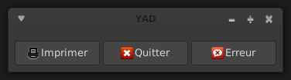

On peut écrire son propre texte :

yad --text "coucou" --button=gtk-no:1 --button="blablabla":1 --button=gtk-yes:0

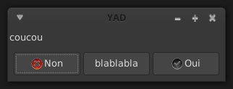

Pour utiliser ses propres icônes, on précède le chemin par un ! :

yad --button=" Un!$HOME/.icons/a.png":1 --button=" Deux!$HOME/.icons/b.png":1 \
--button=" Trois!$HOME/.icons/c.png":1

NOTE : pour que cela fonctionne à partir d’un terminal, il faut désactiver temporairement l’historique avec set +H. Puis réactiver avec set -H.

COMMANDES

retour d’une commande comme texte d’un bouton
Envoyer le retour d’une commande comme texte d’un bouton :

foo=$(date +"%d %b %Y")
yad --text="coucou" --button=gtk-cancel:1 --button="$foo":0

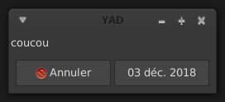

lancer une commande sur un bouton
Le bouton Cancel, la touche ESC, la croix en haut à droite ou tout bouton assigné à 1 (--button=gtk-no:1), la sortie ne renverra rien.
La croix X, en haut pour fermer la fenêtre, renverra 252.
Le bouton OK, la touche ENTRÉE ou tout bouton assigné à 0 (--button=gtk-yes:0), la sortie renverra le choix.

Sinon, on peut assigner le numéro que l’on veut et récupérer ce code dans un script.

Exemple : Lancer un navigateur (ou ouvrier une nouvelle fenêtre si déjà lancé). Touche ENTRÉE pour sortir sans rien :

#!/bin/bash

yad --text="coucou" --button=gtk-cancel:1 --button="Chromium":2 --button="Firefox":3 --button="Dillo":4

foo=$?

[[ $foo -eq 1 ]] && exit 0

if [[ $foo -eq 2 ]]; then
chromium && exit 0
elif [[ $foo -eq 3 ]]; then
firefox && exit 0
else
dillo && exit 0
fi

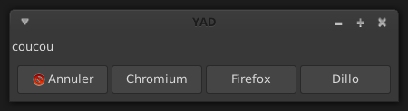

Il est possible d’assigner des commandes aux boutons au lieu d’un code de sortie :

yad --text="coucou" \
--button=gtk-cancel:1 --button="Chromium":chromium --button="Firefox":firefox --button="Dillo":dillo

Pour fermer une boite de dialogue après l’exécution d’une commande : --close-on-unfocus.

LISTE DES ICÔNES DISPONIBLES
Pour voir les icônes par défaut :

#! /bin/bash
export MAIN_DIALOG='
<vbox>
<frame Stock>
<tree rules_hint="true" exported_column="1">
<height>400</height><width>250</width>
<label>Stock ID</label>
<item stock="gtk-dialog-authentication">gtk-dialog-authentication</item>
<item stock="gtk-dialog-info">gtk-dialog-info</item>
<item stock="gtk-dialog-warning">gtk-dialog-warning</item>
<item stock="gtk-dialog-error">gtk-dialog-error</item>
<item stock="gtk-dialog-question">gtk-dialog-question</item>
<item stock="gtk-dnd">gtk-dnd</item>
<item stock="gtk-dnd-multiple">gtk-dnd-multiple</item>
<item stock="gtk-about">gtk-about</item>
<item stock="gtk-add">gtk-add</item>
<item stock="gtk-apply">gtk-apply</item>
<item stock="gtk-bold">gtk-bold</item>
<item stock="gtk-cancel">gtk-cancel</item>
<item stock="gtk-cdrom">gtk-cdrom</item>
<item stock="gtk-clear">gtk-clear</item>
<item stock="gtk-close">gtk-close</item>
<item stock="gtk-color-picker">gtk-color-picker</item>
<item stock="gtk-convert">gtk-convert</item>
<item stock="gtk-connect">gtk-connect</item>
<item stock="gtk-copy">gtk-copy</item>
<item stock="gtk-cut">gtk-cut</item>
<item stock="gtk-delete">gtk-delete</item>
<item stock="gtk-directory">gtk-directory</item>
<item stock="gtk-disconnect">gtk-disconnect</item>
<item stock="gtk-edit">gtk-edit</item>
<item stock="gtk-execute">gtk-execute</item>
<item stock="gtk-file">gtk-file</item>
<item stock="gtk-find">gtk-find</item>
<item stock="gtk-find-and-replace">gtk-find-and-replace</item>
<item stock="gtk-floppy">gtk-floppy</item>
<item stock="gtk-fullscreen">gtk-fullscreen</item>
<item stock="gtk-goto-bottom">gtk-goto-bottom</item>
<item stock="gtk-goto-first">gtk-goto-first</item>
<item stock="gtk-goto-last">gtk-goto-last</item>
<item stock="gtk-goto-top">gtk-goto-top</item>
<item stock="gtk-go-back">gtk-go-back</item>
<item stock="gtk-go-down">gtk-go-down</item>
<item stock="gtk-go-forward">gtk-go-forward</item>
<item stock="gtk-go-up">gtk-go-up</item>
<item stock="gtk-harddisk">gtk-harddisk</item>
<item stock="gtk-help">gtk-help</item>
<item stock="gtk-home">gtk-home</item>
<item stock="gtk-index">gtk-index</item>
<item stock="gtk-indent">gtk-indent</item>
<item stock="gtk-info">gtk-info</item>
<item stock="gtk-unindent">gtk-unindent</item>
<item stock="gtk-italic">gtk-italic</item>
<item stock="gtk-jump-to">gtk-jump-to</item>
<item stock="gtk-justify-center">gtk-justify-center</item>
<item stock="gtk-justify-fill">gtk-justify-fill</item>
<item stock="gtk-justify-left">gtk-justify-left</item>
<item stock="gtk-justify-right">gtk-justify-right</item>
<item stock="gtk-leave-fullscreen">gtk-leave-fullscreen</item>
<item stock="gtk-missing-image">gtk-missing-image</item>
<item stock="gtk-media-forward">gtk-media-forward</item>
<item stock="gtk-media-next">gtk-media-next</item>
<item stock="gtk-media-pause">gtk-media-pause</item>
<item stock="gtk-media-play">gtk-media-play</item>
<item stock="gtk-media-previous">gtk-media-previous</item>
<item stock="gtk-media-record">gtk-media-record</item>
<item stock="gtk-media-rewind">gtk-media-rewind</item>
<item stock="gtk-media-stop">gtk-media-stop</item>
<item stock="gtk-network">gtk-network</item>
<item stock="gtk-new">gtk-new</item>
<item stock="gtk-no">gtk-no</item>
<item stock="gtk-ok">gtk-ok</item>
<item stock="gtk-open">gtk-open</item>
<item stock="gtk-paste">gtk-paste</item>
<item stock="gtk-preferences">gtk-preferences</item>
<item stock="gtk-print">gtk-print</item>
<item stock="gtk-print-preview">gtk-print-preview</item>
<item stock="gtk-properties">gtk-properties</item>
<item stock="gtk-quit">gtk-quit</item>
<item stock="gtk-redo">gtk-redo</item>
<item stock="gtk-refresh">gtk-refresh</item>
<item stock="gtk-remove">gtk-remove</item>
<item stock="gtk-revert-to-saved">gtk-revert-to-saved</item>
<item stock="gtk-save">gtk-save</item>
<item stock="gtk-save-as">gtk-save-as</item>
<item stock="gtk-select-color">gtk-select-color</item>
<item stock="gtk-select-font">gtk-select-font</item>
<item stock="gtk-sort-ascending">gtk-sort-ascending</item>
<item stock="gtk-sort-descending">gtk-sort-descending</item>
<item stock="gtk-spell-check">gtk-spell-check</item>
<item stock="gtk-stop">gtk-stop</item>
<item stock="gtk-strikethrough">gtk-strikethrough</item>
<item stock="gtk-undelete">gtk-undelete</item>
<item stock="gtk-underline">gtk-underline</item>
<item stock="gtk-undo">gtk-undo</item>
<item stock="gtk-yes">gtk-yes</item>
<item stock="gtk-zoom-100">gtk-zoom-100</item>
<item stock="gtk-zoom-fit">gtk-zoom-fit</item>
<item stock="gtk-zoom-in">gtk-zoom-in</item>
<item stock="gtk-zoom-out">gtk-zoom-out</item>
</tree>
</frame>
<hbox>
<button cancel></button>
<button ok></button>
</hbox>
</vbox>
'
gtkdialog --program=MAIN_DIALOG

Pour utiliser l’icône gtk-color-picker et certains autres, il faut utiliser le séparateur :

yad --button=Colours\!gtk-color-picker:0

et dans un script

yad --button=Colours!gtk-color-picker:0

—

yad > les différentes fenêtres possibles

  - INSTALLATION
  - LES DIFFÉRENTES FENÊTRES
    - sélecteur de Police
    - Onglets ou Tablatures
    - Paned
    - image
    - Scale, échelle ou tirette
    - Validations et Alertes
    - calendrier
    - text-info
    - saisie de texte
    - listes
    - barre de progression
    - drag’n'drop
    - sélecteur de fichier
    - sélecteur de couleur
  - OPTIONS GÉNÉRALES
    - fermeture automatique
    - insérer une image dans le message
  - OPTIONS GENERALES
  - Iconbox
  - FONTS
  - HTML
  - Notebook
  - Notification
  - Paned
  - Picture
  - File filters
  - Miscellaneous
    - NOTIFICATION
    - ENVIRONMENT VARIABLES
    - USER DEFINED SIGNALS
    - EXIT STATUS
    - EXAMPLES
    - DEVELOPMENT
    - Règles d’utilisation
    - Options boîtes de dialogue
    - Options générales
    - Options spécifiques

INSTALLATION
https://sourceforge.net/projects/yad-dialog/

Once you have downloaded the source code which should look like yad-0.36.0.tar.xz.
Extract it and open a terminal in the extracted directory, an taper :

./configure --prefix=/usr
make
make install

Simply copy the yad binary to one of your bins, EG: /usr/bin

You can make the yad binary smaller by stripping it.
strip --strip-unneeded yad

Quelques aides : https://groups.google.com/forum/#!forum/yad-common

LES DIFFÉRENTES FENÊTRES
--icons Display box with shortcut icons.
--html Display HTML dialog
--notification Display notification icon.
--print Display print dialog.

sélecteur de Police
yad --font

Onglets ou Tablatures
yad --notebook

Paned
yad --paned

image
yad --picture

Scale, échelle ou tirette
yad --scale

Validations et Alertes
yad --text="coucou"

calendrier
yad --calendar

text-info
Pour afficher un fichier texte.

yad --text-info

saisie de texte
yad --entry ou yad --form

listes
yad --list

barre de progression
yad --progress ou yad --multi-progress

drag’n'drop
yad --dnd

sélecteur de fichier
yad --file

sélecteur de couleur
yad --color

OPTIONS GÉNÉRALES

fermeture automatique
--timeout=X Pour femer la fenêtre après X secondes

Fermer la fenêtre après 10 secondes (ou appuie sur Enter, clic sur OK ou Cancel) :

yad --timeout=10

--timeout-indicator=POS Affiche une progression du décompte.

La position POS peut être : top, bottom, left et right

yad --timeout=10 --timeout-indicator=top

NOTE : il faut obligatoirement utiliser --timeout avec --timeout-indicator

insérer une image dans le message
yad --image /chemin/fichier

OPTIONS GENERALES
--window-icon=ICON Set the window icon.
--parent-win=XID Specify a parent window for the dialog. This makes YAD possible to use as embedded GUI tool.
--kill-parent[=SIGNAL]Send SIGNAL to parent process. Default value of SIGNAL is a SIGTERM. SIGNAL may be specified by it’s numbe r or symbolic name with or without SIG prefix. See signal(7) for details about signals.
--plug=KEY Run dialog in plug mode for swallow as a notebook tab. See NOTEBOOK section for more.
--tabnum=NUMBERSet the tab number for plugged dialog. See NOTEBOOK section for more.
--text-align=TYPE Set type of dialog text justification. TYPE may be left, right, center or fill.
--image=IMAGE Set the dialog image which appears on the left side of dialog. IMAGE might be file name or icon name from current icon theme.
--image-on-top Show image above main widget instead of left. This option is always on for print dialog.
--icon-theme=THEME Use specified GTK icon theme instead of default.
--expander=TEXT Hide main widget with expander. TEXT is an optional argument with expander’s label.
--button=BUTTON:ID Add the dialog button. May be used multiply times. ID is an exit code or a command. BUTTON may be gtk stock item name for predefined buttons (like gtk-close or gtk-ok) or text in a form LABEL[!ICON[!TOOLTIP]] where `!’ is an item separator. Full list of stock items may be found in gtk-demo program, in snippet called "Stock Items and Icon Browser". If no buttons specified OK and Cancel buttons used. See EXIT STATUS section for more. If ID have a non-numeric value it treats like a command and click on such button doesn’t close the dialog.
--no-buttons Don’t show buttons.
--buttons-layout=TYPE Set buttons layout type. Possible types are: spread, edge, start, end or center. Default is end.
--no-markup Don’t use pango markup in dialog’s text.
--no-escape Don’t close dialog if Escape was pressed.
--always-print-result Print result for aby of the return codes. This options doesn’t work if timeout was reached or Escape was pressed.
--dialog-sep Show separator between dialog and buttons. Works only with gtk+-2.0.
--borders=NUM Set dialog window borders.
--sticky Make window visible on all desktops.
--fixed Make window fixed width and height.
--on-top Place window over other windows.
--undecorated Make window undecorated (remove title and window borders).
--skip-taskbar Don’t show window in taskbar and pager.
--maximized Run dialog window maximized.
--fullscreen Run dialog in fullscreen mode. This option may not work on all window managers.
--splash Open window with "splashscreen" window hints. For details see description of _NET_WM_WINDOW_TYPE_SPLASH in EWMH specification. The behavior of dialog with this option is HIGHLY DEPENDS on settings of your window manager.
--no-focus Dialog window never take focus.
--close-on-unfocus Close the dialog window when it loose the focus.
--selectable-labels If set, user can select dialog’s text and copy it to clipboard. This option also affects on label fields in form dialog.
--image-path=PATH Add specified path to the standard list of directories for looking for icons. This option can be used multiply times.
--rest=FILENAME Read extra arguments from given file instead of command line. Each line of a file treats as a single argument.
--response=NUMBER Set default response value for Ctrl+Enter action.
--gtkrc=FILENAME Read and parse additional GTK+ settings from given file. This option doesn’t work with GTK+-3.x builds.
--hscroll-policy=TYPE Set the policy type for horizontal scrollbars. TYPE can be one of the auto, always or never. Default is auto.
--vscroll-policy=TYPE Set the policy type for vertical scrollbars. TYPE can be one of the auto, always or never. Default is auto.
--enable-spell Enable spell checking in textview widgets
--spell-lang=LANGUAGE Set spell checking language to LANGUAGE. By default language guesses from current locale.

Iconbox
--read-dir=PATH Read desktop files from specified directory.
--monitor Watch for changes in directory and automatically update content of iconbox.
--generic Use field GenericName instead of Name for shortcut label.
--sort-by-name Use field Name instead of filename for sorting items.
--descend Sort items in descending order. If data reads from stdin this option is useless without --sort-by-name.
--listen Read data from stdin. Data must be in order - Name, Tooltip, Icon, Command, InTerm separated by newline. InTerm is a case insensitive boolean constant (TRUE or FALSE).
--item-width Set items width.
--compact Use compact mode. Icon and name of each item is placed in a single row.
--single-click Activate items by single mouse click. This option may not works properly in case of compact mode.
--term Pattern for terminal. By default use `xterm -e %s’ where %s replaced by the command. If both directory and stdin specified, content of iconbox will be read from directory.

FONTS
--fontname=FONTNAME Set the initial font. FONTNAME is a string with font representation in the form "[FAMILY-LIST] [STYLE-OPTIONS] [SIZE]".
--preview Set the preview text.
--separate-output Separate output of selected font description.
--separator=STRING Set output separator character. Default is `|’.
--quoted-output Output data will be in shell-style quotes.

HTML
--uri=URI Open specified location. URI can be a filename or internet address. If URI is not an existing file and protocol is not specified a prefix http:// will be added to URI.
--browser Turn on browser mode. In this mode all clicked links will be opened in html widget and command Open will be added to context menu.
--print-uri Print clicked links to standard output. By default clicked links opens with xdg-open.
--mime=MIME Set mime type of data passed to standard input to MIME. Default is text/html.
--encodintg=ENCODING Set encoding of data passed to standard input to ENCODING. Default is UTF-8.

Notebook
--key=KEY Set the key of the children.
--tab=TEXT Add tab with specified label to notebook. TEXT may be in a form LABEL[!ICON[!TOOLTIP]] where `!’ is an item separator.
--tab-pos=TYPE Set the tabs position. Value may be top, bottom, left, or right. Default is top.
--tab-borders=NUMBER Set the borders width around widget in tabs. See NOTEBOOK and PANED section for more about notebook dialog.

Notification
--command=CMD Set the command running when clicked on the icon. Default action is quit if --listen not specified.
--listen Listen for commands on stdin. See NOTIFICATION section.
--separator=STRING Set separator character for menu values. Default is |.
--item-separator=STRING Set separator character for menu items. Default is !.
--menu=STRING Set initial menu for right-click.
--no-middle Disable exit on middle click.
--hidden Doesn’t show icon at startup. See NOTIFICATION section for more about separators.

Paned
--key=KEY Set the key of the children.
--orient=TYPE Set orientation of panes inside dialog. TYPE may be in hor[izontal] or vert[ical].
--splitter=POS Set the initial splitter position. See NOTEBOOK and PANED section for more about paned dialog.

Picture
--size=VALUE Set initial size of picture. Available values are fit for fitting image in window or orig for show picture in original size.
--inc=NUMBER Set increment value for scaling image.
--filename=FILENAME Set picture filename. Some actions on a picture like scaling or rotating available from popup menu. Those actions can be made only on static images.

File filters
--file-filter=NAME | PATTERN1 PATTERN2 … Add a filename filter. NAME is a displayed filter name, PATTERN is a shell-style filename pattern (for example *.txt). This option may be used multiply times.
--mime-filter=NAME | MIME1 MIME2 … Add a mime-type filter. NAME is a displayed filter name, PATTERN is a name of mime type (for example text/plain). This option may be used multiply times.
--image-filter=[NAME] Add filter for images supported by gdk-pixbuf library. NAME in as optional name for this filter.
--add-preview Add preview widget. Preview images loads from large or normal thumbnails according to XDG Thumbnails specification v0.8.0 (http://standards.freedesktop.org/thumbnail-spec/latest/) or creates by yad for image files and saves as large thumbnails.This options applies to all of yad’s file chooser dialogs.

Miscellaneous

NOTIFICATION
Allows commands to be sent to yad in the form command:args.
Possible commands are icon, tooltip, visible, action, menu and quit.
icon:ICONNAME Set notification icon to ICONNAME. tooltip:STRING Set notification tooltip. visible:[true|false|blink] Set notification icon to visible, invisible or blinking states. action:COMMAND Specify the command running when click on the icon. Special string "quit" exit the program. menu:STRING Set popup menu for notification icon. STRING must be in form name1[!action1[!icon1]]|name2[!action2[!icon2]]…. Empty name add separator to menu. Separator character for values (e.g. `|’) sets with --separator argument. Separator character for menu items (e.g. `!’) sets with --item-separator argument. quit Exit the program. Middle click on icon also send quit command.

ENVIRONMENT VARIABLES
YAD_OPTIONS This variable can holds some default options for yad. All options in this variable may be redefined from command line.
YAD_PID This variable sets to the value of current dialog’s pid and accessible in all dialog children.
YAD_XID This variable sets to the value of current dialog’s X Window ID and accessible in all dialog children. This variable is not set in print and notification dialogs, and in a dialogs which acts as a notebook children.

USER DEFINED SIGNALS
SIGUSR1 Close dialog with 0 exit code. SIGUSR2 Close dialog with 1 exit code.

EXIT STATUS
0 The user has pressed OK button
1 The user has pressed Cancel button
70 The dialog has been closed because the timeout has been reached.
252 The dialog has been closed by pressing Esc or used the window functions to close the dialog

EXAMPLES
Show the search results in a list dialog with the title Search Results and the text Finding all header files….
find . -name ‘*.h’ | yad --list --title "Search Results" --text "Finding all header files.." --column "Files"

Display a progress dialog while searching for all the postscript files in your home directory
find $HOME -name ‘*.ps’ | yad --progress --pulsate Display a box with all of the installed desktop applications
yad --icons --read-dir=/usr/share/applications

DEVELOPMENT
tool for discover icons in current or user-specified GTK+ icon theme. Launch it a

yad-icon-browser

—

Règles d’utilisation
  - Yad s’utilise en ligne de commande via un terminal ou dans un script.
  - La ligne de commande doit commencer par yad suivit des options (voir chapitre “Options générales” et “Options spécifiques”).
  - L’ordre dans lequel interviennent le ou les options n’ont pas d’importance.
  - Si une option spécifique n’est pas mentionnée c’est la valeur par défaut qui sera automatique appliqué par yad.
  - Chaque option doit être précédée par 2 tirets “–”.
  - Il existe plusieurs méthodes pour écrire une commande Yad.
Soit le tout sur une ligne:
yad --calendar --center --title="Mon calendrier"
Soit en colonne dans ce cas avant chaque retour à ligne il faut insérer un espace à la fin de l’option suivit par un antislash “\” sauf à la dernier ligne:
yad \
--calendar \
--center \
--title="Mon calendrier"
Soit un mixte des deux méthodes ci-dessus:
yad --calendar \
--center --title="Mon calendrier"

Options boîtes de dialogue
Yad permet d’afficher 17 types de boite de dialogue.
Options
--calendar | Affiche un calendrier
--color | Sélection de couleurs
--dnd | Boîte drag-and-drop
--entry | Permet la saisie de caractères
--icons | Boîte d’affichage avec icônes de raccourci
--file | Sélection de fichiers ou/et dossiers
--font | Sélection de la police
--form | Formulaire
--html | Affiche une boite de dialogue HTLM
--list | Affiche une liste
--multi-progress | Affiche plusieurs barres de progressions
--notebook | Affichage portable
--notification | Affiche l’icône notification
--print | Affichage d’impression
--progress | Permet de suivre une progression
--text-info | Affiche un texte d’information
--scale | Choisir une valeur numérique à l’aide d’un curseur

Options générales
Si l’option est suivit par = et des lettres en majuscule, il suffit de les remplacer par la valeur que nous voulons lui donner et cela entre 2 guillemets.
Options
--title=TITLE | Titre de la boîte de dialogue
--window-icon=ICONPATH | Chemin de l’icône
--width=WIDTH | Hauteur de la boîte de dialogue
--height=HEIGHT | Largeur de la boîte de dialogue
--timeout=TIMEOUT | Temps d’affichage
--timeout-indicator=POSITION | Affiche l’indicateur de délai en position donnée. Les positions sont top (haut), bottom (bas), left (gauche) ou right (droit)e. le style indicateur peut être défini dans le fichier de gtkrc. Voir https://code.google.com/p/yad/wiki/TimeoutIndicator pour plus de détails.
--parent-win=XID | Spécifie une fenêtre parent pour le dialogue. Cela rend YAD la possibilité d’utiliser comme outil graphique intégré.
--kill-parent[=SIGNAL] | Envoie un signal au processus parent. La valeur par défaut de signal est un SIGTERM. SIGNAL peut être spécifié par son numéro ou le nom symbolique avec ou sans préfixe SIG. Voir https://www.mankier.com/7/signal pour plus de détails sur les signaux.
--plug=KEY | Crée un onglet, voir option –netbook
--tabnum=NUMBER | Définit le nombre d’onglet, voir option –netbook
--text=STRING | Texte à l’intérieur de la boîte de dialogue
--text-align=TYPE | Justification du texte, TYPE peut être left (gauche), right (droite), center (centre) or fill (rempli)
--image=IMAGE | Image qui apparaît sur le côté gauche de la boîte de dialogue.  IMAGE peut être un nom de fichier ou le nom de l’icône du thème d’icônes courant.
--image-on-top | Place l’image au-dessus, doit-être utilisé avec l’option --image
--icon-theme = THEME | Utilise une icône du thème GTK au lieu de celle utilisé par défaut
--expander=TEXT | Cache le widget principal avec extension. TEXTE est un argument optionnel avec l’étiquette de expandeur.
--button=BUTTON:ID | Rajoute un bouton, cette option peut-être utilisé plusieurs fois. BUTTON peut être un nom gtk pour les boutons prédéfinis (comme gtk-close ou gtk-ok) ou un texte dans un formulaire LABEL[!ICON[!TOOLTIP]] où `! ‘ est un séparateur d’article. La liste complète des articles en mémoire peut être trouvé dans le programme gtk-demo, l’extrait est appelé «Stock Items and Icon Browser“. Si aucun bouton n’est spécifiés, les boutons OK et Annuler sont utilisés. Voir la section EXIT STATUS pour plus. ID est un code de sortie ou d’une commande. Si ID a une valeur non-numérique il traite ID comme une commande, le clique sur tel bouton ne ferme pas la boîte de dialogue.
--no-buttons | Affiche aucun bouton
--buttons-layout=TYPE | Set de boutons de disposition. Les types possibles sont: lspread, edge, start, end ou center. Par défaut est end.
--no-markup | N’utilise pas la majoration pango dans le texte de dialogue.
--no-escape | Ne fermez pas la boite de dialogue si Escape est pressé.
--always-print-result | Imprime toujours le résultat
--dialog-sep | Montre le séparateur entre la boite de dialogue et les boutons. Fonctionne uniquement avec gtk+-2.0.
--borders=NUM | Définit les bordures de la boîte de dialogue
--sticky | Affiche la boîte de dialogue sur tous les bureaux
--fixed | Verrouille la hauteur et la largeur de la boîte de dialogue
--center | Place la boîte de dialogue à son ouverture au centre de l’écran
--mouse | Place la boîte dialogue à son ouverture sous la position de la souris
--on-top | Place la boîte dialogue à son ouverture par-dessus les autre fenêtre.
--undecorated | Fenêtre sans décoration (retire les titres et les bordures des fenêtres).
--skip-taskbar | Ne affiche pas la fenêtre dans la barre des tâches et le pager.
--maximized | Exécute en mode maximisée.
--fullscreen | Exécute en mode plein écran. Cette option peut ne pas fonctionner sur tous les gestionnaires de fenêtres.
--splash | Ouvre la boite de dialogue avec “SplashScreen” conseils de fenêtre. Pour plus de détails voir la description de _NET_WM_WINDOW_TYPE_SPLASH dans la spécification de EWMH. Le comportement avec cette option dépend fortement des paramètres du gestionnaire de fenêtre utilisées.
--no-focus | Ne prend pas de focus
--geometry=WIDTHxHEIGHT+X+Y | Utilise la notation de géométrie X Window standard pour placer la boite de dialogue. Lorsque cette option est utilisée, la largeur, la hauteur, la souris et les options centré sont ignorés.
--selectable-labels | Si elle est définie, l’utilisateur peut sélectionner le texte de dialogue et le copier dans le presse-papiers. Cette option affecte également sur les champs d’étiquettes dans la boite de dialogue de formulaire.
--image-path=PATH | Ajoute le chemin d’accès spécifié à la liste standard des répertoires pour la recherche d’icônes. Cette option peut être utilisée plusieurs fois.
--rest=FILENAME | Lit les arguments supplémentaires à partir de fichier donné à la place de la ligne de commande. Chaque ligne du fichier sont traité comme un seul argument.
--gtkrc=FILENAME | Lit et analyse les paramètres GTK+ supplémentaires du fichier de donnée.

Options spécifiques

--calendar
Options
--day=INT | Jour par défaut
--month=INT | Mois par défaut
--year=INT | Année par défaut
--date-format=PATTERN | Régle le format de retour de la date. Par défaut c’est `% x ‘  Pour plus info sur les formats de date voir man date.
--details=FILENAME | Lit la description des jours du nom de fichier.  Le fichier avec les détails des jours doit avoir le format suivant: <date> <description>  Le champ de date est au format date spécifié avec –date-format. La description de la chaîne avec des détails de date, peuvent être inclut au balisage Pango.
Si aucun jour, mois, année est spécifiés c’est la date actuel qui est utilisé par défaut

Exemple
Ci-dessous une boite de dialogue de type calendrier, avec une largeur de 250 et une hauteur de 200, comme titre “Calendrier Yad”, date par défaut le 30 janvier 2000 et comme format de retour Année-Mois-Jour.
yad \
--calendar \
--width=250 \
--height=200 \
--title="Calendrier Yad" \
--day="30" --month="1" --year="2000" \
--date-format="%Y-%m-%d"
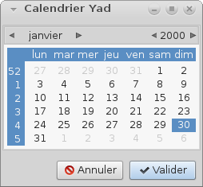

--color
Options
--init-color=COLOR | Définit la valeur initiale de la couleur.
--gtk-palette | Afficher la palette de couleur du système à l’intérieur de la boite dialogue.
--extra | Affiche des informations supplémentaires à propos de la couleur dans la chaîne retournée.
--alpha | Ajoute l’opacité à chaîne de couleur de sortie
--palette[=FILENAME] | Affiche la palette et définit les couleurs prédéfinies du nom de fichier donné. Par défaut /etc/X11/rgb.txt est utilisé.
--expand-palette
--mode=MODE | Régle le mode de couleur de sortie. Les valeurs possibles sont en hexadécimales ou RGB. Par défaut c’est en hexadécimal. Mode hexadécimal ressemble à #rrggbbaa, mode RVB - rgba (r, g, b, a). Dans le mode RGBA l’opacité ont des valeurs de 0.0 à 1.0.

--dnd
Options
--tooltip | Utilise un texte de dialogue comme une bulle d’aide.
--command=CMD | Lance la commande lorsque les données sont reçues. Les chaînes de données passent comme la commande d’un argument.  Par défaut les données sont imprimées sur la sortie standard.

Exemple
Ci-dessous une boite de dialogue de type Drag-and-Drop, avec une largeur de 400 et une hauteur de 100 avec comme titre “Drag & Drop Yad / Mplayer” qui nous permet de lancer une vidéo juste en glissant la vidéo sur la fenêtre. (Il faut au préalable avoir installer Mplayer).
Si on passe avec le curseur sur la boite de dialogue l’info-bulle s’affiche.
yad \
--dnd \
--width=400 \
--height=100 \
--title "Drag & Drop Yad / Mplayer" \
--text "Glisser ici le fichier vidéo à lire" \
--image "insert-object" \
--command=mplayer \
--tooltip
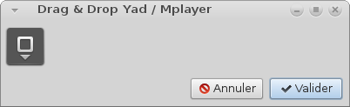

--entry
Options
--entry-label=STRING | Régle le texte de l’étiquette d’entrée. (équivalant à read en bash)
--entry-text=STRING | Régle le texte de l’entrée initiale ou élément par défaut dans la liste déroulante.
--hide-text | Cache le texte d’entrée.
--completion | Utilise l’achèvement au lieu de combo-box.
--editable | Autorise les modifications du texte dans la liste déroulante.
--numeric | Utilise un bouton au lieu de la saisie de texte. Les paramètres supplémentaires en ligne de commande sont traité comme valeurs minimales et maximales, la valeur de l’étape et de précisions (dans cet ordre). Toutes ces valeurs sont facultatifs. Plage par défaut est entre 0 et 65535 à l’étape 1.
--licon=IMAGE | Définit une icône sur un côté gauche de l’entrée.
--licon-action=CMD | Spécifie une commande qui sera exécuté lorsque l’icône de gauche est cliqué. La sortie de la commande sera créée sous forme de texte d’entrée.
--ricon=IMAGE | Définit une icône sur un côté droite de l’entrée.
--ricon-action=CMD | Spécifie une commande qui sera exécuté lorsque l’icône de droite est cliqué. La sortie de la commande sera créée sous forme de texte d’entrée.
--num-sortie | Indice de sortie de l’élément actif au lieu du texte d’entrée pour la combo-box. Toutes les données supplémentaires spécifiées dans la ligne de commande rajoute un des éléments de la liste déroulante à l’entrée, à l’exception du mode numérique. Si on ne donne pas d’icône indiquée et d’icône d’action, le clic sur l’icône retourne juste l’entrée. Les champs numériques sont ignorés par les icônes.

Exemple
Ci-dessous une boite de dialogue de type entry, avec comme titre “Qui est-ce ?”. Cette boite nous demande de taper le nom de l’utilisateur, nous pouvons soit taper le nom de l’utilisateur ou choisir un nom dans la liste déroulante.
yad \
--entry \
--title="Qui est-ce ?" \
--entry-label="Taper votre nom d'utilisateur" \
--editable \
--entry-text="$USER" "Toto"
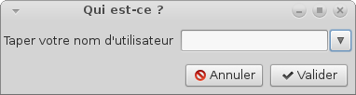

--icons

Options
--read-dir=PATH | Liste les fichiers de type .desktop du répertoire spécifié.
--generic | Utilise le nom générique du raccourci.
--sort-by-name | Trie les icônes par ordre alphabétique
--descend | Trie les éléments dans l’ordre décroissant. Si les données sont STDIN cette option est inutile sans –sort-by-name.
--listen | Lit les données de l’entrée standard. Les données doivent être dans l’ordre -. Nom, Info-bulle, Icône, commande, interm séparés par un saut de ligne interm est insensible à la casse constante booléenne (VRAI ou FAUX).
--item-width | Régle la largeur.
--compact | Utilise le mode compact. l’icône et le nom de chaque élément est placé dans une seule rangée.
--single-click | Active les éléments par simple clic de souris. Cette option ne fonctionne pas correctement en cas de mode compact.
--term | Modèle pour terminal. Utilise par défaut ` xterm-e %s’ où %s remplacé par la commande. Si les deux répertoires et stdin sont spécifiés, le contenu de iconbox sera lu à partir du répertoire.

Exemple
Ci-dessous une boite de dialogue de type icons, avec une largeur de 1000 et une hauteur de 900, comme titre “Mon menu”, qui nous permet de lancer une application par un simple double-clic.

yad \
--icons \
--title="Mon menu" \
--width=1000 \
--height=900 \
--read-dir=/usr/share/applications yad \
--sort-by-name

--file
Options
--filename=FILENAME | Définit le nom du fichier.
--multiple | Permet la sélection de plusieurs noms de fichiers.
--directory | Active la sélection du répertoire uniquement
--save
--separator=STRING
--confirm-overwrite[=TEXT]
--quoted-output

--font
Options
--fontname=FONTNAME
--preview

--form
Options
--field=LABEL[:TYPE]
…
--align=TYPE
--columns=NUMBER
--separator=STRING
--item-separator=STRING
--date-format=PATTERN
--scroll
--quoted-output
--output-by-row
--num-output

--html
Options
--uri=URI
--browser
--print-uri
--mime=MIME
--encodintg=ENCODING

--list
Options
--column=STRING[:TYPE]
…
--checklist
--radiolist
--separator=STRING
--multiple
--editable
--no-headers
--no-click
--no-rules-hint
--print-all
--print-column=NUMBER
--hide-column=NUMBER
--expand-column=NUMBER
--search-column=NUMBER
--tooltip-column=NUMBER
--sep-column=NUMBER
--sep-value=TEXT
--limit=NUMBER
--ellipsize=TYPE
--dclick-action=CMD
--regex-search
--listen
--quoted-output

--multi-progress
Options
--bar=LABEL[:TYPE]
--vertical
--align=TYPE

--notebook
Options
--key=KEY
--tab=TEXT
--tab-pos=TYPE
--tab-borders=NUMBER

--notification
Options
--command=CMD
--listen
--separator=STRING
--item-separator=STRING
--menu=STRING
--no-middle
--hidden
==== PANED ====
Options
--key=KEY
--orient=TYPE
--splitter=POS

--print
Options
--type=TYPE
--filename=FILENAME
--headers
--add-preview
--fontname=FONTNAME

--progress
Options
--progress-text=TEXT
--percentage=NUMBER
--auto-close
--auto-kill
--pulsate
--enable-log[=TEXT]
--log-on-top
--log-expanded
--log-height

--text-info
Options
--filename=FILENAME
--editable
--fore=COLOR
--back=COLOR
--fontname=FONTNAME
--wrap
--justify=TYPE
--margins=NUMBER
--tail
--show-uri
--uri-color
--listen

--scale
Options
--value=VALUE
--min-value=VALUE
--max-value=VALUE
--step=VALUE
--page=VALUE
--print-partial
--hide-value
--vertical
--invert
--mark=[NAME]:VALUE

File Filters Options
Options
--file-filter=NAME | PATTERN1 PATTERN2 …
--mime-filter=NAME | MIME1 MIME2 …
--image-filter=[NAME]
--add-preview

Miscellaneous
Options
-?, --help
--about
--version

—

yad > exemples de scripts

  - Logout dialog
  - Run dialog
  - Autostart editor
  - Graphical frontend for su
  - Discussion
  - Tips on getting user input
    - User-checking the input in YAD
  - Scripting a fancy chooser for recently used files
  - Multiple-item data entry with YAD
  - UN AUTRE

Logout dialog
#! /bin/bash
action=$( yad --width 300 --entry --title "System Logout" \
--image=gnome-shutdown --button="Switch User:2" --button="gtk-ok:0" --button="gtk-close:1" \
--text "Choose action:" --entry-text "Power Off" "Reboot" "Suspend" "Logout" )
ret=$?

[[ $ret -eq 1 ]] && exit 0

if [[ $ret -eq 2 ]] ; then
gdmflexiserver --startnew &
exit 0
fi

case $action in
Power*) cmd="sudo /sbin/poweroff" ;;
Reboot*) cmd="sudo /sbin/reboot" ;;
Suspend*) cmd="sudo /bin/sh -c 'echo disk > /sys/power/state'" ;;
Logout*)
case $(wmctrl -m | grep Name) in
*Openbox) cmd="openbox --exit" ;;
*FVWM) cmd="FvwmCommand Quit" ;;
*Metacity) cmd="gnome-save-session --kill" ;;
*) exit 1 ;;
esac
;;
*) exit 1 ;;
esac

eval exec $cmd

Run dialog
#! /bin/bash

XTERM="xterm"

# create history file
mkdir -p ${XDG_CACHE_HOME:-$HOME/.cache}/
HISTFILE=${XDG_CACHE_HOME:-$HOME/.cache}/ix-run.history
touch $HISTFILE

# create and run dialog
TITLE="Run command"
TEXT="\nEnter command to execute:\n"
rcmd=$( 'yad --width=500 --center --window-icon="gtk-execute" --name="${0##*/}" --title="$TITLE" \
--text="$TEXT" --image="gtk-execute" --entry --editable --rest="$HISTFILE" )

[[ -z "$rcmd" ]] && exit 0

# run command
case $rcmd in
http://*|https://*|ftp://*)
xdg-open $rcmd &
;;
mailto://*)
xdg-email $rcmd &
;;
man://*)
eval $XTERM -e "man ${rcmd#man://}" &
;;
telnet*|ssh*)
eval $XTERM -e "$rcmd" &
;;
*)
eval $rcmd &
;;
esac

# add command to history
grep -q -F "$rcmd" $HISTFILE || sed -i "1 i $rcmd" $HISTFILE

exit 0

Autostart editor
#! /bin/bash

config_dir=${XDG_CONFIG_HOME:-$HOME/.config}
results=$(mktemp --tmpdir autostart.XXXXXXXXXX)

for f in $config_dir/autostart/*.desktop; do
grep -m 1 -e '^[[:blank:]]*Exec' $f | cut -d = -f 2
grep -m 1 -e '^[[:blank:]]*Name' $f | cut -d = -f 2
grep -m 1 -e '^[[:blank:]]*Comment' $f | cut -d = -f 2
done | yad --width=500 --height=300 --title="Autostart editor" --image="gtk-execute" \
--text="Add/remove autostart items" --list --editable --print-all \
--multiple --column="Command" --column="Name" --column="Description" > $results

if [[ ${PIPESTATUS[1]} -eq 0 ]]; then
rm -f $config_dir/autostart/*.desktop
i=0
cat $results | while read line; do
eval $(echo $line | awk -F'|' '{printf "export NAME=\"%s\" COMMENT=\"%s\" COMMAND=\"%s\"", $2, $3, $1}')
cat > $config_dir/autostart/$i$NAME.desktop << EOF
[Desktop Entry]
Encoding=UTF-8
Name=$NAME
Comment=$COMMENT
Exec=$COMMAND
StartupNotify=true
Terminal=false
EOF
$((i++))
done
unset NAME COMMENT COMMAND
fi

rm -f $results
exit 0

Graphical frontend for su
#! /bin/bash

# some defaults
user="root"
suargs="-p"
force="no"

# parse commandline
if [[ $# -eq 0 ]]; then
echo "Usage: ${0##*/} [-f] [-u user] [--] "
exit 1
fi

OPTIND=1
while getopts u: opt; do
case "$opt" in
f) force="yes" ;;
u) user="$OPTARG" ;;
esac
done
shift $((OPTIND - 1))

cmd="$*"

if [[ $force != "no" ]]; then
# check for sudo
sudo_check=$(sudo -H -S -- echo SUDO_OK 2>&1 &)
if [[ $sudo_check == "SUDO_OK" ]]; then
eval sudo $cmd
exit $?
fi
fi

# get password
pass=$(yad --class="GSu" --text="password for <b>$user</b>:" --image="dialog-password" --entry --hide-text)
[[ -z "$pass" ]] && exit 1

# grant access to xserver for specified user
xhost +${user}@ &> /dev/null

# run command
fifo_in="$(mktemp -u --tmpdir gsu.empty.in.XXXXXXXXX)"
fifo_out="$(mktemp -u --tmpdir gsu.empty.out.XXXXXXXXX)"

LC_MESSAGES=C empty -f -i $fifo_in -o $fifo_out su $suargs $user -c "$cmd"
[[ $? -eq 0 ]] && empty -w -i $fifo_out -o $fifo_in "word:" "$pass\n"

exit $?

Discussion
combo-boxes and spin buttons to form dialog

By default, initial value should be the first entry in the list.
To get a little complicate, add another option says "init-val". This option can either be some value to be added to the existing list as initial value or a number specifying the location of initial value in existing list. Examples:

yad --entry "one" "two" "three" #"one" is initial value
yad --entry "one" "two" "three" --init-val "zero" #"zero" is initial value
yad --entry "one" "two" "three" --init-val 1 #"two" is initial value (count start from 0)

yad --form --field="combo:CB" 'test1!test2!test3' give you what you want
here is the simple form like a .desktop entry editor
yad --title="Desktop entry editor" --text="Simple desktop entry editor" \
--form --field="Type:CB" --field="Name" --field="Generic name" \
--field="Comment" --field="Command:FL" --field="Icon" \
--field="In termianl:CHK" --field="Startup notify:CHK" \
"Application!URI" "Name" "Generic name" "This is the comment" \
"/usr/bin/yad" "yad" FALSE TRUE
I have tried to use yad in those situations:
$ yad --form --field="Label:DIR" --item-separator="\$" \
--field="labelys:CB" 'DATA$data$basta' /home/xbg|(null)| <<- in this situation CB flag does not works < WHY?
$ yad --form --item-separator="\$" --field="labelys:CB" 'DATA$data$basta' basta|
you miss data for first field
yad --form --field="Label:DIR" --item-separator="\$" --field="labelys:CB" $HOME 'DATA$data$basta'
would works…
by default yad prints result only for buttons with even return codes. for changing this behavior add --always-print-result option.
make a checkbox (:CHK) be checked by default :by settings initial values in extra arguments :
yad --form --field entry1 --field check1:chk --field entry2 --field check2:chk '' true '' false
in above example first check entry will be activated

Tips on getting user input

User-checking the input in YAD
-editable Suppose the user has entered data in a form dialog like the one below, which defaults to the pipe character (|) as separator for output items. The example dialog is contained in a BASH script called ‘demo’:

#!/bin/bash
yad --form --field="Nom" --field="Prénom" --field="Date de naissance (JJ/MM/AAAA)"

—> retour : Bloggs|Fred|456/12/1985|

Hop hop hop. le jour est 456. No problem, we can help him by offering a confirmation dialog in which his previous entries are editable. First we’ll send the output of the YAD form dialog to a temp file, then extract each of the data entries from that file with the cut command, using the pipe character as delimiter (-d’|’):

#!/bin/bash
yad --form --field="Nom" --field="Prénom" --field="Date de naissance (JJ/MM/AAAA)" > /tmp/entries
nom=$(cut -d'|' -f1 < /tmp/entries)
prenom=$(cut -d'|' -f2 < /tmp/entries)
naissance=$(cut -d'|' -f3 < /tmp/entries)

Puis, we’ll echo those entries back into a YAD ‘text-info’ dialog with the -editable option, storing the edited (or not) result in a variable:

#!/bin/bash
yad --form --field="Nom" --field="Prénom" --field="Date de naissance (JJ/MM/AAAA)" > /tmp/entries
nom=$(cut -d'|' -f1 < /tmp/entries)
prenom=$(cut -d'|' -f2 < /tmp/entries)
naissance=$(cut -d'|' -f3 < /tmp/entries)
final=$( echo -e "Nom:\t$nom\nPrenom:\t$prenom\nDate:\t$naissance" \
| yad --text-info --editable --width="300" --height="200" --text="Tout est OK ?")

Editing is done by Mr Bloggs:

YAD va retourner tous les caractères (\n et \t compris). Mais, nous avons output in a variable, we can replace the tab and newline characters with a single space simply by echoing the variable (echo $final):

Last name: Bloggs Firs name: Fred Date of birth: 16/12/1985

and we can remove the entry-prompts and replace spaces with pipes using sed commands:

foo="Last name: Bloggs Firs name: Fred Date of birth: 16/12/1985"
echo $foo
Last name: Bloggs Firs name: Fred Date of birth: 16/12/1985
echo $foo | sed 's/[A-Z][a-z]*: /|/g'
|Bloggs |Fred |16/12/1985
echo $foo | sed 's/[A-Z][a-z]*: /|/g;s/^|//'
Bloggs |Fred |16/12/1985
echo $foo | sed 's/[A-Z][a-z]*: /|/g;s/^|//;s/ |/|/g'
Bloggs|Fred|16/12/1985

The finished script is shown below; it includes a ‘get me out of here!’ cancel for the text-info dialog:

#!/bin/bash
yad --form --field="Nom" --field="Prénom" --field="Date de naissance (JJ/MM/AAAA)" > /tmp/entries
nom=$(cut -d'|' -f1 < /tmp/entries)
prenom=$(cut -d'|' -f2 < /tmp/entries)
naissance=$(cut -d'|' -f3 < /tmp/entries)
final=$( echo -e "Nom:\t$nom\nPrenom:\t$prenom\nDate:\t$naissance" \
| yad --text-info --editable --width="300" --height="200" --text="Tout est OK ?")

if [[ $? == 1 ]] ; then
rm /tmp/entries
exit
else [[ $? == 0 ]]
echo $final | sed 's/[A-Z][a-z]*: /|/g;s/^|//;s/ |/|/g'
rm /tmp/entries
fi

exit

Scripting a fancy chooser for recently used files
Afficher les 10 derniers fichiers modifiés en ordre chronologique inverse, avec deux fichiers sélectionnés :

Voici le code :

#! /bin/bash

find ~ ! -path $HOME/'\.*' -and ! -path $HOME/'Mail*' -type f -mtime -2 \
| xargs ls -l --time-style=long-iso \
| awk '{print $6,$7,$8}' \
| sort -rk1,1 -rk2,2 \
| head \
| tr ' ' '\t' > /tmp/raw

paste <(awk -F/ '{print $NF}' /tmp/raw) /tmp/raw > /tmp/table10

choices=$(awk -F"\t" '{print "<b>"$1"</b>\n<span color=\"green\">"$2" — "$3"</span>"}' /tmp/table10 \
| yad --list --multiple --column=File --separator="" --width=300 --height=600 --center \
--ellipsize=middle --title="Recent Files")

if [[ -z $choices ]]; then
rm /tmp/raw /tmp/table10 && exit 0
else
echo "$choices" \
| sed 's/<b>\(.*\)<\/b>/\1/' \
| while read line; do xdg-open $(awk -v OPEN="$line" '$1 ~ OPEN {print $4}' /tmp/table10); done
fi

rm /tmp/raw /tmp/table10

exit 0

EXPLICATIONS

find ~ ! -path $HOME/’\.*’ -and ! -path $HOME/’Mail*’ -type f -mtime -2

find cherche dans le rép /home/moi (~) des fichiers (type -f) modifiés les deux dernières 24 heurs (-mtime -2). Excluant (!) les fichiers ou dossiers cachés (commençant par .) et les fichiers du rép Mail

La liste est envoyée dans xargs qui renvoie chaque fichier dans un ls avec comme option une sortie en ‘long listing format’ (-l) et le format de date ISO 8601 (--time-style=long-iso) :

-rw-r--r-- 1 moi moi 456 2015-08-10 19:51 /home/moi/projets/test/contacts

On récupère la date (6ème colonne), l’heure (7ème) et le chemin complet (8ème) grâce à AWK :awk ‘{print $6,$7,$8}’
La date devient donc le 1er champs, l’heure le 2ème et le chemin le 3ème.
sort -rk1,1 -rk2,2 on trie avec la date en ordre inverse, puis on affiche les 10 premiers : head.
tr pour remplacer les espaces par des tabulations.
Le résultat est enregistré dans /tmp/raw

On récupère le nom du fichier (AWK avec / comme séparateur de champs -F/ ) et afficher le dernier champs ($NF) de chaque ligne.

The extracted filenames are then joined to each line in the temp file with the paste command (line 10) with a tab as default separator, and the result is saved to a new temp file, /tmp/table10:

The table /tmp/table10 is now the working file for the chooser dialog, which I build with YAD. I want the YAD dialog to display each filename in bold, and under each filename the modification date and time in green (no special reason, just suits my color sense). To do this I tweak the text of each line in /tmp/table10 with AWK, adding the old-fashioned HTML markup for bold font (<b>) and a newline (line 12), and this time telling AWK that the field separator is a tab (-F"\t"). When I pipe the marked-up lines to YAD, YAD reads the markup as Pango markup and displays the text the way I want (see first illustration, above).
The other YAD options I use (lines 13 and 14) set the size and position of the dialog, its type (list) and the output separator (none), and allow me to make multiple selections from the list (--multiple). YAD also allows me to set where the ellipsis (…) goes in filenames too long for the width of the dialog (see 6th file in list in first illustration, above). Note that YAD only outputs the selected line in the dialog (the filenames), not the entire line as piped from AWK.
The selections I make are saved in the variable ‘choices’ (line 12). If I decide to cancel or close the YAD window, the script deletes my temp files and exits (lines 16 and 17). If I OK the selections, ‘choices’ is echoed (line 19) to sed to remove the bolding markup from the filename (line 20).
In line 21 I again use AWK, this time in a while loop. As each line with its selected filename is read by BASH, AWK looks for that filename in the first field in /tmp/table10. When it finds the line with that filename, AWK prints the full path to that file, which is the 4th field in the line (see above). For each selected filename, the full path is now passed to xdg-open, which opens the file with the default application for that file type.
The script then deletes the temp files and exits, leaving me with the selected files open on my desktop.

Multiple-item data entry with YAD
yad --form --field="Last name"

yad --title="" --text="coucou" --image="/home/moi/monImage.svg" --form --field="Nom"

yad --width=400 --title="" --text="coucou" --image="/chemin/vers/image.svg" --form --field="nom" --field="prénom"

le retour sera de la forme : monNom|monPrenom|
pour changer le séparateur de données --separator="\t" (pour une tabulation par exemple)

combo box

Les choix sont séparés par des !. For example, for the field --field="Last holiday":CB we might specify ‘un!deux!trois‘.
On peut choisir le caractère de séparation par une virgule par exemple : --item-separator="," et alors mes données seront ‘un,deux,trois‘.

On doit renseigner les champs également avant le Select (par "" pour dire vide) :

yad --width=400 --text="coucou" --form --field="nom" --field="prenom" --field="Last holiday":CB "" "" 'un!deux!trois'

I can choose ‘other’, delete it and type in ‘Melbourne’:

Probably the most useful combo box trick is that the combo box list can be read from a variable, keeping the code clearer:

holidays=$(echo "Gold Coast,Bali,Phuket,Sydney,other")
yad --width=400 --title="" --text="coucou" --image="/chemin/image.svg" \
--form --item-separator="," --field="nom" --field="prénom" --field="Last holiday":CBE "" "" "$holidays"

The last field I’ll add to the form is a multi-line text entry one, of type :TXT. Note below that I’ve also added another field ‘placeholder’ in the last line of the code for the new, last field:

holidays=$(echo "Gold Coast,Bali,Phuket,Sydney,other")
yad --width=400 --title="" --text="coucou" --image="/chemin/image.svg" --form --item-separator="," \
--field="nom" --field="prenom" --field="Last holiday":CBE --field="Liste":TXT "" "" "$holidays" ""

return Smith|Jack|8 September 1991|Melbourne|Mum’s bangers and mash\nLamb curry\nHawaiian-style pizza|

In other words, the newlines in the entered, multi-line text are reported by YAD as newline characters (\n).

Yet another nice feature of YAD is shown in the image below, which comes from one of my scripts to manage scientific data.

NOTE : the first three fields are grayed-out? The entries in these three fields come from other dialogs and were fed to this YAD dialog as the variables genus, species and event. Here are the relevant parts of the code:

yad --form --separator='\t' --field="Genus":RO --field="Species":RO --field="Event code":RO \
...
$genus $species $event "" 'ANIC!AusMus!NMV!QldMus!QVMAG!SAM!WAM!other' "" "" 'R. Mesibov!other' "" "" ""

UN AUTRE
I have a large list of directories in an array. I perform CRUD operations on the array. Each time the array is displayed with yad it starts at top of array. I would like to position the list to the last array entry accessed. I’ve set the first field to true but it only shows as selected and doesn’t position the list to that section of array.
I’ve tried piping the directory name into yad (it’s searchable on column 2) by trying:
echo "$DirName" | Record=(`yad --list ... `)
and
Record=(`yad --list ... `) <<< "$DirName"
The complete code is:
Record=(`yad --list --radiolist --separator="|" --grid-lines=hor \
--title="bafman - Born Again File Manager - $DirCnt Directories" \
--text="Navigate to directory and double-click or space bar to use:\
Tag files / Edit comments / Hide Dir buttons." \
--width=1200 --height=800 --center --no-markup \
--button="Tag files":$ButnTag --button="Run command":$ButnCommand \
--button="Edit comments":$ButnComment \
--button="Add Dir":$ButnAdd --button="Hide Dir":$ButnHide \
--button="Update Dirs":$ButnUpdate --button="$VariableCloseText":$ButnCancel \
--button="Save":$ButnSave \
--wrap-width=800 --wrap-cols=2 --dclick-action \
--ellipsize=START --ellipsize-cols=8 \
--search-column=2 --column "Select" \
--column "Searchable Directory Name (just start typing)" \
--column "Modified":HD --column "Owner":HD --column "Status":HD \
--column "File Cnt":NUM --column "File Sizes":SZ --column "Comment...":TXT \
--column "Tag Cnt":NUM --column "Tag Sizes":SZ \
"${DirsArr[@]}"`)
Action=$?
Above code is called in while loop as directories are added, hidden, edited and tagged.
The "Comments…" column doesn’t --ellipsize properly and displays full width. I think it was working correctly so I must have done something to break it. I’ve tried all the START, NONE, MIDDLE and END options but the column is still width of longest element.
To summarize:
1) Is it possible to position yad --list to specific section of array?
2) Why are comments not being ellipsized?
If I understood this, you want to add new rows without closing the list dialog.
I made this little script as an example. You can add folders to the list several times by clicking on "Add Folders" button.
This is only an example not ment for too many folders. :) Just a few to see how you can add more data to the list.
#!/bin/bash

test -e /tmp/yadpipe03 && rm -f /tmp/yadpipe03

# Named pipe initialization
export PIPE_03=/tmp/yadpipe03
mkfifo $PIPE_03
exec 3<> $PIPE_03

function load_data
{
DIRS="$(yad --file --multiple --width=800 --height=600 --directory --title="Select Folders")"

OIFS=$IFS
IFS="|"

[[ ! -z "$DIRS" ]] && YAD_DATA=($(for DIR in "$DIRS" ; do echo "$DIR" ; done ))

IFS=$OIFS

for DATA in "${YAD_DATA[@]}";do
echo True # Adds "True" for the checklist column
echo "${DATA}"
done
}
export -f load_data

function clear_all
{
echo -e '\f'
}
export -f clear_all

# Main Dialog
Record=($(yad --list --checklist --separator="|" --grid-lines=hor \
--width=1200 --height=800 --center --title="Nafman" --text="Example" \
--column "Select" --column "Folder" \
--button="Add Folders!gtk-add":'bash -c "load_data > $PIPE_03"' \
--button="Clear!gtk-clear":'bash -c "clear_all > $PIPE_03"' \
--button="OK!gtk-ok":0 \
--listen --print-all < $PIPE_03))
Action=$?

echo ${Record[@]}
http://ti1.free.fr/index.php/categorie/yad/

http://ti1.free.fr/index.php/categorie/bash-2/

http://ti1.free.fr/index.php/categorie/dos-batch/

https://github.com/topics/yad?o=desc&s=updated

