Zenity – Exibindo caixas de diálogo com scripts do Shell

O Zenity é um software que permite criar diversos tipos de caixas de diálogo simples para interação com os usuários em um ambiente gráfico Linux, que podem ser utilizadas em scripts do shell.
Por exemplo, podemos criar um diálogo para obter informações do usuário, como uma data em um calendário ou um valor numérico em uma caixa de texto, ou ainda criar diálogos para exibir informações, como uma barra de progresso para mostrar o status de uma operação, ou caixas de aviso e de erro.
O Zenity utiliza o GTK, conjunto de bibliotecas utilizado para a construção de interfaces gráficas.
Por padrão, ele vem instalado na grande maioria das distribuições Linux, de modo que seja provável que o programa já esteja presente em sua distro (no Mint 20.1 sim). Verifique a presença do programa emitindo o comando seguir no terminal:
zenity --version
zenity --help
Se o programa estiver instalado, será exibida a versão do programa. A versão mais recente é a 3.22.0 (na data de elaboração deste tutorial). 3.32 (8/05/2021)
Caso contrário, instale-o usando os seguintes comandos:
Sistemas Debian / Ubuntu:
sudo apt install zenity
Sistemas Red Hat / CentOS:
yum install zenity

Sintaxe
A sintaxe básica para uso do programa é a seguinte:
zenity [opções-comuns] [tipo-de-diálogo] [opções-específicas-do-diálogo]

Tipos de Caixas de Diálogo
O Zenity permite criar os seguintes tipos de caixas de diálogo:
- Calendar
- File selection
- Forms
- List
- Notification icon
- Message
  - Error
  - Information
  - Question
  - Warning
- Password entry
- Progress
- Text entry
- Text information
- Scale
- Color selection

Códigos de saída
Os seguintes códigos de saída são retornados ao executar o programa:
Código de Saída | Descrição
0 | O usuário pressionou os botões OK ou Fechar
1 | O usuário pressionou Cancelar ou usou as funções da janela para fechar o diálogo
-1 | Ocorreu um erro inesperado
5 | A caixa de diálogo foi fechada porque ocorreu timeout (tempo esgotado)

Opções Comuns
No Zenity, todas as caixas de diálogo suportam as seguintes opções gerais:
–title=title
Especifica o título da caixa de diálogo.
–window-icon=icon_path
Especifica o ícone que é exibido na janela da caixa de diálogo. Existem 4 tipos de ícones disponíveis que podem ser selecionados usando-se as seguintes palavras-chave: “info”, “warning”, “question” e “error”.
–width=width
Especifica a largura caixa de diálogo.
–height=height
Especifica a altura caixa de diálogo.
–timeout=timeout
Especifica o timeout em segundos após o qual a caixa de diálogo é fechada.

Outras opções
–about
Mostra o diálogo Sobre o Zenity, o qual contém informações sobre a versão do Zenity, copyright e informações sobre os desenvolvedores do software.
–version
Mostra o número de versão do programa.

Caixa de Diálogo File Selection (Seleção de Arquivos)
Com esta caixa o usuário pode selecionar um arquivo a partir de um diretório, e o arquivo é retornado na saída padrão.
O modo padrão de operação do diálogo de seleção de arquivos é o modo open (abrir).

Opções principais:
–filename=NOME_ARQUIVO
Especifica o arquivo ou diretório a ser selecionado na caixa de seleção quando a caixa é exibida pela primeira vez
–multiple
Permite a seleção de múltiplos nomes de arquivo na caixa de diálogo de seleção
–directory
Permite apenas a seleção de diretórios na caixa de seleçãoo
–save
Permite configurar o diálogo de seleção de arquivos no modo Save (salvar)
–separator=SEPARADOR
Especificar a string que será utilizada para dividir a lista de nomes de arquivos retornada.
–file-filter=FILTRO
Permite usar um filtro para especificar o tipo de arquivos que deverá se exibido no diálogo

Exemplos
Vejamos alguns exemplos de uso do utilitário em scripts do shell:
Exemplo 01 – Caixa de diálogo de erro, contendo um botão OK (digitar o comando diretamente no terminal):
zenity --title "Problema detectado" --error --text="Arquivo requisitado inválido."
Exemplo 02 – Caixa de diálogo de texto. Crie um arquivo de texto e entre com os comandos a seguir. Logo após, salve o arquivo com o nome de teste-zenity.sh e dê permissão de execução ao script com o comando chmod 755 teste-zenity.sh:
#!/bin/bash
nome=$(zenity --title="Nome?" --text "Qual é o seu nome?" --entry)
zenity --info --title="Boas-vindas" --text=" $nome" --width="100" height="50"
sobrenome=$(zenity --title="Sobrenome" --text "$primeiro Qual é o seu sobrenome?" --entry)
zenity --info --title="Bóson Treinamentos" --text="Bons estudos, $nome $sobrenome"
Para rodar o script, execute o comando a seguir:
./teste-zenity.sh
Veja duas telas deste script em execução:
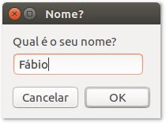

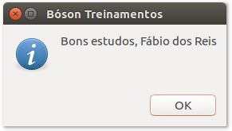
Exemplo 03: Exibindo um diálogo de calendário, capturando a data escolhida pelo usuário em uma variável, e exibindo a data no terminal:
#!/bin/bash
# Capturando a data escolhida pelo usuário a partir de um calendário
data=$(zenity --title="Escolha a data" --calendar)
if (( data ))
then
echo "A data escolhida foi o dia $data"
else
echo "Usuário não escolheu nenhuma data"
fi
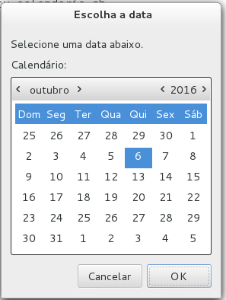
Exemplo 04: Usando uma caixa de diálogo de seleção de arquivos para selecionar um arquivo de texto:
#!/bin/bash
# Selecionando um arquivo de texto a partir de uma caixa de diálogo

ARQUIVO=$(zenity --file-selection --title="Selecione um arquivo")

case $? in
0)
echo "$ARQUIVO selecionado.";;
1)
echo "Nenhum arquivo selecionado.";;
-1)
echo "Ocorreu um erro desconhecido.";;
esac
Exemplo 05: Abrindo um arquivo de texto com extensão .sh e exibindo seu conteúdo em uma caixa de diálogo:
#!/bin/bash
# Selecionando um arquivo de texto a partir de uma caixa de diálogo
ARQUIVO=$(zenity --file-selection --title="Selecione um arquivo" --file-filter="*.sh")
# Usando o diálogo Text Information para exibir o conteúdo do arquivo selecionado:
if [ $ARQUIVO ]
then
zenity --text-info --title="Arquivo" --filename=$ARQUIVO --width=450 --height=500
fi
Exemplo 06: Criando um formulário para captura de dados para um cadastro de usuário:
#/bin/bash
# Criando um formulário com o Zenity
DADOS=$(zenity --forms --title="Cadastro" --text="Preencha o formulário a seguir com seus dados:" \
--separator="," \
--add-entry="Nome" \
--add-entry="Sobrenome" \
--add-calendar="Data de Nascimento" \
--add-entry="E-mail")
echo $DADOS | cut -d, -f1
echo $DADOS | cut -d, -f2
echo $DADOS | cut -d, -f3
echo $DADOS | cut -d, -f4
Exemplo 07: Selecionando itens em uma lista de itens:
#/bin/bash
# Usando uma lista com botões de rádio com o Zenity
ITEM_SELECIONADO=$(zenity --list --text "Selecione seu sistema favorito" \
--radiolist \
--column "Marcar" \
--column "Sistemas" \
FALSE BSD TRUE Linux FALSE "OS X" FALSE Windows);
echo "Seu sistema operacional favorito é o $ITEM_SELECIONADO";
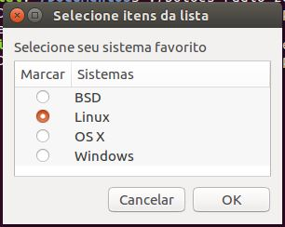
É isso aí! Vimos alguns exemplos do uso do Zenity para criar caixas de diálogo no Linux. Se você quiser se aprofundar no assunto, recomendo uma consulta à página oficial do manual do Zenity: https://help.gnome.org/users/zenity/3.22/
http://www.bosontreinamentos.com.br/shell-script/zenity-exibindo-caixas-de-dialogo-com-scripts-do-shell-no-linux/

How to use graphical widgets in bash scripts with zenity
Zenity is a very useful utility which let us create graphical user interfaces for our shell scripts. Several widgets exists, and can be used by invoking the program with the respective options. The widgets are based on the GTK toolkit, and return the result of the user interaction either on the standard output or as a return code.
In this tutorial you will learn:
- What are the general zenity options
- What are the some of the most useful available widgets and how to use them

Software Requirements and Conventions Used
Software Requirements and Linux Command Line Conventions
Category | Requirements, Conventions or Software Version Used
System | Distribution-independent
Software | The zenity utility
Other | Familiarity with the shell (bash in this case) and concepts like subshell and exit codes
Conventions | # - requires given linux commands to be executed with root privileges either directly as a root user or by use of sudo command  $ - requires given linux commands to be executed as a regular non-privileged user

Installation
The zenity package is included in the repositories of all the major linux distributions, and it may be already installed if you are using the GNOME desktop environment. To install it we can use our favorite distribution package manager, in Fedora, for example, we can use dnf:
$ sudo dnf install zenity
When using Debian and debian-based distributions like Ubuntu, we can use the apt-get command:
$ sudo apt-get install zenity
Zenity is already included in the Archlinux extra repository, therefore we can install it via pacman:
$ sudo pacman -S zenity

Generic options
Before we start to see some of the most useful widgets provided by zenity, we should mention some of the available generic options we can use to change the program behavior.
We call them generic because they can be applied independently of the chosen widget: --title, --widow-icon, --width, --height and --timeout.
First of all we have the --title option: we can use it to specify a title for the dialogue window. Similarly, the --window-icon option let us specify an icon that will be used as the icon for the window, and will be visible, for example, in the taskbar. To display an icon in the widget, instead, we can use the --icon-name option and provide one of the allowed icon names (here is the complete list) as argument. To use the stock icons provided in the error, info, question, or warning dialogues, for example, we can specify respectively: dialog-error, dialog-info, dialog-question or dialog-warning.
The --width and --height options are pretty self-explanatory: they let us define the geometry of our dialogue window.
Finally, by using the --timeout option we can set a timeout in seconds for the dialogue: after the specified amount of time, it will be automatically closed.

The available widgets
There are several widget we can use thanks to zenity: each of them has a specific purpose. Let's see some of them.

The calendar widget
The calendar widget will display a calendar and let the user pick a date, by selecting the month, day and year. The selected values will be returned on the standard output. To launch the widget calendar, all we have to is to invoke zenity, with the --calendar option:
$ zenity --calendar
We can use a series of option to fine-tune the behavior of the widget, for example, by using --day, --month, --year and providing an INT as value, we can set, respectively, the default day, month and year that will be displayed in the widget. To specify a specific format in which the selected date should be returned, we can use the --date option and specify the pattern in the strftime style.
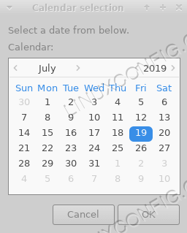
The calendar widget

The entry widget
The entry widget is really useful when we need to ask the user for some text. Say for example we need to ask the user to enter its name; we can run the following command:
$ zenity --entry --title "Name request" --text "Please enter your name:"
Here we used the --title and --entry-text options to customize, respectively, the title and the label that for the widget. Once we run the command above, the widget will appear:
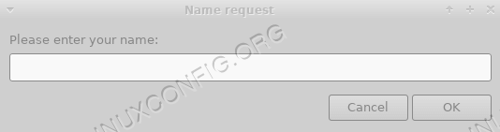
The entry widget
The text entered by the user will be return on the standard output.

File selection widget
The file selection widget let us display a nice graphical interface to let the user select one or more files. Just as we did in the previous examples, we can use a series of options to modify the behavior and appearance of the dialogue. One of the most important one is --filename which can be used to set the file/directory that will be selected by default. Here is a quick overview of the options and the functionalities they provide:
Zenity file selection widget options
Option | Function
--filename | Set the default directory/file that will be selected in the widget
--multiple | Enable the ability to select multiple files at once
--file-filter | Specify a filter for filenames
--directory | Restrict the selection to directories
--save | Run the widget in "save" mode.
--confirm-overwrite | Ask the user for confirmation when overwriting an existing file
--separator | Specify a separator that will be used to separate paths when multiple files are selected
Let's see an example of the widget use. Say we want to let the user select multiple files, and we want the content of the user $HOME directory to be displayed in the widget when it is opened. All we have to do is to run the following command:
$ zenity --file-selection --multiple --filename "${HOME}/"
You can notice that we provided a trailing / to the path: this way the content of the directory is displayed, instead of the directory itself. Here is our widget:
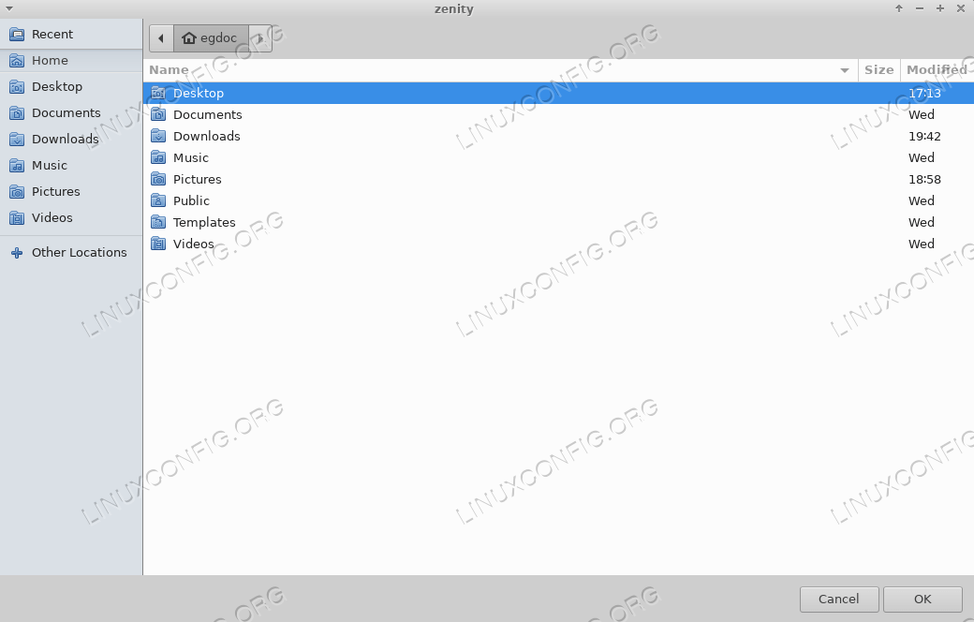
The file selection widget
Once we click on the "ok" button, the absolute path of the selected file(s) will be returned on the standard output, separated by a character, which be default is |:
/home/egdoc/Downloads/a.txt|/home/egdoc/Downloads/b.txt
We can easily change the separator, providing the character we want to use as the argument of the --separator option.
If we open the dialogue in save mode, the user will be asked to provide the name of the file he wants to save. If the file exists and we provided the --confirm-overwrite option, he will be prompted to confirm he wants to overwrite it:
$ zenity --file-selection --save --confirm-overwrite --filename "${HOME}/"
The chosen path will be returned to the standard output, and we will be free to use it in our script.

The progress widget
Another interesting widget is the progress one: we can launch it using by invoking zenity with the --progress option. We can use it, for example, to show the progress of long running operations. Here are some of the most useful options we can use with the widget:
Option | Function
--percentage | Sets the initial percentage value of the progress bar
--auto-close | Automatically close the dialogue when the progress is completed
--auto-kill | Kill the parent process if the dialogue is closed with the cancel button
--no-cancel | Don't display the cancel button
Here is an example of how we can use the widget within a bash script:
#!/bin/bash
#
# Dummy script to demonstrate the zenity progress widget!

(
echo 25
echo "# Setting up..."
sleep 2

echo 30
echo "# Reading files..."
sleep 2

echo 70
echo "# Creating content..."
sleep 1

echo 100
echo "# Done!"
) | zenity --title "Progress bar example" --progress --auto-kill
The script above doesn't actually perform any operation, but it's useful to understand how the widget works. There are two main things that should be noticed in the code: first of all, the commands to be executed are wrapped between parenthesis, therefore are executed in a subshell: this is necessary for the widget to work correctly; second, when we echo a line starting with a number, this will be interpreted as the percentage of the progress bar.
In the same way, when we echo a line which starts with the # character, it will be used as the text to be displayed in the widget. Here is a short video of the script in action:

Info, warning and error widgets
To display info, warning or error messages, we can use zenity with the --info, --warning and --error options, respectively. In this case we use the --text option to specify the message. Here is an example of a notification:
$ zenity --info --width=400 --height=200 --text "This is a notification!"
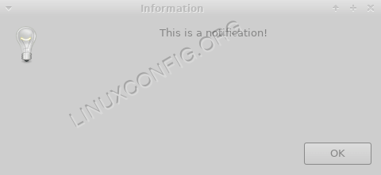
The notification widget
Using the warning widget, is just as easy:
$ zenity --warning --width=400 --height=200 --text "This is a warning!"
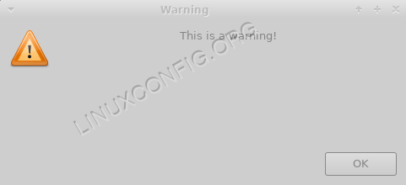
The warning widget
This, instead is an example of an error message:
$ zenity --error --width=400 --height=200 --text "This is an error!"
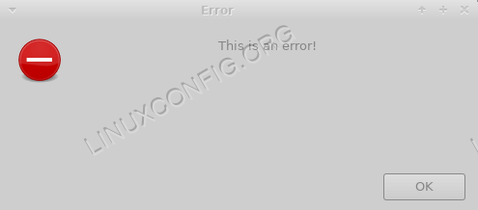
The error widget

The question widget
To ask the user a question and get its answer we can use the question widget, invoking zenity with the --question option. We specify the question using the --text option, and define the labels of the 'ok' and 'cancel' buttons, using respectively the --ok-label and --cancel-label options. Here is an example:
$ zenity --question --text "Are you sure you want to quit?" --no-wrap --ok-label "Yes" --cancel-label "No"
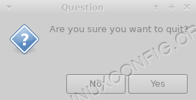
The question widget
In this case, we also used the --no-wrap option, to avoid text wrapping in the widget. The result of the user choice will not be displayed on the standard output; instead, the command will set its exit code accordingly, so it will return 0 if the user clicks on the 'ok' button, and 1 if he clicks on the 'cancel' one or closes the window (this may seems counter-intuitive, but remember than an exit code of 0 means that a command was executed with success in the shell).

The password widget
This is the widget we should use when we want the user to enter a password or any sensitive information: the text he enters is masked by bullets:
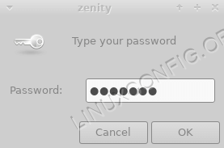
The password widget
While the text entered from the user is masked, the value returned by the widget will be clearly visible on the standard output.

The color selection widget
This is another nice widget. By using it, we can make the user choose a color from a palette. To run it, we use zenity with the --color-selection option. We can specify the initially selected color by using --color and provide the color as argument. Here is an example:
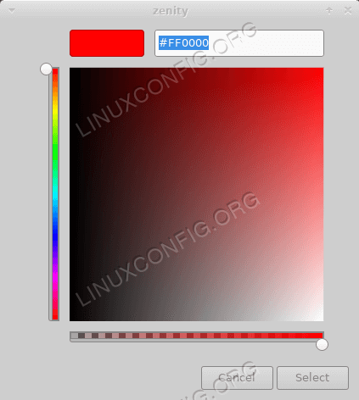
The color selection widget
Optionally, we can display the color palette instead, with the --show-palette option:
$ zenity --color-selection --color red --show-palette
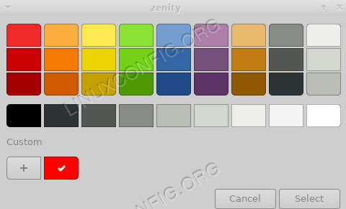
The color selection widget palette
The color selected by the user will be returned in rgb notation on the standard output. For example when selecting the color red, the following will be returned:
rgb(255,0,0)

The list widget
The next widget we will take a look at, is the list widget. With it, it's possible to create a multi-column dialogue, and optionally let the user select one or multiple options via checkboxes or radio buttons. To make zenity display this type of dialogue we use the --list option and define the columns and their contents; if we omit them the command will fail:
$ zenity --list
No column titles specified for List dialog.
To define a column header we use the --column option and provide a string as argument. We repeat the command for each column we want to create:
$ zenity --list --column Selection --column Distribution
With the command above we created two columns, with the "Selection" and "Distribution" headers. Now we will provide the user with a series of row, each of them representing a linux distribution. In the first column of each row we will place a checkbox to let the user select the corresponding entry:
$ zenity --list --column Selection --column Distribution FALSE Debian TRUE
Fedora -radiolist
Each string we provide after the columns definition are associated with the columns, depending on their order of appearance. As you can see we created two rows. In the first column of each row we provided a value: we used FALSE so that the corresponding checkbox or radio button are not selected when the widget is displayed, and TRUE to set the input as flagged by default. Here is the generated widget:
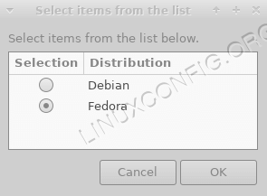
The list widget
When we click on the "ok" button, and perform our selection, the value associated with the row will be reported on the standard output. If we want to let the user select multiple rows we can use the --checklist option: the | character will be used to separated the selected values.

Conclusions
In this tutorial we learned to know zenity, an utility that let us use graphical dialogues in our shell scripts. We saw what are the generic options we can use with all the widgets, like --width and --height, and we learned to use some of the most useful widgets we can generate with the program. To learn more about zenity you can consult its manpage!
https://linuxconfig.org/how-to-use-graphical-widgets-in-bash-scripts-with-zenity

https://help.gnome.org/users/zenity/
e true; do
choice="$(zenity --width=250 --height=240 --list --column "Everest de pobre" --title="Everest de pobre" \
"Placa-mãe" \
"Processador" \
"Memória" \
"USB" \
"Sair")"

case "${choice}" in
"Placa-mãe" )
dmidecode |grep -A 5 Base | zenity --list --title "Informações de Hardware" --text " Abaixo estão listados as informações da sua placa mãe...\n" --column "Placa Mãe" --width=700 --height=270
;;
"Processador" )
dmidecode --type 4 |grep -A 47 Processor | zenity --list --title "Informações do Processador" --text " Abaixo estão listados as informações do processador...\n" --column "Processador" --width=700 --height=500
;;
"Memória" )
dmidecode --type 6 | grep Enable | zenity --list --title "Informações da Memória" --text " Abaixo estão listados as informações de memória...\n" --column "Memória" --width=500 --height=250
;;
"USB" )
lsusb -v |grep -A 1 idVendor | zenity --list --title "Dispositivos USB" --text " Abaixo estão listados os dispositivos USB...\n" --column "USB" --width=500 --height=400
;;
*)
break
;;
esac

done
https://www.vivaolinux.com.br/script/Testando-o-Zenity

Zenity: Shell Scripting with Gnome

Contents
- 1 Install zenity command
- 2 Syntax
- 3 Your first GUI dialog using zenity
  - 3.1 Quotation marks
  - 3.2 Single quotation marks
- 4 Common zenity options

Install zenity command
Type the following command to install the KDialog command line utility under Debian or Ubuntu Linux:
sudo apt-get update
sudo apt-get install zenity
Type the following command to install the dialog command line utility under CentOS, Fedora or Redhat Linux:
yum install zenity

Syntax
The syntax is as follows:
zenity --common-options --dialog-type --dialog-specific-options
Where,
- --common-options : All Zenity dialogs support the following general options:
  - --title="Your Title Text" : Set the title of a dialog.
  - --window-icon=/path/to/icon_path : Set the icon that is displayed in the window frame of the dialog. There are four stock icons also available by providing the following keywords - 'info', 'warning', 'question' and 'error'.
  - --width=width : Set the width of the dialog.
  - --height=height : Set the height of the dialog.
  - --timeout=timeout : Set the timeout in seconds after which the dialog is closed.
- --dialog-type : Set the dialog box type such as calendar or error box.
- --dialog-specific-options are used to set dialog boxes title, and other information

Your first GUI dialog using zenity
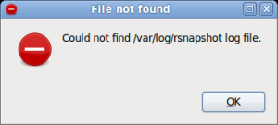
zenity command in action
Type the following command at a shell prompt:
zenity --title "File not found" --error --text="Could not find /var/log/rsnapshot log file."
- The above example shows how to create an error dialog with a single OK button.
- You can use this dialog box to display error messages.
- After reading the message, the user can press the ENTER key so that dialog will exit and the calling shell script can continue its operation.
- If the message is too large for the space, zenity may wrap the message.

Quotation marks
When you use the [[[zenity command]], make sure that you place quotation marks around each argument. For example, use:
zenity --title "File not found" --error --text="Could not find /var/log/rsnapshot log file."
Do not use (note missing quotation marks):
zenity --title File not found" --error --text="Could not find /var/log/rsnapshot log file.
If you do not use quotation marks, you might get unexpected results.

Single quotation marks
The single quote ( 'quote' ) protects everything enclosed between two single quote marks. It is used to turn off the special meaning of all characters. For example, use:
zenity --title='Birthday Planner!' --calendar
Do not use double quote:
zenity --title="Birthday Planner!" --calendar
Sample outputs:
bash: !": event not found

Common zenity options
Usage:
zenity [OPTION...]

Help Options:
-h, --help Show help options
--help-all Show all help options
--help-general Show general options
--help-calendar Show calendar options
--help-entry Show text entry options
--help-error Show error options
--help-info Show info options
--help-file-selection Show file selection options
--help-list Show list options
--help-notification Show notification icon options
--help-progress Show progress options
--help-question Show question options
--help-warning Show warning options
--help-scale Show scale options
--help-text-info Show text information options
--help-misc Show miscellaneous options
--help-gtk Show GTK+ Options

Application Options:
--calendar Display calendar dialog
--entry Display text entry dialog
--error Display error dialog
--info Display info dialog
--file-selection Display file selection dialog
--list Display list dialog
--notification Display notification
--progress Display progress indication dialog
--question Display question dialog
--warning Display warning dialog
--scale Display scale dialog
--text-info Display text information dialog
--display=DISPLAY X display to use
https://bash.cyberciti.biz/guide/Zenity:_Shell_Scripting_with_Gnome

Zenity – Creates Graphical (GTK+) Dialog Boxes in Command-line and Shell Scripts
Editor Categories GTK 11 Comments
GNU Linux, the operating system built on very powerful Kernel called Linux. Linux is famous for its command Line operations. With the invent of Linux in day-to-day and Desktop computing, nix remains no more biased towards command-Line, it is equally Graphical and developing Graphical application remains no more a difficult task.
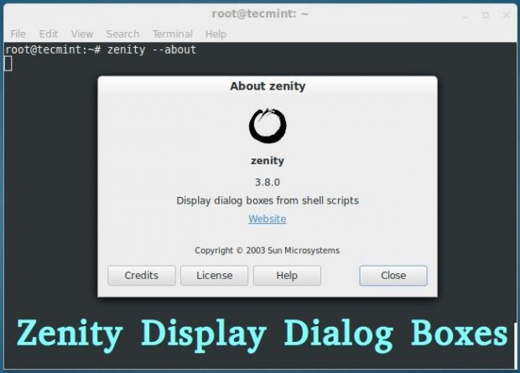
Here in this article we will be discussing creation and execution of simple Graphical Dialog box using GTK+ application called “Zenity“.

What is Zenity?
Zenity is an open source and a cross-platform application which displays GTK+ Dialog Boxes in command-line and using shell scripts. It allows to ask and present information to/from shell in Graphical Boxes. The application lets you create Graphical dialog boxes in command-line and makes the interaction between user and shell very easy.
There are other alternatives, but nothing compares to the simplicity of Zenity, specially when you don’t need complex programming. Zenity, a tool you must have your hands on.

Zenity Features
- FOSS Software
- Cross Platform Application
- Allow GTK+ Dialog Box Execution
- Command Line Tool
- Support in Shell Scripting

Usefulness
- Easy GUI Creation
- Less features than other complex Tools
- Enables shell scripts to interact with a GUI users
- Simple dialog creation is possible for graphical user interaction
Since Zenity is available for all known major platforms, and based on GTK+ library, Zenity program can be ported to/from another platform.

Installation of Zenity in Linux
Zentity is by default installed or available in repository of most of the Standard Linux distribution of today. You can check if is installed onto your machine or not by executing following commands.
ravisaive@tecmint:~$ zenity --version

3.8.0
ravisaive@tecmint:~$ whereis zenity

zenity: /usr/bin/zenity /usr/bin/X11/zenity /usr/share/zenity /usr/share/man/man1/zenity.1.gz
If it’s not installed, you can install it using Apt or Yum command as shown below.
ravisaive@tecmint:~$ sudo apt-get install zenity [on Debian based systems]

root@tecmint:~# yum install zenity [on RedHat based systems]
Moreover you can also build it from the source files, download the latest Zenity source package (i.e. current version 3.8) using a following link.
- http://ftp.gnome.org/pub/gnome/sources/zenity/

Zenity Basic Dialog Boxes
Some of the basic Dialogs of Zenity, which can be invoked directly from the command-line.

1. How about a quick calendar dialog?
root@tecmint:~# zenity --calendar
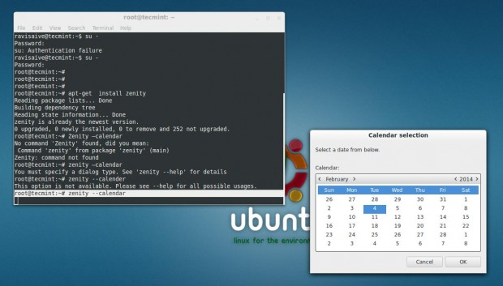

2. An error Dialog Box
root@tecmint:~# zenity --error
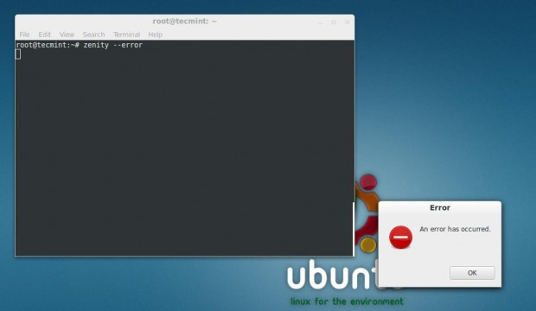

3. A General text Entry Dialog Box
root@tecmint:~# zenity --entry
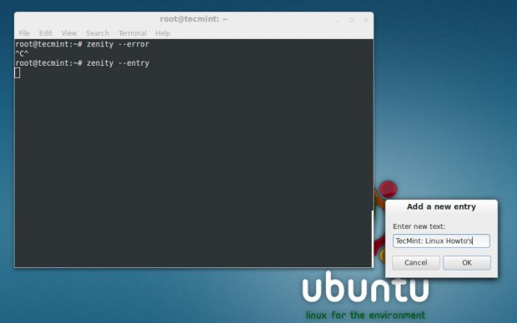

4. An Information Dialog
root@tecmint:~# zenity --info
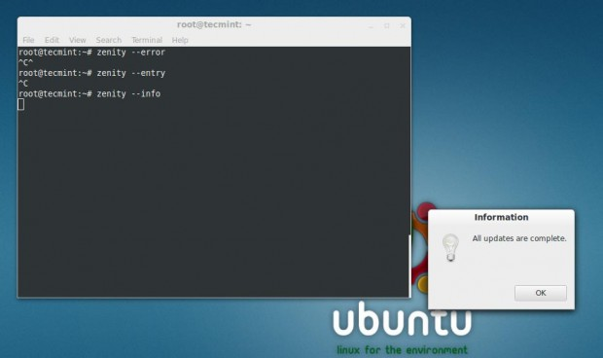

5. A question Dialog box
root@tecmint:~# zenity --question
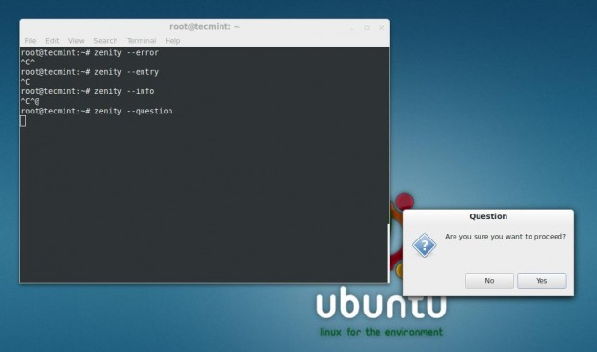

6. A progress Bar
root@tecmint:~# zenity --progress
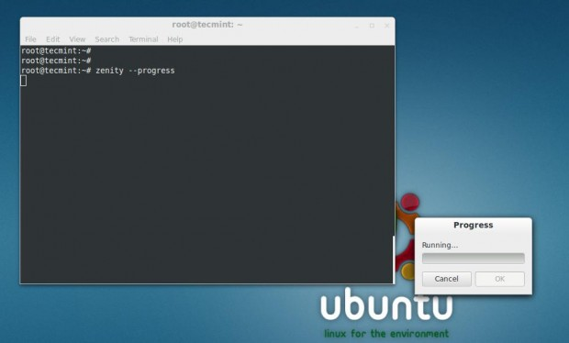

7. Scale Dialog
root@tecmint:~# zenity --scale
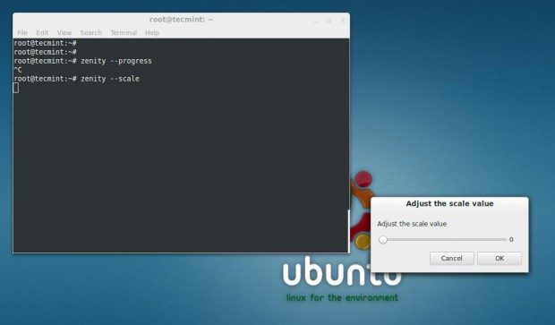

8. A Password Dialog
root@tecmint:~# zenity --password
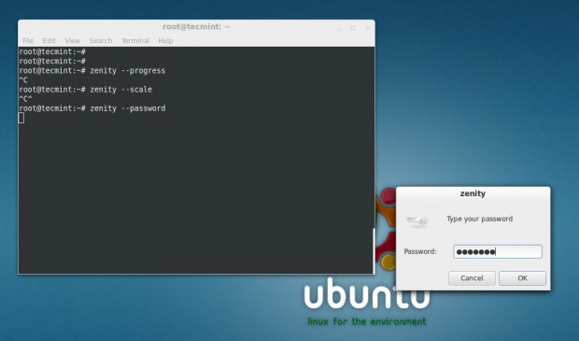

9. A Form Dialog box
root@tecmint:~# zenity --forms
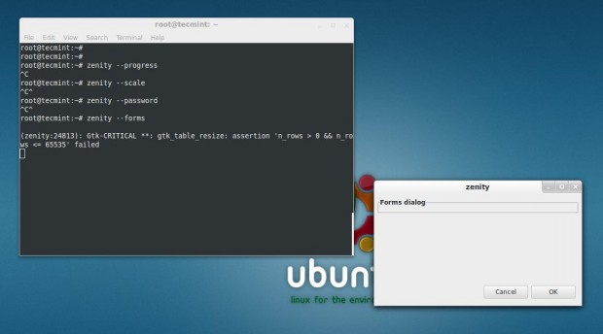

10. An about Dialog
root@tecmint:~# zenity --about
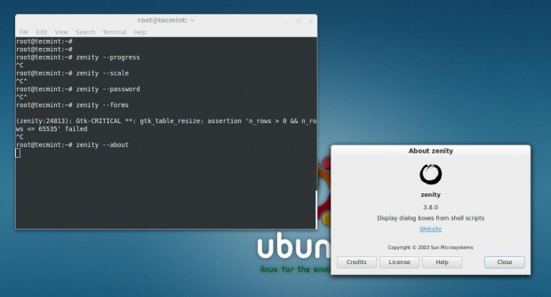

Create Shell Script Dialog
Now we would be discussing Zenity Dialog creation using simple shell scripts here. Although we can create single Dialog by executing Zenity commands directly from the shell (as we did above) but then we can’t link two Dialog boxes in order to obtain some meaningful result.
How about an interactive dialog box which takes input from you, and shows the result.
#!/bin/bash
first=$(zenity --title="Your's First Name" --text "What is your first name?" --entry)
zenity --info --title="Welcome" --text="Mr./Ms. $first"
last=$(zenity --title="Your's Last Name" --text "$first what is your last name?" --entry)
zenity --info --title="Nice Meeting You" --text="Mr./Ms. $first $last"
Save it to ‘anything.sh‘ (conventionally) and do not forget to make it executable. Set 755 permission on anything.sh file and run the script.
root@tecmint:~# chmod 755 anything.sh
root@tecmint:~# sh anything.sh
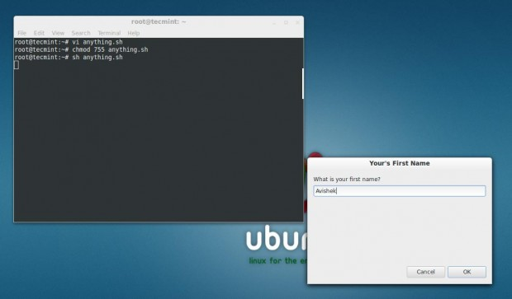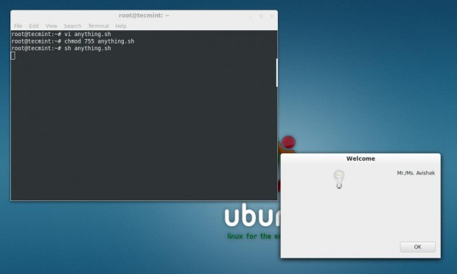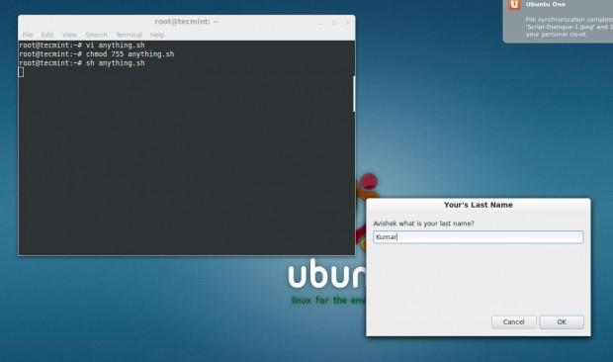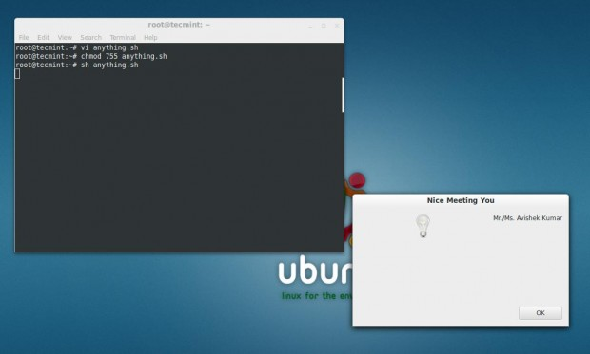

About Script Description
The conventional shebang aka hashbang
#!/bin/bash
In the below line ‘first’ is a variable and the value of variable is Generated at run time.
  - ‘–entry‘ means zenity is asked to generate an text Entry box.
  - ‘– title=‘ defines the title of generated text box.
  - ‘—text=‘ defines the text that is available on text Entry box.
first=$(zenity --title="Your's First Name" --text "What is your first name?" --entry)
This line of the below script file is for generation of Information (–info) Dialog box, with title “Welcome” and Text “Mr./Ms.first”
zenity --info --title="Welcome" --text="Mr./Ms. $first"
This Line of the script is Similar to line number two of the script except here a new variable ‘last’ is defined.
last=$(zenity --title="Your's Last Name" --text "$first what is your last name?" --entry)
This last line of the script is again similar to the third line of the script and it generates information Dialog box which contains both the variables ‘$first’ and ‘$last’.
zenity --info --title="Nice Meeting You" --text="Mr./Ms. $first $last"
For more information on how to create custom dialog boxes using shell script, visit at following reference page Zenity.
- https://help.gnome.org/users/zenity/stable/
In the next article we would be integrating Zenity with more shell script for GUI user interaction. Till then stay tuned and connected to Tecmint. Don’t forget to give your valuable feedback in comment section.
Tags command line graphical boxes, graphical shell scripts, zenity

https://www.tecmint.com/zenity-creates-graphical-gtk-dialog-boxes-in-command-line-and-shell-scripts/

How to Show Dialog Box using Shell Script with Examples
By Ilija Lazarevic
| Updated March 17, 2021 | Categories Tutorials
This tutorial will give couple of examples on how to use utilities like zenity and whiptail in your Bash shell script to provide message / dialog box . With these utilities your script will be able to inform user about the current state of execution, or give an ability to interact. Difference between these two utilities is the way they are displaying message box or dialog. Zenity uses GTK toolkit for creating graphical user interfaces, while whiptail creates message boxes inside terminal window.

Zenity Tool
To install zenity on Ubuntu run:
sudo apt-get install zenity
Since commands for creating message boxes or dialogs with zenity are pretty self explanatory, we will provide you with couple of examples.

Creating information box
zenity --info --title "Information Box" --text "This should be information" --width=300 --height=200

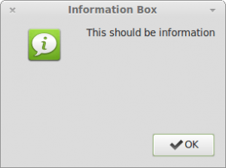
Creating Yes/No dialog
zenity --question --text "Do you want this?" --ok-label "Yeah" --cancel-label="Nope"

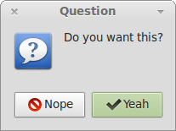
Creating entry box and storing value in variable

a=$(zenity --entry --title "Entry box" --text "Please enter the value" --width=300 --height=200)
echo $a
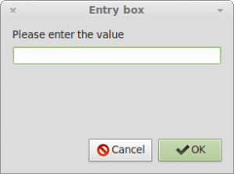
After entering it, value will be stored in $a variable.
Here is the working example which takes user's first name, last name and age and displays it.
#!/bin/bash
#
# This script will ask for couple of parameters
# and then continue to work depending on entered values
#

# Giving the option to user
zenity --question --text "Do you want to continue?"

# Checking if user wants to proceed
[ $? -eq 0 ] || exit 1

# Letting user input some values
FIRSTNAME=$(zenity --entry --title "Entry box" --text "Please, enter your first name." --width=300 --height=150)
LASTNAME=$(zenity --entry --title "Entry box" --text "Please, enter your last name." --width=300 --height=150)
AGE=$(zenity --entry --title "Entry box" --text "Please, enter your age." --width=300 --height=150)

# Displaying entered values in information box
zenity --info --title "Information" --text "You are ${FIRSTNAME} ${LASTNAME} and you are ${AGE}(s) old." --width=300 --height=100
Here are the screenshots of previous script.

Don't forget refer some of the useful zenity options that might help you.

Whiptail Tool
To install whiptail on Ubuntu run
sudo apt-get install whiptail
Commands for creating message box/dialog with whiptail are also self explanatory, so we will provide you with just couple of basic examples.

Creating message box
whiptail --msgbox "This is a message" 10 40

Creating Yes/No dialog
whiptail --yes-button "Yeah" --no-button "Nope" --title "Choose the answer" --yesno "Will you choose yes?" 10 30

Creating entry box with default value
whiptail --inputbox "Enter your number please." 10 30 "10"
One thing to be aware of when trying to use entered value is that whiptail uses stdout for displaying dialog, and stderr for value output. That way, if you use var=$(...) you wont see dialog box at all, and wont get the entered value. Solution is to switch stdout and stderr. To do that just add 3>&1 1>&2 2>&3 at the end of the whiptail command. Same would be with any whiptail command which you want to use to get some entered value.

Creating menu dialog
whiptail --menu "This is a menu. Choose an option:" 20 50 10 1 "first" 2 "second" 3 "third"
Here is a shell script that asks user to enter a path to a folder and then outputs it's size.
#!/bin/bash
#
#

# Since whiptail has to use stdout to display dialog, entered value will
# be stored in stderr. To switch them and get the value to stdout you must
# use 3>&1 1>&2 2>&3
FOLDER_PATH=$(whiptail --title "Get the size of folder" \
--inputbox "Enter folder path:" \
10 30 \
"/home" \
3>&1 1>&2 2>&3)

if [ -d $FOLDER_PATH ]
then
size=$(du -hs "$FOLDER_PATH" | awk '{print $1}')
whiptail --title "Information" \
--msgbox "Size of ${FOLDER_PATH} is ${size}" \
10 40
elif [ -f $FOLDER_PATH ]
then
whiptail --title "Warning!!!" \
--msgbox "The path you entered is a path to a file not a folder!" \
10 40
else
whiptail --title "Error!!!"
--msgbox "Path you entered is not recognized. Please try again" \
10 40
fi
Here are the screenshots from previous example:
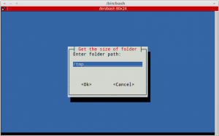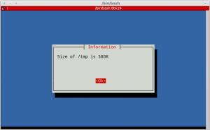
If you are working in terminal , manual pages are always available.

Conclusion
Choosing the right tool for displaying dialogs will depend on whether you expect your script to be run on desktop machine or server machine. Desktop machine users mostly use window environment and will possibly be able to run the script and interact with appearing windows. However, if you are expecting that the user is someone on server machine, you might want to play it safe and use whiptail or any other utility that will display dialogs in plain terminal window.
https://linoxide.com/bash-shell-script-show-dialog-box/

