# LOGO
bold=$(tput bold)
green=$(tput setaf 2)
clear
echo "${green}${bold}"
echo ""
echo " ██████ ██ ██████ ██"
echo "██ ██ ██ ██ ██"
echo "██ ██ ██████ ██"
echo "██ ██ ██ ██"
echo " ██████ ██ ██ ██"
echo ""
echo "Installation has been started... Hold on!"
echo "${reset}"
sleep 3s

Change the prompt color using tput
by Ramesh

You can also change color of the PS1 prompt using tput as shown below:

$ export PS1="\[$(tput bold)$(tput setb 4)$(tput setaf 7)\]\u@\h:\w $ \[$(tput sgr0)\]“

tput Color Capabilities:

tput setab [1-7] – Set a background color using ANSI escape
tput setb [1-7] – Set a background color
tput setaf [1-7] – Set a foreground color using ANSI escape
tput setf [1-7] – Set a foreground color

tput Text Mode Capabilities:

tput bold – Set bold mode
tput dim – turn on half-bright mode
tput smul – begin underline mode
tput rmul – exit underline mode
tput rev – Turn on reverse mode
tput smso – Enter standout mode (bold on rxvt)
tput rmso – Exit standout mode
tput sgr0 – Turn off all attributes

Color Code for tput:

0 – Black
1 – Red
2 – Green
3 – Yellow
4 – Blue
5 – Magenta
6 – Cyan
7 – White

The count of colors available to tput is given by tput colors.
To see the basic 8 colors (as used by setf in urxvt terminal and setaf in xterm terminal):
$ printf '\e[%sm▒' {30..37} 0; echo ### foreground
$ printf '\e[%sm ' {40..47} 0; echo ### background
And usually named as this:
Color #define Value RGB
black COLOR_BLACK 0 0, 0, 0
red COLOR_RED 1 max,0,0
green COLOR_GREEN 2 0,max,0
yellow COLOR_YELLOW 3 max,max,0
blue COLOR_BLUE 4 0,0,max
magenta COLOR_MAGENTA 5 max,0,max
cyan COLOR_CYAN 6 0,max,max
white COLOR_WHITE 7 max,max,max
To see the extended 256 colors (as used by setaf in urxvt):
$ printf '\e[48;5;%dm ' {0..255}; printf '\e[0m \n'
If you want numbers and an ordered output:
#!/bin/bash
color(){
for c; do
printf '\e[48;5;%dm%03d' $c $c
done
printf '\e[0m \n'
}

IFS=$' \t\n'
color {0..15}
for ((i=0;i<6;i++)); do
color $(seq $((i*36+16)) $((i*36+51)))
done
color {232..255}
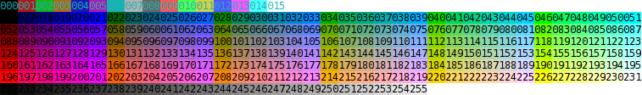

The 16 million colors need quite a bit of code (some consoles can not show this).
The basics is:
fb=3;r=255;g=1;b=1;printf '\e[0;%s8;2;%s;%s;%sm▒▒▒ ' "$fb" "$r" "$g" "$b"
fb is front/back or 3/4.
A simple test of your console capacity to present so many colors is:
for r in {200..255..5}; do fb=4;g=1;b=1;printf '\e[0;%s8;2;%s;%s;%sm ' "$fb" "$r" "$g" "$b"; done; echo
It will present a red line with a very small change in tone from left to right. If that small change is visible, your console is capable of 16 million colors.
Each r, g, and b is a value from 0 to 255 for RGB (Red,Green,Blue).
If your console type support this, this code will create a color table:
mode2header(){
#### For 16 Million colors use \e[0;38;2;R;G;Bm each RGB is {0..255}
printf '\e[mR\n' # reset the colors.
printf '\n\e[m%59s\n' "Some samples of colors for r;g;b. Each one may be 000..255"
printf '\e[m%59s\n' "for the ansi option: \e[0;38;2;r;g;bm or \e[0;48;2;r;g;bm :"
}
mode2colors(){
# foreground or background (only 3 or 4 are accepted)
local fb="$1"
[[ $fb != 3 ]] && fb=4
local samples=(0 63 127 191 255)
for r in "${samples[@]}"; do
for g in "${samples[@]}"; do
for b in "${samples[@]}"; do
printf '\e[0;%s8;2;%s;%s;%sm%03d;%03d;%03d ' "$fb" "$r" "$g" "$b" "$r" "$g" "$b"
done; printf '\e[m\n'
done; printf '\e[m'
done; printf '\e[mReset\n'
}
mode2header
mode2colors 3
mode2colors 4
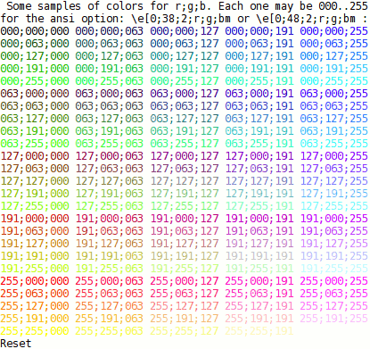

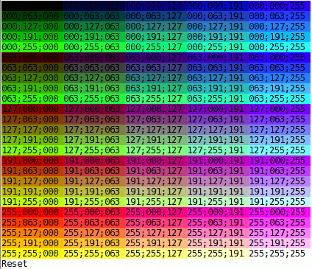
To convert an hex color value to a (nearest) 0-255 color index:
fromhex(){
hex=${1#"#"}
r=$(printf '0x%0.2s' "$hex")
g=$(printf '0x%0.2s' ${hex#??})
b=$(printf '0x%0.2s' ${hex#????})
printf '%03d' "$(( (r<75?0:(r-35)/40)*6*6 +
(g<75?0:(g-35)/40)*6 +
(b<75?0:(b-35)/40) + 16 ))"
}
Use it as:
$ fromhex 00fc7b
048
$ fromhex #00fc7b
048

To find the color number as used in HTML colors format:
#!/bin/dash
tohex(){
dec=$(($1%256)) ### input must be a number in range 0-255.
if [ "$dec" -lt "16" ]; then
bas=$(( dec%16 ))
mul=128
[ "$bas" -eq "7" ] && mul=192
[ "$bas" -eq "8" ] && bas=7
[ "$bas" -gt "8" ] && mul=255
a="$(( (bas&1) *mul ))"
b="$(( ((bas&2)>>1)*mul ))"
c="$(( ((bas&4)>>2)*mul ))"
printf 'dec= %3s basic= #%02x%02x%02x\n' "$dec" "$a" "$b" "$c"
elif [ "$dec" -gt 15 ] && [ "$dec" -lt 232 ]; then
b=$(( (dec-16)%6 )); b=$(( b==0?0: b*40 + 55 ))
g=$(( (dec-16)/6%6)); g=$(( g==0?0: g*40 + 55 ))
r=$(( (dec-16)/36 )); r=$(( r==0?0: r*40 + 55 ))
printf 'dec= %3s color= #%02x%02x%02x\n' "$dec" "$r" "$g" "$b"
else
gray=$(( (dec-232)*10+8 ))
printf 'dec= %3s gray= #%02x%02x%02x\n' "$dec" "$gray" "$gray" "$gray"
fi
}

for i in $(seq 0 255); do
tohex ${i}
done
Use it as ("basic" is the first 16 colors, "color" is the main group, "gray" is the last gray colors):
$ tohex 125 ### A number in range 0-255
dec= 125 color= #af005f
$ tohex 6
dec= 6 basic= #008080
$ tohex 235
dec= 235 gray= #262626

