Getting Started with Linode
Updated , by Linode
Try this guide to receive $100 at signup on a new account.


Welcome to Linode!
Thank you for choosing Linode as your cloud hosting provider! This guide will help you sign up for an account and access Linode’s Cloud Manager, a browser-based control panel which allows you to manage your Linode virtual servers and services.
From there you’ll set up a Linux distribution, boot your Linode, and perform some basic system administration tasks. If you’ve already created an account and booted your Linode, skip ahead to connecting to your Linode using SSH.

Sign Up
If you haven’t already signed up for a Linode account, start here.
- Create a new account at the Sign Up page.
- Newly created Linode accounts have restrictions on ports 25, 465, and 587. If you’d like to …
- Sign in and enter your billing and account information. Most accounts are activated instantly, but some require manual review prior to activation. If your account is not immediately activated, you will receive an email with additional instructions.

Create a Linode
- Log in to the Cloud Manager with the username and password you created when signing up.
- At the top of the page, click Create and select Linode.
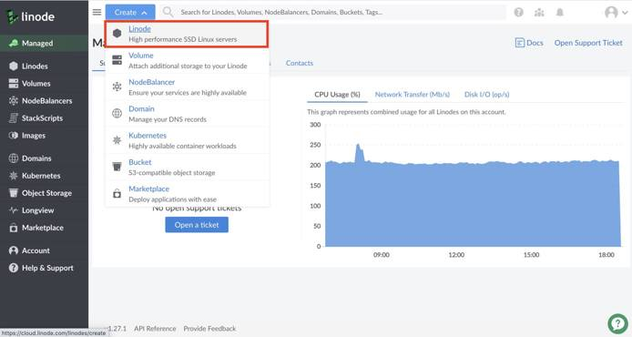
- Select the Distribution, One Click App, or Image you would like to use.
Note
Use a StackScript to quickly deploy software platforms and system configuration options to your Linux distribution. Some of the most popular StackScripts do things like install a LAMP stack, VPN, or WordPress. You can read more about Stackscripts and how they work in our Automating Deployments with Stackscripts Guide.
- Choose the region where you would like your Linode to reside. If you’re not sure which to select, see our How to Choose a Data Center guide. You can also generate MTR reports for a deeper look at the route path between you and a data center in each specific region.
- Select a Linode plan.
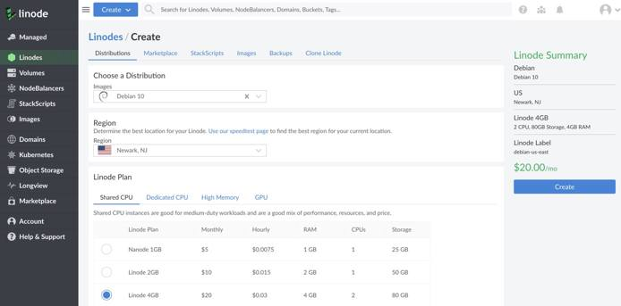
- Give your Linode a label. This is a name to help you easily identify it within the Cloud Manager’s Dashboard. If desired, assign a tag to the Linode in the Add Tags field.
- Create a root password for your Linode in the Root Password field. This password must be provided when you log in to your Linode via SSH. The password must meet the complexity strength validation requirements for a strong password. Your root password can be used to perform any action on your server, so make it long, complex, and unique.
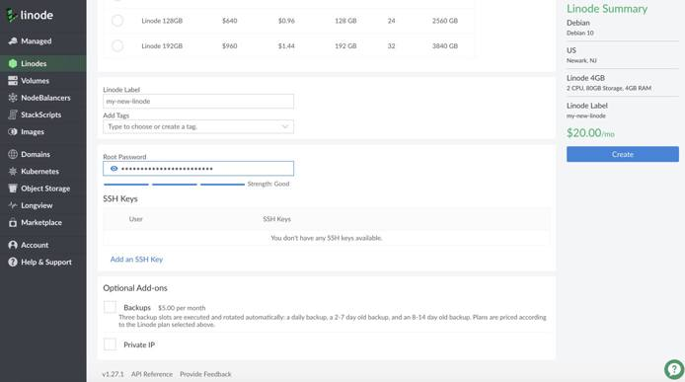
- Click Create. You will be directed back to the Linodes page which will report the status of your Linode as it boots up. You can now use the Cloud Manager to:
  - Boot and shut down your Linode
  - Access monitoring statistics
  - Update your billing and account information
  - Add additional Linode services, like Block Storage
  - Open a support ticket and perform other administrative tasks
- Be sure to bookmark the Linode Status page or subscribe to our system status updates by email.

Network Helper
Network Helper is a host-side service which automatically sets a static IPv4 address and gateway for your Linode. It is enabled by default. However, it can be enabled and disabled globally, and per-Linode.
- If you disable Network Helper globally on your account, and you want it enabled for a single Linode, you will need to enable it for that Linode.
- If you enable Network Helper globally, every new Linode you create will have it enabled upon creation; you can disable it for single Linodes if desired.
Note
If Network Helper is unable to determine the operating system during boot, or if you boot an unsupported operating system, Network Helper will not attempt to write any new configuration files. See the Network Helper guide to learn which distributions it supports. Be aware that Network Helper configures only IPv4 addressing; your Linode’s IPv6 address is assigned by SLAAC.

Connect to Your Linode via SSH
Communicating with your Linode is usually done using the secure shell (SSH) protocol. SSH encrypts all of the data transferred between the client application on your computer and the Linode, including passwords and other sensitive information. There are SSH clients available for every operating system.
- Linux: You can use a terminal window, regardless of desktop environment or window manager.
- macOS: Terminal.app comes pre-installed and can be launched from Spotlight or Launchpad.
- Windows: There is no native SSH client but you can use a free and open source application called PuTTY.

Find your Linode’s IP Address
Your Linode has a unique IP address that identifies it to other devices and users on the internet.
- Click the Linodes menu item in the Cloud Manager’s left hand navigation.
- Find your Linode, click on it’s name and navigate to Networking.
- Your IPv4 and IPv6 addresses appear under the IPv4 and IPv6 sections.
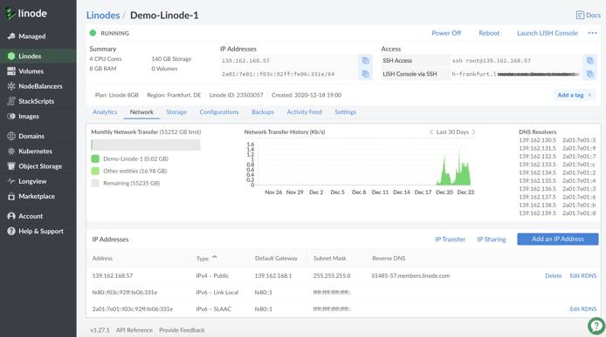
You can also quickly reference your Linode’s IP addresses from the Linodes page:
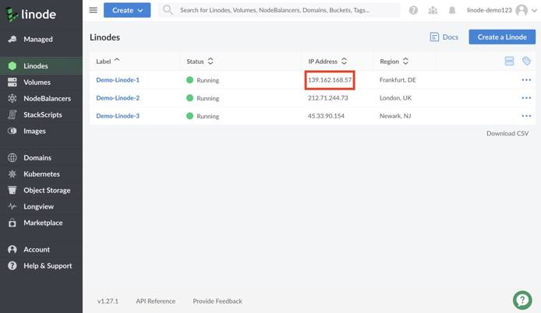

Log in Using SSH
Once you have the IP address and an SSH client, you can log in via SSH. The following instructions are written for Linux and macOS. If you’re using PuTTY on Windows, follow these instructions.
- Enter the following into your terminal window or application. Replace the example IP address with your Linode’s IP address:
ssh root@198.51.100.4
- If this is the first time connecting to your Linode, you’ll see the authenticity warning below. This is because your SSH client has never encountered the server’s key fingerprint before. Type yes and press Enter to continue connecting.
The authenticity of host '198.51.100.4 (198.51.100.4)' can't be established.
RSA key fingerprint is 11:eb:57:f3:a5:c3:e0:77:47:c4:15:3a:3c:df:6c:d2.
Are you sure you want to continue connecting (yes/no)?
After you enter yes, the client confirms the addition:
Warning: Permanently added '198.51.100.4' (RSA) to the list of known hosts.
- The login prompt appears for you to enter the password you created for the root user above.
root@198.51.100.4's password:
- The SSH client initiates the connection and then the following prompt appears:
root@li123-456:~#
Note
If you recently rebuilt an existing Linode, you might receive an error message when you try to reconnect via SSH. SSH clients try to match the remote host with the known keys on your desktop computer, so when you rebuild your Linode, the remote host key changes.
To reconnect via SSH, revoke the key for that IP address.
For Linux and macOS:
ssh-keygen -R 198.51.100.4
For Windows, PuTTY users must remove the old host IP addresses manually. PuTTY’s known hosts are in the registry entry:
HKEY_CURRENT_USER\Software\SimonTatham\PuTTY\SshHostKeys

Install Software Updates
The first thing you should do after connecting to your Linode is update the Linux distribution’s packages. This applies the latest security patches and bug fixes to help protect your Linode against unauthorized access. Installing software updates should be performed regularly.

Arch Linux
pacman -Syu

CentOS
yum update

Debian / Ubuntu
apt-get update && apt-get upgrade
Note
You may be prompted to make a menu selection when the Grub package is updated on Ubuntu. If prompted, select keep the local version currently installed.

Fedora
dnf upgrade

Gentoo
emaint sync -a
After running a sync, it may end with a message that you should upgrade Portage using a --oneshot emerge command. If so, run the Portage update. Then update the rest of the system:
emerge -uDU --keep-going --with-bdeps=y @world

OpenSUSE
zypper update

Slackware
slackpkg update
slackpkg upgrade-all

Set the Hostname
A hostname is used to identify your Linode using an easy-to-remember name. Your Linode’s hostname doesn’t necessarily associate with websites or email services hosted on the system, but see our guide on using the hosts file if you want to assign your Linode a fully qualified domain name.
Your hostname should be something unique, and should not be www or anything too generic. Some people name their servers after planets, philosophers, or animals. After you’ve made the change below, you’ll need to log out and back in again to see the terminal prompt change from localhost to your new hostname. The command hostname should also show it correctly.

Arch / CentOS 7 / Debian 8 / Fedora / Ubuntu 16.04 and above
Replace example-hostname with one of your choice.
hostnamectl set-hostname example-hostname

CentOS 6
Replace example-hostname with one of your choice.
echo "HOSTNAME=example-hostname" >> /etc/sysconfig/network
hostname "example-hostname"

Debian 7 / Ubuntu 14.04
Replace example-hostname with one of your choice.
echo "example-hostname" > /etc/hostname
hostname -F /etc/hostname

Slackware
Replace example-hostname with one of your choice.
echo "example-hostname" > /etc/HOSTNAME
hostname -F /etc/HOSTNAME

Gentoo
Enter the following commands to set the hostname, replacing example-hostname with the hostname of your choice:
echo "HOSTNAME=\"example-hostname\"" > /etc/conf.d/hostname
/etc/init.d/hostname restart

OpenSUSE
Replace example-hostname with one of your choice.
hostname example-hostname

Update Your System’s hosts File
The hosts file creates static associations between IP addresses and hostnames or domains which the system prioritizes before DNS for name resolution. Open this file in a text editor and add a line for your Linode’s public IP address. You can associate this address with your Linode’s Fully Qualified Domain Name (FQDN) if you have one, and with the local hostname you set in the steps above. In the example below, 203.0.113.10 is the public IP address, example-hostname is the local hostname, and example-hostname.example.com is the FQDN.
File: /etc/hosts
127.0.0.1 localhost.localdomain localhost
203.0.113.10 example-hostname.example.com example-hostname
Add an entry for your Linode’s IPv6 address. Applications requiring IPv6 will not work without this entry:
File: /etc/hosts
127.0.0.1 localhost.localdomain localhost
203.0.113.10 example-hostname.example.com example-hostname
2600:3c01::a123:b456:c789:d012 example-hostname.example.com example-hostname
The value you assign as your system’s FQDN should have an “A” record in DNS pointing to your Linode’s IPv4 address. For IPv6, you should also set up a DNS “AAAA” record pointing to your Linode’s IPv6 address.
See our guide to Adding DNS Records for more information on configuring DNS. For more information about the hosts file, see Using your System’s hosts File

Set the Timezone
All new Linodes will be set to UTC time by default. However, you may prefer your Linode use the time zone which you live in so log file timestamps are relative to your local time.

Arch Linux / CentOS 7 / Fedora
- View all available time zones:
timedatectl list-timezones
- Use the Up, Down, Page Up and Page Down keys to navigate. Copy the time zone you want as a mouse selection. Then press q to exit the list.
- Set the time zone (for example, America/New_York):
timedatectl set-timezone 'America/New_York'

Debian / Ubuntu
- Though newer versions of Debian and Ubuntu use systemd with timedatectl, the recommended method to change timezones for these distributions is to use tzdata. It can be called using dpkg:
dpkg-reconfigure tzdata
- Arrow up or down to the continent of your choice and press Enter. Then do the same for the region.

Gentoo
- View a list of available time zones:
ls /usr/share/zoneinfo
- Write the selected time zone to /etc/timezone (for example, EST for Eastern Standard Time):
echo "EST" > /etc/timezone
- Configure the sys-libs/timezone-data package, which will set /etc/localtime appropriately:
emerge --config sys-libs/timezone-data

OpenSUSE
- View a list of available time zones:
yast2 timezone
- Arrow up or down to the Region of your choice and press Enter.
- Press Option+Z (on a macOS) or ALT+Z (on Windows/Linux) to select the Time Zone.
- Use arrow up or down to move through the list of time zones. Press Enter to make your selection.
- Press F10 when done.

Slackware
- Call the timeconfig tool in a terminal:
timeconfig
- Select NO Hardware clock is set to local time.
- Select a timezone.

Check the Time
Use the date command to view the current date and time according to your server.
root@localhost:~# date
Thu Feb 16 12:17:52 EST 2018

Next Steps
Now that you’ve learned the basics of using the Cloud Manager and working with your Linode, secure it and your Linode account from unauthorized access. See the following guides to begin:
- Securing Your Server
- Linode Manager Security Controls

Networking - DDoS Protection
Updated
Linode’s global network is protected by advanced DDoS mitigation in all of our data centers, helping to fend off attacks on your infrastructure. Linode DDoS protection is free for all customers.

Overview

Resources

Availability
Tokyo, Japan; Mumbai, India; Singapore, Singapore; Sydney, Australia; Frankfurt, Germany; London, United Kingdom; Toronto, Canada; Newark, NJ, USA; Atlanta, GA, USA; Dallas, TX, USA; Fremont, CA, USA

Features

Always on Real-Time Intelligent Protection
Always-on DDoS protection monitors, detects, analyzes, and blocks threats to the network in real-time. Attacks are blocked inline, then redistributed across Linode’s global fiber backbone.
Rules are automatically created using machine learning from traffic across the global network to intelligently reroute malicious traffic during a DDoS event.
Your server’s applications are protected from a range of DDOS attack methodologies including UDP, SYN, HTTP floods, and more.

Pricing
Linode’s DDoS Protection is provided for free to all customers.

COMPUTE

Shared Plans
Virtual Machines With Balanced Power and Performance
Learn More
RAM | CPU | Storage | Transfer | Network In | Network Out | Price
1 GB | 1 Core | 25 GB SSD | 1 TB | 40 Gbps | 1000 Mbps | $5 / mo ($.0075 / hr)
2 GB | 1 Core | 50 GB SSD | 2 TB | 40 Gbps | 2000 Mbps | $10 / mo ($.015 / hr)
4 GB | 2 Cores | 80 GB SSD | 4 TB | 40 Gbps | 4000 Mbps | $20 / mo ($.03 / hr)
8 GB | 4 Cores | 160 GB SSD | 5 TB | 40 Gbps | 5000 Mbps | $40 / mo ($.06 / hr)
16 GB | 6 Cores | 320 GB SSD | 8 TB | 40 Gbps | 6000 Mbps | $80 / mo ($.12 / hr)
32 GB | 8 Cores | 640 GB SSD | 16 TB | 40 Gbps | 7000 Mbps | $160 / mo ($.24 / hr)
64 GB | 16 Cores | 1280 GB SSD | 20 TB | 40 Gbps | 9000 Mbps | $320 / mo ($.48 / hr)
96 GB | 20 Cores | 1920 GB SSD | 20 TB | 40 Gbps | 10000 Mbps | $480 / mo ($.72 / hr)
128 GB | 24 Cores | 2560 GB SSD | 20 TB | 40 Gbps | 11000 Mbps | $640 / mo ($.96 / hr)
192 GB | 32 Cores | 3840 GB SSD | 20 TB | 40 Gbps | 12000 Mbps | $960 / mo ($1.44 / hr)
Create Account

Dedicated CPU Plans
Dedicated Virtual Machines For CPU-Intensive Applications
Learn More
RAM | CPU | Storage | Transfer | Network In | Network Out | Price
4 GB | 2 Cores | 80 GB SSD | 4 TB | 40 Gbps | 4000 Mbps | $30 / mo ($.045 / hr)
8 GB | 4 Cores | 160 GB SSD | 5 TB | 40 Gbps | 5000 Mbps | $60 / mo ($.09 / hr)
16 GB | 8 Cores | 320 GB SSD | 6 TB | 40 Gbps | 6000 Mbps | $120 / mo ($.18 / hr)
32 GB | 16 Cores | 640 GB SSD | 7 TB | 40 Gbps | 7000 Mbps | $240 / mo ($.36 / hr)
64 GB | 32 Cores | 1280 GB SSD | 8 TB | 40 Gbps | 8000 Mbps | $480 / mo ($.72 / hr)
96 GB | 48 Cores | 1920 GB SSD | 9 TB | 40 Gbps | 9000 Mbps | $720 / mo ($1.08 / hr)
128 GB | 50 Cores | 2500 GB SSD | 10 TB | 40 Gbps | 10000 Mbps | $960 / mo ($1.44 / hr)
256 GB | 56 Cores | 5000 GB SSD | 11 TB | 40 Gbps | 11000 Mbps | $1920 / mo ($2.88 / hr)
512 GB | 64 Cores | 7200 GB SSD | 12 TB | 40 Gbps | 12000 Mbps | $3840 / mo ($5.76 / hr)
Create Account

High Memory Plans
Virtual Machines Optimized with Dedicated Cores for Memory-Intensive Applications.
Learn More
RAM | CPU | Storage | Transfer | Network In | Network Out | Price
24 GB | 2 Cores | 20 GB SSD | 5 TB | 40 Gbps | 5000 Mbps | $60 / mo ($.09 / hr)
48 GB | 2 Cores | 40 GB SSD | 6 TB | 40 Gbps | 6000 Mbps | $120 / mo ($.18 / hr)
90 GB | 4 Cores | 90 GB SSD | 7 TB | 40 Gbps | 7000 Mbps | $240 / mo ($.36 / hr)
150 GB | 8 Cores | 200 GB SSD | 8 TB | 40 Gbps | 8000 Mbps | $480 / mo ($.72 / hr)
300 GB | 16 Cores | 340 GB SSD | 9 TB | 40 Gbps | 9000 Mbps | $960 / mo ($1.44 / hr)
Create Account

GPU Plans
Dedicated Virtual Machines to Speed Up Complex Compute Jobs with RTX 6000 GPUs
Learn More
RAM | CPU | Storage | GPU Cards | Transfer | Network In | Network Out | Price
32 GB | 8 Cores | 640 GB SSD | 1 | 16 TB | 40 Gbps | 10000 Mbps | $1000 / mo ($1.5 / hr)
64 GB | 16 Cores | 1280 GB SSD | 2 | 20 TB | 40 Gbps | 10000 Mbps | $2000 / mo ($3.0 / hr)
96 GB | 20 Cores | 1920 GB SSD | 3 | 20 TB | 40 Gbps | 10000 Mbps | $3000 / mo ($4.5 / hr)
128 GB | 24 Cores | 2560 GB SSD | 4 | 20 TB | 40 Gbps | 10000 Mbps | $4000 / mo ($6.0 / hr)
*Need a custom GPU plan or implementation? Contact sales to learn more.
Create Account


See how Linode Cloud pricing compares
Cut your infrastructure bills in half with more predictable price-performance and award-winning support.
Cloud Estimator Tool

STORAGE

Block Storage
Increase storage capacity by attaching high-speed Volumes
Learn More
$1/mo
10GiB10240GiB
10GiB
Create Account

Object Storage
S3 compatible storage for backups, big data and archiving needs
Learn More
$5/mo
250GB50TB
250 GB1 TB Outbound TransferUp to 50 Million Objects per Cluster
$.02 / GB Additional Storage$.01 / GB Additional Outbound Transferred
Create Account

Backups
Instant backups with complete independency to your stack. Choose your instance type to backup.
Learn More
- Shared
- Dedicated CPU
- High Memory
- GPU
$2/mo
$.003/hr
1GB192GB
1 GB RAM1 CPU Core25 GB SSD1 TB Transfer
40 Gbps Network In1000 Mbps Network Out
$5/mo
$.008/hr
4GB512GB
4 GB RAM2 CPU Cores80 GB SSD4 TB Transfer
40 Gbps Network In4000 Mbps Network Out
$5/mo
$.0075/hr
24GB300GB
24 GB RAM1 CPU Core20 GB SSD5 TB Transfer
40 Gbps Network In5000 Mbps Network Out
$40/mo
$.06/hr
32GB128GB
32 GB RAM8 CPU Cores640 GB SSD16 TB Transfer
40 Gbps Network In10000 Mbps Network Out
Create Account

NETWORKING

NodeBalancers
Ensure your applications and services are highly-available.
Learn More
$ 10 /mo
Create Account

Services
Responsive, hands-on expertise from professionals who care.


Managed
Infrastructure management


Professional Services
Cloud consulting and migration
Enroll in Linode Managed Service from an existing account with no obligation or contract for $100 per month.
Learn More
Add to My Account
Speak with a Cloud Consultant Today!
Email us or call 866-238-9435
(International: +1-609-380-7562)
Learn More
Get a Quote

All of our packages include…
- No cost, DDoS protection
- 24/7/365 Email & Phone Support
- 99.99% Compute Uptime SLA
- 7-Day Money Back Guarantee
- User-Friendly Cloud Manager
- API & CLI
- Free bundled transfer
- DNS Management
- One-Click Apps
- Worldwide Availability
- IPv6 Support
- Monitoring & Alerts

Frequently Asked Questions

How does hourly billing work?
You are charged the hourly rate for a service up to its monthly cap (rates get rounded up to the nearest hour). For example, if you create a 1GB Linode and delete it after 24 hours of use, you would be billed $0.18 (24 hours x .0075/hr). You will receive an invoice on the first day of the following calendar month; however, you may receive a mid-month invoice if your account reaches a certain billing limit for Linode services used within a single month. Payment collection occurs automatically once an invoice gets generated. Learn more.

What plan should I choose?
If you're not sure, we recommend that you start small and work your way up. You can resize your Linode up or down at any time. If you're planning to migrate your workload from on-premises or between cloud providers, we recommend using our Total Cost of Ownership Cloud Pricing Calculator to receive a full cost breakdown and technical recommendations. Learn more.

What happens if I exceed my monthly transfer quota?
You will be invoiced $0.01 for each GB over your pooled network transfer quota. Please note that all inbound traffic is free and will not count against your quota. Learn more.

Can I prepay for my Linode services?
Yes, you can make payments that front-load your account with credit. When your account gets invoiced for services used, we apply the prepaid credit amount before charging the payment card on file with your account.

I received a promotional credit when signing up for my account. When will my credit card begin to be charged?
Your credit card gets charged after you have exhausted the promotional credit amount or after the promotional credit window expires. For example, if you received a $100 credit for 60 days, then that $100 credit is automatically applied to your account. If you spend $50 during those 60 days, then your card will not be charged. If you spend $150 within those 60 days, then the $100 credit would be fully exhausted, and your credit card will get charged $50. Your credit card gets charged for any active services after the promotional credit window expires.

If my Linode is powered off, will I be billed?
Yes. We maintain your saved data and reserve your ability to use other resources like RAM, transfer, etc. even when your Linode is powered off. You will receive a bill for any other active Linode service, such as Longview Pro or an extra IP. If you want to stop receiving a bill for a particular Linode service, you need to remove it from your account entirely. Learn more.

What forms of payment do you accept?
We accept Visa, MasterCard, American Express, and Discover. You can add credit to your account by transferring funds from a PayPal account. You will still need to sign up using a credit card when transferring from PayPal. Maintaining a valid credit card on file with your account is a requirement of our Master Services Agreement. Learn more.

Does Linode Collect Taxes?
Linode collects taxes for customers who are subject to it. You can refer to our Tax Information guide to learn more about what countries Linode collects taxes for, including tax rates, and how to add your business’s tax ID to your Linode account. Learn more.

Understanding TLS Certificates and Connections
Updated , by Tom Henderson
web server ssl security
Try this guide to receive $100 at signup on a new account.

Understanding the TLS Protocol
The Transportation Layer Security protocol (TLS) is a widely-deployed method to protect and encrypt telecommunications. TLS protects many services, including web traffic, email, and many forms of Instant Messaging (IM). TLS elements may also vet degrees of hosts' authenticity using chains-of-authority while processing communication of many forms. Mutually negotiable certificates are commonly exchanged promoting traceable trust between two hosts.
TLS operates at the Transport Layer (Layer 4) in the ISO/OSI stack. Other popular communications protection mechanisms operate at the Network Layer (IPSec) or the Application Layer (SSH) and even the Presentation Layer (SOCKS). TLS is a TCP-focused protocol, although variants use the Datagram TLS protocol ((D)TLS). This protocol works with out-of-order packet arrival or connections with high error rates and/or jitter. (D)TLS functionality almost completely mimes TLS, so the two can be considered synonymous for purposes of discussion.
TLS is operating system agnostic. The supported ciphers and certificate management characteristics of each host is usually a combination of the operating system, in combination with library and/or application resources used with the application and responding service. The applications, host operating systems, and libraries used with two hosts under TLS can be from completely different resources. Yet the connections achieves privacy, encryption, session management, and trust under TLS/(D)TLS.

The TLS Trust Relationship
The TLS trust relationship is established by one host evaluating an offer from another host. The host inspects a certificate for validity, perhaps against a stored reference certificate, a Certificate Authority (CA), or another desired trust fact (such as another factor of security seen in multi-factor authentication). The verification process uses weights against a trust score that must be met. Once the host accepts the trust score it proceeds to the next step, encryption selection and establishment. After that’s achieved, the hosts permit encrypted traffic.
The highest-denominator trust and strength of encryption are the most desirable ways to establish trust. It can be dangerous to use older cipher suites. However, some responding hosts may only negotiate a combination that is weaker, and hence more undesirable. Many modern browsers refuse to negotiate HTTPS with websites using older, more vulnerable cipher suite combinations.

Protocol Negotiation Methods and TLS Certificates
Protocol types have different negotiation methods. TLS for HTTPS web surfing is used differently than StartTLS used for mail exchange. Generally, you don’t see the construction and operational characteristics of TLS used unless an application alerts you about a stipulation problem. This can happen when there is a weak cipher request. In the case of email, for example, only the system administrator may see the generated error.
Most modern web browsers include a visual indication that TLS is working, such as a lock icon seen in the URL address bar. When the lock is in the lock position, often colored green, your connection is protected by TLS, as is the case when https works. The browser also indicates when the connection is not protected by TLS. When you click on the lock symbol, the browser shows the certificate and encryption relationship between the browser, its host, and the webserver to which it’s connected.
Traffic continues until the certificate expiration time occurs, or until there is an error indicating an alarm condition. Many conditions can trigger an alarm; only a few are considered cause for a recovery. Instead, a new TLS relationship is built between hosts to continue communications, if the conditions causing the error can be successfully removed.
The widest use of TLS trust is used on the Internet between web browsers and applications, and (web) servers. Browsers are provisioned with an initial store of certificate authorities, who are proxy parts of the certificate verification chain. When modern browsers encounter a certificate that is self-signed (self-authoritative), the browser sends you a warning.

Email and TLS
Email exchanges can be covered by TLS, and most are, but this is not a guarantee. Some SMTP hosts are simple, and do not have a TLS mechanism for exchanging mail. An SMTP host may use a TLS mechanism that supports weak trust methods or weak ciphers for mail exchange. Email servers supporting TLS aren’t held to as high a standard as web surfing, where HTTPS has become the mandated default communications privacy protocol.

TLS and Encryption
Encryption requires mathematical calculations to solve the formulas used to encrypt and decrypt TLS conversations. In the past, these calculations placed a high load on CPUs, and was often given as a reason against using TLS. Numerous CPU families now offer encryption/decryption optimizations which allow load capacity and scalability for server applications implementing TLS.

TLS Governance
TLS has been used for many years, and it is the successor to Secure Sockets Layer/SSL. The Internet Engineering Task Force’s IETF TLS Working Group is chartered with considering and evolving any changes. Each of the TLS Requests For Comments (RFCs) are published, building to the currently used RFC for TLS 1.3. Backwards compatibility with prior versions is necessary, although the reasons that prior versions of SSL and TLS were deprecated were because they had vulnerabilities with varying degrees of danger.

The Process of TLS Encryption and Trust
TLS connections are a multi-step process. Here’s how it works.
- An application initiates a TLS connection by connecting to a web server with HTTPS as a preamble rather than HTTP; TLS is intentional.
- The application and web server perform a handshake that initially encrypts the conversation.
- A negotiation begins regarding what cipher suites/encryption methods are to be used.
- Trust credentials are requested, exchanged, and once established, a session starts in full.

A Deeper Dive into TLS Connections and TLS Certificates

Initiating a Connection
To initiate a TLS link, a host application requests TLS coverage of another host. In web conversations, that’s accomplished by a browser making a URL request to a web server specifying the preamble URL of https. As the HTTPS protocol has become the default with many browsers, it has also become the default of many servers.
The https invocation specifically requests TLS/SSL (although SSL is usually discouraged) to the server. A server may accept an https address request call, and answer back with an https connection. If the browser cannot complete the TLS/https protocol, the server hangs up.
Once the initiating TLS transaction is done, a relationship between the two hosts occurs, as a stateful entity called a session. A series of messages constituting a handshake occurs between the hosts. This establishes message encryption, and therefore privacy. in TLS 1.3, a single request-and-answer then causes the next parts of the TLS protocol to be encrypted.
Next, the authenticity of the server’s credentials is checked. These are checked against either a local browser certificate cache or against a chain-of-authorities to a Certificate Authority. If all matches correctly, a session is established. It may have a stated maximum lifetime/expiration.
Once the TLS connection is made between the two hosts, it’s time to pick common encryption mechanisms/ciphers (and hopefully the highest common denominator between the two hosts). In the web service example, a browser has trust information presented by the web service. The browser looks to either its own cache of certificates, or to a chain-of-authorities statement made by the web server to prove its trust. If trust can be proven satisfactorily, and multiple options are possible, then a trust relationship is established (or rejected, ending the conversation).
Subsequent communications within the session is monitored by both hosts for out-of-normal conditions during exchanges. When the authentication method chosen expires or has an alarm condition, the communication session ends. Either host may tear down the session when it perceives that the session finishes, the session expires (the certificate is no longer valid or dies in other ways), or an alarm condition causes session termination.

The Life Cycle of a TLS Connection
- A host makes a request to another host to begin a TLS conversation. This often uses an established IP address at a specific port (as ports represent application portals). Common ports are 443, 80, 8080.
- The responding host replies to the requesting host, offering a choice of cipher or hash options.
- The requesting host chooses a hash option offered, and then responds with a credentials request, now encrypted under the chosen option. Each side may have a minimum satisfactory option for a cipher and hash option set. The highest denominator between them is preferred, as older cipher options are sometimes vulnerable.
- A series of communications between the hosts ensues. Among the offers-and-acceptance negotiation are the site’s credentials. The session ends if the requesting host refuses the credentials. This can occur for many reasons, but most commonly they’re refused because they’ve expired.
If the credentials are not trusted, the destination host asks the requesting host if the stipulation it found is acceptable to the user. This might occur if, say, the responding host offers a self-signed certificate. Self-signed certificates require trust that cannot be verified by either the certificates stored locally (cached certificates, or using the chain of authorities stated in the credentials). A certificate authority is a third-party that could vet the proposed credentials. If it is unavailable, the proposition is implying that you have to trust the certificate without a means of vetting the credentials. That conundrum of trust is usually placed upon the user as an exception handling of trust responsibility. If the application using that requested TLS does not trust it, it forces you to accept this possibly-dubious trust in order to continue. In a browser request to a webserver under TLS, the browser stops cold, waiting for an acknowledgement by the user of this (and other) credential problems proposed by certificate exchange problems.
- TLS sessions expire. Certificates propose a lifetime for which the site is trusted. The session expires automatically when the certificate does; a new session must be established, using a certificate that’s not expired. Some websites become suddenly and oddly available because their web administrators did not do the maintenance work of renewing an expired certificate.

Limitations
There may be other limitations, such as session activity timeouts. These may or may not be part of the TLS protocol. Whatever the reason, these timeouts end the session for the requester. Sessions may need to be renegotiated or re-authenticated, depending upon TLS protocols or (more often) policy limitations at the responding host.
A session may also terminate for other reasons unrelated to TLS. For example, the requesting host’s IP address might have changed; an MTU changed; or the requester is now using a different cipher or packet type. Any alarm condition that doesn’t have an administratively-managed remedy terminates a TLS session.
Ultimately, TLS is a multi-vendor, agnostic method of encrypting communications. It ensures trust in conversations between hosts, whether at the application level (as in web conversations) or as part of communications plumbing (email exchanges and more). Although older versions have proven to be vulnerable, more modern versions coupled with oversight by the IETF make TLS the widest choice in privacy and trust on the Internet.

A SQLite Overview
Updated , by James Turner
database
Try this guide to receive $100 at signup on a new account.
There are two major types of databases: client/server relational databases (such as MySQL or PostgreSQL), and NoSQL databases (like MongoDB or CouchDB). There is, however, a third option that straddles the gap, serverless SQL databases. This type of database offers relational SQL capabilities without the need to set up and maintain a database server.
SQLite is the most popular of the serverless SQL databases. Part of its success lies in the large number of operating systems and languages with which it is compatible.
The major difference between SQLite and a traditional SQL database is that there is no database server required. The database is maintained in files to which the application has direct access. The heavy lifting of processing SQL requests is done inside the application rather than by a separate server process.

The Advantages of SQLite
SQLite can run on its own, and requires no setup before use. An application can be shipped with an existing SQLite database, or the application can create one from scratch when first started. This makes it ideal for embedded and mobile applications where connectivity may be intermittent or non-existent. It also means that there is no need to make sure that a database server is running before starting an application.
Since SQLite’s underlying database file format is common across languages and platforms, you can move your database files around without out concern over compatibility. SQLite is compatible across languages and operating systems, because they all use a common library to access the database.

The Disadvantages of SQLite
If a database is stored locally, multiple machines are not able to access the stored data to read or update it. On the other hand, SQLite does support concurrent reads and writes to a database on from multiple processes on the same machine. When a writes occurs, it locks the entire database until the write completes.
Since your application does all the heavy lifting, its responsiveness can slow down when running complex queries.
SQLite supports many advanced SQL capabilities, but not all of them. There are no stored procedures; and data types may be more limited than those of traditional server-based SQL databases.
Keep in mind, as well, that because the database is maintained inside the same process as the application, a compromised application could gain access to all the data stored in the SQLite database. An abrupt termination of the application might also cause the database to be left in an inconsistent state.

What Are the Right Use Cases?
SQLite is a great choice when you need to deliver relational data to applications that can be accessed in offline environments. For example, a mobile application that needs to search for dealer locations when a phone is off the network could package a SQLite database with the application. Then the database can be updated with periodic downloads that replace the entire file.
Another great use case is for data that only needs to be stored locally, or data that is cached for later transmission to a remote system. A game could use a local SQLite database to store state information about a current player’s progress.
Sometimes SQLite can be the right choice for a utility web service that doesn’t need to scale. A developer can write an application or web service that uses a SQLite database without having to worry about standing up a separate database server and managing the credentials to access it.

Creating a SQLite Database
With SQLite, you don’t have to connect to a database server from a client to create your database. Instead, most applications using SQLite create their database inside the application itself. There are stand-alone programs that allow a user to create a SQLite database file using a traditional GUI. The most popular of these is DB Browser for SQLite.
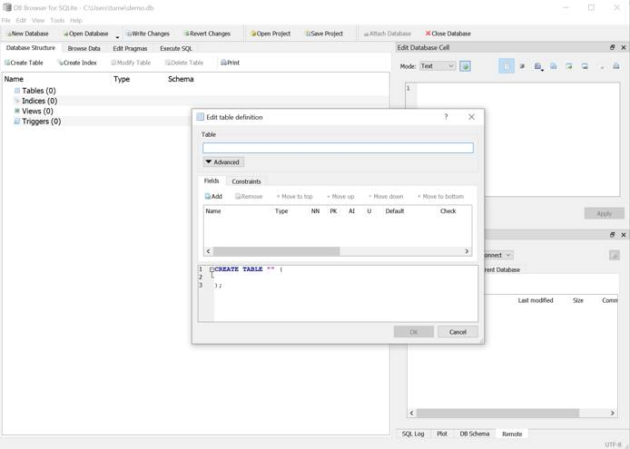

Using SQLite in Applications
From a developer standpoint, using SQLite as a persistence layer is largely the same as with any other SQL database. Drivers exist for Java and libraries are available for Swift, C++, and Python. The typical workflow for a SQLite-based application is to check for an existing database, if a database is not present, the application creates one. Then, your application code can create, read, update, and delete data, as needed.

Visualizing Apache Web Server Logs Using the Elastic Stack on Debian 10
Updated , by Tyler Langlois
debian analytics database monitoring
Try this guide to receive $100 at signup on a new account.
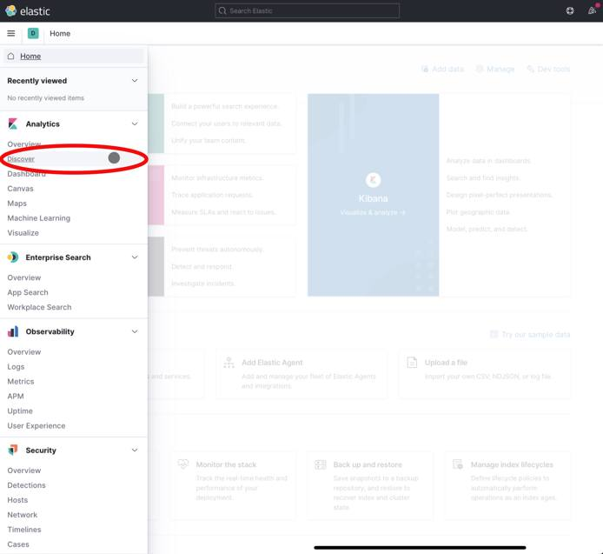

What is the Elastic Stack?
The Elastic stack is a troika of tools that includes Elasticsearch, Logstash, and Kibana. These tools provide a free and open-source solution that searches, collects, and analyzes data. This data can be from any source and in any format. They also visualize the data in real time.
Note
Version 7.11 of the Elastic stack is used in this guide, which is the latest at the time of this writing.

In this Guide
This guide shows how to:
- Install Elasticsearch, Logstash, and Kibana.
- Configure Elasticsearch to run with one shard and no replicas, which is appropriate for testing on a single Linode.
- Configure Logstash to process logs from the Apache web server.
- Connect Kibana to the Logstash index.
- View the logs from your connected Logstash index in Kibana.
- Search the logs in Kibana.
- Visualize the logs in a pie chart, categorized by HTTP response code, in Kibana.

Before You Begin
- Familiarize yourself with our Getting Started guide and create a Linode to install the Elastic stack on. Then, complete the steps for setting your Linode’s hostname and timezone.
Note
Multiple services are run on a single Linode in this guide. We recommend using at least a 2G (or g6-standard-1) sized Linode instance to support these services.
- This guide uses sudo wherever possible. Complete the sections of our Securing Your Server to create a standard user account with sudo privileges, harden SSH access, and remove unnecessary network services.
Note
Commands that require elevated privileges are prefixed with sudo. If you’re not familiar with the sudo command, you can check our Users and Groups guide.
- Update your system:
sudo apt-get update && sudo apt-get upgrade
- Follow the steps in our Apache Web Server on Debian 10 (Buster) guide to set up and configure Apache on your server.
- The Elasticsearch package is bundled with its own version of a Java runtime, but Logstash requires Java to be present on the system. Install the default version of Java available on Debian 10:
sudo apt-get install default-jre-headless

Install the Elastic Stack
Before configuring and loading log data, install each piece of the stack, individually.

Install the Elastic APT Repository
The Elastic package repositories contain all of the necessary packages for this tutorial, so install it first before proceeding with the individual services.
- Install the gnupg package which provides the necessary commands to import GPG keys:
sudo apt-get install gnupg
- Install the official Elastic APT package signing key:
wget -qO - https://artifacts.elastic.co/GPG-KEY-elasticsearch | sudo apt-key add -
- Add the APT repository information to your server’s list of sources:
echo "deb https://artifacts.elastic.co/packages/7.x/apt stable main" | sudo tee -a /etc/apt/sources.list.d/elastic-7.x.list
- Refresh the list of available packages:
sudo apt-get update

Install Elasticsearch
- Install the elasticsearch package:
sudo apt-get install elasticsearch
- Set the JVM heap size to approximately one-quarter of your server’s available memory. For example, on a Linode instance with 2GB of memory, ensure that the Xms and Xmx values in the /etc/elasticsearch/jvm.options file are set to the following, and leave the other values in this file unchanged.
File: /etc/elasticsearch/jvm.options
1  2 | -Xms512m  -Xmx512m
- Note
By default, these options are commented out and have the following values. So, you need to uncomment the lines as well (by removing the two # symbols at the beginning of the line):
## -Xms4g
## -Xmx4g
- Start and enable the elasticsearch service:
sudo systemctl enable elasticsearch
sudo systemctl start elasticsearch
- Wait a few moments for the service to start, then confirm that the Elasticsearch API is available:
curl localhost:9200
Elasticsearch may take some time to start up. If you need to determine whether the service has started successfully or not, you can use the systemctl status elasticsearch command to see the most recent logs. The Elasticsearch REST API should return a JSON response similar to the following:
{
"name" : "localhost",
"cluster_name" : "elasticsearch",
"cluster_uuid" : "tTuwONK4QMW918XkF9VecQ",
"version" : {
"number" : "7.11.1",
"build_flavor" : "default",
"build_type" : "deb",
"build_hash" : "ff17057114c2199c9c1bbecc727003a907c0db7a",
"build_date" : "2021-02-15T13:44:09.394032Z",
"build_snapshot" : false,
"lucene_version" : "8.7.0",
"minimum_wire_compatibility_version" : "6.8.0",
"minimum_index_compatibility_version" : "6.0.0-beta1"
},
"tagline" : "You Know, for Search"
}

Install Logstash
Install the logstash package:
sudo apt-get install logstash

Install Kibana
Install the kibana package:
sudo apt-get install kibana

Configure the Elastic Stack

Configure Elasticsearch
By default, Elasticsearch creates five shards and one replica for every index that’s created. When deploying to production, these are reasonable settings to use. In this tutorial, only one server is used in the Elasticsearch setup. Multiple shards and replicas are unnecessary. Changing these defaults can avoid unnecessary overhead.
- Create a temporary JSON file in your user’s home folder with an index template. This template instructs Elasticsearch to set the number of shards to one and the number of replicas to zero for all matching index names (in this case, a wildcard *):
File: template.json
1  2  3  4  5  6  7  8  9  10  11 | {  "index_patterns": ["*"],  "template": {  "settings": {  "index": {  "number_of_shards": 1,  "number_of_replicas": 0  }  }  }  }
- Use curl to create an index template with these settings that is applied to all indices created hereafter:
curl -XPUT -H'Content-type: application/json' http://localhost:9200/_index_template/defaults -d @template.json
Elasticsearch should return:
{"acknowledged":true}

Configure Logstash
In order to collect Apache access logs, Logstash must be configured to watch any necessary files and then process them, eventually sending them to Elasticsearch.
- Set the JVM heap size to approximately one quarter of your server’s available memory. For example, if your server has 2GB of RAM, change the Xms and Xmx values in the /etc/logstash/jvm.options file to the following, and leave the other values in this file unchanged:
File: /etc/logstash/jvm.options
1  2 | -Xms512m  -Xmx512m
- Note
These options have the following values by default:
## -Xms1g
## -Xmx1g
- Create the following Logstash configuration:
File: /etc/logstash/conf.d/apache.conf
1  2  3  4  5  6  7  8  9  10  11  12  13  14  15  16 | input {  file {  path => '/var/www/*/logs/access.log'  start_position => 'beginning'  }  }  filter {  grok {  match => { "message" => "%{COMBINEDAPACHELOG}" }  }  }  output {  elasticsearch { }  }
- Note
This example configuration assumes that your website logs are stored in the /var/www/*/logs/access.log file path.
If your site was set up by following the Configure Apache for Virtual Hosting section of the Apache Web Server on Debian 10 guide, then your logs are stored in this location. If you website logs are stored in another location, update the file path in the configuration file before proceeding.
- Start and enable logstash:
sudo systemctl enable logstash
sudo systemctl start logstash

Configure Kibana
- Enable and start the Kibana service:
sudo systemctl enable kibana
sudo systemctl start kibana
- In order for Kibana to find log entries, logs must first be sent to Elasticsearch. With the three daemons started, log files should be collected with Logstash and stored in Elasticsearch. To generate logs, issue several requests to Apache:
for i in `seq 1 5` ; do curl localhost ; sleep 0.2 ; done
- By default, Kibana binds to the local address 127.0.0.1. This only permits connections that originate from localhost. This is recommended in order to avoid exposing the dashboard to the public internet. However, in order to access Kibana’s web interface in a browser, the ssh command can forward the port to your workstation.
Run the following command in a local terminal (on your local computer, not your Linode). Leave the command running for the duration of the tutorial. Press Ctrl-C to end the port forward at the conclusion of this tutorial.
ssh -N -L 5601:localhost:5601 <your Linode's IP address>
- Next, open Kibana in your browser at http://localhost:5601. The landing page should look similar to the following. Click on Explore on my own to begin configuring Kibana.

Note
The first time that Kibana starts, the daemon performs several optimization steps that may delay startup time. If the web page is not available immediately, wait a few minutes or check the logs with the command sudo journalctl -u kibana.
- The following dashboard interface appears. Click on the hamburger button in the left side of the top navigation to open the sidebar interface.
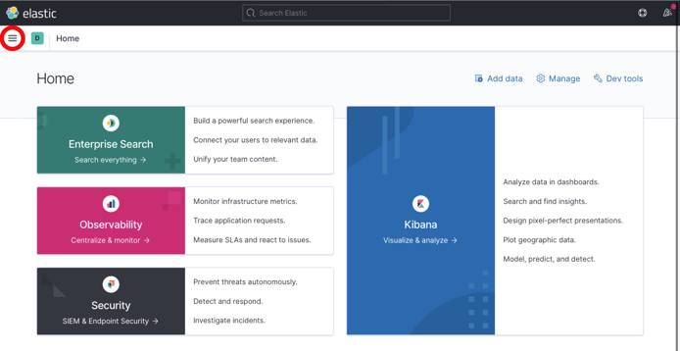
- Click on the Discover menu item in the sidebar.
- Kibana prompts you to create an index pattern, which identifies the logs that should be retrieved. Click on the Create index pattern button.
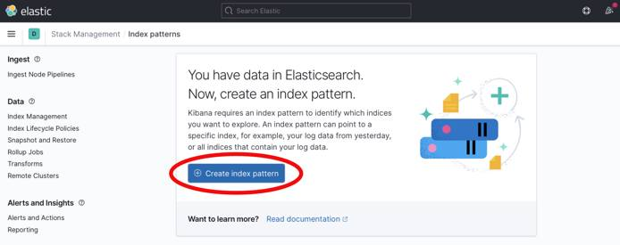
- The Create index pattern form appears. Enter the text logstash-* into the Index pattern name field. Then click the Next step button to continue.
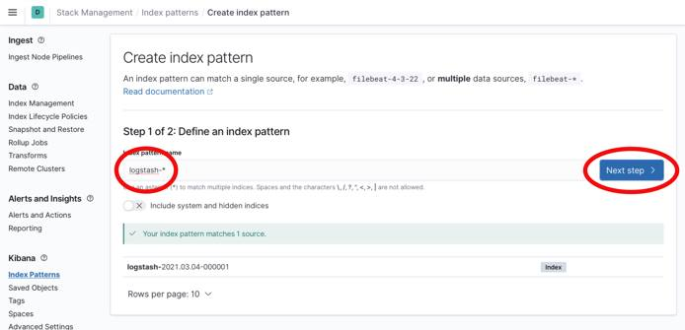
- From the Time field drop down menu, select @timestamp as the time field. This corresponds with the parsed time from web server logs. Click the Create index pattern button to continue.
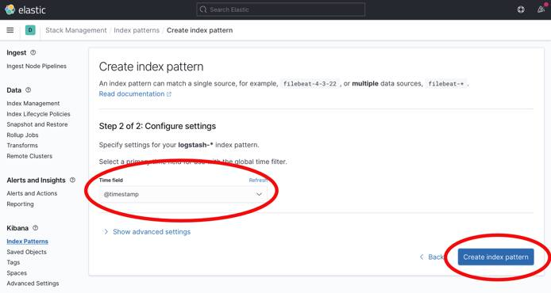
Kibana is now able to display logs stored in indices that match the logstash-* wildcard pattern.

View Logs in Kibana
When the previous curl commands generated entries in the Apache access logs, Logstash indexed them in Elasticsearch. These are now visible in Kibana.
Note
Logs are retrieved based upon a time window that is shown in the upper right corner of the Kibana interface. By default, this panel displays “Last 15 minutes”. At certain points, you may find that log entries are not shown in the Kibana interface. If this happens, click the timespan panel and choose a wider range, such as “Last hour” or “Last 4 hours.” After choosing a broad enough range of time, your logs should appear.
- From the left menu, select the hamburger icon to expand the available menu options.
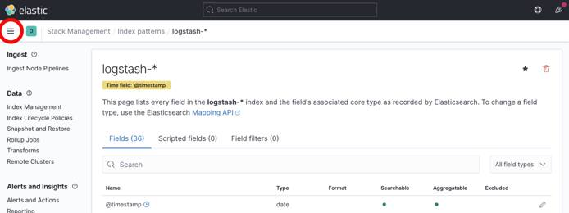
- Select the Discover menu item that appears.
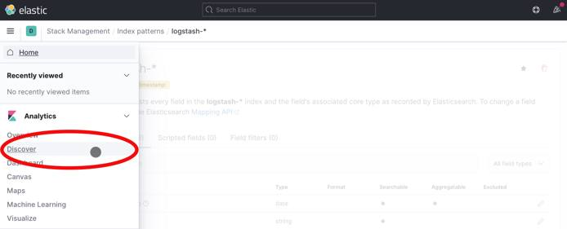
- The Discover interface should show a timeline of log events:
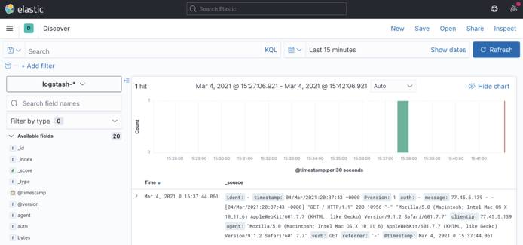
Over time, and as other requests are made to the web server via curl or a browser, additional logs can be seen and searched from Kibana. The Discover tab is a good way to familiarize yourself with the structure of the indexed logs and determine what to search and analyze.
- In order to view the details of a log entry, click the drop-down arrow to see individual document fields:
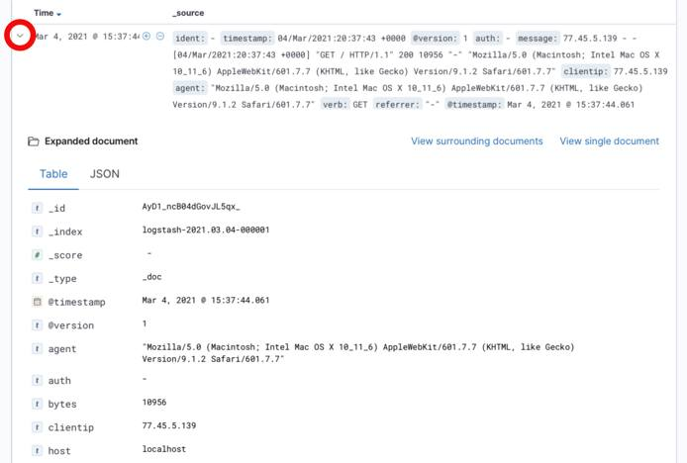
Fields represent the values parsed from the Apache logs, such as agent, which represents the User-Agent header, and bytes, which indicates the size of the web server response.

Search Logs in Kibana
- Generate a couple of dummy 404 log events in your web server logs to demonstrate how to search and analyze logs within Kibana:
for i in `seq 1 2` ; do curl localhost/notfound-$i ; sleep 0.2 ; done
- The top search bar within the Kibana interface allows you to search for queries following the Kibana Query Language to find results. For example, to find the 404 error requests you generated from among 200 OK requests, enter the following in the search box:
response:404
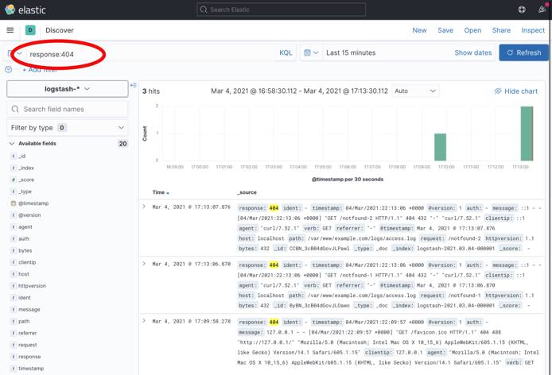
- Then, click the Update button. The user interface now only returns logs that contain the “404” code in their response field.

Visualize Logs in Kibana
Kibana supports many types of Elasticsearch queries to gain insight into indexed data. For example, consider the traffic that resulted in a “404 - not found” response code. Using aggregations, useful summaries of data can be extracted and displayed natively in Kibana.
- To create a visualization, begin by selecting the Visualize menu item from the sidebar. You may first need to expand the menu using the hamburger icon in the upper left-hand corner of the interface:
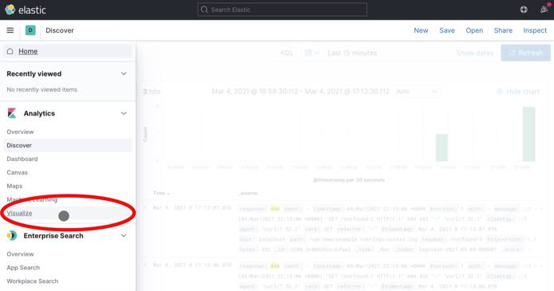
- Then, select the Create new visualization button on the page that appears:
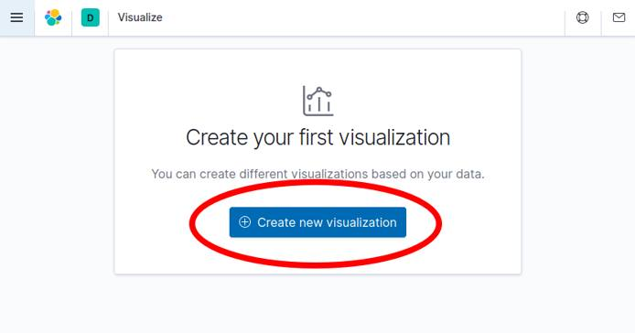
- Select the Aggregation based option from the choices that appear:

- Select Pie from the choices that appear to create a new pie chart. Note that you may need to scroll down to find the Pie visualization:
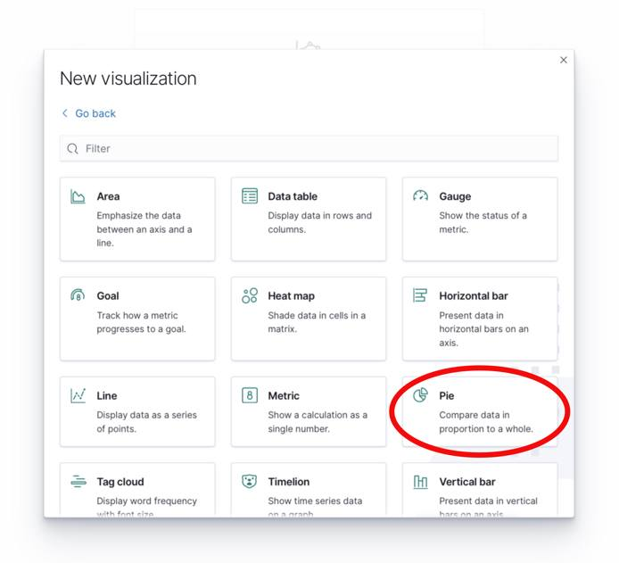
- Then select the logstash-* index pattern to determine where the data for the pie chart is retrieved from:
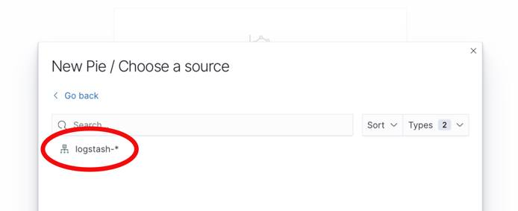
- At this point, a pie chart should appear in the interface ready to be configured. Follow these steps to configure the visualization in the user interface pane that appears to the left of the pie chart:
  - Select + Add under the Buckets card in the right-hand sidebar.
  - Select Split Slices to create more than one slice in the visualization.
  - From the Aggregation drop-down menu, select Terms to indicate that unique terms of a field are the basis for each slice of the pie chart.
  - From the Field drop-down menu, select response.keyword. This indicates that the response field determines the size of the pie chart slices.
  - Finally, click the Update button to update the pie chart and complete the visualization.
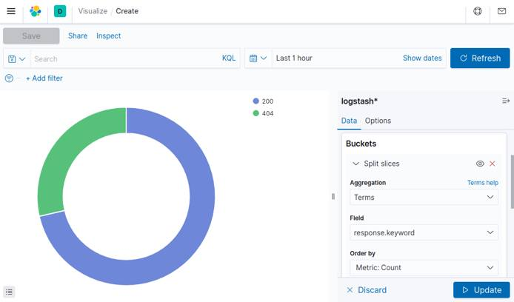
Note
You may need to view a longer time span for the pie chart to show both 200 and 404 HTTP responses. This may be done by clicking the calendar icon next to the search bar and selecting a longer time period, such as “Last 1 Hour”.
- Observe that only a portion of requests have returned a 404 response code (remember to change the time span if your curl requests occurred earlier than you are currently viewing). This approach of collecting summarized statistics about the values of fields within your logs can be similarly applied to other fields, such as the http verb (GET, POST, etc.). Or, you can even create summaries of numerical data, such as the total amount of bytes transferred over a given time period.
- If you wish to save this visualization for use later use, click the Save button near the top of the browser window to name the visualization and save it permanently to Elasticsearch.

Further Reading
This tutorial has provided an overview of each piece of the Elastic stack. More reading is available to learn additional ways to process and view data. For example:
- Additional Logstash filters can enrich log data.
- Other Kibana visualizations can present data in new and useful ways.
Comprehensive documentation for each piece of the stack is available from the Elastic web site:
- The Elasticsearch reference contains additional information regarding how to operate Elasticsearch, including clustering, managing indices, and more.
- The Logstash documentation contains useful information on additional plug-ins that can further process raw data, such as geolocating IP addresses, parsing user-agent strings, and other plug-ins.
- Kibana’s documentation pages provide additional information regarding how to create useful visualizations and dashboards.

More Information
You may wish to consult the following resources for additional information on this topic. While these are provided in the hope that they will be useful, please note that we cannot vouch for the accuracy or timeliness of externally hosted materials.
- Elastic Documentation

Securing Nginx With ModSecurity
Updated , by Hackersploit
security web server nginx
Try this guide to receive $100 at signup on a new account.


What is ModSecurity?
ModSecurity is a free and open source web application that started out as an Apache module and grew to a fully-fledged web application firewall. It works by inspecting requests sent to the web server in real time against a predefined rule set, preventing typical web application attacks like XSS and SQL Injection.
While originally an Apache module, ModSecurity can also be installed on Nginx as detailed in this guide.

Prerequisites & Requirements
In order to install and configure ModSecurity, you need to have a Linux server with the following services running:
- Nginx
For instructions, see our guide on How to Install NGINX on Ubuntu 18.04 LTS. Installation instructions for several other Linux distributions are also accessible from this guide.
Note
This demonstration has been performed on Ubuntu 18.04. However, all techniques demonstrated are distribution agnostic with the exception of package names and package managers.

Downloading & Building ModSecurity
While ModSecurity is not officially supported as a module for Nginx, a workaround exists involving the ModSecurity-nginx connector. The ModSecurity-nginx connector is the connection point between Nginx and libmodsecurity (ModSecurity v3). Said another way, the ModSecurity-nginx connector provides a communication channel between Nginx and libmodsecurity.
The ModSecurity-nginx connector takes the form of an Nginx module that provides a layer of communication between Nginx and ModSecurity.
To begin the installation process, follow the steps outlined below:
- Install all the dependencies required for the build and compilation process with the following command:
sudo apt-get install bison build-essential ca-certificates curl dh-autoreconf doxygen \
flex gawk git iputils-ping libcurl4-gnutls-dev libexpat1-dev libgeoip-dev liblmdb-dev \
libpcre3-dev libpcre++-dev libssl-dev libtool libxml2 libxml2-dev libyajl-dev locales \
lua5.3-dev pkg-config wget zlib1g-dev zlibc libxslt libgd-dev
- Ensure that git is installed:
sudo apt install git
- Clone the ModSecurity Github repository from the /opt directory:
cd /opt && sudo git clone https://github.com/SpiderLabs/ModSecurity
- Change your directory to the ModSecurity directory:
cd ModSecurity
- Run the following git commands to initialize and update the submodule:
sudo git submodule init
sudo git submodule update
- Run the build.sh script:
sudo ./build.sh
- Run the configure file, which is responsible for getting all the dependencies for the build process:
sudo ./configure
- Run the make command to build ModSecurity:
sudo make
- After the build process is complete, install ModSecurity by running the following command:
sudo make install

Downloading ModSecurity-Nginx Connector
Before compiling the ModSecurity module, clone the Nginx-connector from the /opt directory:
cd /opt && sudo git clone --depth 1 https://github.com/SpiderLabs/ModSecurity-nginx.git

Building the ModSecurity Module For Nginx
You can now build the ModSecurity module from a downloaded copy of your Nginx version by following the steps outlined below:
- Enumerate the version of Nginx you have installed:
nginx -v
For example, the following output shows that Nginx version 1.14.0 is installed on the system:
nginx version: nginx/1.14.0 (Ubuntu)
In each of the following commands, replace 1.14.0 with your version of Nginx.
- Download the exact version of Nginx running on your system into the /opt directory:
cd /opt && sudo wget http://nginx.org/download/nginx-1.14.0.tar.gz
- Extract the tarball:
sudo tar -xvzmf nginx-1.14.0.tar.gz
- Change your directory to the tarball directory you just extracted:
cd nginx-1.14.0
- Display the configure arguments used for your version of Nginx:
nginx -V
Here is an example output for Nginx 1.14.0:
nginx version: nginx/1.14.0 (Ubuntu)
built with OpenSSL 1.1.1 11 Sep 2018
TLS SNI support enabled
configure arguments: --with-cc-opt='-g -O2 -fdebug-prefix-map=/build/nginx-GkiujU/nginx-1.14.0=. -fstack-protector-strong -Wformat -Werror=format-security -fPIC -Wdate-time -D_FORTIFY_SOURCE=2' --with-ld-opt='-Wl,-Bsymbolic-functions -Wl,-z,relro -Wl,-z,now -fPIC' --prefix=/usr/share/nginx --conf-path=/etc/nginx/nginx.conf --http-log-path=/var/log/nginx/access.log --error-log-path=/var/log/nginx/error.log --lock-path=/var/lock/nginx.lock --pid-path=/run/nginx.pid --modules-path=/usr/lib/nginx/modules --http-client-body-temp-path=/var/lib/nginx/body --http-fastcgi-temp-path=/var/lib/nginx/fastcgi --http-proxy-temp-path=/var/lib/nginx/proxy --http-scgi-temp-path=/var/lib/nginx/scgi --http-uwsgi-temp-path=/var/lib/nginx/uwsgi --with-debug --with-pcre-jit --with-http_ssl_module --with-http_stub_status_module --with-http_realip_module --with-http_auth_request_module --with-http_v2_module --with-http_dav_module --with-http_slice_module --with-threads --with-http_addition_module --with-http_geoip_module=dynamic --with-http_gunzip_module --with-http_gzip_static_module --with-http_image_filter_module=dynamic --with-http_sub_module --with-http_xslt_module=dynamic --with-stream=dynamic --with-stream_ssl_module --with-mail=dynamic --with-mail_ssl_module
- To compile the Modsecurity module, copy all of the arguments following configure arguments: from your output of the above command and paste them in place of <Configure Arguments> in the following command:
sudo ./configure --add-dynamic-module=../ModSecurity-nginx <Configure Arguments>
- Build the modules with the following command:
sudo make modules
- Create a directory for the Modsecurity module in your system’s Nginx configuration folder:
sudo mkdir /etc/nginx/modules
- Copy the compiled Modsecurity module into your Nginx configuration folder:
sudo cp objs/ngx_http_modsecurity_module.so /etc/nginx/modules

Loading the ModSecurity Module in Nginx
Open the /etc/nginx/nginx.conf file with a text editor such a vim and add the following line:
load_module /etc/nginx/modules/ngx_http_modsecurity_module.so;
Here is an example portion of an Nginx configuration file that includes the above line:
File: /etc/nginx/nginx.conf
1  2  3  4  5 | user www-data;  worker_processes auto;  pid /run/nginx.pid;  include /etc/nginx/modules-enabled/*.conf;  load_module /etc/nginx/modules/ngx_http_modsecurity_module.so;

Setting Up OWASP-CRS
The OWASP ModSecurity Core Rule Set (CRS) is a set of generic attack detection rules for use with ModSecurity or compatible web application firewalls. The CRS aims to protect web applications from a wide range of attacks, including the OWASP Top Ten, with a minimum of false alerts. The CRS provides protection against many common attack categories, including SQL Injection, Cross Site Scripting, and Local File Inclusion.
To set up the OWASP-CRS, follow the procedures outlined below.
- First, delete the current rule set that comes prepackaged with ModSecurity by running the following command:
sudo rm -rf /usr/share/modsecurity-crs
- Clone the OWASP-CRS GitHub repository into the /usr/share/modsecurity-crs directory:
sudo git clone https://github.com/coreruleset/coreruleset /usr/local/modsecurity-crs
- Rename the crs-setup.conf.example to crs-setup.conf:
sudo mv /usr/local/modsecurity-crs/crs-setup.conf.example /usr/local/modsecurity-crs/crs-setup.conf
- Rename the default request exclusion rule file:
sudo mv /usr/local/modsecurity-crs/rules/REQUEST-900-EXCLUSION-RULES-BEFORE-CRS.conf.example /usr/local/modsecurity-crs/rules/REQUEST-900-EXCLUSION-RULES-BEFORE-CRS.conf
You should now have the OWASP-CRS set up and ready to be used in your Nginx configuration.

Configuring Modsecurity
ModSecurity is a firewall and therefore requires rules to function. This section shows you how to implement the OWASP Core Rule Set. First, you must prepare the ModSecurity configuration file.
- Start by creating a ModSecurity directory in the /etc/nginx/ directory:
sudo mkdir -p /etc/nginx/modsec
- Copy over the unicode mapping file and the ModSecurity configuration file from your cloned ModSecurity GitHub repository:
sudo cp /opt/ModSecurity/unicode.mapping /etc/nginx/modsec
sudo cp /opt/ModSecurity/modsecurity.conf-recommended /etc/nginx/modsec/modsecurity.conf
- Remove the .recommended extension from the ModSecurity configuration filename with the following command:
sudo cp /etc/modsecurity/modsecurity.conf-recommended /etc/modsecurity/modsecurity.conf
- With a text editor such as vim, open /etc/modsecurity/modsecurity.conf and change the value for SecRuleEngine to On:
File: /etc/modsecurity/modsecurity.conf
1  2  3  4  5  6  7  8 | # -- Rule engine initialization ----------------------------------------------  # Enable ModSecurity, attaching it to every transaction. Use detection  # only to start with, because that minimises the chances of post-installation  # disruption.  #  SecRuleEngine On  ...
- Create a new configuration file called main.conf under the /etc/nginx/modsec directory:
sudo touch /etc/nginx/modsec/main.conf
- Open /etc/nginx/modsec/main.conf with a text editor such as vim and specify the rules and the Modsecurity configuration file for Nginx by inserting following lines:
File: /etc/modsecurity/modsecurity.conf
1  2  3 | Include /etc/nginx/modsec/modsecurity.conf  Include /usr/local/modsecurity-crs/crs-setup.conf  Include /usr/local/modsecurity-crs/rules/*.conf

Configuring Nginx
Now that you have configured ModSecurity to work with Nginx, you must enable ModSecurity in your site configuration file.
- Open the /etc/nginx/sites-available/default with a text editor such as vim and insert the following lines in your server block:
modsecurity on;
modsecurity_rules_file /etc/nginx/modsec/main.conf;
Here is an example configuration file that includes the above lines:
File: /etc/nginx/sites-available/default
1  2  3  4  5  6  7  8  9  10  11  12  13  14  15  16 | server {  listen 80 default_server;  listen [::]:80 default_server;  root /var/www/html;  modsecurity on;  modsecurity_rules_file /etc/nginx/modsec/main.conf;  index index.html index.htm index.nginx-debian.html;  server_name _;  location / {  try_files $uri $uri/ =404;  }  }
- Restart the nginx service to apply the configuration:
sudo systemctl restart nginx

Testing ModSecurity
Test ModSecurity by performing a simple local file inclusion attack by running the following command:
curl http://<SERVER-IP/DOMAIN>/index.html?exec=/bin/bash
If ModSecurity has been configured correctly and is actively blocking attacks, the following error is returned:
<html>
<head><title>403 Forbidden</title></head>
<body bgcolor="white">
<center><h1>403 Forbidden</h1></center>
<hr><center>nginx/1.14.0 (Ubuntu)</center>
</body>
</html>

Securing MySQL Server
Updated , by Hackersploit
mysql security database
Try this guide to receive $100 at signup on a new account.


MySQL
MySQL is an open-source relational database management system. This guide will show you how to secure and audit a MySQL server. The name is a combination of “My”, the name of co-founder Michael Widenius’s daughter, and “SQL”, the abbreviation for Structured Query Language.

Before You Begin
- Ensure that you have followed the Getting Started and Securing Your Server guides. Ensure that the Linode’s hostname is set.
Check your Linode’s hostname. The first command should show your short hostname and the second should show your fully qualified domain name (FQDN).
hostname
hostname -f
Note
If you have a registered domain name for your website, then add the domain to the Linode server on which you plan to install the LAMP stack. If you do not have a registered domain name, then replace example.com with the IP address of the Linode server in the following instructions.
- Update your system:
sudo yum update
Note
This guide is written for a non-root user. Commands that require elevated privileges are prefixed with sudo. If you’re not familiar with the sudo command, you can check our Users and Groups guide.
- In order to secure and audit MySQL, you need to have a Linux server with the MySQL Server services running. For information about installing MySQL please see Install MySQL
Note
The instructions in this guide are based on Ubuntu 18.04, though all the steps are distribution agnostic with the exception of package names and package managers.

Using The Secure MySQL Installer
The mysql-server package comes pre configured with a utility called mysql_secure_installation that is used to set up a secure starting point for MySQL server, by deleting anonymous users and allowing you to specify the desired password strength policy.
mysql_secure_installation is a shell script available on Unix systems, and enables you to secure the MySQL installation by enabling you to:
- set a password for root accounts
- remove root accounts that are accessible from outside the local host
- remove anonymous-user accounts
- remove the test database, which by default can be accessed by anonymous users
Begin the security process by running this utility immediately after installing mysql-server.
- Invoke the utility by running the following command:
sudo mysql_secure_installation
- The setup process begins and the utility prompts you to specify whether you want to enable the validate password plugin that is used to test passwords and improve security. It is recommended to enable this feature.
Securing the MySQL server deployment.

Connecting to MySQL using a blank password.

VALIDATE PASSWORD PLUGIN can be used to test passwords
and improve security. It checks the strength of password
and allows the users to set only those passwords which are
secure enough. Would you like to setup VALIDATE PASSWORD plugin?

Press y|Y for Yes, any other key for No: y
- After you enable the password plugin, specify your password validation policy based on the level of the strength of the desired passwords.
There are three levels of password validation policy:

LOW Length >= 8
MEDIUM Length >= 8, numeric, mixed case, and special characters
STRONG Length >= 8, numeric, mixed case, special characters and dictionary file

Please enter 0 = LOW, 1 = MEDIUM and 2 = STRONG: 2
Please set the password for root here.

New password:

Re-enter new password:

Estimated strength of the password: 100
Do you wish to continue with the password provided?(Press y|Y for Yes, any other key for No) : y
- Remove anonymous users. This is an important security option as attackers can leverage anonymous users to gain access to the database server.
By default, a MySQL installation has an anonymous user,
allowing anyone to log into MySQL without having to have
a user account created for them. This is intended only for
testing, and to make the installation go a bit smoother.
You should remove them before moving into a production
environment.

Remove anonymous users? (Press y|Y for Yes, any other key for No) : y
- Disable root login remotely, this is an extremely important security configuration as it prevents attackers from remotely authenticating to the MySQL server as root or performing password brute-force attacks. Remote authentication can also be disabled completely, we will take a look at how to do that in the next section.
Normally, root should only be allowed to connect from
'localhost'. This ensures that someone cannot guess at
the root password from the network.

Disallow root login remotely? (Press y|Y for Yes, any other key for No) : y
- Delete the test database created during the mysql-server installation process, this database is created for testing purposes, as a good practice, it is recommended to delete this database.
By default, MySQL comes with a database named 'test' that
anyone can access. This is also intended only for testing,
and should be removed before moving into a production
environment.

Remove test database and access to it? (Press y|Y for Yes, any other key for No) : y
- Reload the privilege tables to ensure that all changes are applied and are in effect.
Reloading the privilege tables will ensure that all changes
made so far will take effect immediately.

Reload privilege tables now? (Press y|Y for Yes, any other key for No) : y
Success.

All done!
You now have a secure base to work with, in the next section, find the instructions to change the default root username and password.

Modifying The “root” user
By default, MySQL server comes predefined with a superuser/admin account that has access to all privileges and functionality of the databases and database users. Given this unparalleled control and access, it is important to lock down and secure the root account as attackers usually target the root account on a MySQL server because it has the potential to provide complete access over the databases and database users.
The first step in securing the “root” user is to change the username from root to something more unyielding, the objective is to make the root username as hard to guess or to brute-force for attackers. After which, it is also recommended to change the root account password regularly as a good practice.
- Login to the MySQL server with the following command:
sudo mysql -u root
- Change the “root” account username by running the following query:
rename user ‘root’@’localhost' to ‘<new-username’@’localhost’;
- Change the root account password to something strong and hard to guess, it is recommended to use a password generator. If you enabled the verify password plugin during the secure installation process, you need to provide a password that meets the policy requirements in terms of strength.
ALTER USER ‘example_username’@’localhost’ IDENTIFIED BY ‘<new-password>’;
- Reload the privilege table to ensure that all changes are saved and activated by running the following command:
flush privileges;
- To confirm whether the root username and password are changed, run the following query:
use mysql;
select user,host,authentication_string from mysql.user;
This displays the user tables stored under the mysql database and should reflect the changes made.
+------------------+-----------+-------------------------------------------+
| user | host | authentication_string |
+------------------+-----------+-------------------------------------------+
| example_user | localhost | *A2550B00C6DF81DACE33551E8293462F6CAE33DA |
| mysql.session | localhost | *THISISNOTAVALIDPASSWORDTHATCANBEUSEDHERE |
| mysql.sys | localhost | *THISISNOTAVALIDPASSWORDTHATCANBEUSEDHERE |
| debian-sys-maint | localhost | *241DC5A20F017D55EE82E46E7996784ED4A5CD8A |
+------------------+-----------+-------------------------------------------+
4 rows in set (0.00 sec)

Creating A New User
A good security practice is the concept of segregation by duties or role. This means that for every database or application that uses the database, create a new user that has CRUD permissions for that particular database. This ensures that at any time, only one user has access to one database at a time and users cannot access other databases.
- Create a Test database, by running the following query within MYSQL:
create database Test;
- Create the user responsible for managing this Test database:
CREATE USER '<username>'@'localhost' IDENTIFIED BY '<password>';
- Assign the appropriate CRUD permissions to the user for the Test database:
GRANT SELECT,UPDATE,DELETE ON Test.* TO '<username>'@'localhost';
- It is important to note that these privileges are applicable only to the Test database, if you are creating a user for an application such as phpMyAdmin, you need to provide the user with root permissions.
- If you decide to delete a particular user, run the following query:
drop user ’<username>’@'localhost';
- Reload the privilege table to ensure the changes made are applied and activated by running the following query:
flush privileges;

Custom MySQL Configuration
You can now setup a secure custom configuration for MySQL that provides additional security configuration options.
- The global MySQL configuration file is located in /etc/mysql/my.cnf, all custom global configurations are to be set up in the configuration file.
- The custom configuration needs to be specified for the mysqld (MySQL daemon), the options displayed in the image are custom security configurations.
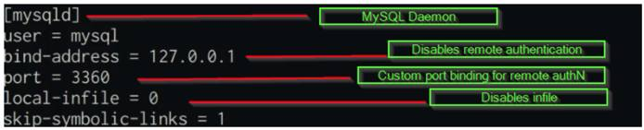
- After adding the custom configurations, you need to restart the mysql service to ensure all changes are applied.
systemctl restart mysql

Auditing MySQL Security
You can now audit the security of the MySQL server by using a tool called MySAT. MySAT performs several tests to analyze database configurations and security policies. MySAT helps to assess and therefore to increase MySQL database security. MySAT is a simple SQL script, it is easy to understand and easy to maintain. MySAT results are output in HTML format.
- Clone the MySAT Github repository, by running the following command:
git clone https://github.com/meob/MySAT.git
- After cloning the directory, navigate into the MySAT directory, where the mysat.sql file is located and it is used in conjunction with the MySQL server to output the results into a MySAT.htm file.
- Audit the security by running the following command:
mysql --user=<root-user> -p<password> --skip-column-names -f < mysat.sql > MySAT.htm
- As indicated, MySAT requires root access to MySQL to run the required tests, after running the command, the MySAT.htm file is generated, copy the MySAT.htm file and the mysat.css file to an Apache or NGINX server, or download them locally with scp, so that you can analyze the results of the audit.
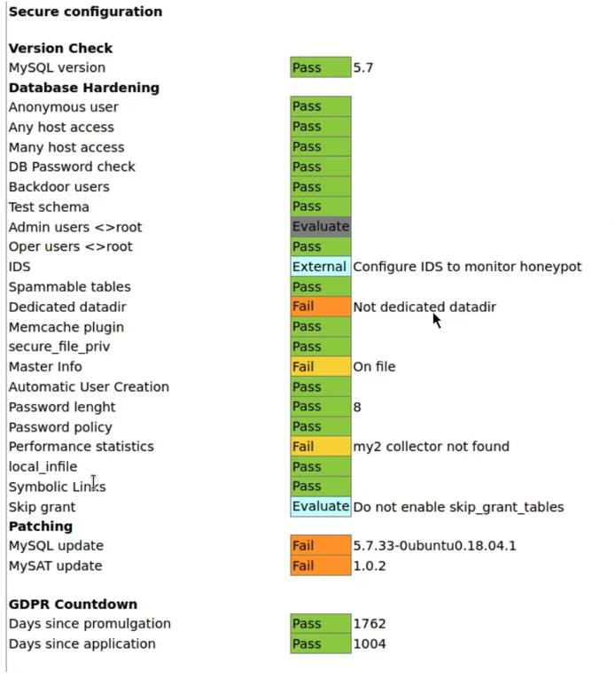
- The results are formatted in a simple to read and understand format, where configurations are checked and results are color coded based on their current configuration and how it affects the security of the mysql server. For example, a failed configuration check is color coded in orange and a passed check is color coded in green.
- The audit report reveals what configurations need to be changed or modified and presents you with a top level picture of the overall security of the MySQL server.

Visualizing Apache Web Server Logs Using the Elastic Stack on Ubuntu 18.04
Updated , by Tyler Langlois
ubuntu analytics database monitoring apache
Try this guide to receive $100 at signup on a new account.
The Elastic stack is a troika of tools that includes Elasticsearch, Logstash, and Kibana. These tools provide a free and open-source solution that searches, collects, and analyzes data. This data can be from any source and in any format. They also visualize the data in real time.
Note
Version 7.11 of the Elastic stack is used in this guide, which is the latest at the time of this writing.

In this Guide
This guide shows how to:
- Install Elasticsearch, Logstash, and Kibana.
- Configure Elasticsearch to run with one shard and no replicas, which is appropriate for testing on a single Linode.
- Configure Logstash to process logs from the Apache web server.
- Connect Kibana to the Logstash index.
- View the logs from your connected Logstash index in Kibana.
- Search the logs in Kibana.
- Visualize the logs in a pie chart, categorized by HTTP response code, in Kibana.

Before You Begin
- Familiarize yourself with our Getting Started guide and create a Linode to install the Elastic stack on. Then, complete the steps for setting your Linode’s hostname and timezone.
Note
Multiple services are run on a single Linode in this guide. We recommend using at least a 2G (or g6-standard-1) sized Linode instance to support these services.
- This guide uses sudo wherever possible. Complete the sections of our Securing Your Server to create a standard user account with sudo privileges, harden SSH access, and remove unnecessary network services.
Note
Commands that require elevated privileges are prefixed with sudo. If you’re not familiar with the sudo command, you can check our Users and Groups guide.
- Update your system:
sudo apt-get update && sudo apt-get upgrade
- Follow the steps in our Apache Web Server on Ubuntu 18.04 guide to set up and configure Apache on your server.
- The Elasticsearch package is bundled with its own version of a Java runtime, but Logstash requires Java to be present on the system. Install the default version of Java available on Ubuntu 18.04:
sudo apt-get install default-jre-headless

Install the Elastic Stack
Before configuring and loading log data, install each piece of the stack, individually.

Install the Elastic APT Repository
The Elastic package repositories contain all of the necessary packages for this tutorial, so install it first before proceeding with the individual services.
- Install the official Elastic APT package signing key:
wget -qO - https://artifacts.elastic.co/GPG-KEY-elasticsearch | sudo apt-key add -
- Add the APT repository information to your server’s list of sources:
echo "deb https://artifacts.elastic.co/packages/7.x/apt stable main" | sudo tee -a /etc/apt/sources.list.d/elastic-7.x.list
- Refresh the list of available packages:
sudo apt-get update

Install Elasticsearch
- Install the elasticsearch package:
sudo apt-get install elasticsearch
- Set the JVM heap size to approximately one-quarter of your server’s available memory. For example, on a Linode instance with 2GB of memory, ensure that the Xms and Xmx values in the /etc/elasticsearch/jvm.options file are set to the following, and leave the other values in this file unchanged.
File: /etc/elasticsearch/jvm.options
1  2 | -Xms512m  -Xmx512m
- Note
By default, these options are commented out and have the following values. So, you need to uncomment the lines as well (by removing the two # symbols at the beginning of the line):
## -Xms4g
## -Xmx4g
- Start and enable the elasticsearch service:
sudo systemctl enable elasticsearch
sudo systemctl start elasticsearch
- Wait a few moments for the service to start, then confirm that the Elasticsearch API is available:
curl localhost:9200
Elasticsearch may take some time to start up. If you need to determine whether the service has started successfully or not, you can use the systemctl status elasticsearch command to see the most recent logs. The Elasticsearch REST API should return a JSON response similar to the following:
{
"name" : "localhost",
"cluster_name" : "elasticsearch",
"cluster_uuid" : "tTuwONK4QMW918XkF9VecQ",
"version" : {
"number" : "7.11.1",
"build_flavor" : "default",
"build_type" : "deb",
"build_hash" : "ff17057114c2199c9c1bbecc727003a907c0db7a",
"build_date" : "2021-02-15T13:44:09.394032Z",
"build_snapshot" : false,
"lucene_version" : "8.7.0",
"minimum_wire_compatibility_version" : "6.8.0",
"minimum_index_compatibility_version" : "6.0.0-beta1"
},
"tagline" : "You Know, for Search"
}

Install Logstash
Install the logstash package:
sudo apt-get install logstash

Install Kibana
Install the kibana package:
sudo apt-get install kibana

Configure the Elastic Stack

Configure Elasticsearch
By default, Elasticsearch creates five shards and one replica for every index that’s created. When deploying to production, these are reasonable settings to use. In this tutorial, only one server is used in the Elasticsearch setup. Multiple shards and replicas are unnecessary. Changing these defaults can avoid unnecessary overhead.
- Create a temporary JSON file in your user’s home folder with an index template. This template instructs Elasticsearch to set the number of shards to one and the number of replicas to zero for all matching index names (in this case, a wildcard *):
File: template.json
1  2  3  4  5  6  7  8  9  10  11 | {  "index_patterns": ["*"],  "template": {  "settings": {  "index": {  "number_of_shards": 1,  "number_of_replicas": 0  }  }  }  }
- Use curl to create an index template with these settings that is applied to all indices created hereafter:
curl -XPUT -H'Content-type: application/json' http://localhost:9200/_index_template/defaults -d @template.json
Elasticsearch should return:
{"acknowledged":true}

Configure Logstash
In order to collect Apache access logs, Logstash must be configured to watch any necessary files and then process them, eventually sending them to Elasticsearch.
- Set the JVM heap size to approximately one quarter of your server’s available memory. For example, if your server has 2GB of RAM, change the Xms and Xmx values in the /etc/logstash/jvm.options file to the following, and leave the other values in this file unchanged:
File: /etc/logstash/jvm.options
1  2 | -Xms512m  -Xmx512m
- Note
These options have the following values by default:
## -Xms1g
## -Xmx1g
- Create the following Logstash configuration:
File: /etc/logstash/conf.d/apache.conf
1  2  3  4  5  6  7  8  9  10  11  12  13  14  15  16 | input {  file {  path => '/var/www/*/logs/access.log'  start_position => 'beginning'  }  }  filter {  grok {  match => { "message" => "%{COMBINEDAPACHELOG}" }  }  }  output {  elasticsearch { }  }
- Note
This example configuration assumes that your website logs are stored in the /var/www/*/logs/access.log file path.
If your site was set up by following the Configure Apache for Virtual Hosting section of the Apache Web Server on Ubuntu 18.04 guide, then your logs are stored in this location. If you website logs are stored in another location, update the file path in the configuration file before proceeding.
- Start and enable logstash:
sudo systemctl enable logstash
sudo systemctl start logstash

Configure Kibana
- Enable and start the Kibana service:
sudo systemctl enable kibana
sudo systemctl start kibana
- In order for Kibana to find log entries, logs must first be sent to Elasticsearch. With the three daemons started, log files should be collected with Logstash and stored in Elasticsearch. To generate logs, issue several requests to Apache:
for i in `seq 1 5` ; do curl localhost ; sleep 0.2 ; done
- By default, Kibana binds to the local address 127.0.0.1. This only permits connections that originate from localhost. This is recommended in order to avoid exposing the dashboard to the public internet. However, in order to access Kibana’s web interface in a browser, the ssh command can forward the port to your workstation.
Run the following command in a local terminal (on your local computer, not your Linode). Leave the command running for the duration of the tutorial. Press Ctrl-C to end the port forward at the conclusion of this tutorial.
ssh -N -L 5601:localhost:5601 <your Linode's IP address>
- Next, open Kibana in your browser at http://localhost:5601. The landing page should look similar to the following. Click on Explore on my own to begin configuring Kibana.
Note
The first time that Kibana starts, the daemon performs several optimization steps that may delay startup time. If the web page is not available immediately, wait a few minutes or check the logs with the command sudo journalctl -u kibana.
- The following dashboard interface appears. Click on the hamburger button in the left side of the top navigation to open the sidebar interface.
- Click on the Discover menu item in the sidebar.
- Kibana prompts you to create an index pattern, which identifies the logs that should be retrieved. Click on the Create index pattern button.
- The Create index pattern form appears. Enter the text logstash-* into the Index pattern name field. Then click the Next step button to continue.
- From the Time field drop down menu, select @timestamp as the time field. This corresponds with the parsed time from web server logs. Click the Create index pattern button to continue.
Kibana is now able to display logs stored in indices that match the logstash-* wildcard pattern.

View Logs in Kibana
When the previous curl commands generated entries in the Apache access logs, Logstash indexed them in Elasticsearch. These are now visible in Kibana.
Note
Logs are retrieved based upon a time window that is shown in the upper right corner of the Kibana interface. By default, this panel displays “Last 15 minutes”. At certain points, you may find that log entries are not shown in the Kibana interface. If this happens, click the timespan panel and choose a wider range, such as “Last hour” or “Last 4 hours.” After choosing a broad enough range of time, your logs should appear.
- From the left menu, select the hamburger icon to expand the available menu options.
- Select the Discover menu item that appears.
- The Discover interface should show a timeline of log events:
Over time, and as other requests are made to the web server via curl or a browser, additional logs can be seen and searched from Kibana. The Discover tab is a good way to familiarize yourself with the structure of the indexed logs and determine what to search and analyze.
- In order to view the details of a log entry, click the drop-down arrow to see individual document fields:
Fields represent the values parsed from the Apache logs, such as agent, which represents the User-Agent header, and bytes, which indicates the size of the web server response.

Search Logs in Kibana
- Generate a couple of dummy 404 log events in your web server logs to demonstrate how to search and analyze logs within Kibana:
for i in `seq 1 2` ; do curl localhost/notfound-$i ; sleep 0.2 ; done
- The top search bar within the Kibana interface allows you to search for queries following the Kibana Query Language to find results. For example, to find the 404 error requests you generated from among 200 OK requests, enter the following in the search box:
response:404
- Then, click the Update button. The user interface now only returns logs that contain the “404” code in their response field.

Visualize Logs in Kibana
Kibana supports many types of Elasticsearch queries to gain insight into indexed data. For example, consider the traffic that resulted in a “404 - not found” response code. Using aggregations, useful summaries of data can be extracted and displayed natively in Kibana.
- To create a visualization, begin by selecting the Visualize menu item from the sidebar. You may first need to expand the menu using the hamburger icon in the upper left-hand corner of the interface:
- Then, select the Create new visualization button on the page that appears:
- Select the Aggregation based option from the choices that appear:
- Select Pie from the choices that appear to create a new pie chart. Note that you may need to scroll down to find the Pie visualization:
- Then select the logstash-* index pattern to determine where the data for the pie chart is retrieved from:
- At this point, a pie chart should appear in the interface ready to be configured. Follow these steps to configure the visualization in the user interface pane that appears to the left of the pie chart:
  - Select + Add under the Buckets card in the right-hand sidebar.
  - Select Split Slices to create more than one slice in the visualization.
  - From the Aggregation drop-down menu, select Terms to indicate that unique terms of a field are the basis for each slice of the pie chart.
  - From the Field drop-down menu, select response.keyword. This indicates that the response field determines the size of the pie chart slices.
  - Finally, click the Update button to update the pie chart and complete the visualization.
Note
You may need to view a longer time span for the pie chart to show both 200 and 404 HTTP responses. This may be done by clicking the calendar icon next to the search bar and selecting a longer time period, such as “Last 1 Hour”.
- Observe that only a portion of requests have returned a 404 response code (remember to change the time span if your curl requests occurred earlier than you are currently viewing). This approach of collecting summarized statistics about the values of fields within your logs can be similarly applied to other fields, such as the http verb (GET, POST, etc.). Or, you can even create summaries of numerical data, such as the total amount of bytes transferred over a given time period.
- If you wish to save this visualization for use later use, click the Save button near the top of the browser window to name the visualization and save it permanently to Elasticsearch.

Further Reading
This tutorial has provided an overview of each piece of the Elastic stack. More reading is available to learn additional ways to process and view data. For example:
- Additional Logstash filters can enrich log data.
- Other Kibana visualizations can present data in new and useful ways.
Comprehensive documentation for each piece of the stack is available from the Elastic web site:
- The Elasticsearch reference contains additional information regarding how to operate Elasticsearch, including clustering, managing indices, and more.
- The Logstash documentation contains useful information on additional plug-ins that can further process raw data, such as geolocating IP addresses, parsing user-agent strings, and other plug-ins.
- Kibana’s documentation pages provide additional information regarding how to create useful visualizations and dashboards.

More Information
You may wish to consult the following resources for additional information on this topic. While these are provided in the hope that they will be useful, please note that we cannot vouch for the accuracy or timeliness of externally hosted materials.

Docker Security Essentials
Updated , by Hackersploit
security docker
Try this guide to receive $100 at signup on a new account.


What is Docker?
Docker is a set of platform as a service (PaaS) products that use OS-level virtualization to deliver software in packages called containers. Containers are isolated from one another and bundle their own software, libraries, and configuration files. Docker containers can also communicate with each other through well-defined channels.
Docker utilizes the host OS Kernel, which makes Docker containers more efficient than hypervisors like VirtualBox. Docker containers also include dependencies and libraries that an application or service needs to run, eliminating the need for installing dependencies manually.

Prerequisites and Requirements
In order to secure Docker containers, you need to have a Linux server with the following services running:
- Docker
For a quick an easy way to install Docker on Linode, check out our guide on How to Deploy Docker with Marketplace Apps.
Otherwise, you can find instructions on how to manually install Docker in our guide on How to Install Docker CE on Ubuntu 18.04.
Note
This demonstration has been performed on Ubuntu 18.04. All techniques demonstrated are distribution agnostic with the exception of package names and package managers.
This guide assumes you are familiar with using Docker and Dockerfiles. For additional guidance, see our guide on How to Use Dockerfiles.

8 Best Practices for Docker Host Security
The security of the host kernel and operating system directly correlates to the security of your Docker containers given their utilization of the host kernel. It is therefore vitally important to keep your host secure. The following steps outline various security best practices to consider for securing your Docker host:
- Secure and harden your host OS.
- Ensure your host is kept updated.
- Ensure you have the latest version of Docker running.
- Consider the use of a minimal Linux distribution such as Alpine that offers a much smaller threat surface.
- Add your host and containers to a robust vulnerability management plan and constantly scan your host and containers for vulnerabilities.
- Only run the services you need to run.
- Ensure your kernel is up to date.
- Keep up with the latest vulnerability news for the Linux kernel and the Docker platform.

Running Docker Containers with an Unprivileged User
Running Docker containers with an unprivileged user instead of the default “root” user prevents privilege escalation attacks. The following steps outline how to run Docker containers with an unprivileged user:
- Always reconfigure and build your own Docker images. This way, you can customize the various security parameters to your specification.
- Prior to building your Docker image, specify an unprivileged user in your Dockerfile by adding the following command, replacing <USER> with your username and <GROUP> with a non-sudo group:
RUN groupadd -r <USER> && useradd -r -g <GROUP> <USER>
Here is an example Dockerfile that includes the above command to create the unprivileged user alexis in the group alexis:
File: Dockerfile
1  2  3  4  5  6  7  8  9 | FROM ubuntu:18.04  LABEL maintainer="Alexis Ahmed"  RUN groupadd -r alexis && useradd -r -g alexis alexis  # Environment Variables  ENV HOME /home/alexis  ENV DEBIAN_FRONTEND=noninteractive
- Build a Docker image by running the following command from the directory that contains your Dockerfile:
docker build .
- Run /bin/bash on a temporary Docker container utilizing your image, replacing <USER> with the unprivileged user and <IMAGE-ID> with the ID of the image you built in the previous step:
docker run -u <USER> -it --rm <IMAGE-ID> /bin/bash
The container shell confirms that it is using the unprivileged user.
alexis@9883456a9e3a:/$

Disabling the Docker Container “root” User
As an added security measure, disable the “root” user by modifying your Dockerfile. You can disable the “root” user by changing the default shell from /bin/bash to /usr/sbin/nologin. This prevents any user on the container from accessing the “root” account irregardless of whether they have the “root” password.
To disable the “root” user, add the following command to your Dockerfile:
RUN chsh -s /usr/sbin/nologin root
This configuration is only applicable if you want to disable the “root” account completely.

Preventing Privilege Escalation Attacks
It is recommended to run your containers with specific permissions and ensure that they cannot escalate their privileges.
You can prevent privilege escalation through the exploitation of SETUID binaries by using the --security-opt=no-new-privileges flag when running containers:
docker run --security-opt=no-new-privileges <IMAGE-ID>

Limiting Docker Container Kernel Capabilities
Linux kernel capabilities are a set of privileges that can be used by privileged containers. However, it is always recommended to not run containers with the --privileged flag as it overrides any other user permission and security restrictions you have set.
Instead, you can change and drop the capabilities required to harden your Docker containers, or you can add some capabilities with the following steps:
- Drop all kernel capabilities by running the following command:
docker run --cap-drop all <IMAGE-ID>
- You can also add the specific kernel capabilities required by your containers by running the following command, replacing <CAPABILITY> with the desired capability key:
docker run --cap-drop all --cap-add <CAPABILITY> <IMAGE-ID>

File System Permissions and Access
You also have the ability to specify file system permissions and access. This allows you to set up containers with a read only file system or a temporary file system. This is useful if you would like to control whether your Docker containers can store data or make changes to the file system.
- Run a Docker container with a read-only file system by running the following command:
docker run --read-only <IMAGE-ID>
- If your container has a service or application that requires the storage of data, you can specify a temporary file system by running the following command:
docker run --read-only --tmpfs /tmp <IMAGE-ID>

Disabling Inter-Container Communication
Given the notion of virtual machine isolation, you can also isolate Docker containers from one another. This prevents them from communicating with each other.
This can be helpful if you want to isolate a particular Docker container. By default, Docker does not isolate containers, allowing them to communicate with each other.
- In order to disable inter-container communication, create a new Docker network with the enable_icc option set to false and replacing <NETWORK-NAME> with any desired name.
docker network create \
--driver bridge \
-o "com.docker.network.bridge.enable_icc"="false" \
<NETWORK-NAME>
- You can now run an isolated container by including the --network flag:
docker run --network <NETWORK-NAME> <IMAGE-ID>

Securing Your LAMP Stack
Updated , by Hackersploit
lamp security web server php mysql apache
Try this guide to receive $100 at signup on a new account.


What is a LAMP Stack?
LAMP is a very common example of a web service stack, named as an acronym of the names of its original four open-source components: the Linux operating system, the Apache HTTP Server, the MySQL relational database management system, and the PHP programming language.
Because LAMP is the most commonly deployed web service stack, it is vitally important to learn how to secure and audit each individual technology that makes up the stack.

Prerequisites and Requirements
In order to secure a LAMP stack, you need to have a Linux server with the following services running:
- Apache2
- MySQL
- PHP
For a quick an easy way to install a LAMP stack on Linode, check out our guide on How to Deploy a LAMP Stack with Marketplace Apps.
Otherwise, you can find instructions on how to manually install a LAMP stack in our guide on How to Install a LAMP Stack on Ubuntu 18.04. Installation instructions for several other Linux distributions are also accessible from this guide.
Note
This demonstration has been performed on Ubuntu 18.04. However, all techniques demonstrated are distribution agnostic with the exception of package names and package managers.

Creating a User Account
The first step to securing your LAMP stack is to add and configure the necessary user accounts on your system. You then need to set up the various groups that are used to assign permissions to particular users with specific roles. Next, you can specify the various file permissions and assign ownership of particular files and directories. This helps you set up a system of accountability and defense in depth.
Linux has multi-user support and as a result, multiple users can access the system simultaneously. This can be seen as both an advantage and disadvantage from a security perspective, in that multiple accounts offer multiple access vectors for attackers and therefore increase the overall risk of the server.
To counter this, you must ensure that user accounts are setup and sorted accordingly in terms of their privileges and roles. For example, having multiple users on a Linux server with root privileges is extremely dangerous as an attacker only needs to compromise one account to get root access on the system. This issue can be solved by segregating permissions for users based on their roles.
To create a new user account, log in as the root user, then follow these steps:
- Create a user account on Linux with the following command:
useradd <arguments> <username>
- Here are some useful arguments to use with the above command:
  - -c: Comments for the user account, such as the user’s full name.
  - -m: Create the user’s home directory if it does not exist.
  - -s: Specify the user’s login shell.
- Using the above arguments, you can create an example user john with the following command:
useradd -c "John Doe" -m -s /bin/bash john
- In the above command, the -c argument specifies the name of the user and the -s argument specifies the default shell to use. The -m argument creates the home directory for the user. Finally, end the statement with the username of the account.
- Next, specify the password for the user account:
passwd john
- You are then prompted to enter a password for the user. Make sure to use a strong password that follows the specification of a security policy.
Enter new UNIX password:
Retype new UNIX password:
passwd: password updated successfully

Setting up SUDO Access
When setting up access on a Linux server, some users may require sudo access to perform tasks like updating packages and installing software. By default, users do not have sudo access, which means they are unable to perform any tasks that require root privileges.
Giving a user sudo access simply involves adding the user to the sudo group with the following command:
usermod -aG sudo john

Disabling “root” Logins
Caution
Before completing this section, make sure that you have created a limited user with sudo access. If you disable root logins without having first created a user account, you may lock yourself out of your system.
The first step in setting up local authentication security is to disable root logins. This prevents any authorized or unauthorized users from gaining access to the root user account and consequently the server.
This is important because the root user has complete power over the system. These privileges can be abused to run any commands provided (malicious or otherwise), including modifying the passwords of other users on the system and consequently locking them out.
Common Linux security practices recommend disabling root logins and creating a separate administrative account which can be assigned sudo privileges to run certain commands with root privileges. This helps mitigate the threats to the root account and reduces the overall attack surface for attackers.

Changing the “root” Default Shell
You can disable root logins in various ways. The first method of disabling root logins is by changing the root user’s default shell from /bin/bash or /bin/sh to /usr/sbin/nologin, which is invalid. This can be done by using the chsh (Change Shell) utility on Linux or by modifying the /etc/passwd file.
- Use the chsh utility to change the root user’s shell with the following command:
sudo chsh root
- When prompted to enter a new value for the root login shell, enter /usr/sbin/nologin:
Changing the login shell for root
Enter the new value, or press ENTER for the default
Login Shell [/bin/bash]: /usr/sbin/nologin
- Login attempts as the root user now fail due to the invalid shell with the following message:
This account is currently not available.
While root logins are disabled using this method, users with sudo access are still able to run commands with root privileges, provided that those privileges are not constrained to certain commands.

Locking the “root” Password
The second method of preventing root logins is by locking the password of the root account with the passwd utility. This adds an additional layer of security as users are unable to log in to the account with any password, correct or not.
Locking the password of an account on Linux does not disable the account. Rather, it simply disables local password authentication for the account. Users are still be able to login to the account remotely via SSH keys if they have been set up.
- Lock the password of the root account by running the following command:
sudo passwd -l root
- If you wish to unlock the password for a specific account, you can do this by using the unlock option with the passwd command:
sudo passwd -u root

Installing & Configuring UFW (Uncomplicated Firewall)
Uncomplicated Firewall is an easy-to-use program for managing a netfilter firewall. It uses a command-line interface consisting of a small number of simple commands and uses iptables for configuration.
- While UFW comes prepackaged with Ubuntu, it is disabled by default. Check the status of UFW with the following command:
sudo ufw status
- Next, set rules allowing Apache and SSH traffic with the following commands:
sudo ufw allow in ssh
sudo ufw allow in 80/tcp
sudo ufw allow in 443/tcp
- Now that you have your desired rules, enable UFW to have it start immediate on startup:
sudo ufw enable
- Check to ensure that your firewall is active with your rules:
sudo ufw status
Status: active

To Action From
-- ------ ----
22/tcp ALLOW Anywhere
443/tcp ALLOW Anywhere
80/tcp ALLOW Anywhere
22/tcp (v6) ALLOW Anywhere (v6)
443/tcp (v6) ALLOW Anywhere (v6)
80/tcp (v6) ALLOW Anywhere (v6)

Securing SSH
Similar to local authentication, the root account must be secured as it can run any command without restrictions. By default, any user can access the root account via SSH with the correct password. This poses a big threat as attackers can perform password brute-force attacks on the SSH protocol directly targeting the root account.
To remove this threat entirely, you can disable root login via SSH by modifying the OpenSSH server configuration file found in /etc/ssh/sshd_config.
- Open the file /etc/ssh/sshd_config with a text editor such as vim. You are greeted with extensive configuration options that you can use to modify how the SSH server functions:
File: /etc/ssh/sshd_config
- # $OpenBSD: sshd_config,v 1.101 2017/03/14 07:19:07 djm Exp $

# This is the sshd server system-wide configuration file. See
# sshd_config(5) for more information.

# This sshd was compiled with PATH=/usr/bin:/bin:/usr/sbin:/sbin

# The strategy used for options in the default sshd_config shipped with
# OpenSSH is to specify options with their default value where
# possible, but leave them commented. Uncommented options override the
# default value.

#Port 22
#AddressFamily any
#ListenAddress 0.0.0.0
#ListenAddress ::

#HostKey /etc/ssh/ssh_host_rsa_key
#HostKey /etc/ssh/ssh_host_ecdsa_key
#HostKey /etc/ssh/ssh_host_ed25519_key

# Ciphers and keying
#RekeyLimit default none

# Logging
#SyslogFacility AUTH
#LogLevel INFO
...

- To disable root login with SSH, set the PermitRootLogin configuration from yes to no. The authentication configurations can be found under the # Authentication section. Ensure that you uncomment the configuration to activate it.
File: /etc/ssh/sshd_config
- ...
# Authentication:

#LoginGraceTime 2m
PermitRootLogin no
#StrictModes yes
#MaxAuthTries 6
#MaxSessions 10
...

- Save the file, then restart the SSH service by running the following command:
sudo systemctl restart ssh
- After restarting the SSH daemon on the server, attempted logins to root receive a “Permission Denied” error. This confirms that you have successfully disabled root logins via SSH.
root@192.0.2.0's password:
Permission denied, please try again.

Setting Up Key-Based Authentication with SSH
Key-based authentication utilizes asymmetric encryption to generate two keys that are used for the encryption and decryption of data. These two keys are called the public key and the private key. Together, they are called a public-private key-pair.
The public key is used to encrypt data which only the corresponding private key can decrypt. This process can also be repeated vice versa. As a result, the private key must be kept private and secure, whereas the public key can be shared. For more information, check out our guide on How to Use SSH Public Key Authentication on Linux, macOS, and Windows.
SSH key-pairs can be generated on your local machine by using the ssh-keygen utility, Then, you can upload the public key to your LAMP stack machine.
- Generate a secure, 4096-bit key-pair to use with your LAMP stack user by running the following command:
Caution
This command will overwrite an existing RSA key pair, potentially locking you out of other systems.
If you’ve already created a key pair, skip this step. To check for existing keys, run ls ~/.ssh/id_rsa*.
If you accidentally lock yourself out of the SSH service on your Linode, you can still use the Lish console to login to your server. After you’ve logged in via Lish, update your authorized_keys file to use your new public key. This should re-establish normal SSH access.
ssh-keygen -b 4096
- Enter the default names and directories for the private key id_rsa and the public key id_rsa.pub. You can optionally set a private key passphrase for an additional layer of security.
- The key-pair is generated and saved in your ssh directory in ~/.ssh.
- Copy the public key to your LAMP stack Linode with the ssh-copy-id utility by running the following command, replacing <username> with the limited user you created on your LAMP stack Linode and <SERVER-IP> with your LAMP stack Linode’s IP address:
ssh-copy-id <username>@<SERVER-IP>
- You are now able to login directly without entering a login password. If you chose to set a passphrase for your SSH private key, you are prompted to enter that passphrase.
ssh <username>@<SERVER-IP>

Disabling Password Authentication
Now that you can login with your private key, you can disable password authentication for your LAMP stack limited user completely. This ensures that no user can authenticate remotely without the key-pair you created in the previous section.
- Using a text editor such as vim, open the OpenSSH configuration file located at /etc/ssh/sshd_config on your LAMP stack Linode and modify it by uncommenting the PasswordAuthentication option and setting it to no:
File: /etc/ssh/sshd_config
- ...
# To disable tunneled clear text passwords, change to no here!
PasswordAuthentication no
#PermitEmptyPasswords no
...

- Save the new changes to the OpenSSH configuration file, then restart the SSH daemon:
sudo systemctl restart sshd
Both your limited user and root user accounts are now secured from unauthorized remote access as you are only able to login to your user account with the unique private key from your SSH key-pair.
Caution
Now, you can only authenticate to your LAMP stack Linode via SSH using your unique private key. Accordingly, it is important to keep it safe and secure. Make a backup of your private key to ensure you are able to re-establish access to your Linode in the event of data loss.

Brute-Force Protection with Fail2Ban
Fail2Ban is an intrusion prevention framework written in Python that protects Linux systems and servers from brute-force attacks. Setting up Fail2Ban provides brute-force protection for SSH on your Linode. It also allows you to monitor the strength of brute-force attacks in regards to the number of authentication attempts.
Brute-force attacks can be extremely powerful and may result in thousands of failed authentication attempts per day. It is therefore vital to understand how to protect your server from these attacks and how to block attacking IP addresses.
Fail2Ban allows you to automate the process of blocking brute-force attacks by limiting the number of failed authentication attempts a user can make before being blocked. This is extremely useful for servers that have user accounts that utilize passwords for remote authentication as opposed to SSH key-pair authentication.
Note
Fail2Ban only works if your authentication method is set to password based authentication as opposed to key based authentication. If you opt to use key based authentication and have disabled password based authentication, you do not need brute force protection as only users with the private key can authenticate to the server.

Installing And Configuring Fail2Ban
Fail2Ban is free to use and can be installed through most of the popular package managers.
- Install Fail2Ban on Ubuntu/Debian by running the following command:
sudo apt-get install fail2ban
- Ensure that Fail2Ban runs on system startup:
sudo systemctl enable fail2ban.service
- You can now begin configuring Fail2Ban to set up a jail for your LAMP stack Linode. Enter the following command to display the Fail2Ban configuration files located in the /etc/fail2ban directory:
ls -alps /etc/fail2ban
total 64
4 drwxr-xr-x 6 root root 4096 Mar 5 13:33 ./
4 drwxr-xr-x 83 root root 4096 Mar 5 13:33 ../
4 drwxr-xr-x 2 root root 4096 Mar 5 13:33 action.d/
4 -rw-r--r-- 1 root root 2328 Dec 9 2016 fail2ban.conf
4 drwxr-xr-x 2 root root 4096 Apr 17 2017 fail2ban.d/
4 drwxr-xr-x 3 root root 4096 Mar 5 13:33 filter.d/
24 -rw-r--r-- 1 root root 21284 Dec 9 2016 jail.conf
4 drwxr-xr-x 2 root root 4096 Mar 5 13:33 jail.d/
4 -rw-r--r-- 1 root root 2375 Dec 9 2016 paths-common.conf
4 -rw-r--r-- 1 root root 642 Dec 9 2016 paths-debian.conf
4 -rw-r--r-- 1 root root 975 Dec 9 2016 paths-opensuse.conf
Fail2Ban uses the default configuration in the jail.conf file. However, we do not recommended using the default configuration files as they can be overwritten by newer updates to the Fail2Ban package.
The preferred approach to creating configurations for a particular service is by creating a new configuration file in the /etc/fail2ban directory with the .local extension.

Creating SSH Jails With Fail2Ban
- Begin by creating a new file within /etc/fail2ban called jail.local:
sudo vim /etc/fail2ban/jail.local
- Here are a list of options for Fail2Ban that you can customize for security and blocking of the SSH service:
Configuration | Function
enabled | Jail status (true or false). This enables (true) or disables (false) the jail.
port | Port specification.
filter | Service specific filter (Log filter).
logpath | The name and location of the log file.
maxretry | Number of login attempts before a ban is applied.
findtime | Amount of allowed time between failed login attempts.
bantime | Number of seconds an IP is banned for.
ignoreip | IP to whitelist.
- With the information in the table above, create a jail configuration for OpenSSH server (sshd) by entering the following values in the jail.local file:
File: /etc/fail2ban/jail.local
- [sshd]
enabled = true
port = ssh
filter = sshd
logpath = /var/log/auth.log
maxretry = 3
findtime = 300
bantime = 3600
ignoreip = 127.0.0.1

- Save the file, then restart the Fail2Ban service with the following command:
sudo systemctl restart fail2ban.service
You now have Fail2Ban active and protecting your LAMP stack Linode from SSH brute force attacks.

Monitoring With Fail2Ban
One of the greatest advantages of using Fail2Ban the ability to monitor all the failed authentication attempts and the various blocked IP addresses. This information is extremely helpful as it can help you understand the scale of attacks you are facing. It also allows you to understand the geolocation of the attacks by analyzing the origins of banned IP addresses.
- Use the Fail2Ban-client tool to check the status of Fail2Ban and the active jails:
sudo fail2ban-client status
Status
|- Number of jail: 1
`- Jail list: sshd
- As shown above, the active jail list is displayed with the names of the respective jails. In this case, the sshd jail is active.
- To view the status and information regarding a particular jail like sshd, use the following command:
sudo fail2ban-client status sshd
Status for the jail: sshd
|- Filter
| |- Currently failed: 0
| |- Total failed: 4
| `- File list: /var/log/auth.log
`- Actions
|- Currently banned: 1
|- Total banned: 1
`- Banned IP list: 192.168.1.101

Installing ClamAV (Anti-Virus Protection)
You can install ClamAV with the apt package manager on Debian or the yum package manager on CentOS.
- Install the clamav package by running the following command:
sudo apt install clamav
- After the installation is complete, check the version of ClamAV by running the following command:
clamscan --version

Scanning with ClamAV
Scanning with ClamAV is simple and can be invoked by running the clamscan command in the terminal.
- Get started by scanning a particular directory. For example, scan the /etc directory for infected files with the following command:
Note
Performing a scan can take several minutes to complete.
sudo clamscan -i -r --remove /etc
  - -i: prints only infected files
  - --remove: removes infected files
  - --r: recursive scan; all the subdirectories in the directory will be scanned
- To scan your entire system, i can run the following command:
sudo clamscan -i -r --remove /
- After the scan is completed, a summary of all infected files found is displayed.
----------- SCAN SUMMARY -----------
Known viruses: 8507334
Engine version: 0.102.4
Scanned directories: 150
Scanned files: 439
Infected files: 0
Data scanned: 2.41 MB
Data read: 0.95 MB (ratio 2.55:1)
Time: 68.775 sec (1 m 8 s)
For more instructions on using ClamAV, see our guide on Scanning for Vulnerabilities with ClamAV.

Configuring ModSecurity on Apache2

Installing ModSecurity
- ModSecurity can be installed by running the following command in your terminal:
sudo apt install libapache2-mod-security2 -y
- Alternatively, you can also build ModSecurity manually by cloning the official ModSecurity Github repository.
- After installing ModSecurity, enable the Apache2 headers module by running the following command:
sudo a2enmod headers
After installing ModSecurity and enabling the header module, you need to restart the apache2 service, this can be done by running the following command:
sudo systemctl restart apache2
You should now have ModSecurity installed. The next steps involves enabling and configuring ModSecurity and the OWASP-CRS.

Configuring ModSecurity
ModSecurity is a firewall and therefore requires rules to function. This section shows you how to implement the OWASP Core Rule Set. First, you must prepare the ModSecurity configuration file.
- Remove the .recommended extension from the ModSecurity configuration file name with the following command:
sudo cp /etc/modsecurity/modsecurity.conf-recommended /etc/modsecurity/modsecurity.conf
- With a text editor such as vim, open /etc/modsecurity/modsecurity.conf and change the value for SecRuleEngine to On:
File: /etc/modsecurity/modsecurity.conf
1  2  3  4  5  6  7  8  9 | # -- Rule engine initialization ----------------------------------------------  # Enable ModSecurity, attaching it to every transaction. Use detection  # only to start with, because that minimises the chances of post-installation  # disruption.  #  SecRuleEngine On  ...
- Restart Apache to apply the changes:
sudo systemctl restart apache2
ModSecurity should now be configured to run. The next step in the process is to set up a rule set to actively prevent your web server from attacks.

Setting Up the OWASP ModSecurity Core Rule Set
The OWASP ModSecurity Core Rule Set (CRS) is a set of generic attack detection rules for use with ModSecurity or compatible web application firewalls. The CRS aims to protect web applications from a wide range of attacks, including the OWASP Top Ten, with a minimum of false alerts. The CRS provides protection against many common attack categories, including SQL Injection, Cross Site Scripting, and Local File Inclusion.
To set up the OWASP-CRS, follow the procedures outlined below.
- First, delete the current rule set that comes prepackaged with ModSecurity by running the following command:
sudo rm -rf /usr/share/modsecurity-crs
- Ensure that git is installed:
sudo apt install git
- Clone the OWASP-CRS github repository into the /usr/share/modsecurity-crs directory:
sudo git clone https://github.com/coreruleset/coreruleset /usr/share/modsecurity-crs
- Rename the crs-setup.conf.example to crs-setup.conf:
sudo mv /usr/share/modsecurity-crs/crs-setup.conf.example /usr/share/modsecurity-crs/crs-setup.conf
- Rename the default request exclusion rule file:
sudo mv /usr/share/modsecurity-crs/rules/REQUEST-900-EXCLUSION-RULES-BEFORE-CRS.conf.example /usr/share/modsecurity-crs/rules/REQUEST-900-EXCLUSION-RULES-BEFORE-CRS.conf
You should now have the OWASP-CRS setup and ready to be used in your Apache configuration.

Enabling ModSecurity in Apache2
To begin using ModSecurity, enable it in the Apache configuration file by following the steps outlined below:
- Using a text editor such as vim, edit the /etc/apache2/mods-available/security2.conf file to include the OWASP-CRS files you have downloaded:
File: /etc/apache2/mods-available/security2.conf
1  2  3  4  5  6 | <IfModule security2_module>  SecDataDir /var/cache/modsecurity  Include /usr/share/modsecurity-crs/crs-setup.conf  Include /usr/share/modsecurity-crs/rules/*.conf  </IfModule>
- In /etc/apache2/sites-enabled/000-default.conf file VirtualHost block, include the SecRuleEngine directive set to On.
File: /etc/apache2/sites-enabled/000-default.conf
1  2  3  4  5  6  7  8  9  10 | <VirtualHost *:80>  ServerAdmin webmaster@localhost  DocumentRoot /var/www/html  ErrorLog ${APACHE_LOG_DIR}/error.log  CustomLog ${APACHE_LOG_DIR}/access.log combined  SecRuleEngine On  </VirtualHost>
- If you are running a website that uses SSL, add SecRuleEngine directive to that website’s configuration file as well. See our guide on SSL Certificates with Apache on Debian & Ubuntu for more information.
- Restart the apache2 service to apply the configuration:
sudo systemctl restart apache2
ModSecurity should now be configured and running to protect your web server from attacks. You can now perform a quick test to verify that ModSecurity is running.

Testing ModSecurity
Test ModSecurity by performing a simple local file inclusion attack by running the following command:
curl http://<SERVER-IP/DOMAIN>/index.php?exec=/bin/bash
If ModSecurity has been configured correctly and is actively blocking attacks, the following error is returned:
<!DOCTYPE HTML PUBLIC "-//IETF//DTD HTML 2.0//EN">
<html><head>
<title>403 Forbidden</title>
</head><body>
<h1>Forbidden</h1>
<p>You don't have permission to access this resource.</p>
<hr>
<address>Apache/2.4.25 (Debian) Server at 96.126.105.75 Port 80</address>
</body></html>

Securing MySQL

Using the Secure MySQL Installer
The mysql-server package comes pre-configured with a utility called mysql_secure_installation that is used to set up a secure starting point for your MySQL server. It does this by deleting anonymous users and allowing you to specify the desired password strength policy.
mysql_secure_installation is a shell script available on Unix systems, and enables you to improve the security of your MySQL installation in the following ways:
- You can set a password for root accounts.
- You can remove root accounts that are accessible from outside the local host.
- You can remove anonymous-user accounts.
- You can remove the test database, which by default can be accessed by anonymous users.
Begin the security process by running this utility immediately after installing mysql-server.
- The utility can be invoked by running the following command:
sudo mysql_secure_installation
- The setup process begins with a prompt to enable the validate password plugin that is used to test passwords and improve security. Enter y to enable this feature.
Securing the MySQL server deployment.

Connecting to MySQL using a blank password.

VALIDATE PASSWORD PLUGIN can be used to test passwords
and improve security. It checks the strength of password
and allows the users to set only those passwords which are
secure enough. Would you like to setup VALIDATE PASSWORD plugin?

Press y|Y for Yes, any other key for No: y
- Specify your password validation policy based on the level of the strength of the desired passwords.
There are three levels of password validation policy:

LOW Length >= 8
MEDIUM Length >= 8, numeric, mixed case, and special characters
STRONG Length >= 8, numeric, mixed case, special characters and dictionary file

Please enter 0 = LOW, 1 = MEDIUM and 2 = STRONG:
- After specifying the password validation policy, you are prompted to remove anonymous users. This is an important security option as anonymous users can be leveraged by attackers to gain access to your database server. It is therefore recommended to remove anonymous users.
By default, a MySQL installation has an anonymous user,
allowing anyone to log into MySQL without having to have
a user account created for them. This is intended only for
testing, and to make the installation go a bit smoother.
You should remove them before moving into a production
environment.

Remove anonymous users? (Press y|Y for Yes, any other key for No) : y
- You are now prompted to disable root login remotely. This is an extremely important security configuration as it prevents attackers from remotely authenticating to the mysql server as root or performing password brute-force attacks. Remote authentication can also be disabled completely by following the steps in the next section.
Normally, root should only be allowed to connect from
'localhost'. This ensures that someone cannot guess at
the root password from the network.

Disallow root login remotely? (Press y|Y for Yes, any other key for No) : y
- You can also choose to delete the test database created during the mysql-server installation process. This database is created for testing purposes. As good practice, it is recommended to delete this database.
By default, MySQL comes with a database named 'test' that
anyone can access. This is also intended only for testing,
and should be removed before moving into a production
environment.

Remove test database and access to it? (Press y|Y for Yes, any other key for No) : y
- The final step is to reload the privilege tables to ensure that all changes are applied and are in effect.
Reloading the privilege tables will ensure that all changes
made so far will take effect immediately.

Reload privilege tables now? (Press y|Y for Yes, any other key for No) : y

Modifying the “root” MySQL User
By default, MySQL servers come predefined with the root superuser/admin account that has access to all privileges and functionality regarding the databases and database users. Given this unparalleled control and access, it is important to lock down and secure the root account as attackers usually target the root account on a MySQL server.
The first step in securing the root user is by changing the username from root to something more unyielding. The objective is to make the root username as hard to guess or brute-force for attackers. After this, it is also recommended to change the root account password regularly as good practice.
- Login to the mysql server with the following command:
sudo mysql -u root
- After logging in, change the root account username by running the following query:
rename user 'root'@'localhost' to '<new-username>'@'localhost';
- Change the root account password to something strong and hard to guess. We recommend using a password generator. If you enabled the verify password plugin during the secure installation process, the password must meet the policy requirements in terms of strength.
alter user '<new-username>'@'localhost' IDENTIFIED WITH mysql_native_password BY '<new-password>';
- Reload the privilege table to ensure that all changes are saved and activated:
flush privileges;
- To confirm whether the “root” username and password are changed, run the following query:
use mysql;
select user,host,authentication_string from mysql.user;
This displays the user tables stored under the mysql database and should reflect the changes made:
+------------------+-----------+-------------------------------------------+
| user | host | authentication_string |
+------------------+-----------+-------------------------------------------+
| new-username | localhost | *DA2C67ADB3F07DF8FBE55B006BD722E61CE8DB9B |
| mysql.session | localhost | *THISISNOTAVALIDPASSWORDTHATCANBEUSEDHERE |
| mysql.sys | localhost | *THISISNOTAVALIDPASSWORDTHATCANBEUSEDHERE |
| debian-sys-maint | localhost | *3AD267E180BF69227068045DFDCB1FFB3322C6F6 |
+------------------+-----------+-------------------------------------------+

Creating a New MySQL User
A good security practice is segregation by duties or role. This means that for every database or application that uses the database, a new user is created that has CRUD permissions for that particular database.
This ensures that at any time, only one user has access to one database at a time and users cannot access other databases.
- First, log into the MySQL server with your new root account username and password:
sudo mysql -u <new-username> -p
- Begin by creating a Test database for this demonstration with the following query:
create database Test;
- Create the user responsible for managing this Test database:
CREATE USER '<test-username>'@'localhost' IDENTIFIED BY '<password>';
- Assign the appropriate CRUD permissions to the user for the Test database:
GRANT SELECT,UPDATE,DELETE ON Test.* TO '<test-username>'@'localhost';
- It is important to note that these privileges are only applicable to the Test database. If you are creating a user for an application like phpMyAdmin, you need to provide the user with root permissions.
- If you decide to delete a particular user, run the following query:
drop user '<username>'@'localhost';
- Reload the privilege table to ensure the changes are applied and activated by running the following query:
flush privileges;

Custom MySQL Configuration
You can now begin the process of setting up a secure custom configuration for MySQL that provides additional security configuration options.
- The global MySQL configuration file is /etc/mysql/my.cnf. All custom global configurations are set up here.
- The custom configuration needs to be specified for mysqld (MySQL daemon). Using a text editor such as vim, edit the /etc/mysql/my.cnf file and add the following configurations to the end of the file:
File: /etc/mysql/my.cnf
- [mysqld] # MySQL Daemon
user = mysql
bind-address = 127.0.0.1 # Disables remote authentication
port = 3360 # Custom port bilding for remote authN
local-infile = 0 # Disables infile
skip-symbolic-links = 1 # Prevents file drop or rename outside of data directory

- After adding the custom configurations, restart the mysql service to ensure all changes are applied:
systemctl restart mysql

Auditing MySQL Security
You can now audit the security of your MySQL server by using a tool called MySAT. MySAT performs several test to analyze database configurations and security policies. MySAT can help to assess and therefore increase MySQL database security.
MySAT is a simple SQL script, so it is easy to understand and maintain. MySAT results are output in HTML format.
- Clone the MySAT Github repository by running the following command:
git clone https://github.com/meob/MySAT.git
- Navigate into the MySAT directory, which contains the mysat.sql file is used in conjunction with the MySQL server to output the results into a MySAT.htm file.
cd MySAT
- Begin the audit by running the following command, entering your root user password when prompted:
sudo mysql --user=<root-user> -p --skip-column-names -f < mysat.sql > MySAT.htm
As indicated, MySAT requires root access to MySQL to run the required tests. After running the command, the MySAT.htm file is generated with the audit results.
- Copy the MySAT.htm and mysat.css files to your Apache server directory:
- In a web browser, navigate to http://<SERVER-IP/DOMAIN>/MySAT.htm to view the MySAT audit results.
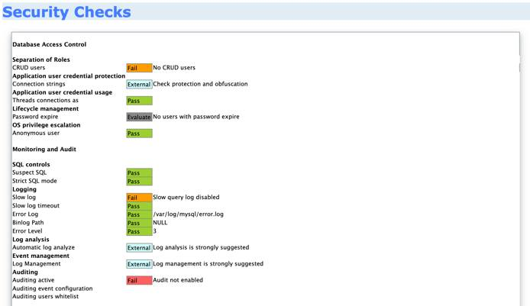
The results are formatted in a simple to read and understand format. Configurations are checked and results are color coded based on their current configuration security impact. For example, a failed configuration check is color coded in orange and a passed check is color coded in green.
The audit report reveals what configurations need to be changed or modified and presents you with a top level picture of the overall security of your MySQL server.

Security Auditing with Lynis

Installing Lynis
Lynis is an extensible security audit tool for computer systems running Linux, FreeBSD, macOS, OpenBSD, Solaris, and other Unix derivatives. It assists system administrators and security professionals with scanning a system and its defenses, with the final goal being system hardening.
To ensure that that you have the latest version of Lynis installed it’s important to manually set up the CISOfy repository. While a version of Lynis is available in most repositories by default, the CISOfy repositories are always the most up to date, ensuring that any auditing performed is based on the best information available. To add the CISOfy repository to your list of repos, enter the following command:
echo "deb https://packages.cisofy.com/community/lynis/deb/ stable main" | sudo tee /etc/apt/sources.list.d/cisofy-lynis.list
Then, import a public GPG key for a secure Lynis installation:
sudo wget -O - https://packages.cisofy.com/keys/cisofy-software-public.key | sudo apt-key add -
Note
You may need to manually install gnupg2 on some systems in order for GPG to successfully import keys. This can be completed with the following command:
sudo apt-get install gnupg2
Update and upgrade to ensure that your system is prepared to use all packages available in the CISOfy repository:
sudo apt-get update && sudo apt-get upgrade
Install Linus by running the following command:
sudo apt install lynis
To display all the options and commands available, run the following command:
lynis show options
Before scanning, ensure that Lynis is up to date. To check if the latest version is running, enter the following command:
sudo lynis update info
== Lynis ==

Version : 3.0.1
Status : Up-to-date
Release date : 2020-10-05
Project page : https://cisofy.com/lynis/
Source code : https://github.com/CISOfy/lynis
Latest package : https://packages.cisofy.com/

2007-2020, CISOfy - https://cisofy.com/lynis/

System Auditing With Lynis
To perform a system audit with Lynis, run the following command:
sudo lynis audit system
Lynis outputs a lot of information that it stores under the /var/log/lynis.log file for easier access. The summary of the system audit reveals important information about your system’s security posture and various security misconfigurations and vulnerabilities.
Lynis also generates output on how these vulnerabilities and misconfigurations can be fixed or tweaked.
Lynis security scan details:

Hardening index : 61 [############ ]
Tests performed : 233
Plugins enabled : 0

Components:
- Firewall [V]
- Malware scanner [X]

Scan mode:
Normal [V] Forensics [ ] Integration [ ] Pentest [ ]

Lynis modules:
- Compliance status [?]
- Security audit [V]
- Vulnerability scan [V]

Files:
- Test and debug information : /var/log/lynis.log
- Report data : /var/log/lynis-report.dat
The output also contains a hardening index score that is rated out of 100, this is used to give you a trackable tangible score of your system’s current security posture.
Also found in the report, Linus displays any potential warnings that indicate a severe security vulnerability or misconfiguration that needs to be fixed or patched. In this case, add rules to the firewall:
-[ Lynis 3.0.1 Results ]-

Warnings (1):
----------------------------
! iptables module(s) loaded, but no rules active [FIRE-4512]
https://cisofy.com/lynis/controls/FIRE-4512/
To increase our hardening index score, Lynis provides us with helpful suggestions that detail the various security configurations to be made.
After following the suggestions and making the necessary changes, run the system audit with Lynis again.
Once all the changes are made, you can expect to see a significant improvement in the hardening index score that confirms the changes and configurations we’ve applied are effective.

Pentest With Lynis
Lynis also has the ability to simulate a privileged/internal pentest on the system, this can be invoked by using the following command:
sudo lynis --pentest
This performs a pentest on the system and outputs a hardening index score that reflects the overall security posture of the system. It also outputs similar recommendations and patches that can be implied to improve the score.
Lynis security scan details:

Hardening index : 61 [############ ]
Tests performed : 233
Plugins enabled : 0

Components:
- Firewall [V]
- Malware scanner [X]

Scan mode:
Normal [ ] Forensics [ ] Integration [ ] Pentest [V] (running privileged)

Lynis modules:
- Compliance status [?]
- Security audit [V]
- Vulnerability scan [V]

Files:
- Test and debug information : /var/log/lynis.log
- Report data : /var/log/lynis-report.dat

Securing Apache 2 With ModSecurity
Updated , by Hackersploit
security web server apache
Try this guide to receive $100 at signup on a new account.


What is ModSecurity?
ModSecurity is a free and open source web application that started out as an Apache module and grew to a fully-fledged web application firewall. It works by inspecting requests sent to the web server in real time against a predefined rule set, preventing typical web application attacks like XSS and SQL Injection.

Prerequisites & Requirements
In order to install and configure ModSecurity, you need to have a Linux server with the following services running:
- Apache 2
For instructions, see our guide on How to Install Apache Web Server on Ubuntu 18.04 LTS. Installation instructions for several other Linux distributions are also accessible from this guide.
Note
This demonstration has been performed on Ubuntu 18.04. However, all techniques demonstrated are distribution agnostic with the exception of package names and package managers.

Installing ModSecurity
- ModSecurity can be installed by running the following command in your terminal:
sudo apt install libapache2-mod-security2 -y
- Alternatively, you can also build ModSecurity manually by cloning the official ModSecurity Github repository.
- After installing ModSecurity, enable the Apache 2 headers module by running the following command:
sudo a2enmod headers
After installing ModSecurity and enabling the header module, you need to restart the apache2 service, this can be done by running the following command:
sudo systemctl restart apache2
You should now have ModSecurity installed. The next steps involves enabling and configuring ModSecurity and the OWASP-CRS.

Configuring ModSecurity
ModSecurity is a firewall and therefore requires rules to function. This section shows you how to implement the OWASP Core Rule Set. First, you must prepare the ModSecurity configuration file.
- Remove the .recommended extension from the ModSecurity configuration file name with the following command:
sudo cp /etc/modsecurity/modsecurity.conf-recommended /etc/modsecurity/modsecurity.conf
- With a text editor such as vim, open /etc/modsecurity/modsecurity.conf and change the value for SecRuleEngine to On:
File: /etc/modsecurity/modsecurity.conf
1  2  3  4  5  6  7  8  9 | # -- Rule engine initialization ----------------------------------------------  # Enable ModSecurity, attaching it to every transaction. Use detection  # only to start with, because that minimises the chances of post-installation  # disruption.  #  SecRuleEngine On  ...
- Restart Apache to apply the changes:
sudo systemctl restart apache2
ModSecurity should now be configured to run. The next step in the process is to set up a rule set to actively prevent your web server from attacks.

Setting Up the OWASP ModSecurity Core Rule Set
The OWASP ModSecurity Core Rule Set (CRS) is a set of generic attack detection rules for use with ModSecurity or compatible web application firewalls. The CRS aims to protect web applications from a wide range of attacks, including the OWASP Top Ten, with a minimum of false alerts. The CRS provides protection against many common attack categories, including SQL Injection, Cross Site Scripting, and Local File Inclusion.
To set up the OWASP-CRS, follow the procedures outlined below.
- First, delete the current rule set that comes prepackaged with ModSecurity by running the following command:
sudo rm -rf /usr/share/modsecurity-crs
- Ensure that git is installed:
sudo apt install git
- Clone the OWASP-CRS GitHub repository into the /usr/share/modsecurity-crs directory:
sudo git clone https://github.com/coreruleset/coreruleset /usr/share/modsecurity-crs
- Rename the crs-setup.conf.example to crs-setup.conf:
sudo mv /usr/share/modsecurity-crs/crs-setup.conf.example /usr/share/modsecurity-crs/crs-setup.conf
- Rename the default request exclusion rule file:
sudo mv /usr/share/modsecurity-crs/rules/REQUEST-900-EXCLUSION-RULES-BEFORE-CRS.conf.example /usr/share/modsecurity-crs/rules/REQUEST-900-EXCLUSION-RULES-BEFORE-CRS.conf
You should now have the OWASP-CRS setup and ready to be used in your Apache configuration.

Enabling ModSecurity in Apache 2
To begin using ModSecurity, enable it in the Apache configuration file by following the steps outlined below:
- Using a text editor such as vim, edit the /etc/apache2/mods-available/security2.conf file to include the OWASP-CRS files you have downloaded:
File: /etc/apache2/mods-available/security2.conf
1  2  3  4  5  6 | <IfModule security2_module>  SecDataDir /var/cache/modsecurity  Include /usr/share/modsecurity-crs/crs-setup.conf  Include /usr/share/modsecurity-crs/rules/*.conf  </IfModule>
- In /etc/apache2/sites-enabled/000-default.conf file VirtualHost block, include the SecRuleEngine directive set to On.
File: /etc/apache2/sites-enabled/000-default.conf
1  2  3  4  5  6  7  8  9  10 | <VirtualHost *:80>  ServerAdmin webmaster@localhost  DocumentRoot /var/www/html  ErrorLog ${APACHE_LOG_DIR}/error.log  CustomLog ${APACHE_LOG_DIR}/access.log combined  SecRuleEngine On  </VirtualHost>
- If you are running a website that uses SSL, add SecRuleEngine directive to that website’s configuration file as well. See our guide on SSL Certificates with Apache on Debian & Ubuntu for more information.
- Restart the apache2 service to apply the configuration:
sudo systemctl restart apache2
ModSecurity should now be configured and running to protect your web server from attacks. You can now perform a quick test to verify that ModSecurity is running.

Testing ModSecurity
Test ModSecurity by performing a simple local file inclusion attack by running the following command:
curl http://<SERVER-IP/DOMAIN>/index.php?exec=/bin/bash
If ModSecurity has been configured correctly and is actively blocking attacks, the following error is returned:
<!DOCTYPE HTML PUBLIC "-//IETF//DTD HTML 2.0//EN">
<html><head>
<title>403 Forbidden</title>
</head><body>
<h1>Forbidden</h1>
<p>You don't have permission to access this resource.</p>
<hr>
<address>Apache/2.4.25 (Debian) Server at 96.126.105.75 Port 80</address>
</body></html>

The Value of Containerization For Small Businesses
Containerization isn’t just for big enterprises. Small businesses can, and should, take advantage of this powerful technology, says Jay Lyman, senior analyst at 451 Research.
Containers are a type of cloud native technology that enables developers to package applications and their dependencies into a lightweight, portable state. The advantages? Speed, productivity, and efficiency. Plus, as more small companies adopt multicloud and hybrid cloud infrastructures, containerization adds consistency across platforms.
Kubernetes, a container orchestration system, can manage container clusters at a massive scale by taking advantage of cloud native characteristics like scaling, provisioning, and automation. There also are cost and security benefits. Using a container is cheaper than spinning up an entire virtual machine, and containerized apps are more secure because their lightweight packaging yields less attack surface.
Organizations are already taking advantage of containerization’s scalability and flexibility, but for SMBs, complexity has been a hurdle. They don’t have to go it alone. The rise of managed Kubernetes services makes containerization more attainable for smaller companies by taking on the work of container configuration and maintenance.
In this video, Lyman explains why containerization is easier—and more critical than ever—for SMBs to consider: “Small organizations can take advantage of innovation without having to contribute large amounts of money or time.”

Use Advanced OpenSSH Features to Harden Access to Your Linode
Updated , by Damaso Sanoja
ssh security linux
Try this guide to receive $100 at signup on a new account.
There’s a good chance you’ve been using SSH (Secure Shell) to access your Linode from your computer. Although SSH is a secure protocol, most system compromises are a result of human error or failure to take advantage of the security features offered. In this guide, we’ll cover a few key features provided by OpenSSH.

OpenSSH is a suite of connectivity tools that sysadmins use daily to access remote servers. From a security point of view, it’s the ‘front door’ for remote logins so it is extremely important to harden SSH as much as possible. The aim of this guide is to build upon our Securing Your Server guide with easy steps that can be implemented in just a few minutes.
Assumptions:
- You’ll be deploying a server open to the internet 24/7.
- Your primary concern is security over simplicity or convenience. Be aware that in most cases, more security implies less convenience.

Before You Begin
- Complete the Getting Started guide.
- Follow the Securing Your Server guide to create a standard user account, harden SSH access, create a basic firewall rule set and remove unnecessary network services.
- Log in to your Linode via SSH and check for updates using the corresponding package manager: apt (Ubuntu/Debian) or yum (RHEL/CentOS) .
sudo apt update && sudo apt upgrade
sudo yum update
- Make a backup of your server’s sshd_config file.
sudo cp /etc/ssh/sshd_config /etc/ssh/sshd_config.BACKUP
Note
This guide is written for a non-root user. Commands that require elevated privileges are prefixed with sudo. If you’re not familiar with the sudo command, see our Users and Groups guide.

Use a Stronger Diffie-Hellman Algorithm
Diffie-Hellman is the name of an asymmetric algorithm used to securely exchange cryptographic keys over public channels (like the Internet). OpenSSH uses the D-H algorithm to generate keys from a configuration file located at /etc/ssh/moduli. Several IT news outlets have reported the possibility that nations may have broken commonly used primes, which mean they could read encrypted traffic transmitted over “secure” channels.
Protecting your server against that threat is fairly simple, just edit the /etc/ssh/moduli file and comment the lines where the fifth field is 1023 or 1535 (which denotes the size). This forces the algorithm to use keys from Group 14 (2048-bit or more). Higher groups mean more secure keys that are less likely to be broken in near future, but also require additional time to compute.
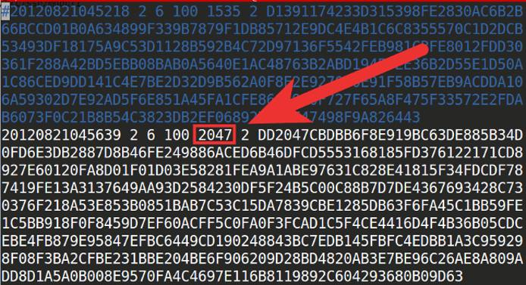

Optional: Generate Your Own Keys
The /etc/ssh/moduli file ships with OpenSSH, so assuming two servers have the same version of OpenSSH, their default moduli files will be identical. This does not mean they are insecure; because Diffie-Hellman is an asymmetric algorithm, the keys it generates are incredibly difficult to crack when generated from sufficiently large primes. That being said, if you want to take the extra time to do so, you may generate new Diffie-Hellman parameters yourself:
ssh-keygen -G "${HOME}/moduli" -b 2048
sudo ssh-keygen -T /etc/ssh/moduli -f "${HOME}/moduli"
rm "${HOME}/moduli"
Caution
Before running these commands on a production server, be aware that depending on the size of the keys you’re generating, this will use significant CPU power and may take anywhere from a minute to several hours.
This sequence of commands generates a new file containing thousands of candidate primes for the Diffie-Hellman algorithm. Next, it tests the candidates and adds suitable primes to your moduli file. Note that these keys append to your existing ones; they do not overwrite the file, so it is still possible that your SSH connection will use a precomputed prime in its key exchange. As stated above, however, this is not a vulnerability.
In our example, we generated Diffie-Hellman parameters with 2048 bits. This is generally considered secure, but you are welcome to modify this value to generate larger prime candidates.
Remember to restart the SSH service after making these changes, whether you edited the file or generated your own:
sudo systemctl restart ssh
For more detailed information on how to decide whether to edit the existing file or generate your own, please refer to RFC4419.

SSH Access Control
Ideally, you should limit the number of users with server access to a bare minimum. Fortunately, OpenSSH Access Control Directives bring an excellent mechanism to set permissions and establish restrictions to users and groups that connect to your server.
There are four directives available executed in sequential order:
DenyUsers: block listed users from SSH service. AllowUsers: login is allowed only for users listed in this directive. DenyGroups: similar to DenyUsers, any user who belongs to this group(s) is blocked. AllowGroups: only users part of this group(s) can access the SSH service.
The default behavior of SSH is to allow any user to log in to the server, but this can be changed by adding access control directives to your /etc/ssh/sshd_config file. The following examples show how to filter who can access the service:

Selectively Deny Users
DenyUsers phpadmin tempuser dbuser@198.51.100.0 - The users phpadmin and tempuser have no SSH access at all, but the user dbuser is only blocked if is connecting from the specific IP address of 198.51.100.0.

Selectively Allow Users
AllowUsers superadmin megauser@yourdomain.tld dbadmin@198.51.100.0 - only the users superadmin, megauser and dbadmin have SSH access, but megauser and dbadmin can only connect from specific domains/IP addresses. On the other hand, superadmin has the ability to connect from any computer.

Custom Rules Example
File: /etc/ssh/sshd_config
1  2  3 | DenyUsers adam ben clark@198.51.100.0/24  AllowUsers clark dan@192.168.5.200 eva
Let’s look at these rules in more detail. In the first line, Adam and Ben are blocked from accessing the server via SSH under any circumstances. Clark is not able to connect from a specific range of IP addresses, specified by 198.51.100.0/24. In the second line, only Clark, Dan, and Eva will have SSH access. However, Clark’s previous restriction from the DenyUsers line applies and Dan is only able to connect from one specific IP address. Eva is the only one who is able to connect via SSH from any computer.
Remember to restart your SSH service after changes have been made:
sudo systemctl restart ssh

Use a Strong Password for your Key-pair
In the Securing Your Server guide, you’re encouraged to use SSH Key Pair Authentication. This is not optional if you are serious about security. But what about remote users that connect to the server with their laptops, which are susceptible to be stolen or lost? Here is where protecting your private key with a strong password or passphrase comes in, at least to gain time before changing the server keys. A strong password shouldn’t be dictionary based. If security is your main concern, the convenience of an easy to remember password isn’t adequate. OpenSSL offers an easy way to generate pseudo-random passwords:
openssl rand -base64 32
The command will generate a 44 character long, base64-encoded password like this:
C4b7Yep8HGQFeG6kbnpEtrm+bg0+958xf1f85PU3/e0=
This kind of password is very hard to crack, but has the obvious disadvantage of being inconvenient each time you log to your server. The recommended method is to use a good password manager, because using a plain-text file for this dilutes the purpose of using the password in the first place.
To add the generated password to your existing private key:
ssh-keygen -p -f ~/.ssh/id_rsa
This assumes you keep your client’s private SSH key in its default location, ~/.ssh/id_rsa. You can modify the file location as needed and use the same command to change your password in the future.
An alternative to this method is the use of a GPG smartcard or YubiKey which should be stored in a different place from your laptop. You can find more information about this implementation in the guide How to use a GPG key for SSH authentication

Chroot Users
OpenSSH has a useful directive called ChrootDirectory that can be used in sshd_config to ‘jail’ a user into any directory, similar to the behavior of chroot_local=YES in an FTP server. This allows sysadmins to implement an additional layer of security for those users that don’t need access to all of a server’s resources.
However, this strategy involves a time-consuming process to configure the jailed user. For the purposes of this guide we’ll setup a bare environment with some basic commands available for a user we’ll create called restricted-user.
- Create a jail directory in any desired location for restricted-user:
sudo mkdir -p /home/chroot/restricted-user
- Create the required /dev nodes using mknod:
sudo mkdir -p /home/chroot/restricted-user/dev/
sudo mknod -m 666 /home/chroot/restricted-user/dev/null c 1 3
sudo mknod -m 666 /home/chroot/restricted-user/dev/tty c 5 0
sudo mknod -m 666 /home/chroot/restricted-user/dev/zero c 1 5
sudo mknod -m 666 /home/chroot/restricted-user/dev/random c 1 8
- Establish permissions as needed for the jail. In this example, we’ll give ownership to root:
sudo chown root:root /home/chroot/restricted-user
sudo chmod 0755 /home/chroot/restricted-user
- Create the remaining directories needed by restricted-user:
sudo mkdir -p /home/chroot/restricted-user/bin /home/chroot/restricted-user/lib/ /home/chroot/restricted-user/lib64/ /home/chroot/restricted-user/lib/x86_64-linux-gnu/ /home/chroot/restricted-user/etc/
- Install the bash shell into the jail:
sudo cp -v /bin/bash /home/chroot/restricted-user/bin
- For each binary copied into the jail, we need to determine which shared libraries are needed. This is done through the ldd command:
sudo ldd /bin/bash
- Manually copy each library from the output to the corresponding location in our restricted-user directory. This is necessary because our user won’t have access outside its own jail.
cp -v /lib/x86_64-linux-gnu/{libncurses.so.5,libtinfo.so.5,libdl.so.2,libc.so.6} /home/chroot/restricted-user/lib/
cp -v /lib64/ld-linux-x86-64.so.2 /home/chroot/restricted-user/lib64/
cp -va /lib/x86_64-linux-gnu/libnss_files* /home/chroot/restricted-user/lib/x86_64-linux-gnu/
- Next, create the restricted-user. You may use a different name for your user if you like:
sudo adduser restricted-user
- Copy user information to the jail:
sudo cp -vf /etc/{passwd,group} /home/chroot/restricted-user/etc/
- Finally, edit your /etc/ssh/sshd_config file to configure your new user:
File: /etc/ssh/sshd_config
1  2 | Match User restricted-user  ChrootDirectory /home/chroot/restricted-user
- Restart your SSH service to apply these changes.
sudo systemctl restart sshd
Keep in mind that our restricted user can’t use any command or binary that is not manually installed in its jail environment. The complete process to set up a user for specific tasks is overwhelming but has the advantage that anything outside the jail is protected in the event that the user is compromised.

Regularly Update your Revoked Keys List
There are cases where you want to revoke specific public keys to prevent attempts to log in with them. For example, if you rotate your SSH keys every few months, you may want to disable them from being used in the future. OpenSSH has a directive to do just that: RevokedKeys. Simply edit your /etc/ssh/sshd_config and add the desired location for revoked keys list:
File: /etc/ssh/sshd_config
1 | RevokedKeys /etc/ssh/revoked_keys
The list should contain one key per line in plain text format. Remember to restart your SSH service each time you add a new key to the file.

Reduce Timeout Interval and Login Grace Time
Unattended SSH sessions are a major security risk. Leaving a remote connection open may allow unauthorized users the power to do whatever they like with your server. After all, you’re already logged. The idle time interval comes in useful to prevent this situation, all you need is to configure two directives:
ClientAliveInterval set the time in seconds before the server sends a message requesting a client response. Default is 0, which means the server won’t request a client response (the session can last forever). ClientAliveCountMax specifies the number of client alive messages sent by the server before closing the connection if no response is returned. The default is 3.
For example, if you decide to limit an idle SSH connection to 2 minutes before disconnecting the client, you can configure it as follows:
ClientAliveInterval 40
ClientAliveCountMax 3
This sends 3 messages to your client (every 40 seconds) requesting some action, after 120 seconds without response the user will be logged out. An alternative configuration could be:
ClientAliveInterval 120
ClientAliveCountMax 0
With these settings, if no messages are sent, the server will disconnect any SSH session after 2 minutes of inactivity.
To apply any combination that suits your needs just edit your server’s /etc/ssh/sshd_config and restart your SSH daemon afterwards.

Use a Warning Banner
This step will not harden your server security, but your legal-conscientious-parameters. In some locations, the simple fact of warning unauthorized users of the consequences of their actions is determinant for taking legal action. To display a warning banner each time a user logs to your server, add the following line to the /etc/ssh/sshd_config configuration:
File: /etc/ssh/sshd_config
1 | Banner /location/of/WarningMessage
The value /location/of/WarningMessage is the path to your banner text file. The following banner example was taken from Ubuntu’s Community Help page for OpenSSH:
***************************************************************************
NOTICE TO USERS

This computer system is the private property of its owner, whether
individual, corporate or government. It is for authorized use only.
Users (authorized or unauthorized) have no explicit or implicit
expectation of privacy.

Any or all uses of this system and all files on this system may be
intercepted, monitored, recorded, copied, audited, inspected, and
disclosed to your employer, to authorized site, government, and law
enforcement personnel, as well as authorized officials of government
agencies, both domestic and foreign.

By using this system, the user consents to such interception, monitoring,
recording, copying, auditing, inspection, and disclosure at the
discretion of such personnel or officials. Unauthorized or improper use
of this system may result in civil and criminal penalties and
administrative or disciplinary action, as appropriate. By continuing to
use this system you indicate your awareness of and consent to these terms
and conditions of use. LOG OFF IMMEDIATELY if you do not agree to the
conditions stated in this warning.

****************************************************************************

More Information
You may wish to consult the following resources for additional information on this topic. While these are provided in the hope that they will be useful, please note that we cannot vouch for the accuracy or timeliness of externally hosted materials.
- OpenSSH
- Diffie-Hellman

