Deployment
Once your application is complete, or even before that you’ll want to deploy it. There are a few things you should do when deploying a CakePHP application.

Moving files
You are encouraged to create a git commit and pull or clone that commit or repository on your server and run composer install. While this requires some knowledge about git and an existing install of git and composer this process will take care about library dependencies and file and folder permissions.
Be aware that when deploying via FTP you will at least have to fix file and folder permissions.
You can also use this deployment technique to setup a staging- or demo-server (pre-production) and keep it in sync with your dev box.

Adjust config/app.php
Adjusting app.php, specifically the value of debug is extremely important. Turning debug = false disables a number of development features that should never be exposed to the Internet at large. Disabling debug changes the following types of things:
- Debug messages, created with pr(), debug() and dd() are disabled.
- Core CakePHP caches are by default flushed every year (about 365 days), instead of every 10 seconds as in development.
- Error views are less informative, and give generic error messages instead.
- PHP Errors are not displayed.
- Exception stack traces are disabled.
In addition to the above, many plugins and application extensions use debug to modify their behavior.
You can check against an environment variable to set the debug level dynamically between environments. This will avoid deploying an application with debug true and also save yourself from having to change the debug level each time before deploying to a production environment.
For example, you can set an environment variable in your Apache configuration:
SetEnv CAKEPHP_DEBUG 1
And then you can set the debug level dynamically in app.php:
$debug = (bool)getenv('CAKEPHP_DEBUG');

return [
'debug' => $debug,
.....
];

Check Your Security
If you’re throwing your application out into the wild, it’s a good idea to make sure it doesn’t have any obvious leaks:
- Ensure you are using the Cross Site Request Forgery component or middleware.
- You may want to enable the Security component. It can help prevent several types of form tampering and reduce the possibility of mass-assignment issues.
- Ensure your models have the correct Validation rules enabled.
- Check that only your webroot directory is publicly visible, and that your secrets (such as your app salt, and any security keys) are private and unique as well.

Set Document Root
Setting the document root correctly on your application is an important step to keeping your code secure and your application safer. CakePHP applications should have the document root set to the application’s webroot. This makes the application and configuration files inaccessible through a URL. Setting the document root is different for different webservers. See the URL Rewriting documentation for webserver specific information.
In all cases you will want to set the virtual host/domain’s document to be webroot/. This removes the possibility of files outside of the webroot directory being executed.

Improve Your Application’s Performance
Class loading can take a big share of your application’s processing time. In order to avoid this problem, it is recommended that you run this command in your production server once the application is deployed:
php composer.phar dump-autoload -o
If you are using deprecated class names in your project or plugins, don’t combine this with -a/--classmap-authoritative. This breaks the class aliases. Instead, you can use the mentioned option 2b instead using --apcu as additional optimization if APCu is installed.
Since handling static assets, such as images, JavaScript and CSS files of plugins, through the Dispatcher is incredibly inefficient, it is strongly recommended to symlink them for production. This can be done by using the plugin shell:
bin/cake plugin assets symlink
The above command will symlink the webroot directory of all loaded plugins to appropriate path in the app’s webroot directory.
If your filesystem doesn’t allow creating symlinks the directories will be copied instead of being symlinked. You can also explicitly copy the directories using:
bin/cake plugin assets copy

Deploying an update
After deployment of an update you might also want to run bin/cake schema_cache clear, part of the Schema Cache Shell shell.

Deploying CakePHP Project To The Cloud
Follow these steps to understand how to deploy a CakePHP application to the cloud. While some cloud providers offer simple solutions, you will notice that others require a bit more technical know-how for you to deploy an app.





Summary
In this article we’re going to show you how to deploy a CakePHP application to the cloud. We’ll take it step by step and show you how to deploy an app to Microsoft Azure as well as Amazon AWS (using Elastic Beanstalk).

For those who are not tech-savvy, coding can be a little frightening. That’s why we’re also going to show you the easiest way you can deploy a CakePHP to any cloud by using Bunnyshell. It’s faster, works better, and it saves you a lot of time and overhead.

Let’s start with the basics:

What is CakePHP and why you should use it
CakePHP is an open-source framework that makes it easier for you to develop and manage any PHP application. For those who don’t want to spend a lot of time coding, and instead focus on app development and design, CakePHP is a great framework. Less coding, more action!

Using a framework instead of pure code is better, especially if you are new to coding. Frameworks like CakePHP come with systems that already contain best practices in “how” your application should be structured and how development needs to be done.

CakePHP itself is a great framework and comes with:

- Robust Performance
- CRUD Scaffolding (Create, Read, Update and Delete)
- Testing Methods
- User-friendly experience

CakePHP application deployment to the cloud
Even before you’ve finished working on your application, you’ll still need to deploy it. You don’t want to risk losing the updates, right?

Before you do, there are a few steps you need to go through:

1. Start by Moving files:

You need to create a git commit and pull or clone that commit or repository on your server and run composer install.

Be aware that when deploying via FTP you will at least have to fix the file and folder permissions.

You can also use this deployment technique to set up any staging- or demo-server and keep it in sync with your dev box.

2. Afterwards, make sure to Adjust config/app.php

Turning debug = false disables a number of development features that should never be exposed to the Internet at large.

This will help you avoid deploying any application with debug true and also save yourself from having to change the debug level every time before deploying to a production environment.

3. Don’t forget to Check your security

You’ll want to have your webroot directory publicly visible. Make sure that your secrets (such as your app salt, and all security keys) are private and unique. Do not forget to check if your models have the correct validation rules enabled.

4. Next, you will want to Set document root

CakePHP applications need to have the document root set to the application’s webroot. This makes the apps and configuration files inaccessible through a URL.

5. Finally, once your CakePHP app is deployed, improve your application’s performance

To do so, you will need to run this command in your production server:

php composer.phar dump-autoload -o
Now that you know the basic steps to deploying a CakePHP application to the cloud, let’s take a look at how you can do it on two of the most important cloud providers: Microsoft Azure and AWS.

How to deploy a CakePHP application to Azure
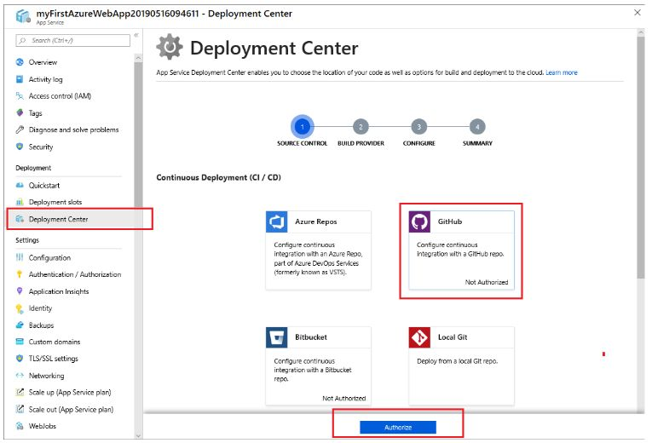
The needs:

To deploy a CakePHP application to Azure you will need:

- An account on Microsoft Azure
- A Git repository
- CakePHP installed
- Your CakePHP application
Some cloud providers make it easier for their users to deploy an app, while others go the old fashion way.

Microsoft Azure seems to be a bit more complicated when it comes to deployments, but it’s actually easier than it seems. Here’s what you need to do before deployment:

1. Create an empty Azure Web Apps and enable Composer extension. If you want, you can enable Visual Studio Online for easy script modifications and command running.

2. Create a file named web.config in the root directory of your application.

3. Add the inlt extension in PHP runtime on Azure. Next, add a folder with the name ext in your root directory and create a file ext.ini in the folder you just created with the content:

extension=php_intl.dll.
4. Add an App Setting to your Web App with the following key:

PHP_INI_SCAN_DIR.
Also, make sure to add the value

d:\home\site\wwwroot\ext
After deployment, you also can do this step to leverage Visual Studio Online extension.

5. Finally, you will need to set up the development environment of your Azure Web Apps and deploy your CakePHP application to Azure via Git.

Deploying the CakePHP application via Git is easy:

- In the local terminal window, add an Azure remote to your local Git repository. Replace
<deploymentLocalGitUrl-from-create-step>
with the URL of the Git remote
- Push to the Azure remote to deploy your app with the following command: git push azure master
Congrats! You’ve successfully deployed your CakePHP application to Azure!

Now that you have deployed your CakePHP application, you can focus on improving and upgrading the app without fearing that you might make a coding error and ruin your process so far.

How to deploy CakePHP to AWS
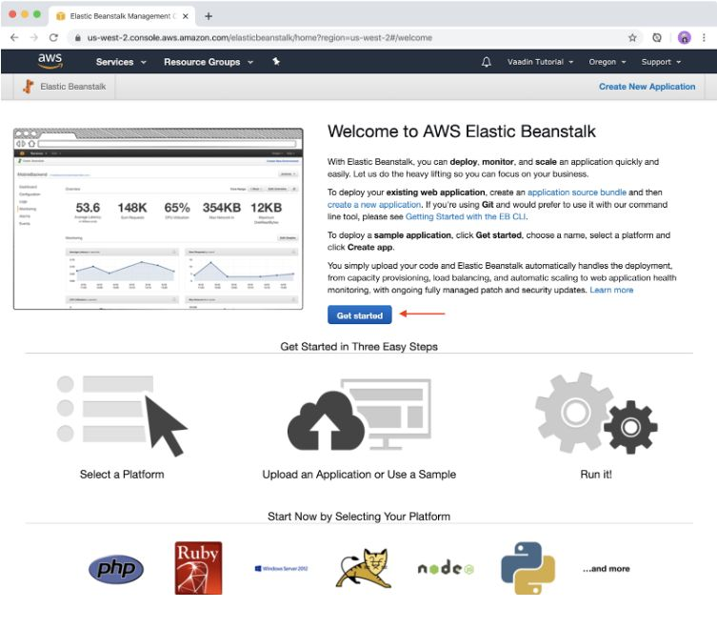
The needs:

In order to deploy a CakePHP application to AWS you will need:

- An account on AWS
- An Elastic Beanstalk subscription
- CakePHP installed
- Your CakePHP application
To deploy your CakePHP application to AWS you’ll want to use Elastic BeanStalk – an orchestration service offered by Amazon Web Services to help its users deploy applications.

With Elastic Beanstalk you will be able to deploy your CakePHP application in no time, by following a few simple steps:

- First off, start by creating a source bundle containing the files created by Composer.
- The following command creates a source bundle named
cake-default.zip
. This also excludes files in the vendor folder, which take up a lot of space. Don’t worry, they are not necessary for the deployment process.
- Upload the source bundle to Elastic Beanstalk to deploy CakePHP to your environment.
- When you choose to deploy a source bundle you will need to go to the Regions list from your Elastic Beanstalk and select your AWS Region.
- In your navigation pane, choose Environments, and then select the name of the environment you want to use from the list.
- Click on Upload and DeployUse the on-screen dialog box to upload the source bundle. Finally, click on Deploy.
As you can see, each cloud provider has its own set of steps that you need to follow to deploy a CakePHP application. If you’re using both of these cloud providers, manually deploying your app could become a time-consuming and repetitive task.

Looking for a better solution? Keep on reading!

How to use Bunnyshell to deploy CakePHP to the cloud
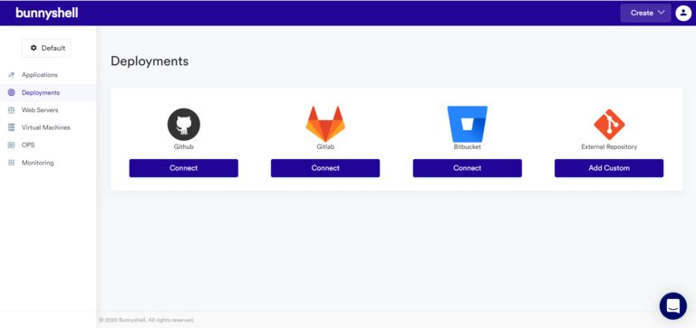
The needs:

In order to deploy a CakePHP application to any cloud with Bunnyshell you will need:

- A Bunnyshell account
- A Git repository
- An account for any cloud provider supported by Bunnyshell (Digital Ocean, AWS and Azure)
- Your CakePHP application
Bunnyshell helps you manage and automate your cloud infrastructure. Creating and deploying applications is easier, faster and more secure, no matter which cloud provider you’re using.

With Bunnyshell, you can deploy your applications directly from Git Repository: just log into your Bunnyshell account, connect your Git Repository, select the application and deploy it. You can also create and deploy your CakePHP applications directly in Bunnyshell, with no repository needed.

Let’s take a look at how you can create and deploy your CakePHP application:

- First, you will need to create your application.
- Click on the button Create, located in the right corner of the dashboard.
- Click on Framework and select CakePHP.Select Virtual machine and your Cloud provider (Bunnyshell supports DigitalOcean, AWS and Azure)
- Select the Location and your desired Plan.
- Finally, name your application and press Create.
Once you finish creating the application, you can deploy it by going to your Application view, specifying the branch or tag you want to deploy, and hitting the Deploy button.

Instant deployments, with just one click. Deploying a CakePHP application in AWS, Azure, or in any other cloud doesn’t have to be a manual, time-consuming task. With Bunnyshell, you can automate these repetitive tasks and boost your end-user experience through agile deployment.

Previously published at https://www.bunnyshell.com/blog/cakephp-application-cloud/
https://hackernoon.com/deploying-cakephp-project-to-the-cloud-kow3u82

Brief explanations
This is a tuto to create a CakePHP 3 project on a synology server and to deploy it.
A small schema to see how it works:
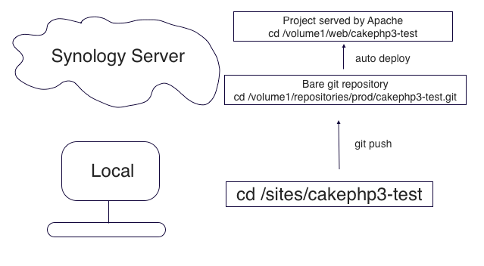

# 1 Remote

# 1.1 Access to Remote
You need to have an access with ssh. If you want to setup one, go to this po
.
So basically, you should be able to access to your remote with something like this::
ssh git@serveName
// or if you changed your ssh port on your server (strongly advised :-)).
// For example if your ssh port is on 7373.
ssh git@serveName -p 7373

# 1.2 Create a Git Bare Repository
cd /volume1/repositories/prod
git init --bare cakephp3-test.git

# 1.3 Setup Git Hooks
I took the script from this website
.
Create the file hooks/post-receive and add this, vi cakephp3-test.git/hooks/post-receive:
#!/bin/sh
## store the arguments given to the script
read oldrev newrev refname

# The deployed directory (the running site)
DEPLOYDIR=/volume1/web/cakephp3-test

## Where to store the log information about the updates
LOGFILE=./post-receive.log

## Record the fact that the push has been received
echo -e "Received Push Request at $( date +%F )" >> $LOGFILE
echo " - Old SHA: $oldrev New SHA: $newrev Branch Name: $refname" >> $LOGFILE

# deploy only for master branch
if [[ $ref =~ .*/master$ ]];
then
## Update the deployed copy
echo "Starting Deploy" >> $LOGFILE

echo " - Starting code update"
GIT_WORK_TREE="$DEPLOYDIR" git checkout -f
echo " - Finished code update"

echo " - Starting composer install"
cd "$DEPLOYDIR"; php composer.phar install --prefer-dist; cd -
echo " - Finished composer install"

echo "Finished Deploy" >> $LOGFILE
fi
And create the folder in /volume1/web/cakephp3-test

# 2 Local

# 2.1 Create a CakePHP repo
composer create-project --prefer-dist -s dev cakephp/app cakephp3-test
cd cakephp3-test
// add composer.phar
curl -sS https://getcomposer.org/installer | php
git init
// remove tmp/ and logs/ from .gitignore (temporarly)
// add plugins/DebugKit in .gitignore
git add --all
git commit -a -m "initialize cakephp3 project"

# 2.2 Push to Remote
git remote add origin ssh://syno_git/volume1/repositories/prod/cakephp3-test.git
git push origin master

# 3 Remote

# 3.1 Apache Config On Synology
Panneau de Configuration/Applications/Services Web/ Click on Hôte Virtuel
Nom du Sous-dossier Nom d'hôte
cakephp3-test www.nomdomaine.com

# 3.2 Check the Website
Go to your www.nomdomaine.com and watch debug info
- if a php extension is missing, you'll see it.
- if your directories are writable or not

# 3.3 Config of app.php on Server
Go with ssh on remote and type vi /volume1/web/cakephp3-test/config/app.php.
Change the following sections:
- put debug to false.
- the database config
- Email config (utf8 to uncomment)
- Salt (normally already defined but check it)

# 4 Locally

# 4.1 Gitignore
// Re-add tmp/ and logs/ in .gitignore
git commit -a -m "add gitignore rules again"
git push origin master

# 4.2 Add a git hook locally
First add the cakephp-codesniffer and phpunit in composer.json. Go here
if you need more information on how to install.
Basically add this in composer.json:
"require": {
...
"phpunit/phpunit": "*",
"cakephp/cakephp-codesniffer": "dev-master"
...
},
I got help from here
Add a bin/pre-commit file (see link)
And a setup.sh file that composer will launch, put this in scripts section:
"scripts": {
"post-install-cmd": [
"App\\Console\\Installer::postInstall"
],
"post-update-cmd": [
"bash bin/setup.sh"
]
},
Don't forget to chmod +x bin/setup.sh
#!/bin/sh

cp bin/pre-commit .git/hooks/pre-commit
chmod +x .git/hooks/pre-commit

# 4.3 Create your project, add Plugins
Now you can add everything you need in your project and then each time you push on your remote, it will deploy it in the /volume1/web/cakephp3-test and launch a composer install.

# 4.4 Another computer or contributor
If you need to install a copy of the project on another computer, you can just make git clone ssh://syno_git/volume1/repositories/prod/cakephp3-test.git. And launch composer install.

# 5 Issues

# 5.1 Mysql/MariaDb
I had to change my /etc/mysql/my.conf to increase the max_allowed_packet = 10M
https://blog.cake-websites.com/backend/2014-11-29-cakephp-deploy.html#_4-3-create-your-project-add-plugins

