CloudPanel

Features#
In this section we will provide an overview about the frontend, cloud and admin area features.

Frontend Area#

Account#
- Account Information
- Two-Factor Authentication

Domains#
- Basics
- Settings
- Vhost
- Domain Aliases
- PHP-FPM Pools
- PHP Settings
- Basic Auth
- Logs
- SSL Certificates

Security#
- IP Blocking
- Bots Blocking

Users#
- SSH Users
- FTP Users

Databases#
- Databases
- Managing Databases

Cron Jobs#
- Cron Jobs
- Settings

Services#
- Services

Cloud Features#
For each cloud, we have implemented features to use them without the need to login to the cloud provider.

Amazon Web Services#
- AWS Access Keys
- Instance
- Security Group
- Route 53
- Amazon Machine Images (AMI)

Digital Ocean#
- Access Token
- Droplet
- Firewalls
- Domains
- Snapshots

Google Cloud#
- Service Account Keys
- Instance
- Firewall Rules
- DNS
- Snapshots

Admin Area#

Users#
- Users

Vhost Templates#
- Vhost Templates

Database Servers#
- Database Servers

Action Log#
- Action Log

Settings#
- Proftpd Settings

CloudPanel CLI Commands
The CloudPanel CLI is a command-line application that offers commands for backing up databases, restoring databases, showing database credentials, disabling two-factor authentification, resetting passwords, and resetting permissions.
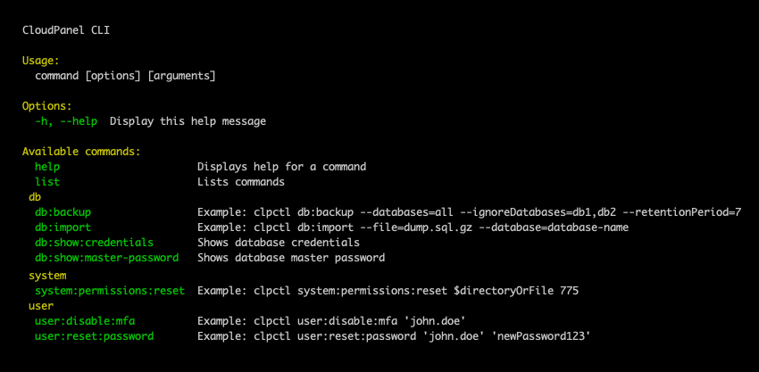
With the following command you see all available commands:
clpctl

Commands
The following commands are available only for the root user:
- db:show:credentials
- db:show:master-password
- user:disable:mfa
- user:reset:password
- vhost-templates:import
The following commands are available for other users:
- db:backup
- db:import
- system:permissions:reset

Database#

Database Backup#
With the Database Backup command you can backup all databases or specific ones.
For backing up databases, CloudPanel uses the standard utility mysqldump.
To backup all databases, run the following command:
clpctl db:backup --databases=all
If you want to exclude some databases, run the following command:
clpctl db:backup --databases=all --ignoreDatabases=db1,db2
To backup only one specific database, run the following command:
clpctl db:backup --databases=$databaseName
The Database Backups will be compressed via gzip and stored in the following directory:
/home/cloudpanel/backups/

Database Import#
Importing or restoring a database can be done with the following command:
clpctl db:import --file=dump.sql.gz --database=database-name
The supported file formats are .sql and sql.gz.

Database Credentials#
The Database Credentials command shows the master credentials for connecting to the database.
clpctl db:show:credentials
The output will look like:
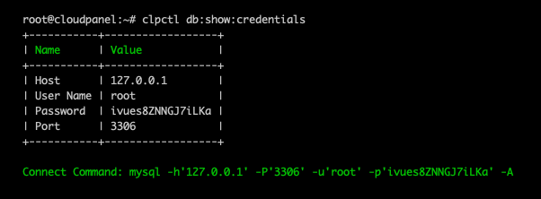
Use the Connect Command to connect to MySQL from the command-line.
This command is only available for the root user.

Database Master Password#
To display only the Database Maste Password run the following command:
clpctl db:show:master-password
This command is only available for the root user.

User#

Disable 2-FA#
To disable Two-Factor Authentication for a user, run the following command:
clpctl user:disable:mfa 'john.doe'
This command is only available for the root user.

Reset Password#
To reset a password for a user, run the following command:
clpctl user:reset:password 'john.doe' 'newPassword123'
This command is only available for the root user.

System#

Permission Reset#
To reset the owner and permissions of files and directories run the following command:
clpctl system:permissions:reset $directoryOrFile 775
The reset of the owner and permissions are applied recursively.

Cloud Features

https://www.cloudpanel.io/docs/cloudpanel-ce/frontend-area/cloud-features-aws#aws-access-keys

https://www.cloudpanel.io/docs/cloudpanel-ce/frontend-area/cloud-features-digital-ocean

https://www.cloudpanel.io/docs/cloudpanel-ce/frontend-area/cloud-features-google-cloud

Vhost Templates

Application#
The right Vhost Template for your Application is essential. For managing the CloudPanel Vhost Templates we are using GitHub. Vhost Templates for all popular PHP Applications can be found there.

Adding an Application#
The Vhost Templates are organized within Applications. The Vhost Template for newer application versions may be different than for an older one.
To add a new Application do the following steps:
1) Login into the CloudPanel as User with admin rights.
2) Go to the Admin Area by clicking on Admin Area top right.
3) In the left menu, click on Vhost Templates and click on the button Add Application.
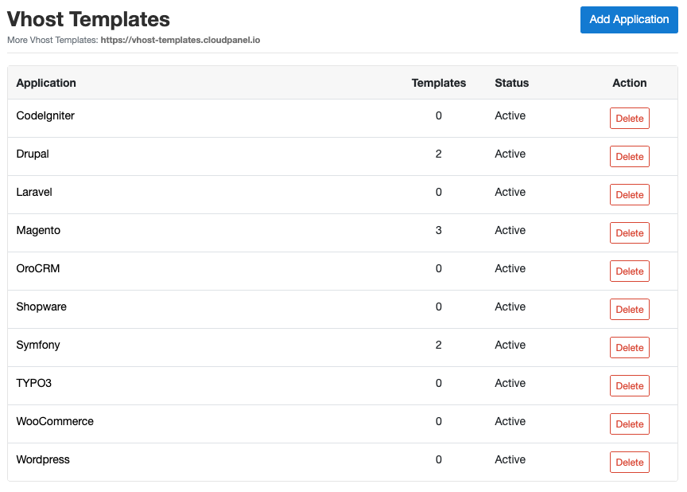
Enter the Application Name and click on the button Add New Application to save.
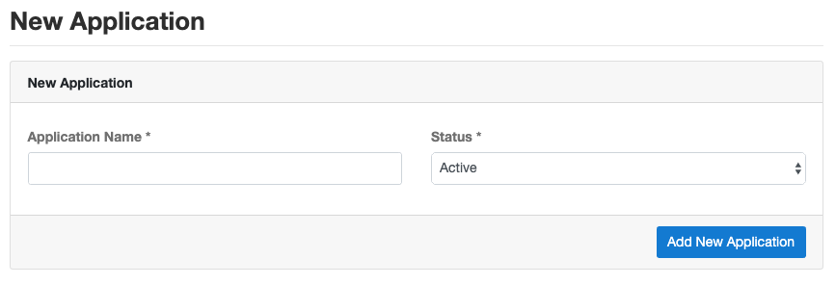

Deleting an Application#
On the Vhost Templates overview site, you can delete an Application by clicking on the button Delete.

Vhost Template#

Adding a Vhost Template#
To add a new Vhost Template to an Application, click on the Application and then on the button Add Vhost Template.
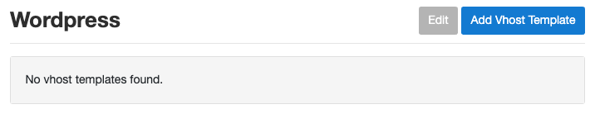
Enter the Template Name and content of the Vhost Template and click on Add Vhost Template.
The following placeholders are required:
- {{ssl_certificate_key}}
- {{ssl_certificate}}
- {{root}}
- {{nginx_access_log}}
- {{nginx_error_log}}
- {{basic_auth}}
- {{php_fpm_listener}}
- {{php_settings}}
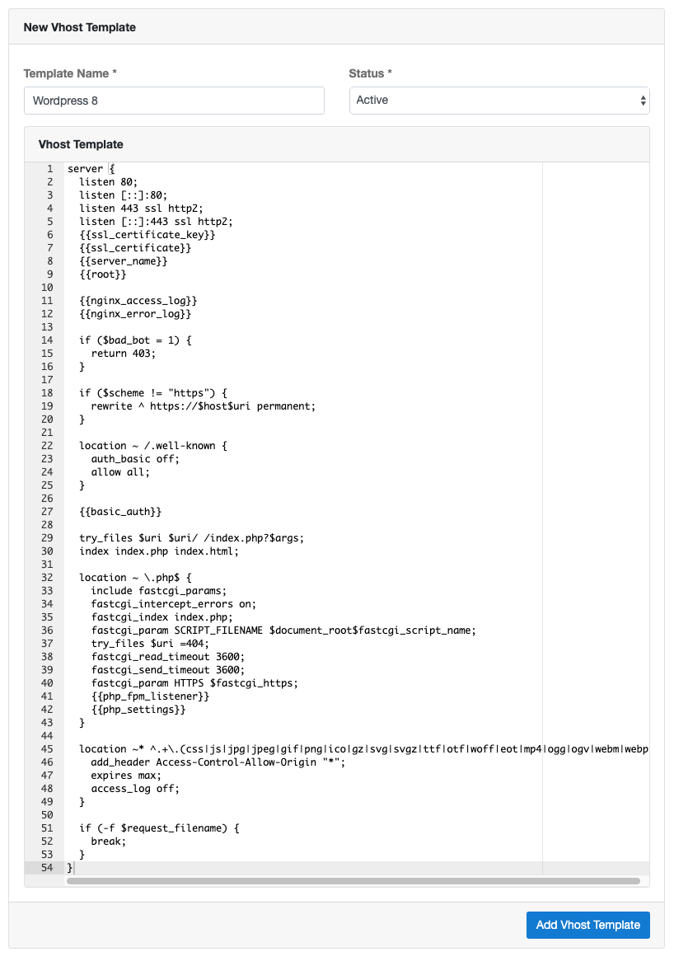
You can use the Vhost Template below and modify it to your needs.
server {
listen 80;
listen [::]:80;
listen 443 ssl http2;
listen [::]:443 ssl http2;
{{ssl_certificate_key}}
{{ssl_certificate}}
{{server_name}}
{{root}}
{{nginx_access_log}}
{{nginx_error_log}}
if ($bad_bot = 1) {
return 403;
}
if ($scheme != "https") {
rewrite ^ https://$host$uri permanent;
}
location ~ /.well-known {
auth_basic off;
allow all;
}
{{basic_auth}}
try_files $uri $uri/ /index.php?$args;
index index.php index.html;
location ~ \.php$ {
include fastcgi_params;
fastcgi_intercept_errors on;
fastcgi_index index.php;
fastcgi_param SCRIPT_FILENAME $document_root$fastcgi_script_name;
try_files $uri =404;
fastcgi_read_timeout 3600;
fastcgi_send_timeout 3600;
fastcgi_param HTTPS $fastcgi_https;
{{php_fpm_listener}}
{{php_settings}}
}
location ~* ^.+\.(css|js|jpg|jpeg|gif|png|ico|gz|svg|svgz|ttf|otf|woff|eot|mp4|ogg|ogv|webm|webp|zip|swf)$ {
add_header Access-Control-Allow-Origin "*";
expires max;
access_log off;
}
if (-f $request_filename) {
break;
}
}

Deleting a Vhost Template#
To delete a Vhost Template, click on the Application and then on the button Delete.
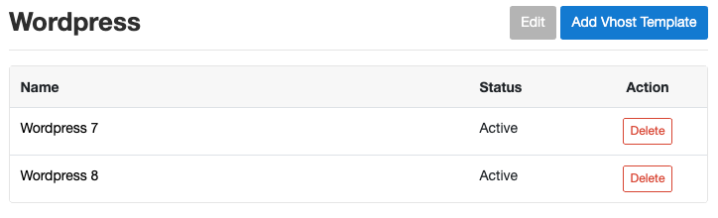

Vhost Templates#

Updating Vhost Templates#
All Vhost Templates are managed via GitHub, where we make constantly changes.
To update the Vhost Templates in your CloudPanel do the following:
1) Login via SSH to your server and become root.
sudo su root
2) Run the following command:
clpctl vhost-templates:import

Database Servers

Database Servers#
Using a separate Database Server to handle all database queries has advantages like better performance and the possibility to restore to a specific time. All major cloud providers are offering MySQL database services.

Add Database Server#
To add a new Database Server do the following steps:
1) Login into the CloudPanel as User with admin rights.
2) Go to the Admin Area by clicking on Admin Area top right.
3) In the left menu, click on Database Servers and click on the button Add Database Server.
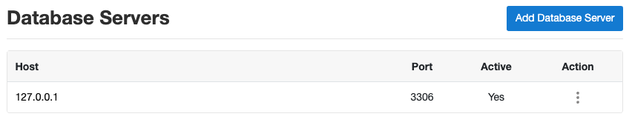
Enter the Host, Port, User Name and Password of the Database Server.
The User should have super privileges like the root user.
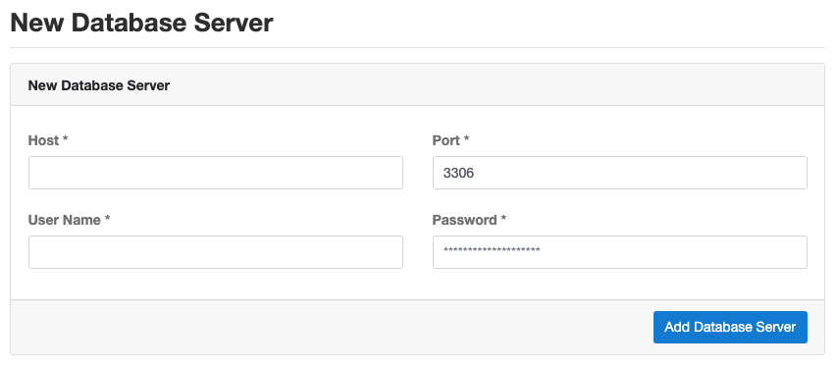

MySQL Versions
Only MySQL 5.5, 5.6 and 5.7 are supported. MySQL 8.0 will be supported in the next major CloudPanel version.

Use Database Server#
To use a Database Server, go to the Database Servers overview site and click on Use.
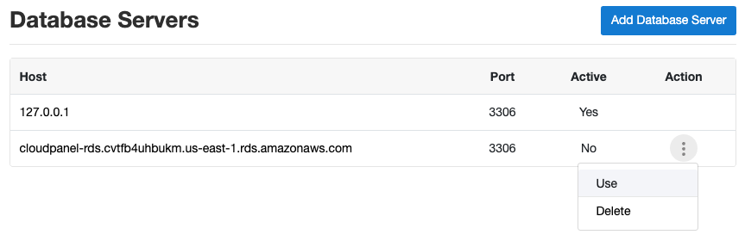

CakePHP 4
On this page, we explain step by step how to setup CakePHP with CloudPanel.

Installation#
In the following example we will setup CakePHP under the domain www.domain.com.

Preparation#
Before we can start with the installation, we need to create an SSH User, a Database, and a Domain.
When you Add the Domain, make sure to select the CakePHP 4 Vhost Template, and the right PHP Version.
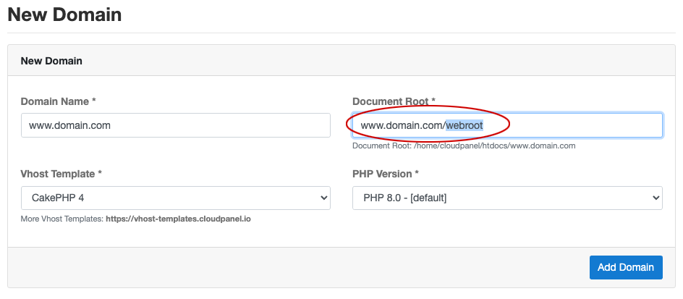

Document Root
Make sure to point the Document Root to the webroot directory.

Installation#
To install CakePHP do the following steps:
- Login via SSH to the server e.g. with john-ssh and go htdocs directory:
cd /home/cloudpanel/htdocs/
- Delete the project directory which has been created by CloudPanel:
rm -rf /home/cloudpanel/htdocs/www.domain.com
- Install via composer:
php8.0 /usr/local/bin/composer create-project --prefer-dist cakephp/app:~4.2 www.domain.com
- Reset permissions.
cd /home/cloudpanel/htdocs/
clpctl system:permissions:reset www.domain.com 775
- Done! You can now open your domain in your browser to see the Welcome to CakePHP 4 page.
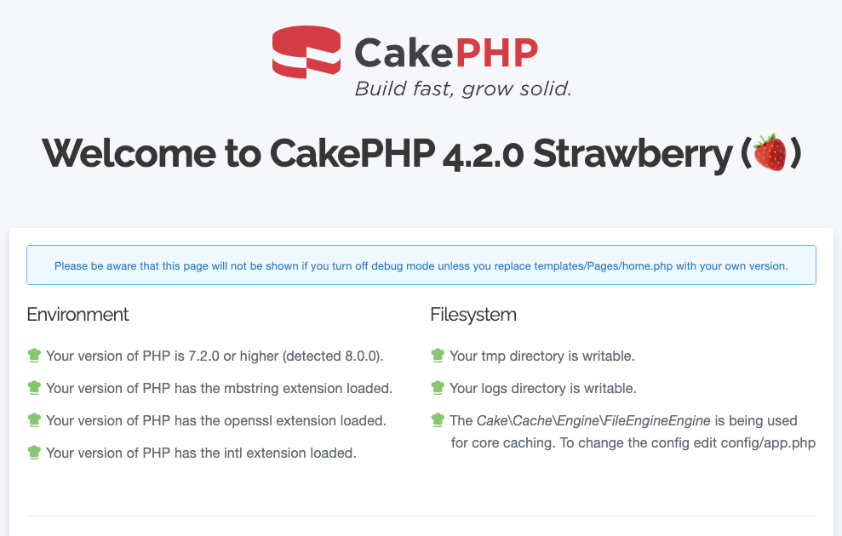

FuelPHP 1.8
On this page, we explain step by step how to setup FuelPHP 1.8 with CloudPanel.

Installation#
In the following example we will setup FuelPHP under the domain www.domain.com.

Preparation#
Before we can start with the installation, we need to create an SSH User, a Database, and a Domain.
When you Add the Domain, make sure to select the FuelPHP 1.8 Vhost Template and the right PHP Version.
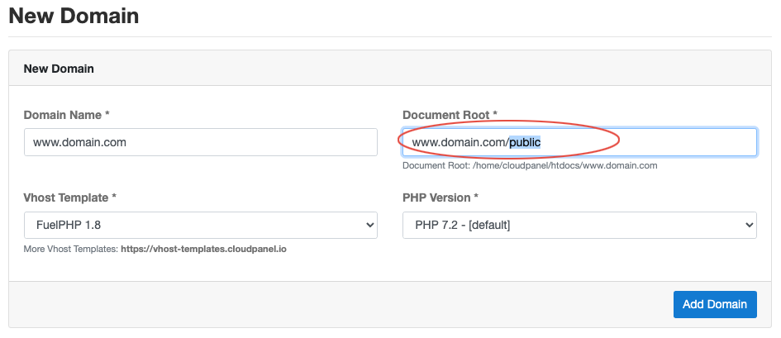

Installation#
To install FuelPHP do the following steps:
- Login via SSH to the server e.g. with john-ssh and go to the users tmp directory:
cd ~/tmp
- Download and extract the latest FuelPHP 1.8 version.
curl -sL https://github.com/fuel/fuel/archive/1.8.2.tar.gz | tar xfz -

Latest Version
You find the latest version on github: https://github.com/fuel/fuel/releases
- Move files to the htdocs directory of the domain:
cp -R fuel-1.8.2/* /home/cloudpanel/htdocs/www.domain.com/
- Install via composer:
cd /home/cloudpanel/htdocs/www.domain.com/
php7.2 /usr/local/bin/composer install
- Reset permissions.
cd /home/cloudpanel/htdocs/
clpctl system:permissions:reset www.domain.com 775
- Clean up the tmp directory.
rm -rf ~/tmp/*
- Done! FuelPHP is now installed.
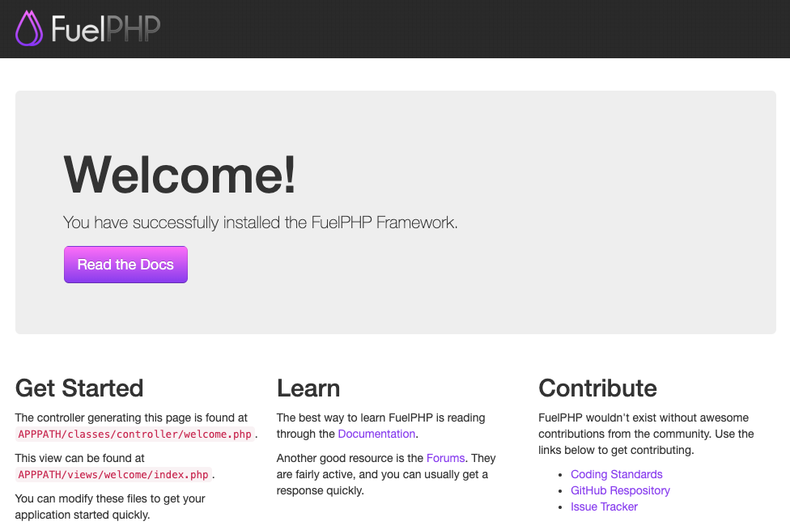

Laravel 8
On this page, we explain step by step how to setup Laravel 8 with CloudPanel.

Installation#
In the following example we will setup Laravel under the domain www.domain.com.

Preparation#
Before we can start with the installation, we need to create an SSH User, a Database, and a Domain.
When you Add the Domain, make sure to select the Laravel 8 Vhost Template and the right PHP Version.
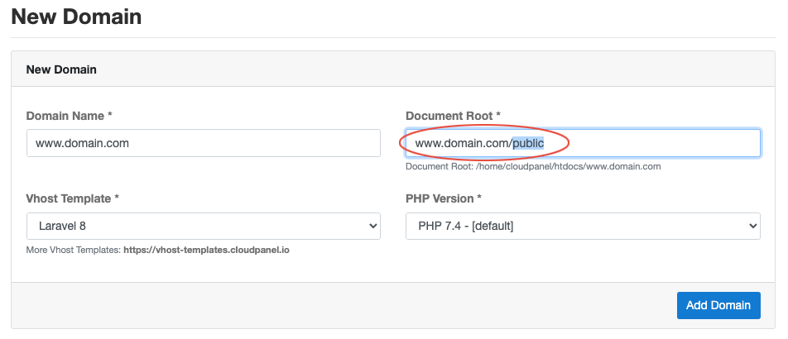

Document Root
Make sure to point the Document Root to the public directory.

Installation#
To install Laravel do the following steps:
- Login via SSH to the server e.g. with john-ssh and go htdocs directory:
cd /home/cloudpanel/htdocs/
- Delete the project directory which has been created by CloudPanel:
rm -rf /home/cloudpanel/htdocs/www.domain.com
- Install via composer:
php7.4 /usr/local/bin/composer create-project --prefer-dist laravel/laravel:^8 www.domain.com
- Reset permissions.
cd /home/cloudpanel/htdocs/
clpctl system:permissions:reset www.domain.com 775
- Done! You can now open your domain in your browser to see the welcome page.
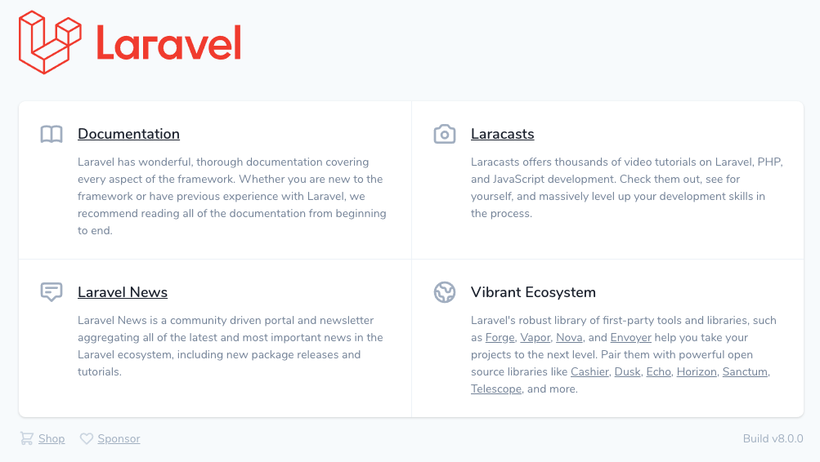

Daemons#
Powered by Supervisor, daemons are used to keep long-running PHP scripts alive.
In case they will be terminated, Supervisor makes sure to restart them automatically.

Installation#
- Login via SSH to the server e.g. as root user.
- Install supervisor
apt install -y supervisor
- Create a supervisor configuration file.
touch /etc/supervisor/conf.d/supervisor.conf
- Open the configuration file and put the following content:
[program:laravel-worker]
process_name=%(program_name)s_%(process_num)02d
command=php7.4 /home/cloudpanel/htdocs/www.domain.com/artisan queue:work redis --sleep=10 --daemon --quiet --queue="default"
numprocs=1
user=john-ssh
autostart=true
autorestart=true
stopsignal=KILL
stdout_logfile=/var/log/supervisor/laravel-worker.log

Attention
Make sure that the php version and the user are correct to avoid permission problems.

tip
For consuming messages in parallel, e.g., when you are working with rabbitMQ, you may increase numprocs.
- Update the configuration and start the worker.
supervisorctl reread
supervisorctl update
supervisorctl start laravel-worker:*
With the command supervisorctl you get information about the status, pid, and uptime.

Nodejs
On this page, we explain step by step how to setup a Nodejs App with CloudPanel.

Installation#
In the following example, we will setup a Nodejs under the domain www.domain.com.

Preparation#
Before we can start with the installation, we need to create an SSH User and a Domain.
When you Add the Domain, make sure to select the Nodejs Vhost Template.
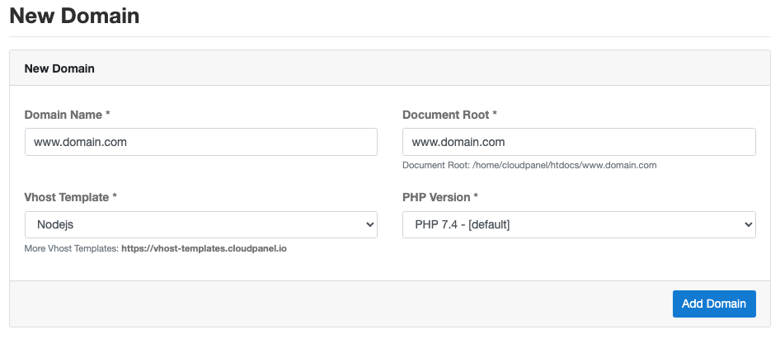

Application Port#
By default, all requests are forwarded to port 3000 via reverse proxy.
If your Nodejs App is running under another port, you can change it easily in the Vhost Editor of your domain.
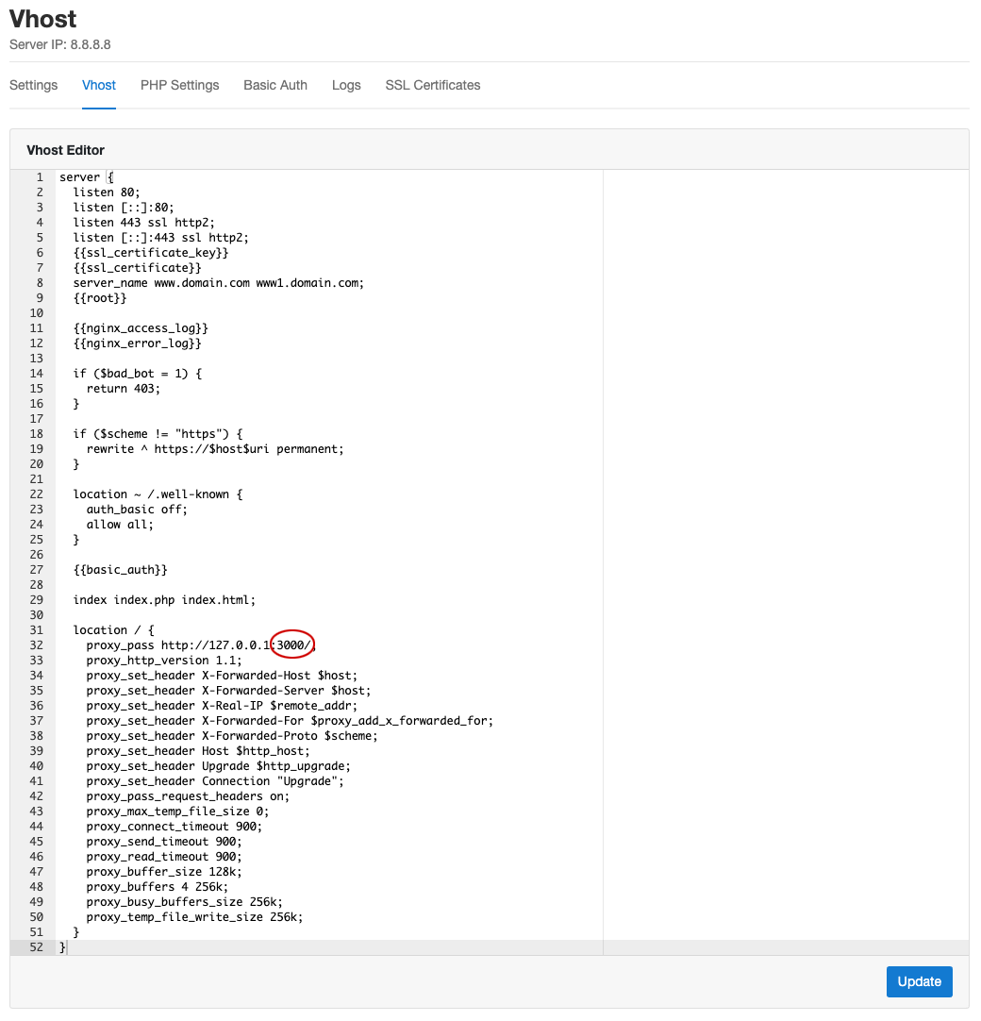

Production Deployment#
For running a NodeJs App in production it's recommended to use a process control system like supervisor, which restarts the node processes automatically in case of a failure.

Setup Supervisor#
- Install the supervisor package:
apt update && apt -y install supervisor
- Create a supervisor configuration file:
touch /etc/supervisor/conf.d/nodejs-app.conf
- Open the configuration file and put the following content:
[program:nodejs-app]
process_name=%(program_name)s_%(process_num)02d
command=/usr/bin/node /home/cloudpanel/htdocs/www.domain.com/app.js
numprocs=1
user=john-ssh
autostart=true
autorestart=true
stopsignal=KILL
stdout_logfile=/var/log/supervisor/nodejs-app.log

Attention
Make sure that the user is correct to avoid permission problems.
- Update the configuration and start the node processes:
supervisorctl reread
supervisorctl update
supervisorctl start nodejs-app:*
With the command supervisorctl you get information about the status, pid, and uptime:

Troubleshooting#
You may want to see what happens in the background; you can do that by tailing the log file:
tail -f /var/log/supervisor/nodejs-app.log -n1000

Strapi 3
On this page, we explain step by step how to setup Strapi 3 with CloudPanel.

Installation#
In the following example we will setup Strapi under the subdomain api.domain.com.

Preparation#
Before we can start with the installation, we need to create an SSH User and a Domain.
When you Add the Domain, make sure to select the Strapi 3 Vhost Template.
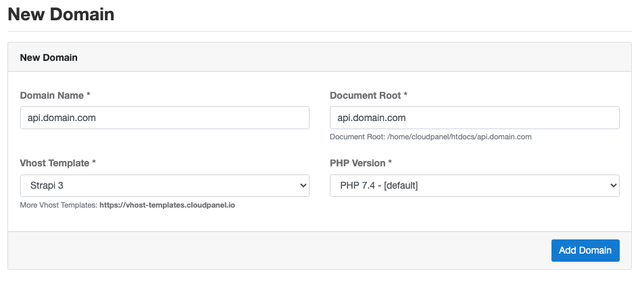

Installation#
To install Strapi do the following steps:
- In the first step, we need to downgrade (as root user) Node.js to version 12.x:
Open the nodesource list file:
nano /etc/apt/sources.list.d/nodesource.list
Replace:
deb https://deb.nodesource.com/node_14.x buster main
deb-src https://deb.nodesource.com/node_14.x buster main
With:
deb https://deb.nodesource.com/node_12.x buster main
deb-src https://deb.nodesource.com/node_12.x buster main
- Update the package sources and remove the old Node.js version:
apt update && dpkg -r --force-depends nodejs
- Install Node.js Version 12.x:
apt -y install nodejs
- Login via SSH to the server e.g. with john-ssh and go htdocs directory:
cd /home/cloudpanel/htdocs/
- Delete the project directory which has been created by CloudPanel:
rm -rf /home/cloudpanel/htdocs/api.domain.com
- We create the Strapi app via yarn:
yarn create strapi-app api.domain.com --quickstart
- Done! Open the admin url in your browser to create an admin user: https://api.domain.com/admin
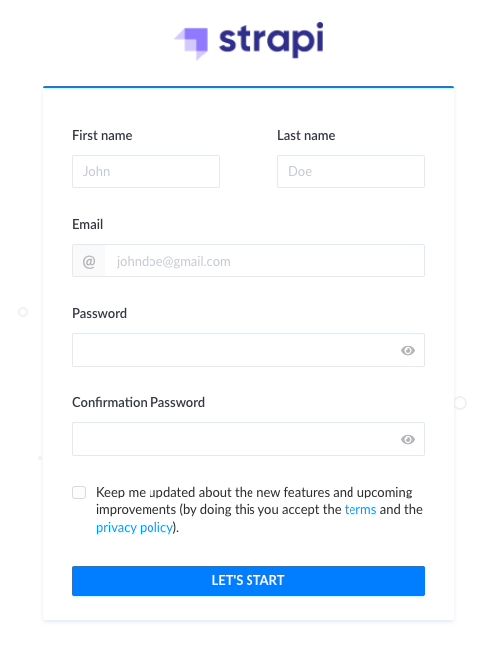

Development#
For the development, you can start Strapi from the commandline with a detailed output:
- Login via SSH to the server e.g. with john-ssh and go the project directory:
cd /home/cloudpanel/htdocs/api.domain.com/
- Start Strapi via yarn:
yarn develop

Production Deployment#
For running Strapi in production it's recommended to use a process control system like supervisor, which restarts the node processes automatically in case of a failure.

Setup Supervisor#
- Got to the project directory and build Strapi with user john-ssh:
cd /home/cloudpanel/htdocs/api.domain.com/ && NODE_ENV=production yarn build
- Install the supervisor package:
apt update && apt -y install supervisor
- Create a supervisor configuration file.
touch /etc/supervisor/conf.d/strapi-api.conf
- Open the configuration file and put the following content:
[program:strapi-api]
process_name=%(program_name)s_%(process_num)02d
environment=NODE_ENV=production
command=/usr/bin/yarn --cwd /home/cloudpanel/htdocs/api.domain.com/ start
numprocs=1
user=john-ssh
autostart=true
autorestart=true
stopsignal=KILL
stdout_logfile=/var/log/supervisor/strapi-api.log

Attention
Make sure that the user is correct to avoid permission problems.
- Update the configuration and start the node processes :
supervisorctl reread
supervisorctl update
supervisorctl start strapi-api:*
With the command supervisorctl you get information about the status, pid, and uptime:

Troubleshooting#
You may want to see what happens in the background; you can do that by tailing the log file:
tail -f /var/log/supervisor/strapi-api.log -n1000

Joomla 3.9
On this page, we explain step by step how to setup Joomla 3.9 with CloudPanel.

Installation#
In the following example we will setup Joomla under the domain www.domain.com.

Preparation#
Before we can start with the installation, we need to create an SSH User, a Database, and a Domain.
When you Add the Domain, make sure to select the Joomla 3.9 Vhost Template and the right PHP Version.
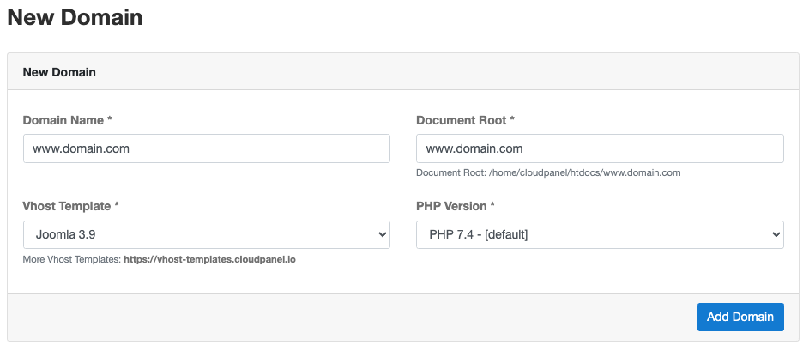

Installation#
To install Joomla do the following steps:
- Login via SSH to the server e.g. with john-ssh and go to the users tmp directory:
cd ~/tmp
- Download and extract the latest Joomla 3.9 version.
mkdir ~/tmp/joomla-3.9 && curl -sL https://downloads.joomla.org/cms/joomla3/3-9-25/Joomla_3-9-25-Stable-Full_Package.tar.gz | tar xfz - -C ~/tmp/joomla-3.9/
- Move files to the htdocs directory of the domain:
cp -R joomla-3.9/* /home/cloudpanel/htdocs/www.domain.com/
- Reset permissions.
cd /home/cloudpanel/htdocs/
clpctl system:permissions:reset www.domain.com 775
- Clean up the tmp directory.
rm -rf ~/tmp/*
- Open your domain in the browser and go through the installation wizard.
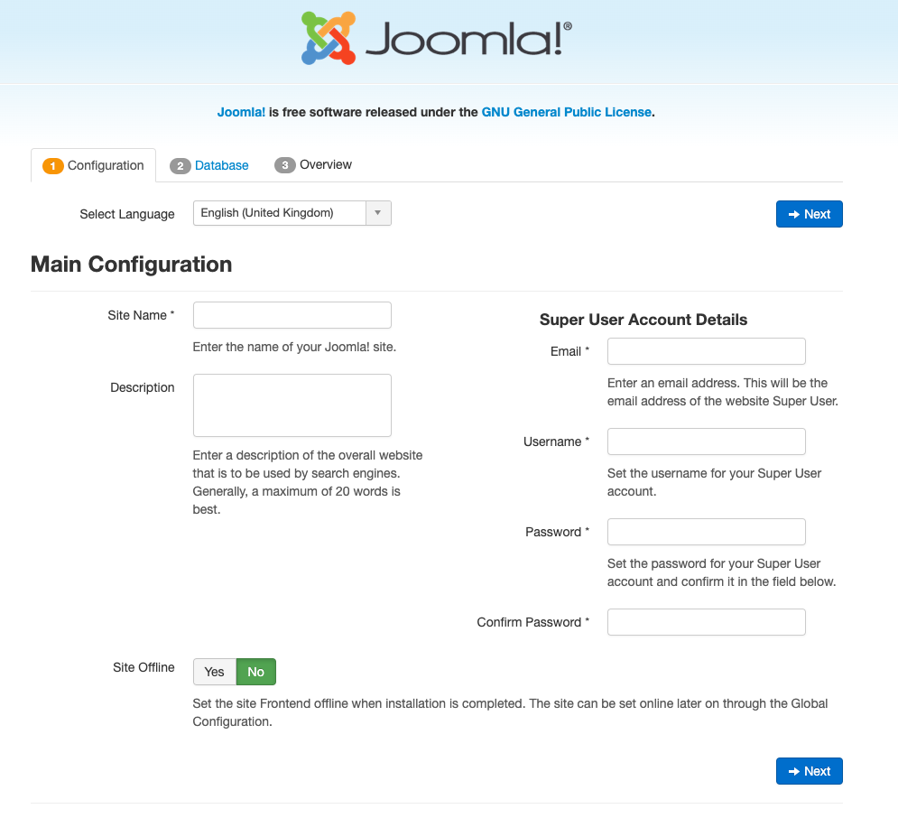
- Done! Joomla 3.9 is now installed.
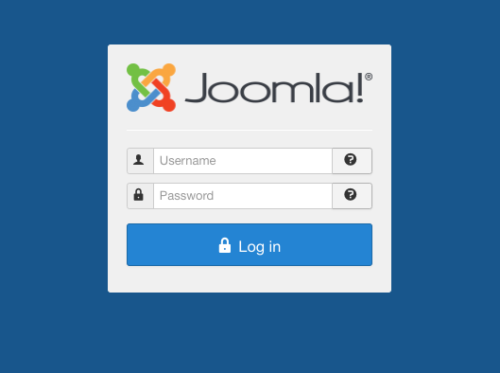

WordPress 5
On this page, we explain step by step how to setup WordPress 5 with CloudPanel.

Installation#
In the following example we will setup WordPress under the domain www.domain.com.

Preparation#
Before we can start with the installation, we need to create an SSH User, a Database, and a Domain.
When you Add the Domain, make sure to select the WordPress 5 Vhost Template and the right PHP Version.
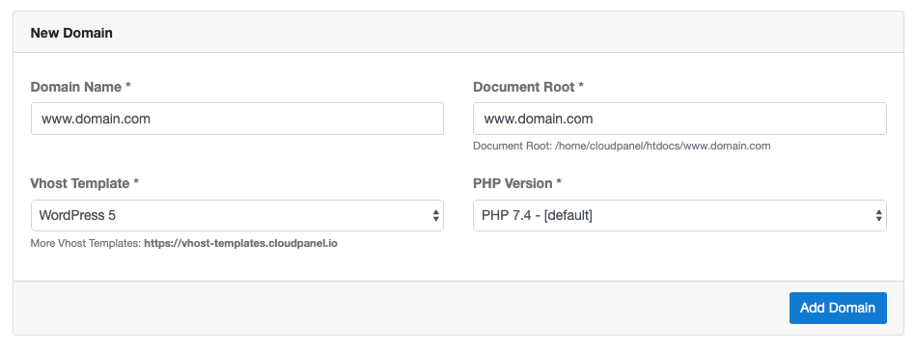

Installation#
To install WordPress do the following steps:
- Login via SSH to the server e.g. with john-ssh and go to the users tmp directory:
cd ~/tmp
- Download and extract the latest WordPress 5 version.
curl -sL https://wordpress.org/latest.tar.gz | tar xfz -
- Move files to the htdocs directory of the domain:
cp -R wordpress/* /home/cloudpanel/htdocs/www.domain.com/
- Reset permissions.
cd /home/cloudpanel/htdocs/
clpctl system:permissions:reset www.domain.com 775
- Clean up the tmp directory.
rm -rf ~/tmp/*
- Open your domain in the browser and go through the Installation Wizard.
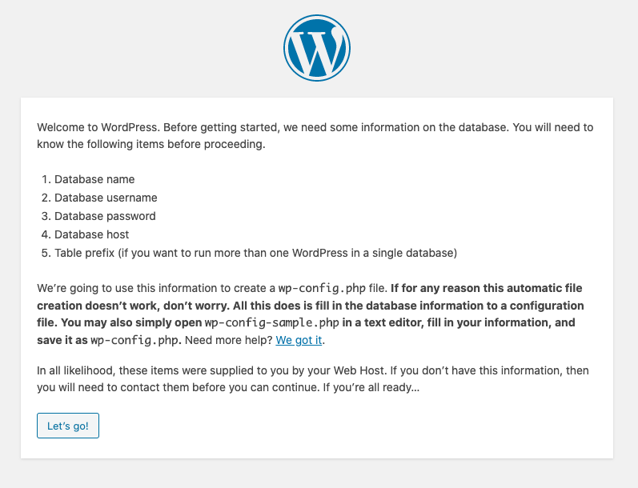
- Open the WordPress configuration file wp-config.php.
nano /home/cloudpanel/htdocs/www.domain.com/wp-config.php
Add the following line after the other constants to download all plugins and themes to the disk.
define('FS_METHOD','direct');
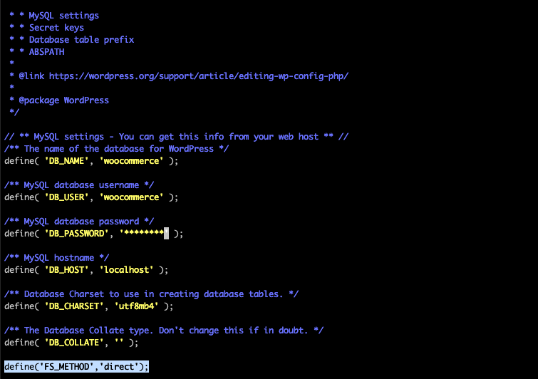
- Done!

Other
On this page, we explain how to set up other PHP Applications with CloudPanel.

Installation#
In the following example we will setup a PHP Application under the domain www.domain.com.

Domain#
When you Add the Domain, make sure to select the Generic Vhost Template and the right PHP Version.
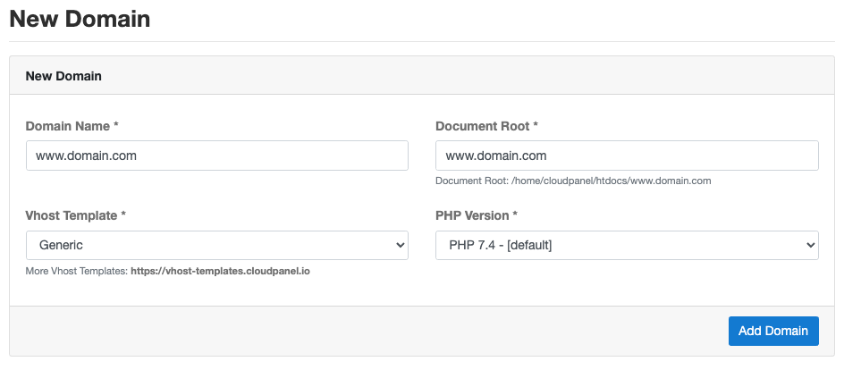

Document Root
Make sure to point the Document Root to the right directory, some applications using public or other directories as Document Root.

Vhost#
After Adding the Domain, you can make changes on the Vhost to your needs like adding application-specific rules.
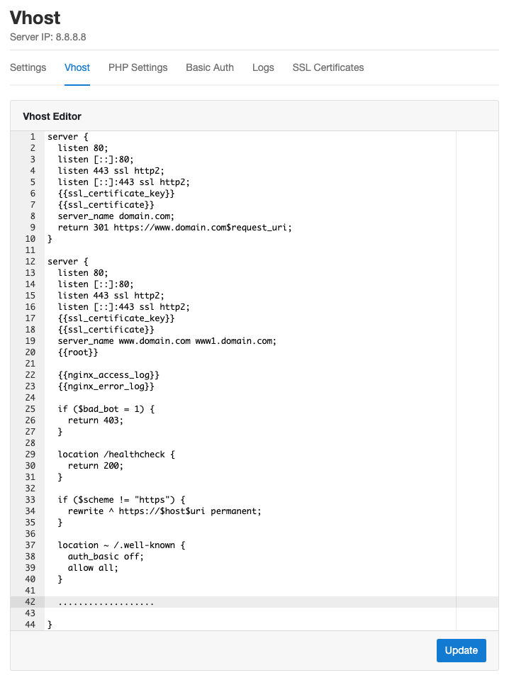

Neos 7
On this page, we explain step by step how to setup Neos 7 with CloudPanel.

Installation#
In the following example we will setup Neos under the domain www.domain.com.

Preparation#
Before we can start with the installation, we need to create an SSH User, a Database, and a Domain.
When you Add the Domain, make sure to select the Neos 7 Vhost Template and the right PHP Version.
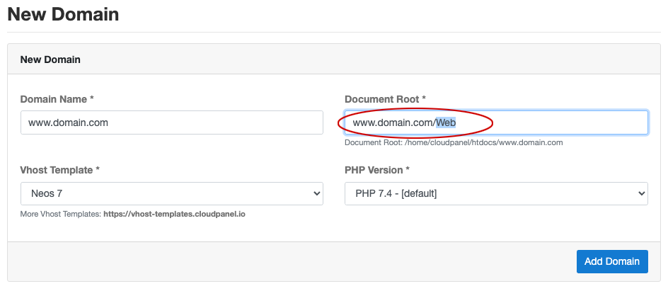

Document Root
Make sure to point the Document Root to the Web directory.

Installation#
To install Neos do the following steps:
- Login via SSH to the server e.g. with john-ssh and go htdocs directory:
cd /home/cloudpanel/htdocs/
- Delete the project directory which has been created by CloudPanel:
rm -rf /home/cloudpanel/htdocs/www.domain.com
- Install via composer:
php7.4 /usr/local/bin/composer create-project neos/neos-base-distribution:~7 www.domain.com
- Reset permissions.
cd /home/cloudpanel/htdocs/
clpctl system:permissions:reset www.domain.com 775
- Open your domain in the browser and start the setup process: https://www.domain.com/setup/
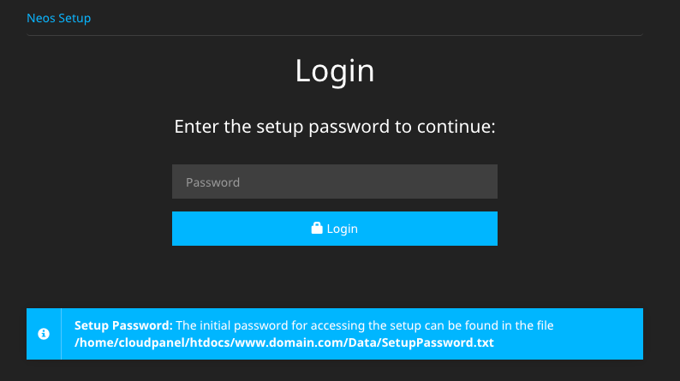
Enter the Setup Password to start the installation process.
The Setup Password can be displayed with the following command:
cat /home/cloudpanel/htdocs/www.domain.com/Data/SetupPassword.txt
- Go through all setup steps to finish the installation.
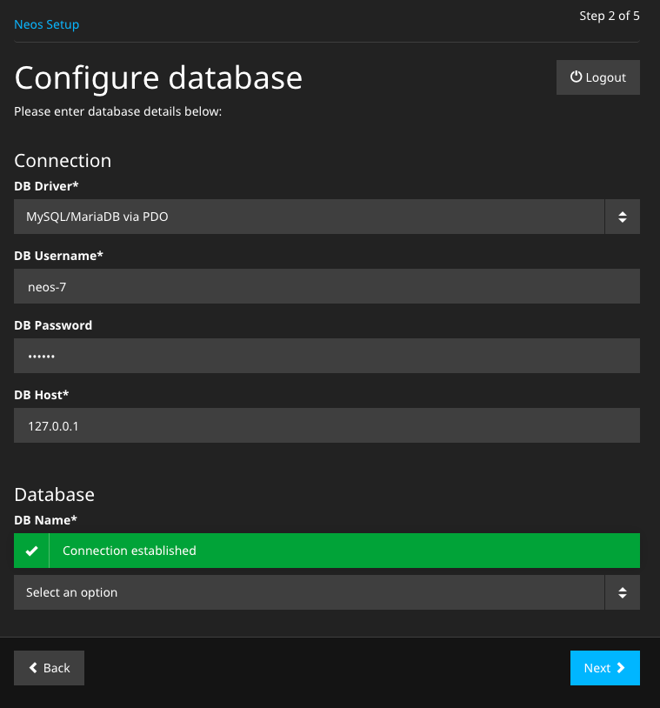
- Done! Neos is now installed.

Aplicativos

https://www.cloudpanel.io/docs/cloudpanel-ce/introduction
Clicar em Applications à esquerda

Guias

CloudPanel under its own domain
On this page, you will find a guide on how to run CloudPanel under its own domain with a Let's Encrypt certificate.
- Add the Domain cp.domain.com and select the Generic Vhost Template.
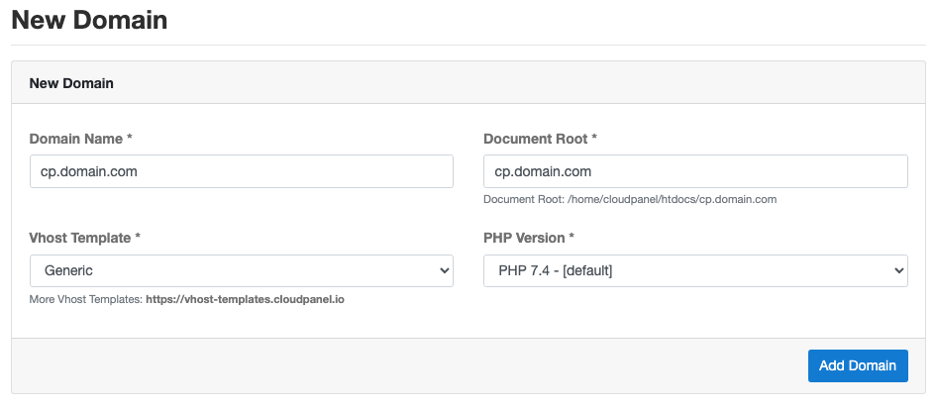
- Go to the Vhost Editor of the domain and replace the template with the following one:
server {
listen 80;
listen [::]:80;
listen 443 ssl http2;
listen [::]:443 ssl http2;
{{ssl_certificate_key}}
{{ssl_certificate}}
server_name cp.domain.com;
{{root}}
{{nginx_access_log}}
{{nginx_error_log}}
if ($bad_bot = 1) {
return 403;
}
if ($scheme != "https") {
rewrite ^ https://$host$uri permanent;
}
#if ($http_x_forwarded_proto != https) {
# return 301 https://$host$request_uri;
#}
#if ($http_x_forwarded_proto ~ https) {
# set $fastcgi_https on;
#}
location ~ /.well-known {
auth_basic off;
allow all;
}
location / {
proxy_set_header Host $http_host;
proxy_set_header X-Real-IP $remote_addr;
proxy_set_header X-Forwarded-For $remote_addr;
proxy_set_header X-Forwarded-Host $http_host;
proxy_pass https://127.0.0.1:8443/;
proxy_max_temp_file_size 0;
proxy_connect_timeout 7200;
proxy_send_timeout 7200;
proxy_read_timeout 7200;
proxy_buffer_size 128k;
proxy_buffers 4 256k;
proxy_busy_buffers_size 256k;
proxy_temp_file_write_size 256k;
}
}
This Vhost Template is using a reverse proxy to forward all requests to the CloudPanel port 8443.

caution
Make sure that your domain is set as server_name.
If you are using Cloudflare, comment the following lines in the Vhost Template:
#if ($scheme != "https") {
# rewrite ^ https://$host$uri permanent;
#}
and uncomment the following ones:
if ($http_x_forwarded_proto != https) {
return 301 https://$host$request_uri;
}
if ($http_x_forwarded_proto ~ https) {
set $fastcgi_https on;
}
- Issue a Let's Encrypt Certificate for your domain.
- Done. CloudPanel is now accessible via https://cp.domain.com

MySQL Commands
On this site, you will find useful MySQL Commands like exporting and importing/restoring databases.

Export#
To export a database, you can use the CloudPanel CLI or the mysqldump client utility.
The CloudPanel CLI uses mysqldump under the hood.
To export a database, do the following steps:
- First, you need to get the database master credentials. Execute the following command as root user:
clpctl db:show:credentials
The output will look like the following image:
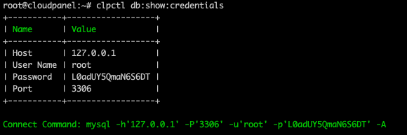
- With the database master credentials, you can export a database:
mysqldump -h127.0.0.1 -uroot -p --opt --single-transaction --quick $databaseName > dump.sql

Import#
To import a database dump, you can use the CloudPanel CLI or the mysql command.
To prevent permission problems, you should use the database master credentials for importing a database.
- To get the database master credentials. Execute the following command as root user:
clpctl db:show:credentials
- Use the following command to import the database dump in your database:
mysql-h127.0.0.1 -uroot -p $databaseName < dump.sql

MySQL Configuration

Configuration#
To make changes on the MySQL Configuration, do the following:
- Open the configuration file as root user:
nano /etc/mysql/my.cnf
- Make changes e.g, adjusting some parameters like innodb_buffer_pool_size.
- Restart MySQL to apply changes:
systemctl restart mysql

Slow Query Log#
The Slow Query Log is useful to log consists of SQL statements that take more than long_query_time seconds to execute.
To enable the Slow Query Log, do the following:
- Open the configuration file file.
- Uncomment the following lines by removing the semicolon in the front:
;slow_query_log=1
;slow_query_log_file=/var/log/mysql/slow.log
;long_query_time=2
- Restart MySQL to apply changes:
systemctl restart mysql

PageSpeed Module

ARM64
The PageSpeed Module is only available for X86 and not yet for ARM64.
On this site, you will find a step by step guide on enabling and using the PageSpeed Module from Google.
The Pagespeed Module is already compiled and shipped with CloudPanel and can be used right away.
The PageSpeed Module for NGINX improves the performance of your site by:
- Combining CSS
- Combining Javascript
- Minifying HTML
- Defer JavaScript
- Optimize Images
- Rewriting Images
- Layz Loading Images
- Rewriting Javascript
- And many more

Enabling the PageSpeed Module#
The PageSpeed Module needs to be enabled in the NGINX Vhost on domain level.
- Go to the Vhost of your domain and add the following lines:
include /etc/nginx/pagespeed.conf;
pagespeed on;
pagespeed FileCachePath "/home/cloudpanel/htdocs/domain.com/wp-content/cache/ngx_pagespeed/";

WordPress
If you have selected the WordPress Vhost Template, then lines already exist. Remove the # to enable it.
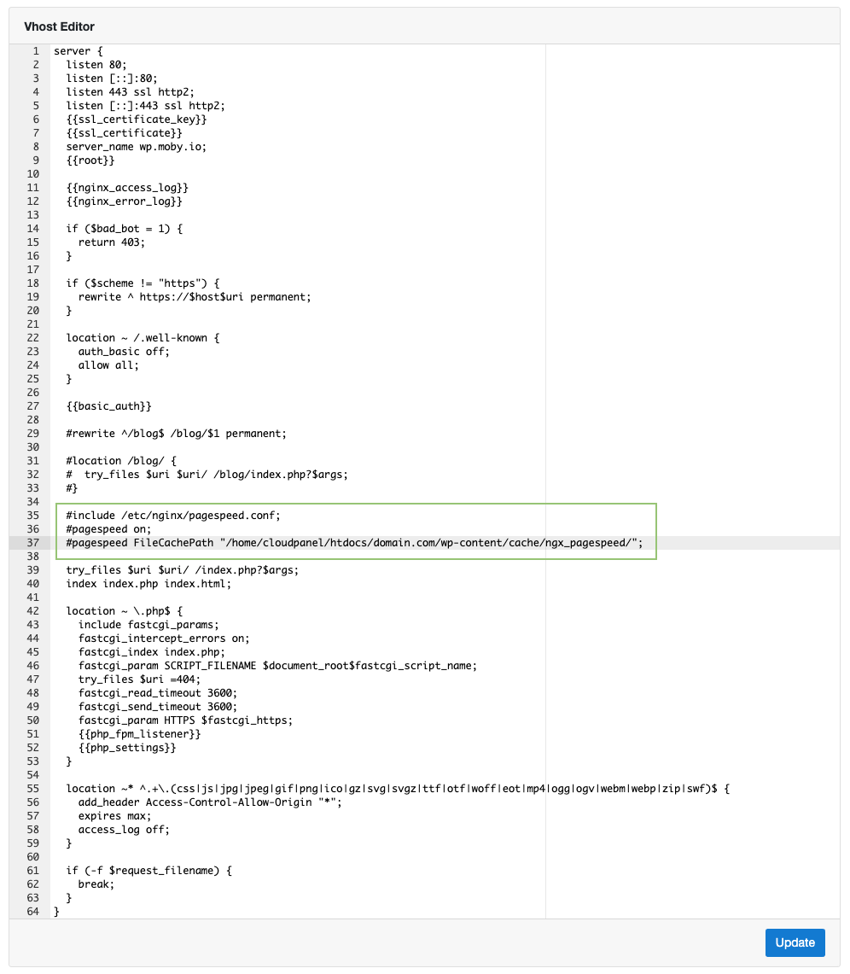
- Change the FileCachePath to your WordPress installation.
- Click on the button Update to enable the PageSpeed Module.

Configuration#
The configuration of the PageSpeed Module can be found in the following file:
/etc/nginx/pagespeed.conf

Testing#
After enabling the PageSpeed Module, you should see your website is loading faster because it's about 40% smaller. All CSS, Javascript, and Images are compressed and optimized.
By checking the page source or the requests with the Chrome Dev Tools you see that the CSS, JS, and Images have been optimized by the NGINX Module.
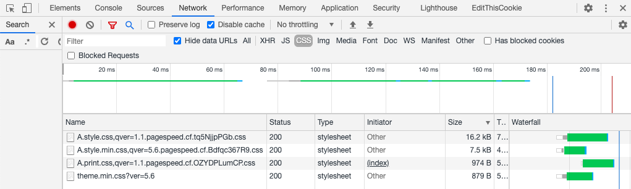

Purging Cache#
The PageSpeed Module can be cleared by deleting all files of the FileCachePath directory that you adjusted.
pagespeed FileCachePath "/home/cloudpanel/htdocs/domain.com/wp-content/cache/ngx_pagespeed/";

Building a PHP Extension
On this site, you find a step-by-step guide on how to build a PHP Extension for a specific PHP Version.

Building a PHP Extension#
- Make a backup of your server.
- Install the dev package for the PHP Version.
apt update && apt install -y php7.4-dev
- Go to https://pecl.php.net/ and search for the extension like ssh2:
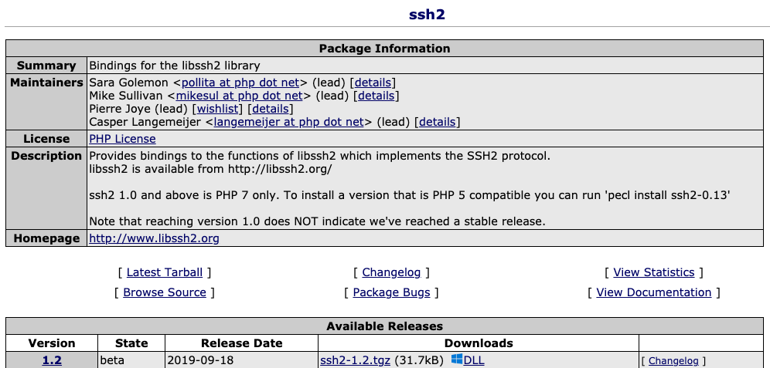
- Download the tgz via cURL:
curl -O https://pecl.php.net/get/ssh2-1.2.tgz
- Extract the tgz:
tar xf ssh2-1.2.tgz
- phpize the extension:
cd ssh2-1.2
phpize7.4
- Compile and build the extension:
./configure
make
make install
- Register the extension for CLI and FPM in the php.ini:
CLI
nano /etc/php/7.4/cli/php.ini
Add the following line at the end:
extension=ssh2.so
FPM
nano /etc/php/7.4/fpm/php.ini
Add the following line at the end:
extension=ssh2.so
- Restart the PHP-FPM service:
systemctl restart php7.4-fpm

Testing#
After registering the PHP Extension, you can check if the extension is loaded for CLI and FPM correctly.

CLI#
You can use grep to check if the extension is loaded:
php7.4 -m |grep 'ssh2'
If you don't get an output, then the extension is NOT loaded.

FPM#
To check if the extension is loaded for FPM, you can check the phpinfo.
- Create the file t.php in the root directory.
- Put the following content in the file:
<?php
phpinfo();
- Open t.php in your browser and search for the extension.
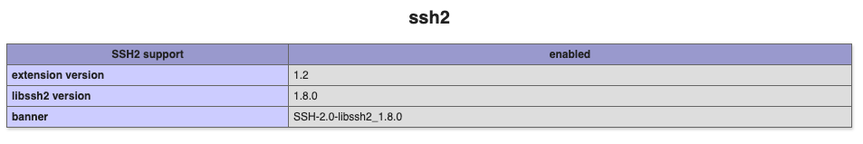
If you don't find information about the extension, then it's NOT loaded.

ionCube Loader
Using ionCube encoded and secured PHP files requires a file called the ionCube Loader to be installed on the web server and made available to PHP.

Enable Loader#
The ionCube Loader extension is being shipped by default for all PHP Versions but disabled for performance reasons.
To enable ionCube Loader for a specific PHP Version, you need to enable it for CLI and FPM:
- Open the php.ini for the CLI and FPM:
nano /etc/php/7.4/cli/php.ini
nano /etc/php/7.4/fpm/php.ini
- Go to the end of the file and remove the semicolon in the beginning.
;zend_extension=ioncube_loader_lin_7.4.so
- Restart the PHP-FPM service:
systemctl restart php7.4-fpm

Opcache Preload
With >= PHP 7.4, support for opcache preloading was added, a feature that improves the application start performance up to 60%.

caution
Keep in mind that it's a very new feature that might not be bug-free.

Configuration#
Some frameworks like Symfony are already providing scripts for preloading the entire code base to improve the performance.
- Open the php.ini of your PHP Version:
sudo nano /etc/php/7.4/fpm/php.ini
- Search for opcache.preload_user and opcache.preload and adjust the values:
opcache.preload_user=clp
opcache.preload=/home/cloudpanel/htdocs/www.domain.com/preload.php
By default, all PHP Versions on CloudPanel have a default PHP-FPM Pool running as user clp and group clp.
If you are using a custom PHP-FPM Pool, change the opcache.preload_user.
- Restart PHP-FPM to apply the changes.
sudo systemctl restart php7.4-fpm

Applications#

Symfony#
You may also want to stay up to date with the Symfony Performance recommendations.
; For Symfony 5.1+
opcache.preload=/home/cloudpanel/htdocs/www.domain.com/var/cache/prod/App_KernelProdContainer.preload.php
; For Symfony 4.4 before 4.4.14
opcache.preload=/home/cloudpanel/htdocs/www.domain.com/var/cache/prod/srcApp_KernelProdContainer.preload.php

Laravel 7 & 8#
Download the preload.php for Laravel 7 & 8 from our Github Repository.
cd /home/cloudpanel/htdocs/www.domain.com/
curl -s -o preload.php https://raw.githubusercontent.com/cloudpanel-io/clp-opcache-preloader/master/laravel/preload.php
Set the opcache.preload path:
opcache.preload=/home/cloudpanel/htdocs/www.domain.com/preload.php

Magento 2#
Download the preload.php for Magento 2 from our Github Repository.
cd /home/cloudpanel/htdocs/www.domain.com/
curl -s -o preload.php https://raw.githubusercontent.com/cloudpanel-io/clp-opcache-preloader/master/magento/v2/preload.php
Set the opcache.preload path:
opcache.preload=/home/cloudpanel/htdocs/www.domain.com/preload.php

Other PHP Apps#
You can use the generic preload script and configure it to your needs.
In the bottom of the script, you can add paths to add and ignore.
$clpPreloader = new ClpPreloader();
$clpPreloader->setDebug(false);
$clpPreloader->paths(realpath(__DIR__ . '/src'));
$clpPreloader->paths(realpath(__DIR__ . '/vendor'));
$clpPreloader->ignore(realpath(__DIR__ . '/vendor/twig/twig'));
$clpPreloader->preload();

Testing#
To test if the opcache preloading is working as expected we can check the output of opcache_get_status().
- Create a file like t.php in your document root:
nano /home/cloudpanel/htdocs/www.domain.com/public/t.php
- Add the lines of php code:
<?php
echo '<pre>';
print_r(opcache_get_status());
echo '</pre>';
- Restart the PHP-FPM service to clear and preload the opcode cache:
sudo systemctl restart php7.4-fpm
- Open the file in the browser. The output will look like this:
Array
(
[opcache_enabled] => 1
[cache_full] =>
[restart_pending] =>
[restart_in_progress] =>
[memory_usage] => Array
(
[used_memory] => 28023040
[free_memory] => 777282624
[wasted_memory] => 704
[current_wasted_percentage] => 8.7420145670573E-5
)
[interned_strings_usage] => Array
(
[buffer_size] => 6291008
[used_memory] => 4359696
[free_memory] => 1931312
[number_of_strings] => 56348
)
[opcache_statistics] => Array
(
[num_cached_scripts] => 1000
[num_cached_keys] => 1000
[max_cached_keys] => 130987
[hits] => 128
[start_time] => 1611310634
[last_restart_time] => 0
[oom_restarts] => 0
[hash_restarts] => 0
[manual_restarts] => 0
[misses] => 25
[blacklist_misses] => 0
[blacklist_miss_ratio] => 0
[opcache_hit_rate] => 83.660130718954
)
[preload_statistics] => Array
(
[memory_consumption] => 12108632
[functions] => Array
(
[0] => Symfony\Component\Routing\{closure}
[1] => Symfony\Component\Routing\{closure}
[2] => Symfony\Bundle\WebProfilerBundle\Csp\{closure}
[3] => Symfony\Component\VarDumper\Dumper\ContextProvider\{closure}
[4] => Symfony\Component\VarDumper\Cloner\{closure}
[5] => Symfony\Component\Validator\{closure}
[6] => Symfony\Component\Translation\{closure}
[7] => Symfony\Component\String\{closure}
[8] => Symfony\Component\String\{closure}
[9] => Symfony\Component\String\{closure}
[10] => Symfony\Component\String\{closure}
[11] => Symfony\Component\String\{closure}
[12] => Symfony\Component\String\{closure}
[13] => Symfony\Component\String\{closure}
[14] => Symfony\Component\String\{closure}
[15] => Symfony\Component\String\{closure}
[16] => Symfony\Component\String\{closure}
[17] => Symfony\Component\String\{closure}
[18] => Symfony\Component\String\Slugger\{closure}
[19] => Symfony\Component\HttpKernel\EventListener\{closure}
[20] => Symfony\Component\HttpFoundation\Session\Storage\{closure}
[21] => Sensio\Bundle\FrameworkExtraBundle\EventListener\{closure}
[22] => Sensio\Bundle\FrameworkExtraBundle\Security\{closure}
[23] => Sensio\Bundle\FrameworkExtraBundle\Security\{closure}
[24] => Sensio\Bundle\FrameworkExtraBundle\EventListener\{closure}
[25] => Sensio\Bundle\FrameworkExtraBundle\Request\ParamConverter\{closure}
[26] => Sensio\Bundle\FrameworkExtraBundle\EventListener\{closure}
[27] => Symfony\Bundle\SecurityBundle\Security\{closure}
..........
As expected, we see all classes and functions are preloaded into the opcache.

CLP E-Mail Sender From
CLP E-Mail Sender From is a WordPress plugin to change the E-Mail from Name and Address.
Services like Amazon SES require to send E-Mails from verified Domains.
You may be interested in: How to configure Amazon SES with Postfix

Installation#
- Clone the CLP E-Mail Sender From Git Repository:
git clone https://github.com/cloudpanel-io/clp-email-sender-from
- Copy the file clp-email-sender-from.php to the directory wp-content/plugins/.
- Active the plugin in your Wordpress Admin:
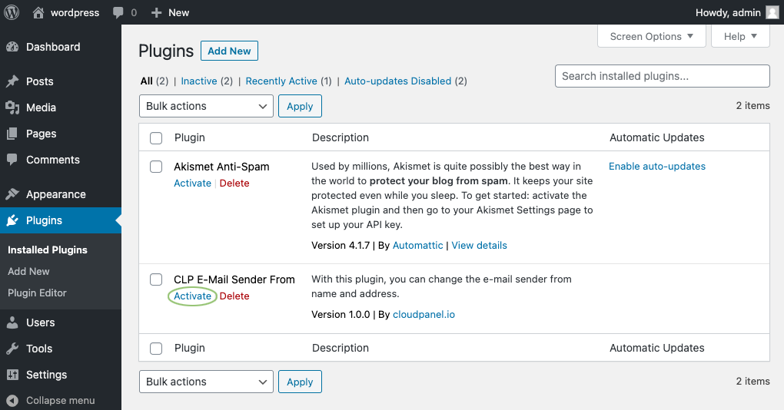
- Go to Settings -> General and set From Name and From E-Mail and click on the button Saves Changes.
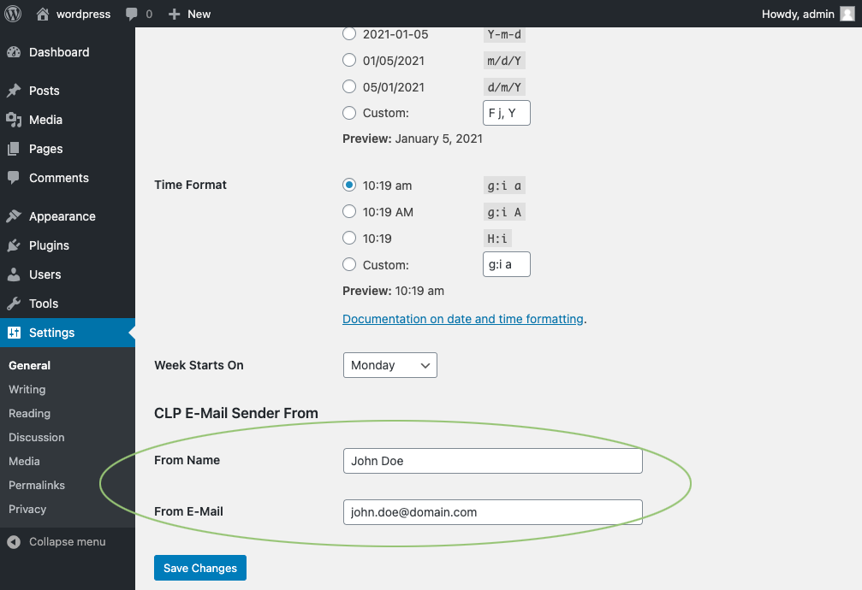

Changelog#
v1.0.0 - [2021-01-05]
- Initial Version

