How to Install and Configure Fail2ban on Ubuntu 20.04
Posted
•
5 min read

Any service that is exposed to the Internet is at risk of malware attacks. For example, if you are running a service on a publicly available network, attackers can use brute-force attempts to sign in to your account.
Fail2ban is a tool that helps protect your Linux machine from brute-force and other automated attacks by monitoring the services logs for malicious activity. It uses regular expressions to scan log files. All entries matching the patterns are counted, and when their number reaches a certain predefined threshold, Fail2ban bans the offending IP using the system firewall for a specific length of time. When the ban period expires, the IP address is removed from the ban list.
This article describes how to install and configure Fail2ban on Ubuntu 20.04.

Installing Fail2ban on Ubuntu
The Fail2ban package is included in the default Ubuntu 20.04 repositories. To install it, enter the following command as root or user with sudo privileges :
sudo apt updatesudo apt install fail2ban
Once the installation is completed, the Fail2ban service will start automatically. You can verify it by checking the status of the service:
sudo systemctl status fail2ban
The output will look like this:
● fail2ban.service - Fail2Ban Service
Loaded: loaded (/lib/systemd/system/fail2ban.service; enabled; vendor preset: enabled)
Active: active (running) since Wed 2020-08-19 06:16:29 UTC; 27s ago
Docs: man:fail2ban(1)
Main PID: 1251 (f2b/server)
Tasks: 5 (limit: 1079)
Memory: 13.8M
CGroup: /system.slice/fail2ban.service
└─1251 /usr/bin/python3 /usr/bin/fail2ban-server -xf start
That’s it. At this point, you have Fail2Ban running on your Ubuntu server.

Fail2ban Configuration
The default Fail2ban installation comes with two configuration files, /etc/fail2ban/jail.conf and /etc/fail2ban/jail.d/defaults-debian.conf. It is not recommended to modify these files as they may be overwritten when the package is updated.
Fail2ban reads the configuration files in the following order. Each .local file overrides the settings from the .conf file:
- /etc/fail2ban/jail.conf
- /etc/fail2ban/jail.d/*.conf
- /etc/fail2ban/jail.local
- /etc/fail2ban/jail.d/*.local
For most users, the easiest way to configure Fail2ban is to copy the jail.conf to jail.local and modify the .local file. More advanced users can build a .local configuration file from scratch. The .local file doesn’t have to include all settings from the corresponding .conf file, only those you want to override.
Create a .local configuration file from the default jail.conf file:
sudo cp /etc/fail2ban/jail.{conf,local}
To start configuring the Fail2ban server open, the jail.local file with your text editor :
sudo nano /etc/fail2ban/jail.local
The file includes comments describing what each configuration option does. In this example, we’ll change the basic settings.

Whitelist IP Addresses
IP addresses, IP ranges, or hosts that you want to exclude from banning can be added to the ignoreip directive. Here you should add your local PC IP address and all other machines that you want to whitelist.
Uncomment the line starting with ignoreip and add your IP addresses separated by space:
/etc/fail2ban/jail.local
ignoreip = 127.0.0.1/8 ::1 123.123.123.123 192.168.1.0/24
Copy

Ban Settings
The values of bantime, findtime, and maxretry options define the ban time and ban conditions.
bantime is the duration for which the IP is banned. When no suffix is specified, it defaults to seconds. By default, the bantime value is set to 10 minutes. Generally, most users will want to set a longer ban time. Change the value to your liking:
/etc/fail2ban/jail.local
bantime = 1d
Copy
To permanently ban the IP use a negative number.
findtime is the duration between the number of failures before a ban is set. For example, if Fail2ban is set to ban an IP after five failures (maxretry, see below), those failures must occur within the findtime duration.
/etc/fail2ban/jail.local
findtime = 10m
Copy
maxretry is the number of failures before an IP is banned. The default value is set to five, which should be fine for most users.
/etc/fail2ban/jail.local
maxretry = 5
Copy

Email Notifications
Fail2ban can send email alerts when an IP has been banned. To receive emails, you need to have an SMTP installed on your server and change the default action, which only bans the IP to %(action_mw)s, as shown below:
/etc/fail2ban/jail.local
action = %(action_mw)s
Copy
%(action_mw)s bans the offending IP and sends an email with a whois report. If you want to include the relevant logs in the email, set the action to %(action_mwl)s.
You can also adjust the sending and receiving email addresses:
/etc/fail2ban/jail.local
destemail = admin@linuxize.com

sender = root@linuxize.com
Copy

Fail2ban Jails
Fail2ban uses a concept of jails. A jail describes a service and includes filters and actions. Log entries matching the search pattern are counted, and when a predefined condition is met, the corresponding actions are executed.
Fail2ban ships with a number of jail for different services. You can also create your own jail configurations.
By default, only the ssh jail is enabled. To enable a jail, you need to add enabled = true after the jail title. The following example shows how to enable the proftpd jail:
/etc/fail2ban/jail.local
[proftpd]

port = ftp,ftp-data,ftps,ftps-data
logpath = %(proftpd_log)s
backend = %(proftpd_backend)s
Copy
The settings we discussed in the previous section, can be set per jail. Here is an example:
/etc/fail2ban/jail.local
[sshd]
enabled = true
maxretry = 3
findtime = 1d
bantime = 4w
ignoreip = 127.0.0.1/8 23.34.45.56
Copy
The filters are located in the /etc/fail2ban/filter.d directory, stored in a file with same name as the jail. If you have custom setup and experience with regular expressions you can fine tune the filters.
Each time you edit a configuration file, you need to restart the Fail2ban service for changes to take effect:
sudo systemctl restart fail2ban

Fail2ban Client
Fail2ban ships with a command-line tool named fail2ban-client that you can use to interact with the Fail2ban service.
To view all available options, invoke the command with the -h option:
fail2ban-client -h
This tool can be used to ban/unban IP addresses, change settings, restart the service, and more. Here are a few examples:
- Check the jail status:
sudo fail2ban-client status sshd
- Unban an IP:
sudo fail2ban-client set sshd unbanip 23.34.45.56
- Ban an IP:
sudo fail2ban-client set sshd banip 23.34.45.56

Conclusion
We’ve shown you how to install and configure Fail2ban on Ubuntu 20.04.
For more information on this topic, visit the Fail2ban documentation .
If you have questions, feel free to leave a comment below.
https://linuxize.com/post/install-configure-fail2ban-on-ubuntu-20-04/

How to Install and Configure Fail2ban on Ubuntu 20.04
JH
Joe Harris
October 15, 2020

Fail2ban is designed to protect open ports and running services on the server. It monitors unsuccessful authorization attempts and blocks the source IP address for a certain time. This significantly reduces the likelihood of server hacking due to automatic means, for example, brute force login and password.
In this tutorial we will install and configure Fail2ban on Ubuntu 20.04.
Cloud ServersIntel Xeon Gold 6254 3.1 GHz CPU, SLA 99,9%, 100 Mbps channelfrom4 EUR/month

Fail2ban installation
To install Fail2ban use this command:
apt install fail2ban
It starts automatically after installation. To check the service status use this command:
systemctl status fail2ban

Fail2ban configuration
To change the default ban settings for all services, make a copy of the jail.conf file.
cp /etc/fail2ban/jail.conf /etc/fail2ban/jail.local
Open the jail.local file and go to the [DEFAULT] section. For example, let’s set the ban time to 3600 minutes.
bantime = 3600m
To see all the available rules, go to the JAILS section. For example:
[nginx-http-auth]
After changing the file, restart the service.
systemctl restart fail2ban

Adding and configuring rules
There is a /etc/fail2ban/jail.d/ folder for managing active rules. You can create a separate file for each of them. For example, nginx-http-auth.conf. The second way is to insert configuration into the existing defaults-debian.conf file. Simply add these lines there:
[nginx-http-auth]
enabled = true
You can add individual parameters for each rule here.
Let’s set the IP address to ignore in the ignoreip parameter, the time for the ban is 2400 minutes, and the number of failed authorization attempts is 10.
ignoreip = 10.10.10.5
bantime = 2400m
maxretry = 10
Save and close the file and restart the service.
systemctl restart fail2ban

Using fail2ban-client
There is a Fail2ban client for managing its rules. Keep in mind that all changes made here will be reset after the system reboot or service restart. To view active rules use this command:
fail2ban-client status
To see jail statistics use this command with the name you need instead of sshd:
fail2ban-client status sshd
To activate a rule, use its name from the configuration file and the command:
fail2ban-client add nginx-http-auth
Then start it.
fail2ban-client start nginx-http-auth
To view all available commands:
fail2ban-client -h
https://serverspace.io/support/help/install-configure-fail2ban-ubuntu-20-04/

Installing and Configuring Fail2ban on Ubuntu 20.04
3 months ago
by Younis Said
Fail2ban is a Python-based utility that provides security against cyber attacks like DDoS attacks, bot attacks brute-forcing, and such. It is both free and open-source and can be used on POSIX systems, which include a local firewall.
To summarize how Fail2ban works, it actively looks out for signs of potential password authentication abuses to filter out IP addresses and regularly update the system firewall to suspend these IP addresses for a certain period.
This brief guide will show you how to set up Fail2ban on your Ubuntu 20.04 system.

Update the official package listing
We will be getting fail2ban from the official Ubuntu repositories. Fire up the terminal and enter the following command to update the package listing for the latest available version of Fail2ban:
$ sudo apt update
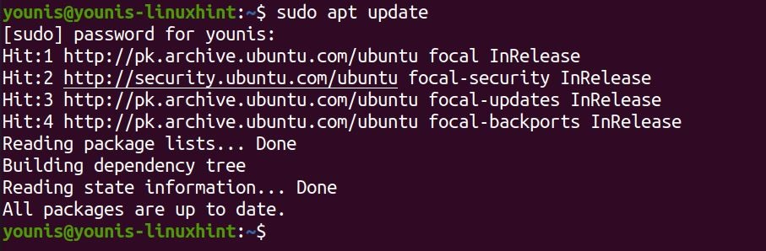

Install Fail2ban
Then, enter the following command to Install the updated Fail2ban package:
$ sudo apt install fail2ban
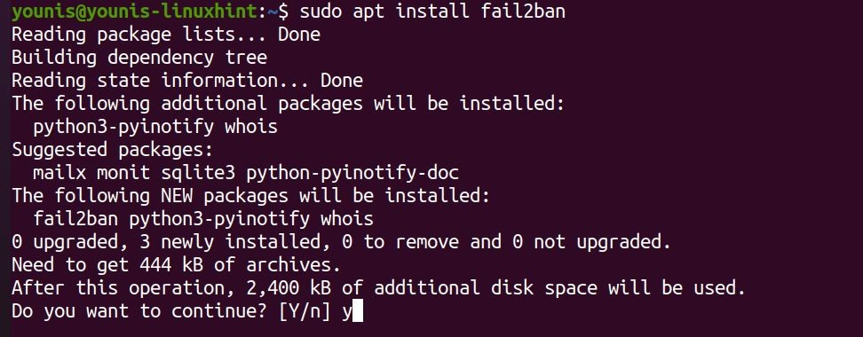
The fail2ban service will activate and launch by itself upon installation.

Verify installation
Still, you should verify if it was installed properly. Run the command below to check the install:
$ sudo systemctl status fail2ban
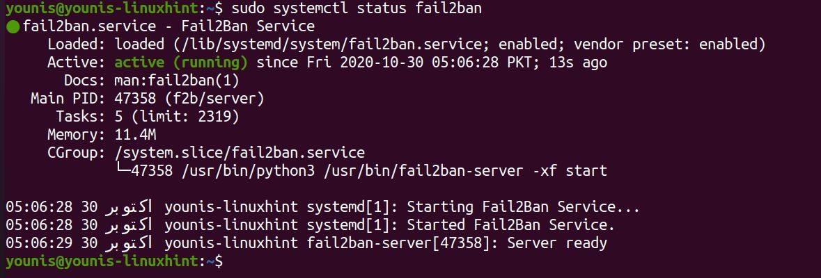
If the Active line in the output contains active (running), you’re all good. Let’s move on and see how to configure Fail2ban.

Configuring Fail2ban on Ubuntu 20.04
To configure Fail2ban on Ubuntu, we will edit two particular configuration files. One is jail.conf in the /etc/fail2ban/ location, and the other is named defaults-debian.conf in /etc/fail2ban/jail.d/. But to maintain their integrity, we will not be editing them directly, as it could potentially break the program, and we most certainly won’t be able to update the software. Instead, we make copies of each and perform editing on them.
Run the command below to copy-paste jail.conf as jail.local:
$ sudo cp /etc/fail2ban/jail.{conf,local}
We will commit ourselves to modify this specific file in this tutorial. Launch the copy in a text editor to start editing. Run the following command:
$ sudo gedit /etc/fail2ban/jail.local
Let’s see what changes we can make.

Configuring IP ban parameters
The ban-time of all IP addresses is set by a parameter known as bantime. The value set for bantime by default is just 10 minutes. You can change set its value to whatever time-limit you want to impose on the banned. For example, to set the bantime for all banned IP addresses, you could set it as:
# bantime = 1d
You can also make permanent bans by assigning a negative value.
Another very important variable is findtime. It defines the time-duration allowed between consecutive login attempts. If the multiple login attempts were made within the time defined by findtime, a ban would be set on the IP.
# findtime = 10m
Lastly, there’s maxretry. It defines the exact number of failed login attempts allowed within the findtime. If the number of failed-authorization attempts within the findtime exceeds the maxretry value, the IP would be banned from logging back in. The default value is 5.
# maxretry = 5
Fail2ban also allows you to grant immunity to IP addresses and IP ranges of your choice. These conditions discussed above won’t be applied to these IPs, essentially letting you create sort of a whitelist.
To add an IP to this whitelist, modify the ignoreip line and type in the IP address to exempt:
# ignoreip = 127.0.0.1/8 ::1 222.222.222.222 192.168.55.0/24
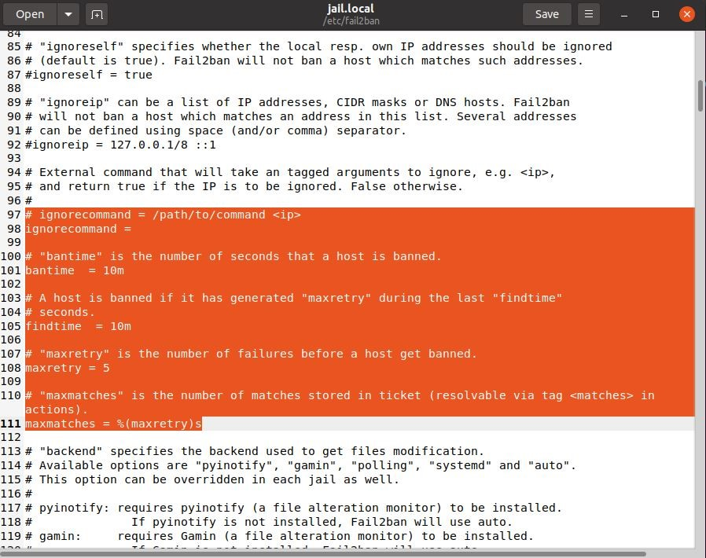
As the administrator, you should add your IP address to this whitelist before anything.

Wrapping up
This tutorial showed you how to set up Fail2ban on Ubuntu. We installed it directly from the Standard Ubuntu repositories. We’ve also looked at how we can configure it and in what ways. You should now know how to set ban conditions and how to exclude IPs from getting the ban.
https://linuxhint.com/install_fail2ban_on_ubuntu_20-04/

