How to set it up

Give the user group permissions to the target table, show target table

Copy the followup folder and place it in the apps folder under the actionpad folder. In the install folder you can find 3 files.

1. followup.html
2. Code_ for_ThisApplication
3. Followup.bas

1. followup.html

Copy the followup.html file and place it under the actionpad folder. 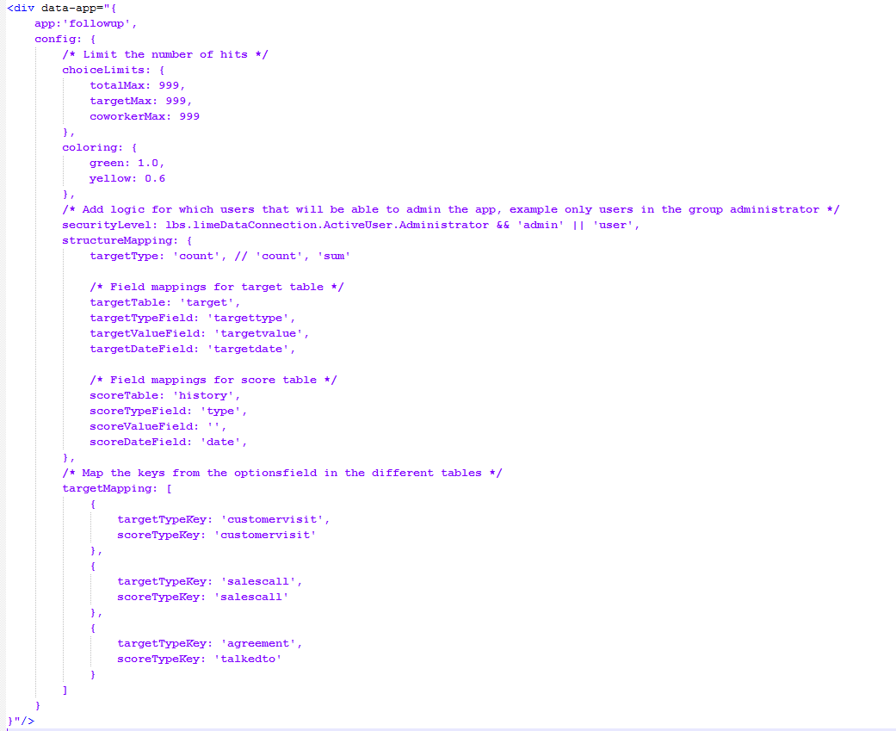

See followup.html for example.

2. Code_ for_ThisApplication

Take the code from the file and paste it in the Setup sub in ThisApplication.

3. Followup.bas

Insert the Followup.bas file in the VBA. Run the sub Install() to create the necessary localization posts for the app.