- Project Report 

Subject: Operating Systems [CP403]

Title: Page Replacement Algorithm Simulation
- FIFO Page Replacement Algorithm
- LRU Page Replacement Algorithm

Guide: Miss Gopi Bhatt

Developer: Samir Solanki [01IT438]

- Overview:

- Page Replacement :
Once the main memory fills up a page must be swapped out to make room for any pages to be swapped in. This is known as page replacement process .
The page-fault service routine will:
- Find the location of the desired page on disk.
- Either find a free frame or create a free frame by selecting a victim frame, writing it to disk, and up-dating the page and frame tables.
- Read the desired page into the free frame.
- Restart the process.
Page replacement requires two page transfers. One approach to reduce this overhead is by using a dirty bit in the page table. When a page is modified the dirty bit is set. Suppose a page fault occurs and a victim is selected. If the bit is not set there is no need to write the page to disk as there already exists the identical page on disk.

- Demand Paging :
  - Frame-allocation algorithm: How many frames do we allocate to each process?
  - Page-replacement algorithm: How do we select the victim to be replaced?

- Page-Replacement Algorithms :
The goal of the page-replacement algorithm is to minimize the page-fault rate. Different algorithms may be compared by computing the number of page faults on a particular reference string. Given the overhead of a page fault, small improvements in the page replacement algorithm will greatly improve the performance of the entire system.
Generally, increasing the number of frames reduces the number of page faults.

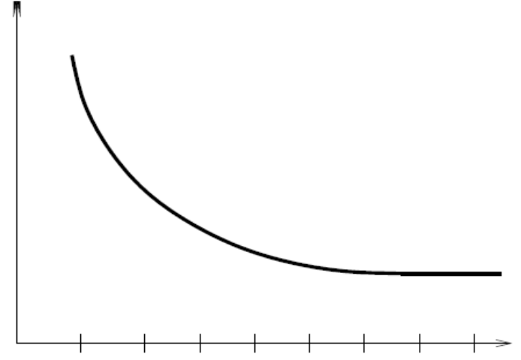
Pages Faults
Frames
- FIFO Page Replacement Algorithm:
FIFO (First In First Out) algorithm is extremely simple. It removes the page with earliest creation time.
This can be implemented using a list. New pages are inserted at the head of the list, and the page at the tail is swapped out.

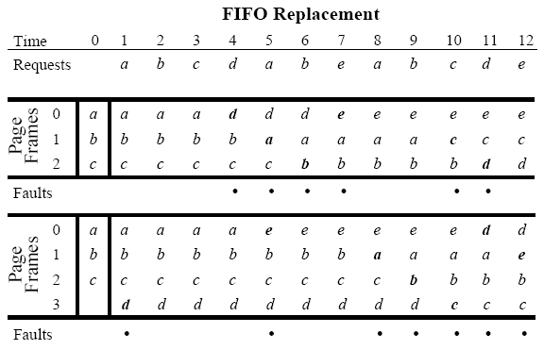

- LRU Page Replacement Algorithm:
The page references that occurred in the recent past are good indicators of what page references will occur in future. That is if a page has just been reference it is likely that it will be referenced again. This gives rise to the least recently used (LRU) algorithm.
The LRU keeps track of how recently a page has been used and keeping the pages that reference is most distant past.

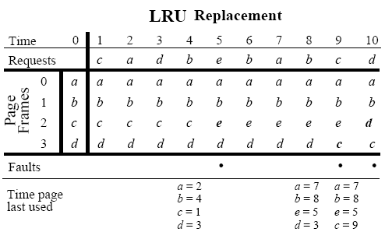

- Program:

1. Class FIFO_Table [FIFO_Table.java]

import javax.swing.table.*;
import javax.swing.*;
import java.awt.*;

public class FIFO_Table
{
Object data[][];
int row,col,i,j,k;
TableModel dataModel;
public FIFO_Table(int irow,int icol)
{
row = irow;
col= icol;
data = new Object[row][col];
for(i=0;i<row;i++)
{
for(j=0;j<col;j++)
{
data[i][j]="";
}
}
resetModel();
}

public void resetModel()
{
dataModel = new AbstractTableModel(
{
public int getColumnCount() { return col; }
public int getRowCount() { return row;}
public Object getValueAt(int rowi, int coli) {return data[rowi][coli];}
public String getColumnName(int column) {return "";}
public Class getColumnClass(int c) {return getValueAt(0, c).getClass();}
public boolean isCellEditable(int rowi, int coli) {return false;}
public void setValueAt(Object aValue, int rowi, int columni) { data[rowi][columni] = aValue; }
};
}

public boolean GetObj()
{
for(i=0;i<row;i++)
{
for(j=0;j<col;j++)
{
if(!data[i][j].toString().equals(""))
return true;
}
}
return false;
}

public void resetObj()
{
data = new Object[row][col];
for(i=0;i<row;i++)
{
for(j=0;j<col;j++)
{
data[i][j]=new Object();
data[i][j]="";
}
}
}

public void setVal(int irow,int icol,int ino)
{
data[irow][icol]=String.valueOf(ino);
resetModel();
}
}

2. Class FIFO_Sim [FIFO_Sim.java]

import javax.swing.table.*;
import java.awt.*;
import javax.swing.*;

public class FIFO_Sim extends javax.swing.JFrame
{
java.util.Vector refList,tList;
FIFO_Table ftable;
Object Pages[][],Algo[];
boolean flg,erf,erf2;
String msg,sAlgo;
int row,col,drow,refId,i,j,pfi,phi,k,fset,tmp;
java.lang.Integer tmpint,tmpint1;
public FIFO_Sim()
{
msg="";
col=0;
erf=true;
row=0;
Algo=new Object[3];
Algo[1]="Select";
Algo[1]="FIFO";
Algo[2]="LRU";
ftable = new FIFO_Table(row,col);
refList= new java.util.Vector();
initComponents();
this.setLocation(200,150);
this.setSize(742,452+35);
}

private void initComponents()
{
jLabel1 = new javax.swing.JLabel();
jSpinner_PageFrame = new javax.swing.JSpinner();
jButton_Set = new javax.swing.JButton();
jPanel2 = new javax.swing.JPanel();
jButton_Simulate = new javax.swing.JButton();
jButton_Reset = new javax.swing.JButton();
jButton_About = new javax.swing.JButton();
jButton_Exit = new javax.swing.JButton();
jPanel3 = new javax.swing.JPanel();
jScrollPane_RefField = new javax.swing.JScrollPane();
jList_RefField = new javax.swing.JList();
jSpinner_RefField = new javax.swing.JSpinner();
jButton_AddEdit = new javax.swing.JButton();
jButton_Delete = new javax.swing.JButton();
jButton_DeleteAll = new javax.swing.JButton();
jButton_Reverse = new javax.swing.JButton();
jButton_Reverse.setToolTipText("Makes reverse order of whole list.");
jLabel4 = new javax.swing.JLabel();
jTextField_refField = new javax.swing.JTextField();
jPanel_PageTable = new javax.swing.JPanel();
jScrollPane_PageTable = new javax.swing.JScrollPane();
jTable_PageTable = new javax.swing.JTable();
jCheckBox_Autoresize = new javax.swing.JCheckBox();
jLabel5 = new javax.swing.JLabel();
jLabel6 = new javax.swing.JLabel();
jLabel7 = new javax.swing.JLabel();
jLabel8 = new javax.swing.JLabel();
jPanel1 = new javax.swing.JPanel();
jLabel3 = new javax.swing.JLabel();
jLabel2 = new javax.swing.JLabel();
jTextField_PHits = new javax.swing.JTextField();
jTextField_PFaults = new javax.swing.JTextField();
jComboBox_Algo = new javax.swing.JComboBox(Algo);
jLabel9 = new javax.swing.JLabel();

getContentPane().setLayout(null);

setDefaultCloseOperation(javax.swing.WindowConstants.EXIT_ON_CLOSE);
setTitle("Page Replacement Algorithm Simulation - SamSol");
setBounds(new java.awt.Rectangle(250, 250, 400, 400));
setCursor(new java.awt.Cursor(java.awt.Cursor.DEFAULT_CURSOR));
setResizable(false);
addWindowListener(new java.awt.event.WindowAdapter() {

public void windowClosing(java.awt.event.WindowEvent evt)
{
formWindowClosing(evt);
}
});

jLabel1.setText("Page Frames :");
getContentPane().add(jLabel1);
jLabel1.setBounds(40, 60, 80, 14);

getContentPane().add(jSpinner_PageFrame);
jSpinner_PageFrame.setBounds(120, 60, 50, 20);

jButton_Set.setText("Set");
jButton_Set.addActionListener(new java.awt.event.ActionListener()
{
public void actionPerformed(java.awt.event.ActionEvent evt)
{
jButton_SetActionPerformed(evt);
}
});

getContentPane().add(jButton_Set);
jButton_Set.setBounds(180, 60, 50, 23);

jPanel2.setLayout(null);

jPanel2.setBackground(new java.awt.Color(170, 201, 235));
jPanel2.setBorder(javax.swing.BorderFactory.createBevelBorder(javax.swing.border.BevelBorder.RAISED));
jButton_Simulate.setText("Simulate");
jButton_Simulate.addActionListener(new java.awt.event.ActionListener()
{
public void actionPerformed(java.awt.event.ActionEvent evt)
{
jButton_SimulateActionPerformed(evt);
}
});

jPanel2.add(jButton_Simulate);
jButton_Simulate.setBounds(20, 10, 80, 30);

jButton_Reset.setText("Reset");
jButton_Reset.addActionListener(new java.awt.event.ActionListener()
{
public void actionPerformed(java.awt.event.ActionEvent evt)
{
jButton_ResetActionPerformed(evt);
}
});

jPanel2.add(jButton_Reset);
jButton_Reset.setBounds(120, 10, 90, 30);

jButton_About.setText("About");
jButton_About.addActionListener(new java.awt.event.ActionListener()
{
public void actionPerformed(java.awt.event.ActionEvent evt)
{
jButton_AboutActionPerformed(evt);
}
});

jPanel2.add(jButton_About);
jButton_About.setBounds(230, 10, 80, 30);

jButton_Exit.setText("Exit");
jButton_Exit.addActionListener(new java.awt.event.ActionListener()
{
public void actionPerformed(java.awt.event.ActionEvent evt)
{
jButton_ExitActionPerformed(evt);
}
});

jPanel2.add(jButton_Exit);
jButton_Exit.setBounds(330, 10, 73, 30);

getContentPane().add(jPanel2);
jPanel2.setBounds(280, 370, 420, 50);

jPanel3.setLayout(null);

jPanel3.setBorder(javax.swing.BorderFactory.createTitledBorder(new javax.swing.border.LineBorder
(javax.swing.UIManager.getDefaults().getColor("Desktop.background"), 1, true), "Reference Fields"));
jPanel3.setEnabled(false);
jScrollPane_RefField.setBorder(new javax.swing.border.SoftBevelBorder(javax.swing.border.BevelBorder.LOWERED));
jScrollPane_RefField.setVerticalScrollBarPolicy(javax.swing.ScrollPaneConstants.VERTICAL_SCROLLBAR_ALWAYS);
jList_RefField.setSelectionMode(javax.swing.ListSelectionModel.SINGLE_SELECTION);
jScrollPane_RefField.setViewportView(jList_RefField);

jPanel3.add(jScrollPane_RefField);
jScrollPane_RefField.setBounds(30, 70, 50, 130);

jPanel3.add(jSpinner_RefField);
jSpinner_RefField.setBounds(30, 30, 50, 20);

jButton_AddEdit.setText("Add");
jButton_AddEdit.addActionListener(new java.awt.event.ActionListener()
{
public void actionPerformed(java.awt.event.ActionEvent evt)
{
jButton_AddEditActionPerformed(evt);
}
});

jPanel3.add(jButton_AddEdit);
jButton_AddEdit.setBounds(100, 30, 60, 23);

jButton_Delete.setText("Delete");
jButton_Delete.addActionListener(new java.awt.event.ActionListener()
{
public void actionPerformed(java.awt.event.ActionEvent evt)
{
jButton_DeleteActionPerformed(evt);
}
});

jPanel3.add(jButton_Delete);
jButton_Delete.setBounds(100, 80, 63, 23);

jButton_DeleteAll.setText("Delete All");
jButton_DeleteAll.addActionListener(new java.awt.event.ActionListener()
{
public void actionPerformed(java.awt.event.ActionEvent evt)
{
jButton_DeleteAllActionPerformed(evt);
}
});

jPanel3.add(jButton_DeleteAll);
jButton_DeleteAll.setBounds(100, 120, 80, 23);

jButton_Reverse.setText("Reverse");
jButton_Reverse.addActionListener(new java.awt.event.ActionListener()
{
public void actionPerformed(java.awt.event.ActionEvent evt)
{
jButton_ReverseActionPerformed(evt);
}
});

jPanel3.add(jButton_Reverse);
jButton_Reverse.setBounds(100, 160, 80, 23);

jLabel4.setHorizontalAlignment(javax.swing.SwingConstants.RIGHT);
jLabel4.setText("Total Reference Fields : ");
jPanel3.add(jLabel4);
jLabel4.setBounds(20, 220, 130, 14);

jTextField_refField.setHorizontalAlignment(javax.swing.JTextField.CENTER);
jTextField_refField.setText("0");
jTextField_refField.setBorder(new javax.swing.border.SoftBevelBorder(javax.swing.border.BevelBorder.LOWERED));
jTextField_refField.setFocusable(false);
jPanel3.add(jTextField_refField);
jTextField_refField.setBounds(150, 220, 30, 20);

getContentPane().add(jPanel3);
jPanel3.setBounds(30, 90, 210, 260);

jPanel_PageTable.setLayout(null);

jPanel_PageTable.setBorder(javax.swing.BorderFactory.createTitledBorder(new javax.swing.border.LineBorder(javax.swing.UIManager.getDefaults().getColor("Desktop.background"), 1, true), "Page Table"));
jScrollPane_PageTable.setBorder(new javax.swing.border.SoftBevelBorder(javax.swing.border.BevelBorder.LOWERED));
jScrollPane_PageTable.setFocusable(false);
jTable_PageTable.setBackground(new java.awt.Color(0, 0, 0));
jTable_PageTable.setFont(new java.awt.Font("Tahoma", 1, 12));

jTable_PageTable.setForeground(new java.awt.Color(102, 255, 102));
jTable_PageTable.setModel(ftable.dataModel);
jTable_PageTable.setGridColor(new java.awt.Color(198, 198, 48));
jTable_PageTable.setRowSelectionAllowed(false);
jTable_PageTable.setSurrendersFocusOnKeystroke(true);
jTable_PageTable.getTableHeader().setReorderingAllowed(false);
jScrollPane_PageTable.setViewportView(jTable_PageTable);

jPanel_PageTable.add(jScrollPane_PageTable);
jScrollPane_PageTable.setBounds(20, 20, 400, 290);

jCheckBox_Autoresize.setSelected(true);
jCheckBox_Autoresize.setText("Set Auto-Resized Columns ");
jCheckBox_Autoresize.setBorder(javax.swing.BorderFactory.createEmptyBorder(0, 0, 0, 0));
jCheckBox_Autoresize.setMargin(new java.awt.Insets(0, 0, 0, 0));
jCheckBox_Autoresize.addChangeListener(new javax.swing.event.ChangeListener()
{
public void stateChanged(javax.swing.event.ChangeEvent evt)
{
jCheckBox_AutoresizeStateChanged(evt);
}
});

jPanel_PageTable.add(jCheckBox_Autoresize);
jCheckBox_Autoresize.setBounds(260, 310, 150, 15);

jLabel5.setForeground(new java.awt.Color(0, 102, 204));
jLabel5.setHorizontalAlignment(javax.swing.SwingConstants.RIGHT);
jLabel5.setText("PF: ");
jPanel_PageTable.add(jLabel5);
jLabel5.setBounds(30, 310, 30, 14);

jLabel6.setText("Page Fault");
jPanel_PageTable.add(jLabel6);
jLabel6.setBounds(60, 310, 60, 14);

jLabel7.setForeground(new java.awt.Color(0, 102, 204));
jLabel7.setHorizontalAlignment(javax.swing.SwingConstants.RIGHT);
jLabel7.setText("PH: ");
jPanel_PageTable.add(jLabel7);
jLabel7.setBounds(130, 310, 30, 14);

jLabel8.setText("Page Hit");
jPanel_PageTable.add(jLabel8);
jLabel8.setBounds(160, 310, 60, 14);

getContentPane().add(jPanel_PageTable);
jPanel_PageTable.setBounds(270, 20, 440, 330);

jPanel1.setLayout(null);

jPanel1.setBorder(new javax.swing.border.LineBorder(javax.swing.UIManager.getDefaults().getColor("Desktop.background"), 1, true));
jLabel3.setHorizontalAlignment(javax.swing.SwingConstants.RIGHT);
jLabel3.setText("Total Page Faults :");
jPanel1.add(jLabel3);
jLabel3.setBounds(10, 40, 100, 20);

jLabel2.setHorizontalAlignment(javax.swing.SwingConstants.RIGHT);
jLabel2.setText("Total Page Hits :");
jPanel1.add(jLabel2);
jLabel2.setBounds(19, 10, 90, 20);

jTextField_PHits.setForeground(new java.awt.Color(153, 0, 0));
jTextField_PHits.setHorizontalAlignment(javax.swing.JTextField.CENTER);
jTextField_PHits.setText("0");
jTextField_PHits.setBorder(new javax.swing.border.SoftBevelBorder(javax.swing.border.BevelBorder.LOWERED));
jTextField_PHits.setFocusable(false);
jPanel1.add(jTextField_PHits);
jTextField_PHits.setBounds(120, 10, 30, 20);

jTextField_PFaults.setForeground(new java.awt.Color(153, 0, 0));
jTextField_PFaults.setHorizontalAlignment(javax.swing.JTextField.CENTER);
jTextField_PFaults.setText("0");
jTextField_PFaults.setBorder(new javax.swing.border.SoftBevelBorder(javax.swing.border.BevelBorder.LOWERED));
jTextField_PFaults.setFocusable(false);
jPanel1.add(jTextField_PFaults);
jTextField_PFaults.setBounds(120, 40, 30, 20);

getContentPane().add(jPanel1);
jPanel1.setBounds(50, 360, 170, 70);

jComboBox_Algo.setModel(new javax.swing.DefaultComboBoxModel(new String[] { "Select", "FIFO", "LRU" }));
getContentPane().add(jComboBox_Algo);
jComboBox_Algo.setBounds(150, 20, 54, 20);

jLabel9.setHorizontalAlignment(javax.swing.SwingConstants.RIGHT);
jLabel9.setText("Select Algorithm: ");
getContentPane().add(jLabel9);
jLabel9.setBounds(50, 20, 100, 20);

pack();
}

private void formWindowClosing(java.awt.event.WindowEvent evt)
{
javax.swing.JOptionPane.showMessageDialog(this,"Developer : SAMir SOLanki [SamSol]\n" +" Subject : Operating Systems\n" +" Contact : solanki.samir@gmail.com","About Developer",javax.swing.JOptionPane.PLAIN_MESSAGE);
}

private void jCheckBox_AutoresizeStateChanged(javax.swing.event.ChangeEvent evt)
{
if(ftable.GetObj())
{
if(jCheckBox_Autoresize.isSelected())
{
jTable_PageTable.setAutoResizeMode(javax.swing.JTable.AUTO_RESIZE_SUBSEQUENT_COLUMNS);
}
else
{
jTable_PageTable.setAutoResizeMode(javax.swing.JTable.AUTO_RESIZE_OFF);
}
}
}

private void jButton_ResetActionPerformed(java.awt.event.ActionEvent evt)
{
erf=true;
col=0;
row=0;
ftable.col=0;
ftable.row=0;
phi=0;
pfi=0;
jComboBox_Algo.setSelectedIndex(0);
jSpinner_PageFrame.setValue(new java.lang.Integer(0));
jSpinner_RefField.setValue(new java.lang.Integer(0));
jTextField_refField.setText(""+refList.size());
jTextField_PHits.setText(""+phi);
jTextField_PFaults.setText(""+pfi);
if(refList.size()>0)
{
refList.removeAllElements();
jTextField_refField.setText(""+refList.size());
jList_RefField.setListData(refList);
}
ftable.resetModel();
jTable_PageTable.setModel(ftable.dataModel);
}

private void jButton_SetActionPerformed(java.awt.event.ActionEvent evt)
{
msg="";
col=1;
ftable.col=1;
tmpint1 = (java.lang.Integer)jSpinner_PageFrame.getValue();
if(tmpint1.intValue()<50&&tmpint1.intValue()>0)
{
if(erf)
{
erf=false;
}
row=tmpint1.intValue();
row++;
ftable.row=row-1;
ftable.resetObj();
ftable.resetModel();
jTable_PageTable.setAutoResizeMode(javax.swing.JTable.AUTO_RESIZE_SUBSEQUENT_COLUMNS);
jTable_PageTable.setModel(ftable.dataModel);
fset=2;
}
else
{
fset=3;
msg+="Page Frames must be between 0 to 50.";
javax.swing.JOptionPane.showMessageDialog(this,msg, "Warning",javax.swing.JOptionPane.WARNING_MESSAGE );
}
}

private void jButton_DeleteAllActionPerformed(java.awt.event.ActionEvent evt)
{
if(refList.size()>0)
{
refList.removeAllElements();
jTextField_refField.setText(""+refList.size());
jList_RefField.setListData(refList);
}
jTextField_refField.setText(""+refList.size());
}

private void jButton_SimulateActionPerformed(java.awt.event.ActionEvent evt)
{
msg="";
erf2=true;
sAlgo=jComboBox_Algo.getSelectedItem().toString();
if(refList.size()>0&&(row-1)<50&&(row-1)>0&&(!sAlgo.equals("Select")))
{
jSpinner_PageFrame.setValue(new java.lang.Integer(row-1));
if(jCheckBox_Autoresize.isSelected())
{
jTable_PageTable.setAutoResizeMode(javax.swing.JTable.AUTO_RESIZE_SUBSEQUENT_COLUMNS);
}
else
{
jTable_PageTable.setAutoResizeMode(javax.swing.JTable.AUTO_RESIZE_OFF);
}
GetData();
erf2=false;
}
if(sAlgo.equals("Select"))
{
msg+="Please select algorithm.\n";
}
if(erf)
{
msg+="Please set page frames.\n";
}
else
{
jSpinner_PageFrame.setValue(new java.lang.Integer(row-1));
}
if(refList.size()<1)
{
msg+="Reference field is empty.\nPlease fill reference field.";
}
if(erf2)
{
javax.swing.JOptionPane.showMessageDialog(this,msg, "Warning",javax.swing.JOptionPane.WARNING_MESSAGE );
}
}

private void jButton_AboutActionPerformed(java.awt.event.ActionEvent evt)
{
javax.swing.JOptionPane.showMessageDialog(this,"Developer : SAMir SOLanki (SamSol)\n" +" Subject : Operating Systems\n" +" Contact : solanki.samir@gmail.com","About Developer",javax.swing.JOptionPane.PLAIN_MESSAGE);
}

private void jButton_AddEditActionPerformed(java.awt.event.ActionEvent evt)
{
tmpint = (java.lang.Integer)jSpinner_RefField.getValue();
if(tmpint.intValue()<0||tmpint.intValue()>99)
{
msg="Reference field must be between 0 to 100.\nPlease re-enter reference field.";
javax.swing.JOptionPane.showMessageDialog(this,msg, "Warning",javax.swing.JOptionPane.WARNING_MESSAGE );
}
else
{
refList.add(jSpinner_RefField.getValue());
jTextField_refField.setText(""+refList.size());
jList_RefField.setListData(refList);
}
}

private void jButton_ExitActionPerformed(java.awt.event.ActionEvent evt)
{
javax.swing.JOptionPane.showMessageDialog(this,"Developer : SAMir SOLanki (SamSol)\n" +" Subject : Operating Systems\n" +" Contact : solanki.samir@gmail.com","About Developer",javax.swing.JOptionPane.PLAIN_MESSAGE);
System.exit(0);
}

private void jButton_DeleteActionPerformed(java.awt.event.ActionEvent evt)
{
if(!jList_RefField.isSelectionEmpty())
{
refId=jList_RefField.getSelectedIndex();
refList.remove(refId);
jTextField_refField.setText(""+refList.size());
jList_RefField.setListData(refList);
}
jTextField_refField.setText(""+refList.size());
}
public void GetData()
{
flg=false;
pfi=1;
phi=0;
ftable.row=row;
ftable.col=refList.size();
col=refList.size();
Pages = new Object[col][row];
ftable.data = new Object[row][col];
for(i=0;i<col;i++)
{
for(j=0;j<row-1;j++)
{
Pages[i][j]="-";
}
}
for(i=0;i<col;i++)
{
Pages[i][row-1]="PF";
}
Pages[0][0]=refList.get(0);
if(sAlgo.equals("FIFO"))
{
for(i=1;i<col;i++)
{
flg=false;
for(k=0;k<i&&k<row-1&&!flg;k++)
{
if(Pages[i-1][k].toString().equals(refList.get(i).toString()))
{
flg=true;
Pages[i][row-1]="PH";
}
}
if(!flg)
{
for(j=1;j<=i&&j<row-1;j++)
{
Pages[i][j]=Pages[i-1][j-1];
}
Pages[i][0]=refList.get(i);
pfi++;
}
else
{
for(k=0;k<i&&k<row-1;k++)
{
Pages[i][k]=Pages[i-1][k];
}
phi++;
}
}
}
else if(sAlgo.equals("LRU"))
{
for(i=1;i<col;i++)
{
flg=false;
for(k=0;k<i&&k<row-1&&!flg;k++)
{
if(Pages[i-1][k].toString().equals(refList.get(i).toString()))
{
flg=true;
tmp=k;
Pages[i][row-1]="PH";
}
}
if(!flg)
{
for(j=1;j<=i&&j<row-1;j++)
{
Pages[i][j]=Pages[i-1][j-1];
}
Pages[i][0]=refList.get(i);
pfi++;
}
else
{
Pages[i][0]=Pages[i-1][tmp];
for(k=1;k<=tmp&&k<row-1;k++)
{
Pages[i][k]=Pages[i-1][k-1];
}
for(k=tmp+1;k<i&&k<row-1;k++)
{
Pages[i][k]=Pages[i-1][k];
}
phi++;
}
}
}
for(i=0;i<col;i++)
{
for(j=0;j<row;j++)
{
ftable.data[j][i] = Pages[i][j].toString();
}
}
jTextField_PHits.setText(""+phi);
jTextField_PFaults.setText(""+pfi);
ftable.resetModel();
jTable_PageTable.setModel(ftable.dataModel);
}
private void jButton_ReverseActionPerformed(java.awt.event.ActionEvent evt)
{
if(refList.size()>0)
{
tList =(java.util.Vector) refList.clone();
refList.removeAllElements();
for(i=tList.size()-1;i>=0;i--)
{
refList.add(tList.get(i));
}
tList=null;
jList_RefField.setListData(refList);
}
}
public static void main(String args[]) {
try
{
javax.swing.UIManager.put("AuditoryCues.playList",UIManager.get("AuditoryCues.allAuditoryCues"));
javax.swing.JFrame.setDefaultLookAndFeelDecorated(true);
javax.swing.JDialog.setDefaultLookAndFeelDecorated(true);
//javax.swing.UIManager.setLookAndFeel(new de.javasoft.plaf.synthetica.SyntheticaStandardLookAndFeel());
javax.swing.UIManager.setLookAndFeel("com.sun.java.swing.plaf.windows.WindowsLookAndFeel");
}
catch (Exception ex)
{
System.out.println("Failed loading L&F: ");
System.out.println(ex);
}
java.awt.EventQueue.invokeLater(new Runnable()
{
public void run() {
new FIFO_Sim().setVisible(true);
}
});
}

private javax.swing.JButton jButton_About;
private javax.swing.JButton jButton_AddEdit;
private javax.swing.JButton jButton_Delete;
private javax.swing.JButton jButton_DeleteAll;
private javax.swing.JButton jButton_Exit;
private javax.swing.JButton jButton_Reset;
private javax.swing.JButton jButton_Reverse;
private javax.swing.JButton jButton_Set;
private javax.swing.JButton jButton_Simulate;
private javax.swing.JCheckBox jCheckBox_Autoresize;
private javax.swing.JComboBox jComboBox_Algo;
private javax.swing.JLabel jLabel1;
private javax.swing.JLabel jLabel2;
private javax.swing.JLabel jLabel3;
private javax.swing.JLabel jLabel4;
private javax.swing.JLabel jLabel5;
private javax.swing.JLabel jLabel6;
private javax.swing.JLabel jLabel7;
private javax.swing.JLabel jLabel8;
private javax.swing.JLabel jLabel9;
private javax.swing.JList jList_RefField;
private javax.swing.JPanel jPanel1;
private javax.swing.JPanel jPanel2;
private javax.swing.JPanel jPanel3;
private javax.swing.JPanel jPanel_PageTable;
private javax.swing.JScrollPane jScrollPane_PageTable;
private javax.swing.JScrollPane jScrollPane_RefField;
private javax.swing.JSpinner jSpinner_PageFrame;
private javax.swing.JSpinner jSpinner_RefField;
private javax.swing.JTable jTable_PageTable;
private javax.swing.JTextField jTextField_PFaults;
private javax.swing.JTextField jTextField_PHits;
private javax.swing.JTextField jTextField_refField;
}

- Output:
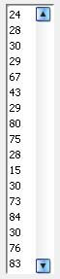
- FIFO Page Replacement Algorithm Simulation:

Consider for 16 page frames and as shown in right side reference fields, we want to simulate FIFO Page Replacement Algorithm.

- Steps:
- Select Algorithm ‘FIFO’ from combo box.
- Set Page frames ‘16’.
- Fill reference fields to reference list.
- Press ‘Simulate’ button.

We get page table with page hits and page faults information.

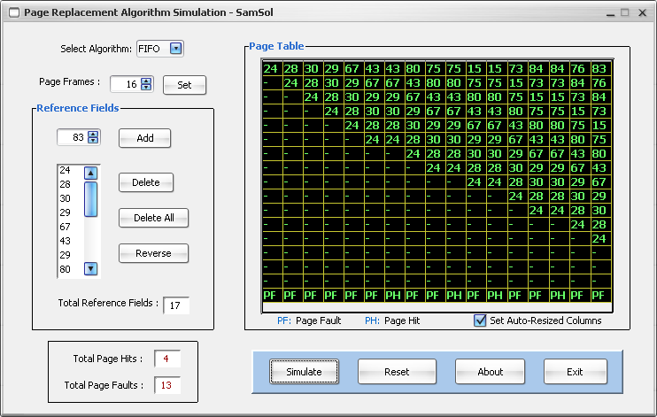

Press ‘Reset’ button to delete all reference fields and reset page frame any time.

- LRU Page Replacement Algorithm Simulation:

Consider for 16 page frames and as shown in right side reference fields, we want to simulate LRU Page Replacement Algorithm.

- Steps:
- Select Algorithm ‘LRU’ from combo box.
- Set Page frames ‘16’.
- Fill reference fields to reference list.
- Press ‘Simulate’ button.

We get page table with page hits and page faults information.

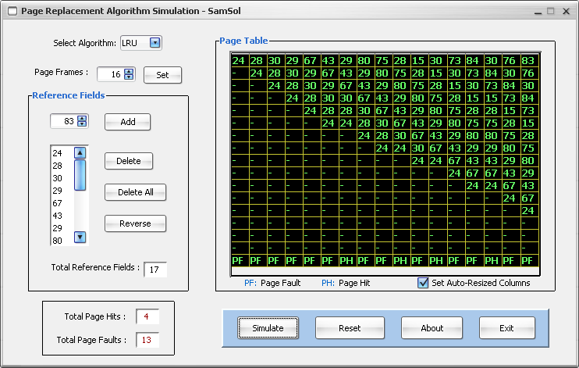

Press ‘Reset’ button to delete all reference fields and reset page frame any time.

Date: Remarks: Signature:

