Ribjisha shakya sec :D
1. ======== ELECTRICITY BILL ========
Units_Used : 80
Rate : 15
Bill : (Units_Used * Rate)
==================================

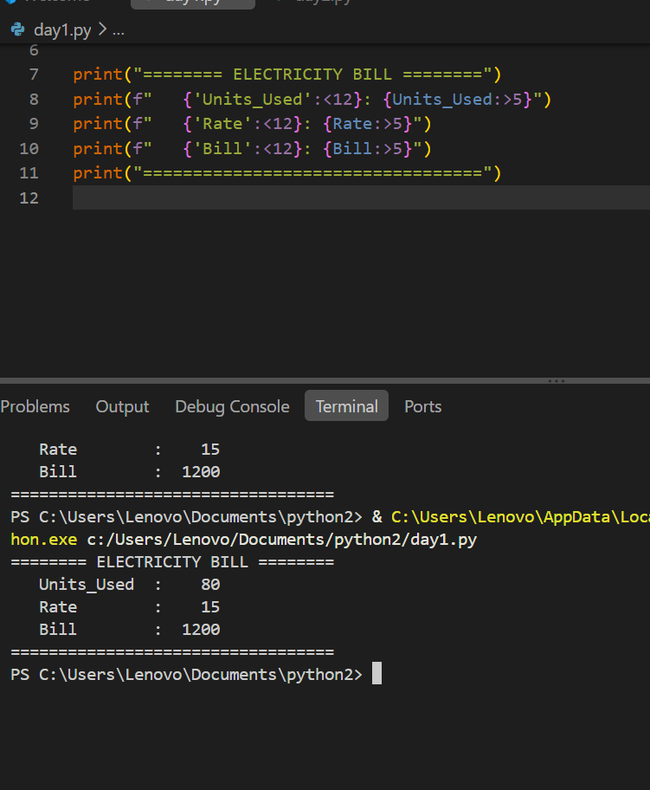

2.
Student Math Python
---------------------------
RAM 85 90
Sita 90 80
Anyone 78 88

