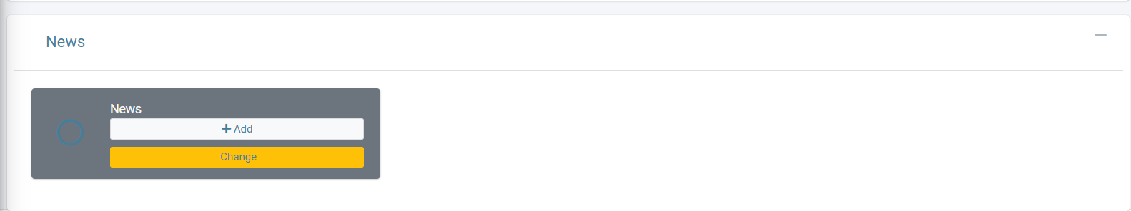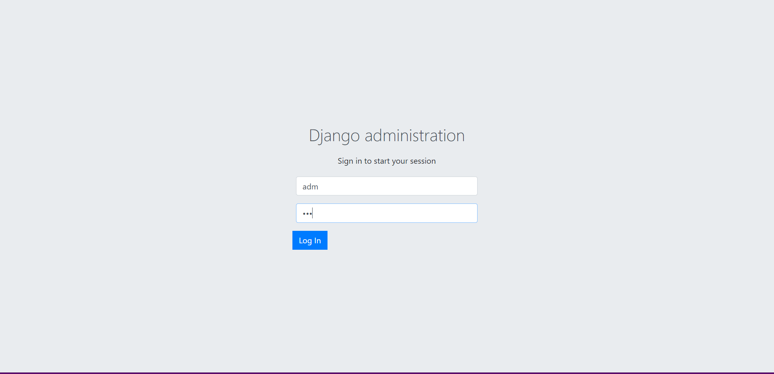

Model of News

Sign-in

Running server

Creating super user

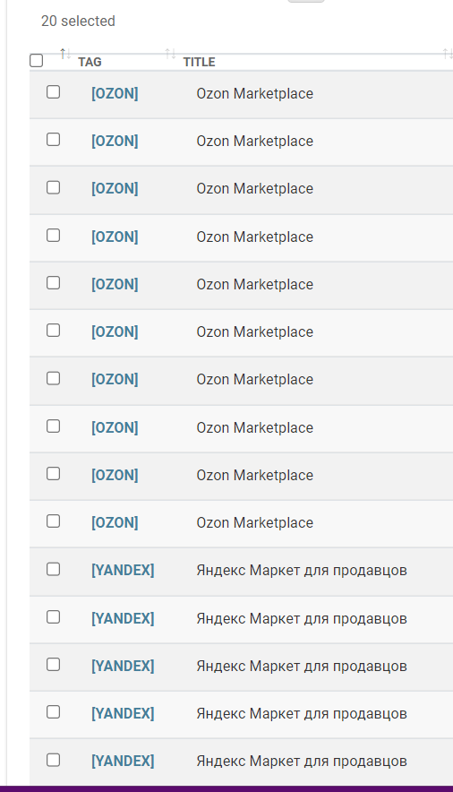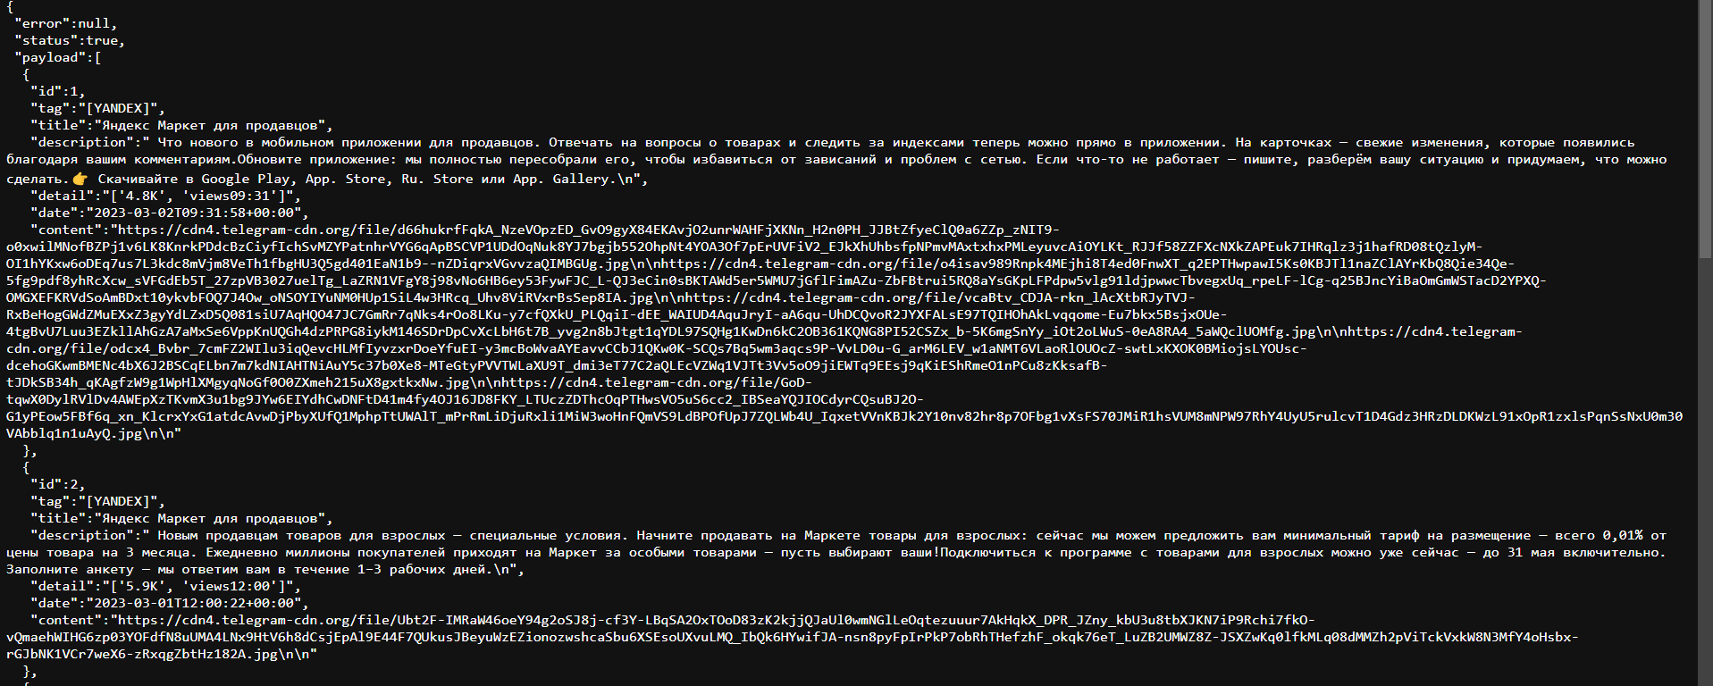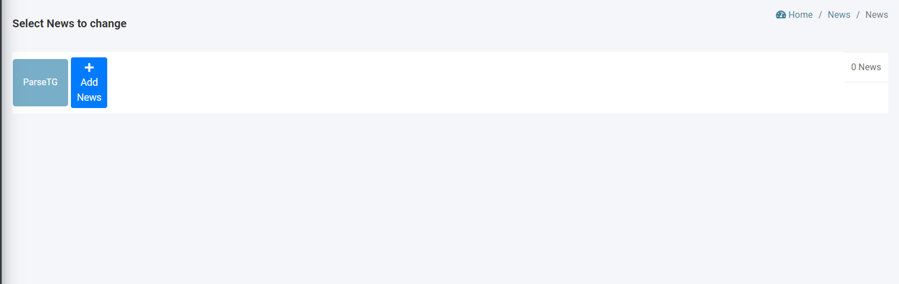

EXAMPLE OF RESPONSE BODY (after we clicked “ParseTG”

1.ParseTG – Parsing tg channel and Returns the response on another page.

After we pushed “CHANGE” ->