**OpenMp**

|  |  |  |  |  |  |  |  |  |
| --- | --- | --- | --- | --- | --- | --- | --- | --- |
| *Versions* | **Time in seconds (NVHPC)** | | | | **Time in seconds (GNU GCC)** | | | |
| **Serial time** | **4.907738** | | | | **6.369754** | | | |
| **Parallel threads** | 2 | 4 | 8 | 16 | 2 | 4 | 8 | 16 |
| **Parallel time** | **2.780051** | **1.447587** | **0.814226** | **0.408386** | **2.968330** | **1.487720** | **0.845733** | **0.440940** |

**Serial time：**

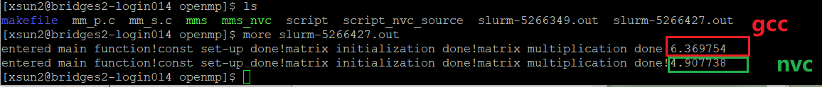

**Parallel Threads**

**Batch script**

**Threads2 :**



**Thread 4:**

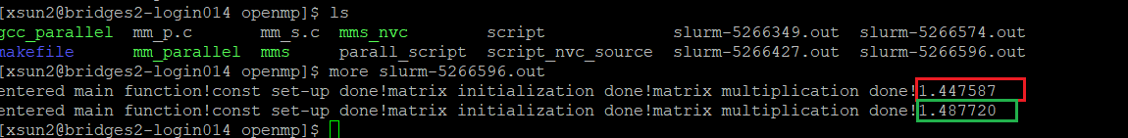

**Thread8:**



**Threa16:**

**Matrix Size (Thread 8)**

|  |  |  |  |  |  |  |  |
| --- | --- | --- | --- | --- | --- | --- | --- |
| **Nvhpc** | | | | **gcc** | | | |
| **Size** | **512** | **1024** | **2048** | **512** | **1024** | **2048** |  |
| **SerialTime** | **0.264033** | **4.907738** | **66.976535** | **0.721901** | **6.369754** | **53.613831** |
| **parallelTime** | **0.260403** | **0.814226** | **63.617135** | **0.120143** | **0.845733** | **8.387561** |

**size512 sirel：**

**Size2048 sirel：**



**Size512 parallel：**



**Size2048 parallel：**

