MOX Fuel Recipe Approximation Tests in GENIUSv2

Kathryn D. Huff, Royal A. Elmore, Kyle M. Oliver, Paul P. H. Wilson
University of Wisconsin-Madison, Department of Engineering Physics, 419 Engineering Research Building, 1500 Engineering Drive, Madison, WI 53706
Tel: (608) 263-0807, Fax: (608) 263-4499, Email: wilsonp@engr.wisc.edu

I. INTRODUCTION

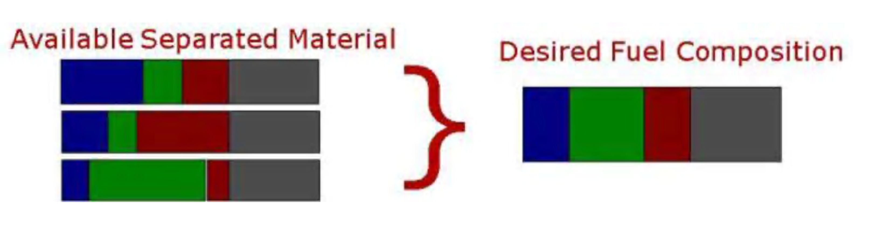
The GENIUS project (Global Evaluation of Nuclear Infrastructure Utilization Scenarios) was conceived as the top-level nuclear enterprise simulation tool in the Simulation Institute for Nuclear Enterprise Modelling and Analysis (SINEMA) framework¹. The current version, GENIUSv2, is an object-oriented C++ application with Python-based pre- and post-processing.
The GENIUSv2 tool proposes to inform nuclear fuel cycle technology and policy by providing a richly detailed, modular platform capable of dynamically modeling complexly integrated international fuel cycles such as those involving separations and reprocessing schemes.
Here we present results of the GENIUSv2 testing suite which demonstrate neutronics weighting methods for approximating optimal mixed oxide fuel compositions. These weighting methods achieve various levels of success at assembling critical fuel recipes from separated spent fuel streams for fuel cycles incorporating mixed oxide reprocessing. Results of neutronics constraining and neutronics weighting methods are here compared and alternative linear programmatic formulations are proposed for determining mixed-oxide (MOX) fuel compositions from available material.

II. POST-SEPARATIONS ACTINIDE STREAMS

II.A. Spent Fuel Separations Schemes
The GENIUSv2 mathematical model of a separations facility is a transformation matrix from a single isotope vector to a set of isotopic streams. This transformation matrix is specified by a set of separated streams and associated separation efficiencies. A separation matrix associated with a specific spent fuel reprocessing scheme (MOX, UREX, UREX+…) will facilitate post-separations fuel refabrication according to the target fresh fuel composition associated with that scheme.
However, recombination of the separated streams into target recipe is inexact due to separation inefficiencies since it is assumed that neither chemical nor isotopic separations processes can be further applied at the stream (‘barrel’) level. Therefore, an approximation that values mass, spectral, and isotopic similarity to the target recipe must employ a nontrivially appropriate weighting scheme. Specifically, this problem is associated with a notion in the literature termed the ‘Winery’ problem and will be referred to here as the Recipe Approximation Problem (RAP).
Fig. 1. Achieving an appropriate isotopic composition from barrels of available material for which no exact match is possible is a challenge that requires appropriate neutronic weighting.
A methodology has been developed for selecting a fraction of each barrel to approximate the desired fuel recipe based on the neutronics performance of the achieved recipe when no exact match is possible for the target fuel recipe.

II.B. Approximation Performance Requirements
A recipe approximation should be accurate enough to arrive at the exact target recipe when it is available and flexible enough to arrive at alternative compositions when it is not. Such alternative compositions, however, must fall within acceptability windows associated with mass and neutronics constraints.
Fundamentally, an acceptable reactor fuel must weigh an appropriate amount, reach criticality, and burn up according to a safe spectral profile.
A first constraint for this otal fuel mass fall within an acceptability window appropriate for its destined reactor.
In this work, the neutronics performance goal is implemented by first attempting to match the k-eigenvalue of the fuel, approximated by a 1-group neutron reproduction factor.
While this offers a similar gross neutronics performance at the time of insertion in the reactor core, it does not match performance in either the reactivity coefficients (safety) of the core or the burnup (lifetime) of the core.

III. Neutronics Weighting Tests in GENIUSv2
The MOX fuel recipe approximation problem (RAP) is based around the linear program (LP) optimization described in Eq. 1.

In Eq. 1, x􀁇 is a vector representing the fraction of each barrel, b, used in the approximation. Matrix M is the mass of each isotope in each barrel such that y􀁇 is a vector of the discrepancies for each isotope between the approximation and the desired recipe, r􀁇.

function, these discrepancies are weighted by the vector,
c􀁇 , defined as the reciprocal of the mass of each isotope in
the target MOX fuel recipe (or the total recipe mass if that
isotope does not exist in the target recipe). This is
necessary to ensure that minor constituents (e.g. 235U) are
matched with the same importance as major ones
(e.g. 238U). Vector w
􀁇
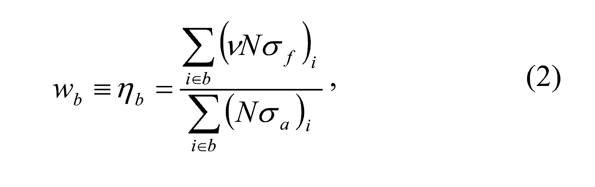
describes the neutronics performance
of each barrel, allowing a constraint that limits the overall
neutronics performance to be within 􀁈w of the target
􀁕􀁈􀁆􀁌􀁓􀁈􀂶􀁖􀀃 􀁓􀁈􀁕􀁉􀁒􀁕􀁐􀁄􀁑􀁆􀁈􀀏􀀃 wr. Vector m
􀁇
is the total mass of
each barrel, allowing a constraint that limits the overall
mass of the approximation to be within 􀁈m of the target
􀁕􀁈􀁆􀁌􀁓􀁈􀂶􀁖􀀃􀁗􀁒􀁗􀁄􀁏􀀃􀁐􀁄􀁖􀁖􀀏􀀃mr.
The neutronics weighting parameter for a barrel is
currently defined in Eq. 2 as
the ratio of the total neutron reproduction to the total
neutron absorption.
GENIUSV2 MOX FUEL SCENARIO RESULTS
A simple MOX recycle scenario was simulated with a
fleet of 12 UOX-fueled PWRs and a fleet of 3 Pu+Np
MOX-fueled PWRs to test the LP. Figure 2 shows how
well the neutronics and mass constraints were achieved
under different constrain tolerance for each of the more
than 800 MOX fuel orders placed in the 100 year
simulation. The neutronics performance is routinely less
than the target performance, and is nearly independent of
the tolerance. The total mass is also less than the target
value and unaffected by the variation in the neutronics
performance tolerance. The recipes fluctuate over time due
to changes in the composition of materials available at the
time of each order. A future scenario will determine the
separations plant unseparated fuel inventory requirements
to achieve desired MOX fuel recipes for a certain number
of MOX reactors.
CONCLUSIONS

IV. CONCLUSIONS
The LP formulation offers a promising paradigm for the recipe approximation problem, but an improved neutronics weighting parameter must be developed. The current weighting parameter treats the total neutron multiplication of the new fuel recipe as an extrinsic property, growing as each new barrel is added. A more correct formulation will redefine this constraint as a function of the extrinsic properties of total neutron production and total neutron absorption, rather than their ratio. Future work will also focus on moving the constraints into the objective function, with different weights to represent the importance of each. In general, this LP formulation of the RAP allows other users/developers to propose and implement alternative sets of constraints.
We conclude from this work that GENIUSv2 is sufficiently detailed to closely approximate the kinds of nuclear fuel cycle scenarios currently modeled by other codes, sufficiently robust to store and process the large amount of data that accumulate when modelling those scenarios discretely, and sufficiently flexible to model technical and socio-economic relationships between the various entities in a region-institution-facility hierarchy. The test suite also demonstrates how the R-I-F hierarchical matching framework, under carefully chosen arc costs, has the potential to help policy makers understand the effects of tools like trade agreements, tax incentives, long-term contracts, and other mechanisms.

ACKNOWLEDGMENTS

The authors would like to thank the Advanced Fuel Cycle Initiative/Global Nuclear Energy Partnership University Fellowship Program for funding Oliver’s work on GENIUS, Arnaud Reveillere for his significant contributions and Milad Fatenejad for his help with designing and implementing the GENIUSv2 debugging framework.
References

- K. O. PASAMEHMETOGLU and P. Finck, “SINEMA: Simulation Institute for Nuclear Energy Modelling and Analyses,” Trans. of the American Nuclear Society, Vol. 95, p. 155-156, American Nuclear Society, La Grange Park, IL, United States (2006).

