SDAF
Single Device Assessment Framework
Connected Device Security Assessment — Generic Edition

Version 1.0 | Field Manual Edition

Purpose
A structured three-phase methodology for assessing the security posture of a single connected device. Device-agnostic — applicable to any networked or wireless device regardless of sector. Network-level and ICS assessments are out of scope and handled separately.

In Scope | Out of Scope
- Single connected device under assessment  - Device firmware and software components  - Device-exposed interfaces and services  - Device-local data handling  - Device update and integrity mechanisms | - Network infrastructure or routing devices  - Cloud backend systems  - Other devices on the same network  - ICS / OT environment assessment  - Mobile application security

Appendix Reference: Evidence supporting all findings is documented in Appendices A, B, and C.

How to Use This Document

This document is a field manual, not a checklist. It has three parts:

Part 1 — Framework Explained | Part 2 — Working Template | Part 3 — Appendices
Phase intent and methodology judgment. Read before your first engagement. | Fill-in fields used during active work. Prompts in italics. | Raw evidence: filesystem, binary captures, network artifacts. Referenced from findings.

Framework, Not Checklist
New information at any stage may invalidate earlier assumptions. A finding in binary analysis that contradicts recon, is the methodology working correctly. Always be prepared to loop back and update earlier sections. Every loop-back should be documented in the relevant section.

Three-Phase Structure
Phase | Name | Output
1 | Intelligence Gathering | True picture of the device raw material + evidence for appendices
2 | Framework Application | Stable structured findings referencing appendix evidence
3 | Deliverable Production | Client report with ATT&CK chains, CVSS, and appendix citations

PART 1 — THE FRAMEWORK EXPLAINED

1 | Intelligence Gathering  Firmware Acquisition · Recon · SBOM · Binary Analysis

Phase 1 builds the ground truth picture of the device. You cannot model threats against interfaces you have not found, and you cannot verify components you have not extracted. The output of this phase is raw material, not conclusions. Captures and artifacts collected here populate the appendices. The relevant information is added to the template in Part 2.

This phase is explicitly iterative. Binary analysis may reveal an interface missed during recon. An unexpected SBOM component may require returning to firmware acquisition. Every loop-back should be documented.

What You Are Building
- A complete inventory of every interface the device exposes: physical, network, and wireless
- The actual firmware running on the device, acquired from hardware, OTA intercept, or vendor source
- A verified SBOM reflecting what is actually present, not what the manufacturer claims
- An understanding of what the device does on a network before any active testing
- Confirmed vulnerabilities from binary analysis with CWE references, documented in Appendix B

Key Activities
- Passive recon: Manufacturer docs, FCC ID database, chip identification from PCB markings
- Interface identification: Network ports, USB, UART, JTAG, wireless, Bluetooth, any exposed debug surface
- Firmware acquisition: Flash memory extraction, UART console, OTA intercept, or vendor portal, use least invasive method
- SBOM: Binwalk extraction, filesystem walk, Syft + Grype, CVE correlation, document unsquashed tree in Appendix A
- Network baseline: Network traffic baseline before active testing — document captures in Appendix C
- Binary analysis: Ghidra or equivalent — decompile targets, identify insecure calls, confirm CWEs — screenshots in Appendix B

Appendix Cross-Reference
As evidence is collected during Phase 1, assign it a figure reference and note it in the relevant appendix section. Every finding in Phase 2 and Phase 3 should cite at least one appendix figure as evidence.

Appendix | Collect During | What Goes There
Appendix A | SBOM / Extraction | Unsquashed filesystem tree, directory listing, notable paths flagged
Appendix B | Binary Analysis | Ghidra screenshots, decompiled C, annotated disassembly, hardcoded strings
Appendix C | Network Baseline / Tools | Wireshark captures, SBOM exports, Grype CVE reports, tool output

Why Binary Analysis Changes the Finding
A finding that says 'this component has CVE-XXXX' is a flag. A finding that says 'CVE-XXXX confirmed present — vulnerable pattern at 0x00401A20, reachable from network interface — see Appendix B, Fig. B-2' is evidence. The appendix is what makes the assertion credible.

2 | Framework Application  Attack Surface · Access Control · Data Security · Device Integrity

Phase 2 converts Phase 1 raw material into structured analysis across four diagnostic categories. This is where looping stops and findings stabilize. Every finding should reference at least one appendix figure as supporting evidence.

The Four Diagnostic Categories

1. Attack Surface
What can be reached and how — every interface is a potential entry point
- Ask: What interfaces exist? Which were found in Phase 1 that were undisclosed or unexpected?
- Look for: Open ports and services, debug interfaces left enabled, wireless attack surface, physical access vectors
- Evidence ref: Appendix A (filesystem confirms running services), Appendix C (network capture shows open ports)

2. Access Control
Who can do what and can it be bypassed
- Ask: How does the device authenticate? Can it be bypassed? Are hardcoded credentials present?
- Look for: CWE-798 hardcoded credentials, default passwords, unauthenticated interfaces, weak tokens
- Evidence ref: Appendix B (Ghidra confirms credential string in binary), Appendix A (passwd/shadow in filesystem)

3. Data Security
What sensitive data exists and how is it protected
- Ask: What data does the device handle, store, or transmit? Encrypted in transit and at rest?
- Look for: Cleartext transmission (CWE-319), unencrypted local storage, exposed API keys, sensitive logging
- Evidence ref: Appendix C (network capture shows cleartext), Appendix A (storage paths, key files identified)

4. Device Integrity
Can the device be tampered with or made to misbehave
- Ask: Can firmware be modified and pushed? Is the update mechanism verified? Can the device be made to fail?
- Look for: Unsigned updates (CWE-347), unverified boot chain, replay attack, denial of service vectors
- Evidence ref: Appendix B (update handler decompile), Appendix C (OTA intercept capture)

3 | Deliverable Production  ATT&CK Chain Mapping · CVSS Scoring · Report Writing

Phase 3 converts structured findings into a professional deliverable. Every finding cites appendix evidence. The appendices serve as the forensic record that substantiates the report claims.

ATT&CK Chain Mapping
- Use Phase 2 categories and CWEs as your working analysis
- Map each finding to ATT&CK tactics and techniques as a Phase 3 step — not a re-analysis
- Build the full chain: Initial Access technique through to Impact technique
- On a standalone device, lateral movement is typically absent — document this explicitly as scope boundary

Example ATT&CK Chain — CWE-78 on a Connected Device
Step | Tactic | Technique ID | Technique Name | What Happens | Evidence
1 | Initial Access | T1190 | Exploit Public-Facing Application | Malformed input to web UI | App. B, Fig. B-2
2 | Execution | T1059 | Command and Scripting Interpreter | Shell command executes | App. B, Fig. B-2
3 | Collection | T1005 | Data from Local System | Stored credentials read | App. A, Fig. A-1
4 | Impact | T1499 | Endpoint Denial of Service | Device made unavailable | —

PART 2 — WORKING TEMPLATE

Fill in this section during the engagement. Fields in italics are prompts. When findings change your understanding, update earlier sections and log the loop-back.

Engagement Information
Device / Product Name  Enter device name and model | Manufacturer / Vendor  Enter name

Assessment Date  Enter date range | Analyst  Enter name

Assessment Driver  Compliance / Insurance / Internal / Customer requirement | Firmware / SW Version  Enter if known

Device Category  Connected instrument / Embedded controller / Smart peripheral / Other | Network Role  Standalone / Client only / Has downstream devices

Phase 1 — Intelligence Gathering

1.1 Reconnaissance
Main Processor / Architecture | Enter chip ID and architecture (ARM / MIPS / x86 / etc.)
Connectivity Modules | WiFi / BT / BLE / Cellular / Ethernet — module IDs if visible
Debug Interfaces Identified | UART / JTAG / SPI / I2C / USB — location, confirmed active Y/N
Firmware Publicly Available | Y / N — source URL if yes
Network Baseline Summary | Destinations, protocols, encrypted Y/N — captures in Appendix C

1.2 Firmware / Software Acquisition
Acquisition Method  Hardware flash / UART / OTA intercept / Vendor portal / Other | Image Hash (SHA256)  Enter hash

Encrypted / Packed  Y / N — method if known | OS / Base Platform  Enter OS, version, kernel if applicable

Acquisition notes:
Document method, obstacles, tools. Note if image could not be acquired and why. Unsquashed filesystem documented in Appendix A.

1.3 SBOM Summary
Total Components  Enter count | SBOM Format  CycloneDX / SPDX / Other

Critical CVEs (9.0+)  Enter count | High CVEs (7.0-8.9)  Enter count

License Issues  Y / N — summary if yes | Unexpected Components  Y / N — note if yes

Notable findings: Gaps between expected and actual component inventory
Document gaps. Full SBOM export in Appendix C.

1.4 Binary Analysis
Primary Tool  Ghidra / Binary Ninja / IDA / Other | Analysis Targets  List binaries selected and why

Finding | Binary / Address | Insecure Pattern | CWE | Conf. | Appendix Ref
e.g. Hardcoded credential | admin.cgi / 0x00403210 | String literal in .rodata | CWE-798 | Y | App. B, Fig. B-1

Loop-backs triggered by binary analysis (what changed, which section updated):
Document any earlier sections revised as a result of binary analysis findings.

Phase 2 — Framework Application
Work through each category using Phase 1 findings. Every finding should cite at least one appendix figure as evidence.

2.1 Attack Surface
Interface | Expected? | Default On? | Notes | Appendix Ref
 | Y / N | Y / N
 | Y / N | Y / N
 | Y / N | Y / N
 | Y / N | Y / N
 | Y / N | Y / N

Undisclosed or unexpected interfaces:
Any interface not expected is an automatic finding. Note here with appendix reference.

2.2 Access Control
Interface / Service | Auth Method | Issues | Appendix Ref

Hardcoded credentials?  Y / N — CWE-798 if yes, App. B ref | Auth bypass confirmed?  Y / N — method, CWE, App. B ref

2.3 Data Security
Data types handled  PHI / PII / Credentials / Telemetry / Other | Encrypted in transit?  Y / N / Partial — App. C ref

Encrypted at rest?  Y / N / Partial — App. A ref | Secrets in firmware?  Y / N — type, CWE, App. B ref

Data flow summary:
Sketch data flow or attach DFD. Note every trust boundary crossing.

2.4 Device Integrity
Update mechanism  OTA / USB / Manual / None | Updates signed?  Y / N — App. B ref

Secure boot?  Y / N / Unknown | Malicious firmware pushable?  Y / N — conditions, App. C ref

DoS vectors?  Y / N — describe | Replay attack viable?  Y / N — describe

Phase 3 — Deliverable Production

3.1 ATT&CK Chain Map
Build the full chain for each exploitable finding. Cite appendix evidence in the Notes column.

Tactic | Technique ID | Technique Name | CWE Reference | Notes
Initial Access | T1190 | Exploit Public-Facing Application | e.g. CWE-78 | Entry point

3.2 Findings Register
Finding Title | Category | MITRE Technique | CWE | CVSS
e.g. OS Command Injection in Web UI | Attack Surface | T1190 / T1059 | CWE-78 | 9.8 Critical

3.3 Finding Detail Template
Copy this block for each finding. The Evidence field must reference an appendix figure.

Finding Title | Short descriptive name
Category | Attack Surface / Access Control / Data Security / Device Integrity
CWE | CWE ID and name — confirmed in binary analysis or active testing
MITRE Tactic | Initial Access / Execution / Persistence / Discovery / Collection / Impact
MITRE Technique | Technique ID and name — e.g. T1059 Command and Scripting Interpreter
ATT&CK Chain | Full chain if multi-step — e.g. T1190 -> T1059 -> T1552
Severity (CVSS 3.1) | Score and vector string
Description | What is the weakness. What does it allow an attacker to do on this device.
Evidence | How confirmed. Reference appendix figure — e.g. See Appendix B, Fig. B-2
Blast Radius | Impact contained to this device? Y/N. If N, describe downstream exposure.
Remediation | Specific actionable fix.
Compensating Control | If fix not immediately possible, what reduces risk in the interim.

3.4 Remediation Prioritization
Classification | Definition | Required Action
Must Remediate | Directly exploitable, high impact, no compensating control available | Fix before submission or release. Document as unresolved if timeline prevents.
Mitigate | Exploitable but compensating controls reduce risk to acceptable level | Document control, residual risk, and remediation timeline
Accept | Low likelihood, low impact, or theoretical given device context | Acceptance must be explicit with documented rationale. Not assumed.

PART 3 — APPENDICES

Appendices contain the raw evidence supporting all findings. Every finding in Part 2 should cite at least one figure from these appendices. Replace sample figures with actual engagement captures.

Appendix | Title | Contents
A | Filesystem & Directory Structure | Full directory tree from unsquashed firmware image
B | Binary Analysis Captures | Ghidra screenshots and annotated decompiled output
C | Supplementary Artifacts | Network captures, SBOM exports, CVE correlation reports

Appendix A — Filesystem & Directory Structure
The full directory tree extracted from the device firmware image after unsquashing. This is the ground truth inventory of what is present on the device. Notable paths — credentials, keys, binaries of interest, unusual files — should be annotated inline.

How to Use This Appendix
When a finding references files present on the device (e.g. exposed private key, world-readable shadow file, suspicious binary), cite the figure here as evidence. Format: 'See Appendix A, Fig. A-1'. Annotate the relevant lines in the figure before including in the final deliverable.

Fig. A-1 — Unsquashed Firmware Filesystem Tree
Extraction command and output. Annotated entries indicate items of security interest.

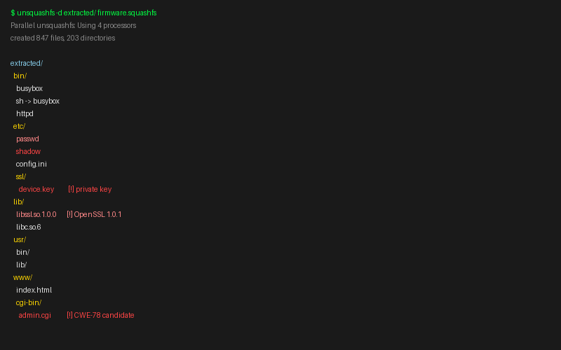
Fig. A-1 — Unsquashed Firmware Filesystem Tree
Full directory listing post-extraction. Highlighted entries indicate files of security interest — private keys, world-readable credentials, CWE-78 candidate binaries.

Fig. A-2 — [Additional Filesystem Figure]
Reserve for additional filesystem captures — specific directory listings, file permission output, or other filesystem-level evidence.

Attach additional filesystem capture here. Replace this placeholder with actual engagement screenshot.

Appendix B — Binary Analysis Captures
Ghidra screenshots, annotated decompiled C output, and disassembly captures supporting findings from binary analysis. Each figure should clearly identify the binary, function, and address of the finding it documents.

How to Use This Appendix
When a finding is confirmed through binary analysis, the Ghidra screenshot or decompile output is the evidence. Annotate the relevant lines or addresses before including. Format: 'See Appendix B, Fig. B-2'. Every CWE confirmed in binary should have a corresponding figure here.

Fig. B-1 — [Hardcoded Credential / CWE-798]
Binary string analysis output showing hardcoded credential value in .rodata section.

Attach Ghidra screenshot showing hardcoded credential string, binary address, and surrounding context. Replace this placeholder.

Fig. B-2 — OS Command Injection Decompile (CWE-78)
Ghidra decompiled C output showing unsanitized user input passed to system() call in admin.cgi handle_request().

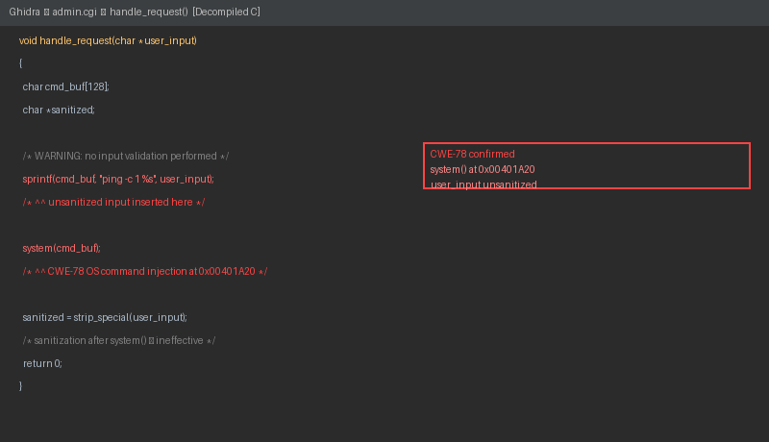
Fig. B-2 — Ghidra Decompile — handle_request() — CWE-78 Confirmed
Decompiled C showing system() call at 0x00401A20. User input inserted into command buffer without sanitization prior to execution.

Fig. B-3 — [Additional Binary Analysis Figure]
Reserve for additional binary captures — update handler decompile, cryptographic implementation review, authentication bypass, or other binary-confirmed findings.

Appendix C — Supplementary Artifacts
Network captures, SBOM exports, CVE correlation reports, and other tool output. These are the machine-generated artifacts that support manual findings and provide an auditable record of the assessment methodology.

How to Use This Appendix
Attach raw tool output here. Network captures support Data Security findings. SBOM exports and CVE reports support component-level findings. Every automated tool used during the engagement should have its output represented here, even if no findings were generated — negative results are also evidence of thoroughness.

Fig. C-1 — Network Traffic Baseline Capture
Wireshark capture from baseline network observation prior to active testing. Cleartext transmissions highlighted.

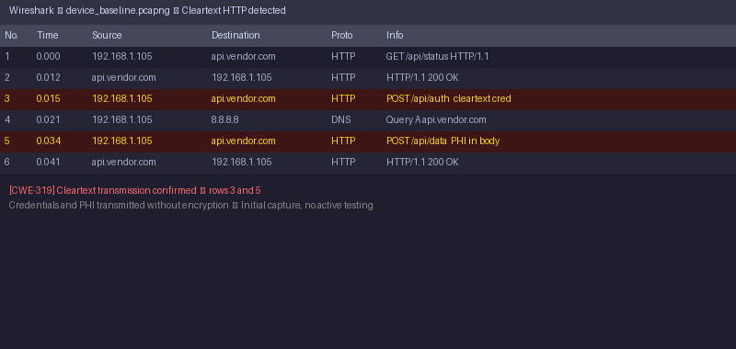
Fig. C-1 — Wireshark — Device Baseline Traffic — CWE-319 Identified
Network capture showing cleartext HTTP POST requests containing credentials and PHI. Captured during passive baseline observation, no active testing performed.

Fig. C-2 — SBOM Export (CycloneDX / SPDX)
Attach full SBOM export in CycloneDX or SPDX format. Include CVE correlation output from Grype or equivalent. Replace this placeholder with actual tool output.

Fig. C-3 — CVE Correlation Report
Component | Version | CVE ID | CVSS | Status
OpenSSL | 1.0.1 | CVE-2014-0160 | 7.5 High | Confirm in binary

SDAF v1.0 — Single Device Assessment Framework — This document is a working field manual. It is not a checklist.

