
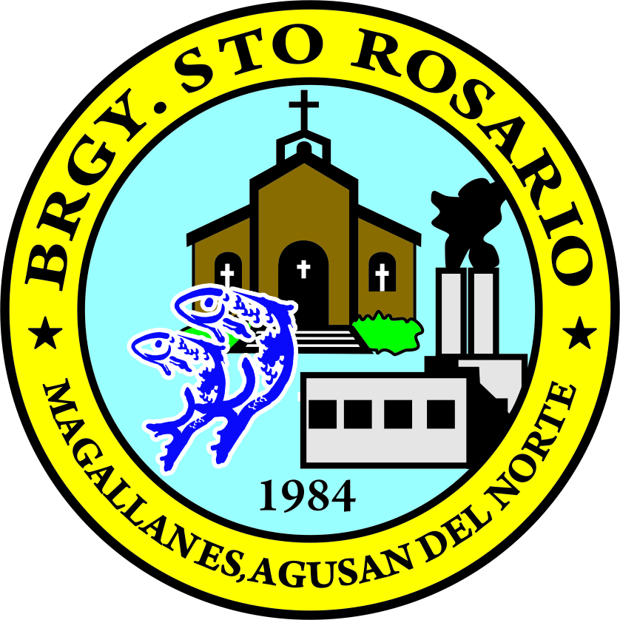
Republic of the Philippines
PROVINCE OF AGUSAN DEL NORTE
Municipality of Magallanes
BARANGAY STO. ROSARIO

OFFICE OF THE PUNONG BARANGAY

CERTIFICATION

TO WHOM IT MAY CONCERN:

THIS IS TO CERTIFY that Mr./Mrs./Ms. ${fullname}, ${age} yrs. old, is bona fide resident of ${purok}, Barangay Sto, Rosario, Magallanes Agusan del Norte.

This certifies further that he has not committed any undesirable acts; thus, he is of good moral character.

This certification is being issued upon the request of the abovementioned person for ${purpose}.

Issued this ${day} day of ${month}, ${year} at the Office of the Punong Barangay, Barangay Sto. Rosario, Magallanes, Agusan del Norte.

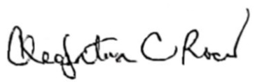

CLEOPATRA C. ROCES
Punong Barangay

Barangay Dry Seal

