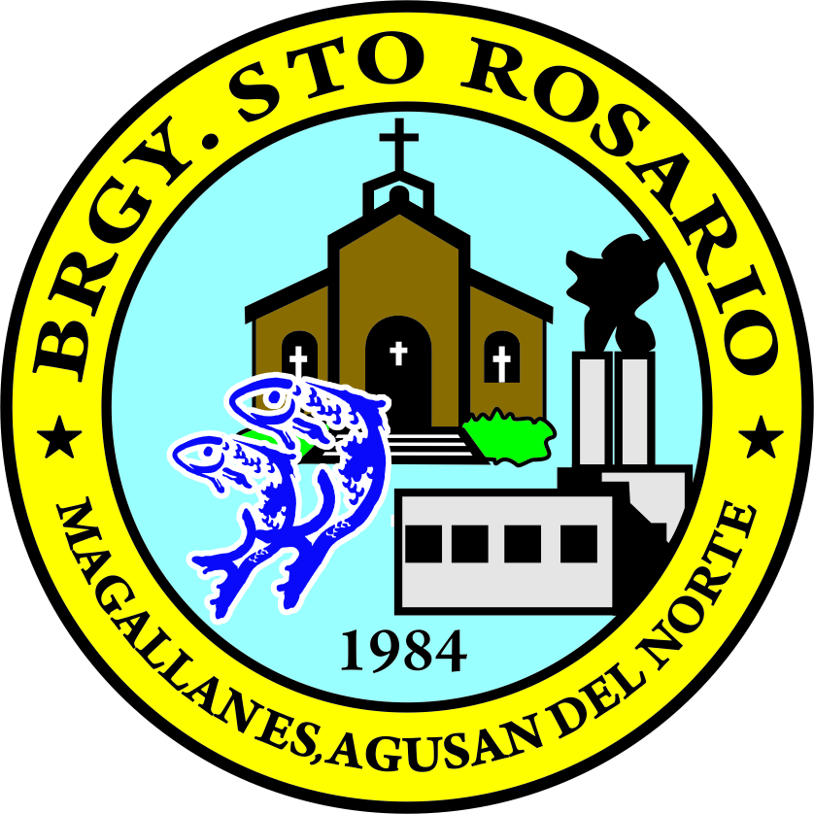
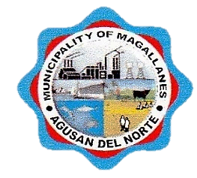
Republic of the Philippines
Province of Agusan Del Norte
Municipality of Magallanes
BARANGAY STO. ROSARIO
Barangay Hall, Purok 1, Brgy. Sto. Rosario, Magallanes, Agusan del Norte
Tel No. (085) 806-0050 | Email Address: barangaystorosario2t@gmail.com

OFFICE OF THE PUNONG BARANGAY

CERTIFICATION

INDIGENT

TO WHOM IT MAY CONCERN:

This is to certify that Mr./Ms./Mrs. ${fullname}, ${age} yrs. old, a resident of ${purok}, Barangay Sto. Rosario, Magallanes, Agusan del Norte is an indigent member of this barangay and has no permanent source of income.
This certification is being issued upon the request of ${fullname} for ${purpose}.

Issued this ${day} day of ${month}, ${year} at the Office of the Punong Barangay, Barangay Sto. Rosario, Magallanes, Agusan del Norte.
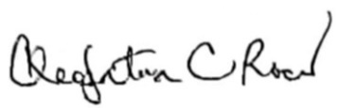

CLEOPATRA C. ROCES Punong Barangay

Barangay Dry Seal

