

Republic of the Philippines
Province of Agusan Del Norte
Municipality of Magallanes
BARANGAY STO. ROSARIO
Barangay Hall, Purok 1, Brgy. Sto. Rosario, Magallanes, Agusan del Norte
Tel No. (085) 806-0050 | Email Address: barangaystorosario2t@gmail.com

OFFICE OF THE PUNONG BARANGAY

BARANGAY PERMIT

TO WHOM IT MAY CONCERN:

This is to CERTIFY that Mr./Mrs./Ms. ${fullname},of legal age, is hereby granted a permission to ${purpose} within the jurisdiction of Barangay Sto. Rosario on ${day} at ${time}, this barangay.
This permit is valid only for the date and time specified.
Issued this ${day_ord} day of ${month}, ${year} at the Office of the Punong Barangay, Barangay Sto. Rosario, Magallanes, Agusan del Norte.

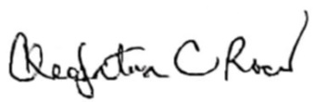

CLEOPATRA C. ROCES
Punong Barangay

Barangay Dry Seal

