
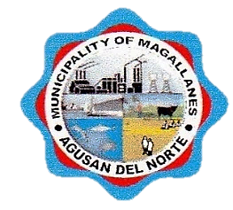
Republic of the Philippines
Province of Agusan Del Norte
Municipality of Magallanes
BARANGAY STO. ROSARIO
Barangay Hall, Purok 1, Brgy. Sto. Rosario, Magallanes, Agusan del Norte
Tel No. (085) 806-0050 | Email Address: barangaystorosario2t@gmail.com

OFFICE OF THE PUNONG BARANGAY
CERTIFICATION

TO WHOM IT MAY CONCERN:

THIS IS TO CERTIFY that Mr./Ms./Mrs. ${fullname}, ${age} yrs. old, resident of ${purok}, Barangay Sto. Rosario, Magallanes, Agusan del Norte, is a bona fide resident of this barangay.
This certification is being upon the request of the ${fullname} for ${purpose}.

Issued this ${day} day of ${month}, ${year} at Barangay Sto. Rosario Magallanes, Agusan del Norte.

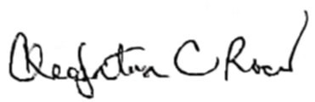

CLEOPATRA C. ROCES
Punong Barangay

Barangay Dry Seal

